Is There A Link Between the Ages of People Buried and The Type of Monuments Used in Saint Peter’s Graveyard, Lampeter, and Where Are These Monuments Placed in Relation to The Location of The Church? Are These Monuments Also Representing Single or Multiple Burials?

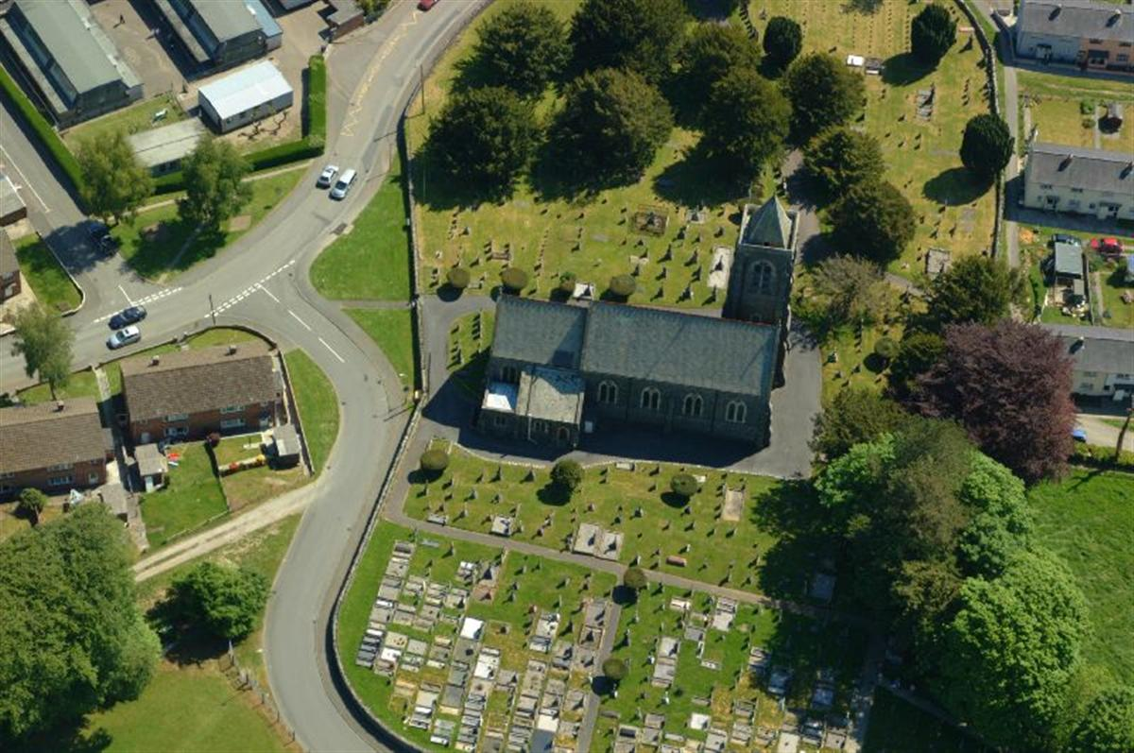

By Ruth Athey (1901992)
Date: 28/01/2020

Contents

- Abstract
- Introduction
- Methodology
- Results of Findings

4.1 Typology in Relation to Immediate Proximity of Church

4.2 Typology and age
4.2.1 Traditional Monuments
4.2.2 Plinth/Stele Monuments
4.2.3 Flat Monuments
4.2.4 Bed Monuments
4.2.5 Table Monuments
4.2.6 Other Monuments

4.3 Years of Death
4.3.1 Traditional Monuments
4.3.2. Plinth/Stele Monuments
4.3.3 Flat Monuments
4.3.4 Bed Monuments
4.3.5 Table Monuments
4.3.6 Other Monuments

4.4 Multiple Occupancies

4.5 Languages

- Discussion
- Conclusion
- Appendices
- Bibliography

1) Abstract
Through collecting and analysing data from monuments situated within the Graveyard it was able to help the question: Is There A Link Between the Ages of People Buried and The Type of Monuments Used in Saint Peter’s Graveyard, Lampeter, and Where Are These Monuments Placed in Relation to The Location of The Church? Are These Monuments Also Representing Single or Multiple Burials?
Data was collected from all types of graves, mostly located within close proximity to the church but further afield also. Graves were also recorded where data could not be collected from them as typology and location could still be determined. After analysing the results conclusive answers were found enabling the question to be answered.
2) Introduction
As stated in Mortuary Monuments and Burial Grounds of the Historic Period (Mytum,2004, p.25) ‘Most graves may have been marked previously in the early modern period through piled up earth or stones, by vegetation planting, or simple uninscribed markers, but these would seem to have only lasted over the period of grave visiting, to be swept away within decades. It is therefore during the period up to the 18th century that the concept of more permanent grave marking for the population beyond a small elite was developed.’
The objective of this report is to analyse the data recorded from 482 graves that use these more permanent markers which are situated within the graveyard of Saint Peter’s Church, Lampeter, and look at the typology of monuments, in relation to the main occupant’s ages as well as looking at where these graves are located within the graveyard grounds in order to answer the title question.
3) Methodology
As this report is based on research that used numbers the primary method used is of a quantitative nature. First of all, data was collected from every monument for all typologies of monuments which were located closest to the church. This included the immediate East plot, North plot, West plot and the South plot up to the tree line. Once all of this data was collected, more data was collected from monuments within the plots further afield, but these monuments came under the typology of Plinth/Stele but could also be mixed with other type of monuments. Also, data from some random monuments located further afield from the immediate church plots, that do not come under the typology of Plinth/Stele typology was also collected.
4) Results of Findings
4.1 Typology in Relation to Immediate Proximity to the Church
By collecting and analysing data, it is recognised that the most favoured type of monument used within the closest proximity to the church is the Traditional style. This came out at 54% with the remaining types making up the other 46%. The least popular type of monument was the Flat style. This made up 5% of the remaining 46%. For the remaining 41%, see appendices 1.
4.2) Typology and Age
4.2.1) Traditional Monuments
Data from 213 Traditional type monuments was collected but there were only ages available to determine from the main occupants of 181 of these monuments. By creating a graph (Appendices 2) for the ages of people who made it to one year and over (171 people) that are marked by a Traditional monument it can be seen that the majority of people made it to 40 years with 109 graves passing this. From 40 years to 50 years 23 people did not age 50 but 50.29% of the main occupants marked with Traditional monuments did.
Ages of 5 of the 181 Traditional type monuments were given in months (Appendices 3) the youngest of which was 3 months and the oldest was given as 13 months. 4 out of 5 of these monuments did not pass 4 months old. There were also 5 traditional monuments that gave ages of the main occupants in weeks (Appendices 4). The oldest only surviving to 7 weeks but the youngest did not even survive 24 hours old.
4.2.2) Plinth/Stele Monuments
Ages could be determined for a total of 148 Plinth/Stele Monuments. Like the Traditional style monuments graphs were created for main occupants ages in years, month and weeks (Appendices 5,6,7). Firstly, analysing the 143 Plinth/Stele monuments that had the ages of the main occupants in years it is recognised that only 6 people didn’t make it over 10 years of age. The rest of the main occupants made it over the age of 20 years. 14 people from the ages of 20 up to the age of 40 did not survive. 72.73% of all main occupants aged to 50. A large proportion (36.36%) of main occupants reached the age of 70 with 28 of these people then passing away before reaching the age of 80. Out of all the main occupants of Plinth/Stele monuments only 2 people made it to the age of 90.
3 of the 148 Plinth/Stele monuments gave the main occupants ages in months. The youngest, 6 months when they died with the others both aged 15 months. The remaining two Plinth/Stele monuments had the main occupants ages given in weeks. These were aged 7 and 11 weeks.
4.2.3) Flat Monuments
Ages of 16 out of 20 of the main occupants for Flat monuments could be determined. All of these were given in years (Appendices 8). 25% of the main occupants died before reaching the age of 20. 68.75% reached over the age of 50. 3 of these people passed away before reaching the age of 60 with only 18.75% of main occupants making it over the age of 70. The oldest main occupant of a Flat monument was 82 years old.
4.2.4) Bed Monuments
Of 56 Bed monuments only 47 of these had ages that could be determined. 45 of these were given in years the other 2 were given in months (Appendices 9, 10). The youngest to die with ages given in years was 12. This occupant was the only one not to make the age of 20. 51.06% of the main occupants where age could be determined made it over the age of 60 years. 4 people survived to over the age of 80 with the youngest occupant of a Bed type monument passing away at the age of 22. The two monuments where the main occupants ages were given in months passed away at the ages of 15 and 7 months.
4.2.5) Table Monuments
All ages of the main occupants of Table type monuments could be determined (Appendices 11) and all ages were given in years. As there is only data for 3 of these graves there is not much to analyse. The youngest main occupant was 35 years of age whereas the oldest main occupant of a Table type monument reached the age of 80.
4.2.6) Other Monuments
Of 12 monuments only 3 had ages recognisable (Appendices 12). Like the Table type monuments all of these ages were also given in years. The youngest main occupant was 22 whereas the oldest was 85 years old.
4.3) Years of Death
4.3.1) Traditional Monuments
Years of death could be determined for 189 of the 213 Traditional type monuments that data was collected from (Appendices 13). 88.36% of burials where Traditional type monuments were later placed occurred after 1850. From 1850 to 1900, 115 burials took place with only 9 happening after 1950 the latest to be buried was 2016.
4.3.2) Plinth/Stele Monuments
154 of 178 Plinth/Stele Monuments could have the years of deaths of the main occupants determined (Appendices 14). 2 of these monuments represented burials that took place before 1850. After 1850 and before 1900, 48 other burials took place where a Plinth/Stele monument was later placed. 68.83% of main occupants all passed away after 1900. 25.32% of people passed away in between the years of 1950 and 2000. After the year 2000 the data shows only 5 people died where the typology of their monument is Plinth/Stele. The latest main occupant to be buried was in 2013.
4.3.3) Flat Monuments
Data collected from 15 of the 20 Flat type Monuments had years of deaths visible on them (Appendices 15). 5 passed away before 1850 with the remaining 40% passing away after 1900. The latest two main occupants to be buried with a Flat type monument died in 1950.
4.3.4) Bed Monuments
Out of the data collected from 56 Bed monuments the years of death could only be determined for 51 of them (Appendices 16). Prior to 1900 only two of the main occupants died. 43.14% of deaths all took place after 1940. The latest burials where dates can be determined, and a Bed type monument was later placed took place in 1962.
4.3.5) Table Monuments
All 3 Table monuments had dates of death of the main occupants included on them (Appendices 17). The earliest year of death was 1858 and the latest death being in 1849.
4.3.6) Other Monuments
Only 1/3 of the 12 Other type monuments had dates of death that were able to be determined (Appendices 18). The earliest date of death for the Other type monument to be recorded was 1887 with the latest being 2001.
4.4) Multiple Occupancies
Out of all 482 monuments the data collected was only able to determine if 449 were of multiple occupancies. 67% of the 449 monuments are multiple occupancies with the remaining 33% just having single occupants (Appendices 19). Splitting the types of monuments up it can be seen that the majority of types of monuments have more multiple occupancies than single occupancies but in some cases this is the other way round with single occupancies being greater than multiple occupancies (Appendices 20,21,22,23,24,25).
4.5) Languages
Combining the languages found on all monuments it can be seen that the majority at 51% are written in English (Appendices 26). There are multiple languages used and sometimes a mix. The minority language is French with only one monument using the language. In their separate typologies Traditional monuments use Welsh over other languages whereas the rest use English as the main language (Appendices 27, 28, 29, 30, 31, 32).
5) Discussion
The methodology used for this report has highlighted that the favoured typology of the monuments used in the closest proximity to the church is the Traditional type (Appendices 1). Traditional monuments tend to be apposed in groups and located by trees (Appendices 33) the majority of which can be found around the tree line on the southside of the church. Some of the Traditional type shapes used include a Gothic Pointed top (Appendices 34) and Bedstead types (Appendices 35).
Comparing the main occupants ages and typology of all monument types, more than half of the people represented by the different typologies of monuments died over the age of 50. 50.29% of Traditional monuments represented people over the age of 50 which was the lowest percentage whereas 80% of main occupants for bed monuments was the highest (Appendices 36).
Analysing the data collected from graves it can be seen that the main monument used for both adults over 20 and children under 20 was a Traditional monument. Usually all of the monuments represent a majority of adults rather than children with some not representing any children at all (Appendices 37). The oldest main occupant where data was collected from was represented by a Plinth/Stele monument and they reached the age of 93, the youngest was represented by a Traditional type monument unfortunately this person did not survive 24 hours old.
6) Conclusion
From analysing the data this report can conclude that there is not a link as such for what monuments are used in relation to the main occupants age. When looking at the more common types of monuments used. Some types of monument for example the Traditional monument is favoured over the Plinth/Stele monuments for representing adults, but this is also the case for representing people under the age of 20. There are some monuments that can be linked to the ages of people and typology of monument used such as the Table monument. The main occupants of this type of monument are all adults. This could be because they are a grander type of monument therefore more expensive and as 2/3 of the main occupants were over the age of 60 this could show a wealth that they left behind.
All types of monument can be found within close proximity to the church, as well as further afield. There is not one typology in any one given plot. If looking for one particular typology a pattern that has being noticed is that Traditional type monuments tend to be in clusters and located close to trees the rest seem to be just dotted around the graveyard with no obvious pattern.
Finally, where data could be determined the majority of monuments including the ones surveyed not within close proximity to the church represent multiple occupancies (Appendices 19). If splitting up all monuments into their separate typologies this is also the case for all monument types except Table and Other monuments (Appendices 20, 21, 22, 23, 24, 25).
Appendices

2)

3)

4)

5)

6)

7)

8)

9)

10)

11)

12)

13)

14)

15)

16)

17)

18)

19)

20)

21)

22)

23)

24)

25)

26)

27)

28)

29)

30)

31)

32)

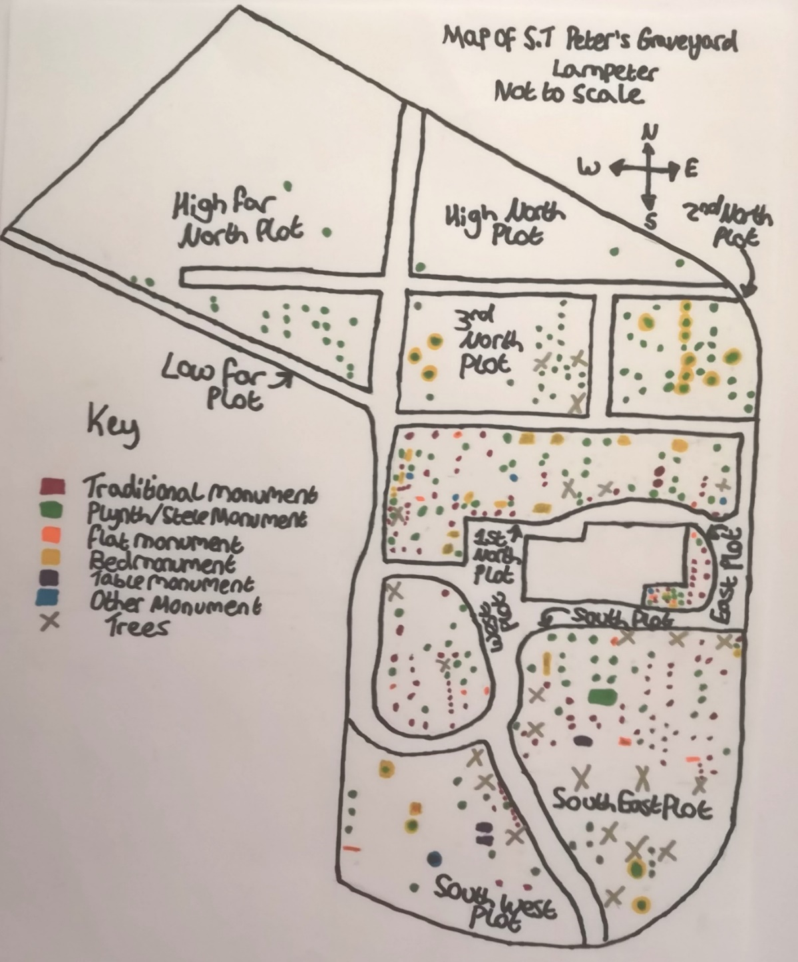
33)

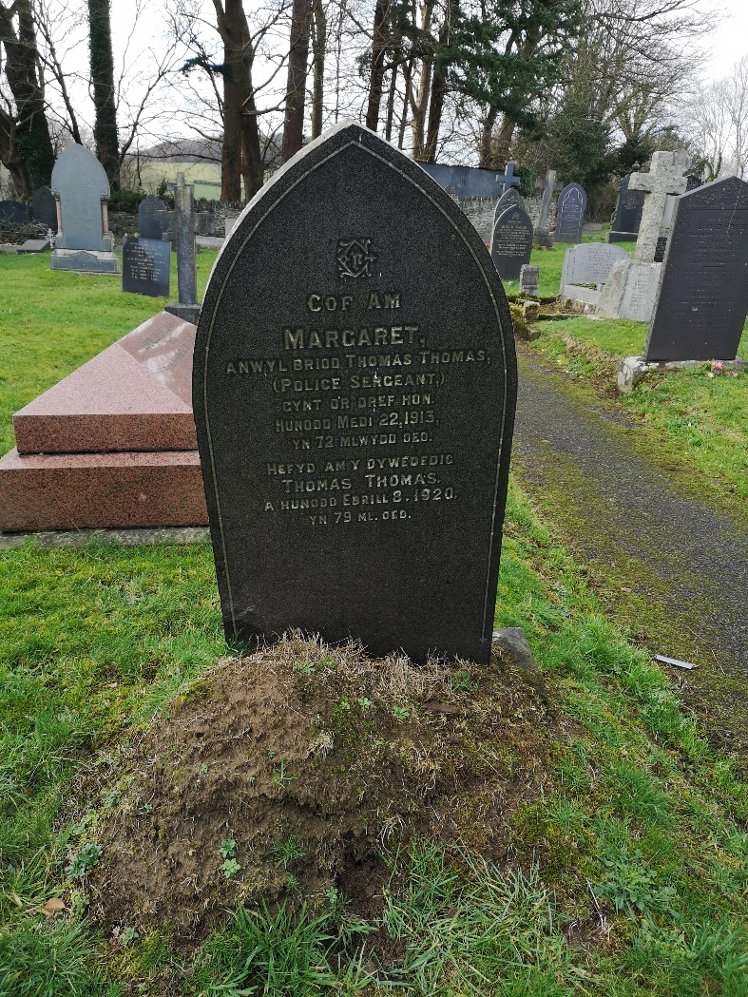
34)

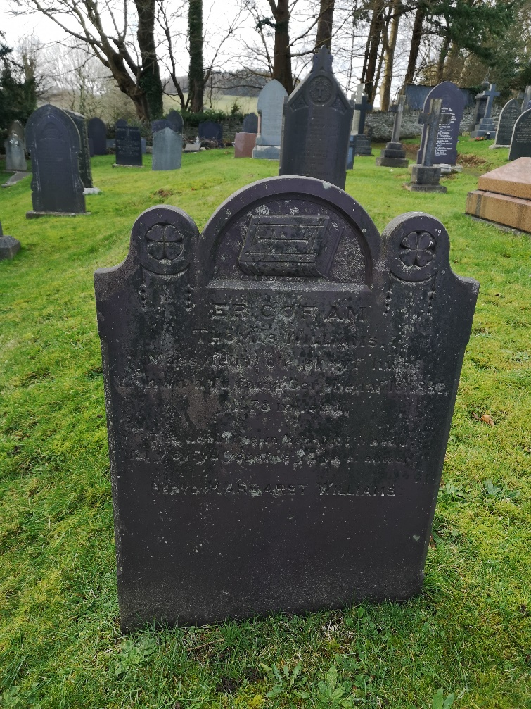
35)

36)

37)

Bibliography
- Mytum, H. (2000) Recording and Analysing Graveyards. York: Council for British Archaeology.
- Mytum, H. (2004) Mortuary Monuments and Burial Grounds of the Historic Period. New York: Kluwer Academic/Plenum Publishers.
- T. G. Driver (2004) RCAHMW colour oblique aerial photograph of St Peter's Church, Lampeter [Online]. Available At: https://coflein.gov.uk/en/archive/6189253/details/504 (Accessed 21 January 2020).

