Mohammed Selim 2007137
Foreign Languages & Cultural Awareness (BMIH5003)
Caution Sign

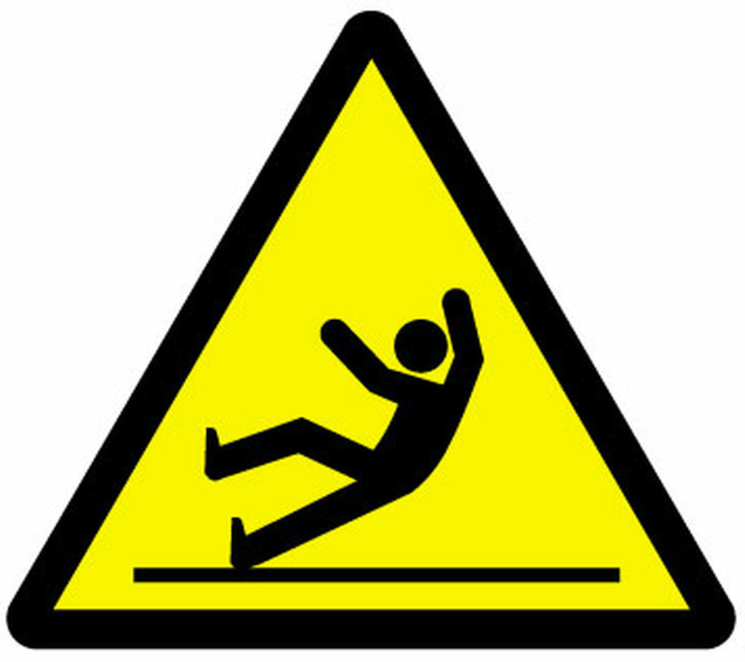

WET FLOOR
PISO MOJADO
CUIDADO
CAUTION

