Sport, Physical Activity and Society Assignment 1
Part 1
This paper discusses the couch to 5k activity intervention project led by the NHS from 2016. It looks at the aims and objectives of the programme whilst discussion the relevant success and short comings.
Josh Clake, an avid runner is famed with first creating the Couch to 5k programme 1996, the programme is aimed at beginner runners and takes them through a series of ever-increasing distances until the reach the target distance of 5km.
The original program was structured over a nine-week period comprising of three sessions per week. Participants are required to undertake varying routines of alternating periods of running with periods of walking. The overall aim to increase the periods of running and reduce the periods of walking over the course of the nine-week programme, until they are able to run continuously for the 5km distance.
Today Couch to 5k (C2K) is very well know globally and has been publicised by the NHS as a great way to get fit, with a guide positioned on the NHS website. Running has long been regarded as a being beneficial for overall health and wellbeing, as well as being largely accessible for the majority of the population. To this end Couch to 5k seems like an ideal easy way for beginners to enter the world of running and build performance over time. But is it all positive, and if not what are the draw backs.

In 2016 The NHS in the UK launched the free couch to 5k app. It was an attempt to encourage more of the population to undertake sufficient levels of actively The following statement is taken from the NHS website. “To stay healthy, the UK Chief Medical Officers' Physical Activity Guidelines, on GOV.UK, state that adults should try to be active every day and aim to do at least 150 minutes of physical activity over a week, through a variety of activities” (NHS, 2024). The NHS feared that people in the UK were nit achieving enough exercise, which was having a negative impact on NHS capacity.
During 2016, public health England conducted a survey into the general health of the population. The results of the survey concluded that “66 per cent of men and 58 per cent of women aged 19 and over met the aerobic activity guidelines of at least 150 minutes of moderate activity or 75 minutes of vigorous activity per week or an equivalent combination of both, in bouts of 10 minutes or more” (NHS, Health Survey for England 2016, 2017).With the launch of the couch to 5k app they hoped to encourage more people to exercise more regularly. Running is an easily accessible sport that requires little equipment and can be done almost anywhere.
The easy access, low cost and the fact that running can be done almost anywhere means that running would seem like an ideal beginner sport. In the section we look at available data to see if there is evidence that the couch to 5k intervention action had positive effect on exercise levels in the UK since its launch in 2016.
The following chart takes data from Public Health England
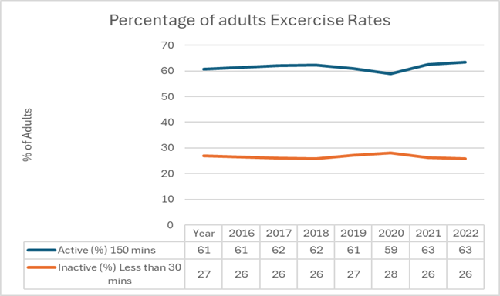

It shows a slight increase since activity levels since the launch of the couch to 5k app in 2016. So there some evidence that the launch may have had a positive on adult exercise levels. The next chart shows the estimated couch to 5k downloads over the same period

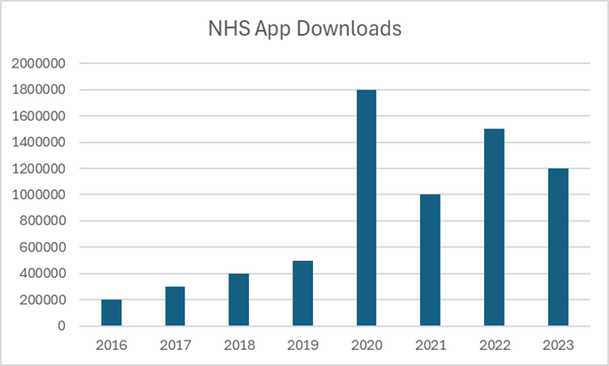

The table shows that there was a significant upwards trend in the download of the app over the period. However, this trend does not directly align to the upturn in exercise levels over the period. For this reason, it is not possible to say with certainty that the launch of the app had a direct effect.

In conclusion, for many people looking to add cardio to their lives, especially those who are new to the idea of exercising, the program has shown to be an extremely effective activity. C25K fills the gap between inactivity and reaching a major fitness milestone: finishing a 5-kilometer run, by providing a systematic, gradual method to boosting confidence and stamina. One of the factors that makes the app so successful is the fact that the users are able to progress at their own pace, with no pressure ensuring that any prospect of injury is kept to an absolute minimum. The element of minimal pressure can also serve as a catalyst of intrinsic accountability and motivation, as it can be perceived as the users choice to improve themselves, making the program easier mentally aswell. However, this is not to say that all users reap the rewards that others do. Mental factors such as motivation, discipline, accountability, aswell as physical barriers such as physical health, picked up injuries, lack of free time and accustomed sedentary lifestyles will play a huge role in the participation and success levels of using the program. Overall, although C25K’s intentions were to improve people’s physical health by getting them introduced to cardiovascular physical activity, it has provoked so much more than that. It undeniably boosts physical health, but also forges discipline, improves mental health, and sets its users up with a starting point of their roadmap to exercise and physical activity. Although it is evidentally not effective for everyone, those who have seen results in both mental and physical aspects of their lives, and has brought out the best in some people who may have thought their health was never going to improve.

Part 2

Introduction
The lock down periods of the Covid pandemic had a lasting detrimental impact on the health and wellbeing of the general population. Social isolation, economic insecurity and the mundane rhythm of pandemic life all had a detrimental impact on everyday life
Particularly impacted were vulnerable populations. Pensioners, people with pre-existing physical health issues, and younger people who lost access to their social norms. Health care professionals, who worked through the hardship of the pandemic were also greatly affected by the impact of the pandemic. Also, many people's diseases worsened due to delayed treatments and limited access to healthcare facilities. Weight gain and other health issues were caused by changes in lifestyle, such as a poor diet, increasing alcohol use, and a decrease in physical activity. Disadvantaged groups were impacted worst by the epidemic, which exacerbated already-existing health issues.
However, the pandemic did coincide with an increase in proactive behavior in relation to health and well-being. Cardiovascular exercise participation levels increased during the pandemic, as evidenced by the dramatic uptake of the couch to 5k application download levels. This trend would have had a positive impact on wellbeing and health within the public.
The National Health Service (NHS) website claim that “regular cardiovascular exercise—such as brisk walking, running, cycling, or swimming—can help improve your heart health, reduce your risk of chronic diseases like heart disease, stroke, and type 2 diabetes, and help maintain a healthy weight. It also has a significant impact on mental well-being, helping to reduce symptoms of depression, anxiety, and stress. Exercise triggers the release of endorphins, which are natural mood boosters, and can improve sleep quality, energy levels, and overall mental clarity." If we link the positive effects and importance of cardiovascular exercise to the government’s health and wellbeing priorities, it will increase the public health of the UK, whilst also minimizing healthcare burdens on a national level.
Cardiovascular exercise can also be undertaken as a form of green exercise. Green exercise is “physical activity performed outdoors in natural environments, enhancing both physical and mental well-being.” Whilst there is no indication as to whether green exercise is more beneficial than typical exercise inside a gym or leisure center, both have their benefits. For example, a study carried out by Martin Gilchrist at Natural England found that “physical exercise or just sitting on a bench outdoors, and the fact that getting out in nature is good for just about everybody, has helped us to inform the development of our work such as our Green Infrastructure standards, which will enable more people to use and benefit from their local greenspaces.” The following images illustrates how outdoor exercise impacts from both and physical and mental perspective.

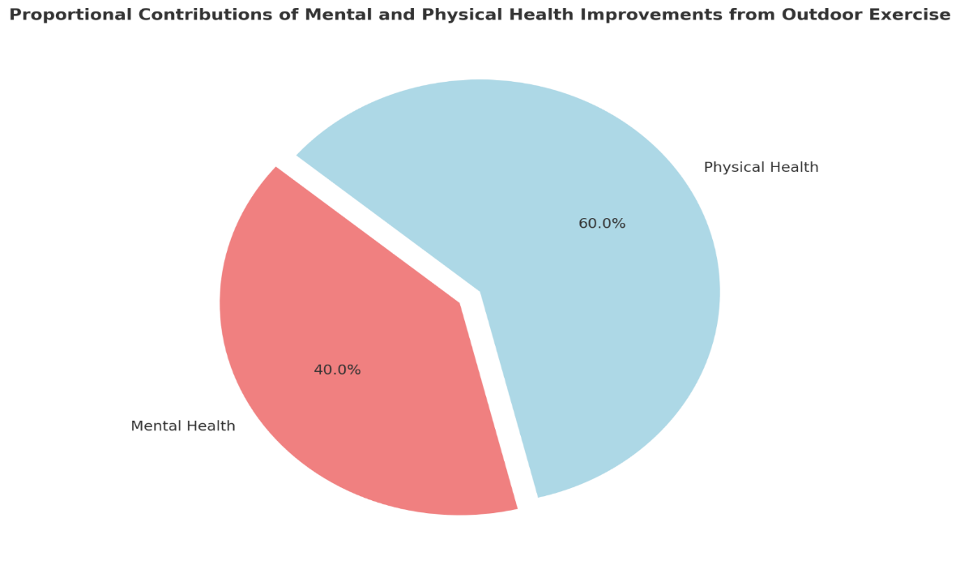
You can also reap the rewards from doing indoor cardio just as much as running in nature. These benefits are excellent way to boost both mental and physical health but can also host benefits to people in really unorthodox ways. Through the use of public gyms and leisure centers, those who may not have access to green spaces where they can get some proper exercise done. In addition to this, an article written by Sport England finds that “leisure centers are vital for community health, particularly in disadvantaged areas, offering accessible exercise options such as indoor cardio. These facilities contribute not only to physical health but also to mental well-being and social inclusion. Their continued operation supports government priorities like reducing health disparities and fostering community resilience.”
Furthermore, a high priority for the government would be to enhance community and social inclusion. Programmes and initiatives such as parkrun, lessen social isolation by encouraging social interaction and group well-being.
Another very popular form of excercise, proven to improve both mental and physical health is strength training.
Strength training has numerous benefits for both physical and mental health. Strength training lowers the risk of chronic diseases like osteoporosis, obesity, and type 2 diabetes by improving muscle mass, bone density, and metabolic function. To improve general health, the UK Chief Medical Officers advise adults to engage in muscle-strengthening exercises at least twice a week.
Mentally, strength training has been linked to reduced symptoms of depression and anxiety. A study published in the Journal of Psychiatric Research (2018) found that “resistance training had a significant antidepressant effect and could serve as an alternative or complementary treatment for depressive symptoms.” This is most likely a result of the endorphins released when undertaking this type of physical activity.
In summary, it is clearly evident that even the simplest forms of exercise can have an extraordinary impact on both the mental and physical health of the population. Physically, it can improve the cardiovascular system, builds strength, increase muscle mass, all of which can drastically help in preventing any chronic illnesses, such as heart disease and even help beat cancers. As for the mental side of things, frequent physical activity improves cognitive performance, lowers anxiety and depressive symptoms, and increases endorphin release. The NHS Long Term Plan and the UK Physical Activity recommendations are two examples of government policies and recommendations that stress the value of incorporating exercise into daily routines. The overall advantages of physical activity, whether done indoors or out, highlight its significance as a pillar for a population that is healthier, happier, and more resilient.

