Knowledge and Information Management Skills for the Workplace
Module code: BMSW 5106
Lecturer: Md Kalam

Knowledge and Information Management of Amazon.com

Donika Fidanova
1916890

Executive Summary

The purpose and aim of this academic report is to uncover the knowledge and information management systems of the global e-commerce platform Amazon.com. Furthermore, the report will aim to understand how the application of certain knowledge management practices is benefitting the company as opposed to what challenges it might create for the business in future. Overall, the report is focused upon the definition and implementation of knowledge management systems within Amazon.com.

Table of Contents
- Introduction……………..………………………………………….…………….…………3
- Amazon.com………………………………………………………………………………...4
- Knowledge and Information Management…..…………………………………………5
- Evaluation of Knowledge and Information Management Models….………………7
- Investigating of KM techniques used by Amazon.com………………...………….11
- Conclusions and Recommendations…………………………………………….…...13
- Bibliography…………………………………………………………………………….....15
- Task Two – Poster………………………………………………………………………...16

Introduction
According to Sanchez (2003) knowledge is a set of beliefs about some form of casual relationships, whether in the world or in an organisation. Furthermore, he mentions, that the concept of knowledge assists in recognising the distinction between simply being aware of something, which means being equipped with data and information, and having knowledge, which implies knowing how to do certain things or cause certain occurrences in various situations. Therefore, when talking about knowledge management one refers to skills and abilities to arrange and share information with a company such as Amazon.com and expect successful results which bring benefits to the company. Furthermore, knowledge management is used to manage employees and project teams in an effective manner, however the approach can differ in the different cases. Amazon.com is one of the largest drop shipping providers across the globe, serving customers in Europe, America, and Asia. Therefore, the company must have effectively applied knowledge management techniques in the past which has led to its worldwide success.
Knowledge management is one of the most important tasks for companies, as knowledge leads to further opportunities and innovations within the organisations. The purpose of this report is to identify and analyse knowledge management models, as well as information management models. Moreover, the report will consider the current techniques which are being used by Amazon.com in their operations and how they have adapted these techniques to ensure their success in the global market for goods and services. The distinction and relationship between data, knowledge, and information will be analysed and clarified for ease of understanding knowledge management techniques. Lastly, the report will consist of recommendations and conclusions based on the evaluations made about the company and its knowledge and information management practices. Overall, the work will consider the relationship between personal knowledge and organisational knowledge within an organisational setting such as Amazon.com.

Amazon.com
In 2021, Amazon.com has become the largest online retailer in the world, simply by providing customers in various countries with what seems like an infinite catalogue of products, which are easily delivered to the home of the consumer. It is widely believed that the tools which have aided Amazon.com and its leader Jeff Bezos to become a multi-billion e-commerce business include customer relationship management integration, alongside knowledge and information management system usage. (Demir, 2017) Furthermore, since its initial launch, Amazon.com has grown to be more than a physical goods provider, through its innovative AI assistance provision, the cloud-computing platform and more. Through its success, Amazon.com has disrupted various businesses across the globe which have not yet implemented e-commerce tactics. Therefore, it can be stated that the hugely scaled success of the e-commerce giant has had significant effect on the economic state of countries across the world, and on businesses worldwide.
However, it is interesting to dive into the depth of what drove Amazon’s success and to understand what types of tools were really implemented and helped its fast growth. Surely, one of them is the easy and straightforward user interface, which allows anyone – even children, to search for their desired object and receive it, sometimes in less than a day. As the company is a drop shipping business, Amazon.com does not even require massive warehouses to store products, as sometimes sellers can directly send their products. However, as it seems, in a step towards brand management, most of Amazon’s products, at least in the United Kingdom go through an Amazon warehouse as they are delivered in their brand packaging to the door of a customers. The next section of the report will introduce the knowledge management theories that will underpin the analysis of the report.

Knowledge and Information Management
To be able to analyse and evaluate the practices within a company and create accurate observations, it is necessary to first be equipped with the knowledge and information management systems understanding. To achieve such an understanding, this section of the report will provide the reader with the definition, the identifying traits, and the different uses for both knowledge and information systems. Through this, the development of perspective will be made possible for the reader, as well as for the author during the analysis and evaluation of the knowledge and information management systems used in Amazon.com. The implementing of advanced information systems within the company can be seen as one of the best tools used by the company over the years. Moreover, such integration of information management systems into the daily processing of the company, can also have caused decentralised decision-making processes, as there are less layers of employees. Thus, it can be stated that due to the implementation of adequate and sustainable knowledge and information systems, Amazon. com has ensured efficiency in its business processes.
According to Al Imran (2014), the company operates a two-piece information management software, which consists of the Simple Storage Service and is connected to an intertwined database. This is the process which amazon.com has applied for customers to be able to create multiple user accounts, as well as personalise their personal profiles while using Amazon’s online services. However, it is safe to say that the system which amazon.com comprises of, is much more complicated and intricate on the backends of code-writing and other website creation and upkeeping responsibilities. Hence, said processes which are undertaken by the company’s tech team, are not necessarily what drove amazon to its success. On the contrary, they have assisted the company, as without them the website would not exist, however it was the customer management techniques and beliefs applied in Amazon.com which helped the sales skyrocket in such a small period of time.
“The advent of the Internet, the World Wide Web, has made unlimited sources of knowledge available to us all.” (Dalkir, 2017) This is the main benefit which Amazon.com has used to its advantage in the past decade – the increase in worldwide use of tele communicational devices which are surely connected to the Internet. The rise of the internet and the rise of social media usage can also be said to play a key role in the sudden and sustainable growth of the company in the past few years. Therefore, Amazon.com has used its website service provision as a tool for sales achievement and customer attraction, by providing a simply looking website, which on the other side consists of thousands of smaller details which need to be managed and adjusted for the benefit of all stakeholders. Furthermore, Dalkir (2017) mentions that for a company to be successful with the knowledge it possesses – such as the knowledge Amazon had of increased Internet usage – it needs to constantly learn, remember, and act upon the knowledge for achievement to occur.
The knowledge management theories to be discussed and applied in the case of Amazon.com include The Choo Sense-Making knowledge management model, as well as The European Foundation for Quality Management. Through research and analysis, the two theories appear to be the most accurately connected to the ones used at Amazon.com, however the assumptions made in this report are in no way final or conclusive. Therefore, whilst acknowledging the two models in the next section of the paper, it is important to understand the delicacy of knowledge management, as well as the ways it may transform from case to case. Nevertheless, the following analysis and evaluations are academically researched and involve a degree of adaptability to the interesting case of Amazon.com.

Evaluation of Knowledge and Information Management Models
The importance of effective and sustainable creation, storing, sharing and application of information, alongside its constant integration in business practices, is vital for knowledge management practices to be successfully applied in a business. This statement is largely derived from the knowledge management theories to be discussed in this chapter and is supported by the vision of knowledge being far more than just the acquisition of information within a company or an individual. However, if applied to the case of Amazon.com, knowledge becomes an incredibly big and important instrument and necessity for the company to be able to deliver its service to customers worldwide. In other words, if the employees of the business are not aware of the large scope of information and precision required within Amazon.com, then the business would not operate as successfully and efficiently as it currently does. As mentioned earlier in the report, the theories derived come from two very distinct knowledge management models and they will be applied in the analysis of the companies processes and successes.
Choo Sense-Making Knowledge Management Model
According to Choo (1998) his defining of the sense-making model of knowledge management, highlights that sense-making, knowledge creation and decision-making are key for successful knowledge management. Moreover, the theory is focused upon the way in which information elements are selected and then used in the actions and decisions a company makes. What makes organisational action important is its concentration and absorption of information from the external environment, into each successive cycle. (Dalkir, 2017) Each of the above-mentioned stages is in some ways impacted by external factors or stimulus, which leads to certain outcomes on the side of the company decision-making. In the below figure the stages of the Choo Sense-Making Model can be observed.

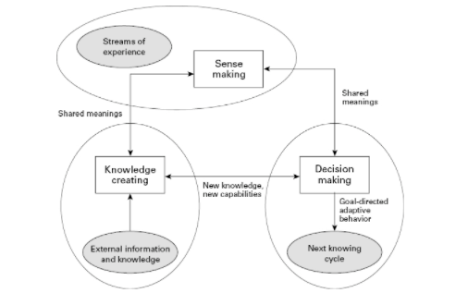(Choo, 1998)
As seen on the figure, the sense making phase is the stage in which employees attempt, usually successfully, to make sense of all the information which is coming in from the external environment. Once the information is made sense of it should be filtered, and the most important data should be seen as priority. However, it is in the knowledge creation stage of the model, that individuals (or employees) transform the information they have received into personal knowledge, which can be achieved through dialogue, storytelling, and more. The knowledge creating stage according to Dalkir (2017) is directed by knowledge vision of the current situation, alongside knowledge vision of the desired state. This stage allows the scope of decisions and the potential choices to be made become more, as there is more and new knowledge coming in from the outside. In the case of Amazon.com this can clearly be envisioned through their use of the Internet boom almost a decade ago in the United States, and used it to create a new, innovative approach towards sales of goods and provision of services – online.
Interestingly, it has become an observation that the research and development invested not only in Amazon’s customer systems, but also in the innovative AI products being sold by the company, have been almost revolutionary to the modern society, and have modernized it even more. Therefore, it seems accurate that the Choo Sense-Making Knowledge Management theory can be applied in the case of Amazon.com. This is because, if we are to observe the company’s processes simply as a customer being served, we would discover that what make the business so lucrative to consumers worldwide, is the personal care and attention with which all orders are being cared of. Hence, it is evident that it is through sense-making and equipping themselves with information and knowledge about the needs and desires of consumers, that Amazon.com has been able to establish such astonishing success in such periods. Dalkir (2017) mentions that the results which knowledge creation brings regarding decision-making processes involve innovative strategies which extend a company’s ability to make informed and rational decision. Thus, through observing and digesting the external environment, Amazon.com creates its ability to thrive as a company in the modern society.
The European Foundation for Quality Management Knowledge Management Model
The European Foundation for Quality Management Knowledge Management model considers the ways in which knowledge management is used in order to achieve the goals of an organisation. Surely, each organisation’s main desire is to achieve certain goals in a given period of time, therefore, there is reasoning behind the use of continuous knowledge for the achievement of objectives. Bhatt (2001) says that the European Foundation model is based on more traditional models of quality, as well as excellence, so there is a strong relationship between the knowledge management processes of a company and there expected organisational results. The main stages of the European Foundation model include people, leadership, policy, strategy, resources, processes, and performance results. Through these stages, the European Foundation positions knowledge management as the key for the business to achieve all its goals. The relationship of the stages for the European Foundation Knowledge Management Model can be seen on the below figure.

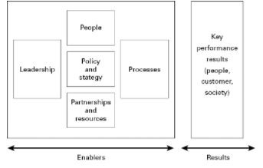(Bhatt, 2001)
Unlike the Choo knowledge management model, this model focuses upon the achievement of company goals, instead of having strict knowledge management goals. According to Dalkir (2017), one of the main reasons for knowledge management systems to fail is the focus on the knowledge management goals, instead of applying knowledge management for the sake of the company. If this is to be true, then the use of said model and the application of the theory should lead a company to huge levels of success. Therefore, the ways in which Amazon.com can apply the European Foundation knowledge management model is to use it as support for the organisational goals and to use the shared knowledge in ways that all employees within the company can benefit. In other words, the European Foundation Model highlights the necessity for companies to use knowledge management as a tool for collective benefit and application of the best possible practices for the company to benefit from. Therefore, the company will be able to ensure improved services, better product, and a higher amount of customer satisfaction. Moreover, this would provide the employees with a better ability of implementing changes within the organisational practices for the benefit of the organisational success, rather than for personal gains.

Investigating of KM techniques used by Amazon.com
The efficiency and effectiveness of the knowledge and information management techniques applied by Amazon.com can be determined by the efficiency of their delivery in key business processes. This can be easily measured because of the business’ digital presence, as opposed to a ‘brick-and-mortar’ company. The key business processes of Amazon.com as a drop-shipping company involve the online ordering, transaction processing, delivery of orders, and the management of customer relations within the business. It can be stated that Amazon has successfully and sustainable been integrating its information systems with its customer relationship systems in a way to improve their business processes. The ease and adaptability of the website’s user face is commendable and as earlier mentioned – vital for the continuous success of the business. Through implementation of services such as product reviews, and customer relationship ability, Amazon has created its ability to better understand the market they are providing to and ensure their systems are working correctly and are up to date.
Studies show that one of the tactics Amazon.com within its knowledge and information management systems, is the creation of a physical copy of the virtual marketplace, in order to enhance their understanding in the fluctuations and variations within demand and supply. This is also how the business can achieve spectacular sales periods across national holidays, or even in the latest case – the global pandemic. Therefore, the implementation of communication management systems within their information and knowledge management systems has allowed the company to use more automation within its business processes and resolve customer issues in quicker and more efficient ways. Furthermore, the company’s intensive use of AI systems, has allowed the business to resolve consumer issues in real time, however there is not necessarily a person sitting behind the resolution. This is revolutionary even for the modern society and highlights a challenge which the company may experience by further applying AI practices in their processes. However, as much as this challenge will exist for the company, it might be a bigger challenge for the society and the nations across the world, as the introduction of AI within companies as large as Amazon.com will lead to severe unemployment rates across their operations.
Amazon.com is clearly using knowledge and information management to their benefit when it comes to the decentralisation of decision-making processes within the business. This could have resulted in less managerial integration within said knowledge management systems, however the limitation of human involvement does not necessarily have to be a negative one. On the other hand, such automation might have provided the business with easier decision-making, simplified processes, and even decreased costs when it comes to salary and employee remuneration. However, despite the success which automatised systems may have been bringing companies across the world, automatised service can have its drawbacks and negative impact on a company’s footprint. It is definitely theorised, that the environmental impact which a business creates upon the world has to be taken into consideration when it comes to decision-making and knowledge management. And whilst Amazon’s organisation has been aiming for a lesser environmental footprint, the increased use of digital and automatised services, can only increase the company’s CO2 footprint.
In this case, even though the company has been reaping incredible financial successes in the past years, the business has been disregarding its environmental responsibility and thus used its knowledge management systems for the benefit of the company today, without acknowledging the future impact. Therefore, the company is risking serious implications in future in regard with their environmental impact and responsibility, especially since the company is operating on such large scales. Despite this challenge, should the business plan and implement an environmental strategy for its future operations, the company would be able to disregard worries of decrease in sales and operations. However, for this to be achieved, the environmental challenge must be considered by the company and appropriate action should be taken for the lessening of the Amazon’s environmental footprint.
Conclusions and Recommendations
During this report the international e-commerce business Amazon.com was introduced and analysed in regard with their implementation of knowledge and information systems within their operational approach. The analysis of the company’s practices was derived from academic resourcing and application of modern knowledge and information management theories, while underpinning the importance of understanding that efficient creation, storing, and overall using of information is key for successful knowledge management practices to be developed. Through the application of the Choo Sense-Making Knowledge Management model, as well as the European Foundation’s knowledge management theory, the evaluation of Amazon’s knowledge management practices was made possible and accurate due to the defining and characterising of knowledge management practice and structure. Throughout the report it was discovered that the overall efficiency of Amazon’s knowledge and information management practices is high and beneficial for the company’s financial success, and their high rates of customer satisfaction. Nevertheless, the analysis also uncovered some future challenges which might hinder the knowledge management, as well as the overall organisational success if said challenges are not successfully resolved.
The introduction of the successful customer relationship management models as seen in the report proved to be essentially supported by the automatised knowledge management systems the company possesses. However, it was also discovered that while the automatised processes can and have been extremely beneficial for the company’s success, they can also become a challenge in future stages if the economy becomes impacted by high rates of unemployment. Moreover, the increased use of electricity and fuel required for the continued operations of the drops-shipping business have uncovered a negative environmental impact by the company. Overall, while the knowledge and information management systems used by the company are beneficial today, they may pose as challenging in future organisational practices and operations. Hence, the company must implement continuous evaluation of their knowledge and information management practices, to overcome the challenge and continue its worldwide operational success.

Bibliography
Al Imran, Md Abdullah. (2014). A STUDY ON AMAZON: INFORMATION SYSTEMS, BUSINESS STRATEGIES AND e-CRM. 10.13140/RG.2.1.1366.8247.
Amazon (2021) About. Available at: https://www.amazon.com/. Accessed on (12/12/2021).
Bhatt, G. (2001). Knowledge management in organizations: Examining the interactions between technologies, techniques, and people. Journal of Knowledge Management, 5(1), 68–75.

Burton-Jones, A., (1999) Knowledge Capitalism: Business, Work, and Learning in the New Economy. Oxford: Oxford University Press.
Choo, C. (1998). The knowing organization. New York: Oxford University Press.
Dalkir, K. (2017) Knowledge management in theory and practice. 3rd ed. Cambridge, Mass: MIT Press.
Graham, M., and William H. D., eds. (2014) Society and the Internet: How Networks of Information and Communication are Changing Our Lives. Oxford: Oxford University Press.
Horaguchi, H.H. (2014) Collective knowledge management: foundations of international business in the age of intellectual capitalism. Cheltenham, England;: Edward Elgar.

Ichijo, K., (2006) Knowledge creation and management: new challenges for managers. Oxford University Press.
Lilley, S., Lightfoot, G. (2004) Representing Organization: Knowledge, Management, and the Information Age. Oxford: Oxford University Press.
Sanchez, R., (2003) Knowledge Management and Organizational Competence. Oxford: Oxford University Press.
Wiig, K. (1993). Knowledge management foundations: Thinking about thinking. How people and organizations create, represent, and use knowledge. Arlington, TX: Schema Press.

Task Two – Poster
Practical Evaluation of the Proposed Knowledge Management Framework for Amazon

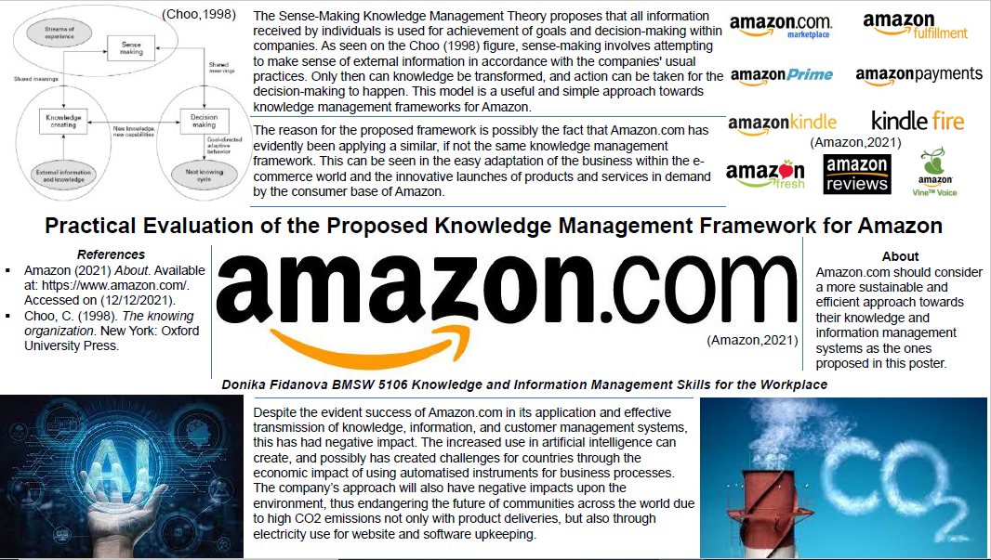(Presentation Poster by Donika Fidanova, 2021)

