Digital Skills and Research Methods

Alina Daniela Halunga
Student number: 1907863

Introduction
 (Picsearch.com, 2020)
The purpose of this essay is to produce a research and explain how Virtual Learning Environment (VLE) – Moodle has impacted students in their learning experiences, which was the challenges they faced, if it was in a negative or positive way. I will also explain the advantages and disadvantages of using Moodle. Virtual Learning Environment (VLE) is a way of teaching and learning aimed to improve students learning experience by using computers and internet (Definition from WhatIs.com, 2019).
This research is made by using questionnaires given to students from University of Wales Trinity Saint David London Campus. This questionnaire was designed by me to give them an understanding how Moodle impacted their way of learning, if it helped them in a negative or positive way and if is anything that they will want to change on it. For me, online studies have a positive impact in my daily activities, it helped me a lot to save time for my other things. I was spending a lot of time traveling to get to University which is not really close from where I live. It was hard for me to get there in the morning because I am working night shifts, and I was always in a rush to get in time there after work. I cannot say that studying online is worse than face to face in class, for me is a good option and I am happy using Virtual Learning Environment.

Background:
Virtual Learning Environment is used across UK in most places and became a common way of delivering important information’s.
A VLE is a set of incorporated devices facilitating the administration of online learning, helping students to keep tracking their work, their feedback and access to sources (Jisc, n.d.). VLE contains some important parts that help students to use it effectively and having a positive impact on their learning experience.
The main one is communication. To use effectively VLE, communication between students and teachers need to be effectively. If I would need to give an example from my own experience, I can say I find extremely helpful Microsoft Teams app. Is a particularly good way of communication between tutors and students. Also, outlook email is a useful way of communication between each other and tutors. Is a simple way to discuss with our tutors, to receive useful information’s from them, like assignments deadlines, timetables, and other things.
Another useful part of VLE is assessment. There we are able view our work, re-submit if e need, receive feedback from our tutors and check our work similarity. This an area where we can submit our assignments and receive separately feedback.
Collaboration is another important part of VLE where students can collaborate their work within different apps, power point, word excel, adding images. Collaboration and communication by VLE look an easy way of sharing ideas, information’s, presentations between students and tutors because peoples do not have to travel to meet face to face. For VLE to be effective, students and teacher’s collaboration is important.
Moodle was introduced to the Universities instead of ‘My Courses’, which has not got many useful information’s. Moodle was introduced to increase student’s experiences by offering a more adaptable VLE that could be used as part of mixed learning.

Advantages of e-learning:
Some of the advantages of the use of VLE obvious for everyone.
-Students have opportunity to study from all world if they are in possession of a computer and they have internet connection.
- Sometimes, working from home is a peace of mind.
- Student have always support from Universities IT teams in case if they struggle to use a computer.
- Students have benefits of using free apps for learning that usually are not free.
-Flexibility of managing time for any other personal activities.
- Studying online, students have more opportunities to develop their IT skills.
- Students can catch up lessons that they have missed by having access to the recorded streaming.

Disadvantages of e-learning
As well as advantages, there are many disadvantages that students are facing during virtual learning.
- Streaming was the one which many students struggled with. They were struggling to hear, to connect to the right channel, to be able to type a message in the chat box of the channel.
- Many student’s complaint as well that they are not happy how the communication in a channel during streaming is organised, because people were talking all in the same time and no one could understand nothing.
- Also, people struggle with online courses, because many of them were using universities computers, and now, not having one at home makes their studies almost impossible.
- Another disadvantage of e-learning for students is that not everyone has good computer skills, struggling to upload a file, to download something, to work in power point, in word.
- Many students feel frustration not being able to attend face to face classes, they feel they are lonely, and this cause sometimes lack inspiration, resulting delay in delivering their work on time.

Aims and Objectives:
 (Gallacher, 2015)
The word, Moodle, is an abbreviation for integrated object-oriented dynamic learning environment. But for its Australian inventor, Martin Dougiamas, it is also a verb that defines "an entertaining playing that leads to understanding and originality" (Krechowiecka, 2005).
Moodle is free to use for educational and public reasons. It aims to provide the educator with tools supporting creative design and to establish and maintain vital online learning communities. The aim of introducing Moodle was to improve students experience into online learning and to provide a better knowledge and encourage independent learning. This offered to them the flexibility to manage their time in a way that face to face courses did not. Using VLE, students were offered the chance to engage more in online activities, to ask questions regarding their missed lessons, to research useful information’s about their work such as using Library section. Also, Moodle deliver supplies, to sustain learning environment which allows students to expand their achievements.
When Dougiamas created Moodle, he imagined that this platform will be used in a large number by high schools, but he was surprised to find out that secondary schools are using it more than everyone. In a single phrase, VLE has the aims and objectives to deliver an effective e-learning by having well-known e-learning strategies, value e-learning techniques, quality in course layout, knowledge of e-learning advantages, knowledge in e-learning, and collaborative conversations.

Method:
The method used by me to analyse how Virtual Learning Environment (VLE)- Moodle has impacted students in their studies was by creating a questionnaire using Monkey surveys app. This was the easiest way considering the issues which are surrounding us these days and not being able to meet people face to face. I created a 10 questions questionnaire and I emailed to them, giving them the option to answer to questions with multiple answers. My questionnaire was completed by 15 students from University of Wales Trinity Saint David, London Campus. I selected them because they are all my study colleagues, I know them personally and I know sure they are using Moodle. I gave them questions based on their experience using Moodle to find out if they faced any issues using it if they would change anything to Moodle if they would have the chance. I was surprised to find out that many from my colleagues said they are not happy with the structure of Moodle. They said Moodle could have easiest links to submit assignments and to access materials. They also said that Moodle has to many materials included there which are not part of our group, and this makes them to struggle to find our courses in a convenient time.

Results:
These are my questionnaire results from my 15 colleagues of University of Wales Trinity Saint David, London Campus.

First question addressed to them was if they use Moodle. Being my colleagues, I knew they do, so as you see in the results, all 15 responded “yes”.
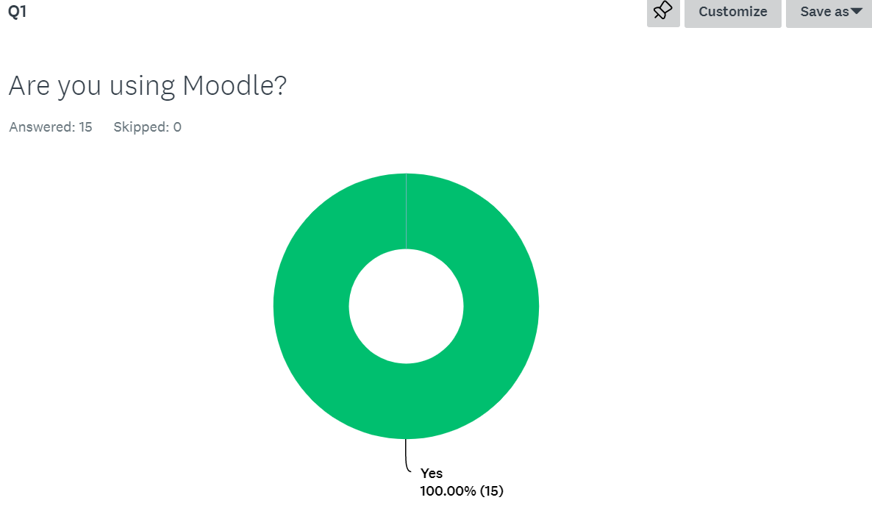

Second question was about how often they use Moodle if they use it. The biggest percent of 60% said they do once/twice a week, where 33.33% said they are using it daily and 6.67% does not using Moodle at all.
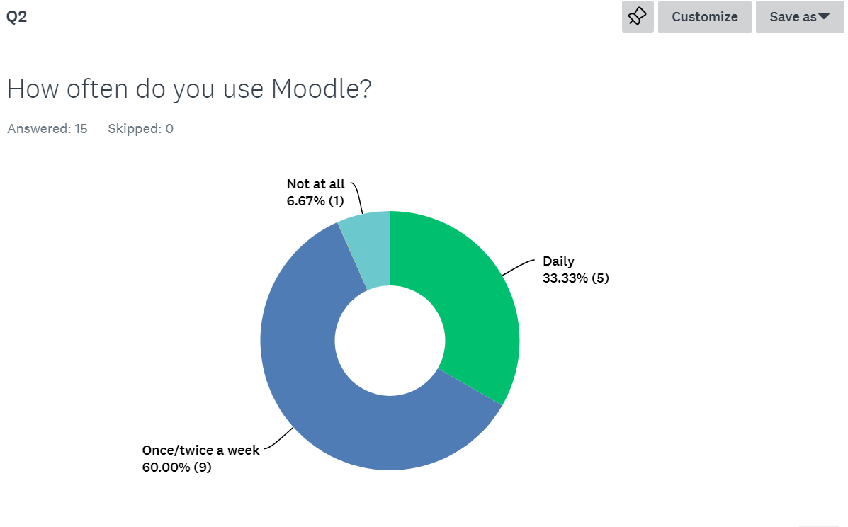

In the third question, I asked them how easy they find Moodle to use from a scale of 1 to 10, where 10 meaning the happiest feedback. From 15 people, only 1 is strongly confident using it.
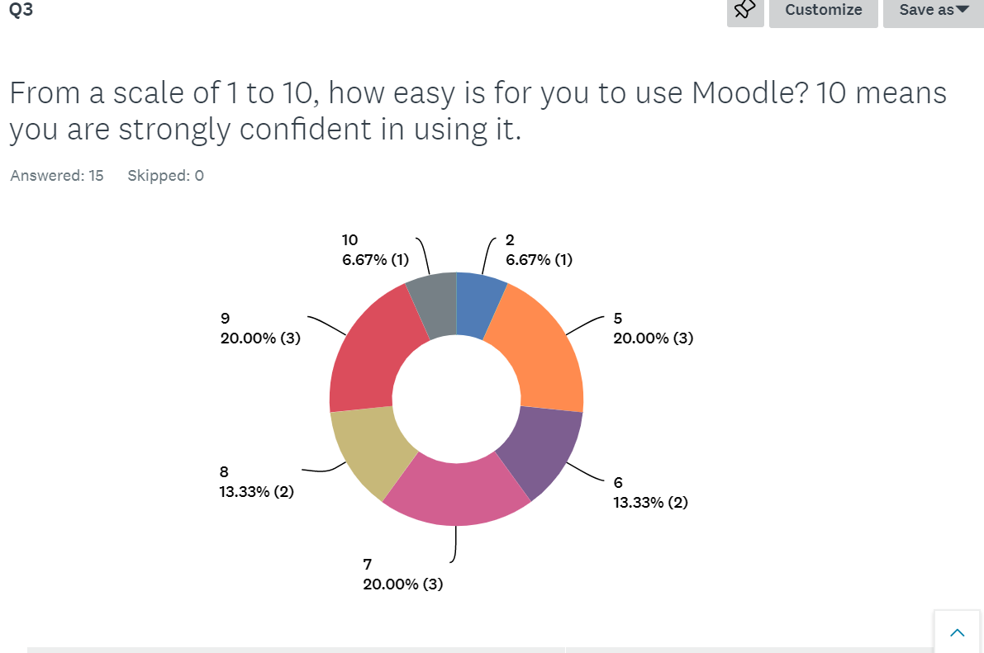

The fourth question was design to find out what they are using Moodle for? 53.33% said they are using it to work on it and do research, while the other part of 46.67% said they use Moodle just for essential things like submitting assignments.
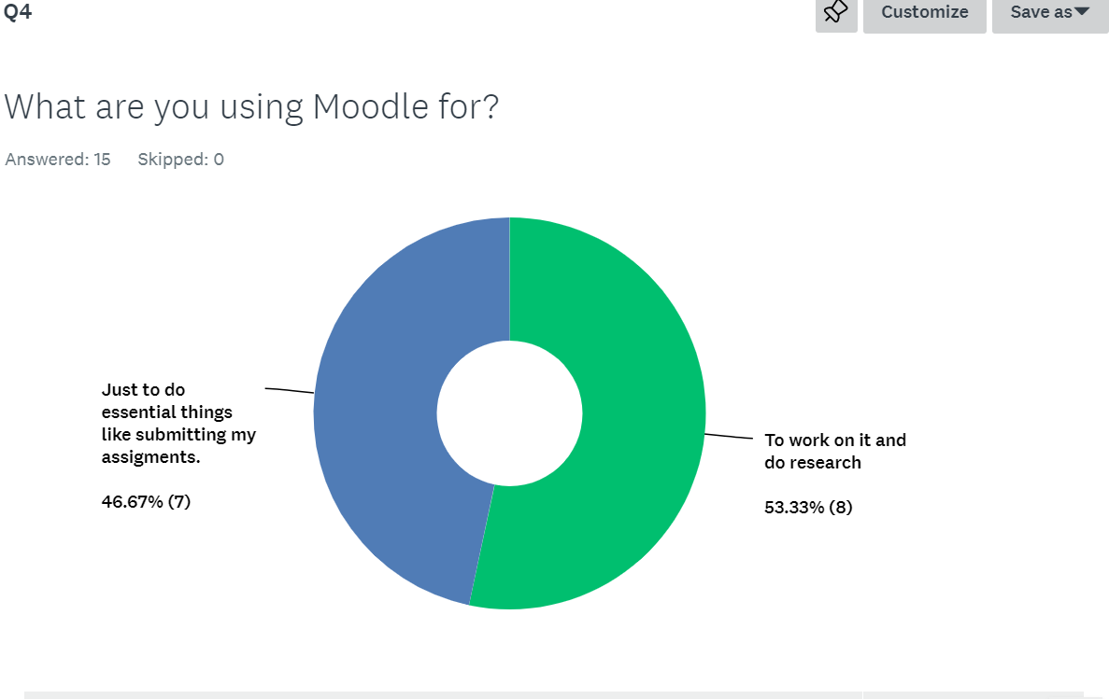

In question 5, I found out that Moodle is not well structured in students view, and the results showed that 40% of them are not happy with this aspect.
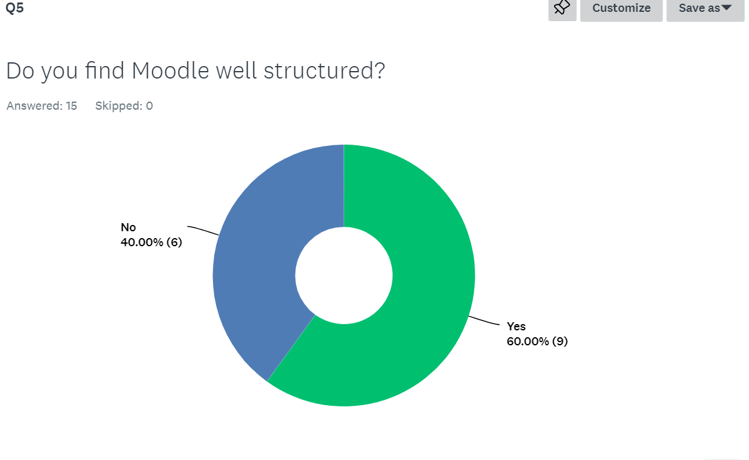

Question 6 is about Library. This is the section where students can do research for their work. 40% from my colleagues are not using Library at all.

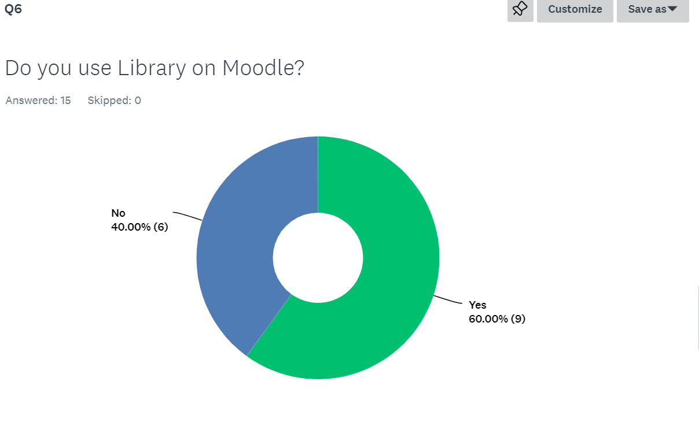

In question 7, students were explaining if Library helped them to do research for their work. 20% of them was happy with their research, while 53.33% said they tried but they could not find any useful information’s for their work, and 26.67% said Library did not helped at all.
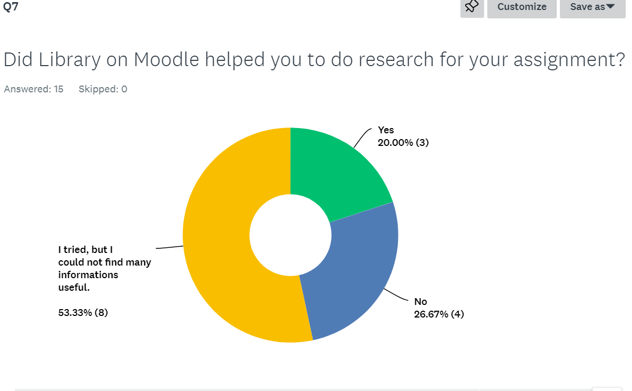

In question 8 I found out that one of my colleagues, do not recommend Moodle to others, that means a percentage of 6.67%,
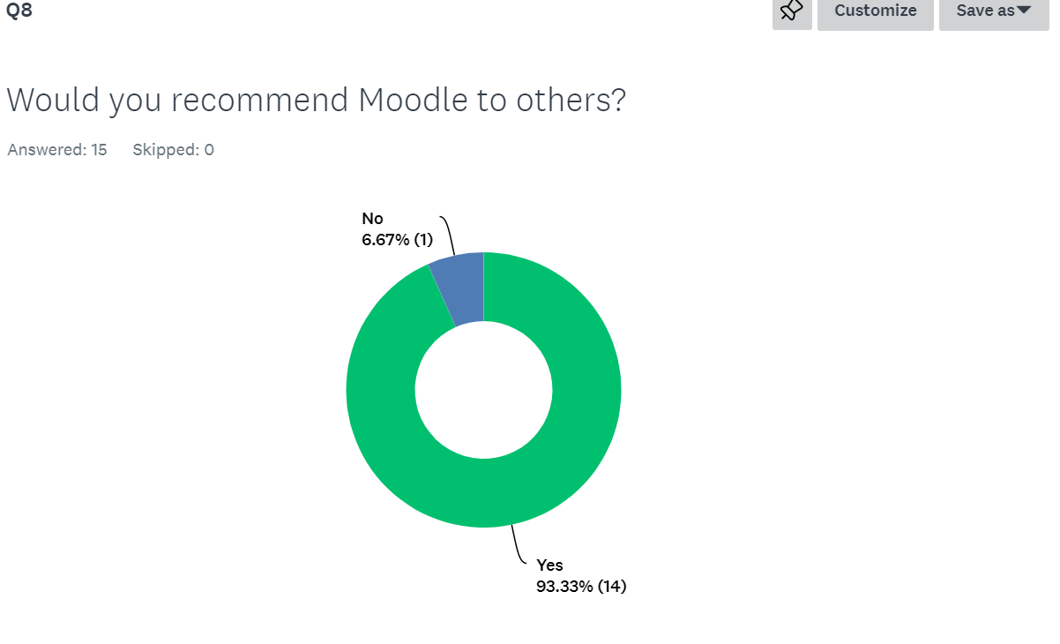

Here, in question 8, I was surprised to see that more than half of them would like to change something to Moodle if they could do it and this is about the way how Moodle is structured, the information’s from it, and the assignment links which many students found them difficult to manage.
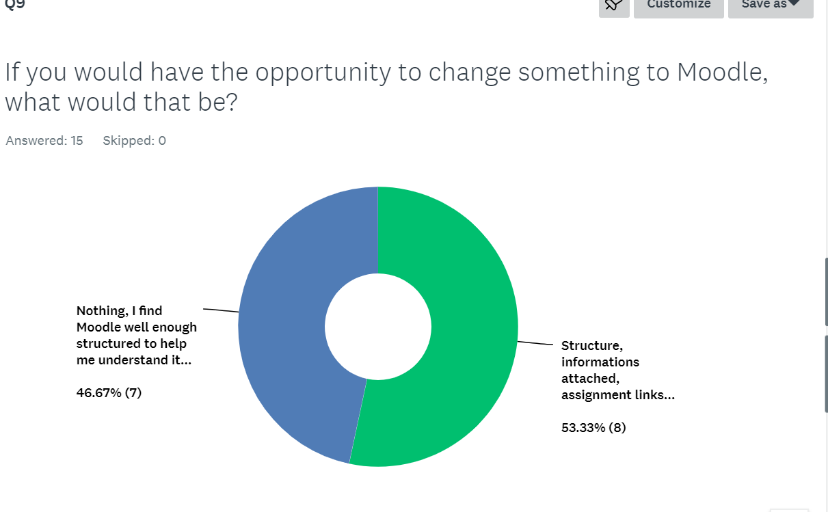

Final question, came up with the result that only 2 students are happy that someone created Moodle. The other ones are still in doubts if Moodle was a good idea for students.
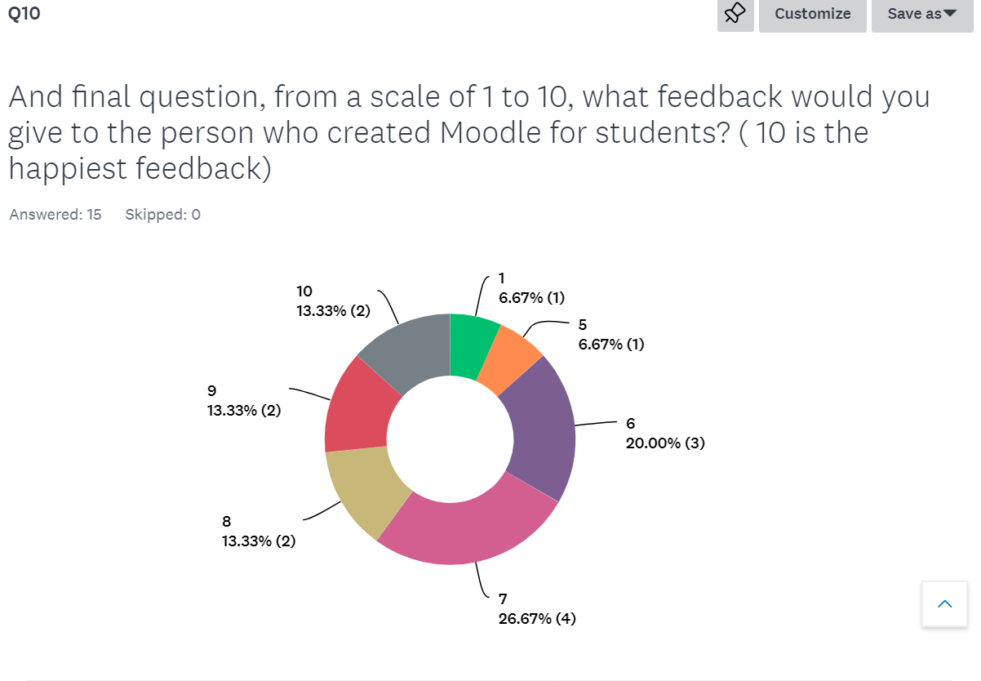

DISSCUSION:
From the results obtained in my questionnaire, it looks like more than half percentage of students are not happy with Moodle. They find Moodle not well enough structured, the information’s from it are not useful many times and the links attached there for submitting assignments are difficult to manage for them. Many of them are using Moodle just for essential things like struggling to submit their assignments, and that is. Library is a source where students can find useful information’s for their work, but 40% of them are not using it at all and the reason is because they are saying it does not have supporting resources and that is why they gave up using it. They would change things to Moodle if they would have the chance, and this is the reason why they do not recommend Moodle to others. I found out that students preferred Moodle not to became part of their studies, and they could not give a high feedback to the person who created it.

CONCLUSION:
Virtual Learning Environment (VLE) – Moodle was created to improve people learning experiences and to make thing simpler for people who prefer online platform. From the questionnaire results I can say that opinions are in a percentage of 50% to 50%. People who are happy with Virtual Learning Environment (VLE) – Moodle, are the ones who probably prefer online platform for learning and are more highly skilled in digital skills. The other ones are the ones who are struggling to submit an assignment and are not happy using Moodle resources for learning preferring face to face studies. They are the one as well who are struggling using a streaming app having difficulties to join an online class. In my opinion, I would recommend Virtual Learning Environment (VLE)-Moodle to other. Is a new way of leaning, providing the opportunities to improve our Digital skills and research methods, giving us the chance to improve our time managing and having a good collaboration with others.

APENDIX
Feedback received from my tutor as a result of my survey.

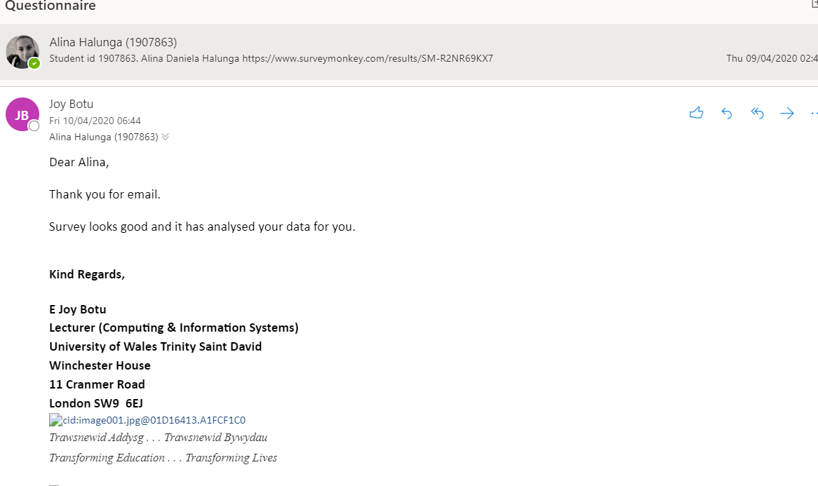

REFERENCES
Gallacher, C. (2015). What is a VLE (Virtual Learning Environment?). [online] EPALE - European Commission. Available at: https://epale.ec.europa.eu/en/blog/what-vle-virtual-learning-environment [Accessed 25 Apr. 2020].
Jisc. (n.d.). Jisc. [online] Available at: http://www.jiscinfonet.ac.uk/ [Accessed 23 Apr. 2020].
Krechowiecka, I. (2005). Open source: Virtual learning environments. The Guardian. [online] 4 Oct. Available at: https://www.theguardian.com/education/2005/oct/04/elearning.technology6 [Accessed 25 Apr. 2020].
Picsearch.com. (2020). [online] Available at: https://media3.picsearch.com/is?YWvotQ0Z4jji_LTYiJHL62MB-MX3bZIzTBfhjK1auYE&height=268 [Accessed 23 Apr. 2020].
What is virtual learning environment (VLE) or managed learning environment (MLE)? - Definition from WhatIs.com (2019). What is virtual learning environment (VLE) or managed learning environment (MLE)? - Definition from WhatIs.com. [online] WhatIs.com. Available at: https://whatis.techtarget.com/definition/virtual-learning-environment-VLE-or-managed-learning-environment-MLE.

