Name :
Student ID :
Date & Time :

This is an individual practical lab-test, held under examination conditions. You will be assigned three Routers, you should configure these Routers based on the following specifications.

The routers that you will configure are: Paris, London, and Rome.

This paper is marked out of 100.

You will have 2 hours to complete this task.

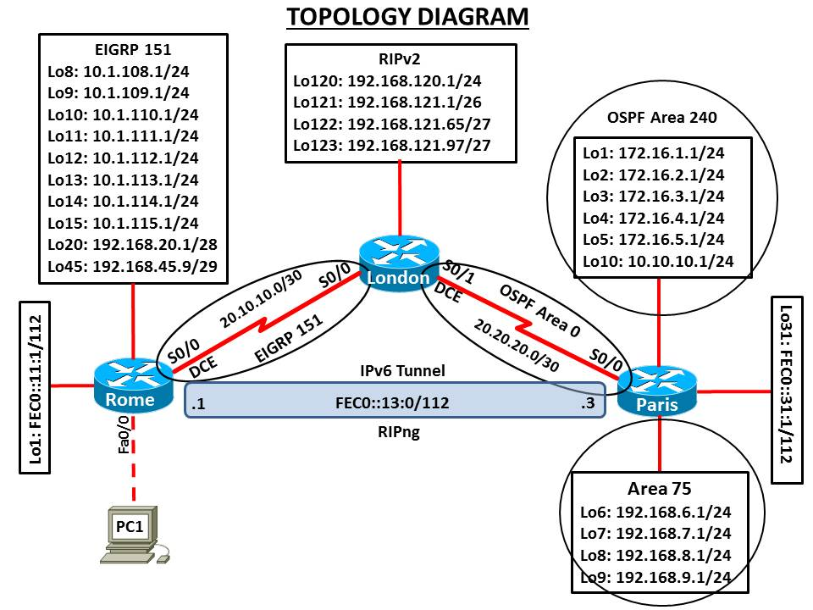

Requirements:
Task 1: Addressing Scheme Table

Device | Interface | IP Address | Subnet Mask
Paris | Serial 0/0
 | Loopback 1
 | Loopback 2
 | Loopback 3
 | Loopback 4
 | Loopback 5
 | Loopback 6
 | Loopback 7
 | Loopback 8
 | Loopback 9
 | Loopback 10
 | Loopback 31
London | Loopback 120
 | Loopback 121
 | Loopback 122
 | Loopback 123
 | Serial 0/1
 | Serial 0/0
Rome | Fast Ethernet 0/0
 | Serial 0/0
 | Loopback 1
 | Loopback 8
 | Loopback 9
 | Loopback 10
 | Loopback 11
 | Loopback 12
 | Loopback 13
 | Loopback 14
 | Loopback 15
 | Loopback 20
 | Loopback 45

Task 2 – Network Connections (10 marks)

Physically cable the network as shown in the topology diagram.

Configure the router with hostname, Passwords (Console, Vty and privilege EXEC), line description, banner, disable DNS lookup, and synchronous logging.

Configure interfaces on all routers and verify IP addressing.

Task 3 – Configure Routing (80 marks)

- Configure the router to be in EIGRP AS 151. Add all networks as shown in the diagram. Ensure that your network statements are as specific as possible. Disable automatic summarisation.

- Configure Rome router as DHCP server with following details: DHCP pool (Pool name: RomeLAN) for the subnet 192.168.254.0/24, default router 192.168.254.254, dns server 192.168.254.253, domain name: mh505.com, lease time of 1day 16hrs and 30mins and exclude address range 192.168.254.240 to 192.168.254.254.

- Configure RIP version 2. Add all networks as shown in the diagram. Ensure that your network statements are as specific as possible. Disable automatic summarisation.

- Configure OSPF Area 0 on the link between London and Paris as shown in the diagram. Ensure that your network statements are as specific as possible.

- Configure OSPF Area 240 and add all networks as shown in the diagram. Ensure that your network statements are as specific as possible.

- Configure OSPF Area 75 and add all networks as shown in the diagram. Ensure that your network statements are as specific as possible.

- Configure all loopbacks and LAN interfaces in passive state.

- Configure a manual summarization on Rome’s serial 0/0 interface for all loopbacks 8 to 15 in EIGRP 100. Use the most efficient mask.

- Change the network type for the loopback interfaces to point-to-point so that they are advertised with the correct mask in OSPF.

- Configure summarization of area 240 into a single inter-area route. Use the most efficient mask.

- Configure EIGRP links to use MD5 authentication between R1 and R2 routers. Use password "cisco".

- Configure OSPF interfaces to use MD5 authentication between R2 and R3 routers. Use password "class".

- Configure the bandwidth to reflect the actual bandwidth of all serial links.

- Redistribute OSPF into EIGRP. Use the following metrics: bandwidth 10000, delay 100, reliability 255/255, load 1/255 and MTU 1500

- Configure mutual redistribute between RIP, EIGRP and OSPF with appropriate metrics.

- Make the link between London and Paris to have hello timers and dead timers that are double the default values.

- Make the link between London and Paris have a cost of 500.

- Make the link between Rome and London to have hello interval of 2 seconds and hold interval of 8 seconds.

- Change the intra-area distance to 105, inter-area distance to 115, and external routes to 175 on Paris.

- Configure the IPv6 loopback and tunnel interfaces on Rome and Paris.

- Enable RIPng on Rome and Paris and configure the advertisement of the loopback and tunnel networks.

- On Rome, issue show ip route command and copy and save the output in to a text file.

- Filter Paris loopback 7 and 9 networks from being redistributed into EIGRP on London. Configure an access-list that matches these two network addresses and a route map that denies based on a match for that access list.

- Verify those networks are removed from Rome’s routing table. Copy and save Rome’s routing table on to the text file created in step 21.

Task 5 – Test network connectivity and path control (10 marks)

- Issue ipconfig /all from PC1 and record the following information:
Description: ________________________________
Physical Address: ____________________________
IPv4 Address: _______________________________
Subnet Mask: _______________________________
Default Gateway: ____________________________
DNS Server: ________________________________

- Test Connectivity from PC:
From PC1, ping loopback addresses on Paris. Is it successful? _________________

- Create a Tcl script and test connectivity from each router to the addresses shown in the diagram.
tclsh

foreach address {
+>10.1.108.1
+>10.1.109.1
+>10.1.110.1
+>10.1.111.1
+>10.1.112.1
+>10.1.113.1
+>10.1.114.1
+>10.1.115.1
+>192.168.20.1
+>192.168.45.9
+>20.10.10.1
+>20.10.10.2
+>192.168.120.1
+>192.168.121.1
+>192.168.121.65
+>192.168.121.97
+>20.20.20.1
+>20.20.20.2
+>172.16.1.1
+>172.16.2.1
+>172.16.3.1
+>172.16.4.1
+>172.16.5.1
+>192.168.6.1
+>192.168.7.1
+>192.168.8.1
+>192.168.9.1
+>10.10.10.1
+>192.168.254.254
+>} {
+>ping $address }

Submission Requirements:

All documentation for your solution should be submitted. Your name should be clearly printed on the documents.

At the end of the test a flash memory will be given to you, the configuration files for all routers should be copied to the media and handed in to your instructor. It is you responsibility that you copy the files correctly.

The file name should be studentname_Pno_routername.txt

Show running-configuration
Show ip interface brief
Show ip route (On Rome, before and after applying route filter)
Show ip protocols
Show ip route ospf

