ECGE4002: Academic study skills for students

Student number: 1905460
Student name: Nicola Tulley

Contents
Portfolio task 1 – Developing your skills: vision of success as a student teacher 3
Portfolio Task 1 – Vision of success as a student teacher 4
Portfolio Task 1 – Developing your skills: vision of success as a student teacher 5
Portfolio Task 2 – Developing Critical Thinking 6
Portfolio Task 3 – Developing Critical Writing 8
References 10

Portfolio task 1 – Developing your skills: vision of success as a student teacher
Digital Mind Map

Available Resources
Home
University
Myself
School
Family
Notes from tutor led session
Teachers
Other student teachers
Pupils
Tutor led sessions
Module leads
Peers
Online
HWB
Moodle
Online library
Library
Personal experience
Independent study
Notes taken

Portfolio Task 1 – Vision of success as a student teacher
Current Skills Audit

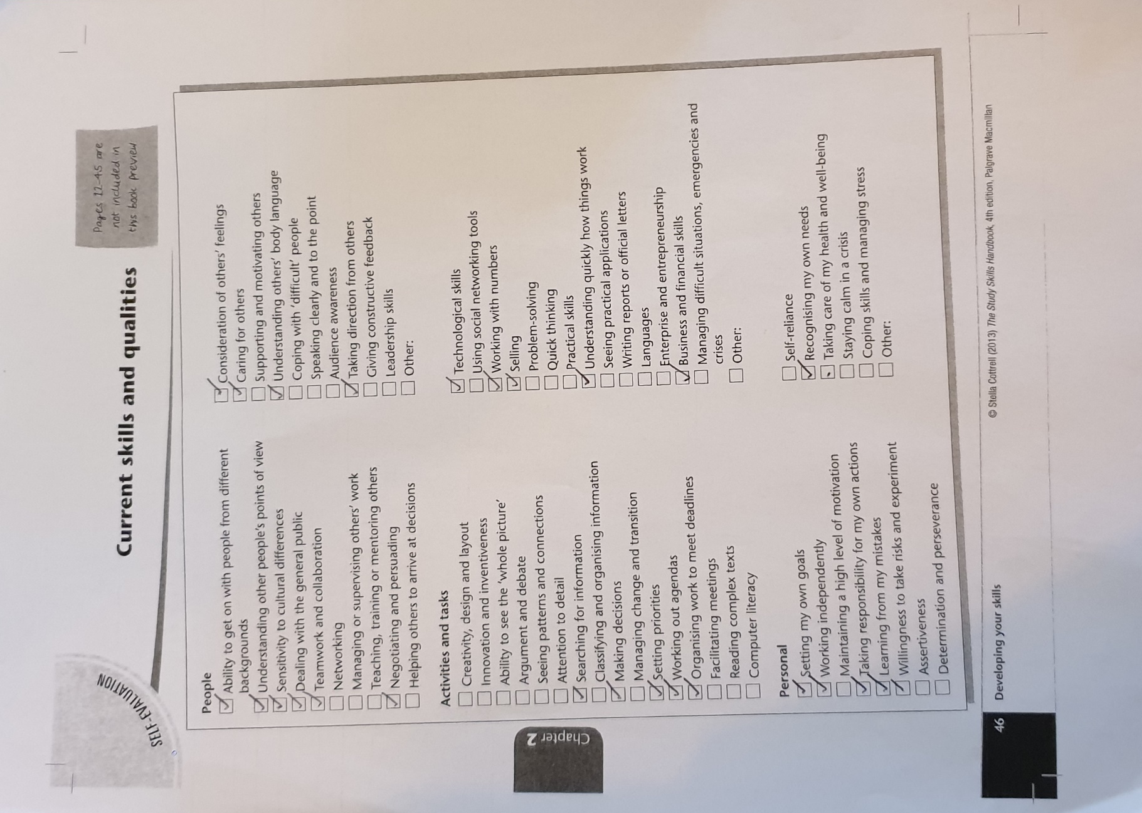
Portfolio Task 1 – Developing your skills: vision of success as a student teacher
What success looks like to me

For me, career success would be to become a great teacher, to perfect my leadership skills, to be able to support and motivate others, as well as showing creativity in a lesson to get the children engaged. To be able to gain these skills, I think it is important to get experience of working with others, such as in group exercises and from working in the classroom. Personal success is the ability to be able to cope with and to manage stress and not allow a problem to take control but to fix the problem at hand. I may need to turn to the module lead or peers and use the resources available at the university library. The journey of transformation will involve learning to know your own needs, being able to work independently and having the willingness to take a risk. This independent transformation will be a very personal experience that will need the determination to change and become the best version of yourself. All these qualities will ensure I become the successful teacher that I aim to be.

Portfolio Task 2 – Developing Critical Thinking
Critical Thinking

Critical thinking is when you are presented with a piece of information about a topic and instead of taking all the information as reliable you take a step back and look at any factors that could mean that the information is not completely true and accurate. Factors to look at for example, would be who the author of the piece of writing is, what the purpose of them writing it is, if there is a certain point that they are trying to get across to persuade the reader and whether there are biased views. To ensure that you have got the correct information and understanding of a topic it is best to do further research from multiple sources and compare them with each other, this way you are more likely to have more solid facts and less personal opinions.

There is importance and benefits of critical thinking in academic contexts and everyday life. Being able to find what information is useful and having more precision in your work. Also, not just when looking for information, but when you are reflecting on your own work and where you can improve it is also important to critically think. As Cottrell (2005) suggests “a lack of self-awareness and weak reasoning skills can result in unsatisfactory appraisals at work or poor marks for academic work” (Cottrell, 2005, p.4). Showing that it is helpful in life to know where your strengths and weaknesses are to be able to thrive in your work.

Certain skills are needed to be able to successfully think critically. Cottrell (2005) lists these skills and explains about each one, suggesting that checking information multiple times and looking at the information in a different light will mean that you will not miss anything that has been presented to you. This shows that taking time to really study and break down a piece of information will give you the best results and a greater understanding for all angles.

However, critical thinking is a hard process to suddenly begin doing. We all critically think with everyday activities but doing it in an academic style or really having to focus on doing it can be a challenge. A barrier causing problems with successfully doing this could be confusion over what is meant by criticism in this context. Cottrell explains that “some people assume ‘criticism’ means making negative comments” (Cottrell, 2005, p.10). However, this is not what is needed to be done, instead constructive criticism can be used, by not being negative but by being helpful. So, when critically thinking it is not about picking apart a piece of writing and finding everything wrong in it, but instead finding possible areas of bias or false logic that could affect the results you are collecting.
In summary, critical thinking is not an easy process to learn. However, through practise and learning the methods it can be achieved and enhance individual understanding of the topic at hand.

Portfolio Task 3 – Developing Critical Writing
What I think about Education in Wales

Education in Wales is currently going through a new change of curriculum. This new curriculum has come about after Professor Graham Donaldson did a review on the curriculum and where there is a need for things to be changed for children and young people to get the best out of education. I believe this is also going to be a beneficial change for the teachers, for them to be able to teach more freely on how they think is best.

I believe this new curriculum is going to bring a new life to education. “The new curriculum will have more emphasis on equipping young people for life” (gov.wales, 2019). This will set children up for the future and give them skills that they need in life and ensure that they are able to excel and become the best of their ability. These are extremely important factors to learn in life and everyone should have to chance in their education to experience and learn like this. I find this new curriculum an exciting and amazing time for education in Wales and truly believe the learning experience for children is going to become even better than it ever has been.

Donaldson’s review recommended four curriculum purposes to help children develop and there are then six Areas of Learning Experience. These new changes will work together to ensure the four purposes are being worked on. As well as these there is also the acknowledgement of modern technology and bringing that into learning. “There should be three cross-curriculum responsibilities: literacy, numeracy and digital competence” (Donaldson, 2017, p.6). Bringing the knowledge of technology into education will mean that the children are learning for the time that we are in now, this will also help with their skills they need later on in life as technology is such a big part of society and the world that we live in today.

In Donaldsons successful features report he notes how there as been concerns about the transitioning between stages. In this new curriculum “all children and young people should make progress along the same continuum” (Donaldson, 2015, p.115). Doing this will keep everyone learning together, there still could be students learning at a slightly faster and slower rate than others, however, it is a more fair and equal way of learning and ensuring that each child has the same chance at success as the next.

In conclusion, I believe education in Wales is currently heading in the right direction. With this new curriculum being put in place children and young people have got the best foundations for the future. To be successful in the future you need to have the basic skills for life, as well as knowing how to function in the highly digital society that we live in.

References

Cottrell, S (2005) Critical Thinking Skills: Developing Effective Analysis and Argument. Palgrave Macmillan

Cottrell, S (2013) The Study Skills Handbook 4th Ed. Basingstoke: Palgrave Macmillan

Donaldson, G. (2017) ‘A Systematic Approach to Curriculum Reform in Wales’, Wales Journal of Education, 19(1), pp. 7-20.

Donaldson, G (2015) Successful Features: Independent Review of Curriculum and Assessment Arrangements in Wales. Available at: https://dera.ioe.ac.uk/22165/2/150225-successful-futures-en_Redacted.pdf (Accessed: November 6 2019)

Gov.wales (2019) New School Curriculum: Overview. Available at: https://gov.wales/new-school-curriculum-overview (Accessed: November 6 2019)

