Name: Amber Wilkes
Student Number: 1802240
Course Title: Graphic Design
Word Count: 1509
Tutor’s Name: Scott Smith

Exploring the theme of fears and phobias, I will be curating my own imagined exhibition, consisting of three artists whose work relates to the topic. Curation is to ‘select, organize, and look after the items in (a collection or exhibition)’ (Simpson & Weiner, 1989), meaning that I will be deciding exactly what goes into the imagined space, how the artwork will be arranged, and what the venue will be. From an outside perspective, you may imagine that an art exhibition is purely about the artwork being displayed on the walls, however, ‘to enter a gallery is to encounter not only the current exhibition, but a particular view of how works should be shown: in what kind of space and lighting, against which surfaces, among what furnishings, with what kind of framing and documentation’ (Tickner, 2007), meaning I intend to design every detail, making it an immersive experience for anyone that chooses to view it. I intend to make the space in which the artwork is displayed a perfect environment to inspire certain feelings and emotions within the people entering the exhibition.
To begin this process, I started by selecting an overarching theme that all the artwork would fall into, so that I would be able to narrow down the selection of artists. I wanted to choose a topic that inspired me, which led to me settling on the intriguing, somewhat thought-provoking theme of fears and phobias, ‘just as it is interesting to explore the dreams of other people, it is also interesting to explore their worst nightmares’ (Sauchelli, 2014). I think that people are often curious about other people’s fears, but there is little opportunity for people to explore them ordinarily, hence the exploration of my imagined exhibition. I plan for everything in the imagined space from the lighting to the sounds playing in the background to reflect fears and phobias, so it is a complete experience. After I had chosen this, it allowed me to start selecting artists, and deciding how the venue would look.
Figure 1. Exhibition Space by the Author (Wilkes, 2019)
ENTRANCE
Room 1
Room 2
Room 3

Figure 1 depicts how I imagine my exhibition floor plan to look, which I plan to explore in detail. When deciding on the venue I explored selecting an existing location first, I looked at locations that would match the fears and phobias theme, such as spaces that could be perceived as being haunted, for example castles and prisons. However, although these places were available to rent for an exhibition, I found that they didn’t fit the needs the artwork has, such as the scale of one of the pieces.
The floorplan starts with a long, thin hallway, made to build suspense and uncertainty, and perhaps causing claustrophobia, the fear of small spaces. All the walls in my exhibition will be black with no windows or natural lighting, to make the space seems smaller and more enclosed than it actually is, ‘two rooms of the same size will feel altogether different if one has natural light and the other is lit artificially’ (Goldberger, 2009). From the entrance you would be able to see the shadows from the artwork in the distance, but you wouldn’t be able to see them in detail, which may put the viewer on edge. Some may wonder why anyone would want to visit an exhibition that is meant to spark fear for the viewers, however it has been shown that some people actually enjoy feeling scared, ‘the excitement that we feel in fear is what makes fear potentially enjoyable, especially for someone who leads a relatively dull life’ (Morreall, 1985). For many, life is fairly relaxed and mundane, so they may want to visit this space to make themselves feel some of the feelings associated with fear, for example being more alert, tense and experiencing a racing heartbeat. As this sculpture is in the centre, it will be a starting point for everyone, but also, everyone will have to come back to it every time they leave a smaller artist’s room, reinforcing the fear.

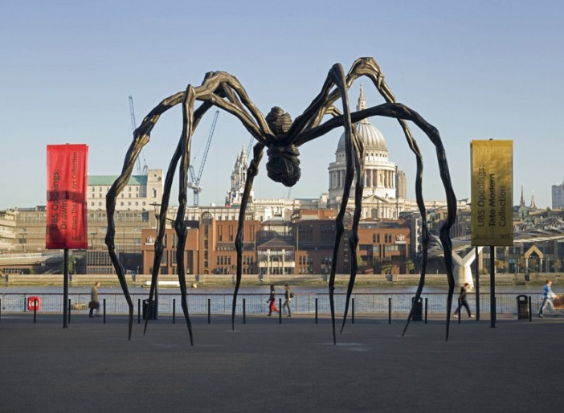
Figure 2. Maman, Louise Bourgeouis, 1999
The first artist my exhibition will feature is Louise Bourgeouis, and her artwork, ‘Maman’; a large sculpture of a spider measuring over 30ft tall and 33ft wide. It is because of the scale of this sculpture that I decided to design my own exhibition space, instead of choosing an existing one as it would have been difficult to find one where this sculpture would fit. This sculpture will be in room one (see figure 1) of my venue; the biggest room, making it the main feature of my exhibition. I have purposefully put this sculpture in the main room so that everyone who enters has to walk under it to reach the other artwork, making it unavoidable. This may play on everyone’s phobias, as arachnophobia, the fear of spiders, is very common. The lighting in this room will be artificial and dim, it will shine from different angles on the walls so that random shadows are cast on the floor below the sculpture; playing on sciophobia, the fear of shadows. Not only this, but there will also be some ambient sounds playing in this room, I want the sound of scratching and scurrying to be heard, to put everyone on edge as if there are actual spiders in the room, ‘The use of touch specimens, sounds, and smells to complement the object … have a strong influence on visitors’ experiences, especially creating a strong sense of flow – being fully immersed and focused in a task’ (Vi, Ablart, Gatti, Velasco & Obrist, 2017) I believe this will complete the experience of this room, making it fully immersive.
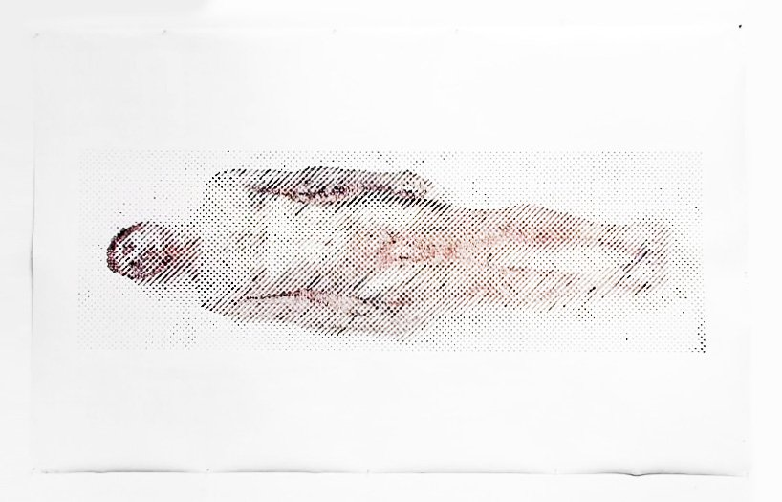
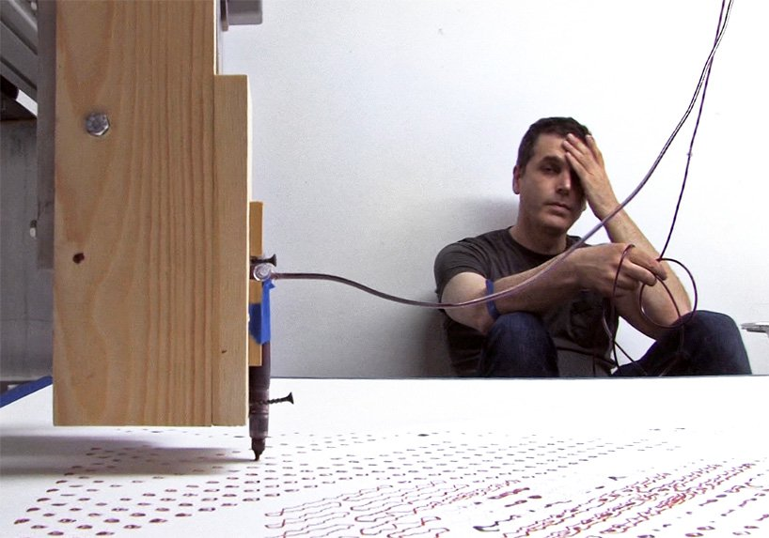
Figure 3. Ghost in the Machine, Ted Lawson, 2014
In room two my second artist, Ted Lawson, will be featured, and his artwork ‘Ghost in the Machine’; a life size self portrait created using his own blood. I intend for this piece to be displayed in the centre of the room in the way it would have been when the artist was creating it, allowing everyone to be able to walk around the display, and see it from all angles. The viewers will be able to see all of the tools and equipment associated with the artwork, which would make it feel more real than just being able to see the final piece; making them feel the connection between the process and the outcome. I chose this piece of artwork because I am aware that many people have a fear of needles and blood, so I am specifically targeting those with this phobia. The lighting in this room will be from above the artwork, so that only the artwork is lit, and the rest of the room is pitch black, so it draws in everyone’s attention. To make it an immersive experience, I also plan for there to be sounds like what there would have been when the artist was making the piece. For example, I want there to be an intense buzzing sound, similar to the noise the machine would have been making, as well as the scratching sound of the device on the paper.

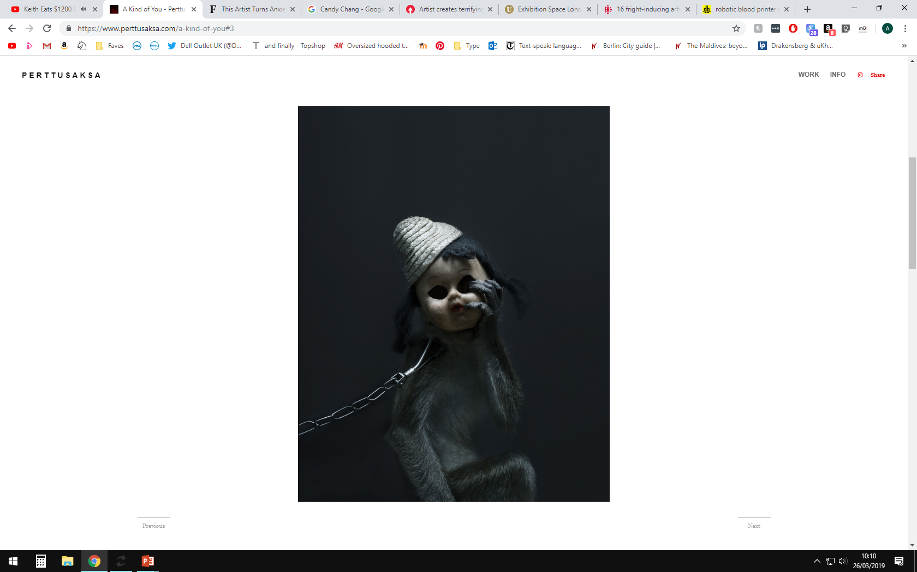
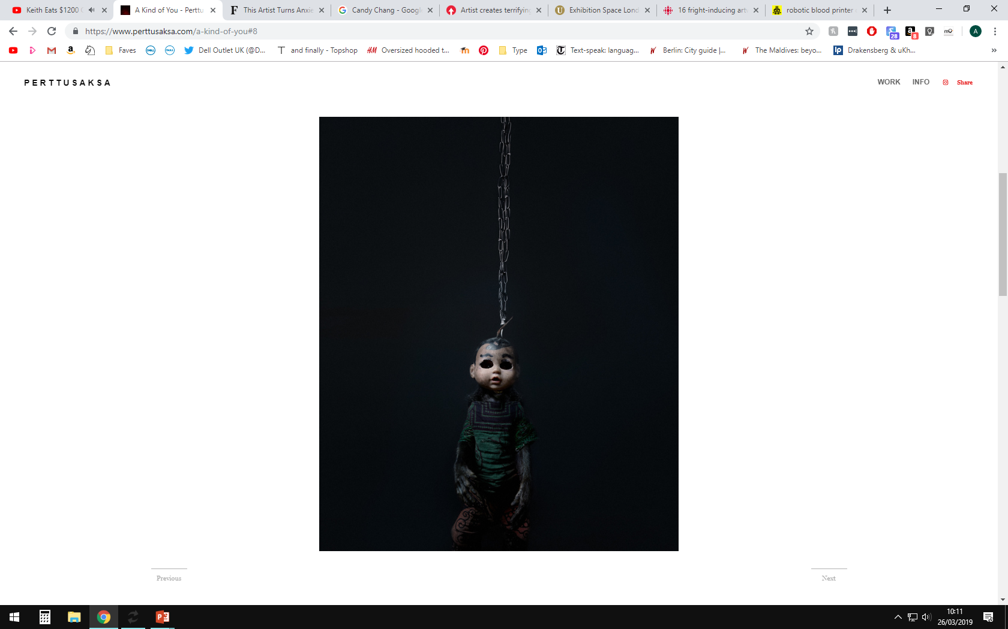
Figure 4. A Kind of You, Perttu Saksa, 2013
The final room will feature the work of Perttu Saksa, and his photography ‘A Kind of You’; a collection of photographs featuring macaque monkeys; where most are wearing masks and children’s clothing. Not only are the masks alone unsettling and eerie but there is also a very real message behind this collection; these images are inspired by monkeys in Indonesia who are chained and then used for entertainment. I plan for the collection of photographs to be on every wall in the room, so that the viewer is surrounded by them, making for a shocking and overwhelming experience. Not only this but having them on the walls allows the space in the centre in the room to be used to hang chains down from the ceiling, representing the ones in the images which were used to capture and enslave the monkeys; making for a more realistic and haunting experience. Music will also play an important part in this room, ‘frightening images and ideas can be made even more intense when accompanied with frightening musical sounds, and music in horror film frequently makes us feel threatened and uncomfortable through its sudden stinger chords and other shock affects’ (Lerner, 2008). I intend for there to be circus like music playing in this room, representing how the monkeys are being used for entertainment, which may seem eerie. I plan for the music to vary in volume, perhaps frightening the viewer when it suddenly changes from quiet to loud. This room contains juxtaposition, as circus music is usually very upbeat, this may make the viewer question it, perhaps leading them to truly think about the artwork in depth. There would also be other ambient sounds in this room, such as monkey noises, and the sound of rattling chains in the background so that it would be as immersive and thought provoking as possible.

Bibliography
Simpson, J., & Weiner, E. (1989). curate. Oxford English Dictionary. Oxford: Oxford University Press
Tickner, L. (2007) ‘The Kasmin Gallery’, Oxford Art Journal, 30(2), pp. 235-268.
Sauchelli, A. (2014) ‘Horror and mood’, American Philosophical Quarterly, 51(1), pp. 39-50.
Goldberger, P. (2009) Why Architecture Matters. New Haven: Yale University Press
Morreall, J. (1985) ‘Enjoying Negative Emotions in Fictions’ Philosophy and Literature, 9(1), pp. 95-103.
Vi, C., Ablart, D., Gatti, E., Velasco, C., & Obrist, M. (2017) ‘Not just seeing, but also feeling art’, International Journal of Human-Computer Studies, 108, pp. 1-14.
Lerner, N. (2008). Music in the horror film. New York: Routledge

List of Figures
Figure 2 accessed from “https://www.tate.org.uk/context-comment/blogs/work-week-maman-louise-bourgeois”, accessed on 22/04/2019
Figure 3 accessed from “https://www.designboom.com/art/ted-lawson-robotic-blood-machine-08-26-2014”, accessed on 23/04/2019
Figure 4 accessed from “https://www.perttusaksa.com/a-kind-of-you”, accessed on 23/04/2019

