

Task 1 – Reading Task Template
Upload your photo of your A3 in-class notes here:
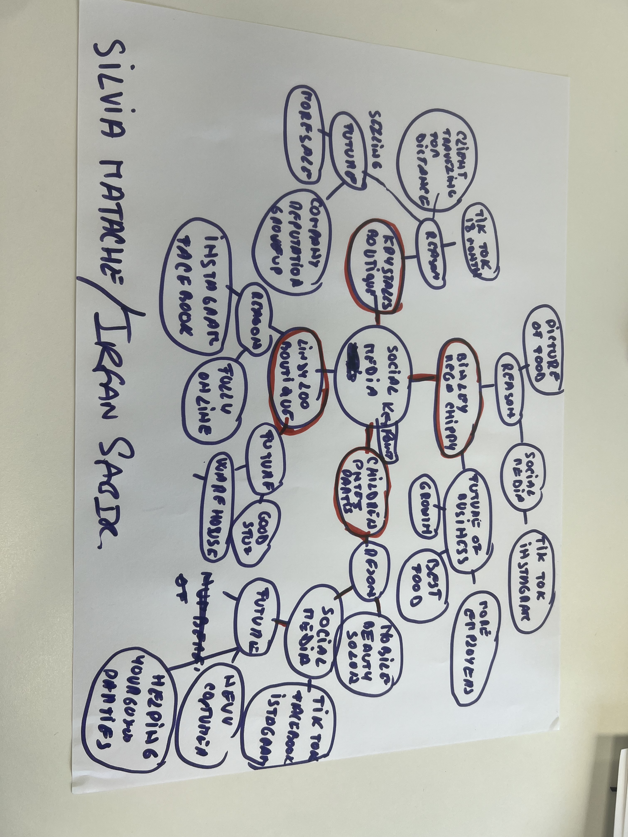

1. Answer these questions using the sentence starters below
a. What is the main idea of the text?
The main idea is that social media helps businesses advertise their products and services to a large number of people quickly and cheaply. This promotion can attract more customers, increase product sales, improve communication with customers, and help the business become more popular.
b. What are two key points?
One key point is social media promotion helps businesses reach more people. When businesses post adverts, pictures, or videos online, many users can see them and become interested in buying the products.
Another key point is social media allows businesses to interact with customers directly. Businesses can reply to comments and messages, which helps build trust and encourages customers to continue supporting the business.
c. What part of the text did you find most important? Why?
The most important part is that social media helps businesses reach more costumers and grow faster. Social media platforms help achieve costumers from different places.
d. Was anything unclear or difficult to understand?
I was fine understanding everything.
e. How did your group help you understand the text better?
My group helped me by discussing topics and sharing examples.
3. One sentence reflection
Question: What did you find challenging about this task?
The hardest part was understanding the relationship between social media engagement and costumer behaviour.

