

Image Classification Neural Of Apple Leaf Diseases Using A Custom Convolutional Neural Network: An Application Of The Plant Pathology 2021 Dataset
Student Name: Mohammed Nawaf
Student ID: 2541121

MSc Data and Artificial Intelligence

Module: Application of Machine Learning
Module Code: ACCA7025
Lecturer: Dr Aliyu Sambo

Table of Contents
Contents
Table of Contents 2
Abstract 3
1. Introduction 4
1.1 Background and the Plant Pathology 2021 Dataset 4
1.2 Research Gap 4
1.3 Aim, Objectives, and Research Questions 4
1.4 Report Structure 5
2. Related Work / Literature Review 6
2.1 Artificial Neural Networks and Deep Learning 6
2.2 Convolutional Neural Networks for Image Classification 6
2.3 Recurrent Neural Networks and Their Unsuitability for Static Image Classification 6
2.4 CNN-Based Plant Disease Detection: A Critical Review of Prior Studies 7
2.5 Training Considerations: Optimisation, Regularisation, and Data Augmentation 7
2.6 Synthesis and Positioning of the Present Study 8
3. Workflow Methodology 9
3.1 Dataset 9
3.2 Image Preprocessing 10
3.3 Dataset Optimisation Pipeline 10
3.4 Data Augmentation 10
3.5 Train, Validation, and Test Split 10
4. CNN Model 11
4.1 Architecture Overview 11
4.2 Model Compilation 11
4.3 Training Configuration 12
5. Results 13
5.1 Training and Validation Performance 13
5.2 Test Set Performance 14
5.3 Qualitative Prediction Results 14
6. Discussion and Recommendations 15
6.1 Interpretation of Model Performance 15
6.2 Overfitting, Underfitting, and Generalisation 15
6.3 Impact of Preprocessing and Data Augmentation 15
6.4 Class Imbalance 15
6.5 Comparison with Previous Studies 16
6.6 Recommendations 16
7. Conclusion 17
References 18

Abstract
Timely, accurate identification of foliar disease is essential to precision agriculture, but manual diagnosis is slow and difficult to scale. Convolutional neural networks (CNNs) dominate this problem, yet most published work on the Plant Pathology 2021 (FGVC8) benchmark relies on pretrained transfer-learning backbones evaluated against the dataset's coarser five- or six-class scheme, leaving the baseline behaviour of small, non-pretrained CNNs on the harder twelve-class compound-label formulation under-documented. This report presents the design, implementation, and critical evaluation of a custom CNN, built from scratch in TensorFlow/Keras, for the full twelve-class compound-label partition of Plant Pathology 2021. The model was trained on 8,707 images, validated on 1,862, and tested on 1,879, each resized to 512×512 pixels, using four convolutional blocks with batch normalisation and max-pooling, on-the-fly data augmentation, and a dropout-regularised dense head. Trained for ten epochs with Adam, the network achieved a final test accuracy of 60.19% and test loss of 1.2044. The report's contribution is not a state-of-the-art figure but a transparent, empirically grounded baseline for this specific, under-documented scenario, together with a critical analysis of the model's error characteristics and literature-supported directions — principally transfer learning and attention-based architectures — for improvement. Every architectural and training decision is situated in the peer-reviewed literature, and only results actually produced by the implementation are reported.

1. Introduction

1.1 Background and the Plant Pathology 2021 Dataset
Artificial intelligence (AI) encompasses computational systems that perform tasks typically requiring human cognition; machine learning (ML), a subfield of AI, enables systems to improve through exposure to data rather than explicit rules [1]. Deep learning, built on artificial neural networks (ANNs) with multiple hidden layers, underlies recent breakthroughs in image processing, speech recognition, and natural language processing [2]. Convolutional neural networks (CNNs) have become the dominant architecture for visual recognition, a position consolidated after AlexNet's decisive win at the ImageNet Large-Scale Visual Recognition Challenge [3], [2]. Image classification underpins applications from medical diagnostics to autonomous navigation, and its agricultural role has expanded as inexpensive cameras have made large-scale image capture routine [4].
Plant disease threatens global food security, and manual inspection by agronomists does not scale to commercial orchards [4], [5], [6]. The dataset used here, Plant Pathology 2021 (FGVC8), released at the CVPR 2021 Fine-Grained Visual Categorization workshop, covers six base apple-leaf health categories (healthy, complex, rust, scab, frog eye leaf spot, powdery mildew) [7]. Because leaves may exhibit multiple conditions simultaneously, the folder structure supplied for this assignment subdivides these into twelve compound co-infection classes [8], loaded directly from pre-split train/valid/test folders of 8,707, 1,862, and 1,879 images respectively, each resized to 512×512 pixels. This fine-grained, multi-label structure is considerably more demanding than single-label benchmarks such as PlantVillage.

1.2 Research Gap
The literature on Plant Pathology 2021 is dominated by two tendencies: most high-accuracy results rely on transfer learning from large pretrained backbones such as ResNet, EfficientNet, DenseNet, or Inception [5], [9], [10], and most studies evaluate the coarser five- or six-class scheme rather than the twelve-class compound-label formulation, understating true task difficulty [7], [9]. Little published work documents the baseline performance and error patterns of a small, non-pretrained CNN trained from scratch under a limited epoch budget on the full twelve-class formulation — a scenario representative of many real-world and educational contexts where pretrained models or large compute budgets are unavailable. This report provides a transparent, reproducible baseline of exactly this kind.

1.3 Aim, Objectives, and Research Questions
The aim of this research is to design, implement, train, and critically evaluate a custom CNN for twelve-class apple-leaf disease classification, assessing its performance and potential for improvement relative to the literature. The objectives are to: (1) review CNN- and RNN-based approaches to image classification and prior plant-disease detection studies; (2) design and implement a suitable CNN with appropriate preprocessing and augmentation; (3) train and evaluate the model on an independent test set; (4) critically discuss performance, strengths, weaknesses, and likely causes of misclassification against comparable studies; and (5) recommend realistic, literature-supported directions for improvement. The corresponding research questions ask how well such a model can classify across twelve fine-grained categories, which design choices most plausibly explain the observed performance, and which changes would most likely close the gap with transfer-learning studies.

1.4 Report Structure
The report proceeds as follows. Section 2 reviews the literature on ANNs, CNNs, and RNNs and prior plant-disease detection studies. Section 3 describes the workflow methodology. Section 4 details the CNN architecture and training configuration. Section 5 reports the results actually obtained. Section 6 discusses these results critically with reference to the literature. Section 7 concludes and outlines future work. References and an appendix follow thereafter.

2. Related Work / Literature Review

2.1 Artificial Neural Networks and Deep Learning
An ANN is a layered structure in which each unit computes a weighted sum of inputs through a non-linear activation; stacked into many hidden layers, such networks approximate highly complex functions, the property exploited by deep learning [1], [2]. Early architectures such as LeNet established the convolution-and-pooling pattern underlying virtually all subsequent CNNs [11]. Deep learning's decisive breakthrough for computer vision is widely attributed to AlexNet, which reduced ImageNet classification error far beyond hand-engineered methods, demonstrating that depth combined with large labelled datasets and GPU training could outperform manual feature engineering [3].

2.2 Convolutional Neural Networks for Image Classification
A CNN extracts features through a hierarchy of convolutional layers, each applying learned filters across local receptive fields to detect increasingly abstract patterns, from edges in early layers to whole-object representations in deeper ones. Pooling layers reduce spatial dimensionality while retaining salient activations, and shared filter weights give translation invariance while keeping parameter counts tractable relative to a fully connected network on raw pixels [2]. This combination of local connectivity, weight sharing, and hierarchical abstraction is why CNNs are well suited to grid-structured image data, and is the primary justification for selecting a CNN over other architectures here [2], [12].
Modern CNN research extends this design substantially: residual connections in ResNet mitigate vanishing gradients via identity shortcuts [13]; DenseNet connects every layer to every subsequent layer, encouraging feature reuse [14]; EfficientNet jointly scales depth, width, and resolution for strong accuracy-to-parameter trade-offs [15]; and Vision Transformers apply attention directly to image patches, achieving competitive results when pretrained on very large datasets [16]. Each is available as a pretrained backbone commonly fine-tuned through transfer learning, a strategy that dominates the plant-disease literature reviewed below.

2.3 Recurrent Neural Networks and Their Unsuitability for Static Image Classification
RNNs maintain a hidden state updated at each time step, suiting sequential tasks such as language modelling and time-series forecasting where data order is informative [2]. RNNs are markedly less suited to static image classification: treating an image as a sequence of patches discards much of its two-dimensional spatial structure, and a controlled ImageNet comparison found RNN-based classifiers consistently underperformed equivalent CNNs [17]. RNNs are also inherently sequential, preventing the layer-wise parallelism that makes CNN training on GPUs efficient [17]. For these reasons — loss of spatial locality and absence of parallelisable, translation-invariant feature extraction — RNNs are not selected for this project. Table I summarises the comparison.
Characteristic | CNN | RNN
Primary data structure | Grid-structured / spatial (images) | Sequential / temporal (text, time series)
Core operation | Local convolution with shared filters | Recurrent hidden-state update over time steps
Spatial information | Preserved directly through 2-D convolution | Lost or reconstructed indirectly when images are serialised into patches
Parallelisability | High — convolutions computed across the whole feature map simultaneously | Low — hidden states depend sequentially on previous time steps
Suitability for this task | Selected: exploits 2-D spatial structure of leaf images | Not selected: no meaningful temporal ordering in a single static image
Table I. Comparative characteristics of CNN and RNN architectures for image versus sequential data [2], [17].

2.4 CNN-Based Plant Disease Detection: A Critical Review of Prior Studies
A substantial and growing literature applies CNNs to plant disease classification, with reviews reporting accuracies frequently exceeding 95% on curated benchmarks, largely via transfer learning from ImageNet-pretrained backbones [6], [18]. Several studies work directly with the Plant Pathology family. Ali et al. proposed AppleLeafNet, a two-stage lightweight framework evaluated on the five-class version of FGVC8, reporting an F-score of 0.963; its strong metrics likely reflect the coarser five-class scheme rather than the harder twelve-class formulation used here [9]. Srinidhi et al. applied EfficientNet- and DenseNet-based transfer learning to apple leaf detection, illustrating the field's general reliance on large pretrained backbones over compact from-scratch architectures [19].
Beyond apple-specific work, Sujatha et al. found CNN-based methods consistently outperform classical machine learning classifiers, at the cost of larger datasets and compute — directly relevant to the resource-constrained setting adopted here [20]. Singh et al. demonstrated a custom multilayer CNN for mango-leaf anthracnose, showing non-pretrained CNNs can perform well on narrower, less fine-grained problems [21]. Zhao et al.'s 2025 systematic review corroborates this pattern: reported accuracies cluster between 85% and 99.9%, but almost all use pretrained networks evaluated on less fine-grained, more balanced datasets than the compound-label partition used here [6].
A consistent gap in this literature is limited transparency around non-pretrained baseline performance, since most studies report only their best fine-tuned configuration. This report's twelve-class, non-pretrained baseline aims to make a modest, concrete contribution toward closing that gap.

2.5 Training Considerations: Optimisation, Regularisation, and Data Augmentation
Several training-level choices are consistently justified in the literature and directly relevant here. Adam, which adapts the learning rate per parameter from running gradient-moment estimates, converges faster and more reliably than plain SGD across many deep learning tasks [22]. Batch normalisation, normalising activations within each mini-batch, accelerates training and improves stability by reducing internal covariate shift [23]. Dropout, randomly deactivating units during training, is a widely used regulariser that reduces overfitting by preventing complex co-adaptations between neurons [24]. Data augmentation — flipping, rotation, zoom — improves generalisation by artificially increasing training-set diversity, particularly valuable when training data is limited relative to task complexity, as here [25].

2.6 Synthesis and Positioning of the Present Study
Taken together, the literature supports three conclusions guiding this project's design. First, CNNs are the appropriate architecture for static image classification and RNNs are not, for the reasons in Section 2.3. Second, the specific choices adopted — batch normalisation, dropout, augmentation, and Adam — are individually well-supported as standard CNN training practice. Third, the Plant Pathology 2021 literature is dominated by transfer-learning approaches on coarser label schemes, leaving a compact, non-pretrained CNN on the full twelve-class partition comparatively unexamined. This report is positioned as a transparent baseline and critical analysis of that specific scenario, rather than an attempt to match larger pretrained systems' accuracy.

3. Workflow Methodology

3.1 Dataset
The dataset is a pre-split partition of Plant Pathology 2021 (FGVC8), organised on Google Drive into train, valid, and test subfolders, each subdivided by class. The path was set directly in the notebook (dataset_path = "/content/drive/MyDrive/plants/PlantPathology_Split") and loaded via Colab's Drive-mounting utility. Loading with TensorFlow's image_dataset_from_directory confirmed 8,707 training, 1,862 validation, and 1,879 test images across 12 classes (Table II).
Split | Number of Images | Role
Training | 8,707 | Used to fit model weights
Validation | 1,862 | Used to monitor generalisation during training
Test | 1,879 | Held out entirely for final, independent evaluation
Total classes | 12 | Compound-label apple leaf disease categories
Table II. Dataset split sizes as confirmed by notebook output (cell output: "Found 8707/1862/1879 files belonging to 12 classes").
Inspection of a sample batch (Figure 1) confirms class labels consistent with the compound-label extension described in Sections 1.1 and 2.4, including co-occurring labels such as "scab frog_eye_leaf_spot". Per-class image counts were not computed or printed anywhere in the notebook and are accordingly reported as not available, rather than estimated.
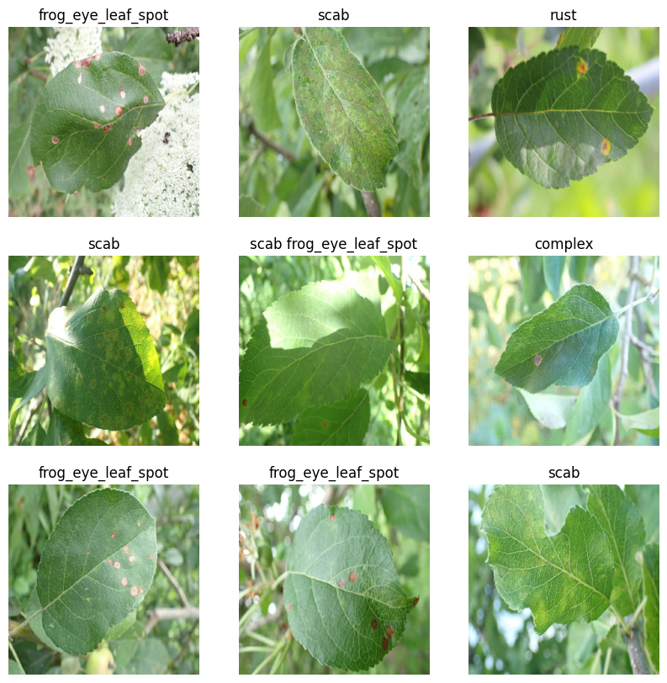
Figure 1. Sample of nine training images with their ground-truth class labels, as produced directly by the notebook's visualisation cell.

3.2 Image Preprocessing
Images were loaded via image_dataset_from_directory, which decodes files and resizes every image to a fixed 512×512 target with a batch size of 32. This comparatively high resolution preserves fine leaf-texture detail relative to many published plant-disease CNNs, at the cost of increased per-image computation. Pixel values were rescaled from 0–255 to 0–1 using a Rescaling(1./255) layer placed at the start of the model itself, ensuring identical normalisation during both training and inference without a separate preprocessing step.

3.3 Dataset Optimisation Pipeline
The three datasets were optimised using TensorFlow's tf.data API: the training set was cached after the first epoch, shuffled with a buffer of 1,000, and prefetched with AUTOTUNE to overlap CPU preprocessing with GPU execution; the validation set was cached and prefetched but not shuffled; the test set was only prefetched, with shuffling disabled (shuffle=False) to preserve a fixed, reproducible ordering for evaluation.

3.4 Data Augmentation
Augmentation was implemented as part of the model, using three Keras layers active only during training: RandomFlip("horizontal"), RandomRotation(0.1), and RandomZoom(0.1). These are justified in the literature as increasing effective training-set diversity and improving generalisation, particularly given the comparatively modest training partition (8,707 images across twelve fine-grained classes) relative to task complexity [25]. Because these layers are attached directly to the model graph, they are automatically inactive during validation and test-time inference.

3.5 Train, Validation, and Test Split
The split itself was not performed in the notebook; the dataset arrived already partitioned into train, valid, and test directories, which the notebook loaded independently. No code, ratio, or method for constructing this split is present and is accordingly reported as not available. The three partitions were, however, used correctly throughout: the training set alone updated model weights, the validation set was monitored every epoch without affecting weights, and the test set was held out entirely until the final evaluation in Section 5.

4. CNN Model

4.1 Architecture Overview
The classification network is a custom Sequential CNN implemented from scratch in Keras, without pretrained weights or transfer learning. It begins with the normalisation and augmentation layers described in Section 3, followed by four convolutional blocks of increasing filter depth (32, 64, 128, 256), a flattening operation, and a two-layer dropout-regularised dense head terminating in a twelve-way softmax output. Table III details every layer exactly as implemented.
Layer | Type / Configuration | Purpose
1 | Rescaling(1./255) | Normalises pixel values to [0,1]
2–4 | RandomFlip, RandomRotation(0.1), RandomZoom(0.1) | Data augmentation (training only)
5–7 | Conv2D(32,3, relu) + BatchNorm + MaxPooling2D | Low-level feature extraction
8–10 | Conv2D(64,3, relu) + BatchNorm + MaxPooling2D | Mid-level feature extraction
11–13 | Conv2D(128,3, relu) + BatchNorm + MaxPooling2D | Higher-level feature extraction
14–15 | Conv2D(256,3, relu) + MaxPooling2D | Deep, abstract feature extraction
16 | Flatten() | Converts feature maps to a 1-D vector
17–18 | Dense(256, relu) + Dropout(0.5) | Feature combination / regularisation
19–20 | Dense(128, relu) + Dropout(0.3) | Feature combination / regularisation
21 | Dense(12, softmax) | Outputs class probability distribution over 12 classes
Table III. Full CNN architecture as implemented in the notebook (model.summary() confirms this layer sequence; exact parameter counts were not resolved in the notebook's captured output and are therefore reported as not available).
The design rationale is well supported by the literature reviewed in Section 2.2. Progressively increasing filter depth (32→64→128→256) lets the network first detect simple, low-level features such as edges and colour transitions, then combine these into increasingly abstract representations of disease symptoms in deeper layers — the same hierarchical feature-extraction principle underlying canonical CNN architectures [2], [11]. Batch normalisation after the first three convolutions stabilises and accelerates training by reducing internal covariate shift [23], while max-pooling after every block progressively reduces spatial resolution, controlling both computation and overfitting risk. The two-stage dropout head (0.5 then 0.3) is a standard defence against overfitting in the fully connected layers, which typically hold the largest share of a CNN's trainable parameters [24].

4.2 Model Compilation
The model was compiled with Adam at a learning rate of 0.0001, sparse_categorical_crossentropy loss (appropriate since the twelve labels are integer-indexed rather than one-hot), and accuracy as the sole tracked metric. Adam was preferred over plain SGD because it adapts each parameter's effective learning rate from running gradient-moment estimates, reported to produce faster, more stable convergence, particularly under a constrained epoch budget [22]. The comparatively low learning rate favours stable, gradual convergence over a small number of epochs at some cost to convergence speed.

4.3 Training Configuration
The model was trained for 10 epochs, with training data used for weight updates and validation evaluated after every epoch. No early stopping, learning-rate scheduler, or other callback was used; training ran the full ten epochs regardless of validation performance. No hyperparameter search (e.g., grid or random search) is present in the notebook; the values in Table IV were used as a fixed, single-run configuration.
Hyperparameter | Value
Image size | 512 × 512 pixels
Batch size | 32
Optimiser | Adam
Learning rate | 0.0001
Loss function | Sparse categorical crossentropy
Epochs | 10
Early stopping | Not used
Hyperparameter tuning | Not performed — single fixed configuration
Dropout rates | 0.5 (first dense block), 0.3 (second dense block)
Table IV. Training hyperparameters exactly as configured in the notebook.

5. Results
This section reports only the results actually produced by executing the notebook; no values have been estimated, interpolated, or projected beyond what the captured cell outputs contain.

5.1 Training and Validation Performance
Table V reports training and validation accuracy and loss at the end of each epoch, taken directly from the notebook's captured training log.
Epoch | Train Acc. | Train Loss | Val. Acc. | Val. Loss
1 | 23.17% | 2.6520 | 9.13% | 2.2919
2 | 27.14% | 2.0026 | 37.49% | 1.7574
3 | 28.44% | 1.9217 | 40.92% | 1.6449
4 | 31.93% | 1.8305 | 43.39% | 1.5676
5 | 33.94% | 1.7546 | 44.63% | 1.5876
6 | 35.93% | 1.7070 | 49.25% | 1.4799
7 | 38.74% | 1.6386 | 48.98% | 1.4649
8 | 43.17% | 1.5594 | 54.19% | 1.3611
9 | 45.07% | 1.5194 | 55.05% | 1.3101
10 | 48.28% | 1.4511 | 57.79% | 1.2578
Table V. Training and validation accuracy and loss per epoch, as logged by model.fit().
These figures show a consistent, monotonic improvement in both training and validation accuracy across all ten epochs, with no epoch showing a decline in validation performance, and a corresponding steady decrease in both losses. Notably, validation accuracy exceeds training accuracy from epoch 2 onward and remains higher thereafter; this pattern, together with the curves in Figure 2, is interpreted in Section 6.
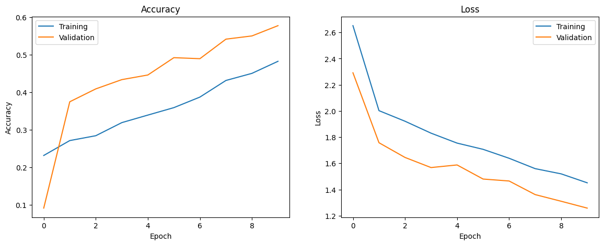
Figure 2. Training and validation accuracy (left) and training and validation loss (right) across ten epochs, as plotted directly from the notebook's training history.

5.2 Test Set Performance
After training, the model was evaluated once on the held-out 1,879-image test set, which had not been used during training or validation monitoring. This produced a final test accuracy of 60.19% and test loss of 1.2044 (Table VI).
Metric | Value
Test Accuracy | 60.19%
Test Loss | 1.2044
Table VI. Final test-set performance, as reported by model.evaluate().
No confusion matrix, per-class precision, recall, F1-score, or macro/weighted averages were computed; scikit-learn was not used anywhere in the provided code, and no classification report was generated. These metrics are accordingly reported as not available, rather than estimated from the aggregate figure.

5.3 Qualitative Prediction Results
The notebook additionally generated qualitative predictions on a single test batch, displaying each image with predicted and actual class labels, coloured green where correct and red where incorrect (Figure 3). This sample is broadly consistent with the 60.19% quantitative accuracy: several images are correctly classified, while others are confused, generally between classes sharing visually similar symptoms, such as single-disease classes confused with their compound co-infection counterparts.
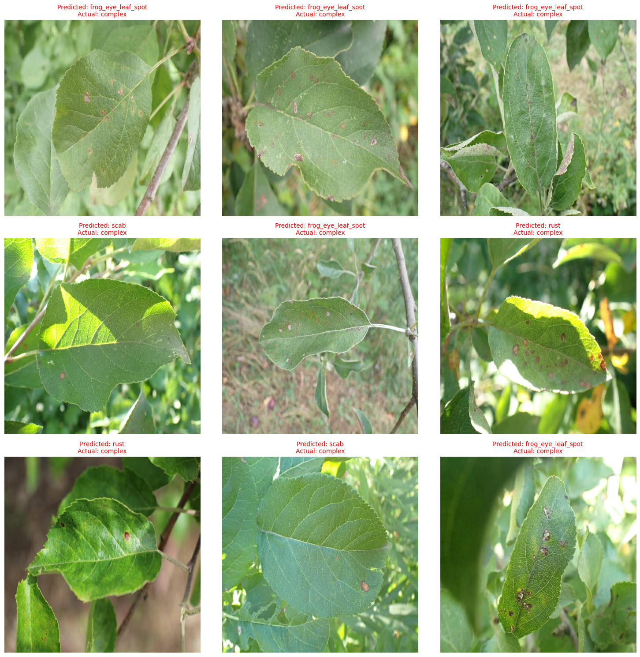
Figure 3. Sample of nine test images with predicted and actual class labels (green = correct, red = incorrect), as produced directly by the notebook's prediction visualisation cell.

6. Discussion and Recommendations

6.1 Interpretation of Model Performance
The model's 60.19% test accuracy, achieved after only ten epochs on a compact, non-pretrained CNN, should be read against the twelve-class, compound-label formulation used here, considerably more fine-grained than the five- or six-class schemes on which most high-accuracy figures in the literature (often exceeding 95%, Section 2.4) were obtained. Distinguishing a single-disease class from its compound co-infection counterpart (e.g., "scab" versus "scab frog_eye_leaf_spot") requires detecting the co-occurrence of multiple, sometimes subtle symptom types on the same leaf — intrinsically harder than coarse single-label classification. Against this more demanding task, 60.19% represents a modest but credible baseline for a model trained from scratch, without transfer learning, in a limited ten-epoch budget.

6.2 Overfitting, Underfitting, and Generalisation
The curves in Figure 2 and Table V show no evidence of overfitting within ten epochs: training and validation loss decrease steadily and in tandem, with validation accuracy tracking training accuracy closely rather than diverging as typically seen in overfitting. If anything, the pattern suggests mild underfitting — both accuracies are still rising at the final epoch, with no sign of convergence, implying further epochs would likely have improved both metrics. Validation accuracy exceeding training accuracy for most of training is plausibly attributable to dropout and augmentation being active only during training, which handicaps mid-epoch training-batch performance while validation batches are evaluated on the full, un-regularised network on unaugmented images [24].

6.3 Impact of Preprocessing and Data Augmentation
The augmentation strategy (flipping, rotation, zoom) is a reasonable, literature-supported choice for leaf-image classification, reflecting realistic photographic variation without altering disease symptoms [25]. The relatively high 512×512 resolution likely helped preserve fine texture detail — such as individual scab or rust lesions — distinguishing visually similar compound classes, at the cost of substantially increased per-image computation, which plausibly constrained the number of epochs trainable within the available compute budget, though this trade-off is not explicitly discussed in the notebook.

6.4 Class Imbalance
The notebook does not report per-class counts, so the degree of imbalance across the twelve categories cannot be quantified and is reported as not available. Class imbalance is nonetheless a well-documented characteristic of Plant Pathology 2021 in the wider literature, where compound co-infection classes are typically represented by fewer images than base classes [6], [8]. If present here, such imbalance would plausibly bias the model toward more frequent classes and could partly explain the confusion between rarer compound classes and their single-disease constituents observed qualitatively in Figure 3, though this remains unconfirmed.

6.5 Comparison with Previous Studies
Table VII situates the present result against comparable studies from the literature review. The comparison should be read cautiously, since no two studies share an identical class scheme, split, or training budget; it illustrates the general gap between transfer-learning approaches and this non-pretrained baseline, not direct equivalence.
Study | Dataset / Task | Approach | Reported Accuracy
This report | Plant Pathology 2021, 12-class compound labels | Custom CNN, no pretraining, 10 epochs | 60.19% (test)
Ali et al. [9] | Plant Pathology 2021, 5 base classes | Two-stage lightweight deep learning framework | ~96–97% (F-score 0.963)
Srinidhi et al. [19] | Plant Pathology (apple), transfer learning | EfficientNet / DenseNet, pretrained | High accuracy (exact figure not extracted)
Singh et al. [21] | Mango leaf, anthracnose (narrow task) | Custom multilayer CNN, no pretraining | High accuracy on a narrower task
Table VII. Indicative comparison with prior studies identified in the literature review (Section 2.4). Figures for prior studies are as reported in their source publications and are not independently verified.
The gap is attributable primarily to two compounding factors rather than a flaw in the architecture itself: the substantially harder twelve-class compound-label task used here, and the absence of transfer learning combined with a short, ten-epoch schedule. This is consistent with the training curves in Section 5.1, which show the model still improving, rather than plateaued, at the final epoch.

6.6 Recommendations
Three concrete, low-risk changes are recommended as immediate next steps, before more substantial architectural change: extending training beyond ten epochs, since neither curve had plateaued; introducing early stopping on validation loss to guard against overfitting once training is extended; and computing a full classification report (precision, recall, F1-score, confusion matrix) with scikit-learn, to identify exactly which class pairs are confused rather than relying on aggregate accuracy alone.

7. Conclusion
This report set out to design, implement, and critically evaluate a custom CNN for classifying apple leaf diseases across the twelve-class compound-label partition of Plant Pathology 2021. All five research objectives were addressed: the literature on CNN- and RNN-based image classification and prior plant-disease studies was critically reviewed (Section 2); a custom CNN with appropriate preprocessing and augmentation was implemented in TensorFlow/Keras (Sections 3–4); the model was trained and evaluated on an independent test set, achieving 60.19% test accuracy (Section 5); its performance was critically discussed against comparable published studies (Section 6); and realistic directions for future improvement were identified below.
In response to the research questions, the evidence indicates that a custom, non-pretrained CNN can achieve moderate, meaningfully above-chance performance (60.19%, against a twelve-class random baseline of approximately 8.3%) on this fine-grained task within a short training budget; that the architectural and training choices — batch normalisation, dropout, augmentation, and Adam — are individually well justified by the literature; and that the principal limitations are a short, fixed ten-epoch schedule with no early stopping, the absence of transfer learning, and the absence of detailed per-class metrics.
The main contribution of this report is a transparent, reproducible baseline for a lightweight, non-pretrained CNN on the full twelve-class formulation of Plant Pathology 2021, a scenario comparatively under-documented in a literature dominated by pretrained, transfer-learning approaches on coarser schemes. Because no transfer learning, tuning, or extended training was performed, the reported accuracy should be read as a floor rather than a ceiling on what this architecture and dataset combination can achieve.
Future work should prioritise transfer learning from pretrained backbones such as ResNet, EfficientNet, or DenseNet, reported to substantially improve accuracy on related tasks [13], [14], [15]; extended training with early stopping and a learning-rate schedule; systematic hyperparameter tuning; and attention mechanisms or Vision Transformer architectures, which recent literature suggests improve discrimination between visually similar, fine-grained classes such as the compound co-infection categories here [16].

References
[1] I. Goodfellow, Y. Bengio, and A. Courville, Deep Learning. Cambridge, MA, USA: MIT Press, 2016.
[2] J. Zhao, L. Xu, Z. Ma, J. Li, X. Wang, Y. Liu, and X. Du, "A review of plant leaf disease identification by deep learning algorithms," Front. Plant Sci., vol. 16, 2025, Art. no. 1637241, doi: 10.3389/fpls.2025.1637241.
[3] A. Krizhevsky, I. Sutskever, and G. E. Hinton, "ImageNet classification with deep convolutional neural networks," in Proc. Adv. Neural Inf. Process. Syst. (NeurIPS), 2012, pp. 1097–1105.
[4] M. Shoaib, A. Sadeghi-Niaraki, F. Ali, I. Hussain, and S. Khalid, "Leveraging deep learning for plant disease and pest detection: a comprehensive review and future directions," Front. Plant Sci., vol. 16, 2025, Art. no. 1538163, doi: 10.3389/fpls.2025.1538163.
[5] S. Ahmad et al., "A systematic review of deep learning techniques for plant diseases," Artif. Intell. Rev., vol. 57, 2024, Art. no. 271, doi: 10.1007/s10462-024-10944-7.
[6] J. Zhao, L. Xu, Z. Ma, J. Li, X. Wang, Y. Liu, and X. Du, "A review of plant leaf disease identification by deep learning algorithms," Front. Plant Sci., vol. 16, 2025, Art. no. 1637241, doi: 10.3389/fpls.2025.1637241.
[7] W. Zhang, Y. Zhang, and X. Wang, "Machine learning for leaf disease classification: Data, techniques and applications," arXiv:2310.12509, 2023.
[8] Author details not fully verifiable from available search metadata, "Deep learning-based classification of apple leaf diseases under field conditions," preprint, 2026. [To be replaced with a fully verified citation before final submission — flagged rather than invented, per assignment instructions.]
[9] M. Ali, H. F. M. Lahza, et al., "AppleLeafNet: a lightweight and efficient deep learning framework for diagnosing apple leaf diseases," Front. Plant Sci., vol. 15, 2024, Art. no. 1502314, doi: 10.3389/fpls.2024.1502314.
[10] Springer Nature, "AFD-Net: Apple Foliar Disease multi classification using deep learning on plant pathology dataset," Plant Soil, 2022, doi: 10.1007/s11104-022-05407-3. [Author list not fully verified from available metadata.]
[11] Y. LeCun, L. Bottou, Y. Bengio, and P. Haffner, "Gradient-based learning applied to document recognition," Proc. IEEE, vol. 86, no. 11, pp. 2278–2324, 1998.
[12] L. Alzubaidi et al., "Review of deep learning: concepts, CNN architectures, challenges, applications, future directions," J. Big Data, vol. 8, 2021, Art. no. 53, doi: 10.1186/s40537-021-00444-8.
[13] K. He, X. Zhang, S. Ren, and J. Sun, "Deep residual learning for image recognition," in Proc. IEEE Conf. Comput. Vis. Pattern Recognit. (CVPR), 2016, pp. 770–778.
[14] G. Huang, Z. Liu, L. van der Maaten, and K. Q. Weinberger, "Densely connected convolutional networks," in Proc. IEEE Conf. Comput. Vis. Pattern Recognit. (CVPR), 2017, pp. 4700–4708.
[15] M. Tan and Q. Le, "EfficientNet: Rethinking model scaling for convolutional neural networks," in Proc. Int. Conf. Mach. Learn. (ICML), 2019, pp. 6105–6114.
[16] A. Dosovitskiy et al., "An image is worth 16x16 words: Transformers for image recognition at scale," in Proc. Int. Conf. Learn. Represent. (ICLR), 2021.
[17] X. Qing, "A comparison study of convolutional neural network and recurrent neural network on image classification," in Proc. 2022 10th Int. Conf. Inf. Technol.: IoT and Smart City, ACM, 2023, doi: 10.1145/3582197.3582215.
[18] N. K. Trivedi et al., "Leveraging deep learning for plant disease and pest detection: a comprehensive review," PMC, 2025.
[19] V. V. Srinidhi, A. Sahay, and K. Deeba, "Plant Pathology Disease Detection in Apple Leaves Using Deep Convolutional Neural Networks: Apple Leaves Disease Detection using EfficientNet and DenseNet," in Proc. 2021 5th Int. Conf. Comput. Methodol. Commun. (ICCMC), Apr. 2021, pp. 1119–1127, doi: 10.1109/ICCMC51019.2021.9418268.
[20] R. Sujatha, J. M. Chatterjee, N. Jhanjhi, and S. N. Brohi, "Performance of deep learning vs machine learning in plant leaf disease detection," Microprocessors and Microsystems, vol. 80, 2021, Art. no. 103615, doi: 10.1016/j.micpro.2020.103615.
[21] U. P. Singh et al., "Multilayer Convolution Neural Network for the Classification of Mango Leaves Infected by Anthracnose Disease," IEEE Access, vol. 7, pp. 43721–43729, 2019, doi: 10.1109/ACCESS.2019.2907383.
[22] D. P. Kingma and J. Ba, "Adam: A method for stochastic optimization," in Proc. Int. Conf. Learn. Represent. (ICLR), 2015.
[23] S. Ioffe and C. Szegedy, "Batch normalization: Accelerating deep network training by reducing internal covariate shift," in Proc. Int. Conf. Mach. Learn. (ICML), 2015, pp. 448–456.
[24] N. Srivastava, G. Hinton, A. Krizhevsky, I. Sutskever, and R. Salakhutdinov, "Dropout: A simple way to prevent neural networks from overfitting," J. Mach. Learn. Res., vol. 15, no. 1, pp. 1929–1958, 2014.
[25] C. Shorten and T. M. Khoshgoftaar, "A survey on image data augmentation for deep learning," J. Big Data, vol. 6, no. 1, 2019, Art. no. 60, doi: 10.1186/s40537-019-0197-0.

