Student Name: Aisha Kanwal
Student Number: 2211905
Lecturer Name: Julius Azasoo
LCHS4002_BIRM
Digital Skills and Research Methods.

1: Introduction 3
2. Research design 4
2.1. Research Question 4
2.2. Method: 5
2.3. Ethical Considerations 6
3. Results: 6
4. Discussion: 13
5. Conclusion: 14
6. References 15
7. Appendix A 16

1: Introduction

In this report, various digital tools will be examined, and a survey will be conducted to decide which collaborative tool is most often used by students at uwtsd. A study was done to demonstrate how Moodle and Microsoft Teams may improve university e-learning. In order to create synergistic effects and improve course outcomes, study was done on examples of online courses and how to combine the features of the systems under discussion. The various student cooperation platforms were contrasted through research. According to Paterson (2022), Zoom and MS Teams offer a complete platform for collaboration that includes video calling, chat, and meetings. Moodle is a good, complicated tool despite being a difficult platform, the investigation shows. On the other hand, MS Teams is a fresh, contemporary, and simple programme. Collaboration is the process by which a team of people cooperates to complete a task. In education, collaboration can take many various forms. The most common examples include student participation in the learning process, peer teaching and team teaching among teachers, collaborative research, and collaborative curriculum development. When students work together to complete assignments or accomplish goals, they are collaborating. (2022 Paterson)

2. Research design
This study's purpose was to find out how students felt about Microsoft Teams, the most widely used collaborative tool.
2.1. Research Question:

Which Digital tool is most used for collaboration at UWTSD (University of Wales Trinity Saint David)?
Which digital tool, MS Teams or One Drive, is mostly used by the students at UWTSD?
How often do the students use MS teams to collaborate with others on OneDrive?
Ms. Teams is a brilliant tool that students can use in a variety of ways. Microsoft Teams is a great platform for online meetings, teamwork, and even recording in-person lessons. Students can communicate with one another through texting and interacting with their classmates and the lecturer. They can share, store, and upload files, making it much easier to catch up on missed classes. The most common type of teamwork among UWTSD students is Ms. Teams. (Victor, 2021)

2.2. Method:
Students who use Microsoft Teams collaborate by taking advantage of the platform's distinct features. The data was gathered using a quantitative method because it is easily accessible, and a questionnaire was created. There are two types of methods in research, Quantitative and Qualitative. According to Paley (2000) The difference between qualitative and quantitative research approaches is typically said to be based on two opposing perspectives, each of which has its own, mutually exclusive set of philosophical guiding principles. A quantitative approach's component is creating the questions for surveys and questionnaires. They are used to assess attitudes and beliefs and are particularly appropriate for people who can read. The comparison with other studies makes things easier. (Nardi, 2018). This shows that qualitative research assumes a world that is mostly subjective and devoid of any obvious reality, while quantitative research assumes absolute facts and a single, unchanging reality. The research sample was chosen from this specific group of people because it was difficult to survey a big population. It was possible to utilise it to find patterns and averages, create theories, investigate causes, and extrapolate findings to bigger groups. A lot of different tools were analysed and it was suggested that Microsoft Teams is the one that students use the most often for online collaboration. This was because all UWTSD students, faculty, and staff have access to MS teams. You have the choice to either join already-existing teams or form your own. This helps teachers and students work together and communicate with one another. (Victor, 2021).
14 UWTSD (University of Wales Trinity Saint David) students were given a web-based MS questionnaire. It was proved that restricting the sample to female students would have reduced generalisations about male students and minimised the possibility of gender prejudice. Participation in the study was purely voluntary. Microsoft Forms was used to provide the survey link to the students. The participants used Microsoft Structures to reply. Using a Likert 5-scale inquiry (Appendix A) with the options "strongly agree," "agree," "neutral," "disagree," and "strongly disagree," the opinions of the students on Microsoft Teams were acquired. Because of this, respondents had a choice of possible answers. In the second question, the most popular tool was chosen after a selection of tools was ranked. One of the last multiple-choice problems focused on using Ms. Teams efficiently. ( Florjancic and Wiechetek, 2022 p. 265) The appendix includes a blank copy of the questionnaire.

2.3. Ethical Considerations:

The phrase "ethical considerations in research" refers to a set of guidelines that govern the designs and methods of your studies. Scientists and researchers must always follow a set of ethical guidelines while collecting data from individuals. Human research typically aims to understand real-world events, investigate effective remedies, examine behaviors, and improve lives in other ways. Both the topic of your research and the methods you use have significant ethical implications. We shall conduct an ethical analysis of the student data we have gathered. No student will be compelled against their will to take part in this study. They will make their own decision on this. We must consider our own security and protection while posing ethical questions to pupils. (Bhandari, 2022)

3. Results:

The following conclusions were reached after an analysis of the data obtained from the responses that 14 persons provided to the survey, we issued to UWTSD students in order to collect the findings. The following tables list the details for each query and the results:

Table 1 Consent

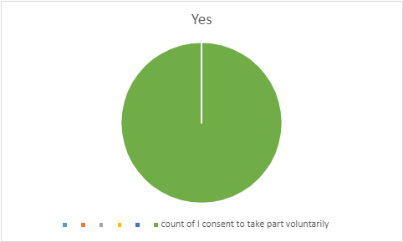

Table 1 shows that every student consented to the sharing of their data to use in this report.

Table 2 Most used tool

Results for table 2 shows 9 (64%) of students use MS teams more than any other digital tools to work with peers at UWTSD while 5 (36%) of students said no.

Table 3 collaboration:
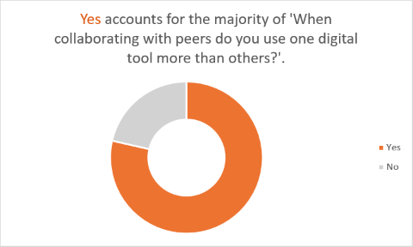
Results for table 3 show 11 (79%) of students said yes, they are using MS teams more than other digital tools, and 3 (21%) of students said no they do not use MS teams to collaborate with the teachers and students at UWTSD.

Table 4:

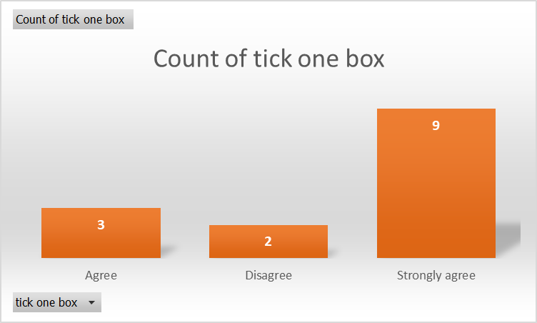

Results for table 4 shows students using WhatsApp more than MS teams to collaborate with fellow students and teachers at UWTSD.

Table 5:
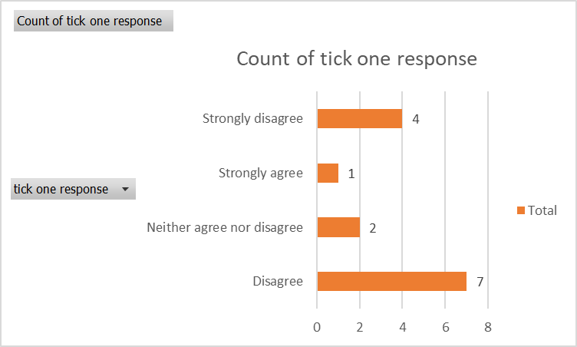

Results for table 5 show that 7 students disagree and 4 strongly disagree that they do not use any digital tool to collaborate and 1 strongly agrees and 2 neither agree nor disagree to collaborate at UWTSD.

Table 6:
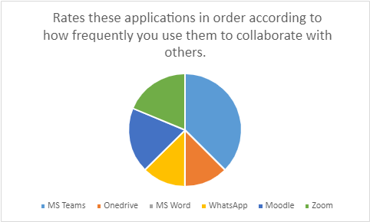

Table 6 shows that 46.2 students said they are most often using MS teams to collaborate and 23.1% said zoom and 23.1% said Moodle and 15.4 % said they use OneDrive, and 15.4% said WhatsApp, and no one talked about MS Word at UWTSD.

4. Discussion:

Digital learning platforms, which offer a friendly and beneficial environment for this, enable teachers and students to engage with one another, produce content, and share knowledge. Moodle, Canvas, and Microsoft Teams are a few examples of digital learning platforms. Microsoft Teams' collaboration tools let you exchange and modify documents in real time. What does it mean to collaboration? Collaboration means working together on a common project or goal. Make information generation and editing simple for students 'team by utilising research collaboration tools. Teachers are embracing the usage of innovative digital platforms, much like how the educational profession has evolved. The most modern networking and communication platforms are increasingly often used by teachers. As a part of the Microsoft Office 365 software suite, Microsoft Teams was unveiled in 2017 as a platform for online communities and group collaboration. There is a place online that is ideal for collaboration and streamlining communication for everyone interested in online higher education learning and teaching. Microsoft Teams is simple to use, flexible, and suitable for online education. Additionally, it provides a possibility to enhance learning. Online learning is more communicative, interactive, and engaging thanks to Microsoft Teams. With Microsoft Teams' help, students and teachers can create teams. They commonly contain participants in the same project or members of the same organisation. It seems that teachers who include Microsoft Teams technologies in their lessons acquire a greater comfort level with technology. The learning environment becomes more interesting for everyone when students are urged to take an active role in it. Six questions were designed to confirm this study and data was collected from students at UWTSD. Data was collected for quantitative analysis to show the genuine answer. The first question was the consent to take part voluntarily in the questionnaire, as it was critical to obtain the participant`s permission before going ahead. All respondents agreed to take part in the study. In research studies, ethical considerations are critical. Second, as shown in table 2, all UWTSD (Trinity St David's University of Wales) students used Ms. Teams more than any other digital tool in collaborating with their peers. It was clear that Ms. Teams. According to the findings, the participants found Microsoft Teams to be extremely beneficial for conversations, discussions, and receiving and supplying feedback. On the third table it shows again the students are using MS team to collaborate with teacher and fellow students more than other digital tools such as WhatsApp and Zoom. According to table 4's findings, students at UWTSD prefer using WhatsApp over Microsoft Teams for collaboration. Table 5's findings indicate that 7 students disagree, 4 strongly disagree, 1 strongly agrees, and 2 neither agree nor disagree that they collaborate at UWTSD using any digital medium. According to Table 6, 46.2% of students at UWTSD indicated that they collaborate most often using Microsoft Teams, whereas 23.1% mentioned Zoom, 23.1% mentioned Moodle, 15.4% mentioned OneDrive, and 15.4% mentioned WhatsApp. No one mentioned using Microsoft Word. The majority of students' positive feedback demonstrates that for students who wish to study more efficiently, the Microsoft team is the perfect environment. Beyond a simple set of collaborative features with integrated notes, grades, and assignments, it has developed into a platform that is crucial for online learning, research, sharing, and communication. In open areas with lots of natural light, the power of a group is highly valued. (Haider, 2022)

5. Conclusion:

According to the study, Microsoft Teams is an effective tool for collaboration and communication at UWTSD. Microsoft Teams seems to have a solid reputation for assisting teachers with matters about teaching and learning. Students discovered MS Teams to be simpler to learn and use than other collaboration platforms they had previously tried. Microsoft Teams can be useful in online learning environments with live lectures, recorded videos, and the sharing of academic content. The education sector can access a variety of conceptual thinking and online research tools thanks to Microsoft Teams. Teachers and students who are geographically and chronologically separated can still geographically and chronologically separate students together on educational opportunities using Microsoft Teams. Microsoft Teams can be used as a tool to implement creative teaching methods. (Haider, 2022)

6. References
- Bhandari, P. (2022) Ethical Considerations in Research. Available at: http://www.scribbr.co.uk/research-methods/ethical-considerations (Accessed on 28/09/2022)
- Florjancic, V. and Wiechetek, L. (2022) 'Using Moodle and MS teams in higher education-a comparative study', International Journal of Innovation and learning, 32(2) pp. 264-286. DOI: 10.1504/IJIL.2022.120650
- Haidar, A. (2022) 'Using Microsoft Teams as Online Teaching Instrument in Kuwaiti Schools', International Journal of Digital Society, Issue 1, Vol 13.

- Nardi, M.P. (2018) Doing Survey Research: a guide to quantitative methods. 4th edn. Milton: Taylor and Fransis.
- Paterson, K. (2022) 'zoom vs teams', Which is better for remote meetings in 2022?[blog] 7 April. Available at: http://zapier.com/blog/zoom-vs-teams/#collaboration (Accessed on 13/10/2022)
- University of Massachusetts Amherst (2022) Microsoft OneDrive vs Teams and SharePoint. Available at : http://www.umass.edu/it/online-storage/onedrive-vs-teams (Accessed on 14/10/2022)
- Victor, A. (2021) Multi skills: why more schools are adopting Microsoft teams for education. Available at: http://www.multiskills-ng.com/ (Accessed: 03/10/2022)
- Paradigms and Presuppositions: The Difference Between Qualitative and Quantitative Research - ProQuest

7. Appendix A

