WORKPLACE CULTURE AND ITS IMPACT ON ORGANISATIONAL
Student name : Florina Anghel
Student Id : 1605361
Lecturer : Dr Mushfiqur Rahman
BMSK5005

Executive Summary
Workplace culture of any organization creates the base for success of that organization. Hence this report sheds light on the impact of workplace culture on the organization performance. Holland and Barrett is considered here as the organization for evaluation. The report had introduced the scope of workplace culture in current UK market. Thereafter the study had critically evaluated the culture, values and ethos of Holland and Barrett in brief. The next section for evaluation is the currently used communication channels of Holland and Barrett along with the system of developing a relationship with their employees. The next part had focused on the critical evaluation of internal environment of Holland and Barrett using SWOT analysis tool. It was followed by examining the impact of external environmental factors on operations of Holland and Barrett through PESTLE Analysis tool. The next section had provided a comparative analysis of organizational and personal ethical standards and beliefs of Holland and Barrett and its employees. The next section had elaborated about the policies and legislations incorporated with Holland and Barrett to abide by the industry standards. It was followed determining the ways through which sustainability can be implemented within Holland and Barrett. Then several barriers of workplace culture were identified in the context of Holland and Barrett. Lastly the report was concluded with a set of recommendation to avoid the selected barriers within Holland and Barrett.

Table of Contents
Introduction 4
Critical Evaluation of workplace culture in Holland and Barrett 4
Organizational culture, ethos and values 4
Communication channels for sharing information and building relationships 5
Establishing a culture of sustainability within the workplace 6
Critical evaluation of environmental impacts on Holland and Barrett workplace culture 8
SWOT 8
PESTLE 10
Examining cultural and ethical behaviour on Holland and Barrett and evaluation of own cultural and ethical behaviour 13
Personal ethical standards, values and beliefs 13
Formal and informal relationships between departments and people 13
Barriers to effective functioning in the organization 14
Recommendation 15
Conclusion 17
Reference List 18
Appendices 21

Introduction
Culture is one of the most important aspects of an organisation as it defines the characteristics and nature of that particular organisation. Every organisation has some unique workplace culture which provides an idea about the value, beliefs, tradition, attitude, communication and other characteristics of the organisation. Culture of an organisation has an huge impact on its performance and revenue as well. Implementing a positive work culture always motivates the employees who are the foundation of any company to work in a better way. This eventually increases the productivity and profitability of the company. The goals and objective that is set by an organisation can be achieved only by implementing a strong and positive culture. Organisation culture not only governs the interaction of the organisation with its employees but also with its vendors, suppliers and customers. This report focuses on the UK based food retail company Holland & Barrett and their organisational culture. This report critically evaluates the workplace culture of that organisation and the impact of external and internal environment on that organisation. It also provides some detailed information on the ethical code and behaviour of Holland & Barrett, its communication system and the challenges they face in case of implementing effective functioning of the company.

Critical Evaluation of workplace culture in Holland and Barrett
In this age of advanced technology, it can be stated that automation has created a vital risk on the jobs of ordinary workers. Hence Holland and Barrett had focused on training their staffs to enhance their competitiveness. However it was reported that the main reason to focus on training and developments was Holland and Barrett’s inability to incorporate a proper remuneration scheme (Birchall, 2017). Moreover it was also highlighted that the payment amount of apprenticeship was also very low. Thus the recruitment teams were compelled to withdraw their joint venture with the UK Government for attracting job seekers (Malik, 2012).

Organizational culture, ethos and values
Ethical standards are essential for any organization to ensure the quality of its products and services. Martin (2014, p.89) highlighted organizational vision statement is the main driving factor of any workforce within a successful organization. The mission of Holland and Barrett to spread health related information and guidance all over the world. They mainly work with the same vision that helps them to differentiate them from any other retailers. T.I.A.R.A is the vision statement followed by the management of Holland and Barrett. They believes Teamwork, integrity, accountability, respect and agility are the key to success (Holland & Barrett, 2018). Hence they provide training each and every day to their staffs to ensure that their staffs are able to suggest proper vitamins for each customer. Thus customers will prefer Holland and Barrett and this will create a loyal customer base for this retailer. The following are the main ethos followed by the management of Holland and Barrett:
- Holland & Barrett strives to gain the popularity and trust of their customers.
- They prefer to achieve success through teamwork.
- Holland & Barrett suggests their staffs to listen instead of collaborating information blindly.
- Vanilla Ice prefers to select the correct product for the customers without any compromises (Holland & Barrett, 2018).
- They train their employees to take pride of their success and act like a representative of Holland & Barrett as a brand.
- They consider respect as the core for their business. Hence they not only respect their customers but also are concerned about their employees.
- Flexibility and agility are essential for any business to adapt the developing trends of changing markets.
Hence the higher authority of Holland & Barrett is focused on developing the same mission and vision within every staff members working with them. However, it was reported that several employee of this organization had termed the workplace culture of Holland & Barrett as a ruthless culture (Simpson, 2016).

Communication channels for sharing information and building relationships
Communication style within a retail sector is essential for get a firm grip over the market. Alimuddin and Sukoco (2017, p.2) depicted that in this age of globalisation leadership styles that utilise the communication channels effectively are mostly used by any organization. However, it was reported that most of the employees of Holland & Barrett were compelled to opt for workfare against Holland & Barrett. It can be analysed that the major reason behind this was the spatial behaviour of their immediate supervisors. Another major reason was forcing their employees to work for long hours and a management style of shouting at people with no or les remuneration (Birchall, 2017). The following are the additional reasons apart from these main issues of Holland & Barrett. It was also reported that around working days of around 140 million were lost from illness and injuries (Rodionova, 2017). The following are the communication gaps of Holland & Barrett:
- Employees were compelled to continue work while they are feeling unwell.
- Employees are forced to spend long hours without their consent. Team managers are not approachable or non-cooperative and sharing information becomes difficult (Simpson, 2016).
- Managers and leaders were unable to develop an effective employee engagement system. On the contrary employees were unable to develop a bond with the organization.
- Holland & Barrett invests fewer amounts to hire the required amount of employees. Thus the workload for an individual becomes high.
- Immediate supervisors are not able to manage their teams due to inability and lack of competency. As a result although staff members develops interpersonal skills within themselves but were unable to act as a representative of Holland & Barrett.
Hence it can be analysed that there exists a vital communication gap within the employees and management of Holland & Barrett. The immediate supervisors are unable to bridge this gap and fulfil their allocated job responsibilities due to their lack of knowledge and competency (Simpson, 2016).

Establishing a culture of sustainability within the workplace
It is essential for any organization to engage their employees with sustainability work processes. However to achieve this objective Hill+Knowlton Strategic Model will be effective. The main steps to incorporate this model require executing the following steps are:
Simplicity
It is the cognitive tendency for each of the human being to focus on the easy way of finishing a task. Hence if the sustainable approach is simple and easy adaptable then it will get popular easily. Ruohomäki, Lahtinen and Reijula, (2015, p.185) highlighted that based on the past records the success rate of simple sustainable processes are around 75% (Valmohammadi and Roshanzamir, 2015, p.169). Thus it can be analysed that Holland & Barrett can start to incorporate sustainability within their workplace by treating each and every staff and leaders of the organization equally. Thus it will in turn reduce the rate of resignation within the organization.
Make it Fun
Most of the human beings are attracted to an entertainment or enjoyable activity. Lamm, Tosti-Kharas and King, (2015, p.209) illustrated that leaders can incorporate the process of fun Friday and asks for a feedback on the workplace culture of Holland & Barrett following a fun full activity. Hence this will guide the leaders to get an actual overview about the workplace culture.
Initiate Small
This strategy states that to start sustainability from small habits. Thus leaders of Holland & Barrett can focus on guiding their employees to provide feedback after a training session. This will help the leaders to access whether the trainings are helpful to the employees or not.
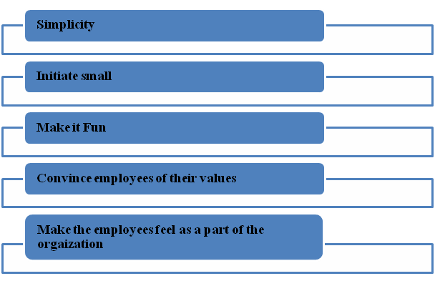
Figure 1: Hill+Knowlton Strategic Model
(Source: Lamm, Tosti-Kharas and King, 2015, p.209)
Convince employees of their values
This strategy states that an employee needs to be reminded about their responsibilities towards the society. Hence it can be suggested to the leaders of Holland & Barrett can use sticky notes to share their views and considerations with the lower level employees (Greenwood, 2017). For example these sticky notes can guide the employees to adapt few workplace gestures and postures which will help the employees to become more energetic throughout the day.
Make the employees feel as a part of the organization
This strategy states that based on the cognitive behaviour any human being tends to follow the practices which are followed by their leaders and role models. Hence the management executives and leaders of Holland & Barrett can consider starting to follow the process of evaluation for any service (Malik, 2012). Thus employees will derive a perception that their opinion also matters for the development of Holland & Barrett.

Critical evaluation of environmental impacts on Holland and Barrett workplace culture

SWOT
Strength  - Presentable infrastructure  - Local centres for shopping within walking distance.  - Efficient system for organising products in the store which makes the finding of products easier.  - Efficient strategy related to inventory  - Huge range of products.  - Well educated, presentable and highly experienced staffs | Weakness  - Absence in internet and no active website  - No social media accounts  - Mobile app is feasible only in UK.
Opportunities  - Excellent condition of UK market  - High GDP of UK  - Various Subsidies from UK Government | Threat  - Huge number of competitors in the market of UK  - Customer Switching  - Threats from new entries
Table 1: SWOT analysis of Holland & Barrett
(Source: Stevens, 2018)
Analysis
From the above table it is seen that the overall internal environment of Holland & Barrett is strong. It has a high quality infrastructure which make them able in case of attracting more number of customers. Infrastructure of the organisation always provides various benefits to the company regarding the customer satisfaction as well as increasing employee motivation. Apart from that Holland & Barrett has multiple numbers of stores in the walking distance of the various locality area of UK. This attracts the passer by customer which in turn increase their sales. Holland & Barrett has implemented some effective strategies in case of organising the products. This helps the customers finding the products they are looking for in a very sort time thus increasing their satisfaction. They have a well-maintained inventory system as they always keep their products available in the stores, so that customers can always get the product they want in any stores. They have a huge range of products which is another reason for their huge number of customer. They offer various kinds food products that can fulfil the need of the customers in the market in UK (Hooker, 2017). Employees of Holland & Barrett are well educated and presentable with high experience which makes them able to satisfy the queries of the customers and solving any issues they face while shopping.
However, the weakness of Holland & Barrett includes their absence in internet. As per the view of Terzioglu et al. (2016, p.738), in this era of social media, every organisation should invest their capital as well as time in case of establishing a strong place in the internet. people, mainly customers often surf internet before buying anything in order to gain idea of the organisation as well as their products. Thus poor amount of presence in internet as well as social media can be considered as the primary weakness of the company. Another weakness is that their mobile app is not efficient enough in case of working outside of UK. Thus people who live outside of UK face various problems in case of buying the products using their mobile app. Thus the dissatisfaction among the customers increases.
The opportunities of the company include the strong economic condition of the UK market and low rate of interest. Ying Liao et al. (2017, p.1185) stated that condition of UK market is extremely favourable and the number of customers is also high. Stable government of UK provides various subsidies to the retail sectors and they implement various strategies for increasing the profitability of the business organisation of UK. However some threat in the market of UK also exists in term of competition. UK provides a suitable condition for the business organisation to expand their business. Thus the retail sectors have higher risks of competition as well as new entries in the industry. Due to the high amount of competition, the rate of customer switching is also high. Organisations that are better that Holland & Barrett can provide various offers to the customers in order to make them switch and the switching cost is negligible (Hooker, 2017)

PESTLE
Factors | Impact
Political | - Fiscal and monetary initiatives of government  - Strategies for restricting the increasing rate of unemployment  - Stable Government  - Brexit
Economic | - High GDP  - Increase in price of products.  - Higher wages.  - Inflation rate  - Interest rate
Social | - Huge Population of UK  - Cultural Diversity  - Broad nature of the society
Technological | - Technological advancement  - Excellent Hub for technological institute  - Contribution of technological sectors  - Huge amount of investment in technological sectors
Legal | - Equality Act 2010  - Code of Ethics
Environmental | - Initiative of Government and other non-profit organisations in environmental awareness  - Challenging condition of the weather  - Waste management system
Table 2: PESTLE factors
(Source: Based on the views of Kianto et al. 2016, p.630)
Analysis
The political condition of UK is stable which is extremely beneficial for the business organisations. However, Brexit has created some uncertainties and debate in the political aspects of UK (Politics.co.uk, 2018). Some of the analysts think that Brexit will bring a huge amount of opportunities in UK whereas some of them believe that it will create unimaginable chaos. The economic condition was deteriorating. Thus, UK government has taken some fiscal and monetary initiatives in order to make the condition of the economy of the country better. In the year 2009 UK government has announced to provide help in case of restricting the increasing unemployment (Politics.co.uk, 2018).
UK is in the 5th position in the largest economy of the world based on the GDP. The recession in the year 2008 has created a huge amount of trouble in the UK economy but the government took necessary steps in order to improve it. Prices in the shops increased fast in the year 2017 as the cost of goods imported from outside increased due to the weakening of pound. Current wage for the people of age 25 and more is 7.50 pound per hour which has increased to 7.8 pound per hour from April 2018 which indicates a strong economic condition of the country (Gov.uk, 2018). The rate of inflation increased 3.1% in the year 2017 (Gov.uk, 2018). Rate of interest has increased to 0.5% from 0.25% which can affect the business of Holland & Barrett (Gov.uk, 2018).
Population of UK was 65.6 million in the year 2016. The population is predicted to reach 74 million if birth outnumbers death. Thus the business organisations like Holland & Barrett can achieve a huge number of customers which in turn increases their sales and profitability. 18% of the total population consists of the people aged 65 and more whereas 2.4% of the overall population aged 85% (Stevens, 2018). Thus it can be said that the young generation consists the maximum amount of the overall population. This is a good sign for the organisations as they can get a huge number of employees and labours who are capable of doing more amount of hard work. Cultural diversity is another part of the UK society, which is extremely beneficial for Holland & Barrett and other companies. Cultural diversity in the society increases the acceptance of various products of the business organisation among the customers whereas the diversity among the employees generates various innovative ideas.
UK is extremely advance in terms of technology and London can be considered as one of the greatest hub for the technological institutions. This technological advancement has provided huge opportunities in the business sectors by making the overall process of business more effective and efficient.
The legal system of UK has a huge responsibility in case of implementing a positive workplace culture and system in Holland & Barrett and other organisation. The Equality Act 2010 prevents any kind of discrimination in workplace based on racism, gender, nationality and other matters (Legislation.gov.uk, 2018). Code of ethics is maintained by Holland & Barrett and every other organisation in order to maintain the work culture. Based on this code ethics employees of the Holland & Barrett maintain the integrity and professionalism in the organisation. The confidentiality of the business related information is maintained based on the code of ethics. It helps the organisation to set some objective in order to provide a guideline to the operations and performance of the companies.
UK government and other non-profit organisations have taken various initiatives in order to spread the environmental awareness and reduce the negative impact of the environment. UK has implemented various strategies for managing the waste effectively and recycling in order to improve environment. Weather of UK sometimes affects the business of UK but it is the main attraction for the tourists.

Examining cultural and ethical behaviour on Holland and Barrett and evaluation of own cultural and ethical behaviour
Organizational policies and legislations play a major role in developing any workplace culture due to the fact that each employee is bound to follow the policies. Moreover, as Holland and Barrett is associated with healthcare related products it is crucial for this organization to follow the ethical and industry standards of their products and services.

Personal ethical standards, values and beliefs
The main issues within the workplace culture of Holland and Barrett are the difference between the organizational ethics and values with personal ethics and values of Holland and Barrett. Hence it can be observed that employees are able to develop an interpersonal relationship with their teammates. However, they were not able to develop a relation with their supervisors or managers. The gap within the organizational ethics and personal ethics can be considered as the main reason for this issue (Holland & Barrett, 2018). However, it was reported that the employees of Holland and Barrett satisfied with the workplace culture due to the fact that they were able to work within a team. On the contrary, it was also highlighted that the main conflict gets aroused due to the mismatch of personal and organizational beliefs (Holland & Barrett, 2018).

Formal and informal relationships between departments and people
Achieving a competitive edge over the others in the industry is the aim of any organization these days. Hence Holland and Barrett is popular for following the national policies and regulations of UK government related to healthcare industry to achieve the trust of its customers. As per the provisions of Health and Social Care Act 2012, Holland and Barrett was able to reorganize its structure to ensure its “duty of candour” for each of its customers and employees (Legislation.gov.uk, 2018). Thus based on this act Holland and Barrett had proposed to offer the apprenticeship of £2.60 per hour. Holland and Barrett is also famous for providing sufficient amount of incentives to its employees during Christmas and other occasions. However based on the provisions of National Health Service Act 2006, Holland and Barrett was able to adapt the concept of training their employees to develop their skills (Legislation.gov.uk, 2018). This will ensure that each staff of Holland and Barrett will be certified to advise about Vitamins, supplements and other health care products. Ang and Van (2015, p.25) stated that organizations which are enriched with efficiency of their human resource are able to success in the industry at a much higher rate. On the contrary, it was reported that employees are not able to grasp these trainings due to the fact that most of these trainings were scheduled after their shift hours or within their shift hours. Hence that wills in turn forces these employees to stay at work for whole day and without their concerns. It was also depicted that Holland and Barrett were also unable to incorporate an effective leave policy. The main reason behind this is they do not allow employees to take leave at all (Rodionova, 2017). Holland and Barrett had also incorporated the “Plan it green” policy to incorporate sustainability with the organization. It was declared by the financial statement of Holland and Barrett that they will be committed to abide by the provisions of Modern Slavery Act 2015 (Legislation.gov.uk, 2018). Hence based on these provisions Holland and Barrett needs to achieve industry standard ethical considerations and zero tolerance for corruption and bribery. Hence Holland and Barrett had restructured their policy statements that incorporate the terms and condition of Modern Slavery Act 2015 (Legislation.gov.uk, 2018). They are focused to maintain accountability and transparency.

Barriers to effective functioning in the organization
It can be analysed from the aforementioned discussion that these are several issues within the workplace culture of Holland and Barrett. These are various ethical models that can be used to enhance the ethical standards of any organization. Giorgi, Leon-Perez and Arenas, (2015, p.228) highlighted that as per the Harrison’s Cultural theory organizational structure, activities and functions needs to measured based on their contribution to achieve their vision statements. (Refer to appendix 1)
Thus appropriate amount of competence and knowledge needs to be examined to gain authority in any organization. It will ensure that all the personnel are effectively able to manage their responsibilities. However in case of Holland and Barrett, it is the main issue that creates a major gap of communication within its employees and management. Hence it has created a barrier within Holland and Barrett.
Another model of work culture ethical model is Deal & Kennedy Cultural Theory. Barak et al. (2016, p.813) depicted this model is applicable for the young generation of employees. It is also termed as the tough-guy theory. This theory focuses on the internal competitions to enhance the overall business performance. However in case of Holland and Barrett it can be observed that creating a healthy competitive workplace environment is the responsibility of the immediate supervisors. However due to lack of management skills they were unable to perform this responsibilities. This is also a reason for a barrier within Holland and Barrett. (Refer to appendix 2)
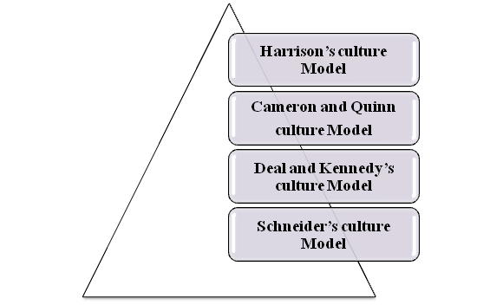
Figure 2: Theoretical Aspect of Barriers
(Source: Demirtas and Akdogan, 2015, p.65)
On the contrary Kianto et al. (2016, p.625) described that culture is developed based on the organization, its employees and organizational success. However, Ruiz-Palomino and Martínez-Cañas (2014, p.98) opined that the most applicable tool to access any organizational culture is termed as Cameron and Quinn Cultural Model. Thus based on this model any organization that has an effective policy statement is able to develop a healthy workplace culture. It can be analysed that policies brings the organization together. Hence the leaders need to be efficient coordinators also. This model was also not implemented in case of Holland and Barrett which creates a barrier as this organization does not have any leave policy. (Refer to appendix 3)

Recommendation
Holland & Barrett has successfully implemented a positive and effective workplace culture in their organisation. However, they face various challenges and issues related to the organisational culture and some suggestions for mitigating those issues are provided here. Based on the views of Tuan (2016, p.588), Holland & Barrett should implement proper code of ethics which will address the challenges faced by employees. They should implement a proper communication system in their organisation so that employee can express their perception related to the job pressure and other issues. Managers and leaders of Holland & Barrett should invest more time in finding various strategies which can increase the engagement of the employees as well as their other stakeholders. They can provide various training to their employees in order to increase their skills and implement (Riivari and Lämsä, 2014, p.5).
Holland & Barrett can implement an efficient system in order to recognise the contribution of employees and motivate their effort by providing various type of rewards. They should track the cultural changes in the industries and implement in their organisation so that they can gain the competitive advantages and better employee satisfaction. Shafer (2015, p.44) opined that dividing employees in various teams would be a great way to increase their performance as well as establish a better communication system. Employees who are in a same team will interact and generate a wide range of innovative ideas which help in the development of the business. Holland & Barrett can implement Hill-Knowlton Strategic model in their business in order to improve their workplace culture. Holland & Barrett should create an environment that is ready for change based on the external environment and the situation of the market so that their business does not become stagnant.
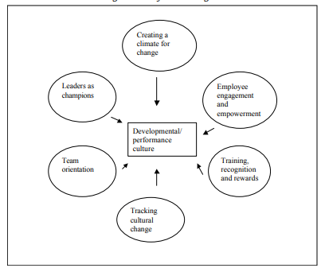
Figure 3: Framework for understanding and managing organisational culture
(Source: Parsons et al. 2017, p.23)

Conclusion
This report highlights the importance of workplace culture and its impact on the organisation. Culture of an organisation is one of the most critical part of the company as it provides the idea of the company to their customers. It reflects the internal environmental of the company and their values, beliefs, vision and objectives. This report focuses on Holland & Barrett which is a UK based food retail sector and their workplace culture and issues associated with it. The external environment of the company has a huge impact on the business operations. The PESTLE analysis of UK provides the fact that all the political, legal, social, economic aspects are extremely favourable for this particular industry. SWOT analysis provides the information of the internal environment of the company. Various issues of Holland & Barrett related to the workplace culture includes improper implementation of code of ethics which makes their employees work without their consent and they are forced to work even when they are unwell. These issues should be mitigated by Holland & Barrett in order to make a better culture in their organisation which will improve their overall performance.

Reference List
Adebanjo, D., Teh, P.L. and Ahmed, P.K., (2016). The impact of external pressure and sustainable management practices on manufacturing performance and environmental outcomes. International Journal of Operations & Production Management, 36(9), pp.995-1013.
Alimuddin, A. and Sukoco, A., (2017). The Leadership Style Model That Builds Work Behavior Through Organizational Culture. JURNAL LENTERA: Kajian Keagamaan, Keilmuan Dan Teknologi, 3(2).
Ang, S. and Van Dyne, L., (2015). Conceptualization of cultural intelligence: Definition, distinctiveness, and nomological network. In Handbook of cultural intelligence (pp. 21-33). Abingdon: Routledge.
Barak, M.E.M., Findler, L. and Wind, L.H., (2016). Diversity, inclusion, and commitment in organizations: International empirical explorations. Journal of Behavioral and Applied Management, 2(2), p.813.
Birchall, G., (2017). Ten of the ‘worst’ companies to work for in the UK revealed as staff lift lid on dodgy bosses and killer hours. The Sun [online]. Available at: https://www.thesun.co.uk/money/3956031/worst-companies-to-work-for-uk-rankings-revealed-employee-ratings-glassdoor/ [Accessed 16/07/2018]
Demirtas, O. and Akdogan, A.A., (2015). The effect of ethical leadership behavior on ethical climate, turnover intention, and affective commitment. Journal of Business Ethics, 130(1), pp.59-67.
Giorgi, G., Leon-Perez, J.M. and Arenas, A., (2015). Are bullying behaviors tolerated in some cultures? Evidence for a curvilinear relationship between workplace bullying and job satisfaction among Italian workers. Journal of Business Ethics, 131(1), pp.227-237.
Gov.uk (2018). UK economy. Available at: https://www.gov.uk/government/topics/uk-economy [Accessed 18/07/2018]
Greenwood, S., (2017). Seven ways to create a culture of sustainability in the workplace. BusinessGreen [online]. Available at: https://www.businessgreen.com/bg/opinion/3023458/seven-ways-to-create-a-culture-of-sustainability-in-the-workplace[Accessed 17/07/2018]
Holland & Barrett, (2018). Saving your money. Naturally. Available at: https://www.hollandandbarrett.com/ [Accessed 16/07/2018]
Hooker, L., (2017). Holland & Barrett: Bargain basement or High Street star? BBC News [online]. Available at: https://www.bbc.com/news/business-40402372 [Accessed 22/07/2018].
Kianto, A., Vanhala, M. and Heilmann, P., 2016. The impact of knowledge management on job satisfaction. Journal of Knowledge Management, 20(4), pp.621-636.
Legislation.gov.uk (2018). Equality Act 2010. Available at: https://www.legislation.gov.uk/ukpga/2010/15/contents [Accessed 20/07/2018].
Legislation.gov.uk, (2018), Health and Social Care Act 2012, 27 March 2012 Available at: http://www.legislation.gov.uk/ukpga/2012/7/contents/enacted [Accessed 17 June 2018]
Legislation.gov.uk, (2018), Modern Slavery Act 2015, 26 March 2015 Available at: http://www.legislation.gov.uk/ukpga/2015/30/contents/enacted [Accessed 17 June 2018]
Legislation.gov.uk, (2018), National Health Service Act 2006, 08 November 2006 Available at: https://www.legislation.gov.uk/ukpga/2006/41/contents [Accessed 16 June 2018]
Malik, S., (2012). Holland & Barrett pulls out of jobseekers' scheme. The Guardian [online]. Available at: https://www.theguardian.com/uk/2012/jul/06/holland-and-barrett-jobseekers-scheme [Accessed 17/07/2018]
Marchington, M., (2015). Analysing the forces shaping employee involvement and participation (EIP) at organisation level in liberal market economies (LME s). Human Resource Management Journal, 25(1), pp.1-18.
Martin, G.C., (2014). The effects of cultural diversity in the workplace. Journal of Diversity Management (Online), 9(2), p.89.
Parsons, E., Maclaran, P. and Chatzidakis, A., (2017). Contemporary issues in marketing and consumer behaviour. Abingdon: Routledge.
Pilch, I. and Turska, E., (2015). Relationships between Machiavellianism, organizational culture, and workplace bullying: Emotional abuse from the target’s and the perpetrator’s perspective. Journal of Business Ethics, 128(1), pp.83-93.
Politics.co.uk (2018). Homepage. Available at: http://www.politics.co.uk/ [Accessed 19/07/2018]
Riivari, E. and Lämsä, A.M., (2014). Does it pay to be ethical? Examining the relationship between organisations’ ethical culture and innovativeness. Journal of Business Ethics, 124(1), pp.1-17.
Rodionova, Z., (2017). 70% of UK workers still go to work even when they are ill, survey finds. INDEPENDENT [online]. Available at: https://www.independent.co.uk/news/business/news/uk-workers-go-to-work-when-ill-fewest-sick-days-survey-70-per-cent-a7737031.html[Accessed 16/07/2018]
Ruiz-Palomino, P. and Martínez-Cañas, R., 2014. Ethical culture, ethical intent, and organizational citizenship behavior: The moderating and mediating role of person–organization fit. Journal of business ethics, 120(1), pp.95-108.
Ruohomäki, V., Lahtinen, M. and Reijula, K., (2015). Salutogenic and user-centred approach for workplace design. Intelligent Buildings International, 7(4), pp.184-197.
Shafer, W.E., (2015). Ethical climate, social responsibility, and earnings management. Journal of Business Ethics, 126(1), pp.43-60.
Simpson, E., (2016). Holland & Barrett accused of squeezing suppliers. BBC NEWS [online]. Available at: https://www.bbc.com/news/business-35347578 [Accessed 17/07/2018]
Stevens, B., (2018). Holland & Barrett sees 37% profit slump despite rising sales. RETAIL GAZETTE [online]. Available at: https://www.retailgazette.co.uk/blog/2018/05/holland-barrett-sees-37-profit-slump-despite-rising-sales/ [Accessed 21/07/2018].
Terzioglu, F., Temel, S. and Uslu Sahan, F., (2016). Factors affecting performance and productivity of nurses: Professional attitude, organisational justice, organisational culture and mobbing. Journal of nursing management, 24(6), pp.735-744.
Tuan, L.T., (2016). Organisational ambidexterity and supply chain agility: the mediating role of external knowledge sharing and moderating role of competitive intelligence. International Journal of Logistics Research and Applications, 19(6), pp.583-603.
Valmohammadi, C. and Roshanzamir, S., (2015). The guidelines of improvement: Relations among organizational culture, TQM and performance. International Journal of Production Economics, 164, pp.167-178.
Ying Liao, Y., Soltani, E., Wang, W.Y. and Iqbal, A., (2017). The dynamics of workplace relationships in a diverse internationally staffed organisation: a qualitative ethnographic assessment. The International Journal of Human Resource Management, 28(8), pp.1182-1211.

Appendices
Appendix 1
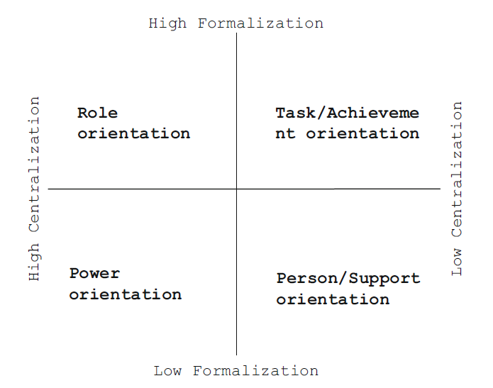
Harrison’s Cultural Theory

Appendix 2

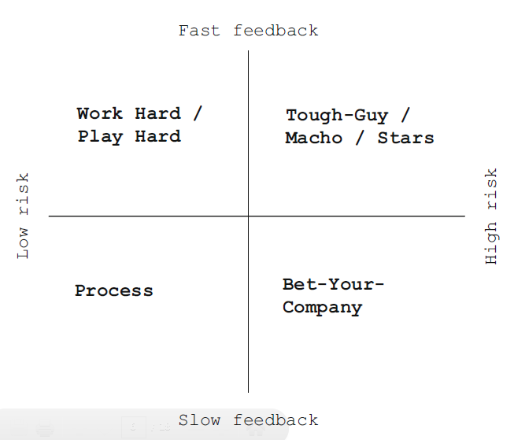
Deal & Kennedy Cultural Theory

Appendix 3

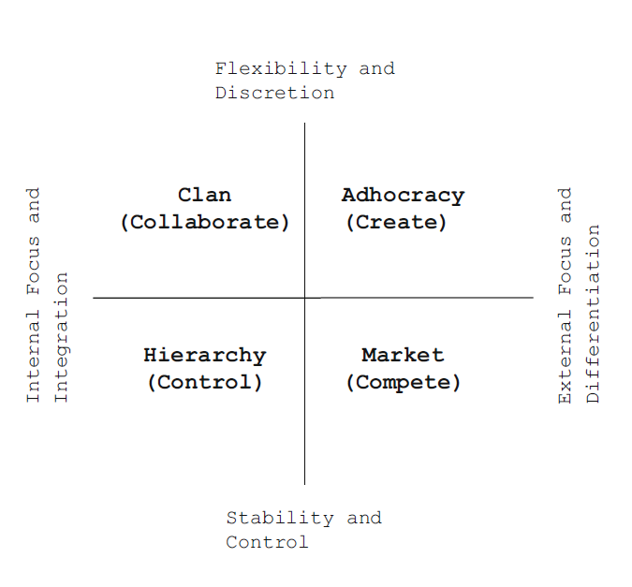
Cameron and Quinn Cultural Model

