

University of Wales Trinity Saint David
Prifysgol Cymru Y Drindod Dewi Sant
School of Engineering

Stress Analysis & Dynamics: Designing a MTB Fork
(ACMA5010)

Aneurin (Nye) Evans
(1907963)
14/03/2022

Contents
1 Introduction 1
2 Calculations (Question 1) 2
2.1 Minimum Outside Diameter (a) 2
2.2 Assumptions, Limitations & Alternative Principles (b) 4
2.2.1 Given & Assumed Values 4
2.2.2 Limitations 5
2.2.3 Alternative Principles 6
3 History & Development (Question 2) 7
3.1 Anatomy of a Fork 7
3.2 Earliest Recorded Bicycles 7
3.3 History of Forks on MTB’s 8
3.3.1 Rigid Forks 8
3.4 Potential Future Development 9
4 Materials & Manufacturing Processes used in Development (Question 3) 11
5 Prototype & Interpretation of Results (Question 4) 12
6 References 14

Introduction
Bicycle forks are seen mainly on road and mountain bikes (MTB). The makeup of a typical fork for an MTB can be seen in Figure 1 below. Like almost every component of a bike, they can vary in material, design, build quality and inevitably price. In the world of mountain biking, the forks are hugely important to absorb a lot of the stresses that the front end of an MTB will experience over the course of a downwards descent over rough terrain. The standard of the suspension system will have a bearing on the comfort of the rider, with MTB’s typically experiencing much higher forces on their forks than typical road bikes.
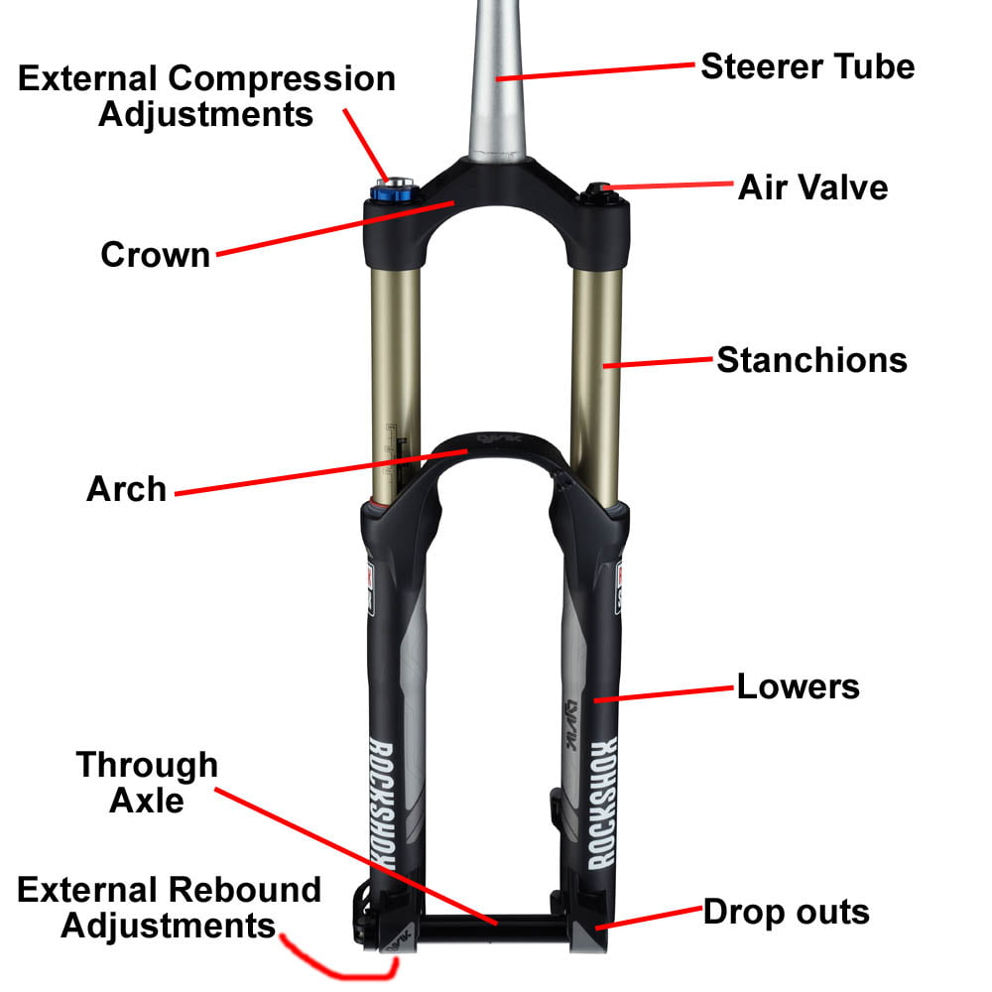
Figure 1 – Diagram showing the different components of a suspension fork [1]
Innovations in research, development, technology, simulation, material analysis and engineering practices have meant that modern day MTB forks can have the same, if not higher level of sophistication and level of function, but at a lower weight and sometimes a lower price. In an article from MTB Mag titled “A Brief History of Suspension Forks Part 1” [2], the author explains how a bike shop owner and experienced mountain biker showed them some of his MTB fork collection. Some of these were some of the earliest MTB forks seen, and one cost the equivalent of €10,000 in todays money! Comparing that price to now, where you can get high standard MTB forks from anywhere between £250 and £3,000, it is clear that you can get a bit more for your money now that the engineering surrounding forks has developed so much over the decades.

Calculations (Question 1)

Minimum Outside Diameter (a)
The following pictures show the workings out done to calculate the minimum outside diameter the forks can be for the desired maximum deflection of 10mm. The workings out will be explained and walked through later in the section.
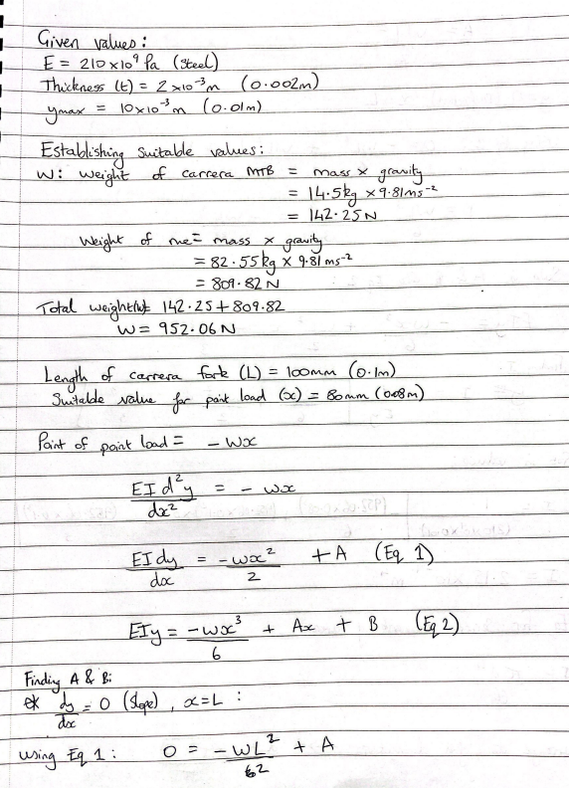
Figure 2 - Page 1 of answer sheet

Figure 3 - Page 2 of answer sheet

Figure 4 - Page 3 of answer sheet
The final equation is a derivation of the second moment of area equation, in which diameter (d) is found and further calculated to find the minimum outside diameter allowable for the maximum deflection.

Assumptions, Limitations & Alternative Principles (b)

Given & Assumed Values
The given values were combined with suitable assumed values that could be combined in calculations to obtain the desired results. These values are given below.
Given values:
- $E=210×{10}^{9}p_{a}$ (Steel)
- Gauge thickness (t): $2×{10}^{-3}m \left(2mm\right)$
- $y_{max}=0.01m (10mm)$
Suitable assumed values:
- Weight - W (mass x acceleration due to gravity known to be 9.81m/s$¯²$): This was calculated for the combination of both the bike and the rider, in this instance, the rider mass was the mass of me (82.55kg) plus the mass of my Carrera Vengeance MTB (14.5kg), which came to 952.06N
- Length – L of the fork is given to be 100mm for the bike
- Assuming L to be 100mm, the value for x, the distance from the end point to the point load, can suitably be given as anywhere between 0 and 100mm, in this case, 80mm was chosen

Limitations
There are some clear limitations to this problem. The main of which being the lack of given values and the subsequent reliance on assumed values. These will obviously vary from person to person doing the calculations. For example, in my calculations I have used my weight and the weight of my bike, whereas another student will likely have a different value for the total weight. This means that the results will not only not be the same, but can never be truly accurate and reliable, unless maybe an average weight was calculated. But even then, this is not ideal as the average weight may mean very little to some who are not average themselves or have a preference of a weight ratio of bike to rider that is away from the norm. This can be extended to bikes whose functions lend themselves to having a higher or lower bike to rider weight ratio than the average.
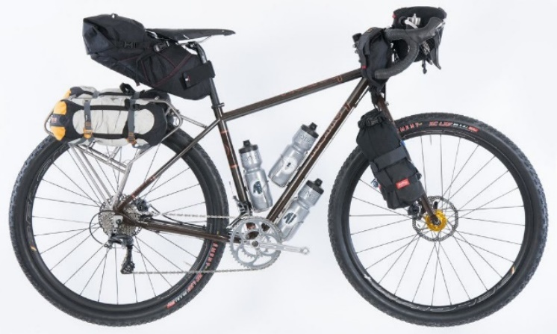
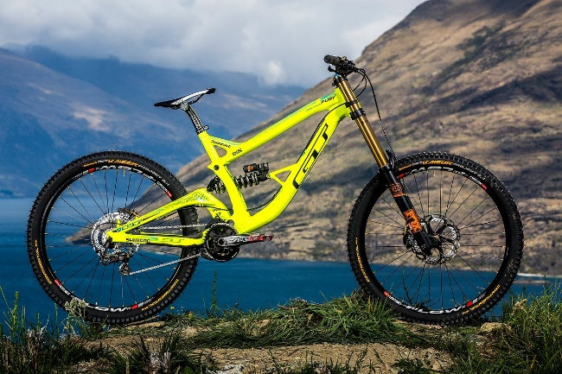
Figure 5 - Example of a bike with a heavier load in mind [3]
Figure 6 - Example of a lightweight MTB [15]

Alternative Principles
There are almost always other methods to calculate another value in engineering. It is very useful to check answers in this way to back-up and validate an answer, or alternatively, find that an answer or method has an error. In this case, there is a calculation that can be derived in which the second moment of area can be found by transposing a calculation for the maximum deflection ($y_{max}$) and looks like this:
$y_{max}=-\frac{wL^{3}}{3EI}$ $I=-\frac{wL^{3}}{3Ey_{max}}$

History & Development (Question 2)

Anatomy of a Fork
The fork of any bike essentially connects the handlebars to the front wheel. It consists of an upper central shaft that splits into two ‘forks’ that come down either side of the wheel. Briefly mentioned in the introduction, although the basic structure of forks is the same for all bikes, MTB’s often require different types of forks due to the different forces, stresses and conditions that MTB’s are likely to be exposed to over a regular road bike. For example, the specification for a road bike’s fork will prioritise weight rather than maximum stress load. This is due to the fact that a road bike is likely to be ridden on smooth, flat roads. Whereas an MTB is more likely to be ridden on rough, hilly surfaces, which obviously would experience more direct, shear and torsion stresses, as well as bending moments. This means that the material specification for an MTB fork will prioritise strength and durability over lightness.
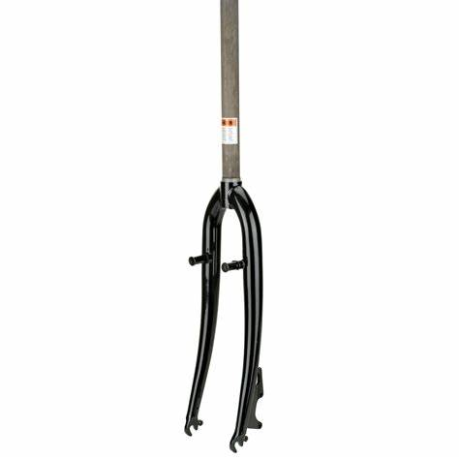
The figure shown to the right shows a typical bike fork. Even with the part being isolated it is still easy to picture where on the bike this can be seen.
The many variations that can be seen in forks, and more specifically MTB forks can include materials used, where the breaks are mounted, the type of suspension and where its mounted, and more. Modern day forks seen in MTB’s are very sophisticated, but they have come a long way from their beginnings and the improvements and developments made over many years have led to better ride quality, steering, durability, and speed experienced on MTB’s.

Earliest Recorded Bicycles
The first bicycles can be dated back to the 19th century. Even in these very early designs you can see the basic fork structure and layout, which isn’t too dissimilar to what we see now. The image seen below shows one of the earliest known bicycles, made in 1817. The use of wood for the main frame of the bike is noticeable, but the fork itself appears to be made out of steel. This suggests that wood could not have dealt with the stresses, strains and bending moments that a fork may experience.
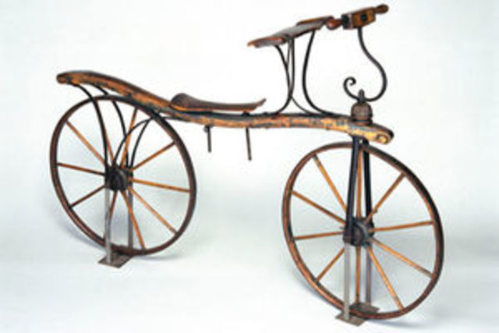
Figure 7 - Picture showing one of the earliest bicycles [4]

History of Forks on MTB’s
The very first bike designed for mountain biking was in 1896 [5], which is just under 80 years after the first recorded bikes. However, it wasn’t until 1966 that the first mountain bike as we know it was made. It is also worth noting that MTB’s are considered to have been under much more innovation over recent decades compared to road bikes. This may be a result of them not being around as long as road bikes, but let’s have a look at the innovation, focussing particularly on design, structure, and materials of the forks.

Rigid Forks
Bike frames and forks are mainly made of one of: Aluminium, Steel, Carbon Fibre or Titanium [6]. Steel is a very popular material choice for MTB forks and, interestingly, rigid forks too. These are forks that are just shafts either side of the wheel, no suspension. They have been around since the inception of the bike itself, while suspension, which got more sophisticated, was introduced at a later point [7]. They are considered for the authentic sensation of riding and the feeling of being more in touch with the surroundings and the bike itself. This is brought up due to the fact that most rigid forks are made out of steel. This is due steels ‘material memory’ i.e., its allowing for a higher amount of elasticity. This increased elasticity over a different material, Carbon Fibre for example, shows a key point of the different materials having different functions and being able to be used with different customer preference in mind.
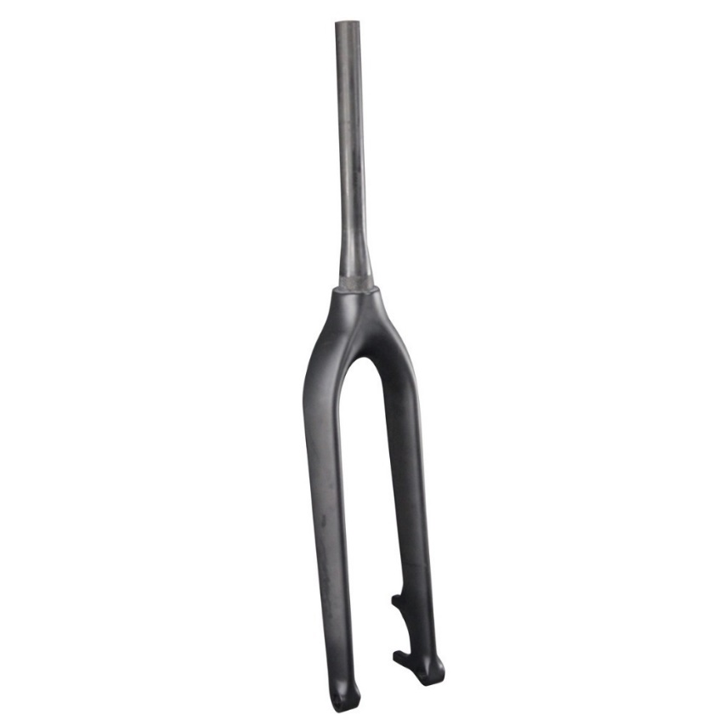
Figure 8 - Image of a typical rigid fork [8]

Potential Future Development
Looking at what has been done in the past to innovate, develop and improve bike forks, we can make some assumptions on which direction they may go in the future. It is worth noting that development isn’t always a steady line as time goes on. At some points, there may be a breakthrough, whether it be a new found material, new engineering design, or someone thinks of something that no one else could do. These breakthroughs lead to various things: being able to do things that was not previously possible (and some thought never would be); once a breakthrough or a big leap in advancement is made, that new concept is exposed to a much larger audience, who can then take that concept and expand on it, which leads to further improvements; the concept can be refined and developed until it reaches a point where it cannot improve any further (its peak).
A past example of this would be the exposure of electric vehicles (EV) to the wider production of the automotive industry. As little as 10 years ago, EVs were very early in their development, there were very few of them on the market and big companies didn’t seem to be rushing to develop them, despite the increasing concerns surrounding the finite supply of petrol and diesel. Fast forward to present day (2022) and there is a huge number of EVs on the market, coming in all sizes and from almost all companies. The breakthrough in EV technology has meant that EVs themselves are becoming a mainstream mode of transport for many in the developing world, so much so we are seeing many refinements when it comes to range and charge times in each and every new make and model that is released.
As for an example of a development of the future, again looking at vehicles, the hydrogen fuel cell is a hugely researched technology. It is joked that the person/people who manage to crack the puzzle of how to get it refined, stable and easily available will make themselves the richest people on Earth! Much like and possibly even more so than EVs, a breakthrough in hydrogen fuel cell power for vehicles would see mass major development like nothing we have witnessed before.
This is being brought up because different areas if MTBs themselves, along with the forks, will experience these different paces and types of development. There may be breakthroughs which breeds more and more development off that, or there could be marginal refinement, where engineers spend years trying to shave half a gram of weight off a fork while maintaining its strength. If there is to be a massive breakthrough in MTB forks, it may come in the form of a new found material, or more likely, a newly developed composite. We on Earth are unlikely to stumble across a mine of pure Vibranium or Beskar!
If something like this were to happen though, we would likely see big changes to the mass, if a new material was found to have the same properties as steel, but could be lighter, then we would see lighter forks. This may have a knock-on effect on other parts of the bike too, as engineers may want to add weight and strength to another section of the bike, which they felt they couldn’t before. One such material that could potentially male an impact is a new two-dimensional polymer created by MIT scientists, which is said to be as strong as steel, while being as light as plastic, while also being easily manufactured [9].

Materials & Manufacturing Processes used in Development (Question 3)
Different materials for MTB forks are manufactured in different ways, the level of quality and subsequently, price, will also depend somewhat on the manufacturing processes that take place. For example, carbon is a high-end material, it is very strong whilst being light, and an entire carbon bike frame can take between 50-100 hours of crafting to complete, hence its high cost [10].
The same thing can be said when looking at steel vs aluminium. People quite often are left choosing between the two for their bikes, and although this mentions the frames rather than the forks, the points still stand. Steel is a more expensive material to buy as it is handmade, unlike Aluminium which can be mass produced, hence is usually cheaper [11].

Prototype & Interpretation of Results (Question 4)
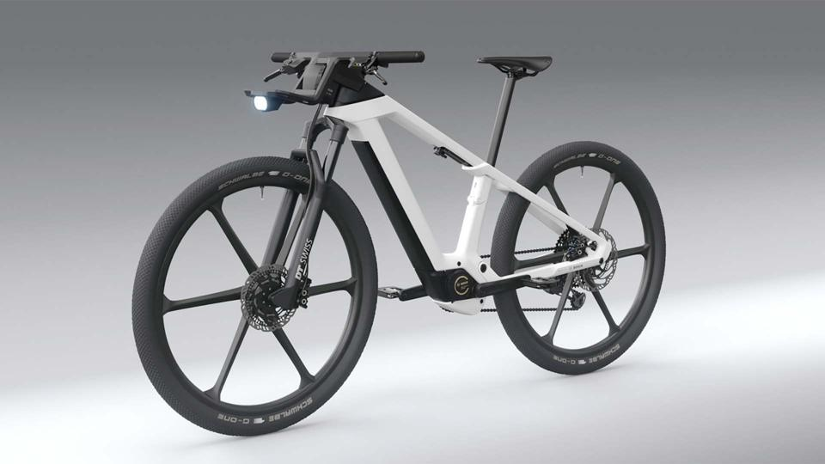
Figure 9 - Image of a futuristic looking prototype electric bicycle [12]

Prototypes have been a key aspect in engineering since it began. It allows companies to not only see their designs in the flesh, but more importantly, run real life tests on them. Admittedly, with simulations now as advanced as they are, the actual testing side of prototypes are less full of surprises. However, this improvement in simulation has meant that although less prototypes are likely to be made, those that are made are built using more money and can be designed to be closer to the desired outcome.
For these forks specifically, I would possibly use both steel and aluminium forks (if financially viable), with the steel manufactured by hand, while the aluminium mass produced. This would allow for each material and manufacturing method to be compared and allow us to see whether the extra financial and labour cost of the steel is actually worth it in the real world.
Again, like materials and manufacturing, there are many options available for testing. In this instance, I am choosing the bend test. This tests the strength of a material by bending it over a given radius and done so under a number of configurations [13]. This means of testing would give a good idea of the strength, in terms of bending, of each material. From this, we can give a better recommendation and be more confident in our choice. Also, any necessary changes can be made at this stage easily and testing like this is the best way to see if your calculations are correct!
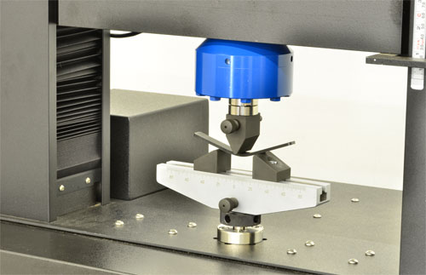
Figure 10 - Image of a bend test taking place [14]

References

[1] | [Online]. Available: mtb fork diagram - Bing images. [Accessed 07 March 2022].
[2] | A. Boyce, “A Brief History of Suspension Forks Part 1,” MTBMag.com, 19 March 2015. [Online]. Available: https://www.mtb-mag.com/en/a-brief-history-of-suspension-forks-part-1/. [Accessed 10 March 2022].
[3] | [Online]. Available: https://www.bing.com/images/search?view=detailV2&ccid=5R4Y7Hew&id=F2B279BCA312CD43AB1641FEDB1B23CB7D674617&thid=OIP.5R4Y7HewV6yuNvmbfsiTIwHaEc&mediaurl=https%3a%2f%2fi.pinimg.com%2foriginals%2f23%2f47%2fb4%2f2347b435d4a93e5a81f7cdd8c21cee05.jpg&cdnurl=htt. [Accessed 14 March 2022].
[4] | [Online]. Available: https://www.bing.com/images/search?view=detailV2&ccid=VmubNIKh&id=0B8FCC51D3E59378A8B3D8EBC7D9C3C5E0E10645&thid=OIP.VmubNIKhEoGMFwTAzZStPgHaE8&mediaurl=https%3a%2f%2fs3.amazonaws.com%2fs3.timetoast.com%2fpublic%2fuploads%2fphotos%2f9629837%2fbike_1_pdf.jp. [Accessed 10 March 2022].
[5] | The Flow MTB, “The History of Mountain Biking”.
[6] | C. B. o. T. Bicycles, “Bike Frame & Fork Materials, A Discussion,” New Horizons Bikes, [Online]. Available: https://www.newhorizonsbikes.com/articles/bike-frame-fork-materials-a-discussion-pg169.htm#:~:text=Bicycle%20frames%20and%20forks%20are,%2C%20titanium%2C%20and%20carbon%20fiber.. [Accessed 12 March 2022].
[7] | L. Branquinho, “Best rigid forks for mountain biking,” BIKE PERFECT, 9 December 2019. [Online]. Available: https://www.bikeperfect.com/features/best-rigid-forks-for-mountain-biking. [Accessed 13 March 2022].
[8] | [Online]. Available: https://www.bing.com/images/search?view=detailV2&ccid=bKpXxxxR&id=ADB3B0BA307BF2C0FD256C563F98B14E3CA7F556&thid=OIP.bKpXxxxRDfc553Zeus95IgHaHa&mediaurl=https%3a%2f%2fae01.alicdn.com%2fkf%2fHTB1nZUjKpXXXXbTXpXXq6xXFXXXC%2fFull-carbon-fork-29er-mtb-bicycle-. [Accessed 11 March 2022].
[9] | A. Trafton, “New lightweight material is stronger than steel,” 02 February 2022. [Online]. Available: https://news.mit.edu/2022/polymer-lightweight-material-2d-0202. [Accessed 14 March 2022].
[10] | Bike Hike, “Question: How mountain bikes are made work,” Bike HIke, [Online]. Available: https://bikehike.org/how-mountain-bikes-are-made-work/#What_materials_are_used_to_make_a_mountain_bike. [Accessed 14 March 2022].
[11] | wheretheroadforks, “Steel vs Aluminium bike frame pros and cons,” wheretheroadforks, 11 March 2022. [Online]. Available: https://wheretheroadforks.com/steel-vs-aluminum-bike-frame-pros-and-cons/. [Accessed 14 March 2022].
[12] | [Online]. Available: https://www.bing.com/images/search?view=detailV2&ccid=S7AbNfT%2f&id=514B69E7B34C21BC6AF13EF3FCFA16784F241164&thid=OIP.S7AbNfT_bVk3wX__XkGukgHaEK&mediaurl=https%3a%2f%2fspecials-images.forbesimg.com%2fimageserve%2f5f046ce4c9b14d0007d32f0a%2f960x0.jpg%3ffit. [Accessed 14 March 2022].
[13] | Metal Test, “Bend Testing,” [Online]. Available: http://www.metaltest.co.uk/bend-testing/. [Accessed 14 March 2022].
[14] | [Online]. Available: https://www.bing.com/images/search?view=detailV2&ccid=v3TJJm4F&id=3B9CD1274B0E686E56661674156B9A21BB585CE2&thid=OIP.v3TJJm4Fe1jDaFJc2R0AVgHaEy&mediaurl=https%3a%2f%2fwww.admet.com%2fwp-content%2fuploads%2f2015%2f08%2fbend-astm-d790-bend-test.jpg&cdnurl=ht. [Accessed 14 March 2022].
[15] | [Online]. Available: https://www.bing.com/images/search?view=detailV2&ccid=zK0vg8Vg&id=5F3F22837722A48BD221EDBC2CC8159271B418E8&thid=OIP.zK0vg8VgpdljL9wqvEQ74QHaE8&mediaurl=https%3a%2f%2fwww.mtb-mag.com%2fwp-content%2fuploads%2f2015%2f03%2fAR_NZ_55a0463.jpg&cdnurl=https%3a%2f. [Accessed 14 March 2022].

