

Putting paws on student stress:
Effects of Animal Assisted Therapy on Stress, Arousal and Emotion

Dissertation in Applied Psychology
2020

Michaela Paterson: 1704051

DECLARATION
This work has not previously been accepted in substance for any degrees and is not being concurrently submitted in candidature for any degrees.
Signed  (candidate)
Date 18/04/2020
STATEMENT 1
This dissertation is being submitted in partial fulfilment of the requirements for the degree of
Applied Psychology BSc
Signed  (candidate)
Date 18/04/2020
STATEMENT 2
This dissertation is the result of my own independent work/investigation, except where otherwise stated.
Other sources are acknowledged by giving explicit references. A reference list is appended.
Signed  (candidate)
Date 18/04/2020
STATEMENT 3
I hereby give consent for my dissertation, if accepted, to be available for photocopying and for inter-library loan, and for the title and summary to be made available to outside organisations.
Signed  (candidate)
Date 18/04/2020

Dedication

I would like to dedicate this dissertation to my parents. Their love and support in life, transcends from across the rainbow bridge.

Acknowledgments

I would like to thank my lecturers, Dr Charlotte Greenway, Dr Stuart Jones, and Dr Karen Eaton-Thomas. Their dedication and support during the last three years has been inspiring. I would like to give a special thank you to my dissertation supervisor Dr Stuart Jones for his patience and encouragement. I would like to thank Dr Charlotte Greenway and the university for giving permission for Mika (my dog) to join me on campus and making my dissertation possible. I would like to give a special thank you to Soo Phillips, Mark Ingram, and Liza Gilbert. Without your commitment, belief, empathy, and unwavering support my university journey would not have been possible. My family and partner Alex for their emotional support and encouragement to continue with my dream.

My dog, Mika “Dr Paws”, my research assistant who has been at my side throughout. Data collection would not have been possible without her. Her unconditional loyalty, devotion, enthusiasm, and wagging tail never failed to uplift the spirits of myself, my fellow students and lecturers. You have earned your “Dogtorate”. Finally, I would like to acknowledge my fellow classmates. Each of you supported my research and were active and willing participants, I owe you much gratitude. We have completed this journey together, through frustration and laughter. I wish you all every success in your future voyage.

Table Contents

Abstract……………………………………………………………………………. 6
Chapter 1
Introduction…………………………………………………………………………. 7
Theories
(Bowlby’s Attachment Theory) …………………………………………………… 11
Anthropomorphism…………………………………………………………….... 11
Literature Review……………………………………………………………………. 12

Chapter 2
Methodology
Design………………………………………………………………………… 18
Materials / Measures……………………………………………………………. 19
Participants……………………………………………………………………. 21
Procedure……………………………………………………………………… 23

Chapter 3
Results
Pet Acceptance…………………………………………………………………. 25
Correlation, stress, emotion, arousal…………………………………………….. 26
Psychological Stress and Arousal Pre and Post Therapy…………………………….. 28
Students’ Perceived and Psychological Stress Between Level of Study………………… 30

Chapter 4
Discussion……..…………………………………………………………………….. 34

References….……………………………………………………………………… 43
Appendices………………………………………………………………………… 59
Appendix A: Lexington Attachment to Pets Scale……………………………………. 60
Appendix B: Perceived Stress Scale……………………………………………….. 63
Appendix C: The Positive and Negative Affect Scale…………………………………. 65
Appendix D: The Stress and Arousal Checklist…………………………………….... 66

SPSS Data
Appendix E: Pet Acceptance and Psychological Stress: t-test…………………………. 67
Appendix F: Pet Acceptance and Perceived Stress: t-test……………………………... 68
Appendix G: Correlation, stress, emotion, arousal…………………………………... 69
Appendix H: Positive and Negative Emotion (Negative)……………….……………... 70
Appendix I: Positive and Negative Emotion (Positive)……………………………….. 71
Appendix J: Positive and Negative Emotion Interaction (ANOVA)…………………….. 72
Appendix K: Psychological Stress and Arousal (Arousal)………..…………………… 77
Appendix L: Psychological Stress and Arousal (Stress)………………………………. 78
Appendix M: Psychological Stress and Arousal Interaction (ANOVA)………………….. 79
Appendix N: Perceived Stress Level of Study………………………………………... 83
Appendix O: Psychological Stress Level of Study……………………………………. 85

Consent / Debrief / Ethical Approval

Appendix P: Participant Consent Form…………………………………………..… 87
Appendix Q: Participant Debrief Form…………………………………………….. 89
Appendix R: Ethical Approval…………………………………………………….. 91

Abstract

Animal Assisted Therapy within the student population has gathered much interest. With student stress increasing it is putting a strain on student support and counselling services. High stress, negative emotion and low arousal have been linked to poor academic achievement; therefore, it is important to implement strategies to help reduce students’ stress, improve positive emotion, and increase arousal. The current study examined the effects interacting with a therapy dog for five minutes had on undergraduate students’ (n=56) perceived stress (PSS), psychological stress and arousal (SACL), and positive and negative emotion (PANAS). There were significant differences between stress, emotion, and arousal pre and post intervention. No significant differences in levels of perceived stress and psychological stress were found between level of study. It is concluded that AAT is a useful activity in promoting positive well-being within the student population. Pet acceptance (LAPS) appeared to contribute to the level of stress experienced by students.

CHAPTER 1
Introduction

The relationship between animals and humans is one that has evolved from ancient cultures spiritual and mystical reverence to domestication, partnership formation and co-habitation. In ancient cultures around the world, the human-animal bond has been a part of human survival. Animals have been honoured by way of spiritual traditions that believe animals connect us to the spirit world (Serpell, 2006). Some cultures believed that their ancestors’ guardians were animal spirits (Serpell, 2010). This is a view that is rooted in animism, a belief system that conceptualises living creatures and phenomena have invisible “animal spirits” (Serpell, 2010). However, the Christian Church identified animist spirit animals with the devil and persecuted pagans as witches (Serpell, 2006). Some animals became folklore and mythological figures. One such legend is the “Fu-Dog”, a Chinese mythological creature part lion part canine; the Chinese believed this hybrid creature protected humans (Walsh, 2010). Belief systems of the Chinese culture pair us with characteristics and creative forces of animals depending on the year and month we are born (Walsh, 2010).

The evolution of the relationship between humans and animals has meant the mythological and spiritual ideals have moved towards the domestication of animals and their utilitarian abilities (Grandgeorge & Hausberger, 2011). The domestication and socialisation of animals have bought a further change in how animals interact with humans. This process has been mutually interactive co-operation and co-evolution based on the need for food, shelter and protection for both the animal and human. The human-animal bond phenomenon has been well documented ever since the domestication of animals; dogs, for example, have been bred to co-exist with humans (Turner, 2007). They fulfil many roles in our cohabited lives from serving a purpose, such as herding, hunting and protection, to becoming companions (Turner, 2007). Bowlby (1970) attachment theory may offer an explanation to this cohabited bond as affectional bonding. This is the result of social behaviour of individuals of a species, where, a bonded pair elicits behaviours such as remaining in close proximity to each other. Should separation occur, one would, sooner or later, seek out the other and thus, proximity is renewed.

Purebred dogs became the prized possessions of the aristocracy; some dogs were bred for their small size and appeal as lap dogs or comforters. The Pekinese breed, as an example, was bred particularly small so they could fit into the sleeve of their Chinese Empress’ dresses so they could be carried around with ease. Owners began to imbue human-like qualities on pets; clothing them, while nurturing of their pet resulted in companionship and comfort during a time of child or parent mortality (Walsh, 2010). Anthropomorphism offers an explanation to this anthropomorphic behaviour in that it describes the tendency of humans to “Imbue real or imagined behaviour of nonhuman agents with humanlike characteristics, motivations, intentions or emotions” (Epley, Waytz & Cacioppo, 2007, p. 864). Ancient Egyptians deeply respected dogs and considered them in life as loyal companions, in the afterlife dogs were revered as guides (Ikram, 2005). Early Roman and Greek empires, although they predominantly kept dogs for hunting, herding and guarding, they were also considered as loyal companions (Coren, 2002). It is suggested that the breeding of domesticated animals was an unconscious human decision that was born from the human appreciation of the animals’ qualities. Thus domesticated animals became even more appealing and eventually through bonding with the domesticated animal, relationships have formed (Grandgeorge & Hausberger, 2011). The domestication of animals has led them to become companions and ever more significant in many aspects of human life.

Statistics of pet ownership in 2018/19 show that 40% of the UK population own a pet; dog, cat, small furies, reptiles and birds. Dogs are the most popular pet; a total of 25% of households in the UK own one, with an estimated population of pet dogs being 9.9 million (Sabanoglu, 2016, sited in Statista, 2019). Perspectives of pet owners feelings in regards to their experience of owning a pet show that 93% say owning a pet makes them happy, 88% feel a pet improves their lives, and it is a privilege not a right to own one, and, 80% of pet owners claim they feel mentally healthier (Sabanoglu, 2016, sited in Statista, 2018). A high percentage of pet owners take their pets on holiday, take time off work to care for a sick pet, take their pet to work (Wells & Perrine, 2001), and a majority of pet owners view their pets as family members and friends (Walsh, 2010). These statistics are a strong indication that pets have become far more than domesticated animals and humans consider their pets as a partnership and companion.

The continuing evolution of the human-animal bond (HAB) brings forward the therapeutic benefits of animals in clinical settings. The 19th century bought into communality the presence of pet animals in mental institutions in the UK. This arose from the work of John Locke in the 17th century, who advocated that children should have animals to look after to encourage responsibility and tender feelings towards others (Locke, 1699, p. 154). Later reformers of the 18th century continuing the works of John Calvin and Thomas Hobbs, believed that a child’s innate “beast-like” characteristics could be controlled through the care of living animals (Myers, 1998). One example of the fondness of animals was evident in the Bethlem Hospital; it was reported by the Illustrated London News of 1860, that, patients would share their woes with cats and dogs while pacing the gallery when no one else was there to listen (cited in Allderidge, 1991). There is documentary evidence from 1867 of the utilisation of horses and farm animals in the treatment of patients with epilepsy in Bethel, Germany (Bustad, 1980). Despite the apparent success of animal interactions within the institutional care settings during the 19th century, scientific medicine within the hospital setting had eliminated animals by the early 20th century (Allderidge, 1991).

Scientific explanations of the therapeutic benefits of animals have, since the 1970s, moved away from past medical scepticism and the earlier ideas of animals as spiritual mediators. Noticeably, the 1970s saw the advancement of animal-assisted interventions (AAI). A “petmobile” program began in the mid-1970s where animals visited a nursing home in Colorado (Arkow, 2004) and in a children’s psychiatric hospital in Michigan, a dog named “Skeezer”, a visiting therapy dog, came to be a permanent resident (Yates, 1973). Boris Levison, a child psychologist, observed a child who was nonverbal talking to his dog “Jingles” during their therapy session. Levinson saw the potential therapeutic benefits of having a dog as a facilitator to open communication between patients and their therapists (Levinson, 1969). As a result of this accidental discovery, Levinson coined the phrase “Pet Therapy”.

Animal-assisted therapy (AAT) is a type of complementary treatment where animals are an integral part of the healing process (Kruger & Serpell, 2010). AAT is goal orientated and designed to promote positive improvements in a patient’s emotional and/or cognitive functioning, as well as educational and motivational effectiveness (Kruger & Serpell, 2010; Urbanik & Vitztum, 2016); these are measured and documented. Animal-assisted activities (AAA) offer educational, therapeutic and recreational benefits that in turn, enhance the quality of life. AAAs can include animals visiting environments such as nursing homes, schools and correctional facilities (Pet Partners, 2020) and can be utilized in a range of populations such as the elderly, dementia patients, youth substance abuse, and children with autism (Nordgren & Engström, 2012; Kelly & Cozzolino, 2015; O’Haire, 2017). In 1996, standardized terms and definitions were published; The Standards of Practice for Animal-Assisted Interventions, and has been subsequently revised (Pet Partners, 2020). AAT is facilitated by a therapist who is licensed and specialises in this type of intervention. These include, but are not limited to, psychologists, occupational therapists and licensed councillors; AAA can be facilitated by assistants of licensed professionals and students (Pet Partners, 2020). Empirical research on the topic of animal-assisted interventions (AAI), animal-assisted therapy (AAT), and animal-assisted activities (AAA) and pet ownership have given further insight as to the benefits animals have on our well-being. For this paper, the term animal-assisted therapy (AAT) will be used as an umbrella term for these three interventions.

Dogs are the most used animal closely followed by cats, although, many animals have been used as a fundamental part of a persons’ treatment. Small animals such as rabbits, gerbils and chickens are popular in AAT. As early as 1790, rabbits and chickens were part of the therapy process with mentally ill patients in York, England (Salotto, 2001). Rabbits have shown efficacy improving emotion expression, communication and socialization skills in kindergarten pupils (Loukaki & Koukoutsakis, 2014). Large animals are also used; horses have shown to be a successful therapeutic medium in the treatment of depression, anxiety and post-traumatic stress disorder (PTSD) (Frame, 2006; Earles, Vernon & Yetz, 2015; Frederick, Haltz & Lanning, 2015).

Theories

Animal-assisted therapy relies on the human-animal bond. Theories of attachment and anthropomorphism may offer some explanation of the human-animal bond (HAB) phenomena and the reasons why children and adults engage in the care of dependent animals. Attachment Theory (Bowlby, 1970; Bowlby, 1973) provides an understanding for the human need to protect and be protected and of separation and the mother-infant bond. According to this theory, humans learn how to form relationships and interact from the early bonding experiences they have as an infant. This bond between a mother/primary caregiver and child has evolved into a co-ordinated relationship. When the infant signals that they are in distress or exhibit fear, it is noted by the mother/primary caregiver; the response is to offer the child comfort and protection.

The human-pet relationship and our orientations towards pets have been conceptualized as an attachment bond by Zilch-Mano, Mikulincer & Shaver (2011). This is a useful construct in understanding our relationship with pets and how we relate to them. In theory, if the relationship we have with our pets is an attachment bond; the affectionate bond and close proximity to a pet should reduce distress in the same way a mother does in a securely attached child. A study by Kurdek (2008) found that if students had a high attachment to dogs, this was synonymous to high attachment towards an attachment figure. Dogs have shown behaviours indicative of Bowlby attachment theory. An example of this is proximity seeking as a way of coping with stress where the dog will seek out the attachment figure for comfort (Schöberl, Wedl, Bauer, Day, Möstl, & Kotrschal, 2012).

Humans tend to romanticise and humanise animals, and by doing so, they are disrespecting the animal (Fine, 2019). Although human attributes should not be imposed onto animals, without anthropomorphism, domestication of animals would not have taken place (Mithen, 1996). Within the field of AAT, it is perceived that animals find enjoyment from the human-animal interaction just as much as their human counterparts (Haubenhofer & Kirchengast, 2007). Serpell (1996) argues that without the belief that humans genuinely feel their animals love them; our relationship with our pet would have no meaning. Fine & Eisen (2016) suggest this anthropomorphic belief may have connotation and say something about our human needs.

Anthropomorphism is key in AAT as therapists use this anthropomorphised human-animal bond to reflect patients’ experiences. An example of how anthropomorphism is used within AAT has been illustrated by Kruger & Serpell (2010). A child projected details of their nightmare on to a dog called Buster when the child was told Buster had a nightmare. The child was asked what they thought the nightmare was about and described a fear of being hurt. Children openly communicate and develop relationships with companion animals. Therefore, a child who may not feel comfortable expressing themselves to another human will openly communicate personal feelings to a pet (Kurdek, 2008). It is anthropomorphism that made it possible for the child to disclose their feelings to the therapist. Therefore, anthropomorphism allows for the utilization of animals in a therapeutic setting as the human attributes feelings and behaviours onto the animal. Thus, through the anthropomorphic process therapists can employ animals therapeutically.

Literature Review

One of the first researchers to empirically study canine-assisted interventions were Samuel Corson and Elizabeth O’Leary Corson in the 1970s (Fine, 2019). They witnessed how patients with psychiatric disorders showed an interest in dogs that were in a nearby kennel. It was observed that patients who interacted with the dogs, one of whom was selectively mute, communicated with greater ease. It was the ease of communication from the human-animal interactions that gave rise to the phrase that animals act as a “social lubricant” (Corson, Corson, Gwynne & Arnold, 1975). These early experiences lead to the realization that the relationship we have with animals, not just in therapeutic settings but also in our homes, has its benefits.

A ground-breaking study was that of Friedman, Katcher, Lynch & Thomas (1980). They found outpatients of a cardiac care unit who owned a pet had an 84% survival rate at year one follow-up. Further studies discuss the possible mechanisms that may be responsible for the beneficial effects of pet ownership and human-animal interactions. Katcher, Friedmann, Beck & Lynch (1983) found that animals attract our attention and hold it. This induces a physiological de-aroused state that is immediately relaxing to the human. Animals have been found to act as social buffers, in turn, reducing the impact of psychosocial stress (Heinrichs, Baumgarner, Kirschbaum & Ehlert, 2003; O’Haire, McKenzie, Beck & Slaughter, 2015). Pets have also been found to help decrease the feeling of stress (Carmack, 1998), play a role in helping individuals cope during times of stress and decrease the negative consequences of stress (McClaskey, 2019).

Wisdom, Saedi & Green (2009) found primary themes in the recovery of patients suffering from mental illness; pets provide empathy, support self-efficacy, assist in the redevelopment of social avenues and can serve as a family member in the absence of human family members. Furthermore, animals have been found to stimulate the release of neurotransmitters (Pugliese, Famulari & Britt, 2010) such as endorphins and oxytocin (Uvnäs-Moberg, Handlin & Peterson, 2011; Nagasawa et al., 2015), through physical contact and emotional attachment; the release of these neurotransmitters helps promote overall well-being and relaxation.

A student’s transition to university can be a time of high stress. Perceived stressors, such as pressure of exam and grade achievement, multiple examinations, interpersonal or relationship stressors and financial worry add to students’ stress (Furr, Westfield, McConnell & Jenkins, 2001; Brougham, Mendoza & Miller, 2009). Adjustment to moving away from home and settling into new surroundings is a demanding time for students, particularly in the first year (Thelwell, 2019). Studies have found that psychological distress is higher in student populations; it significantly increases at the beginning of university and remains high for the duration of study (Bewick, Koutsopoulou, Miles, Slaa & Barkham, 2010; Conley, Kirsch, Dickson & Bryant, 2014; Eskin et al., 2016).

According to a report by the Institute for Public Policy Research, 2017 (Thorley, 2017) mental distress and illness among the student population in higher education are increasing due to academic pressures. This is evident in the increasing number of students who are reporting mental distress; 94% of universities have experienced an increase in students seeking counselling support. In 2015/16, the figure for first-year students studying in UK universities who disclosed a mental health problem rose to 15,395. This equates to 2% of first-year students. The report further highlights that the number of students who dropped out of university due to mental health problems increased by 201% in 2014/15 compared to 2009/10. This is an indication that the transition to university is a stressful experience.

The prevalence of student stress is increasing, and undergraduate students are experiencing higher stress levels compared to the general population (Brown & Ralph, 1999; Adlaf et al., 2001; Bennett, 2003; Gallagher, 2012). High stress among the student population is particularly pervasive and has been linked to the onset of anxiety; in turn leading to poor coping skills that in turn affects academic performance (Hughes, 2005; Black, 2012). Stress has been linked to mental health, depression (Bayram & Bilgel, 2008), low self-esteem, poor physical health, high blood pressure (Hughes, 2005), lower immune functioning (Otsuki, 2004), sleep disturbance (Niemi & Vainiomäki, 2006) and decreased attention (Shapiro, Shapiro & Schwartz, 2000). Studies have highlighted that perceived stress is linked to unhealthy eating habits (Mikolajczyk, El Ansari & Maxwell, 2009). Furthermore, termination of higher education courses has been noted in individuals suffering from early onset of mental distress (Eisenberg, Golderstein, & Hunt, 2009; Kessler, 2012).

Studies on the effects of perceived stress on academic performance have found statistically significant results. Balaji, Murthy, Kumar & Chaudhury (2019) found an association between academic achievement and perceived stress among first and second-year medical and engineering students. Higher levels of perceived stress indicated lower academic performance. The research supported earlier studies of perceived stress and academic performance. Bennett (2003) found 40% of a 377-student sample experienced high stress after entering university and revealed a significant association between high stress and poor academic performance. Further studies found perceived stress to have a negative effect on academic performance in undergraduate psychology students, (Elias, Ping & Abdullah, 2011; Stoliker & Laferiere, 2015).

First-year students have been found to have higher levels of perceived stress. Pancer, Hunsberger, Pratt & Alisat (2000) found the level of perceived stress in this group of students is significantly related to how well a student adjusts to university life. The study highlights that lower levels of perceived stress indicated better adjustment opposed to those with higher perceived stress. However, Elias, Ping & Abdullah (2011) study of stress levels among undergraduate students suggests that final year students have the highest level of stress and not first-year students. The study contradicts the findings of Pancer et al. (2000); Bennett (2003); Balaji, Murthy, Kumar & Chaudhury (2019) who imply stress is higher for first-year students. These results highlight that the year of study affects the level of stress among undergraduate students. This is supported by Yusoff, Rahim & Yaacob (2010) who found the year of study was associated with levels of stress.

Interacting with a therapy dog for as little as ten-minutes has been shown to reduce stress, depression, anxiety, blood pressure, homesickness, increase life satisfaction, increase positive affect and act as a catalyst for emotional experiences (Wells, 2009; Katcher & Beck, 2010; Aydin et al., 2012; Crossman, Kazdin & Knudson, 2015; Daltry & Mehr, 2015; Wheeler & Faulkner, 2015; Barker, Barker, McCain & Schubert, 2016; Binfet & Passmore, 2016; Fine, 2019). A study by Pendry, Carr, Roeter & Vandagriff (2018) found that a 10- minute interaction with a dog or cat increased positive emotion and decreased negative emotion. The study by Crossman, Kazdin & Knudson (2015) found that 10 minutes interacting with a dog showed a decline in negative mood and an increase in positive mood among Yale medical students. Emotion and arousal affect our well-being and health (Peterson, Park & Seligman, 2005). Arousal can affect learning performance; this is dependent on the degree to which the emotional experience of the positive and negative emotion is (Chung, Cheon & Lee, 2015). Positive emotions help us achieve individual psychological growth as well as long term flourishment and well-being (Fredrickson, 2001). Positive moods can motivate us to continue with actions which we have initiated (Gohm & Clore, 2000), in turn, reversing the negative emotion that had previously taken hold (Fredrickson, 2001).

Studies have shown interacting with animals can increase arousal (Palley O'Rourke, & Niemi, 2012). Crump & Derting (2015) found that first-year college students who engaged in AAT had significantly decreased stress and increased arousal compared to the group who did not interact with a therapy dog. The study also observed that students’ responses to the therapy dog during the interaction was highly animated. It is possible that an increase in emotion towards the therapy dog increased arousal. This is a consistent theme with emotion theories in that the intensity of the emotion is determined by the level of physiological arousal (Russell, 1980). The study by Chung et al. (2015) found levels of arousal to be of greater importance than valence within the context of learning. Consequently, it was the arousal of both positive and negative emotion that leads to a higher degree of learning performance. This finding further supports emotion theories, in particular, control-value theory (Pekrun, 2000; Pekrun, Frenzel, Götz & Perry, 2006). Control-value theory posits that enhanced performance is the result of activating emotions, for example, the facilitation of critical thinking is resultant of positive activating emotions. Conversely, the enhancement of focused attention is the result of negative activating emotion which is beneficial to process information.

Research has shown that positive emotion is related to academic performance, although this appears to be limited. However, there is growing interest in the field of positive psychology. Carmona-Halty, Salanova, Llorens & Schaufeli (2019) found that students who experienced positive emotions engaged more with their studies and academic performance were more effective with positive attitudes. As positive emotional experiences, such as enjoyment, relates positively to a students’ academic success, negative emotions, such as hopelessness, boredom and anxiety relates to negative academic achievement (Daniels et al., 2009; Pekrun, Elliot & Maier, 2009; Pekrun et al., 2011).

AAT has become an increasingly popular intervention on college and university campuses to reduce student stress, many of which involve dogs (Barker, Knisely, McCain, Schubert & Panaurangi, 2010; Crump & Derting, 2015; Haggerty & Mueller, 2017; House, Neal & Backels, 2018; Thelwell, 2019). In Adamle, Carlson & Riley (2009) study, pets are viewed as a source of support and comfort for students during times of stress. Students also expressed that pet therapy was beneficial, and the dogs were a temporary substitute providing support in the absence of support systems that students have while living at home. Students who partake in AAT studies expressed an eagerness to have therapy dogs return to campus (House, Neal & Backels, 2018).

The literature has highlighted that students are increasingly reporting mental health problems and accessing counselling services. This puts a strain on universities student services. Stress is pervasive among the student population and can lead to the onset of mental health conditions such as anxiety and depression. Mental distress is also linked to the termination of higher education courses. Therefore, it is conducive to the well-being of students to implement interventions to reduce stress, increase positive emotions and increase arousal. Research on interacting with a therapy dog for short periods is gathering much interest and is showing positive results. More research is needed on the effects of AAT in reducing stress and increasing positive emotion and arousal. It has been documented that students engage more with their studies and show higher academic achievement when positive emotions and lower stress is experienced.

The intention of this study is to build on the existing body of literature that examines the effects that AAT has on students’ perceived stress, psychological stress, emotions and arousal, and to determine if pet acceptance affects students’ level of stress. The aim of the study is to examine whether interacting with a therapy dog for five minutes will reduce stress, increase positive emotion and increase arousal. Therefore, it is hypothesised that 1) Students who have a high level of pet acceptance will have lower perceived stress and psychological stress than students with low pet acceptance pre interaction with a therapy dog. 2) There will be a significant correlation between students’ perceived stress, positive and negative emotion, psychological stress and arousal: a) High perceived stress will indicate low positive emotion, b) Negative emotions will increase psychological stress, c) Perceived stress will indicate high psychological stress d) positive emotions will indicate high arousal. 3) There will be a significant effect on the endorsement of the positive/negative emotion; Post interaction will show increased positive emotion and reduced negative emotion. 4) Interacting with a therapy dog will have a significant effect on stress and arousal and show a decrease in stress and increase in arousal. 5) First-year students will have higher levels of perceived and psychological stress than 2nd and 3rd - year students pre-therapy dog interaction.

CHAPTER 2
Methodology
Design

This research is a qualitative study of a mixed design comprising of within and between groups analysis. The within-subjects design, participants in all year groups took part in both conditions, pre-therapy dog interaction and post-therapy dog interaction. At the end of a two-hour lecture participants in each year group completed four questionnaires/scales that measured; acceptance of pets and pet ownership, perceived stress, positive and negative feelings/emotions and stress and arousal.

At the end of the lecture, participants were briefed that the second part of the study involved interacting with a therapy dog, and they would be required to complete two scales. This took take place in a private room where each participant was allocated a 10-minute time slot; 5 minutes to interact with the therapy dog and 5 minutes to complete two scales. At the end of the 5-minute interaction period participants completed two of the questionnaires that had been presented pre-interaction. The dependent variables (DVs) are the levels of perceived stress, the endorsement of the positive and negative emotion and the levels of stress and arousal. The independent variable is the interaction with the therapy dog, pre-interaction and post- interaction. The between subjects design divided participants into three groups depending on the year of study. Group 1, first-year students (n = 23), group 2, second-year students (n = 20), and group 3, third-year students (n = 14). Participants in each group completed both conditions.

One-way analysis of variance (ANOVA) was conducted to assess the differences in perceived stress and psychological stress depending on year of study. Paired sample t-tests were conducted to measure the effect pet ownership has on perceived stress and psychological stress in all year groups combined. Two-way analysis of variance (ANOVA) was used to measure the interaction effect of the positive and negative emotion pre-and post-interaction.

Two paired sample t-tests measured the differences between the levels of positive and negative emotions pre and post-interaction of all participants. A second two-way analysis of variance (ANOVA) measured the interaction effect of psychological stress and arousal pre and post-interaction. Two paired sample t-tests measured the differences between the levels of psychological stress and arousal pre and post-interaction of all participants. A Pearson’s r: parametric test of correlation was conducted to calculate the relationship between positive emotion, negative emotion and perceived stress in all participants. Demographic information was collected.

Materials / Measures

Demographic information was collected at the start of the study and included age, gender and pet ownership (See Table 1). Four measurement instruments were used to collect data on students’ pet acceptance, perceived stress, emotion, arousal and psychological stress. Each measurement instrument is detailed below.

The Lexington Attachment to Pets Scale (LAPS) (Johnson, Garrity & Stallones, 1992) was used to assess participants’ emotional attachment to pets (See appendix A). All participants were given the LAPS pre-therapy dog interaction. The scale was initially developed by Stallones, Johnson, Garrity & Marx (1990) with adequate consistency (Cronbach’s alpha = 0.75). It was later improved by (Johnson, Garrity & Stallones, 1992) (Cronbach’s alpha = 0.95). It is the most widely used questionnaire for this type of assessment (Wilson & Netting, 2012). The LAPS is a 5-point Likert scale with 23 questions with response options that asks the degree to which the participant agrees or disagrees with the statement. The scale has three subscales that assess people’s substitution, attachment and animal rights. Example questions are, quite often I confide in my pet, my pet understands me, I think my pet is just a pet. Participants indicate their agreement with the statement; strongly agree to strongly disagree.

The Perceived Stress Scale (PSS) (Cohen, Kamarck & Mermelstein, 1983) was used to assess participants’ level of stress (See appendix B). All participants were given the PSS pre-therapy dog interaction. The PSS is a 5-point Likert scale and consists of 14 questions about feelings and thoughts experienced during the past month. Questions ask how often an individual has felt a certain way, for example: How often have you felt nervous and stressed? Responses are, never, almost never to very often. The scale has shown reliability (Cronbach’s α value range 0.73 – 0.86) and has been translated into other languages (Andreou et al., 2011; Lee, 2012; Lesage, Berjot & Deschamps, 2012; Eklund, Bäckström, & Tuvesson, 2014).

The Positive and Negative Affect Schedule (PANAS) (Watson, Clark & Tellegen, 1988) was used to measure endorsement of positive and negative emotion (See appendix C). The scale was given to participants pre and post-therapy dog interaction to measure differences between pre and post-interaction. The PANAS is a 5-point Likert scale with two factors - ten positive and ten negative adjectives that describe emotions and feelings. Participants are asked to indicate the extent to how the adjective reflects their level of engagement in the moment, either negative or positive. For example, is an individual feeling, interested, excited, upset or scared. An individual would respond, very slightly or not at all, a little, moderately, quite a bit or extremely. The scale has shown reliability, (Cronbach’s alpha α value range of 0.76 - 0.90) for positive affect, and (Cronbach’s alpha α value range 0.75 - 0.87) for negative affect (Watson, Clark & Tellegen, 1988; Thompson, 2007).

The Stress - Arousal Checklist (SACL) (Mackay, Cox, Burrows & Lazzerini, 1978) measures an individual’s mood and feelings in the moment (See appendix D). The SACL has 34 adjectives with two factors, stress and arousal. The participant is asked how a word best describes their feelings and mood in the moment. For example, is an individual feeling active, energetic, drowsy or worried. The individual is asked to indicate if the word definitely describes the feeling, more or less describes the feeling, cannot decide or it does not describe the feeling or mood. Participants indicate the answer by circling ++, +, ? respectively. The scale has shown reliability (Cronbach’s alpha α value range of 0.87) (Utoguchi et al., 1997).

Participants

The subject matter for this research is concerned with undergraduate stress, arousal and the endorsement of positive and negative emotion. Fifty-seven students were recruited from a university in West Wales to take part in the study. Students were in either level 4, 5 or 6 of undergraduate study. The age range is 18 – 57yrs with a mean age of 30yrs. There were 8 male participants (14%) and 49 female participants (86%). In the sample size of 57 students, 76% owned a dog, 12% owned a cat and 12% did not own a pet. 79% took part in both conditions, pre and post-therapy dog interaction.

Students were introduced to the study during lectures and invited to participate. Exclusion criteria included allergies to dogs and/or fear of dogs. It was explained that the study would be conducted in two parts and the second part would include interacting with a therapy dog. Consent was given for the two conditions (pre and post-therapy dog interaction) at the beginning of the study. It was explained that participation was voluntary, confidential, and participants may withdraw at any time. The following table shows participants demographic information.

Table 1

Demographic information of participants in frequencies and percentages.

Level of Study  Demographic Variables | Level 4  N  23 | %  40 | Level 5  N  20 | %  35 | Level 6  N  14 | %  25
Gender  Male  Female  Age  18 - 25  26 – 40  41+  Pet Ownership  Dog  Cat  None  Pet ownership % Calculated on Individual Year Group.  Dog  Cat  None | 1  22  12  4  7  16  4  3  16  4  3 | 2  39  21  7  12  28  7  5  70  17  13 | 3  17  10  7  3  15  3  2  15  3  2 | 5  30  18  12  5  27  5  3  75  15  10 | 4  10  6  7  1  12  0  2  12  0  2 | 7  17  11  12  2  21  0  4  86  0  14
Procedure

Pre-therapy dog intervention

Ethical approval was obtained for the study and permissions given by the university, health and safety, and ethical committee to bring the therapy dog onto campus. Participants were level 4, 5, & 6 undergraduate students studying psychology at a West Wales University. Students were recruited and briefed on the research topic during lectures. The dog was a Springer Spaniel and registered as a therapy dog, (Reg No: D/2019/0830) with the charity Therapy Dogs Nationwide; Reg No: 1167622. Participants were informed that the research was part of a level 6 student’s dissertation and were aware that the study involved interacting with a therapy dog. It was explained that participation was voluntary, and participants had the right to withdraw at any point should they wish to. Written consent was obtained. At the end of the lecture students who had consented to partake in the study were presented with two questionnaires and two scales to complete. These were the LAPS, PSS, PANAS and SACL. (See appendix A, B, C, D). The study took place over three weeks during the first semester.

Post-therapy dog intervention

The interaction with the therapy dog took place in a designated room where participants attended individually. The time slots corresponded with the students break between lectures. Upon arrival, it was explained to each participant that they could interact with the therapy dog in a calm manner for five minutes. Individuals were encouraged to stroke, pat and play with the dog and give the dog a treat that was provided. After five minutes participants were asked to fill in the PANAS and SACL, (See appendix C, D). Participants were briefed that the scales reflected how they may be feeling in the moment.

One therapy dog was used for the experiment. To ensure the dog was not overwhelmed, each participant interacted with the dog individually. The therapy dog saw a maximum of 12 participants each day spread over a three-week period. Each session was no longer than two hours each day that was divided into 10-minute time slots.

CHAPTER 3
Results

The following section presents the analysis of the data collected during the current study. The purpose of the study was to examine whether interacting with a therapy dog would reduce student stress and increase positive emotion and arousal. The results are organised according to the hypotheses outlined in Chapter 1 and begin with the results of the pre-therapy dog interaction.

Pet Acceptance and Perceived Stress and Psychological Stress Pre-Therapy Dog Interaction

A paired sample t-test was used to measure whether pet acceptance would have an effect on perceived stress (PSS) and psychological stress (SACL). Hypothesis 1 predicts that high pet acceptance would result in lower measures of stress. Table 2 shows the mean and SD for the four conditions, pet acceptance and perceived stress pre-therapy dog interaction, (n = 57) and pet acceptance and psychological stress (n = 56).

Table 2

Mean and SD scores for the level of pet acceptance and levels of perceived stress and psychological stress pre-therapy dog interaction.

Condition | Mean | SD
Pet Acceptance  Perceived Stress  Pet Acceptance  Psychological Stress | 72.63  31.52  72.39  7.51 | 16.77  7.60  16.82  4.74

Table 2 shows a low to moderate mean score of pet acceptance. The mean score for perceived stress was high, and the mean score for psychological stress was moderate to high. The results for level of pet acceptance and perceived stress was statistically significant t(56) = 17.48, p <.001, Cohen’s d = 3.15. The effect size was large (Cohen, 1988). The results for level of pet acceptance and psychological stress was statistically significant t(55) = 27.17, p<.001, Cohen’s d = 5.25. The effect size was large (Cohen, 1988). The results indicate that lower pet acceptance has a significant effect on students’ perceived stress and psychological stress pre-interaction. In this instance, the mean scores for pet acceptance were low to moderate (M = 72.63) and perceived stress was high (M = 31.52) indicating that low pet acceptance increases levels of perceived stress. The mean score for pet acceptance (M = 72.39) was low to moderate and psychological stress was moderately high (M = 7.51) indicating that a lower level of pet acceptance increases psychological stress.

Correlation Between Perceived Stress, Positive/Negative Emotions and Psychological Stress/Arousal Pre-Therapy Dog Interaction

A Pearson’s r: parametric test of correlation was used to calculate if there is a relationship between perceived stress, positive emotion and negative emotion. There was a significant negative association between perceived stress and positive emotions r(56) = -356, p = .007. Here high perceived stress means lower positive emotions. Perceived stress and negative emotions showed a significant association r(56) = .620, p = .001, meaning high perceived stress was indicative of high negative emotions. Psychological stress and negative emotions were statistically significant r(56) = .530, p = .001 suggesting negative emotion increases levels of psychological stress. The effect of perceived stress and psychological stress was statistically significant r(56) = .672, p = .001 indicating high perceived stress is representative of high psychological stress. Positive emotions and arousal showed significant positive correlations r(56) = .425. p = .001. Here positive emotions indicated high arousal. There was no significant correlation between perceived/psychological stress and arousal. The results of the Pearson’s r supports hypothesis 2a, that high levels of stress would have a significant negative effect on the endorsement of the positive and negative emotion. 2b, that negative emotion increases psychological stress. 2c, perceived stress is an indicator of high psychological stress and, 2d, positive emotion indicates high arousal.

Positive and Negative Emotion Pre and Post-Therapy Dog Interaction

To measure students’ endorsement of the positive and negative emotions two paired sample t-tests and a two-way analysis of variance (ANOVA) were used to analyse the scores of the Positive and Negative Affect Scale (PANAS) pre and post-therapy dog interaction. Hypothesis 3 predicted that interacting with a therapy dog for five minutes would have a positive effect on the endorsement of the positive and negative emotions pre and post-therapy dog interaction. Table 3 shows the mean and SD for the interaction effect of the four conditions. Positive emotions pre and post interaction, and, negative emotions pre and post interaction.

Table 3

Mean and SD scores for the interaction effect of the positive and negative emotion pre and post-therapy dog interaction.

Condition | Mean | SD
Positive Emotions Pre  Positive Emotion Post  Negative Emotion Pre  Negative Emotion Post | 31.71  35.20  22.66  10.91 | 6.94  7.93  7.41  2.14

Table 3 shows that students’ endorsement of positive emotions is higher post-therapy dog interaction, and students’ endorsement of negative emotions is lower post-therapy dog interaction. The paired sample t-test indicated that there was a statistically significant difference between the endorsement of the positive emotion pre and post-therapy dog interaction t(45) = -3.084, p = .004, Cohen’s d = .46. The effect size was large (Cohen, 1988). The positive emotion was significantly lower pre interaction (See table 3). The second t-test indicated that there was a statistically significant difference between the endorsement of the negative emotion pre and post-therapy dog interaction t(45)=10.822, p = .001, Cohen’s d = 2.15. The effect size was considerably large (Cohen, 1998). The negative emotion was significantly higher pre interaction (See table 3).

A two-way 2 (Positive Emotion: Pre and Post) x 2 (Negative Emotion: Pre and Post) repeated measures ANOVA was conducted to evaluate the effect of interacting with a therapy dog for 5 minutes has on the endorsement of positive and negative emotions. Results indicate significant interactions between positive emotion and negative emotion with a large effect size F(1,44) = 84.64, p < .000, ɳp² = .658. Thus, pre interaction saw lower positive emotions and higher negative emotions while post interaction saw higher positive emotions and lower negative emotions (See table 3).

Psychological Stress and Arousal Pre and Post Therapy

To measure students’ stress and arousal two paired sample t-tests and a two-way analysis of variance (ANOVA) was used to analyse the scores of the Stress and Arousal Check List (SACL) pre and post-therapy dog interaction. Hypothesis 4 predicted that interacting with a therapy dog for five minutes would have a positive effect on students’ stress and arousal pre and post-therapy dog interaction. Table 4 shows the mean and SD for the four conditions, stress pre and post interaction, and, arousal pre and post interaction.

Table 4

Mean and SD scores for the interaction effect of psychological stress and arousal pre and post-therapy dog interaction.

Condition | Mean | SD
Stress Pre Interaction  Stress Post Interaction  Arousal Pre Interaction  Arousal Post Interaction | 7.38  1.36  5.34  8.65 | 4.44  2.11  3.00  2.90

Table 4 shows that students’ stress is higher pre-therapy dog interaction and arousal is lower pre-therapy dog interaction. The paired sample t-test indicated that there was a statistically significant difference between the level of stress pre and post-therapy dog interaction t(44) = 9.637. p = .000, Cohen’s d = 1.73. The effect size was considerably large (Cohen, 1988). The level of stress was significantly lower post-therapy dog interaction (See table 4 for mean and SD). The second t-test indicated that there was a statistically significant difference between the level of arousal pre and post-therapy dog interaction t(44) = -6.932, p = .000, Cohen’s d = 1.12. The effect size was considerably large (Cohen, 1998). The level of arousal was significantly higher post-therapy dog interaction (See table 4 for mean and SD).

A two-way 2 (Stress: Pre and Post) x 2 (Arousal: Pre and Post) repeated measures ANOVA was conducted to evaluate the effect of interacting with a therapy dog for 5 minutes has on levels of stress and arousal. Results indicate significant interactions between levels of stress and arousal with a large effect size F(1,43) = 117.08, p <.000, ɳp² = .731. Thus, pre interaction saw higher stress and lower arousal while post interaction saw lower stress and higher arousal (See table 4 for mean and SD).

Students’ Perceived and Psychological Stress between Level of Study

Two one-way analysis of variance (ANOVA’s) were conducted to evaluate hypothesis 5 that there would be significant differences in stress depending on year of study. The independent variable, level of study has three groups, level 4, 5, and 6. Table 5 shows the mean and SD for the three levels of study in the perceived stress group.

Table 5

Mean and SD scores for perceived stress for level 4, 5, and 6 pre-therapy dog interaction.

Condition | Mean | SD
Level 6  Level 5  Level 4 | 29.42  31.63  32.95 | 9.20  7.04  7.21

Table 5 shows that level 4 students have higher levels of perceived stress than level 5 and 6 students, and level 5students have higher perceived stress than level 6 students. The assumption of homogeneity of variance was tested and found tenable using Levene’s test. The ANOVA for perceived stress was not statistically significant F(2,53) = .866, p = .426. Therefore, it is concluded that there was no significant difference in students’ level of stress based on the level of study.

A second one-way analysis of variance (ANOVA) was conducted to evaluate measured stress using the scores from the SACL. Table 6 shows the mean and SD for the three levels in the measured stress group.

Table 6

Means and SD scores for psychological stress for level 4, 5, and 6 students pre-therapy dog interaction.

Condition | Mean | SD
Level 6  Level 5  Level 4 | 6.28  9.00  7.04 | 4.21  5.23  4.49

Table 6 shows that level 6 students had the lowest perceived stress between the three groups and level 5students had the highest. The assumption of homogeneity of variance was tested and found tenable using Levene’s test. The ANOVA for measured stress was not statistically significant F(2,53) = 1.544, p = 223. Therefore, it is concluded that there was no significant difference in students’ level of stress based on level of study. Therefore, hypothesis 5, levels of stress would be significantly higher for level 4 students compared with level 5 and level 6 students was not supported.

CHAPTER 4
Discussion

The purpose of this study is to empirically support the notion that the presence of a therapy dog in universities can elicit reduced levels of stress, and, in turn, increase positive emotion and arousal among the student population. The study examined, whether interacting with a therapy dog for as little as five minutes, would affect students’ psychological stress, the endorsement of positive and negative emotion and arousal. Hypothesis 1 and 2 aimed to determine if prior to interacting with the therapy dog, the level of pet acceptance affects students’ perceived stress and psychological stress and if there was a correlation between perceived stress, emotion, psychological stress and arousal. Participants reported baseline scores for perceived stress (PSS), psychological stress and arousal (SACL), and positive and negative emotion (PANAS) pre-therapy dog interaction. These were compared to the SACL and PANAS scores collected post-therapy dog interaction to determine if having a therapy dog in university reduced student stress and increased arousal and positive emotion.

The literature has highlighted that pet ownership has a beneficial effect on our health (Friedman et al., 1980; Friedman et al., 1983; Heinrichs et al., 2003; O’Haire et al., 2015). Hypothesis 1 examined whether pet acceptance affects perceived stress and psychological stress. Results of pet acceptance highlighted that a lower level of pet acceptance showed an increase in the level of perceived stress and psychological stress, (See table 2). The findings supported hypothesis 1. The effects of psychological stress showed a higher statistical significance than perceived stress. Low acceptance of pets in the current study may be conducive of non-pet ownership. Demographic information collected prior to commencement of the research shows that 12% of participants did not own a pet. Therefore this group of participants with low attachment to pets may have indicated higher levels of stress.

Pugliese et al. (2010), Uvnäs-Moberg, Handlin & Peterson (2011) and Nagasawa et al., (2015) highlight that the release of endorphins and oxytocin as a result of emotional attachment and physical contact with a pet promotes relaxation. The higher significance of psychological stress, therefore, may be explained by this group not having an emotional attachment to a pet. Furthermore, data for this part of the study was collected at the end of students’ lectures, indicating that levels of stress may be elevated. Carmack (1998) found pets help people cope during times of stress; therefore, not having a pet may have had a marked effect on stress levels in this particular group.

The study examined whether there was a relationship between perceived stress, positive and negative emotions, psychological stress and arousal. The results of the Pearson’s r indicate that there is a statistical significance. Hypothesis 2 predicted that there would be a correlation between stress, emotion and arousal. The results supported all four sections of the hypothesis. Data collected pre-therapy dog interaction showed a statistically significant correlation between perceived stress and negative emotion, high perceived stress and low positive emotion, negative emotion and increased psychological stress. Perceived stress showed higher psychological stress and positive emotion and indicated higher arousal. The results emphasize that there is a relationship between stress, positive/negative mood and arousal. This is a significant finding as there are implications to students having high stress and supports the need for introducing interventions that focus on stress reduction, as stress is particularly pervasive among the student population.

The consequences and implications of high stress within the student population affects academic performance (Hughes, 2005; Elias et al., 2011; Black, 2012; Balaji et al., 2019) and attention (Shapir et al., 2000). Furthermore, perceived stress was found to be related to how well a student adjusts to university (Pancer et al., 2000). Carmona-Halty et al. (2019) found that there is a relationship between experiencing positive emotion and a student’s engagement with study and academic performance. Chung et al. (2015) found arousal affects learning performance depending on how positive or negative the emotional experience is. The correlation between high stress and high negative emotion was statistically significant; high perceived and psychological stress resulted in low positive emotion. Research has found positive emotion in the learning environment to be more advantageous than negative emotions. Positive emotion stimulates a student’s curiosity, that leads to the exploration of new knowledge (Pekrun et al., 2011). The results from the data collected are an indicator that without interventions that address the reduction of stress, positive emotion and arousal will show higher negativity. Therefore there it can be suggested that the introduction of interventions such as AAT to stimulate enjoyment and positive emotion, reduce stress and increase motivation would be advantageous within the student population.

Positive emotion and arousal were statistically significant. This finding can be interpreted in one of two ways as the emotional valence can be seen as both a threat, and an opportunity (Chung et al., 2015). The response to an emotional experience can activate our motivational response. The intensity of the activation is dependent on the level of the threat or opportunity. Thus, the level of cognitive processing can vary depending on the level of intensity of the motivational system that is activated (Lang, 2006). In the context of the current study, positive emotion resulted in high arousal. This is significant as studies have shown positive emotion and arousal affects our well-being, health, long term flourishment and psychological growth (Gohm & Clore, 2000; Fredrickson, 2001; Peterson et al., 2005). Therefore, a circular argument may ensue; by introducing an intervention that reduces stress within the student population suggests that an increase in positive emotion and arousal will follow, thus, promoting engagement in academic study. Conversely, the circular argument can also debate that interventions that stimulate the increase of positive emotion and arousal will be advantageous in reducing stress, and promote better adjustment to university that leads to positive emotional experiences and academic achievement.

The findings in this study have indicated that there is a relationship between stress, emotion and arousal. Empirical research supports each as affecting well-being and academic performance, (Bennett, 2003; Chung et al., 2015; Balaji et al., 2019; Carmona-Halty et al., 2019). The results of the data collected pre-therapy dog interaction support the notion that stress, positive and negative emotion and arousal are intrinsically connected. Therefore there is an implication that introducing interventions, such as AAT, to target the reduction of stress and increase positive emotion and arousal would be prudent within the student population.

Research has shown that emotion is related to academic performance (Barker et al., 2010; Crump & Derting, 2015; Hagerty & Mueller, 2017; House et al., 2018; Carmona-Halty et al., 2019). Hypothesis 3 predicted that there would be a significant effect on the endorsement of the positive and negative emotion. Results of the PANAS pre and post intervention showed an increase in positive emotion and a decrease in negative emotion post-therapy dog interaction. These results were statistically significant (See table 3). Students’ negative emotions showed a decline of 50% after 5 minutes of interacting with the therapy dog. This finding supports previous studies by Crossman et al. (2015) and Pendry et al. (2018), and further supports the evidence that having a therapy dog in university for students to interact with significantly increases positive mood and reduces negative mood.

The interaction between positive and negative emotion was statistically significant (See table 3). In this instance, an increase in positive emotion significantly reduced negative emotion. A 5-minute interaction with the dog showed that the increase of positive emotion had reduced students’ negative emotion by 67%. This is important as research has found that emotions affect students’ well-being, psychological growth and motivation (Gohm & Clore, 2000; Fredrickson, 2001; Peterson et al., 2005). Therefore there may be implications that by not addressing students emotional well-being and introducing interventions that address the problem, students will not fulfil their academic potential. Previous research has highlighted that academic achievement is affected by emotion and, positive emotional experiences are related to students’ engagement with their studies and academic performance (Daniels et al., 2009; Pekrun et al., 2009; Pekrun et al., 2011).

One explanation for the increase in positive mood may be that through physical contact the dog acted as an emotional catalyst (Wells, 2009) and stimulated the release of endorphins and oxytocin (Uvnäs-Moberg, Handlin & Peterson, 2011; Nagasawa et al., 2015). The release of oxytocin can occur by stimulation of the senses and psychological mechanisms; oxytocin is known to induce an anti-stress like effect (Uvnäs-Moberg & Peterson, 2005). Social interaction and positive environments activate the release of oxytocin; therefore, the interaction with the dog may have induced a positive emotional experience through touch and psychological support. Consequently, it can be prophesied that the positive action of the interaction motivated the reversal of the previous negative emotion that had taken hold (Fredrickson, 2001).

The researcher had observed during the five-minute interaction with the dog that students had become animated. Crump & Derting (2015) noted the same observation. Students were also talking to the dog and expressing their emotions to the dog. This action can be interpreted as the dog providing comfort and/or a temporary support system (Adamle, 2009). An explanation to the physiological theory, i.e., the release of oxytocin, may posit that the reactions exhibited by the students were related to them having a positive emotional experience with the dog. If this was the case, the arousal experienced by the student translated to an elevation in positive mood. Students expressed before the interaction an eagerness to visit the dog. This eagerness or anticipation preceding the interaction phase of the study may have prompted in advance elevated levels of positive mood. The argument is, that either the anticipation of interacting with the dog, or the release of oxytocin during the interaction, was the catalyst for the increase in positive emotion and a decline in negative emotion.

Stress is pervasive among the student population and can lead to the onset of anxiety, depression and low self-esteem (Hughes, 2005; Bayram & Bilgel, 2008; Black, 2012). Studies on AAT have found positive results on students’ stress and arousal while interacting with a dog (Crump & Derting, 2005). Hypothesis 4 predicted that interacting with a therapy dog will reduce stress and increase arousal. Results of the SACL revealed statistically significant differences between psychological stress and arousal pre and post-therapy dog interaction (See table 4). Stress levels after interacting with the dog for 5-minutes had reduced by 75%. These results support previous studies (Barker et al., 2010; Crump & Derting, 2015; Hagerty & Mueller, 2017; House et al., 2018; Thelwell, 2019). The difference in arousal pre and post-therapy dog interaction was also statistically significant (See table 4). Students’ arousal after interacting with the dog for 5-minutes had increased by 60%. This supports the findings of Palley et al. (2012). The results of the ANOVA (See table 4) further reveals that there is a significant interaction between psychological stress and arousal. In this instance, the interaction with the dog increased arousal and decreased psychological stress.

Arousal has been found to affect learning. Chung et al. (2015) found that it was arousal levels that were of greater importance than how positive or negative the emotional experience is, and that the level of arousal lead to a higher level of learning performance. They also found that arousal was lower when participants were exposed to a calming stimulus. The data collected before participants interacted with the dog highlighted that there was a strong correlation between emotion and arousal, this is consistent with (Chung et al., 2015) and emotion theories (Russel, 1980; Pekrun, 2000; Pecrun et al., 2006). The results of the ANOVA (see table 4) indicate a significant interaction between stress and arousal, in this instance reduced stress increased arousal. This further supports Crump & Deting (2015) findings that reducing stress increases arousal. However, conversely, the pre interaction data (See Pearson’s r appendix G) indicated there was no significant correlation between arousal and stress. Although it did reveal that stress significantly correlates to the endorsement of emotion. One explanation may be that a stimulus to activate the endorsement of positive emotion, in this instance, the dog, had not been introduced. The data obtained before the interaction with the dog was collected at the end of lectures, when stress was elevated, and emotion and arousal was low. Therefore, this re-introduces a further circular argument that it was the emotional experience that increased arousal, supporting (Chung et al., 2015) or the calming nature of interacting with the dog that increased arousal, contradicting (Chung et al., 2015). Furthermore, the argument can posit that it was the reduction of stress resulting from calmly stroking and petting the dog that increased positive affect and acting as a catalyst for the emotional experience that increased arousal and reduced stress. Either way, the findings supports the notion that AAT can be a key intervention to reduce stress and increase arousal, in turn promoting positive academic performance (Peterson, Park & Seligman, 2005; Chung et al., 2015; Crump & Derting, 2015).

High stress is prevalent among the student population and statistics have shown an increase in mental distress, increased dropout rates due to mental health and students accessing counselling support (Thorley, 2017). Under-graduate students have shown to have higher levels of stress than the general population (Brown & Ralph, 1999; Adlaf et al., 2001; Bennett, 2003; Gallagher, 2012). This can affect academic performance (Hughes, 2005; Black, 2012), disturb sleep (Niemi & Vainiomäki, 2006) and decrease attention (Shapiro, Shapiro & Schwartz, 2000). The notion that stress significantly increases in students at the beginning of university and remains high for the duration has been well documented (Berwick et al., 2010; Conley et al., 2014; Eskin et al., 2016). Additionally, research has found the year of study effects the level of stress that is experienced within the student population (Pancer et al., 2000; Bennett, 2003; Yusoff et al., 2010; Elias et al., 2011; Murthy et al., 2019). Hypothesis 5 predicts that first year (level 4) students will have higher levels of stress than 2nd and 3rd year students (level 5 & 6 respectively).

The results of perceived stress among level 4, 5 & 6 students revealed no statistical significance. The results did, however, show a linear decrease in stress between level 4 & 5 students, and level 5 & 6 students (See table 5). Level 4 students had the highest level of stress followed by level 5 & 6 students respectively. The hypothesis was not supported, as the results were not statistically significant. The results of psychological stress among level 4, 5 & 6 students revealed no statistical significance (See table 6). Level 5 showed the highest level of stress and level 6, as with perceived stress, showed the lowest level of psychological stress. Therefore, the results did not support the hypothesis that there would be a significant difference between levels of stress depending on the level of study.

Perceived stress has been linked to how well a student adjusts to university life (Hunsberger et al., 2000). In the current study perceived stress was higher in this student population, this may be indicative of first year students adjusting to life at university. The data was collected during the first semester. This may support previous research as perceived stress declined in a linear fashion from level 4 to level 5 and again to level 6. This decline in stress as year of study increased suggests that adjustment to university may have occurred. Elias et al. (2011) found that stress was higher in students studying in their final year of university and contradicts the findings of (Hunsberger et al., 2000). The current study somewhat supports the findings of Hunsberger as perceived stress was higher in first year students; however, the results were not statistically significant. Studies on stress levels dependent on level of study have been contradictory. Pancer et al. (2000); Bennett, (2003); Murthy et al., (2019) supported the notion of first year students having higher stress. However, Elias et al. (2011) found final year students to have the highest level of stress. Results of the current study found that final year students had the lowest level of perceived stress and psychological stress; this finding somewhat challenges that of Elias et al. (2011).

The findings of the current study did indicate, although not statistically significant, that there is evidence to suggest that stress does affect students depending on the level of study. This supports Yusoff et al. (2010) who found an association between stress and year of study. This finding may have future implications it provides an insight to the degree of student stress and the type of stress experienced; for example, perceived stress was higher for first year students. This may be due to the apprehension of progressing to higher education and the perceived pressure of academic achievement. Binfet & Passmore (2016) study of AAT within the student cohort found first year undergraduate students experienced a reduction in homesickness and an increased connectedness to university campus when exposed to an eight-week AAT program. Therefore, this finding and the results of this research may be of benefit to student support and counselling services within universities to better equip themselves to the type of support needed within the student population, for example adaptation to university life. The higher level of perceived stress in first year students in this study does support the notion that this group may be experiencing difficulty in adjustment to university. A further explanation to stress showing a linear decline may be contributable to dog ownership.

Demographic information (see table 1) shows that 76% of students owned a dog, 12% owned a cat, and 12% did not own a pet. When the percentage of dog ownership is calculated between each level of study, the students who own a dog correlates to the level of perceived stress. Level 4 students had the lowest dog ownership at 70% and the highest level of perceived stress, level 5 students followed with 75% of students owning a dog, and level 6 students who had the lowest level of perceived stress had the highest dog ownership at 86%. These findings support research that people who own a dog experience less perceived stress than those who do not own a dog (McConnel, Brown, Shoda, Stayton & Martin, 2011; Ramírez, & Hernández, 2014). Lee & Chai (2015) found that students who owned a dog had significantly lower perceived stress than students who did not own a dog. The statistics of the current study further supports previous research.

Studies on AAT have consistently shown that interacting with a dog significantly reduced stress within the student population (Adamle, Carlson & Riley, 2009; Barker, Knisely, McCain, Schubert & Panaurangi, 2010; Crump & Derting, 2015; Haggerty & Mueller, 2017; House, Neal & Backels, 2018; Thelwell, 2019). The current study has added to this body of research and found evidence that a five-minute interaction with a dog significantly reduces student stress and supports previous research highlighted in this study. An increase in positive emotion, and decrease in negative emotion supports research by Pendry et al. (2018) and Crossman et al. (2015) and increased arousal supports the findings of Peterson et al. (2005). Results of the data collected pre-therapy dog interaction emphasized that there is a relationship between perceived/psychological stress, emotion and arousal. This is important as it supports the notion that introducing AAT as an intervention that targets emotional well-being, increases arousal and reduces stress in the undergraduate student population will be beneficial.

Limitations and Future Research

There are limitations to the study. The participant cohort was small, 56 in total divided between three levels of study. Also, the cohort was predominantly female, and therefore, may not be completely representative of the student population. This limitation, however, appeared to be the result of fewer male students in the classroom and not through a lack of interest in taking part in the study. A larger student population would give greater insight to the advantages of AAT. Dog ownership was high, and participants were pet friendly; furthermore, participation was voluntary, and students indicated that they were keen to meet the dog. This favourable bias towards dogs may have had an impact on the results.

Data was collected at two points, pre-therapy dog interaction and post-therapy dog interaction with no follow-up data. The SACL and PANAS measurements are “in the moment” and do not assess emotion, stress and arousal over a period of time. Therefore, it is difficult to determine if a 5-minute interaction that produces a change in arousal, stress and emotion is substantive enough to affect stress, arousal and emotional function over time. In addition to this, no measure was taken to assess the impact AAT had on the students’ behaviour, for example, motivation and learning performance. Arousal was measured using the SACL, this produced a single score for arousal. A broader examination of arousal levels in future research would give more insight to the emotional valence of the interaction with the dog and whether the emotional experience after interaction with the dog was calming or arousing. This is important as research has identified that cognitive learning processes are affected by emotional valence and arousal.

Longitudinal studies that repeat the measurement of stress, arousal and emotion over time would be advantageous and ameliorate whether continued exposure to a dog throughout the academic year would maintain positive mood and arousal. The PSS is a measurement of feelings and thoughts during the past month and was collected at the start of the study before participants were introduced to the dog. A second measurement of perceived stress in a longitudinal study after repeated exposure to a therapy dog would give a greater understanding to the changes a student has in feelings and thoughts and whether the therapy dog has mitigated positive change.

The current study highlights empirical research that has linked stress, arousal and emotion to academic performance and achievement. However, no measurement of cognitive performance was utilised in this study. This may be a useful tool in future research, although there is clear evidence that supports this notion. Future research that measures stress, arousal, emotion as well as cognitive performance after the implementation of animal assisted activities will provide a greater insight to the benefits of AAT within the student population. This further adds insight as to whether the improvement in stress, emotion and arousal translates to academic achievement.

Conclusion

The evidence from the research reported in this study has presented significant findings that supports AAT as an intervention to reduce stress and increase arousal and positive emotion. Research on academic performance and achievement has identified stress, emotion and arousal as having a negative impact on learning outcome and academic achievement. The results in this study provide evidence that supports the importance of having interventions to target this area of student well-being; as results found that interacting with a dog for as little as five minutes significantly decreased stress and increased emotion and arousal. This is valuable as positive emotional experiences, arousal and reduced stress has been shown to promote positive academic performance, achievement outcomes, psychological growth, engagement in study and long-term flourishment. Therefore, it can be concluded that the introduction of a stimulus that promotes positive emotional experiences in the learning environment such as AAT programs, is a beneficial activity in improving students’ emotion, arousal and levels of stress.

References

Adamle, K. N., Riley, T. A., & Carlson, T. (2009). Evaluating college student interest in pet therapy. Journal of American College Health, 57(5), 545-548.

Adlaf, E. M., Gliksman, L., Demers, A., & Newton-Taylor, B. (2001). The prevalence of elevated psychological distress among Canadian undergraduates: Findings from the 1998 Canadian Campus Survey. Journal of American College Health, 50(2), 67-72.

Allderidge, P. H. (1991). A cat, surpassing in beauty, and other therapeutic animals. Psychiatric Bulletin, 15, 759-762.

Andreou, E., Alexopoulos, E. C., Lionis, C., Varvogli, L., Gnardellis, C., Chrousos, G. P., & Darviri, C. (2011). Perceived stress scale: reliability and validity study in Greece. International journal of environmental research and public health, 8(8), 3287-3298.

Aydin, N., Krueger, J. I., Fischer, J., Hahn, D., Kastenmüller, A., Frey, D., & Fischer, P. (2012). “Man's best friend:” How the presence of a dog reduces mental distress after social exclusion. Journal of Experimental Social Psychology, 48(1), 446-449.

Barba, B. E. (1995). A critical review of research on the human/companion animal relationship: 1988 to 1993. Anthrozoös, 8(1), 9-19.

Barker, S.B., Barker, R.T., McCain, N.L., & Schubert, C.M. (2016). A randomized cross-over exploratory study of the effect of visiting therapy dogs on college student stress before final exams. Anthrozoös, 29, 35- 46.

Bayram, N., & Bilgel, N. (2008). The prevalence and socio-demographic correlations of depression, anxiety and stress among a group of university students. Social psychiatry and psychiatric epidemiology, 43(8), 667-672.

Bennett, R. (2003). Determinants of undergraduate student drop out rates in a university business studies department. Journal of further and Higher Education, 27(2), 123-141.

Bewick, B., Koutsopoulou, G., Miles, J., Slaa, E., & Barkham, M. (2010). Changes in undergraduate students’ psychological well‐being as they progress through university. Studies in Higher Education, 35(6), 633-645.

Binfet, J. T., & Passmore, H. A. (2016). Hounds and homesickness: The effects of an animal-assisted therapeutic intervention for first-year university students. Anthrozoös, 29(3), 441-454.

Black, K. (2012). The relationship between companion animals and loneliness among rural adolescents. Journal of Pediatric Nursing, 27(2), 103-112.

Bowlby, J. (1970). Disruption of affectional bonds and its effects on behavior. Journal of Contemporary Psychotherapy, 2(2), 75-86.
Bowlby, J. (1973). Attachment and loss: Volume II: Separation, anxiety and anger. In Attachment and Loss: Volume II: Separation, Anxiety and Anger (pp. 1-429). London: The Hogarth Press and the Institute of Psycho-Analysis.

Brougham, R. R., Zail, C. M., Mendoza, C. M., & Miller, J. R. (2009). Stress, sex differences, and coping strategies among college students. Current psychology, 28(2), 85-97.

Brown, M., & Ralph, S. (1999). Using the DYSA programme to reduce stress and anxiety in first‐year university students. Pastoral Care in Education, 17(3), 8-13.

Bustad, L. K. (1980). Animals, aging, and the aged. Minneapolis: Univ. of Minnesota PreSS Bustad LK, Gorham JR, Hegreberg GA, Padgett GA (1976) Comparative medicine–progress and prospects. JAm Wet Med Assoc, 169, 90-105.

Carmack, B. J. (1998). Companion animals: social support for orthopedic clients. The Nursing Clinics of North America, 33(4), 701-711.

Carmona-Halty, M., Salanova, M., Llorens, S., & Schaufeli, W. B. (2019). Linking positive emotions and academic performance: The mediated role of academic psychological capital and academic engagement. Current Psychology, 1-10.

Chung, S., Cheon, J., & Lee, K. W. (2015). Emotion and multimedia learning: an investigation of the effects of valence and arousal on different modalities in an instructional animation. Instructional Science, 43(5), 545-559.

Cohen, J. (1988). Statistical power analysis for the social sciences. Retrieved from http://www.utstat. toronto.edu/~brunner/oldclass/378f16/readings/CohenPower.pdf.

Cohen, S., Kamarck, T., & Mermelstein, R. (1983). A global measure of perceived stress. Journal of health and social behavior, 385-396.

Conley, C. S., Kirsch, A. C., Dickson, D. A., & Bryant, F. B. (2014). Negotiating the transition to college: Developmental trajectories and gender differences in psychological functioning, cognitive-affective strategies, and social well-being. Emerging Adulthood, 2(3), 195-210.

Coren, S. (2002). The pawprints of history: Dogs and the course of human events. New York: Free Press.

Corson, S. A., Corson, E. O., Gwynne, P. H., & Arnold, E. A. (1975). Pet facilitated psychotherapy in a hospital setting. Current psychiatric Therapies, 15, 277-286.

Cronbach, L. J. (1951). Coefficient alpha and the internal structure of tests. Psychometrika, 16, 297–334.

Crossman, M. K., Kazdin, A. E., & Knudson, K. (2015). Brief unstructured interaction with a dog reduces distress. Anthrozoös, 28(4), 649-659.

Crump, C., & Derting, T. L. (2015). Effects of Pet Therapy on the Psychological and Physiological Stress Levels of First-Year Female Undergraduates. North American Journal of Psychology, 17(3).
Daltry, R. M., & Mehr, K. E. (2015). Therapy dogs on campus: Recommendations for counseling center outreach. Journal of College Student Psychotherapy, 29(1), 72-78.

Daniels, L. M., Stupnisky, R. H., Pekrun, R., Haynes, T. L., Perry, R. P., & Newall, N. E. (2009). A longitudinal analysis of achievement goals: From affective antecedents to emotional effects and achievement outcomes. Journal of Educational Psychology, 101(4), 948.

Earles, Julie L., Laura L. Vernon, and Jeanne P. Yetz. "Equine‐assisted therapy for anxiety and posttraumatic stress symptoms." Journal of traumatic stress 28, no. 2 (2015): 149-152.

Eklund, M., Bäckström, M., & Tuvesson, H. (2014). Psychometric properties and factor structure of the Swedish version of the Perceived Stress Scale. Nordic journal of psychiatry, 68(7), 494-499.

Elias, H., Ping, W. S., & Abdullah, M. C. (2011). Stress and academic achievement among undergraduate students in Universiti Putra Malaysia. Procedia-Social and Behavioral Sciences, 29, 646-655.

Epley, N., Waytz, A., & Cacioppo, J. T. (2007). On seeing human: a three-factor theory of anthropomorphism. Psychological review, 114(4), 864.

Eskin, M., Sun, J. M., Abuidhail, J., Yoshimasu, K., Kujan, O., Janghorbani, M., ... & Hamdan, M. (2016). Suicidal behavior and psychological distress in university students: a 12-nation study. Archives of Suicide Research, 20(3), 369-388.

Espejo, E. P. (2009). An examination of abnormal stress processes in the risk for depression and anxiety disorders. University of California, Los Angeles.

Fine, A. H. (2019). Handbook on Animal-Assisted Therapy: Foundations and Guidelines for Animal-Assisted Interventions. CA. United States: Academic Press.

Fine, A. H., & Eisen, C. (2016). Afternoons with puppy: Inspirations from a therapist and his therapy animals (2nd ed.) West Lafayette. IN: Purdue University Press.

Frame, D. L. (2006). Practices of therapists using equine facilitated/assisted psychotherapy in the treatment of adolescents diagnosed with depression: A qualitative study. New York University.

Frederick, K. E., Hatz, J. I., & Lanning, B. (2015). Not just horsing around: The impact of equine-assisted learning on levels of hope and depression in at-risk adolescents. Community mental health journal, 51(7), 809-817.

Friedmann, E., Katcher, A. H., Lynch, J. J., & Thomas, S. A. (1980). Animal companions and one-year survival of patients after discharge from a coronary care unit. Public health reports, 95(4), 307.

Furr, S. R., Westefeld, J. S., McConnell, G. N., & Jenkins, J. M. (2001). Suicide and depression among college students: A decade later. Professional Psychology: Research and Practice, 32(1), 97.

Gallagher, R. P. (2012). Thirty years of the national survey of counseling center directors: A personal account. Journal of College Student Psychotherapy, 26(3), 172-184.

Gerwolls, M. K. (1990). Effects of confiding, emotional expression, and additional pet ownership on adult adjustment to the death of a companion animal (Doctoral dissertation, University of Toledo).

Gohm, C. L., & Clore, G. L. (2000). Individual differences in emotional experience: Mapping available scales to processes. Personality and Social Psychology Bulletin, 26(6), 679-697.

Grandgeorge, M., & Hausberger, M. (2011). Human-animal relationships: from daily life to animal-assisted therapies. Annali dell'Istituto superiore di sanità, 47, 397-408.

Haggerty, J. M., & Mueller, M. K. (2017). Animal-assisted stress reduction programs in higher education. Innovative Higher Education, 42(5-6), 379-389.

Haubenhofer, D. K., & Kirchengast, S. (2006). Physiological arousal for companion dogs working with their owners in animal-assisted activities and animal-assisted therapy. Journal of Applied Animal Welfare Science, 9(2), 165-172.

Heinrichs, M., Baumgartner, T., Kirschbaum, C., & Ehlert, U. (2003). Social support and oxytocin interact to suppress cortisol an;d subjective responses to psychosocial stress. Biological psychiatry, 54(12), 1389-1398.

House, L. A., Neal, C., & Backels, K. (2018). A doggone way to reduce stress: An animal assisted intervention with college students. College student journal, 52(2), 199-204.

Hughes, B. M. (2005). Study, examinations, and stress: Blood pressure assessments in college students. Educational Review, 57(1), 21-36.

Ikram, S. (2005). Divine creatures: Animal mummies in ancient Egypt. New York: American University of Cairo Press.

Johnson, T. P., Garrity, T. F., & Stallones, L. (1992). Psychometric evaluation of the Lexington attachment to pets scale (LAPS). Anthrozoös, 5(3), 160-175.

Katcher, A. H. (1983). Looking, talking, and blood pressure: the physiological consequences of interacting with the living environment. New perspectives on our lives with companion animals, 351-359.

Katcher, A. H., & Beck, A. M. (1986). Dialogue with animals. Transactions & studies of the College of Physicians of Philadelphia, 8(2), 105-112.

Katcher, A. H., & Beck, A. M. (2010). Newer and older perspectives on the therapeutic effects of animals and nature. In Handbook on animal-assisted therapy (pp. 49-58). Academic Press.

Kelly, M. A., & Cozzolino, C. A. (2015). Helping at-risk youth overcome trauma and substance abuse through animal-assisted therapy. Contemporary Justice Review, 18(4), 421-434.
Kessler, R. C. (2012). The costs of depression. Psychiatric Clinics, 35(1), 1-14.

Kruger, K. A., & Serpell, J. A. (2010). Animal-assisted interventions in mental health: Definitions and theoretical foundations. In Handbook on animal-assisted therapy (pp. 33-48). Academic Press.

Kurdek, L. A. (2008). Pet dogs as attachment figures. Journal of Social and Personal Relationships, 25(2), 247-266.

Lee, E. H. (2012). Review of the psychometric evidence of the perceived stress scale. Asian nursing research, 6(4), 121-127.

Lee, V. K., & Chai, M. S. (2015). Dog ownership, perceived social supports and stress among university students. American Journal of Applied Psychology, 4(3-1), 45-50.

Lesage, F. X., Berjot, S., & Deschamps, F. (2012). Psychometric properties of the French versions of the Perceived Stress Scale. International journal of occupational medicine and environmental health, 25(2), 178-184.

Levinson, B, M. (1969). Pet-oriented child psychotherapy. Springfield, IL: Charles C Thomas.

Locke, J. (1699). Some thoughts concerning education. Reprinted with an introduction by F.W. Garforth (1964). London: Heinemann.

Mackay, C., Cox, T., Burrows, G., & Lazzerini, T. (1978). An inventory for the measurement of self‐reported stress and arousal. British journal of social and clinical psychology, 17(3), 283-284.

McClaskey, B. (2019). Companion Animals and their Impact on Human Lives. The Midwest Quarterly, 60(3), 335-351.

McConnell, A. R., Brown, C. M., Shoda, T. M., Stayton, L. E., & Martin, C. E. (2011). Friends with benefits: on the positive consequences of pet ownership. Journal of personality and social psychology, 101(6), 1239.

Mikolajczyk, R. T., El Ansari, W., & Maxwell, A. E. (2009). Food consumption frequency and perceived stress and depressive symptoms among students in three European countries. Nutrition journal, 8(1), 31.

Mithen, S. (1996). The prehistory of the mind: An exchange. London, UK: Thames and Hudson.

Myers, O. E. (1998). Children and animals. Boulder. CO: Westview Press.

Niemi, P. M., & Vainiomäki, P. T. (2006). Medical students’ distress–quality, continuity and gender differences during a six-year medical programme. Medical teacher, 28(2), 136-141.

Nordgren, L., & Engström, G. (2012). Effects of animal-assisted therapy on behavioral and/or psychological symptoms in dementia: A case report. American Journal of Alzheimer's Disease & Other Dementias®, 27(8), 625-632.

O’Haire, M. E. (2017). Research on animal-assisted intervention and autism spectrum disorder, 2012–2015. Applied Developmental Science, 21(3), 200-216.

O'Haire, M. E., McKenzie, S. J., Beck, A. M., & Slaughter, V. (2015). Animals may act as social buffers: Skin conductance arousal in children with autism spectrum disorder in a social context. Developmental psychobiology, 57(5), 584-595.

Otsuki T, Sakaguchi H, Hatayama T, Takata A, Hyodoh F, Tsujita S, Ueki A, Morimoto K. 2004. Secretory IgA in saliva and academic stress. Int J Immunopathol Pharmacol 17:45–48.

Palley, L. S., O'Rourke, P. P., & Niemi, S. M. (2012). Mainstreaming pet therapy. ILAR Journal, 51, 199-207.

Pancer, S. M., Hunsberger, B., Pratt, M. W., & Alisat, S. (2000). Cognitive complexity of expectations and adjustment to university in the first year. Journal of Adolescent Research, 15(1), 38-57.

Pekrun, R. (2000). A social-cognitive, control-value theory of achievement emotions. In J. Heckhausen (Ed.), Advances in psychology, 131. Motivational psychology of human development: Developing motivation and motivating development (p. 143–163).
Pekrun, R., Elliot, A. J., & Maier, M. A. (2009). Achievement goals and achievement emotions: Testing a model of their joint relations with academic performance. Journal of educational Psychology, 101(1), 115.

Pekrun, R., Frenzel, A. C., Götz, T., & Perry, R. P. (2006). Control-value theory of academic emotions: How classroom and individual factors shape students affect. In Annual Meeting of the American Educational Research Association.

Pekrun, R., Goetz, T., Frenzel, A. C., Barchfeld, P., & Perry, R. P. (2011). Measuring emotions in students’ learning and performance: The Achievement Emotions Questionnaire (AEQ). Contemporary educational psychology, 36(1), 36-48.

Pendry, P., Carr, A. M., Roeter, S. M., & Vandagriff, J. L. (2018). Experimental trial demonstrates effects of animal-assisted stress prevention program on college students’ positive and negative emotion. Human-Animal Interaction Bulletin, 6(1), 81-97.

Pet Partners. (2020). The Importance of Standards. Retrieved from https://petpartners.org/stan dards/

Pugliese, A., Famulari, L., & Britti, D. (2010). Pet therapy and geriatrics: a social-sanitary connection. BMC geriatrics, 10(1), L25.

Ramírez, M. T. G., & Hernández, R. L. (2014). Benefits of dog ownership: Comparative study of equivalent samples. Journal of Veterinary Behavior, 9(6), 311-315.

Russell, J. A. (1980). A circumplex model of affect. Journal of Personality and Social Psychology, 39, 1161–1178.

Salotto, P. (2001). Pet assisted therapy: A loving intervention and an emerging profession: Leading to a friendlier, healthier, and more peaceful world. Norton, MA: D. J. Publications.

Schöberl, I., Wedl, M., Bauer, B., Day, J., Möstl, E., & Kotrschal, K. (2012). Effects of owner–dog relationship and owner personality on cortisol modulation in human–dog dyads. Anthrozoös, 25(2), 199-214.

Serpell, J. (1996). In the company of animals: A study of human-animal relationships. Cambridge University Press.

Serpell, J. A. (2010). Animal-assisted interventions in historical perspective. In A. H. Fine Ed.), Handbook of animal-assisted therapy: Theoretical foundations and practical guidelines, (3rd ed.) (pp. 17-32). San Diego, CA: Academic Press.

Serpell, J.A. (2006). Animal-assisted interventions in historical perspective. In A. Fine (Ed.), Handbook on animal-assisted therapy (2nd ed., pp. 3–20). San Diego, CA: Academic Press.

Shapiro, S. L., Shapiro, D. E., & Schwartz, G. E. (2000). Stress Management in Medical EducationTable 1. A Review of the Literature on Stress Management in Medical Education, 1969 to 1998Table 1. Continued. Table 1. Continued. Table 1. Continued. Table 1. Continued. Table 1. Continued.: A Review of the Literature. Academic Medicine, 75(7), 748-759.
Stallones, L., Johnson, T. P., Garrity, T. F., & Marx, M. B. (1990). Quality of attachment to companion animals among US adults 21 to 64 years of age. Anthrozoös, 3(3), 171-176.

Statista. (2018). Perspective on owning a pet in the United Kingdom (UK) 2016. Retrieved from https://www.statista.com/statistics/541082/views-on-pet-ownership-in-the-united-kingdom-uk/

Statista. (2019). Leading pets owned by households in the United Kingdom (UK) 2018/19. Retrieved from https://www.statista.com/statistics/308218/leading-ten-pets-ranked-by-household-ownership-in-the-united-kingdom-uk/.

Stoliker, B. E., & Lafreniere, K. D. (2015). The influence of perceived stress, loneliness, and learning burnout on university students' educational experience. College Student Journal, 49(1), 146-160.

Thelwell, E. L. (2019). Paws for Thought: A Controlled Study Investigating the Benefits of Interacting with a House-Trained Dog on University Students Mood and Anxiety. Animals, 9(10), 846.

Thompson, E. R. (2007). Development and validation of an internationally reliable short-form of the positive and negative affect schedule (PANAS). Journal of cross-cultural psychology, 38(2), 227-242.

Thorley, C. (2017). Not By Degrees: Not by degrees: Improving student mental health in the UK’s universities. IPPR: London, UK.
Turner, W. G. (2007). The experiences of offenders in a prison canine program. Federal Probation, 71(1), 38-43.

Utoguchi, K., Nishisaka, S., Tokui, N., Mizoue, T., Ogimoto, I., & Yoshimura, T. (1997). Association between self-reported stressful feeling by SACL and mortality in a Japanese community. Journal of epidemiology, 7(1), 9-16.

Uvnäs-Moberg, K., & Peterson, M. (2005). Oxytocin, a mediator of anti-stress, well-being, social interaction, growth and healing. Z Psychosom Med Psychother, 51(1), 57-80.

Uvnäs-Moberg, K., Handlin, L., & Peterson, M. (2011). Promises and pitfalls of hormone research in human-animal interaction. How animals affect us, 53-81.

Vitztum, C., & Urbanik, J. (2016). Assessing the dog: A theoretical analysis of the companion animal’s actions in human-animal interactions. Society & Animals, 24(2), 172-185.

Walsh, A. (2010). Human-animal bonds I: The relational significance of companion animals. Family Process, 48, 462-480.

Watson, D., Clark, L. A., & Tellegen, A. (1988). Development and validation of brief measures of positive and negative affect: the PANAS scales. Journal of personality and social psychology, 54(6), 1063.

Wells, D. L. (2009). The effects of animals on human health and well‐being. Journal of Social issues, 65(3), 523-543.
Wells, M., & Perrine, R. (2001). Critters in the cube farm: Perceived psychological and organizational effects of pets in the workplace. Journal of Occupational Health Psychology, 6(1), 81–87.

Wheeler, E. A., & Faulkner, M. E. (2015). The “pet effect”: Physiological calming in the presence of canines. Society & Animals, 23(5), 425-438.

Wilson, C. C., & Netting, F. E. (2012). The status of instrument development in the human–animal interaction field. Anthrozoös, 25(1), 11-55.

Wisdom, J. P., Saedi, G. A., & Green, C. A. (2009). Another breed of “service” animals: STARS study findings about pet ownership and recovery from serious mental illness. American Journal of Orthopsychiatry, 79(3), 430-436.

Yates, E. (1973). Skeezer: Dog with a mission. New York: Harvey House.

Yusoff, M. S. B., Rahim, A. F. A., & Yaacob, M. J. (2010). Prevalence and sources of stress among Universiti Sains Malaysia medical students. The Malaysian journal of medical sciences: MJMS, 17(1), 30.

Appendices

Appendix A: Lexington Attachment to Pets Scale (Johnson, Garrity & Stallones, 1992)

Lexington Attachment to Pets Scale (LAPS)

Instruction. Please indicate your agreement or disagreement with the following brief statements about your pet dog(s) using the scale provided.

Please put a line through your response:

- My pet means more to me than any of my friends.
Strongly Disagree Somewhat Disagree Neutral Somewhat Agree Strongly Agree

- Quite often I confide in my pet.
Strongly Disagree Somewhat Disagree Neutral Somewhat Agree Strongly Agree

- I believe that pets should have the same rights and privileges as family members.
Strongly Disagree Somewhat Disagree Neutral Somewhat Agree Strongly Agree

- I believe my pet is my best friend.
Strongly Disagree Somewhat Disagree Neutral Somewhat Agree Strongly Agree

- Quite often, my feelings toward people are affected by the way they react to my pet.
Strongly Disagree Somewhat Disagree Neutral Somewhat Agree Strongly Agree

- I love my pet because he/she is more loyal to me than most of the people in my life.
Strongly Disagree Somewhat Disagree Neutral Somewhat Agree Strongly Agree

- I enjoy showing other people pictures of my pet.
Strongly Disagree Somewhat Disagree Neutral Somewhat Agree Strongly Agree

- I think my pet is just a pet
Strongly Disagree Somewhat Disagree Neutral Somewhat Agree Strongly Agree

- I love my pet because it never judges me.
Strongly Disagree Somewhat Disagree Neutral Somewhat Agree Strongly Agree

- My pet knows when I’m feeling sad.
Strongly Disagree Somewhat Disagree Neutral Somewhat Agree Strongly Agree

- I often talk to other people about my pet.
Strongly Disagree Somewhat Disagree Neutral Somewhat Agree Strongly Agree

- My pet understands me.
Strongly Disagree Somewhat Disagree Neutral Somewhat Agree Strongly Agree

- I believe that loving my pet helps me stay healthy.
Strongly Disagree Somewhat Disagree Neutral Somewhat Agree Strongly Agree

- Pets deserve as much respect as humans do.
Strongly Disagree Somewhat Disagree Neutral Somewhat Agree Strongly Agree

- My pet and I have a very close relationship
Strongly Disagree Somewhat Disagree Neutral Somewhat Agree Strongly Agree

- I would do almost anything to take care of my pet.
Strongly Disagree Somewhat Disagree Neutral Somewhat Agree Strongly Agree

- I play with my pet quite often.
Strongly Disagree Somewhat Disagree Neutral Somewhat Agree Strongly Agree

- I consider my pet to be a great companion.
Strongly Disagree Somewhat Disagree Neutral Somewhat Agree Strongly Agree

- My pet makes me feel happy
Strongly Disagree Somewhat Disagree Neutral Somewhat Agree Strongly Agree

- I feel that my pet is part of my family.
Strongly Disagree Somewhat Disagree Neutral Somewhat Agree Strongly Agree

- I am not very attached to my pet.
Strongly Disagree Somewhat Disagree Neutral Somewhat Agree Strongly Agree

- Owning a pet adds to my happiness.
Strongly Disagree Somewhat Disagree Neutral Somewhat Agree Strongly Agree

- I consider my pet to be a friend.
Strongly Disagree Somewhat Disagree Neutral Somewhat Agree Strongly Agree

Thank you. Please continue to the Perceived Stress Scale.

Appendix B: Perceived Stress Scale (Cohen, Kamarck, & Mermelstein, 1983).

Perceived Stress Scale -14
The questions in this scale asks you about your feelings and thoughts during THE LAST MONTH. In each case, you will be asked to indicate your response by ticking the circle representing HOW OFTEN you felt or thought a certain way. Although some of the questions are similar, there are differences between them, and you should treat each one as a separate question. The best approach is to answer fairly quickly. That is, don’t try to count up the number of times you felt a particular way, rather indicate the alternative that seems like a reasonable estimate.

IN THE LAST MONTH…

- How often have you been upset because of something that happened unexpectedly?
Never o Almost Never o Sometimes o Fairly Often o Very Often o

- How often have you felt that you were unable to control the important things in your life?
Never o Almost Never o Sometimes o Fairly Often o Very Often o

- How often have you felt nervous and “stressed”?
Never o Almost Never o Sometimes o Fairly Often o Very Often o

- How often have you dealt successfully with the day to day problems and annoyances?
Never o Almost Never o Sometimes o Fairly Often o Very Often o

- How often have you felt that you were effectively coping with important changes that were occurring in your life?
Never o Almost Never o Sometimes o Fairly Often o Very Often o

- How often have you felt confident about your ability to handle your personal problems?
Never o Almost Never o Sometimes o Fairly Often o Very Often o

- How often have you felt that things were going your way?
Never o Almost Never o Sometimes o Fairly Often o Very Often o

- How often have you found that you could not cope with all the things that you had to do?
Never o Almost Never o Sometimes o Fairly Often o Very Often o

- How often have you been able to control irritations in your life?
Never o Almost Never o Sometimes o Fairly Often o Very Often o

- How often have you felt that you were on top of things?
Never o Almost Never o Sometimes o Fairly Often o Very Often o

- How often have you been angered because of things that happened that were outside of your control?
Never o Almost Never o Sometimes o Fairly Often o Very Often o

- How often have you found yourself thinking about things that you have to accomplish?
Never o Almost Never o Sometimes o Fairly Often o Very Often o

- How often have you been able to control the way you spend your time?
Never o Almost Never o Sometimes o Fairly Often o Very Often o

- How often have you felt difficulties were piling up so high that you could not overcome them?
Never o Almost Never o Sometimes o Fairly Often o Very Often o

Thank you. Please go onto the next scale.
Appendix C: The Positive and Negative Affect Scale (Watson, Clark & Tellegen, 1988)

The PANAS Scale.

This scale consists of a number of words that describe different feelings and emotions. Read each item and then mark the appropriate answer (number) in the space next to that word. Indicate to what extent you feel this way in general, that is, on the average. Use the following scale to record your answers.

- 2 3 4 5
Very slightly A little Moderately Quite a bit Extremely or not at all

Put 1, 2, 3, 4 or 5 next to the word…
____ Interested  ____ Distressed  ____ Excited  ____ Upset  ____ Strong  ____ Guilty  ____ Scared  ____ Hostile  ____ Enthusiastic  ____ Proud | ____ Irritable  ____ Alert  ____ Ashamed  ____ Inspired  ____ Nervous  ____ Determined  ____ Attentive  ____ Jittery  ____ Active  ____ Afraid

Thank you. Please go to the last scale.

Appendix D: The Stress and Arousal Checklist (Mackay, Cox, Burrows & Lazzerini, 1978)

The SACL scale

The words shown below describe different feelings and moods. Please use this list to describe your feelings at this moment.

If the word “definitely” describes your feelings, circle the double (++)
If the word “more or less” describes your feelings, circle the (+)
If you do not understand the word, or you “can not decide” whether or not it describes how you feel, circle the (?)
If the word “does not describe” the way you feel circle the minus (-)

TENSE | ++ + ? - |  | TIRED | ++ + ? -
RELAXED | ++ + ? - |  | IDLE | ++ + ? -
RESTFUL | ++ + ? - |  | UP-TIGHT | ++ + ? -
ACTIVE | ++ + ? - |  | ALERT | ++ + ? -
APPREHENSIVE | ++ + ? - |  | LIVELY | ++ + ? -
WORRIED | ++ + ? - |  | CHEERFULL | ++ + ? -
ENERGETIC | ++ + ? - |  | CONTENTED | ++ + ? -
DROWSY | ++ + ? - |  | JITTERY | ++ + ? -
BOTHERED | ++ + ? - |  | SLUGGISH | ++ + ? -
UNEASY | ++ + ? - |  | PLEASANT | ++ + ? -
DEJECTED | ++ + ? - |  | SLEEPY | ++ + ? -
NERVOUS | ++ + ? - |  | COMFORTABLE | ++ + ? -
DISTRESSED | ++ + ? - |  | CALM | ++ + ? -
VIGOROUS | ++ + ? - |  | STIMULATED | ++ + ? -
PEACEFUL | ++ + ? - |  | ACTIVATED | ++ + ? -

SPSS Data
Appendix E: Pet Acceptance and Psychological Stress: t-test

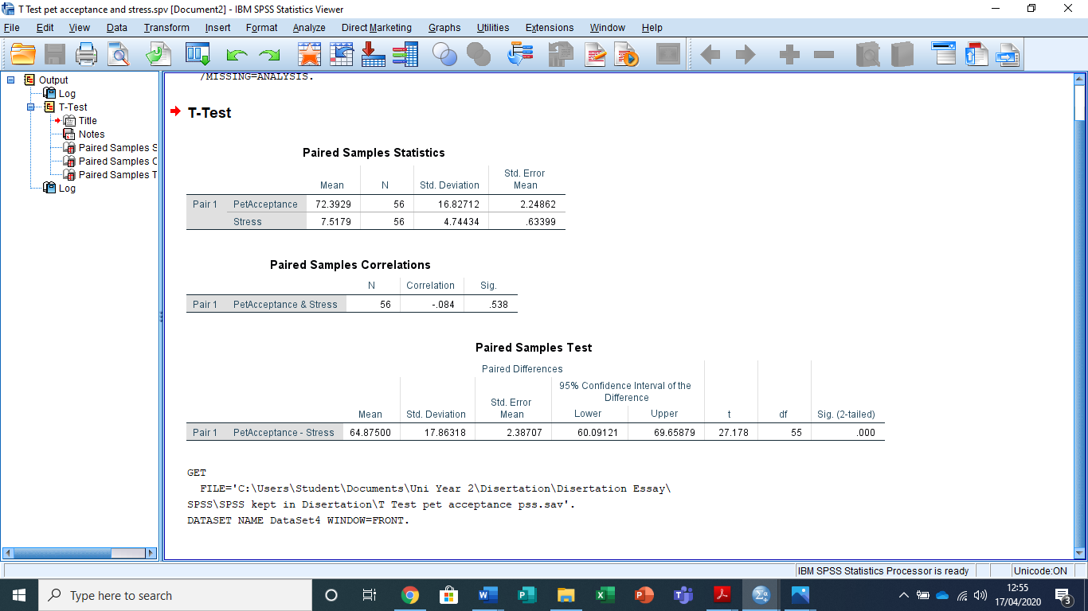
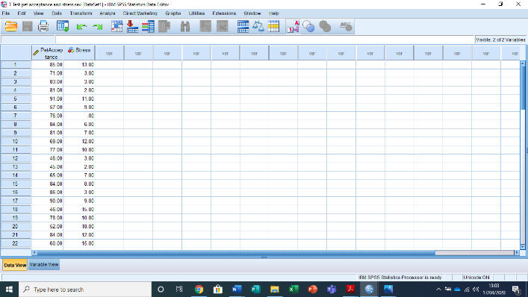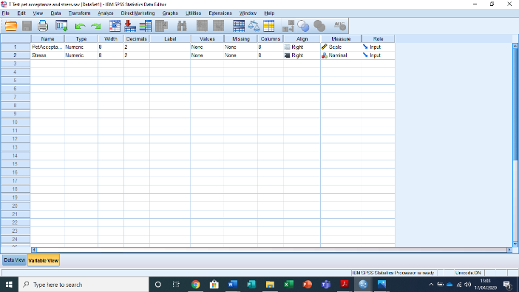

Appendix F: Pet Acceptance and Perceived Stress: t-test

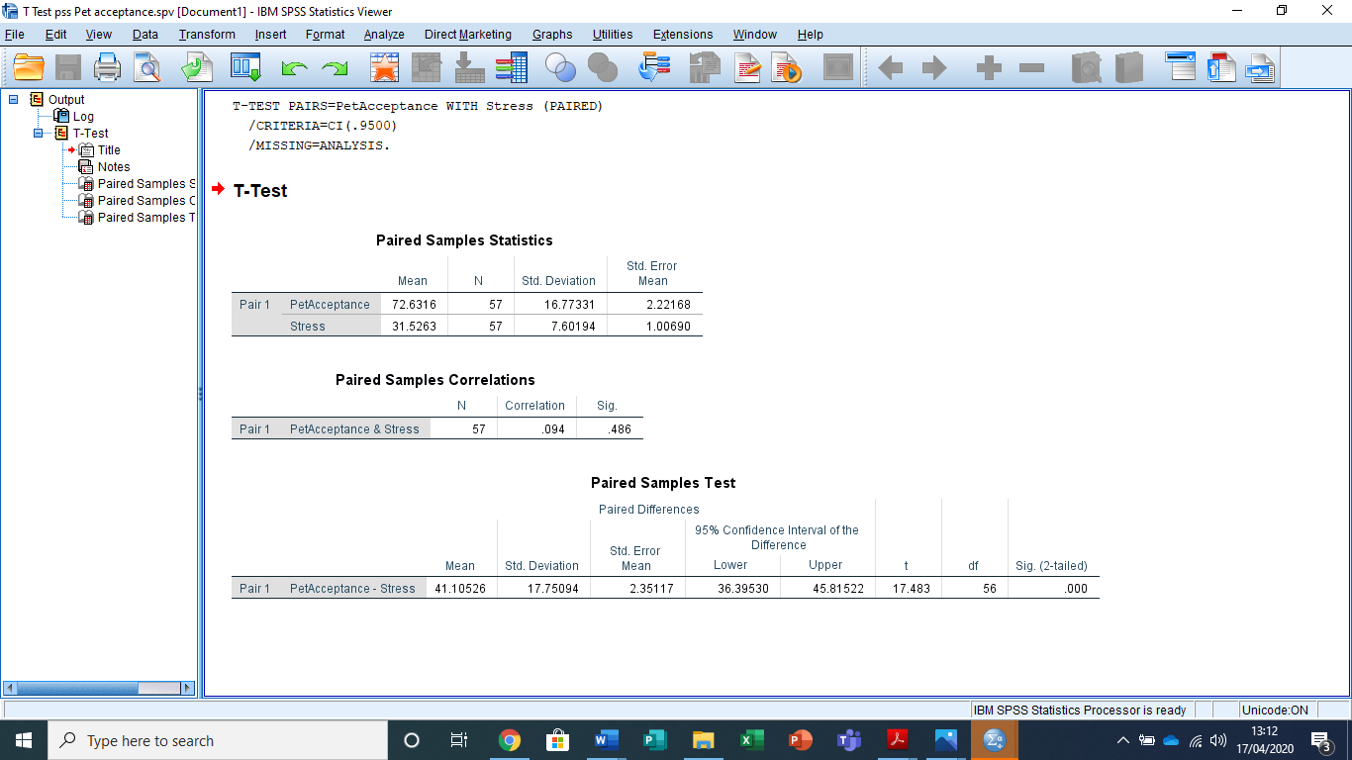
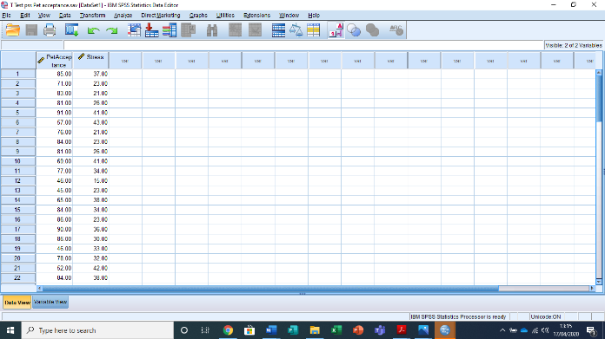

Appendix G: Correlation Between Perceived Stress, Positive/Negative Emotions and Psychological Stress/Arousal Pre-Therapy Dog Interaction
Pearson’s r: parametric test of correlation

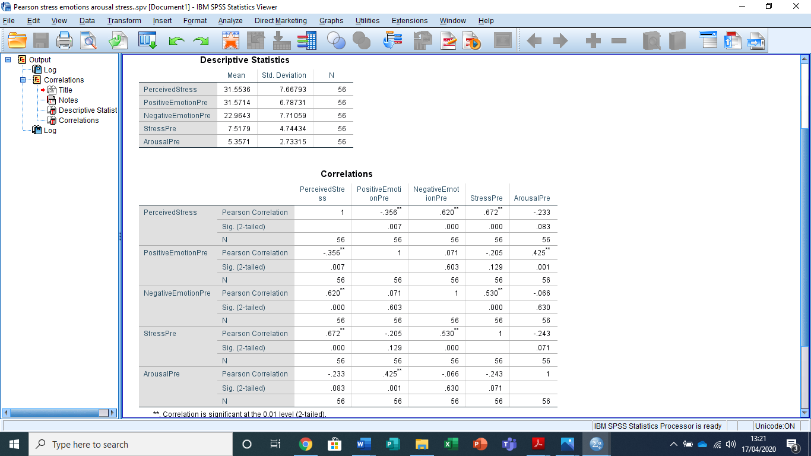
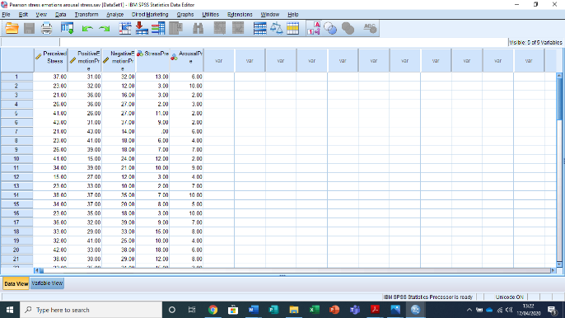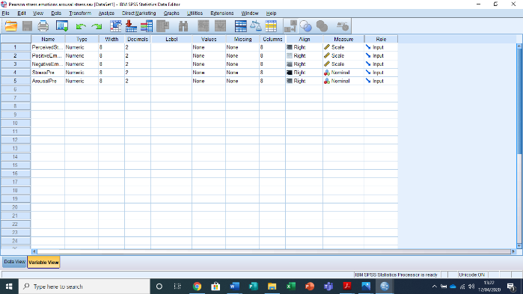

Appendix H: Positive and Negative Emotion Pre and Post-Therapy Dog Interaction: t-test
Negative Emotion

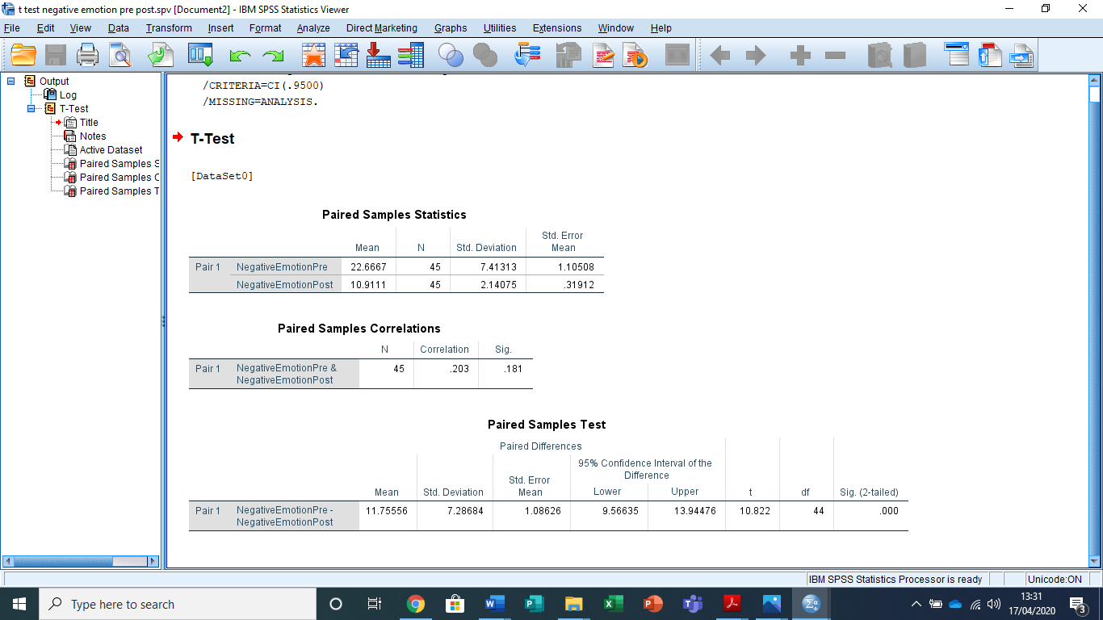
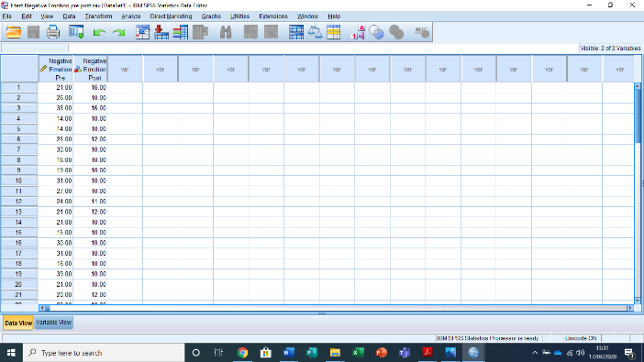

Appendix I: Positive and Negative Emotion Pre and Post-Therapy Dog Interaction: t-test
Positive Emotion

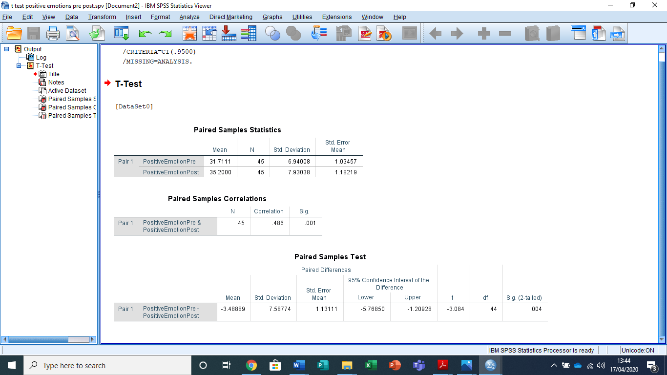
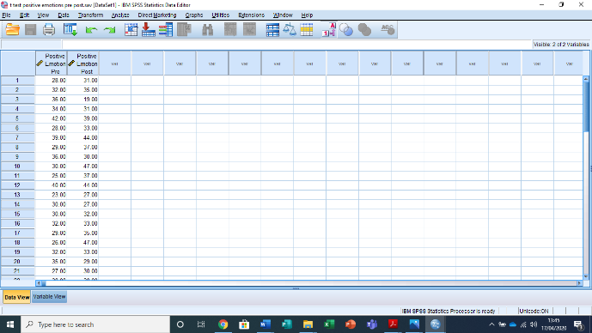

Appendix J: Positive and Negative Emotion Pre and Post-Therapy Dog Interaction: 2x2 ANOVA

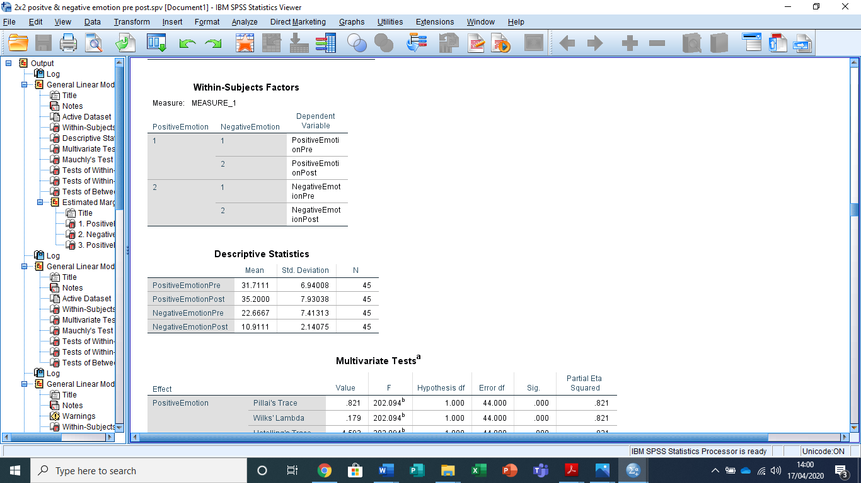
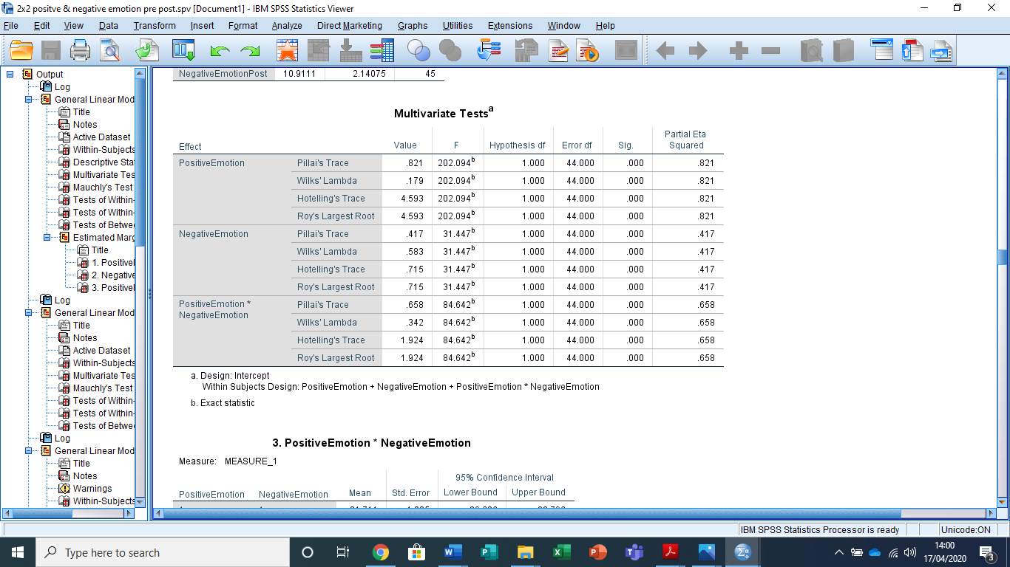
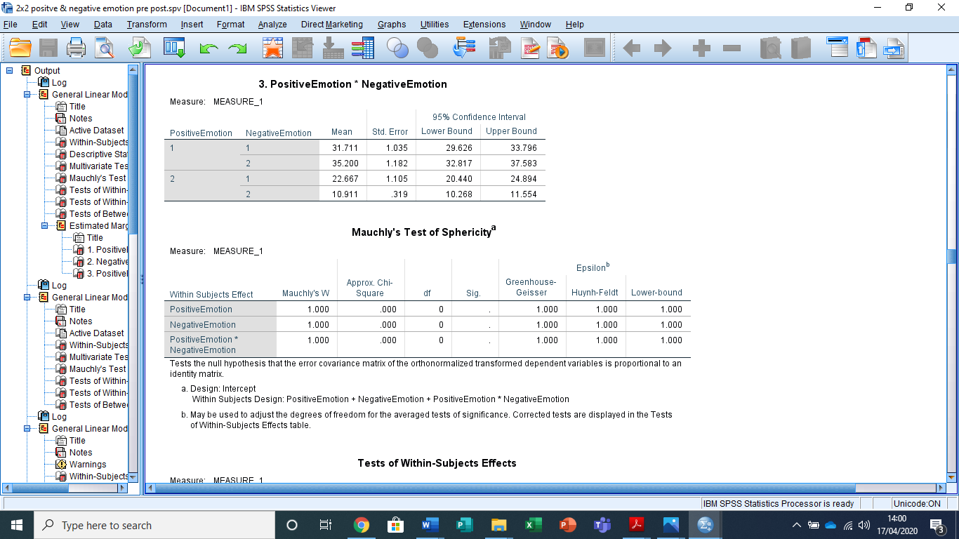
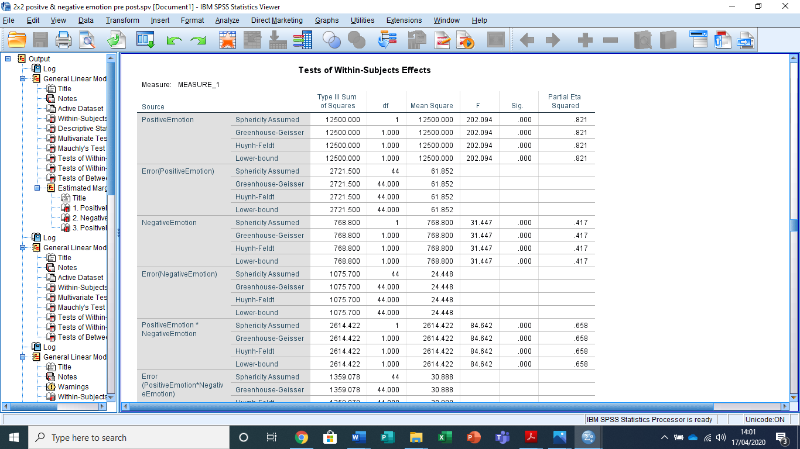
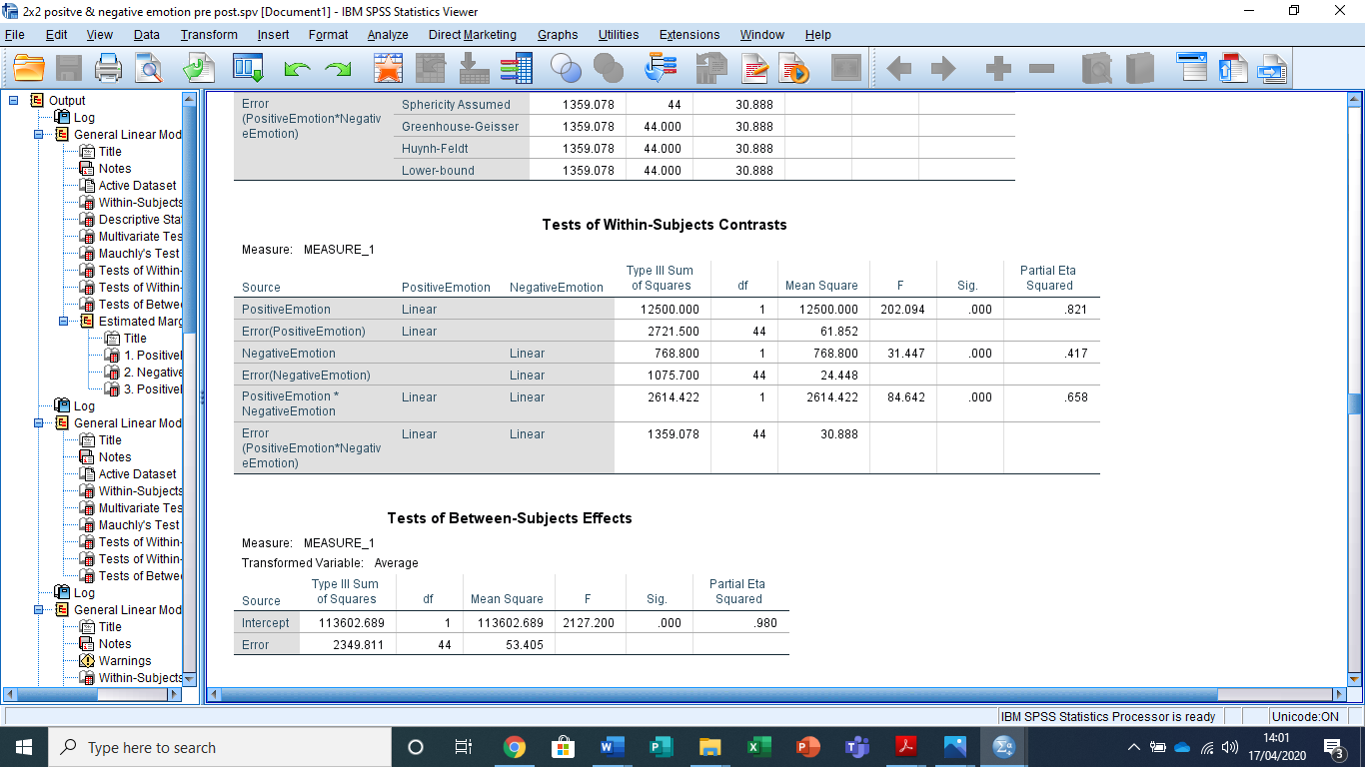
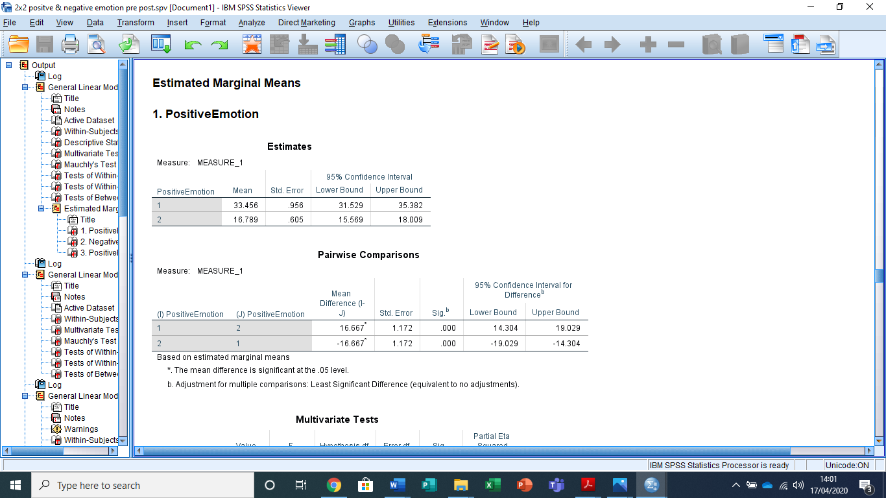
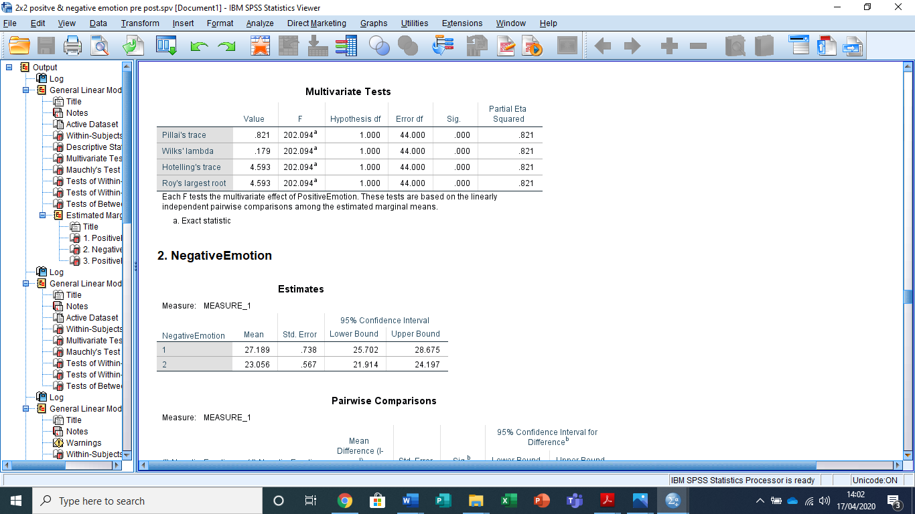
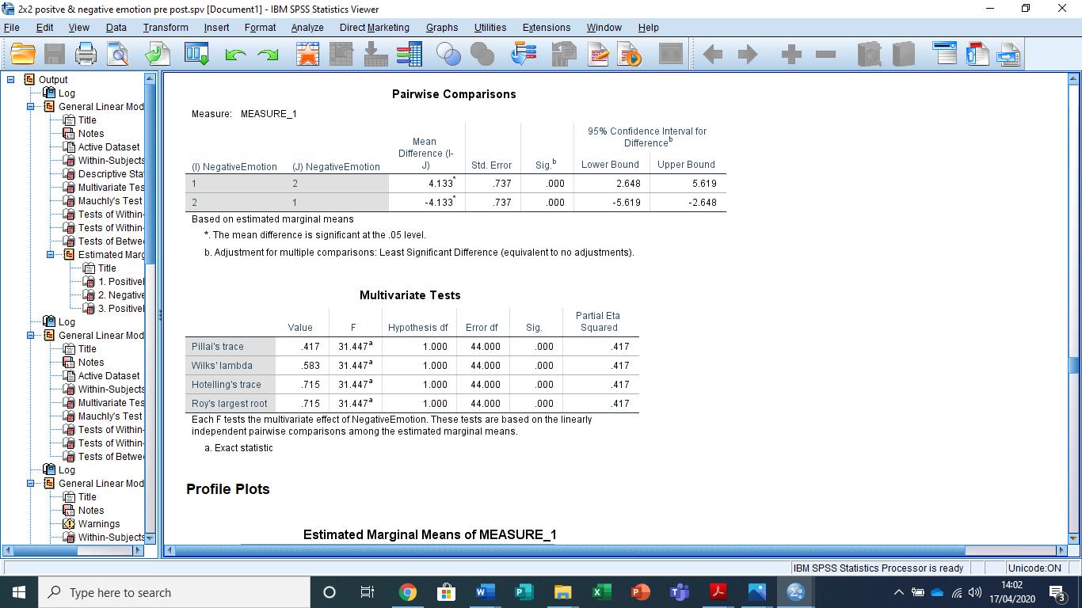
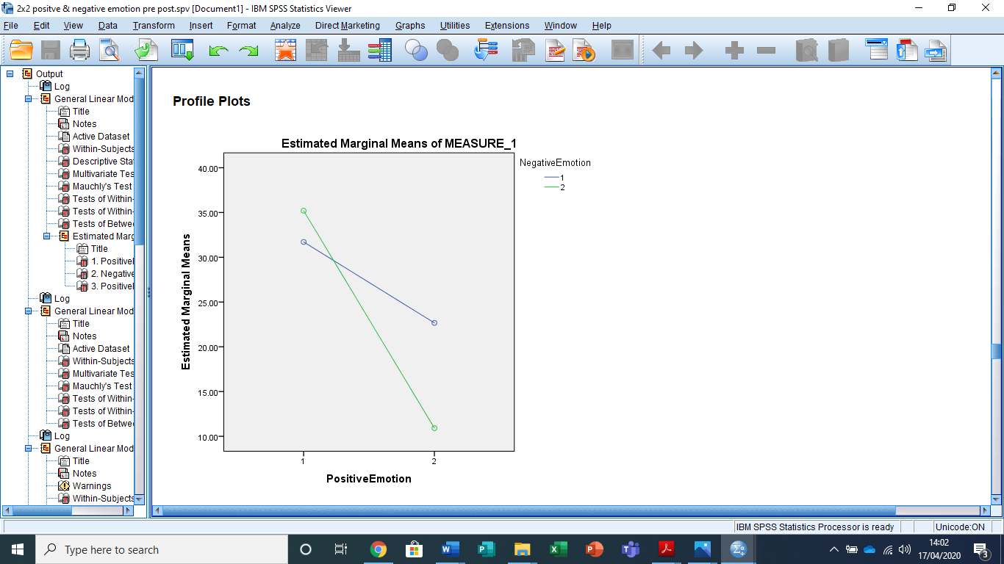
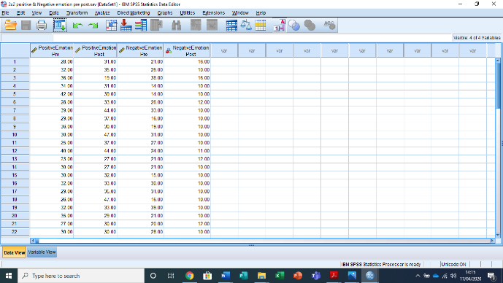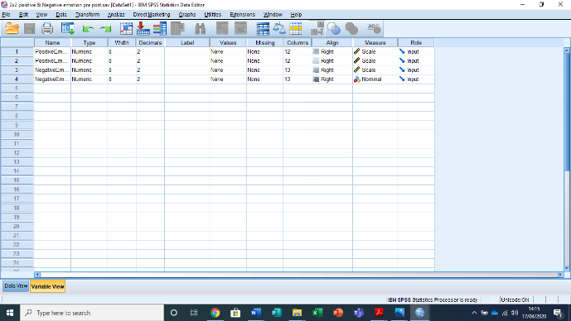

Appendix K: Psychological Stress and Arousal Pre and Post Therapy: t-test
Arousal

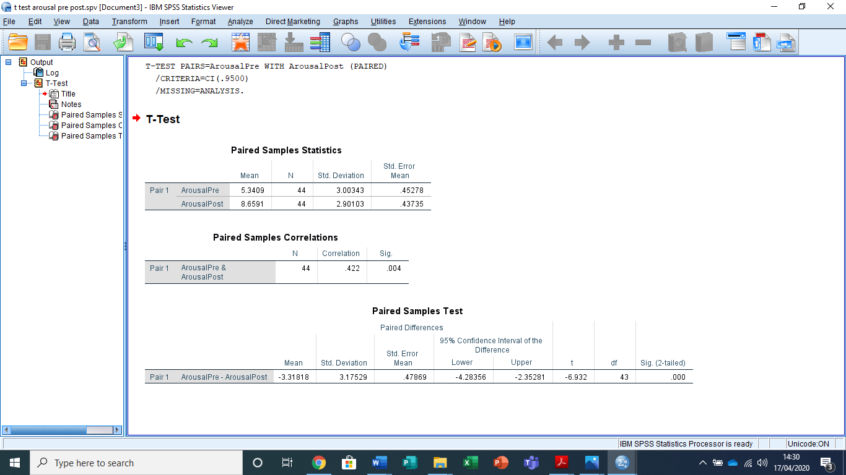
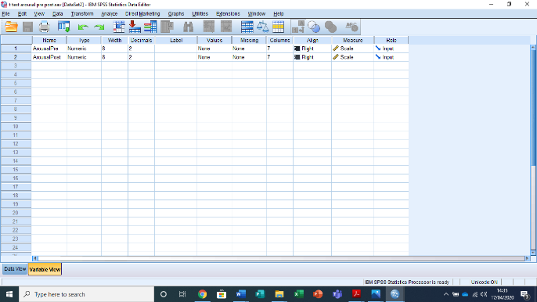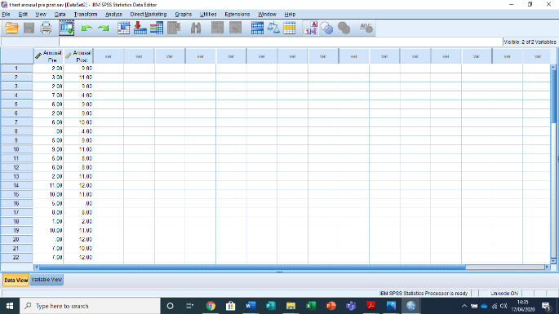

Appendix L: Psychological Stress and Arousal Pre and Post Therapy: t-test
Stress

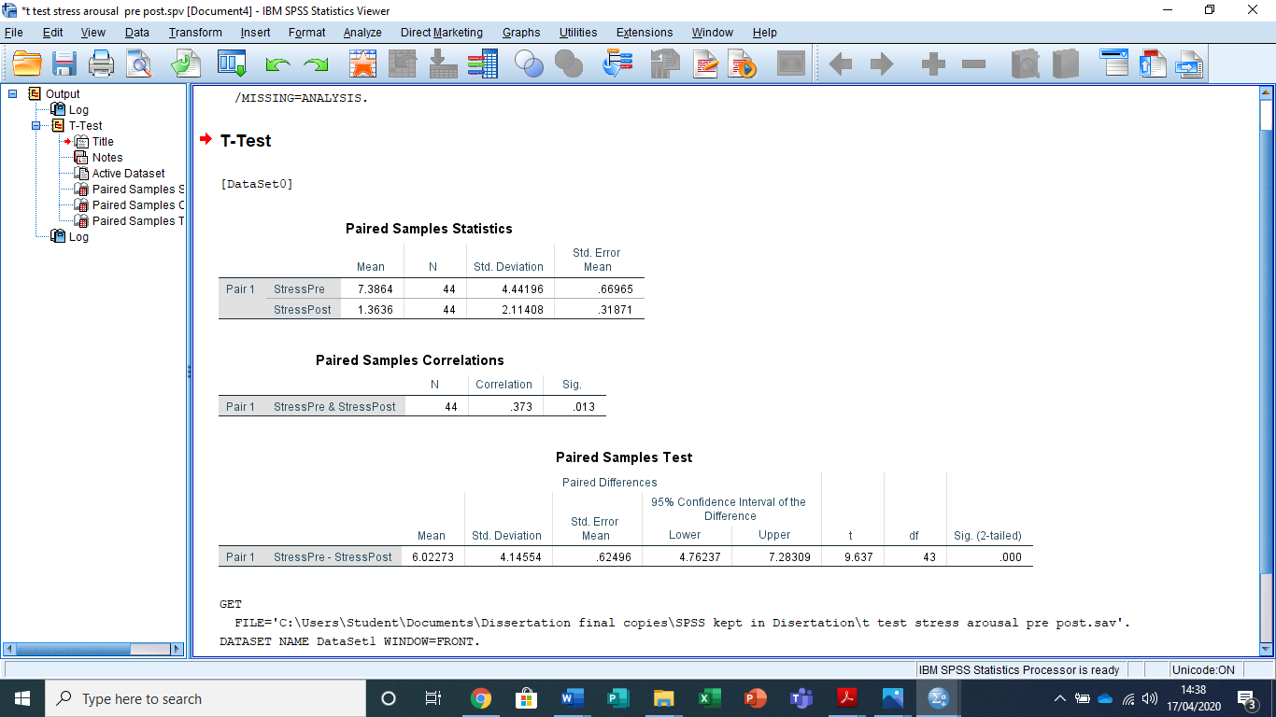

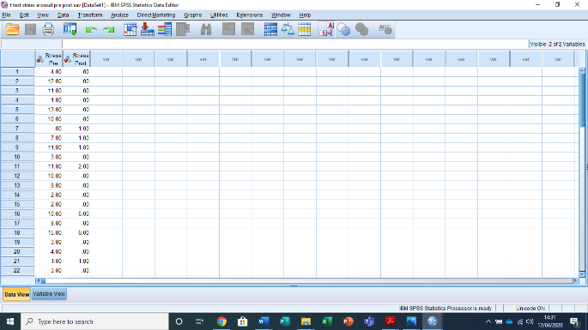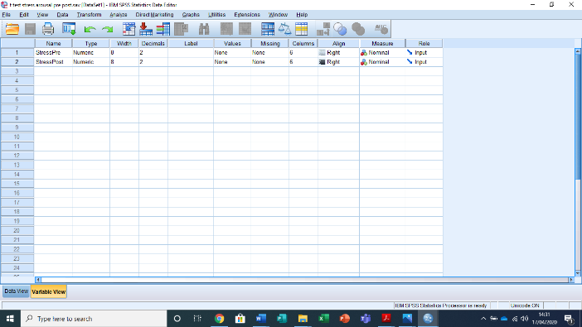

Appendix M: Psychological Stress and Arousal Pre and Post Therapy Interaction: 2x2 ANOVA

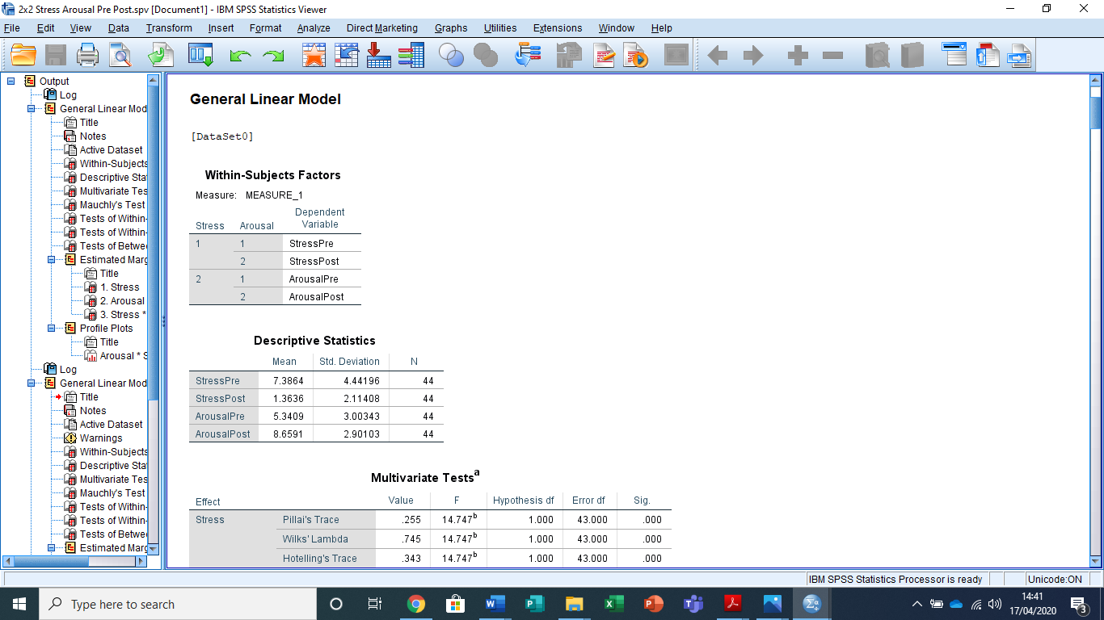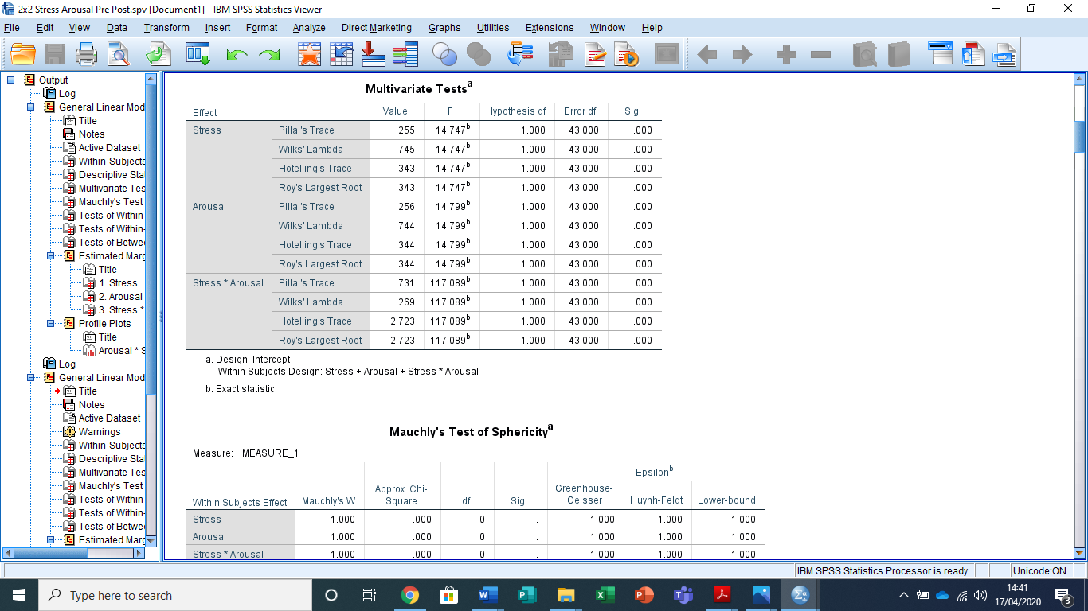
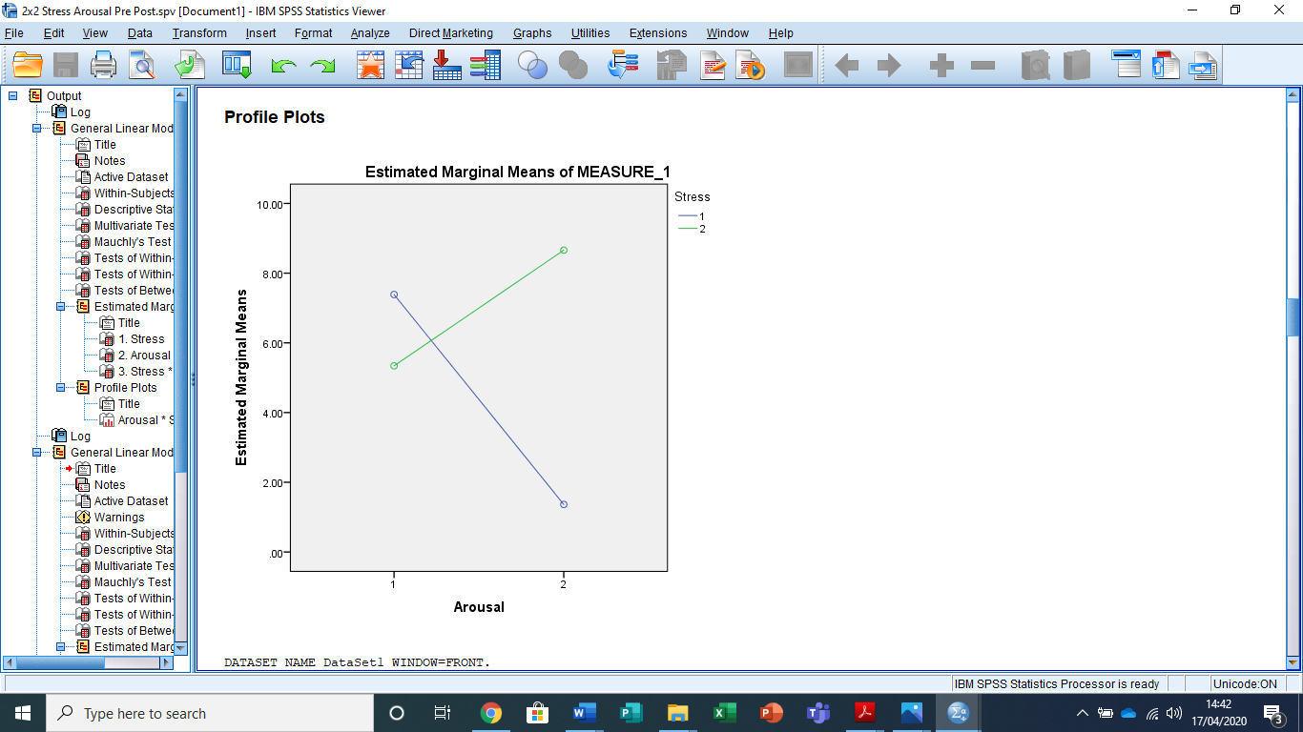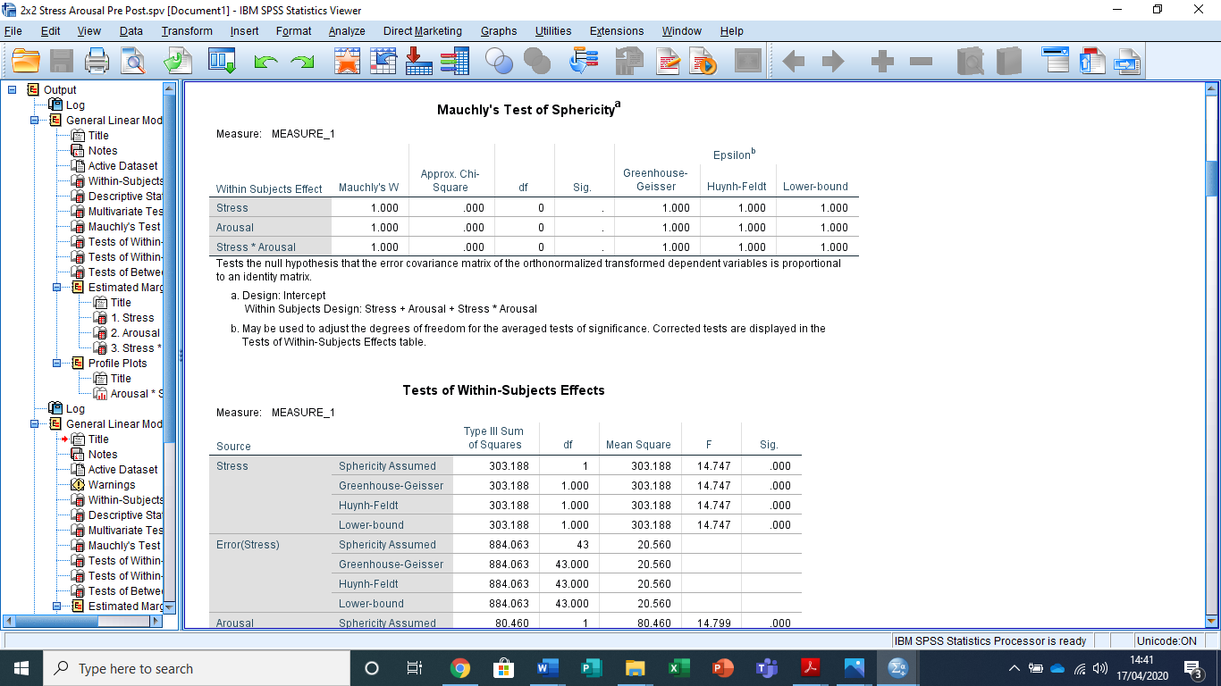
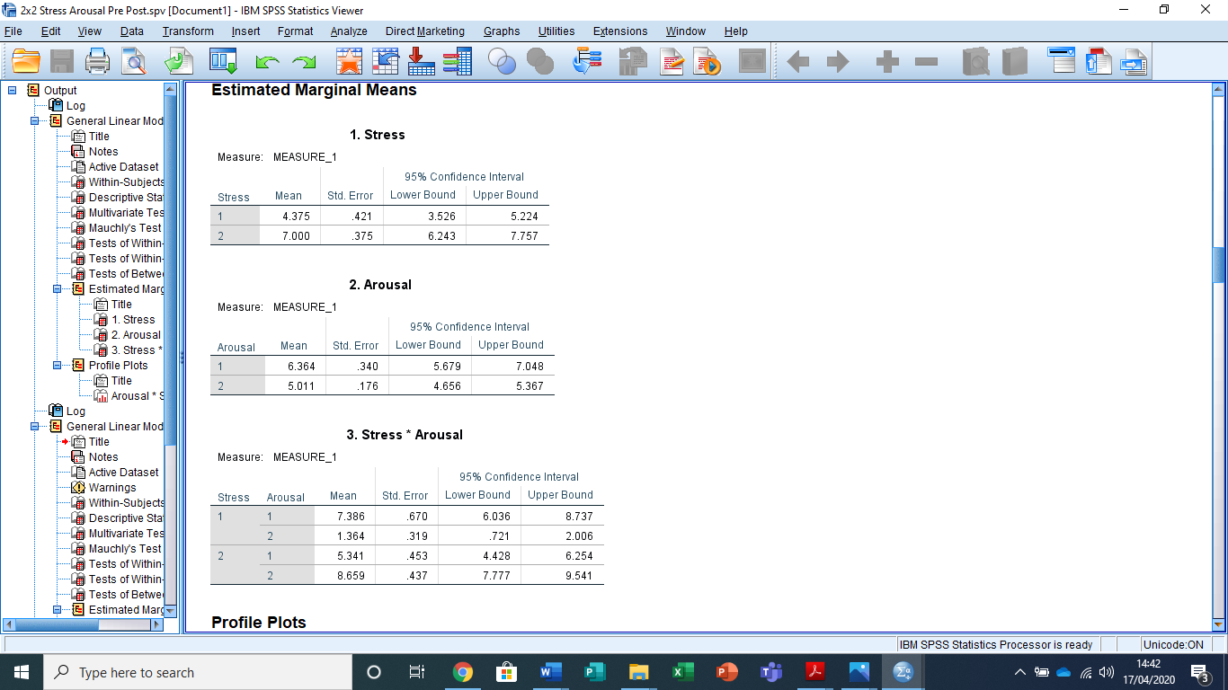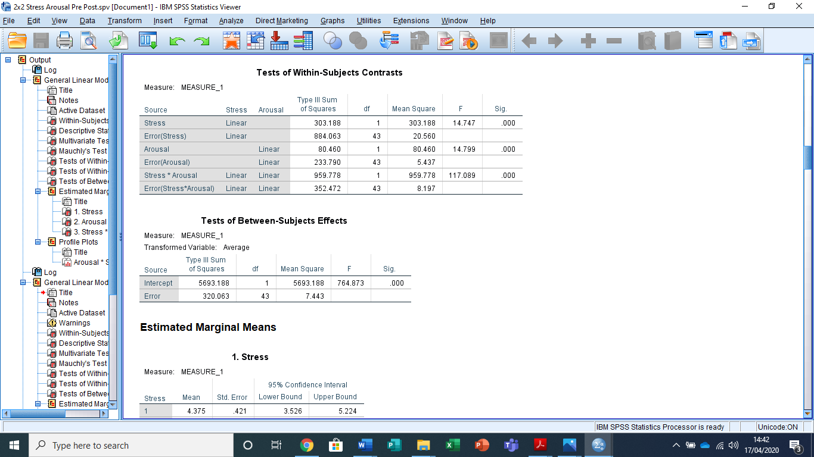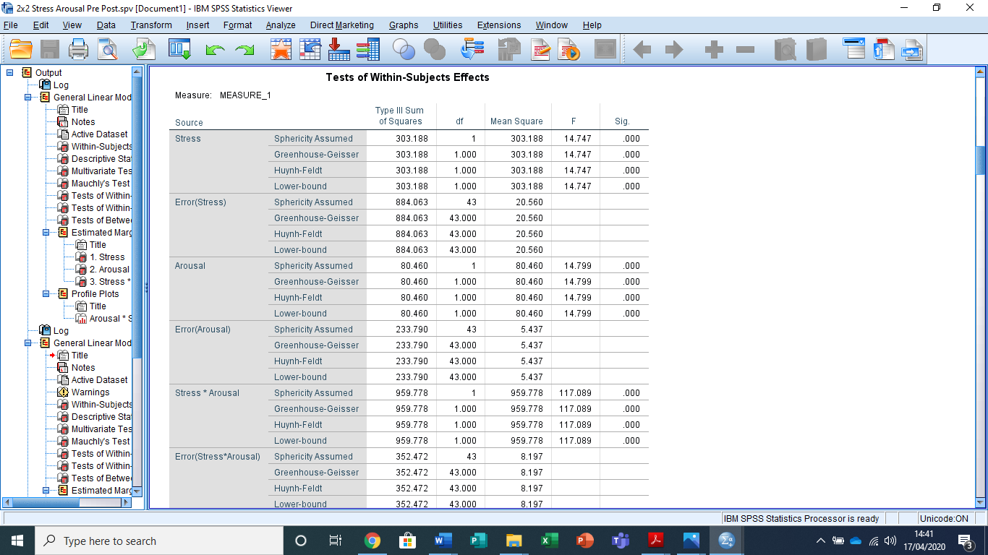

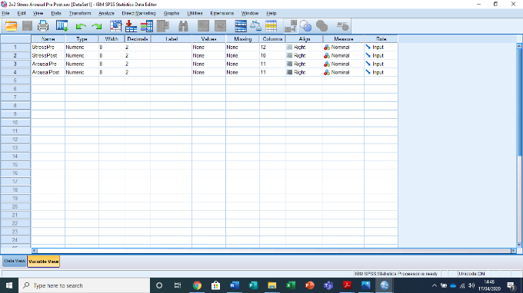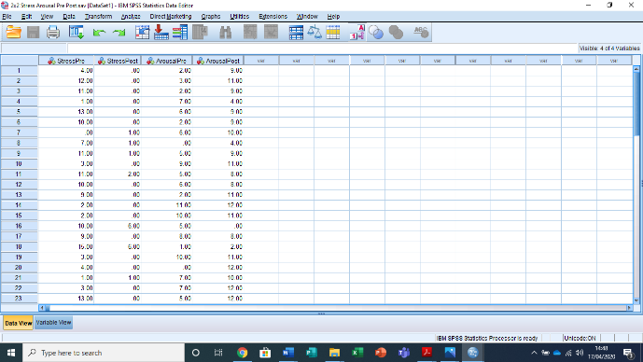

Appendix N: Students’ Perceived and Psychological Stress Between Level of Study: ANOVA
Perceived Stress

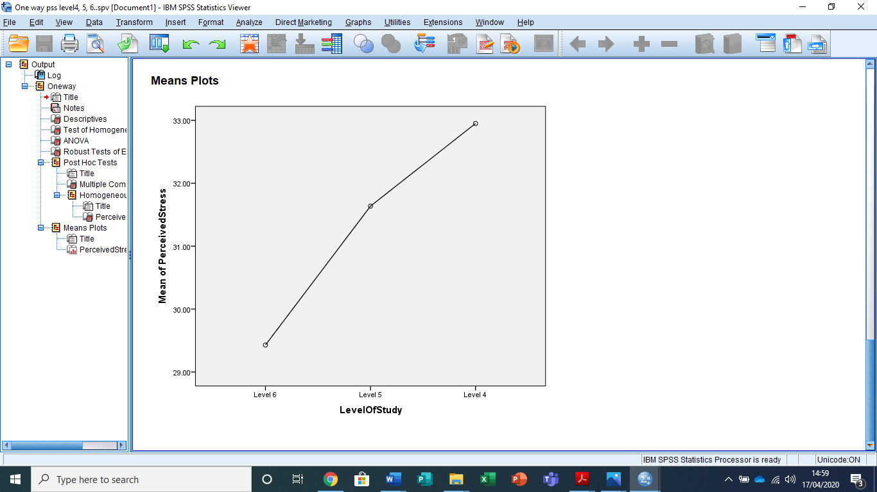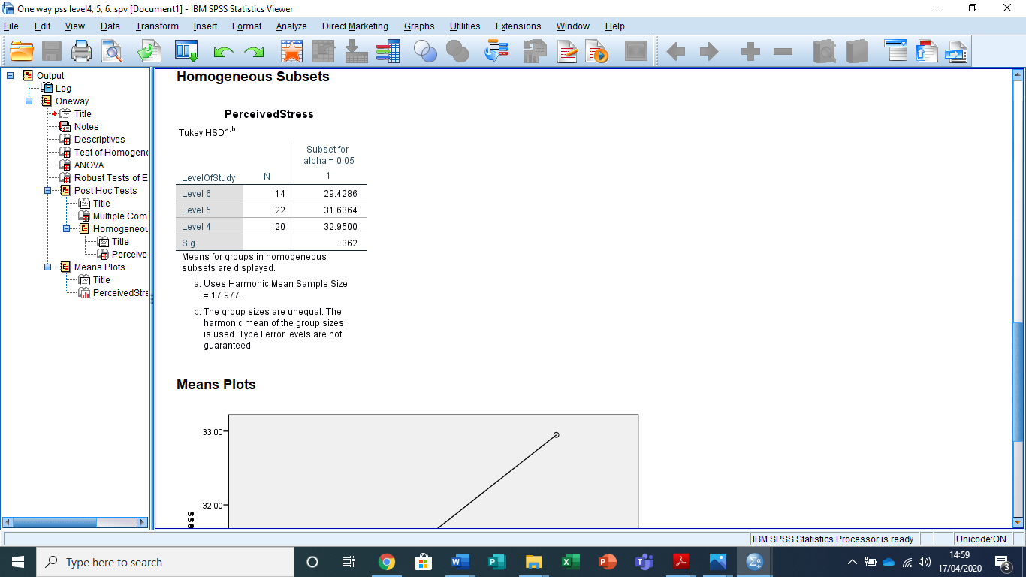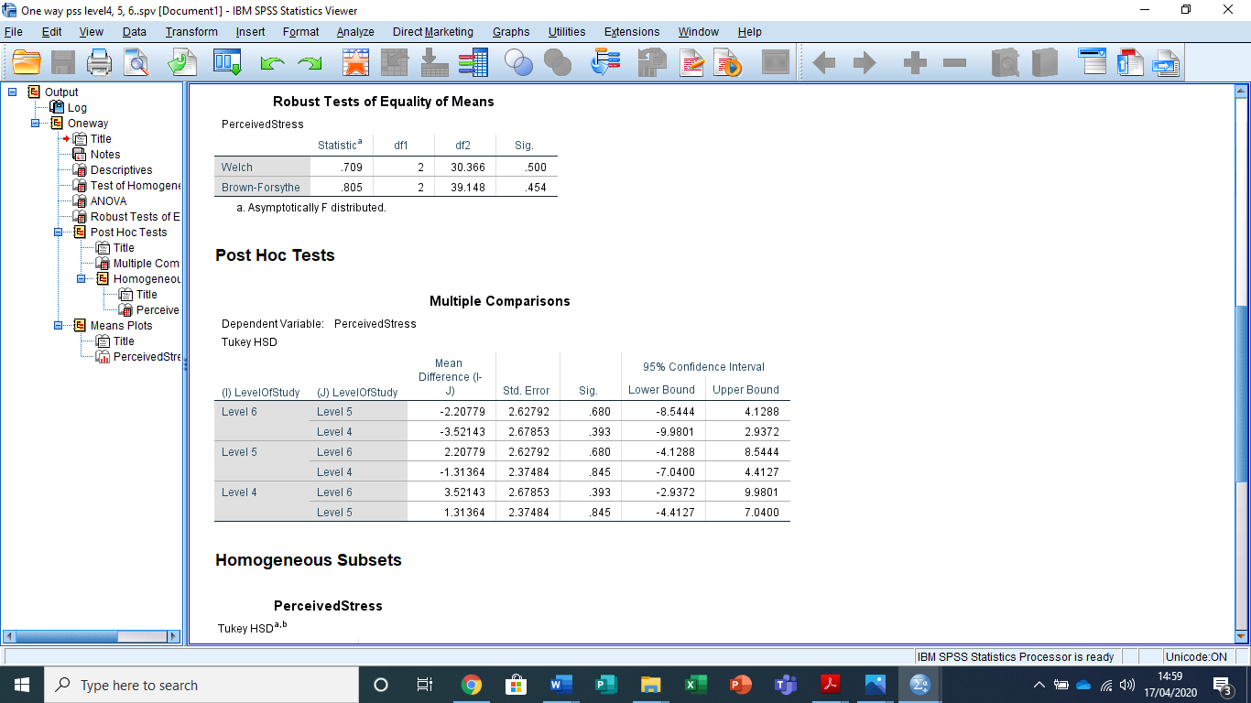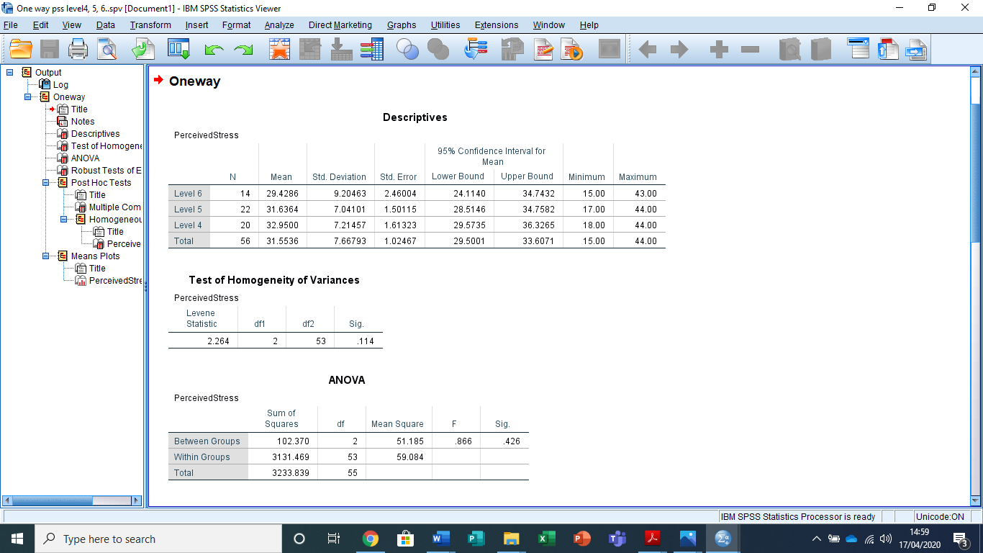
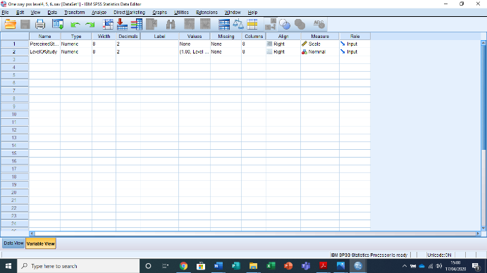

Appendix O: Students’ Perceived and Psychological Stress Between Level of Study: ANOVA
Psychological Stress

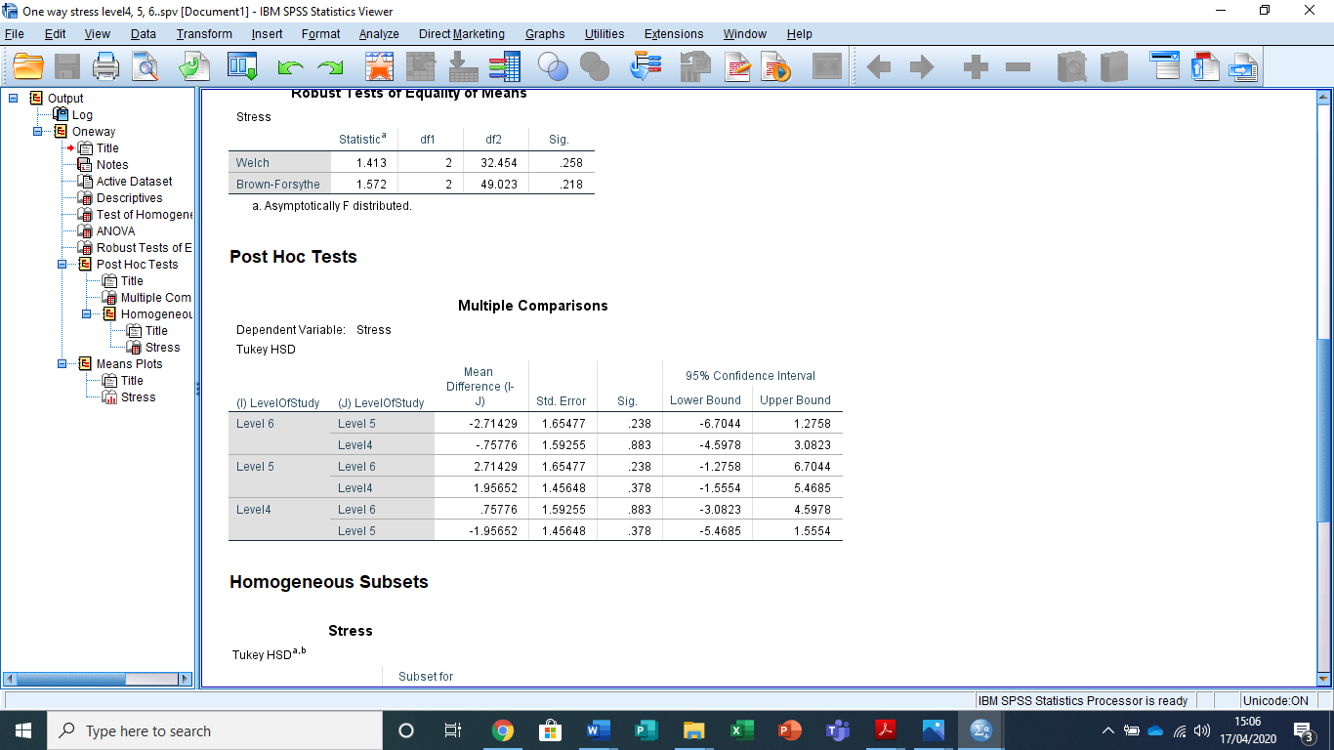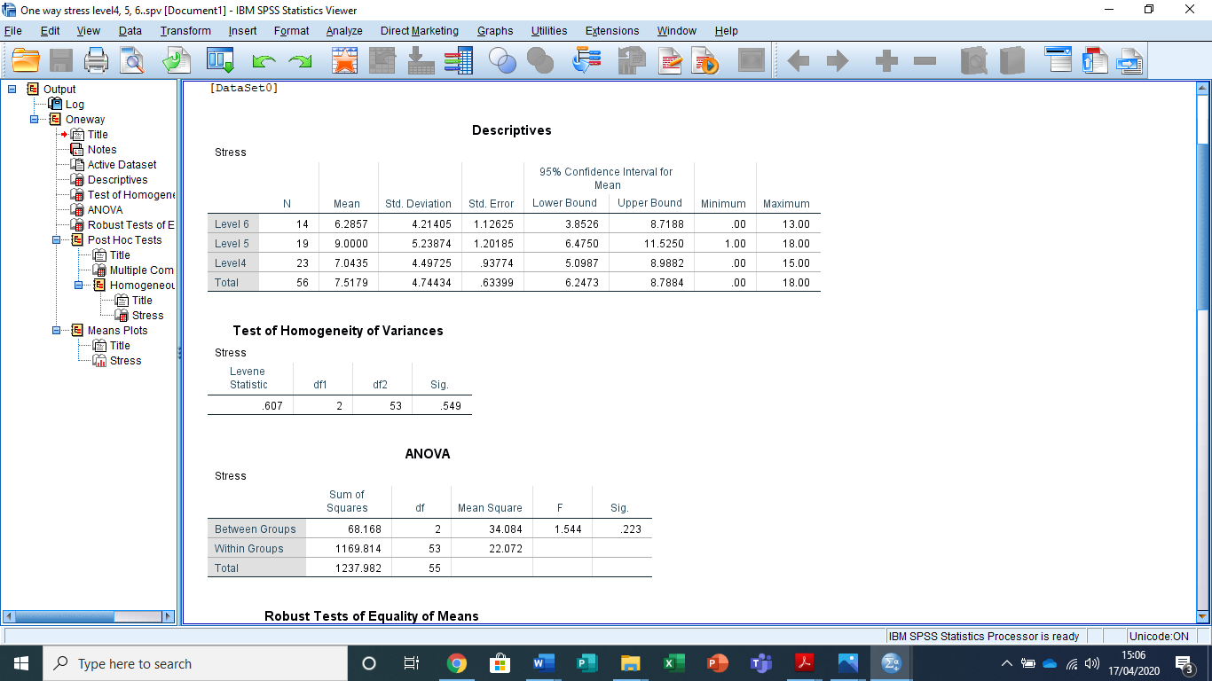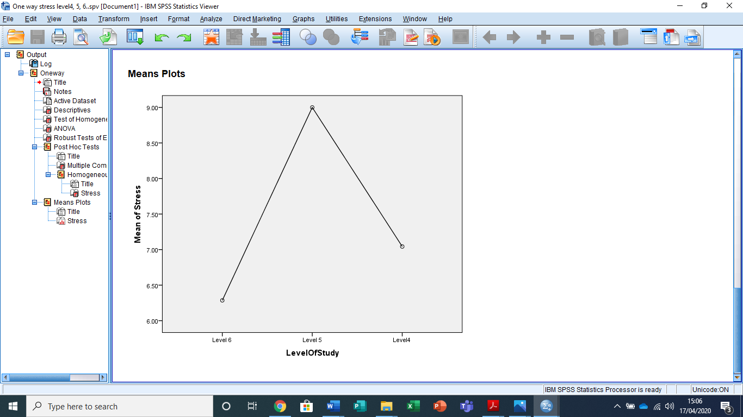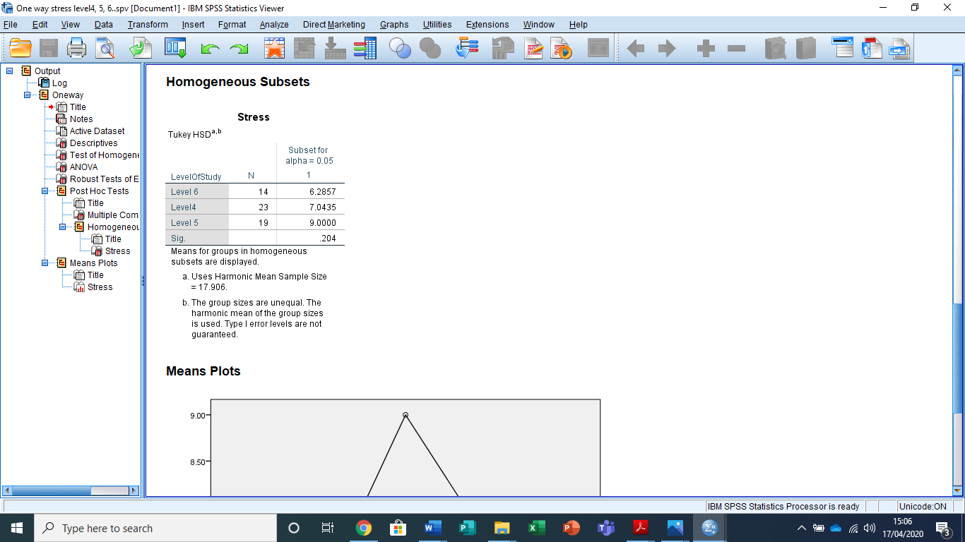

Appendix P: Consent Form.

School of Psychology
Carmarthen Campus

Study Consent Form

I understand that this research study is being carried out by a 3rd year Psychology Student for their dissertation. The study is about the effect’s animals have on perceived stress. The study is conducted in two parts. Taking part in this study will involve answering questionnaires on pet acceptance, perceived stress and will involve interacting with a dog. The questionnaires will take approximately 15 minutes to complete in part one. The second part of this experiment will involve interacting with a dog, this will be for 5 minutes. Then 5 minutes to answer two scales.
I understand that participation in this study is entirely voluntary and I am free to withdraw participation at any time without giving a reason. I am aware that if I have concerns about the study I can discuss these concerns with the researcher or academic supervisor at any time during or after the study.
I understand that the information provided by me will be held confidentially, with a code assigned in place of my name. These data will be stored indefinitely in accordance with the Data Protection Act.
I also understand that at the end of the study I will be provided with a debrief form and the opportunity to discuss any issues with the researchers.

I, ___________________________________( NAME) consent to participate in the study conducted by [student], School of Psychology, University of Wales Trinity Saint David, Swansea under the supervision of [ supervisor]

Participant Signature:________________________________________________
Date:___________________

Name and signature of researcher taking consent

Appendix Q: Debrief Form.

School of Psychology
Carmarthen Campus

Debrief Form

Title of study: Pushing Paws on Student Stress: Effects of Animal Assisted Therapy on stress, arousal and emotion.

Thank you for taking part in my research.
The purpose of this study is to look at the effects of interacting with a therapy dog after lectures, has on levels of perceived stress, arousal and positive emotion. This study builds on the existing research that has highlighted that interacting with a therapy dog has a positive effect on reducing student stress. Reducing stress in the student population can help with student wellbeing and reduce the need for counselling support, in turn, relieving pressure on university resources and promoting positive student wellbeing. Studies have supported the notion that dogs decrease stress and improve cognitive performance (Halm, 2008).
The data collected in this study will remain anonymous and will be used as part of my final dissertation. If you have concerns about this research or feel affected by issues raised, you can contact the study supervisor Dr Stuart Jones at the Carmarthen Campus Trinity St David. Alternatively, counselling services within the university may be able offer support.
https://www.uwtsd.ac.uk/counselling/

If you have any questions about this research, you can contact me via email 1704051@student.uwtsd.ac.uk or my supervisor S.AJones@uwtsd.ac.uk.

Appendix R: Ethical Approval.

APPLICATION FOR ETHICAL APPROVAL

In order for research to result in benefit and minimise risk of harm, it must be conducted ethically. A researcher may not be covered by the University’s insurance if ethical approval has not been obtained prior to commencement.

The University follows the OECD Frascati manual definition of research activity: “creative work undertaken on a systematic basis in order to increase the stock of knowledge, including knowledge of man, culture and society, and the use of this stock of knowledge to devise new applications”. As such this covers activities undertaken by members of staff, postgraduate research students, and both taught postgraduate and undergraduate students working on dissertations/projects.

The individual undertaking the research activity is known as the “principal researcher”.

Ethical approval is not required for routine audits, performance reviews, quality assurance studies, testing within normal educational requirements, and literary or artistic criticism.

Please read the notes for guidance before completing ALL sections of the form.

This form must be completed and approved prior to undertaking any research activity. Please see Checklist for details of process for different categories of application.

Delete the Guidance Notes at the end of the form BEFORE submitting your application

SECTION A: About You (Principal Researcher)
Full Name: |  | Michaela Paterson
Tick all boxes which apply: |  | Member of staff: | ☐ | Honorary research fellow: | ☐
Undergraduate Student | ☒ | Taught Postgraduate Student | ☐ | Postgraduate Research Student | ☐

Faculty/School/Centre: | Psychology
Campus: | Carmarthen
E-mail address: | 1704051@student.uwtsd.ac.uk
Contact Telephone Number:
For students:
Student Number: | 1704051
Programme of Study: | Applied Psychology
Director of Studies/Supervisor: | Dr Stuart Jones

SECTION B: Approval for Research Activity
Has the research activity received approval in principle?  (please check the Guidance Notes as to the appropriate approval process for different levels of research by different categories of individual) |  | YES | ☒ | NO | ☐
 |  |  |  | Date
If Yes, please indicate source of approval (and date where known): Approval in principle must be obtained from the relevant source prior to seeking ethical approval | Research Degrees Committee |  | ☐
 | Faculty Research Committee |  | ☐
 | Other (write in)  Dr Stuart Jones |  | ☒ | July 2019

SECTION C: Internal and External Ethical Guidance Materials
Please list the core ethical guidance documents that have been referred to during the completion of this form (including any discipline-specific codes of research ethics, and also any specific ethical guidance relating to the proposed methodology). Please tick to confirm that your research proposal adheres to these codes and guidelines.
UWTSD Research Ethics & Integrity Code of Practice 2017-2020. | ☒
UWTSD Research Data Management Policy | ☒
BPS Code of Ethics and Conduct 2018  BPS Guidelines for Psychologists Working with Animals 2012  BPS Code of Human Research Ethics 2014 | ☒

SECTION D: External Collaborative Research Activity
Does the research activity involve collaborators outside of the University? |  | YES | ☐ | NO | ☒
If Yes, please provide the name of the external organisation and name and contact details for the main contact person and confirmation this person has consented to their personal data being shared.as part of this collaboration.
Institution | N/A
Contact person name | N/A
Contact person e-mail address | N/A
Has this individual consented to sharing their details on this form? |  | YES | ☐ | NO |  |  | ☒
Are you in receipt of a KESS scholarship? |  | YES | ☐ | NO |  |  | ☒
Is your research externally funded |  | YES | ☐ | NO |  |  | ☒
Are you specifically employed to undertake this research in either a paid or voluntary capacity? | Voluntary | YES | ☐ | NO |  | ☒
 | Employed | YES | ☐ | NO |  | ☒
Is the research being undertaken within an existing UWTSD Athrofa Professional Learning Partnership (APLP) | If YES then the permission question below does not need to be answered. | YES | ☐ | NO |  |  | ☒
Permission to undertake the research has been provided by the partner organisation | (If YES attach copy)  If NO the application cannot continue | YES | ☐ | NO |  |  | ☒

Where research activity is carried out in collaboration with an external organisation
Does this organisation have its own ethics approval system? | YES | ☐ | NO | ☒
If Yes, please attach a copy of any final approval (or interim approval) from the organisation

SECTION E: Details of Research Activity
Indicative title: | Pushing Paws on Student Stress: The effects of therapy dog interaction on student stress.
Proposed start date: | November 2019 | Proposed end date: | 27th March 2019
Introduction to the Research (maximum 300 words)
Ensure that you write for a Non-Specialist Audience when outlining your response to the three points below:
- Purpose of Research Activity
- Proposed Research Question
- Aims of Research Activity
- Objectives of Research Activity
Demonstrate, briefly, how Existing Research has informed the proposed activity and explain
- What the research activity will add to the body of knowledge
- How it addresses an area of importance.
Purpose of Research Activity

The purpose of the current study is to measure the effect interacting with a therapy dog has on students’ perceived stress levels. This study builds on the existing research that has highlighted that interacting with a therapy dog has a positive effect on reducing student stress. The current research will look at perceived stress of first-, second- and third-year university students’ pre and post interaction with a therapy dog, and, whether the interaction has a positive effect on student stress. Reducing stress in the student population can help with student wellbeing and reduce the need for counselling support, relieving pressure on university resources and promoting positive student wellbeing. Studies have supported the notion that dogs decrease stress and improve cognitive performance (Halm, 2008).

Studies have shown interacting with a therapy dog lowers perceived stress and has a relaxing effect on students when introduced into the learning environment (Jalongo, Astorino, & Bomboy, 2004). An interaction for as little as 5 minutes can lower physiological symptoms associated with stress (Barker, Knisely, McCain & Best, 2005; Barker, Knisely, McCain, Schubert & Pandurangi, 2010; Odendaal & Meintjes, 2003).

(this box should expand as you type)
Research Question

Does interacting with a therapy dog act as a buffer to reducing stress and increase arousal and positive emotion in undergraduate students?

Hypotheses:: -
Interacting with a therapy dog will:-

1) Act as a buffer in reducing stress in undergraduate students.

2) Have a positive effect on the endorsement of the positive/negative emotion. (PANAS)

3) Have a positive effect on stress and arousal. (SACL)

Additional Hypotheses:-

4) Students who have a companion pet at home will have lower perceived stress.

5) First year students will have higher perceived stress than second and third-year students.

(this box should expand as you type)
Aims of Research Activity

The aim of this study is to examine if the presence of a therapy dog in the learning environment can have a buffering effect on self-reported / perceived stress and the endorsement of the positive and negative emotion. The aim is to measure stress levels pre and post interaction with a therapy dog. By doing this the current study will build on the body of existing evidence that suggests interacting with a therapy dog has a positive effect on reducing stress.

Mental Illness and distress are increasing among students in higher education. Increased risk of experiencing lower wellbeing can be related to academic pressures, this is evident in the high number of students reporting mental distress. 94% of universities have experienced an increase in students seeking counselling support (Institute for Public Policy Research, 2017). High stress levels in undergraduate students is pervasive and has been linked to anxiety and depression (Bayram, Bilgel, 2008).

It is important to examine methods of reducing stress levels in undergraduate students as this population is increasingly reporting mental distress and seeking counselling support. Furthermore, high levels of stress have been found to impair learning, memory and cognition. By introducing a therapy dog into the learning environment to act as a buffer to academic stressors can be beneficial in reducing stress in the academic setting, and, reducing the detrimental effects stress can have on cognition, learning and health outcomes.

(this box should expand as you type)
Objectives of Research Activity

- To determine whether interacting with a therapy dog for short periods of time (5 minutes) will benefit students by helping to reduce stress during academic study.

- Test the efficacy of the interaction in reducing student stress.

- If predictions are supported the current study will help aid universities in developing and implementing further strategies to help reduce student stress and promote positive student wellbeing.

(this box should expand as you type)
Proposed methods (maximum 600 words)
Provide a brief summary of all the methods that may be used in the research activity, making it clear what specific techniques may be used. If methods other than those listed in this section are deemed appropriate later, additional ethical approval for those methods will be needed.
A mixed subjects design within/between groups will be used.

Participants are undergraduate students studying psychology at a university in West Wales. The study group is of mixed gender, over the age of 18yrs and capable of giving consent. The study will be carried out with level 4,5 & 6 students. It is estimated that between 60-80 students will take part.

The experiment will be conducted in two parts. Participants will be briefed that participation is completely voluntary and they may withdraw at any time.

Part 1. Questionnaires (see questionnaires/scales) will be presented to participants pre interaction with the therapy dog. Pre intervention questionnaires will be filled out at the beginning of lectures.

Upon completion of the questionnaires, Participants will be briefed and invited to partake in the second part of the experiment.

Part 2. Interaction with the therapy dog. Participants will be asked to sit quietly with the therapy dog for 5 minutes, participants are encouraged to interact and stroke the dog in a calm manner. At the end of the 5 minute interaction participants will be asked to complete questionnaires (see questionnaires/scales).

The time allocated to each participant will be 10 minutes:
- Interaction time with the therapy dog will be 5 minutes.
- 5 minutes is then allocated to the participant to fill out the questionnaires, allowing the dog a break between participants.

The therapy dog will see a maximum of 12 participants in any session. The study will be spread over 4/5 weeks and each session will be no longer than two hours within a 24 hour period, this ensures the therapy dog is not overwhelmed. The study will take place during the first and second semester in a private room that has been allocated for the experiment.

Questionnaires/Scales.

Perceived stress and acceptance of pets will be measured at the beginning of the experiment using the Perceived Stress Scale (PSS) (Cohen, Kamarck & Mermelstein, 1983) and the Lexington Attachment to Pets Scale (LAPS) (Johnson, Garrity & Stallones, 1992).The PSS scale is a 5-point likert scale consisting of 14 questions that asks the participant about their feelings and thoughts in the past month. The LAPS is a 5-point likert scale with 23 questions asking the level to which the participant agrees or disagrees with the statement.

Two further scales will be used pre and post intervention. The first will measure the positive and negative effect of the interaction with the therapy dog. Positive and Negative Affect Schedule (PANAS) (Watson & Tellegen, 1988). The PANAS is a 5-point likert scale with two factors - 10 positive and 10 negative adjectives that describe emotions and feelings. Participants are asked to indicate the extent to how they feel, e.g. Not at all, slightly, quite a bit. The second scale measures stress and arousal pre and post interaction with the therapy dog. Stress - Arousal Checklist (SACL) (Mackay, Cox, Burrows & Lazzerini, 1978). The SACL has 34 adjectives with 2 factors, stress and arousal. The participant is asked how the word best describes their feelings and mood in the moment, e.g., definitely yes, not sure.

Results and Analysis.

This is a quantitative study. To measure hypotheses 1-3 two independent measures 2x2 ANOVA’s will be conducted. 1) The effect the interaction with a therapy dog has on the endorsement of the positive and negative emotions (PANAS), and 2) The effect the interaction with the therapy dog has on stress and arousal (SACL).

To measure hypotheses 4-5 two unrelated t-test’s will be conducted to measure the differences of stress levels between groups. 1) Companion & no companion pet, 2) first year students compared to 2nd/3rd year students.

In addition to the statistical analysis it is my intention to measure 2 further elements in this study.

1) The percentage of students that believe having a therapy dog in the learning environment would be beneficial in reducing stress.
2) Whether pet acceptance is indicative of students wanting a therapy dog in the learning environment.

(this box should expand as you type)

Location of research activity
Identify all locations where research activity will take place.
University of Wales Trinity St David, Carmarthen Campus.
(this box should expand as you type)
Research activity outside of the UK
If research activity will take place overseas, you are responsible for ensuring that local ethical considerations are complied with and that the relevant permissions are sought. Specify any local guidelines (e.g. from local professional associations/learned societies/universities) that exist and whether these involve any ethical stipulations beyond those usual in the UK (provide details of any licenses or permissions required). Also specify whether there are any specific ethical issues raised by the local context in which the research activity is taking place, for example, particular cultural and/or legal sensitivities or vulnerabilities of participants.
N/A

(this box should expand as you type)
Use of documentation not in the public domain: Are any documents NOT publicly available? | NO | ☒
 | YES | ☐
If Yes, please provide details here of how you will gain access to specific documentation that is not in the public domain and that this is in accordance with prevailing data protection law of the country in question and England and Wales.

N/A

(this box should expand as you type)

SECTION F: Scope of Research Activity
Will the research activity include: | YES | NO
Use of a questionnaire or similar research instrument? | ☒ | ☐
Use of interviews? | ☐ | ☒
Use of diaries? | ☐ | ☒
Participant observation with their knowledge? | ☐ | ☒
Participant observation without their knowledge? | ☐ | ☒
Use of video or audio recording? | ☐ | ☒
Access to personal or confidential information without the participants’ specific consent? | ☐ | ☒
Administration of any questions, test stimuli, presentation that may be experienced as physically, mentally or emotionally harmful / offensive? | ☐ | ☒
Performance of any acts which may cause embarrassment or affect self-esteem? | ☐ | ☒
Investigation of participants involved in illegal activities? | ☐ | ☒
Use of procedures that involve deception? | ☐ | ☒
Administration of any substance, agent or placebo? | ☐ | ☒
Working with live vertebrate animals? | ☒ | ☐
Other primary data collection methods, please explain in this box  For example, ‘focus groups’. Please indicate the type of data collection method(s) in this box and tick the accompany box. | ☐ | ☒
Details of any other primary data collection method:  N/A  (this box should expand as you type) | ☐ | ☒
If NO to every question, then the research activity is (ethically) low risk and may be exempt from some of the following sections (please refer to Guidance Notes).

If YES to any question, then no research activity should be undertaken until full ethical approval has been obtained.

SECTION G: Intended Participants
Who are the intended participants: | YES | NO
Students or staff at the University? | ☒ | ☐
Adults (over the age of 18 and competent to give consent)? | ☒ | ☐
Vulnerable adults? | ☐ | ☒
Children and Young People under the age of 18? (Consent from Parent, Carer or Guardian will be required) | ☐ | ☒
Prisoners? | ☐ | ☒
Young offenders? | ☐ | ☒
Those who could be considered to have a particularly dependent relationship with the investigator or a gatekeeper? | ☐ | ☒
People engaged in illegal activities? | ☐ | ☒
Others (please identify specifically any group who may be unable to give consent) please indicate here and tick the appropriate box. | ☐ | ☒
Other – please indicate here:  (this box should expand as you type) | ☐ | ☒

Participant numbers and source
Provide an estimate of the expected number of participants. How will you identify participants and how will they be recruited?
How many participants are expected? | To run the experiment efficiently it is estimated that 60-80 students will take part in the experiment.  (this box should expand as you type)
Who will the participants be? | Participants are undergraduate students over the age of 18yrs, studying at The University of Wales Trinity St David, Carmarthen Campus. Participants will be studying at level 4,5 & 6.  (this box should expand as you type)
How will you identify the participants? | Participants will be approached at the beginning of lectures at the Carmarthen campus and asked if they are willing to partake in the study. The first questionnaires will be completed at the beginning of the lecture, an identification number will be given to each participant. The second part of the experiment will be a pre-arranged meeting with the therapy dog in a room within the university,  (this box should expand as you type)

Information for participants: | YES | NO | N/A
Will you describe the main research procedures to participants in advance, so that they are informed about what to expect? | ☒ | ☐ | ☐
Will you tell participants that their participation is voluntary? | ☒ | ☐ | ☐
Will you obtain written consent for participation? | ☒ | ☐ | ☐
Will you explain to participants that refusal to participate in the research will not affect their treatment or education (if relevant)? | ☒ | ☐ | ☐
If the research is observational, will you ask participants for their consent to being observed? | ☐ | ☒ | ☐
Will you tell participants that they may withdraw from the research at any time and for any reason? | ☒ | ☐ | ☐
With questionnaires, will you give participants the option of omitting questions they do not want to answer? | ☒ | ☐ | ☐
Will you tell participants that their data will be treated with full confidentiality and that, if published, it will not be identifiable as theirs? | ☒ | ☐ | ☐
Will you debrief participants at the end of their participation, in a way appropriate to the type of research undertaken? | ☒ | ☐ | ☐
If NO to any of above questions, please give an explanation
Participants involved in this study are not observed, the data is collected by way of questionnaires that ask specific questions in relation to their interaction with the therapy dog.

(this box should expand as you type)

Information for participants: | YES | NO | N/A
Will participants be paid? | ☐ | ☒ | ☐
Is specialist electrical or other equipment to be used with participants? | ☐ | ☒ | ☐
Are there any financial or other interests to the investigator or University arising from this study? | ☐ | ☒ | ☐
Will the research activity involve deliberately misleading participants in any way, or the partial or full concealment of the specific study aims? | ☐ | ☒ | ☐
If YES to any question, please provide full details
N/A

(this box should expand as you type)

SECTION H: Anticipated Risks

Outline any anticipated risks that may adversely affect any of the participants, the researchers and/or the University, and the steps that will be taken to address them.

If you have completed a full risk assessment (for example as required by a laboratory, or external research collaborator) you may append that to this form.
Full risk assessment completed and appended? |  | Yes | ☐
 |  | No | ☒
Risks to participants
For example: emotional distress, financial disclosure, physical harm, transfer of personal data, sensitive organisational information
Risk to Participant:  Some students may not be accepting of dogs.  Emotional distress. Participants may feel upset when interacting with the therapy dog, some may have pets at home that they are missing, and emotions may surface. The participant may feel the therapy dog has not reciprocated affection in the way they expected.  The dog may exhibit distress, bark, mouth the participant, pull away and react in a way that is not expected/acceptable by the participant.  (this box should expand as you type) | How will you mitigate the Risk to Participant  The researcher will ask all participants before introducing the therapy dog if they are happy to go ahead with the experiment and interact with the dog. It will be explained that participation is completely voluntary, and they have the right to withdraw from the experiment at any time.  The researcher will conduct themselves in an empathetic and professional manner so as not to cause any further distress to the participant. The researcher will inform the participant of counselling services within the university and other organisations that may offer support.  https://www.uwtsd.ac.uk/counselling/  The therapy dog attending is experienced and has not exhibited any inapropriate behaviour while interacting with patients during visitation sessions. The dog is kept on a lead, so the researcher has control of the therapy dog at all times. Should the dog exhibit behavioural distress the researcher will move the dog away from the participant to avoid any further contact. The experiment will be terminated. Only one participant will interact with the therapy dog at any given time.  The dog will be given regular breaks as the experiment can be tiring for the dog.  (this box should expand as you type)
If research activity may include sensitive, embarrassing or upsetting topics (e.g. sexual activity, drug use) or issues likely to disclose information requiring further action (e.g. criminal activity), give details of the procedures to deal with these issues, including any support/advice (e.g. helpline numbers) to be offered to participants. Note that where applicable, consent procedures should make it clear that if something potentially or actually illegal is discovered in the course of a project, it may need to be disclosed to the proper authorities
N/A

(this box should expand as you type)
Risks to investigator
For example: personal safety, physical harm, emotional distress, risk of accusation of harm/impropriety, conflict of interest
Risk to Investigator:  Some participants may behave inappropriately e.g. confrontational, towards the researcher and the therapy dog.  Distress to the therapy dog.  (this box should expand as you type) | How will you mitigate the Risk to Investigator:  The researcher will respect the participants views and try to defuse any situation should it arise. If any inappropriate behaviour be exhibited to the researcher or the therapy dog the experiment will end and any data collected will be withdrawn. The researcher will follow university, BPS, and the Therapy Dog Nationwide guidelines. The researcher will conduct themselves in a professional manner should any incident arise.  Should any participant or the dog become distressed the experiment will conclude. The welfare of the dog will be monitored at all times, and breaks will be scheduled for the dog.  (this box should expand as you type)
University/institutional risks
For example: adverse publicity, financial loss, data protection
Risk to University:  A participant may feel the need to report the researcher to the University.  The therapy dog may exhibit antisocial behaviour towards the participant.  (this box should expand as you type) | How will you mitigate the Risk to University:  The researcher will conduct the study in a professional manner and do their best to avoid any conflict with other students to ensure the integrity of the research is upheld. Should any incident arise the researcher will follow the BPS guidelines, Code of Ethics and conduct and follow the protocols of the University and Therapy Dogs Nationwide. Should there be a complaint against the researcher the procedures set out in the University’s AQH 2017/18 will be followed.  The safety of the participant and the therapy dog is of upmost importance, the therapy dog will be kept on a lead at all times, so the researcher has control of the dog. The welfare of the dog will be monitored, and regular breaks given to the dog to reduce distress that may lead to antisocial behaviour.  The dog has been assessed by Therapy Dogs Nationwide and been declared suitable as a therapy dog. The dog is registered with Therapy Dogs Nationwide. Should an incident arise the researcher will follow the protocols set out by the therapy dog organisation and follow the protocols of the university.  (this box should expand as you type)

Disclosure and Barring Service
If the research activity involves children or vulnerable adults, a Disclosure and Barring Service (DBS) certificate must be obtained before any contact with such participants. | YES | NO | N/A
Does your research require you to hold a current DBS Certificate? | ☐ | ☐ | ☒

SECTION I: Feedback, Consent and Confidentiality
Feedback
What de-briefing and feedback will be provided to participants, how will this be done and when?
Participants will be debriefed at the end of the experiment after their interaction with the therapy dog. The reasons for the study will be explained at the end of the questionnaires for the participant to read. The researcher will answer any questions/concerns a participant may have.

(this box should expand as you type)
Informed consent
Describe the arrangements to inform potential participants, before providing consent, of what is involved in participating. Describe the arrangements for participants to provide full consent before data collection begins. If gaining consent in this way is inappropriate, explain how consent will be obtained and recorded in accordance with prevailing data protection legislation.
Participants will be asked to sign a consent form at the beginning of the experiment, it will be explained that they may withdraw at any time. It will be explained that once the questionnaires have been handed to the researcher at the end of the experiment consent to use the data has been given.

(this box should expand as you type)
Confidentiality / Anonymity
Set out how anonymity of participants and confidentiality will be ensured in any outputs. If anonymity is not being offered, explain why this is the case.
Participants are anonymous. No personal information that can identify the participant will be collected. Participants are identified by a number only. Data collected will be stored in line with the Data Protection Act 2018.

(this box should expand as you type)

SECTION J: Data Protection and Storage
In completing this section refer to the University’s Research Data Management Policy and the extensive resources on the University’s Research Data Management web pages (http://uwtsd.ac.uk/library/research-data-management/).
Does the research activity involve personal data (as defined by the General Data Protection Regulation 2016 “GDPR” and the Data Protection Act 2018 “DPA”)? | YES | NO
“Personal data” means any information relating to an identified or identifiable natural person (‘data subject’). An identifiable natural person is one who can be identified, directly or indirectly, in particular by reference to an identifier such as a name, an identification number, location data, an online identifier or to one or more factors specific to the physical, physiological, genetic, mental, economic, cultural or social identity of that natural person. | ☐ | X
If YES, provide a description of the data and explain why this data needs to be collected:
N/A
(this box should expand as you type)
Does it involve special category data (as defined by the GDPR)? | YES | NO
“Special category data” means sensitive personal data consisting of information as to the data subjects’ –  (a) racial or ethnic origin,  (b) political opinions,  (c ) religious beliefs or other beliefs of a similar nature,  (d) membership of a trade union (within the meaning of the Trade Union and Labour Relations (Consolidation) Act 1992),  (e) physical or mental health or condition,  (f) sexual life,  (g) genetics,  (h) biometric data (as used for ID purposes), | ☐ | X
If YES, provide a description of the special category data and explain why this data needs to be collected:
N/A
(this box should expand as you type)
Will the research activity involve storing personal data and/or special category data on one of the following: | YES | NO
Manual files (i.e. in paper form)? | ☒ | ☐
University computers? | ☐ | ☐
Private company computers? | ☐ | ☒
Home or other personal computers? | ☒ | ☐
Laptop computers/ CDs/ Portable disk-drives/ memory sticks? | ☐ | ☒
“Cloud” storage or websites? | ☐ | ☒
Other – specify: | ☐ | ☒
For all stored data, explain the measures in place to ensure the security of the data collected, data confidentiality, including details of password protection, encryption, anonymisation and pseudonymisation:
No personal data will be stored, only raw data and scores. Data will be stored electronically on the researcher’s computer that is password protected. Data will be stored in line with the Data Protection Act 2018.

(this box should expand as you type)
All Data Storage
Will the research activity involve any of the following activities: | YES | NO
Electronic transfer of data in any form? | ☒ | ☐
Sharing of data with others at the University? | ☐ | ☒
Sharing of data with other organisations? | ☐ | ☒
Export of data outside the European Union or importing of data from outside the UK? | ☐ | ☒
Use of personal addresses, postcodes, faxes, emails or telephone numbers? | ☐ | ☒
Publication of data that might allow identification of individuals? | ☐ | ☒
Use of data management system? | ☐ | ☒
Data archiving? | ☐ | ☒
If YES to any question, please provide full details, explaining how this will be conducted in accordance with the GDPR and DPA (and/or any international equivalent):
Data will be transferred from paper form (Questionnaires) to electronic data for analysis using statistical software SPSS. Only raw data (the scores) is transferred. No personal information is collected and the participants remain anonymous.

(this box should expand as you type)
List all who will have access to the data generated by the research activity:
The principle researcher, Michaela Paterson (Student at Carmarthen Campus) and supervisor, Dr Stuart Jones.
(this box should expand as you type)
List who will have control of, and act as custodian(s) for, data generated by the research activity:
The principle researcher, Michaela Paterson.

(this box should expand as you type)
Give details of data storage arrangements, including security measures in place to protect the data, where data will be stored, how long for, and in what form. Will data be archived – if so how and if not why not.
Raw data will be stored on the researcher’s computer in their home for 12 months. The computer is password protected and data will be stored I line with data protection 2018 policies.

(this box should expand as you type)
Please indicate if your data will be stored in the UWTSD Research Data Repository (see https://researchdata.uwtsd.ac.uk/ ). If so please explain. (Most relevant to academic staff)
N/A

(this box should expand as you type)
Confirm that you have read the UWTSD guidance on data management (see https://www.uwtsd.ac.uk/library/research-data-management/) | YES | ☒
 | NO | ☐
Confirm that you are aware that you need to keep all data until after your research has completed or the end of your funding | YES | ☒
 | NO | ☐

SECTION K: Declaration
The information which I have provided is correct and complete to the best of my knowledge. I have attempted to identify any risks and issues related to the research activity and acknowledge my obligations and the rights of the participants.

In submitting this application I hereby confirm that I undertake to ensure that the above named research activity will meet the University’s Research Ethics and Integrity Code of Practice
Signature of applicant: |  | Date:

For STUDENT Submissions:
Director of Studies/Supervisor: |  | Date:
Signature: |  | Date:

For STAFF Submissions:
Head of School/Assistant Dean: |  | Date:
Signature: |  | Date:

Checklist: Please complete the checklist below to ensure that you have completed the form according to the guidelines and attached any required documentation:
☒ | I have read the guidance notes supplied before completing the form.
☒ | I have completed ALL RELEVANT sections of the form in full.
☒ | I confirm that the research activity has received approval in principle
☐ | I have attached a copy of final/interim approval from external organisation (where appropriate)
☐ | I have attached a full risk assessment (and have NOT completed Section H of this form) (where appropriate) ONLY TICK IF YOU HAVE ATTACHED A FULL RISK ASSESSMENT
☒ | I understand that it is my responsibility to ensure that the above named research activity will meet the University’s Research Ethics and Integrity Code of Practice.
☒ | I understand that before commencing data collection all documents aimed at respondents (including information sheets, consent forms, questionnaires, interview schedules etc.) must be confirmed by the DoS/Supervisor, module tutor or Head of School.
☐ | I have deleted the guidance notes before submitting the PG2 for consideration

RESEARCH STUDENTS AND STAFF ONLY
All communications relating to this application during its processing must be in writing and emailed to pgresearch@uwtsd.ac.uk , with the title ‘Ethical Approval’ followed by your name.
You will be informed of the outcome of your claim by email; therefore it is important that you check your University and personal email accounts regularly.

STUDENTS ON UNDERGRADUATE OR TAUGHT MASTERS PROGRAMMES should submit this form (and receive the outcome) via systems explained to you by the supervisor/module leader.

This form is available electronically from the Academic Office web pages: http://www.uwtsd.ac.uk/academic-office/

Application Process

All staff research projects and all research students must submit the Ethical Approval Form to the University Ethics Committee via the Academic Office (pgresearch@uwtsd.ac.uk). Staff research directly in relation to personal study for taught undergraduate or Masters programmes should be submitted via the Faculty procedures explained below.

Taught masters and taught undergraduate research Ethical Approval Forms are considered within Faculties. Faculties will provide details of the specific processes for this. Where the Ethical issues within any single ethical application are of particular concern the Faculty will refer these to the University Ethics Committee. Any student activity that involves the collection of primary data needs to undergo Ethical approval, this includes assignment work as well as dissertations.

Notes for guidance in completion of this form

Section A: About You
Please complete all relevant sections

Section B: Approval for research activity
Research proposals must be approved in principle before applying for Ethical Approval. The proposal approval only becomes final when the ethical approval is received.

The process for proposal approval varies according the individual and programme of study:
- Research students, by application on form PG1 to the Research Degrees Committee
- Taught students by review of research proposal within Faculties (Faculties provide specific details of these processes)
- Staff, by agreement by the Head of School/Assistant Dean

Section C: External Ethical Guidance materials
Many discipline areas are required to operate with the discipline specific codes of research ethics (for example health, psychology, education etc.), any such codes must be listed and you must tick to confirm that you have consulted with these.

Section D: External Collaborative Research Activity
Provide details of the external collaborative partners, where appropriate you might want to submit a copy of the external collaboration agreement with the Ethical Approval Form. If the partner requires the research to be subject to its own internal Ethical approval process then please provide details of that process and a copy of any final (or interim) approvals received from the organisation.

Section E: Details of Research Activity
Remember that the individuals reviewing this Ethical Approval Form may not have seen your research proposal, and also may not be experts in the specific area of your research. The information provided should therefore be jargon free and clearly stated.
Indicative Title: please use the same title as used on the research proposal.
Purpose: the Ethical approval process will want to ensure that the methods you propose are adequate and appropriate to address the research aims and objectives. Excessive additional data collection can be seen as unethical.
Proposed Methods: the Ethical approval process seeks to ensure that you understand the methods that are intended, and that the implementation of those methods will be appropriate and without unnecessary impact on respondents. This section must explain how the methods described will lead to the collection of necessary and sufficient data, but not excessive data. Please be specific.
Location: this needs to mention geographical location and also local situation (for example, within Local Authority Offices in Cardiff, using a private room but close to other individuals). If you are collecting data within an organisational setting then you need to explain the permissions that you have obtained to do this.
Research Activity outside of the UK: please complete this section in detail, and note any guidance you have received. Also describe your own familiarity (or not) with the location that you will be utilising.

Section F: Scope of Research Activity
Please tick ALL of the research activities that might be undertaken. If any additional types of activity are intended then please add an extra box and describe these.
If you have answered no to all questions in F then sections G and J do not need to be completed. Section H should be considered, and may be completed. Signatures are still required in section K.

Section G: Intended Participants
Please tick all categories that might apply.
Numbers & Source: if you are using a series of different methods or research activities please list numbers for each stage/phase. Be clear about how you will find respondents. Will you use intermediaries, and if so how? How will you ensure compliance with your sampling strategy?
Information for participants: all participants should be appropriately informed about the research, what is expected of them and what will happen to the information that they provide. The Ethical review process does not ask to see this documentation, but requires this to be reviewed and approved by the Director of Studies in the case of research students, the supervisor/module tutor in relation to students on taught programmes and the Head of School/Assistant Dean in relation to staff research.

Section H: Anticipate Risks
All research carries some level of risk. The answers you provide to questions in this section will be reviewed to ensure that you have an appropriate understanding of the type of risks involved and how you can mitigate against these risks. If you have completed a full risk assessment, as required for example for laboratory work, field work, clinical tests, diving operations, or by a collaborative partner, you may append that to this form. In that case, please tick the box indicating this has been provided. You will not then be required to complete Section H.
Risk to participants Think very carefully about how your actions/questions/discussions might affect the people you are involving as participants. You might identify the risk as small but it would still be a risk. Many types of question have the potential to make respondents less content with their life / job; you need to recognise and try to ameliorate any such effects
If these are business owners, time with you may reduce profit.
In some locations physical risk is very real to both participants and yourself, please consider this.
Risk to you, the researcher Think about where you will meet people, if there are any dangers involved in the location. If you are meeting people as individuals think about using a public place. In general do not visit people in their own homes or remote locations. If you are talking to individuals about certain issues think about how their responses might affect you emotionally. What about the risk of collecting insufficient data?
Risk to the University When undertaking your research, you are acting as a member of the University (student or staff). Professionalism is important, so it is important to be well organised and well prepared. Punctuality, clarity etc. are all part of this. What will you do to ensure this? You must ensure you do not harm the good name of the University in any way and do nothing to undermine the reputation of the research it conducts and sponsors. Upholding high standards of conduct and integrity are vital in this regard. You must also conduct the research in such a way to minimise the potential for claims of negligence made against the University, its researchers and any collaborating individual or organisation. In this respect you should always comply with ethical, legal and professional frameworks, obligations and standards as required by statutory and regulatory authorities, as well as the university’s Research Integrity and Ethics Code of Practice. Research misconduct in this respect can take many forms, including:
- fabrication: making up results or other outputs (eg, artefacts) and presenting them as if they were real
- falsification: manipulating research processes or changing or omitting data without good cause
- plagiarism: using other people’s material without giving proper credit
- failure to meet ethical, legal and professional obligations: for example failure to declare competing interests; misrepresentation of involvement or authorship; misrepresentation of interests; breach of confidentiality; lack of informed consent; misuse of personal data; and abuse of research subjects or material
- improper dealing with allegations of misconduct: failing to address possible infringements such as attempts to cover up misconduct and reprisals against whistle-blowers

Adverse Outcomes. Think carefully about the possibilities, and cover here

Section I: Feedback, Consent and Confidentiality
Feedback to participants: outline your approach. Will interview transcripts be shared with respondents to check accuracy? Will summaries of questionnaire analysis be made available to respondents in some way? Will an overview report be provided? How and when?
Informed consent: Draft letter / e-mail / or heading (or footer) section of questionnaire must be approved by DoS/supervisor (if research student), supervisor/module tutor if taught student, or Head of School / Assistant Dean if a member of staff.
Confidentiality/Anonymity. Explain clearly how you will ensure confidentiality and anonymity.

Section J: Data Protection and Storage
Before completing this section it is necessary to read the University’s Research Data Management information. The questions that follow are designed to ensure compliance with the Data Protection Act as well as established research protocols.

Many research activities will involve electronic transfer of data and use of data management systems in the summarisation and analysis of data. You will need to explain these in relation to compliance with the Data Protection Act.
Think carefully about who will have access to your data, this will include supervisors and examiners. Also that a thesis will be made available via the University library and the British Library system. If you are seeking an access bar for a period of time after completion then mention it here. If you will provide a copy of your findings, or intend to give a presentation, to a facilitating/ supporting/accessing organisation then explain that in this section. But also think about the general principle of data sharing, as explained in the Research Data Management information.
In terms of storage of data please ensure security, and also mitigate against loss of data.

Section K: Declaration
Ensure the appropriate countersignatures have been provided
Look carefully at the checklist and ensure that you comply with and tick all that are relevant to your research.

