Global Marketing Strategy


May 2019

MODULE NAME: M3X9086
Name: Yifei li
Student Number: 1700899

Content
1.0 The marketing mix combined with TW and market entry strategy 4
1.1 Product 5
1.2 Promotion 6
1.3 Place 7
1.4 Process management 8
1.5 People 9
1.6 Physical evidence 10
1.7 Price 11
1.8 Agent’s responsibility and duty 13
Conclusion 13

Introduction
There are many reasons for a company expanding its market to an international market. The first reason is the product life cycle. Because the intensified local competition, some business organisations attempt to explore an oversea market (Blanton and Peksen, 2017; Kokemuller, 2018). For the contemporary companies, globalisation is also equivalent to expand its business to a greater market. A new market allows company generating extra income and margins in a new market. On the other hand, considering the product life cycle, it is reasonable for a company to start from its product from mature stage when a specific product is at a declining stage in home market (Bhander, Hauschild and McAloone, 2003). To define a target market in an international market, marketing screening is a powerful tool for an enterprise to identify a target market in a large geographical range (Papanikolaou, 2009). All the marketing screens are a highly customised way to match the critical success factors for an enterprise (Papanikolaou, 2009). Therefore, in this given context, Tomos Watkins has to expand its market to overseas, the process of market screen is necessary. Due to the word limitation, to sufficiently conduct a plausible evaluation, there is a country to be entered: Mexico. This marketing report will present a target market. Then, a suitable marketing mix will be contained. The chosen market is Russia, direct exporting will be adapted by TW.

The marketing mix combined with TW and market entry strategy
Based on the market screening and market demographic in Russia, there are seven dimensions in marketing-mix: product, promotion, place, process, physical evidence, people and price. Considering the long-term based strategy, the direct exporting would be suitable for TW to enter a new market in other country. As a direct entry mode, direct exporting shows a situation in which an international business exports and sells its products to the foreign customers in overseas market directly. This market entry mode is strictly without any intermediary and any trade agreement. However, there are some trade barriers for different countries. There are advantages and disadvantages in direct exporting: a) exporters can impose greater control upon the oversea market. b) Exporters can protect their trademark, patent rights and copyrights through this market entry mode. c) Customers in foreign countries can directly feedback to the exporters. Correspondingly, there are some disadvantages: a) it requires more human resource and budget to enter a foreign market. b) It requires more investment at early stage. According to the advantages and disadvantages, this following marketing-mix will maximise the effect brought by advantages and minimise the effects generated by disadvantages (Yaşar, 2013).

On the other hand, in the following sections, a marketing mix will be carried out to suit the the proposed market entry strategy. Considering the contemporary circumstances, TW, as a small and medium sized company, has to carry out a plan by taking profitability and feasibility into account. To enter an international market, a company has to consider its future development in the target market.

1.1 Product
The product strategy should be based on the market demographic and market screening first. By emphasising on the market demographic and consuming behaviour, the ethnicity and religion believes may affect the beer consumption in Russia (Chen and Schwartz, 2013). Therefore, the research relating to those two factors have to be conducted for a tailored product strategy in Russia market.

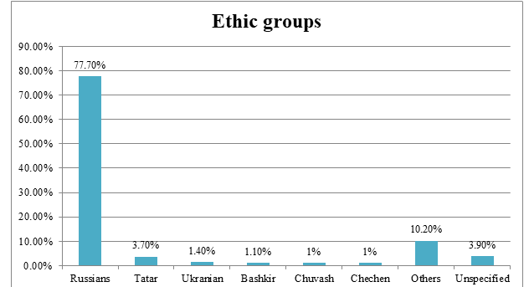
Figure 1.1: the ethnic groups in RUSSIA 2018
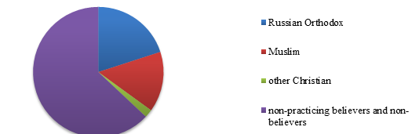
Figure 1.2: the religion believes in RUSSIA 2018

Based on those two chats, Russian market has a relatively homogenous characteristic: the Russian population is combined Russian Orthodox with Russian ethnicity. Those two factors can be considered as the emphasized points for TW. The product strategy should be based on the religion believes and ethnicity, to meet those needs would be essential to decide a product strategy. The core product, beer, remains unchanged (because it requires extra research and development fee to develop a new product). However, the product strategy should be combined with the package strategy. The meaningful package, printed religion figure on it, would be highly attractive for those religion believers (Callaway, 2019). For those non-believers, some religion figures would be reckoned as a “cool” and “fashion” figure (Callaway, 2019). Therefore, a recognisable figure representing by orthodox cross (figure 1.1) should be printed on TW’s beer exporting to Russia.


Figure 1.3: Russia orthodox cross

1.2 Promotion
The advertisements broadcasting is under a strict control imposed by Russian semi-planned economy. The illegal promotion strategy may increase the likelihood that TW be expropriated by RUSSIA government. Therefore, to carry out a promotion mode, the research of political environment is needed. The political structure in Russia differs from other democratic regimes sharply. President’s power with system of civil law are forming a semi-presidential federation is Russia area (Gorenburg, 2013). To consider the business environment in legislation perspective, the legislative branch (bicameral assembly or parliament) has decisive power in a policy-making process (Gorenburg, 2013).

The guidance of advertisement in Russia is based on the fourth set in of Russian law stressing that the advertisement should be strictly banned when it contains misleading and false (Yarnykh, 2019).
- “Contains incorrect comparison of the advertised goods with other goods in circulation produced by other manufactures and sold by other sellers;
- Denigrates the honour, dignity and business reputation of other persons;
- Advertises goods that are prohibited from being advertised if it is done in the likeness of the advertising of other goods whose trademark is identical or confusingly similar; or constitutes an act of unfair competition (Yarnykh, 2019)”.
Therefore, by taking those regulations into account, the promotion strategy should strictly follow the rule of game in Russia. The advertisement broadcasting should not contain any extravagated content.

1.3 Place
Due to budget limitation, TW cannot directly export its product to all districts in RUSSIA. Volga FD, Central FD and Southern FD are the top-three districts of the beer consumptions. TW only needs to rent a storage in the suburb area in Moscow to post its products to those three FDs (rent fee for a storage is cheap in suburb area is Moscow). To minimise the distribution and delivery fee, TW can corporate with Russian Post which is the cheapest carrier in those three districts.

However, the developed technology of e-commerce and other related technology would be the main stream in retailing sector (Ecommerce News, 2019). Following the logic above, the e-commerce and telecommunication technology are the most important factors in technological aspect for TW. In 2015, 73.4% population in Russia is capable to assess internet (Ecommerce News, 2019). The information technology has been mainly developed in Russian market. This means TWB is capable to develop their business in form of online store.

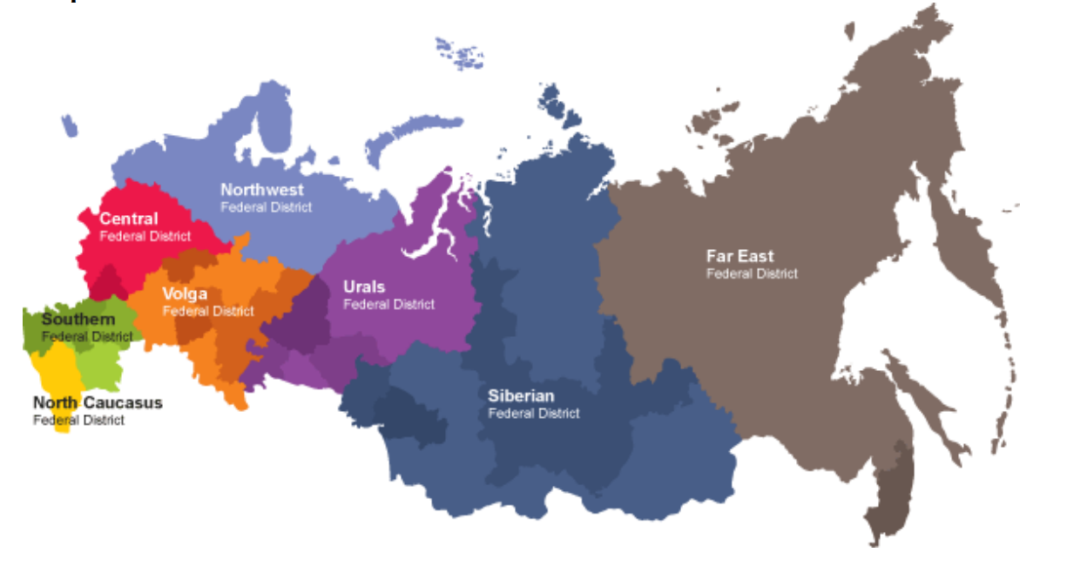
Figure 1.4 Russian governance and its districts (Russian Federation, 2016)

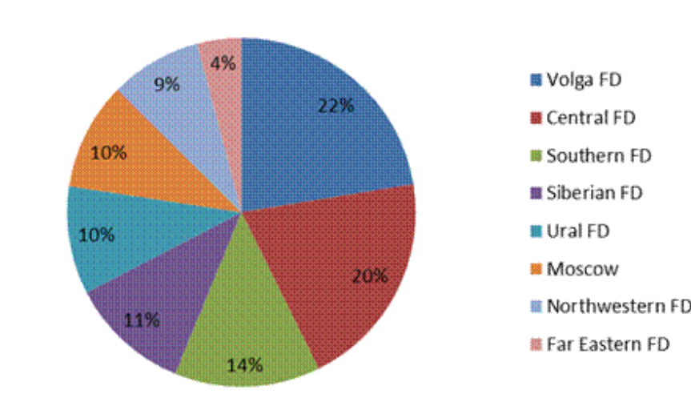
Figure 1.5 the beer consumption in different districts (Russian Federation, 2016)

Hence, to enter into Russia market, TW does not need to find a retail seller. The online store combined with a delivery company would be a suitable combination in e-commerce era (Russian Federation, 2016).

1.4 Process management
As an indirect exporting in manufacturing sector, the process management is not the issue that needs to be considered seriously. The concept of process management is widely adapted in service industry. As an international company, to ensure the same service applied to all customers in the world would be vital ( ). However, TW has to consider its product’s quality changes before the international transportation and after the international transportation. Hence, the logistics and shipping method have to be emphasised in the process management issues.

The only issue in process management for TW is the product transportation. To grant the beer’s tastes and quality, the cold chain logistics ought to be chosen by TW. As a major player of cold chain logistics in Russia, Pharma presents a good offer to liquid transportation through international cargo (Pharma, 2019). Pharma also offers a good price when an international company purchases the combination of international shipping and Russian inbound distribution (Pharma, 2019).

1.5 People
People factor, as a critical factor in marketing mix, is implementing the service in an international market (Pulido Polo, 2018). However, people are also an important factor in manufacturing sectors. TW, as a beer manufacturer, has to consider its craftsmanship in manufacturing process in an international market.

The volume of production has to be inclined due to the increased demands from an international market.

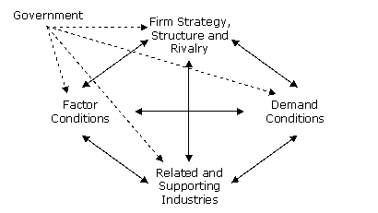
Figure 1.6: Porter diamond mode (Porter, 2019)

Porter’s diamond mode is trying to transfer the local advantages to the international advantages by developing the core competencies (Porter, 2019). Regardless other factors, the craftsmanship within the demand conditions would be an important factor for TW. Therefore, the people factor within the marketing-mix would be critical in terms of the supplies of beer from Wales to Russia. It is certainly that the general demands will increase to enter a new market. Therefore, it may require more workload and more production from TW’s factories in Wales. To sustain a good taste and quality control, the income and motivation should be inclined accordingly by considering the higher volume of product comparing with the production volume before entering Russia market.

1.6 Physical evidence
The definition of physical evidence is relevant to the promotion strategy. This physical evidence would be an extension of the previously proposed promotion strategy. Generally, physical evidence, as an idea from service industry, is a convert mechanism from intangible services to tangible feelings or effects (The Marketing Mix, 2019). Most customers’ decision-making process to buy a product is highly depending on the physical cues to support them examine the product before the purchase.

For TW’s circumstances, the tastes of beer and quality would be two essential points to affect customer’s decision to buy its product. The physical evidence can be shown in the TV advertisement broadcasting which can present an advertising video to the public. This advertising video has to contain the several critical points in physical evidence perspective: good tastes, good quality and reasonable price.

The general guidance for TW’s TV advertisement video is that “a Russian man drinks TW’s beer, and he is very pleasure for drinking it. Then, he keeps drinking and drinking.” During the advertisement broadcasting, the TW’s slogan can be presented accordingly to emphasis the taste of beers which is authentic Walsh taste.

1.7 Price
Within the generic strategy matrix, the low price strategy can be chosen by TW as a market penetration strategy. TW offers beers product principally for their exporting products. There is a generic strategy in marketing strategy in two dimensions (strategic advantage and strategic target). Considering the TW’s product and the local competitors in Russia, the low cost position and industrywide have to be tackled. The definition of market penetration shows that to compete with the local competitors, the low price strategy can be selected to penetrate a foreign market (Prasad, 1997). However, considering the tariff and trade policies, the low price strategy may be forbidden due to anti-dumping policies (Kugler, 2018).
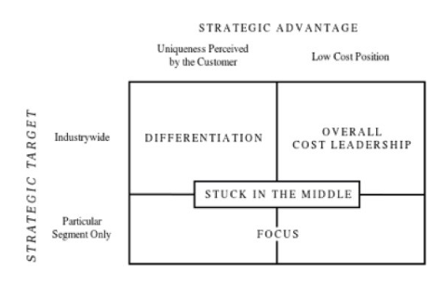
Table 1.2: Generic strategy matrix table

But, the pricing strategy has to follow the economic trend in Russia. The economic changes are currently happening in Russia, this changes occurred because the switched ideology from the Soviet Union (planned economy) to a relatively free economy (FPRI, 2019).

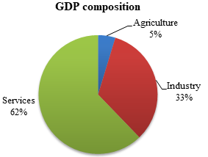
Figure 1.3: the GDP composition in Russia in 2018 (Russian Federation, 2016)

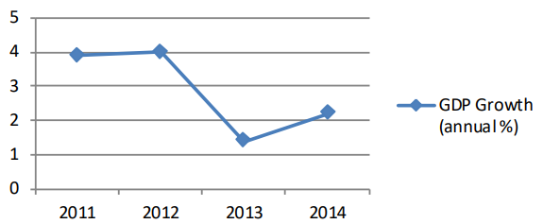
Figure 1.4: Russian GDP growth from 2011 to 2014 (Russian Federation, 2016)

By acknowledging the price elasticity and the effect income elasticity of demand, beer is a normal goods (income increases demand increases and vice versa) (Rassenfosse and Potterie, 2011). Therefore, Russia is in its economic downturn, beer with low price will present a more attractive option for consumers. The top 3 brands of beer in Russia are following: Baltika Bochkarev, Krepkoe Efes, Stary Melink (Ranker, 2019).

Brand | Price/ Litre
Baltika | 2,48 € / Litre
Bochkarev Krepkoe | 3,47 € / Litre
Efes Stary Melink | 4,48 € / Litre

The pricing strategy adapted by TW would be the lowest among those three. TW may offer 2, 39 € / Litre in the Russian market by direct exporting.

1.8 Agent’s responsibility and duty
The products provided to the agents from TW are standardised. Agent’s responsibilities are roughly focusing on sales. At first, TW will offer 2, 39 € / Litre in the Russian market by direct exporting. TW will set a sales target to its agent, one million euro for example. TW also can require to have some promotions provided by its agent or distributors in Russia.

Conclusion
In general, the market entry method for TW is the direct exporting which will maximise the profitability in Russia market. Product standardisation will be selected to enter into this market. In addition, a suitable marketing mix has been provided to suggest that the Russia market is profitable for the direct exporting from TW.

Reference
Bhander, G., Hauschild, M. and McAloone, T. (2003). Implementing life cycle assessment in product development. Environmental Progress, 22(4), pp.255-267.

Blanton, R. and Peksen, D. (2017). Dying for Globalization? The Impact of Economic Globalization on Industrial Accidents. Social Science Quarterly, 98(5), pp.1487-1502. [Accessed 8 Apr. 2019].

Callaway, E. (2019). Religion is a product of evolution, software suggests. [online] New Scientist. Available at: https://www.newscientist.com/article/dn13983-religion-is-a-product-of-evolution-software-suggests/ [Accessed 8 Apr. 2019].

Cambell, H. (1991). Class, Politics, and Popular Religion in Mexico and Central America:Class, Politics, and Popular Religion in Mexico and Central America. Latin American Anthropology Review, 3(1), pp.15-16.

Chen, Y. and Schwartz, M. (2013). Product Innovation Incentives: Monopoly vs. Competition. Journal of Economics & Management Strategy, 22(3), pp.513-528.

FPRI (2019). The Russia Political Economy Project - FPRI. [online] Foreign Policy Research Institute. Available at: https://www.fpri.org/research/eurasia/russia-political-economy/ [Accessed 1 May 2019].

Gorenburg, D. (2013). Civil Society in Russian Politics. Russian Politics & Law,
51(2), pp.3-5.

Kokemuller, N. (2018). Why Do Companies Go International?. [online] Bizfluent. Available at: https://bizfluent.com/facts-5256365-do-companies-go-international.html [Accessed 18 Apr. 2019].

Papanikolaou, N. (2009). Market Structure, Screening Activity, and Bank Lending Behavior. SSRN Electronic Journal.

Pharma (2019). IPL | PHARMA LOGISTICS. [online] I-p-l.ru. Available at: http://www.i-p-l.ru/index-en.php [Accessed 18 Apr. 2019].

Porter, M. (2019). Porter Diamond Model, a great competitive advantage analysis | ToolsHero. [online] ToolsHero. Available at: https://www.toolshero.com/strategy/porter-diamond-model/ [Accessed 18 Apr. 2019].
Prasad, B. (1997). Analysis of pricing strategies for new product introduction. Pricing Strategy and Practice, 5(4), pp.132-141.

Pulido Polo, M. (2018). Acts or events? A perspective from the marketing mix. IROCAMM-International Review Of Communication And Marketing Mix, (1), pp.56-66.
Ranker (2019). The Top Beers from Russia. [online] Ranker. Available at: https://www.ranker.com/list/top-beers-from-russia/reference [Accessed 15 Apr. 2019].

Russian Federation (2016). Russian Beer Market Update. 1st ed. [ebook] Moscow: Russian Federation. Available at: https://gain.fas.usda.gov/Recent%20GAIN%20Publications/Russian%20Beer%20Market%20Update_Moscow%20ATO_Russian%20Federation_2-19-2016.pdf [Accessed 12 Apr. 2019].

The Marketing Mix (2019). Marketing Mix Physical Evidence - Marketing Mix. [online] The Marketing Mix. Available at: https://marketingmix.co.uk/marketing-mix-physical-evidence/ [Accessed 15 Apr. 2019].

Yaşar, M. (2013). Direct and Indirect Exporting and Productivity: Evidence from Firm-Level Data. Managerial and Decision Economics, 36(2), pp.109-120.

