Catherine Angharad Ford 1650242
Ways of Thinking ADAD4018

Manifesto Points
- Art is embedded within everything we do.
- Memory has an impact on all new experiences.
- Life has no purpose if you simply go with the flow.
- Boundaries need to be pushed to have a true meaning to life.
- Art is the best therapy.
- Constantly learning is one of the best ways to thrive at life.
- Failing is the best way to learn.
- Routine is key.

My manifestos are based on my own personal life experiences. I have had some past traumas that I truly believe would still be having a more severe impact on my life if it were not for art and the acceptance of mistakes and learning from them. One of the main ways that I was able to heal was through art therapy. Being able to create something that mimicked a deeper feeling that I couldn’t put into words or express to anyone. I have been working on a piece of my father in his last days. Every time I have an overwhelming feeling of sadness that pulls me into a deep hole of grief, I get the painting and start working into it. Being able to create a piece that just have many layers of medium but many layers off feeling and emotion that would of simply just been trapped inside with no way to come out.” Art therapy is based on the idea that the creative process of art making facilitates reparation and recovery and is a form of nonverbal communication of thoughts and feelings.” (Malchiodi,2011, p.293).

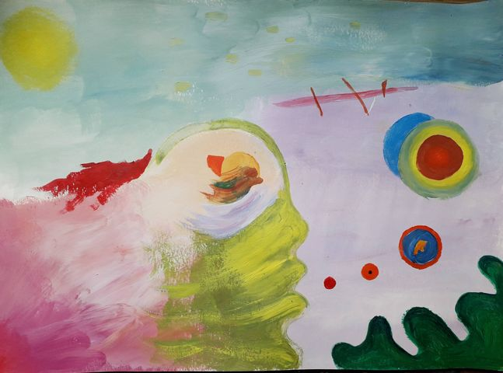
Brodrick, 2020

As shown in Condgon’s chapter in Putting Folklore to Good Use “I soon realised that much of the group sessions in the jail could have been the result of a well-applied art therapy session.” (Condgon, 2015, p139). Condgon job role was as an art teacher to the inmates, but as time progressed, she could see that not only was she having an impact on their skills but also on their mental health. Learning from mistakes is more than just acknowledging the mistake, but also finding the cause of the mistake and rectifying it. “Reframing failure from something associated with shame and weakness to something associated with risk, uncertainty and improvement is a critical first step on the learning journey.” (Cannon and Edmonson, 2005, p299). Being able to access the point in which the mistake was made, why was it made and whether there as environmental impacts that created that mistake or sampling just human error. Pinpointing that exact moment and then looking at different ways to work through it. Sometimes creating more mistakes in the process but going back to the drawing board again to take from the experience, learn from it. Finally being able to get to the point that was needed of achieving what ever the end goal is. The feeling over failure is something that isn’t easily overcome. But it intertwines with pushing the boundaries of the norm and just going with the flow of everyday life to be able to achieve a feeling of zen that the best was done and achieved. That no experiences were missed from being to scared of pushing out from societies standards.

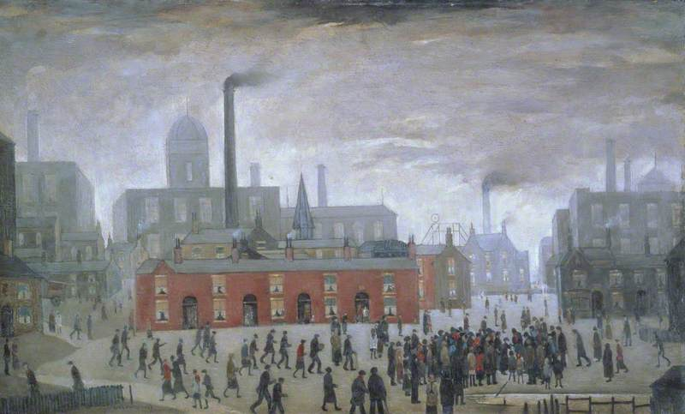
Lowry, 1926
The image above shows and industrial setting in England in the mid 1920’s. Capturing the hustle and bustle of an industrial city, with houses stacked upon houses. The muddy look to the painting gives a sense of the thickens of the pollution spilling from the factories in the background of the painting. It shows a heaviness to the work, a dooming cloud of smog over the people below. “Seen against a backdrop of terraced houses, civic and industrial buildings, which are arranged across the background of the composition rather like a stage set against which the activity happens.” Manchester Art Gallery,2020. At the foreground of the painting there is a clear gathering of people. A simple game, or maybe an argument taking place. In the bottom left corner, there are two what appears to be men heading in the other direction, have they just no interest to what is going on, is it their way of making sure they are in no way involved. “A genuine local suicide actually inspired the painting.” The Art Gallery, 2015. After finding that the painting is based on a suicide it changes my outlook. The smog filled sky of grey creates and feeling of mourning and loss. The crowd of by standers, just standing and watching. Did anyone try and help, or was she just found. It shows what can be missed when everyone is busy working and making sure their families have food on the table. A simple checking in on someone’s mental health could make the difference. Going back to the men in the bottom left corner, there is now more of a feeling of getting back to tell the family. As there was when the tragedy of the Twin Towers struck, there is a morbid curiosity with almost everyone shown in the painting. When the towers fell, everyone in the world found a way to watch, whether it was at their own homes on tv, going to family and friends to watch it, as well as the people in the streets, unable to pull their eyes away from the tragedy that unfolds in front of their very own eyes. This shows in the painting. Although a person lays there dead, there is a morbid curiosity in the crowd to look at what has happened, to then discuss this with those surrounding them, to watch and see what happens next if anything does happen at all. This is where my feelings changed, its not just showing a busy industrial city, its showing the true form of human kind.

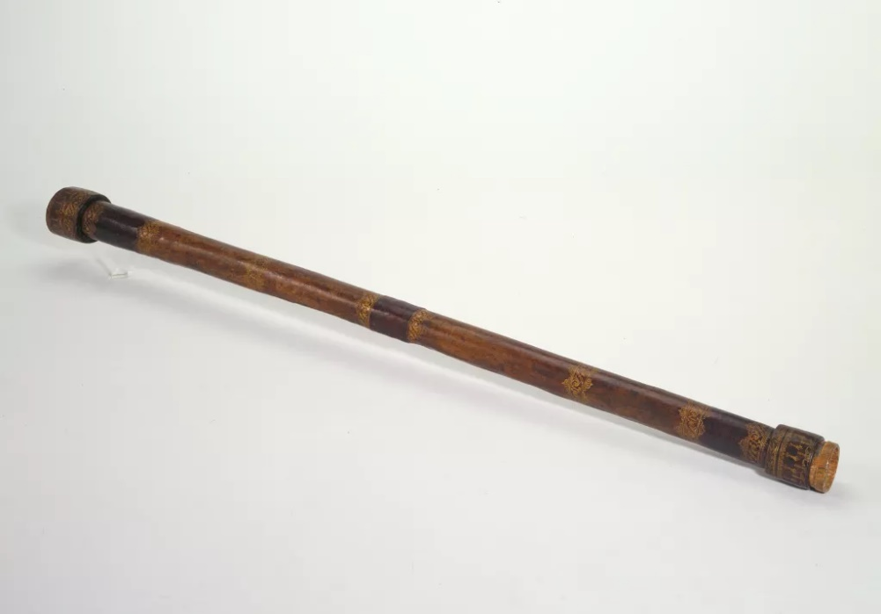
Nasa,
The telescope. Used for centuries to look up. Galileo was one of the first to point it towards the sky, “Galileo aimed the telescope towards the stars during the summer of 1609.” (Strano, 2009). The telescope to help view objects from a further distance. Being able to view not only what is within our own sight. Showing the world what is above and beyond our own clouds. Being able to view the stars and the moon being one of man kinds greatest discoveries. Not only enabling us to see but the further our own thoughts and minds. Being able to come to terms with there being more than just us, our home, our street and planet. For centuries believing that we were the only ones and God’s creation. Questioning that very thought of creation. Causing some form of uproar and seclusion especially to those who wanted to search further and find out if there was more. Galileo having to spend is finally years on house arrest for simply looking into what was further than our own atmosphere.

Bibliography
Andrew Brodrick, (2020) Head, Available: https://twitter.com/baat_org/status/1337506653063745542 (Accessed : 20/12/2020).
Cathy A Malchiodi, (2011), Page 293, Handbook of Art Therapy Guilford Press.
Giorgio Strano, (2009), Galileo’s telescope: history, scientific analysis, and replicated observations, Article Number 17, Available at https://link-springer-com.ezproxy.uwtsd.ac.uk/article/10.1007/s10686-009-9142-0, Accessed on 01/01/2020
Kristin G Gongdon, (2015), Page 139, Putting Folklore To Use The University Press Of Kentucky.
L.S. Lowry, (1926), An Accident, Manchester Art Gallery, Manchester, Available at : https://artuk.org/discover/artworks/an-accident-205453 , Accessed:30/12/2020
Mark D.Cannon Amy C.Edmondson, (2005), Failing to Learn and Learning to Fail (Intelligently): How Great Organizations Put Failure to Work to Innovate and Improve, Volume 38, P.299 Available at: https://www-sciencedirect-com.ezproxy.uwtsd.ac.uk/science/article/pii/S0024630105000580?via%3Dihub Accessed: 15/10/2020
The Art Gallery, (2016), Available at : https://artgallery.co.uk/blog/post/2015/11/02/5-famous-paintings-with-hidden-meanings , Accessed 30/12/2020

