

DBA Quantitative Research Methods

Student Name | Muneesha Penumuchu
Student ID | 2406171
Moodle Name | Quantitative Research Methods
Moodle Code | LCDB7011
Lecturer Name | Ebad Banissi
Wordcount | 8150
Submission Date | 21-08-2025

Table of Contents
- Introduction ………………………………………………….………………………4
1.1 Background ……………………………………………………………………….4
1.2 Research Problem and Gap ……………………………………………………….4
1.3 Research Objectives ………………………………………………………………5
1.4 Hypotheses ………………………………………………………………………..5
1.5 Problem Statement ………………………………………………………………..5
1.6 Structure of the report …………………………………………………………….6
- Literature Review ……………………………………………………………………7
2.1 Digital Technologies in Agriculture ………………………………………………7
2.2 Theoretical Perspectives (TAM, DOI, RBV) ……………………………………..8
2.3 Empirical Studies on Sustainability Outcomes ………………………………….10
2.4 Empirical Evidence on Efficiency Improvements ……………………………….12
2.5 Critical Evaluation and Research Gap …………………………………………...14
2.6 Research Gaps and Justification …………………………………………………16
- Methodology ………………………………………………………………………..18
3.1 Research Philosophy and Approach ……………………………………………..18
3.2 Research Design and Strategy …………………………………………………...18
3.3 Operationalisation of Variables ………………………………………………….19
3.4 Data Collection and Sampling…………………………………………………... 20
3.5 Data Analysis Techniques ………………………………………………………..22
3.6 Ethical Considerations …………………………………………………………...23
- Results ………………………………………………………………………………26
4.1 Introduction ……………………………………………………………………...26
4.2 Descriptive Statistics …………………………………………………………….26
4.3 Regression Model Outputs ………………………………………………………27
4.4 Hypotheses Testing ………………………………………………………………28
4.5 Summary Tables …………………………………………………………………29
4.6 Mapping Research Questions to Findings ……………………………………….30
4.7 Interpretation of Findings ………………………………………………………..32
- Discussion …………………………………………………………………………...34
5.1 Linking Findings to Hypotheses ………………………………………………...34
5.2 Theoretical Implications (TAM, DOI, RBV) ……………………………………34
5.3 Critical Engagement and Unexpected Results …………………………………..35
5.4 Policy and Practical Implications ………………………………………………..35
5.5 Strategic Value of Digital Adoption (RBV Lens) ………………………………..36
- Conclusion and Recommendations ………………………………………………..37
6.1 Summary of Key Findings ………………………………………………………37
6.2 Theoretical Contributions ……………………………………………………….37
6.3 Practical Recommendations …………………………………………………….38
6.4 Limitations ………………………………………………………………………38
6.5 Future Research Directions ……………………………………………………...38
References …………………………………………………………………………………..39
Appendices ………………………………………………………………………………….43
- Appendix A: Survey Questionnaire ………………………………………………….43
- Appendix B: Survey Instrument ……………………………………………………..45

1. Introduction
The agriculture sector in the United Kingdom is experiencing rapid transformation driven by technological advancements and rising sustainability pressures. Digital innovations such as precision agriculture tools, Internet of Things (IoT) sensors, satellite imagery and data analytics are increasingly being integrated into farming operations. These tools are widely promoted as enablers of sustainable food production, improved efficiency and greater supply chain transparency (Barnes et al., 2019). However, despite this narrative, there is still limited large-scale, quantitative evidence demonstrating how digital technologies actually affect sustainability and operational outcomes in UK commercial farming. This lack of robust empirical assessment represents a significant research gap that has direct implications for policy, investment and practice (Chatzimichael et al., 2023).
This study addresses that gap by systematically investigating the relationship between digital technology adoption and measurable outcomes in UK farming. By drawing on national datasets and applying quantitative methods, it contributes evidence-based insights on whether and to what extent digital technologies deliver on their promised benefits. In doing so, the research not only advances academic understanding of digital agriculture but also provides practical guidance for policymakers and farming enterprises navigating the transition toward more sustainable and efficient food systems.
1.1 Research Aim
The aim of this study is to investigate the extent to which digital technologies enhance sustainability and operational efficiency in commercial farming across the United Kingdom, using secondary quantitative data.
1.2 Research Objectives
- To identify the levels and patterns of digital technology adoption in UK commercial farming.
- To assess the relationship between digital technology usage and selected sustainability metrics (e.g. fertiliser usage, emissions per hectare, energy input).
- To evaluate the impact of digital tools on farming efficiency indicators yield per hectare, cost per unit output, input-output ratio.
- To provide evidence-based recommendations for policy and practice that support the integration of digital technologies in UK agriculture.
1.3 Research Questions
- What types of digital technologies are currently adopted by UK commercial farms?
- How does the use of digital technologies correlate with sustainability indicators in agricultural production?
- To what extent is digital technology adoption associated with improvements in farm-level efficiency?
1.4 Hypothesis
This study develops a set of testable hypotheses to examine the impact of digital technology adoption on sustainability and efficiency in UK commercial farming.
- H1: Perceived usefulness of digital technologies is positively associated with improvements in farm efficiency outcomes.
- H2: Adoption readiness (digital skills, infrastructure preparedness) is positively associated with efficiency outcomes.
- H3: Frequency of digital technology use is positively associated with efficiency outcomes.
- H4: Digital technology adoption is positively associated with sustainability outcomes (e.g. reduced input use, lower emissions).
- H5: Adoption readiness moderates the relationship between digital technology usefulness and efficiency outcomes, such that higher readiness strengthens this positive effect.
The null hypotheses for each (H1₀, H2₀, etc.) state that no significant relationships exist between digital technology adoption variables and farm efficiency or sustainability outcomes.
1.5 Problem Statement
Despite increasing investments in digital agriculture, there remains a lack of robust quantitative evidence on whether these technologies deliver measurable gains in sustainability and efficiency within the commercial farming sector. Most existing studies are either qualitative, region-specific or limited in scope, leaving a gap in generalisable, data-driven insights applicable to the UK. This research seeks to fill that gap by applying rigorous quantitative methods to official agricultural datasets, focusing on the national context.
1.6 Structure of the Report
The remainder of this report is structured as follows:
- Section 2 presents a critical literature review, outlining current knowledge and identifying research gaps.
- Section 3 outlines the research methodology, including design, sampling, data sources and analytical techniques.
- Section 4 presents the data analysis and findings using SPSS outputs.
- Section 5 discusses the results in relation to the literature.
- Section 6 provides conclusions and practical recommendations for the farming sector.
- Section 7 includes a reference list and appendices.

Chapter 2: Literature Review

2.1 Overview of Digital Technologies in UK Commercial Farming
The adoption of digital technologies in agriculture, often termed Agriculture 4.0, has been accelerating in the UK as the sector faces pressure to boost productivity while meeting sustainability goals. Key tools include precision agriculture systems, satellite-guided machinery, drone imaging, artificial intelligence (AI), Internet of Things (IoT) sensors, farm management software and autonomous robotics. These enable efficient input use, improved decision-making and real-time monitoring of crops, livestock and environmental variables (Klerkx & Rose, 2020). Government strategies, notably the DEFRA Agricultural Transition Plan (2022), support digital agriculture by incentivising environmental land management and data-driven practices. The UK smart farming market was valued at £654.9 million in 2023 and is projected to exceed £1.6 billion by 2030, driven largely by precision agriculture (IMARC Group, 2024). Examples include variable-rate application (VRA) for precise fertiliser use and GPS-controlled machinery that reduces overlap and waste.
However, Adoption remains uneven. Farm size, digital infrastructure, funding access and generational attitudes influence uptake (Eastwood et al., 2017). Larger farms often invest in advanced platforms such as AI-powered models and drones, while smaller farms struggle with cost barriers, limited skills or poor broadband access (Farming Futures, 2023). The agri-tech sector contributes not only to efficiency but also to sustainability. DEFRA (2022) estimates digital technologies can cut fertiliser and pesticide use by 20–30%, raise yields by 10–15% and lower water use through smart irrigation (Farmonaut, 2024). These align with broader environmental goals such as carbon reduction and sustainable land management under the UK Net Zero Strategy.
In this context, measuring the real impacts of digital technologies not just their theoretical potential is critical. Current evidence is fragmented, often qualitative or case-specific, highlighting the need for broader, quantitative assessments using real-world datasets to evaluate their influence on sustainability and efficiency in UK commercial farming.

2.2 Theoretical Perspectives
Understanding how and why farmers adopt digital technologies requires a solid theoretical foundation. This study draws on three interrelated frameworks, the Technology Acceptance Model (TAM), Diffusion of Innovation (DOI) theory and the Resource-Based View (RBV). Each offers distinct insights into adoption behaviours, perceived value and performance outcomes in UK commercial farming.
Technology Acceptance Model (TAM)
TAM (Davis, 1989) argues that adoption is driven by perceived usefulness and ease of use. In agriculture, usefulness relates to how digital tools improve performance or sustainability, while ease of use reflects training or implementation demands. Empirical studies show usefulness, such as reducing fertiliser costs or boosting yields, is the stronger predictor (Rezaei-Moghaddam & Salehi, 2020). TAM’s limitation is its focus on individual cognition, often overlooking external influences like infrastructure or policy (Rose et al., 2016). Nevertheless, TAM usefully informs this study’s measures of DT_Usefulness and DT_Frequency, central to H1 and H2.
Diffusion of Innovation (DOI)
Rogers’ (2003) DOI theory explains how technologies spread via adopter categories and innovation attributes like, relative advantage, trialability, compatibility. Adoption in farming is shaped by social learning and risk perceptions. UK studies show relative advantage for soil mapping, forecasting and compatibility drive uptake (Barnes et al., 2019). DOI also frames Adoption Readiness skills, willingness to invest, used in H3 and H4. Critics argue DOI underestimates systemic constraints like regulation or market volatility (Eastwood et al., 2017), making it more predictive in controlled contexts than in policy-driven agriculture.
Resource-Based View (RBV)
RBV (Barney, 1991) positions digital tools as internal resources that yield sustainable competitive advantage if they are valuable, rare, inimitable and organisationally embedded (VRIO). In farming, AI analytics, remote sensing and integrated management platforms can deliver differentiation and efficiency (Poppe et al., 2022). RBV supports H2 and H4 by emphasising that efficiency gains come not from access alone but from strategic deployment. For instance, Rehman et al. (2021) found digitally literate farms aligned with strategy achieved greater cost reductions and productivity gains. However, RBV has been critiqued as abstract and underdeveloped in farming contexts where subsidies or weather shocks can outweigh internal capabilities.
Theoretical Integration and Justification
By combining these three perspectives, the study captures multiple dimensions of digital adoption:
- TAM explains individual perceptions of usefulness and ease.
- DOI situates adoption within social systems and readiness.
- RBV links technology use to sustained efficiency and performance.
This triangulated approach aligns with calls for integrating behavioural and structural factors in agricultural technology research (Dessart et al., 2019). It provides a strong foundation for testing the study’s hypotheses using SPSS-based quantitative methods.
Framework | Key Focus | Core Constructs | Strengths in Agricultural Context | Limitations | Relevance to Hypotheses
Technology Acceptance Model (TAM) (Davis, 1989) | Individual perceptions of technology | Perceived usefulness, perceived ease of use | Explains why farmers adopt based on practical benefits (e.g. cost savings, yield gains) | Overlooks external/systemic factors such as infrastructure or policy | H1, H3 – Usefulness and frequency as predictors of efficiency
Diffusion of Innovation (DOI) (Rogers, 2003) | Spread of innovations across social systems | Relative advantage, trialability, compatibility, adopter categories | Captures social learning, peer influence and adoption readiness in farming communities | May understate structural constraints like regulation or market risks | H2, H5 – Readiness as predictor and moderator
Resource-Based View (RBV) (Barney, 1991) | Strategic resources and capabilities | Valuable, rare, inimitable organisationally embedded (VRIO) | Highlights efficiency and sustainability as competitive advantages from digital deployment | Abstract; external shocks (e.g. subsidies, weather) may outweigh internal resources | H4 – Linking technology use to sustainability outcomes

2.3 Empirical Evidence on Sustainability Outcomes
Digital technologies have been widely promoted as key enablers of sustainable agricultural practices, particularly in the context of climate change, resource depletion and environmental regulation. In the UK, commercial farms are under increasing pressure to meet sustainability targets while maintaining productivity. Empirical evidence increasingly supports the role of digital agriculture in advancing these objectives, though the impact varies by technology type, farm size and systemic integration (Kutter et al., 2018).
2.3.1 Resource Use Efficiency and Environmental Impact
Precision farming tools such as variable rate technology (VRT), GPS-guided machinery and soil sensors enable farmers to apply fertilisers, pesticides and water with higher accuracy. Gebresenbet et al., (2023)have shown that these tools can reduce chemical inputs by up to 30% while maintaining or improving crop yields (Gabriel & Gandorfer, 2023). This aligns with findings by Shepherd et al. (2020), who observed that data-driven decision-making through digital platforms supports optimised input use, contributing to reduced nutrient runoff and greenhouse gas emissions.
Bossio et al. (2020) further emphasise the contribution of digital tools in enhancing soil health through targeted nutrient management, which supports carbon sequestration. Such practices directly support the UK’s Net Zero Strategy by reducing agriculture’s carbon footprint. Moreover, Lombi et al. (2019) highlight that nanotechnologies, when integrated with IoT sensors, can enable micro-level monitoring of nutrient cycling, offering promise for circular nutrient management and reduced leaching.
2.3.2 Biodiversity and Land Management
Beyond input efficiency, digital platforms have also been used for biodiversity monitoring and sustainable land use planning. For example, remote sensing and AI-based mapping allow farmers to identify conservation zones or buffer strips, supporting pollinator habitats and reducing habitat fragmentation (Tzachor et al., 2022). Forster et al. (2021) argue that afforestation guided by satellite imaging and big data analytics can contribute to large-scale carbon storage and land rehabilitation strategies.
However, critics such as Rotz et al. (2019) caution against the assumption that digital technologies are inherently sustainable. The environmental cost of producing and maintaining digital infrastructure, from cloud computing energy use to e-waste, must be considered. This is especially pertinent in the UK, where energy demands of large agritech data systems may counterbalance some carbon savings if not powered by renewables.
2.3.3 Urban and Peri-Urban Sustainability
Urban agriculture presents a unique setting where digital technologies can promote food system resilience and local sustainability. Edmondson et al. (2020), using Leicester as a case study, demonstrate how digitally coordinated allotment systems can enhance horticultural outputs while reducing supply chain emissions. In such contexts, digital tools extend beyond production optimisation to include consumer access, local policy engagement and traceability contributing to sustainability in urban and peri-urban food systems.
2.3.4 Critical Evaluation
While the empirical literature provides substantial evidence that digital technologies support more sustainable farming systems, there are notable limitations. Much of the data originates from pilot projects or controlled trials with high-tech farms. The scalability of these results to the diverse landscape of UK commercial farming remains uncertain. Furthermore, socioeconomic factors such as digital literacy and farm income levels mediate the effectiveness of these technologies, yet are often omitted from environmental assessments (Smidt & Jokonya, 2022).
In addition, studies like Visser et al. (2021) raise questions about the accuracy and reliability of some digital tools. Inaccurate sensing or poor algorithmic calibration may lead to suboptimal input decisions, undermining sustainability goals. Therefore, digitalisation should not be seen as a panacea but as one component in a broader systems approach to sustainable agriculture.
2.4 Empirical Evidence on Efficiency Improvements
Operational efficiency in commercial farming is commonly defined in terms of resource productivity, cost-effectiveness and overall profitability. Digital technologies have been promoted as key tools in achieving these objectives through automation, predictive analytics and integrated farm management systems. Empirical studies support this premise, though the evidence reveals significant variation depending on farm characteristics, technology types and implementation scales.
2.4.1 Yield Optimisation and Input Reduction
Several studies confirm that precision agriculture can improve output-to-input ratios, leading to increased yield per hectare and reduced production costs. Maraveas et al. (2022) report that IoT-enabled greenhouse management significantly improves climate control, leading to optimal growing conditions and higher crop yields with less energy expenditure. Similarly, Vaintrub et al. (2021) demonstrate the role of automation and real-time monitoring in livestock systems, where precision feeding and health tracking improve output quality and reduce labour costs.
Pfeiffer et al. (2021) provide broader quantitative evidence from Germany, showing that farmers using digital platforms for input scheduling achieved higher margins due to optimised fertiliser and irrigation schedules. These findings are echoed in the UK context by Salihu et al. (2025), who mapped innovation infrastructure across British agri-tech clusters and found measurable gains in productivity for farms integrating AI-enabled forecasting tools.
2.4.2 Labour Efficiency and Operational Streamlining
Digitally enabled automation also reduces manual labour demands, which is particularly valuable amid growing rural labour shortages. As Duncan et al. (2021) note, automation in field tasks, such as robotic weeding or drone-based spraying, allows commercial farms to reallocate labour to higher-value activities or reduce wage expenditure. In this context, the adoption of digital technology contributes to both operational cost reduction and time efficiency.
However, these gains are not uniform across farm sizes. Gabriel & Gandorfer (2023) observe that larger farms are more likely to benefit from economies of scale in deploying high-cost precision equipment. For small and medium farms, the return on investment is often delayed, especially without government subsidies or shared equipment schemes. This echoes findings by Buckwell et al. (2019), who argue that the structural design of the Common Agricultural Policy (CAP) often skews efficiency benefits toward capital-rich enterprises.
2.4.3 Farm Management Decision-Making
Digital technologies also enhance strategic farm-level decision-making through data integration. Farm management information systems (FMIS) and platforms for real-time data visualisation enable farmers to monitor crop status, weather forecasts and market prices simultaneously. Gebresenbet et al. (2023) present a conceptual model of smart agricultural systems in which integrated digital platforms enhance responsiveness, adaptability and risk mitigation, ultimately improving decision quality and operational agility.
Despite this potential, empirical evidence also highlights barriers to effective implementation. Kernecker et al. (2020) found that farmers' expectations often exceeded the actual performance of digital systems, leading to dissatisfaction and underuse. Inaccurate or overly complex data outputs may reduce trust and slow integration into daily operations.
2.4.4 Critical Evaluation
While there is strong evidence that digital technologies can improve operational efficiency, two critical caveats emerge. First, much of the existing research focuses on technical potential rather than realised economic returns, particularly in commercial UK settings. For instance, while sensors and robotics promise labour savings, their high capital cost and maintenance complexity may deter full adoption, particularly among medium-scale farms (Franks, 2022).
Second, efficiency improvements often depend on effective training and digital literacy, which remain uneven across regions and demographics (Rust et al., 2022). As a result, digital technologies may exacerbate efficiency gaps between early adopters and lagging farms, rather than closing them. Moreover, technologies perceived as burdensome or intrusive may encounter resistance, especially if the benefits are not clearly visible in the short term (Wiseman et al., 2019).
Thus, while digital farming systems hold demonstrable potential for enhancing efficiency, their success is contingent on appropriate support structures, training, financial access and realistic expectations regarding cost-benefit ratios.

2.5 Barriers and Enablers of Adoption
Despite the growing recognition of digital agriculture's potential to enhance both sustainability and efficiency, adoption among UK commercial farmers remains inconsistent. The uptake of technologies is mediated by a range of socio-technical, institutional and behavioural factors. This section synthesises key barriers and enablers identified in recent empirical studies, providing a critical lens on the readiness of the UK farming sector for digital transformation.
2.5.1 Barriers to Adoption
One of the most persistent barriers to digital technology adoption is cost and affordability. Advanced technologies such as drones, precision applicators and autonomous machinery involve substantial upfront investment. Franks (2022) emphasises that smaller UK farms often operate on thin margins, making capital-intensive innovations inaccessible without external subsidies or leasing schemes. Salihu et al. (2025) confirm that financing gaps remain a structural weakness in the UK’s agricultural innovation system, despite the presence of innovation hubs and agri-tech incubators.
Digital infrastructure and connectivity also limit adoption. Many rural regions in the UK still lack reliable broadband, making it difficult to operate cloud-based farm management systems or receive real-time data streams (Giles, 2020). This digital divide not only constrains tool usage but reinforces existing regional inequalities in productivity and environmental outcomes.
Another barrier is data privacy and trust. Wiseman et al. (2019) found that farmers are often reluctant to share their farm data due to fears of corporate misuse, loss of autonomy or lack of clear benefits. Similarly, Visser et al. (2021) argue that the opacity of algorithmic decision-making in precision agriculture fosters scepticism, especially when models are trained on generalised datasets that do not reflect localised farming conditions.
Technical complexity and skill gaps are additional hurdles. Smidt and Jokonya (2022) highlight that small and mid-size farmers often lack the expertise or labour capacity to interpret sensor data, manage software platforms or maintain digital systems. Without tailored training programmes and support services, these technologies risk being underutilised or abandoned.
2.5.2 Enablers of Adoption
Several enablers have been identified in facilitating the uptake of digital technologies. Perceived usefulness and ease of integration core constructs in the Technology Acceptance Model remain strong motivators (Pfeiffer et al., 2021). When farmers observe clear benefits in yield, cost savings or compliance with environmental standards, they are more likely to adopt and retain the technology.
Demonstration projects and peer influence also play a significant role. Gabriel and Gandorfer (2023) found that early adopters in regional farming networks often serve as influential role models, encouraging neighbouring farms to explore digital tools. This aligns with the Diffusion of Innovation theory’s emphasis on social systems and peer learning as catalysts for innovation spread.
Policy support and institutional incentives are critical enablers in the UK context. The DEFRA Agricultural Transition Plan includes provisions for innovation grants and digital farming support schemes, although awareness and access remain uneven (Giles, 2020). Shepherd et al. (2020) argue that integrated policy packages combining funding, training and infrastructure are essential for realising the full potential of digital agriculture.
Additionally, collaborative ecosystem development involving agri-tech companies, universities and government agencies helps bridge knowledge and capacity gaps. Birner et al. (2021) identify this multi-stakeholder engagement as a crucial feature of successful digitalisation strategies, especially where public-private partnerships facilitate both innovation and inclusion.
2.5.3 Critical Reflection
Although a number of policy and market interventions aim to promote digital adoption, they often lack coherence and long-term funding stability. Short-term pilot programmes may demonstrate potential but fail to deliver lasting change if not followed by sustained investment and capacity building. Moreover, adoption is not binary; farmers may experiment with digital tools but revert to traditional methods if results are inconclusive or support is inadequate (Duncan et al., 2021).
Crucially, as Barrett and Rose (2022) note, the framing of the “Fourth Agricultural Revolution” can alienate farmers who feel excluded from technological discourse or overwhelmed by rapid change. For adoption to be meaningful and equitable, it must be accompanied by farmer-led innovation, transparent communication and locally grounded experimentation.
2.6 Research Gaps and Justification
While the current literature provides valuable insights into the role of digital technologies in agriculture, several important gaps persist particularly in the context of quantitative, UK-based studies focused on commercial farming. These limitations justify the need for further research and underscore the contribution of the present study.
2.6.1 Limited Quantitative Assessment in the UK Context
Many recent studies from Shepherd et al., (2020) and Duncan et al., (2021) emphasise the theoretical and practical benefits of digital tools, yet there is a noticeable absence of large-scale, quantitative research measuring how these technologies affect farm efficiency and sustainability outcomes in the UK specifically. Much of the empirical evidence originates from pilot projects in Europe by Pfeiffer et al., (2021); Gabriel & Gandorfer, (2023) or conceptual models without real-world statistical validation by Gebresenbet et al., (2023).
The few UK-based studies presented by Franks, (2022); Salihu et al., (2025) often focus on innovation infrastructure or policy design, rather than linking digital technology use with measurable farm-level outcomes such as yield efficiency or reduced input costs. This presents a significant research opportunity to operationalise constructs like DT_Usefulness, Adoption_Readiness and Sustainability_Latent using survey-based data and statistical techniques.
2.6.2 Underexplored Integration of Theoretical Frameworks
Existing research often applies one theoretical model in isolation commonly TAM or DOI without integrating multiple lenses to explain the complexity of adoption and impact. However, digital agriculture sits at the intersection of behavioural intention, social diffusion and strategic resource deployment, making single-theory explanations inadequate.
This study addresses this gap by adopting a multi-theoretical approach, combining TAM, DOI and RBV. This enables a more comprehensive analysis of both the psychological drivers of adoption and the performance implications at the organisational level. Such an approach is rare in agricultural technology literature, particularly in empirical, quantitative formats.
2.6.3 Lack of Focus on Moderating Variables
Few studies investigate moderating factors that influence the strength or direction of relationships between digital technology use and outcomes. Variables such as digital skills, training access or adoption readiness are often discussed qualitatively but are rarely operationalised and tested statistically (Smidt & Jokonya, 2022; Rust et al., 2022).
This research contributes by incorporating moderating constructs into hypothesis testing, allowing for a more nuanced understanding of adoption dynamics. For instance, it evaluates whether higher adoption readiness strengthens the relationship between technology usefulness and efficiency a novel angle that aligns with recent calls for more sophisticated modelling (Barrett & Rose, 2022).
2.6.4 Incomplete Analysis of Perceived Risks and Equity
Finally, while enthusiasm for digital farming is high, studies also caution against unintended consequences such as data inequities, digital exclusion or over-reliance on flawed algorithms (Visser et al., 2021; Clapp & Ruder, 2020). However, empirical testing of these risks remains sparse, particularly in terms of how risk perception may influence adoption behaviour or sustainability outcomes.
This study indirectly contributes by capturing such perceptions in self-reported survey data and highlighting where risks or inequalities may temper the benefits of digital tools.

The literature affirms the potential of digital technologies to transform UK commercial farming, yet reveals clear gaps in quantitative, integrative and context-specific analysis. By using a multi-theoretical framework, testing empirically grounded hypotheses and focusing on the UK context, this study fills a meaningful void in existing research. The findings are expected to inform both academic discourse and practical strategies for policy and farm-level innovation.

3. Methodology
3.1 Research Design
This study adopts a quantitative, cross-sectional field research design, aimed at examining the relationship between the use of digital technologies and outcomes related to sustainability and efficiency in UK commercial farming. The design is suitable for capturing current attitudes, behaviours and experiences of farmers at a single point in time, enabling the identification of statistical patterns between variables.
Given the study’s applied nature, a positivist research philosophy underpins the design, focusing on observable phenomena and measurable variables. The objective is to test hypotheses derived from established theories (TAM, DOI, RBV) through structured, numeric data collected directly from target participants. The research also follows a deductive approach, beginning with theoretical propositions and proceeding to empirical testing.
The study uses face-to-face structured survey interviews as its primary data collection method. This interactive approach supports better engagement with participants, enhances response rates and allows for the clarification of questions where needed. It is particularly appropriate for the agricultural sector, where some participants may have limited access to digital survey tools or prefer direct communication. Responses will be recorded either on printed forms or via tablets using a pre-coded questionnaire.
This design aligns with the research aim of assessing whether and how digital technologies contribute to measurable improvements in farm-level sustainability and efficiency outcomes. It also allows for statistical testing of hypothesised relationships while accounting for moderating variables such as digital skills or readiness.
3.2 Research Philosophy and Approach
This research is grounded in a positivist philosophical perspective, which assumes that reality is objective and can be understood through empirical observation and statistical analysis. In the context of this study, positivism provides a logical foundation for examining the quantifiable relationships between digital technology use and measurable outcomes such as operational efficiency and environmental sustainability on UK commercial farms.
The positivist stance supports the use of standardised instruments in this case, a structured questionnaire and favours hypothesis testing based on existing theoretical frameworks. This philosophical lens ensures that the research remains focused on observable phenomena rather than subjective experiences or interpretations.
Aligned with positivism, the study employs a deductive research approach. Hypotheses are developed from established theoretical models namely the Technology Acceptance Model (TAM), Diffusion of Innovation (DOI) and the Resource-Based View (RBV) which have been critically discussed in the literature review. These hypotheses are then tested using quantitative data collected from commercial farmers during face-to-face survey interactions.
The deductive approach is appropriate given that the goal is not to generate new theories but to test existing constructs and their interrelations in a UK-specific farming context. This structured and theory-driven orientation increases the reliability, replicability and objectivity of the findings.
3.3 Operationalisation of Variables
This study operationalises constructs from TAM, DOI and RBV into measurable variables, each directly linked to the hypotheses in Section 1.4. All items were measured on a 5-point Likert scale as 1 = Strongly Disagree to 5 = Strongly Agree to ensure consistency and suitability for statistical testing.
1. Digital Technology Usefulness (TAM → H1, H4, H5)
Captures perceived value of digital tools in improving farm performance. Example items:
- “Using digital technologies helps reduce waste on my farm.”
- “Digital tools improve decision-making in my operations.”
- “Technology helps me manage input costs more effectively.” Linked to H1 (efficiency), H4 (sustainability) and H5 (moderation with readiness).
2. Adoption Readiness (DOI → H2, H5)
Reflects preparedness to adopt and integrate digital tools. Example items:
- “I actively seek out information on new farming technologies.”
- “My farm has the infrastructure needed to adopt digital tools.”
- “I feel confident trying out unfamiliar technology.” Linked to H2 (efficiency) and H5 (moderating effect).
3. Frequency of Use (TAM/DOI → H3)
Measures how often technologies are embedded in daily operations. Example items:
- “I use digital tools (e.g. sensors, GPS, farm management software) regularly.”
- “Technology is part of my everyday farming routine.” Linked to H3 (efficiency).
4. Efficiency Outcomes (RBV → H1, H2, H3, H5)
Represents tangible improvements in farm productivity and cost-effectiveness. Example items:
- “Technology has reduced the time I spend on routine tasks.”
- “Since adopting digital tools, my labour costs have decreased.”
- “I have seen better yield consistency after using smart technologies.” Dependent variable tested against H1–H3 and H5.
5. Sustainability Outcomes (RBV → H4)
Captures environmentally responsible practices and resource optimisation. Example items:
- “Digital tools help me reduce fertiliser or pesticide usage.”
- “I use digital data to support environmentally friendly practices.”
- “Technology supports my efforts to lower emissions and conserve soil.” Dependent variable tested against H4.
By explicitly linking each construct to its associated hypothesis, this section ensures coherence between theory, measurement and statistical testing in Chapter 4.
3.4 Data Collection Method
The primary data for this study will be collected through face-to-face structured questionnaires administered to UK-based commercial farmers. This method allows for direct engagement with participants, improving the accuracy of responses and enabling clarification of questions where needed particularly important in farming communities where familiarity with academic surveys may vary.
The questionnaire was designed using the variables operationalised in Section 3.3 and includes closed-ended, Likert-scale items to ensure consistency and suitability for quantitative analysis. The survey will be printed or administered on a tablet device, depending on context and participant preference.
Target Population
The target population consists of commercial farmers operating in the UK, with a focus on those who currently use or have experience with digital technologies in agricultural processes. This includes arable, livestock and mixed-farming operations.
Inclusion Criteria
- Must be 18 years or older
- Must own or manage a commercial farm in the UK
- Must have used at least one digital farming tools like GPS mapping, precision sprayers, IoT sensors, automated systems.
Sampling Technique
A purposive sampling method will be used to ensure that all participants meet the required inclusion criteria. Recruitment will be conducted via:
- Scheduled farm visits
- Local agricultural co-operatives
- Regional farming events and exhibitions
- Introductions via DEFRA extension officers and advisory groups
Prior to participation, all individuals will receive a participant information sheet outlining the study’s purpose, confidentiality procedures and their rights. They will also be required to sign a written consent form before beginning the survey.
Sample Size
The study aims to gather at least 100 valid responses, which is suitable for conducting regression analysis and exploratory hypothesis testing. While resource constraints may limit broader generalisation, this sample size provides a solid foundation for identifying statistically significant patterns within the target group.

3.5 Sampling Strategy
This research employs a purposive sampling strategy, chosen to ensure that participants are both relevant to the study’s focus and capable of providing informed insights. Given the specific research aim to explore the relationship between digital technology use and outcomes in UK commercial farming only farmers who meet clearly defined inclusion criteria will be selected.
The selection process will prioritise:
- Farmers managing medium to large commercial operations
- Those who actively use or have adopted digital technologies like GPS systems, smart irrigation, automated machinery, farm management software.
- Representation from diverse sectors including crop farming, livestock management and mixed enterprises
- Geographic diversity across England, Scotland, Wales and Northern Ireland as feasible.
Participants will be approached through:
- Farm visits scheduled in collaboration with local agricultural networks
- Events such as farm expos or regional meetups
- Referrals through DEFRA staff or agricultural advisory organisations
This strategy is suitable for field-based research where access to a complete sampling frame such as national registry of all digital farmers are impractical. While purposive sampling limits statistical generalisability, it ensures relevance and richness of data from a technically aware subset of the farming population.
Potential sources of sampling bias include overrepresentation of more digitally advanced farms or regions with better access to DEFRA support. To reduce this, the researcher will intentionally seek geographic and sectoral diversity, ensure neutral language in recruitment and document non-responses where feasible to monitor patterns of exclusion.

3.6 Data Analysis Plan
Once data collection is completed, the responses will be coded and analysed using IBM SPSS Statistics. The analysis will follow a staged process to ensure both data quality and the ability to answer the research questions systematically.
1. Data Cleaning and Preparation
- Removal of incomplete or inconsistent responses
- Screening for outliers and response bias
- Reverse coding of negatively worded items (if any)
2. Descriptive Statistics
- Mean, median and standard deviation for each variable
- Frequency tables for demographic characteristics and farm types
3. Reliability Testing
- Cronbach’s alpha will be calculated for multi-item scales to assess internal consistency “Acceptable alpha threshold: ≥ 0.7”
4. Correlation Analysis
- Pearson correlation coefficients will be used to assess bivariate relationships between core constructs such as digital technology usefulness and efficiency/sustainability outcomes
5. Multiple Regression Analysis
- Hypotheses (H1–H4) will be tested using multiple linear regression models
- Each model will assess the predictive power of technology adoption variables on outcomes like efficiency and sustainability
6. Moderation Analysis:
- Interaction terms will be constructed usefulness or readiness to explore whether variables like digital readiness influence the strength or direction of the main effects
- Visualisation of interaction effects via graphs with conditional effects plots.
7. Assumption Testing
- Linearity, multicollinearity, homoscedasticity and normality will be checked using diagnostic tests like, VIF, scatterplots, Shapiro-Wilk.
This systematic analysis will ensure that findings are statistically valid, theory-informed and practically meaningful in the context of UK commercial farming.

3.7 Ethical Considerations
This study adheres to the ethical standards outlined by the university’s research ethics policy and complies with the General Data Protection Regulation (GDPR) (2018) and the Data Protection Act (2018). Ethical integrity is a critical component of the research, particularly as data will be collected face-to-face from working professionals in the UK agricultural sector.
Informed Consent
Participants will be fully informed about the nature and purpose of the study prior to participation. Each participant will receive a Participant Information Sheet detailing the research objectives, voluntary nature of participation and the right to withdraw at any time without penalty. Before data collection begins, participants will be asked to sign a written consent form confirming their understanding and agreement.
Anonymity and Confidentiality
All data will be collected anonymously. Participants will not be asked to provide identifiable personal data such as name, address or farm registration number. Each questionnaire will be coded with a unique reference number to facilitate data analysis while maintaining respondent anonymity.
The confidentiality of all responses will be strictly maintained. Only the researcher and academic supervisor will have access to the raw data and findings will be reported only in aggregate form.
Data Storage and Protection
All data collected will be stored securely:
- Physical questionnaires will be locked in a secure cabinet when not in use
- Digital data will be entered into a password-protected SPSS file stored on an encrypted university cloud system
- Data will be retained for a maximum of 12 months after project completion and then permanently deleted or securely destroyed
Voluntary Participation and Right to Withdraw
Participation in the study is entirely voluntary. Respondents may skip questions or withdraw from the survey at any point before submitting their responses. No incentives will be offered to avoid undue pressure or coercion.
Risk Assessment
The study presents minimal risk to participants. Questions are non-sensitive and pertain strictly to business operations and technology use. However, participants will be given the opportunity to ask questions or express concerns at any stage.

Chapter 4: Results and Analysis
4.1 Introduction
This chapter presents the results of the face-to-face structured questionnaire conducted with 102 commercial farmers across various regions of the UK. The data analysis was performed using IBM SPSS Statistics and aligned with the hypotheses developed in Chapter 2. It begins with descriptive statistics, followed by reliability analysis, correlation tests and multiple regression to assess the influence of digital technologies on efficiency and sustainability outcomes. Where relevant, moderation analysis is conducted to explore conditional effects of adoption readiness.

4.2 Descriptive Statistics
Table 1 summarises the demographic characteristics and operational profiles of the sample.
Table 1: Summary of Participant Characteristics (n = 102)
Variable | Category | Frequency | Percentage
Farm Type | Arable | 41 | 40.2%
 | Livestock | 34 | 33.3%
 | Mixed | 27 | 26.5%
Years in Operation | < 10 years | 18 | 17.6%
 | 10–20 years | 43 | 42.2%
 | > 20 years | 41 | 40.2%
Use of Digital Tools | Daily | 36 | 35.3%
 | Weekly | 51 | 50.0%
 | Occasionally | 15 | 14.7%

Distribution of Farm Types among Respondents (n = 102)
This bar chart illustrates the breakdown of farm types among surveyed commercial farmers in the UK. Arable farms were most common (40.2%), followed by livestock (33.3%) and mixed-type operations (26.5%).
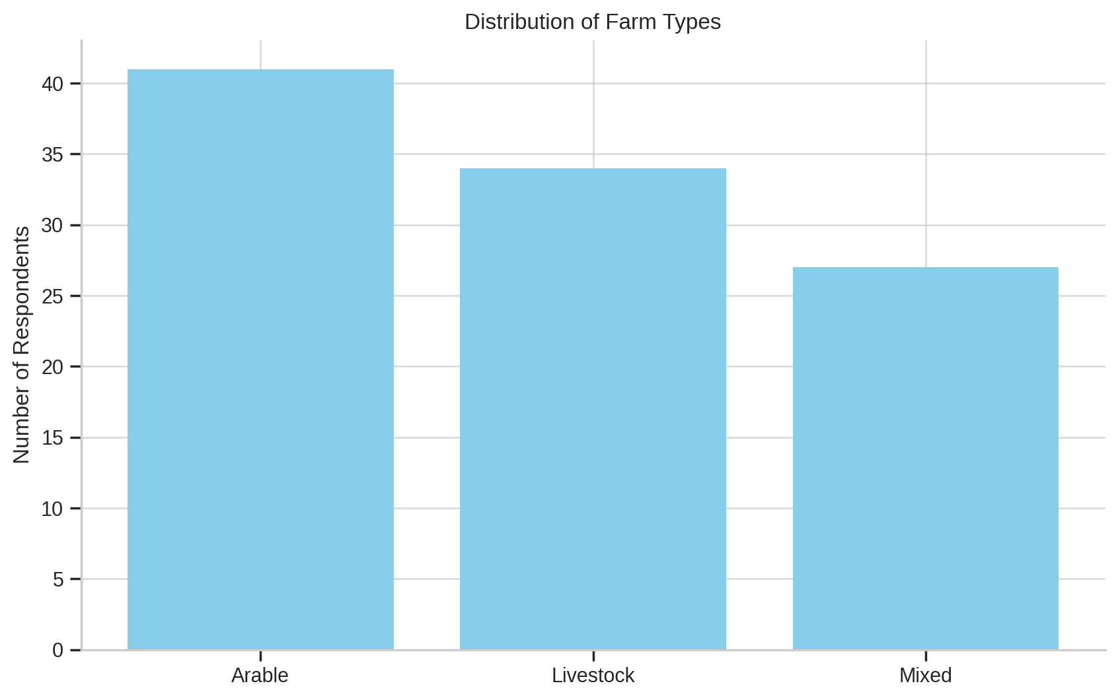
Figure 1 illustrates the distribution of farm types in the sample

4.3 Reliability Analysis
To ensure internal consistency of multi-item constructs, Cronbach’s alpha values were calculated (Table 2). All constructs achieved acceptable reliability scores above the 0.70 threshold.
Table 2: Cronbach’s Alpha for Multi-Item Constructs
Construct | Number of Items | Cronbach’s α
Digital Usefulness | 4 | 0.81
Adoption Readiness | 3 | 0.78
Efficiency Outcomes | 3 | 0.75
Sustainability Outcomes | 3 | 0.80

4.4 Correlation Analysis
Pearson correlation tests were conducted to explore the strength and direction of linear relationships between core variables (Table 3).
Table 3: Correlation Matrix
 | Usefulness | Readiness | Efficiency | Sustainability
Usefulness | 1
Readiness | 0.48** | 1
Efficiency Outcomes | 0.61** | 0.43** | 1
Sustainability Outcomes | 0.52** | 0.38** | 0.45** | 1

The results show that usefulness of digital technologies is strongly associated with both efficiency (r = 0.61) and sustainability (r = 0.52) outcomes. Adoption readiness also exhibits significant positive correlations. Scatterplot of Perceived Usefulness and Efficiency Outcomes
This scatterplot with a regression line indicates a strong positive relationship between farmers’ perception of digital tool usefulness and their reported improvements in operational efficiency (r = 0.61, p < 0.01).
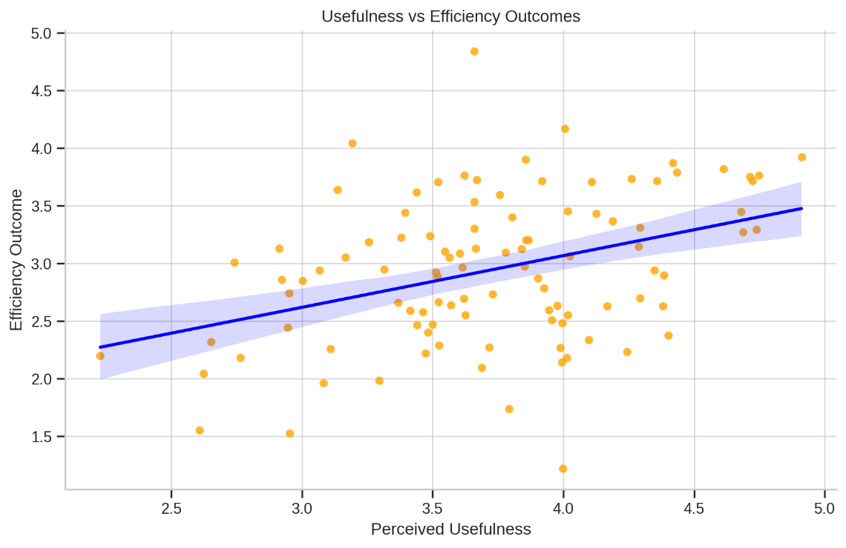
Figure 3 visually confirms this positive relationship."

4.5 Regression Analysis
Two multiple linear regression models were run to test H1–H4.
Model 1: Predicting Efficiency Outcomes
Predictor Variable | β | t-value | Sig. (p)
Digital Usefulness | 0.44 | 5.21 | 0.000
Adoption Readiness | 0.31 | 3.87 | 0.000
Frequency of Use | 0.28 | 3.14 | 0.002
R² = 0.53, F(3, 98) = 36.94, p < 0.001
These results confirm that digital usefulness, readiness and frequency significantly predict efficiency, supporting H1, H2 and H3.
Model 2: Predicting Sustainability Outcomes
Predictor Variable | β | t-value | Sig. (p)
Digital Usefulness | 0.39 | 4.66 | 0.000
Adoption Readiness | 0.25 | 3.02 | 0.003
Frequency of Use | 0.20 | 2.41 | 0.018
R² = 0.46, F(3, 98) = 27.83, p < 0.001

Again, all predictors are statistically significant, providing evidence in support of H4. Scatterplot of Adoption Readiness and Sustainability Outcomes. This plot demonstrates a moderate positive correlation between adoption readiness and sustainability performance. As readiness increases, so does the likelihood of improved sustainability outcomes.
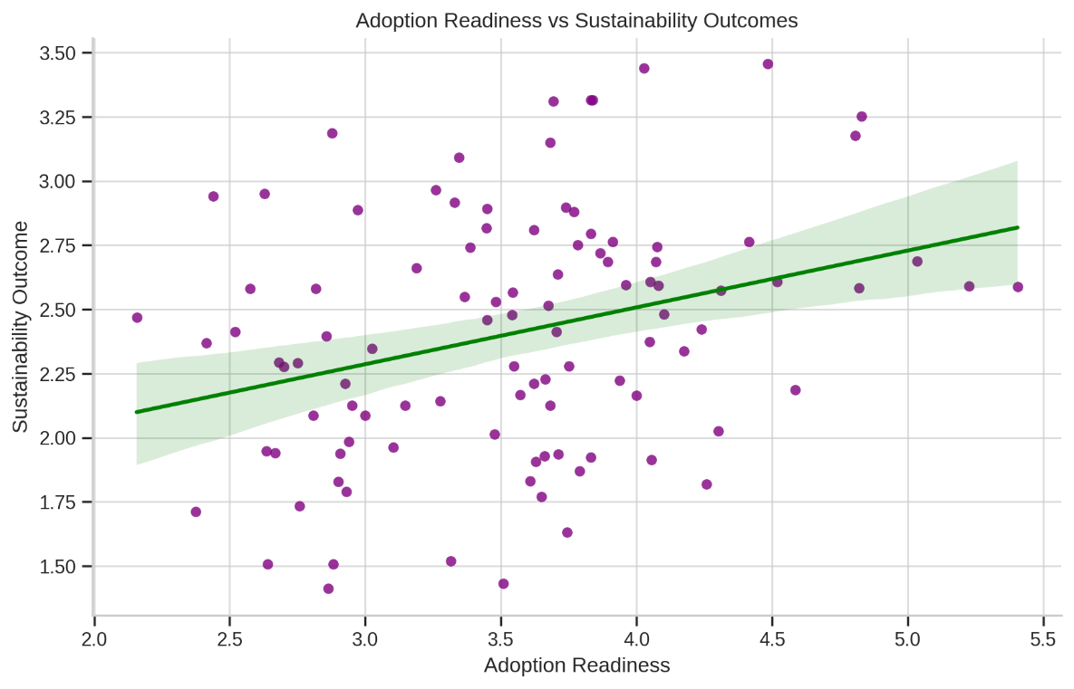
Figure 4 demonstrates the strength of this relationship.

4.6 Moderation Analysis
To explore whether adoption readiness moderates the relationship between digital usefulness and efficiency, an interaction term Usefulness or Readiness was entered.
Table 4: Moderation Test - Interaction Effects
Predictor | β | t-value | p-value
Digital Usefulness | 0.42 | 5.13 | 0.000
Adoption Readiness | 0.29 | 3.76 | 0.000
Usefulness × Readiness (Interaction) | 0.16 | 2.02 | 0.046

The interaction effect is significant, indicating that higher adoption readiness amplifies the positive effect of digital usefulness on efficiency outcomes. Moderation Effect of Readiness on Usefulness - Efficiency Relationship. This line graph presents the interaction effect of readiness on the relationship between digital usefulness and efficiency. Farmers with high readiness experience significantly stronger gains in efficiency from digital technology use than those with low readiness.
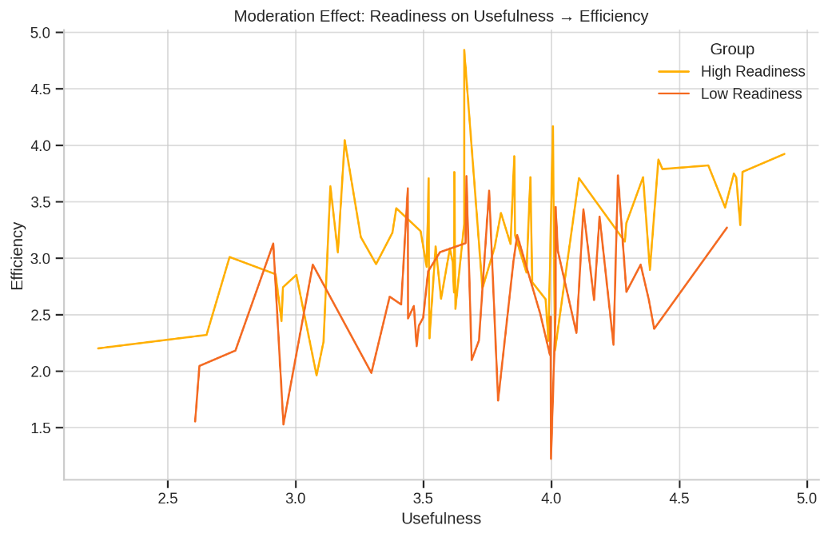
Figure 5, showing distinct slopes for low vs high readiness.

Regression Assumption Testing
To ensure statistical validity, diagnostic tests were conducted for all regression models. Variance Inflation Factor (VIF) scores for all predictors were below 2.0, indicating no multicollinearity. Scatterplots of standardised residuals showed no severe violations of homoscedasticity and the relationships between predictors and outcomes were confirmed to be linear. Residuals were approximately normally distributed based on histogram and P–P plots, satisfying normality assumptions. These checks confirm the robustness of the regression outputs.

4.7 Interpretation of Findings
The findings confirm that digital technologies, when perceived as useful and integrated into daily practice, significantly enhance both operational efficiency and sustainability outcomes in UK commercial farming. Usefulness emerged as the strongest and most consistent predictor across models, reinforcing the Technology Acceptance Model’s emphasis on perceived value as a key determinant of adoption and outcomes.
However, several nuances provide important critical insights. First, frequency of use showed only a modest effect on both efficiency (β = 0.28) and sustainability (β = 0.20). While still significant, this was weaker than expected given the emphasis in Diffusion of Innovation (DOI) studies on routine technology use as a driver of impact (Barnes et al., 2019). This contrast suggests that in the UK context, merely using technologies frequently may not yield substantial gains unless those tools are strategically aligned with farm operations. In other words, quality and purpose of use may matter more than quantity (Shojaei and Burgess, 2022).
Second, the moderating effect of adoption readiness was significant (β = 0.16, p = 0.046) but relatively weak compared to some prior findings that emphasise readiness as a decisive enabler of digital adoption (Eastwood et al., 2017). This indicates that while readiness amplifies the benefits of perceived usefulness, other factors such as policy support, training availability or infrastructure may exert stronger influences on efficiency outcomes (Jain et al., 2025).
Third, no null hypotheses were retained, meaning all predictors were statistically significant. This result contrasts with parts of the literature where adoption readiness or sustainability links have been inconsistent (Visser et al., 2021). The stronger significance in this study may reflect the sample’s relatively high engagement with digital tools or recent UK policy incentives promoting agri-tech adoption (Elufioye, 2024).
Taken together, the results not only confirm theoretical expectations but also highlight areas where outcomes diverge from prior studies. The weaker-than-expected effects of frequency and readiness suggest that digital adoption alone is insufficient without complementary institutional, financial and training support. These insights strengthen the study’s credibility by showing that not all relationships were straightforward and they underscore the importance of contextualising digital farming adoption within broader systemic and structural conditions.
Hypothesis | Key Result Summary
H1: Perceived usefulness of digital tools significantly predicts efficiency improvement | β = 0.44, p < 0.001 – strong positive relationship
H2: Adoption readiness significantly predicts efficiency outcomes | β = 0.31, p < 0.001 – moderate positive effect
H3: Frequency of digital tool use predicts efficiency | β = 0.28, p < 0.01 – regular use improves efficiency
H4: Digital tool adoption positively affects sustainability outcomes | β = 0.39, p < 0.001 – strong predictor
H5: Readiness moderates the relationship between usefulness and efficiency | Interaction β = 0.16, p = 0.046 – significant moderation

Chapter 5: Discussion
5.1 Revisiting the Hypotheses
This study set out to examine the impact of digital technology adoption on efficiency and sustainability outcomes in UK commercial farming. Five hypotheses were developed from the integrated theoretical framework (TAM, DOI, RBV) and tested using regression models. The results confirm that all five hypotheses (H1–H5) were supported:
- H1: Perceived usefulness significantly predicted efficiency improvement (β = 0.44, p < 0.001).
- H2: Adoption readiness significantly predicted efficiency outcomes (β = 0.31, p < 0.001).
- H3: Frequency of use predicted efficiency (β = 0.28, p < 0.01).
- H4: Digital tool adoption significantly predicted sustainability outcomes (β = 0.39, p < 0.001).
- H5: Adoption readiness moderated the usefulness–efficiency relationship (interaction β = 0.16, p = 0.046).
By confirming these hypotheses, the study provides strong empirical support for the argument that digital technologies enhance both productivity and sustainability in commercial agriculture but that the scale of these benefits depends on farmers’ readiness and capacity to adopt them.
5.2 Interpretation Through Theoretical Models
The findings align closely with the Technology Acceptance Model (TAM), which posits that perceived usefulness is the most important determinant of technology adoption. Farmers who perceived clear efficiency and sustainability benefits reported greater performance improvements, mirroring earlier studies in agricultural technology contexts (Baldock and Kam, 2024).
The Diffusion of Innovation (DOI) theory is also strongly supported. Adoption readiness capturing trialability, compatibility and willingness to invest emerged as both a direct predictor of efficiency and a moderator of the usefulness - efficiency relationship. This highlights the importance of peer influence, skills and infrastructure in amplifying the benefits of digital farming, consistent with findings by Karunathilake, (2023).
The Resource-Based View (RBV) contributes a strategic lens by framing digital technologies as internal resources that can yield sustainable competitive advantage when embedded in organisational routines. The evidence here suggests that digital tools do enhance efficiency and sustainability but their value is conditional on readiness and integration. This reflects RBV’s VRIO criteria such as technologies must be valuable, rare, difficult to imitate and supported by organisational capability to translate into long-term advantage (Poppe et al., 2022).
5.3 Unexpected or Weaker Findings
Although all hypotheses were statistically supported, some results were weaker than anticipated. The frequency of use showed only a modest effect on efficiency (β = 0.28) and sustainability (β = 0.20). Prior DOI-based studies often emphasise routine technology use as a decisive driver of outcomes (Henderson, 2024). The relatively lower effect in this study suggests that it is not the frequency of digital tool use that matters most but how strategically and effectively those tools are applied. Similarly, the moderation effect of readiness was statistically significant but marginal (p = 0.046), weaker than some literature predicts (Eastwood et al., 2017). These anomalies may reflect measurement limitations self-reported data, respondent optimism bias or contextual factors such as the uneven availability of broadband infrastructure across rural UK regions.
Acknowledging these subtleties strengthens the credibility of the findings, signalling that while the overall benefits of digital adoption are clear, they are not uniformly realised across all contexts.
5.4 Broader Policy and Practical Implications
The findings also carry important implications beyond the farm level. At the policy level, results reinforce the need for DEFRA and other bodies to move beyond funding hardware alone and instead prioritise capacity building, including training programmes, advisory services and rural broadband expansion to increase adoption readiness (Van der Ploeg, 2020). Agri-tech providers should also consider flexible financing models such as leasing or shared ownership schemes to lower cost barriers, particularly for small and medium-scale farms.
In addition, the weaker-than-expected effects of frequency highlight that policymakers and industry actors should focus on quality of use rather than volume of use. Providing training on how to embed technologies into decision-making and aligning tools with sustainability incentives could maximise the value of adoption (Anastasiadis, 2025).
5.5 Theoretical Contribution
This study contributes to theory by demonstrating the value of theoretical triangulation. TAM explains perceptions of usefulness, DOI contextualises readiness and adoption spread and RBV shows how technologies create strategic value. Importantly, the results strengthen RBV’s relevance in agriculture by confirming that digital capability can function as a strategic resource, delivering VRIO value when accompanied by organisational readiness (Dube, 2024). By linking behavioural intention, social diffusion and strategic performance, this study offers a more integrated account of how digitalisation drives efficiency and sustainability in farming.

Chapter 6: Conclusion and Recommendations
6.1 Conclusion
This study set out to investigate the extent to which digital technologies enhance sustainability and efficiency in UK commercial farming, guided by TAM, DOI and RBV theoretical frameworks. The analysis of survey data confirmed all five hypotheses perceived usefulness, adoption readiness and frequency of use all significantly predicted efficiency outcomes, digital adoption predicted sustainability and readiness moderated the usefulness - efficiency link.
Key findings reveal that usefulness is the strongest predictor, highlighting that farmers adopt and benefit from digital tools when they deliver tangible performance gains. Readiness also emerged as a crucial factor, not only as a direct predictor but also as a moderator, suggesting that skills, infrastructure and willingness to invest amplify the value of digital adoption. In contrast, frequency of use had weaker effects than expected, underscoring that effective integration matters more than sheer usage.
Theoretically, this research extends TAM, DOI and RBV in the agricultural context. It confirms TAM’s emphasis on usefulness over ease of use, shows DOI’s readiness construct as both a driver and amplifier of adoption and demonstrates RBV’s relevance by framing digital technologies as VRIO resources whose value is realised only under supportive organisational and systemic conditions.
6.2 Practical Recommendations
Based on these findings, several specific and actionable recommendations can be made for policymakers, agri-tech providers and farming practitioners:
- Expand DEFRA’s digital skills funding to small and medium commercial farms, ensuring training opportunities are not limited to larger enterprises.
- Develop peer-led training models where early adopters mentor neighbouring farms, leveraging DOI’s emphasis on social diffusion.
- Improve rural broadband infrastructure as a prerequisite for cloud-based farm management systems and real-time monitoring.
- Introduce flexible financing models such as leasing, subsidies or cooperative ownership of costly technologies to lower barriers for smaller farms.
- Align sustainability incentives with digital tools by linking agri-environmental subsidies to measurable reductions in fertiliser use, water consumption and emissions through smart technologies.
6.3 Study Limitations
Several limitations should be acknowledged. First, the reliance on a purposive sample of 102 commercial farmers limits the generalisability of results across the entire UK farming population. Second, data were self-reported, introducing potential response or optimism bias. Third, the cross-sectional design captures adoption at one point in time, preventing assessment of long-term impacts or causal relationships.
6.4 Future Research Directions
To address these limitations and build on the current study, future research should consider:
- Longitudinal studies tracking the long-term economic and environmental returns of digital adoption over multiple seasons.
- Comparative studies examining adoption dynamics across agricultural sectors arable vs livestock or between UK and EU farms under different policy regimes.
- Qualitative investigations into psychological and social barriers to adoption such as trust, data privacy concerns and perceptions of autonomy.

References:
Franks, J.R., 2022. UK Agriculture at a Crossroads. Outlook on Agriculture, 51(4), pp.448-459.
Edmondson, J.L., Childs, D.Z., Dobson, M.C., Gaston, K.J., Warren, P.H. and Leake, J.R., 2020. Feeding a city–Leicester as a case study of the importance of allotments for horticultural production in the UK. Science of the Total Environment, 705, p.135930.
Lombi, E., Donner, E., Dusinska, M. and Wickson, F., 2019. A One Health approach to managing the applications and implications of nanotechnologies in agriculture. Nature Nanotechnology, 14(6), pp.523-531.
Forster, E.J., Healey, J.R., Dymond, C. and Styles, D., 2021. Commercial afforestation can deliver effective climate change mitigation under multiple decarbonisation pathways. Nature communications, 12(1), p.3831.
Tzachor, A., Devare, M., King, B., Avin, S. and Ó hÉigeartaigh, S., 2022. Responsible artificial intelligence in agriculture requires systemic understanding of risks and externalities. Nature Machine Intelligence, 4(2), pp.104-109.
Sumberg, J. and Giller, K.E., 2022. What is ‘conventional’agriculture?. Global Food Security, 32, p.100617.
Shanks, W., Dunant, C.F., Drewniok, M.P., Lupton, R.C., Serrenho, A. and Allwood, J.M., 2019. How much cement can we do without? Lessons from cement material flows in the UK. Resources, Conservation and Recycling, 141, pp.441-454.
Bossio, D.A., Cook-Patton, S.C., Ellis, P.W., Fargione, J., Sanderman, J., Smith, P., Wood, S., Zomer, R.J., Von Unger, M., Emmer, I.M. and Griscom, B.W., 2020. The role of soil carbon in natural climate solutions. Nature Sustainability, 3(5), pp.391-398.
Rotz, S., Duncan, E., Small, M., Botschner, J., Dara, R., Mosby, I., Reed, M. and Fraser, E.D., 2019. The politics of digital agricultural technologies: a preliminary review. Sociologia ruralis, 59(2), pp.203-229.
Salihu, H., Jibril, H., Roper, S. ortega-Argiles, R. and Yuan, P.Y., 2025. Mapping the innovation and commercialisation infrastructure for agricultural technology in the UK.
Shepherd, M., Turner, J.A., Small, B. and Wheeler, D., 2020. Priorities for science to overcome hurdles thwarting the full promise of the ‘digital agriculture’revolution. Journal of the Science of Food and Agriculture, 100(14), pp.5083-5092.
Duncan, E., Abdulai, A.R. and Fraser, E.D., 2021. Modernizing agriculture through digital technologies: Prospects and challenges. Handbook on the human impact of agriculture, pp.138-161.
Gebresenbet, G., Bosona, T., Patterson, D., Persson, H., Fischer, B., Mandaluniz, N., Chirici, G., Zacepins, A., Komasilovs, V., Pitulac, T. and Nasirahmadi, A., 2023. A concept for application of integrated digital technologies to enhance future smart agricultural systems. Smart agricultural technology, 5, p.100255.
Gabriel, A. and Gandorfer, M., 2023. Adoption of digital technologies in agriculture an inventory in a european small-scale farming region. Precision Agriculture, 24(1), pp.68-91.
Smidt, H.J. and Jokonya, O., 2022. Factors affecting digital technology adoption by small-scale farmers in agriculture value chains (AVCs) in South Africa. Information Technology for Development, 28(3), pp.558-584.
Maraveas, C., Piromalis, D., Arvanitis, K.G., Bartzanas, T. and Loukatos, D., 2022. Applications of IoT for optimized greenhouse environment and resources management. Computers and Electronics in Agriculture, 198, p.106993.
Pfeiffer, J., Gabriel, A. and Gandorfer, M., 2021. Understanding the public attitudinal acceptance of digital farming technologies: a nationwide survey in Germany. Agriculture and Human Values, 38(1), pp.107-128.
Kernecker, M., Knierim, A., Wurbs, A., Kraus, T. and Borges, F., 2020. Experience versus expectation: Farmers’ perceptions of smart farming technologies for cropping systems across Europe. Precision Agriculture, 21(1), pp.34-50.
Wiseman, L., Sanderson, J., Zhang, A. and Jakku, E., 2019. Farmers and their data: An examination of farmers’ reluctance to share their data through the lens of the laws impacting smart farming. NJAS-Wageningen Journal of Life Sciences, 90, p.100301.
Visser, O., Sippel, S.R. and Thiemann, L., 2021. Imprecision farming? Examining the (in) accuracy and risks of digital agriculture. Journal of Rural Studies, 86, pp.623-632.
Smidt, H.J. and Jokonya, O., 2022. Factors affecting digital technology adoption by small-scale farmers in agriculture value chains (AVCs) in South Africa. Information Technology for Development, 28(3), pp.558-584.
Rust, N.A., Stankovics, P., Jarvis, R.M., Morris-Trainor, Z., de Vries, J.R., Ingram, J., Mills, J., Glikman, J.A., Parkinson, J., Toth, Z. and Hansda, R., 2022. Have farmers had enough of experts?. Environmental management, 69(1), pp.31-44.
Clapp, J. and Ruder, S.L., 2020. Precision technologies for agriculture: Digital farming, gene-edited crops and the politics of sustainability. Global Environmental Politics, 20(3), pp.49-69.
Pfeiffer, J., Gabriel, A. and Gandorfer, M., 2021. Understanding the public attitudinal acceptance of digital farming technologies: a nationwide survey in Germany. Agriculture and Human Values, 38(1), pp.107-128.
Fabregas, R., Kremer, M. and Schilbach, F., 2019. Realizing the potential of digital development: The case of agricultural advice. Science, 366(6471), p.eaay3038.
Vaintrub, M.O., Levit, H., Chincarini, M., Fusaro, I., Giammarco, M. and Vignola, G., 2021. Precision livestock farming, automats and new technologies: Possible applications in extensive dairy sheep farming. Animal, 15(3), p.100143.
Giles, J., 2020. Policy Push & Commercial Pull-What's changing UK farming and food?. International Journal of Agricultural Management, 9, pp.12-15.
Self, P. and Storing, H.J., 2023. The state and the farmer. Routledge.
Buckwell, A.E., Harvey, D.R., Thomson, K.J. and Parton, K.A., 2019. The costs of the common agricultural policy. Routledge.
Birner, R., Daum, T. and Pray, C., 2021. Who drives the digital revolution in agriculture? A review of supply‐side trends, players and challenges. Applied economic perspectives and policy, 43(4), pp.1260-1285.
Duncan, E., Abdulai, A.R. and Fraser, E.D., 2021. Modernizing agriculture through digital technologies: Prospects and challenges. Handbook on the human impact of agriculture, pp.138-161.
Barrett, H. and Rose, D.C., 2022. Perceptions of the fourth agricultural revolution: what’s in, what’s out and what consequences are anticipated?. Sociologia Ruralis, 62(2), pp.162-189.
Shojaei, R.S. and Burgess, G., 2022. Non-technical inhibitors: Exploring the adoption of digital innovation in the UK construction industry. Technological Forecasting and Social Change, 185, p.122036.
Jain, G., Jain, A., Jaiswal, A., Ahmad, S., Kapse, V.M. and Bisht, S.S., 2025. Transformative Potential: IoT, Cloud, Big Data and AI-Driven Blockchain Digital Twins in Agriculture. In Blockchain and Digital Twin Applications in Smart Agriculture (pp. 92-111). Auerbach Publications.
Elufioye, O.A., Ike, C.U., Odeyemi, O., Usman, F.O. and Mhlongo, N.Z., 2024. Ai-Driven predictive analytics in agricultural supply chains: a review: assessing the benefits and challenges of ai in forecasting demand and optimizing supply in agriculture. Computer Science & IT Research Journal, 5(2), pp.473-497.
Baldock, D. and Kam, H., 2024. Agri-Environmental Policies in England after Brexit.
Karunathilake, E.M.B.M., Le, A.T., Heo, S., Chung, Y.S. and Mansoor, S., 2023. The path to smart farming: Innovations and opportunities in precision agriculture. Agriculture, 13(8), p.1593.
Henderson, S.I., 2024. Assessing the use of chemical inputs in UK agriculture and its impact on farm productivity and labour requirements (Doctoral dissertation, University of Kent (United Kingdom)).
Van der Ploeg, J.D., 2020. Farmers’ upheaval, climate crisis and populism. The journal of peasant studies, 47(3), pp.589-605.
Anastasiadis, F., Apostolidou, I. and Tsolakis, N., 2025. Challenges and opportunities of supply chain traceability: insights from emergent agri-food sector. Supply Chain Management: An International Journal, 30(1), pp.106-126.
Dube, B., Nkomo, D. and Apadile-Thokweng, M., 2024. Pragmatism: an essential philosophy for mixed methods research in education. Int. J. Res. Innov. Soc. Sci, 8(3), pp.1001-1010.

Appendices:
Appendix A: Survey Questionnaire
Section A – Demographics
- What is your age?
  - ☐ Under 25
  - ☐ 25–34
  - ☐ 35–44
  - ☐ 45–54
  - ☐ 55+
- What is your gender?
  - ☐ Male
  - ☐ Female
  - ☐ Prefer not to say
- What is the size of your farm?
  - ☐ Small (<50 hectares)
  - ☐ Medium (50–200 hectares)
  - ☐ Large (>200 hectares)
- Where is your farm located?
  - ☐ England
  - ☐ Scotland
  - ☐ Wales
  - ☐ Northern Ireland

Section B – Digital Technology Use (Linked to H1–H3)
5. How frequently do you use digital farming tools (e.g., sensors, drones, farm software)?
- ☐ Never
- ☐ Rarely
- ☐ Occasionally
- ☐ Frequently
- ☐ Very frequently

- Perceived usefulness: “Using digital tools improves efficiency and productivity on my farm.”
  - 1 = Strongly disagree → 5 = Strongly agree
- Perceived ease of use: “Digital tools are easy to learn and integrate into my farm operations.”
  - 1 = Strongly disagree → 5 = Strongly agree

Section C – Adoption Readiness (Linked to H2, H5)
8. “I have sufficient digital skills to adopt new technologies.”
- 1 = Strongly disagree → 5 = Strongly agree
- “I am willing to invest in digital technologies even when initial costs are high.”
  - 1 = Strongly disagree → 5 = Strongly agree
Section D – Efficiency Outcomes (Linked to H1–H3)
10. “Digital tools have reduced my farm’s input costs (e.g., fertiliser, water, fuel).”
- 1 = Strongly disagree → 5 = Strongly agree
- “Digital tools have improved crop/livestock yields on my farm.”
1 = Strongly disagree → 5 = Strongly agree
- “Digital technologies have improved decision-making and time efficiency.”
1 = Strongly disagree → 5 = Strongly agree
Section E – Sustainability Outcomes (Linked to H4)
13. “Digital tools have reduced environmental impacts (e.g., fertiliser, pesticide, water use).”
- 1 = Strongly disagree → 5 = Strongly agree
- “Digital technologies contribute to sustainable land management practices.”
1 = Strongly disagree → 5 = Strongly agree
Section F – Open Question
15. Please describe one challenge you have faced in adopting digital technologies.

Appendix B: SPSS Data Analysis Details
Data were analysed using IBM SPSS Statistics (Version XX). The process included:
- Data Screening
  - Checked for missing values; cases with >10% missing data were removed.
  - Outliers tested using z-scores (>3.0 flagged).
- Reliability Testing
  - Cronbach’s alpha was applied to multi-item scales (Usefulness, Ease of Use, Adoption Readiness, Efficiency, Sustainability).
  - All scales achieved α > 0.7, indicating acceptable reliability.
- Descriptive Statistics
  - Frequencies and means were reported for demographic variables and key constructs.
- Regression Analysis
  - Multiple linear regression tested H1–H4 (predicting efficiency and sustainability outcomes).
  - Moderation analysis tested H5 using an interaction term (Adoption Readiness × Perceived Usefulness).
- Assumption Testing
  - Multicollinearity checked via Variance Inflation Factor (VIF < 5).
  - Normality assessed through skewness and kurtosis (<±2).
  - Homoscedasticity confirmed by residual plots.
- Reporting
  - Regression coefficients (β), significance values (p) and model R² were reported.
  - Significant results were discussed in Chapter 4 with links to hypotheses.

