26/06/2023
Jamie Leung

Design for X Project
Manufacturing Design & Technology
Contents
Introduction 2
What is Additive Manufacturing? 2
Renishaw 2
Component 3
Automated Modelling 4
5
Generative design 6
AM 8
Material Choice 10
Titanium Ti6Al4V (Grade 23) 10
Task 2 11
Concept Design Appraisal 11
Design Specification 11
QFD 12
Manufacturing Process Proposal 0
5s 0
Poke-Yoke 0
Production 1
Design and Development Work Undertaken 2
Scamper 2
FMEA 0
Conclusion 0
References 1

Introduction

What is Additive Manufacturing?
The process of additive manufacturing, sometimes referred to as AM or 3D printing, uses thin layers of material to create complex structures that are impossible to create with conventional techniques like machining. AM can be used from anywhere to creating prototype parts to medical equipment. The AM process involves melting layers of material or powder with lasers to create the component required from a digital file. New design opportunities, such as the ability to integrate several components in production, optimise material consumption, and save tooling costs, are made possible by additive manufacturing (AM). There are several different types of additive manufacturing such as, Powder Bed Fusion, Sheet Lamination, Material Extrusion, Material Jetting, Vat Polymerisation, Direct Energy Deposition and Binder Jetting.

Renishaw
Gloucestershire serves as the home of the British corporation Renishaw. When John Deer and David McMurtry founded their business in 1973, the touch trigger probe was their initial offering. Production, measurement, and precise metrology are the main areas of concentration for Renishaw. Furthermore, Renishaw is a market leader in the area of additive manufacturing (Renishaw plc, 2020).

This report will cover two tasks with one relating to DfAM. A design process called Design for Additive Manufacturing (DfAM) focuses on using computer-aided design (CAD) to manufacture parts and goods made with 3D printing or other additive manufacturing technologies. DfAM uses these methods' unique characteristics to produce lighter, intricate designs at a cheaper price than those produced by conventional manufacturing procedures. Task one covers choosing an component that is used by Renishaw plc with the final design of this component created on Fusion 360. Different techniques will be used such as, automated and generative design with a detailed overview of material selection and selected AM process.

Task two looks at redesigning parts on a wind turbine for mass production. A concept designed has been provided and further development to optimise the manufacturability of the system has been studied. The production volume will be between 1000 and 2000 units per week.

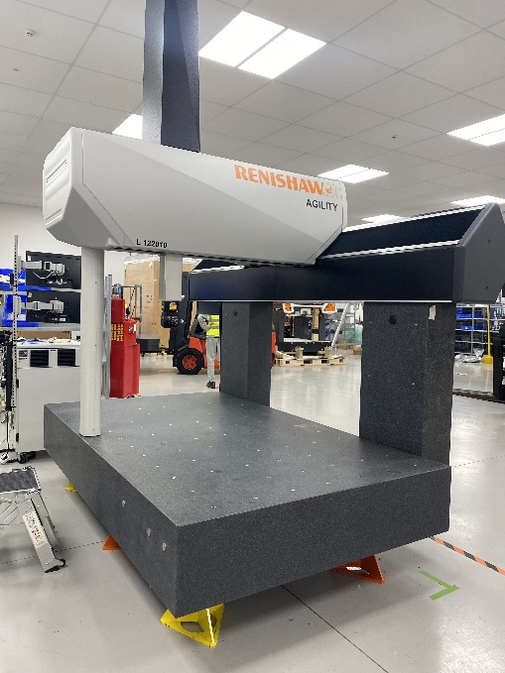
Component
Figure 1 - CMM

Component of choice is a bracket holding up an air bearing located on an CMM machine at Renishaw. The CMM stands for Coordinate Measuring Machine. A CMM is a multi-axis measurement machine used to precisely measure areas on the surface of a part by determining the geometry along the X, Y, and Z axes using a touch-trigger probe. For the CMM to move freely, the machine relays on air bearings so this bracket is a vital piece of kit. The Renishaw CMM can be seen as one of the most accurate measuring machines in the world and can measure under 4 microns. Figure 1 shows a fully built up CMM. Figure 2/3 shows where the existing bracket is currently located on the machine.

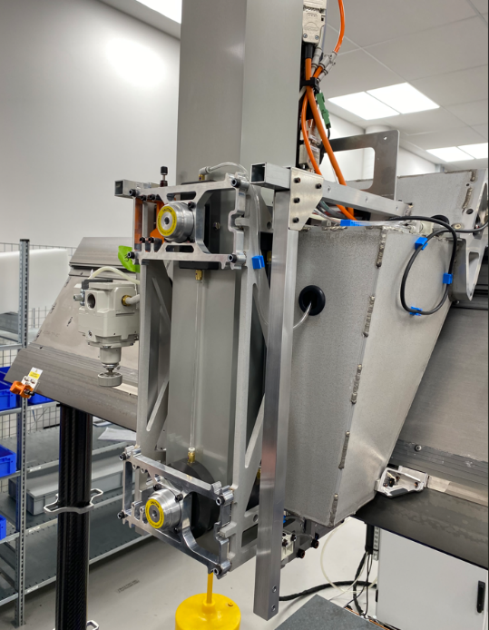
Figure 2
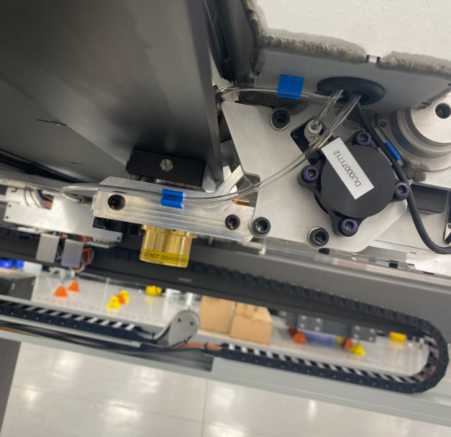
Figure 3 - Existing Bracket

Autodesk Fusion 360 is the primary software used to redevelop the component. Fusion allowed to sketch the model using the simple functions like line, circles and extrude. Shown below in Figure 4 is the initial sketch design of the component.
Figure 4 - Sketch of component
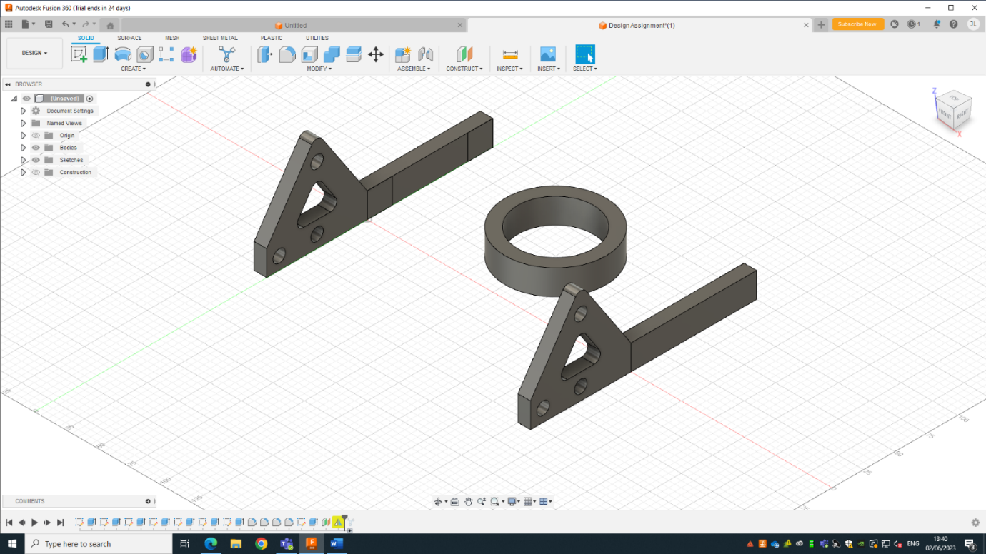

Automated Modelling

Automated Modelling on Fusion 360 is a design tool and It utilises automated design exploration and concept generation based on basic specifications of what to include and what to avoid. With these fundamental inputs, people can quickly create a variety of designs. A chosen design is transformed into a new body or element into the design. Figure 5 shows the automated modelling in action with inputs for faces to connect in blue and faces to avoid in red.

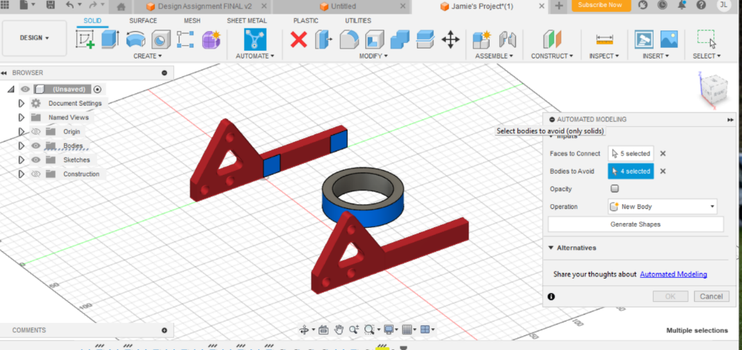
Figure 5- Automated

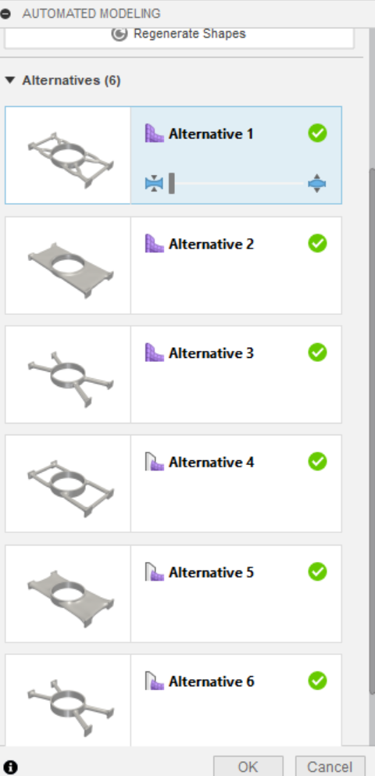
Figure 6 displays the various conclusions reached by the Fusion programme using automated modelling. The software has shown 6 completely different designs and users are able to pick whichever one looks the best for the component.
Figure 6 - Options for Automated

The completed automated modelling design is shown in Figure 7. At this point, defining the performance criteria, manufacturing method, and materials are not necessary to begin using automated modelling.

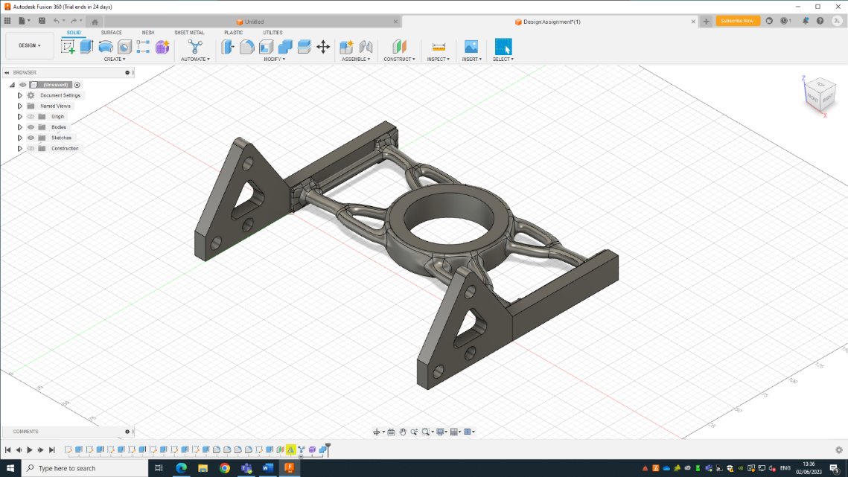
Figure 7 - Final Automated Design

Generative design

Generative design gives creative solutions and is generated automatically in line with user-pre-defined requirements, limitations, spatial requirements, materials, manufacturing methods, and cost constraints (Autodesk, 2018). In alignment with the functions and qualities that is specified for the component, the programme creates a design for it. Generative design is an effective tool that may provide fresh and creative concepts that are challenging or impossible to execute using conventional design techniques. Generative design is quite similar to Automated modelling where the software decides the different outcomes that is possible.
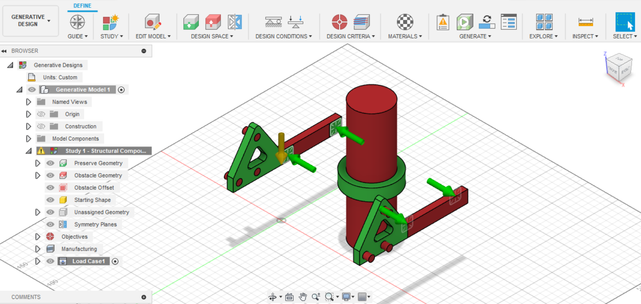
Figure 8 - Generative Design

Generative design seemed like the best option for this component compared to other techniques such as Topology Optimisation. Topology is a procedure that enhances material structure and arrangement inside a given 3D geometric design space for a specified set of rules established by the creator of the design. The major difference between these two methods is that generative is all automated once you have set the parameters with artificial Intelligence. However, topology only uses the CAD model that someone has designed which leads into why topology optimisation is less adaptable and agile than generative design. Unlike topological optimisation, which is restricted to the analysis and improvement of existing structures, generative design may also take into consideration performance and cost constraints (Orban, 2020).

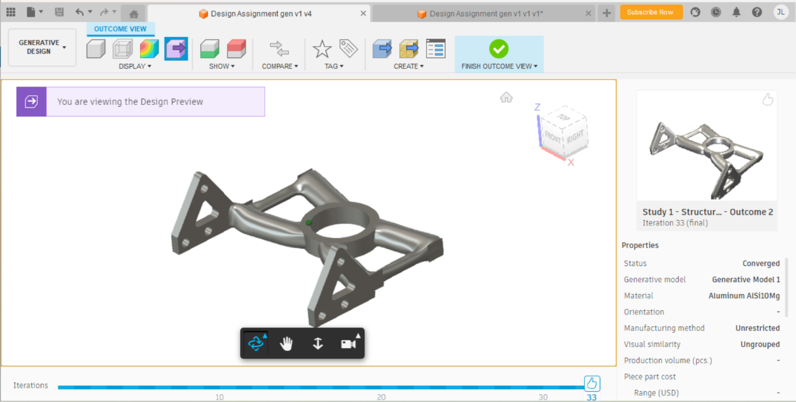
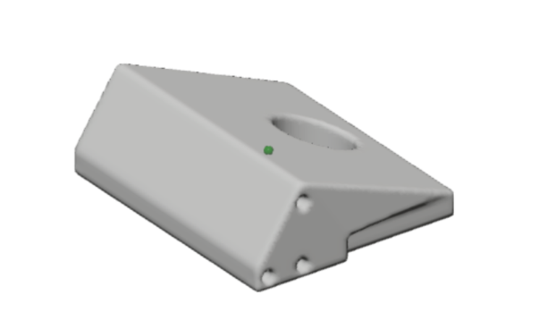
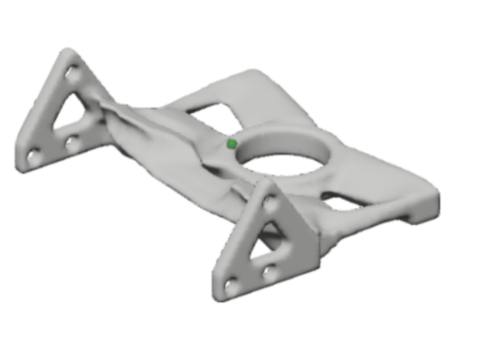
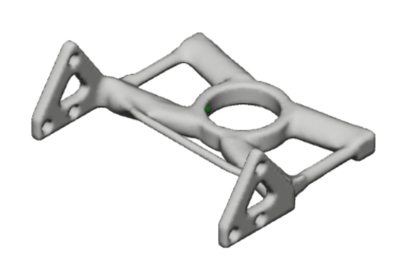
Figure 12 - Final Design 1
Figure 11 - Stage 3 Generative
Figure 10 - Stage 2 Generative
Figure 9 - Stage 1 Generative

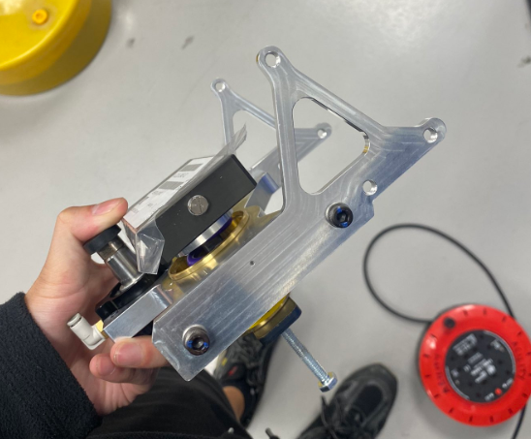
The final design and various stages of generative design processes are seen above. This is a useful method for imagining how the product will seem at various stages. Figure 12 displays the finished design created using generative design and automation.
Figure 13
By enabling users to produce complicated and optimised solutions with minimal effort, generative design has enhanced the original design process. Generative design is able to deliver effective solutions without many hours of trial and error by a designer by developing a set of design constraints.

AM Process

The additive manufacturing process that would suit this project best is Powder Bed Fusion. In the process known as powder bed fusion, powder is melted together using a heat source, often a laser. comparable to other additive techniques the laser melts a layer of powder that has been applied to a build platform to create a single solid layer. To create the required design, this process is done layer by layer. This technique differs from other traditional methods in that it adds materials to the foundation rather than removing them as in milling or turning (Global, 2021).
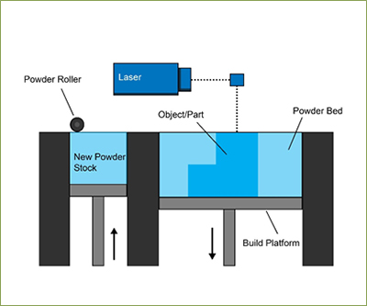

Figure 14 - Powder Bed Fusion Diagram 2

The process of PBF consists of adding new layers of material. The powdered material is delivered from a hopper and distributed evenly across build platform area using a wiper. The laser beam will then melt each layer to its required need and the process repeats itself until the product is complete. The chamber is normally filled up with some sort of gas like argon to improve print quality and any unused powder will get recycled or disposed correctly (Kent, 2020).

There are different types of Powder Bed Fusion;
- Selective Laser Sintering (SLS)
- Selective Laser Melting (SLM)
- Direct Metal Laser Sintering (DMLS)
- Electron Beam Melting (EBM)
- Selective Laser Melting (SLM)

The process that stands out the most for the bracket is the Selective Laser Melting (SLM). From its high-powered laser beam and capacity to melt significant amounts of metal powder, SLM is preferable to the other types of Powder Bed Fusion techniques. Compared to items printed using the other methods, they can be stronger, more precise, and more detailed. The use of a high-power beam using SLM decreases thermal strains and eliminates the need for supports or machining. Considering to its more powerful features, it can also produce pieces in a single step rather than layer by layer (Kauppila, 2022).

Powder Bed Fusion is the most suitable AM method for this application due to the quality of the component once it has finished being manufactured. Powder bed fusion also can be considered the more accurate am technique where it offers higher precision and control in the process as each layer is melted together by using a high precision laser beam. Additionally, it has an advantage over certain AM techniques in that manufacturing may produce a detailed three-dimensional component with relatively few defects, which is important for making parts with intricate shapes.

Another advantage of using PBF is that you can use a wide range of materials that are powder based such as, Titanium, Steel, Cobalt Chrome, Stainless Steel and Aluminium for SLM.

Support structures are vital when it comes to Powder Bed Fusion. There are different types of support structures available and to ensure a quality creation and to prevent component overhang, certain support structure requirements must be met. Support structures must be incorporated into the part in order to reinforce it and ensure that the printed layers stay in place and do not distort over time. To prevent the component from sticking to the powder bed, an active heat dissipation device, such as ventilation, may also be necessary. Support structures can be in the form of unused powder that supports the component or some sort of support material which can be seen in the diagram below (Cadsparc, 2022).

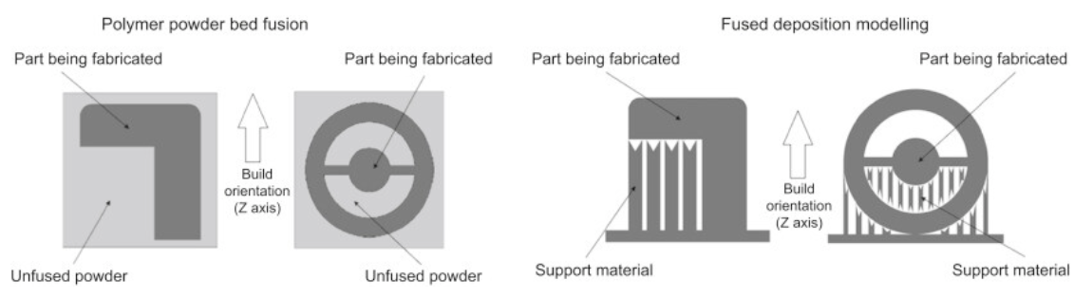
Support Structure Diagram 1

Material Choice

Titanium Ti6Al4V (Grade 23)

Aluminium, vanadium, and various other tiny elements are alloyed with titanium to create the Ti6Al4V alloy. Extra Low Interstitial (ELI) is another name for Ti6Al4V grade 23, which refers to the interstitial impurities of oxygen, carbon, and nitrogen. It is a purer form of Ti6Al4V grade 5, where the grade 23's decreased interstitial elements result in an improvement in ductility and fracture toughness (Renishaw, 2021).
Because of its outstanding strength to weight ratio, titanium is a great material to use for lightweight load structures like the CMM. It is ideal for this bracket because it has exceptional biocompatibility and corrosion resistance. A light yet sturdy bracket is essential since a component that is overly dense might weigh down a product unnecessarily and expensively. By using a lightweight yet durable bracket, the item's overall weight is decreased while still being able to handle the required load. It will also result in less structural deterioration over time. This is crucial because if the bracket failed, the air bearings that it is supposed to be supporting would drop and the CMM would be unable to move, impairing its ability to work as a whole. A light-weight bracket also makes the device lighter overall, which makes installation simpler. (Renishaw, 2021)

Material Properties;
- Highly effective against corrosion
- Low thermal conductivity
- Superior to other lightweight alloys in terms of fatigue resistance
- The components meet the chemical specifications for Grade 23 alloy.
- High strength paired with low weight.
- Good osseointegration
- Low thermal expansion

In terms of stiffness and durability, titanium outperforms aluminium, which is another factor that makes it more suitable. Furthermore, titanium has the advantage of lasting longer although often costing more than aluminium.
With comparison to steel, steel has a higher tensile yield strength and is stronger than titanium. However, having a high level of fatigue resistance, titanium can sustain numerous stress cycles without breaking. However, steel may not be the optimum material for this bracket because it is more prone to fatigue cracking (Ulbrich, 2020)

Task 2

Concept Design Appraisal

Design Specification

Company Name: UWTSD
Project Name: Portable Wind Turbine
Due Date: June 2023
Market Requirements: Portable wind turbines must be simple to use, compatible, safe, efficient, and economical. The turbines must be simple to install, run, and maintain. They must also adhere to strict safety requirements, have little downtime, and are highly reliable with regular maintenance. The turbines should also be affordable for both mass manufacturing and customers.

Conformance Requirements: Portable wind turbines need to be built and engineered to endure a range of environmental scenarios. While the turbine itself must be able to endure operational pressure as well as external factors like impacts, the turbine blades must be made to provide the most power achievable. The turbine's structure must be strong and long-lasting to ensure sustained performance, and it must be simple to carry around and set up without the use of specific instruments or equipment.

Production Requirements: To ensure the greatest degree of production quality, all parts used in manufacturing must adhere to precise industrial and regulatory criteria, and a strong quality control system must be in place. The turbine should be built with environmentally safe materials and manufacturing processes, a senior engineer must be appointed to oversee the final product's assembly. To guarantee component traceability, all production documents must be securely stored. Before being sold to customers, the turbine must also pass examination and evaluation with some sort of poke-yoke system. Material selection must be a material that is suitable for harsh environments and that is heavily corrosion resistant.

QFD

QFD or Quality Function Deployment, is a technique for converting client needs into design traits and using them to direct the creation of product designs. It is an approach to create a design that is focused on the needs of the customer, convert those needs into design goals, and turn those design goals into key quality assurance points that will be used throughout the manufacturing process (Nguyen, 2023).

QFD of the portable wind turbine is shown below in figure 15. A QFD for a portable wind turbine provides a visualisation that shows the relationship between customer requirements, design characteristics, and development methodologies. It will illustrate how these components interact and affect the result. The table will highlight customer needs and make clear how the design team incorporated them into the development strategy. It will also provide the design and engineering teams with a strong foundation for collaboration and communication, helping to guarantee that the product gets the desired outcome and achieves the intended result.
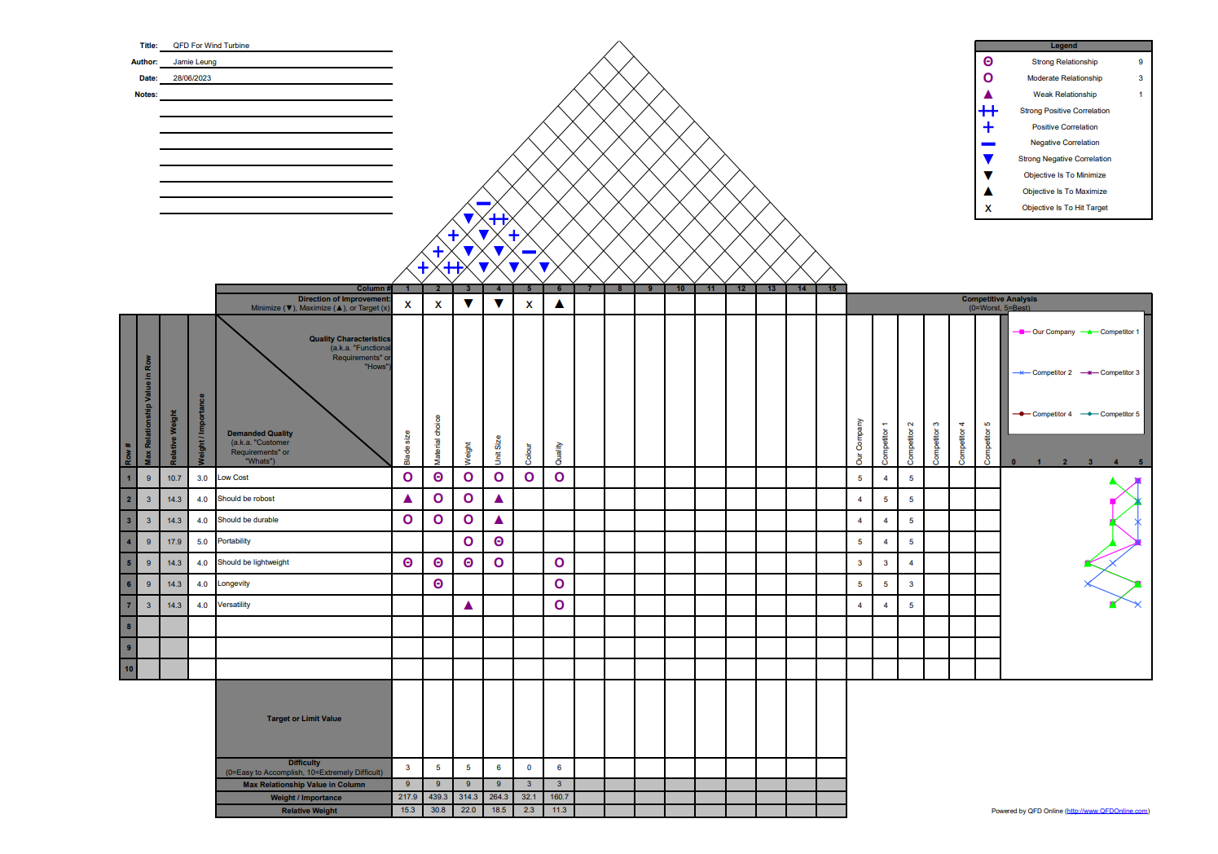
Figure 15 - QFD 1

Manufacturing Process Proposal

5s
For mass production, processes like 5s should be implemented for production to run smoothly. 5S is a methodical strategy for increasing productivity and effectiveness at work. The five Japanese terms seiri/sort, seiton/set in order, seiso/shine, seiketsu/standardise, and shitsuke/sustain are together referred to as the 5S system. The objective of 5S is to establish a safe, orderly workplace that is simple to take care of. For mass production of 1000 – 2000 units per week, the correct procedures and environment are vital in production. The sort stage helps remove any unneeded components from the working environment. Set in order focuses on organising and identifying places for equipment, tools and paperwork – for example, shadow boards for tooling. Shine is a procedure that involves regular housekeeping. Standardise involves setting these different procedures in place for production to run correctly. Lastly sustain allows management to apply discipline to team members where they would potentially assign responsibility, keep on top of how the cycle is going and to continue implementing these procedures.

Poke-Yoke

'Mistake proofing' is the English translation of the Japanese manufacturing word poka-yoke. This can include a straightforward go/no-go gauge or barcode scanners to make sure things is configured properly. It is crucial because manufacturing procedures often have a high potential for errors, such as parts that are put together incorrectly or mishaps that happen throughout the assembly process, which can result in flaws in the finished product (Hallifax, 2019).
Poka-yoke is a very helpful method when attempting to reduce the price of quality. Although poka-yoke does not modify human behaviour, it does reduce the likelihood that anything will go wrong, which promotes greater quality and lessens workplace stress. It is frequently used in conjunction with sensors, boundary switches, and other control devices that recognise improper input or motion and react by alerting the operator or stopping the activity. Businesses are using poka-yoke more frequently to boost productivity and lower costs of production (Cyger, 2018).

Production

From looking at the concept design there are numerous ways to assemble it incorrectly. For example, installing the wind blades the wrong orientation. It's crucial to have clear instructions and clearly readable marks on each component to avoid manufacturing mistakes. This makes sure that operators can understand the correct configuration of the things they are installing quickly and precisely. Each employee should also be well trained in the proper installation method and have a thorough grasp of the procedure. Before moving on to the next stage of manufacturing, things should be inspected after installation. Features to add to avoid these kinds of mistakes are error proofing or known as Poke-Yoke.

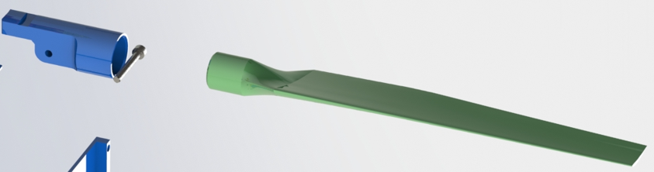
Figure 16

An illustration of a wind blade and the part it attaches to is shown above. The blade can now be installed in any orientation, which may result in the blade facing the incorrect direction. This wind turbine has four blades, and it's highly likely that the operator installs one of them incorrectly. Implementation of error proofing for this component is perfect. One with point of assembly and one point of use. To make certain the blades can only fit in correctly when they are arranged appropriately, a tight tolerance hole-and-pin system might be utilised. In addition to this the use of a template or jig to easily direct the pieces into the proper alignment. The implementation of visual indicators, such as colour coding or arrow markings, to lead the installation in the right way is another error proofing method for the blade. In addition, a feature that can notify assemblers when a wind turbine has been manufactured incorrectly or has a component error would be valuable. For example, a testing system with sensors could be installed after the wind turbine has been assembled, and it could even be possible to set up testing procedures that define what the wind turbine should be doing with pass or fail requirements before it is shipped to customers.

Design and Development Work Undertaken

Scamper

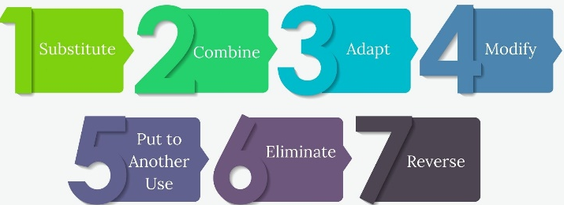
Figure 17 – Scamper

Scamper stands for Substitute, Combine, Adapt, Modify/Magnify, Put to Other Use, Eliminate, and Reverse. This approach encourages you to ask seven various sorts of questions, which will help you comprehend how you may innovate and enhance existing items, and thus helps you come up with ideas for new goods and services (MindTools, 2021). Parts of scamper for this wind turbine can be seen below.
Substitute
- Material swap
- Different bonding process
Combine
- Combining of components
Adapt
- Adding features
Modify
- Implantation of Poke-Yoke system
Put to Another Use
- Recycle the waste from the product.
Eliminate
- Getting rid of unnecessary components to make it smaller and lighter.
Reverse
- Try different bonding processes.

Shown below is the redesign of the blade and blade housing with poke-yoke added feature which was designed on Fusion 360. The blade has now been designed with a pin attached onto the end and the housing part has a hole where the blade slots into. The feature will ensure the correct orientation will be installed each time as it only slots in one way. Figure 17 illustrates the updated blade system and Figure 18 shows the updated housing unit.
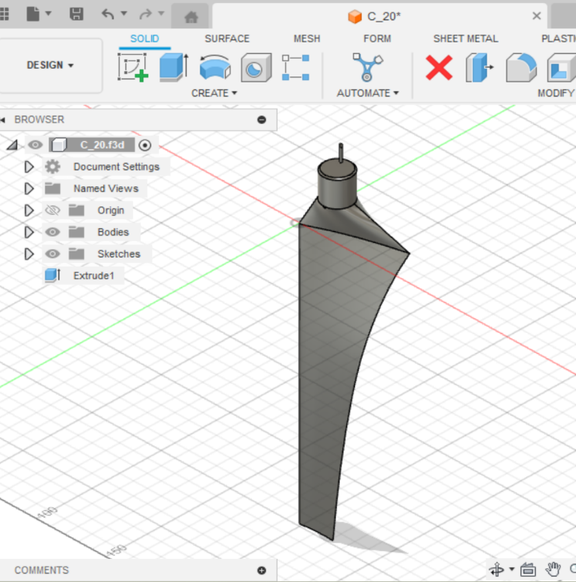
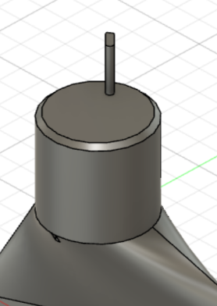
Figure 18

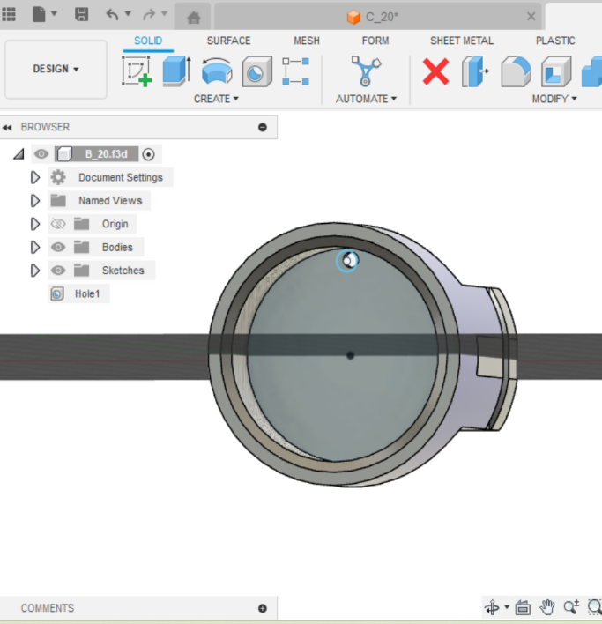
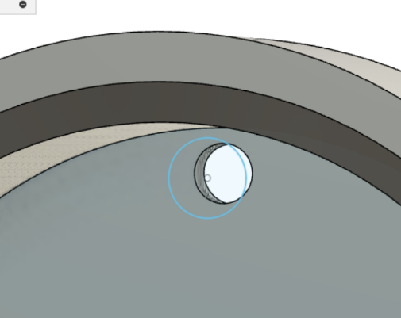
Figure 19

One improvement for this concept design is there are too many unnecessary separate components that can be consolidated. For example, shown below all these parts can be manufactured together as one piece.
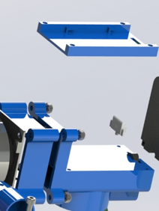
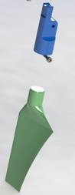
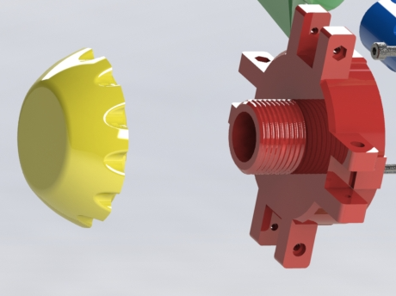
Figure 22
Figure 21
Figure 20

The use of fewer parts results in advantages in terms of time, expenses, and quality when producing a product. It also provides faster turnaround times can result from shorter production procedures, which allows items to reach customers sooner. Additionally, using fewer components can produce a product of greater quality with less potential for mistakes and flaws. It helps assemblers worry about less components to assemble so they can focus on the other parts. Additionally, it usually simpler to solve any production-related concerns when there are fewer components present. In general, identifying and fixing is more straightforward and takes less time when there are fewer items to track and manage. This may result in more effective issue solutions and minimise production delays. Furthermore, the less components that is used equals to less maintenance that is potentially required which is a good selling point for customers. With combining these components together, the actual function of the wind turbine does not change but it helps with the production side of things (Allwood et al., 2013)

Other things to be taking into account is how each component is currently bonded together. If the process consists of gluing components together this may lead into faults further down the line. In general, it is best to prevent gluing in production processes if at all feasible. Components that were improperly bonded may come unglued with time, requiring more frequent product replacement. In terms of repairs or compensation, this might result in higher expenditures for the business. Due to the wait for the glue to fully cure, adhesion bonding might take a long time and will increase production times. Additionally, if a worker glues a component incorrectly, it will be difficult to dismantle the part, which results in more scrap, which management, and the company dislike.
The implementation of screws to assemble this product would be more feasible. In general, screws are preferred over adhesives because they may produce longer-lasting connection. This is a way that screws may strongly connect two components together by creating an internal thread. Since the primary location of the wind turbine will be in adverse weather, this form of bond is often stronger than normal adhesives, which might deteriorate over time or with exposure to particular conditions. Additionally, screws are more effective for repairs because they make it simpler to reach and swap out any broken parts. Compared to gluing, components may be easily unscrewed and repaired or changed without requiring the item to be taken apart. The usage of screws may significantly cut down on maintenance times, which is advantageous to businesses of any kind (Besley, 2022).

Material choice is another factor the design should look at. Any product's design, but in particular the design of a portable wind turbine, depends heavily on the material choices made. This is such that the performance, longevity, and cost of the turbine may all be affected by the material selection. For a portable wind turbine, using a lightweight material is advantageous since it will be much simpler to move. Lighter materials may also aid in lowering the turbine's drag, which may lead to a more effective functioning. To guarantee that the turbine's components survive over time in perfect working order, it is also desirable to choose materials which possess strong corrosion resistance.
The performance and dependability of any process or product, including transportable wind turbines, can be impacted by the environment. Wind speed and direction are environmental parameters that should be taken into account while developing a portable wind turbine. The design of this wind turbine needs to take average speed into consideration, with various settings for various speeds. Additionally, it must be built to function in all possible directions.

This process contains aspects of the modify process that may be identified when utilising the Scamper technique. With the development of a new articulation mechanism, the tail can now spin 180 degrees and is supported by its own weight. (Cubas, 2023)
Figure 23 shows the original tail system and Figure 24 shows the modified section per to Adrian Cubas.

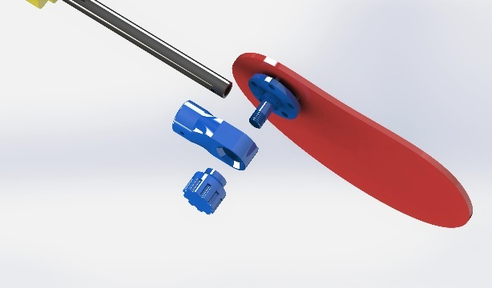
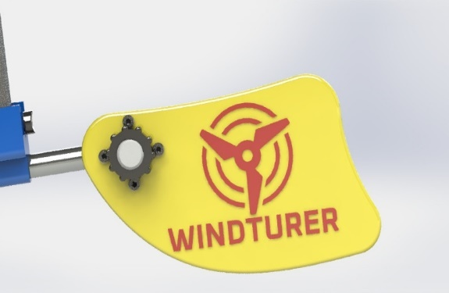
Figure 24 – Tail After
Figure 23 – Tail Before

FMEA
Process Function | Potential Failure Mode | Potential Effect(s) of Failure | Sev | Potential Cause(s)/ Mechanism(s) of Failure | Occur | Current  Process  Controls | Detec | RPN | Recommended Action(s) | Responsibility | Action Results
 |  |  |  |  |  |  |  |  |  |  | Actions Taken | Sev | Occ | Det | RPN
Operator assembling components incorrectly | Product not functioning correctly | Wind turbine not working or potential safety concern | 8 | Lack of training | 5 | N/A | 4 | 160 | Poke-Yoke system | Process | No action carried out yet | 0 | 0 | 0 | 0
Incorrect material choice | Weak structural points | Easily damaged materials/damage from environmental conditions | 5 | Design Choice | 3 | N/A | 1 | 15 | Pick materials that are corrosion resistance and that can withstand wear overtime | Design | No action carried out yet | 0 | 0 | 0 | 0
Wind blades swinging off | Not assembling correctly | Blade hitting someone | 9 | Incorrectly way to bond together or not assembled properly. | 2 | N/A | 3 | 54 | Poke-Yoke / testing system | Process | No action carried out yet | 0 | 0 | 0 | 0
Wind blades | Sharpness | Cutting someone that may come into contact with it | 6 | Design Choice | 3 | N/A | 1 | 18 | Select wind blade that is free not sharp edges or set up a safety parameter around it | Design | No action carried out yet | 0 | 0 | 0 | 0
The FMEA table you see above was created from a design perspective and the process for a wind turbine. Failure Mode Effect Analysis, or FMEA, is a useful method of risk management that can identify up-to-date and potential failures, rank potential risks according to their significance, offer different options, and enable a proactive approach to issue prevention (Wilhelmsen and Ostrom, 2019, p. 7). Users can easily understand that a poke-yoke system would be the best fit for this kind of product after using this tool.

Conclusion

In conclusion, this project has demonstrated a good grasp of Fusion 360 software and the practical techniques that can be utilised on it, such as Generative Design and Automated Modelling. The report covers research on a particular form of additive manufacturing process called powder bed fusion and the various methods that are under the same tree as powder bed fusion, along with a choice of material that works well for the component bracket.

Task 2 addresses how managing the design process and identifying client demands with the use of an FMEA and QFD may assist in producing an efficient and reasonably priced product. Companies may make sure their products will be able to fulfil client requests, be more dependable, and be better performing in the long term by taking environmental conditions and potential failure modes into account during the design process. In the end, using fewer components, adopting the right assembly techniques, and choosing the right materials are crucial factors to take into account while manufacturing a product. These components may assist guarantee that a product is of a high standard, satisfies client expectations, and is ultimately more affordable. In addition to this, the main outcome of this project from a production view is that Poke-Yoke system is vital, and every company should implement it along with the 5s system for any mass production facility to improve productivity and effectiveness.

References

Allwood, J.M., Ashby, M.F., Gutowski, T.G. and Worrell, E. (2013). Material efficiency: providing material services with less material production. Philosophical Transactions of the Royal Society A: Mathematical, Physical and Engineering Sciences, [online] 371(1986), p.20120496. doi:https://doi.org/10.1098/rsta.2012.0496.
Autodesk (2018). What is Generative Design | Tools & Software | Autodesk. [online] Autodesk.com. Available at: https://www.autodesk.com/solutions/generative-design [Accessed 17 Jun. 2023].
Besley, T. (2022). Mechanical fasteners VS. Adhesives: What’s the best bonding method? [online] Forgeway Ltd. Available at: https://forgeway.com/mechanical-fasteners-or-adhesives-best-joining-method/ [Accessed 26 Jun. 2023].
Cadsparc (2022). Support Structures used in Powder Bed Fusion | Internship Experience at CADSPARC. [online] www.linkedin.com. Available at: https://www.linkedin.com/pulse/support-structures-used-powder-bed-fusion-internship-experience- [Accessed 28 Jun. 2023].
Cubas, A. (2023). 3D PRINTED PORTABLE WIND TURBINE. [online] hackaday.io. Available at: https://hackaday.io/project/185070-3d-printed-portable-wind-turbine [Accessed 28 Jun. 2023].
Cyger, M. (2018). Poka-Yoke Definition. [online] iSixSigma. Available at: https://www.isixsigma.com/dictionary/poka-yoke/ [Accessed 25 Jun. 2023].
Global, T. (2021). What is Powder Bed Fusion? Process Definition and Advantages. [online] www.twi-global.com. Available at: https://www.twi-global.com/technical-knowledge/faqs/what-is-powder-bed-fusion [Accessed 21 Jun. 2023].
Hallifax, A. (2019). Poka-Yoke in Manufacturing. [online] RNA Automation. Available at: https://www.rnaautomation.com/insight/poka-yoke-in-manufacturing/ [Accessed 25 Jun. 2023].
Kauppila, I. (2022). Selective Laser Melting – The Ultimate Guide. [online] All3DP Pro. Available at: https://all3dp.com/1/selective-laser-melting-guide/ [Accessed 21 Jun. 2023].
Kent, F. | B., Design & Development Agency in (2020). Key advantages of powder bed fusion. [online] Kingsbury. Available at: https://kingsburyuk.com/key-advantages-of-powder-bed-fusion/ [Accessed 24 Jun. 2023].
Nguyen, S. (2023). What is quality function deployment (QFD)? Phases, example. [online] LogRocket Blog. Available at: https://blog.logrocket.com/product-management/quality-function-deployment-qfd-example-phases/ [Accessed 25 Jun. 2023].
Orban, R. (2020). Topology Optimization is not Generative Design. [online] Fusion 360 Blog. Available at: https://www.autodesk.com/products/fusion-360/blog/topology-optimization-is-not-generative-design/ [Accessed 18 Jun. 2023].
Renishaw (2021). Data sheet: RenAM 500 series Titanium Ti6Al4V (Grade 23) material data sheet. [online] www.renishaw.com. Available at: https://www.renishaw.com/resourcecentre/en/details?data=130336&lang=en [Accessed 24 Jun. 2023].
Renishaw plc (2020). Renishaw: About Renishaw. [online] Renishaw. Available at: https://www.renishaw.com/en/about-renishaw--6432 [Accessed 17 Jun. 2023].
Tools, M. (2021). MindTools | Home. [online] www.mindtools.com. Available at: https://www.mindtools.com/ao2rt8j/scamper [Accessed 25 Jun. 2023].
Ulbrich (2020). Titanium Versus Steel: A Battle of Strength. [online] Ulbrich. Available at: https://www.ulbrich.com/blog/titanium-versus-steel-a-battle-of-strength/#:~:text=Steel%20is%20stronger%20than%20titanium [Accessed 24 Jun. 2023].
Wilhelmsen, C.A. and Ostrom, L.T. (2019). Risk Assessment: Tools, Techniques, and Their Applications. [online] Google Books. John Wiley & Sons. Available at: https://www.google.co.uk/books/edition/Risk_Assessment/Ca-hDwAAQBAJ?hl=en&gbpv=1&pg=PP1.

