c.340 BC Amphora
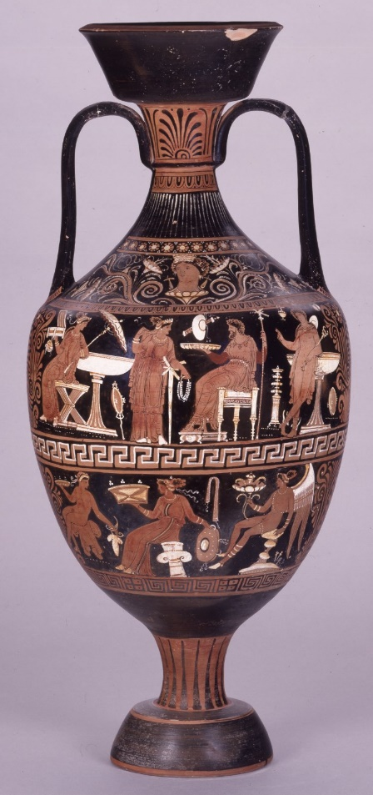
This Amphora dated around 340-330 was produced in Puglia (Southern region of Italy), however the pottery was excavated in Basilicata which is roughly “123.5 km” (Google.com, 2015) away from its production site. The British Museum attributes the Amphora to “The Patera Painter whose name is unknown” (British Museum, 2018), the amphora was “typically used in antiquity for the storage and transportation of foodstuffs such as wine and olive oil”. (Google.com, 2020.
Figure 1: Pottery: red-figured amphora with cover. (Image from; (British Museum, 2018)
There were Two styles of Amphoras in Apulian pottery popular around 8th and 5th century b.c the "Plain Style" and "Ornate Style" (sometimes "Rich Style") the style adapted by the artist for this piece is that of the “Plain Style” as the “Ornate style” consisted of much bigger pottery sometimes fitting up to “20 figures”. (En.wikipedia.org,2020) In the Hellenistic era, inaugurated by the military victories of Alexander the Great, black and red-figure pottery largely disappeared which then saw the creation of new styles of pottery such as Apulian Pottery.
The amphora features multiple deities on it, at the centre sits Pluto (Or Hades) wearing a purple garment which is typically a “sign of wealth and money as it was the most expensive flower (dye)”. (Novaroma.org, 2020). To the right of him stands Hermes leaning against a laver with his tell-tale staff caduceus as well as his golden winged sandals Talaria.

Bibliography

British Museum. (2018). amphora. [online] Available at: https://research.britishmuseum.org/research/collection_online/collection_object_details.aspx?objectId=463510&partId=1&searchText=Hades+and+Persephone+&page=2.

‌ Google.com. (2015). basilicata to puglia - Google Search. [online] Available at: https://www.google.com/search?biw=1366&bih=657&ei=Cy40Xrq-HeiV1fAP1NKN4A4&q=basilicata+to+puglia&oq=Basilicata+to+P&gs_l=psy-ab.1.0.0i22i30l10.19518.23542..26443...0.2..0.179.666.1j4......0....1..gws-wiz.......0i71j0i273j0.nsCEDruSdCQ [Accessed 31 Jan. 2020].

British Museum. (2018). Term details. [online] Available at: https://research.britishmuseum.org/research/search_the_collection_database/term_details.aspx?bioId=95211 [Accessed 31 Jan. 2020].
‌Novaroma.org. (2020). Ancient Greek Clothing - NovaRoma. [online] Available at: http://www.novaroma.org/nr/Ancient_Greek_Clothing [Accessed 2 Feb. 2020].
En.wikipedia.org. (2020). Apulian vase painting. [online] Available at: https://en.wikipedia.org/wiki/Apulian_vase_painting [Accessed 2 Feb. 2020].
‌

