Community Engagement Assignment 2 2018 – Problem Solving within Alliance Healthcare



APRIL 2018

MODULE NAME: COmmunity Engagement
Project Name: Place of work: Alliance healthcare
Name: Jessica Rees
Student Number: 1703037

Table of Contents

1. eXECUTIVE sUMMARY 1
2. Introduction 2
2.1 Report Remit 2
2.2 Brief background the organisation 2
2.3 The problem 2
3. Problem solving techniques 3
3.1 Solving the problem 3
3.2 Problem solving implementation 3
4. Conclusion 4
5. References 5

List of Figures
Figure 1 – Source: https://amigobulls.com/stocks/AIQ/income-statement/annual
Figure Two: https://www.mindtools.com/pages/article/newTMC_5W.htm
Figure three: https://pt.slideshare.net/mayurchallawar/5ws-and-a-h1/3
Figure Four: https://www.edrawsoft.com/5w1h-cause-effect-analysis.php
Figure Five: https://open.buffer.com/5-whys-process/
Figure Six: https://twitter.com/seanellis/status/811553310134169600

eXECUTIVE sUMMARY
Within the report, I have outlined my place of work and what the company’s mission statement is which is to keep all relevant stakeholders and customers happy and loyal. Once I discussed my place of work I then looked at the problems that occur. To fully understand the scope of the issue, I researched and looked into relevant problem-solving techniques. I wanted to find techniques that would give me a better understanding and that would also relate well to the type of company I work for.
The two problem-solving techniques I used was the 5 Why’s and the 5W and H techniques. Marathamuthu (2015) describes the 5 Whys as an iterative interrogative technique used to explore the cause-and-effect relationships underlying a problem. The primary goal of the technique is to determine the root cause of a defect or problem by repeating the question “Why?” and each answer forms the basis of the next question. When researching this, I found this to be a great technique of understanding the issue more as each answer formed the next solution to the next question. When using this technique, I found it useful as it allows multiple people to get the same understanding which in this instance is what is necessary as the issue affects over 50% of the warehouse operatives.
The second technique I used was the 5W and H problem-solver. I found this interesting as it was similar to the 5 Why’s but provided a different perspective of the issue, allowing room for a better understanding which is what the aim of these solutions are helping to achieve. By putting this technique to the test, it helped me to understand the people it was affecting and how it was slowing down production process and also who needs to be communicating the problem to the relevant people.
After finalising the techniques, I found the relevant solutions. I found the best recommendations to be upgrading the machinery as I found out that the lifter which caused the issue was the original lifter from installation 15 years ago. I would only have known this by using the problem-solving techniques so overall, the 5 Whys and the 5W and H proved to be very useful, even within a company such as pharmaceutical. It is important to know that to be able to use the technique to the full advantage, it is important to understand where the techniques came from, how they have previously been used in other company’s and how it can be used to prevent any other issues the company may face in the future.

Introduction
In this report, I will be discussing occurring problems within my workplace; Alliance Healthcare. The problems within this report reflect the issues that affect myself and my colleagues, of which can have an affect on customers and profit if it reaches a point where it affects production. After establishing the issue, I will then look at plausible solutions to solve the issues to make the workplace more effective. 68

Report Remit
In this report, I have been asked to create a report on my workplace and use problem-solving techniques to provide myself and my colleagues with a broader understanding of the issue and the relevant steps needed to be taken to resolving the issue and how to prevent it in the future. Since my place of work is a pharmaceutical company, the company holds a high responsibility regarding meeting customer and stakeholder expectation and prides themselves on the fast pace production, all done efficiently. Within this report, I will look at the best possible problem-solving techniques that are useful to the issue within my workplace, as well as explaining them to get a better understanding and then use the process to my advantage of scoping out the issue. Once I have issued a possibly solution due to the use of the techniques, I will then look at making the relevant recommendations which are useful for my company to take in mind if any similar problems appear in the future. 168

Brief background the organisation
The organisation I will be using in this report is my place of work Alliance Healthcare. Alliance Healthcare is a pharmaceutical company that delivers medicines and controlled drugs to hospitals, pharmacies and surgeries around Wales.
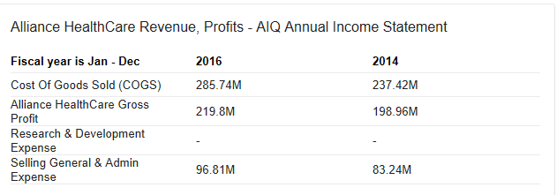
Figure 1 – Source: https://amigobulls.com/stocks/AIQ/income-statement/annual
Figure 1 above, shows the annual income statement of Alliance Healthcare from 2016. Just like any other business, my company is particularly interested in the Cost of Goods Sold which equated to a total of £285.74m. Alliance holds a very serious responsibility due to the seriousness of the products we deal with daily. 92

The problem – N.B headings are only indicative – yours should be related to your work
For a multimillion pound company, there are many responsibilities that must be done in order to carry out a good business environment as well as keeping stakeholders happy and loyal. Amongst the scope of the business and the different departments, it is inevitable that problems will occur, whether that is in the transport department, the replenishing of products, the packaging or even machinery issues. (Define problem solving in the workplace)
Careerbuilder (2017) describes problem solving in the workplace as a universal job skill that applies to any position and every industry. Understanding the critical components involved in problem-solving will help employees improve this skill set and demonstrate their expertise to employers. Strong problem solvers are a valuable addition to any team.
A problem my workplace often faces is machinery issues. An automatic running belt runs the length of the warehouse, reaching every department so that the individual boxes that carry orders for many pharmacies and hospitals can be transported safely and efficiently. I work in a department that works directly with the products, meaning that I scan each box that has an individual order and I collect all necessary products. My job requires the automatic belt to be fully functional as it allows me to find all medicines for an order quickly and push it onto the parallel belt to transport it to the next department before moving onto the next order. The Belt is split into 6 sections, allowing orders to be filled with the correct medicines from different parts of the warehouse quickly and effectively, but relying on machinery often means there will be many problems.
A few weeks ago, we came across a problem that slowed down our production to a complete stand still and what first was one problem eventually became two. The belt is a complex machine. It has a lifter to rotate and push the boxes onto the right section. The lifter had stopped working meaning that all boxes were being transported to the wrong section and building up dangerously as they had nowhere to move. Forland (1999) describes the acute diagnosis of machinery problems as phase information. Phase information can be used to detect subtle changes to the machinery that may go unnoticed.
Within my workplace, we have a designated engineer that takes care of any issues such as this issue, but the scope of the problem with the belt was so bad that external engineers had to be called in to solve the issue. During this time, this meant that we had no work to do and that also put strain on time for processing the orders through to the vans to deliver the orders in just a few hours. This issue can affect at least 50% of the workplace which is not good for a pharmaceutical company at all. Due to the belt breaking, it meant that orders were behind by a day until it was fixed, but due to the demand of medicines and how they are needed quickly to treat patients, the surgeries and pharmacies had to get an emergency delivery directly from the suppliers of the medicines that we receive and send out in bulk. Because of this, the company lost out on profit for the day. 539

Problem solving techniques
To help me look at possible solutions to the problem, I will be using two problem solving techniques; the 5W’s and the 5 Why’s.
Marathamuthu (2015) describes the 5 Whys as an iterative interrogative technique used to explore the cause-and-effect relationships underlying a problem. The primary goal of the technique is to determine the root cause of a defect or problem by repeating the question “Why?” and each answer forms the basis of the next question. The “5” is the name derives from an anecdotal observation on the number of iterations needed to resolve the problems, but it is important to understand that not all problems have a single root cause. As listed by isixisigma.com (2018), the benefit of this technique is because it if one of the simplest tools to use and complete without statistical analysis and can help identify the root problem as well as looking at ways to prevent it happening again. The way the technique works is to firstly source the specific problem. By doing this, it will help formalise the issue and describe it completely and if the issue is something that involves many people then it will help the team focus on the same problem. From there, ask why the problem has happened. For the next stage, if the answer provided doesn’t identify the root cause of the problem in step 1, ask why again to source a different outlook. For the final stagem look back to step 3 until it is finalised that the problem’s root cause has been identified. Even though the technique is called the 5 Whys, it may take more than 5 whys to identify the issue. 277
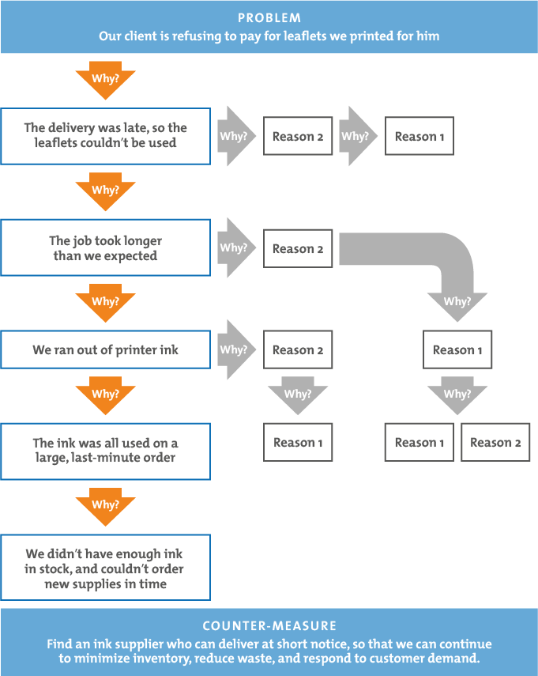
Figure Two: https://www.mindtools.com/pages/article/newTMC_5W.htm

The next problem solving technique I will use is the 5Ws and H. This problem solving technique has been around since the early 1900s. The 5W’s are questions whose answers are considered basic in information gathering or problem solving. The simple 5W1H method can also be adopted to ease the analysis process. This process has many benefits as it provides a visual graph of the problem and potential categories of causes and it allows various categories of causes to be explored and uncovers bumps in the road in a certain process. 91
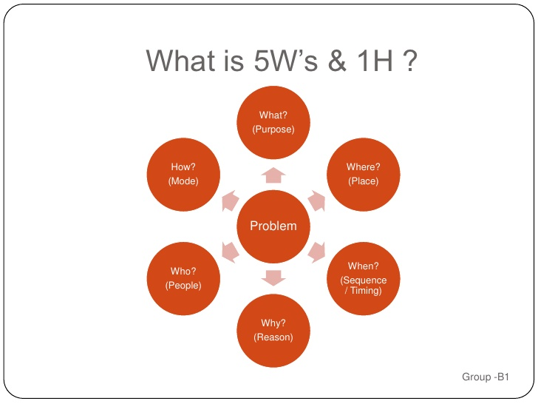
Figure three: https://pt.slideshare.net/mayurchallawar/5ws-and-a-h1/3
Each question allows a full analysis of the full scope of the problem so no areas go unmissed. 18
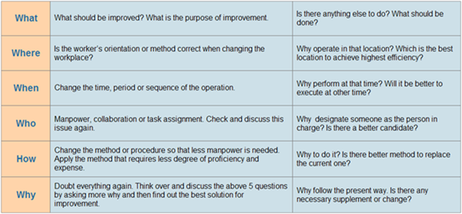
Figure Four: https://www.edrawsoft.com/5w1h-cause-effect-analysis.php
The understanding of this technique is that it allows all questions to provide a better understanding and to learn facts about the issue that may not have been plausible without using the techniques. Unlike the 5 Whys, it gives an understanding of who is affected by the issue, where and when it took place, why it happened and how we can go from there and look into improvements.

Solving the problem
Due to the scope of the issue that is affecting my workplace, it is important that we use one or more problem solving techniques to find the root of the problem and how we can prevent it happening again in the future. Using more than one problem-solving technique allows a broader understanding of the problem and can provide a wider perspective in regarding a solution.
Firstly, I am going to use the 5 Why’s problem-solving technique. This technique uses the questions to establish a ground for what the issue is.
Openbuffer.com (2014) says “Five Whys involves holding meetings immediately following the resolution of problems the company is facing. These problems can be anything: development mistakes, site outages, marketing program failures, or even internal missed schedules. Any time something unexpected happens, we could do some root cause analysis.”
So, the first stage is asking why the belt stopped working. Why did the lifter snap? And the answer is that there was a technical difficulty and that it is due an upgrade. Why does it need an upgrade? Because it is the same lifter that was installed 15 years ago when the machinery was first introduced to the warehouse. Why has the lifter not been changed since? Because the lifter proved to be working fine but has outlived its time. We need to look into upgrading to a more modern lifter with a longer life ratio. Why should we look into upgrading? To prevent this happening in the future.
By using this technique, I have established that the lifter is the same one from when it was first installed 15 years ago which indicates that it is due a change due to the technological advances made within the last 15 years. If I had not have used this technique, it is a possibility that we would not have remembered that it is still the original lifter, and perhaps may have just looked into fixing it instead of replacing which in fact, would be more beneficial long-term.
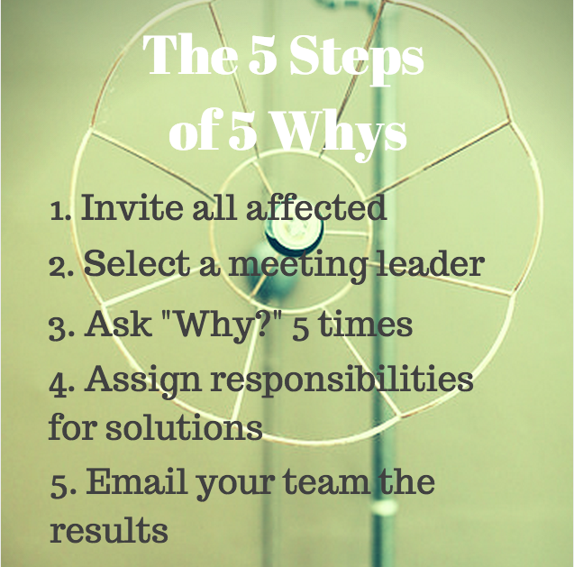
Figure Five: https://open.buffer.com/5-whys-process/
Figure Five is an example of how the 5 Why’s would be communicated through the company. Since the scope of this has affected a large majority of the employees, the management team and engineers would need to communicate what the problem was and how it has been solved and how, if it was to happen again, the diagnosis process. Darling (2003) mentions that oral communication is recognized as an essential element of the curriculum in technical disciplines, which is very important within the workplace.
The second problem-solving technique is the 5W and H technique.
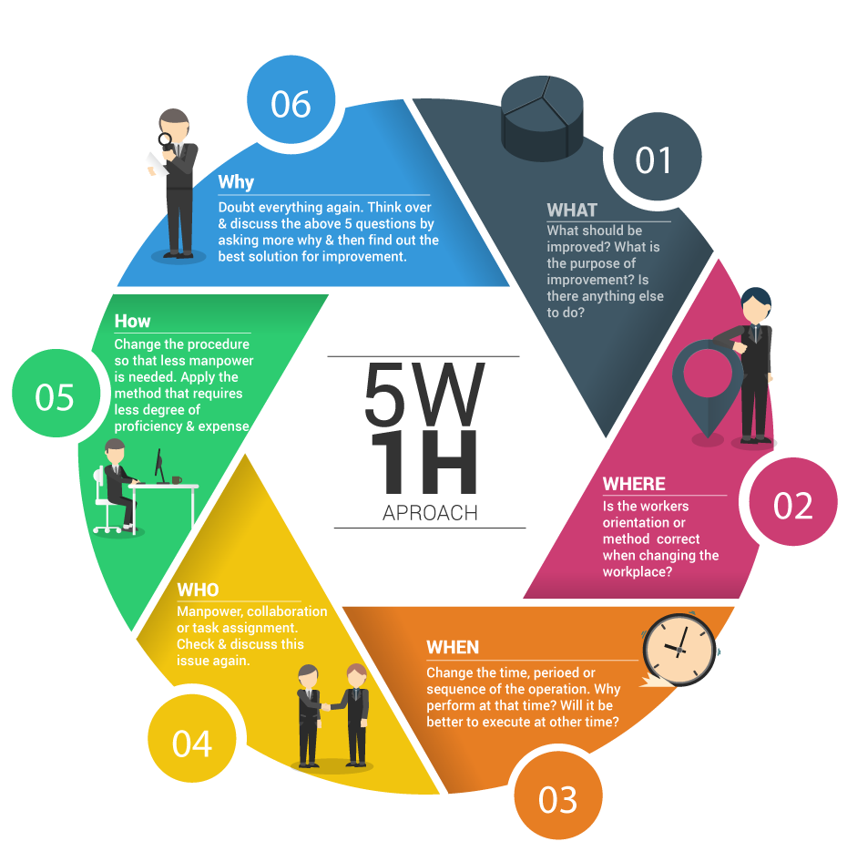
Figure Six: https://twitter.com/seanellis/status/811553310134169600
This problem-solving technique is similar to the 5 Why’s but gives a slightly different perspective. The first stage is What? What should be improved and what is the purpose of improvement? So it would mean that the lifter needs to be replaced to more modern technology which evidentially could help productivity. Secondly, where? The lifter itself is the issue and since it’s a vital part of the production process, it needs to be fixed as soon as possible. Thirdly, when? The problem occurred within the working night but was during its running and not on start up. Next, who? Is the problem skill related? No, but it affects the employees who use the machinery as it is necessary to complete the work. Which? Does this problem have a pattern? Does it randomly occur or happen frequently? Rarely happens but every so often which indicates its ageing is the issue. And finally, how? How is the state of equipment changed from its optimal normal running condition? Due to the scope of the problem, until the lifter is fixed and updated, it would need manual handling to be able to sort into the correct section, which puts a strain on other areas of the company as someone has to manually help a machine.
Using these two problem-solving techniques, it has given me a better understanding of the depth of the problem and the solutions to getting production back on track as soon as possible. 676
This section is concerned with the actual application of the problem-solving tools and techniques. It is an opportunity for you to propose several solutions to the problem you scoped out earlier in the document. It is ok at this point to put forward more than one potential solution, in fact this would be ideal. What you are then able to do is to critique your own solutions, before making a final recommendation premised on your discussion. Again, this is an opportunity to engage with the broader literature (i.e. where have similar problems existed for other organisations in similar sectors etc, how effective has their problem solving been etc)

Problem solving implementation
Due to the difficulty of the issue and how it slows down over 50% of the warehouse and productivity, timeframes and resources are needed quickly and effectively to get production back on track as the company has many stakeholders that are imperative to the profit made and keeping loyal customers. When something such as this goes wrong within the workplace, it is important that it is communicated to the relevant stakeholders and put in place and alternative method of delivery during the time the issue is being solved. Engineers will also need to be brought in to perhaps write up a method of resolving in the instance that engineers are not available or on sick. From this issue, the engineers and company should then look at ways of improving the machinery, whether that’s due to an age issue or to install developed technology. Hersh (1997) talks about the importance of upgrading and the well keeping of machinery in the work place by saying in order to ensure work equipment does not deteriorate to the extent that it may put people at risk, employers, the relevant self-employed and others in control of work equipment in efficient order and good repair. The frequency and nature of maintenance should be determined through risk assessment taking full account of the intensity of use, operating environment and the risk to health and safety from any foreseeable failure or malfunction. 234

Conclusion
Overall, there are many issues within my workplace and due to the responsibility of the company being a pharmaceutical warehouse, we must ensure that our machinery and production is on time and efficient and to the best standard it can be for our stakeholders. Using the above problem-solving techniques, it opens a wide understanding for all people involved and can lead to the problem being solved more quickly and can also mean preventing it in the future. These techniques provide an in depth look so a broader understanding is necessary regarding solving. Overall, I found these problem-solving techniques really helpful and gives you ways to find a solution without thinking too hard. 112

References

Figure One - https://amigobulls.com/stocks/AIQ/income-statement/annual

https://www.careerbuilder.com/advice/what-are-problemsolving-skills-and-why-are-they-important (Accessed: 18th April 2018)

Forland, C., 1999. Why phase information is important for diagnosing machinery problems. Orbit. Bently Nevada Corporation, pp.29-31.

Benjamin, S.J., Marathamuthu, M.S. and Murugaiah, U., 2015. The use of 5-WHYs technique to eliminate OEE’s speed loss in a manufacturing firm. Journal of Quality in Maintenance Engineering, 21(4), pp.419-435.

https://www.isixsigma.com/tools-templates/cause-effect/determine-root-cause-5-whys/ (Accessed: 22nd April 2018)

https://www.isixsigma.com/tools-templates/cause-effect/determine-root-cause-5-whys/ (Accessed: 23rd April 2018)

Figure Two: https://www.mindtools.com/pages/article/newTMC_5W.htm

Figure Three: https://pt.slideshare.net/mayurchallawar/5ws-and-a-h1/3

Figure Four: https://www.edrawsoft.com/5w1h-cause-effect-analysis.php

https://www.edrawsoft.com/5w1h-cause-effect-analysis.php (Accessed: 23rd April 2018)

Hersh, M.A. and Johnson, M.A., 1997. A study of advanced control systems in the work place. Control Engineering Practice, 5(6), pp.771-778.

https://open.buffer.com/5-whys-process/ (Accessed: 24th April 2018)

Darling, A.L. and Dannels, D.P., 2003. Practicing engineers talk about the importance of talk: A report on the role of oral communication in the workplace. Communication Education, 52(1), pp.1-16.

Figure Six: https://twitter.com/seanellis/status/811553310134169600

