
Developing workplace critical thinking
[Shahida Miah 1710331]



May 3, 2019
University of Wales Trinity Saint David

Executive Summary
The purpose of this report is to analyse the value, belief and attitude of the chosen organisation Tesco. Tesco being the British multinational grocery store selling food, clothes, electronics, insurances and banking founded by Jack Cohen in the 1919s. Tesco have many employees and have a guideline of value and belief and a certain attitude towards employees and customers to drive the success of the business. Tesco have displayed the values on the website visible to the public and implement this throughout all stores, although there have been many contradicting views on review sites from employees and customers regarding how much of these values are being followed.
This report will also be looking at the management theories being implemented within Tesco’s to motivate, give reward and give recognition, having nearly 7,000 stores the company follow many models to keep in line ways to encourage employees to work towards high productivity. Tesco also have shown that staff have many financial benefits as well as non-financial benefits that please many workers values and beliefs and a happy environment.
To conclude the report, it was found that values, belief and attitude are followed but some stores do have issues in following these guidelines, many employees’ values are not fitted in well. Customers also have shown disappointment to certain contradiction on the values not being met such as, not being treated fairly. Other management theories were found that can further improve the service such as thorough training and understanding behaviour.
In aligning the values, belief and attitude of the researcher, Tesco do have some compatibility in the principles however, the company that fits better is Apple organisation which have values that impresses the researcher, also it is an environment the researcher would feel most comfortable working due to the opportunity offered by the company.

Table of Contents
Executive Summary 1
Introduction 3
Main Finding 4 to 10
Conclusion 11
Recommendation 12
Reference List 11 to 16
Appendices 17

Introduction
An individual develops self-value, belief and attitude which are contributed from personal experiences, family and friends explained Sielearning (2009), these attributes influences on how the world is viewed and behaviour in personal and professional life. According to Mind Tool (2019), having a set of values in a workplace works as a guideline about the way work should be accomplished and direct an employee towards organisational performance.
Attitude is an evaluation made by people that can be positive or negative towards customers or staff and is often influenced by opinions and work environment stated Psychology (2019). Attitude plays a vital part in having productive staff explained Belcher (2019), skills is not enough as obtaining the right attitude helps to implement in positive manner. Attitude in a workplace consist of respecting others, committing to a job and innovating ideas. However, every decision and communication made in a workplace is influenced by belief stated Intentional Workplace (2011) and is the most powerful component. Belief are influenced by thoughts, culture and emotion carried from childhood.
Implementing management theories in a workplace can increase the quality, service and productivity. Combination of theories are followed by organisations depending on the purpose and which is more beneficial for the company needs (EDUCBA 2019).

Main Findings
Tesco’s founded by Jack Cohen in 1919 are now selling products from groceries to insurances (FactSite 2019). According to Our Tesco’s (2019), the core values consist of, serving shoppers a little better every day, no one tries harder for customers, Tesco treat people how Tesco wants to be treated and every little help makes a big difference. Tesco offer childcare vouchers, staff discounts, colleague mobile tariff, to discounts on holidays and attractions. However according to BBC News (2018), Tesco is facing a huge fine for equal pay as male are receiving more hourly rate than females, even though the values is equivalent.
The belief of Tesco stated Study Moose (2019) is, customers will return if offers are good and employees will work hard if reward is given, Tesco’s success depends on these people. According to Tesco PLC (2019), Tesco’s attitude is to try and understand the customers and meet the needs, to act responsibly for the communities, trusting, respecting one another, listening, supporting, being kind, sharing knowledge and experiences.
However, in implementing the Pearson’s RED critical thinking model, according to Becker (2015), recognising assumptions is taking viewpoints of other individuals and separates facts from assumptions. Evaluation is analysing the evidence, seeing if a situation is influenced by emotions, finally drawing a conclusion comes from what evidence has been found ensuring it is from diverse information. According to Harris (2015), the RED critical thinking model aids in decision making, this can help organisations to improve in success on performance and if applied constantly then this skill can become a powerful asset.
To separate assumptions as one of the core values being to serve customers better every day, Tesco Privacy Centre (2019) explained, how personal data is used to understand how Tesco can offer a personalised and better experience, this value also reflects the belief of customers coming back due to good offers. The assumptions will be investigated to see how the motivation factor effects this value through employee’s behaviour. Trust Pilot (2019) stated by a customer, how Tesco are a “rip off” for over pricing and leaving stock on the shop floor in the way of customers. Another reviewer said how Tesco is a preferred supermarket over Morrison as food was better quality along with polite staff.
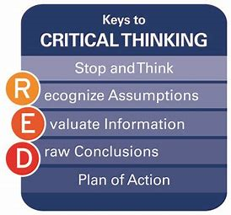

In evaluation of the information, for Tesco’s to serve customers better, employees need to be fully trained and motivated to fulfil customers’ needs explained Times 100, (2019). Tesco believe the more motivated workforce the more positive impact on customers, therefore Times 100 (2019) revealed how Tesco use the Frederick Winslow Taylor’s theory developed in 1911. Taylor believed salary was the main motivator. Tesco has taken the approach of rewarding by results, although Tesco do offer non-financial incentives, but most rewards consist of free shares, employee discounts, gym membership and pension schemes. Times 100 (2019) also states, surveys undertaken at Tesco for staff to put across any viewpoints to lead to staff satisfaction.
Although Frederick Taylor theory has advantages as according to Wise Step (2019), this method enhances production, management has control, inaccuracy is decreased, production cost is lower along with better pay system and easy decision-making process. However, Wise Step (2019) also state the limitation, which are, management taking complete control leaving employees less room to develop, a costly system, demotivate staff, employees become like machines, not ideal for teams, work is divided, chances of financial loss, and time consuming.

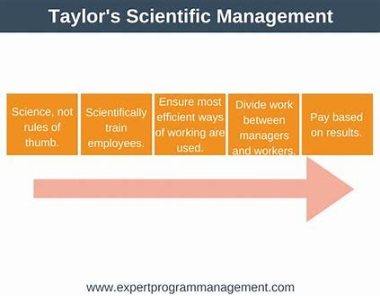
In drawing the conclusion using the RED model, the researcher believes the application of the Kirkpatrick four level developed by Donald Kirkpatrick in 1959 explained by Mind Tool (2019, this developmental vehicle could help Tesco’s with training, the four levels that are Reaction, Learning, Behaviour and Results, can help offer training and analyse how effective it has been. Employees then can put what is learnt into practice and follow the core values effectively, rather than working like a machine only for reward.
According to Times 100 (2019), Tesco offer training development, by applying this method during training programmes can aid in effective results. The Kirkpatrick’s model has many advantages explained Edwin (2019), these are; an easy and quick way to gain insight about training, the employees and management can acknowledge skills possessed and abilities in need of enhancing, see if workers have the right attitude to utilise obtained skill and understand if required skills has improved productivity. However, Edwin (2019) stated the limitations being; the reactions of the training levels can be too quick, too much time, effort and money involved, and employees must regularly review if skills are being used

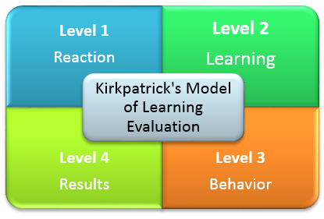

Looking at the researchers own values and beliefs, working in a place like Tesco’s would not be an issue. The researcher has values and belief of, every organisation should motivate employees financially and non- financially for staff to feel valued and aid in growth which Tesco provide. Working at Tesco may offer rewards systems but as according to Cole and Kelly (2011), Maslow’s Hierarchy of needs developed by Abraham Maslow in 1930s which has five levels is also implemented. This theory states how people are satisfied when needs are met, as Tesco’s 100 (2019) explained, Tesco fulfil the basic needs by giving a place to work right up to offering a self-developmental plan which completes the self-actualisation level. This fits well with the researcher’s value as there is an opportunity to grow with the company rather than getting rewarded with no growth. The objective of the manager is more focusing in rewarding employees through different ways to encourage staff to work efficiently as acknowledgement is the key to success of all businesses.
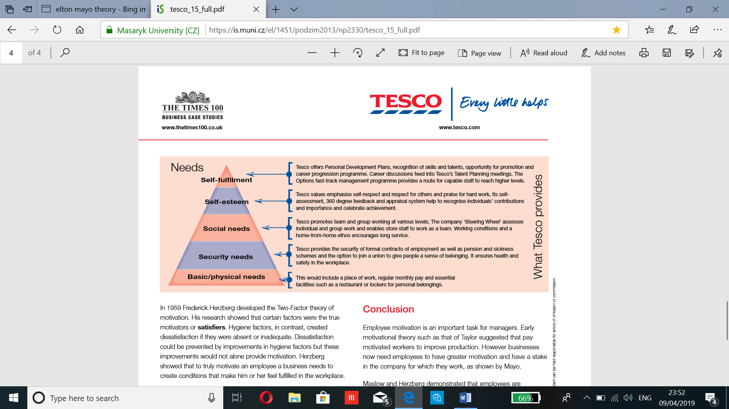
However, the technology company Apple is somewhere the researcher would feel more comfortable to work, the researcher’s values of a company should recognise all aspects of staff need as an employee is an asset to an organisation, giving benefits that involve looking after the own health shows consideration from the employer. According to Glassdoor, (2019) explained, health insurance is also offered to part timers, USA staff are given dental, vision and health checks. This organisation gives workers the importance of recognition through financial rewards also understands the importance of employee’s wellness. Apple value and belief are available to view in the appendices.
One of Tesco’s core values is, the organisation like to treat people how Tesco would like to be treated. According to BBC News (2013), Tesco do not implement this value with the workers. In Harlow, one of the distribution centres was being shut down therefore employees where offered redeployment 20 miles away and further. Workers were not happy and felt Tesco was treating employees “like scum”.
However, in separating assumptions from an argument, Tesco Complaint (2017) explained, a staff expressed managers where mistreating by not allowing workers to have water bottles on duty. The management constantly talk about safety law, human right and quick to apply disciplinary for genuinely being off sick. According to Stones (2013), Tesco was also criticised for treating suppliers unfairly by breaching the code of practice for groceries, although a Tesco’s spokesperson state that this is just a speculation.
In evaluation using the RED model, according to Trust Pilot (2019), a customer complained of receiving online shopping with fresh produce and bakery with little date, when customer service was called the member in charge was not very helpful and dismissive. Another customer also complained how online shoppers were used to get rid of unwanted old stock.
Tesco seem to not treat customers, employees or suppliers fairly. However, Adzuna (2019) stated by current employees that Tesco do offer great schemes and programmes. The company have good opportunities, although the pay is not ideal but still is a wonderful place to work at. Unfortunately, other reviews stated Adzuna (2019) highlight’s negative points such as, management being useless, and staff treated inadequately.
To draw a conclusion using RED model, according to Nicholson (2019), the importance of treating employees fairly is to reduce staff turnover rate, also having to trust and respect is vital to increase productivity. Imani (2019) stated, treating employees unfairly reduces employee morale which effects customers.
Tesco like to pay attention to employees by good communication, holding forums and paying attention which is known as the hygiene factors as Tesco implement the Frederick Herzberg theory developed in 1959 stated Tesco 100 (2019), this is a two-factor theory. This model identifies the hygiene factors being; delegation, good working condition, staff making decision together, pay rise, holding forums for discussions and administering policies, these encourages motivation, although this model is applied, the fair treatment seems to remain the problem. This method displays the value of treating employees fairly which is one of the values.
However, according to Kunchala (2017), the limitation of the Herzberg theory it overlooks productivity and concentrates on satisfaction, employees that are implementing this theory on normally blame dissatisfaction on external factors and hold themselves responsible for satisfaction.
Applying the Douglas McGregor’s theory developed in the 1960s stated by Tools Hero (2019), this is a model that explains how a manager’s belief can lead to two perception of Theory X which are people that are lazy, different needs and no interest in work. Theory Y is hard workers, focused and like responsibility. Tesco managers can apply this theory to help drive employees by providing training and support needed to improve performance and encourage theory X staff to further productivity. The limitation is explained by Study Guide (2019), Douglas McGregor’s theory to be outdated and less innovated which few organisations implement.
In aligning the value of the researcher, it is believed that to be treated fairly then others must be treated the same way. Tesco may use various theories and methods to encourage recognition and productivity but looking at the review site as many employees state the style of leadership is yet to change. With the current findings of indications of the management problems in the organisation, the researcher would not like to work where managers cannot have decent behaviour towards employees. The company’s mission is manipulated by misbehaviour of management towards staff and the implementation of models only seem to work in certain stores. The researchers own value is that being comfortable at a workplace is vital and that involves having a good relationship with managers, if management mistreat people then it is only a matter of time employees will leave.
Apple being the preferred company the researcher would rather work at as the organisation treat employees with respect according to Kosoff, (2016), Apples work environment is much more mature. Working in Apple help employees to commute to work with great leadership, aiding in hard workers through relevant training rather than being micromanaged.
Tesco’s attitude may be to understand the need of customers and to act responsibly however, in separating assumptions from facts using the RED model, Study Moose (2019) stated, Tesco’s is a large and competitive market and need to monitor customer service. Tesco’s use mystery shoppers to act as normal customers to see if there is any scope of improvements. Tesco use customer questionnaire to see views along with any suggestion boxes for staff as well, on how to improve services. The company do not use focus groups for feedback which can aid towards customer service (Study Moose 2019).
Attitude (2015) explain, how Tesco had to apologise for staff making comments to a gay couple about dying alone and not deserving to have children. The employee that made this comment had strong belief and attitude against homosexuality. Tesco’s were prompted to change policies and procedures; the company promised an internal investigation (Attitude 2015).
To evaluate the attitudes of Tesco, Glassdoor (2019) a review site, highlighted issues with employees against the management. Some workers stated how the managers need to listen to co-workers, another said the management do not give clear messages. Glassdoor (2019) does have some positive comments such as, there is great opportunities and supportive managers. From these reviews it does not seem Tesco’s managers are acting responsibly.
Tesco PLC (2014) corporate online strongly state how values are followed through policies and welcome stakeholders to give feedback to improve performances that may impact any aspects of value, belief and attitude. To evaluate further, Tesco PLC (2019), made some corporate changes to be able to understand the customer’s needs and make shopping trips simple. The company introduced different service desks which allow workers to concentrate on good service.
According to BBC News (2017), Tesco also introduced green labels to cut the cost of energy efficient products, this step was taken for the environmental impact also falls with acting responsibly for the community. However, according to BBC News (2019) Tesco face a drop of profits, the organisation brands have dropped in customer relevance and does not hold the status it did in last five years.
To draw the conclusion using the RED model. Tesco’s main issue with attitude is giving a negative impact on the organisation which seems to underly with the management. According to Browne (2019), a good relationship between the management and staff can make all the difference, this can aid in attitude, motivation and productivity leaving customers satisfied. A poor attitude can only create bad work habits, unhappy workers and clients.
For Tesco to improve on good attitude towards staff and employees, Tesco need to develop better relationship amongst each other and how to motivate towards growth. The Elton’s Mayo’s theory is implemented by Tesco’s explained Times 100 (2019), this was developed after the Hawthorn studies in the 1930s, it was discovered after splitting two groups, one with improved lighting and with reduced which then was found that social factor was the main element to motivation. Tesco 100 (2019) stated, the motivation aspect was several fundamental factors such as; good communication, great teamwork and showing interest in others. This method can improve the attitude of workers in respecting the well-being of others. In the application of the Mayo’s theory, Tesco use the appraisal system and newsletter along with the 360-degree feedback system to value and give opportunity for employees to have a positive outlook and attitude.
Although Elton Mayo’s do have positive aspects explained Large SEO Tools (2019) such as; great freedom and teamwork the limitations are that the responsibility is increased which leads to stress and pressure leaving management with less control.
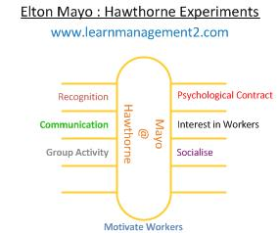

Tesco’s attitude is to understand the need of customers and acting responsibly, Tesco could also implement the Attribute Theory to enhance the Elton Mayo theory and attitude of workers. This was introduced by Heider in 1958, according to Cole and Kelly (2011), this model aid to make sense of the social society and find explanation on other people’s behaviour which could be internal or external factors. Attribution theory help to judge the cause of the problem and put in place performance management. However, Kipenji (2019) states the limitation to this model is that it takes away the accountability of owning up to the owns choices and misses the point of the workers efforts.
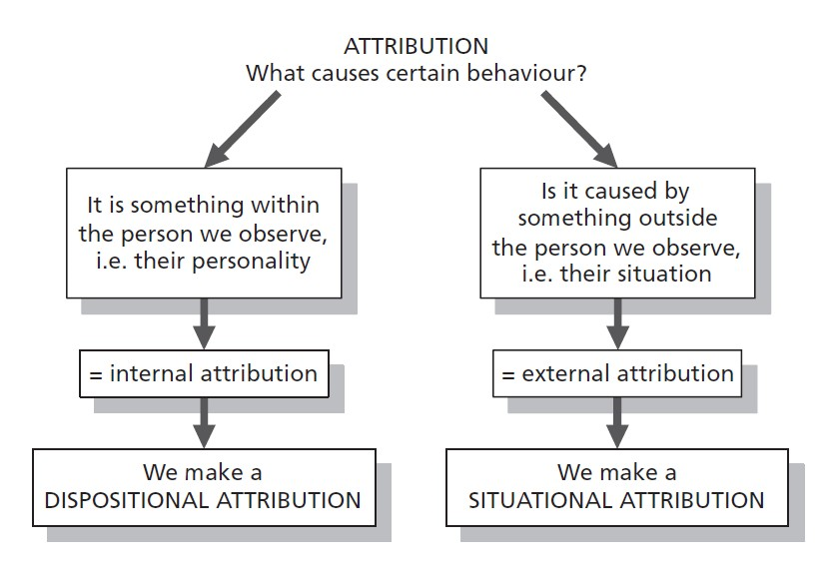
In aligning the attitude of the researcher, it is believed to fulfil customers’ needs and act responsibly towards the communities it is vital to have a good relationship with the management which increases staff morale. The evidence does state there are issues with management in some stores such as Glassdoor (2019) stating, managers not listening, but there is also performance management in place to improve what can be done explained Times 100 (2019). Although Tesco does have a rocky status now, the company do still have a good reputation and try to improve it. The researcher feels to work in Tesco would not go against the attitude obtained as every organisation faces challenges but not all companies want to do something about it. According to Tesco 100 (2019), Tesco offer lifestyle and career breaks to individual that are in need to move away for a while also provide self-assessments for employees to reach full potential. Programmes such as appraisals and the 360-degree feedback system also to aid development.
The researcher’s attitude of providing the best for customers no matter where the researcher is based within the company links well within Apple organisation. According to Retail Customer Experience, (2012), all employees working at the front or back, staff offer the best customer experience as workers have the same goal. Employees provide products depending on the need of customers. Apple do not push for sales and ensure customers are cared for. These attitudes only display that Apple understands the importance of treating employees and customers well and acts towards these attitudes.

Conclusion

To conclude it has been discovered that Tesco had mixed reviews as according to Trust Pilot (2019), customers described Tesco’s being overpriced and others explained Tesco being better quality in products. Tesco 100 (2019) displayed the usage of Frederick Taylors model to motivate which directs the organisation to follow the value and belief that was stated by Tesco Privacy Centre (2019) which is “To serve customers better every day”. However, the researcher found the Kirkpatrick model stated by Edwin (2019) to aid workers in enough and insightful training to be able to follow these values and belief more adequately.

One of Tesco’s values of Tesco treating people fairly was argued by BBC News (2013) stating workers were treated unfairly due to shut down of stores. Tesco Complaint 92017) also stated that management was not being fair to staff. Customers took review sites Trust Pilot (2019) explaining bad customers service. Although Frederick Herzberg model was implemented according to Tesco 100 (2019), the researcher found Douglas MacGregor’s theory application can help managers to connect with staff and employees (Humanresource.com 2019).

Tesco’s attitude of acting responsibly was tested when the company had to apologise on behalf of a staff for making hate comments to a gay couple (Attitude 2015). However, Glassdoor (2019) explained, the mix reviews of managers acting responsibly in some stores, and others stating managers not listening to staff. Although Tesco PLC (2014) state that values are followed through policies and feedback system to improve on attitudes. According to Tesco 100 (2019) Tesco follow the Elton Mayo’s model to motivate which can impact towards the attitude. However, the researcher found the Attribution theory stated by Cole and Kelly (2011) can help to understand behaviour.

To conclude further, the researcher aligned the own values, belief and attitude and found that Tesco is a good company to work for and does have some matches to the components of principles held. However, Apple organisation offer more similar values by offering great customer experience according to Retail Customer Experience (2012). Kosoff (2016) explained, Apple has a more mature work environment.

Recommendations
- Tesco can improve on critical thinking to guide beliefs and action, this can be done by analysing, conceptualising, synthesizing and evaluating. This can help the organisation to make better decisions and improve performance (Patterson 2017).

- For Tesco managers to have better relationship with employees, managers can communicate the company’s mission to show the organisations direction. Managers can ask for input from staff, recognising a job done well, promoting work life balance and offering any development opportunities (Augment HR 2017).

- For Tesco to treat employees fairly to stay in line with values, Tesco should ensure there is no favouritism, follow rules and apply equally, if any rules are not fair then change them, not to take advantage and think of others when making a decision (Reh 2018).

- Tesco could ensure the treatment of customers is fair by behaving encouragingly, customer treatment should be how is expected to be treated when visiting a store, communicate well and respect customers, aligning products to customer needs, taking feedback and ensuring staff are trained up to date to provide quality service (Close Brother 2019).

Reference List

Adzuna. (2019), Tesco Reviews, [Online]. Available: https://www.adzuna.co.uk/jobs/company/tesco/reviews. [Accessed 11th April 2019].

Augment HR. (2017), 5 Ways to Improve Employee Relation, [Online]. Accessed: https://www.augmenthr.com/blog/5-ways-improve-employee-relations/. [Accessed 1st May 2019].

Ahmed, K. (2018), Tesco faces record £4bn equal pay claim, [Online]. Available: https://www.bbc.co.uk/news/business-42968342. [Accessed 30th April 2019].
Attitude. (2015), Tesco Employee tells Couple that all Gay People Should Die Alone, [Online]. Available: https://attitude.co.uk/article/tesco-employee-tells-couple-that-all-gay-people-should-die-alone/5122/. [Accessed 8th April 2019].
BBC News. (2013), Tesco 'treating staff like scum' over Harlow depot, [Online]. Available: https://www.bbc.co.uk/news/uk-england-essex-21900237. [Accessed 10th April 2019].
BBC News. (2017), Tesco boss unveils green pledges, [Online]. Available: http://news.bbc.co.uk/1/hi/business/6276351.stm. [Accessed 9th April 2019].
BBC News. (2019), Tesco, [Online]. Available: https://www.bbc.co.uk/news/topics/c77jz3mdmlvt/tesco. [Accessed 9th April 2019].

Becker, J. (2015), Critical Thinking, [Online]. Available: http://www.aligning4healthpa.org/presentations/Critical_Thinking_How_to_see_the_big_picture.pdf. [Accessed 30th April 2019].

Belcher, L.M. (2019), Five Attitudes That Are Important in Workplaces, [Online]. Available: https://smallbusiness.chron.com/five-attitudes-important-workplaces-19114.html. [Accessed 24th April 2019].
Browne, C. (2019), How to Better Employee Work Attitude & Performance, [Online]. Available: https://smallbusiness.chron.com/better-employee-work-attitude-performance-25457.html. [Accessed 9th April 2019].
Cole, G.A and Kelly, P. (2011), Management Theory and Practice, (7th Ed). China: R.R, Donnelley.

Close Brothers. (2019), How we treat our customers fairly at Close Brothers Business Finance, [Online]. Available: https://www.closebusinessfinance.co.uk/treating-customers-fairly. [Accessed 1st May 2019].

EDUCBA. (2019), How to Apply Management Theories at Workplace, [Online]. Available: https://www.educba.com/how-to-apply-management-theories-at-workplace/. [Accessed 25th April 2019].
Edwin, H. (2019), Is Kirkpatrick’s Model of Evaluating a Training Program the Best? [Online]. Available: https://blog.commlabindia.com/elearning-design/kirkpatrick-model-of-evaluation. [Accessed 9th April 2019].
Fact Site. (2019), The History of Tesco, [Online]. Available: https://www.thefactsite.com/history-of-tescos/. [Accessed 7th April 2019].
Glassdoor, (2016), Apple, [Online]. Available: https://www.glassdoor.co.uk/Benefits/Apple-US-Benefits-EI_IE1138.0,5_IL.6,8_IN1.htm?countryRedirect=true. [Accessed 23rd April 2019].
Glassdoor. (2019), Tesco Review, [Online]. Available: https://www.glassdoor.co.uk/Reviews/Tesco-Reviews-E10250.htm. [Accessed 9th April 2019].

Harris, B. (2015), The Status of Critical Thinking in the Workplace, [Online]. Available: https://www.pearsoned.com/the-status-of-critical-thinking-in-the-workplace/. [Accessed 1st May 2019].
Imani, F. (2019), How to Treat Employees Fairly in the Workplace, [Online]. Available: https://work.chron.com/treat-employees-fairly-workplace-3070.html. [Accessed 12th April 2019].

Intentional Workplace. (2019), The Power of Beliefs at Work, [Online]. Available: https://intentionalworkplace.com/2011/05/20/the-power-of-beliefs-at-work/. [Accessed 25th April 2019].
Kipenji, O. (2019), Disadvantages of Attribution Theory; Distracts the Attention from our own Responsibility, [Online]. Available: https://www.12manage.com/forum.asp?TB=heider_attribution_theory&S=20. [Accessed 9th April 2019].
Kosoff, M. (2016), Apple employees reveal the 19 best things about working for the world's most valuable company, [Online]. Available: https://www.businessinsider.com/best-things-about-working-at-apple-2016-1?r=US&IR=T. [Accessed 23rd April 2019].
Kunchala, K.S. (2017), Implication, Limitations Suggest of Two-Factor Theory of Motivation, [Online]. Available: https://www.mbahelp24.com/implications-limitations-suggestions-two-factor-theory-motivation/. [Accessed 12th April 2019].
Large SEO Tools. (2019), Elton Mayo Theory Advantage and Disadvantage, [Online]. Available: http://www.largeseotools.org/2019/01/07/elton-mayo-theory-advantages-and-disadvantages/. [Accessed 9th April 2019].
Management Study Guide. (2019), Theory X and Theory Y, [Online]. Available: https://www.managementstudyguide.com/theory-x-y-motivation.htm. [Accessed 12th April 2019].

Mind Tool. (2019), Kirkpatrick's Four-Level Training Evaluation Model, [Online]. Available: https://www.mindtools.com/pages/article/kirkpatrick.htm. [Accessed 8th April 2019].

Mind Tool. (2019), Understanding Workplace Values, [Online]. Available: https://www.mindtools.com/pages/article/understanding-workplace-values.htm. [Accessed 24th April 2019].
Nicholson, N. (2019), Why Treating Employees Fairly is Important, [Online]. Available: https://hr.sparkhire.com/talent-management/why-treating-employees-fairly-is-important/. [Accessed 11th April 2019].

Our Tesco. (2019), Our Core Purpose and Values, [Online]. Available: https://www.ourtesco.com/working-at-tesco/our-company/our-values/. [Accessed 7th April 2019].

Patterson, R. (2017), 7 Ways to Improve Your Critical Thinking Skills, [Online]. Available: https://collegeinfogeek.com/improve-critical-thinking-skills/. [Accessed 1st May 2019].

Psychology. (2019), Attitude and Beliefs, [Online]. Available: https://psychology.iresearchnet.com/industrial-organizational-psychology/job-satisfaction/attitudes-and-beliefs/. [Accessed 30th April 2019].
Reh, F.J. (2018), Being a Fair Manager, [Online]. Available: https://www.thebalancecareers.com/fairness-is-good-management-2275883. [Accessed 1st May 2019].

Sabutey, F. (2017), The 7 Core Values Which Made Apple the Most Valuable Brand in the World, [Online}. Available: https://www.expandgh.com/7-core-values-which-made-apple-most-valuable brand-in-the-world/. [Accessed 27th April 2019}.

Sielearning. (2009), Personal values, belief and attitudes, [Online]. Available: https://sielearning.tafensw.edu.au/MCS/CHCAOD402A/chcaod402a_csw/knowledge/values/values.htm. [Accessed 25th April 2009].
Stones, M. (2013), Tesco Denies Squeezing its Suppliers after Analyst Criticism, [Online]. Available: https://www.foodmanufacture.co.uk/Article/2013/12/02/Tesco-denies-treating-its-suppliers-unfairly. [Accessed 11th April 2019].
Study Moose. (2019), Customer Service at Tesco Essay, [Online]. Available: https://studymoose.com/customer-services-at-tesco-essay. [Accessed 8th April 2019].

Study Moose. (2019), Customer Service Tesco’s Customer Expectation Essay, [Online]. Available: https://studymoose.com/customer-service-tescos-customer-expectations-essay. [Accessed 7th April 2019].
Tesco Complaint. (2007), Tesco Won’t Even give Water to Staff, [Online]. Available: https://tesco-complaint.blogspot.com/2007/09/no-water-for-tesco-staff.html. [Accessed 10th April 2019].
Tesco PLC. (2004), Corporate Responsibility Review, [Online]. Available: https://www.tescoplc.com/media/1146/cr_report_2004.pdf. [Accessed 9th April 2019].

Tesco plc. (2019), Core Purpose and Values, [Online]. Available: https://www.tescoplc.com/about-us/core-purpose-and-values/. [Accessed 7th April 2019].
Tesco PLC. (2019), New Releases, [Online]. Available: https://www.tescoplc.com/news/news-releases/2017/tesco-continues-changes-to-improve-customers-shopping-trip/. [Accessed 9th April 2019].

Times 100. (2019), Motivational Theory in Practice at Tesco, [Online]. Available: https://is.muni.cz/el/1451/podzim2013/np2330/tesco_15_full.pdf. [Accessed 7th April 2019].
Tools Hero. (2019), McGregor Theory X and Y, [Online]. Available: https://www.toolshero.com/leadership/mcgregor-theory/. [Accessed 12th April 2019].
Trust Pilot. (2019), Tesco, [Online], https://uk.trustpilot.com/review/www.tesco.com. [Accessed 11th April 2019].

Trust Pilot. (2019), Tesco, [Online]. Available: https://uk.trustpilot.com/review/www.tesco.com. [Accessed 7th April 2019].
Whatishumanresource.com. (2019), Douglas Murray McGregor, [Online]. Available: http://www.whatishumanresource.com/mcgregors-theory-x-and-theory-y. [Accessed 12th April 2019].

Wise Step. (2019), Scientific Management Theory advantages and Disadvantages, [Online]. Available: https://content.wisestep.com/advantage-disadvantage-scientific-management-theory/. [Accessed 7th April 2019].

Young, C. (2012), Five Core Apple Beliefs Every Company Should Have, [Online]. Available: https://www.therainmakergroupinc.com/blog/bid/118523/five-core-apple-beliefs-every-company-should-have. [Accessed 27th April 2019].

Appendices

The Values of Apple
- “We believe that we’re on the face of the Earth to make great products that will change the world.”
- “We believe in the simple, not the complex.”
- “We believe that we need to own and control the primary technologies behind the products we make.”
- “We participate only in markets where we can make a significant contribution.”
- “We believe in saying no to thousands of projects so that we can really focus on the few that are truly important and meaningful to us.”
- “We believe in deep collaboration and cross-pollination of our groups, which allow us to innovate in a way that others cannot.”
- “We don’t settle for anything less than excellence in every group in the company, and we have the self-honesty to admit when we’re wrong and the courage to change” (Sabutey, 2017).

Apple’s Belief
- Clear Direction
- Individual Accountability
- Sense of Urgency
- Constant Feedback
- Clarity of Mission (Young 2012).

