Problem Solving and Decision Making

Yolanda Maria Fernando Rainho
Student ID 1809940
BMSK4004_LON
University Of Wales Trinity Saint David

Table Of Contexts

Introduction………………………………………………………………………………………………………………3
What is favouritism at workplace……………………………………………………………………………….4
My experience of Favouritism at workplace ……………………………….………………..…………5/6
Scope of the problem …………………………………………………………………………...……………………6
Impact of the issue…………………………………………………………………………………………….….……6
Analysis on the problem …………….…………………………………………………………...…………………7
Steps to problem solving…………………………………...……………………………………………………7/8
The decision-making process…………………………………………………………….………………….9/10
Types of decision……………………………………………..…………………………………………………10/11
Factors affecting decision making………………………………………………….………………………….12
Ingredients of good decision making………………………….…………………………………………..…13
Fishbone analysis …………………………………………………………………….……………………….13/14
The solutions ………………………………………….……………………………………...………………….14/15
Evaluation………………………………………………………………………………………………………….15/16
Plan for implementing the solution to the issue…………………………………………………………16
Monitoring the implementation of the plan to solve the problem ………………………………17
Conclusion ………………………….……………………………………………………………………….…………18
References …………………………………………………………………………………………….………….19/20

Introduction
There are many benefits and challenges associated with doing business in the business sector. Most of the times the issues related to the business come from both internal and external means and can influence the workplace of the companies. However, each company in the business sector is run by managers who are responsible for keeping the pace of the operations and ensure that the company could maintain its operations to reach its objectives. This is where the problem solving and decision making of the managers are important. Among many functions; a manager should be able to identify the issues related with the workplace and be aware of strategies that can be taken as soon as possible to tackle the issues. It does not mean that the managers have to rely on their skills when taking risks in decision making, as there are tools that can be useful when identifying issues and solving these. With that focus in mind, this report will demonstrate the basics of problem solving and decision making in the context of Zara UK, a retail shop for clothing. The company, just like any other companies in the market, has issues in its workplace, but most common is the issue of favouritism, so this report will provide an understanding of this issue as well as the solutions that the management can take to eliminate this issue from the workplace.

What is favouritism?
Favouritism is a term that indicates the extra benefits that is given to certain individual or several people without any judgement or equality. This kind of behaviour puts others who are not in the favour to a situation where they do not get any benefit for their efforts, despite their characteristics or skills (Johnson et al., 1998). In terms of work scenario; this is rather common and in some organizations it is severe. No matter what the severity is; issues like this can significantly damage the morale of employees and can harm the workplace performance. For instance; if a manager prioritizes to promote an employee just because of having good relationship or favours while ignoring actual talented and hardworking employees who deserved can be seen as favouritism in workplace.
Benefits of favouritism
- It does encourage the staffs to strive for better performance in workplace to gain higher favours at work
- It also creates good relationship among individuals.
Costs that comes with favouritism
- It reduces the staff motivation significantly
- It develops negative politics and unfair practice within the organization
- It can also break relationships among individuals or could cause serious conflicts
- It hides the real talent within the workplace, thus negatively affecting the performance of the workplace
- It lessens career development opportunities for staffs.
Resolving favouritism
There are some common ways to resolve favouritism from workplace which include –
- Checking facts before relying on statements
- Proper communication within workplace
- Banning the practice of gossips and rumours from workplace
- Treating every individual in workplace fairly and providing equal opportunities.

My experience of Favouritism at workplace

Organizations depend on how employees perform, and it is the skills and knowledge of the workforce that contributes to the development of the organizational objectives. Every manager wants skilled workforce, therefore, opportunities in workplace is expected for allowing employees to develop their skills through working. And that is why there are things like promotions, bonus, added benefits to certain positions etc. that encourages employees to improve themselves, which in turn improves the organizational outcomes from its operations in the market. However, when these opportunities for staffs in the workplace are only available to people who might have favours from management due to various reasons, this can create a lot of issues for others, especially skilled employees who might not be trying to win favours from management but are trying to reach higher position through their talents. And this is where the favouritism comes in. These are actions that harms the equality in the workplace and cause conflicts as well. A lot of talented employees even start to leave just because of such issue, leaving the organizational development at peril.
I have work as a store supervisor for a retail store by Zara UK, among many stores. And from my understanding based on working for this company, most of the performance related issues in workplace arise from the problem of favouritism in the workplace that had formed throughout the times. A lot of this is due to the negligence of the top management to mitigate this issue, hence there are bad politics all around the workplace. I’ve seen higher ranked managers doing favours to some employees just because they keep in touch with the people from management both personally or professionally. Some are even related with higher positioned employers as well. And sometimes I’ve even noticed employees working in teams prioritizing on helping members whom they have close relations with, rather than a member who might not be understanding how to do a task properly. In any case, the result of favouritism always ends up in one thing; conflict. At Zara UK a lot of staffs think that their skills aren’t valued, and they lose their trust on management. Practice of favouritism have developed a negative politics in the workplace as well where some individuals would use their power from hierarchal position in the department to favour others when there is a promotion opportunity rather than giving equal opportunity to everyone to use their skills and knowledge instead of gaining personal favours in workplace. In past years the company has seen a high number of turnovers just because employees do not have career growth options, as it is barred by
the favours and personal relationships within the workplace. Losing skilled employees have cost the company a lot of performance and the sales of the company in the market. Service is delivered and handled by people with fewer skills, while actual skilled employees stay unnoticed by the top management, leaving them demotivated to work efficiently for the organization.

SCOPE OF THE PROBLEM
So, from my own experience at workplace, favouritism seems to have been affecting the workplace environment of the Zara UK and this is causing the company to have reduced performance from the employees, leading to poor sales as well. There seems to be a culture of favours among some employers and employees which leaves a lot of talented employees go unnoticed. Just because of this, a lot of staffs are being deprived of career development opportunities and they have started to neglect the organizational objectives in general due to their low motivation to work efficiently.

IMPACT OF THE ISSUE
With the increased practice of the favouritism in workplace, Zara UK is having some crisis at some of their stores in terms of increased turnovers and poor performance from existing staffs. Management and employees seem to have poor relationship and use of favours seems to have created a lot of conflicts among the employees as well. Some employees are seeing teamwork as irrelevant due to the fact that a lot of the times members in the team being close to each other results in neglecting other members of the team. Communication among the employers and the employees are not taking its full effect since employees have assumed that they have no voice and equality in workplace. All of these are affecting the workplace and if this keeps going on, then Zara UK might see a significant lack of performance in the company operations, especially the sales operations in the market.

ANALYSIS ON THE PROBLEM
Equal opportunities and positive behaviours towards every employee in workplace can result in forming a good work environment where employees can shine and make use of their talents freely which in turn benefits the organization in terms of its efforts to reach the organizational objectives (Maund et al., 2017). However; issues like favouritism can lead to further issues which not only breaks the organizational policies, but at the same time it affects the ethical aspects of the organization as well. In order to tackle such issues, formation of strategies required, therefore, management should analyse this.
As mentioned, several times already, unnecessary and unethical favours within workplace are taking place at the Zara UK which is causing them reduced performance in terms of sales operations. There are some key reasons behind it. Firstly, the policies within the workplace is definitely not effective enough, therefore, some employers are using their hierarchal position to their own benefits, which leads to some employees being close to these employers for getting favours. While positive relationship among employers and employees is necessary, in this case it is only for personal gain and to gain benefits without efforts. While top management does not support such form of behaviour, the organizational policies could’ve been stronger to support this. Secondly, the culture of rumours has developed among employees and allegations are sometimes made without evidences and employees with the favour of employers have the best defence in this case. Also, these same employees seem to be getting better work opportunities and promotions rather than staffs who actually work harder but have no intention to win favours unethically in workplace. All of these are causing conflicts and poor performance.

STEPS TO PROBLEM SOLVING
Organizations are common to have problems and that is why it is important to identify the right solution as well, since there are ways to tackle any issue if the management is able to take necessary actions (Mills et al., 2002). However; problem solving does follow some phases that leads to effective solutions. If Zara UK has to find the right solution to tackle the issue of the favouritism in workplace, then they could follow the McKinsey’s seven steps of problem-solving process to achieve this.

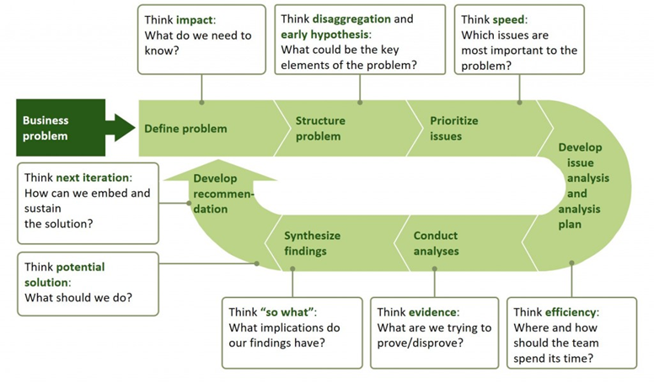
Figure: Problem solving process
According to the McKinsey’s seven steps of problem solving, the process begins with identifying the problem at first (Radwan, 2000). So, favouritism in this case would be the main problem for Zara UK. This leads to structuring the problem by identifying the major factors behind the situation in order to prioritize the most important factors in order to focus the actions of the management to be used on the most likely causes behind this situation. Then gathering as much evidences as the management can to approve or disapprove this issue and gather an understanding of what needs to be done next. Based on the possible actions that can be taken, the final step of this model is to form recommendations based on solutions that would be appropriate for such issue.
By following this process, the management at the Zara UK would be able to tackle the problems of the favouritism within the workplace.

THE DECISION-MAKING PROCESS
Decision-making process is an action that managers are responsible for when they have to take measures against specific problems that are occurring within the organization or affecting its internal and external operations in general (Rollinson et al., 2007). Before moving on to making decisions for the organization, the problem-solving process explained earlier suggests finding evidences to approve or disapprove the situation, which means the management has to find what positive and negative aspects lie within the workplace.
With a tool known as the SWOT analysis, the managers can identify the strength, weakness, opportunity and threat that are present for the company which might indicate in what areas the management should not focus and in what areas where changes are necessary for the company (Graetz et al., 2011). So, for this reason, a SWOT analysis has been developed based on Zara UK that should help with making the right decisions.

Strength | Weakness
- Zara UK is known for its quality fashionable clothing and is a brand valued by customers due to the fine service delivered by the staffs at the store who have a lot of experiences  - The practice of positive work environment is valued by the management which attracts a lot of skilled candidates to join and work for the Zara UK most of the time | - Significant decrease in motivations within the workplace in recent years due to favouritism  - Negative politics harming the positive work environment  - Managers failing to maintain equal opportunities for employees  - Personal agenda and favours are prioritized than the skills and knowledge
Opportunity | Threat
- Reformed policies should be able to tackle this issue for Zara UK with enough monitoring  - The managers at Zara UK can provide training and other opportunities to support career development and equal rights to employees in workplace  - There are resources to support benchmarking for the performance of the employees which should make it easier to distinguish good employees from bad ones to promote the right employees in the organization | - The decrease in motivation is costing the company valuable skilled employees since a lot of employees have left the job due to unethical practice of favours within workplace  - Poor performance of the employees is affecting the service of the company as well.

TYPES OF DECISION
Based on the strengths and weaknesses that the company has; the management can conduct appropriate decisions for Zara UK. But their approach to the decisions can vary as well (Greenwood, 2001). Usually there are two approaches to decision-making process. These are –
Rational
This is the most common approach to making a decision. Usually with this approach the managers try to define the problem at hand, then obtaining as much information as they can to form and evaluate possible solutions in order to pick the most appropriate solution to solve the problem.
Creative
This is rather uncommon for the managers and might not apply to every organization. In this approach the managers abandon the traditional structure of finding solutions and use their creativity to come up with a solution instead. And for this reason, this approach takes longer time to effect as creativity does not come instantly and requires a lot of brainstorming, hence a lot of organization prefer the other approach most of the time during dire situations.
For Zara UK, the situation is critical, therefore, the company has to go with rational approach to save time and efforts.
But whichever approach they take, their decision can be based on several types. The decision types are the following –
Routine decision
Usually taken for solving issues that almost always occur and are easier to solve. Takes less time to form and it does not require the managers to go through various solutions, as common solutions seem to work for common issues that happen in workplace (Chen, 2013).
Adaptive decision
This type of decision applies to situations that does not usually occur within the workplace but is known to the managers. Usually there are solutions known to the managers but takes a while to figure which one is applicable to the situation (Papadimitriou, 2008).
Innovative decision
This kind of decisions are taken when creativity is necessary to solve a problem that is rare and also unknown without spending a lot of time to analyse this (Gibson et al., 2009). Usually this type of decisions does not apply most of the time, but when it does, it is for a critical situation that management has to take creative approach to solve.

FACTORS AFFECTING DECISION MAKING
Decision-making can be quite complicated; therefore, a lot of positive and negative factors can influence this. The factors are as follows –
- Existing skills and experiences can influence the decisions for a specific issue
- Personal interests can influence decisions
- Stress is also responsible for affecting decisions
- Depending on the creativity of the managers, the outcomes of the decisions can vary
- Interpersonal conflicts within the workplace can also be related with the decisions
- Finance can be a great motivator or demotivator when making decisions for workplace (Aswathappa, 2002).
- Time limit can influence decisions
- Individuals making the decisions in general can also influence the outcomes
- Laws within the organization is also relevant when making decisions for the workplace
- Ethics can also influence the decisions as well.

INGREDIENTS OF GOOD DECISION MAKING
A decision can be good or bad. Usually there are some major factors that relate with good decisions which include the following –
- Involving people in the decision-making who have ideas on the situation and skills to find appropriate solutions
- Maintaining the known process of solving problems (Kramar et al., 2012).
- Taking specific approach to decision making rather than using several approaches which can disorganize the decision-making steps
- Taking time to evaluate the causes and evidences before jumping into a solution right away
- Thinking creatively at times
- Controlling emotions when making decisions and prioritizing on solving the issue.

FISHBONE ANALYSIS
There are certain causes to an issue that leads to certain effect and all of these forms the main issue which is the main idea behind the cause and effect and based on this idea there are many tools to identify causes and effects to problem. Fishbone analysis is such tool which is a diagram that is represented with drawing an arrow that points towards the main effect while the arrow has several bone-like arrows that are represented as causes behind the effect that the main arrow is showing. The causes also include sub-causes which altogether forms the main cause, leading to the effect in specific (Noe et al., 2015). This diagram can be used by managers to analyse a problem before making effective decisions for the workplace.
A fishbone analysis for Zara UK has been formed that shows the reasons behind the favouritism in workplace to occur. The diagram is as follows

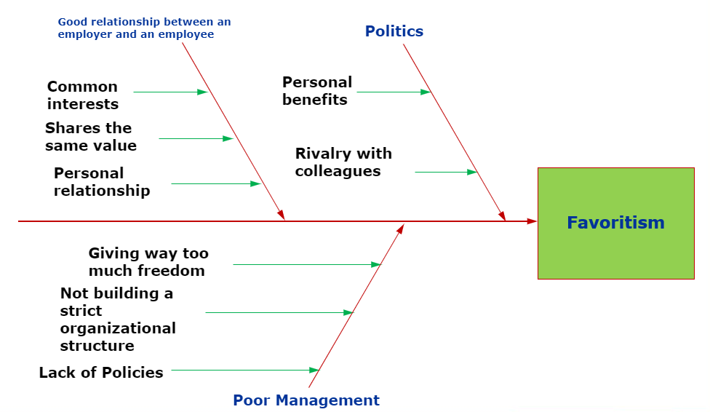
Figure: Fishbone analysis of Zara UK

THE SOLUTIONS
There are several actions that can be taken by the management at Zara UK. But the following solutions are most appropriate to the scenario and the management can go with either of the suggested options to combat the issue of favouritism in the workplace.
The managers can use benchmarking tools to evaluate the performance of the employees on monthly basis in order to use this result when prioritizing on whom to promote or recruit in the organization, rather than focusing on people with favours who got referred by other employers. This way the management would be able to identify the talented individuals to promote for the right jobs as well as recruit candidates who meet the job requirement. The benchmarking would be used in the recruitment and selection process as well to evaluate the test result in order to reduce chances of biasness. With this strategy, the management would be able to promote the culture of equality while blocking the practice of favours within workplace. If an employee is referred by someone, then management should also evaluate the candidate’s skills and knowledge, despite the relationship with the person who referred the candidate.
Another solution that also meets the factors of a routine decision is to simply change the organizational policies to implement penalties for unfair practice of giving favours to others or taking favours from others that might prevent opportunities for others or bring conflicts in workplace (Deci et al., 1985). In this case the management will have to closely monitor this for several months until the system fully takes effect. Employees can be encouraged to complaint to management if they notice favouritism in workplace, and this way the managers can tackle the favouritism from the workplace environment (Hand et al., 2012). Penalties could include reducing a portion from the salary for a specific period, temporary suspension, officially announced warning within workplace of the people involved with such behaviours, or in worst case scenario sacking the person or demoting them who are responsible for such practice in workplace.

EVALUATION
There couple of things that can either benefit or cause further issues if the above suggestions are implemented at Zara UK.
In the first solution suggested for the company, benchmarking tool can turn out to be authentic for the company to get the most talented employees for the organization instead of relying on referrals from employers. However, this does not necessarily mean that the practice of favouritism would stop. While skills and knowledge can help employees to develop their career instead of favours; the favouritism can still occur anyway in situations that are not necessarily for career development. It could be reasons like one individual disliking another individual in workplace, cultural differences, poor attitude etc. So, this solution can bring talents but does not mean that it would stop favouritism from the workplace of Zara UK.
The other solution which is to change the polices and strictly implement penalties based on the severity of favouritism practice on the other hand can be resisted by some employees at first since this would be a major change that a lot of employees would not like at first. But if managers can use their change management strategies to establish the penalty system against favouritism, then this solution has the chance to actually prevent the practice of favouritism. It would take time, but at least the effects would be mitigated, and management should be able to handle such behaviours in workplace.

PLAN FOR IMPLEMENTING THE SOLUTION TO THE ISSUE
The best solution in this case for Zara UK would be to change the policies and implement some penalties to stop employers or employees from doing favours that can affect others in workplace or the favours that are for their personal gain with no organizational benefits.
In order to implement this solution, the managers can go through their existing policies, then choose what punishments they would like to give to people who would conduct favouritism within workplace, then conduct a formal meeting to let the stakeholders of the company know about it, then letting the employees know about the upcoming changes to give them time to be prepared with the changes in policies, implement the changes and then monitoring the entire plan to see if changes are required.
A Gantt Chart can be used in this case to monitor the progress of this plan. This tool helps to assign different time limit for several tasks in order to prioritize on important tasks first while completing the entire list of tasks results in successful completion of the strategy. The following Gantt Chart shows that the managers at Zara UK should take 12 weeks to establish this plan in workplace successfully.
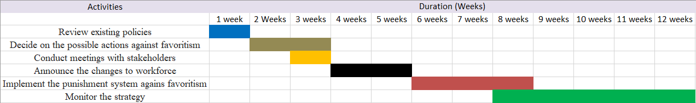
Figure: Gantt Chart

MONITORING THE IMPLEMENTATION OF THE PLAN TO SOLVE THE PROBLEM
According to the planning from the Gantt Chart, the entire plan should take 12 weeks to establish within the workplace at Zara UK to combat the favouritism in workplace. Monitoring it, however, would be the most important step since there could be issues with the strategy or further changes might be necessary. So, after implementing the plan, it will be monitored closely for at least five weeks straight to see if there are any changes being noticeable in terms of reduced favouritism in workplace. If there isn’t any change occurring or if there are problems with the strategy, then management will further make changes as necessary until the favouritism practice is eliminated from the workforce.

CONCLUSION
There should be opportunities for employees as well as good behaviours among the employers and employees working for an organization. The organizational objectives cannot be succeeded if the workforce isn’t motivated. So, practices like favouritism should be avoided so that equality can be ensured by the people who run the organization. Zara UK has been known for their good service and experienced staff who are able to communicate with customers properly. However, if the culture of favours and unfair advantages keep happening, then it would block talented and skilled employees from developing which could lead to them performing poorly for the organization. So, it is important that the company starts to value skills and knowledge of the employees rather than personal favours among themselves and with the suggested solution to tackle this issue, the management should have no issue with mitigating favouritism from the organization and then develop a positive work culture.

REFERENCE
Johnson, G. and Scholes, K. (1998). Exploring corporate strategy. Hemel Hempstead: Prentice Hall, p.155.
Maund, A. Schriek, M. and Tinkler, P. (2017). Certificate in Higher Education: Skills for the Workplace Student Yearbook. Sage Publications
Mills, J., Neely, A., Bourne, M., Richards, H. and Platts, K. (2002). Strategy and performance. Cambridge: Cambridge University Press, p.1.
Radwan, A. (2000). Computerised dynamic Gantt-chart for maintenance scheduling and management. International Journal of Computer Applications in Technology, 13(3/4/5), p.251.
Rollinson, D. and Dundoon, T. (2007). Employee relations. Maidenhead: McGraw-Hill Education.
Graetz, F., Rimmer, M., Smith, A. and Lawrence, A. (2011). Managing Organisational Change. 3rd ed. Brisbane: John Wiley and Sons Australia, Ltd.
Greenwood, M. (2001). The Importance of Stakeholders According to Business Leaders. Business and Society Review, 106(1), pp.29-49.
Chen, C. (2013). Nonprofit Managers' Motivational Styles: A View Beyond the Intrinsic-Extrinsic Dichotomy. Nonprofit and Voluntary Sector Quarterly, 43(4), pp.737-758.
Deci, E. and Ryan, R. (1985). Intrinsic motivation and self-determination in human behavior. 1st ed. New York: Plenum.
Hand, J., Davis, B. and Feast, P. (2012). Unification, simplification, amplification? An analysis of aspects of the British Equality Act 2010. Commonwealth Law Bulletin, 38(3), pp.509-528.
Papadimitriou, D. (2008). Promoting Equality Through an Employment of Last Resort Policy. SSRN Electronic Journal.
Gibson, S. and Haynes, J. (2009). Perspectives on participation and inclusion. London: Continuum.
Aswathappa, K. (2002). Human resource and personnel management. New Delhi: Tata McGraw-Hill Pub.
Kramar, R. and Syed, J. (2012). Human resource management in a global context. Houndmills, Basingstoke, Hampshire: Palgrave Macmillan.
Noe, R., Hollenbeck, J., Gerhart, B. and Wright, P. (2015). Human Resource Management: Gaining a competitive advantage. 4th ed. New Jersey: McGrew-Hill.

