

Digital Skills and Research Methods

BMSW4003
Lecturer: Koushik Modak

CertHE Health and Social Care Group:2

Petya Petrova (2009077)

The impact of Virtual Learning Environment (VLE)

Contents
Introduction 2
Literature Review 2
Research Methodology 2
Data collection process 6
Conclusion 11
References 11
Class activity 1 13
Class activity 2 14

Introduction.
This report has the sole purpose of presenting the learning impacts of Virtual learning on UWTSD students, weather mental or physical. What is meant by the term ‘Virtual learning environment’ and how it is used on day-to-day basis, and in general the lifestyle of the students today? To begin, a virtual learning uses software and online programming framework intended to encourage learning and education with the help of devices.
Literature Review
Authentic foundation on the utilisation and advancement of virtual learning environment.
In 1960, the university of Illinois created an invention that would set the concept for technologies today. The university of Illinois created an internet-like system for its students. (History.com Editors, 2018) This framework embodies a system of connected computer terminal stations where students could get access to course materials as well as listen to recorded lectures. This project would eventually advance into PLATO ( Programmed Logic for Automatic Teaching Operations).(PLATO | computer-based education system | Britannica, 2019)

The 1990s marked the beginning of a new technological era. Products like PowerPoint and word, were developed, which educational institutions still use to this day.(en.m.wikipedia.org, n.d.) In 1991, the World Wide Web was made available for public use. In combination with the personal computer which became widely popular for the average household, these technological advancement established the foundation for a significant fraction of modern life. Around this time governments around the globe started to consider the viability of this strategy, and started budgeting utilisation of technology. This report will focus on the positive and negative impacts of VLE and how they affect students of UWTSD.

Research Methodology
• An Online Learning Environment for Higher Education
This part of the report focuses on the impacts of positive and negative VLE, which is supported by a research conducted by Coventry University, United Kingdom. (Wikipedia Contributors, 2019) In order to acquire feedback on the research, the conductors performed a evaluation with 20 participants. One of the users mentioned that they liked the idea that they can learn from the comfort of their home. Another mentioned that is incredible the concept that students can study at their own pace. The participants were asked about the general experience of VLE. According to the results recorded, 70% of the members agree with the idea of learning things virtually, and have generally positive feedback towards the VLE.

Furthermore the participants were asked how they feel about the distant learning experience and would virtual learning environment help them learn. The data recorded shows that VLE is in their interest, because they can login into the system at any time and start the learning process. They can also interact with fellow students and staff from the comfort of their home. The response indicates that 65% of the participants from the survey think that it be in their advantage to learn virtually. The 45% of the individuals of all ages combined, had positive feedback about the entire idea of VLE

The finale question asked was how the individuals felt about the over idea and weather they would be interested in recommending others about learning in the particular virtual environment. The results from this question shows that 55% of the participants would recommend learning in a virtual environment. The results concluded that more than a halve of the participants, have positive experience using technology.

• Suitability of a Virtual Learning Environment for higher education
Furthermore, the following information is supported by the research of a VLE, conducting in the University of technology in Finland.(Marileena Mäkelä et al., 2012) . The researchers aim to examine the suitability of VLE for higher education. The information presented at the following section is based on research conducted in 2004. Satisfactory results were delivered by comparing the students’ opinions of their learning process. The courses the participants will take are ‘introduction to safety engineering’ and occupational safety engineering’. The courses consists of lectures covering studies such as: ergonomics, risk assessment, occupational hygiene and accident prevention.

The students were separated in two separate groups. For the virtual learning sessions there were 54 students of which 47 were males and 7 females. According to the research the students did not about the experiment. Regarding the second group, 74 students were thought the traditional way.

The researchers conducted their virtual session in a computer suite at the university. Each student had his/her own computer station to work with. The understudies were informed that they were required to study occupational hygiene, independently and to study as they saw fit. Researchers gave the participants one and a half hour to study the given subject and complete the exam after. Finally, after the exam has concluded, the participants were asked to fill in a questionnaire. The traditional lecture lasted for 45 minutes, after which the students were told that there would be an exam and a questionnaire.

After short exam, the participants were asked to fill in the questionnaire, which had the purpose to gather information about the VLE sessions and the traditional lectures. The maximum points a student can achieve is 14.

After the experiment was concluded, the researchers examined the data gathered. According to the results 61.1% of the students strongly agree that the virtual learning environment is very easy to use and they did not had problems using it. 19 mentioned that they found the virtual learning to be very clear. The researchers share that many students appreciated that they were able to control the speed of the studying themselves. 48.1% of the students said that VLE could be used as self-study method, and have general positive experience using VLE. And finally, regarding the test results. It seems that the understudies which were part of the VLE, did better then the students form the traditional lecture group. 20 students were able to achieve maximum points on the test. In contrast only 5 students were able to obtained maximum points from the traditional lectures.

- The role of e-learning, the advantages and disadvantages of its adoption in Higher Education
In a research conducted in the College of Distance Education, University of Cape Coast, Ghana,(Valentina Arkorful. (2014) it was explored the effectiveness and impact of virtual learning environment on students. The investigation found some disadvantages which needs to be considered as well. According to their findings, it comes to attention that the VLE can be less effective than the traditional method, where the face-to-face lectures are considered to be easer and more effective. In a virtual environment is usually hard to regulate activities such as cheating. In general the use of virtual learning outside the classroom will not deliver

as good communication as with face-to-face lectures. When using online sources for learning, there is a higher misled to piracy and plagiarism.

- Research on Negative Effect on E-Learning
A research exploring the effect of e-learning on students, was conducted in the Islamic Azad University in Iran (Nazarlou, 2013) . According to this research, the long time usage of computers can cause harm to the people’s health. Most computers emit minimal electromagnetic radiation. Yet, this minimal radiation can cause seriously damage the eyesight. According to research in Britain, these magnetic fields and low radiation can cause disease such as: itchy eyes, running nose, pain in the neck and back and so on. Moreover, studies shows that electromagnetic radiation can cause cancer. Specialist warn that long studying in front of computers, exposes the human body to huge threat.

Furthermore, the research explores the mental impact of e-learning. The researchers warn that the virtual environment can have serious impact on people’s communication capabilities. The study shows that contact between the human and the computer can block people’s opportunities such as outdoor time and face-to-face communication. This will led to reduction in people’s functional capacity.

- The use of virtual learning environments and their impact on academic performance Despite how much organised a VLE is, there will consistently be a distinction in how assorted understudies utilise the asset. The research investigated 209 understudies at Coventry University, according to the results it was discovered that 57% of the understudies read learning materials, 52% downloaded learning materials and yet just 14% accessed external web pages (Bromage, 2003). The end results of the research suggests that the participants will in use VLE resources basically as online version of lecture notes instead of as a wellspring of extra data to additional their agreement.

Researchers suggest that sometimes the available resources online can be too overwhelming or not enough and difficult to understand. This could lead to further confusion in students and demotivation.

- Disadvantages to e-learning
Technology issues –Some understudies may not have access to broadband connectivity or the proper hardware. Therefore it is harder for some people to fully experience e-learning.

Computer proficiency – Another problem students may encounter, is the usage of hardware or software. Not all students may have computer literacy at minimum. (citation:Tamm, 2019)

Data collection process

A questionnaire was prepared for the purpose of this report .Of all students from the UWTSD a questionnaire was sent to 22 students by email . It was explained that the answers will be used only for the purposes of this report.
I conducted research regarding the student's views on VLE. The results are presented below. The results are based on the primary data collection.

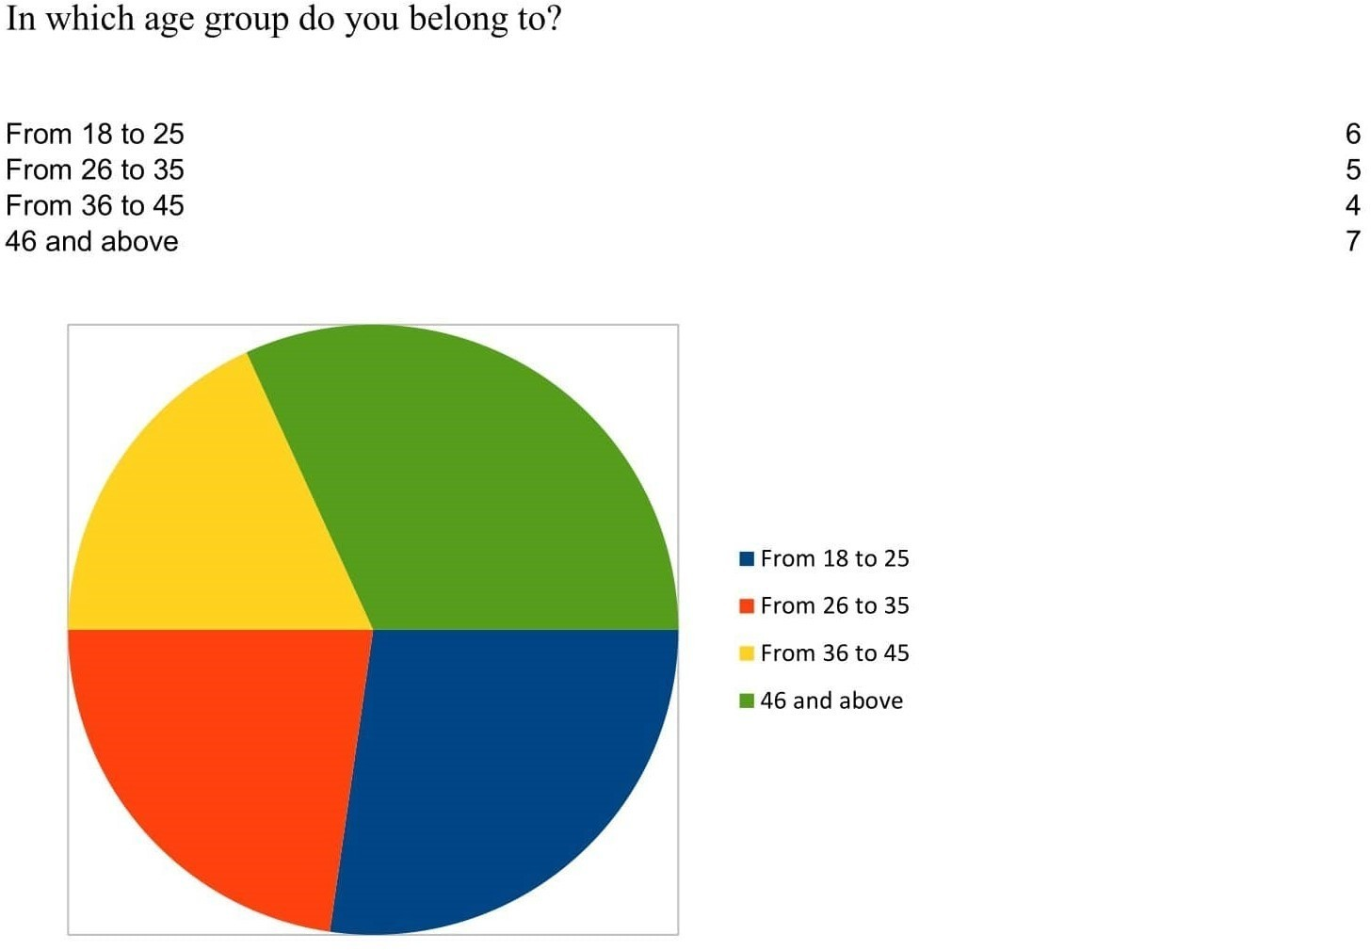

This graph represents the age groups of the students asked about their age. The results show that most of the students are 46 or above, followed by 18 to 25. The graph shows that the students between 36 to 45 fall in the smallest age group.

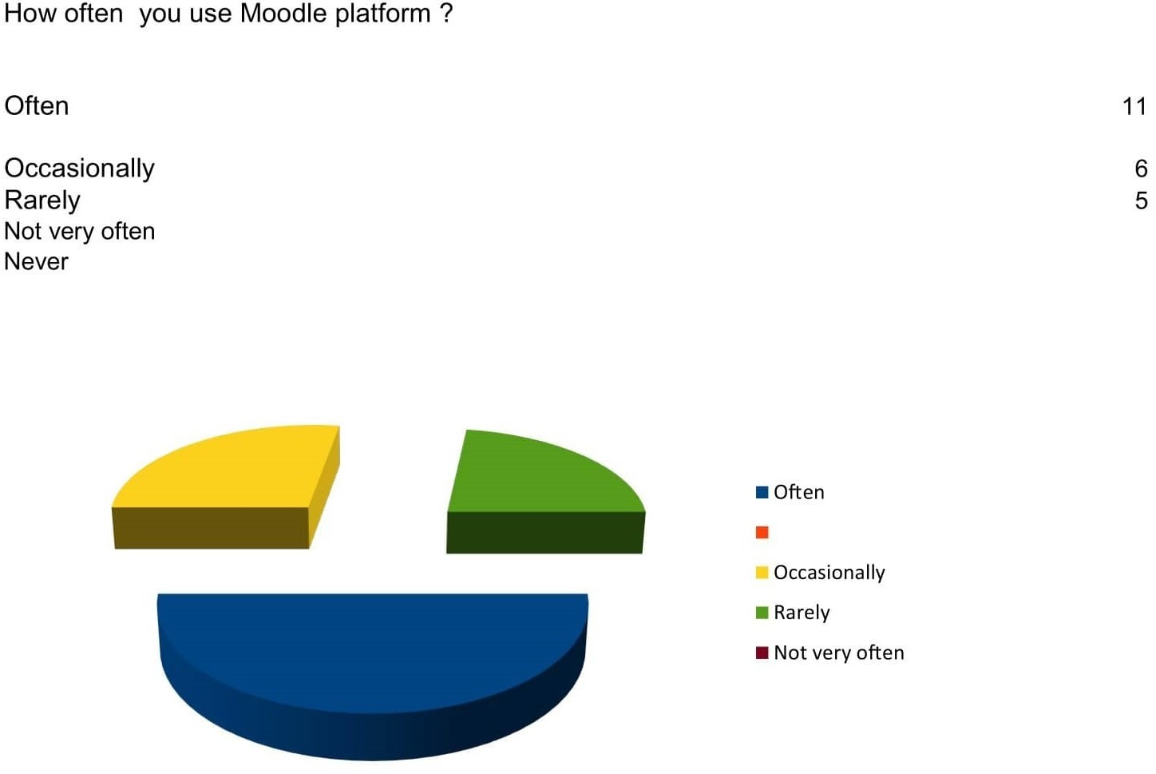

This graph represents the fraction of students using the Moodle platform. The results show that 50% of the students asked use the platform often. Where only 25% rarely. The data shows that half of the students use the platform.

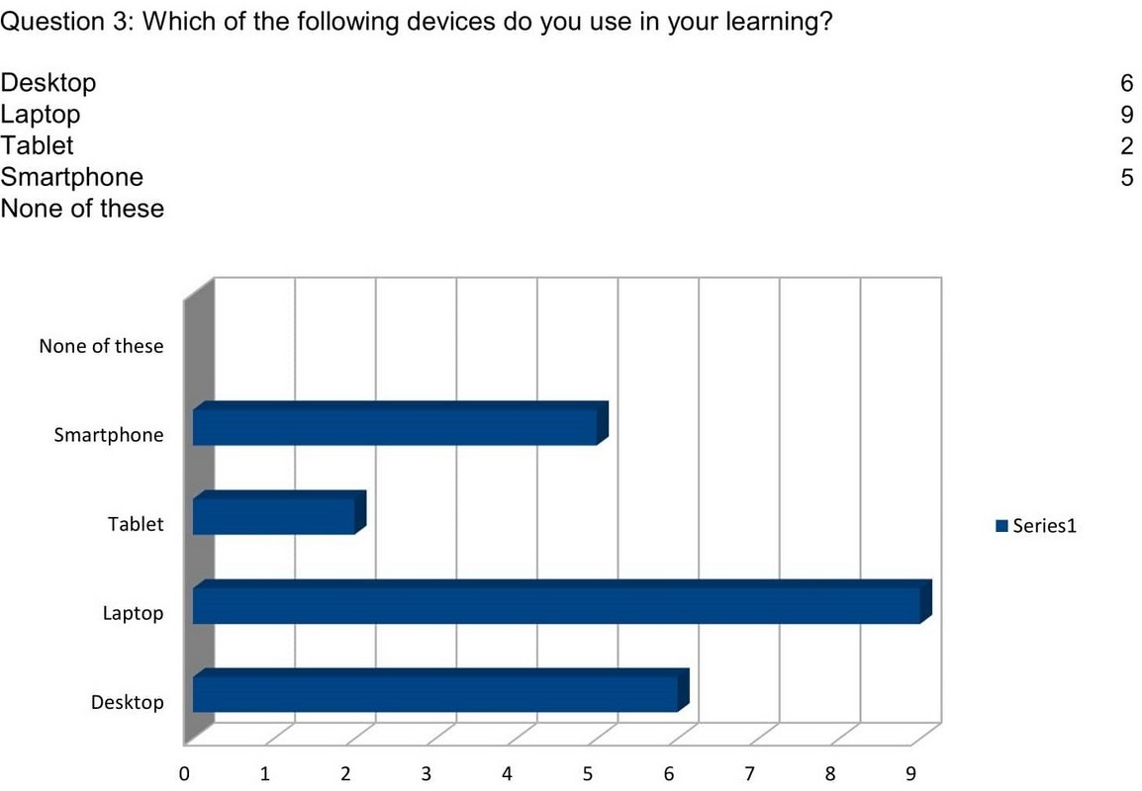

The bar chart above shows the preferred device for learning. The chart shows that 9 of the students prefer to use laptops. Following desktop computers and smartphones. The least used device is tablets

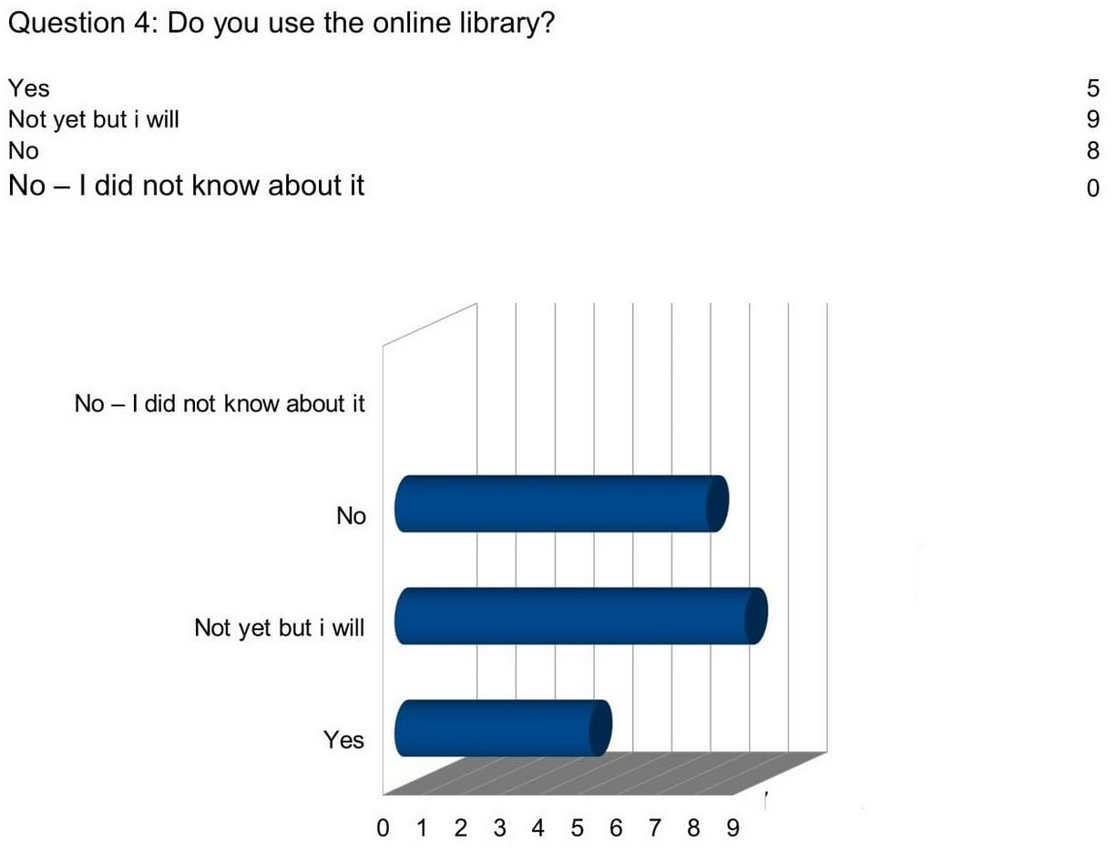

The question above asks the students if they use the online library. To this question, most of the participants answered with “Not yet, but I will”, followed by “No”. 5 of the students answered with yes. This shows that students are motivated to use the online library. But do not use it yet.

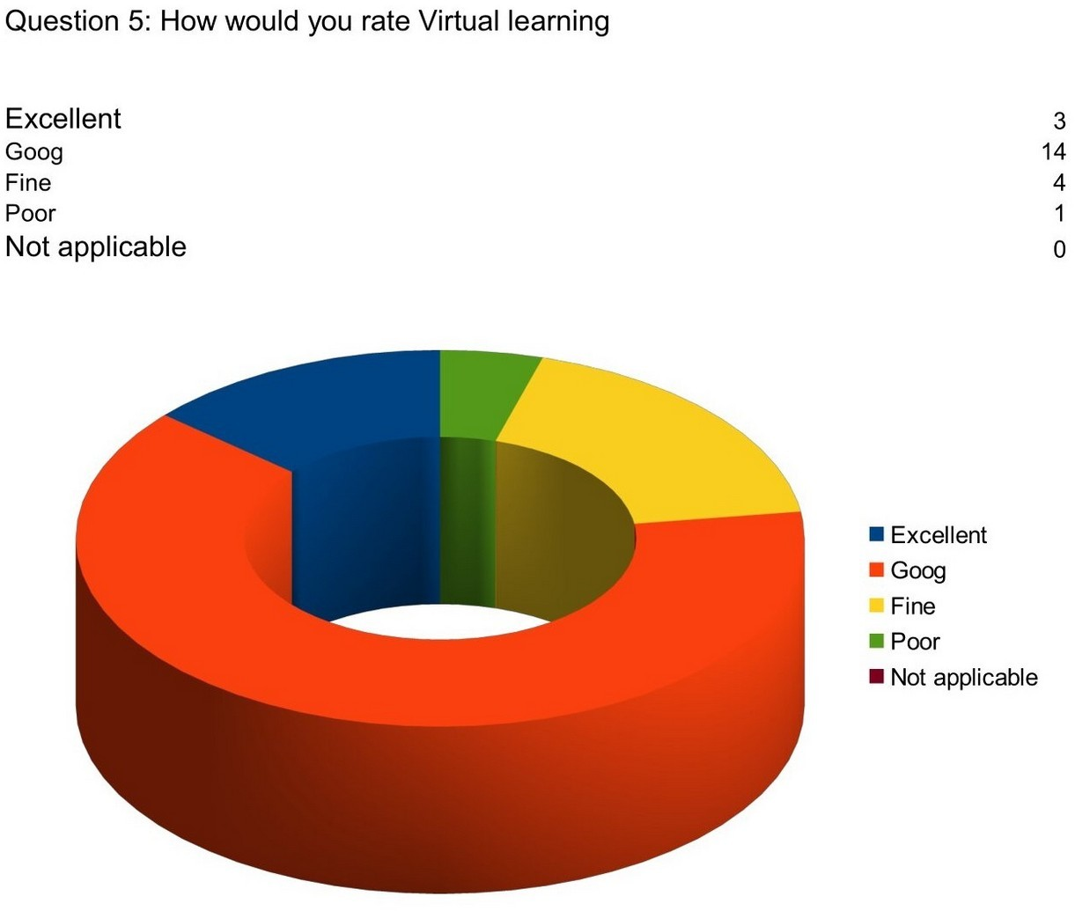

This question asks the participants about their experience using virtual learning. 14 students answered with good, making the majority of the people. Only one person answered with poor, and 3 with excellent. The results here show that more than half of the students enjoy using VLE.

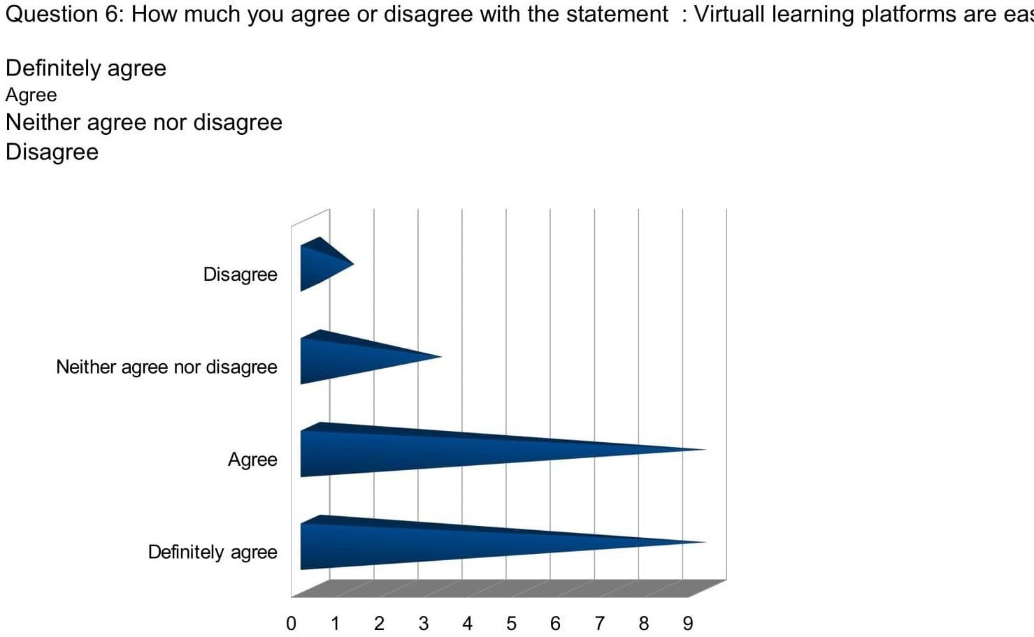

Here students were asked if they find the virtual platform easy to use. 9 student definitely agree and 9 agree. 3 student neither agree nor disagree and 1 disagree. This shows that according to the students, the platform is easy to use.

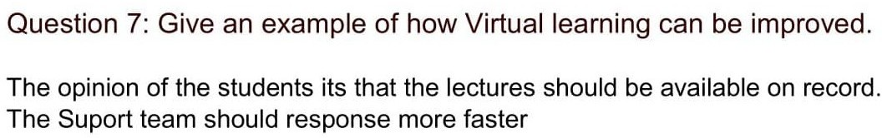

As a result of the survey we can conclude that students from UWTSD are positive about Virtual learning.Some of them have difficulty using the virtual platforms .But most of the students find the Virtual form of education better than traditional one.
Conclusion
The conclusion reviews and discusses the information presented above. VLE gives students the opportunity of studying easer outside the classroom and at their own pace. Statistics above shows that the VLE is very useful in the education, and students genuinely fell

positive about e-learning. Experiments prove that students using VLE did significantly better and genuinely achieved better results than the one learning the traditional way. However a big subject to be considered is mental and physical health. Studies showed that the long use of VLE will affect people’s social interactions and communications in a negative way.
Technological issues can be a disadvantage as well. Not all people may have basic computer literacy. Another problem could be the software. The application could be difficult to use and not user friendly, therefore making it hard to learn and demotivating to students. The information can be too overwhelming or not very informative, making the experience of e- learning hard. Bad activities like cheating is also hard regulate in an online environment.

References

PLATO | computer-based education system | Britannica. (2019). In:Encyclopedia Britannica. [online] Available at: https://www.britannica.com/topic/PLATO-education-system. [Accessed 4 Jan. 2021]

en.m.wikipedia.org. (n.d.).Computers in the classroom - Wikipedia. [online] Available at: https://en.m.wikipedia.org/wiki/Computers_in_the_classroom [Accessed 4 Jan. 2021].

History.com Editors (2018).The Invention of the Internet. [online] HISTORY. Available at: https://www.history.com/topics/inventions/invention-of-the-internet. [Accessed 4 Jan. 2021]

Wikipedia Contributors (2019).History of virtual learning environments. [online] Wikipedia. Available at: https://en.wikipedia.org/wiki/History_of_virtual_learning_environments. [Accessed 4 Jan. 2021]

Marileena Mäkelä, Piia Kiltti, Inka Vilpola and Janne Tervonen (2012).Suitability of a Virtual Learning Environment for Higher Education. [online] ResearchGate. Available at: https://www.researchgate.net/publication/253306757_Suitability_of_a_Virtual_Learning_Envi ronment_for_Higher_Education [Accessed 4 Jan. 2021].

Tamm, S. (2019).10 Biggest Disadvantages of E-Learning | E-Student. [online] e- student.org. Available at: https://e-student.org/disadvantages-of-e-learning/. [Accessed 4 Jan. 2021].

Wikipedia . (2020). World Wide Web. Available: https://en.wikipedia.org/wiki/World_Wide_Web. Last accessed 2020.

Fotis Liarokapis, V. Jaligama. (2011).An online learning environment for higher education .Available:
https://www.researchgate.net/publication/224249396_An_Online_Virtual_Learning_Environ ment_for_Higher_Education. [Last accessed 2020].

Valentina Arkorful. (2014).The role of e-learning, the advantages and disadvantages of its adoption in Higher Education..Available: https://www.ijern.com/journal/2014/December- 2014/34.pdf.[Last accessed 2020 ].

Nazarlou, M.M. (2013). Research on Negative Effect on E-Learning.International Journal of Mobile Network Communications & Telematics, [online] 3(2), pp.11–16. Available at: https://wireilla.com/papers/ijmnct/V3N2/3213ijmnct02.pdf [Accessed 24 Nov. 2020].

Peter Demian, James Morrice. (2012).The use of virtual learning environments and their impact on academic performance.Available: https://www.tandfonline.com/doi/full/10.11120/ened.2012.07010011.[ Last accessed 2020].

Tom. (2017).The history of online education.Available: https://www.petersons.com/blog/the-history-of-online-education/.[ Last accessed 2020].

Class activity 1

In-Class exercise: Questionnaire Design
Student Name:Petya Petrova Student ID:2009077
Module Name: Digital Skills and Research Methods H&Sc) Term 2 Group:_2

Aim: This exercise is aimed to help you in your questionnaire design. Please note, you need to use this questionnaire to conduct a survey which is also one of the important parts of your research report.

Please write down your questions that you are going to use in your primary data collection. Try to have different types of questions such as close-ended question, open ended question, multiple choice question, Likert-scale question.

Question 1: In which age group do you belong to?

From 18 to 25 /From 26 to 35 / From 36 to 45 / from 46 and above

Question 2: How often you use Moodle platform ?
Often / Occasionally / Rarely / Not very often / Never

Question 3: Which of the following devices do you use in your learning? Desktop :Laptop : Tablet: Smartphone : None of these

Question 4: Do you use the online library?

Yes / Not yet but i will / No / No – I did not know about it

Question 5: How would you rate Virtual learning

Excellent /Good / Fine /Poor/ Not applicable

Question 6: How much you agree or disagree with the statement : Virtuall learning platforms are easy to use
Definitely agree / Agree / Neither agree nor disagree / Disagree

Question 7: Give an example of how Virtual learning can be improved.

Class activity 2


