Destination Management: Dubai

Student Name: Malik Arosh Miah
Student No: 2107169

Sustainable Hospitality & Tourism Management
BMIH5006

Lecturers Name: Ruth Taylor-Davies

CONTENTS

 |  |  | PAGE
1. | Executive Summary |  | 2-3
2.  3. | Tourism Area Life Cycle  Doxey’ Irredex |  | 5-7  8
4. | Economic Sustainbility |  | 9
5. | Sociocultural |  | 10-11
6. | Environmental |  | 12
7. | Transport |  | 13
8. | Conclusion |  | 14
9  10. | Recommendation  References |  | 15 16-18

Executive Summary

This report will assess the Development Management Plan of Dubai and the three pillars of sustainability, and their correlation with general development principles, by using Butler's life cycle model and Doxey's Irridex model.
Dubai is currently in the Development stage of the Tourism Area Life Cycle (TALC), characterized by a surge in tourist numbers and external organizations providing advanced tourism facilities.

In Dubai, the successful growth of tourism has resulted in a positive perception among the local community, as they embrace the benefits it brings to the city. This suggests that there is potential for further tourism development in Dubai without causing significant tension within the host population.

Dubai has experienced a steady increase in international tourism, resulting in a positive economic impact and expansion of the labour force. The investment in expanding accommodation also stimulates the construction sector and has a multiplier effect on the overall economy.

The report emphasizes the need for Dubai to develop an economically and environmentally sustainable tourism industry. It recognizes the impact of tourism on transportation, water, and electricity usage and highlights the importance of maintaining sustainability in these areas. Dubai demonstrates its commitment to sustainability by supporting the United Nations Sustainable Development Goals and through the efforts of the Dubai Electricity and Water Authority (DEWA. The Dubai government is actively working to reduce resource demand, increase clean energy supply, and implement strategies to lower carbon emissions.

The DMP acknowledges that the growing tourism sector in Dubai will have implications for transportation and emphasizes the need to address transportation challenges to sustain investments in tourism. While specific details about sustainability measures for transport are not provided, the DMP highlights the goal of establishing an economically and environmentally sustainable tourism industry, indicating that transportation sustainability is a consideration. Dubai's public transportation system has been successful in increasing the usage of public and shared transportation.

In conclusion, this report assesses Dubai's sustainability in the tourism sector, highlighting its current stage of development and positive impact on the local community and economy. Dubai is actively working towards establishing an economically and environmentally sustainable tourism industry, recognizing the importance of transportation, water, and electricity sustainability. The city's commitment to sustainability is demonstrated through its support for the UN Sustainable Development Goals and efforts by DEWA. While specific details about transport sustainability are not provided, Dubai aims to increase public and shared transportation usage. Overall, Dubai's tourism sector is poised to contribute to the city's long-term socio-cultural and environmental well-being through sustainable development and stakeholder collaboration.

It is recommended, to enhance tourism, Dubai should collaborate with other UAE Emirates to develop a coordinated strategy that capitalizes on their unique attractions, creating diverse tourism offerings. Improving stakeholder coordination in the tourism industry is crucial, and Dubai should establish a platform for effective collaboration among government bodies, tourism agencies, businesses, and local communities. Investing in renewable energy and sustainable water solutions is essential for long-term sustainability. Setting ambitious targets for energy efficiency, carbon emissions reduction, and renewable energy utilization, while exploring innovative water conservation and desalination methods, will ensure a sustainable water supply. Prioritizing responsible tourism practices is necessary, and Dubai should promote awareness among tourists and local businesses through educational campaigns, incentives for sustainable practices, and respect for the local culture, environment, and community. These efforts will help preserve Dubai's heritage and minimize the negative impacts of mass tourism.

Introduction

Dubai stands as a mesmerizing oasis in the Arabian desert, captivating with its ambition and allure. It beautifully blends its rich cultural heritage with rapid economic advancements (Anthonisz & Mason, 2019). And this report will examine the Destination Management Plan (DMP) of Dubai 2018. This report will assess the three pillars of sustainability. and their correlation with general development principles. Additionally, it will try to determine the current stage of Dubai, by using Butler's life cycle model and Doxey's Irridex model.

Tourism Area Life Cycle

The Tourism Area Life Cycle (TALC) is a conceptual framework used for destination analysis, highlighting the consistent developmental process and cycle followed by tourist destinations (George, 2021). This model suggests that destinations reach a threshold indicating a decline in desirability and that the development of a destination brings about changes in the physical and socio-cultural environments, influencing the attitudes of the local community. The TALC model consists of stages including exploration, involvement, development, consolidation, stagnation, decline, and rejuvenation (An and Jang, 2020). Dubai's current state and long-term sustainability can be assessed by employing the TALC model.
Based on the provided information in the DMP, it is possible to identify some insights related to the Tourism Area Life Cycle of Dubai. Here are the key points:
- Dubai has maintained its market share from its main source countries over the past few years.
- The attraction of tourists from the top seven countries to visit Dubai has shown stability in recent years.
- The facilitation procedures for visa issuance on arrival for Chinese and Russian nationals have contributed to their increased visits to Dubai.
- Russian visitors experienced a significant increase of 121 percent in one year, indicating a recovery from previous levels.
- China has risen in importance as a source country, with a substantial increase in visitors over the three years.
- Efforts have been made to diversify Dubai's tourist mix by targeting new source markets like South Korea, Indonesia, Malaysia, and Iran.
- The easing of visa regulations has resulted in a rise in arrivals from European Union countries.
- Dubai aims to attract a greater share of mid-market visitors to achieve its 2020 target of 20 million tourist arrivals.
- Marketing efforts are focused on China, utilizing social media as a marketing tool.
- Construction of hotels aimed at the three- and four-star market segments is underway to cater to the target demographic.
.

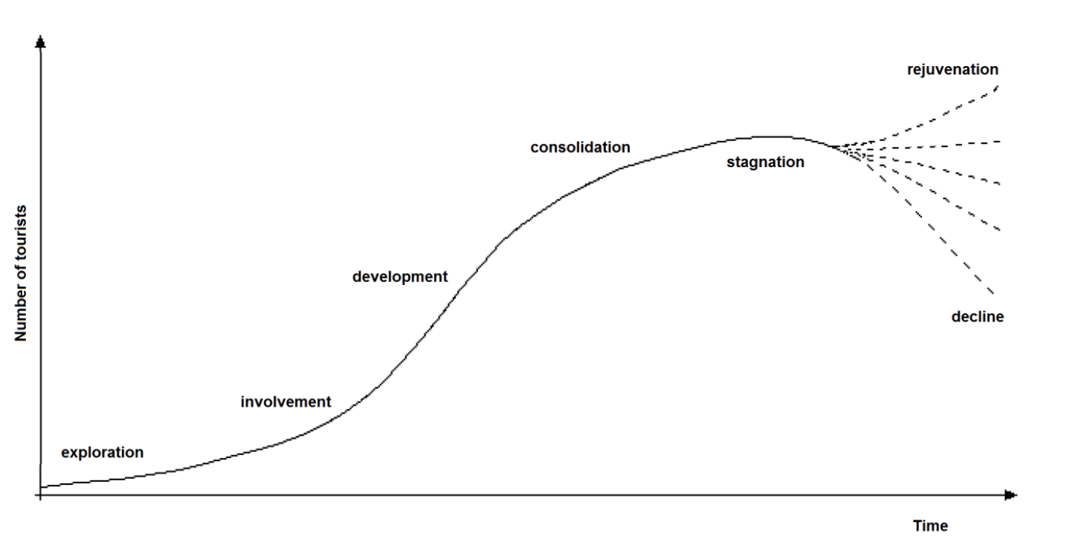
Figure 1 (Stainton, 2020)

Based on this information, Dubai appears to be in the Development stage of TALC This stage is characterized by a clearly defined tourist market area, experiencing a significant surge in tourist numbers that may surpass the local population. Local participation and control over accommodation services decline rapidly, while external organizations take over the provision of more advanced tourism facilities and attractions. During this stage, noticeable changes in the physical appearance of the tourist destination occur (Sahli, 2020). The city is actively expanding its target markets and developing infrastructure to attract a wider range of tourists. Tourism continues to yield results and contribute to the long-term socio-cultural and environmental conditions in Dubai (Khudhair & Mardani, 2021).
However, the simplicity of the concept of destination development stages has been a subject of criticism, leading to questions about its applicability. Scholars such as Haywood (1986), Agarwal (1997), and Johnson and Snepenger (1993) have raised concerns about the difficulty in distinguishing between the various stages mentioned earlier. Moreover, the notion of carrying capacity, which plays a crucial role in determining a destination's development stage, has also faced criticism. It is often viewed as imprecise and vague because its interpretation depends on the specific aspects being examined, such as physical capacity (e.g., accommodation and bed availability) or the environmental and psychological capacities of a destination (Berry, 2000).

Doxey's Irridex model

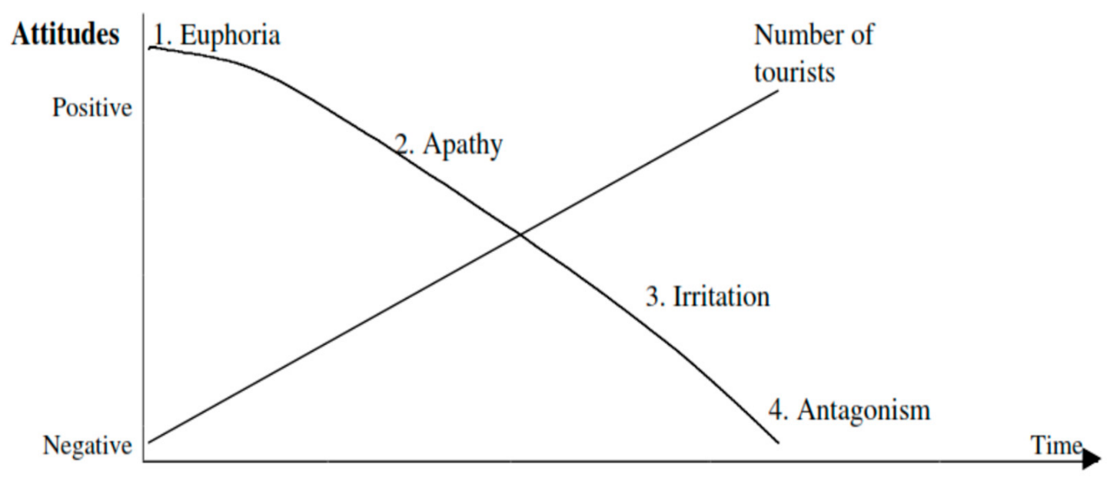
Figure 2 Doxy (1975)

Doxey's Irridex model (1975) is a relatively straightforward conceptual model that visually depicts the relationship between levels of tourism development and changes in the attitudes of the host population. Figure 2 provides a clear representation of this trend. According to the model, different stages of tourism growth are associated with varying levels of tension within the host population. Specifically, the model highlights that the level of irritation experienced by the residents, ranging from enthusiasm to antagonism, is influenced by the presence of outsiders and the resulting pressures on the quality of life in the community. The successful growth of tourism in Dubai, attracting millions of visitors, has played a vital role in shaping the overall positive perception of tourism among the local population (Zaidan and Kovacs, 2017). From the report, we can see the Emirati community in Dubai embraces tourism and its consequences, primarily due to the substantial benefits it brings to their city. They may perceive tourism as the only viable option to address the current trend. Recognizing that the success of tourism hinges upon the attitudes and behaviours of the local society, this observation suggests that there is still potential for additional tourism development without causing considerable tension within Dubai's host population.

Economic Sustainability
Economic sustainability aims to achieve long-term economic growth while preserving natural and financial resources and minimizing negative impacts on the environment, society, and culture (Yas et al., 2020).
We can see from the DMP report that, the number of visitors to Dubai has consistently increased at an average annual rate of 8.7% since 2009, surpassing the growth rate of the overall economy. In Dubai's National Accounts, the tourism sector specifically encompasses Accommodation and Food Services activities such as hotels and restaurants. In 2017, the contribution of accommodation and food services activities to Dubai's GDP reached 4.9%, driven largely by tourism, compared to 3.5% in 2009. This indicates that the tourism sector has experienced faster growth than Dubai's real GDP over the same period.
Dubai has witnessed a steady increase in the influx of international tourists, with an annual growth rate of 8.7%. According to the Mastercard Global Destinations Survey (2018), tourists spent a significant amount of AED 109.3 billion in 2017, which far exceeds the AED 19 billion spent specifically on hotels and food. The adoption of tourism has resulted in positive economic outcomes, including increased employment opportunities, improved living standards, and significant economic empowerment (Ayoub and Alheety, 2018). The increased investment in expanding accommodation to accommodate the growing number of visitors has a direct impact on the construction sector. And one of Dubais’ commitments to sustainability is the focus on formulating urban planning policies that prioritize environmental preservation and enhancing the environmental efficiency of housing and buildings (u.ae, 2021). Various sectors have benefited from this growth, leading to an expansion in the labour force as well.

.

Socio-cultural

The socio-cultural aspect is often integrated into the broader concept of social sustainability. It refers to the cultural diversity, social cohesion, and community well-being within a society. Socio-cultural sustainability involves preserving and valuing cultural heritage, promoting intercultural dialogue, fostering inclusivity, and respecting human rights (United Nations, 2015).
Based on the information in the DMP, it is possible to identify some insights related to the sociocultural sustainability of Dubai. Here are the key points:
- The Dubai Department of Tourism and Commerce Marketing's strategy aims to develop modern, luxurious, and affordable facilities for visitors, indicating a focus on providing social benefits to tourists.
- The decision to permit homeowners to apply for holiday home rental licenses can be seen as a step towards engaging local communities and promoting sustainable tourism practices.
- The report also mentions attractions and events in Dubai, such as cultural sporting venues and family attractions.
- There is a mention of concerns about a potential oversupply of accommodation in Dubai after reaching the 2020 target of 20 million visitors. This indicates a recognition of the need for sustainable development in the tourism sector to avoid negative impacts, such as an oversaturation of hotels and housing units.
- The government of Dubai has established the "Higher Committee for Dubai Urban Planning" to oversee and regulate the emirate's overall urban growth, including housing and hotels. This indicates a commitment to strategic urban planning and management, which is crucial for sustainable development.
- The report emphasizes the importance of a strong national authority to plan and coordinate long-term strategies for sustainable tourism development. It highlights the need for coordination with the private sector to ensure the supply of sustainable tourist infrastructure and resources. This indicates a recognition of the collaborative nature of sustainable development and the involvement of multiple stakeholders.
- The report also suggests that sustainable tourism policies should involve and engage the support of local communities and businesses. It mentions the use of incentives, certification, and education programs to align the economic interests of locals and residents with the long-term development of a sustainable tourism sector. This highlights the importance of community engagement, empowerment, and inclusivity in sustainable tourism practices.
- The importance of identifying and preserving the natural and cultural assets that attract tourists. This indicates an understanding of the social value of preserving the local environment and cultural heritage, which contributes to the long-term sustainability of the tourism sector. However, despite being part of the tourist circuit, museums in Dubai are not a primary focus of the tourism industry, and cultural heritage has taken a backseat (Zaidan and Kovacs, 2017).
Overall, the DMP recognizes the social aspects of sustainability in tourism, including community involvement, preservation of cultural assets, fostering cultural exchange, community engagement, job creation, offering residents recreational opportunities, and coordination among stakeholders for long-term planning and development.

Environmental Sustainability
The report states that Dubai must strive to establish an economically and environmentally sustainable tourism industry. It acknowledges that tourism has implications for transportation, water, and electricity usage, and emphasizes the importance of maintaining sustainability in these areas. It mentions that Dubai has a commitment to sustainability and supports the United Nations Sustainable Development Goals (United Nations, 2015). The Dubai Electricity and Water Authority (DEWA) plays a significant role in ensuring sustainability in the tourism sector by managing power and water resources. The government of Dubai is focused on reducing resource demand, increasing the supply of clean energy, and implementing strategies to reduce carbon emissions.

Transport

The DMP mentions the implications of rising tourist numbers for transport and sustainability. It states that an expanding tourism sector in Dubai will have implications for transportation, as more visitors will require transportation services. This indicates a recognition of the need to address transportation challenges to maintain the viability of investments in the tourism sector. The transportation sector may also be affected by the increased demand generated by rising tourist numbers. While the DMP doesn't provide specific details about sustainability measures related to transport, it highlights the need for Dubai to establish an economically and environmentally sustainable tourism industry, which implies that transportation sustainability would be a consideration.
Dubai's comprehensive public transportation system serves as the fundamental infrastructure for facilitating people's movement within the city. The network has effectively increased the usage of public and shared transportation from 6% in 2006 to an impressive 19.4% in 2022. Building upon this achievement, the goal is to further elevate the proportion to 25% by 2030 (ArabianBusiness, 2023).

Conclusion
In conclusion, this report provides a comprehensive assessment of Dubai's sustainability in the tourism sector. Dubai is currently in the Development stage of the TALC. The successful growth of tourism has resulted in a positive perception among the local community, indicating the potential for further development without causing tension. Dubai's tourism industry has had a significant positive economic impact, benefiting various sectors and expanding the labour force. Tourists' spending has contributed to total consumer expenditure, stimulating multiple industries, and creating a multiplier effect on the economy. The DMP recognizes the social aspects of sustainability, including community involvement, cultural preservation, job creation, and stakeholder coordination. It emphasizes the need to establish an economically and environmentally sustainable tourism industry, considering the implications on transportation, water, and electricity usage. Dubai's commitment to sustainability is demonstrated through its support for the UN Sustainable Development Goals and the efforts of DEWA in managing power and water resources. While specific details about sustainability measures for transport are not provided, the report highlights the importance of addressing transportation challenges and the goal of increasing public and shared transportation usage to 25% by 2030. Overall, Dubai's tourism sector is positioned to further contribute to the city's long-term socio-cultural and environmental conditions, with a focus on sustainable development and stakeholder collaboration.

Recommendation
To enhance tourism, Dubai should collaborate with other UAE Emirates. They should develop a coordinated strategy that leverages each emirate's unique attractions, promoting complementary experiences. This collaboration will create diverse tourism offerings, appealing to a broader international audience.
Dubai should improve stakeholder coordination in the tourism industry by establishing a platform for effective collaboration among government bodies, tourism agencies, businesses, and local communities. This will enable the sharing of best practices, knowledge exchange, and ensure alignment in sustainability efforts.
Dubai should invest in renewable energy and sustainable water solutions for long-term sustainability. This includes setting ambitious targets for energy efficiency, carbon emissions reduction, and renewable energy utilization. Exploring innovative water conservation and desalination methods will also ensure a sustainable water supply.
Dubai should prioritize responsible tourism practices by promoting awareness among tourists and local businesses. This can be done through educational campaigns, incentives for sustainable practices, and encouraging respect for the local culture, environment, and community. These efforts will preserve Dubai's heritage and mitigate the negative effects of mass tourism.
Dubai should monitor and report sustainability progress regularly to evaluate initiatives and identify areas for improvement. Transparent reporting enhances accountability, enables benchmarking, and drives continuous improvement in sustainable tourism efforts.
By implementing these recommendations, Dubai can further strengthen its position as a leading sustainable tourism destination, contributing to the UAE's long-term economic growth, environmental preservation, and cultural heritage.

References
Agarwal, S., 1997. The public sector: planning for renewal?, G. Shaw and A. Williams
(eds.) The Rise and Fall of British Coastal Resorts, London: Pinter.

An, Y. and Jang, Y., 2020. Applying the tourist life cycle concept to the evolution of commercial areas using density, diversity, and land price, 34(4), pp.55-74
Annual Conference Proceedings (195-198). San Diego, September 8-11.
Anthonisz, A. and Mason, G., 2019. Reinventing tourism: the Dubai phenomenon. Worldwide Hospitality and Tourism Themes.
ArabianBusiness. (2023). Dubai shows off self-driving vehicles and flying taxis plan at transport summit. [online] Available at: https://www.arabianbusiness.com/industries/transport/dubai-shows-off-self-driving-vehicles-and-flying-taxis-plan-at-transport-summit. Accessed 5 June 2023.

Ayoub, T.K.B. and Alheety, S.N.Y. (2018). Tourism Contribution to Dubai Economic Growth. World Journal of Research and Review, 7(5).

Berry, E.W. (2000). An application of Butler’s (1980) tourist area life cycle theory to the Cairns region, Australia, 1876-1998.

Doxey, G.V. 1975. A causation theory of visitor-resident irritants: Methodology and research inferences. The impact of tourism: Travel Research Association, 6th
George, R., 2021. Marketing Tourism Destinations. In Marketing Tourism and Hospitality (pp. 447-484). Palgrave Macmillan, Cham.
Haywood, K.Michael. (1986). Can the tourist-area life cycle be made operational? Tourism Management, 7(3), pp.154–167

Johnson, J.D. and Snepenger, D.J. (1993). Application of the tourism life cycle concept in the greater Yellowstone region. Society & Natural Resources, 6(2), pp.127–148.
Khudhair, H.Y. and Mardani, A., 2021. The positive role of the tourism industry for Dubai city in the United Arab Emirates. International Journal of Economics and Management Systems, 6.
Mastercard.com. (2018). Mastercard Global Destination Cities Index 2018. [online] Available at: https://newsroom.mastercard.com/news/press/digital-press-kits/2018/mastercard-global-destination-cities-index-2018/ Accessed 8 Jun. 2023.

Sahli, E. (2020). (PDF) Tourism Destination Development An Application of Butler’s (1980) Tourism Area Life Cycle Model to Hammamet, Tunisia. [online] ResearchGate. Available at: https://www.researchgate.net/publication/341804244_Tourism_Destination_Development_An_Application_of_Butler. Accessed 5 June 2023.

Stainton, H. (2020). Butler’s Tourism Area Life Cycle Model: A simple explanation. [online] Tourism Teacher. Available at: https://tourismteacher.com/butlers-tourism-area-life-cycle-model/ Accessed 5 June 2023.

u.ae. (2021). Green Economy for Sustainable Development - The Official Portal of the UAE Government. [online] Available at: https://u.ae/en/about-the-uae/economy/green-economy-for-sustainable-development. Accessed 5 June 2023.

United Nations (2015). The 17 sustainable development goals. [online] United Nations. Available at: https://sdgs.un.org/goals. Accessed 5 June 2023.
United Nations (2015). Transforming our world: The 2030 agenda for sustainable development. [online] United Nations. Available at: https://sdgs.un.org/2030agenda. Accessed 5 June 2023.
Yas, H., Mardani, A., Albayati, Y.K., Lootah, S.E. and Streimikiene, D., 2020. The Positive Role of the Tourism Industry for Dubai City in the United Arab Emirates. Contemporary Economics, 14(4), pp.601-617.
Zaidan, E. and Kovacs, J.F. (2017). RESIDENT ATTITUDES TOWARDS TOURISTS AND TOURISM GROWTH: A CASE STUDY FROM THE MIDDLE EAST, DUBAI IN UNITED ARAB EMIRATES. European Journal of Sustainable Development, 6(1).

