Customer Relationship Management Emerging Themes

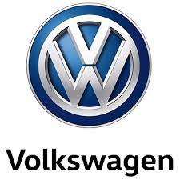

BMSW5103
Student number: 2019914
Student: Andrea Barros dos Santos
Lecture name: Dr Richmond Lamptey

Table of Contents
Introduction …………………………………………….3
Customer touch point………………………………4
Strategy…………………………………………………….4
Strategy implemented by the company…….5,6
Company marketing strategy………………………7,8
Customer service experience……………………….8
Strategic fields of action……………………………….9,10
quality models /theories……………………………….11,12
Conclusion…………………………………………………….13
Reference………………………………………………………14



The objective of this work is to develop a proposal of Relationship Marketing
for the Volkswagen company. (Volkswagen AG generation),
the work will be developed on the topic of relationship marketing, an important area
so that the company grows with good communication with the customer and that it has an excellent
public service work. This research is descriptive, it has a case study and I also did a bibliographic research and I applied a questionnaire and the observation of participants. this study has as its main point the administration with its
areas mainly on marketing, information on marketing management with a focus on
on the customer, the importance of relationship marketing and the application of the tool
used, in addition to the history of the company in question. the results were analyzed and classified as strengths and weaknesses. on these two points and that the need for improvement identified in the study will be determined, an action plan was suggested
for better use of the work carried out in the company.com all this is intended to have a
strengthening of relationship marketing within the organization, with this they were indicated
some actions with the application of the CRM relationship tool (Customer
Relationship Management). The main actions suggested were meetings with the directors
to show the problems, train and make salespeople aware that it is
necessary to properly feed the system, and stay for a certain time charging and
making it routine, optimizing the use of CRM (Customer Relationship
Management), configure the CRM for more accurate and assertive reports, optimize
campaigns and continue to work with matrix promotions in different ways, reward
salespeople and give lectures with incentive meetings, in addition to publicizing and awarding the
salespeople who best operate and feed the CRM system.
since 2016, Volkswagen has continued to implement the strategy outlined in 2015 and which covered the following three years, until 2018. the strategy would be the guidelines for the future of the company, which remained as a company connected to the rapid transformations of society and which was increasingly reaching out to people – employees, consumers, and other audiences.
To make the plan worthwhile, the company placed the Our People pillar at the centre of its strategy, which made professionals more engaged and motivated to contribute to this transformation movement. The pillars of Customers, Suppliers, Factories, Products, and Image were also defined. The unfolding of each of these pillars has been carried out through various projects and action plans, and is closely monitored by the company's management, with a member of the Executive Committee as the direct leader and a multidisciplinary team involved in its execution.

What is customer touch point?
A customer touchpoint is any direct or indirect contact a customer has with a brand. Customer touch points can be inside and outside a brand's control and can also happen before, during or after the purchase of a brand's product or service.
The Pre-Shopping Experience. ...
Create a Welcome Arrival Process. ...
Clear Communication in a Comfortable Space. ...
Demonstrate Your Value. ...
Communicate After Drive-Off. ...
Direct Mail, Emails, and Phone Calls to Client Base.

The strategy works on the repositioning of the Brand, which leads to an evolution in the relationship with the dealer network and the strengthening of the product portfolio, ensuring that deliveries to consumers fully respond to their current desires. and design – attributes already consolidated throughout the history of this company –, the objective is to contribute to making the lives of customers even better.

global strategy
To remain aligned with the directives of the Matrix, at the end of 2016 Volkswagen revisited its future to adapt to the recently launched strategies of the Volkswagen Group (Together – Strategy 2025) and of the Volkswagen Brand (Transform 2025+), which established the new strategic objectives for the company's next growth cycle.

The work being developed by Volkswagen in the pillars People, Customers, Suppliers, Factories, Products, and Image will be maintained. Two new themes were added to these pillars in 2017. They are Digitization and Connectivity and New Business, which include, among other things, the strengthening of Industry 4.0 in the company's industrial plants, new forms of relationship with consumers, the structuring of its own digital platform and the offer of new services and new business. One of the goals of the Transform 2025+ strategy is to make Volkswagen a reference in electric mobility, enabling the production and commercialization of hybrid and electric vehicles on a large scale.

sustainability strategy
Sustainability is one of Volkswagen's management principles, essential to ensure the ethical and responsible conduct of the business, as it will always have the creation of medium and long-term value for the company's different stakeholders and the care and use of resources natural. Therefore, the sustainability vision, in its broad meaning, is considered in the execution of all the pillars of the company's strategy.

At the heart of strategy

Volkswagen in a more modern company, as it invests in the preparation of workers to face the challenges of the future. Constant dialogue and the development of people and the promotion of well-being are some of the elements that will drive this change. People are at the heart of the company's strategy, which recognizes the value of teamwork. In 2016 Volkswagen maintained a frank and transparent dialogue with employees and unions to implement the necessary measures. Through this relationship, collective agreements were formalized for the next five years in all units.

Strategy implemented by the company

After the Second World War, Volkswagen was already focused on providing services for the satisfaction of its customers,
but with everything they were just thinking about improving the product among them was the improvement of the service for the car and not for the perception of the customers.

• In the automotive sector, information on customer satisfaction is very large, but this is something that is not only exclusive to a single company, but that is also, all companies in the competition have free access to customer data, thus having to race against time to have competitive strategies to take advantage of always being one step ahead so they don’t lose data on their customers.

• Processes based on the “voice of the customer” – Quality Concept
• Seeking to build loyalty, understanding not only satisfaction but the
consumer’s emotional state to act quickly if the consumer changes
• Develop relationships between Volkswagen employees,
dealerships and customers – “Volkswagen Family”
• Customer forums and focus groups

Quality
• Evolution:
• Age of inspection.
• Age of statistical control.
• Era of total quality.
• According to ISO 9001, quality means satisfying the needs
of customers (internal, intermediary, and external)
• Lean Six Sigma

costs
• According to my research Volkswagen has an average cost of maintenance services at a dealership in the first few years after purchasing your car is 160 to 210 pounds.
• in the initial period, Volkswagen's market share is 85%
• after eleven years of purchase the annual cost of maintenance services has risen to £810.
• However, Volkswagen's market share drops to 25%

How did the company achieve the loyalty of its customers?
• Service guarantee, emergency plan, mobility guarantee, SAC
("0800")
• VOLKSWAGEN Exclusive Service: pick up and drop off service, reserve car, exclusive SAC
• Card: gives access to the concessionaire before opening and other advantages
• Bonus program with partner companies
• Two-way communication with lifestyle data collection,
hobbies, demographics and purchase history enriching the database
central data
• Volkswagen Magazine
• Database management for disclosure of all benefits

collected, such as:
• Personal data: gender, date of birth, marital status, house size,
profession, nationality, hobbies, interests, lifestyle.
• Product information: current model, place and date of production, number
chassis, accessories, financial information, service information.
• Customer history: purchase information, complaints, loyalty,
dissatisfaction.
• Status information: non-customer, current customer, former customer, personal customer
physical, corporate client, state of interest
• Business relationship information: profit, perk club.

Company marketing strategy

- A new vision: the “Transform 2025+” strategy
this platform was announced in 2016 so that
“Starting in 2020, we will launch our biggest offensive in electric mobility. As a volume manufacturer, we are not concerned with niche products, but rather with what governs the market. By 2025 we want to sell one million electric cars a year and be the leader in this area. Our electric cars will be the new brand image of Volkswagen”, explains Herbert Diess, head of the Group.
Another challenge of the Transform 2025+ is digitization, for this reason Volkswagen has developed its own digital platform to bring it closer to its customers and to create new business models during a large number of services. with this strategy they expect an average of 80 million active users by 2025.
- User ID: the bespoke car
Volkswagen has an application system available for IOS and Android that gives access to an individual User ID in which the user can manage all their car settings, as well as multimedia and mobility service.
this platform will give its customers the ease of configuring personal settings through a package of preferences that are always available and immediately applicable to their cars, that is, the car will always play their favourite music while maintaining the pre-selected configuration of the displays and even adjust the seats. driver-sized seats.

Customer service experience

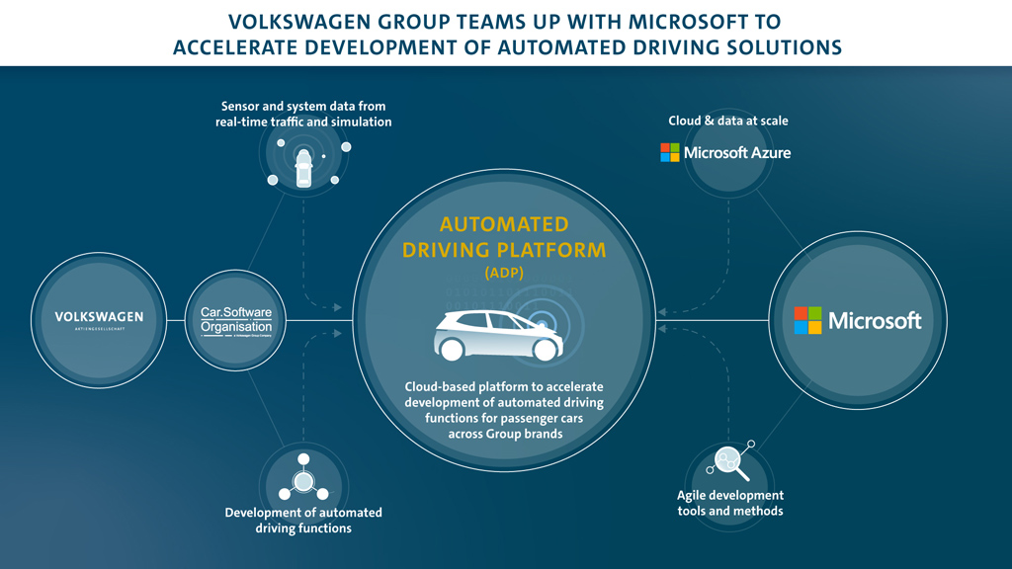

Strategic fields of action

- Leadership
- Process and efficiency improvement
- Learning
- value proposition
- Well-being and health and safety
- Communication
- Union relations
- Diversity, integrity, and respect
- Meritocracy
- digitization

- high specialization
Volkswagen is a company that offers technical courses in Mechatronics.
- financial education
Volkswagen also offers workers and their families the Financial Education Program, created in partnership with B3 (formerly BM&FBovespa) to guide participants on financial balance and the conscious use of money. The information is passed on in the form of lectures and workshops. In 2016, the program registered the participation of 135 workers.
- Interns and trainees
It is a company that opens doors to new talents, especially for professionals with new skills demanded by Volkswagen.

Inspired by people's lives
the strategy of this brand to keep its consumers closer and to bring a technology as an aid for your company, improving all stages of customer experience and relationship with the brand.
Volkswagen focuses on the current potential of its customers – which represents one of the pillars of the company's current strategy. The objective of the different areas of the company is to have customers always satisfied with the products and services offered, ensuring their loyalty and, consequently, the sustainable leadership of Volkswagen in the automotive market. The key message “Volkswagen Inspired by your life”, the transformation seeks to make Volkswagen a Brand even closer to its customers, capable of quickly and pioneering understanding of their desires, contributing to make their lives better. and adopted from the conception of a new product, from a structured process of listening to consumers, to the post-sales stage. One of the work focuses is to provide accurate and clear information at the different points of contact with the Brand, including face-to-face and virtual channels, generating even more relevance to the experiences with Volkswagen.
- bet on technology
In today's times, the digital age is increasingly present, the company sees technology as an important ally. Ensuring a more assertive contact with customers, thus increasing investments in so-called digital CRM (Customer Relationship Management) tools, which will allow the company to understand more deeply the aspirations of different consumer profiles and serve them. them better. We have as a clear example of how Volkswagen is using technology to strengthen the relationship with customers happened in 2016, when the company launched the Volkswagen Virtual Experience initiative, which started to offer a new experience to consumers through a 360-degree visit to your virtual showroom. This action guarantees even more visibility of the new technologies used in the product portfolio, expanding the interaction with the Brand and contributing to the customers' purchase decision process.

- Digital media
Language aims at transparency, Volkswagen offers relevant and updated content on its pages on Facebook, Instagram and on the exclusive YouTube channel. It also invests in continuously improving the experience of users on its offer’s website and, since the beginning of 2016, it has been working on the SAC 2.0 project, which offers differentiated service to customers and followers of the Brand on Twitter.

- Dealership network
Volkswagen is the company in the automotive sector with the largest distribution network. In addition to selling Volkswagen vehicles, authorized dealerships offer a wide range of services:
Detailed presentation of the Volkswagen portfolio.

Availability of vehicle manuals.
- Day and night reviews.
- On-call service on Saturdays.
- General repairs and maintenance.
- Installation of automotive parts and accessories
- Bodywork and painting services.
- Sales of parts and accessories.
- Original parts with quality assurance.

Quality models /theories
What is Deming quality model/theories?
The Deming cycle is a continuous quality improvement model which consists of a logical sequence of four key stages: Plan, Do, Study, and Act. In the 1920s, the prominent statistician Walter A.30 Jun 2020

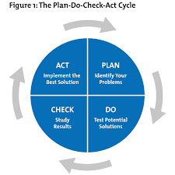

this theory has the concept of the emergence of 14 Deming points, which are listed here:
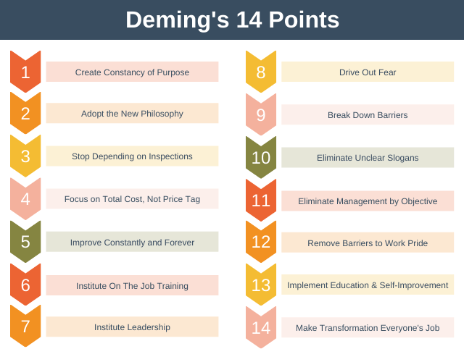

Joseph Moran’s Theory
This Romanian engineer and lawyer started his career as a consultant in Japan, where he received several merits due to his help in the country's development. He is a well-known author, having published eleven books on quality.

According to him, to achieve the highest quality in a company's products or services, it is necessary to work on five points:
- Specify the dangers of having a low quality.
- Adapt the product to its intended use
- Achieve previously defined quality standards
- Apply constant improvements

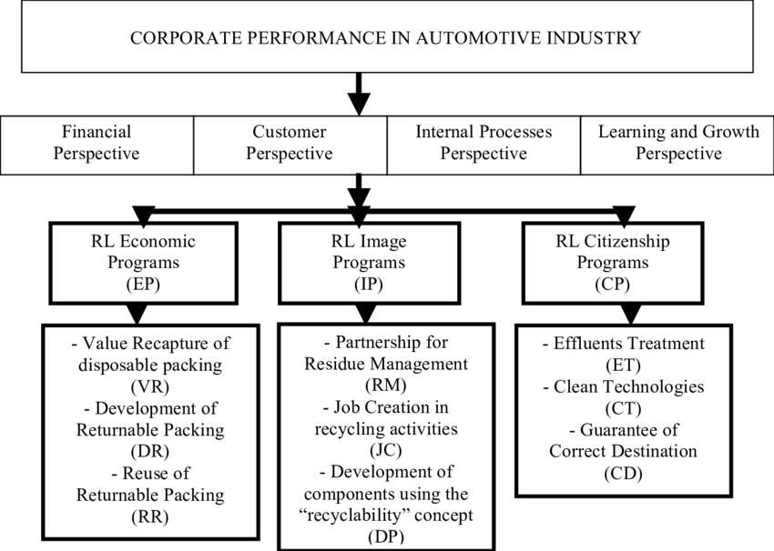
Having quality management software for the automotive industry offers quality advantages such as:
Improve product quality
Compliance with industry standards
Customer satisfaction and retention
Reduced time to market
Reduced General Expenses
Supplier Quality Management



Each company or industry must understand that we end up being all consumers and customers.
so that they have a guaranteed success, you must know your customers well so that they are not surprised by their lack of loyalty when looking for better service in other companies because not everything that is cheap is good and not everything that is expensive is worth it. What matters in the end is to have a good service and feel comfortable spending our money to buy the product, whether it is of good or less good quality.
having good feedback from your consumers is always an asset to any company.



- Bakhtieva, E., 2017. B2B digital marketing strategy: a framework for assessing digital touch points and increasing customer loyalty based on Austrian companies from heating, ventilation, and air conditioning industry. Oeconomia Copernicana, 8(3), pp.463-478.
- Haryono, E.B., 2010. Assessing the aligment between human resource strategy and business strategy implemented in PT Telkom (Doctoral dissertation, Universitas Gadjah Mada).
- Latham, J.R., 2014. Leadership for quality and innovation: Challenges, theories, and a framework for future research. Quality Management Journal, 21(1), pp.11-15.
- Išoraitė, M., 2009. Theoretical aspects of marketing strategy. Ekonomika ir vadyba: aktualijos ir perspektyvos: mokslo darbai, (1), pp.114-125.
- Kungl, G. and Hess, D.J., 2021. Sustainability transitions and strategic action fields: A literature review and discussion. Environmental Innovation and Societal Transitions, 38, pp.22-33.
- Tran, Q.X., Van Dang, M. and Tournois, N., 2020. The role of servicescape and social interaction toward customer service experience in coffee stores. The case of Vietnam. International Journal of Culture, Tourism and Hospitality Research, 14(4), pp.619-637.
- Roop, J.C., Payne, J.K. and Vallerand, A.H., 2011. Theories and conceptual models to guide quality of life research. Quality of life: from nursing and patient perspectives: theory, research, practice, pp.45-51.
- Peter, M.K., Kraft, C. and Lindeque, J., 2020. Strategic action fields of digital transformation: An exploration of the strategic action fields of Swiss SMEs and large enterprises. Journal of Strategy and Management
- Vlad, D.V., Pintea, F.R. and Gârbo, V.I., 2015. Analysis of Marketing Strategies Implemented of Advertising Environment:" Vitrina Advertising" Cluj-Napoca. Calitatea, 16(S2), p.193.
.

