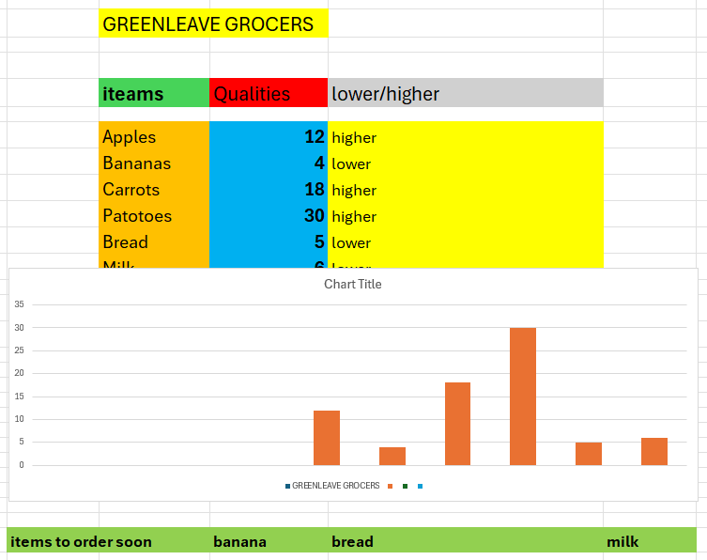
- 1) why you chose the scenario,
- I have selected the Greenleaf Grocers because I have understood well and its very simple and clear and is easy to explain the Digital skills.
- Therefore is clear show how spreadsheet can help tracking quantity and identify the low stock,items.
- 2) why you chose a particular tool,
- I used the 360 microsoft exel,because is its easy tools to organisation for data,calculation result.
- 3) how you developed and improved your work.
- I entery my grocers items and their quantities in the table and I added the table columan to shows weather items hinger and lower.
- After that I added small summary line at the bottom list itema to order soon.

