Network Security
To find and provide solutions to vulnerabilities discovered.

Author – William Thomas
Organization - UWTSD
City - Swansea

Abstract – This paper will explore different scanning techniques for any website. Each vulnerability found by these scanning techniques must be noted and reported to be patched by the company to stop malicious attackers from exploiting the vulnerability any further which can cause problems such as accessing private data or installing malicious code/software.

Introduction
This report will cover different scanning techniques to attempt to find vulnerable areas on the server hosting the website for example, the server could have an open port, but no authentication is required. Websites should always be updated and maintained to prevent an attacker from executing malicious code to gain access to areas where they should not have access too. The report will provide information on the vulnerabilities found, how they were detected such as what program was used and what problems could the vulnerability cause to the site.

Contingency Policy
A contingency policy must be in-place to ensure the pen-tester stays within the limits and not exceed them limit asked for. For this assignment TevelCyber has asked for vulnerability scanning, social-engineering and any other method without causing the companies website downtime or accessing any personal information such as phone numbers, financial information or any confidential information. Any harmful applications that could cause the company harm are banned.

Reconnaissance For TevelCyber
The chosen target for the assignment is TevelCyber.

Standard Information Gathering
- Domain URL - https://tevelcyber.com/
- Domain IP Address – 192.185.39.52 (Windows 10 command prompt used with ping command)
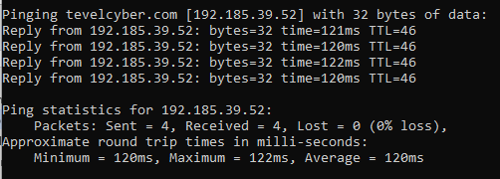
- Hostname – ns8202.hostgator.com [1]
- ISP – Websitewelcome.com [1]
- Country – United States [1]
- State/Region -Texas [1]
- Standard Information about a website must be gathered before any testing of the website’s security can begin. The information here shows where the server is located from the IP address found and what hostname has been used. We now know that tevelcyber uses HostGator. [1]

Advanced Information Gathering – RED HAWK
Program used – RED HAWK (Kali Linux) [2]
- Web Server – nginx/1.14.1 [2]
- CMS – WordPress [2]
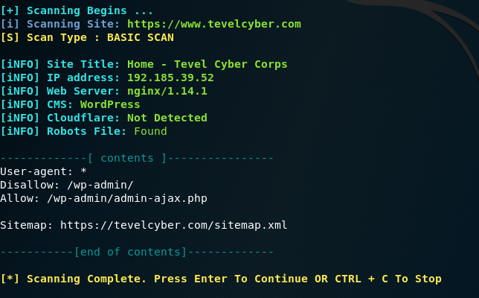

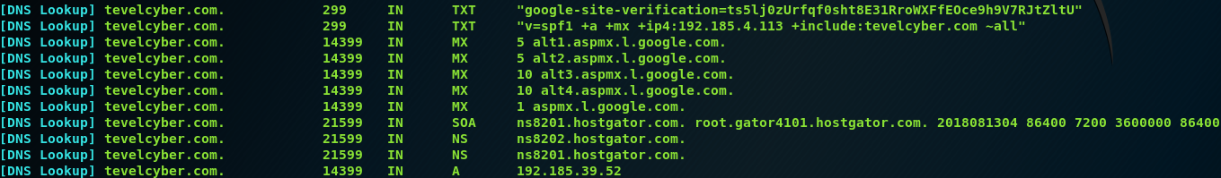
- DNS Information – [2]

- DNS information and webserver information can help when looking for vulnerabilities for the website such as WordPress must be updated regularly since a lot of websites use it and there are many exploits for it.

Advanced Information Gathering – MALTEGO
Program used – MALTEGO (Kali Linux) [3]
MALTEGO is an advanced information gathering tool, to use
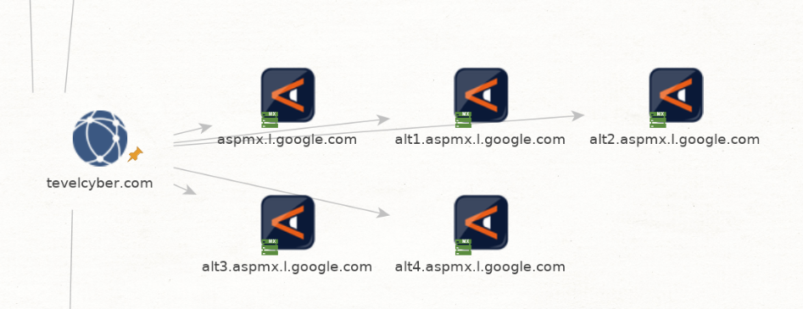

This screenshot shows the Domain Name which tevelcyber.com and DNS MX Info.

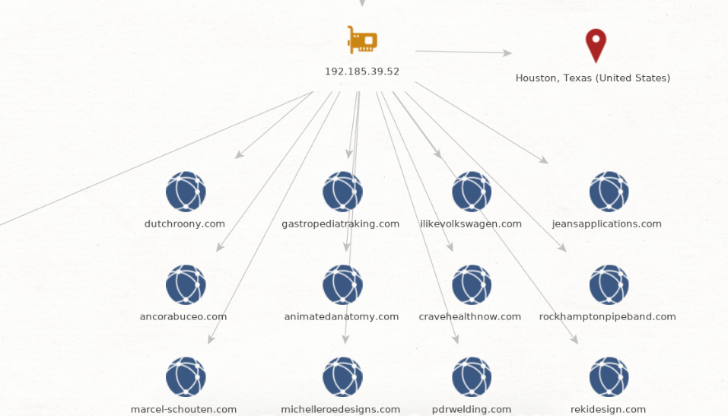
This screenshot shows a range of hosted websites from the same IP address as tevelcyber.com, this means that the tevelcyber website is also hosted with a bunch of other websites which is all sharing the same bandwidth.

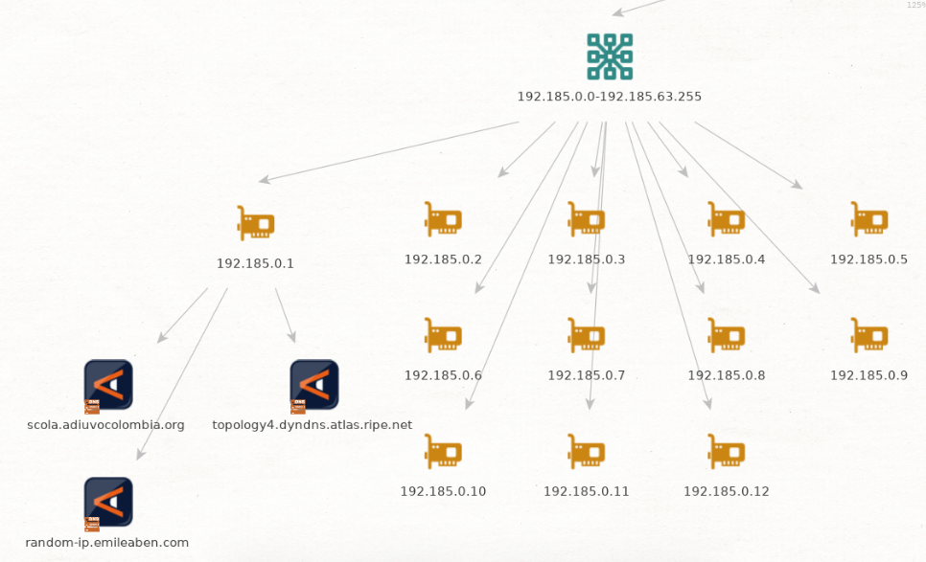

This screenshot shows the internal IP addresses for which tevelcyber.com is hosted, one of the severs has been expanded to show as an example, the internal server with the IPV4 address is hosting a site other than tevelcyber.com.

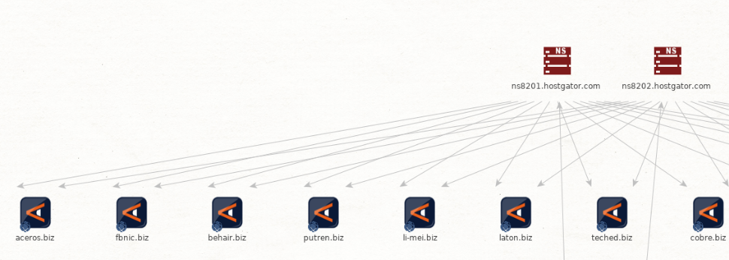
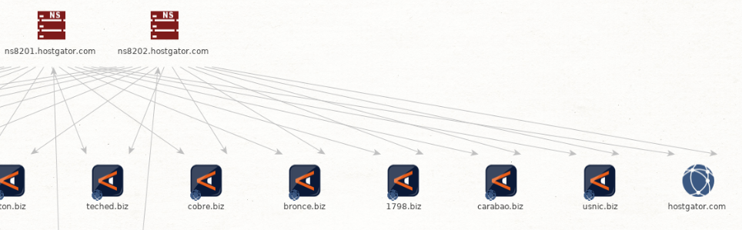
These screenshots show the DNS information in-which has been stored and can be resolved by the user. The servers store information of IP address and hostname’s and resolves them for the user. The screenshots show a list of hostnames that the DNS can resolve for the users.

Advanced Information Gathering – Port Scanning
Program used – NMAP (Kali Linux) [4]
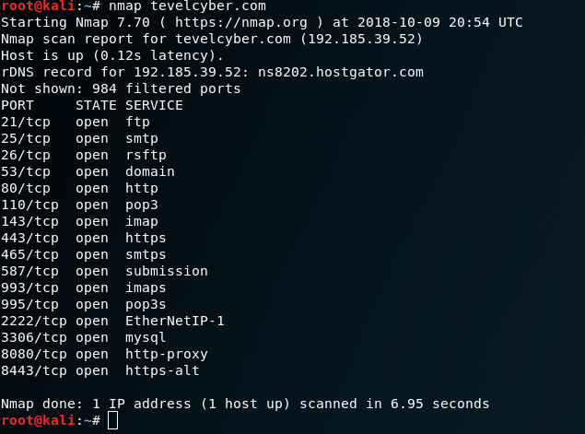
Tevelcyber.com was scanned using a program called NMAP on the Kali Linux operating system. NMAP has found 16 open ports for the IP address in-which tevelcyber.com is being hosted. Since tevelcyber.com is being hosted on the IP address as many other servers, it doesn’t necessary mean that tevelcyber.com is exposed as the other servers could have opened port 21 for ftp which could be for a file sharing site.

The common listed ports open are –
21 TCP – FTP
25 TCP – SMTP
53 TCP – DNS
80 TCP – HTTP
443 TCP - HTTPS
995 TCP – POP3 (For Email servers)

Scanning for ports and finding open ports doesn’t necessarily mean that they are vulnerable for example, if you try to connect to the FTP server using the FTP port, you might be prompted with a username and password. The FTP port might not be open on the internal server that you wanted to attack but it’s open on another internal server using the same public IP address.

Vulnerabilities

Vulnerability 1 – [12]
Program used – WPScan (Kali Linux) [5] [6]
- WPScan is a WordPress scanning tool pre-installed on to Kali Linux. WPScan found 4 vulnerabilities when scanning the selected target.
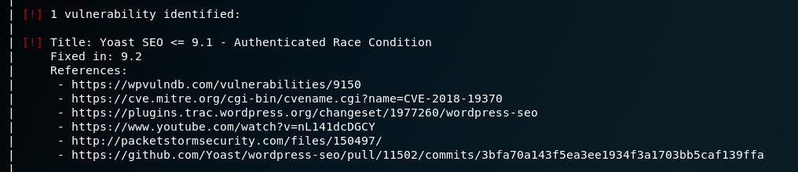
- This vulnerability comes from a plugin that the company has been installed onto the site. The identified vulnerability has been fixed in newer versions of the plugin which seems to tell us that the company doesn’t allow automatic updates on their plugins.
- This vulnerability allows command execution to take place so in theory an attacker could attempt to attack the plugin and make it execute commands.

Vulnerability 2 –
Program used – WPScan (Kali Linux)
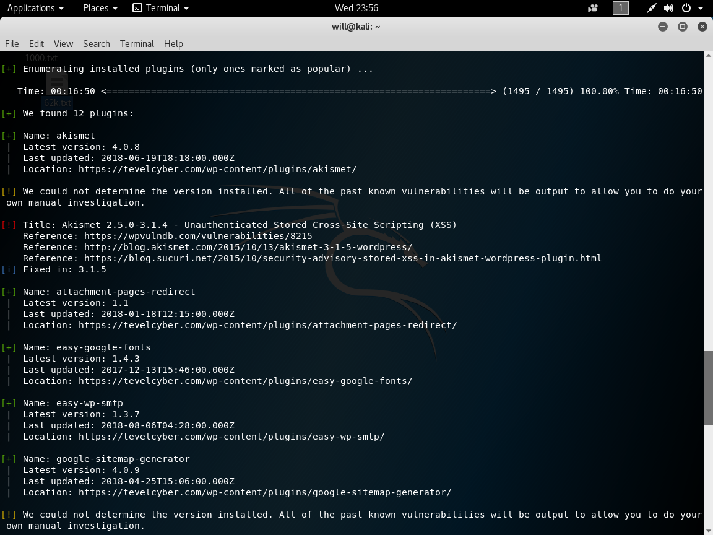
- This vulnerability is from a plugin which the company added onto their website, for extra features. The plugin has a vulnerability which allows unauthenticated commands to be stored into a database and allow a user to gain more permission or attempt to modify or remove a webpage which is known as stored cross-site scripting (XSS).
- Cross-Site Scripting is a major problem for website as it allows entries to be added, modified or even removed from the website database.

Vulnerability 3 –
Program used – WPScan (Kali Linux)
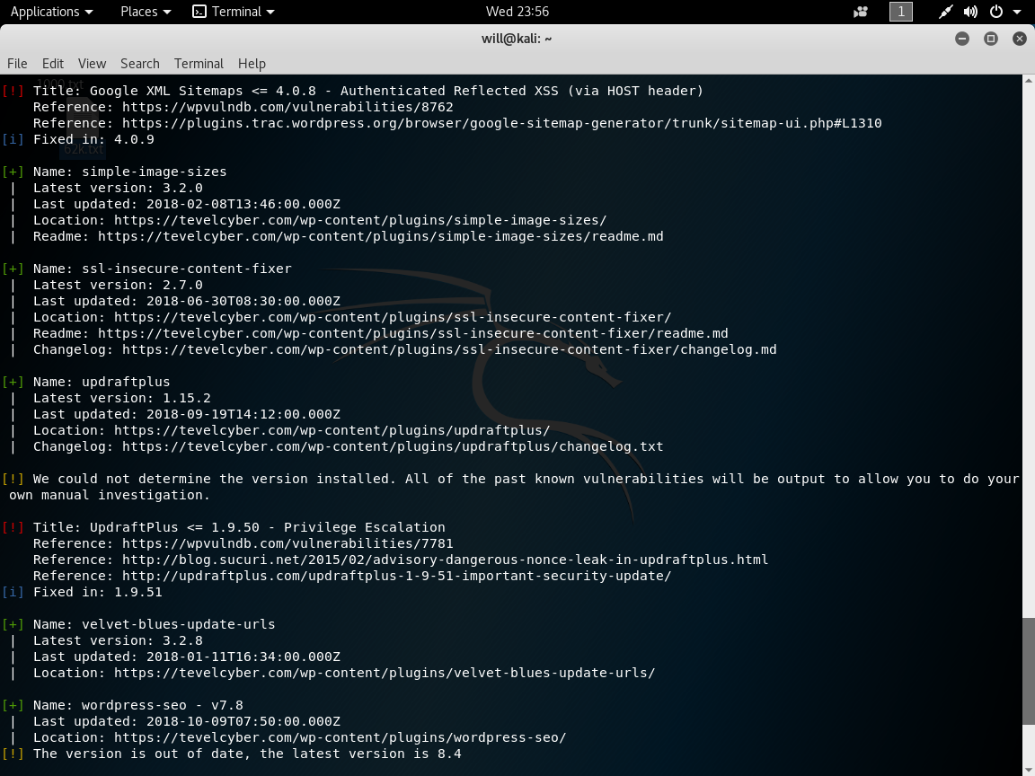
- This vulnerability allows cross-site scripting via the HOST header of the website
- Cross-Site Scripting is a major problem for website as it allows entries to be added, modified or even removed from the website database.

Vulnerability 4 –
Program used – WPScan (Kali Linux)
- This vulnerability comes from a plugin which the site owner has added to gain more features on the site, but it came with a vulnerability which has exposed the website to open threats.
- Privilege Escalation allows the attack to gain more privileges on the site to access areas in-which they shouldn’t have access to.

Vulnerability 5 –
Research Found [7]
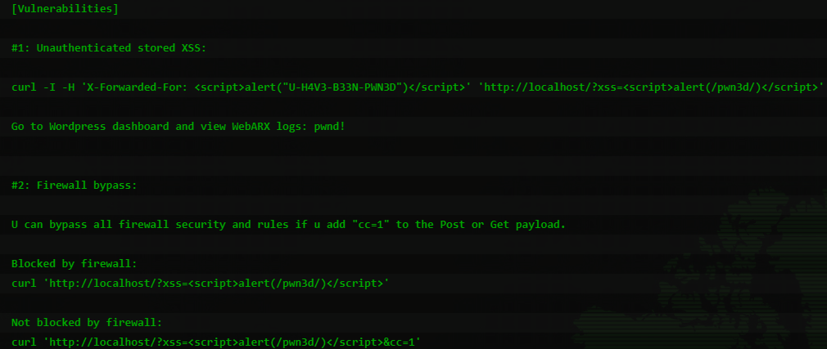
- From earlier testing and information gathering, the target is currently using WordPress version 4.9.8.
- WordPress version 4.9.8 has a known vulnerability where a user can store information or run scripts for malicious activity to gain more permissions etc. This vulnerability also is a firewall bypass which means that not even the firewall can protect it against the attacks. This is a dangerous attack and can allow a user to remove internal server files or add new ones like re-directing traffic and capturing login information.

Vulnerability 6 –
Online WordPress security scanning [8]
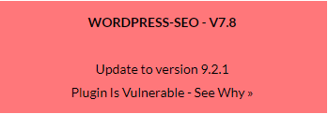
- WordPress-SEO is a WordPress plugin which has a known vulnerability which can allow an attacker to execute commands remotely which can be dangerous since the commands can be used to add new files or even remove files from the site directory. It’s currently on version V7.8 which is a very old version since the currently version is 9.2.1 which adds a lot more features and fixes many security problems.

Analysis of vulnerabilities –
Six vulnerabilities have been listed and five of them are WordPress plugins which have been installed by the company and not pre-installed with WordPress. These plugins should always be updated, and the owner should allow automatic updates for all plugins since adding so many plugins to a WordPress server allows more exploitation to take place and allow the attacker to find a vulnerable spot. On the other hand, one of the vulnerabilities listed was a WordPress vulnerably which means that the whole site is exposed to attacks even without the additional plugins. The attack allows XSS attacks which bypass the firewall. The WordPress site itself has a vulnerability.

Solutions
These vulnerabilities are all software related and not hardware related. The company should turn on automatic updates or at least check for new updates regularly for bug fixes and even exploitation fixes. The updates should be for everything including the WordPress site itself and all its custom plugins installed. The company could remove a lot of its custom plugins to make the site less vulnerable in the future.

Re-tested one month later
This section involves further reconnaissance testing. This means that an attacker can learn more about how the company operates by testing it again over a certain period to see if the company have adapted and patched the found vulnerabilities or if the company is still vulnerably and or if new vulnerabilities can be found. The testing will remain the same expect for some further additional testing which will determine if the WordPress site has been setup correctly. [10]

Vulnerability 1 –
Online WordPress security scanning [9]
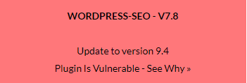
- WordPress-SEO is a WordPress plugin which has a known vulnerability which can allow an attacker to execute commands remotely which can be dangerous since the commands can be used to add new files or even remove files from the site directory. It’s currently on version V7.8 which is a very old version since the currently version is 9.4 which adds a lot more features and fixes many security problems.
- Compared to the older vulnerably scanning which happened just over a month ago, the plugin is still running version v7.8 has still hasn’t been updated but the new version has increased from v9.2.1 to v9.4.

Vulnerability 2 –
Online WordPress security scanning [11]
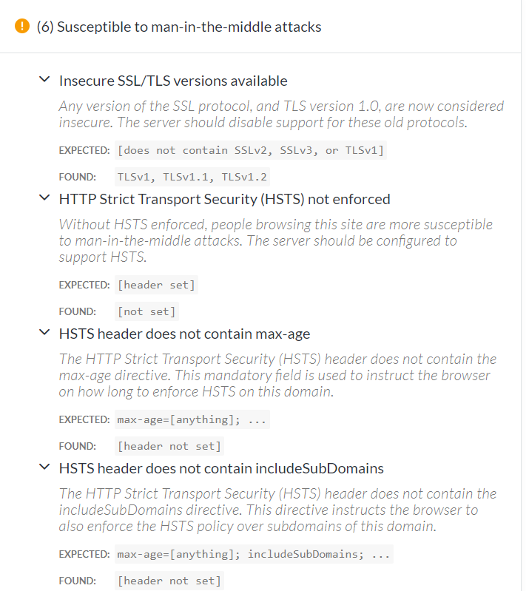
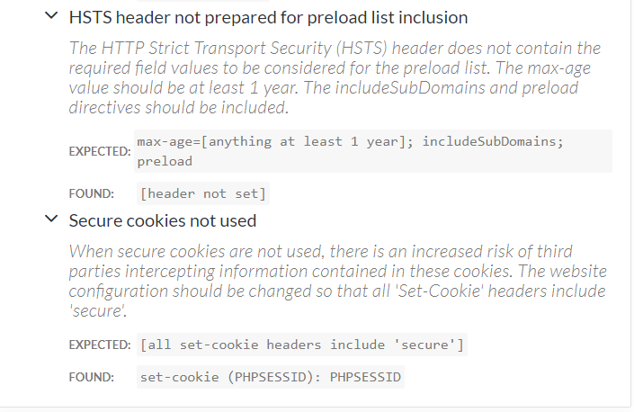
This test is for man-in-the-middle attacks in-which an attacker can use to retrieve a user’s information on the site such as viewing their internet traffic to the site whether it’s unencrypted or encrypted. TLSv1 is used on the site which is considered insecure and still vulnerable. TLS should be upgraded to TLSv3 for better protection. HSTS is not used which is a web security policy that protects websites against protocol downgrade attacks and cookie hijacking.

Vulnerability 3 –
Online WordPress security scanning [11]
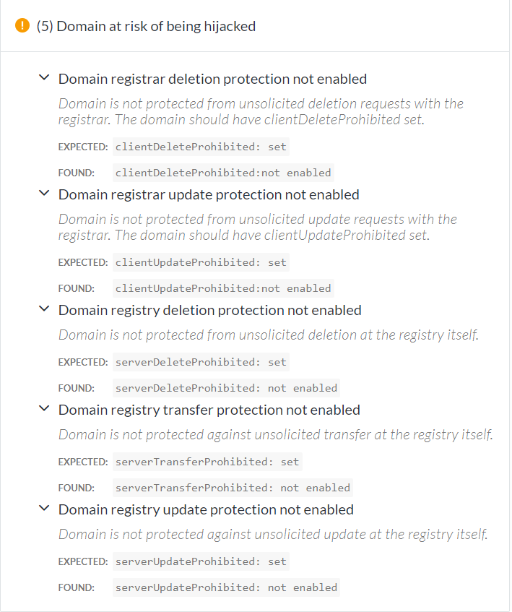
This test shows that the website is at risk of being hijacking via a series of methods such as not configuring the necessary protection. The domain registry is the company that is hosting the site. Protection hasn’t been setup so if the domain registrar was hijacking the website could be deleted, updated, or transferred. If the protection was added, then the company would contact the client which is tevelcyber and ask them to modify or remove content if it breaks terms of services etc.

Vulnerability 4 –
Online WordPress security scanning [11]
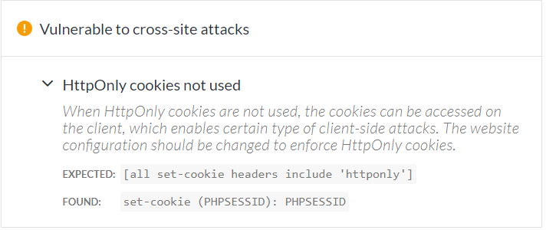
Clients can access the cookies from the session when viewing the website from their machine and if they are logged into the website the cookies can be compressed and used since the proper cookie protection hasn’t been setup using the httponly flag which doesn’t allow the user to view or modify the cookies.

Vulnerability 5 –
Online WordPress security scanning [11]
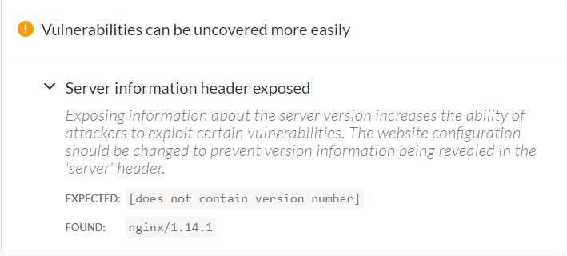
This test shows that the server information is public during vulnerability scanning or even basic scanning. The server information was also found during the basic scanning level. Since the server information is public which is nginx/1.14.1 the attacker and research vulnerabilities for that version and attempt to exploit it. There is protection from leaking the server version information by removing it from the website header. Researching vulnerabilities for this version there are none but once some arise attackers can use them against this server if not updated or alternated protection is taken.

Vulnerability 6 –
Online WordPress security scanning [11]
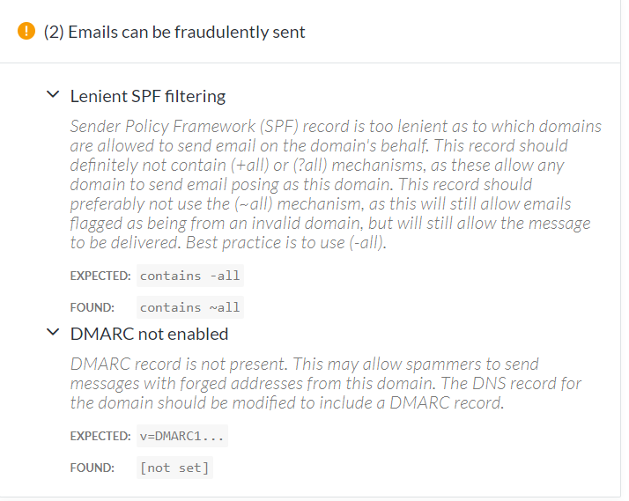
This test shows if the correct and most secure settings have been setup for the email server in-which the company has setup. The results show that spam can be sent to users within the company but appear as spam email, but if the company changed the setting to a high security level then the email would automatically be deleted and not flagged. This is great for when companies are receiving a large spam of emails.

Vulnerability 7 –
Online WordPress security scanning [11]
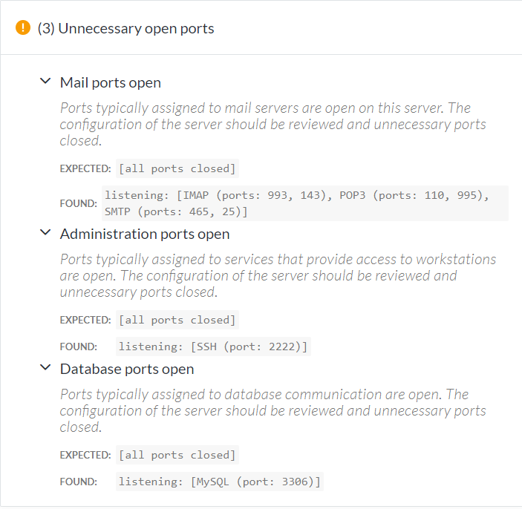
This test shows open ports on the server in-which was covered earlier, the company should close unused ports or add security to prevent exploiting such as username and passwords with firewall and anti-brute-force protection.

Vulnerability 8 –
Online WordPress security scanning [11]
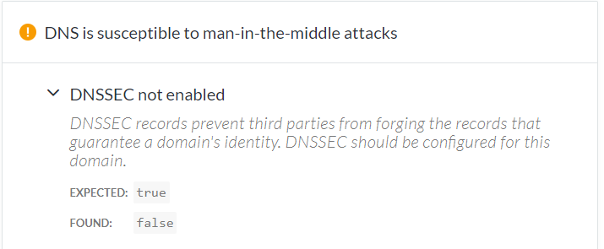
This test shows the DNSSEC result in-which should be setup by the domain user. This will prevent the DNS records being tampered with and provide a false identity to other users. The current setting for DNSSEC is false but it should be changed to true.

Analysis of vulnerabilities –
To summarize this section, WPScan in-which was done first time around to discover four plugins available for exploitation have been updated and the latest updates have no known vulnerabilities. The second scan was an online scan which displayed the same outcome as last time which was the WordPress-SEO vulnerability which exposes the website to exploitation should have been patched during the patching of the plugins. Further scans were done from last time which provided information about the current set-up of the server. There are many things the company should change in the set-up of the server to prevent man-in-the-middle attacks such as upgrading the TLS version etc. From the testing it seems WordPress was updated from 4.9.8 to 4.9.9 but during both of those scans version 5.0 was released and several more but not used. This means that the current WordPress version was updated to an outdated version for reasons unknown.

Solutions
The only solutions that can be given for these sorts of vulnerabilities for to update all plugins in-which was not done and to check all configuration of the server or even update the configuration from the current configuration.

More Information

FireWall Information –
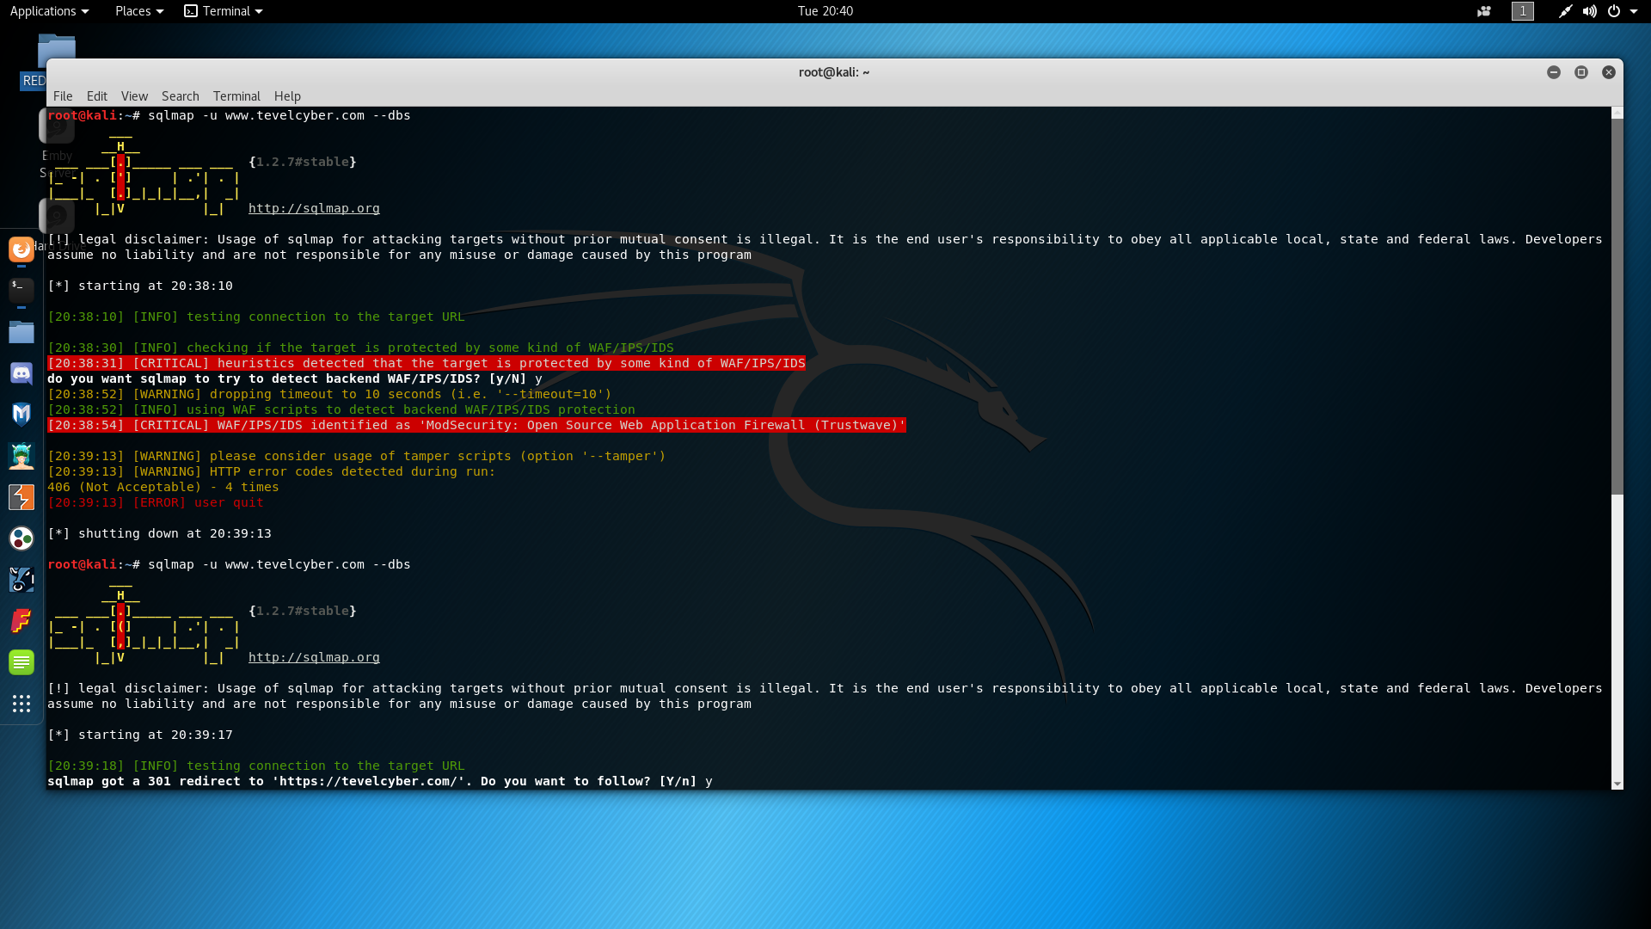
TevelCyber is using a free firewall called Mod Security. Mod Security is an open-source firewall and can be setup to run on Linux and Microsoft operations systems. Mod-Security prevented many scanning techniques but not all.

Kali Linux –
Kali Linux is a network penetration operating system with many pre-installed tools. Some tools which were pre-installed where used to gather the necessary information, but Kali Linux runs off the Linux OS which allows Linux based programs to be executed. Since some of the software weren’t pre-installed on Kali Linux then Terminal was used to download GitHub repository’s for additional software.

Software Used –
- RED HAWK – Kali Linux application which was installed from GitHub via Terminal. RED HAWK uses a series of scanning techniques which gather basic information about a website such as port scanning, location of the server and IP address of the server. [2]
- MALTEGO – Kali Linux application which was installed from GitHub via Terminal. MALTEGO allows the creation of diagrams to show how the website is set-up, this means that by entering the URL of a site, MALTEGO will retrieve information and place it into a flow chart for example – [3]

- WPScan – WPScan also known as WordPress Scan is pre-installed on Kali Linux. It’s designed to scan and find vulnerabilities against WordPress sites. It shows IP information, WordPress theme information, WordPress plugin information and much more. [5]

Attacking
In this section, this is all theory-based and has not been conducted.

Attack 1 (Before the second scans) –
Exploit the plugins which are currently vulnerable on the site, which were Yoast-SEO, Akismet, Google XML Sitemaps and UpdraftPlus. Some of these plugins had XSS vulnerably which was a cross-site scripting vulnerability that allowed any user to store information to a database or remove information to a database which, they could increase their permissions or even create a new user account with admin privileges. [13]

Attack 2(Before the second scans) –
Exploiting the open ports using a brute-force attack. Currently the port is open for an FTP server, which an attacker could brute-force or just using a standard dictionary attack. Once the attacker gains access to the FTP server the attacker and retrieve company files if the user-account that has been brute-force has high enough permissions. This attack would require a lot of patience as a brute-force would take a lot of time to run through each sort of combination until the correct one has been entered.

Attack 3 –
Exploiting using man-in-the-middle attacks against users on the website since HSTS is not enabled and TLS v1 is used and is considered insecure which should be updated to TLS v3.

Conclusion
In conclusion of this report, there were many vulnerabilities found during both time frames of each scans, first scans showed the plugins were the most vulnerable part of the website but since then they have been updated so additional scanning must have been taken to find other vulnerabilities on the website. Currently the most vulnerable areas of the website are the standard configuration which uses TLS 1.0 instead of TLS 3.0, httponly for protection of cookie tampering and more. It seems that TevelCyber did notice that they needed to update their plugins, but they didn’t update all of them which is still a problem as the one that was not updated has a vulnerability. When using certain scanning techniques, Mod Security which is the companies Firewall detected and prevented them which is great. When it comes to the attacking aspect there are some vulnerabilities which still make it possible for exploitation to happen. This can be fixed by recommending turning on auto-updates for all plugins and WordPress related features.

References
- WhatsMyIPAddress
https://whatismyipaddress.com/ip/192.185.39.52
Time Accessed – 08:10 07/12/2018
- REDHAWK (Kali Linux Application)
https://github.com/Tuhinshubhra/RED_HAWK
Time Accessed – 03:20 24/01/2019
- MALTEGO (Kali Linux Application)
https://www.paterva.com/web7/
Time Accessed – 03:42 24/01/2019
- NMAP (Kali Linux Application)
https://nmap.org/
Time Accessed – 03:50 24/01/2019
- WPScan (Kali Linux Application)
https://github.com/wpscanteam/wpscan
Time Accessed – 04:09 24/01/2019
- T. Koskinen, P. Ihantola and V. Karavirta, "Quality of WordPress Plug-Ins: An Overview of Security and User Ratings," 2012 International Conference on Privacy, Security, Risk and Trust and 2012 International Confernece on Social Computing, Amsterdam, 2012,pp. 834-837. doi: 10.1109/SocialCom-PASSAT.2012.31
https://ieeexplore-ieee-org.ezproxy.uwtsd.ac.uk/document/6406333
Time Accessed – 04:25 24/01/2019
- CxSecurity
https://cxsecurity.com/issue/WLB-2018090286
Time Accessed – 04:25 24/01/2019
- WPScan (Online Web-Site)
https://wpscans.com/scan/?id=ffcad5ad8ba8b5ce88e3e3afd3a45c1b
Time Accessed – 04:25 09/12/2018
- WPScan (Online Web-Site)
https://wpscans.com/scan/?id=fc99825ab51f4d5f73967b173c790e36
Time Accessed – 22:34 24/02/2019
- N. I. Daud, K. A. A. Bakar and M. S. M. Hasan, "A case study on web application vulnerability scanning tools," 2014 Science and Information Conference, London, 2014, pp. 595-600.
doi: 10.1109/SAI.2014.6918247
https://ieeexplore-ieee-org.ezproxy.uwtsd.ac.uk/document/6918247
Time Accessed – 22:34 24/02/2019
- Upguard
https://app.upguard.com/webscan#/https://tevelcyber.com/
Time Accessed – 23:00 24/02/2019
- Y. Wang and J. Yang, "Ethical Hacking and Network Defense: Choose Your Best Network Vulnerability Scanning Tool," 2017 31st International Conference on Advanced Information Networking and Applications Workshops (WAINA), Taipei, 2017, pp.110-113.doi: 10.1109/WAINA.2017.39
https://ieeexplore-ieee-org.ezproxy.uwtsd.ac.uk/document/7929663
Time Accessed – 23:20 24/02/2019
- J. Fonseca, M. Vieira and H. Madeira, "Testing and Comparing Web Vulnerability Scanning Tools for SQL Injection and XSS Attacks," 13th Pacific Rim International Symposium on Dependable Computing (PRDC 2007), Melbourne, Qld., 2007, pp. 365-372.
doi: 10.1109/PRDC.2007.55
https://ieeexplore-ieee-org.ezproxy.uwtsd.ac.uk/document/4459684
Time Accessed – 23:58 24/02/2019

marking criteria and Student FEEDBACK

This section details the assessment criteria. The extent to which these are demonstrated by you determines your mark. The marks available for each criterion are shown. Lecturers will use the space provided to comment on the achievement of the task(s), including those areas in which you have performed well and areas that would benefit from development/improvement.

Common Assessment Criteria Applied (Assignment 1) | Marks available | Marks  awarded
1. Research-informed Literature
Extent of research and/or own reading, selection of credible sources, application of appropriate referencing conventions.
References to a limited range of sources. Your work could be improved by including more peer reviewd/academic journal articles The research informed literature could include more cited related work and other relevant background information. (Grade mark: 50.00%) | 10 | 5
2. Knowledge and Understanding of Subject
Extent of knowledge and understanding of concepts and underlying principles associated with the discipline.
Evidence of understanding of the main theories and concept. However, your report does not demonstrate knowledge of related work/literature review of findings that other researchers in the field have done. (Grade mark: 55.00%) | 10 | 5.5
3. Analysis
Analysis, evaluation and synthesis; logic, argument and judgement; analytical reflection; organisation of ideas and evidence
Your analysis is very focused to the given scenario, well documented but discussion could be elaborated more upon with cross referenced to relevant literature review related work. In other words it is lacking critical analysis. You could provide a basic cost solution. Some areas could be improved upon. The introduction need to begin with the most general information, like background and/or definitions and end with the most specific information: a guide to the scope and structure of your report (What coming next in each section). Conclusion could be better written with clear outline of recommendation for the future; Your abstract need improvement also. (Grade mark: 65.71%) | 35 | 23
4. Practical Application and Deployment
Deployment of methods, materials, tools and techniques; application of concepts; formulation of innovative and creative solutions to solve problems.
A number of tests were carried out. Results of the actual test was provided and explained; nature of how it was done, application used and protocol involved was discussed. (Grade mark: 71.43%) | 35 | 25
5. Skills for Professional Practice
Attributes in professional practice: individual and collaborative working; deployment of appropriate media; presentation and organisation.
You can communicate in a suitable manner with room for improvement. Writing style can be improved. Your report need formatting. (Grade mark: 55.00%) | 10 | 5.5

Assignment Mark (Assessment marks are subject to ratification at the Exam Board. These comments and marks are to give feedback on module work and are for guidance only until they are confirmed. ) | Late Submission Penalties (tick if appropriate) |  | 64%
 | Up to four weeks late |  | 64%
 | First Attempt? |  | 64%

