

The Impact of Sustainable Packaging on Consumer Purchase Decisions in the UK Retail Sector
Name: Bhavdip Maheshkumar Gudechiya (2506737)

Dissertation (BMMB7003)

Academic year 2025-26

Course: master’s in business administration (MBA)

Abstract
There has been an increasing focus on sustainable packaging in the retail sector in the UK, but to date the evidence has been limited, mainly international and very often qualitative, about the impact of sustainable packaging on actual purchases. This research aims to fill this gap, investigating the role of four factors (depicting the components of sustainable package design: sustainable packaging features, environmental awareness, regulatory frameworks and circular economy practices) on consumers' purchase decision in retail sector in UK based on Theory of Planned Behaviour and Theory of Circular Economy.
Using a positivist, deductive, quantitative methodology, primary data was gathered from a structured questionnaire with 5-point Likert scale used to collect the data, and 200 valid UK consumer responses were obtained. The data was analysed by reliability test, correlation, multiple regression and cross tabulation in SPSS program to test four hypotheses (H1-H4).
The regression model predicts 70.5% of the variance in the purchase decisions (R² = 0.705 and p < 0.001). The items of sustainable packaging (β = 0.400), energy concerns (β = 0.379) and circular economy activities (β = 0.163) were positive and significant other supportive factors to support H1, H2, and H4. When controlling for the other variables regulatory frameworks were not significant (β = −0.049, p = 0.461), implying that the indirect impact of purchase decisions is not significant. H3 was not supported.
The study results provide UK-specific evidence of all four dimensions connected in one tested model, identifies the indirect impact of regulation, and offers evidence-based suggestions for the UK retailer to enhance sustainable packaging strategy.

Declaration
DECLARATION

This work has not previously been accepted in substance for any degree and is not being concurrently submitted in candidature for any degree.

Signed  Bhavdip Maheshkumar Gudechiya

Date 24/09/2026

STATEMENT 1

This work is the result of my own investigations, except where otherwise stated.

Other sources are acknowledged by footnotes giving explicit references. A bibliography is appended.

Signed Bhavdip Maheshkumar Gudechiya

Date 24/09/2026

STATEMENT 2

I hereby give consent for my work, if accepted, to be available for photocopying and for inter-library loan, and for the title and summary to be made available to outside organisations.

Signed Bhavdip Maheshkumar Gudechiya

Date 24/09/2026

.

Contents
Abstract 2
Declaration 3
Acknowledgement 10
Chapter 1: Introduction 11
1.1 Introduction to Sustainable Packaging 11
1.2 Background of the Study 12
1.3 Research Problem 13
1.4 Research Gap 14
1.5 Research Rationale 14
1.6 Research Aim 16
1.7 Research Objectives 16
1.8 Research Question 16
1.9 Dissertation Structure 16
Chapter 2: Literature Review 18
2.1 Introduction 18
2.2 Conceptualising Sustainable Packaging 18
2.3 Sustainable Packaging Features 19
2.4 Packaging Materials, Design and Consumer Perception 21
2.5 Consumer Purchase Decisions and Green Consumption 22
2.6 Theory of Planned Behaviour 23
2.7 Environmental Awareness 25
2.8 Regulatory Frameworks 26
2.9 Circular Economy Theory and Practices 27
2.10 Cross-Cultural and Sectoral Perspectives 28
2.11 Relationships Between Variables and Hypotheses Development 28
2.12 Conceptual Framework 29
2.13 Chapter Summary 31
Chapter 3: Research Methodology 32
3.1 Introduction 32
3.2 Research Philosophy 32
3.3 Research Approach 33
3.4 Research Design 33
3.5 Data Collection Method 34
3.6 Sampling 34
3.7 Questionnaire Design 35
3.8 Variables and Measurement 36
3.9 Data Analysis Techniques 36
3.10 Validity and Reliability 37
3.11 Ethical Considerations 37
3.12 Limitations of the Methodology 38
Chapter 4: Findings and Data Analysis 39
4.1 Introduction 39
4.2 Response Rate and Sample Profile 39
4.3 Demographic Analysis 39
4.4 Reliability Analysis 41
4.5 Descriptive Statistics 43
4.6 Correlation Analysis 44
4.7 Regression Analysis 45
4.8 Hypothesis Testing Results 47
4.9 Cross-Tabulation and Demographic Analysis 48
4.9.1 Gender and Purchase Frequency 48
4.9.2 Age Group and Environmental Awareness 50
4.9.3 Purchase Frequency and Consumer Purchase Decisions 51
4.9.4 Gender and Sustainable Packaging Features 52
4.10 Summary of Key Findings 52
Chapter 5: Discussion 54
5.1 Introduction 54
5.2 Discussion of H1: Sustainable Packaging Features → Consumer Purchase Decisions 54
5.3 Discussion of H2: Environmental Awareness → Consumer Purchase Decisions 55
5.4 Discussion of H3: Regulatory Frameworks → Consumer Purchase Decisions 56
5.5 Discussion of H4: Circular Economy Practices → Consumer Purchase Decisions 57
5.6 Discussion in Relation to the Theory of Planned Behaviour 58
5.7 Comparison with Research Objectives 59
Chapter 6: Conclusion and Recommendations 61
6.1 Introduction 61
6.2 Summary of Key Findings 61
6.3 Achievement of Research Objectives 61
Objective 1: To analyse sustainable packaging in the UK retail sector 62
Objective 2: To examine the impact of sustainable packaging attributes on consumers' buying decisions 62
Objective 3: To ascertain the impact of environmental awareness on consumers' buying decisions 62
Objective 4: To assess the effect of sustainability-related dimensions on consumers' sustainable packaging attitudes 63
Objective 5: To deliver recommendations on how to enhance sustainable packaging in UK retail 63
6.4 Contribution to New Knowledge 63
6.5 Theoretical Implications 64
6.6 Practical and Managerial Implications 64
6.7 Limitations of the Study 65
6.8 Recommendations for Future Research 65
6.9 Concluding Remarks 66
References 67
Appendix A: Questionnaire 94
Participant Information Sheet 160
Research Title 160
Invitation to Participate 160
Purpose of the Study 160
Why Have I Been Invited? 160
What Will Participation Involve? 160
Voluntary Participation 161
Risks and Benefits 161
Confidentiality and Anonymity 161
Data Protection 161
What Will Happen to the Results? 161
Contact for Further Information 162
List of Table
Table 1 Operationalisation of Study Variables. 36
Table 2 Demographic Profile of Respondents (N=200) 40
Table 3 Reliability Statistics by Construct. 42
Table 4 Descriptive Statistics for Study Constructs (N=200). 43
Table 5 Pearson Correlations between Independent Variables and CPD. 44
Table 6 Regression Model Summary 46
Table 7 Regression Coefficients 46
Table 8 Summary of Hypothesis Testing 48
Table 9 Cross-Tabulation of Gender by Purchase Frequency 49
Table 10 Mean Environmental Awareness Score by Age Group 50
Table 11 Mean Consumer Purchase Decision Score by Purchase Frequency 51
List of Figures
Figure 1: Conceptual Framework. 30
Figure 2: The Research Onion Model. 32
Figure 3 Gender Distribution of Respondent’s (N=200) 41
Figure 4 Age Distribution of respondents (N=200) 41
Figure 5 Mean Scores by Construct 43
Figure 6 Correlation of Independent Variables with Consumer Purchases Decisions (CPD) 45
Figure 7 Standardised Regression coefficients (Beta) predicting Consumer Purchase Decisions 47
Figure 8 Purchase frequency by Gender 49
Figure 9 Mean Environmental Awareness by Age Group 50
Figure 10 Mean Consumer Purchase Decision Score by Purchase Frequency 51

Acknowledgement
I would like to thank all those who helped me along in the process of this dissertation. I would like to express my sincere gratitude to my supervisor for his valuable guidance, patience and constructive criticism at each stage of this research ranging from the initiation of the proposal to the analysis and compilation of the same. They provided understanding and support on the direction and the quality of this study.
In addition, I am grateful to the academic staff members of University Name for the resources and encouragement that enabled me to conduct this research project and the 200 UK consumers that took the time to fill out this questionnaire, which underlies this research work.
My family and friends' consistent encouragement and patience throughout this project is as much my sincere thanks as is my thanks to my peers for discussing it along the way, as well as the difficult times of data collection and analysis. This dissertation could not have been accomplished without the support of all of those above.

Chapter 1: Introduction

1.1 Introduction to Sustainable Packaging
Environmental sustainability is one of the greatest challenges for the business, governments and societies of the 21st century. As climate change and resource scarcity have become greater issues, biodiversity loss and environmental pollution, there has been a greater pressure on organisations to do more to enhance their sustainability. Packaging waste recycling is one of these environmental issues due to the quality of the waste disposed in landfills, the marine pollution and the greenhouse gas emissions. With the increasing use of single-use plastic, the environmental impact of packaging material has become more well known in the retail sector, where a large quantity of products is packaged and sold every day (Boz, Korhonen and Koelsch Sand, 2020).
Packaging is a key industry in the protection, transportation and conveying information about the product to consumers. But many traditional packaging solutions are made of non-renewable materials and create a significant amount of waste during the product's lifespan. As people become more environmentally conscious, businesses need to adopt alternative packaging methods and encourage people to go greener. Generally speaking, sustainable packaging involves packaging materials that are recyclable, reusable, biodegradable, or compostable, while minimizing impact on the environment, and that maintain functionality and product safety. (Jain and Hudnurkar, 2022)
Consumers' attitudes towards sustainability have also evolved drastically. Today, consumers are increasingly holding businesses accountable for their “green footprint” and being more aware of business's responsibility towards the environment. Sustainable consumption is reflected in the tendency for constant demand for environmentally conscious products and for sustainable resource consumption. Therefore, sustainable packaging has become a key strategic aspect to enhance the brand reputation, customer interaction, and meet sustainability expectations (Genoveva, 2020).
In the UK, a large focus has been placed on sustainability as a policy goal and steps are taken to reduce waste and increase the application of circular economy. Now, however, retailers are under pressure from regulators, investors, environmental and consumer groups to improve the sustainability of its package and reduce plastic waste. Hence today, sustainable packaging is no longer a simple environmental practice but an integral business strategy that can significantly affect consumers' perceptions and purchasing behaviour (Afif, Rebolledo and Roy, 2022).

1.2 Background of the Study
One of the biggest and most important industries in the UK economy is the retail sector. Packaging plays a vital role in the retail business, not only to ensure product protection but also to preserve product quality, facilitate logistics operations and to convey marketing messages. But growing environmental concerns of packing waste has created serious problems for retailers. With the growing adoption and use of plastic packaging, there have been growing calls for more sustainable packaging options in retail food supply chains (Morashti, An and Jang, 2022).
To support efforts to overcome these challenges, attention has turned to sustainable packaging and business companies, and policy makers have invested in the topic. Sustainable packaging programmes are used to minimise environmental impacts by using better packaging materials, minimising waste, enabling recycling of packaging materials and packaging reuse systems. As pointed out by Wandosell et al. (2021), sustainable packaging is becoming an important part of the greater sustainability plans due to its dual function of tackling sustainability issues and meeting the evolving market demands.
Also, there is a remarkable rise in consumer awareness towards the environment over the past few years. Increased awareness on environmental issues, such as climate change, plastic waste and waste management has led consumers to be more mindful of their environmental characteristics of products and packaging. As per Norton et. al (2022), consumers in the UK are more likely to recognize green packaging as a signal of brand environmental responsibility and a positive brand image. In addition, Norton et al. (2023) found that knowledge of packaging sustainability is still a factor in attitudes towards sustainability and purchase intent.
To meet this need, retailers are required to ensure they are environmentally responsible with measurable steps such as sustainable packaging. Retailers should strive for model actions in relation to sustainable packaging as they are a good example of their commitment to respect the environment. Addressing sustainability issues otherwise can lead to damage in reputation and loss of the stakeholders' confidence.
This growth is compounded by the growth of the Circular Economy, which has created a demand for promoting sustainable packaging. Circular economies promote waste minimisation, re-use and recycle to increase resource efficiency, minimize environmental impacts and foster better sustainability results. Sustainable packaging is frequently considered as one of the most important tools to promote the goals of the circular economy as an approach to packaging design directly reflects the possibilities for material recovery and recycling (Asim et al., 2022). For this reason, there is an increased demand for new packaging materials in the market to showcase the circular economy and sustainability.

1.3 Research Problem
More and more consumers are expressing their preference for products and packaging that are more sustainable as demand for this type of packaging grows. Pervasive consumer-level concerns with sustainability have included media coverage of climate change, public awareness campaigns and concern about plastic pollution. But, as observed in previous studies, there is a gap between words and actions amongst people, when it comes to buying things (Sharma, 2021). Studies have revealed that whilst many consumers voice their preferences for Sustainable products, they don't always do so when they purchase products.
It is an important challenge for retailers that there is this discrepancy. Major investments are being made in the creation and implementation of sustainable packaging solutions. As a result, the businesses invest in the recycling materials, biodegradable packaging, reusable systems, and innovations in packaging that are environmentally friendly, to meet the sustainability expectations and to improve environmental performance (Afif, Rebolledo and Roy, 2022). But growth's impact on buying habits is not known.
There are several studies that indicate the positive impact sustainable packaging can have on a consumer's perception and purchasing intention (Mahmoud et al., 2022; Duarte et al., 2024). But other research indicates that traditional factors such as quality of the product, competitiveness and convenience, and brand, can still play a role in the buying process (Piracci, Boncinelli and Casini, 2023). This translates to retailers having no certainty of sustainable packaging's commercial return on investment.

1.4 Research Gap
While there has been an increasing amount of literature on sustainable packaging and consumer behaviour, there are important gaps between the literature. One gap is between the geographical aspects of the current literature. Although sustainable packaging practices have been a focus of study internationally, many research studies have been conducted in developed economies, outside of the United Kingdom, or at a broader European level (Boz, Korhonen and Koelsch Sand, 2020; Piracci, Boncinelli and Casini 2023). As a consequence, there is limited evidence about the retail sector and the UK consumers' response to sustainable packaging initiatives. The findings of other countries are not particularly transferable to the UK with the unique regulatory framework, consumer culture and sustainability agenda in the UK.
Secondly, a methodological gap can be found. Many of the previous studies have been on the notion of sustainable packaging (Vik and Ikeda, 2012; Jo et al., 2021), and/or on systematically reviewing literature (Osafo et al., 2021; Kim and Seo, 2021), and/or using qualitative methods to discuss sustainable packaging and consumer attitudes (Morashti et al., 2022; Afif et al., 2022). Although these studies contribute to this, there are limited recent quantitative studies on the direct effects of sustainable packaging on consumer buying decisions. Limited evidence exists to comprehend the strength and significance of this relationship in real world retail situations.
Thirdly, there is a gap in the literature. Much previous research focuses on sustainable packaging, environmental awareness, consumer behaviour and sustainability practices in isolation. A lack of research suggested that there has not yet been an analytical model linking sustainable packaging attributes/characteristics and environmentally aware consumers and purchase decision. Moreover, research that explores the interaction between these factors at the UK's retail sector is still underdeveloped. Retailers need evidence to make the case for investing in sustainability and to enhance packaging approaches, making it crucial to fill these gaps. The aim of this research is to contribute to the literature in a meaningful way by providing quantitative evidence of the effect of sustainable packaging on consumers' buying behaviour in the UK retail sector.

1.5 Research Rationale
Academic Importance
Academically the value of this research is that it's contributing to the knowledge base on sustainable packaging and consumer behaviour. The research on sustainable consumption is becoming more prominent in recent years, due to the increasing environmental issues and consumer demands. Although there are studies to gauge consumer attitudes towards sustainability packaging, there is a lack of understanding of the relationship between sustainability packaging and purchasing behaviours (Sharma, 2021). The literature on environmental awareness and sustainable packaging, respectively, is therefore often quite distinct and little is known about the effect of sustainable packaging on consumers' decision-making processes.
The work in this report provides a contribution to the literature focused on the issue of sustainable packaging in the context of UK retail. The study also seeks to resolve the methodological and conceptual gaps identified by applying a quantitative study to address the consumer perceptions and buying behaviour. The results could also serve as inputs for broader discussions on the issue of sustainable consumption and green purchase patterns and environmentally friendly business activities (De Canio, Martinelli and Endrighi, 2021). The research will produce empirical evidence to better understand how sustainable packaging an impact on consumers can have purchasing.
Practical Importance
The utility of the study is of great importance as well. With Sustainable Packaging being a key priority for many businesses in their journey to long-term sustainability, they continue to invest heavily in this initiative. But there is still doubt that packaging sustainability is actually a factor for consumers when they make a purchase. Knowing how consumers react to certain packaging attributes can aid the retailer in effective resource allocation and packaging strategy development according to the market's demands (Duarte et al., 2024).
Results may also help packaging manufacturers and other actors in the packaging value chain to assess what is the most important packaging attribute for consumers. In some research, it has been found that the perception of the optimal packaging characteristic such as "recyclability, usability and/or environmental friendliness" may lead to positive consumers' attitudes toward the packaging and purchase intentions (Płoska et al., 2024). Knowing about these preferences can help to create more efficient and profitable sustainable packaging options.
Further, policies and environment organisations can profit from improved understanding of the consumer behaviour concerning sustainable packaging. This data can help inform the creation of sustainability initiatives and policies to encourage sustainable consumption practices and reduce packaging waste (Norton et al., 2023). The study can thus have a potential impact on both businesses as well as consumers and policymakers.

1.6 Research Aim
The aim of this research is:
To explore the impact of Sustainable Packaging on Consumer Buying in UK Retail.

1.7 Research Objectives
To achieve the study, aim, the study will have the following objectives:
- Analyse the sustainability packaging in retail industry UK.
- Examine the impact of sustainable packaging attributes on consumers' buying decisions.
- To ascertain the impact of environment awareness on buy acts of the consumers.
- To assess the effect of sustainability related dimensions on Sustainable packaging attitude of the consumers.
- To deliver recommendations on how to enhance the sustainable packaging in UK retail.

1.8 Research Question
The research question of the study is:
What role does sustainable packaging play in the U.K. retail industry in driving consumer buying choices?

1.9 Dissertation Structure
This dissertation is organised into five chapters. Topic of the research is presented in Chapter One followed by Sustainable Packaging, Environmental concerns, Consumer behaviour, research problem, research gap, research rationale, research aim, research objectives and research question. In this chapter, laying the foundation and justification for the study is done.
Chapter Two results from a critical literature review of literature related to sustainable packaging, consumer purchasing behaviour, consumer environment awareness and sustainable consumption. The theories and empirical studies are analysed to gain conceptual understanding of the factors that affect consumer purchase decision.
The research methodology used for the study is explained in chapter Three. This chapter discusses the research philosophy, approach, design, sampling, data collection, data analysis and ethical issues in research. The reason behind the use of a quantitative approach is also given.
Chapter Four discusses the findings obtained from the questionnaires and also the analysis of the findings obtained using various statistical tools. The findings are analysed in the light of literature, and the research objectives.
The last chapter, Chapter Five is devoted to conclusions of the study, assessment of the objectives of research achievement and discussion of theoretical and practical implications. It also offers suggestions for retailers and ideas for further research.

Chapter 2: Literature Review

2.1 Introduction
One of the most popular and quickly developing areas of consumer behaviour & retail management and sustainability concerns sustainable packaging. With increasing awareness of consumers around waste occurring in packaging systems and with increasing pressure from the environment, organisations in all sectors have begun to think twice about packaging, protecting and presenting products to the market (Afif, Rebolledo and Roy, 2022; Petrenko et al., 2024). Retailers, in particular, have always been challenged with a balancing act between environmental objectives and operational efficiency, shoppers' satisfaction and commercial performance, as shown in Pålsson & Sandberg (2022) and Silva & Pålsson (2022), respectively. Consumers' buying habits are, thus, recognized as being influenced by sustainable packaging, which has become a significant and rapidly expanding field of academic research (Branca et al. 2024; Gonella et al. 2024).
Sustainable packaging has been shown to have an impact on the perceptions of brands and product evaluations; this impact can extend to the purchase decision, but with mixed results (Boz, Korhonen and Koelsch Sand, 2020; Piracci, Boncinelli and Casini, 2023). According to some studies ascribing environmental responsibility to the packaging had a positive effect on purchase intention (Ploska et al., 2024; Mahmoud et al., 2022) while other studies show that price, convenience and product quality remains the most important purchase influences (Czeczotko, Górska-Warsewicz and Laskowski, 2020; Sharma, 2021).

2.2 Conceptualising Sustainable Packaging
Defining "sustainable packaging" is quite broad: packaging that is the least impactful on the environment throughout the product's value chain, and still provides three functions: protecting the product, informing the consumer, and adding value to the product (Afif, Rebolledo and Roy, 2022; Jain and Hudnurkar, 2022). RCS has evolved from what was originally a “peripheral” part of the environment into a strategic business concern having implications which draw heavily on consumer preferences and investor expectations along with regulatory pressures (Kazancoglu et al., 2023; Georgakoudis, Pechlivanidou and Tipi, 2025). As is befitting the truly cross-disciplinary nature of the topic, Packaging for sustainability research can be traced back to practices of sustainable packaging supply chain, materials science, and consumer psychology (as mentioned by Morashti et al., 2022).
The conflict between environment and business practice is one of the themes. For example, Georgakoudis and Tipi (2021) prove in a case study of the corrugated paper packaging industry that tackling overpackaging can help decrease both the material cost and environmental footprint. However, several more recent studies have established that at times, green packaging may evoke scepticism when marketed as green and may lead to a green confusion even when marketed as green (Wang, 2023; Qayyum, Jamil and Sehar, 2023; Chang, 2023.

2.3 Sustainable Packaging Features
Recyclability, reusability, biodegradability and composability are the four features that stand out from the literature related to sustainable packaging. Both have unique repercussions on the purchasing decision and perception of consumers.
Recyclability
Recyclable packaging is packaging which can be recovered and process to be repacked or re-made from packaging. So far, it is one of the most implemented and the most studied sustainable packaging practices (Jain and Hudnurkar, 2022; Chen et al., 2022). Norton et al (2022) report that UK consumers often believe that recyclable packaging reflects a company's overall sustainability measures which was also reflected in Herrmann, Rhein and Sträter (2022)'s finding that willingness-to-pay for packaging alternatives is strongly associated with their perceived recyclability. Also, use of recyclability cues to influence perceptions of product and brand quality seems to have therapeutic benefits as highlighted by Magnier and Crié earlier work in the area of eco-designed packaging.
The potential of recyclable packaging is, however, limited by the region's differences in recycling infrastructure (Boz, Korhonen and Koelsch Sand, 2020; Silva and Pålsson, 2022). Another persistent obstacle is the confusion over what is and isn't recyclable the country's labelling practices hinder participation even in countries with recycling systems at the ready, as revealed by both Omondi and Asari (2021) and Muposhi et al. (2022), who study the issue in Ghana and Tanzania, respectively, and by Landaran Isfahani et al. (2023) and Chen et al. (2022) in Morocco and the Philippines, respectively. For Herbes, Beuthner and Ramme (2020), the signals that consumers use to distinguish an "environmentally friendly" package also vary significantly from one market to another making the statement that “recyclability” is a convincing signal of “environmentally friendly” difficult to sustain.
Reusability
An emerging tool for plastic packaging waste reduction and aiding the goals of the circular economy is reusable packaging (Beswick-Parsons, Jackson and Evans, 2023; Wandosell et al., 2021). Long et al. (2022) reveal that barriers to consumer acceptance, such as logistical and familiarization, are important and overlooked challenges, whereas Song et al. (2023) demonstrate that norm activation is not just due to convenience, but is also the key driver in the willingness of young consumers to pay for reusable express packaging. A similar study by Gu et al (2022), also shows that packages for reusable tableware and online retail information about the environment have a measurable impact on consumer decisions. Despite this, there are still significant hurdles to overcome: Beswick-Parsons et al. (2023) argue that much of this investment in reusable systems is large and not readily available to most organisations; and Corbier et al. (2025) contend that a lack of economy of scale is a significant factor in the success of the EPR scheme.
Biodegradability
Biodegradable packaging refers to packaging materials that can be decomposed by natural environmental factors and is often suggested as an alternative to traditional plastics (Yadav et al., 2025). There has been a greater awareness of plastic pollution, which has been associated with increased levels of acceptance of biodegradable alternates as signalled by James and Kurian (2021) with UK people who made purchases online, corroborated internationally by Leal Filho et al. (2022) and Brazil's La Fuente, Tribst and Augusto (2022). In this regard, Mohamed Noor et al. (2024) also demonstrate that consumers in Malaysia are willing to pay more for the introduction of biodegradable bag schemes. However, the environmental performance of products in the real world remains uncertain: Petrenko et al. (2024) highlight that many of the biodegradable products they studied require special composting conditions to achieve composting, and Nagy, Nayga and Temesi (2024) suggest that consumer concern regarding microplastics can increase their valuation long before environmental merits.
Composability
Compostable packaging is one segment of biodegradable products that break down without forming any harmful substances and have become popular as an alternative packaging formats. (Yadav, Maurya and Chaurasia, 2025). The compostables packaging is seen as innovative and beneficial to the environment, in general, and especially for consumers with high environmental consciousness, as found by Duarte et al. (2024) and by both Lignou and Oloyede (2021) and Oloyede and Lignou (2021), in the UK, who provide sensory evidence of its broad acceptability for both sustainability and usability reasons. Although access to composting facilities is not as uniform as it could be, and consumers lack understanding about the differences between compostable and biodegradable waste products, these limitations prevent correct disposal behaviours, as mentioned by Norton et al. (2023) in their research about eco-design packaging and food waste avoidance, Zeng and Durif (2020) and Zeng, Durif and Robinot (2021).

2.4 Packaging Materials, Design and Consumer Perception
In addition to functional attributes of sustainability, attributes of packaging materials and categories and design elements powerfully influence consumer perceptions. In a series of robust experiments, Sokolova, Krishna and Döring (2023) reveal a “paper meets plastic” heuristic, where, despite the similar or even contradictory life cycle impacts of the two, a pack with paper presence is always seen as more sustainable, with strong implications for how retailers position sustainability. The same goes for Koenig-Lewis, Grazzini and Palmer (2022) who report that there is a strong implicit association favouring the compostable, biobased materials over plastic in the context of food packaging. Dolci et al. (2025) regards life-cycle assessment studies more generally and warns that such "perceptual benefits" may not correspond to the object of the environmental performance of the materials in question.
Purchase-relevant judgments are not influenced by the material chosen but by visual and sensory design aspects. Hallez et al. (2023) conclude that both packaging colour and claims have a considerable influence on young consumers' perception of the healthiness, sustainability and tastiness of the packaged food, and Li and Li (2024) demonstrate that colour is the absolute best design feature for being able to convey 'green' concepts to food packaging. Taking this research further, Mabalay (2024) considers sensory packaging in social enterprise coffee, concluding that while the material is important, so it is not in terms of the consumer's impression, which is given more weight by the graphic elements, with gender also influencing the significance of the impression through visual elements vs. material. Dopico-Parada, López-Miguens and Álvarez-González (2021) add a validated scale of "packaging value" which highlights that consumers examine packaging from multiple dimensions, not just through sustainability.
Too much or "exquisite" packaging can detract from the sustainability strategy rather than bolster it. Wang (2023) proves that excessive complexity of packaging on circular products results in "greenwashing perceptions" and "green confusion", causing a decrease in the willingness to accept the product, whereas "double-edged sword" presented by Chang (2023) assumes that while designed packaging can be a marketing signal on the positive side, it can also work on the wrong side if it is over developed, and causes green "blue confusion" on the consumer side. The Analysis then shows that excessive product packaging positively influences the perception of greenwashing and green confusion among consumers having negative downstream consequences for the green brand equity, therefore proving that the packaging is a genuine issue influencing the perception of green brand equity, in line with Qayyum, Jamil and Sehar (2023).

2.5 Consumer Purchase Decisions and Green Consumption
Consumer's buying behavior is influenced by one set of psychological, social, cultural and economic factors which acts as an interaction and numerous studies of sustainability have focused on specifying the role of environment in the total decision-making process (Sharma 2021). Peattie (2010) thus conceptualises green consumption as a mainstream and not niche consumer movement, which is supported by the more recent evidence in this study, especially with regard to younger consumers, who show that they place greater importance on environmental factors when making their purchasing decisions. De Canio, Martinelli and Endrighi (2021) reveal that when consumers are asked about their purchase intentions for environmentally friendly products, answering positively is more likely to happen when they consider the product to be environmentally friendly, but availability, convenience and affordability often gets in the way between intent to purchase and actual purchasing behaviour.
Evidence specifically in relation to sustainable packaging tends to confirm a positive association (even though qualified), with the purchase. According to Ploska et al. (2024), sustainable packaging characteristics can also improve the consumer's perception of sustainability and eventually their purchase decisions, which was also noted by Mahmoud et al. (2022) in Ghana, and by Guo, Ramadhan and Hendijani (2023) among millennials in Indonesia. That is true even cross-culturally (Bravo and Vieira, 2024), the improvement of the purchase inducing effect of green packaging is found in both "Western" and "Eastern" cultures, but the detail is different. Deng and Yang (2024), Zheng et al. (2023) and Zheng et al. (2022) all suggest that the driving forces of green purchases behavior are a chain of psychological constructs between packaging cues and green purchase intention, instead of just green packaging cues.
Supportive evidence points to ‘SUSTAINABILITY' as a limitations-buying driver. This suggests that functional product characteristics generally dominate sustainability ones in random regret minimisation choice models, as also demonstrated by Czeczotko, Górska-Warsewicz and Laskowski (2020) who indicate that the concern for sustainability does not necessarily translate into the act of purchasing sustainable products in cases of sustainability price premium. Popovic, Bossink and van der Sijde (2019) and Popovic et al. (2020) also conclude that there is a willingness to pay for eco-friendly food and liquid packaging, but only to a certain degree, depending on the product category and customer segment.

2.6 Theory of Planned Behaviour
The Theory of Planned Behaviour (TPB) was suggested by Ajzen (1991) and is one of the most used models for understanding green purchasing behaviour. The theory is based on a belief that behaviour is more likely to be influenced by behavioural intention, which is influenced by three constructs: attitude, subjective norm and perceived behavioural control. Through extensive research and testing on different sustainable packaging contexts–including online shopping in Taiwan (Lee, 2022), circular products (Wang, 2023), and reusable express packaging (Song et al., 2023)–TPB was extended and evaluated across these various contexts, offering a systematic narration of the mechanisms linking environmental attitudes to purchasing outcomes.
Attitude
In the sustainability domain attitude is closely linked to beliefs about the environment and the perceived benefits of acting responsibly and reflects a positive or negative appraisal of a behaviour on the part of the individual (Ajzen, 1991). The relationships between environmental concern and pro-environmental purchasing behaviour and positive attitudes towards green packaging and the purchase intention has been demonstrated however by De Canio, Martinelli and Endrighi (2021) and Mahmoud et al. (2022) respectively. But Sharma (2021) notes that the attitude-behaviour gap – negative attitudes despite positive attitudes and initiative-taking behaviours for sustainable clothing consumption as noted by Nedovic and Tortorella (2025) in relation to sustainable grocery shopping – is often observed in consumer attitudes toward sustainability.
Subjective Norms
Ajzen (1991) explained that subjective norms measure the social pressure on performing and/or refraining a behaviour. With increasing awareness of packaging waste among Winnipeggers, environmental expectations of behaviour have increased alongside with growing norms of environmentally responsible consumption, as evidenced by the robust social expectations that Norton & Lignou (2023) found when engaging in inter-generational education, and the active construction and reinforcement of such norms in the context of green marketing communication as claimed by Genoveva (2020). In their extension of the value-attitude-behaviour framework, Amalia, Sosianika and Christabel (2021) show that there is a difference in NPB influence in regard to Indonesian youths and their response to advertising messages that emphasize gifting bags as eco-friendly. Zheng et al. (2022) discover that advertisements presiding around sustainability heighten preparedness to pay a premium, in keeping with a normative-pressure interpretation, though the impact is not uniform across all the segments of the shopper market.
Behavioural Intention
The term behavioural intention is used in TPB (Ajzen 1991) as an immediate term explaining behaviour and is frequently used as an indicator of purchasing behaviour in sustainability research. The study conducted by Duarte et al. (2024) revealed that there exists a positive correlation between the environmental responsibility of packaging and consumers' willingness to purchase the product, which was supported across several different product categories by Mandarić, Hunjet and Vuković (2022). Stable purchase intentions resulting from "green" cues attracted to clear packaging can, however, be negatively influenced at the point of sale by convenience and/or Price (Kuang et al., 2024), which is similar to the non-linear relationship between purchase intentions and actual purchases with other contexts of green consumption studies (Sharma, 2021).
Criticisms of TPB
Though TPB is frequently used, it has been subject of continuous condemnation. However, the model overemphasises rational decision making with little consideration of the emotional, habit, or impulsive aspects that would influence purchasing decisions, which is supported by evidence that emotional responses like disgust and guilt have a significant impact on the adoption of circular packaging (Raggiotto et al., 2024), and that people's judgements based on colour and sensory cues are more built up on habit than rational thought (Hallez et al., 2023). The model has also faced criticism for neglecting other factors, such as product availability, marketing activity, and organisational sustainability efforts, which have an impact on buying behavior apart from the influence of individual attitudes and intentions (Kazancoglu et al., 2023; Silva and Pålsson, 2022). The ensuing attitude-behaviour divide is a quandary deeply embedded in present research into sustainable consumption that has been confirmed by recent systematic reviews, as Peattie (2010) stated 20 years ago and later as Gonella et al. (2024) and Branca, Resciniti and Babin (2024) did.

2.7 Environmental Awareness
The environmental awareness is defined as sensitivity to environmental issues and awareness of the impact of human activity on the environment which was considered in literature as one of the important antecedents of sustainable consumption (Mahmoud et al., 2022). Norton et al., (2022) report higher levels of awareness amongst UK consumer group members of the environmental impacts of packaging waste and report that businesses should move towards sustainable packaging through increased environmental awareness; and Norton and Lignou (2023) conclude that education across multiple generations through structured, multi-generational interventions can measurably increase the awareness of the environmental impact of packaging waste amongst consumers. Unlike in more basic constructs, which focus only on the magnitude of awareness, Zheng, Zheng, Chen and Tang (2023) demonstrate that the difference in awareness between consumers is more important for the outcome of green food consumption than awareness.
Environmental awareness relates closely with sustainably aware consumers at a larger level, called green consumerism. There is proof that changes in consumer awareness of sustainable business models can occur rapidly: During the pandemic period they became stronger, as shown by Csutora et al. (2022); and digital communication tools are able to raise consumer awareness about packaging related sustainable development in B2C communicational context – to a certain extent, as proven by Wojciechowska and Wiszumirska (2022). But, just as with attitude, the correlation between awareness and behaviour is not a direct and automatic one: for example, Rhein and Schmid (2020) find that, beyond just being ‘environmentally aware’ consumer awareness of plastic packaging extends to health and convenience motives too; and Yang, Xue and Qiao (2024) reveal that being aware of an eco-label isn't enough, as it is the capacity to access and understand this information that drives awareness into trust and consequently purchase.

2.8 Regulatory Frameworks
For organisations it is important that regulatory frameworks contribute to speeding up the transition towards sustainable packaging, by setting binding targets and incentives. Packaging waste rules in the UK and EU place growing emphasis on the recycling and packaging-management of organisations in its overall framework to promote less landfill waste and sustainable resource management (Thapliyal et al., 2024). An Extended Producer Responsibility (EPR) scheme is one of the most significant regulatory developments, as it puts responsibility and incentive on manufacturers to take more responsibility during the entire lifecycle of the packaging material, as argued by Niero (2023), who further argues that EPR is a major driver of change in organisations' packaging systems and material choices, as evidenced by changes in consumer behaviour as presented by Corbier et al. (2025).
“Environmental, social and governance (ESG)” concerns place an additional layer of regulatory and reputational pressure and as investors pay increasing attention to the sustainability performance of organisations, ESG considerations has become a significant factor in their decision-making process (Ferreira et al., 2022). Typically, regulatory measures act indirectly on consumers' behaviour, affecting not the consumers' preferences of consciousness, but rather by promoting (or not) available and salient sustainable packaging options (Schalk, 2025). Despite this, the implementation is still uneven: while compliance can be quite costly, it can be kicked into effect primarily by changing representations and expectations, which is not always possible due to uncertainty across jurisdictions (Schalk, 2025; Graham and Potter, 2015; see also Alenazi, 2025, who demonstrates that even if the regulatory pressure is present, the price is a factor that still influences willingness to pay for compliant packaging).

2.9 Circular Economy Theory and Practices
Circular Economy Theory is one of the most impactful approaches to solving problems of waste and resources use associated with environmental sustainability, therefore, encouraging the preservation of materials through re-use, re-cycle, refurbish and recover rather than the linear ‘take-make-dispose' model traditionally used for managing materials use and waste production (Ellen MacArthur Foundation 2019; United Nations Environment Programme 2023). Circular economy initiatives, focusing on the recovery of materials, reduction of waste and extension of product life cycles, are a dominant current strategy identified in worthwhile sustainable packaging transition by Tarantino et al. (2025) and Gonella et al. (2024) conducted a global literature review that showed a medium to high level of public awareness of circular economy principles with inter-region variations.
The principles of resource efficiency and minimisation of waste are key elements of the circular economy for packaging systems. Asim et al. (2022) directly relate resource efficiency with the reduction in material usage; the adoption of recycled content and enhancement of recoverability at the end of the packaging life; Zhu et al. (2022) conduct a systematic review that confirms that it is always these two circular design strategies that are emphasised in relation to resource efficiency. These findings are extended by Duan et al. (2024) and Guan et al. (2023) for the booming e-commerce and food delivery sectors, where they estimated significant amounts of packaging waste and carbon emissions originated by e-commerce consumption, and observed consumers are willing to do their part to cut down on food delivery “takeout” packaging waste. Others have highlighted the need for a circular intervention for the online shopping packaging waste issue, as reported by Kim, Kang and Chun (2022).
The level of engagement of consumers in circular economy practices depends on the circular economy mechanism. Other research—such as that of Szilagyi et al. (2022) which employed a path-analytic model to show that purchasing behaviour depended upon 'environmental values' and 'perceived consumer effectiveness', and situational factors, and that of Testa, Iovino and Iraldo (2020) which found that the link between the values of the circular economy and purchasing behaviour was mediated by information-seeking—also has found that information-seeking acts as a mediator between the values of the circular economy and purchasing behaviour. In their study (2025), Ram et al. draw out the structure of circular economy in the context of e-commerce packaging and conclude that convenience and trust in logistics for packaging re-use are strong factors to influence behavioural intentions. Raggiotto et al (2024) also introduce emotions into the mix, revealing the possible provocation of disgust or guilt towards circular packaging, elements that detract from more positive feelings.

2.10 Cross-Cultural and Sectoral Perspectives
Comparative findings allow researchers to determine which relationships occur at the national level and which only occur in culturally or sector ally specific contexts, so that research on packaging sustainable development takes place in a broad range of contexts – national and sectoral. The evidence across all the aforementioned countries is consistent in showing that sustainable packaging attributes, when positively linked to consumer purchase behaviour, are not difficult to replicate, but rather differ significantly in both strength of the association and intermediary processes as this association is and could be shaped by market maturity, regulatory framework and cultural orientation.
This is enhanced by specific evidence in each sector. In the field of fashion, Jestratijevic and Vrabič-Brodnjak (2022) highlight the prevalence of sustainable packaging in market and Lisboa, Vitorino and Antunes (2022) identify a different attitude-behaviour relation for the purchase of sustainable packaging products among the young people (Generation Z). Kaestner et al. (2023) and Ren, Zhang and Gao (2022) present circular packaging design, as more and more a part of brand strategy in cosmetics. In case of food retail, Brennan et al. (2021) and Brennan et al. (2023) tie consumer food waste reduction efforts to packaging design, and Northen et al. (2023) demonstrate a non-linear relationship between UK consumers' attitudes along the coastal cities and their food waste disposal activities depending on the local food disposal infrastructure. Together, Kim, Kang and Chun (2022), Song et al. (2023), Yang et al. (2022) and Lu et al. (2020) demonstrate that each type of e-behaviour is driven by one of these three social influencing factors in the rapidly expanding e-commerce/express delivery channel.

2.11 Relationships Between Variables and Hypotheses Development
The useful analysis of the above literature shows a clear pattern that can be observed between the independent variables in the present study and the consumers' purchasing decisions, with obvious qualifications.
When it comes to sustainable packaging, there are a number of features and consumer decisions to consider. There is extensive evidence that the perception and behaviour of consumers are influenced favourably by the recyclability, reusability, biodegradability and composability of products, but that correlation is stronger for certain material types and depends on how recyclable, reusable, biodegradable or compostable the product is, and on the perceived authenticity of the products (Ploska et al., 2024; Duarte et al., 2024; Sokolova, Krishna and Döring, 2023; Oliver et al., 2023).
Awareness and choices about the environment and buying products. Environmental awareness has always been considered as a positive determinant of green purchase intention (Zheng, Zheng, Chen and Tang, 2023; Norton et al., 2022; Mahmoud et al., 2022), but there is a strong correlation between the attitude-behaviour gap that has been well documented, meaning that environmental awareness does not necessarily guarantee behavioural change (Peattie, 2010; Sharma, 2021).
Applications of regulations and consumer choice. While most of the influence of regulation on consumer behaviour is indirect (through availability, visibility and credibility of sustainable packaging options), the influence of price has remained to moderate the practical influence of the regulatory pressure when making a purchase decision (Niero, 2023; Schalk, 2025).
Consumer purchases and circular economy practices. There is a positive link between re-use scheme and recycling systems to consumers' assessment of organisational sustainability performance and, consequently, their purchasing decisions, although convenience, trust and infrastructures remain as barriers to uptake of re-use scheme and recycling systems (Wandosell et al., 2021; Ramadhanti, Suryandaru and Amelia, 2024; Testa, Iovino and Iraldo, 2020).

2.12 Conceptual Framework
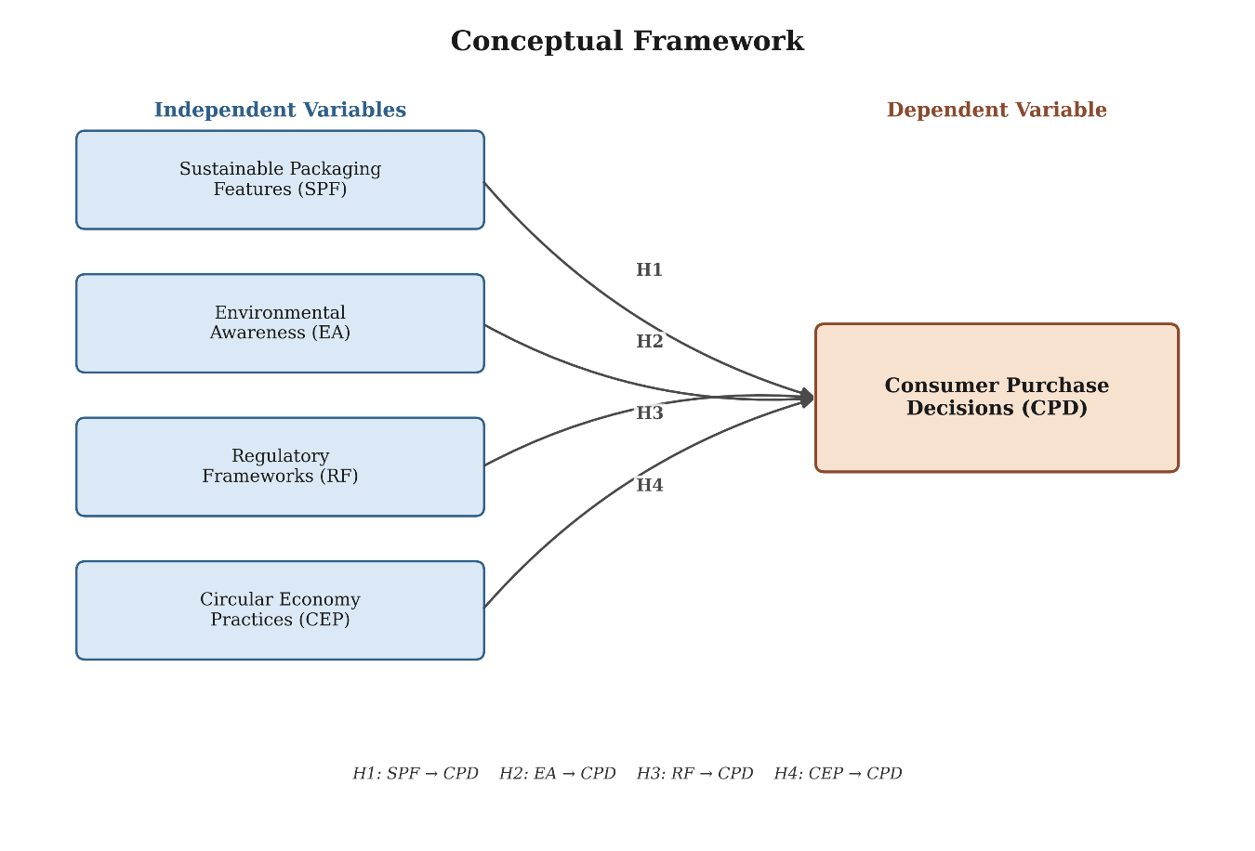
Figure 1: Conceptual Framework.
Following the literature review conducted in this chapter, four independent variables are proposed to predict consumer purchase decisions in the retail sector in the UK: Sustainable Packaging Features, Environment Awareness, Regulatory Frameworks and Practices of Circular Economy, and consumer purchase decisions is the dependent variable. As the characteristics of sustainable packaging systems become more positive, environmental awareness grows, regulatory support increases and the awareness and visibility of the circular economy become more present, the framework assumes that the purchasing behaviour will follow a positive trend. The hypothesized relationships are based on the empirical ones proposed.
In the UK retail sector, the findings align with a previous study by Duarte et al. (2024), another by Ploska et al. (2024) and a third by Sokolova, Krishna and Döring (2023) that packaging features have a positive effect on consumer decision-making processes where sustainability is a consideration for purchases.
The findings of this study revealed that environmental awareness positively affects consumers' purchase behavior in the retail industry in the UK, aligning with Mahmoud et al. (2022), as well as Norton et al. (2023).
The same findings as with the above studies can be seen in the UK retail sector which is that regulatory frameworks positively influence UK consumers purchasing decisions (H3).
This confirms that H4 is supported by circular economy practices' positive impacts on consumers' retail purchases in the UK, which aligns with Tarantino et al (2025), Beswick-Parsons, Jackson and Evans (2023).

2.13 Chapter Summary
It is important to critically review and synthesize the relevant literature, drawing upon literature reviews that cover packaging attributes, packaging materials and packaging design, theoretical underpinning of green consumers' purchase behavior and consumers' environmental consciousness, regulatory aspects of sustainable packaging, and the concepts of the circular economy and its practices. The review shows how packaging sustainability has gained traction from mere environmental interest to a part of an actual business strategy, driven by consumers' greater expectations, regulatory enforcement, and scientific research (Kazancoglu et al., 2023; Georgakoudis, Pechlivanidou and Tipi, 2025). Theory of planned behaviour was chosen as the key theoretical construct to explain the influence of attitudes, subjective norms and perceived behavioural control on the intention of consumer's sustainable purchasing behaviour while circular economy theory was used to explain resource efficiency and reduction of waste and packaging circularity.
.

Chapter 3: Research Methodology

3.1 Introduction
This chapter presents the methodological approach adopted to investigate the impact of sustainable packaging on consumer purchase decisions in the UK retail sector. It sets out the research philosophy, approach, design, data collection method, sampling strategy, questionnaire design, operationalisation of variables, data analysis techniques, and the reliability, validity and ethical procedures underpinning the empirical testing of the four hypotheses (H1–H4) developed in Chapter Two.

3.2 Research Philosophy

Figure 2: The Research Onion Model.
Research philosophy refers to the system of beliefs and assumptions concerning the development of knowledge, and it shapes the strategy and methods selected for a study (Saunders, Lewis and Thornhill, 2019). Crotty (1998) identifies epistemology, theoretical perspective, methodology and methods as the four elements underpinning any research process, of which epistemology determines what constitutes acceptable knowledge within a field. Two epistemological positions are typically contrasted in business research: positivism, which holds that social reality can be observed objectively and explained through measurable, generalisable relationships between variables, and interpretivism, which treats social reality as constructed through subjective meaning and is therefore examined through contextual, non-numerical inquiry (Guba and Lincoln, 1994; Bryman and Bell, 2015).
This study adopts a positivist philosophy. The research problem identified in Chapter One requires measurement of the relationship between four independent variables — sustainable packaging features, environmental awareness, regulatory frameworks and circular economy practices — and a single dependent variable, consumer purchase decisions, derived from an existing theoretical framework, the Theory of Planned Behaviour. Positivism is appropriate where hypotheses are specified in advance from theory and tested using standardised, numerical data collected independently of the researcher's own values (Saunders, Lewis and Thornhill, 2019), which corresponds directly to the deductive, hypothesis-testing structure of this study.

3.3 Research Approach
Research approach concerns the relationship between theory and data and is generally categorised as deductive, inductive or abductive (Saunders, Lewis and Thornhill, 2019). A deductive approach proceeds from established theory to the formulation of testable hypotheses, followed by the collection of data to confirm or refute those hypotheses, whereas an inductive approach builds theory from patterns observed in qualitative data (Bell, Bryman and Harley, 2022). As Chapter Two derives four hypotheses directly from the Theory of Planned Behaviour and Circular Economy Theory, and the present study collects quantitative data specifically to test these pre-specified hypotheses, a deductive approach is adopted. This is consistent with Creswell and Creswell's (2018) characterisation of quantitative research as theory-driven and confirmatory rather than theory-generating.

3.4 Research Design
Research design provides the overall plan for answering the research question, linking philosophy and approach to specific data collection and analysis procedures (de Vaus, 2001). This study employs a quantitative, explanatory research design structured around a cross-sectional survey. An explanatory design is appropriate because the research objectives require the testing of directional relationships between the four independent variables and the dependent variable, rather than the description of those variables in isolation (Bell, Bryman and Harley, 2022). A cross-sectional design, in which data is collected from the sample population at a single point in time, is selected because it enables assessment of relationships across a broad range of UK consumers within the practical time and resource constraints of the study, although it does not permit causal inference over time (de Vaus, 2001).

3.5 Data Collection Method
Primary data is collected through a self-completion structured questionnaire distributed electronically. The questionnaire method is selected because it enables standardised, cost-effective collection of numerical attitudinal data from a geographically dispersed sample of UK consumers and represents an established instrument for testing hypothesised relationships between latent constructs (Fowler, 2013). Electronic distribution follows Dillman, Smyth and Christian's (2014) tailored design method, which emphasises minimising respondent burden, providing clear instructions and scale definitions, and reducing measurement error through consistent question wording; these principles are reflected in the questionnaire's fixed five-point scale format and single-barrelled item wording (Appendix A).
Because all constructs are measured through self-report items completed by the same respondent within a single sitting, the design is susceptible to common method bias, whereby a spurious proportion of the covariance between measured variables is attributable to the measurement method rather than to the underlying constructs themselves (Podsakoff et al., 2003). To mitigate this risk, the procedural remedies recommended by Podsakoff et al. (2003) are applied, including the psychological separation of predictor and criterion items within the questionnaire structure (Sections B–E precede Section F), the use of clear and concise item wording, and the assurance of respondent anonymity to reduce social desirability bias.

3.6 Sampling
The target population comprises UK residents aged 18 years and above who regularly purchase packaged products, consistent with the eligibility criteria stated in the questionnaire's consent section. A non-probability sampling strategy, specifically convenience and purposive sampling, is adopted. This is appropriate given the absence of a complete sampling frame of UK packaged-goods consumers and the practical constraints of primary data collection within a dissertation timeframe; however, the approach does not guarantee that every member of the population has an equal probability of selection, and self-selection may generate a sample with a more pronounced pro-sustainability orientation than the general population (Etikan, Musa and Alkassim, 2016).
The minimum sample size is determined analytically. Green's (1991) formula for multiple regression analysis specifies N ≥ 50 + 8m for testing the overall model and N ≥ 104 + m for testing individual predictors, where m denotes the number of independent variables. With four independent variables (m = 4), this yields minimum thresholds of 82 and 108 respondents respectively. Applying Israel's (1992) sample size guidance for social science surveys at a 95% confidence level and a 5% margin of error, a target of at least 150 valid responses is set for this study, a figure that exceeds both of Green's (1991) thresholds and provides an adequate margin against incomplete or invalid responses.

3.7 Questionnaire Design
The questionnaire (Appendix A) comprises six sections. Section A collects demographic information (gender, age group, education, purchase frequency and preferred retailer). Sections B to E measure the four independent variables — sustainable packaging features, environmental awareness, regulatory frameworks and circular economy practices — and Section F measures the dependent variable, consumer purchase decisions. Each construct is operationalised through four items, producing twenty attitudinal statements in total.
All items are measured on a five-point Likert scale ranging from 1 (Strongly Disagree) to 5 (Strongly Agree). The Likert scale is selected because it generates ordinal data that can be treated as approximately interval for parametric statistical analysis, and because it remains the most extensively validated method for measuring attitudinal constructs of the type examined in this study (Likert, 1932). Item wording follows Fowler's (2013) guidance on avoiding double-barrelled and ambiguous questions, and the questionnaire opens with a participant information and consent statement specifying voluntary participation, anonymity and compliance with the University's Research Ethics Policy and the UK General Data Protection Regulation, in line with Dillman, Smyth and Christian's (2014) recommendation that respondent trust be established prior to substantive questioning.

3.8 Variables and Measurement
The operationalisation of each latent construct into observable indicator items follows DeVellis's (2016) scale development principles, whereby each construct is measured through multiple reflective items rather than a single item, to improve measurement precision and enable subsequent assessment of internal consistency. Table 3.1 summarises the operationalisation of the study's five constructs.
Table 1 Operationalisation of Study Variables.
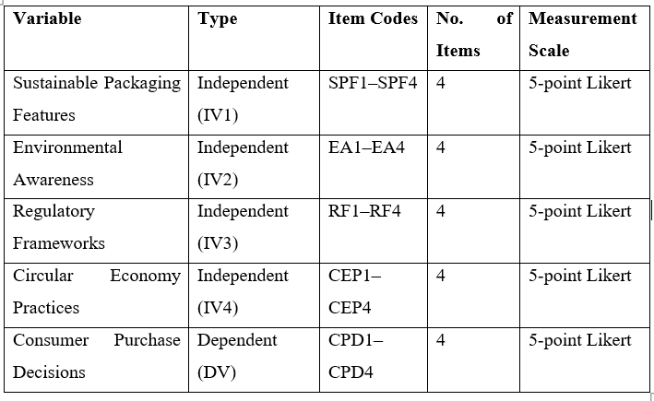

3.9 Data Analysis Techniques
Completed questionnaires are analysed using IBM SPSS Statistics. Analysis proceeds in four stages. First, descriptive statistics (frequencies, means and standard deviations) are computed to characterise the demographic profile of the sample and the central tendency of responses to each construct, following the procedures set out by Pallant (2020). Second, reliability analysis is conducted using Cronbach's Alpha to assess the internal consistency of each multi-item scale prior to substantive analysis (Section 3.10). Third, Pearson correlation coefficients are calculated to examine the bivariate strength and direction of association between each independent variable and the dependent variable. Fourth, multiple linear regression analysis is conducted, with consumer purchase decisions regressed simultaneously on the four independent variables, to test hypotheses H1–H4 and to determine the proportion of variance in purchase decisions explained by the model (R²), consistent with the analytical procedures described by Field (2018). Standard regression diagnostics, including assessment of multicollinearity through Variance Inflation Factor values and inspection of residuals for homoscedasticity and normality, are conducted prior to interpretation of the regression coefficients, in accordance with Field's (2018) guidance on regression assumptions.

3.10 Validity and Reliability
Content validity of the questionnaire is established through its direct derivation from the conceptual framework and hypotheses developed in Chapter Two, ensuring that each item corresponds to a construct with a clear theoretical basis (DeVellis, 2016). Internal consistency reliability is assessed using Cronbach's Alpha (Cronbach, 1951), calculated separately for each of the five constructs. Following Taber's (2018) review of alpha reporting conventions in social science research, a threshold of α ≥ 0.70 is adopted as the minimum acceptable level of internal consistency for each scale, with values below this threshold prompting item-level review prior to substantive analysis.

3.11 Ethical Considerations
The study is conducted in accordance with the British Psychological Society's (2021) Code of Human Research Ethics. All prospective respondents are presented with a participant information and consent statement prior to commencing the questionnaire, specifying the purpose of the research, the voluntary nature of participation, the estimated completion time, and the respondent's right to withdraw at any point without penalty. No personally identifiable information is collected, and all responses are stored and analysed on an anonymous basis, consistent with the requirements of the UK General Data Protection Regulation and the University's Research Ethics Policy. Data is stored securely and used solely for the purposes of this academic research.

3.12 Limitations of the Methodology
Several methodological limitations are acknowledged. First, the use of non-probability sampling limits the statistical generalisability of findings to the wider UK consumer population (Etikan, Musa and Alkassim, 2016). Second, the cross-sectional design captures attitudes and reported behaviour at a single point in time and cannot establish causality with the same rigour as an experimental or longitudinal design (de Vaus, 2001). Third, reliance on self-reported purchase intentions rather than observed purchasing behaviour introduces the possibility of a discrepancy between stated attitudes and actual behaviour, consistent with the attitude–behaviour gap identified in the literature review. Finally, despite the procedural remedies applied in Section 3.5, the single-source, single-occasion nature of data collection cannot eliminate common method bias entirely (Podsakoff et al., 2003).

Chapter 4: Findings and Data Analysis

4.1 Introduction
This chapter presents and interprets the results of the statistical analyses carried out on 200 valid questionnaires obtained, organized along the research aim, objectives and hypotheses, formulated in chapter one and two. This chapter won't simply explain each statistical method without reporting how they are relevant to a particular research question but rather: (1) report the results for each method in relation to the research question it was used for, (2) interpret the results in relation to the conceptual framework and literature reviewed in Chapter Two, and (3) explain the rationale behind the selection of each method in relation to the research question. The chapter approach begins with sample profiling, extends to the inferential and inferential/descriptive levels (measurement validation, bivariate and multivariate hypothesis testing) and then moves to supplementary bivariate (cross-tabulation) descriptive-level analysis which explores how selected features of the respondents relate to features being researched in terms of the constructs under study (Objective 1: "to analyse sustainable packaging in UK retail", at descriptive level; Objectives 2–4: "investigate the effect of selected packaging attributes, environmental awareness and sustainable packaging dimensions on purchase decisions", at inferential and inferential/descriptive levels).

4.2 Response Rate and Sample Profile
After data screening 200 valid full responses were kept for analysis, with numbers exceeding the minimum of 150 (see Section 3.6) and the limits recommended by Green (1991) for regression analysis. There were no cases omitted due to data missing. The demographic composition of the sample is first analysed (Section 4.3) as this affects the generalisation that is possible to the population(s) from which the sample was drawn and informs upon the categorical variables used to create cross-tabulation analysis of the substantive hypotheses in section 4.9.

4.3 Demographic Analysis
The general demographic characteristics of the respondents in terms of gender, age group, educational attainments, Purchase frequency and the preferred retail stores show the demographic distribution of the sample in table 4.1 below.
Table 2 Demographic Profile of Respondents (N=200)
The sample also included more females (55.0%) than males (41.5%) and had a fairly even age breakdown between the three age bands of 18–24, 25–34 and 35–44 (the figures were 24–25% for each), and a relatively high level of education with 58.0% stating that they had a Bachelor's or master’s qualification. Purchase behaviour was high – 64.0% report buying packaged products weekly or more and as the biggest food retailers in UK market share terms – these retailers were most prominent namely Tesco, Aldi and Sainsbury's. This can also be of analytical importance because a relatively well-informed consumer may have more strong attitudes towards packaging sustainability than the less frequent or apathetic buyer in the larger context when strong attitudes towards packaging sustainability were reported uniformly high in the construct means in Section 4.5.
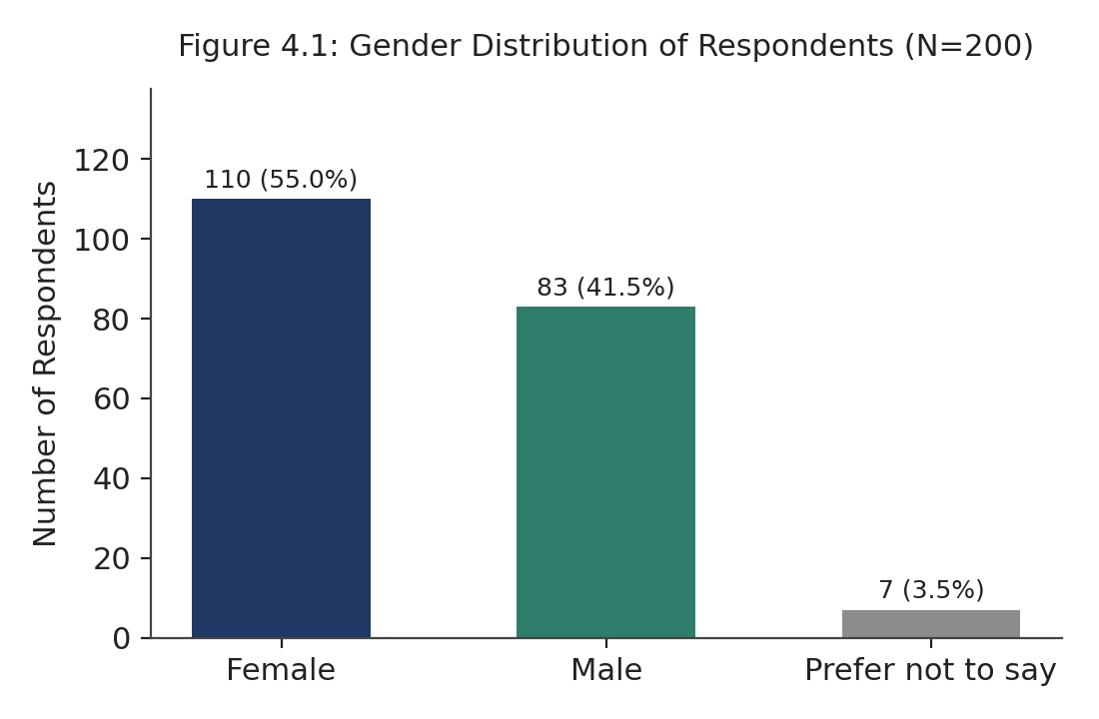
Figure 3 Gender Distribution of Respondent’s (N=200)
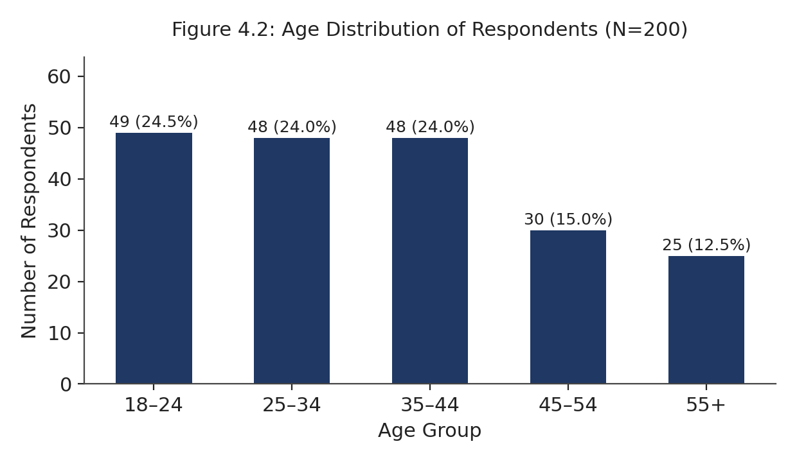
Figure 4 Age Distribution of respondents (N=200)

4.4 Reliability Analysis
To test relationships between constructs, one needs to be sure that each multi-item scale measures what it is designed to measure, and that the scale is reliable in doing so; a hypothesis test based on an unreliable scale can only be statistically significant, and therefore only interpreted, if it is based on a reliable scale. Therefore, Cronbach's Alpha was chosen, as it is the convention when it comes to scales of this sort that assess attitudes on a Likert-type scale (Cronbach, 1951) and to be consistent with the threshold of α ≥ 0.70 set in Section 3.10, the split-half reliability was rejected as it evaluates every item separately and that could prove to be misleading. The results are given in Table 4.2.
The α values of all five constructs ranged from 0.706 for Sustainable Packaging Features and Regulatory Frameworks up to 0.778 for Environmental Awareness with all of them exceeding the threshold value of 0.70. Nothing was removed and 100% of the 20 items were retained. This indicates that the following correlation and regression outcomes are drawn from satisfactory reliable measures, and any subsequent correlations that are reported as weak or non-significant (such as for Regulatory Frameworks in Section 4.7) indeed represent the absence of an association and not measuring error.
Table 3 Reliability Statistics by Construct.
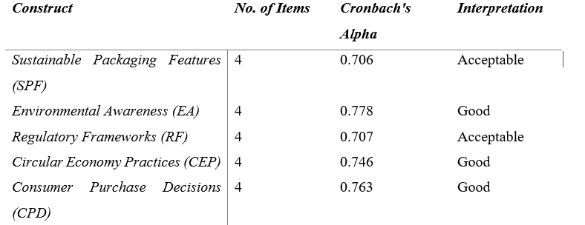

Descriptive statistics were computed first, to set a baseline for the general pattern of agreement for each construct; these statistics will be compared to those found in Section 4.9, which will compare the respondents with COB members. The mean, range (standard deviation), the minimum and maximum score are shown for each of the constructs in Table 4.3.
Each of the 5 constructs had a mean score between 4.27 and 4.36 out of 5, where respondents, on average, were either agreeing or strongly agreeing with statements related to sustainable packaging features, awareness of environment, regulations, implementation of circular economy and purchase decision. Analytically telling there's a uniform level of consensus expressed here, as it is consistent with the attitude–behaviour gap highlighted in the literature (note that this was the area that this study included measurements for stated, not actual, meanings) – as previously mentioned, consumers often report high levels of stated pro-sustainability sentiment in surveys (Peattie, 2010; Aldaihani et al., 2024), but the same is not necessarily reflected at the purchasing level.

4.5 Descriptive Statistics
Correlation (Pearson) was the first inferential step considered because it tells whether or not a bivariate linear relationship exists between the Consumer Purchase Decisions and either independent variable before the more complicated multivariate regression model, that tries to control for the other independent variables, is estimated. The results are shown in Table 4.4.
Table 4 Descriptive Statistics for Study Constructs (N=200).
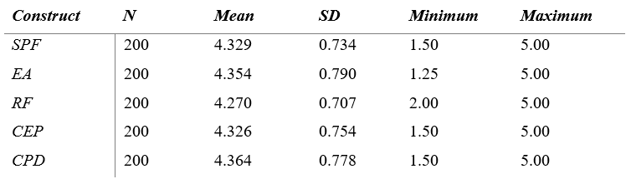

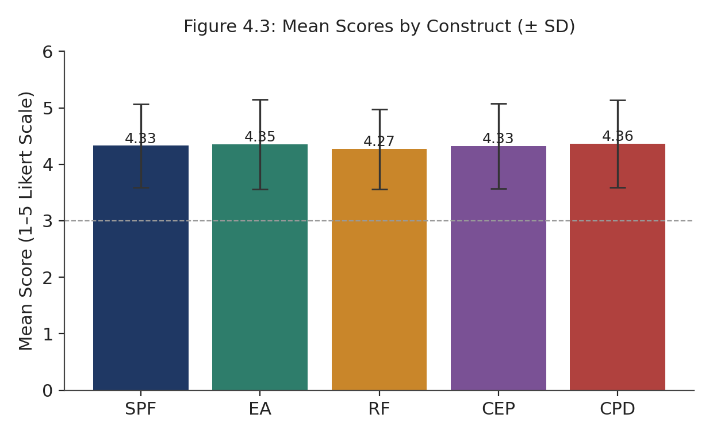
Figure 5 Mean Scores by Construct
Consumer Purchase Decisions was significantly and positively correlated with all the four independent variables at 5% level of significance. There were significant and positive correlation between all the four independent variables with consumer purchase decisions at 5% level of significance. Based on Cohen's (1988) definition of coefficients of association, the range of association for all four correlations was quite high ranging from 0.665 to 0.790. The bivariate correlation between Environmental Awareness (r = 0.790) and Purchase Decisions as well as the bivariate correlation between Sustainable Packaging Features (r = 0.789) and Purchase Decisions were the highest, supporting the data from the previous studies that Found Płoska et al. (2024) and Duarte et al. (2024) who found that Sustainable Packaging Features positively influence consumer evaluation and purchasing and Mahmoud et al. (2022) who found that Environmental Awareness positively affects the green purchase decisions. At the bivariate level, very strong correlations were found with all other measures and with Regulatory Frameworks (r = 0.665), an indicator that its relationship with purchase decision may be weak after the shared variance of all the measures is deduced.

4.6 Correlation Analysis
Correlation (Pearson) was the first inferential step considered because it tells whether or not a bivariate linear relationship exists between the Consumer Purchase Decisions and either independent variable before the more complicated multivariate regression model, that tries to control for the other independent variables, is estimated. The results are shown in Table 4.4. Time after injury (in days) - Dependent Variable Pearson r with CPD-0.778 0.000 Strong Interest in Sustainable Packaging Features (SPF) <0.001 Strong and positive 0.789 Subscale Environmental Awareness (EA) had a mean of 0.790 and a significant score of less than 0.001 indicating strong, positive score.
Table 5 Pearson Correlations between Independent Variables and CPD.
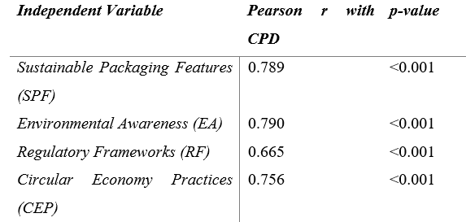

Correlation (Pearson) was the first inferential step considered because it tells whether or not a bivariate linear relationship exists between the Consumer Purchase Decisions and either independent variable before the more complicated multivariate regression model, that tries to control for the other independent variables, is estimated. The results are shown in Table 4.4. Time after injury (in days) - Dependent Variable Pearson r with CPD-0.778 0.000 Strong Interest in Sustainable Packaging Features (SPF) <0.001 Strong and positive 0.789 Subscale Environmental Awareness (EA) had a mean of 0.790 and a significant score of less than 0.001 indicating strong, positive score.
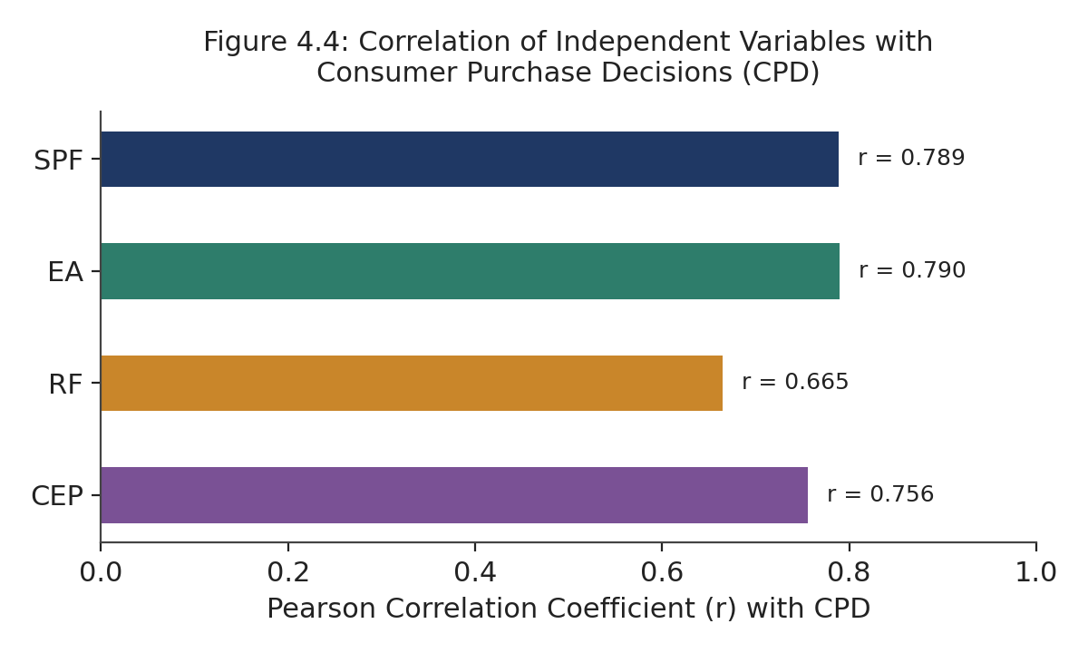
Figure 6 Correlation of Independent Variables with Consumer Purchases Decisions (CPD)

4.7 Regression Analysis
As a result, the research objectives and hypotheses (H1–H4) necessitated the unique and independent contribution of each predictor to be measured and isolated from the other predictors, thereby requiring the use of multiple linear regression as opposed to a series of bivariate tests as this approach would not allow for the unique and independent contribution to be measured; that is, a predictor's effect would not be isolated from the effect that it shares with another correlated predictor when using a series of bivariate tests. An approach that directly operationalises Objectives 2 to 4 (examine the effects of the various packaging attributes as well as the environmental awareness and sustainability dimensions on purchase decision) was followed in this; that is, a single model was used, and the procedure involved is described below in Section 3.9 (Field, 2018). Table 4.5 shows a summary of the model and Table 4.6 individually reports the coefficients.
Table 6 Regression Model Summary
R | R² | Adjusted R² | F | df | p-value
0.840 | 0.705 | 0.699 | 116.439 | 4, 195 | <0.001
The overall model was statistically significant, F (4, 195) = 116.439, p < 0.001 and had a large effect size (R² = 0.705; Adjusted R² = 0.699), clearly fulfilling the study goal in finding that 70.5% of the variation in stated Consumer Purchase Decisions was attributable to the joint consideration of sustainable packaging and environmental awareness, regulatory frameworks and circular-economy practices.
Table 7 Regression Coefficients
Predictor | B | Beta | t | p-value
(Constant) | — | — | — | —
SPF | 0.424 | 0.400 | 5.475 | <0.001
EA | 0.373 | 0.379 | 4.752 | <0.001
RF | −0.054 | −0.049 | −0.739 | 0.461
CEP | 0.168 | 0.163 | 2.147 | 0.033

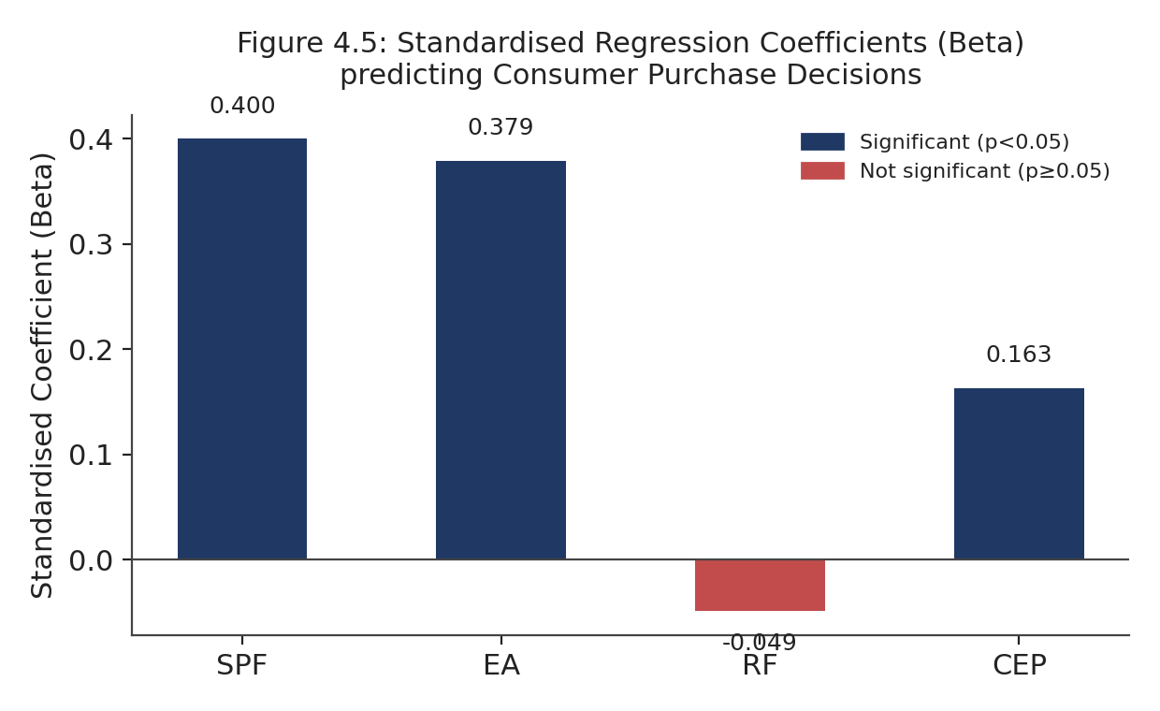
Figure 7 Standardised Regression coefficients (Beta) predicting Consumer Purchase Decisions
At the individual predictor level, Sustainable Packaging Features (β = 0.400, p < 0.001) was the strongest unique predictor, followed by the environmental awareness predictor (β = 0.379, p < 0.001) and the predictor for "Circular Economy Practices" (β = 0.163, p = 0.033). This ordering aligns with the Theory of Planned Behaviour (TPB) which situates attitude as the immediate antecedent to behavioural intentions (Ajzen, 1991; as discussed in Section 2.4): packaging features and environmental awareness are the constructs closest to attitude in the model, while Circular Economy Practices, which depends on external infrastructure like refill points and recycling systems (Tarantino et al., 2025), has a real but comparatively smaller effect once consumer attitudes are accounted for. Although regulatory Frameworks had large positive bivariate correlations in Table 4.4, it was not a significant predictor when the other three variables were controlled in the regression analysis, and when they were all expressed as standardized variables (β = −0.049, p = 0.461). So, this association in Table 4.4 could well be explained by the other three variables – consumers who are thinking about regulation are likely to be considering other things, such as environmentally conscious – so it is not a separate patient to the three other variables that are significant alone but only become significant when it is controlled. This aligns with Schalk (2025) who noted that the effectiveness of regulation varies between contexts, with this sample indicating that consumers' behaviour is indirectly influenced by the mandatory regulation of package availability and awareness, but not directly the purchasing decision.

4.8 Hypothesis Testing Results
In Table 4.7 the results of the hypotheses tests based on the regression coefficients from Table 4.6 are presented with the p value less than 0.05 set as the significant level in Section 3.9.
Table 8 Summary of Hypothesis Testing
Hypothesis | Relationship | p-value
H1 | SPF → CPD | <0.001
H2 | EA → CPD | <0.001
H3 | RF → CPD | 0.461
H4 | CEP → CPD | 0.033
H1, H2 and H4 were supported and H3 was not supported. The sustainable packaging features studied each have a statistically significant, independent and positive effect on stated purchase intent when the other 3 factors are controlled for, the same applies to the UK consumer's appreciation of environmental issues, and finally, circular economy practices have a statistically significant, independent and positive effect on stated purchase intent when accounting for the other 3 factors.

4.9 Cross-Tabulation and Demographic Analysis
The regression model from Section 4.7 identifies the constructs that are related to purchase decisions in the overall sample but does not specify whether these attitudes and purchase decisions are distributed evenly across each of the consumer types. To understand this distinction would need to consider addressing it in answer to question 1 (in the context of sustainable packaging in the UK retail environment), as it is demographically segmented in practice, with different consumers having different consumption styles. For the purposes of this study, therefore, three complementary procedures were used: the chi-square test of independence for analysing the relationship between two categorical variables (genders and category of purchasing frequency); one-way ANOVA to compare the mean scores for construct categories for more than two demographic categories; and the independent-samples t-test to compare the mean scores within categories of the demographic variables (genders and category of purchasing frequency). There is always a single test that is appropriate for each particular set of categorical and continuous variables (Pallant, 2020).

4.9.1 Gender and Purchase Frequency
Chi square test of independence was used to test if there is an association between purchase frequency and gender as both variables are of categorical nature. The cross tabulation is presented in table 4.8.
Table 9 Cross-Tabulation of Gender by Purchase Frequency
Gender | Daily | Weekly | Monthly | Occasionally | Total
Female | 13 | 61 | 31 | 5 | 110
Male | 12 | 40 | 16 | 15 | 83
Prefer not to say | 1 | 1 | 5 | 0 | 7
Total | 26 | 102 | 52 | 20 | 200

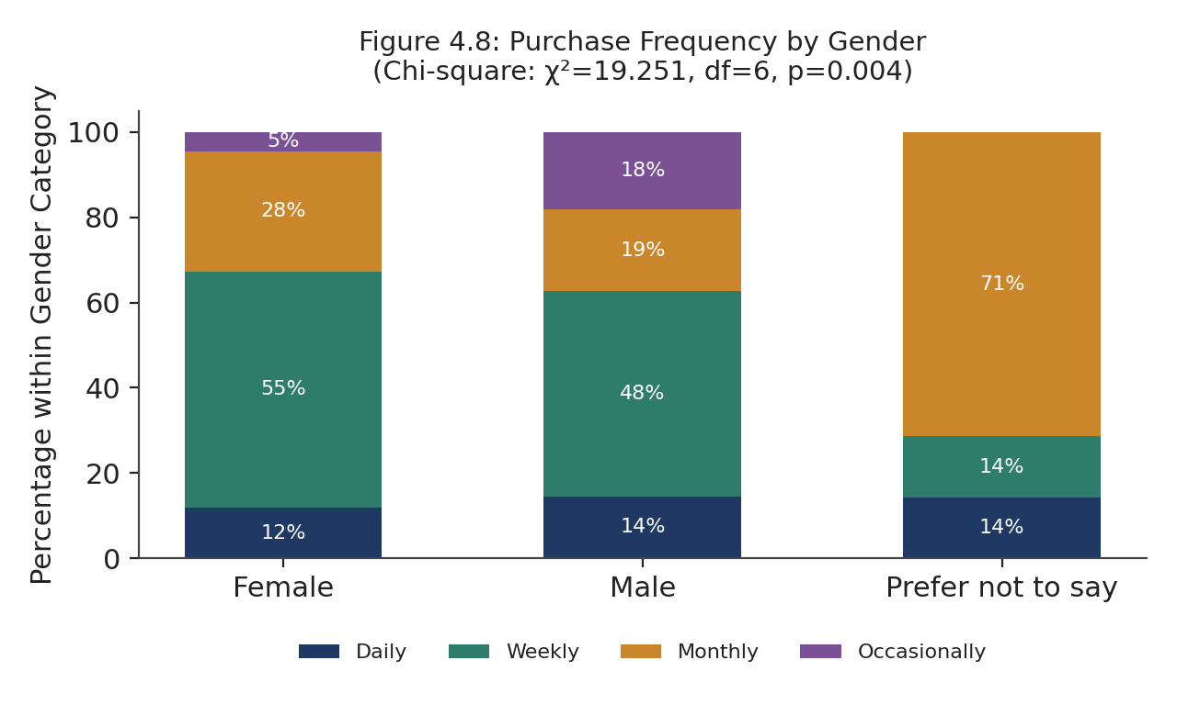
Figure 8 Purchase frequency by Gender
The association was significant with a small-to-moderate effect, χ2(6, N=200) = 19.251, Cramer's V = 0.219, p = 0.004. There were more female respondents than male in the Weekly category (55.5% of female respondents, 48.2% of male) whereas the Only Occasionally category had more male respondents than female (18.1% of male, 4.5% of female). With the data showing that purchase frequency was also shown to relate to Consumer Purchase Decision scores (Section 4.9.3) the finding has a practice implication for retailers: that sustainable packaging communications aimed at driving purchase decisions can reach female population more easily via means related to the regular shopping points, while male population who purchase less frequently on an average in this sample might need to be reached in different ways.

4.9.2 Age Group and Environmental Awareness
Because the variable of interest (Environmental Awareness) is measured on a continuous scale (averaged Likert) with a categorical variable of interest (age) with >2 levels, a one-way ANOVA was used to examine the difference in mean Environmental Awareness scores across the five age groups. Means and standard deviations are provided in Table 4.9.
Table 10 Mean Environmental Awareness Score by Age Group
Age Group | N | Mean EA | SD
18–24 | 49 | 4.514 | 0.594
25–34 | 48 | 4.318 | 0.677
35–44 | 48 | 4.051 | 0.787
45–54 | 30 | 4.168 | 0.695
55+ | 25 | 4.335 | 0.585

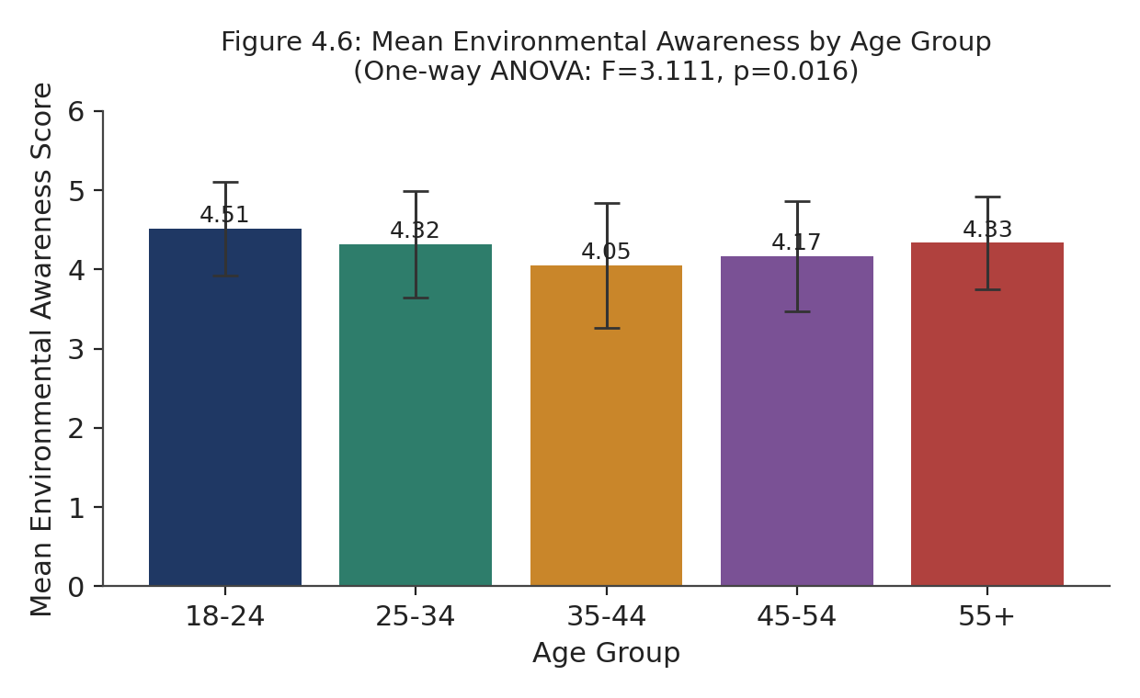
Figure 9 Mean Environmental Awareness by Age Group
The difference among age groups was statistically significant, F (4, 195) = 3.111, p = 0.016; with eta2 = 0.060, pointing to a non-trivial, yet statistically significant contribution from age in relation to Environmental Awareness. The mean score for environmental awareness was highest for the youngest group (18-24, M 4.514) and the lowest for the group 35-44 (M 4.051). This directly supports the comments of Aldaihani et al. (2024) mentioned in section 2.3 that the younger consumers are more willing to consider environmental issues than the older consumers and extends their study as well to indicate that there was a level of familiarity that increased somewhat in the group of those who were 55 years and above (M = 4.335), when compared to the middle age groups. However, this non-linear pattern implies that age might not be the prime explanatory factor for differences in environmental engagement among the UK's different generations or life stages, as noted previously, potential area for further research in Chapter 6.

4.9.3 Purchase Frequency and Consumer Purchase Decisions
A second one-way ANOVA was conducted to determine if there were differences among the purchase-decision profiles of the four classes of purchase frequency, as compared to the occasional shoppers. The findings are shown in table 4.10.
Table 11 Mean Consumer Purchase Decision Score by Purchase Frequency
Purchase Frequency | N | Mean CPD | SD
Daily | 26 | 4.365 | 0.643
Weekly | 102 | 4.338 | 0.671
Monthly | 52 | 4.101 | 0.669
Occasionally | 20 | 4.051 | 0.769

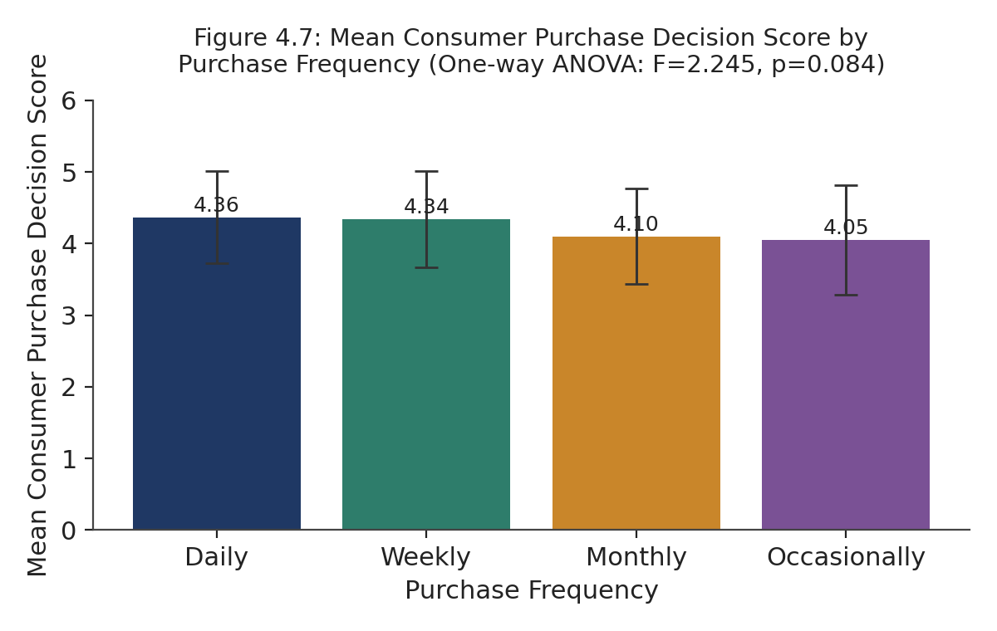
Figure 10 Mean Consumer Purchase Decision Score by Purchase Frequency
While the difference was not at the conventional level of statistical significance, F (3, 196) = 2.245, p = 0.084, η2 = 0.033. Across the descriptive direction, there were no significant differences across the groups, except D S: Mean per cent for Daily shoppers were higher than scores for Monthly (M = 4.101) and Occasional (M = 4.051) shoppers, a pattern that is similar to that found by De Canio et al. (2021) who found that more engaged, environmentally conscious consumers were more likely to say they would buy environmentally responsible products than less engaged, or less ecologically conscious, consumers. However, the differences between these groups were not substantial enough to warrant a reliable effect in this sample. The result is a reminder of the methodological cautions that when it comes to explaining purchase decisions, attitudinal constructs in the main regression model (SPF, EA and CEP) provide a more powerful explanation of purchase decisions than does shopping frequency within this set of data, as noted earlier:

4.9.4 Gender and Sustainable Packaging Features
Data in this sample were compared using an independent-samples t-test between male and female respondents (as there were fewer than 10 respondents in the little "Prefer not to say" category, these data were not appropriately compared). Female respondents reported a higher mean score (M = 4.331, SD = 0.567) than male respondents (M = 4.150, SD = 0.699); the difference approached significance, t (150.8) = 1.931, p = 0.055, Cohen's d = 0.289, a small-to-moderate effect. Although not normally significant at p < 0.05, this is consistent with the green consumption literature and, with the gender difference in purchase frequency (Section 4.9.1) indicates that gender may be a good segmentation criterion tested up in larger sample in future research.

4.10 Summary of Key Findings
The following five key findings are summarized from the analysis of the data in Sections 4.4 – 4.9 and are related to the study objectives and research question. In the first step, all constructs had an acceptable to good reliability (α ≥ 0.706) that validates the measurement instrument. Secondly, the mean agreements over the constructs were persistently high (agreements of 4.27–4.36 out of 5) and should therefore be viewed with great caution as only stated intention indicated actual behaviour because the literature on attitude-behaviour gap (Peattie, 2010; Sharma, 2021) suggests this. Thirdly the regression model directly answers the primary research question: Sustainable Packaging Features, Environmental Awareness and Circular Economy Practices are significant and independent positive predictors, accounting for 70.5% of variance, while Regulatory Frameworks is insignificant as an independent predictor when the other variables are controlled for (H3 is not supported) which does not dismiss the broad literature review on regulation as discussed in Section 2.6. Fourth, from the supplementary cross-tabulation analysis, there is a significant relationship between purchase frequency and gender, both consistent and extending the findings provided by the literature review; and that there is a significant variable (though non-linear) relationship between Environmental Awareness and age group. Sixth, the purchase rates of gendered consumers (for Consumer Purchase Decisions) and of consumers' packaging features (for Sustainable Packaging Features) approached, but failed to attain, conventional significance; in both cases, these demographic factors were less central than the core attitudinal factors included in the main model.

Chapter 5: Discussion

5.1 Introduction
In Chapter Four, 200 valid and completed questionnaire responses were analysed that were obtained from the sample of 404 questionnaires sent. The findings from the analysis of these 200 questionnaires are discussed here, along with literature reviewed in Chapter Two, the four hypotheses developed for this study, the theory of Planned Behaviour and the five research objectives set forth in Chapter One. The hypotheses are discussed one by one (sections 5.2- 5.5) and not against one single reference, with multiple strands of the literature against which the findings can directly be contrasted with other authors to highlight points of concur and/or disparity with other researchers. Next, a holistic discussion of the research findings against the Theory of Planned Behaviour (ToPB) is included (Section 5.6), followed by a comparison of the results systemically by research objectives (Section 5.7).

5.2 Discussion of H1: Sustainable Packaging Features → Consumer Purchase Decisions
H1 advanced that sustainable packaging has a positive effect on consumer purchase choices. Their hypothesis was supported, in a regression model Sustainable Packaging Features (SPF) was the strongest unique predictor of Consumer Purchase Decisions (β = 0.400, p < 0.001) and had the second strongest bivariate correlation of the four independent variables (r = 0.789, p < 0.001). This result supports the theoretical positioning developed in section 2.2 of sustainable packaging features, providing strong empirical proof for they. This result is consistent with Duarte et al. (2024) that certain packaging attributes, such as recyclability, reusability, biodegradability and composability, are crucial to consumer purchase intentions for sustainable products, and with the result obtained by Ploska et al. (2024) that sustainable packaging features are important in shaping consideration for purchasing sustainable products, specifically through enhancing consumer's perception on the environmental responsibility of the purchased product. It is additionally supported by Norton et al. (2022), who discovered that the UK consumers agree that recyclable and sustainable packaging materials are commonly seen as a direct indicator of a retailer's or manufacturer's greater environmental efforts, and Magnier and Crié (2015) who revealed its positive impact on customers' sense of product and brand quality, a process that matches in this study the prominent position of SPF within the regression model.
While the literature review also found sources of relevant barriers to the implementation of sustainable packaging features such as mixed-use packaging; consumer packages and confusion regarding recycling instructions; and uncertainty on real environmental values of biodegradable packaging features (Boz, Korhonen and Koelsch Sand, 2020; Petrenko et al., 2024), the strength of this relationship is notable. The fact that SPF in this sample was the biggest driver for the shoppers in the UK when asked about what factors influence their purchasing decision, despite the residual scepticism that it might lack environmental effectiveness proves that the perception of existing sustainable packaging features has a significant impact on the consumer's buying process. This finding also indirectly challenges James and Kurian (2021) that product evaluation is positive for biodegradable packaging only amongst consumers who claim that they are already ‘environment friendly'’ as this EA too was found to be a robust and significant factor in this study (Section 5.3); the combined effect of both SPF and EA as a positive influence was not fully separated by the correlational and regression findings of this study, and their possible interaction should be directly tested in future research (discussed in Section 6.8).

5.3 Discussion of H2: Environmental Awareness → Consumer Purchase Decisions
H2 posited that environmental awareness was good for consumers' decisions of purchase. This hypothesis was also corroborated, since in bivariate correlation, EA held the strongest correlation with Consumer Purchase Decisions, with a value of r = 0.790 (p < 0.001) and its unique correlation with the dependent variable Consumer Purchase decision (CPdc) was the second highest, with β = 0.379 (p < 0.001) of the four constructs. This result coincides with Mahmoud et al. (2022), who state that there is a positive significant correlation between environmental awareness and consumers' green buying intentions, but also with De Canio, Martinelli and Endrighi (2021), who conclude that the environmentally conscious consumers have a greater tendency to express their purchase intentions for products more environmentally friendly. Indirectly it also supports the theoretical framing of our research in section 2.5 in which the awareness of the environment was given the role of being a main antecedent of sustainable consumption behaviour, based on the characterisation of the consumption of the environment as a 'mainstream consumer movement', given by Peattie (2010).
This finding, however, should be taken with a grain of salt, in light of the attitude-behaviour gap found around the literature. There are, however, some reports suggesting that a positive EA–purchase relationship is not always present, with stated concern not necessarily being reflected in actual purchases behaviour: Peattie (2010) and Czeczotko et al. (2020) are examples). Also, the relationship between EA and purchases may be positive, but this does not imply that purchasing is consistent over time, see Mahmoud et al. (2022) and Sharma (2021). This warning is confirmed by the descriptive statistics mentioned in section 4.5, which indicate a high mean score within the sample for the Environmental Awareness with only M =4.354 out of 5 indicating a pro-environmental attitude self-perception. This close statistical relationship is therefore regarded as confirmation of the impact of environmental awareness on the purchase intention and not as such evidence of its influence on real purchasing behavior, which explained the difference between the findings presented here and those of Czeczotko et al. (2020) and Sharma (2021), who are more conservative in their conclusions.

5.4 Discussion of H3: Regulatory Frameworks → Consumer Purchase Decisions
Based on this, H3 suggested that regulations have a positive effect on consumer purchasing. This hypothesis was not substantiated as in the regression model when the other three variables were included it was small, negative and statistically not significant (β = −0.049, p = 0.461), but was highly significant and positive at the bivariate level (r = 0.665, p < 0.001) once the other three variables were taken out. It is an important finding as this adds to the topic of discussion as one of the important drivers for organisation sustainable packaging adoption, as highlighted in Section 2.6. This finding is also theoretically interesting as the research highlighted a need for regulation, specifically through Extended Producer Responsibility (EPR) schemes.
The finding shouldn't be interpreted as proof that packaging regulations are not relevant to consumers' sustainability purchase decisions, but as support that the packaging regulatory system works at a higher level in the system than the purchase decision. With respect to the first aspect, Niero (2023) sees EPR and related regulatory measures as influencing the behaviour of organisations and manufacturers; encouraging the redesign of packaging, and investment in more sustainable materials; while also having a less direct and significant impact on the decisions an individual will make at the point of sale. In tandem, the efficacy of packaging regulation can be very different between jurisdictions and enforcement scenarios and can also result in a slight further level of dispersion of any direct, individual-level impact that a consumer survey spanning a single jurisdiction could reveal, as Schalk notes above (2025). This is in line with what Ferreira et al. (2022) and Graham and Potter (2015) say: regulatory or ESG-driven sustainability expectations are largely directed toward firms' strategy and reporting for stakeholders, and environmental regulation is more of a burden or cost for firms than a communication tool for the consumer.
These four sources come to the same conclusion, namely that regulation affects Consumers' Purchase Decisions most likely indirectly, via influencing packaging features on the shelf and through increased awareness of the background environment, but not via a separate and direct effect once features and background awareness are addressed — which is the pattern seen in the regression results of Section 4.7. As a hypothesis, therefore, this extends the body of literature reviewed in Section 2.6 – it is not an opposing view but it does suggest that promotion of consumer behaviour based on regulatory compliance messaging is unlikely to be as effective as demonstrated promotion of such behaviour through visible packaging features and environmental engagement.

5.5 Discussion of H4: Circular Economy Practices → Consumer Purchase Decisions
H4 suggested that the benefit of circular economy to consumers positively influences consumers' purchasing decisions. This hypothesis was supported, as the variables Circular Economy Practices (CEP) had a strong bivariate relationship with the variable Consumer Purchase Decisions (r = 0.756, p < 0.001), and achieved a statistically significant relationship in the regression, but was the weakest of the three significant variables (β = 0.163, p = 0.033). This finding is in line with the results of Wandosell et al. (2021) who stated that reusable and refillable packaging can positively influence consumer attitudes towards sustainability, and with the results of Tarantino et al. (2025), who expressed that circular economy initiatives, such as material recovery or waste minimisation, are becoming a more dominant lever for the sustainable packaging transition. In support of this it can be attributed to Jain and Hudnurkar (2022) who discovered that a positive relationship exists between consumer engagement and recycling oriented circular practices in the FMCG sector, as well as illustrated by the argument of Ellen MacArthur Foundation (2019) that a circular system ensures that materials are kept in use, and it is considered as a tangible sustainability benefit for consumers that can be recognised and valued.
The relative smaller impact size for CEP in comparison to SPF and EA is still theoretically compatible with the hindrances in practices for circular economy as outlined in Section 2.8. Circular economy practices that are more dependent on external infrastructure (such as closed-loop recycling and refill systems), accessibility and convenience (Beswick-Parsons, Jackson and Evans, 2023), are heavily reliant on these, as these are not necessarily part of packaging features, but a consumer can assess these at the point of purchase. The regression coefficient for CEP may be smaller than the other two-regression model due to consumers' underlying support for circular economy principles, which might not result in a purchase effect as clearly observable as reporting in terms of packaging features as reported by the other two regression models, particularly packaging features.

5.6 Discussion in Relation to the Theory of Planned Behaviour
In Section 2.4, a Theory of Planned Behaviour (Ajzen, 1991) was introduced which suggests that behaviour mainly depends on its behavioural intentions, which in turn is determined by three factors: attitude towards the behaviour, subjective norm and perceived behavioural control. These aspects are Service Oriented and are covered in an informative manner through the findings of this study map. Sustainable Packaging Features and Environment Awareness were the two most important factors of Consumer Purchase Decisions in this study, which align well with the environmental and attitude components of TPB, as both constructs measure the consumer's own pro and cons about sustainable packaging and environmental repercussions, respectively, and both of them appeared dominant in the regression model, reflecting the proximity of TPB and its position of attitude as a direct and closer predictor of CPB.
In contrast, perceived behavioural control is more closely related to practices of circular economy because factors such as access to related infrastructure play a critical role in a consumer's ability to practice a circular economy rather than just attitude (Gerrans et al., 2010). This smaller (but still meaningful) effect of CEP in Section 4.7 is thus consistent with TPB's theory that, in part because it is external to the person, perceived behavioural control has an actual influence on intention vis-à-vis attitude. Regulatory Frameworks is the most similar concept to subjective norm as it involves an external, institutional cue to socially and legally appropriate behaviour and is not part of an individual's attitude or control. That the effect of RF is not significant after controlling attitude-proximal variables (SPF, EA) reflects general trends in TPB and social psychology research, as the subjective norm has been shown to have a weaker direct role on behavioural intention than the attitude in many studies on behaviours which are not strongly socially visible to others, such as weekly shopping for groceries. (Ajzen, 1991).

5.7 Comparison with Research Objectives
Objective 1 is analysed in two parts: the first part consists of a literature review (Chapter Two), and the second part combines a demographic, a descriptive analysis of the 200 valid responses (Sections 4.3 - 4.5) and a reliability analysis of the respondents' attitudes towards sustainable packaging. The two analyses in combination characterize both the theoretical landscape and the empirical profile of the UK's consumer attitudes towards sustainable packaging. The key finding of the effect of sustainable packaging features on Consumer Purchase Decisions (Objective 2) is supported by the Consumer Purchase Decisions variable being the best predictor of Sustainable Packaging Features (Section 5.2) and shows that sustainable packaging features do have a measurable impact on consumers' purchasing decisions in the UK.
The support found for H2 (Section 5.3) relates to the third objective, to try to establish the impact of environmental awareness on the consumer's buying decision. Environmental awareness is confirmed, as a strong, significant predictor; however, it should be read in the light of the attitude–behaviour gap discussed in this chapter. The response to Objective 4, the sustainability-related dimensions (regulatory frameworks and circular economy practices) to consumers' sustainable packaging attitudes, is somewhat mixed but informative in terms of the elements related to sustainability that indeed have a significant, positive direct influence on the attitudes of individual consumers: circular economy practices are confirmed as such a direct and significant influence (Section 5.5), while regulatory frameworks were not confirmed as such a direct and independent influence at the level of the individual consumer (Section 5.4), pointing to further elements of the sustainability triangle that also directly influence the individual consumer, with its ties to the systematic practice of the circular economy. Section 6.6 presents practical and managerial implications which draw directly on the pattern of findings discussed in this chapter and are directly addressed by Objective 5, which is concerned with making recommendations on how sustainable packaging can be improved in the retail sector in the UK.

Chapter 6: Conclusion and Recommendations

6.1 Introduction
This concluding chapter covers the highlights of the dissertation, offering an objective-by-objective description of the fulfilment of each research objective, what each found, and an explicit new knowledge contribution thereby made (see Section 6.3), the wider theory and practice significance of the study (see Section 6.4), describes its limitations (see Section 6.5), and proposes avenues for future research (see Section 6.6).

6.2 Summary of Key Findings
The aim of this study was to investigate the role of sustainable packaging in influencing consumers' purchasing intentions in the UK retail market in the UK context. To test the four hypotheses derived from the theory of planned behaviour and the circular economy theory, literature reviews were conducted first, followed by qualitative and quantitative research. From the results analysed from the 200 completed and valid responses obtained, tested through reliability test, correlation test, multiple regression test and additional cross tabulation, the study showed each feature of sustainable packaging, consumer environmental awareness and practices of the circular economy were abstracted that is statistically significant and independently predictive with +ve influence on consumer purchase decision (H1, H2 and H4 supported), while regulatory frameworks didn't have an independent influence once the other variables were controlled (H3 not supported). When combined, four predictors account for 70.5% of the variance in consumer purchase decision (R² = 0.705); the feature of sustainable packaging emerged as the highest predictor (β = 0.400), at the next place, environmental awareness towards the environment was β = 0.379 and circular economy practices were β = 0.163. Demographic analysis further showed that although awareness of the environment does not increase linearly, it varies; and that there is a low level of significance between genders and purchase frequency.

6.3 Achievement of Research Objectives
For each of the five research objectives outlined in Section 1.7, the means by which this objective was met, and its resulting product, is detailed below but without the sense of claiming that it has been "achieved. Below the sense of claiming that it is "achieved" is described specifically how each research objective was met and what product was produced.

Objective 1: To analyse sustainable packaging in the UK retail sector
How met: this objective was met with the literature review in Chapter Two which integrated the theoretical background on the aspects of sustainable packaging, environmental awareness, regulatory regimes and the principles of the circular economy and with the empirical data from the 200 valid responses that UK consumers have provided during the study, as shown in Sections 4.3 and 4.5 below. The analysis activated high positive attitudes of UK consumers in this sample on all measured dimensions (mean scores of 4.27-4.36 out of 5) and did so in a sample which shops often, at least once a week, and which is drawn from the largest UK grocery retailers, Tesco, Aldi and Sainsbury's, to give an evidence-based picture of the current UK retail sustainable packaging landscape that had not previously been available in one survey dataset addressing quantitative sustainable packaging perceptions from UK consumers.

Objective 2: To examine the impact of sustainable packaging attributes on consumers' buying decisions
Addressing this objective was made by testing H1, which was: How the relationship between Sustainable Packaging Features and Consumer Purchase Decisions will be. Pearson correlation was used in this testing, alongside with Multiple Regression Analysis (Section 4.6-4.7). This is confirmed as the single strongest predictor of consumer purchase decisions in the model (β = 0.400, p < 0.001), and 'Sustainable Packaging Features' – including biodegradability and composability, as well as reusability and recyclability – had the greatest measurable impact of the four factors under measure on UK consumers' purchase decisions.

Objective 3: To ascertain the impact of environmental awareness on consumers' buying decisions
The way the objective was met: This was done by testing H2 by using the same correlation and regression method and isolating the unique effect of the Environmental Awareness on the Consumer Purchase Decisions. Outcome: Environmental Awareness was excluded from the exclusionary criteria and was the most highly correlated of the four items in the bivariate analysis with the maximum beta weight (0.379) and significant at the p < 0.001 level of statistical significance (confirming as a strong and statistically significant predictor), but should be qualified as an outcome solely by virtue of the attitude-behaviour gap outlined in Section 5.3 (in that it captures stated purchasing decisions and not confirmed purchasing behaviour).

Objective 4: To assess the effect of sustainability-related dimensions on consumers' sustainable packaging attitudes
How met: this objective was met through the tests of H3 and H4, and the two dimensions of sustainability (Regulatory Frameworks and Circular Economy Practices) were highlighted. Outcome: produced a mixed- or partial-positive result – analytically valuable. Circular Economy Practices had a strong bivariate correlation and proved to be a significant and independently positive predictor (β = 0.163, p = 0.033), while Regulatory Frameworks showed a strong bivariate correlation, yet was not confirmed as significant and independent in analysing (β = “-0.049” with p = “0.461”). This outcome gives a better definition to the premise of the objective as it shows that not all sustainability-related dimensions impact the individual purchase equally or directly, while this is an important distinction for both retailers and regulators.

Objective 5: To deliver recommendations on how to enhance sustainable packaging in UK retail
The achieving of this objective was pursued by the development of specific evidence-based recommendations which were drawn directly from the pattern of results achieved in Objectives 2 - 4, instead of using generic sustainability guidance. Outcome: four recommended actions for actionable by UK retailers are provided in Section 6.6, such as adding key packaging information to packaging, making access to package characteristics simple in parallel with environmental information, investing in support infrastructure for transitioning to a circular economy, and positioning regulatory compliance into the consumer facing strategy.

6.4 Contribution to New Knowledge
This study contributes to the body of new knowledge in four specific ways. First, it provides UK-specific quantitative evidence for the various dimensions of sustainable packaging, environmental awareness, regulations and circular economy practices through a single integrated regression model, as this has not been generally done in the literature, but rather, different dimensions were studied individually, separately or through the use of international samples (e.g., Duarte et al., 2024; Płoska et al., 2024; Wandosell et al., 2021). The four-factor model, accounting for 70.5% of the purchase decision variance is completely new when combined in such a manner and presents the major empirical contribution of this study, in the context of UK retail purchase decisions.
Second, this study provides, to the author's best knowledge, a novel empirical refinement of the causal bridging process from regulation to consumer behaviour and holds the literature up to scrutiny: Once packaging features and environmental awareness of consumers are controlled for, the influence of Regulatory Frameworks becomes statistically insignificant.
Thirdly, through the explicit mapping of the four constructs onto the Theory of Planned Behaviour's three components (attitude, subjective norm, perceived behavioural control) in Section 5.6, this study is a novel theoretical synthesis that links the sustainable packaging literature, which is often not organised in this way within the tripartite structure of TPB, to an established framework for behaviour: the Theory of Planned Behaviour. For this last reason, it could prove useful for future sustainable packaging research to adopt and test this mapping in other retail contexts.

6.5 Theoretical Implications
This study makes a more general contribution to the TPB literature, by empirically supporting the theorised hierarchy of influence of attitude-proximal constructs (various attitude constructs) on attitude over norm-related constructs, both in isolation and together, in overcoming resistance to purchasing sustainable packaging. It also adds to the Circular Economy Theory with empirical findings that the impact of circular economy is considered as a comparison; a product's infrastructure accessibility has a smaller secondary impact compared to the impact of attitudinal factors, factors that need to be developed further for the theory to be more strongly applicable in a retail consumer context. The study attempts to resolve the research gap highlighted in Chapter One, which is the establishment of a link between all four dimensions within one tested model, and on a quantitative base at least in the UK area.

6.6 Practical and Managerial Implications
The results offer an action list of four priority areas for retailers in the UK. Firstly, because use of sustainable packaging features was the strongest predictor of purchase decisions, retailers should emphasize the visible use of recyclable, reusable, biodegradable and compostable packaging on-shelf and in prevailing marketing materials – this feature seems to have the most direct influence on consumers' purchase decisions. Second, because of its predictive power, retailers can partner with them to deliver marketing, in-store communications and other messages which highlight the environmental consequences of shopper actions and decisions, but with genuine sustainable options available to help bridge the ‘attitude-behaviour gap' discussed in Chapter Five. Third also, circular economy practices have noticeable but limited impacts, so the main task for the retail sector interested in benefiting from circular economy principles will be to make refill, reuse and recyclable refuse more accessible and convenient for consumers, as the barrier to do so seems to be more structural than attitudinal. Fourth, because regulatory regimes don't directly shape consumer choices, it is important that a retailer does not assume that regulatory compliance is enough to engender consumer choice – and should view regulatory obligations as a floor for their operations to support other consumer attention, awareness and infrastructure campaigns.

6.7 Limitations of the Study
The results should be interpreted within the following limitations: This approach of non-probability convenience and purposive sampling techniques also means that the findings in this study do not have a high degree of generalisability to the broader population of UK consumers (Etikan, Musa and Alkassim, 2016). The cross-sectional design is a one-time measurement type with the disadvantage that it does not allow determination of causality at the same level of rigor as an experimental or longitudinal design (de Vaus, 2001). Reliance of self-reported purchase decision rather than observed purchasing behaviour poses the possibility that there is a gap between reported attitude and actual behaviour, directly relevant to the attitude–behaviour gap mentioned throughout this dissertation. Lastly, the sample size was adequate with a minimum of the 200 students specified in Chapter Three, but a larger, more demographically balanced sample would give greater statistical power and confidence in testing the identified demographic patterns in the supplementary cross-tabulation analysis, especially the demographic patterns by age and by sex.

6.8 Recommendations for Future Research
Three lines of research result from these limitations. Three avenues for future research are suggested, building on these restrictions. First, a longitudinal research design would enable researchers to follow-up the level of attitudinal change (environmental awareness) over time and determine if there is sustained purchasing behaviour over time, which this cross-sectional study could not predict or find an answer to, the attitude behaviour gap. Third, the findings presented here can be understood further with the use of qualitative follow-up research, including in-depth interviews and/or focus groups with UK consumers, which can help explain why these consumers are not executing services on B2B platforms, even given their functions with B2C platforms. Third, qualitative follow-up research (such as in-depth interviews and/or focus groups with UK consumers) would be able to explain why these consumers are not conducting services via B2B platforms, even though they are conducting services via B2C platforms. Third, the implications for this study extend to other sectors of UK retail, such as comparing grocery retail with fashion/electronics retail, as the factors that affect people's perceptions of sustainable packaging could not be assumed to apply across the board within retail.

6.9 Concluding Remarks
This dissertation aimed to investigate how sustainable packaging could influence purchase decisions in the retail market in the UK and, using a large-scale quantitative survey of 200 UK consumers, identified three non-regulatory factors, sustainable packaging features, environmental awareness and circular economy practices to be considered important and independent factors in purchase decisions. The resounding contribution of this dissertation, beyond confirming three of the four hypotheses formulated is the integrated and unique UK-specific empirical model first developed (alongside measurement of its adaptation of regulation's indirect role, and its synergy with expectation theory), the latter of which presents a clear, evidence-based framework for UK retailers and future researchers for prioritising sustainable packaging strategies, both that are obvious and available to them.

References
Afif, K., Rebolledo, C. and Roy, J. (2022) ‘Drivers, barriers and performance outcomes of sustainable packaging: A systematic literature review’, British Food Journal, 124(3), pp. 915–935.
Ajzen, I. (1991) ‘The theory of planned behavior’, Organizational Behavior and Human Decision Processes, 50(2), pp. 179–211.
Alagarsamy, S., Mehrolia, S. and Mathew, S. (2021) 'How green consumption value affects green consumer behaviour: the mediating role of consumer attitudes towards sustainable food logistics practices', Vision: The Journal of Business Perspective, 25(1), pp. 65–76. Available at: https://doi.org/10.1177/0972262920977986
Alam, S.S., Masukujjaman, M., Lin, C.-Y., Omar, N.A., Na, M. and Othman, A.S. (2022) 'Green product buying intentions among young consumers: extending the application of theory of planned behavior', Problems and Perspectives in Management, 26(1), p. 276. Available at: https://businessperspectives.org/journals/problems-and-perspectives-in-management/issue-282/green-product-buying-intentions-among-young-consumers-extending-the-application-of-theory-of-planned-behavior
Aldaihani, F.M.F., Islam, M.A., Saatchi, S.G. and Haque, M.A. (2024) ‘Harnessing green purchase intention of Generation Z consumers through green marketing strategies’, Business Strategy & Development, 7(3), p. e419.
Alenazi, S.A. (2025) 'Sustainability awareness, price sensitivity, and willingness to pay for eco-friendly packaging: a discrete choice and valuation study in the Saudi retail sector', Sustainability, 17(16), p. 7287. Available at: https://doi.org/10.3390/su17167287
Almeida, C., Laso, J., Baptista de Sousa, D., Cooney, R., Quinteiro, P., Rowan, N., Dias, A.C., Clifford, E., Reboredo, R.G., Margallo, M., Nunes, M.L. and Marques, A. (2023) 'Seafood consumers engagement in reducing environmental impacts from packaging', Science of the Total Environment, 863, p. 160846. Available at: https://doi.org/10.1016/j.scitotenv.2022.160846
Al-Swidi, A.K. and Saleh, R.M. (2021) 'How green our future would be? An investigation of the determinants of green purchasing behavior of young citizens in a developing country', Environment, Development and Sustainability, 23, pp. 13436–13468. Available at: https://doi.org/10.1007/s10668-020-01220-z
Amalia, F.A., Sosianika, A. and Christabel, F.A. (2021) 'Green purchase intention of Indonesian young consumers: extending VAB framework', Journal of Marketing Innovation (JMI), 1(1). Available at: https://doi.org/10.35313/jmi.v1i01.9
Amani, D. (2024) 'Is ethical packaging the right way to go? The impact of green packaging on consumer legitimacy in cosmetics industry', Cogent Social Sciences, 10(1). Available at: https://doi.org/10.1080/23311886.2024.2319375
Asim, Z., Shamsi, I.R.A., Wahaj, M., Raza, A., Abul Hasan, S., Siddiqui, S.A., Aladresi, A., Sorooshian, S. and Seng Teck, T. (2022) ‘Significance of sustainable packaging: A case study from a supply chain perspective’, Applied System Innovation, 5(6), p. 117.
Atta-Delgado, M.X., Velazquez, G., Welti-Chanes, J. and Torres, J.A. (2024) 'Assessing consumer perceptions of sustainable packaging solutions', CyTA – Journal of Food, 22(1). Available at: https://doi.org/10.1080/19476337.2024.2425403
Avrami, E., Filatov, E.A., Durmanov, A.Sh., Shkalenko, A.V., Kosov, M.E., Ponkratov, V.V., Pozdnyaev, A.S. and Nikolaeva, I.V. (2024) 'A new concept of consumer behavior in the circular economy', Emerging Science Journal, 8(4), pp. 1536–1553. Available at: https://doi.org/10.28991/ESJ-2024-08-04-018
Beswick-Parsons, R., Jackson, P. and Evans, D.M. (2023) ‘Understanding national variations in reusable packaging: Commercial drivers, regulatory factors, and provisioning systems’, Geoforum, 145, p. 103844.
Bósquez, N.G.C., Veas-González, I., Naranjo-Armijo, F., Llamo-Burga, M.J., Ortiz-Regalado, O., Ruiz-García, W., Guerra-Regalado, W. and Vidal-Silva, C. (2024) 'Advertising and eco-labels as influencers of eco-consumer attitudes and awareness—case study of Ecuador', Foods, 13(2), p. 228. Available at: https://doi.org/10.3390/foods13020228
Boz, Z., Korhonen, V. and Koelsch Sand, C. (2020) ‘Consumer considerations for the implementation of sustainable packaging: A review’, Sustainability, 12(6), p. 2192.
Branca, G., Resciniti, R. and Babin, B.J. (2024) 'Sustainable packaging design and the consumer perspective: a systematic literature review', Italian Journal of Marketing, 2024(1), pp. 77–111. Available at: https://doi.org/10.1007/s43039-023-00084-1
Branska, L., Patak, M. and Pecinova, Z. (2025) 'Circular packaging innovation from business and consumer perspectives: desirable directions for innovation in small and medium-sized enterprises', Ekonomski Vjesnik, 38(2), pp. 219–233. Available at: https://doi.org/10.51680/ev.38.2.2
Bravo, A. and Vieira, D. (2024) 'Modelling the purchase of green packaged products: the significant impact of the west–east cultural context', Sustainability, 16(3), p. 1206. Available at: https://doi.org/10.3390/su16031206
Brennan, L., Francis, C., Jenkins, E.L., Schivinski, B., Jackson, M., Florence, E., Parker, L., Langley, S., Lockrey, S., Verghese, K., Phan-Le, N.T., Hill, A. and Ryder, M. (2023) 'Consumer perceptions of food packaging in its role in fighting food waste', Sustainability, 15(3), p. 1917. Available at: https://doi.org/10.3390/su15031917
Brennan, L., Langley, S., Verghese, K., Lockrey, S., Ryder, M., Francis, C., Phan-Le, N.T. and Hill, A. (2021) 'The role of packaging in fighting food waste: a systematised review of consumer perceptions of packaging', Journal of Cleaner Production, 281, p. 125276. Available at: https://doi.org/10.1016/j.jclepro.2020.125276
British Educational Research Association (BERA) (2018) Ethical Guidelines for Educational Research. 4th edn. London: British Educational Research Association.
Bryman, A. and Bell, E. (2015) Business Research Methods. 4th edn. Oxford: Oxford University Press.
Bryman, A. and Cramer, D. (2009) Quantitative Data Analysis with SPSS 14, 15 and 16: A Guide for Social Scientists. London: Routledge.
Bulsara, H.P. and Trivedi, M. (2023) 'Exploring the role of availability and willingness to pay premium in influencing smart city customers' purchase intentions for green food products', Ecology of Food and Nutrition, 62(2), pp. 107–129. Available at: https://doi.org/10.1080/03670244.2023.2200942
Calderón, H., Fayos, T., Cotarelo, M. and Derqui, B. (2025) 'Toward a plastic-free world: antecedents of consumer purchase intentions and their relationship with purchasing behaviour for plastic-free fresh products', Journal of Sensory Studies, 40(5), p. e70067. Available at: https://doi.org/10.1111/joss.70067
Caner, C., Pascall, M.A., Aday, M.S. and Bicki, D. (2025) 'Consumer survey on the environmental impact of food packaging and how it influences purchasing decisions', International Journal of Food Science. Available at: https://doi.org/10.1155/ijfo/9458195
Chang, T.-W. (2023) 'Double-edged sword effect of packaging: antecedents and consumer consequences of a company's green packaging design', Journal of Cleaner Production, 406, p. 137037. Available at: https://doi.org/10.1016/j.jclepro.2023.137037
Chen, J., Mu, X., Tu, C. and Hu, G. (2022) 'Influence of ecological cognition on consumers' willingness to participate in beverage packaging recycling', Resources, Conservation & Recycling Advances, 14, p. 200070. Available at: https://doi.org/10.1016/j.rcradv.2022.200070
Chirilli, C., Molino, M. and Torri, L. (2022) 'Consumers' awareness, behavior and expectations for food packaging environmental sustainability: influence of socio-demographic characteristics', Foods, 11(16), p. 2388. Available at: https://doi.org/10.3390/foods11162388
Chowdhury, T. and Kabir, G. (2024) 'Life cycle assessment (LCA) of package deliveries: sustainable decision-making for the academic institutions', Green and Low-Carbon Economy, 2(1), pp. 1–13. Available at: https://doi.org/10.47852/bonviewGLCE3202824.
Chun, L.C. (2010) The Comparison Research of Kindergarten Teachers' Understanding and Teaching Fulfilment to Music Curriculum Standard in Taiwan. MEd thesis. National University of Tainan.
Clark, N., Trimingham, R. and Wilson, G.T. (2020) 'Incorporating consumer insights into the UK food packaging supply chain in the transition to a circular economy', Sustainability, 12(15), p. 6106. Available at: https://doi.org/10.3390/su12156106
Clark, N., Trimingham, R. and Wilson, G.T. (2022) ‘A remote ethnography methodology to gain packaging behaviour insights’, Packaging Technology and Science, 35(5), pp. 405–418.
Corbier, D., Pettifor, H., Agnew, M. and Nagashima, M. (2025) 'Shaping sustainable consumption practices: changing consumers' habits through lifestyle changes and extended producer responsibility schemes', Resources, Conservation and Recycling, 217, p. 108214. Available at: https://doi.org/10.1016/j.resconrec.2025.108214
Csutora, M., Harangozo, G. and Szigeti, C. (2022) 'Factors behind the consumer acceptance of sustainable business models in pandemic times', Sustainability, 14(15), p. 9450. Available at: https://doi.org/10.3390/su14159450
Czeczotko, M., Górska-Warsewicz, H. and Laskowski, W. (2020) ‘Towards sustainable private labels—What is the consumer behaviour relating to private labels in the UK and Poland?’, Sustainability, 12(15), p. 6035.
Daryanto, A. (2025) Quantitative Research Techniques Using SPSS and R. Abingdon: Routledge.
De Canio, F., Martinelli, E. and Endrighi, E. (2021) ‘Enhancing consumers' pro-environmental purchase intentions: The moderating role of environmental concern’, International Journal of Retail & Distribution Management, 49(9), pp. 1312–1329.
Deng, Y. and Yang, Y.-C. (2024) 'Impact of green packaging design on green purchase intention', Social Behavior and Personality: An International Journal, 52(4), pp. 1–13. Available at: https://doi.org/10.2224/sbp.12893
DeVellis, R.F. (2017) Scale Development: Theory and Applications. 4th edn. Thousand Oaks, CA: SAGE Publications.
Dillman, D.A., Smyth, J.D. and Christian, L.M. (2014) Internet, Phone, Mail, and Mixed-Mode Surveys: The Tailored Design Method. 4th edn. Hoboken, NJ: John Wiley & Sons.
Dinh, V.H., Nguyen, N.N.A., Nguyen, T.X., Pham, N.H., Do, P.N., Nguyen, L.K.L., Luu, N.K., Vuong, T.T. and Trang, T.-T.D. (2025) 'Pathways to green purchase intention in FMCG industry: a combined approach of PLS-SEM and fsQCA', SAGE Open. Available at: https://doi.org/10.1177/21582440251378964
Dolci, G., Puricelli, S., Cecere, G., Tua, C., Fava, F., Rigamonti, L. and Grosso, M. (2025) 'How does plastic compare with alternative materials in the packaging sector? A systematic review of LCA studies', Waste Management & Research. Available at: https://doi.org/10.1177/0734242X241241606
Dopico-Parada, A., López-Miguens, M.J. and Álvarez-González, P. (2021) 'Building value with packaging: development and validation of a measurement scale', Journal of Retailing and Consumer Services, 63, p. 102685. Available at: https://doi.org/10.1016/j.jretconser.2021.102685
Dörnyei, K.R., Uysal-Ünalan, I., Krauter, V., Weinrich, R., Incarnato, L., Karlovits, L., Colelli, G., Chrysochou, P., Fenech, M.C. and Pettersen, M. (2023) 'Sustainable food packaging: an updated definition following a holistic approach', Frontiers in Sustainable Food Systems, 7, p. 1119052. Available at: https://doi.org/10.3389/fsufs.2023.1119052
Duan, H., Song, G., Zou, Q., Mao, R. and Liu, X. (2024) 'Characterizing the packaging waste generation patterns and carbon emissions of university delivery service', Circular Economy, 3(3), p. 100103. Available at: https://doi.org/10.1016/j.cec.2024.100103
Duarte, P., Silva, S.C., Roza, A.S. and Dias, J.C. (2024) ‘Enhancing consumer purchase intentions for sustainable packaging products: An in-depth analysis of key determinants and strategic insights’, Sustainable Futures, 7, p. 100193.
Ellen MacArthur Foundation (2019) Completing the Picture: How the Circular Economy Tackles Climate Change. Available at: https://ellenmacarthurfoundation.org (Accessed: 28 May 2026).
Ersoy, N. and Budak, B. (2025) 'Sustainability logos and claims on food packaging and labels: the case of Türkiye', PLOS ONE. Available at: https://doi.org/10.1371/journal.pone.0337813
Escursell, S., Llorach-Massana, P. and Roncero, M.B. (2021) 'Sustainability in e-commerce packaging: a review', Journal of Cleaner Production, 280, p. 124314. Available at: https://doi.org/10.1016/j.jclepro.2020.124314
Fachrurazi, F., Purwanto, F., Dewianawati, D., Purwoko, B. and Darmawan, D. (2022) 'Medical products and environmentally friendly purchase intention: what is the role of green consumers behavior, environment concern, and recycle behavior?', Frontiers in Public Health, 10. Available at: https://doi.org/10.3389/fpubh.2022.960654
Ferreira, M., Matos, A., Couras, A., Marto, J. and Ribeiro, H. (2022) ‘Overview of cosmetic regulatory frameworks around the world’, Cosmetics, 9(4), p. 72.
Field, A. (2018) Discovering Statistics Using IBM SPSS Statistics. 5th edn. London: SAGE Publications.
Ge, W., Bai, X., Zhang, Z. and Gao, Q. (2022) 'The impact of consumer participation certification on the trust of eco-agricultural products based on the mediating effects of information and identity', Sustainability, 14(7), p. 3825. Available at: https://doi.org/10.3390/su14073825
Genoveva, G. (2020) ‘Green marketing: Strengthen the brand image and increase the consumers’ purchase decision’, MIX Jurnal Ilmiah Manajemen.
Genoveva, G. (2020) ‘Green marketing: Strengthen the brand image and increase the consumers’ purchase decision’, MIX Jurnal Ilmiah Manajemen.
Georgakoudis, E.D. and Tipi, N.S. (2021) 'An investigation into the issue of overpackaging - examining the case of paper packaging', International Journal of Sustainable Engineering, 14(4), pp. 590–599. Available at: https://doi.org/10.1080/19397038.2020.1780337
Georgakoudis, E.D., Pechlivanidou, G.G. and Tipi, N.S. (2025) 'Sustainable packaging design: packaging optimization and material reduction for environmental protection and economic benefits to industry and society', Applied Sciences, 15(15), p. 8289. Available at: https://www.mdpi.com/2076-3417/15/15/8289
George, H.J., Susainathan, S. and Parayitam, S. (2023) 'The relationship between green packaging awareness, initiatives, and behavior: an exploratory study on India rural population', RAUSP Management Journal, 58(4), pp. 286–317. Available at: https://doi.org/10.1108/RAUSP-11-2022-0240
Gherheş, V., Fărcaşiu, M.A. and Para, I. (2022) 'Environmental problems: an analysis of students' perceptions towards selective waste collection', Frontiers in Psychology, 12, p. 803211. Available at: https://doi.org/10.3389/fpsyg.2021.803211
Gonella, J.d.S.L., Godinho Filho, M., de Campos, L.M.S. and Ganga, G.M.D. (2024) 'People's awareness and behaviours of circular economy around the world: literature review and research agenda', Sustainability Accounting, Management and Policy Journal, 15(5), pp. 1118–1154. Available at: https://doi.org/10.1108/SAMPJ-08-2022-0413
Graham, S. and Potter, A. (2015) ‘Environmental operations management and its links with proactivity and performance: A study of the UK food industry’, International Journal of Production Economics, 170, pp. 146–159.
Granato, G., Fischer, A.R.H. and van Trijp, H.C.M. (2022) 'The price of sustainability: how consumers trade-off conventional packaging benefits against sustainability', Journal of Cleaner Production, 365, p. 132739. Available at: https://doi.org/10.1016/j.jclepro.2022.132739
Gu, C., Chen, J., Wei, W., Sun, J., Yang, C., Jiang, L., Hu, J., Lv, B., Lin, S. and Jiang, Q. (2022) 'The impact of reusable tableware packaging combined with environmental propaganda on consumer behaviour in online retail', PLOS ONE, 17(3), p. e0264562. Available at: https://doi.org/10.1371/journal.pone.0264562
Guan, Y., Wei, F., Liu, S., Tan, Q. and Li, J. (2023) 'Consumer perceptions and behaviors toward take-out food plastic packaging reduction: a case study of college students in China', Circular Economy, 2(3), p. 100052. Available at: https://doi.org/10.1016/j.cec.2023.100052
Gunawan, A.I., Amalia, F.A., Ramadhan, M. and Bansah, P.F. (2024) 'Exploring the reasons of Indonesian young adult consumers toward sustainably packaged food & beverages product', Journal of Marketing Innovation (JMI), 4(1). Available at: https://jmi.polban.ac.id/jmi/article/view/9
Guo, C., Ramadhan, S.F. and Hendijani, R.B. (2023) 'Sustainable packaging's effect on millennial green purchase decision in Indonesia', Open Journal of Business and Management, 11(4), pp. 1723–1744. Available at: https://doi.org/10.4236/ojbm.2023.114097
Hallez, L., Vansteenbeeck, H., Boen, F. and Smits, T. (2023) 'Persuasive packaging? The impact of packaging color and claims on young consumers' perceptions of product healthiness, sustainability and tastiness', Appetite, 182, p. 106433. Available at: https://doi.org/10.1016/j.appet.2022.106433
Hao, Y., Liu, H., Chen, H., Sha, Y., Ji, H. and Fan, J. (2019) 'What affect consumers' willingness to pay for green packaging? Evidence from China', Resources, Conservation and Recycling, 141, pp. 21–29. Available at: https://doi.org/10.1016/j.resconrec.2018.10.001
Henaku, E.A. and Amu, T.A. (2023) 'University students' awareness and use of ecolabels: a case of the University of Education, Winneba', American Journal of Education and Learning, 8(1), pp. 10–21. Available at: https://doi.org/10.55284/ajel.v8i1.843
Herbes, C., Beuthner, C. and Ramme, I. (2018) 'Consumer attitudes towards biobased packaging – A cross-cultural comparative study', Journal of Cleaner Production, 194, pp. 203–218. Available at: https://www.sciencedirect.com/science/article/abs/pii/S0959652618309388
Herbes, C., Beuthner, C. and Ramme, I. (2020) 'How green is your packaging—a comparative international study of cues consumers use to recognize environmentally friendly packaging', International Journal of Consumer Studies, 44(3), pp. 258–271. Available at: https://doi.org/10.1111/ijcs.12560
Herrmann, C., Rhein, S. and Sträter, K.F. (2022) 'Consumers' sustainability-related perception of and willingness-to-pay for food packaging alternatives', Resources, Conservation and Recycling, 181, p. 106219. Available at: https://doi.org/10.1016/j.resconrec.2022.106219
Hudayah, S., Ramadhani, M.A., Sary, K.A., Raharjo, S. and Yudaruddin, R. (2023) 'Green perceived value and green product purchase intention of Gen Z consumers: Moderating role of environmental concern', Environmental Economics, 14(2), pp. 87–102. Available at: https://doi.org/10.21511/ee.14(2).2023.07
Jain, P. and Hudnurkar, M. (2022) ‘Sustainable packaging in the FMCG industry’, Cleaner and Responsible Consumption, 7, p. 100075.
James, F. and Kurian, A. (2021) ‘Sustainable packaging: A study on consumer perception on sustainable packaging options in e-commerce industry’, Natural Volatiles & Essential Oils, 8(5), pp. 10547–10559.
Jang, Y., Kim, K.N. and Woo, J. (2023) 'Post-consumer plastic packaging waste from online food delivery services in South Korea', Waste Management, 156, pp. 177–186. Available at: https://doi.org/10.1016/j.wasman.2022.11.036
Jerzyk, E. (2016) 'Design and communication of ecological content on sustainable packaging in young consumers' opinions', Journal of Food Products Marketing, 22(6), pp. 707–716. Available at: https://www.tandfonline.com/doi/abs/10.1080/10454446.2015.1121435
Jestratijevic, I. and Vrabič-Brodnjak, U. (2022) 'Sustainable and innovative packaging solutions in the fashion industry: global report', Sustainability, 14(20), p. 13476. Available at: https://doi.org/10.3390/su142013476
Johnstone, L. and Lindh, C. (2022) 'Sustainably sustaining (online) fashion consumption: using influencers to promote sustainable (un)planned behaviour in Europe's millennials', Journal of Retailing and Consumer Services, 64, p. 102775. Available at: https://doi.org/10.1016/j.jretconser.2021.102775
Kaestner, L., Scope, C., Neumann, N. and Woelfel, C. (2023) 'Sustainable circular packaging design: a systematic literature review on strategies and applications in the cosmetics industry', Proceedings of the Design Society, 3, pp. 2779–2788. Available at: https://www.cambridge.org/core/journals/proceedings-of-the-design-society/article/sustainable-circular-packaging-design-a-systematic-literature-review-on-strategies-and-applications-in-the-cosmetics-industry/B8F37C03707EA23B7DA0B00C2ADEC6E6
Kazancoglu, Y., Ada, E., Ozbiltekin-Pala, M. and Aşkın Uzel, R. (2023) 'In the nexus of sustainability, circular economy and food industry: circular food package design', Journal of Cleaner Production, 415, p. 137778. Available at: https://doi.org/10.1016/j.jclepro.2023.137778
Ketelsen, M., Janssen, M. and Hamm, U. (2020) 'Consumers' response to environmentally-friendly food packaging - a systematic review', Journal of Cleaner Production, 254, p. 120123. Available at: https://doi.org/10.1016/j.jclepro.2020.120123
Kilian, S. and Mann, A. (2020) 'When the damage is done: effects of moral disengagement on sustainable consumption', Journal of Organizational Psychology, 20(1). Available at: https://doi.org/10.33423/jop.v20i1.2764
Kim, Y., Kang, J. and Chun, H. (2022) 'Is online shopping packaging waste a threat to the environment?', Economics Letters, 214, p. 110398. Available at: https://doi.org/10.1016/j.econlet.2022.110398
Kingston, A. and Paulraj, G. (2021) 'Examining the effects of green attitude on the purchase intention of sustainable packaging', Strategic Research, 8(7), pp. 179–196. Available at: https://doi.org/10.37896/sr8.7/020
Kıymalıoğlu, A., Özbük, R.M.Y., Ünal, D.A., Dirlik, O. and Akar, N. (2024) 'Unpacking sustainable packaging through the Stimulus-Organism-Response model: a systematic literature review', SAGE Open. Available at: https://doi.org/10.1177/21582440241302320
Klug, K. and Niemand, T. (2021) 'The lifestyle of sustainability: testing a behavioral measure of precycling', Journal of Cleaner Production, 297, p. 126699. Available at: https://doi.org/10.1016/j.jclepro.2021.126699
Koenig-Lewis, N., Grazzini, L. and Palmer, A. (2022) 'Cakes in plastic: a study of implicit associations of compostable bio-based versus plastic food packaging', Resources, Conservation and Recycling, 178, p. 105977. Available at: https://doi.org/10.1016/j.resconrec.2021.105977
Koenig-Lewis, N., Palmer, A., Dermody, J. and Urbye, A. (2014) 'Consumers' evaluations of ecological packaging – Rational and emotional approaches', Journal of Environmental Psychology, 37, pp. 94–105. Available at: https://www.sciencedirect.com/science/article/abs/pii/S0272494413000941
Krah, S., Todorovic, T. and Magnier, L. (2019) 'Designing for packaging sustainability: the effects of appearance and a better eco-label on consumers' evaluations and choice', Proceedings of the International Conference on Engineering Design (ICED19). Available at: https://doi.org/10.1017/dsi.2019.332
Kronrod, A., Grinstein, A. and Wathieu, L. (2012) 'Go green! Should environmental messages be so assertive?', Journal of Marketing, 76(1), pp. 95–102. Available at: https://journals.sagepub.com/doi/abs/10.1509/jm.10.0416
Kuang, T., Yang, D. and Zou, D. (2024) 'The impact of transparent packaging: how transparent packaging for organic foods affects tourists' green purchasing behavior', Frontiers in Nutrition. Available at: https://doi.org/10.3389/fnut.2024.1328596
Kular, M.A.A., Dapari, R., Syed Abdul Rahim, S.S. et al. (2021) ‘Development and validation of a structured survey questionnaire on knowledge, attitude, preventive practice, and treatment-seeking behaviour regarding dengue among the resident population of Sabah, Malaysia: An exploratory factor analysis’, BMC Infectious Diseases, 21(1).
La Fuente, C.I.A., Tribst, A.A.L. and Augusto, P.E.D. (2022) 'Knowledge and perception of different plastic bags and packages: a case study in Brazil', Journal of Environmental Management, 301, p. 113881. Available at: https://doi.org/10.1016/j.jenvman.2021.113881
Landaran Isfahani, S., Jamshidi, A., Razzaghi, E. and Afzal, S.A. (2023) 'Investigating the effect of the consumer's perceived value of sustainable marketing features on the willingness to participate in packaging container recycling', Management and Sustainable Development Studies, 3(1), pp. 21–47. Available at: https://doi.org/10.30495/msds.2023.1980038.1121
Langley, S., Phan-Le, N.T., Brennan, L., Parker, L., Jackson, M., Francis, C., Lockrey, S., Verghese, K. and Alessi, N. (2021) 'The good, the bad, and the ugly: food packaging and consumers', Sustainability, 13(22), p. 12409. Available at: https://doi.org/10.3390/su132212409
Le, T.-T.-Y. (2022) '"Why do we buy green products?" An extended theory of the planned behavior model for green product purchase behavior', Sustainability, 14(2), p. 689. Available at: https://doi.org/10.3390/su14020689
Leal Filho, W., Barbir, J., Abubakar, I.R., Paço, A., Stasiskiene, Z., Hornbogen, M., Fendt, M.T.C., Voronova, V. and Klõga, M. (2022) 'Consumer attitudes and concerns with bioplastics use: an international study', PLOS ONE, 17(4), p. e0266918. Available at: https://doi.org/10.1371/journal.pone.0266918
Lee, Y.-C. (2022) 'News consumption and green habits on the use of circular packaging in online shopping in Taiwan: an extension of the theory of planned behavior', Frontiers in Psychology, 13. Available at: https://doi.org/10.3389/fpsyg.2022.1025747
Li, R. and Li, H. (2024) 'The impact of food packaging design on users' perception of green awareness', Sustainability, 16(18), p. 8205. Available at: https://doi.org/10.3390/su16188205
Lignou, S. and Oloyede, O.O. (2021) 'Consumer acceptability and sensory profile of sustainable paper-based packaging', Foods, 10(5), p. 990. Available at: https://doi.org/10.3390/foods10050990
Lin, B. and Wang, X. (2023) 'Are Chinese residents willing to pay for green express packaging and to participate in express packaging recycling?', International Review of Economics & Finance, 88, pp. 429–441. Available at: https://doi.org/10.1016/j.iref.2023.06.016
Lisboa, A., Vitorino, L. and Antunes, R. (2022) 'Gen Zers' intention to purchase products with sustainable packaging: an alternative perspective to the attitude-behaviour gap', Journal of Marketing Management, 38(9–10), pp. 967–992. Available at: https://doi.org/10.1080/0267257X.2022.2083214
Long, Y., Ceschin, F., Harrison, D. and Terzioğlu, N. (2022) 'Exploring and addressing the user acceptance issues embedded in the adoption of reusable packaging systems', Sustainability, 14(10), p. 6146. Available at: https://doi.org/10.3390/su14106146
Lu, S., Yang, L., Liu, W. and Jia, L. (2020) 'User preference for electronic commerce overpackaging solutions: implications for cleaner production', Journal of Cleaner Production, 258, p. 120936. Available at: https://doi.org/10.1016/j.jclepro.2020.120936
Luchs, M.G., Naylor, R.W., Irwin, J.R. and Raghunathan, R. (2010) 'The sustainability liability: Potential negative effects of ethicality on product preference', Journal of Marketing, 74(5), pp. 18–31. Available at: https://journals.sagepub.com/doi/abs/10.1509/jmkg.74.5.018
Mabalay, A.A. (2024) 'Enhancing social enterprise coffee marketability through sensory packaging: consumer impressions, willingness to buy, and gender differences', Asia Pacific Journal of Marketing and Logistics, 36(11), pp. 3236–3254. Available at: https://doi.org/10.1108/APJML-01-2024-0098
Maduku, D.K. (2024) 'How environmental concerns influence consumers' anticipated emotions toward sustainable consumption: the moderating role of regulatory focus', Journal of Retailing and Consumer Services, 76, p. 103593. Available at: https://doi.org/10.1016/j.jretconser.2023.103593
Magnier, L. and Crié, D. (2015) ‘Communicating packaging eco-friendliness: An exploration of consumers’ perceptions of eco-designed packaging’, International Journal of Retail & Distribution Management, 43(4/5), pp. 350–366.
Magnier, L. and Schoormans, J. (2015) 'Consumer reactions to sustainable packaging: The interplay of visual appearance, verbal claim and environmental concern', Journal of Environmental Psychology, 44, pp. 53–62. Available at: https://www.sciencedirect.com/science/article/abs/pii/S0272494415300362
Mahmoud, M.A., Tsetse, E.K.K., Tulasi, E.E. and Muddey, D.K. (2022) ‘Green packaging, environmental awareness, willingness to pay and consumers’ purchase decisions’, Sustainability, 14(23), p. 16091.
Malhotra, N.K., Nunan, D. and Birks, D.F. (2017) Marketing Research: An Applied Approach. 5th edn. Harlow: Pearson.
Mandarić, D., Hunjet, A. and Vuković, D. (2022) ‘The impact of fashion brand sustainability on consumer purchasing decisions’, Journal of Risk and Financial Management, 15(4), p. 176.
Martinho, G., Pires, A., Portela, G. and Fonseca, M. (2015) 'Factors affecting consumers' choices concerning sustainable packaging during product purchase and recycling', Resources, Conservation and Recycling, 103, pp. 58–68. Available at: https://www.sciencedirect.com/science/article/abs/pii/S0921344915300446
Mohamed Noor, M.F.B., Matthew, N.K. and Puan, C.L. (2024) 'Consumers' willingness to pay for an increase fee in biodegradable plastic bag use in Bandar Baru Bangi, Selangor, Malaysia', SAGE Open. Available at: https://doi.org/10.1177/21582440241244668
Mola Ghalghachi, M. and Bashir Khodaparasti, R. (2023) 'Investigating the effect of greenwashing on green trust and green purchase intention with the mediation of green confusion and perceived risk', Journal of New Marketing Research, 12(4), pp. 177–194. Available at: https://doi.org/10.22108/nmrj.2023.136059.2819
Mongula, A., Masnita, Y. and Kurniawati, K. (2023) 'Environmental concern: does it drive green purchase intention of sustainable packaging?', Jurnal Ekonomi Bisnis dan Kewirausahaan, 12(3), pp. 290–308. Available at: https://doi.org/10.26418/jebik.v12i3.67498
Moorthy, K., Kamarudin, A.A., Xin, L., Hui, L.M., Way, L.T., Fang, P.S. and Carmen, W. (2021) 'Green packaging purchase behaviour: a study on Malaysian consumers', Environment, Development and Sustainability, 23(10), pp. 15391–15412. Available at: https://doi.org/10.1007/s10668-021-01302-6
Morashti, J.A., An, Y. and Jang, H. (2022) ‘A systematic literature review of sustainable packaging in supply chain management’, Sustainability, 14(9), p. 4921.
Muposhi, A., Mpinganjira, M. and Wait, M. (2022) 'Considerations, benefits and unintended consequences of banning plastic shopping bags for environmental sustainability: a systematic literature review', Waste Management & Research, 40(3). Available at: https://doi.org/10.1177/0734242X211003965
Nagy, L.B., Nayga, R.M. and Temesi, Á. (2024) 'Nudging consumers about the issue of microplastics: an experimental auction study on valuation for sustainable food packaging', Scientific Reports, 14(1), pp. 1–10. Available at: https://doi.org/10.1038/s41598-024-69962-8
Ngo, T.T.A., Vo, C.H., Tran, N.L., Nguyen, K.V., Tran, T.D. and Trinh, Y.N. (2024) 'Factors influencing Generation Z's intention to purchase sustainable clothing products in Vietnam', PLOS ONE, 19(12), e0315502. Available at: https://doi.org/10.1371/journal.pone.0315502
Nguyen Quoc, T., Phuc, N.N. and Duong, N.-H. (2025) 'Examining green packaging, branding, and eco-labeling strategies: the case of young consumers' perceptions and responses in the F&B industry', Cleaner and Responsible Consumption, 16, p. 100258. Available at: https://doi.org/10.1016/j.clrc.2025.100258
Nguyen, L., Mai, N.T.B., Tran, A.B. and Huynh, N.T. (2026) 'Consumer purchase behaviour of eco-friendly packaging products: the roles of perceived green value, attitudes, ecological concerns, advertisement, and construal level', Acta Psychologica, 263, p. 106318. Available at: https://doi.org/10.1016/j.actpsy.2026.106318
Nguyen, T.H. (2026) 'Understanding young consumers' interaction with recycled packaging: strategic insights for green marketing communication', SAGE Open. Available at: https://doi.org/10.1177/21582440261420543
Niedermeier, A., Emberger-Klein, A. and Menrad, K. (2021) 'Which factors distinguish the different consumer segments of green fast-moving consumer goods in Germany?', Business Strategy and the Environment, 30(4), pp. 1823–1838. Available at: https://doi.org/10.1002/bse.2718
Niero, M. (2023) ‘Implementation of the European Union’s packaging and packaging waste regulation: A decision support framework combining quantitative environmental sustainability assessment methods and socio-technical approaches’, Cleaner Waste Systems, 6, p. 100112.
Nordin, N. and Selke, S. (2010) 'Social aspect of sustainable packaging', Packaging Technology and Science, 23(6), pp. 317–326. Available at: https://onlinelibrary.wiley.com/doi/abs/10.1002/pts.899
Northen, S.L., Nieminen, L.K., Cunsolo, S., Iorfa, S.K., Roberts, K.P. and Fletcher, S. (2023) 'From shops to bins: a case study of consumer attitudes and behaviours towards plastics in a UK coastal city', Sustainability Science. Available at: https://doi.org/10.1007/s11625-022-01261-5
Norton, V. and Lignou, S. (2023) 'QUIZ IT! An all-generation approach to encourage sustainable food packaging practices', Societal Impacts, 1(1–2), p. 100017. Available at: https://doi.org/10.1016/j.socimp.2023.100017
Norton, V., Oloyede, O.O., Lignou, S., Wang, Q.J., Vásquez, G. and Alexi, N. (2023) ‘Understanding consumers' sustainability knowledge and behaviour towards food packaging to develop tailored consumer-centric engagement campaigns: A Greece and the United Kingdom perspective’, Journal of Cleaner Production, 408, p. 137169.
Norton, V., Waters, C., Oloyede, O.O. and Lignou, S. (2022) ‘Exploring consumers’ understanding and perception of sustainable food packaging in the UK’, Foods, 11(21), p. 3424.
Nunan, D., Birks, D.F. and Malhotra, N.K. (2020) ‘Navigating the methodological limitations of online survey research’, International Journal of Market Research, 62(3), pp. 287–300.
Oliver, M.O., Jestratijevic, I., Uanhoro, J. and Knight, D.K. (2023) 'Investigation of a consumer's purchase intentions and behaviors towards environmentally friendly grocery packaging', Sustainability, 15(11), p. 8789. Available at: https://doi.org/10.3390/su15118789
Oloyede, O.O. and Lignou, S. (2021) 'Sustainable paper-based packaging: a consumer's perspective', Foods, 10(5), p. 1035. Available at: https://doi.org/10.3390/foods10051035
Omondi, I. and Asari, M. (2021) 'A study on consumer consciousness and behavior to the plastic bag ban in Kenya', Journal of Material Cycles and Waste Management, 23, pp. 425–435. Available at: https://doi.org/10.1007/s10163-020-01142-y
Otto, S., Strenger, M., Maier-Nöth, A. and Schmid, M. (2021) 'Food packaging and sustainability – consumer perception vs. correlated scientific facts: a review', Journal of Cleaner Production, 298, p. 126733. Available at: https://doi.org/10.1016/j.jclepro.2021.126733
Pålsson, H. and Sandberg, E. (2022) 'Adoption barriers for sustainable packaging practices: a comparative study of food supply chains in South Africa and Sweden', Journal of Cleaner Production, 374, p. 133811. Available at: https://doi.org/10.1016/j.jclepro.2022.133811
Pasonen, J. (2023) Promoting Sustainable Development as a Packaging Manufacturer in the EU and the US Regulatory Environments.
Pasonen, J. (2023) Promoting Sustainable Development as a Packaging Manufacturer in the EU and the US Regulatory Environments.
Peattie, K. (2010) ‘Green consumption: Behaviour and norms’, Annual Review of Environment and Resources, 35, pp. 195–228.
Petrenko, L., Puzko, S., Lavrenenko, V. and Gernego, I. (2024) ‘Fostering sustainable packaging industry: Global trends and challenges’, European Journal of Sustainable Development, 13(2), pp. 63–63.
Phipps, D.J., Brown, D.J., Hagger, M.S. and Hamilton, K. (2024) 'Can the cans: determinants of container deposit behavior before and after introduction of a container refund scheme', Behavioral Sciences, 14(2), p. 112. Available at: https://doi.org/10.3390/bs14020112
Piracci, G., Boncinelli, F. and Casini, L. (2023) ‘Investigating consumer preferences for sustainable packaging through a different behavioural approach: A random regret minimization application’, Environmental and Resource Economics, 86, pp. 1–27.
Płoska, R., Malinowska, E., Szymańska-Brałkowska, M. and Chmielewski, M. (2024) ‘The importance of sustainable packaging features of food products in the process of consumers’ purchasing decisions’, Scientific Papers of Silesian University of Technology. Organization and Management, (205).
Popovic, I., Bossink, B.A.G. and van der Sijde, P.C. (2019) 'Factors influencing consumers' decision to purchase food in environmentally friendly packaging: what do we know and where do we go from here?', Sustainability, 11(24), p. 7197. Available at: https://doi.org/10.3390/su11247197
Popovic, I., Bossink, B.A.G., van der Sijde, P.C. and Fong, C.Y.M. (2020) 'Why are consumers willing to pay more for liquid foods in environmentally friendly packaging? A dual attitudes perspective', Sustainability, 12(7), p. 2812. Available at: https://doi.org/10.3390/su12072812
Prakash, G. and Pathak, P. (2017) ‘Intention to buy eco-friendly packaged products among young consumers of India: A study on a developing nation’, Journal of Cleaner Production, 141, pp. 385–393.
Prakash, G. and Pathak, P. (2017) 'Intention to buy eco-friendly packaged products among young consumers of India: A study on developing nation', Journal of Cleaner Production, 141, pp. 385–393. Available at: https://www.sciencedirect.com/science/article/abs/pii/S0959652616314573
Qayyum, A., Jamil, R.A. and Sehar, A. (2023) 'Impact of green marketing, greenwashing and green confusion on green brand equity', Spanish Journal of Marketing - ESIC, 27(3), pp. 286–305. Available at: https://doi.org/10.1108/SJME-03-2022-0032
Raggiotto, F., Confente, I., Scarpi, D. and Russo, I. (2024) 'Consumer reactions to circular packaging: the impact of disgust, guilt, and value on adoption intentions', Journal of Cleaner Production, p. 143937. Available at: https://doi.org/10.1016/j.jclepro.2024.143937
Ram, N., Ahmad, P., Toth-Peter, A., Torres de Oliveira, R. and Acharyulu, G. (2025) 'Developing a circular economy framework for e-commerce packaging materials: a study on behavioural intentions of online consumers', Business Strategy and the Environment, 34(1), pp. 982–1006. Available at: https://doi.org/10.1002/bse.4020
Ramadhanti, F., Suryandaru, R. and Amelia, N. (2024) 'Green purchase behavior in circular packaging: the case of young consumers in Indonesia', Cleaner and Responsible Consumption, 14, p. 100208. Available at: https://www.sciencedirect.com/science/article/pii/S2666784324000432
Ren, Z., Zhang, D. and Gao, Z. (2022) 'Sustainable design strategy of cosmetic packaging in China based on life cycle assessment', Sustainability, 14(13), p. 8155. Available at: https://doi.org/10.3390/su14138155
Rhein, S. and Schmid, M. (2020) 'Consumers' awareness of plastic packaging: more than just environmental concerns', Resources, Conservation and Recycling, 162, p. 105063. Available at: https://doi.org/10.1016/j.resconrec.2020.105063
Rokka, J. and Uusitalo, L. (2008) 'Preference for green packaging in consumer product choices – Do consumers care?', International Journal of Consumer Studies, 32(5), pp. 516–525. Available at: https://onlinelibrary.wiley.com/doi/abs/10.1111/j.1470-6431.2008.00710.x
Ruan, C., Zhang, X., Quan, Y., Zhang, T. and Zhao, X. (2026) 'Green wraps, healthy bites: how eco-friendly packaging shapes food perceived healthiness and purchase intentions', Foods, 15(1), p. 165. Available at: https://doi.org/10.3390/foods15010165
Saunders, C. and Kulchitsky, J. (2021) ‘Enhancing self-administered questionnaire response quality using code of conduct reminders’, International Journal of Market Research, 63, pp. 715–737.
Saunders, M., Lewis, P. and Thornhill, A. (2019) Research Methods for Business Students. 8th edn. Harlow: Pearson.
Saunders, R.P., Pate, R.R., Felton, G., Dowda, M., Weinrich, M.C., Ward, D.S., Parsons, M.A. and Baranowski, T. (1997) ‘Development of questionnaires to measure psychosocial influences on children’s physical activity’, Preventive Medicine, 26(2), pp. 241–247.
Schalk, B. (2025) Unpacking Sustainability: A Comparative Analysis of Policy and Regulations for Sustainable Packaging across North America and the European Union. Doctoral dissertation. Duke University.
Sharma, A.P. (2021) ‘Consumers’ purchase behaviour and green marketing: A synthesis, review and agenda’, International Journal of Consumer Studies, 45(6), pp. 1217–1238.
Shen, F., Li, J., Chen, J. and Wang, W. (2023) 'Exploring young consumers' intention to pay for shared express packaging: a multi-study analysis', Journal of Business Research, 167, p. 114153. Available at: https://doi.org/10.1016/j.jbusres.2023.114153
Silva, N. and Pålsson, H. (2022) 'Industrial packaging and its impact on sustainability and circular economy: a systematic literature review', Journal of Cleaner Production, 333, p. 130165. Available at: https://doi.org/10.1016/j.jclepro.2021.130165
Smith, M.M. and Cho, E. (2015) 'Impact of environmentally friendly packaging on consumers' attitudes and patronage intentions toward apparel retail brands', Discovery, The Student Journal of Dale Bumpers College of Agricultural, Food and Life Sciences, 16(1), pp. 92–99. Available at: https://scholarworks.uark.edu/discoverymag/vol16/iss1/16/
Sokolova, T., Krishna, A. and Döring, T. (2023) 'Paper meets plastic: the perceived environmental friendliness of product packaging', Journal of Consumer Research, 50(3), pp. 468–491. Available at: https://doi.org/10.1093/jcr/ucad008
Song, J., Cai, L., Yuen, K.F. and Wang, X. (2023) 'Exploring consumers' usage intention of reusable express packaging: an extended norm activation model', Journal of Retailing and Consumer Services, 72, p. 103265. Available at: https://doi.org/10.1016/j.jretconser.2023.103265
Steenis, N.D., van Herpen, E., van der Lans, I.A., Ligthart, T.N. and van Trijp, H.C. (2017) 'Consumer response to packaging design: The role of packaging materials and graphics in sustainability perceptions and product evaluations', Journal of Cleaner Production, 162, pp. 286–298. Available at: https://www.sciencedirect.com/science/article/abs/pii/S0959652617311699
Stockemer, D. (2019) Quantitative Methods for the Social Sciences: A Practical Introduction with Examples in SPSS and Stata. Berlin: Springer.
Su, D.N., Duong, T.H., Dinh, M.T.T., Nguyen-Phuoc, D.Q. and Johnson, L.W. (2021) ‘Behaviour towards shopping at retailers practising sustainable grocery packaging: The influences of intra-personal and retailer-based contextual factors’, Journal of Cleaner Production, 279, p. 123683.
Sunita, D.C. (2023) 'Consumer perception towards sustainable packaging in e-commerce industry: a factor analytic approach', Quing: International Journal of Commerce and Management, 3(2), pp. 177–185. Available at: https://doi.org/10.54368/QIJCM.3.2.0012
Szilagyi, A., Cioca, L.-I., Bacali, L., Lakatos, E.-S. and Birgovan, A.-L. (2022) 'Consumers in the circular economy: a path analysis of the underlying factors of purchasing behaviour', International Journal of Environmental Research and Public Health, 19(18), p. 11333. Available at: https://doi.org/10.3390/ijerph191811333
Tanzares, J., Rahmiati, F., Jokhu, J.R. and Mangkurat, R.S.B. (2024) 'The impact of willingness to pay, environmental awareness, consumer behavior, consumer attitudes toward purchase decisions on sustainable packaging in Indonesia', Journal of Character and Environment, 2(1), pp. 15–35. Available at: https://doi.org/10.61511/jocae.v2i1.2024.878
Tarantino, M., Mosconi, E.M., Tola, F., Gianvincenzi, M. and Matacera, A. (2025) ‘Increasing circularity: A systematic review of the sustainable packaging transition towards the European regulation’, Collana del Dipartimento di Economia Aziendale, p. 65.
Taylor, R.L.C. (2022) 'It's in the bag? The effect of plastic carryout bag bans on where and what people purchase to eat', American Journal of Agricultural Economics, 104(5), pp. 1563–1584. Available at: https://doi.org/10.1111/ajae.12289
Testa, F., Iovino, R. and Iraldo, F. (2020) 'The circular economy and consumer behaviour: the mediating role of information seeking in buying circular packaging', Business Strategy and the Environment, 29(8), pp. 3435–3448. Available at: https://doi.org/10.1002/bse.2587
Thapliyal, D., Karale, M., Diwan, V., Kumra, S., Arya, R.K. and Verros, G.D. (2024) ‘Current status of sustainable food packaging regulations: Global perspective’, Sustainability, 16(13), p. 5554.
Tobler, C., Visschers, V.H. and Siegrist, M. (2011) 'Eating green. Consumers' willingness to adopt ecological food consumption behaviors', Appetite, 57(3), pp. 674–682. Available at: https://www.sciencedirect.com/science/article/abs/pii/S0195666311004813
Tran, L.-H., Nguyen, N.-A., Tran, T.-D. and Nguyen, T.-P.-L. (2022) 'A dataset of factors affecting sustainable consumption intention in Vietnam', Data in Brief, 42, p. 108127. Available at: https://doi.org/10.1016/j.dib.2022.108127
Ukenna, S.I., Thompson, O.M. and Nkamnebe, A.D. (2026) 'Symbols, sustainability and consumer responsibility: investigating consumer responses to waste disposal and recycling labels in an emerging market context', Global Business Review. Available at: https://doi.org/10.1177/09721509261417758
United Nations Environment Programme (2023) Turning off the Tap: How the World Can End Plastic Pollution and Create a Circular Economy. Nairobi: United Nations Environment Programme.
Van Birgelen, M., Semeijn, J. and Keicher, M. (2009) 'Packaging and proenvironmental consumption behavior: Investigating purchase and disposal decisions for beverages', Environment and Behavior, 41(1), pp. 125–146. Available at: https://journals.sagepub.com/doi/abs/10.1177/0013916507311140
Vila-Lopez, N. and Küster-Boluda, I. (2021) 'A bibliometric analysis on packaging research: towards sustainable and healthy packages', British Food Journal, 123(2), pp. 684–701. Available at: https://doi.org/10.1108/BFJ-03-2020-0245
Vöröskői, K., Földesi, P., Kóczy, L.T. and Böröcz, P. (2020) 'Fuzzy approach for the decision on disposable or returnable packaging', Sustainability, 12(18), p. 7304. Available at: https://doi.org/10.3390/su12187304
Wandosell, G., Parra-Meroño, M.C., Alcayde, A. and Baños, R. (2021) ‘Green packaging from consumer and business perspectives’, Sustainability, 13(3), p. 1356.
Wang, C.-H. (2023) 'Why does excessively exquisite packaging hinder consumers to buy circular products? A perspective of signaling theory', Frontiers in Environmental Science, 11. Available at: https://doi.org/10.3389/fenvs.2023.1198788
Wang, J., Li, G. and Luh, D.-B. (2026) 'Influential factors shaping consumers' green packaging purchase intentions', Frontiers in Psychology. Available at: https://doi.org/10.3389/fpsyg.2025.1730088
Wojciechowska, P. and Wiszumirska, K. (2022) 'Sustainable communication in the B2C market—the impact of packaging', Sustainability, 14(5), p. 2824. Available at: https://doi.org/10.3390/su14052824
Wu, S., Gong, X., Wang, Y. and Cao, J. (2022) 'Consumer cognition and management perspective on express packaging pollution', International Journal of Environmental Research and Public Health, 19(8), p. 4895. Available at: https://doi.org/10.3390/ijerph19084895
Yadav, M., Maurya, A.K. and Chaurasia, S.K. (2025) ‘Eco-friendly polymer composites for green packaging: Environmental policy, governance and legislation’, in Sustainable Packaging Strengthened by Biomass. Cambridge: Woodhead Publishing, pp. 317–346.
Yan, Z., Wang, T., Song, Z., Liu, J. and Lyu, W. (2025) 'Consumer willingness to pay for green express packaging in e-commerce: an eye-tracking experiment analysis', Frontiers in Psychology. Available at: https://doi.org/10.3389/fpsyg.2025.1615315
Yang, J., Long, R., Chen, H. and Sun, Q. (2022) 'Identifying what shapes the words and actions of residents' environmentally friendly express packaging: evidence from a two-stage payment model', Journal of Environmental Management, 307, p. 114496. Available at: https://doi.org/10.1016/j.jenvman.2022.114496
Yang, Y., Xue, F. and Qiao, G. (2024) 'The impact of information acquisition ability on consumers' trust in eco-labels in China: insight of food sustainability', Frontiers in Sustainable Food Systems, 8. Available at: https://doi.org/10.3389/fsufs.2024.1449848
Yeoh, S.F. (2025) An Introductory Guide to Quantitative Data Analysis and Interpretation Using SPSS 30. Abingdon: Routledge. Available at: https://www.taylorfrancis.com/books/mono/10.4324/9781003673903 (Accessed: 20 May 2026).
Young, E., Mirosa, M. and Bremer, P. (2020) 'A systematic review of consumer perceptions of smart packaging technologies for food', Frontiers in Sustainable Food Systems, 4. Available at: https://doi.org/10.3389/fsufs.2020.00063
Young, W., Hwang, K., McDonald, S. and Oates, C.J. (2010) 'Sustainable consumption: Green consumer behaviour when purchasing products', Sustainable Development, 18(1), pp. 20–31. Available at: https://onlinelibrary.wiley.com/doi/abs/10.1002/sd.394
Zeng, T. and Durif, F. (2020) 'The impact of eco-design packaging on food waste avoidance: a conceptual framework', Journal of Promotion Management, 26(5), pp. 768–790. Available at: https://doi.org/10.1080/10496491.2020.1729320
Zeng, T., Durif, F. and Robinot, E. (2021) 'Can eco-design packaging reduce consumer food waste? An experimental study', Technological Forecasting and Social Change, 162, p. 120342. Available at: https://doi.org/10.1016/j.techfore.2020.120342
Zhang, Q., Husnain, M., Usman, M., Akhtar, M.W., Ali, S., Khan, M.A., Abbas, Q., Ismail, R., Rehman, T. and Akram, M. (2022) 'Interplay of eco-friendly factors and Islamic religiosity towards recycled package products: a cross-cultural study', Frontiers in Psychology. Available at: https://doi.org/10.3389/fpsyg.2022.840711
Zhang, X. and Dong, F. (2020) 'Why do consumers make green purchase decisions? Insights from a systematic review', International Journal of Environmental Research and Public Health, 17(18), p. 6607. Available at: https://doi.org/10.3390/ijerph17186607
Zheng, M., Tang, D., Chen, J., Zheng, Q. and Xu, A. (2022) 'How different advertising appeals (green vs. non-green) impact consumers' willingness to pay a premium for green agricultural products', Frontiers in Psychology, 13. Available at: https://doi.org/10.3389/fpsyg.2022.991525
Zheng, M., Zheng, Q., Chen, J. and Tang, D. (2023) 'Are non-competitors greener? The effect of consumer awareness differences on green food consumption', Frontiers in Psychology, 14, p. 1276261. Available at: https://doi.org/10.3389/fpsyg.2023.1276261
Zhu, Z., Liu, W., Ye, S. and Batista, L. (2022) 'Packaging design for the circular economy: a systematic review', Sustainable Production and Consumption, 32, pp. 817–832. Available at: https://doi.org/10.1016/j.spc.2022.06.005

Appendix A: Questionnaire
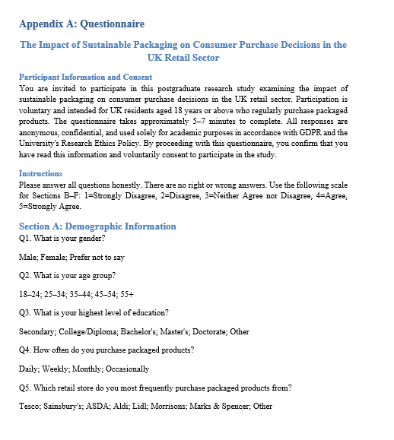
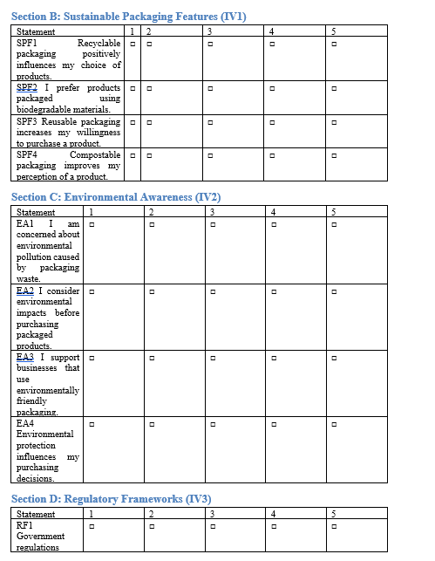
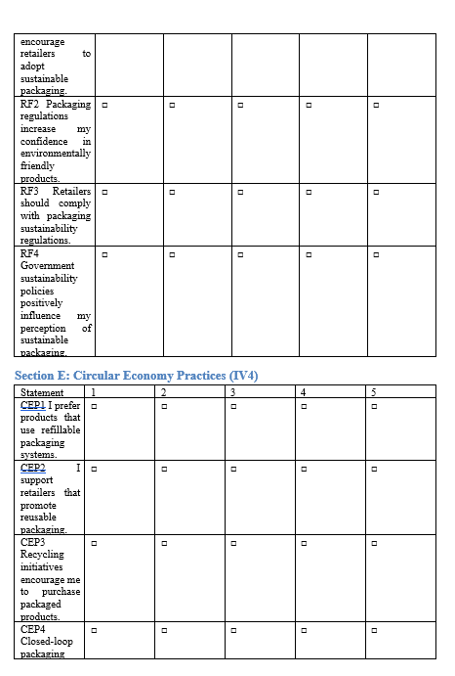
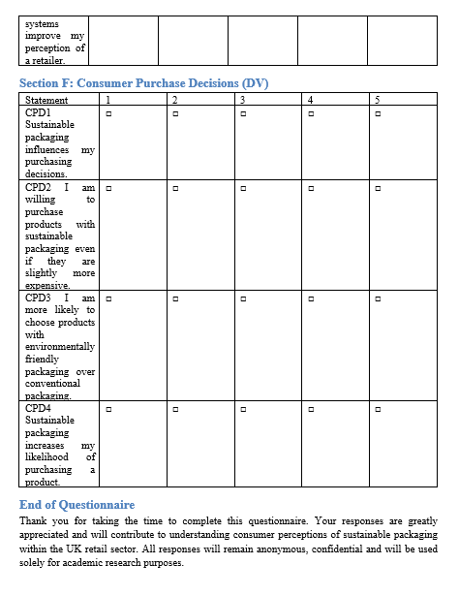

Appendix: Ethical Form
APPLICATION FOR ETHICAL APPROVAL – INTRODUCTORY NOTES

In order for research to result in benefit and minimise risk of harm, it must be conducted ethically. A researcher may not be covered by the University’s insurance if ethical approval has not been obtained prior to commencement.

The University follows the OECD Frascati manual definition of research activity:
“[C]reative work undertaken on a systematic basis in order to increase the stock of knowledge, including knowledge of man, culture and society, and the use of this stock of knowledge to devise new applications”.
As such this covers activities undertaken by:
- Members of staff (academic staff or support staff);
- Individuals holding honorary title from the University;
- Postgraduate research students;
In all of these cases ethical review is required regardless of discipline.

The individual undertaking the research activity is known as the lead researcher.

Ethical approval is not required for routine audits, performance reviews, quality assurance studies, testing within normal educational requirements, and literary or artistic criticism.

For most projects you will only need to complete sections in the main part of the form. A few projects will need more detailed ethical consideration and will need you to fill in sections in an appendix. At some points in this form you will be asked questions about your research in the following way:

1 | Does your research involve <<something specific>>? | YES | Click to continue to appendix <<N>> | NO | Continue to the next section
2 | Have you completed appendix <<N>>? | YES | ☐ | NO | ☑

Clicking in the appropriate box will take you to the appropriate location in the text. At the end of each appendix is a box. Clicking on this will return you to the question that originally took you to the appendix.

Return to the main form

NB These clickable links will only work if you are editing the document in the desktop version of Word, not the browser version. Please download and save the form before editing it.

Guidance notes are provided as comments or as text IN GREEN throughout this form. Please ensure that the comments are removed and that the green text is replaced by your own text or removed as appropriate BEFORE submitting this form.

Please ensure that you have read the UWTSD Research Ethics and Integrity Policy and the UWTSD Research Data Management Policy BEFORE submitting this form.

APPLICATION FOR ETHICAL APPROVAL
SECTION A: About You (Lead Researcher)
1 | Full Name: |  | BHAVDIP MAHESHKUMAR GUDECHIYA
2 | Tick all boxes that apply: |  | Member of staff: |  | ☐ | Honorary research fellow: |  | ☐
2 | Undergraduate Student | ☐ | Taught Postgraduate Student |  | ☐ | Postgraduate Research Student |  | ☒
3 | Institute/Academic Discipline/Centre: |  | Swansea Campus
4 | Campus: |  | IQ-CAMPUS
5 | E-mail address: |  | 2506737@student.uwtsd.ac.uk
6 | Contact Telephone Number: |  | 07818924570
7 | Project Title |  | "The Impact of Sustainable Packaging on Consumer Purchase Decisions in the UK Retail Sector"
8 | Proposed Start Date |  | 20 MAY, 2026 | Proposed End Date |  |  | 25 SEPTEMBER, 2026
For students:
9 | Student Number: |  | 2506737
10 | Programme of Study: |  | MASTER OF BUSINESS ADMINISTRATION
11 | Director of Studies/Supervisor: |  | Daniela Hellyer

SECTION B: Grant or Contract Funding
1 | Has your research been awarded, applied for, or intend to apply for external funding? | YES | Click to continue to appendix 1 | NO | Continue to the next section
2 | Have you completed appendix 1? | YES | ☐ | NO | ☑

SECTION C: Internal and External Ethical Guidance Materials
Ethical Guidance Documents
Please list the core ethical guidance documents that have been referred to during the completion of this form (including any discipline-specific codes of research ethics, location-specific codes of research ethics, and also any specific ethical guidance relating to the proposed methodology). Please tick to confirm that your research proposal adheres to these codes and guidelines. You may add rows to this table if needed.
1 | UWTSD Research Ethics & Integrity Policy | ☒
2 | UWTSD Research Data Management Policy | ☒
3 | UWTSD Open Access Publications Policy | ☒
4 | UWTSD Export Control Policy  Required if Appendix 8 completed | ☐
5 | UWTSD Trusted Research and Innovation Policy  Required if research is taking place outside the UK | ☐
6 | [List any other relevant documents here] | ☐

SECTION D: External Collaborative Research Activity
1 | Does your research involve collaborating partners at another institution or organisation? | YES | Click to continue to appendix 2 | NO | Continue to the next section
2 | Have you completed appendix 2? | YES | ☐ | NO | ☑

SECTION E: Details of Research Activity
Aims, Vision and Approach of the Research (maximum 200 words per section)
Please outline what are you hoping to achieve with your proposed work and how will you deliver it?
1 | Research aims and objectives
Aim
To analyse the impact of sustainable packaging on consumer purchase decisions within the UK retail sector.
Objectives
- To examine the concept and development of sustainable packaging within the UK retail sector.
- To analyse the impact of sustainable packaging features on consumer purchase intentions.
- To evaluate the influence of environmental awareness on consumer purchasing behaviour.
- To assess the role of regulatory frameworks in sustainable packaging adoption.
- To recommend strategies for improving sustainable packaging practices within UK retail businesses.

(this box should expand as you type)
2 | Vision
Explain how your research:
- Is of importance within or beyond your area of research
- Has the potential to advance current understanding, generates new knowledge, thinking or discovery within or beyond the field or area
- Is timely given current trends, context and needs
- Has the potential to generate impact in society, the economy or the environment

This research is important because sustainable packaging has become a major issue for retailers, policymakers, and consumers due to increasing environmental concerns and packaging waste. The study will contribute to current knowledge by examining how sustainable packaging influences consumer purchase decisions within the UK retail sector. The findings may help retailers understand consumer preferences and support evidence-based sustainability strategies. The research is timely because businesses face increasing pressure from environmental regulations, ESG expectations, and changing consumer attitudes. The study has the potential to contribute to environmental sustainability by encouraging more effective sustainable packaging practices and supporting responsible consumption behaviour.

(this box should expand as you type)
3 | Approach
Explain your approach and how you have designed:
- Clearly describe both the methodological framework for data collection (if applicable) and any specific analysis methods proposed, making it clear what specific techniques may be used
- Explain the reasons for their choice
- Explain how these are feasible, effective and proportionate to achieve your objectives
- Identify any risks to delivery and how they will be managed
- Explain how your approach will maximise translation of outputs into outcomes and impacts

This study will adopt a quantitative research methodology under a positivist philosophy and deductive approach. Primary data will be collected through an online questionnaire distributed to UK retail consumers. The questionnaire will include structured Likert-scale questions measuring perceptions of sustainable packaging, environmental awareness, regulatory influences, and purchasing behaviour. Data will be analysed using SPSS software through descriptive statistics, frequencies, percentages, cross-tabulation, and correlation analysis.
The approach is appropriate because it enables objective measurement of relationships between variables and allows findings to be statistically analysed. Potential risks include low response rates and self-reported bias. These risks will be reduced through online distribution to a larger audience and careful questionnaire design.

(this box should expand as you type)
4 | Location of research activity  Identify all locations where research activity will take place.
The research will be conducted online across the United Kingdom. Data collection will take place through an online questionnaire administered via Google Forms and distributed through social media platforms, online consumer groups, and personal networks. Data analysis will be conducted remotely using SPSS software. No face-to-face data collection activities will take place.

(this box should expand as you type)

5 | Will any of your research be undertaken outside of the UK? | YES | Click to continue to appendix 3 | NO | Continue to the next section
6 | Have you completed any of appendix 3? | YES | ☐ | NO | ☑

SECTION F: Research Methods
Will the research activity include: |  | YES | NO
1 | Use of a questionnaire or similar research instrument? | ☒ | ☐
2 | Use of interviews? | ☐ | ☒
3 | Use of focus groups? | ☐ | ☒
4 | Use of participant diaries? | ☐ | ☒
5 | Use of video or audio recording? | ☐ | ☒
6 | Use of computer-generated log files? | ☐ | ☒
7 | Participant observation with their knowledge? | ☐ | ☒
8 | Participant observation without their knowledge? | ☐ | ☒
9 | Access to personal or confidential information without the participants’ specific consent? | ☐ | ☒
10 | Administration of any questions, test stimuli, presentation that may be experienced as physically, mentally or emotionally harmful / offensive? | ☐ | ☒
11 | Performance of any acts which may cause embarrassment or affect self-esteem? | ☐ | ☒
12 | Investigation of participants involved in illegal activities? | ☐ | ☒
13 | Use of procedures that involve deception? | ☐ | ☒
14 | Administration of any substance, agent or placebo? | ☐ | ☒
15 | Working with live vertebrate animals? | ☐ | ☒
16 | Procedures that may have a negative impact on the environment? | ☐ | ☒
17 | Other primary data collection methods. Please indicate the type of data collection method(s) below. | ☐ | ☒
Details of any other primary data collection method:  (this box should expand as you type) |  | ☐ | ☒

SECTION G: Research Participants

Research participants include people who will be taking part in your research as providers of research data (e.g. being interviewed, answering questionnaires, or doing user testing of hardware or software). This includes animal participants.
1 | Does your research involve human or non-human participants? | YES | Continue this section | NO | Click to continue to section N

Participant numbers and source
How will you ensure an appropriately convened sample group in order to meet the aims of the research? Give details for subgroups separately, if appropriate. How will any potential pitfalls, for example dual roles or potential for coercion, be addressed?
1 | How many participants will be recruited and how was the number decided upon? | Approximately 150–200 participants will be recruited. This sample size is considered appropriate for quantitative analysis and is consistent with postgraduate research requirements. The sample size will provide sufficient responses for descriptive and correlation analysis using SPSS.  (this box should expand as you type)
2 | Who will the participants be? | Participants will be UK retail consumers aged 18 years and above who regularly purchase packaged consumer products from retail stores or online retailers.  (this box should expand as you type)
3 | How will you identify the participants? | Participants will be identified through convenience sampling. The questionnaire will be distributed through social media platforms, online consumer groups, and personal and professional networks.  (this box should expand as you type)
4 | Will you be excluding any groups of people, and if so what is the rationale for that? | Individuals under the age of 18 will be excluded because they cannot legally provide independent consent. Participants who do not regularly purchase packaged retail products will also be excluded as they do not meet the study requirements.  (this box should expand as you type)
5 | Will the research involve any element of deception? If yes, please describe why this is necessary and whether participants will be informed at the end of the study | No deception will be used in this research.  (this box should expand as you type)
6 | Describe whether participants will be able to withdraw from the study, and up to what point (eg if data is to be anonymised). If withdrawal is not possible, after a certain point, explain why not. | Participants will be able to withdraw at any time before submitting their questionnaire. Once responses have been submitted and anonymised, withdrawal may not be possible because individual responses cannot be identified.  (this box should expand as you type)
7 | How long will the participant have to decide whether to take part in the research? | Participants will be given sufficient time to read the participant information sheet before deciding whether to participate. They may complete the survey at their convenience.  (this box should expand as you type)
8 | What arrangements have been made for participants who might have difficulties understanding verbal explanations or written information, or who have particular communication needs that should be taken into account to facilitate their involvement in the research? | The questionnaire will use simple and clear language. Participation is voluntary and online, allowing respondents to complete the survey at their own pace.  (this box should expand as you type)

SECTION H: Research with Vulnerable People
1 | Are your participants classed as vulnerable people? | YES | Click to continue to appendix 4 | NO | Continue to the next section
2 | Have you completed appendix 4? | YES | ☐ | NO | ☑

SECTION I: Research Involving Animals
1 | Are your participants non-human animals? | YES | Click to continue to appendix 5 | NO | Continue to the next section
2 | Have you completed appendix 5? | YES | ☐ | NO | ☑

SECTION J: Research with the Prison Service or the Probation Service
1 | Are your participants staff or offenders within the Prison Service or the Probation service? | YES | Click to continue to appendix 6 | NO | Continue to the next section
2 | Have you completed appendix 6? | YES | ☐ | NO | ☑

SECTION K: Health and Social Care Research
1 | Are your participants selected due to their health or social care needs? | YES | Click to continue to appendix 7 | NO | Continue to the next section
2 | Have you completed appendix 7? | YES | ☐ | NO | ☑

SECTION L: Types of Personal Data
Personal Data  Does the research activity involve personal data (as defined by the General Data Protection Regulation 2016 and the Data Protection Act 2018)? |  | YES | NO
1 | Personal data means any information relating to an identified or identifiable natural person (‘data subject’). An identifiable natural person is one who can be identified, directly or indirectly, in particular by reference to an identifier such as a name, an identification number, location data, an online identifier or to one or more factors specific to the physical, physiological, genetic, mental, economic, cultural or social identity of that natural person. Any video or audio recordings of participants and transcription of such are considered to be personal data. | ☒ | ☐
1 | If you ticked YES, provide a description of the data and explain why this data needs to be collected: | ☒ | ☐
The study will collect limited demographic information including age group, gender, education level and purchasing behaviour relating to packaged retail products. No names, addresses, telephone numbers, email addresses or other directly identifiable information will be collected. All responses will remain anonymous.

(this box should expand as you type)

Special Category Data  Does the research involve the processing of special category data (as defined by the General Data Protection Regulation 2016 and the Data Protection Act 2018)? |  |  | YES |  | NO
2 | Racial or ethnic origin |  | ☐ |  | ☒
3 | Political opinions |  | ☐ |  | ☒
4 | Religious or philosophical beliefs |  | ☐ |  | ☒
5 | Genetic, biometric or health data |  | ☐ |  | ☒
6 | Sex life or sexual orientation |  | ☐ |  | ☒
7 | Trade union membership |  | ☐ |  | ☒
If you ticked YES to any of questions L2-L7, provide a description of the data and explain why this special category data needs to be collected to support the research and that it is in the public interest to do so:
8 | (this box should expand as you type)
9 | Please describe how the research has been designed to gather the minimum amount of personal data necessary for the specified research purpose:
Only demographic information necessary for statistical analysis will be collected. No directly identifiable information will be requested.

(this box should expand as you type)
10 | Demonstrate that the processing is not likely to cause substantial damage or distress to individuals and that their interests will be safeguarded:
The research poses minimal risk. Participants will answer general questions regarding sustainable packaging and consumer behaviour. No sensitive topics will be discussed.

(this box should expand as you type)
11 | Demonstrate that the data will not be used to take any action or make decisions in relation to the individuals concerned:
The collected data will only be used for academic research purposes and will not be used to make decisions regarding any participant.

(this box should expand as you type)
12 | Data should be anonymised wherever possible, either at point of capture or once collated. If the data cannot be anonymised, and if pseudonymisation is not possible, demonstrate why the that is possible. If special category data cannot be anonymised, explicit consent to share that data must normally be obtained.
Responses will be anonymous at the point of collection. No identifying information will be collected, ensuring participant anonymity throughout the study.

(this box should expand as you type)
13 | If special category data cannot be anonymised, will you obtain explicit consent to share that data? | YES |  | NO |  | N/A
13 |  | ☐ |  | ☐ |  | ☒

SECTION M: Participant Information and Consent

Information for participants  It is normally expected that those participating in research should do so having given their informed consent. If this is not appropriate or practical, explicit justification must be provided, in line with prevailing disciplinary conventions. Please note however, that informed consent to participate in the research is separate from consent to process (e.g. collect, analyse, store, reuse or share) personal data, as the University’s lawful basis for processing personal data in research activities is part of its ‘public task’. |  | YES |  | NO |  | N/A
1 | Will you obtain written consent for participation? | ☒ |  | ☐ |  | ☐
2 | Will you describe the main research procedures to participants in advance, so that they are informed about what to expect? | ☒ |  | ☐ |  | ☐
3 | Will you tell participants that their participation is voluntary? | ☒ |  | ☐ |  | ☐
4 | Will you explain to participants that refusal to participate in the research will not affect their treatment or education (if relevant)? | ☒ |  | ☐ |  | ☐
5 | If the research is observational, will you ask participants for their consent to being observed? | ☐ |  | ☐ |  | ☒
6 | Will you tell participants that they may withdraw from the research at any time and for any reason? | ☒ |  | ☐ |  | ☐
7 | Will participants be made aware of how you will treat any information that may reasonably by considered as confidential? | ☒ |  | ☐ |  | ☐
8 | If your research requires your participants to sign up for a service provided by an external company or organisation will you inform them that their data may be stored and processed outside UWTSD? | ☒ |  | ☐ |  | ☐
9 | Will you give participants the UWTSD Privacy Notice for Research? | ☒ |  | ☐ |  | ☐
If you have answered NO to any of questions M1-M8, please provide justification detailing why this is necessary for the research.
10 | (this box should expand as you type)
Informed consent: Describe the arrangements to inform potential participants, before providing consent, of what is involved in participating. Describe the arrangements for participants to provide full consent before the research begins. If gaining consent in this way is inappropriate, explain how consent will be obtained and recorded.
11 | Participants will receive a Participant Information Sheet explaining the purpose of the study, participation requirements, confidentiality arrangements, and withdrawal rights. Consent will be obtained electronically before participants access the questionnaire.  (this box should expand as you type)
Confidentiality: Confidential information refers to information that can be related to an identifiable individual, whether living or deceased, which is not in the public domain and which is given with the expectation that it will be kept confidential. Under Common Law when an individual entrusts a researcher or research team with confidential information, the team must handle this in line with ‘reasonable expectations’. In other words, confidential information should only normally be shared when there would be ‘no surprises’ for the individuals concerned. Where participants would not expect the researcher to be sharing their confidential information with others, researchers can manage their expectations by informing them of their intentions (e.g. in the participant information sheet or during discussions about participation) and asking them if they are happy with these plans. They should understand what is being proposed and what this might mean for them, before they decide whether the researcher can share their confidential information with others.
Please detail how you will treat confidential information:
12 | All responses will remain anonymous and confidential. Data will be stored securely on password-protected devices accessible only to the researcher and supervisor. Results will be reported in aggregated form and individual participants will not be identifiable.  (this box should expand as you type)
Copies of any written consent form, written information and all other explanatory material should accompany this application. If you have included these then please list the documents included here.
13 | Sample information sheets and consent forms are available from the University ethical review intranet page at https://intranet.uwtsd.ac.uk/research/research-integrity-and-ethics  Copies of documents included with this application:  • Participant Information Sheet  • Online Participant Consent Form  • Online Questionnaire for the research project: “The Impact of Sustainable Packaging on Consumer Purchase Decisions in the UK Retail Sector”
14 | Consent form attached? |  | YES  ☒ |  | NO  ☐ |  | N/A  ☐

SECTION N: Research with Potential Military Application
1 | Does your research have any potential military application? | YES | Click to continue to appendix 8 | NO | Continue to the next section
2 | Have you completed appendix 8? | YES | ☐ | NO | ☑

SECTION O: Use of Artificial Intelligence Tools
Use of generative AI and other AI-based tools  There are a number of ethical issues relating to the use of generative AI and other AI-based tools, including data security, output bias, and output errors. In general you should assume that any generative AI or other AI-based tool that you pay to use is more secure and accurate than one which is free to use.  Will the research use AI tools to do any of the following: |  | YES | NO | N/A
1 | Capture data? | ☐ | ☒ | ☐
2 | Generate and/or edit text? | ☐ | ☒ | ☐
3 | Generate graphics? | ☐ | ☒ | ☐
4 | Generate video? | ☐ | ☒ | ☐
5 | Generate sound/music? | ☐ | ☒ | ☐
6 | Generate code? | ☐ | ☒ | ☐
7 | Generate synthetic data? | ☐ | ☒ | ☐
8 | Analyse data? | ☐ | ☒ | ☐
9 | Analyse personal or sensitive data? | ☐ | ☒ | ☐
10 | Classify data? | ☐ | ☒ | ☐
11 | Do you intend to use the free version of any AI tools? | ☐ | ☒ | ☐
If you have answered YES to any of questions O1-O11, please provide justification detailing why this is necessary for the research.
12 | (this box should expand as you type)

Section P: Research Data Management Plan

1 | Data Summary
The study will generate quantitative questionnaire data collected from UK retail consumers regarding sustainable packaging and purchasing behaviour.

2 | Responsibilities
- The researcher will be responsible for data collection, storage, analysis, and management under the supervision of the dissertation supervisor.

3 | Assessment of existing data
- No existing datasets will be used. Primary data will be collected through questionnaires.
4 | Management and curation of data
- Data will be organised in SPSS and Excel files with clear variable labels and coding procedures.
5 | Quality assurance of data
- Pilot testing, questionnaire validation, and data cleaning procedures will be applied.
6 | Short-term data storage
- Data will be stored on password-protected devices and secure cloud storage.
7 | Long-term data storage and preservation
- Anonymised data will be retained for five years in accordance with university policy.

8 | Documentation and metadata
- A codebook, questionnaire, and SPSS dataset documentation will accompany the data.
9 | Data sharing
- Only anonymised aggregated findings may be shared within the dissertation and academic publications.
10 | Copyright and intellectual property ownership
- Copyright and intellectual property will belong to the researcher and UWTSD according to university regulations.
11 | Resources
- Resources include Google Forms, SPSS software, university library databases, internet access, and personal computer equipment.

SECTION Q: Risk Assessment

Outline any anticipated risks that may adversely affect any of the participants, the researchers and/or the University, and the steps that will be taken to address them.

If you have completed a full risk assessment (for example as required by a laboratory, or external research collaborator) you may append that to this form.
1 | Full risk assessment completed and appended? |  | YES | NO
1 |  |  | ☐ | ☒
Risks to participants, researchers, and the University
2 | Social risks: disclosures that could affect participants standing in the community, in their family and their job. |  | YES | NO
2 |  |  | ☒ | ☐
Risk:  Participants may feel uncomfortable expressing their views on environmental issues or sustainable purchasing behaviour. There is a small risk that opinions disclosed could cause minor discomfort if confidentiality were breached.  (this box should expand as you type) |  | How will you address any risks?  Participation will be anonymous and voluntary. No names, contact details, or identifying information will be collected. Participants may skip any question they do not wish to answer and may withdraw before submitting the questionnaire. All responses will be reported in aggregated form only.
3 | Legal risks: activities that could result in the participant, researchers and / or University committing an offence; activities that might lead to a participant disclosing criminal activity to a researcher which would necessitate reporting to enforcement authorities; activities that could result in a civil claim for compensation |  | YES | NO
3 |  |  | ☒ | ☐
Risk:  The study presents minimal legal risk because it does not involve illegal activities, sensitive personal data, or questions relating to criminal behaviour. However, there is a small risk associated with the handling and storage of participant data.  (this box should expand as you type) |  | How will you address any risks?  Data will be collected and stored in accordance with UK GDPR and University policies. Only anonymous information will be collected. Data will be stored securely on password-protected devices and accessed only by the researcher and supervisor.
4 | Economic harm: financial harm to participant, researcher and / or University through disclosure or other event. |  | YES | NO
4 |  |  | ☒ | ☐
Risk:  There is a minor risk that confidential business or personal information disclosed during the research could result in financial or professional disadvantage if accidentally revealed to unauthorised individuals.  (this box should expand as you type) |  | How will you address any risks?  All data will be anonymised, stored securely on password-protected devices, and accessed only by the researcher. No identifiable financial or organisational information will be included in the final report. Participants may skip questions or withdraw from the study at any time without consequence.
5 | Reputational risk: damage to public perception of University or the University / researchers’ reputation in the eyes of funders, the research community and / or the general public. |  | YES | NO
5 |  |  | ☒ | ☐
Risk:  Participants or organisations may experience reputational harm if identifiable comments, opinions, or sensitive information are disclosed through the research findings.  (this box should expand as you type) |  | How will you address any risks?  Participant anonymity and confidentiality will be maintained throughout the study. No names, job titles, organisations, or identifying details will be reported. Findings will be presented in aggregated form and used solely for academic purposes. All data will be handled in accordance with GDPR and University ethical guidelines.
6 | Safeguarding risks: Risk to young people, vulnerable adults and / or researcher from improper behaviour, abuse or exploitation. Risk to researcher of being in a comprising situation, in which there might be accusations of improper behaviour. |  | YES | NO
6 |  |  | ☐ | ☒
Risk:  (this box should expand as you type) |  | How will you address any risks?
7 | Sensitive, embarrassing or upsetting topics. If research activity may include sensitive, embarrassing or upsetting topics or issues likely to disclose information requiring further action (e.g. criminal activity), give details of the procedures to deal with these issues, including any support/advice (e.g. helpline numbers) to be offered to participants. Note that where applicable, consent procedures should make it clear that if something potentially or actually illegal is discovered in the course of a project, it may need to be disclosed to the proper authorities. |  | YES | NO
7 |  |  | ☐ | ☒
(this box should expand as you type)
 | Health and safety risks
8 | Location hazards: for example: fire; visiting or working in participant’s homes; working in remote locations and in high crime areas; overseas travel; hot, cold or extreme weather conditions; working on or by water. Also hazardous work locations, such as construction sites, confined spaces, roofs or laboratories. For overseas travel, researchers will need to check country / city specific information, travel health requirements and consider emergency arrangements as part of their research planning. In all cases the University’s International Travel Policy must be followed. |  | YES | NO
8 |  |  | ☐ | ☒
Risk:  (this box should expand as you type) |  | How will you address any risks?
9 | Activity hazards: for example: potentially mentally harmful activities; distressing and stressful work and content; driving; tripping, or slipping; falling from height; physically demanding work; lifting, carrying, pushing and pulling loads; night time and weekend working. |  | YES | NO
9 |  |  | ☐ | ☒
Risk:  (this box should expand as you type) |  | How will you address any risks?
10 | Machinery and equipment: for example: ergonomic hazards, including computer workstations and equipment; contact with electricity; contact with moving, rotating, ejecting or cutting parts in machinery and instruments; accidental release of energy from machines and instruments. |  | YES | NO
10 |  |  | ☐ | ☒
Risk:  (this box should expand as you type) |  | How will you address any risks?
11 | Chemicals and other hazardous substances: the use, production, storage, waste, transportation and accidental release of chemicals and hazardous substances; flammable, dangerous and explosive substances; asphyxiating gases; allergens; biological agents, blood and blood products. |  | YES | NO
11 |  |  | ☐ | ☒
Risk:  (this box should expand as you type) |  | How will you address any risks?
12 | Physical agents: for example: excessive noise exposure, hand-arm vibration and whole body vibration; ionising radiation; lasers; artificial optical radiation and electromagnetic fields |  | YES | NO
12 |  |  | ☐ | ☒
Risk:  (this box should expand as you type) |  | How will you address any risks?
13 | Environmental risks: for example: accidental spillage of pollutants, damage to local ecosystems |  | YES | NO
13 |  |  | ☐ | ☒
Risk:  This research presents minimal risk to participants, researchers, and the University.  (this box should expand as you type) |  | How will you address any risks?  The study involves an anonymous online questionnaire addressing consumer attitudes towards sustainable packaging. No vulnerable participants, sensitive topics, physical activities, hazardous materials, or invasive procedures are involved. Appropriate measures relating to confidentiality, informed consent, data protection, and GDPR compliance will be implemented throughout the research process.

SECTION R: Disclosure and Barring Service

Disclosure and Barring Service
1 | If the research activity involves children or vulnerable adults, a Disclosure and Barring Service (DBS) certificate must be obtained before any contact with such participants. | YES | NO | N/A
 | Does your research require you to hold a current DBS Certificate? | ☐ | ☐ | ☒
2 | If YES, please give the certificate number. If the certificate number is not available please write “Pending”; in this case any ethical approval will be subject to providing the appropriate certificate number.

SECTION S: Declaration
The information which I have provided is correct and complete to the best of my knowledge. I have attempted to identify any risks and issues related to the research activity and acknowledge my obligations and the rights of the participants.

In submitting this application I hereby confirm that I undertake to ensure that the above named research activity will meet the University’s Research Ethics and Integrity Policy which is published on the website: https://www.uwtsd.ac.uk/research/research-ethics/

1 | Name of applicant | BHAVDIP MAHESHKUMAR GUDECHIYA
2 | Electronic or written signature of applicant:
3 | Date |   09/06/2026
4 | Name of Director of Studies | Supervisor: Daniela Hellyer
5 | Electronic or written signature of Director of Studies: | 
6 | Date | 11th June 2026

Checklist: Please complete the checklist below to ensure that you have completed the form according to the guidelines and attached any required documentation:
1 | ☒ | I have read the guidance notes supplied before completing the form.
2 | ☒ | I have completed all relevant sections of the form in full.
3 | ☒ | I have attached a copy of the Participant Information Sheet (PIS) or Consent Form
4 | ☐ | I have attached a completed copy of the Trusted Research and Innovation Checklist (where applicable)
5 | ☐ | I have attached a full risk assessment (where appropriate)
6 | ☒ | I understand that it is my responsibility to ensure that the above named research activity will meet the University’s Research Ethics and Integrity Code of Practice
7 | ☒ | I understand that it is my responsibility to ensure that the above named research activity will meet the University’s Research Data Management Policy
8 | ☒ | I understand that it is my responsibility to ensure that the above named research activity will meet the University’s Research Export Control Policy
9 | ☒ | I understand that it is my responsibility to ensure that the above named research activity will meet the University’s Open Access Research Policy
10 | I have completed the following appendices: |  | 1 | ☐ | 2 | ☐ | 3 | ☐ | 4 | ☐
10 |  |  | 5 | ☐ | 6 | ☐ | 7 | ☐ | 8 | ☐

All communications relating to this application during its processing must be in writing and emailed to pgresearch@uwtsd.ac.uk , with the title ‘Ethical Approval’ followed by your name.

APPENDIX 1 – Grant or Contract Funding

A1.1 | Has your research been awarded external funding? | YES | ☐ | NO | ☒
A1.2 | Have you applied for funding / awaiting decision? | YES | ☐ | NO | ☒
A1.3 | Are you intending to apply for funding? | YES | ☐ | NO | ☒
A1.4 | Funding Body
A1.5 | Lead institution (grant holder)
A1.6 | If awarded, grant reference
A1.7 | If awarded, grant value
A1.8 | If awarded, start date and duration

Return to the main form

APPENDIX 2: External Collaborative Research Activity

INSTITUTION 1
A2.1 | Name
A2.2 | Researcher name and position
A2.3 | Role in project (e.g. co-investigator)
A2.4 | Contact e-mail address
A2.5 | External Ethical Approval  Please detail the ethical approval required and arrangements for this partner. See Section 14 of the UWTSD Research Ethics and Integrity Policy. If approved, please supply confirmation. | Obtained? | YES | NO | PENDING
A2.5 |  | Obtained? | ☐ | ☐ | ☐

INSTITUTION 2
A2.6 | Name
A2.7 | Researcher name and position
A2.8 | Role in project (e.g. co-investigator)
A2.9 | Contact e-mail address
A2.10 | External Ethical Approval  Please detail the ethical approval required and arrangements for this partner. See Section 14 of the UWTSD Research Ethics and Integrity Policy. If approved, please supply confirmation. | Obtained? | YES | NO | PENDING
A2.10 |  | Obtained? | ☐ | ☐ | ☐

INSTITUTION 3
A2.11 | Name
A2.12 | Researcher name and position
A2.13 | Role in project (e.g. co-investigator)
A2.14 | Contact e-mail address
A2.15 | External Ethical Approval  Please detail the ethical approval required and arrangements for this partner. See Section 14 of the UWTSD Research Ethics and Integrity Policy. If approved, please supply confirmation. | Obtained? | YES | NO | PENDING
A2.15 |  | Obtained? | ☐ | ☐ | ☐

Add additional collaborators as needed

Return to the main form

APPENDIX 3: Research Undertaken Outside of the UK

A3.1 | Research activity outside of the UK  If research activity will take place overseas, you are responsible for ensuring that local ethical considerations are complied with and that the relevant permissions are sought. Specify any local guidelines (e.g. from local professional associations/learned societies/universities) that exist and whether these involve any ethical stipulations beyond those usual in the UK (provide details of any licenses or permissions required). Also specify whether there are any specific ethical issues raised by the local context in which the research activity is taking place, for example, particular cultural and/or legal sensitivities or vulnerabilities of participants. Describe the measures you have taken to comply with these and provide evidence of approvals etc. If you live in the country where you will do the research then please state this. If you have a local research supervisor or research advisor then please give their contact details here.
(this box should expand as you type)
A3.2 | Responsible Research and Innovation  If research is taking place overseas please refer to the UWTSD Trusted Research and Innovation Policy and complete the Trusted Research and Innovation Checklist and submit it with this form.
A3.3 | Confirm that you have read the Trusted Research and Innovation Policy | ☐

If you are a postgraduate research student working with a research supervisor or research advisor at your local university then you do not need to fill in any more sections of this appendix.  If you are working in a research collaboration with an overseas partner please complete the remaining sections of this appendix. | Return to the main form

Organisational Details
A3.4 | Name of Organisation
A3.5 | Country where organisation is based:
A3.6 | Registration number and name of registration body (examples of relevant registration bodies are government, tax, corporation, charity, educational authority):
(this box should expand as you type)
A3.7 | What is the legal status of the organisation? (for example: public university, private university, charity, private company, non-profit making company, government research organisation, independent research organisation) Please include the date of foundation. Note: We may be required to ask for evidence of this at a later stage.
(this box should expand as you type)
A3.8 | Is your organisation affiliated to any other organisation? (i.e. is the organisation legally part of a larger organisation or a group of larger organisations).
(this box should expand as you type)
A3.9 | Name(s) of investigators in the organisation who will be responsible for the collaborative research and innovation
(this box should expand as you type)

About New Partners
A3.10 | Why does a partner want to work with you?
(this box should expand as you type)
A3.11 | What are they expecting in return for their financial support or involvement?
(this box should expand as you type)
A3.12 | Is the organisation associated with a country which may be viewed as hostile to the UK or one which has different democratic and ethical values from our own? If you have ticked YES, please briefly describe below how you will maintain the UK’s democratic and ethical values within the research. | YES | NO
A3.12 |  | ☐ | ☐
(this box should expand as you type)
A3.13 | Has due diligence into the partner identified any involvement in research on behalf of the military or police with links to a hostile state? If you have ticked YES, please summarise below how you will prevent information from this research from being released to these organisations. | YES | NO
A3.13 |  | ☐ | ☐
(this box should expand as you type)
A3.14 | Set within the context of any information gained from due diligence, could your research be misused or have unintended applications which would be negative? If you have ticked YES, please summarise below how this might occur. | YES | NO
A3.14 |  | ☐ | ☐
(this box should expand as you type)
A3.15 | Are there any legal, regulatory or university policy constraints on undertaking your research with this partner? If you have ticked YES, please summarise these below. | YES | NO
A3.15 |  | ☐ | ☐
(this box should expand as you type)
A3.16 | Having considered the answers to questions A3.10-A3.15, are there potential reputational or ethical risks to you or the university? If you have ticked YES, please summarise these risks below. | YES | NO
A3.16 |  | ☐ | ☐
(this box should expand as you type)

About Research Relationships |  | YES | NO
A3.17 | Are the terms of any proposed Memorandum of Understanding (MoU) in keeping with the expectations of your department and university? | ☐ | ☐
A3.18 | Are you providing existing intellectual property (IP), research data, confidential or personally identifiable data to the project? If so, how is this going to be protected? | ☐ | ☐
(this box should expand as you type)
A3.19 | Who will own any IP that is generated?
(this box should expand as you type)
A3.20 | What plans do you have in place for protecting the resulting IP?
(this box should expand as you type)
A3.21 | What contractual requirements are you able to put in place to protect the interests of your academic institutions?
(this box should expand as you type)
A3.22 | What access will the research partner have to your IT network? If they do have access, what broader visibility might this provide?
(this box should expand as you type)
A3.23 | Is there any physical separation or protection required between research in similar fields?
(this box should expand as you type)

About Existing Partners
A3.24 | Would proceeding with the research raise potential conflicts of interest with existing research partners? If you have ticked YES, please explain these conflicts below. | YES | NO
A3.24 |  | ☐ | ☐
(this box should expand as you type)
A3.25 | Have you spoken with your existing partners about any potential conflict of interest? If you have ticked YES, please briefly summarise their response(s) below. | YES | NO
A3.25 |  | ☐ | ☐
(this box should expand as you type)
A3.26 | Does any non-disclosure agreement for this project include an expectation that you will need to provide visibility to existing partners? If you have ticked YES, please explain below how this will be managed. | YES | NO
A3.26 |  | ☐ | ☐
(this box should expand as you type)
A3.27 | Will this research breach any existing contractual agreements that you, your department or university already have? If you have ticked YES, please explain below how this will be managed. | YES | NO
A3.27 |  | ☐ | ☐
(this box should expand as you type)

Return to the main form

APPENDIX 4: Research with Vulnerable People

Will the research involve data processing involving the following data subjects: |  |  |  |  | YES |  | NO
A4.1 | Children under 16 |  |  |  | ☐ |  | ☐
A4.2 | Adults with learning disabilities |  |  |  | ☐ |  | ☐
A4.3 | Adults with other forms of mental incapacity or mental illness |  |  |  | ☐ |  | ☐
A4.4 | Adults in emergency situations |  |  |  | ☐ |  | ☐
A4.5 | Prisoners or young offenders |  |  |  | ☐ |  | ☐
A4.6 | Those who could be considered to have a particularly dependent relationship with the investigator, e.g. members of staff, students |  |  |  | ☐ |  | ☐
A4.7 | People who have not given their explicit consent to participate in the project |  |  |  | ☐ |  | ☐
A4.8 | People engaged in illegal activities |  |  |  | ☐ |  | ☐
A4.9 | Any other people who can be considered vulnerable in the context of this project |  |  |  | ☐ |  | ☐
Please justify the inclusion of the above people (if applicable), explaining why the research cannot be conducted on non-vulnerable people.
A4.10 | (this box should expand as you type)
Please give details of extra steps taken to assure the protection of vulnerable people participating in the research. You should describe any arrangements to be made for obtaining consent from a legal representative.
A4.11 | (this box should expand as you type)
It is the researcher’s responsibility to check whether a DBS check (or equivalent) is required and to obtain one if it is needed. Please confirm:
A4.12 | DBS Check required? | YES |  | NO
A4.12 | DBS Check required? | ☐ |  | ☐
A4.13 | DBS certificate obtained? | YES | NO |  |  | N/A
A4.13 | DBS certificate obtained? | ☐ | ☐ |  |  | ☐

Return to the main form

APPENDIX 5: Research Involving Animals
The use of animals in research is tightly governed and monitored by law and by the Home Office, specifically under the Animals (Scientific Procedures) Act 1986 and its accompanying codes of practice and processes. The Act regulates procedures that are carried out on protected animals for scientific or educational purposes that may cause pain, suffering, distress or lasting harm. Under the Act, a protected animal is ‘any living vertebrate, other than man, and any living cephalopod’. The University does not hold a Home Office issued Establishment Licence and therefore researchers must ensure that any proposed work involving animals is either exempt from the Act or falls outside of its scope. Exempted research, for example involving routine veterinary practice or clinical veterinary research, may still require external ethical approval from the Royal Society of Veterinary Surgeons. When undertaking collaborative research involving animals, the UWTSD Research Ethics Committee must be assured that the partner institution(s) conform to the appropriate regulatory framework or legislation, and have approval from their local Research Ethics Committee. Any such work must follow the guidance of the National Centre for the Replacement, Reduction and Refinement of Animals in Research, known as the 3Rs. In all cases, advise must be sought from INSPIRE for any proposed research involving animals, either at UWTSD, or by research collaborators in partnership with UWTSD. This should be at the very early stages of research design, so that an appropriate due diligence exercise can be undertaken.
Will the research involve any work with any of the following animals (including observation in their natural habitat) |  | YES | NO
A5.1 | Any living vertebrates, other than humans? | ☐ | ☐
A5.2 | Any living cephalopods? | ☐ | ☐
A5.3 | Has INSPIRE undertaken an initial due diligence exercise? | ☐ | ☐
A5.4 | Due diligence assessment appended to this application? | ☐ | ☐
Please provide a summary of the due diligence exercise, noting arrangements for compliance with the necessary regulatory frameworks and legislation. Please append the full due diligence assessment from INSPIRE.
A5.5 | (this box should expand as you type)

Return to the main form

APPENDIX 6: Research with Staff or Offenders in Prison Establishments and Probation Services

Research with staff and/or offenders in prison establishments, the Probation Service or within His Majesty’s Prison and Probation Services requires additional approvals.
Will the research involve any of the following? |  | YES | NO
A6.1 | Staff in prison establishments | ☐ | ☐
A6.2 | Offenders in prison establishments | ☐ | ☐
A6.3 | The Probation Service | ☐ | ☐
A6.4 | His Majesty’s Prison and Probation Services | ☐ | ☐
All researchers wanting to conduct research with staff and/or offenders in prison establishments, the Probation Service regions or within HM Prison and Probation Service (HMPPS) Headquarters are required to formally apply for research approval to the HMPPS National Research Committee (NRC). Before doing so, INSPIRE must undertake an initial due diligence exercise. If you have not contacted INSPIRE, please do so immediately. If YES to any of the above, please confirm:
A6.5 | Has INSPIRE undertaken an initial due diligence exercise? | ☐ | ☐
A6.6 | Have you applied to the HMPPS National Research Committee (NRC)? | ☐ | ☐
A6.7 | Has HMPPS National Research Committee approval been granted? If yes, please append to this application. | ☐ | ☐
A6.8 | Due diligence assessment appended to this application? | ☐ | ☐
Please provide a summary of the due diligence exercise, noting arrangements for compliance with the necessary regulatory frameworks and legislation. Please append the full due diligence assessment from INSPIRE.
A6.9 | (this box should expand as you type)

Return to the main form

APPENDIX 7: Health and Social Care Research
All health and social care research must have a sponsor as defined by the Health Research Authority UK Policy Framework for Health & Social Care. The University will under no circumstances act as the sponsor of health and social care research (i.e. that which requires approval by a NHS Research Ethics Committee). In all cases, therefore, an appropriate collaborating partner must lead the research. Any health and social care research therefore requires an initial due diligence exercise, which will be undertaken by INSPIRE. The purpose of the due diligence exercise is to ensure that the University has the capability to undertake the research, either independently or in collaboration with research partners. This will include advice on suitable collaborative arrangements and the appropriate involvement of UWTSD researchers in the proposed research study. This is likely to apply to the following areas:
Will the data processing involve: |  |  |  | YES |  |  | NO
A7.1 | Participants who have been recruited on the basis of medical and health conditions, life stage or other physical or mental attribute. |  |  | ☐ |  |  | ☐
A7.2 | Participants who will engage in physical exercise, activity or exertion of any kind, or who use exercise equipment, assistive devices or other apparatus for the purposes of the research study. This includes interventions that are minimally invasive. |  |  | ☐ |  |  | ☐
A7.3 | Patients and users of the NHS (including NHS patients treated in the private sector). |  |  | ☐ |  |  | ☐
A7.4 | Individuals identified as potential participants because of their status as relatives or carers of patients and users of the NHS. |  |  | ☐ |  |  | ☐
A7.5 | Patients who are cared for in private and voluntary sector nursing homes. |  |  | ☐ |  |  | ☐
A7.6 | Confidential patient information. |  |  | ☐ |  |  | ☐
A7.7 | Clinical trial of a medicinal product or medical device. |  |  | ☐ |  |  | ☐
A7.8 | Access to organs or other bodily material of past and present NHS patients, or any material consisting of or containing human cells. |  |  | ☐ |  |  | ☐
A7.9 | Use of human tissue (including non-NHS sources) where the collection is not covered by a Human Tissue Authority licence. |  |  | ☐ |  |  | ☐
A7.10 | Foetal material and IVF involving NHS patients. |  |  | ☐ |  |  | ☐
A7.11 | The recently deceased under NHS care. |  |  | ☐ |  |  | ☐
A7.12 | NHS staff or premises. |  |  | ☐ |  |  | ☐
A7.13 | Practising midwives conducting a clinical trial. |  |  | ☐ |  |  | ☐
A7.14 | Investigational medicinal product. |  |  | ☐ |  |  | ☐
A7.15 | Medical devices that are not CE-marked or CE-marked medical devices that have been modified or are being used for a new purpose. |  |  | ☐ |  |  | ☐
A7.16 | Exposure to ionising radiation. |  |  | ☐ |  |  | ☐
A7.17 | Other health and social care related research. |  |  | ☐ |  |  | ☐
Please specify  (this box should expand as you type) |  |  |  |  |  |  | ☐
Researchers proposing to work on projects involving health and social care research must check whether their study meets the HRA definition of research and whether it should undergo ethics review by a NHS Research Ethics Committee. If you have answered YES to any of questions A7.1-A7.17 then this is likely to be the case and sponsorship by a third party will be required. This can be checked via the Health Research Authority’s Decision Tool : https://www.hra-decisiontools.org.uk/research/
A7.18 | Does the research meet the HRA definition of research? | YES | NO |  |  | N/A
A7.18 | Does the research meet the HRA definition of research? | ☐ | ☐ |  |  | ☐
A7.19 | Is the Research being sponsored by a collaborating partner? | YES | NO |  |  | N/A
A7.19 | Is the Research being sponsored by a collaborating partner? | ☐ | ☐ |  |  | ☐
A7.20 | Has NHS ethics approval been granted? | YES | NO |  |  | N/A
A7.20 | Has NHS ethics approval been granted? | ☐ | ☐ |  |  | ☐
A7.21 | Has INSPIRE undertaken an initial due diligence exercise? | YES |  |  | NO
A7.21 | Has INSPIRE undertaken an initial due diligence exercise? | ☐ |  |  | ☐
Please provide a summary of the due diligence exercise, noting arrangements for compliance with the necessary regulatory frameworks and legislation. Please append the full due diligence assessment from INSPIRE. If you have not contacted INSPIRE, please do immediately.
A7.22 | (this box should expand as you type)

A7.23 | Have you been granted NHS ethical approval? | YES | Click to continue to Section R | NO | Return to the main form

APPENDIX 8: Export Control for Research with Potential Military End Uses
Export controls apply to the physical, electronic or oral transmission outside the UK of applied research, sensitive technology, software and equipment that could potentially be misused, either directly or indirectly, for military purposes. These legal controls are a serious obligation and UWTSD researchers must actively manage the risks of these being misused to fuel conflict, threaten national security, support terrorism and crime, violate human rights or proliferate Weapons of Mass Destruction. UWTSD’s Export Control Policy provides a clear six step process to determine if your research is covered by export controls. Please complete the following screening to judge if you need to compete a full export control assessment. If you are in any doubt, then please contact INSPIRE. Any research in UWTSD involving the following high-risk areas must be screened.
Will the research involve:
Defence |  | YES | NO
A8.1 | Military equipment and munitions | ☐ | ☐
A8.2 | Defence equipment, including satellites | ☐ | ☐
A8.3 | Technical data, including some border and port information | ☐ | ☐
A8.4 | Dual use research | ☐ | ☐
Materials and Technologies |  | YES | NO
A8.5 | Nuclear materials, facilities and equipment | ☐ | ☐
A8.6 | Chemicals, microorganisms and toxins | ☐ | ☐
A8.7 | Electronics design, development and production | ☐ | ☐
A8.8 | Computers | ☐ | ☐
A8.9 | Telecommunications | ☐ | ☐
A8.10 | Sensors and lasers | ☐ | ☐
A8.11 | Navigation and avionics | ☐ | ☐
A8.12 | Marine technology | ☐ | ☐
A8.13 | Composite materials | ☐ | ☐
A8.14 | Aerospace and propulsion | ☐ | ☐
Sensitive Information |  | YES | NO
A8.15 | Cryptology | ☐ | ☐
A8.16 | Counterterrorism | ☐ | ☐
A8.17 | Counternarcotics | ☐ | ☐
A8.18 | Cyber-related | ☐ | ☐
A8.19 | Non-proliferation | ☐ | ☐
A8.20 | Transnational criminal organisations | ☐ | ☐

Genetic Resources |  | YES | NO
A8.21 | Genetic material of actual or potential value | ☐ | ☐
A8.22 | Organisms, or parts thereof | ☐ | ☐
A8.23 | Populations (or organisms) | ☐ | ☐
A8.24 | Other biotic components of ecosystems | ☐ | ☐
A8.25 | Domesticated or cultivated species in which the evolutionary process has been influenced by humans | ☐ | ☐

Will you be exporting military or dual-use technology, now or possibly in the future? This information may take many forms, including: |  | YES | NO
A8.26 | Physical transfer of goods, technologies, material or equipment | ☐ | ☐
A8.27 | Blueprints | ☐ | ☐
A8.28 | Plans | ☐ | ☐
A8.29 | Diagrams | ☐ | ☐
A8.30 | Models | ☐ | ☐
A8.31 | Formulae | ☐ | ☐
A8.32 | Tables | ☐ | ☐
A8.33 | Engineering designs and specifications | ☐ | ☐
A8.34 | Manuals and instructions | ☐ | ☐
A8.35 | Software | ☐ | ☐
A8.36 | Know-how | ☐ | ☐

Will your project transfer technology using any of the following physical methods? |  | YES | NO
A8.37 | USB flash drives | ☐ | ☐
A8.38 | Portable hard drives | ☐ | ☐
A8.39 | Laptops | ☐ | ☐
A8.40 | Tablets | ☐ | ☐
A8.41 | Intangible forms by using electronic media, such as email, phone storage and cloud file sharing | ☐ | ☐
A8.42 | Physical exports | ☐ | ☐

Will your project involve any of the following? |  | YES | NO
A8.43 | Oral transfer by phone or videoconferencing or presentations | ☐ | ☐
A8.44 | Travelling overseas for any purpose, while unintendingly carrying any of the above. | ☐ | ☐
A8.45 | Will you be hosting foreign visitors? | ☐ | ☐

If you answer YES to any of questions A8,1-A8.45 then you should complete a full export control assessment and append that to this application. Before doing this please contact INSPIRE who will advise further. |  | YES | NO
A8.46 | Full export control assessment required? | ☐ | ☐
A8.47 | Full export control assessment completed? | ☐ | ☐
A8.48 | Full export control assessment appended? | ☐ | ☐

Return to the main form

Consent Form Guidelines

The informed consent process requires that prospective participants are provided with as much information as possible about a research project in order that they and / or their legal guardians / advocates can make an “informed decision” about whether or not they want to take part in the project.

Consent forms should be provided after the participant has read and had time to consider all the information provided on the participant information sheet. With this in mind, this document has been produced to act as guidance for staff and students when designing their consent forms.

General Information

The design of your consent form should reflect the nature of the research study. Some consent forms may therefore need to be more detailed than others; or may use graphics rather than just text. If you are researching a vulnerable population or working with children please adapt your consent forms to the appropriate language and layout.

Consent forms should be signed and dated by the participant – or witnessed in the case of verbal assent - and name of person taking consent and stored securely for the appropriate amount of time.

In the case of online studies involving anonymous data collection at a single time point, it is good practice to create an introductory information page where participants can read information on the study and then tick a box to indicate understanding of the information and agreement to take part in the study.

Please see below the UWTSD Consent Form template which consist of mandatory statements which apply to each research project. Appendix 1 details optional statements which apply only to specific studies. Please read these carefully and add any that are appropriate to your research project.

Please note:

- If an amendment to a document is made, the version number and date must also be amended.
- Failure to include version dates will slow up the approval process as they will be sent back to the researcher for amendment.

It is essential that any logos, project titles, contact details, etc. are consistent across all documents, and that a record of the changes to documents is logged through version numbers and dates for each document.

The template provided on the following pages reflects the best practice in research ethics and data protection for most studies. However, for some studies it may be necessary to include additional consenting statements (for example, to obtain specific consent for transferring personal data outside the UK and EU); or to deviate from the University template in order to ensure that the consent form is suitable for the study population (for example, research involving children). Additional consent statements and examples of tailored consent forms for specific groups can be found in the appendices.

Participant Consent Form
Version number and date: Version 1.0, 09/06/2026
Research ethics approval number: Pending / To be confirmed by UWTSD
Title of the research project: The Impact of Sustainable Packaging on Consumer Purchase Decisions in the UK Retail Sector
Name of researcher: BHAVDIP MAHESHKUMAR GUDECHIYA
Please tick each box to confirm your consent:
- I confirm that I have read and understood the Participant Information Sheet dated 09/06/2026 for the above study. I have had the opportunity to consider the information and understand what participation involves. ☐
- I understand that taking part in the study involves completing an anonymous online questionnaire about sustainable packaging, environmental awareness and consumer purchase decisions in the UK retail sector. ☐
- I understand that my participation is voluntary and that I am free to stop taking part at any time before submitting the questionnaire, without giving a reason and without my rights being affected. I also understand that I am free to decline to answer any question. ☐
- I understand that I can withdraw before submitting the questionnaire. However, once I have submitted the questionnaire, withdrawal may not be possible because the responses will be anonymous and cannot be linked back to me. ☐
- I understand that the information I provide will be held securely and managed in accordance with UK GDPR and University of Wales Trinity Saint David data protection requirements. ☐
- I understand that no names, addresses, telephone numbers, email addresses or other directly identifiable personal information will be collected. ☐
- I understand that the research data will be stored securely on password-protected devices and/or secure cloud storage, and only the researcher and academic supervisor will have access to it. ☐
- I understand that the findings will be reported in aggregated form in an MBA dissertation and that I will not be personally identified in the research report. ☐
- I agree to take part in the above study. ☐
Participant confirmation:
By ticking the consent boxes and continuing to the questionnaire, I confirm that I consent to participate in this research study.
Researcher: BHAVDIP MAHESHKUMAR GUDECHIYA
Student Investigator
University of Wales Trinity Saint David
Email: 2506737@student.uwtsd.ac.uk
Supervisor: Daniela Hellyer
University of Wales Trinity Saint David

Appendix 1: Optional statements (choose as appropriate)

This section provides examples of statements that may be appropriate to specific types of studies; but which will not be appropriate to all studies. Please read the sections below carefully and consider which statements are relevant to include in your study.

Situations where the participant information sheet has been read to aloud to the participant [add the following statement above the signature line]

I have accurately read out the information sheet to the potential participant and, to the best of my ability, ensured that the participant understands to what they are freely consenting:

Transferring personal data outside the EU

I agree for my personal data to be transferred outside of the EU and I have been informed of the safeguards in place to protect my personal data when it is transferred.
☑

Transferring personal data outside the UK

I agree for my personal data to be transferred outside of the UK and I have been informed of the safeguards in place to protect my personal data when it is transferred.
☑

Open data and data sharing

I understand that the information I provide will be held securely at the UWTSD until it is [fully anonymised] and then deposited in the [Archive] for sharing and use by other authorised researchers to support other research in the future.
☑

I understand that other authorised researchers may use my words in publications, reports, webpages, and other research outputs, only if they agree to preserve the confidentiality of the information as requested in this form.
☑

I understand that personal information collected about me that can identify me, such as my name or where I live, will not be shared beyond the study team.
☑

Audio / video recordings

I understand and agree that my participation will be [audio recorded / video recorded] and I am aware of and consent to your use of these recordings for the following purposes: [specified purposes].
☑

Storage of documents

I understand that signed consent forms and [original audio/video recordings/ questionnaires] will be retained in [specify location and who has access to data] until [specific relevant period].
☑

I understand that a transcript of my interview will be retained for [specific relevant period].
☑

Exclusion criteria

I understand that I must not take part if… [list exclusion criteria, for example pregnancy].
☑

Risk to participants

I understand that taking part in the study has [description of risk] as a potential risk.
☑

Affording participants the opportunity to receive a copy of the report

The information you have submitted will be published as a report; please indicate whether you would like to receive a copy.
☑

Confidentiality of the data

I understand that my responses will be kept strictly confidential. I give permission for members of the research team to have access to my fully anonymised responses. I understand that my name will not be linked with the research materials, and I will not be identified or identifiable in the report or reports that result from the research.
☑

I understand that confidentiality and anonymity will be maintained and it will not be possible to identify me in any publications [Explain the possible anonymity options that you are offering participants and provide appropriate tick box options accordingly].
☑

Disclosure of criminal activity

I understand that the confidentiality of the information I provide will be safeguarded and won’t be released without my consent unless required by law. I understand that if I disclose information which raises considerations over the safety of myself or the public, the researcher may be legally required to disclose my confidential information to the relevant authorities.
☑

Use of quotes and fully identifiable information

I agree that my information can be quoted in research outputs such as [list research outputs].
☑☑

I would like my name used and I understand and agree that what I have said or written as part of this study will be used in reports, publications and other research outputs so that anything I have contributed to this project can be recognised.
☑

I agree that my real name can be used for quotes.
☑

Health-related findings in research

I agree for my GP to be contacted if any unexpected results are found in relation to my health.
☑

Re-contacting participants for the purpose of inviting them to take part in future studies
☑
I agree to being contacted at a later date and invited to take part in future studies. I understand that I am only agreeing to receive information and I am under no obligation to take part in any future studies. If you decide not to consent to being contacted in the future it will not have any influence on your involvement in this particular research study [and will not affect any standard of care that you receive (if relevant)].

For human material projects only:
☑
I agree to gift my samples to UWTSD and I consent to the storage and use of my samples for future unspecified research, including genetic analysis.

I agree to gift my samples to UWTSD l and I consent to the storage and use of my samples for future unspecified research.
☑

The potential benefits of storing my [sample] for future research have been explained to me and I consent to the use of my [sample] with ethical committee approval:
☑
I. For future similar studies
☑

II. For future unspecified research
☑

III. For future unspecified studies including genetic analysis* [if appropriate]
☑

IV. For future unspecified studies including commercial research* [if appropriate]
☑

V. For future unspecified studies including non-human models* [if appropriate]
☑

VI. I do not wish my [Sample] to be used for any purpose other than this study.
☑

I understand that I will not profit from any commercial research involving my [sample].

☑

I agree to being contacted at a later date and invited to take part in future studies of a similar nature.

I understand that I am only agreeing to receive information and I am under no obligation to take part in any future studies. If you decide not to consent to being contacted in the future it will not have any influence on your involvement in this particular research study [and will not affect any standard of care that you receive].
☑

I agree to being contacted at a later date and invited to take part in future studies. I understand that I am only agreeing to receive information and I am under no obligation to take part in any future studies. If you decide not to consent to being contacted in the future it will not have any influence on your involvement in this particular research study [and will not affect any standard of care that you receive].
☑

☑

I agree that my current and historical medical records may be accessed for the purpose of this study/this and future studies by members of the NHS Trust or regulatory authorities.
☑

☑

I understand that any samples or information given to research groups will be anonymised and my identity will be protected.

I understand that I am free to withdraw my consent and request destruction of my [sample] without giving a reason and without my medical treatment or legal rights being affected.
☑

Appendix 2: Example participant consent forms

Examples of participant consent forms can be accessed through the following links:

- Health Research Authority
- UK Data Service

Examples of age appropriate consent forms for children can be found using the below resources:

- Health Research Authority
- Global Kids Online

UWTSD example child assent form

A bit for the researcher / your class teacher / your parent or guardian to fill in:

I have witnessed ________________________________ give their verbal assent to participating in this study.

Name and occupation (researcher/teacher/parent or guardian) of witness:

_____________________________________________________________________________

Signature:____________________________________________________________________

Date:_________________________________________________________________________



Participant Information Sheet
Version Number: 1.0
Date: 09/06/2026

Research Title
The Impact of Sustainable Packaging on Consumer Purchase Decisions in the UK Retail Sector

Invitation to Participate
You are invited to participate in a research study being conducted as part of an MBA dissertation at the University of Wales Trinity Saint David (UWTSD).
Before deciding whether to participate, please read this information carefully.

Purpose of the Study
The purpose of this study is to investigate how sustainable packaging influences consumer purchase decisions within the UK retail sector. The research aims to explore consumer perceptions of environmentally friendly packaging and examine the factors influencing purchasing behaviour.

Why Have I Been Invited?
You have been invited because you are aged 18 years or above and regularly purchase packaged products from retail stores or online retailers within the United Kingdom.

What Will Participation Involve?
Participation involves completing an online questionnaire consisting of questions relating to sustainable packaging, environmental awareness and purchasing behaviour.
The questionnaire will take approximately 5–10 minutes to complete.

Voluntary Participation
Participation is entirely voluntary. You may choose not to participate or stop completing the questionnaire at any time before submission.

Risks and Benefits
There are no significant risks associated with participation in this study.
Although there are no direct personal benefits, your responses will contribute to research examining sustainable packaging and consumer behaviour.

Confidentiality and Anonymity
The questionnaire is anonymous. No personally identifiable information will be collected.
All responses will remain confidential and will be used solely for academic research purposes.

Data Protection
All data will be stored securely and managed in accordance with UK GDPR requirements and University policies.
Only the researcher and academic supervisor will have access to the research data.

What Will Happen to the Results?
The findings will be presented within an MBA dissertation submitted to the University of Wales Trinity Saint David. Results may also be used in academic presentations and reports. Individual participants will not be identifiable.

Contact for Further Information
Researcher: BHAVDIP MAHESHKUMAR GUDECHIYA
Student Researcher
Student Number: 2506737
Email: 2506737@student.uwtsd.ac.uk
Supervisor: Daniela Hellyer
University of Wales Trinity Saint David
Complaints
If you have concerns regarding the conduct of this study, you may contact:
Data Protection Officer
University of Wales Trinity Saint David
Swansea Business Campus
High Street
Swansea
SA1 1NE
Email: foi@uwtsd.ac.uk
Thank You
Thank you for considering participation in this study.

