
Natural Portfolio Wilcoxon Test
Exercise 1 Climate change views
Perform a Wilcoxon test on the following
Likert (0-7) assessment of climate change amongst school children who have seen an IPCC factual YouTube programme.



- Construct a Null and alternative hypothesis
- Perform the Wilcoxon test on the following data set and comment on the significance of the results. P 0.05 & P0.01
- What do the results tell us about the research, and what doesn't this test tell us about the data set?

Gender | Likert Before YouTube | Likert After YouTube | Differences | Rank Diff. | signed rank
M | 4 | 5 | 1 | 4.5 | 4.5
M | 4 | 4 | 0 | - | -
M | 3 | 3 | 0 | - | -
F | 1 | 6 | 5 | 19.5 | 19.5
F | 0 | 5 | 5 | 19.5 | 19.5
M | 5 | 6 | 1 | 4.5 | 4.5
F | 7 | 7 | 0 | - | -
F | 3 | 6 | 3 | 15.5 | 15.5
M | 6 | 5 | 1 | 4.5 | -4.5
F | 2 | 4 | 2 | 11 | 11
M | 6 | 7 | 1 | 4.5 | 4.5
M | 5 | 7 | 2 | 11 | 11
F | 2 | 5 | 3 | 15.5 | 15.5
M | 1 | 3 | 2 | 11 | 11
F | 3 | 3 | 0 | - | -
F | 2 | 5 | 3 | 15.5 | 15.5
F | 5 | 7 | 2 | 11 | 11
M | 7 | 7 | 0 | - | -
M | 6 | 7 | 1 | 4.5 | 4.5
F | 1 | 6 | 5 | 19.5 | 19.5
M | 3 | 4 | 1 | 4.5 | 4.5
M | 4 | 5 | 1 | 4.5 | 4.5
M | 3 | 5 | 2 | 11 | 11
F | 2 | 5 | 3 | 15.5 | 15.5
F | 1 | 6 | 5 | 19.5 | 19.5
F | 3 | 4 | 1 | 4.5 | 4.5
T+ =226.5 | T- =4.5 (W value)
n=21
T= Tab 58 (0.05)
42 (0.01)
T Tabulated (P<0.05) = | Reject null. | Is a difference between…..
Interpretive statement | The importance of communication in awareness-raising …. (2/3 sentences max)

Exercise 2 Environmental regeneration
ANSWERS BELOW. PLEASE NOTE THE -/+ ARE THE OTHER WAY ROUND BUT DOES NOT INFLUENCE THE RESULT. IMPORTANT POINTS IN RED BOXES.
An urban environmental regeneration project in 2020 (Bristol) asked adults over 18 years to rank a list of issues in order of importance. They were then asked to attend a public meeting where urban and environmental issues were discussed with stakeholders, and they again ranked the issues. Use a Wilcoxon matched-pairs test to assess if there is a significant difference between the groups.
- Construct a Null and alternative hypothesis
- Perform the Wilcoxon test on the following data set and comment on the significance of the results. P 0.05 & P0.01
- What do the results tell us about the research and the statistical test?
Importance | Rank before meeting | Rank after meeting | Differences | Rank Diff. | signed rank
Pollution | 1 | 7.5
Vandalism | 2 | 1
Right to access | 3 | 20
Litter | 4 | 14.5
Physical access | 5 | 9
Safety and danger | 6 | 17
Facilities / services | 7 | 3
Public footpaths | 8 | 17
Building design | 9 | 23.5
Flora (Local) | 10 | 7.5
Social demographics | 11 | 4
Councils plans | 12 | 26
Aesthetics | 13 | 23.5
Friends/family/carers (proximity) | 14 | 10.5
Pets | 15 | 17
Signage | 16 | 12.5
Weather | 17 | 10.5
Alien Species | 18 | 23.5
Transport | 19 | 12.5
Energy conservation | 20 | 20
Sustainability | 21 | 6
Heritage conservation | 22 | 5
Recreational activities | 23 | 2
Health | 24 | 23.5
Playgrounds | 25 | 14.5
Fauna (local) | 26 | 20
T+=
T-=
n=
T=
T Tabulated (P<0.05) =
Interpretive statement
SEE RESULTS BELOW
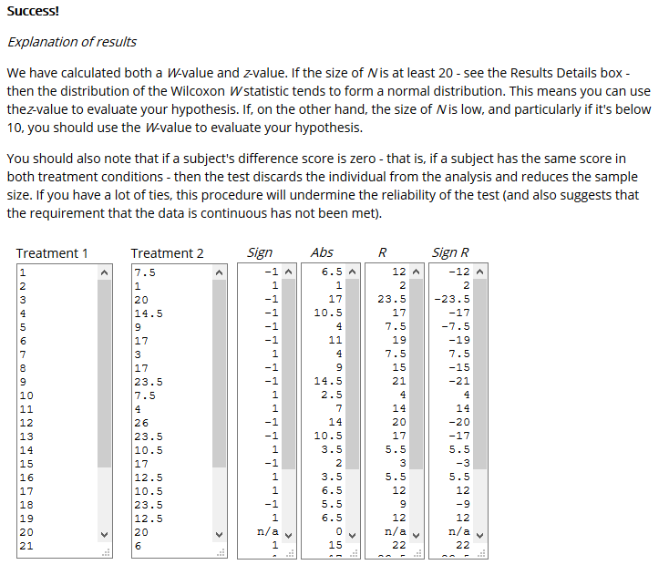
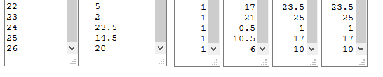
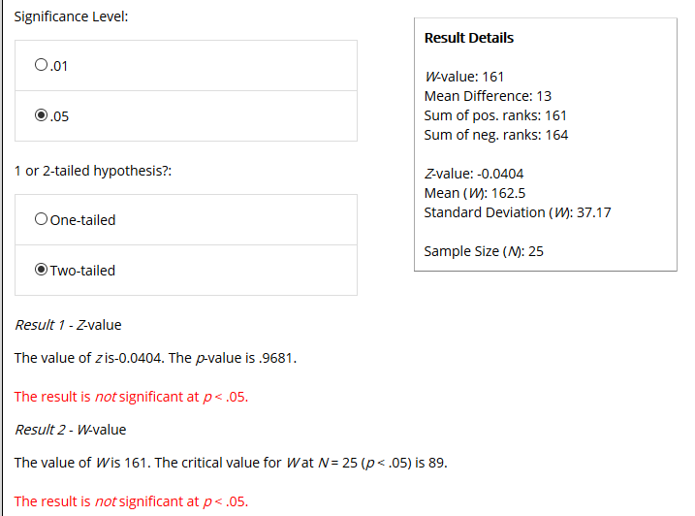

Exercise 3 Alder health near water treatment works
ANSWERS BELOW. PLEASE NOTE THE -/+ ARE THE OTHER WAY ROUND BUT DOES NOT INFLUENCE THE RESULT. IMPORTANT POINTS IN RED BOXES.

The same trees were assessed using a likert scale (1-7 (1=dead, 7=very healthy) for their health pre and post establishment of a water treatment works. The same expert horticultural researchers used GPS to identify the same trees and assessed the trees health 1 years after the first test. Use a Wilcoxon matched pairs test to assess if there is a significant difference between the groups.
- Construct a Null and alternative hypothesis
- Perform the Wilcoxon test on the following data set and comment on the significance of the results. P 0.05 & P0.01
- What do the results tell us about the research and the statistical test?
Trees selected and GPS from local woodland (all Alder Alnus glutinosa) | Likert before Treatment Works | Likert scale after Treatment works | Differences | Rank Diff. | signed rank
1 | 6 | 5
2 | 5 | 4
3 | 7 | 5
4 | 4 | 5
5 | 5 | 6
6 | 6 | 4
7 | 5 | 4
8 | 4 | 2
9 | 2 | 2
10 | 7 | 5
11 | 7 | 5
12 | 6 | 5
13 | 5 | 3
14 | 6 | 6
15 | 5 | 6
16 | 5 | 3
17 | 7 | 5
18 | 7 | 3
19 | 7 | 6
20 | 5 | 4
T+=
T-=
n=
T=
T Tabulated (P<0.05) =
Interpretive statement



