
Programme: Master of Business Administration
Module Name: International Marketing: Principles and Practices
Module code: LCMB7026
Student Name: Md Lokman Hossain
Student ID: 2421688
Lecturer’s Name: Tushara Balendran

Table of Contents

1. Introduction 1
2. Brand Overview 2
3. Comparison and Contrast 5
3.1 Pestle Analysis of the United Kingdom and South Korea 5
3.2 Strategic Advantages and Disadvantages 13
3.3 Favourable and Unfavourable Cultural Factors 14
3.4 STP (Segmentation, Targeting, and Positioning) Strategies of Netflix in the UK and South Korea 17
3.5 Marketing Mix Strategies of Netflix in the UK and South Korea 22
4. Strategic Evaluation: United Kingdom and South Korea 34
4.1 Strategic Evaluation: United Kingdom 34
4.2 Strategic Evaluation: South Korea 35
5. Ethical Evaluation: United Kingdom 36
5.1 Ethical Evaluation 36
5.2 Unethical Evaluation 36
6. Recommendations for Future International Strategy 36
7. Conclusion 38
References 39

1. Introduction
The UK is Netflix’s high-revenue and mature market that focuses on prestige content to produce with the investment of Shepperton Studios and targeting the affluent households, whereas South Korea is the main Asian growth driver with K-content accounting for 8-9 per cent of the total viewing hours, outperforming the UK at 7-8 per cent (Ampere Analysis 2025). This assignment is a critical analysis of the international marketing activity of Netflix in these two markets based on its Segmentation-Targeting-Positioning strategy, 7Ps marketing mix and the macro environment using PESTLE. It also assesses the strategic and ethical consequences of the decisions Netflix has made and suggests possible ways to maintain the competitive advantage and reconcile the global brand consistency with the local adaptation.

2. Brand Overview
Company Overview
Netflix, Inc. is a multinational entertainment company that has its head office in Los Gatos, California and focuses on streaming media and video-on-demand services (Netflix, 2025). Created in 1997 as a DVD rental company, Netflix transformed the entertainment industry by becoming a streaming platform globally, operating in more than 190 countries and having a base of over 300 million paid customers worldwide to date (Netflix, 2025).
Mission Statement
The mission of Netflix is to make the world entertain. This mission shows how the company believes in the production of high-quality video content and providing their customers with high-quality entertainment services throughout the world (Netflix, 2025).
Vision Statement
The vision of Netflix is to be the best in the world in the distribution of entertainment. This vision shows that Netflix has a desire with the aim of dominating the global on-demand video streaming market and establishing excellence as a benchmark (Netflix, 2025).
Market Position
The streaming market share in the UK is shared by Netflix (27 per cent) and ahead of Prime Video (22) and Disney+ (21) (Fabric Data, 2024). Netflix dominates in South Korea with 35% of the market, and the local competitor, Tving, is increasing by 34 per cent. In the global viewing time, South Korean content occupies 8-9% of Netflix, just after the US, and by far, more than the content viewing in the UK at 7-8% (Merican, 2025).
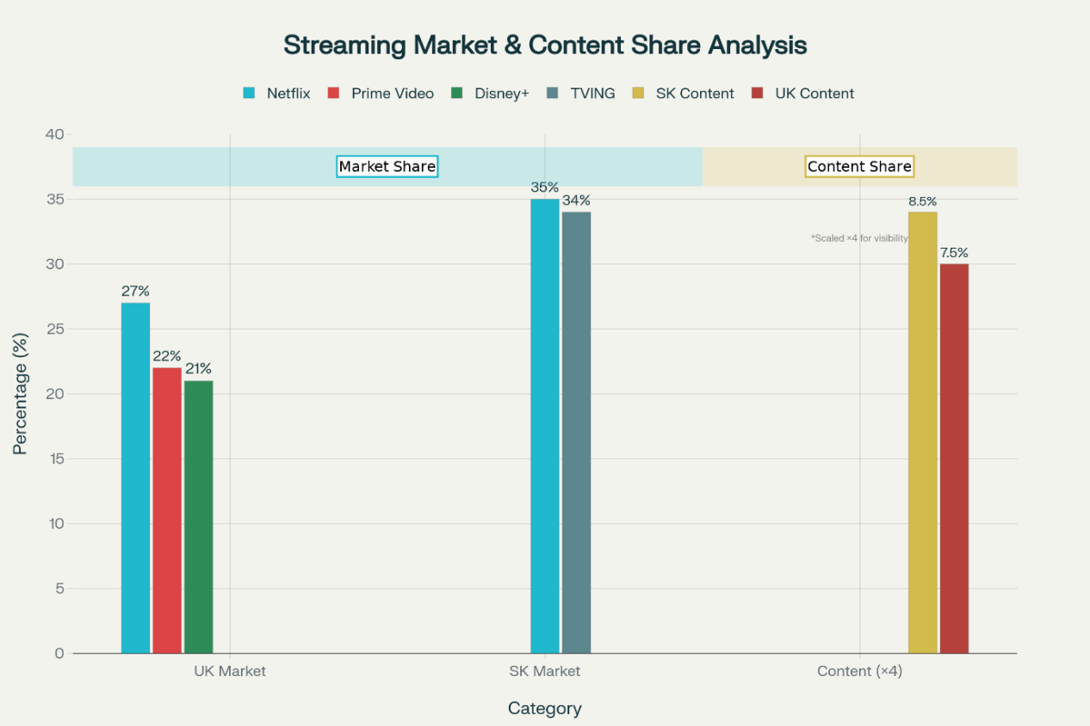
Figure 1: Streaming Market & Content Share Analysis (Stoll, 2024; Brzeski, 2024)
Overview of Operations
United Kingdom
The UK is the second biggest production centre in the world, with the largest number of subscribers (18.4 million) in comparison with the United States (66.7 million) (World Population Review, 2025; Lee, 2025). The area is not only the key to subscriber income but also a major source of English-language content that is being exported to the global market. Recently, Netflix UK recorded an 11% growth in revenue to reach London 1.85 billion (2.48 billion) in 2024 (Ramachandran, 2025; Castle, 2024).
South Korea
Netflix has its main growth engine in Asia and a content powerhouse globally in South Korea (Omdia, 2021). The business strategy herein is investing heavily in K-Content (Korean wave or Hallyu) to satisfy the demands of the world population, as Korean shows are the second most-often-watched genre on Netflix in the world after the US media (Dasom, 2024). Netflix has invested in South Korean content from 2024 to 2028, the sum of which is 2.5 billion (Kahn, 2025; Ramachandran, 2025a).
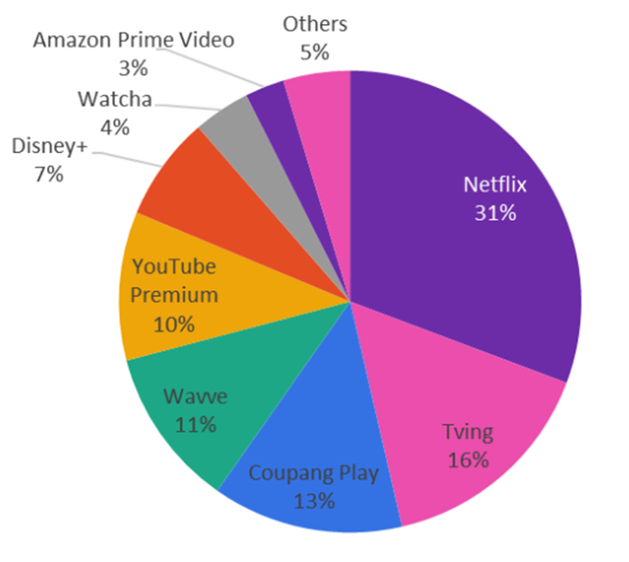

Figure 2: South Korea Online Video Market Shares (Omdia, 2021)
Netflix dominates the South Korean streaming market with a 31–38% market share, dwarfing local competitors like Tving and Wavve (Tandon, 2025).

3. Comparison and Contrast

3.1 Pestle Analysis of the United Kingdom and South Korea
A PESTLE analysis is a strategic framework used to identify and analyse the key external macro-environmental factors that can influence an organisation (Kar, Das and Kar, 2025).

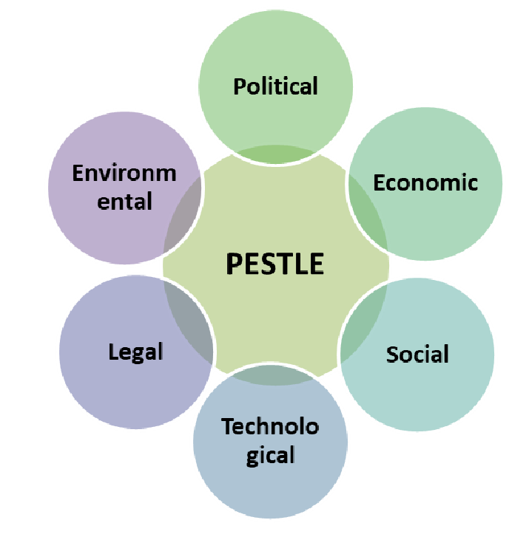
Figure 3: PESTLE Framework (Kar, Das and Kar, 2025)

Political
United Kingdom (UK): With the Media Bill, which was announced in the King's Speech in November 2023, the regulatory environment is becoming much stricter (Osborne Clarke, 2023). This law puts streaming services within the regulatory scope of Ofcom, which forces them to comply with a new Video-on-Demand Code like linear broadcasters such as the BBC (Osborne Clarke, 2023).
Unfavourable: Factors like regulatory burden, compliance costs, and Ofcom fines risk make the political factor for Netflix unfavourable.
South Korea (SK): The political environment can be characterised by the Fair Share controversy, which is established by Article 22-7 of the Telecommunications Business Act (the Service Stabilisation Act) (Lundgreen, 2023). According to this law, the big content providers, who are also the ones that contribute to the national traffic above 1 per cent, such as Netflix and Google, are required to negotiate with the ISPs to stabilise the networks (Lundgreen, 2023).
Unfavourable: Factors like fair share costs, network fee uncertainty, and local competitor preference make the political factor for Netflix unfavourable.
Economic
United Kingdom (UK): Netflix is operating within a stagnating growth condition that is aggravated by macroeconomic factors in a mature market. GDP of the UK is projected to increase at a low rate of 0.1 per cent in the third quarter of 2025, and the total GNP is projected to be 969.7 billion in June 2025 (KPMG, 2025).
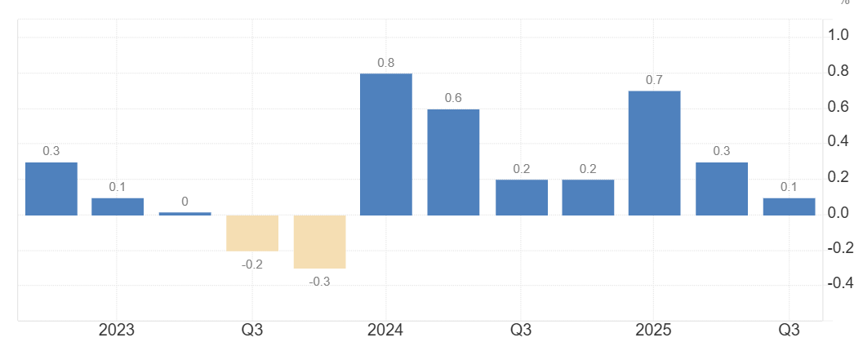
Figure 4: UK GDP Growth Rate (Trading Economics, 2025)
It is projected to have a per capita GDP of about 47,974 by the end of the year 2025 (Trading Economics, 2025).
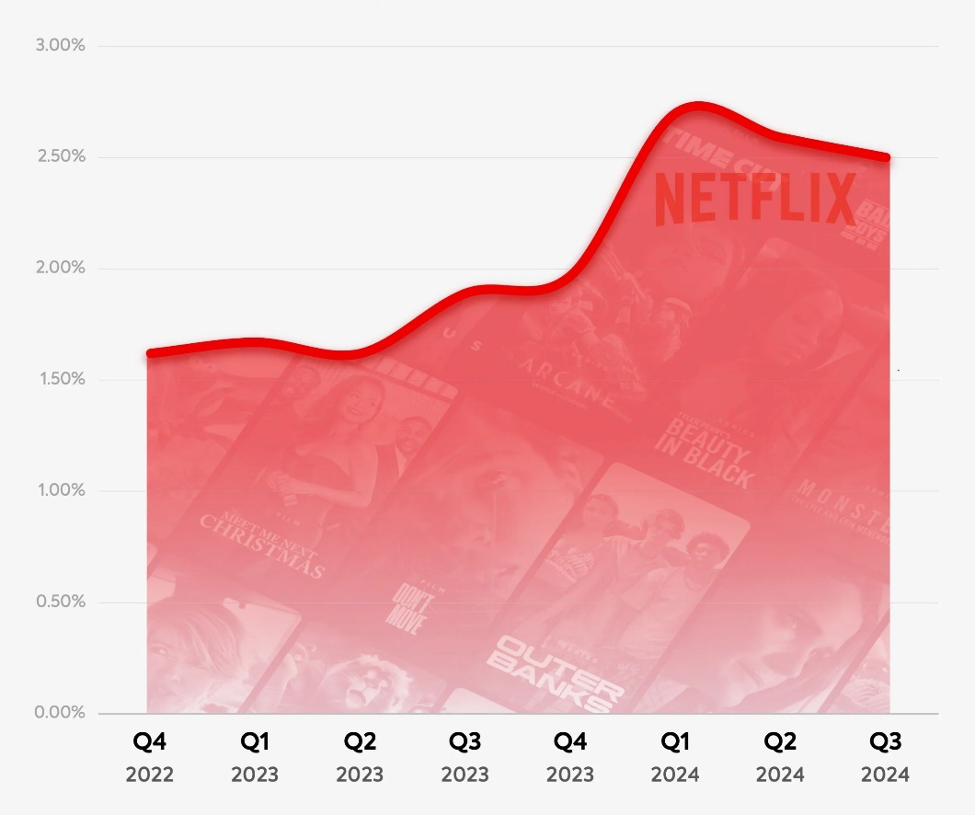
Figure 5: Netflix Lowest Churn Rate (Katz, 2024)

Favourable: Netflix continues to have a high pricing power with the status of a default utility in the household, which allows the company to have the lowest churn rate in the industry (~14%), which suggest favorable economic factor.
South Korea (SK): The economic environment is that of a high-value export production with moderate domestic growth. According to the GNP, South Korea was recorded to have a GNP of $493.5 billion in Q3 2025, and is projected to have a GDP per capita of 36,132 in 2024.
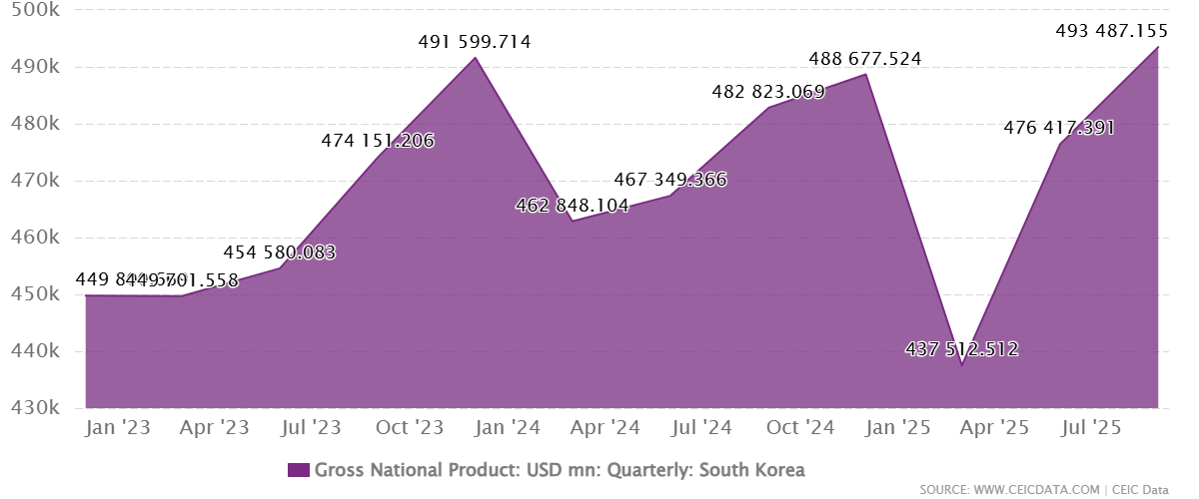
Figure 6: South Korea’s GNP (CEIC, 2025)
Although the IMF forecasts the growth rate at 2.2 per cent in 2025, the actual outlook of Netflix is that of production inflation.
Favourable: High-growth, improving margins, global export potential, along with the local creative industry, which has been turbocharged by a huge investment of $2.5 billion, make the economic factor favourable.
​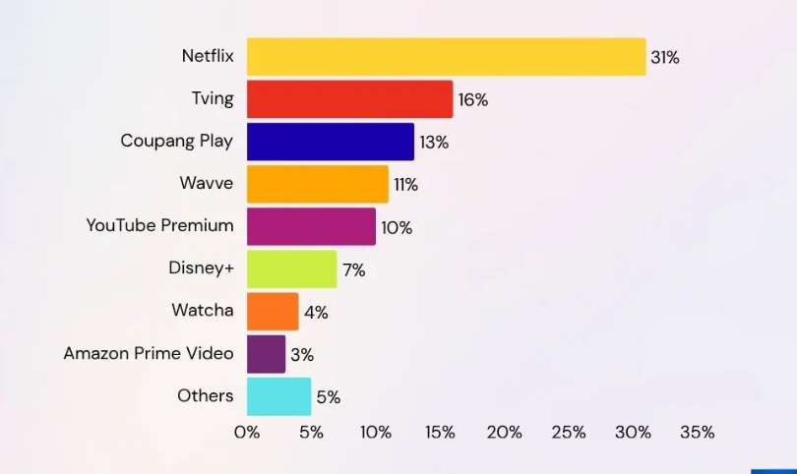
Figure 7: South Korea’s Online Video Market Share (Lee, 2025)

Social
United Kingdom (UK): The United Kingdom is also characterised by an individualistic culture that defines the social environment, where the person can be autonomous, express him/herself and make independent decisions that are the main part of daily life. This has been translated into media consumption behaviour whereby the viewers perceive the entertainment choices to be a continuation of their personal identity and not a strictly collective activity.
Favourable: The social environment in the UK is very favourable to Netflix with the levels of acceptance of leisure viewing, openness to customised content, and established streaming behaviour, but at the same time requires a steady and quality content without howling the churn.
South Korea (SK):The social environment in South Korea is basically influenced by collectivism, high group orientation and sensitivity to social trends. The consumption of entertainment is also closely associated with belonging to a specific group, common experiences, and engagement in group discussions. To most South Korean viewers, especially those belonging to the MZ Generation (Millennials and Gen Z).
Favourable: The social context in South Korea provides robust opportunities to Netflix because it allows reaching masses of people with the viral message quickly and positioning the popular content as an essential part of social life.

Comparison among Hofstede’s Dimension
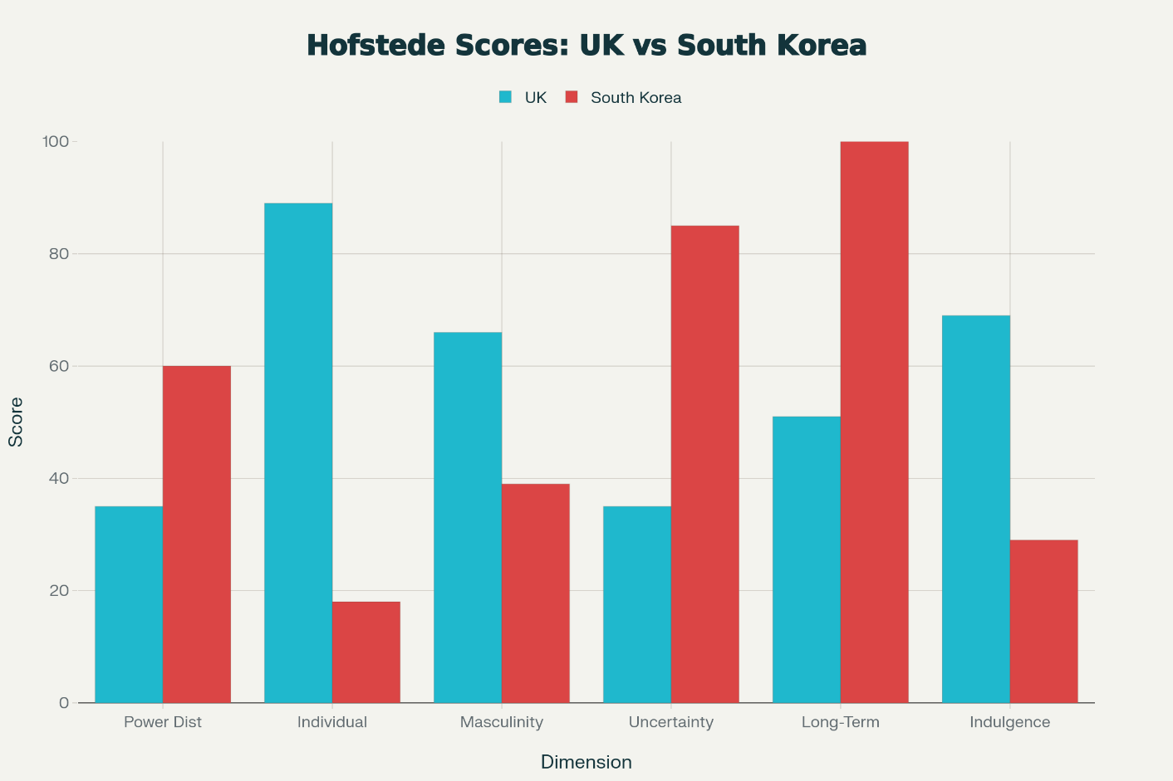
Figure 8: Hofstede Cultural Dimensions: UK vs. South Korea (The Culture Factor Group, 2025)

Dimension | United Kingdom | South Korea
Power Distance (PDI) | Low (35)  Society dislikes hierarchy and is suspicious of corporate overreach. Favours anti-establishment content and scepticism toward authoritative messaging. | Moderate-High (60)  Society respects social order and age-based hierarchy. Content that disrespects seniority or social structures without narrative justification can be offensive.
Individualism (IDV) | Very High (89)  Characterised by the supremacy of personal choice. | Very Low (18)  Collectivist: viewing content is a form of social currency.
Masculinity (MAS) | Moderate (66)  A relatively competitive and success-driven society. Content often reflects themes of achievement, but is balanced by a strong undercurrent of wit and sarcasm. | Moderate (39)  A more consensus-oriented society that values cooperation and quality of life. Storytelling may emphasise group harmony, relationships, and communal resolution.
Uncertainty Avoidance (UAI) | Low (35)  Audiences are open to experimentation, innovation, and genre-bending formats (e.g., interactive films). Tolerates ambiguity and unconventional storytelling. | Very High (85)  Audience demands perfection and is highly critical of technical, historical, or translation inaccuracies. Requires heavy investment in quality control and localisation to avoid backlash.
Long-Term Orientation (LTO) | Low (51)  Cynicism and focus on immediate value suggest a shorter-term perspective. | Very High (100)  Society values perseverance, delayed gratification, and long-term plots.
Indulgence (IND) | High (69)  Leisure is considered a right; binge-watching is socially condoned and even glorified. "Pub culture" translates into a societal acceptance of extended, indulgent viewing sessions. | Low (29)  The "Pali-Pali" (hurry-hurry) culture and a restrained, disciplined ethos prioritise efficiency and control over gratification.

Figure 9: Detail Hofstede Cultural Dimensions: UK vs. South Korea (The Culture Factor Group, 2025)

3.2 Strategic Advantages and Disadvantages
United Kingdom
Advantages: High Individualism (89) is the largest contributor to the success of Netflix in the UK. The high individualism brings about a society of the supremacy of personal choice. Low Uncertainty Avoidance (35) means British audiences are extremely open to experimenting and genre-bending (e.g., Black Mirror: Bandersnatch) (New York Weekly, 2024).
Disadvantages: However, Low Power Distance (35) presents a disadvantage, as the British do not like hierarchy, so they are suspicious of corporate overreach. Marketing can be perceived as heavy-handed, or preachy content can backfire. They favour anti-establishment content, and Netflix should always be able to provide it to be relevant in contrast to the more conservative BBC.
South Korea
Advantages: Collectivism (Low Individualism - 18) is the driving force behind the K-Wave viral phenomenon. In a collective society, watching the hit show of the moment is not mere entertainment; it's an essential form of social currency. When something trending, such as Squid Game, is being watched, the whole population watches it to keep socially connected (FOMO), which produces enormous, spiky peaks in viewership (Beugelsdijk and Welzel, 2018).
Disadvantages: A significant disadvantage is High Uncertainty Avoidance (85), as Korean audiences want perfection. They are super-critical of technical inaccuracy, subtitle inaccuracy or cultural gaffes. One inaccuracy in historical data or translation is enough to cause a huge online boycott, and Netflix has to make a huge investment in quality localisation.

3.3 Favourable and Unfavourable Cultural Factors
United Kingdom
Favourable: The "Pub Culture" (Indulgence - 69) represents a favorable cultural factor. A high indulgence score in the UK indicates that the society of the UK considers leisure time as a right. Long viewing is socially condoned and even glorified, and binge-watching takes away the stigma of long viewing (Cook, 2023).
Unfavourable: An unfavorable cultural factor is Cynicism. The British culture of scepticism implies that brand loyalty is not easily attained and lost in case there is a decline in quality (Cook, 2023). The UK users are likely to churn easily once the value proposition diminishes, unlike high brand attachment markets (Cook, 2023).
South Korea
Favourable: The "Pali-Pali" (Hurry-Hurry) Culture represents a favorable cultural factor. The Korean busy lifestyle requires efficient and quality consumption in the form of mobile devices. The better mobile application and download power of Netflix is something that fits well into the culture of the daily commute in Seoul.
Unfavourable: An unfavorable cultural factor is High Hierarchical Sensitivity (Power Distance - 60). Material which disrespects social orders or age-based veneration (without explaining the story) can be regarded as offensive. The Western, edgy style adopted by Netflix should be well balanced to not drive away their more mature customer segment that places value on conventional social organisation.
Technological
United Kingdom: The primary technological challenge is the development of automated compliance infrastructure. As a way of evading the Media Bill fines, Netflix may be required to refreeze its recommendation algorithms and metadata systems to categorize content considered harmful by the new Ofcom code (Watson, 2024).
Unfavourable: The necessity to restructure algorithms and metadata to comply is a change in investment focus to regulatory filtering rather than UX, and introduces a very expensive and complicated technological load.
South Korea: The problem is with the exponential load on the world-class infrastructure. The internet traffic of Netflix in Korea has increased about 24 times since 2018 (Jurist, 2021). Although the penetration of 5G in Korea is among the most successful worldwide, this enormous amount (out of the 11,814 TB of national video traffic projected during the last quarter of 2022) is offered as the technical information on which ISPs base their network usage fees (Jurist, 2021).
Unfavourable: The fast-growing traffic overloads the world-class infrastructure, resulting in controversies over paying the network usage cost and struggling with the scalability of Netflix operations.
Legal
United Kingdom (Uk): There is a certain cost of legal liability, which is approximately £250,000. This amount, or 5% of qualifying revenue, is the maximum fine that Ofcom can impose in case of serious breach of content standards by the Media Bill (Legislation.GOV.UK, 2024).
Unfavourable: The risk of tremendous fines due to content standard violations poses a great monetary risk, compelling Netflix to think of dropping content to reduce the financial risk.
South Korea (SK): Netflix is in court with SK Broadband regarding the payment of the network usage fees (sender pays) model (Al Jazeera, 2023). The defeat in this would break the worldwide internet standard of net neutrality.
Unfavourable: The stakes of the two matters concerning legal battles over network fees endanger the concept of net neutrality and are a significant regulatory and precedential threat to the Netflix operating model.
Environmental
United Kingdom (UK): The operations in this country are highly regulated by the system of certification of sustainability in production in the United Kingdom, which is called Albert (Tredinnick, 2025). Netflix has to disclose carbon information regarding local productions such as The Crown, and should pay attention to diesel generators and minimize the travel emission levels to comply with the legal requirements of net-zero in the UK.
Unfavourable: The high cost of compliance with strict sustainability certifications and net-zero legal requirements means that carbon disclosure and reduction steps are detailed, making local productions more expensive.
South Korea (SK): Environmental review is concerned with the energy intensity of streaming per se. The large mobile data consumption in Korea draws attention to digital energy waste, as 38% of Netflix's corporate carbon footprint is a result of streaming (data centers and content delivery networks). The reduction of half the number of emissions by 2030 is one of the global commitments of Netflix (Jessen, 2024).
Unfavourable: High energy intensity of streaming with gigantic data consumption directly complicates the Netflix global emission reduction objectives by highlighting a substantial part of its corporate carbon footprint.
Similarities and Differences
The Media Bill imposes on Netflix the demands of broadcast-like content regulated by Ofcom in the UK and the prospects of fines, whereas in South Korea, the controversy of the Fair Share and the current legal dispute involving Netflix and SK Broadband in the network fees present financial and regulatory risks (Osborne Clarke, 2023; Lundgreen, 2023; Al Jazeera, 2023).
Nevertheless, one of the key distinctions is that of socio-economic and technological circumstances. The UK is an economically and socially mature and individualistic market where Netflix has stable utility and low churn, but needs to deal with stagnating growth and a cynical audience, which can easily shift to churning in case of quality deterioration (Katz, 2024; Cook, 2023). South Korea, conversely, is a high-growth, collectivist marketplace in which content can become viral and have a societal level of success, but this requires huge technological investment to accommodate exponential traffic congestion and perfectionist localisation to satisfy the audiences (Lee, 2025; Jurist, 2021).

3.4 STP (Segmentation, Targeting, and Positioning) Strategies of Netflix in the UK and South Korea
Segmentation
United Kingdom
- Demographic: The user base is extensive, with the demographics ranging between Gen Z and Baby Boomers. But the latest statistics show a division with young users (18 to 34) being high churners, constantly moving between services (or multi-homing), whereas older audiences (35 and above) are more loyal, considering Netflix as a service to supplement the TV license (Marshall, 2024). ​
- Psychographic (VALS): Experiencers (young, interested in new trends, such as Stranger Things) and Thinkers (mature, educated, appreciating documentaries and films with high ratings, such as The Crown).
- Behavioral: Behavior starts with the viewing occasion, between lean-back living room viewing (competing with BBC) and mobile-first commuting.
South Korea
- Demographic: The target audience is the so-called MZ Generation (Millennials + Gen Z), most of whom are the main source of streaming traffic. This is a digitally native, culturally influential group.
- Psychographic (VALS equivalent): The most prevalent are those of Achievers and Innovators. Koreans consider subscriptions to premium services such as Netflix as not only a source of entertainment, but also a cultural connectedness and a symbol.
- Behavioural: FOMO (Fear Of Missing Out) is a large motivator of segmentation. The consumption rate is quicker; users are divided based on the rate at which they binge a new viral sensation (Squid Game, The Glory) to be a part of the national discussion.
Targeting
United Kingdom: "The Default Utility"
Netflix targets the Mass Market with a "retention-first" strategy (Shah, 2025).
- Primary Target: Households that are replacing the linear TV. It is the aim to push the first button on the remote.
- Secondary Target: Price-sensitive Switchers (Strivers) through the ad tier of 4.99.
- Tactics: Investment in the so-called British heritage content (Baby Reindeer, The Gentlemen) that is domestic in nature, actually appealing to the loyal viewer of the BBC by providing them with better production values of a similar theme.
South Korea: "The Cultural Trendsetter"
Netflix aims to reach the Cultural Influencers and Heavy Users through a strategy of being a hit-maker.
- Primary Target: The hyper-social MZ generation who are the trendsetters of social media.
- Secondary Target: International through Korea. Netflix is addressing the Korean users as not only a consumer market, but also a test market, before entering the global content export market.
- Tactics: High fidelity K-dramas aggressively invested in (2.5bn). The aim is to tap the "Premiumness" market, i.e. with 4K quality, uncensored content (e.g. violence/thrillers) that the local terrestrial television (KBS/SBS) is not allowed to broadcast because of its stringent regulations. ​
Positioning
United Kingdom
- Positioning Statement: To British households, Netflix is the home of high-quality entertainment that would allow them to incorporate Hollywood with the touch of British storytelling, providing a better alternative to traditional TV.
- Perception: Utility of the best quality. It has been viewed as an essential service, almost a tax and not a luxury.
- Key Attribute: Diversity and Consistency. There is nothing but to watch.
South Korea
- Positioning Statement: To the contemporary Korean trendsetter, Netflix is the unrestricted, high-quality key to the most discussed stories in the world, allowing local officials to transcend the restrictions of global television.
- Perception: Creative Liberator & Status Symbol. It is being positioned as edgier and higher quality than the domestic competitors, such as TVING or Wavve.
- Key Attribute: Prestige & Scale. "Blockbuster quality you can't see on TV."

.
Perceptual Map Analysis
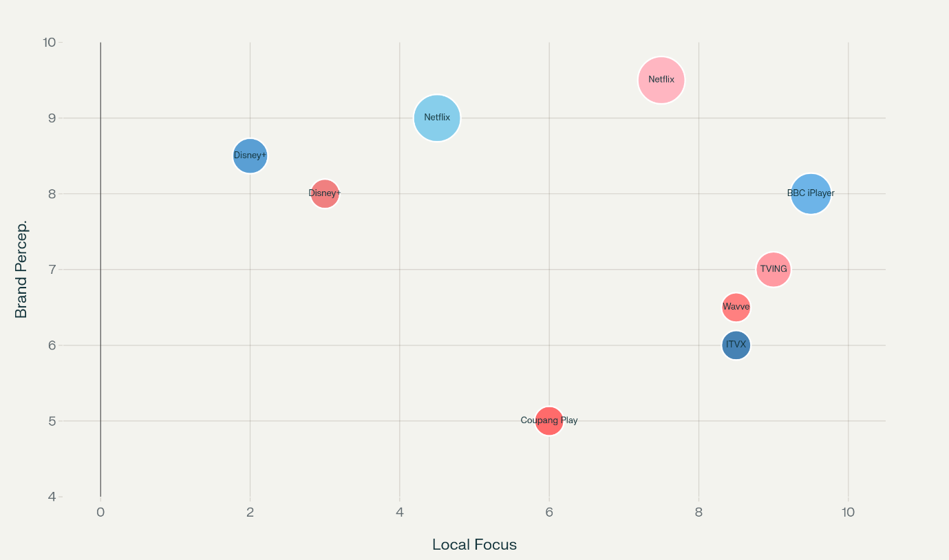
Figure 10: Perceptual Map (Adapted from Kan, 2023; Gyu-lee, 2025; Schwanke, 2025)
Key Positioning Differences
United Kingdom Market
Netflix UK finds itself in the high-quality and high-price segment with the premium players (Schwanke, 2025). The standard plan of 12.99 makes it pricier than Disney+ (7.99-10.99), Prime Video (8.99), and Apple TV+ (9.49), which is supported by the greater range of content and a 90 per cent CSAT rating. This is indicative of an advanced market approach to maximise ARPU (Average Revenue Per User) in which Netflix is a TV replacement utility. ​
South Korea Market
Netflix SK enjoys a similar quality perception (maximum OTT satisfaction at 3.75/5) but at lower prices, which are competitive (13,500 KRW/~7.40) (Kan, 2023). This places it in the same category as local competitors such as Tving (£7.40, 3.66/5) and above value competitors such as Wavve (£6) and Coupang Play (£5-7) (Gyu-lee, 2025). It is a strategy of edge and exclusivity by the K-content production, where Korea is viewed as a content export business rather than a pure revenue maximisation.
Similarities and Dissimilarities
Similarities
Netflix positions itself as the Premium Standard in both markets, the standard to which all other streamers are measured. It is aimed at the InnoVator and Experiencer VALS segments in both areas and will be based on early adopters to generate buzz on new titles. The logic of having Originals as the major distinguishing factor is the same, be it The Crown (UK) or Squid Game (Korea), the proprietary content is the wedge that is utilised to ensure some loyalty.
Dissimilarities
The fundamental distinction is in the strategic role of the market. The UK is being handled as a Consumption Hub, a mature market, where maximizing ARPU (Average Revenue Per User) and churn minimization are the objectives within a stable, broad demographic. By contrast, South Korea is being handled as a Production Hub, a driver of growth where the idea is to invest in risky, high-budget content that can be sold around the world.

3.5 Marketing Mix Strategies of Netflix in the UK and South Korea
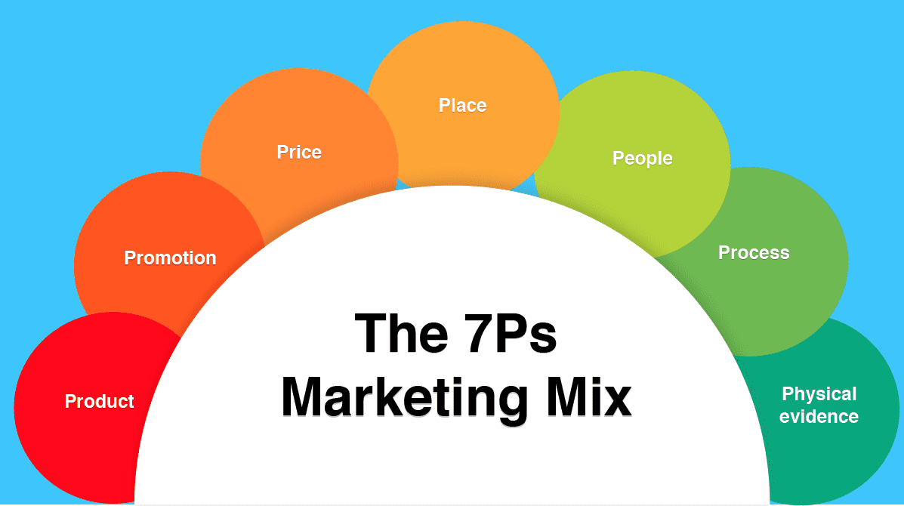
Figure 11: 7P’s of Marketing Mix (Hanlon, 2023)
1. Product (The "Ingredients")
Netflix adapts its "product ingredients" (content library) to match local tastes while leveraging these markets as global production hubs (Latterly, 2016).
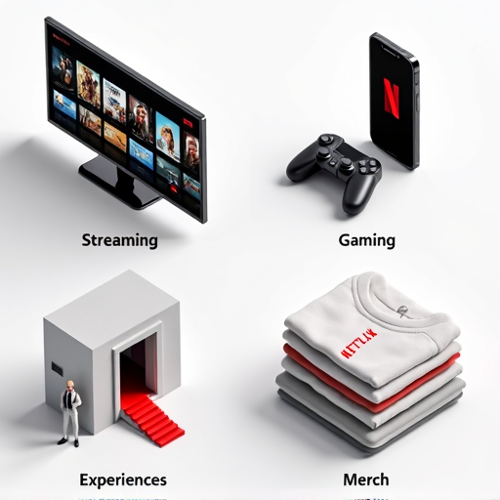
Figure 12: Netflix’s Product Breadth (Netflix, 2025)
Figure 13: Products Comparison
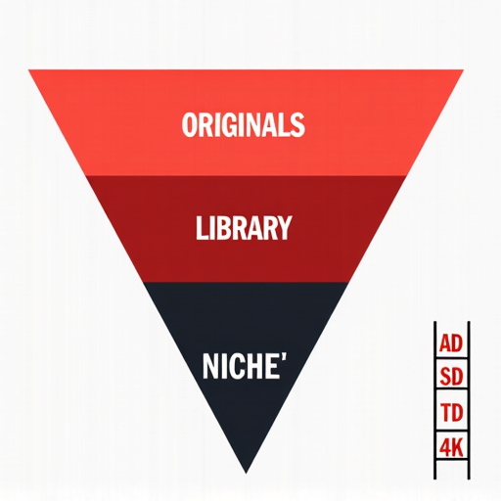
Figure 14: Netflix Product Depth (Netflix, 2025)
2. Price
Netflix uses tiered pricing in both markets but positions itself differently relative to local purchasing power (Lau, 2025).
Figure 15: Price Comparison
3. Place (Distribution Channels)
United Kingdom:
- "Cable" Integration: Netflix is heavily integrated with Sky Q, Sky Glass, and Virgin Media set-top boxes (Brown, 2024).
- Physical Button: Remote controls for major UK TV providers (Sky, BT) feature a dedicated Netflix button, cementing its status as a "default" service (Singh, 2023).

South Korea:
- Mobile & IPTV Partnership: Netflix collaborated with SK Broadband, KT, and LG U+ after paying the lawsuits over network usage fees (Kim and Lee, 2025).
- Bundled Ecosystems: It is bundled into mobile data plans (5G streaming packs) and IPTV services, acknowledging that Korean consumption is heavily mobile-first and data-intensive.
- Market Entry: Netflix launched in South Korea in 2016 and grew rapidly to 13 million users by 2024, fueled by hit original content like "Kingdom." To manage its traffic surge and deepen market reach, it forged strategic partnerships with major Korean telecoms—LG U+, KT, and SK Broadband—integrating its service into their IPTV and mobile bundles.
4. Promotion (Advertising & Visuals)
Here is the area of the most apparent cultural difference. The UK is more likely to accept wit and immersion; Korea is more likely to accept ubiquity and experience hype.
United Kingdom:
- Strategy: Contextual and OOH (Out-of-Home). Netflix takes over the Underground and the billboards with high concept art in London.
- Visual Example: In the case of Stranger Things, Netflix put up rifts to the Upside Down on actual billboards in London, lit eerily and with 3D effects that made it look like the street was tearing apart (Zanni, 2025).

Figure 16: Netflix's Chilling Stranger Things Billboards Haunt London (Zanni, 2025)
- Tone: Sarcastic, self-aware social media presence (e.g., poking fun at Bridgerton tropes) that aligns with British humour.
South Korea:
- Strategy: Immersive Pop-Ups & PPL. Marketing is physical and experiential.
- Visual Example: For Squid Game S2, Netflix created massive interactive "play zones" in Seoul subway stations (e.g., Itaewon), featuring giant "Red Light, Green Light" dolls and pink-suited guards where fans could play games to win prizes.

Figure 17: Squid Game's season 2 promo features a real-life game for South (Ngo, 2024)
- Product Placement (PPL): Aggressive integration of brands (like Subway sandwiches or Samsung phones) inside the shows themselves, creating a "shoppable" content experience.
5. People
United Kingdom: The Fitzrovia HQ has many commissioning editors and talent scouts, who are attracted by the BBC/Channel 4 ecosystem (Señal News, 2024). Their position is relationship-oriented: preserving connections with high-profile showrunners and writers in order to get the scripts of BAFTA calibre.
South Korea: The office in Seoul deals with production logistics and creator relations. The employees serve as bridges between the strict global technical requirements of Netflix and the highly dynamic and sometimes anarchic culture of the Korean drama production known as live-shooting. In them, there is a blend between Hollywood frugality and Korean ingenuity. ​
6. Process
The delivery mechanism differs to accommodate local consumption habits.
United Kingdom (The "Binge" Model): This is the All-at-Once drop of the default process. Culturally, UK viewers are used to eating the narrative arcs within a weekend and not extended seasons (6 episodes). The algorithm is optimal in terms of completion rate in the first 28 days.
South Korea (The "Simulcast" Model): The process is adjusted to the "Weekly Drop." In the case of licensed K-Dramas, the episodes are uploaded as soon as they appear on Korean TV (e.g., tvN or JTBC). The result of this hybrid process is a watercooler effect, and keeps the process engaged during 8-10 weeks instead of in a spike. ​

7. Physical Evidence
United Kingdom (Prestige Badging):
- UI Evidence: The "Top 10" row is often dominated by "BAFTA Winner" or "Critical Acclaim" badges.
- Tangible Evidence: Luxury partnerships in merchandise (e.g., Bridgerton afternoon tea sets or fashion collections at Selfridges) support the luxury image of the brand.
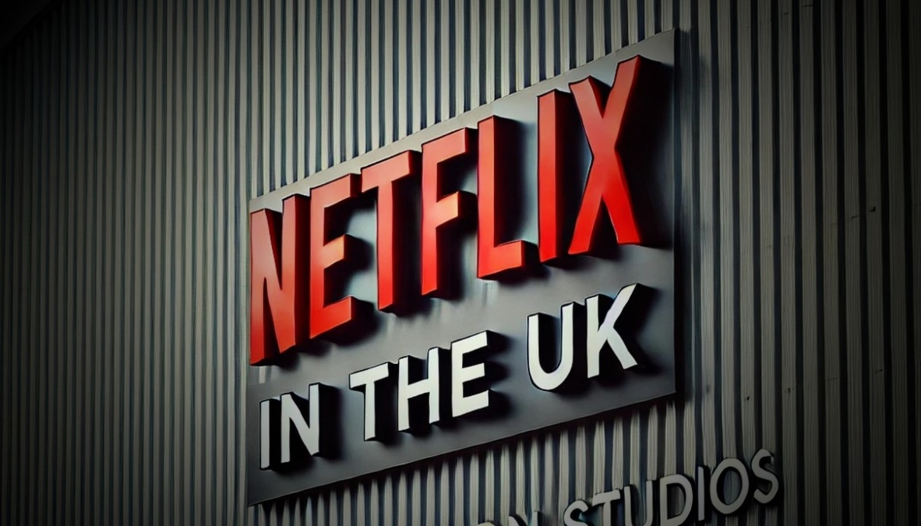
Figure 18: Netflix in the UK (LinkedIn, 2024)
South Korea (Viral Ubiquity):
- UI Evidence: UI is aggressive with the badges of New Episode and the animation of Trending Now to evoke FOMO.
- Tangible Evidence: Pop-up Zones and their sets, such as the Squid Game doll in Olympic Park, are physically recreated as proof of the show as a culturally dominant one, which are Instagrammable. The capability of fans entering into the world of the show physically is the so-called physical evidence.
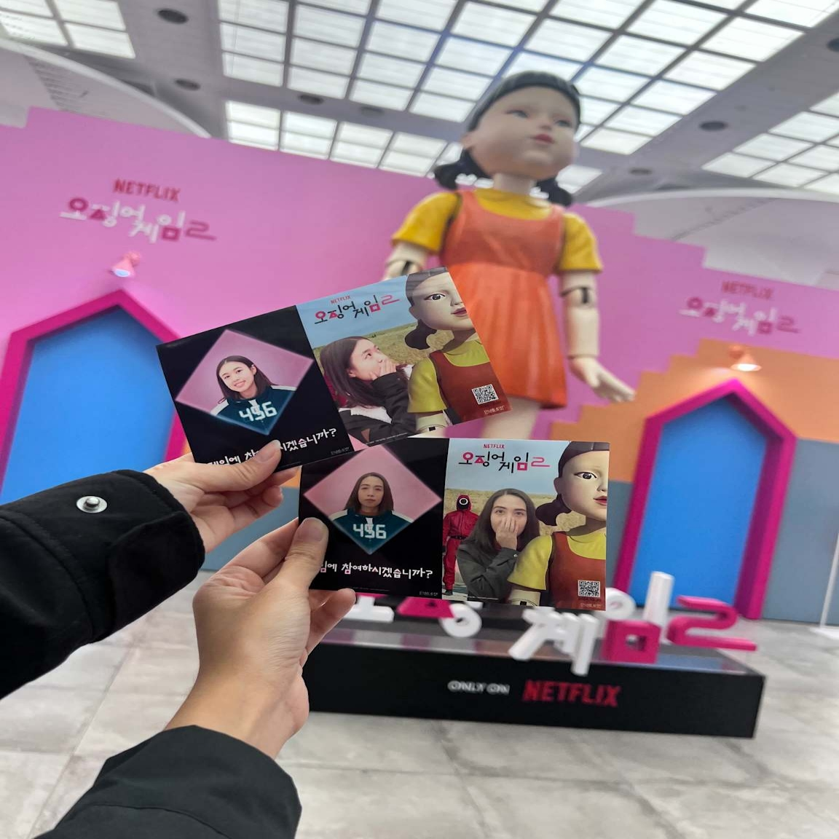
Figure 19: Step Inside the Squid Game Season 2 Pop-Up: Busan & Seoul (A Fan Girl's Heart, 2025)
Similarities & Dissimilarities: A 7Ps Perspective
Similarities
In both markets, prioritising the Product strategy is based on the halo effect of the Originals, i.e. the exclusive proprietary content of high budget (The Crown in the UK, Squid Game in Korea) is the key retention tactic. The Physical Evidence on the digital world (UI) is not very different since it uses identical algorithmic top 10 rows and match percentages to motivate the engagement. Moreover, both HQs have a fundamental "Freedom and Responsibility" corporate culture within their People element, where they recruit the best creative resources by attracting the best local legacy media (BBC in London, CJ ENM in Seoul).
Dissimilarities:
The concept of positioning of price also varies at a basic level: in the UK, Netflix is sold as a Premium Utility (bundled with cable packages such as Sky), which gives the impression of a core infrastructure. Conversely, the Korean model is more oriented towards "Accessible Luxury," with much lower barriers to entry (approximately 35 per cent lower) to counteract the cheap-end mobile-first competitors in a massively price-sensitive market.

4. Strategic Evaluation: United Kingdom and South Korea

4.1 Strategic Evaluation: United Kingdom
Verdict: Highly Successful (Dominant Incumbent)
The company has a dominant 22 per cent portion of the streaming market, leading over other significant competitors such as Prime Video and Disney+ (Gaines, 2025). This leadership is supported by the fact that the market is almost saturated, with the brand awareness being 97 per cent among video-on-demand users and active usage being 73 per cent. Most importantly, the strategy has created a huge customer loyalty base; Netflix continues to have the lowest churn rate in the industry at only 1.6, which is far better than its competitors, such as Apple TV+, which has a churn rate that is almost four times greater. The UK operation is financially a powerhouse. Revenue increased by 11% to hit 1.85 billion pounds (2.48 billion dollars) in 2024, and the operating profit is large of 478 million pounds (644 million dollars) (AInvest, 2025). Such profitability is the expression of the effectiveness of scale and success in managing its yields (The Drum, 2023).

4.2 Strategic Evaluation: South Korea
Verdict: Highly Successful (Critical Growth Engine)
The platform maintains the top position with a 35% share of the total viewership and barely beats the local competitor Tving, which is on the rise. More to the point, Netflix retains a better share of the overall revenue of the industry, 43 per cent, which is a testimony to its greater pricing power and perceived value of its high-quality library of premium content, Netflix Originals. Subscriber trends continue to be favourable, and Monthly Active Users (MAU) have been increasing by 12 per cent to almost 13 million by the year-end 2024 due to the cultural phenomenon of hit shows such as Squid Game Season 2. Growth in local revenue increased to around ₩900 billion (630 million US dollars), and operating profit increased by 44% in 2024, indicating that the high initial cost spending is now starting to pay off with substantial operational leverage (The Chosun Daily, 2025).

5. Ethical Evaluation: United Kingdom

5.1 Ethical Evaluation
The major ethical shortcoming in the UK revolves around the strategic move by Netflix to make a profit out of true stories without putting in place sufficient protection mechanisms for the real-life characters represented.

5.2 Unethical Evaluation
The latter issue reached its peak in the 2024 hit Baby Reindeer, where the marketing campaign of the show revolved around the irrevocable statement, "It is a true story," instead of the industry norm of using the term based on true events (Dickie, 2025). This particular advertisement decision helped rally the internet detectives to find the true identity of the character known as Martha, exposing her to extreme cyberbullying and death threats.

6. Recommendations for Future International Strategy
According to the analysis, the next decade of Netflix expansion should be based on the shift towards sustainable immersion and focus instead of expansion.
Recommendation for the United Kingdom
1. Implement a "Duty of Care" Protocol for Reality TV (The "Safeguarding" Pillar)
Actionable Step: Have an international "Participant Welfare Charter" which requires independent psychological screening and suffering cooling-off periods before reality show contestants, with stricter standards than local laws would mandate. ​
2. Establish "Creator Academies" to Secure the Supply Chain
Actionable Step: Introduce "Netflix Creator Academies" in strategic centres (e.g., Seoul, London, Mumbai, Lagos). Such schools would provide education in screenwriting, post-production and showrunning, but on the standards of Netflix, technically and narratively
3. Hyper-Localise the "Process" (The "Pali-Pali" Adaptation)
Actionable Step: Drop the Binge Model that is strict in those markets where ROI increases with the frequency of interaction per week. In a high linear TV culture (including India, Turkey, Brazil), use the Hybrid Release Strategy (weekly drops) of local originals to keep the social media buzz running months and not days, as a watercooler reaction to K-Dramas. ​
4. Diversify the "Product" with Interactive Formats
In order to lessen the dependence on blockbuster production, which costs a lot, tap into the gaming infrastructure.
Actionable Step: Add "Playable Stories" into the core app. Work on narrative-driven games that are based on hits (e.g., a Peaky Blinders strategy game) that will enable the user to keep the story going between seasons. This adds to time spent metrics and minimises churn in manufacturing lapses.
Recommendations for South Korea
1. Expand "Physical Evidence" into "Retailtainment"
Actionable Step: Start the permanent action of opening the Netflix Houses in major cultural capitals (London, Seoul, Tokyo). They ought to be combined retail/ entertainment spaces with rotating immersive experiences (e.g., a Bridgerton ball or Stranger Things arcade) and exclusive merchandise. ​
2. Introduce a Tier of Carbon-Conscious streaming.
Actionable Step: Have an optional user option that would stream at a quality that consumes less data and less energy especially in those markets whose carbon footprint of digital is high such as South Korea.

3. Prepare Algorithms Transparency Reports of Regulated Markets
Actionable Step: In states with stringent content rules such as the UK, release regular (e.g. quarterly) public reports on the compliance of the recommendation algorithms with the local content regulations. Such proactive disclosure would establish regulatory confidence, prove due diligence and avoid controversies about automated compliance and convert a compliance liability into a brand value.

7. Conclusion
The report identified that the core difference is that the strategic positioning of Netflix in the UK is focused on maximising revenues by premium positioning of utility and binge-model releases, while South Korea is focused on establishing cultural phenomena by high-risk blockbuster productions and simulcasting weekly. In this analysis, the competitive edge of Netflix has been shown to be culturally-intelligent and market-specific strategies, as opposed to global strategies—positioned as a lifestyle necessity in Britain and acting as a cultural trendsetter in Korea, it ends up showing that effective international marketing needs both strategic flexibility and brand recognition.​

References
A Fan Girl's Heart (2025). Step Inside the Squid Game Season 2 Pop-Up: Busan & Seoul Experiences and Exclusive Merch. [online] Afangirlsheart.com. Available at: https://www.afangirlsheart.com/2024/12/squid-game-season-2-pop-up-busan-seoul-experience-merch.html [Accessed 7 Dec. 2025].
AInvest (2025). Netflix’s U.K. Revenue Rises 11% to $2.48 Billion, Membership Gains Strong. [online] Ainvest. Available at: https://www.ainvest.com/news/netflix-revenue-rises-11-2-48-billion-membership-gains-strong-2508/. [Accessed 7 Dec. 2025].
Al Jazeera (2023). Netflix, SK Broadband end dispute over network traffic costs. [online] Al Jazeera. Available at: https://www.aljazeera.com/economy/2023/9/18/south-korean-broadband-provider-announces-end-to-dispute-with-netflix [Accessed 7 Dec. 2025].
Beugelsdijk, S. and Welzel, C. (2018). Dimensions and Dynamics of National Culture: Synthesising Hofstede With Inglehart. Journal of Cross-Cultural Psychology, [online] 49(10), pp.1469–1505. doi:https://doi.org/10.1177/0022022118798505.
Brown, A. (2024). Sky TV and EE TV have to choose between a price rise and adverts. [online] GB News. Available at: https://www.gbnews.com/tech/sky-tv-ee-tv-netflix-basic-change [Accessed 7 Dec. 2025].
Brzeski, P. (2024). Tving Gains on Netflix in Korea’s Streaming Market: MPA Study. [online] The Hollywood Reporter. Available at: https://www.hollywoodreporter.com/business/business-news/tving-netflix-korea-streaming-market-study-1235974302/. [Accessed 7 Dec. 2025].
Castle, V. (2024). Netflix and Amazon expand production at Shepperton Studios. [online] BBC News. Available at: https://www.bbc.com/news/articles/cy0zjd7eg4xo. [Accessed 7 Dec. 2025].
CEIC (2025). South Korea Gross National Product [1960 - 2020] [Data & Charts]. [online] www.ceicdata.com. Available at: https://www.ceicdata.com/en/indicator/korea/gross-national-product. [Accessed 27 Nov. 2025].
Content Asia (2024). ‘Squid Game 2’ lights up Seoul ahead of 26 Dec release; Socio-political cloud hangs low, ‘I am here with a heavy heart,’ director Hwang Dong-hyuk says | ContentAsia. [online] Contentasia.tv. Available at: https://www.contentasia.tv/news/squid-game-2-lights-seoul-ahead-26-dec-release-socio-political-cloud-hangs-low-i-am-here-heavy [Accessed 27 Nov. 2025].
Cook, T.B. (2023). The United Kingdom: Its Cultural Dimensions and Cultural Values. [online] TBC Culture Hub. Available at: https://www.tbcculturehub.com/post/the-united-kingdom-its-cultural-dimensions-and-cultural-values. [Accessed 27 Nov. 2025].
Dasom, L. (2024). Korean content on Netflix in 2024 ranked 2nd in global views: Korea.net: The official website of the Republic of Korea. [online] Korea.net. Available at: https://www.korea.net/NewsFocus/Culture/view?articleId=269924. [Accessed 7 Dec. 2025].
Dickie, D. (2025). Richard Gadd makes a plea after Baby Reindeer scoops two Golden Globe awards. [online] Scottish Daily Express. Available at: https://www.scottishdailyexpress.co.uk/tv/baby-reindeers-richard-gadd-breaks-34423800 [Accessed 7 Dec. 2025].
Fabric Data (2024). UK Streaming Market Trends, Business Models, and Churn Rates. [online] Fabricdata.com. Available at: https://www.fabricdata.com/uk-streaming-market-trends.
Fallon, H. (2025). Netflix UK revenues hit £1.8bn, but profit growth slows. [online] Screen. Available at: https://www.screendaily.com/news/netflix-uk-revenues-hit-18bn-but-profit-growth-slows/5207702.article. [Accessed 7 Dec. 2025].
G2A (2025). How Much Is Netflix a Month in 2025? Subscription Plans Prices Compared Across Countries. [online] G2A News. Available at: https://www.g2a.com/news/features/how-much-is-netflix-a-month-in-2025-subscription-plans-prices-compared-across-countries/.
Gaines, B. (2025). Streaming Service Market Share 2024 (Global Data). [online] evoca.tv. Available at: https://evoca.tv/streaming-service-market-share/. [Accessed 27 Nov. 2025].
Gyu-lee, L. (2025). Will the Tving-Wavve merger prompt local streaming services’ recovery? [online] Koreatimes.co.kr. Available at: https://www.koreatimes.co.kr/business/tech-science/20250810/will-tving-wavve-merger-prompt-local-streaming-services-recovery. [Accessed 7 Dec. 2025].
Hanlon, A. (2023). How to Use the 7Ps Marketing Mix. [online] Smart Insights. Available at:https://www.smartinsights.com/marketing-planning/marketing-models/how-to-use-the-7ps-marketing-mix/. [Accessed 7 Dec. 2025].
LinkedIn (2024). How Netflix’s Investment in UK Productions is Shaping Global Streaming Trends. [online] Linkedin.com. Available at: https://www.linkedin.com/pulse/how-netflixs-investment-uk-productions-shaping-global-philip-crewe-njxke/. [Accessed 7 Dec. 2025].
IMDb (2024). South Korean content overtakes UK in global Netflix viewership - IMDb. [online] IMDb. Available at: https://www.imdb.com/news/ni65233033/ [Accessed 27 Nov. 2025].
Jessen, J. (2024). Is Netflix Succeeding in Making Streaming Greener? [online] sustainabilitymag.com. Available at: https://sustainabilitymag.com/articles/is-netflix-succeeding-in-making-streaming-greener.
Jurist (2021). South Korea's internet service provider sues Netflix for increased traffic costs. [online] Jurist.org. Available at: https://www.jurist.org/news/2021/10/south-korea-internet-service-provider-sues-netflix-for-increased-traffic-costs/ [Accessed 7 Dec. 2025].
Kahn, E. (2025). South Korean content overtakes the UK in global Netflix viewership. [online] Screen. Available at: https://www.screendaily.com/news/south-korean-content-overtakes-uk-in-global-netflix-viewership/5203968.article.
Kan, M. (2023). Netflix User Satisfaction Score Tanks: Here’s Who Came Out on Top. [online] PCMAG. Available at: https://www.pcmag.com/news/netflix-user-satisfaction-score-tanks-heres-who-came-out-on-top. [Accessed 7 Dec. 2025].
Kar, S., Das, S. and Kar, B. (2025). PESTEL Framework Analysis: Challenges, Government Support and Performance in Agricultural SMEs. SEDME (Small Enterprises Development, Management & Extension Journal): A worldwide window on MSME Studies. Doi:https://doi.org/10.1177/09708464251334891.
Katz, B. (2024). Hooked On Netflix: Analysing The Streaming Giant’s Low Churn Rates. [online] TVREV. Available at: https://www.tvrev.com/news/hooked-on-netflix-analyzing-the-streaming-giants-low-churn-rates.
Kim, J. and Lee, H. (2025). A dispute between Netflix and SK Broadband in South Korea: Who should pay the network usage fees? Telecommunications Policy, p.102913. doi:https://doi.org/10.1016/j.telpol.2025.102913.
KPMG (2025). UK GDP growth could hit 1.2% in 2025 as trade agreements lower uncertainty. [online] KPMG. Available at: https://kpmg.com/uk/en/media/press-releases/2025/06/uk-gdp-growth.html. [Accessed 12 Dec. 2025].
Latterly (2016). Netflix Branding Strategy: Algorithmic Personalisation And Global Originals - Latterly.org. [online] Latterly.org. Available at: https://www.latterly.org/netflix-branding-strategy/ [Accessed 7 Dec. 2025].
Lau, S. (2025). Netflix Pricing Strategy Analysed: Balancing Value and Subscriber Growth - NewswireJet. [online] NewswireJet. Available at: https://newswirejet.com/netflix-pricing-strategy/. [Accessed 7 Dec. 2025].
Lee, R.A. (2025). Netflix Statistics 2025: Growth, Trends & Insights • SQ Magazine. [online] SQ Magazine. Available at: https://sqmagazine.co.uk/netflix-statistics/.
Legislation.GOV.UK (2024). Media Act 2024. [online] Legislation.gov.uk. Available at: https://www.legislation.gov.uk/ukpga/2024/15/schedule/10 [Accessed 7 Dec. 2025].
Lundgreen, C. (2023). Fair Share: South Korean court orders network usage fee methodology for intractable Netflix. Broadband cost recovery update. - Strand Consult. [online] Strand Consult. Available at: https://strandconsult.dk/fair-share-south-korean-court-orders-network-usage-fee-methodology-for-intractable-netflix-broadband-cost-recovery-update/ [Accessed 7 Dec. 2025].
Marshall, J. (2024). Subscriber shifts: Analysing 2024 churn trends in streaming. [online] Yougov.com. Available at: https://yougov.com/en-gb/articles/49117-svod-streaming-churn-research-2024.
Merel (2024). Netflix Abo 2025: Price differences. [online] Startselect. Available at: https://startselect.com/gb-en/blog/netflix-subscriptions. [Accessed 7 Dec. 2025].
Merican, S. (2025). South Korean Content Second Only To U.S. In Netflix’s Global Viewership — Ampere Report. [online] Deadline. Available at: https://deadline.com/2025/04/south-korea-content-second-us-squid-game-netflix-viewership-ampere-report-1236367710/.
Netflix (2025). About Netflix. [online] Netflix. Available at: https://about.netflix.com/en.
New York Weekly (2024). The Rise Of Genre Blending: Redefining Literary Boundaries. [online] New York Weekly. Available at: https://nyweekly.com/book/the-rise-of-genre-blending-redefining-literary-boundaries/.
News.com.au (2023). Rigging allegations hit Netflix show. [online] News.com.au. Available at: https://www.news.com.au/entertainment/tv/streaming/rigging-allegations-hit-netflixs-physical-100/news-story/f5ed4595e8f6415e1561220f1f53f4a3 [Accessed 7 Dec. 2025].
Ngo, P. (2024). ‘Squid Game’ season 2 promo features a real-life game for South Korean commuters. [online] VnExpress International – Latest news, business, travel and analysis from Vietnam. Available at: https://e.vnexpress.net/news/life/arts/squid-game-season-2-promo-features-real-life-game-for-south-korean-commuters-4801111.html [Accessed 7 Dec. 2025].
Nickerson, C. (2025). Hofstede’s Cultural Dimensions Theory & Examples. [online] Simply Psychology. Available at: https://www.simplypsychology.org/hofstedes-cultural-dimensions-theory.html. [Accessed 27 Nov. 2025].
Omdia (2021). Omdia: South Korea emerges as Asia’s next FAST powerhouse, driven by global k-content boom. [online] Omdia. Available at: https://omdia.tech.informa.com/pr/2025/aug/south-korea-emerges-as-asia-next-fast-powerhouse [Accessed 27 Nov. 2025].
Osborne Clarke (2023). UK King’s Speech announces legislation for the digital, data and media spheres. [online] Osborneclarke.com. Available at: https://www.osborneclarke.com/insights/uk-kings-speech-announces-legislation-digital-data-and-media-spheres.
Ramachandran, N. (2025a). ‘Squid Game 2’ Leads Korean Content Dominance on Netflix Global Charts. [online] Variety. Available at: https://variety.com/2025/tv/news/squid-game-2-korean-content-netflix-global-charts-1236368709/. [Accessed 27 Nov. 2025].
Ramachandran, N. (2025b). Netflix U.K. Revenue Surges to $2.4 Billion, Profits Grow. [online] Variety. Available at: https://variety.com/2025/tv/news/netflix-uk-revenue-surges-2-billion-profits-grow-1236482444/.
Resonate (2025). South Korean Content Is Dominating Netflix – Just Behind the U.S. [online] Resonate. Available at: https://www.weareresonate.com/2025/04/south-korean-content-is-dominating-netflix-just-behind-the-u-s/.
Schwanke, A. (2025). Netflix raises fees in the UK once more, and I’m not sure how many more price hikes I can take. [online] TechRadar. Available at: https://www.techradar.com/streaming/netflix/netflix-raises-fees-in-the-uk-once-more-and-im-not-sure-how-many-more-price-hikes-i-can-take [Accessed 7 Dec. 2025].
Señal News (2024). Channel 4 confirms new appointments to its commissioning team - Señal News. [online] Senalnews.com. Available at: https://senalnews.com/en/content/channel-4-confirms-new-appointments-to-its-commissioning-team [Accessed 7 Dec. 2025].
Shah, Y. (2025). Why Streaming Platforms Fail at Retention (and How Netflix Solves It). [online] Streamit Laravel. Available at: https://streamit.tech/streaming-platforms-retention-netflix/ [Accessed 7 Dec. 2025].
Signorini, P., Wiesemes, R. and Murphy, R. (2009). Developing Alternative Frameworks for Exploring Intercultural learning: a Critique of Hofstede’s Cultural Difference Model. Teaching in Higher Education, [online] 14(3), pp.253–264. doi:https://doi.org/10.1080/13562510902898825.
Singh, E. (2023). BBC plans game-changing extra button for your TV remote to take on Netflix, Amazon Prime and Disney+... [online] The Sun. Available at: https://www.thesun.co.uk/tech/22556783/bbc-plans-extra-button-tv-remote/ [Accessed 7 Dec. 2025].
Stoll, J. (2024). UK streaming services market share 2024 | Statista. [online] Statista. Available at: https://www.statista.com/statistics/1487721/uk-svod-to-tv-streaming-usage/.
Tandon, A. (2025). Netflix holds 31% share in South Korea’s streaming market | Communications Today. [online] Communications Today. Available at: https://www.communicationstoday.co.in/netflix-holds-31-share-in-south-koreas-streaming-market/ [Accessed 27 Nov. 2025].
The Chosun Daily (2025). Netflix leads S. Korea’s streaming market with $630m revenue. [online] The Chosun Daily. Available at: https://www.chosun.com/english/industry-en/2025/04/14/H6JUKZXVL5AOFCRTM5GU5DUSGM/.
The Culture Factor Group (2025). Country Comparison Tool. [online] The Culture Factor Group. Available at: https://www.theculturefactor.com/country-comparison-tool. [Accessed 27 Nov. 2025].
The Drum (2023). One year on from being crowned the UK’s most-loved media brand, is Netflix still king? [online] The Drum. Available at: https://www.thedrum.com/opinion/one-year-being-crowned-the-uk-s-most-loved-media-brand-netflix-still-king. [Accessed 27 Nov. 2025].
Trading Economics (2025). United Kingdom GDP Growth Rate. [online] Tradingeconomics.com. Available at: https://tradingeconomics.com/united-kingdom/gdp-growth.
Tredinnick, M. (2025). What Is Albert Accreditation — and Why It Matters for Film and TV Productions - Media Dog Hire. [online] Media Dog Hire. Available at: https://www.mediadoghire.com/what-is-albert-accreditation-and-why-it-matters-for-film-and-tv-productions/ [Accessed 7 Dec. 2025].
Watson, O. (2024). The new UK Media Act tightens up the regulatory framework for video-on-demand services. [online] Taylorwessing.com. Available at: https://www.taylorwessing.com/en/interface/2024/media-update-2024/the-new-uk-media-act-tightens-up-the-regulatory-framework-for-video-on-demand-services. [Accessed 12 Dec.2025].
World Population Review (2025). Netflix Users by Country 2025. [online] worldpopulationreview.com. Available at: https://worldpopulationreview.com/country-rankings/netflix-users-by-country. [Accessed 12 Dec.2025].
Zanni (2025). Netflix’s Chilling Stranger Things Billboards Haunt London Streets. [online] Bmoutdoor.com. Available at: https://bmoutdoor.com/info/Netflix-Stranger-Things-Billboards-London. [Accessed 12 Dec.2025].

