Kian Nightingale (2108732)

Graphics and Games Programming Assigment 1

Task one

The graphics pipeline is a series of steps that a computer uses to transform 3D objects made from multiple vertices into a 2D image that can be displayed onto screen. The pipeline typically consists of several steps and optimizing the graphs pipeline is vital for achieving real-time rendering in applications such as videogames. A few of the steps are as follow:
Object Space
This is where the 3D model exists in its original form, without having any changes, the models are typically made from hundreds of vertices and polygons, this can cause issues for people with older GPUs as due to the ever-aspiring development of video games these models’ vertex and polygon counts are becoming extremely large making it more difficult for people with older systems to run these games. However, there are people making attempts to combat this by developing more advanced culling algorithms that allow less of those polygons to be rendered if they are unnecessary allowing for smoother gameplay.
World Space
World Space transforms objects from their local Object Space to a global World Space coordinate system. However, there is a downside to this, that is with potentially hundreds of objects within the scene the number of matrices to handle each object can eventually become quite computationally extensive on the systems requirements thus slowing performance and hindering user experience.
Clipping Space
Clipping Space is typically where culling takes place, meaning that any objects that are outside of the frustrum are cut from the scene while allowing the parts of any object that is still inside the frustrum to continue to exist within the frustrum of the player. Due to the nature of these tests for intersections within the frustrum it can become quite demanding for the system. However, when an object is culled it can free up more space for other computational tasks to take place meaning more optimization and less wasted resources.
View Space
View Space is the object within a scene are manipulated and transformed relative to a virtual camera that can be call the “Synthetic Camera”, once again setting up a projection matrix and calculating it’s view can be quite demanding on resources, to solve or lessen the impact of this issue it is best to use precompiled matrices and ensure that you can use clip space to cull any unnecessary objects within the scene via frustum culling.

Translation matrix
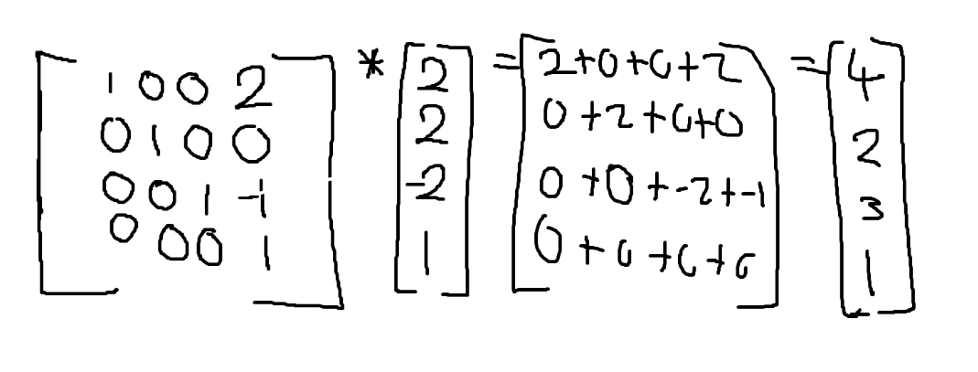

Rotation Matrix
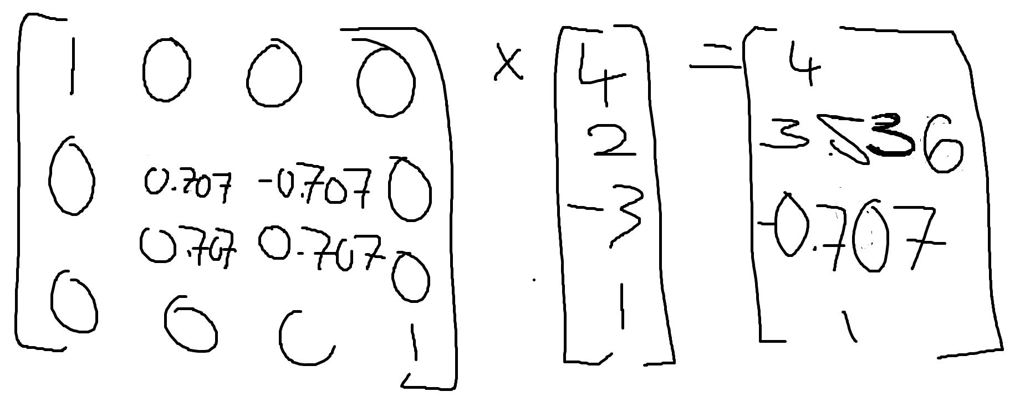

Projection Matrix
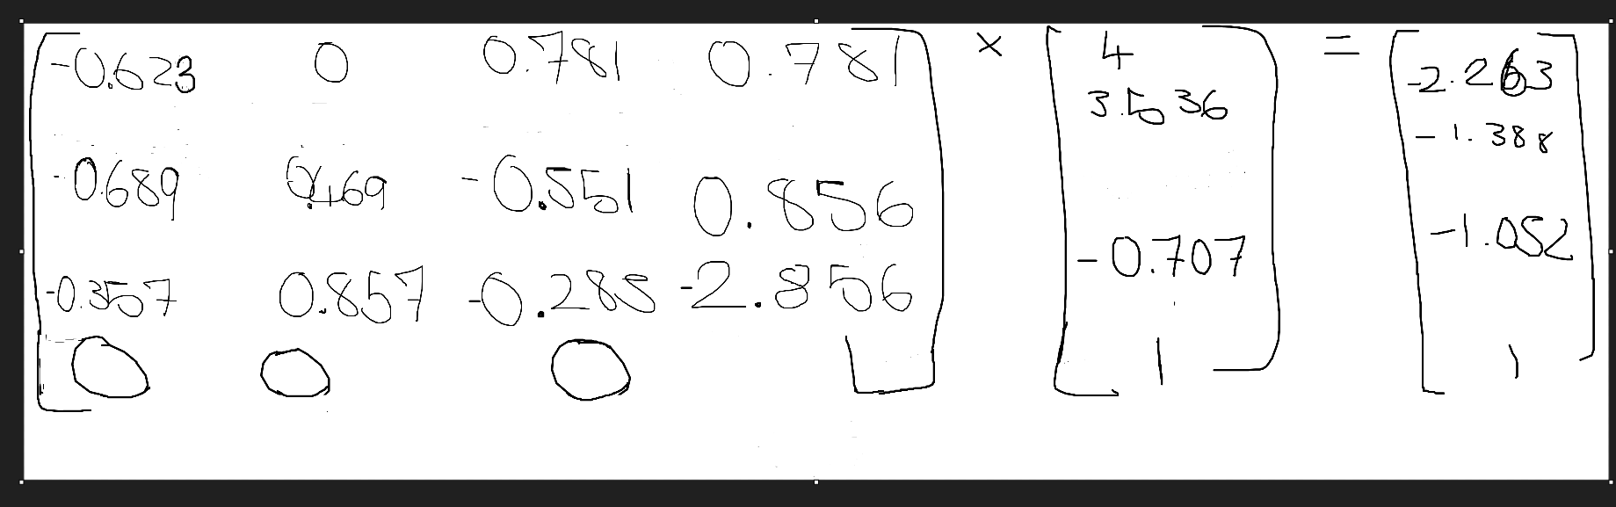
Perspective Matrix
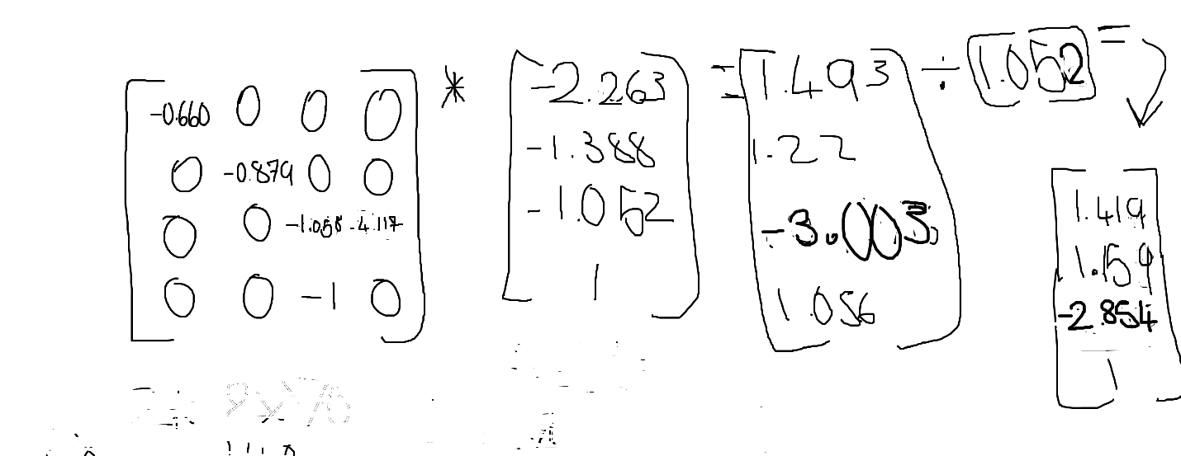

Given that the camera is looking the direction of positive x and given the position of the camera and it would be safe to assume that the camera can see the can see the vertex at 2,2, -2 as it is also in the direction of positive x.

Task 2
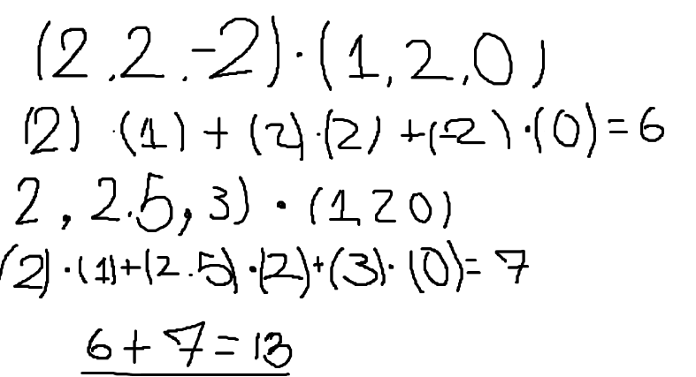
As the near plane is located at a distance of 2 and that the far plane is located at a distance of 70, also given that my previous assumption that the camera can in fact see the vertex, it is safe to assume that the vertex is inside the frustrum and will not be culled as is at a distance of 13 with is safely within the bounds of the frustrum.
Task 3
Source Code
#include <iostream>
using namespace std;
//GLM maths library is used here
#include "include/glm/glm.hpp" // vec2, vec3, mat4, radians
// Include all GLM extensions
#include "include/glm/ext.hpp" // perspective, translate, rotate
#include "include/glm/gtx/string_cast.hpp" // To string
int main(void)
{
//Orignial Vertex Position
glm::vec4 vertPos(2, 2, -2, 1);
//Rotation Angle in degrees
float rotangle = 45.0;
//Translation Vector
glm::vec3 transDist(2, 0, -1);
//Camera ViewPort location
glm::vec3 camVP(0, 3, -1);
//Temp Up Vector
glm::vec3 upVec(0, 1, 0);
//Look at Point
glm::vec3 lookAtPoint(1.5, 0, 0);
//Fov
float fov = 36.0;
//near plane
float nearPlane = 2.0;
//far plane
float farPlane = 70.0;
//coverting degrees into radians
float theta = glm::radians(rotangle);
float aspRat = 1.33;

glm::vec3 vertex(2, 2, -2);
//Point on Plane
glm::vec3 p0(2.0, 2.5, 3.0);
//plane normal
glm::vec3 planeNormal(1.0, 2.0, 0.0);

float distanceToPlane = glm::dot(vertex, planeNormal) + glm::dot(p0, planeNormal);

// TRANSLATION

// Creating a translation matrix
glm::mat4 transMat = glm::translate(glm::mat4(1.0f), transDist);

//Applying the translation.
glm::vec4 transVert = transMat * vertPos;

// ROTATION

//Creating a Rotation Matrix around the x-axis.
glm::mat4 rotMat = rotate(glm::mat4(1.0f), theta, glm::vec3(1.0f, 0.0f, 0.0f));

//applying a the rotation matrix to the translated vertex
glm::vec4 rotVert = rotMat * transVert;

// VIEWSPACE

//Creating a view matrix
glm::mat4 viewMat = glm::lookAt(camVP, lookAtPoint, upVec);

//Applying the view space transformation to the rotated vertex.
glm::vec4 viewSpaceVert = viewMat * rotVert;

// PROJECTION

//Perspective Projection Matrix
glm::mat4 projMat = glm::perspective(glm::radians(fov), aspRat, nearPlane, farPlane);

//Applying the proMat Matrix to the vertex in
glm::vec4 projVert = projMat * viewSpaceVert;

//Starndardizing the homogeneous co-ordinate
projVert = projVert / projVert.w;

//Printing the Original Position
cout << "Original Vertex: " << glm::to_string(vertPos) << endl;
//Printing the applied transformation
cout << "Translate: " << glm::to_string(transDist) << endl;
//Printing the applied transformation
cout << "Translated Vertex: " << glm::to_string(transVert) << endl;
//Translated and Rotated Vertex
cout << "Translated and Rotated Vertex: " << glm::to_string(rotVert) << endl;
//Translated and Rotated Vertex in view space
cout << "Translated and Rotated Vertex in view space: " << glm::to_string(viewSpaceVert) << endl;
//Translated and Rotated Vertex in clip space
cout << "Perspective Projection: " << glm::to_string(projVert) << endl;

cout << "Distance from vertex to plane: " << distanceToPlane << endl;
float distance = glm::dot(glm::vec3(rotVert), planeNormal) + glm::dot(p0, planeNormal);

if (distanceToPlane < 0) {
std::cout << "Object should be culled." << std::endl;
}
else {
std::cout << "Object is visible." << std::endl;
}

return 0;
}

