Katy Jones
2100222
APPENDICES FOR ECAD6010 ASSIGNMENT

Table of Contents
Appendix A: Ethical considerations form 2
Appendix B: Letter to school 16
Appendix C: Information letter with consent form to parents 17
Appendix D: Blank Questionnaire………………………………………………….…19
Appendix E: Questionnaire transcript………………………………………………22
Appendix F: Pie charts to represent some data collected……………………31
Appendix G: Interview schedule……………………………………………..…..32
Appendix H: Interview transcript…………………………………………...…..33
Appendix I: Professional conversations……………………………….……49
Appendix J: Blank observation schedule………………………………….57
Appendix K: Observation schedule………………………………….…….58
Appendix L: Themes and key points recognised from the data……62

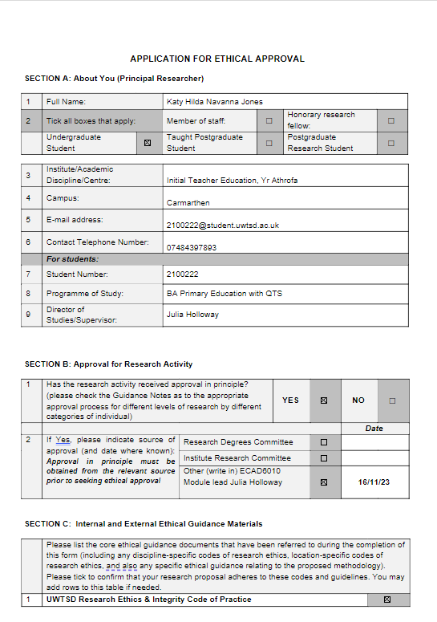
Appendix A: Ethical considerations form
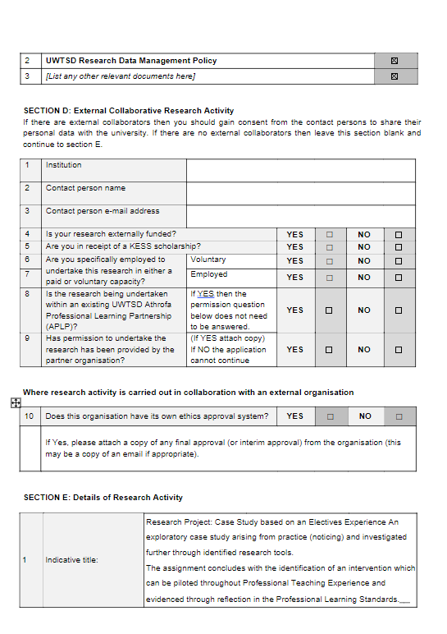

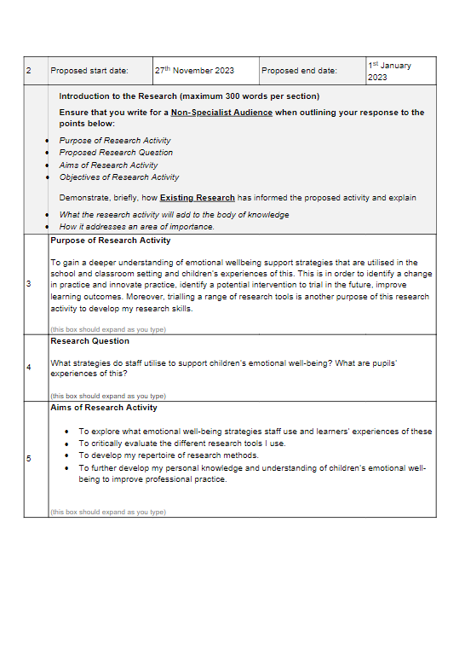

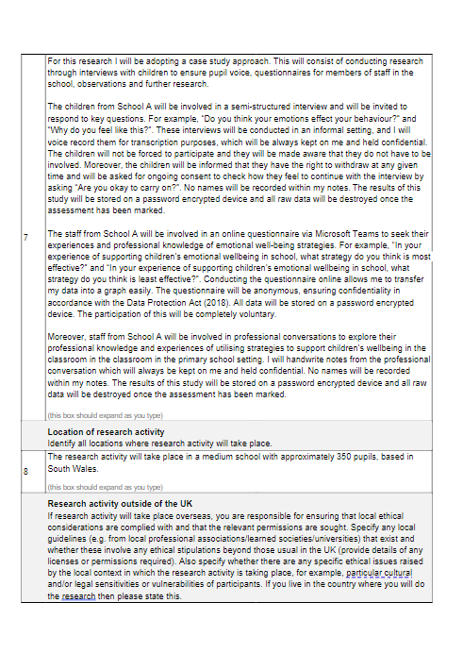

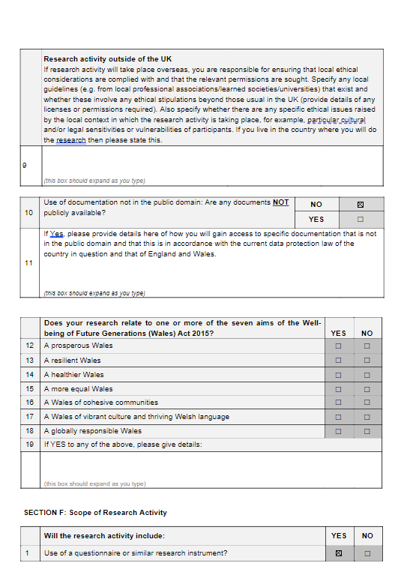

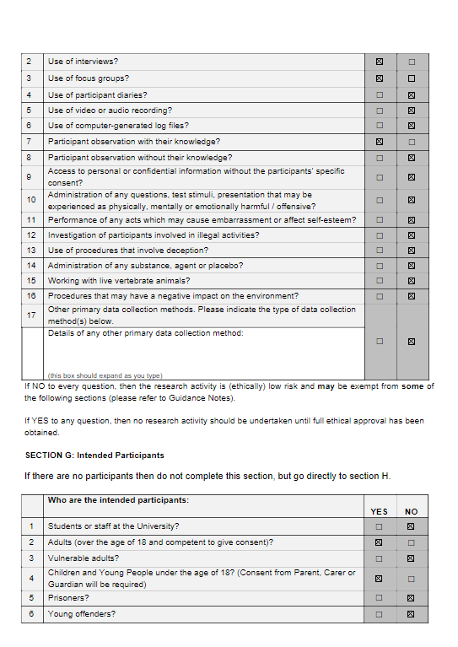

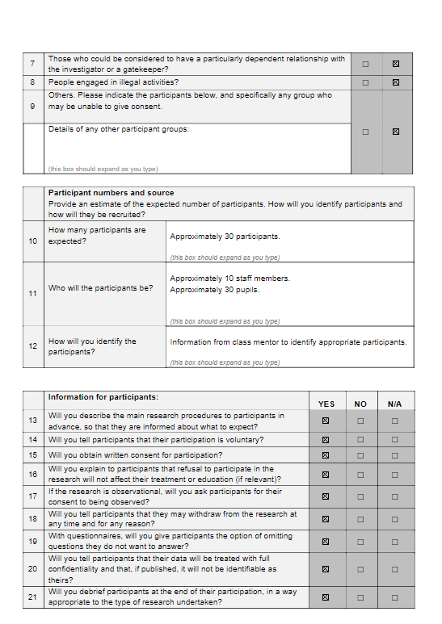
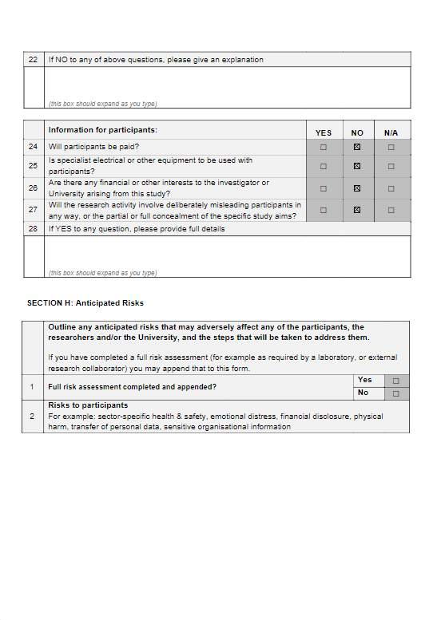
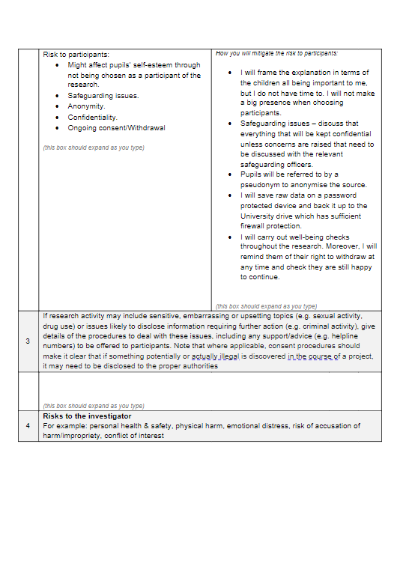
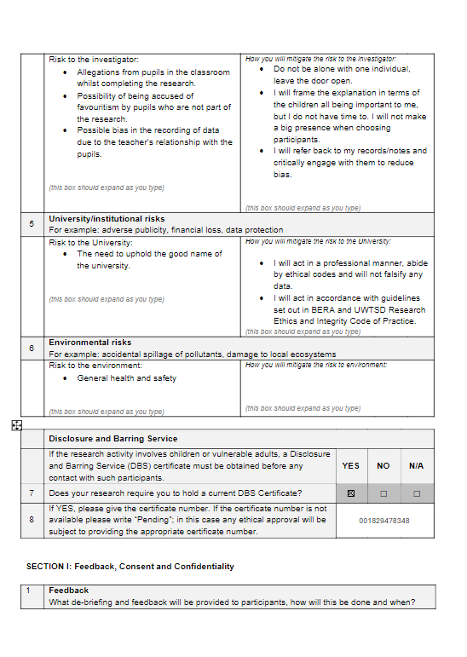
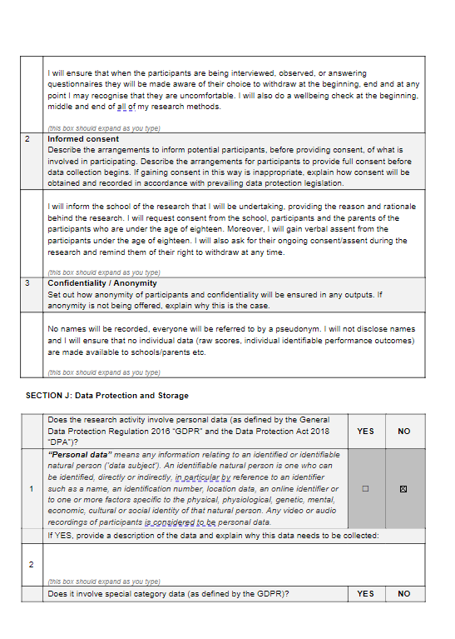
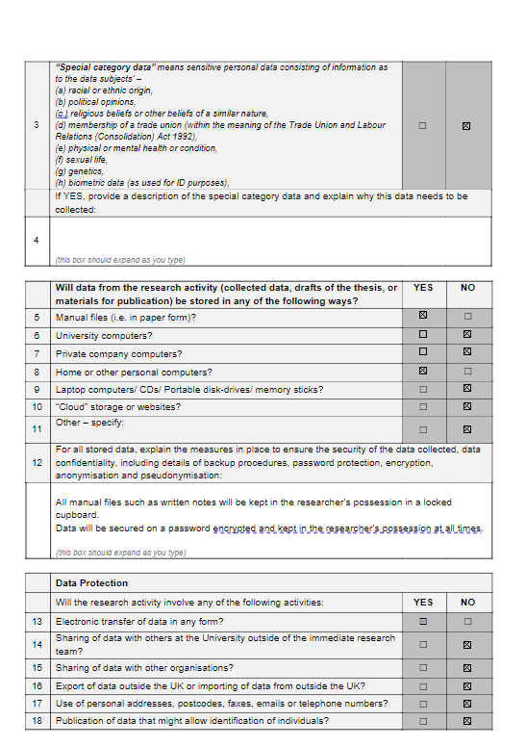
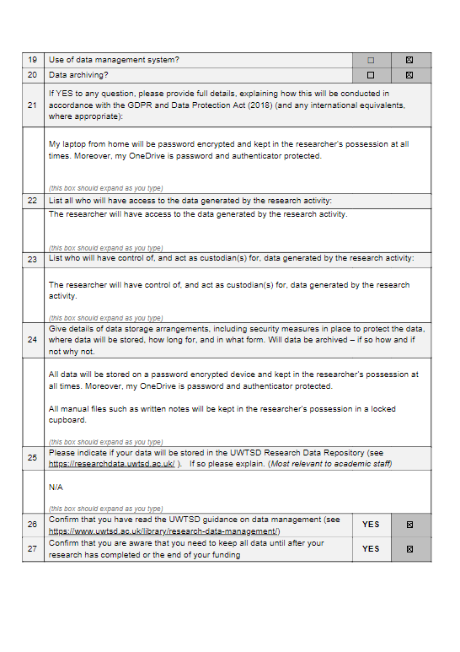
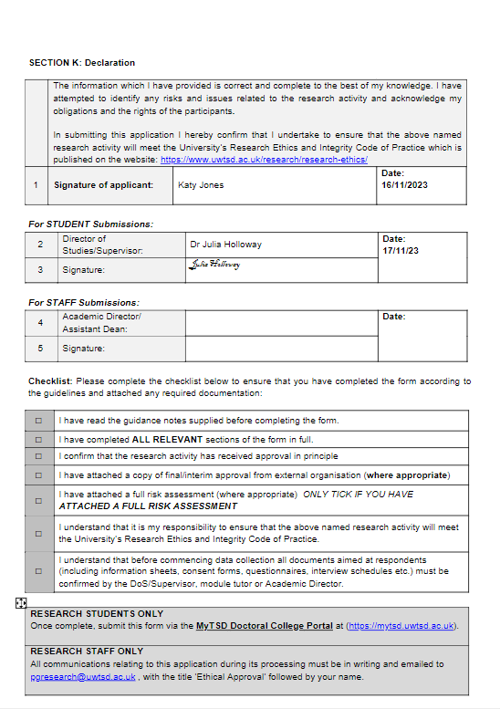

Appendix B: Letter to school

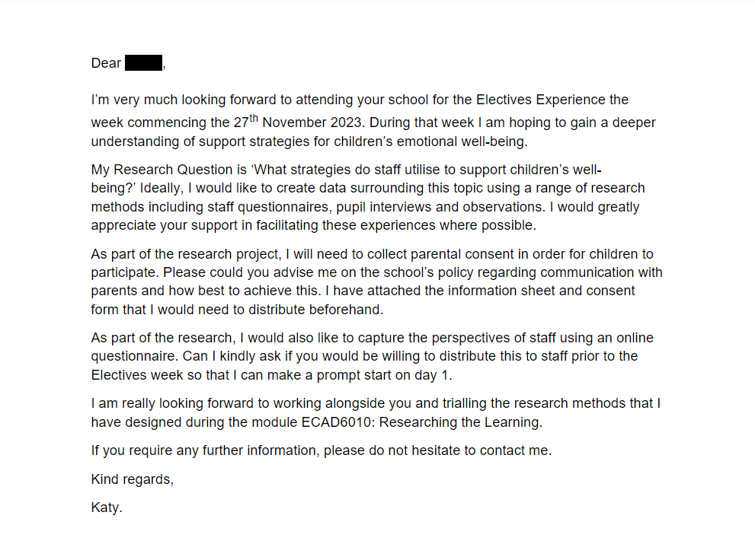

Appendix C: Information letter with consent form to parents
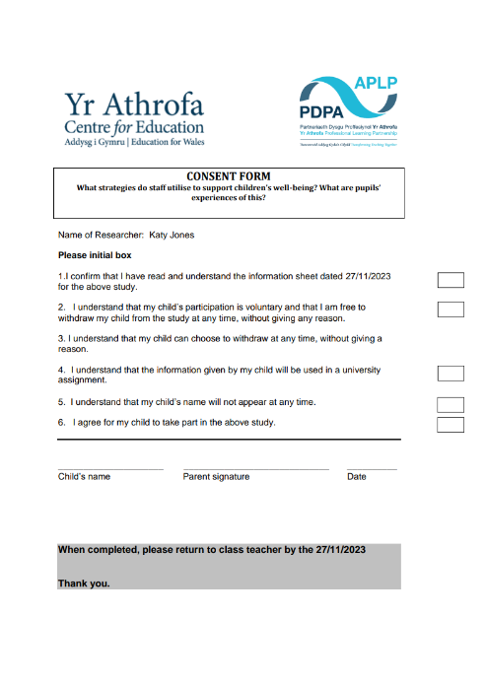

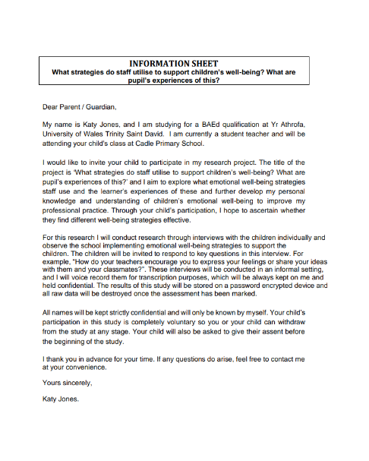

Appendix D: Blank questionnaire:
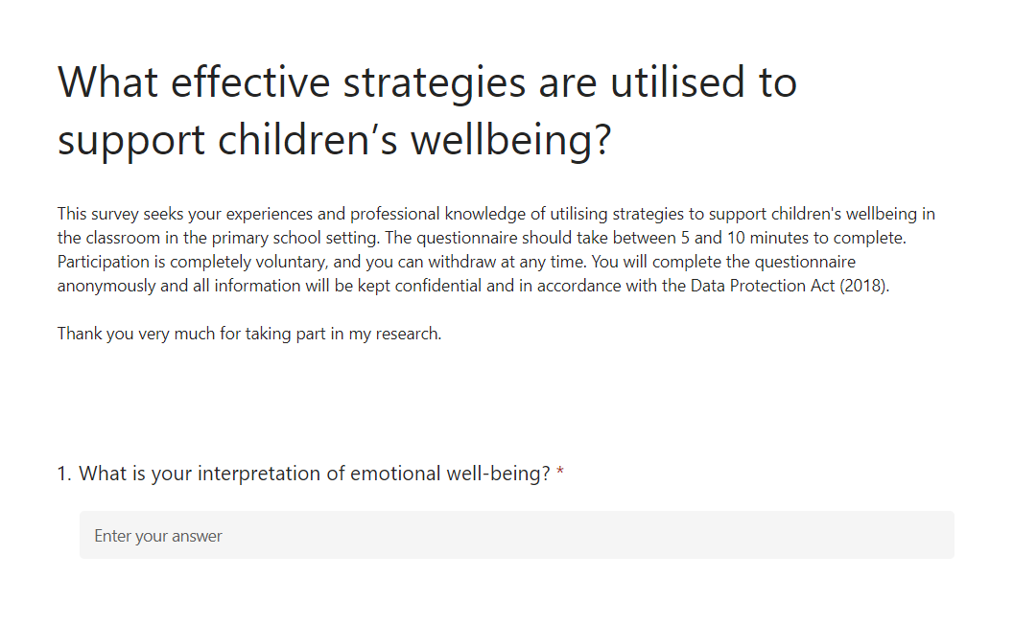
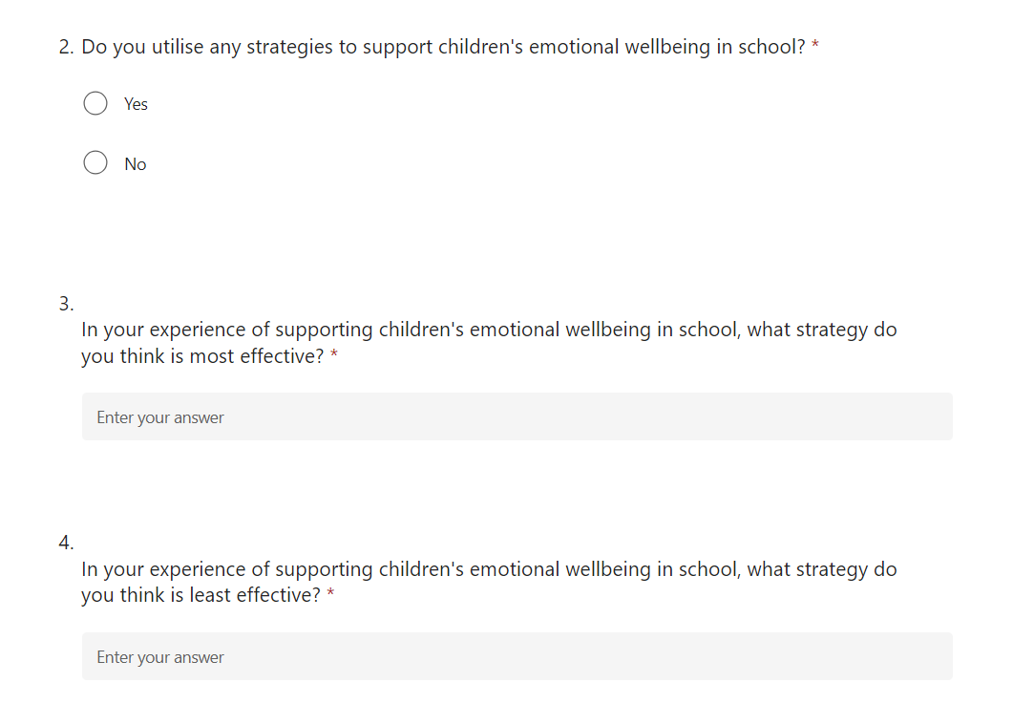

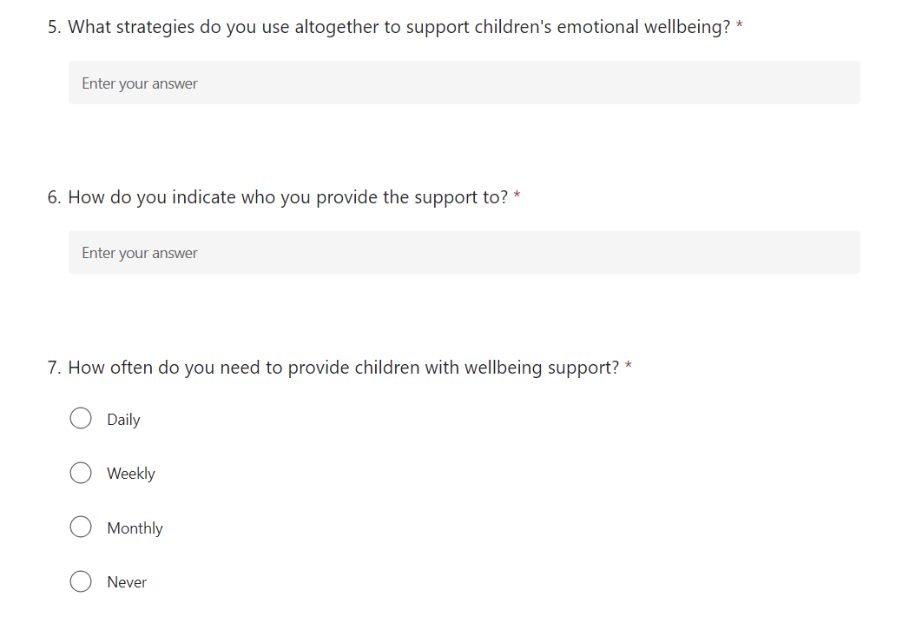
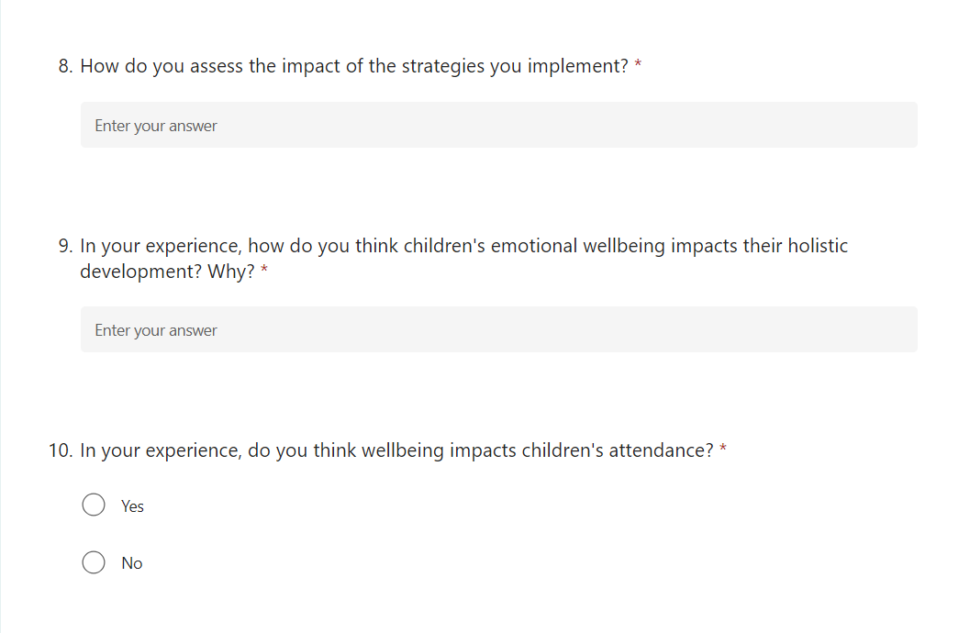

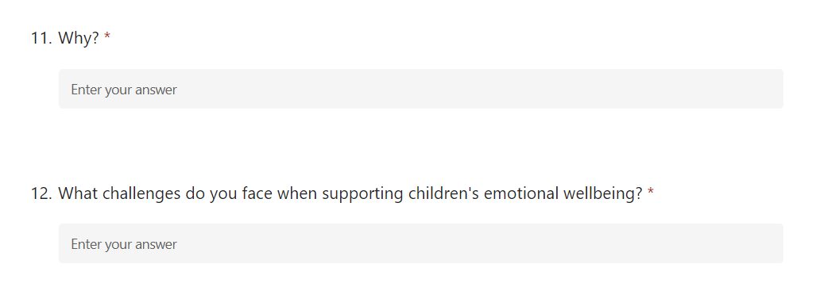

Appendix E: Questionnaire transcript
Question 1:
Staff response | What is your interpretation of emotional well-being?
A | “Being happy, healthy and safe. The overall quality of their emotional experiences - Understanding and managing emotions.”
B | “Pupils feeling safe and happy.”
C | “That children feel happy, safe and cared for but have the understanding to accept that sometimes we don't feel that way and to accept that this is okay.”
D | “The person's state of mind.”
E | “Having the tools to cope when dysregulated, to develop positive relationships , and level of resilience when dealing with challenges that impact on your emotions and wellbeing.”
F | “Emotionally aware, self & others. Able to regulate or co regulate when distressed. Having positive social interactions with peers & motivation & enjoyment in activities.”
G | “Emotional well-being refers to the state of one's emotional health and resilience. It involves understanding and managing one's emotions, coping with stress, building positive relationships, and maintaining a sense of balance and fulfilment in life.”
H | “The ability to manage your emotions both negative and positive and manage your response to change.”
I | “Ability to produce positive emotions and mindset to others and one selves when confronted with difficult situation.”
J | “Being able to communicate and self-regulate feelings. Knowing it is ok to feel a breadth of emotions, it is how we manage them is the important thing.”
K | “Person’s mood/feelings which will promote positive or negative effects.”
L | “That children are able to regulate themselves. That they can interpret their feelings and know how this can make them feel.”
M | “Feeling safe go express your emotions and be able to talk about them”

Question 2:
Staff response | Do you utilise any strategies to support children's emotional wellbeing in school?
A | “Yes.”
B | “Yes.”
C | “Yes.”
D | “Yes.”
E | “Yes.”
F | “Yes.”
G | “Yes.”
H | “Yes.”
I | “Yes.”
J | “Yes.”
K | “Yes.”
L | “Yes.”
M | “Yes.”

Question 3:
Staff response | In your experience of supporting children's emotional wellbeing in school, what strategy do you think is most effective?
A | “Strong, secure relationships. This needs to be at the heart of everything we do.”
B | “Thrive.”
C | “Getting down to their level and listening properly, then naming the emotion and exploring how to change it if need be.”
D | “Check in with pupils, listening to them, building relationships.”
E | “Emotion coaching-connecting and attuning (emphasising with pupil) , recognising how they are feeling, regulation to help them manage their feelings , problem solving on how to deal with this if it occurs again.”
F | “Positive relationships & ethos, use of social stories.”
G | “Listening. Being aware that you cannot teach a pupil until they are emotionally ready. Making sure you are there for every child in your class.”
H | “Empathising with children and validating their feelings. A simple hug also goes a long way for many children seeking comfort.”
I | “Our emotion coaching training along with trauma informed.”
J | “Showing empathy, listening, building a relationship with the child.”
K | “Depends on the child/situation. Talking is highly effective.”
L | “Regulation areas, talk and do work around emotions. Labelling emotions and staff modelling how this might make them feel. Watch videos, drama and scenarios. Sharing it’s okay to feel a particular way – strategies of how to support.”
M | “PACE.”

Question 4:
Staff response | In your experience of supporting children's emotional wellbeing in school, what strategy do you think is least effective?
A | “Being overly punitive.”
B | “N/A”
C | “I think all strategies we use are effective with different children, it is about knowing the children.”
D | “N/A”
E | “Distraction / dismissive / laissez – faire approach.”
F | “A range of strategies is always good to use and individual children respond to different strategies.”
G | “N/A”
H | “Perception that negative behaviours are being rewarded.”
I | “The use of a laptop to reduce a stressful situation.”
J | “Trying to talk the child round without acknowledging the pupil’s feelings i.e, trying to distract the child when it is better to say, I can see you’re angry etc…”
K | “Every child is different and will need variety of strategies. Some will work on some where sometimes it will not work on others.”
L | “Shouting, stopping children doing something unless they can not keep themselves safe.”
M | “Shaming or shouting.”

Question 5:
Staff response | What strategies do you use altogether to support children's emotional wellbeing?
A | “*Provide a safe and secure environment for all pupils where they can thrive to be the best that they can be. * Mindfulness and relaxation techniques. *Physical exercise. * Parental involvement. * Allowing children to express themselves through art, music and other creative activities to provide an outlet for emotions and contribute to a sense of accomplishment and self-expression. * Reinforcing positive behaviours through acknowledgement and rewards can also be effective.”
B | “Check ins, Thrive profiling, PSD lessons.”
C | “Feelings board, name it to tame it, kind hands visuals, dough disco, Ffa La La, Thrive practices.”
D | “Reassurance, check in, calm voice, emotion coaching.”
E | “Emotion coaching, co regulation, thrive approach, restorative practice.”
F | “Social stories, think equal programme, stories, songs, check in’s, regulation station, buddies, games, outdoor learning, creative activities, thrive targets & suggested activities.”
G | “Finger breathing techniques, massage partners, check in and out daily, emotion coaches, having regulations stations available, thrive assessments.”
H | “Name it to tame it. Emotion coaching. Finger breathing. Massage partners. Empathising. Compliment Circle.”
I | “Daily check in and check outs.”
J | “Thrive practices, emotion coaching, relationship based play, outdoor learning where possible.”
K | “Many – talking, name it tame it, restorative, listening, visual.”
L | “Recognising that it is okay to feel a particular way. Discuss strategies. Ongoing daily discussions and praise.”
M | “Emotion coaching. PACE.”

Question 6:
Staff response | How do you indicate who you provide the support to?
A | “Pupils check-in daily so staff can monitor their emotional wellbeing. Staff ensure that they chat with pupils where needed. Thrive Profiles indicate pupils who require reparative work – either group or 1:1. Parent’s might contact school to discuss concerns. Classroom / playground observations can indicate the need for support. The wellbeing team work closely with staff, families and pupils to address the need when it occurs. This might require sign-posting support or making referrals to outside agencies such as Brighter Futures, SNAP Cymru, Exchange Counselling, CAMHS, CHYPS, Educational Psychologist or Behaviour Support.”
B | “Thrive profiling.“
C | “All children need some support at some time. Those who need extra are highlighted by the whole team and strategies discussed to help.”
D | “It is dictated by check in poster. “
E | “Thrive assessments done termly – identify who need 1to1 support / group support / class targets to work on emotion coaching in the moment, restorative circles – after events.”
F | “All children, interventions are for those identified from low percentages in thrive assessment or teacher assessment or known family problems.”
G | “Thrive assessments.”
H | “Children in need at the time.”
I | “Body language. Facial expression. Social interactions.”
J | “Year group pupil tracking, Thrive profiles.”
K | “Check in process, circle time, general mood of child.”
L | “Discussions, reassess all the time where the need is, talk as a team.”
M | “Dysregulated children.”

Question 7:
Staff response | How often do you need to provide children with wellbeing support?
A | “Daily.”
B | “Daily.”
C | “Daily.”
D | “Daily.”
E | “Daily.”
F | “Daily.”
G | “Daily.”
H | “Daily.”
I | “Daily.”
J | “Daily.”
K | “Daily.”
L | “Daily.”
M | “Daily.”

Question 8:
Staff response | How do you assess the impact of the strategies you implement?
A | “Through Thrive Assessments (Whole class, group or individual) and daily observations.”
B | “Thrive profiling.”
C | “Observations.”
D | “Observation of pupils response.”
E | “As I am an emotion coach practitioner, I have filled in a log.”
F | “Thrive assessment, knowledge of the child, check in responses.”
G | “Yes.”
H | “Responses from children, time taken to regulate themselves.”
I | “A solution to support the child being implemented.”
J | “Children are assessed three times yearly on Thrive.”
K | “Childs behaviour.”
L | “By the children and whether they can manage.”
M | “Through talking to the child.”

Question 9:
Staff response | In your experience, how do you think children's emotional wellbeing impacts their holistic development? Why?
A | “Children who have well developed emotional wellbeing feel good about themselves, form trusting relationships, become more resilient and develop skills to overcome difficulties. It is closely linked with children’s social skills, mental and physical health.”
B | “If a child is happy then they will succeed.”
C | “All behaviour is a communication of something, so I think it does have an impact. Young children are learning to navigate such a lot at a young age and need to learn the skills that enable them to recognise, deal with and act on emotions they are feeling.”
D | “Pupils cannot learn if not in a good emotional state – ensuring they’re ready to learn is vital.” “
E | “It can have a significant impact on their readiness for learning in terms of their social skills – developing empathy and understanding and resilience in order to deal with challenges and impacts on intrinsic motivation and believing in capabilities.”
F | “Wholly, a happy child is ready to learn, participate & interact with others positively.”
G | “Children’s emotional well-being significantly influences their holistic development because emotions play a crucial role in shaping cognitive, social and physical aspects of their growth. A child with positive emotional well-being is likely to have better cognitive skills, form healthier relationships, and exhibit more resilience in facing challenges. Conversely, difficulties in emotional well-being can impede various aspects of a child’s development, affecting their learning, social interactions, and overall ability to navigate life’s experiences. Emotional well-being serves as a foundation for a child’s holistic development.”
H | “Disrupts their learning – coming into school in a negative state of mind / dysregulated. Stress and worry impacts on how much focus and energy they are able to give to a learning experience / skill.”
I | “The children will not be ready to learn, interact or progress within their own lives if they have emotional barriers in the way.”
J | “Can affect health, on times children who are anxious complain of bad tummies. Affects relationships with others. Affects academic performance.”
K | “If there is emotional difficulty then cannot access learning.”
L | “In every way.”
M | “If they can’t regulate their emotions its hard for them to do anything.”

Question 10:
Staff response | In your experience, do you think wellbeing impacts children's attendance?
A | “Yes.”
B | “Yes.”
C | “Yes.”
D | “Yes.”
E | “Yes.”
F | “Yes.”
G | “Yes.”
H | “Yes.”
I | “Yes.”
J | “Yes.”
K | “Yes.”
L | “Yes.”
M | “Yes.”

Question 11:
Staff response | Why?
A | “Emotional well-being plays a significant role in school attendance. Children who do not feel safe, supported, and engaged in the school environment are more likely to have higher absences. Home environment directly influences pupils’ wellbeing and subsequent attendance levels.”
B | “Pupils are more likely to attend school if they are happy.”
C | “Children are often more switched on than we give them credit for and if they feel that they are not being listened to or of value, they can be quite adept at pushing their parents’ buttons and persuading them to let them stay at home. It is about making sure that the children want to come to school because they enjoy it and feel safe.”
D | “If pupils are likely to become dysregulated on arrival, parents may feel reluctant to send them.”
E | “When pupils have a positive sense of wellbeing, they are more likely to develop positive relationships with teachers – so if this is not the case the desire to attend regularly is not there.”
F | “Children with low wellbeing often feel reluctant to attend school.”
G | “Yes, wellbeing can impact children’s attendance. Children with positive emotional well-being are more likely to feel motivated, engaged, and connected to their school environment. Conversely, those facing emotional challenges may experiences difficulties in attending regularly due to factors such as anxiety, stress, or disengagement. Addressing and promoting emotional well-being in children can contribute to a positive school experience, potentially improving attendance and overall academic performance.”
H | “Negative wellbeing can cause pupils not to want to be in school or dislike learning.”
I | “Social interaction will support positive wellbeing.”
J | “Children may stall coming to school possibly for reasons listen in question 9.”
K | “Feeling low has negative impact on health.”
L | “If the children do not ‘feel safe or happy they will not want to come to school.”
M | “Children who have low resilience and low self esteem struggle to attend school.”

Question 12:
Staff response | What challenges do you face when supporting children's emotional wellbeing?
A | “Throughout the school there are diverse needs – there is no ‘one-size fits all’. It is imperative to really get to know each child to be able to support them fully – this takes time. Being responsive to dynamic changes is really important and therefore careful management of staff is needed. Parental engagement and understanding.”
B | “If pupils are dysregulated. Time limitations.”
C | “Understanding all the complex needs that present in our school on a daily basis, having the staff and the time to really pay attention and give that child the support that they need.”
D | “Pupils dysregulation can lead to disruption of others’ learning“
E | “The behaviour that comes alongside the emotions, and also having the staff to give the children 1to1 time to support their wellbeing.”
F | “Children who often have low emotional wellbeing present communicate their feelings through behaviour. This behaviour can sometimes be negative & challenging and requires the trusted adult to look beneath the surface of the behaviour & support the child with their specific needs. Often very withdrawn children may be difficult to engage with & it is the responsibility of the trusted adult to build good relationships & support the child.”
G
  “1. **Identifying Needs:** Recognising and understanding the unique emotional needs of each child can be challenging as they vary widely. 2. **Communication:** Children might find it difficult to express their emotions verbally, making it challenging for adults to understand and address their feelings. 3. **Resource Limitations:** Limited resources, such as time and personnel, can hinder the ability to provide adequate support and interventions for every child. 4. **External Factors:** Factors outside the immediate support system, such as family dynamics or societal influences, can impact a child's emotional well-being and pose challenges in addressing those issues. 5. **Changing Circumstances:** Children's emotional well-being is dynamic, and their needs may change over time. Adapting support strategies accordingly can be a continuous challenge. 6. **Stigma:** Overcoming stigma or negative perceptions associated with seeking help for emotional well-being can be a barrier for both children and their caregivers. 7. **Collaboration:** Ensuring effective communication and collaboration between parents, educators, and mental health professionals is crucial but can be challenging due to various factors. Addressing these challenges requires a holistic and collaborative approach involving educators, parents, mental health professionals, and the community.”
H | “Ability to be all things to them whilst attending to the other pupils in class. Love and care for the children can make it difficult to separate school from home life.”
I | “Parents and time.”
J | “Resources such as staffing and time – it can be difficult to withdraw a pupil who needs support with limited staff in the class.”
K | “You need to cater for a whole class too.”
L | “That the well-being / actions can have implications on others’ choices. The setting can get dysregulated very quickly.”
M | “Time, staff, resources.”

Appendix F: Pie charts to represent some data collected.
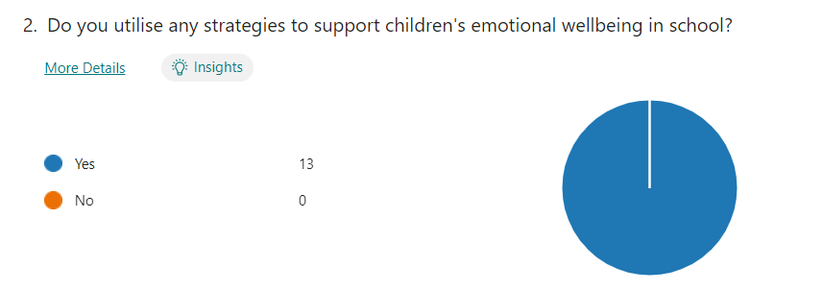
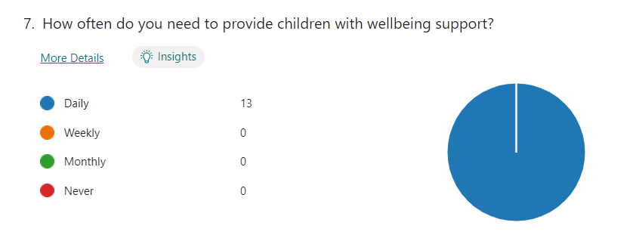
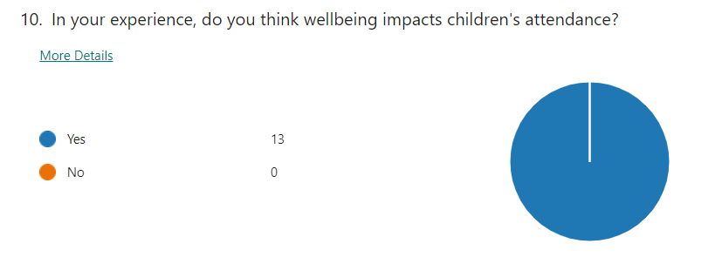

Appendix G: Interview schedule
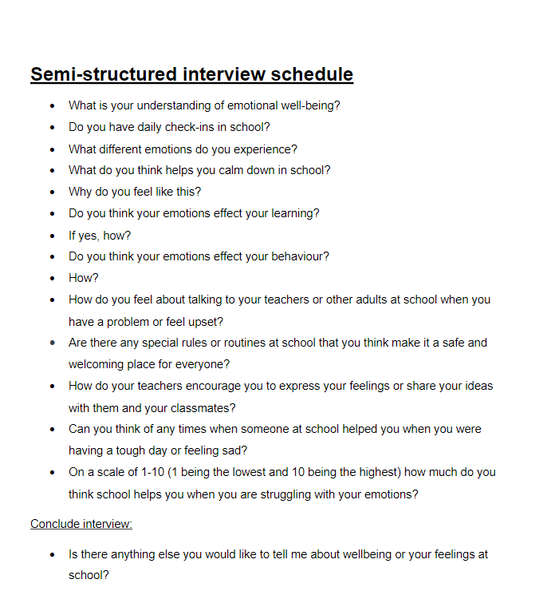

Appendix H: Interview transcripts
  - Transcript 1
Interviewer: “The first question is what is your understanding of emotional well-being? What do you think it means?”
Interviewee: “Like people understanding things. So, when you're, like upset, they understand how you feel and stuff.”
Interviewer: “Do you have daily check-ins in school?”
Interviewee: “Yeah, we have daily check-ins, like there’s emotions on the board and then we stick our peg on there and we normally move them around if we feel different emotions, but we don’t always do them.”
Interviewer: “So, whenever you want to move it, you can?”
Interviewee: “Yeah, whenever we want.”
Interviewer: “Oh, that's good. Do you feel like you can speak to your teacher about how you are feeling?”
Interviewee: “Sometimes.”
Interviewer: “What different emotions do you think you experience in school?”
Interviewee: “Sometimes upset, happy, excited. A bit ill sometimes.”
Interviewer: What do you think helps you calm down during school?
Interviewee: We normally go to the corner and read books and stuff, or we have the little fidgets, and then we can calm down with our friends or on our own. I can speak to the teacher too.”
Interviewer: “Oh, that's nice. Do you think it helps you?”
Interviewer: “Do you think your emotions affect your behaviour?”
Interviewee: “No I’ll carry on with everything.”
Interviewer: “How do you feel about talking to your teachers or any other adults in the school? Would you speak to anybody about your feelings?”
Interviewee: “Someone who I am comfortable with, and I know that a lot will listen to me.”
Interviewer: “Are there any special routines at school that you think make it feel like a safe and welcoming place? Is there anything you do to feel safe in school?”
Interviewee: “Registers, check-in, check-out.”
Interviewer: “Do you check out before you leave school then?”
Interviewee: “That's on Friday afternoon. We all sit in a circle, and we get all the pegs, help us choose our one peg and we stick them on the emotions and normally I'm happy.”
Interviewer: “How do your teachers encourage you to express your feelings or share your ideas? Do they encourage you to say something about your feelings?”
Interviewee: “Um, they don’t really encourage us, but we can say our feelings if we want to.”
Interviewer: “Can you think of any times when somebody at school helped you with your emotions?”
Interviewee: “Once I was like, feeling sick, my stomach was really hurting, and my head and my friends came over to me straight away and then we went to the corner to read some books.”
Interviewer: “Oh, that's nice. So, you know that your friends can help you as well?”
Interviewee: “Yeah”
Interviewer: “Yeah? That's good, that you have good friends. On a scale of one to ten, one being the lowest and ten being the highest, how much do you think school helps you when with your feelings?
Interviewee: “Um, 5.”
Interviewer: “Is there anything else you can think of about well-being that you'd like to tell me?”
Interviewee: “Um, we do the register, and we say different languages and say ‘shwmae’ to some people. We go down the register, say some people are at the top and I was next they’d say ‘bonjour’ or something to me. It makes me express my feelings because like if I say it clear, in a sad voice or something and it helps the teacher understand and then we do um, over to yous which help teachers to see what level we’re on, usually in math.”
Interviewer: “Do you find those helpful?”
Interviewee: “Yeah”
Interviewer: “Is there anything else you’d like to tell me about wellbeing?”
Interviewee: “No.”
Interviews: “No worries, thank you.”

Transcript 2
Interviewer: “What is your understanding of emotional well-being? What do you think it means?”
Interviewee: “Um, I don’t know.”
Interviewer: “It's okay if you don't think you know. Don’t worry, it’s fine. Do you want to do the next question?”
Interviewee: “Yeah.”
Interviewer: “The next question is, do you have daily check-ins at school?
Interviewee: “Yeah.”
Interviewer: “What different emotions do you think you have whilst you’re at school?”
Interviewee: “Um, I’m always angry, most of the time I'm annoyed. It's just because of football. Sometimes happy.
Interviewer: “What happens in football that makes you annoyed?”
Interviewee: “Well, don't get passed to.”
Interviewer: “What do you think helps you calm down if you're feeling upset, angry or annoyed?”
Interviewee: “If it’s at home like being on my phone, but in school it’s like only eating. All I ever want to do in school is have my lunch already.”
Interviewer: “Do you think your emotions affect your learning?”
Interviewee: “Yeah, when I'm angry., I’m kind of like not that nice”
Interviewer: “How do you feel about talking to your teachers or any other adults about your feelings? Do you feel like you can speak to them?”
Interviewee: “Yeah, but I don't because by the time I feel like I want to, it's already, I'm not, I don't feel that bad anymore.”
Interviewer: “So you're already feeling better by the time you feel ready to talk?”
Interviewee: “Yeah.”
Interviewer: “Are there any special routines at school that you think make you feel safe at school?”
Interviewee: “I don't really know about routines because you already said them all but I do feel safe at school.”
Interviewer: “Yeah, that's fine. Do you feel like you have some friends here?”
Interviewee: “Yeah, one friend in my class. He just gets really angry sometimes. He's my best friend.”
Interviewer: “Do your teachers encourage you to share your feelings?”
Interviewee: “We do like check-out and check-in. Like, so we got our pegs, some people have to choose it from a bucket and then clip it on to what you're feeling and then once you come back, you have to say why you're feeling that that way.”
Interviewer: “Oh, that's good. Can you think of any times at school when someone has helped you when you’re having a bad day? ”
Interviewee: “Uhh, one day. It was on a Tuesday and it was the Halloween disco. I didn't feel that well, my head was really hurting but I got distracted like playing football. When I'm distracted, it doesn't hurt that much.”
Interviewer: “It makes you feel a bit better because you’re distracted does it?”
Interviewee: “Yeah and then my friend, I told you about. Yeah, he like he said he’d get me distracted, so, I can't be thing, so my head doesn’t hurt so he helps get me distracted all the time, so my head doesn’t hurt.”
Interviewer: “That's nice. So, your friend helps you?”
Interviewee: *nods head*
Interviewer: “That's a good friend. On a scale of one to ten (so one's the lowest and ten’s the highest) How much do you think school helps you with your feelings?”
Interviewee: “Four.”
Interviewer: “The last question is, is there anything else you could think of that I haven't mentioned, and you would like to tell me about wellbeing?”
Interviewee: “No, no.”
Interviewer: “Okay, perfect. Thank you.”

  - Transcript 3
Interviewer: “The first question is, what do you think well-being is?”
Interviewee: “Eating healthy stuff.”
Interviewer: “Do you have any daily check-ins at school?”
Interviewee: “Um, yeah.”
Interviewer: “What do you do for your daily check-ins?”
Interviewee: “Um, I say if I’m happy
Interviewer: “What different emotions do you think you experience?”
Interviewee: “I don’t know really.”
Interviewer: “You’re not sure? That's fine. What's your what do you think helps you calm down in school?”
Interviewee: “When we do finger breathing.”
Interviewer: “Is there anything else?”
Interviewee: *shook head*
Interviewer: “No? That's fine. Do you think you're how you're feeling affects your learning or your behaviour?”
Interviewee: “Um, I always be good.”
Interviewer: “How do you feel about talking to your teachers or anybody else about your feelings?”
Interviewee: “I’m kind of not upset, because I feel happy.”
Interviewer: “That's fine. Are there any special routines at school so anything you do every day or quite often they think makes it a safe place for you to come to and welcome in?
Interviewee: *Nods head*
Interviewer “Yeah? Can you name any?”
Interviewee: “Um, my teachers protect me.”
Interviewer: “So, you feel comfortable with your teachers?”
Interviewee: “Yeah”
Interviewer: “How do your teachers encourage you to express your feelings? Do you think they encourage you?”
Interviewee: “Um, no.”
Interviewer: “Can you think of any time where somebody at school's helped you with your feelings?”
Interviewee: “They helped me feel better when I was sad”
Interviewer: “That's nice, isn't it?”
Interviewee: “Yeah”
Interviewer: “On a scale of one to 10, so one is the lowest and ten is the highest – How much do you think the school helps you when you with your emotions?”
Interviewee: “A lot.”
Interviewer: “Is there anything else you want to tell me?”
Interviewee: “No.”
Interviewer: “No? That's fine.”

Transcript 4
Interviewer: “So the first question is what is your understanding of emotional wellbeing, what do you think it means?”
Interviewee: “Sad, happy.”
Interviewer: “Do you have daily check-ins at school?”
Interviewee: *nods head*
Interviewer: “Yeah? What do you do for daily check-ins?”
Interviewee: “We don't really have any check-ins but on a Monday, we say how the weekend has gone and that and um, we have an emotion coach. So, this is her station, and she helps us like if I'm sad, she'll say, do you want to come out in the regulation station and then um, she'll see if I’m okay.”
Interviewer: “That's nice. What different emotions do you experience altogether?”
Interviewee: “Sad, excited, happy and sometimes angry.”
Interviewer: “What do you think helps you calm down when you’re in school?”
Interviewee: “Um, finger breathing and sitting in the regulation station and um, talking about my emotions.”
Interviewer: “Do you think your emotions affect your learning or your behaviour?”
Interviewee: “Um, no.”
Interviewer: “How do you feel about talking to your teachers or any other adults at school about your emotions? Do you feel like you could speak to anyone?”
Interviewee: “Yeah.”
Interviewer: “Who would you usually speak to?”
Interviewee: “My class teacher, the TA, the emotion coach or the wellbeing officer.”
Interviewer: “Are there any special routines, so something you do every day or every week in school that you think makes it feel safe here?”
Interviewee: “Finger breathing.”
Interviewer: “How do your teachers encourage you to express your feelings? How do they make you feel like you should speak about your feelings?”
Interviewee: “Um, they help me, like any time I’m sad. I think it’s just because I can talk to them because I got strong relationships with them.”
Interviewer: “Aw, that’s good, isn’t it? Do you think it took long to build these relationships?”
Interviewee: “No, it's taken me like two days to build a relationship with my class teacher.”
Interviewer: “Can you think of any time when somebody at school has helped you with your emotions?”
Interviewee: “Yeah, my class teacher helps me.”
Interviewer: “On a scale of one to ten (so ten being the highest and one being the lowest), how much do the school help you with your emotions?”
Interviewee: “Ten”
Interviewer: “Ten? That’s good! Is there anything else that you would like to tell me about wellbeing at school?”
Interviewee: “No.”
Interviewer: “Okay, no worries, thank you.”

Transcript 5
Interviewer: “What is your understanding of emotional well-being? What do you think it means?”
Interviewee: “What I think it means is if somebody is like sad or if they have like a different emotion like even if they can’t control their emotion, you would like have to regulate them for their emotion. So, like if they're angry, they would have to regulate and if they were sad they would have to regulate and if they were any type of emotion that they can’t really like maybe handle, they would have to like regulate.”
Interviewer: “Do you have any daily check-ins at school?”
Interviewee: “Yeah, we do on a .... Sometimes we do it on a Wednesday or Tuesday, but on a Monday and a Friday, on Mondays, we check if everybody's okay. So first we say ‘ Sut wyt ti?’ and they say ‘hapus’ or ‘drist’ and then miss will ask them if they want to have a chat and if they said yes, miss would have a chat with them and if they said no, then miss would say ‘do you want to go in the regulation station?’ and then they would say ‘yes’ or ‘no’.”
Interviewer: “Oh, that’s good.”
Interviewee: “And then on a Friday, she would also make sure if everybody's okay and in the middle of the week.”
Interviewer: “Have you ever used the regulation station before?”
Interviewee: "Yeah.”
Interviewer: “Do you find it useful?”
Interviewee: “Yeah because usually the emotion coach will always make sure everybody’s okay. So, like if somebody is really fidgety and like if they just need something to do, she will go and get like a poppet or something for them to play with or she would grab something else and she would make sure everybody’s okay. She would let them draw and stuff to make sure that like... and sometimes people don’t like speaking up, so she will like... So, like if somebody doesn’t want to speak but they want to tell someone she would say like ‘Do you want to write it on a piece of paper?’ and then we could like maybe talk about it like if you don’t want to say it all.”
Interviewer: “Aw, that’s good.”
Interviewee: “Yeah because we have a folder and it’s, the emotion coach puts all the things in there so *class teacher* can have a look to make sure like everyone is good.”
Interviewer: “I like that idea. What types of emotions do you experience when you're in school?”
Interviewee: “So, you mean like other people or just me?”
Interviewer: “Just you.”
Interviewee: “If somebody would say something like I would get upset or if somebody was saying something I would probably get upset but I don’t really, I’m not really, I’m usually only happy in school unless somebody’s like said something to me or like if I feel a little bit left out, I feel sad. But, they’re really the only emotions that I feel in school because I don’t really get angry because I really just don’t get angry that much.”
Interviewer: “When you’re sad do you feel like there’s someone you can speak to?”
Interviewee: “Yes.”
Interviewer: “Yeah?”
Interviewee: “Yeah, I could speak to my teacher, I could speak to any of my friends because *class teacher* lets you speak to your friends if you don’t want to like talk to a certain person because like if I didn’t want to speak to **** who is our emotion coach, she would say ‘Do you want to speak to somebody else?’ and then they would say ‘Yeah’ so you can speak to whoever you want.
Interviewer: “That's nice. What do you think helps you calm down when you're in school? If you're upset or anything, what do you think helps you calm down?”
Interviewee: “Probably just doing something that I usually find like reading a book or doing some drawings or writing.”
Interviewer: “What would you write?”
Interviewee: “Sometimes I would just write about things that like I find happy or something, and sometimes I would write stuff, like anything, I would just write anything that came to my head.”
Interviewer: “Aw, that’s nice. Do you think how you feel can affect your learning?”
Interviewee: “So, maybe like if I’m really upset and somebody’s, the person who made me upset was sitting next to me, I would maybe feel like a little bit uncomfortable or I would be a little bit like, not like away, but like I wouldn't really be concentrating because I would be concentrating on whether they are going to say something to me. So, if someone is around me who makes me feel uncomfortable or if they said something to me, I would ask *class teacher* if I could move seats or I’d just be distracted because I do like learning and it just entertains me when um, sometimes I get distracted but sometimes I don’t.”
Interviewer: “That's nice to know that you can ask to move seats. Have you had to ask to move seats before?”
Interviewee: “Um, yeah because sometimes people can get like really distracting when you’re like doing your work, like if my friends want to talk to me and I’m really concentrating and then they’re distracting.”
Interviewer: “Do you think your emotions affect how you behave?”
Interviewee: “No.”
Interviewer: “How do you feel about talking to any of your teachers or any other adults in school about your feelings?”
Interviewee: “I’m okay with speaking to any teacher or anyone in the school. I’m fine with speaking to them, because like I feel like they would actually keep everything that I didn't want them to tell anybody or anything and they would always keep it to themselves and wouldn’t like tell anybody. So, I really like trust the teachers and stuff in school.”
Interviewer: “Are there any special routines you have in school? Is there anything you do every day or every week that makes it feel like a safe place?”
Interviewee: “Like I was saying earlier, the check-in area and it's like sometimes if someone, it makes us feel like safe because we have somebody to talk to and stuff. Sometimes if something like happened and you’re not really happy all the time, miss would do a daily check with you so that’s what happens sometimes, miss does daily checks with people or like she sends them to *wellbeing officer*.”
Interviewer: “How does your teacher encourage you to speak about your feelings?”
Interviewee: “Um, she doesn't really. So, she doesn’t force us to tell and if we don't want to talk about it, she like, she'll just leave us alone and she'll just let us. But, like, if she knows that something's really gone wrong, and she just thinks that, like it won't be safe or anything she will like say ‘Will you just tell me? I won’t tell anyone I will just keep it to myself.’ She doesn’t force you to say anything, she just waits until you’re ready to says something.
Interviewer: “Can you think of any time when somebody’s helped you at school when you were feeling a bit sad, angry or any other emotion?”
Interviewee: “Well, I don't really get angry or sad that much, but like if I did get like sad or because of something then like usually the emotion coach or *class teacher* will talk to me because the emotion coach is my best friend and I trust her to speak to and also *class teacher* I would speak to.”
Interviewer: “On a scale of one to ten (so one is the lowest and 10 is the highest) How much does school help if you’re struggling?
Interviewee: “Um, for like work or maybe like your emotions?”
Interviewer: “With your emotions.”
Interviewee: “Like as I was saying, like I don't really get that thing but like my judge from other people, they do help them a lot. So sometimes the teachers, if they’ve maybe done something wrong, and maybe they're a little bit um, moody, um the teachers will say, well, if you don't want to speak. But, they do help- you a lot, so it's probably a nine out of ten and the one that's a –1 is because sometimes the people is the way that they act to the teachers and the teachers just don't want to really get them even more angrier or anything, so they just make sure that they stay away if, like, they get really unregulated. They usually help you a lot.
Interviewer: “Is there anything else you can think of that I haven't asked you about?”
Interviewee: “No.”
Interviewer: “No? Perfect, thank you.”

Transcript 6
Interviewer: “What do you think emotional well-being means?”
Interviewee: “I think it means like when you're like, if you're like helping someone if they're like angry or something, or like they're sad or angry.
Interviewer: “Do you have any daily check-ins in school?”
Interviewee: “No, not really.”
Interviewer: “What different emotions do you experience when you're in school?”
Interviewee: I experience sad, happy. Um, usually I would have people come to the regulation station. I have had like annoyed, sad, but never angry, like maybe a little but angry, but no one having like a proper fit or something. Just there a little bit annoyed.”
Interviewer: “What do you think helps you calm down? So, you're the emotion coach, so what would you do?”
Interviewee: “Um, I would usually just say to miss that if I could just come to the regulation station on my own or with like a friend. So, they would come in as well with me and they, like, would help me, basically like a second emotion coach, but yeah.”
Interviewer: “That's good because I was thinking, if you're the emotion coach who could help you. Do you think your emotions affect your learning?”
Interviewee: “No, not really.”
Interviewer: “Do you think they affect your behaviour?”
Interviewee: “Um, no.”
Interviewer: “How do you feel about talking to your teachers, or any other adults in school about your feelings?”
Interviewee: “Yeah, maybe like sometimes. It depends on what it’s about.”
Interviewer: “Are there any routines that you do every day in school or every week related to wellbeing and safety at school?”
Interviewee: “We do usually a lock down, so basically if someone's trying to get into the school, we practice that stuff. Yeah. And it makes us feel more safe.
Interviewer: “How do your teachers encourage you to express your feelings?”
Interviewee: “I don't think she would really mind, but I think it's if she's happy with me.”
Interviewer: “Can you think of any times when somebody at school has helped you with your feelings?”
Interviewee: “Um, yeah.”
Interviewer: “Do you know who that person was thar helped you?”
Interviewee: “My teacher and the wellbeing officer. One time, I was arguing with a friend about something silly, but then she said something again, so I spoke to them.”
Interviewer: “Do you think speaking to them made it better?”
Interviewee: “Yeah.”
Interviewer: “On a scale of one to ten, so one is the lowest and ten is the highest, how much do you think school helps you with your feelings?”
Interviewee: “About eight.”
Interviewer: “Is there anything else you think I haven't mentioned or anything you want to tell me about wellbeing?”
Interviewee: “No, it’s okay.”
Interviewer: “No worries, thank you.”

Transcript 7
Interviewer: “So the first question is what is your understanding of emotional well-being?”
Interviewee: “So, it's like being healthy and being like helpful and kind.”
Interviewer: “Yeah, that's good. Yeah. Being helpful and kind. Definitely. Do you have any daily and daily check-ins at school?”
Interviewee: “Um, not that much.”
Interviewer: “No? What different emotions do you experience altogether?”
Interviewee: “So, sometimes I'm like sad, but I'm mostly happy.”
Interviewer: “Mostly happy? Oh, that's nice to know. What do you think helps you calm down in school? So, if you are feeling a bit upset, what do you think helps you calm down?”
Interviewee: “So, like my friends talk to me or I could like go to like read a book.”
Interviewer: “Oh, that's good. So, if your friends aren't available, you know you can go and read a book. Do you think your emotions can affect your learning?”
Interviewee: “Umm, yeah, sometimes.”
Interviewer: “Yeah? How do you think it affects your learning?”
Interviewee: “Um, by like writing, by my writing because sometimes if I am sad and I have to do work, my writing just goes all like bad.”
Interviewer: “Do you think it affects your behaviour? The way you behave?”
Interviewee: “No.”
Interviewer: “No? How do you feel about talking to your teachers? So, if you're sad or anything, do you think you'd speak to your teachers?”
Interviewee: “Yeah.”
Interviewer: “Are there any special routines you do at school, is there anything they do daily or weekly that makes you feel safe in school?”
Interviewee: “Um, well, we have a dinner register, and I usually do the dinner register, but when we come to school, I'm always safe.”
Interviewer: “Oh that's nice to know. So, you always feel safe when you come to school. How do your teachers encourage you to express your feelings?”
Interviewee: “So, like, they might give us something to do, like a real challenge.”
Interviewer: “Yeah.?”
Interviewee: “Yeah.”
Interviewer: “Can you think of any times when somebody at school helped you when you've been a bit sad or anything?”
Interviewee: “My friends, like this week I fell on Tuesday, and I couldn't get up because the ground was all wet and cold, so my friends helped me up.
Interviewer: “Oh, that's nice of them.”
Interviewee: “I’m the nicest boy in the school.”
Interviewer: “Oh, that's really nice to know. On a scale of one to ten (one's the lowest and tens the highest) how much do you think the school helps you when you're a bit sad?”
Interviewee: “Ten.”
Interviewer: 2Is there anything else you want to tell me about wellbeing and your feelings?”
Interviewee: “No.”
Interviewer: “That’s fine, thank you.”

Appendix I: Professional conversations
Professional conversation transcripts
Acting headteacher
“I believe there are three key things to ensure wellbeing, kindness, stepping up to bullying and acceptance.”
“If any children are bullying other children at school, I schedule a meeting with their parents because I will not tolerate bullying and will discuss removing the child from the school if the behaviour is going to consist, because it is not welcome in our school.”
“As a school we have eight different values including patience, friendship, responsibility, love, respect, honesty, kindness, working together. We focus on a different value every month to promote our values which all link to wellbeing.”
“Every member of staff at our school currently has trauma informed sessions to become trauma informed practitioners which are conducted as twilights, during inset days and additional development sessions.”
“Every child in our school receives a Thrive assessment to identify trauma and children that require support, but not all children are chosen for the intervention. Although, these assessments do create class targets. Thrive is pro-active because it identifies triggers and provides support.”
“We are using invisible walls to support children with ACE’S and anger issues which identifies how to manage anger.”
“We also have the spectrum project which tackles domestic abuse and demonstrates the impact of domestic abuse on a child as a whole school approach.”
“Our non-negotiables to support children’s wellbeing include:
- Accurate up-to-date record keeping on my concern.
- Weekly safeguarding meetings between SLT and the Wellbeing officer.
- Open communication between staff and the wellbeing team to discuss initial/ongoing concerns.
- Check-ins daily, using class appropriate strategies, for example flowerpots, pebbles.
- Check in on Monday mornings where every child shares their feelings with an adult.
- Check out Fridays which includes a discussion about the week and the weekend’s activities.
- Regulation stations.
- Calming music in classes, especially after transition times.
- Calming activities after transition from break.
- Use of the outdoors, as much as possible.
- The behaviour policy is displayed, discussed, followed and adhered to.
- Use of emotion coaching.
- Use of movement breaks.
- Discussion of values at the beginning of each month, for example dojos awarded and certificates given.
Year 3 and 4 (class 1)
“We have a regulation station that the children can ask to use when they need to emotionally regulate. We also have a calming area which the children can ask to use which has playdough and mindful colouring for them to do.”
“After breaktimes the children to finger breathing to calm down, relax and get ready to learn.”
“We play calming music in the background of most of the children’s learning because it helps them be calm and relaxed whilst working.”
“We have an emotion coach in our class to help children regulate their emotions when they are struggling with their emotions.”
“It is important to validate children’s feelings and providing strategies to help them.”
“We do a lot of deep breathing with the children, cosmic yoga and movement breaks with ‘Go Noodle’ to support their wellbeing.”
“Good relationships with the children in your class is key to supporting their wellbeing because they will feel more comfortable with speaking to you.”
“When children have anger outbursts, I think it is important to be firm, but not shout at them.”
“Children’s wellbeing has an impact on their attendance, so using the children’s interests is important to encourage their attendance.”
“When helping children with their emotions, it is important to explain appropriate responses.”
“I reward the children for good behaviour and completion of work, for example one child likes the iPad so I let him use the iPad if he completes the work. The iPad can sometimes result in negative emotions and behaviour because he doesn’t like it when he is told no.”
“I make sure that I set boundaries and rules with the children, for example missing play for certain behaviours.”
Year 3 and 4 (class 2) - (Deputy headteacher)
“We use daily check-ins in our class, but I remind the children that they can change their emotion throughout the day. To introduce this at the beginning of the year we discussed feelings as a class and explained the importance of sharing how we feel.”
“At the beginning of every school year, our first topic is relationships and wellbeing. During this topic we did tasks including ‘What is important to me?’, ‘People important to me in my relationship circle’ and ‘what people admire about me’.”
“We do daily ‘how do you feel? / sut wyt ti’n teimlo?’ check ins with pegs that they put on different emotions to show how they feel. I remind the children that they can change their emotion throughout the day. To introduce this, I introduced it when doing the relationships and wellbeing topic. If the children have chosen a certain emotion, I will speak to them about it and see if they want to talk when the children are all on task.”
“We do finger breathing after every breaktime to relax the children.”
“We have made healthy relationship keyrings that had 5 beads, a heart to represent that they should feel loved in a relationship, a star for them to remember they should allow you to shine, a heart to remember you should feel loved in a relationship, a smiley face to remember you should feel happy and safe in a relationship and yellow because you should feel warm inside.”
Year 5 and 6
“We have an emotion coach in our class who helps the children with their emotions if they need support and helps them emotionally regulate. She is also there to talk with them whenever they want.”
“We use finger breathing to help the children relax.”
“There is an emotional regulation corner with pillows, blankets and chairs, sometimes they play music there too to listen to and calm down. They can go there alone or with their emotion coach.”

Reception class teacher
“We do daily affirmations and check-ins. We follow up on the daily check-ins dependent on what emotion they have chosen to see if they want to talk about how they are feeling when all children are on task. We discuss the children’s chosen feeling with them if it is a possible concern.”
“I think it’s important to do weekend discussions when the children come into school on a Monday because some children will only speak about something that has bothered them on the weekend if they are asked about their weekend.”
“We do a lot of yoga and go noodle. Yoga helps the children relax and calm down when they are stressed or when they come in from breaktime. Go noodle is fun for the children and makes them get their body’s moving and makes them happy and laugh.”
“Positive reinforcement is important for children’s wellbeing.”
Family liaison officer
“As a school we use ‘My Concern’ to write up any concerns, when writing these up it is important to use the child’s actual words and not paraphrase. When a child mentions something to you it is important to prevent prompting or leading questions.”
“All staff are required to keep detailed notes on any concerns raised.”
“My concern can be accessed by the relevant outside agencies such as social services and can be monitored to identify if something happens as a ‘one off’ or whether it is something that has happened before.”
“Classes also have alert cards and contact lists that alert the relevant people such as teaching staff of who cannot pick up specific children.”
“If we are concerned about a child who has not been attending school much recently then myself and the wellbeing officer, occasionally do home visits just to do a wellbeing check on the child.”
“The Educational Welfare Officer often visits children’s homes more often than myself and the wellbeing officer to seek why children are not in school and do a wellbeing check.”

Outside agencies conversation:
“We as a school use an outside agency called exchange which is a counselling service, it is for children who have trauma, are always upset or that might have an underlying issue. Parental consent is required for this service, it often consists of six sessions, but if they are particularly struggling, they may have up to twelve sessions. The sessions build emotional resilience for the learners. The sessions are usually between 30 minutes and an hour.”
“We also do therapeutic play sessions for the children through an agency called ‘Brighter Futures agency project’ which is run by faith in families. It is tailored to the child and family accessing the support. It engages and helps parents, sometimes they visit home and identify family dynamics. They provide families with strategies that they can use to help them cope and make worry bags to help them.”
“The YMCA is another agency that we work with, who support young carers and give them a break and support because of how much they do. They sometimes do fun activities with the children and take them on trips in the summer and during half terms.”
“CHYPS is another child and young person's service by woman’s aid, they support those with trauma from domestic violence. It’s a short-term intervention (6 sessions). A lot of the staff at CHYPS are domestic violence survivors themselves.”
“Early help help is an outside agency for children under the age of eighteen and supports their family with anything such as mess, and children’s behaviour. They can also help them with budgeting and help them make referrals. They also run courses for parents. To provide them with the support, they must assess the situation to put the support in place. The support it voluntary. It is a preventive measure, instead of social services but they can still be involved. They have a long waiting list. A lot of families do not want this support due to its relationship with social services.”
“HomeStart Cymru is another agency, they are a voluntary organisation who do not have a relationship with social services. They can just turn up once a week for tea and a chat to offload or help clean the house. The family must have a child under the age of eleven to access this service.”
“SnapCymru early help is a similar service but helps homes that specifically have Additional Learning Needs in.”
Wellbeing officer
“Sports sessions have been introduced to support children who aren’t ready for learning in the mornings. The children that attend are chosen by the staff. The sessions focus on teamwork and two of the main things they do are the bikes and dodgeball. There are some specific children there that struggle working in a team, so we are trying to encourage them to work as a team and demonstrate the importance of teamwork. The sports sessions help the children regulate their emotions, release their hyperactivity and emotions. It also helps them make friends. It helps children who are hyper or chatty, makes them tired and calms them down.”
“A sports club is also run after school for anyone that wants to attend and has a consent form completed.”

Trauma informed professional conversation:
“Trauma impacts relationships, behaviour, self-esteem, socialisation and more.”
“Thrive interventions identify ACE’S”
“A good activity to do with children is the ‘time to draw’ activity which is putting paper on your head and drawing something because children find this funny, and it makes them happy and increases their cortisol levels.”
“There is a 7-minute rule which suggests that children can only concentrate properly for 7 minutes.”
“We feel physical pain as a result of an emotion that we feel.”
“When supporting children’s wellbeing, it is important to match children’s energy and consider the use of your language when you approach it (WINE).”
“Relationship plays decreases impulsivity and increases capacity for focussed attention. It also develops the brain to manage stress and inhibit anger.”
“I wish my teacher knew... tasks are beneficial for children to express their feelings because they might be too scared to speak about it.”
“Protect, regulate, reflect, relate.”

Thrive professional conversation:
“Each child has an online profile, teacher’s answer generalised questions about each individual child at the start of the school year to assess. These develop targets for each class. Each class has an action plan (two sentences) for class based thrive for every child which the class teacher to carry out. A summary sheet of pupils is then made and organised into groups based on each development focus (no more than four in a group). Examples of groups focusses include worry, confidence and behaviour. Then the children that need 1:1 (priority) cannot work in a group because of their behaviour or trauma. Thrive sessions are guided with thrive guidance sheets with questions on. Thrive can be done in individual or group session. Thrive suggest between eight and ten strategies (only two – three in an action plan. Trauma children won’t usually want to work in a group. In the spring term, the impact of Thrive on each child is evaluated.”

ELSA professional conversation:
“An ELSA intervention is done more on a one-to-one basis. An ELSA referral form is done by the class teacher which consists of them rating the child’s emotional awareness, emotional regulation, social skills, friendship skills and self-esteem. The teacher chooses three aims for the child. ELSA begins target planning which can only be done after a class teacher has completed a referral form, this form includes background information, strengths and interests, presenting issues and underlying thoughts and feelings. The ELSA then sets a six-week smart target and strategies. ELSA intervention session plans need to be completed by the ELSA themselves (one for every session conducted) which include the session objective, activities, resources and an evaluation. Parents can discuss their concerns about their children too, but the class teacher will still need to do the referral form on behalf of the parents. There’s a minimum of six sessions, maximum of twelve. The number of sessions a child has is fully dependent on the individual. An ELSA session consists of a check-in prior to starting, a game like a social skills board game to discuss children’s manners, emotions and build relationships. We then do an activity, for example a ‘feelings bottle’. This activity is when a child fills a bottle with some water and different colours of paint, each colour represents a different emotion and it shows what the strongest emotion the child is feeling. Before the child leaves, I do a check-out to make the child ready to go back to class and ask and discuss with the child what they have learnt in the session.”
Additional Learning Needs teachers
“A lot of the children are non-verbal, so they can’t explain how they are feeling. To overcome this, we try to use pictures for the children to point at as an identifier of how they feel. We also have a good relationship with the children, so we can often just tell how they are feeling.”
“We have started researching TacPac massaging to start with the children to support their well-being and help them relax.”
“I have recently found a book called ‘Once upon a touch’ which has good massaging techniques and things to do with the children as well.”
“We use a visual timetable because it helps some of the children understand the plan for the day and relaxes some of them, so they know what is going to happen throughout the day.”
“We use dojo points to reward the children’s good behaviour.”
“We use an alternative behaviour policy for the children because it is not fair for them to follow the whole-schools behaviour policy due to their additional needs.”
“Sensory is key for the children here.”
“We use seesaw to communicate with parents about how the children are feeling. We have a strong relationship with the children and their parents.”
“The non-verbal children often take us to the door if they want to go for a walk to help them calm down.”
“We use weighted blankets to help comfort the children and occasionally calm them down.”
“We often do sensory circuits with the children for their wellbeing, they really enjoy it.”
“We sometimes have meetings with the children’s parents to discuss their emotions if it is a concern for either the family or the school.”
Trauma informed member of staff
“We use play therapy a lot to support children's wellbeing.”
“I am conducting whole school training to train all staff to be trauma informed practitioners.”
“I think it is important to identify children’s triggers, for example play because it is unstructured, assemblies, home time, iPads.”
“We use now and next cards to help the children get through the day and we also use visual timetables.”
“My class has daily check-ins that I follow up on throughout the day and tell the importance of changing it if their emotion changes but still check on all the children. My daily check-ins have worried, happy, excited, angry, tired and sad. I have a range of emotions, so I know exactly how they feel.”
“As a trauma informed practitioner, I sometimes find it hard not to dive deep into a child’s emotions and behaviour.”

Appendix J: Blank observation schedule
Year group / class / session | Observed (strategies, techniques, displays, behaviour, learning)
Class 1

Class 2

Class 3

Class 4

Class 5

Whole school:

Appendix K: Observation schedule

Year group / class / session | Observed (strategies, techniques, displays, behaviour, learning)
Reception  (Class 1) | - ‘Choice’ area – dough disco, marvellous maths, excellent English, terrific technology  - Emotion trees (children’s faces on log circles to put on different trees that have different emotions on them to display how they’re feeling). Emotions – ‘Don’t know’, ‘Angry’, ‘Sad’, ‘Happy’ (not many emotions? May benefit from introducing more)  - ‘Every child is an artist’ display – self-portrait panting's with feelings. For example, happy and sad.
Reception  (Class 2) | - Emotional check-in area (unhappy, happy, angry, tired, excited and worried) Accompanied with cards that explain different emotions for the children to understand. They stick their circle logs with their faces on, on the emotion that they’re feeling. Mood monsters' theme.  - Inspirational quote displays. For example, ‘we can do it!’ display.  - Regulation station (bean bags, pillows, emotion posters, bright colours, rainbows, calming strategy posters).
Year 1/2 | Christmas concert practice:  - ‘Superstars’ when referring to the children.  - Gentle encouragement.  - Children have strong relationships with the class teacher and TA – one child holding TA’s hand to be encouraged to go to concert practice.  - Constant positive reinforcement - ‘well done’, ‘amazing’ etc.  - Class teacher shares her impression of the children to encourage the behaviour.  - Modelling positive emotions, encouraging expression.  - Rewards good behaviour with dojo points.  Classroom:  - Allows children to sit where they desire. For example, on chair, playing iPad at the back of the class etc.  - Always listens to the children and responds to them. Always acts on children who have their hands up – doesn't dismiss them.  - Ability grouping named as positive Welsh words including ‘fantastig’, ‘bendegedig’.  - ‘Calm down corner’ (pillows, blankets, display posters with relevant language related to emotional regulation.  - Mirror display with ‘I’m spectacular, remarkable, awesome, terrific’ etc around the mirror.
Year 3/4 (class 1) | - Regulation station  - Calming area (playdough, mindful colouring)  - Finger breathing after break time  - Calming music whilst the children are working throughout the day, reduced chat and the environment seems calm.
Year 3/4 (class 2) | Finger breathing after break time:  - All children come in from break and sit on the carpet.  - The ‘helper heddiws’ demonstrate hand/finger movements alongside calming music for the rest of the children to copy them.  - Most children engaged and seemed relaxed.  - It gets their ‘learning body’s’ ready.  - Good participation of this was rewarded with dojo points.  - The helpers chose who was rewarded.  General:  - Let’s the children discuss their feelings/talk at any point.  - Firm with behaviour but shows empathy. For example, “Move now.... Thank you.”  Music / Singing – Antibullying chant:  - It emphasises the importance of bully’s being jealous, that school shouldn’t have bullies and should be a good place, we should always be kind and never be mean and shouldn’t be bullies, we should be people’s friends.  - Teacher asked children how to be responsible when using instruments.  - As a result of the children being responsible and not banging instruments when they were waiting, the class teacher let them make as much noise as they wanted with the instruments for a few minutes.  - The class teacher didn’t make a fuss about a child needing to leave due to the task being too noisy for her.  - Most of the children appeared to be happy and involved.  - The children were allowed to swap instruments, to experience the use of different ones.  - The teacher demonstrated how to use each instrument.  - The teacher called the headteacher to observe the children when they got the hang of it.  - Allowed an ALN pupil to observe the song.  - The teacher recorded the children using the instruments to upload to the school’s online platforms to show parents and the community the importance of wellbeing. She then showed the children the recording and rewarded them with dojo points.  - ‘Helping others’ dojo points.  - The teacher models emotions with facial expressions.  - The use of a doorbell is used to reduce chat and get children’s attention.  - Pupil voice – asked children how they felt about the music (lovely, fantastic, fabulous, “I didn’t like it” so the teacher showed empathy, asked why etc but the child said it was because they loved it! “Anxious because of the pressure to use an instrument at the right time” (teacher helped child explain this emotion because they weren’t sure how to explain) - Teacher showed empathy and said “it’s okay because practice makes perfect, I understand... etc  - Visual timetable  - Emphasised importance of being a good friend and standing up to bullies. Children who are a good friend are rewarded with an ‘ambitious, capable learner’ leaf.  General:  - Daily check-in area ‘how do you feel? / sut wyt ti’n temilo?’ (inside out themed)
Year 5/6 | - Emotional regulation corner (pillows, blankets and chairs)
Additional Learning Needs class | - ‘Growing together board’ - information about each child.  - Not all children can explain how they feel, they used pictures to help.  - ‘We are amazing display’ - demonstrates progress and learning.  - Reading corner (beanbags, comfy mat, weighted blankets).  - Visual timetables
Pet therapy | - The dog gave the child more confidence to speak and made them comfortable  - When the dog moved away slightly, the child became less confident and less comfortable to talk (shivering, went quiet, wasn’t responding, etc)  - When stroking the dog, the child appeared to be relaxed.  - They talked about the weekend, discussed transitions and feelings about transitioning to comp.  - The staff asks questions about how the children feel during these sessions.  - It helps children with low self-esteem or social issues.  - It can be done as a group, individuals or siblings.
Thrive session (1) | - Individual sessions.  - Asks how the child is feeling at the beginning and how their week has gone.  - Asks what the child wants to work on – gives child suggestions such as building confidence, managing anger, knowing how amazing you are etc.  - Child chose to make a poster with an acrostic poem of their name.  - The member of staff asked them to think of something good about themselves, the child couldn’t think so she gave some suggestions.  - Encouraged the use of colour and pictures.  - Asks about the child’s feelings whilst on task.  - Positive reinforcement and gentle encouragement  - Gives child the choice of what to worn on, what colours to use, etc  - “Can you think of something good about yourself? What makes you a good friend?”
Whole school:
- ‘Need someone to talk to? We are here to help’ posters addressing the key staff (wellbeing officer, deputy head, headteacher, safeguarding lead, ALNCO and family liaison officer).
- ‘A problem shared is a problem halved. No problem is too small’ poster.
- ‘Boys and girls are different bus equal!’ poster.
- ‘You should be proud of yourself!’ poster.
- Values of the month around the school.
- ‘You can’t have a rainbow, without a little rain.’ poster
- ‘Rights respecting school’ display board with different cultures and children from different cultures that are in the school.
- ‘Childline’ posters across the school.

Appendix L: Themes and key points recognised from the data.
  - Daily check-ins
- All classes have daily check-in stations (Observations).
- Some staff noted their use of daily check-ins (Staff questionnaires).
- Most of the children said they do not do daily check-ins often, only once or twice a week (Child interviews).
- Every class had a differently designed check-in (Observations, professional conversations and child interviews).
  - Relationships
- Most staff noted the effectiveness of building positive relationships with the children to support their wellbeing (Staff questionnaires).
- Some children noted that their relationship with their teachers makes a difference (Child interviews).
- Most class teachers noted the importance of having relationships with children. Key members of staff such as the Wellbeing Officer and Deputy Head also discussed the importance of building relationships with children and relationship-based play (Professional conversations and staff questionnaires).
  - Strategies
- Every member of staff utilises strategies to support children’s wellbeing (Staff questionnaires).
- Some teachers believe that no strategies are deemed as least effective because the strategies effectiveness is dependent on the individual (Staff questionnaires).
- The importance of using a range of different strategies (Staff questionnaires).
- “Every child is different” (Staff questionnaires).
- A common strategy used in the classes was finger breathing (Professional conversations, staff questionnaires, child interviews and observations).
- Every member of staff consistently used positive reinforcement (Observations and professional conversations).
- Emotion coaches were used in some classes, not all (Observations, child interviews, professional conversations and staff questionnaires).
- Calming music used in most classes either in the background or whilst doing a wellbeing exercise such as finger breathing (Observations and professional conversations).
- Emotional regulation stations/corners were a common theme in every class, each one was differently designed. For example, some had pillows, blankets, posters, bean bags, bright colours, rainbows, calming strategy posters and more. (Observations, professional conversations, staff questionnaires and child interviews).
How they indicate who they provide support to
- Whole school approach (discovered through professional conversations and staff questionnaires) of thrive assessments and profiling.
- Check-ins (Staff questionnaire).
How they assess the support they provide
- Collaborative discussions (Staff questionnaires and Professional conversations).

