University of Wales Trinity Saint David

Wales Institute of Science of Art

Energy in a flywheel
(ACHA4007)

Ryan Hunt
2405213
(03/2025)

Contents
1. Introduction 1
2. Background information 1
3. Experimental procedure 2
4. The results of the Lab experiment. 4
5. Analysis of data 4
6. Conclusions 7
7. Evaluation 7
8. Further work 8
9. References list 8

Introduction
The following report will discuss how an experiment was performed to show how changing the potential energy in a flywheel using increasing weights effects the falling time of the platform holding the weight, as well as how this data can be used to calculate other factors such as PE loss, while also allowing us to see how the increase in weight changes the angular acceleration and the torque applied to the flywheel during the experiment.

Background information
Before conducting the experiment, the relevant equipment had to be collected and assembled.
Equipment list:
- Work panel
- Pulley block
- Flywheel
- String
- Weight platform
- Multiple weights
- Steel ruler
- Stands for work panel.
- Stopwatch
- Pen
- paper

Experimental procedure
In order to complete the experiment, the group set up a work panel with stands to hold it upright. Next, they attached a pulley block. The flywheel was then secured to the pulley block, string was added, and a weight platform was tied on by the tutor. As shown in figure 1
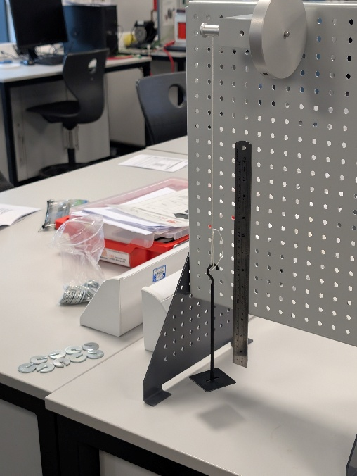
Figure 1

We considered the weight of the platform and added small disk weights to it until the combined weight of the platform and disks reached 0.1kg. The small disk weights can be seen in the bottom right of figure 1.
One person attached a magnetic ruler to the board so that it was zeroed next to the bottom of the weight platform. They then spun the flywheel so that the weight was lifted to a point known as height 1(H1) which was 280mm. A second person held a stopwatch.
The two people then communicated with a countdown as to when the first would release the flywheel, thus dropping the weights and allowing them to freefall towards the bottom of the ruler.
The countdown allowed the two team members to coordinate so that the person with the stopwatch could start the timer roughly at the same time that the wheel was released. This allowed the group to eliminate a factor of reaction time at the start of the drop, meaning that the time between when the weight was released and when the stopwatch timer was activated was lessened as the person with the timer could anticipate the release based on the countdown.
The person who released the flywheel was looking closely at the ruler so that they could see how far the weights rose back up the ruler after reaching the bottom. This new height was recorded as height 2.
An example of the person viewing the weight’s movement against the ruler can be seen in figure 2
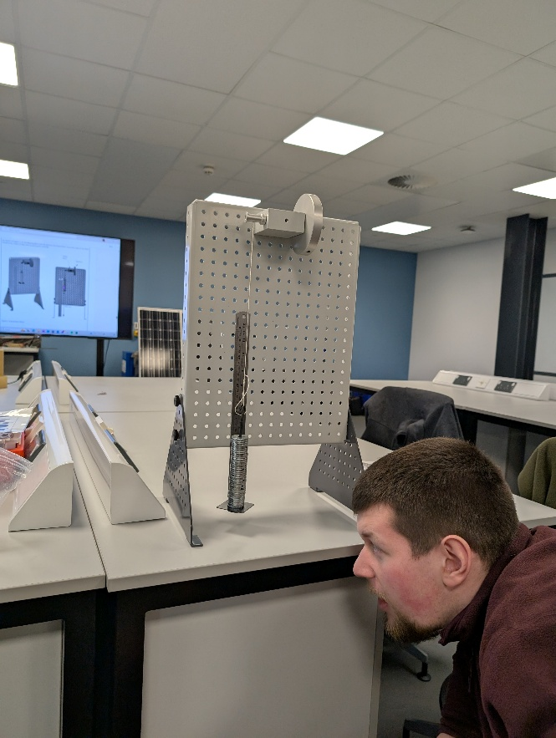
Figure 2

The person with the stopwatch was also looking at the weight platform’s movement from a distance so they could stop the timer as the weight reached the top of its movement.
The group recorded height 2 and the time taken on a table and repeated the experiment, so they had done this process a total of 3 times. They then took an average based on the second height and time and recorded that onto an excel sheet.
They repeated increased the weights in increments, so the flywheel was holding weights of 0.2kg, 0.3kg, 0.4kg and 0.5kg. repeating the whole process at every interval, until we had recorded a set of data for each weight group.

The results of the Lab experiment.
The raw data was as follows
Mass (kg) | Height | Time (s)
.1 | 236 | 4,34
 | 237 | 4.21.
 | 237 | 3.93
.2 | 251 | 3.02
 | 250 | 2.72
 | 251 | 2.97
.3 | 250 | 2.34
 | 253 | 2.48
 | 254 | 2.57
.4 | 250 | 2.29
 | 251 | 2.01
 | 249 | 2.20
.5 | 240 | 2.01
 | 245 | 1.86
 | 235 | 2.11

Analysis of data
To take averages, the group added the heights for each Mass size together and divided it by the amount of data used in the addition. As we performed the experiment 3 times, the Sum of the Height was divided by 3. For example, (236mm+237mm+237mm) divided by 3 gives us 236.66mm. If the experiment follows base units, this requires the group to convert the results meters, so the result would be 0.23666m, which would then be rounded to 0.237m.
The same method of finding the average was used for the time periods.
This information was put into a table on Microsoft excel and was then used in various calculations to find information such as the potential energy in Jules (PE) of the weights and weight platform when lifted. The acceleration of the weights when released.
PE is found when you take the Mass*gravity*height1 (H1)
Below are the tables and a graph made from the data.
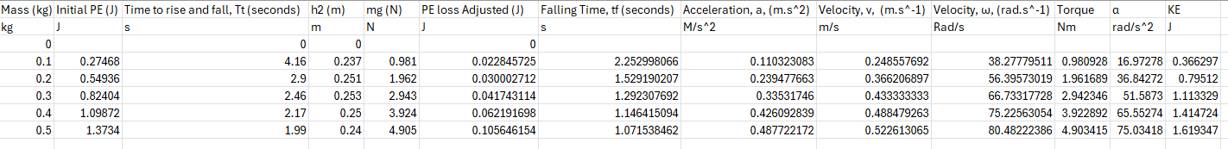
Figure 3
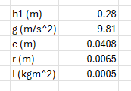
Figure 4
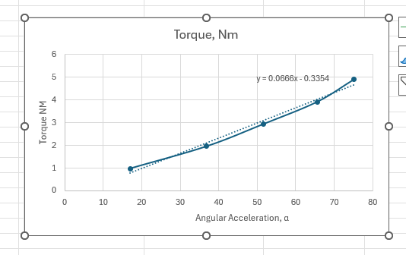
Figure 5

As you can see from the charts, the Kinetic energy (KE) is not the same as the PE. This is because the set up loses some of its energy when in motion due to factors like drag in the bearings. It is because of this, that the weights do not return to its original height when moving back upwards. We can calculate the PE loss (adjusted) by taking:
mass*gravity *height1/(Height1+height2) which is (0.1*9.81)*0.28/(0.28+0.237) which comes out as 0.022845725 Jules.
The acceleration is calculated, using the following formula: 2*H1/total falling time^2
This formula is then used to calculate the torque using the formula:
(Mass*Gravity-Mass*acceleration)*radius of the flywheel.
After all of the information on the tables is filled out. You can see useful information, such as the fact that as the mass moving the pulley increases, this increases the Torque on the pulley.
The then created a graph from the angular acceleration against the torque values, which shows that the increase in torque also increases the angular acceleration of the pulley.

Conclusions
In conclusion, as the weight moving the pulley increases, this increases the torque and acceleration of the pulley as there is more mass pulling the movement. This is to be expected as the increase in mass means that gravity is affecting a higher weight on the system than it was with the smaller weights. As the weight increases, the PE loss also increases. This is possibly due to the fact that the increased weight causes more friction within the mechanisms, which there for increases the amount of energy needed to be used to overcome the friction.

Evaluation
There were many components of this experiment that could have affected our results.
The method used means that the croup has to ‘eyeball’ the experiment. This means that they were essentially guessing how far the weight had risen back up the ruler. This is because of the speed as to which the apparatus rose back up to second height. This leaves room for inaccuracies, especially during the last 2 weight increments, where the weight platform would rattle during its ascension, which would have made it harder to see the measurement on the ruler as it rose back up. The timing side of the experiment also relied on the reaction time of the person with the stopwatch as they had to wait for the platform to stop rising before clicking pause on the timer. This method also relies on the timing person to not pre-emptively press the pause button, which would mean the time taken shows as a shorter time.
To ensure a fair test, the group made sure to use one person watching the weight, and another person using the timer, not switching either of these group members throughout the test.
Although the 2 people observing the components during the test will achieve a better reaction time as the test goes on, as they will have ‘warmed up’ throughout the testing process. If the observation people were swapped out, this would introduce more room for error, and make the test unfair, as every member of the team is likely to have a different reaction time, possibly leading to anomalous results or inefficiencies while observing.
These reasons are why the group took averages. This helps eliminate issues with recording results by increasing the size of the results pool per step of the experiment.

Further work
Given unlimited time and money to improve the experiment, I would employ the use of High speed cameras, using editing software to time the motion of the weights platform.
You would be able to go through frame by frame, starting with the very first moment the platform moves, to the very last frame that the platform rises, adding tags in the editing software for these two events. These tags would then produce a time frame between the start and stop of the motions. This could still be repeated 3 times per weight increment, allowing for the averages to still be recorded.

References list
Engineering Science Guidance Notes and Potential and kinetic energy kit ES9 – TecQuipment Ltd 2012
Engineering Science Guidance Notes and Potential and kinetic energy kit ES9 Workbook – TecQuipment Ltd 2012

