Sanwar Ali Ahmed 1920465
UWTSD
Network Operating Systems and Services
ACCA5023
Research, build, and deploy a Virtualised Enterprise network

Table of Contents
Task 1 2
Type 1 and Type 2 2
In class virtualisation setup 3
Configure IP Addressing 3
Task 2 5
Lab virtualisation 5
Task 3 12
Reflection 12

Task 1

Type 1 and Type 2

A hypervisor, or Virtual Machine Monitor (VMM), is software that enables multiple operating systems to run on a single physical hardware. It will use the underlying resources, allowing virtual machines (VMs) to operate independently. There are two primary types: Type 1 and Type 2.
Type 1, known as bare-metal hypervisors, install directly on the physical hardware. They function like an operating system but are optimized for virtualization. Because they interact directly with the hardware, they offer superior performance and security. This architecture is ideal for enterprise data centres where efficiency is critical.
Type 2, or hosted hypervisors, run as an application on top of a conventional host operating system like windows. The hypervisor relies on the host OS to manage hardware resources. It is easier to install and use, this layer adds overhead, resulting in slightly lower performance compared to Type 1. This architecture suits developers and individuals needing VMs for testing or personal use without dedicated hardware and to minimise or zero risk security risk.
In summary, Type 1 is built for environments requiring high performance and stability directly on hardware. Type 2 is designed for convenience on existing personal computers, sacrificing some speed for ease of use.

In class virtualisation setup

Type 2 Hypervisor Setting Four virtual machines on a desktop at the university lab,
for this topology to work adequately, it requires 2 Windows environments and 2 Linux environments, Host Machine Will need a minimum of 8 CPU cores, 64GB RAM, and approximately 600GB HDD to work efficiently, Windows Environment Requires a minimum of 2 CPUs, 8GB RAM, and 80GB HDD Linux Environment Requires a minimum of 1 CPU, 2-4GB RAM, and 40GB HDD.

For the SWANSEA simulation, I selected a Type 2 Hyper. Even though Type 1 is generally faster, University hardware 64GB RAM and over 10 CPUs has enough power to handle the Type 2 setup without issues.
Running Hyper-V on a Windows host makes it easy to manage the Windows Server 2022 domain controller because they use similar tools. It also runs Debian Server smoothly without needing complex settings. For security, Hyper-V keeps the virtual machines separate from the main system, which is safe enough for this learning project.
While Type 1 is better for real business data centres, Type 2 fits this task because the goal is to learn network services, having a main operating system makes it simpler to fix errors and save progress during testing. This choice uses my current hardware well and meets the Swansea site requirements.

Configure IP Addressing

Data travels between computers using IP addresses, which act like unique digital postal codes. They tell routers where to send information packets across the Internet, during our group activity, we discussed how switches connect devices within a single network using hardware addresses. Routers work differently; they connect different networks together and use IP addresses to find the best path for data.
IPv4 uses 32-bit numbers example 192.168.1.1, while IPv6 uses longer codes to prevent running out of addresses, Subnetting divides large networks into smaller sections. This improves efficiency and security by limiting traffic flow. For example.
Effective IP addressing is vital for network performance. It prevents congestion and helps isolate security issues. In the SWANSEA.ACCA topology, structured addressing ensures Windows and Debian servers communicate correctly without errors. This needs proper draft planning and test to work correctly.
During our group lectures, we explored how data travels across the Internet. IP addresses act as unique logical identifiers, guiding packets from source to destination Switches manage local traffic using hardware addresses, while routers use IP routing tables to connect different networks.
IPv4 uses 32-bit binary while IPv6 uses 128-bit hexadecimal to solve address limitations, Subnetting divides large networks into smaller segments.
Effective IP addressing is crucial for network functionality. It ensures devices communicate correctly and isolates faults quickly. In the SWANSEA topology, addressing separates Windows and Debian servers logically. This segmentation enhances performance by limiting unnecessary traffic between departments. Without proper planning.

Routing protocols determine the path data takes across networks, ensuring packets reach destinations efficiently via routing tables Static routing uses manually configured paths, offering security and low overhead. Dynamic routing employs algorithms to automatically update paths, for large networks.
For the SWANSEA topology, static routing is most suitable. The setup includes a Windows Server for Active Directory and a Debian Server acting as a DHCP Relay. Since the network structure is stable within this lab, manual configuration ensures predictable traffic flow between subnets.
Dynamic routing supports scalability, static routing minimizes configuration errors. This ensures reliable connectivity for domain IP assignment.

Network services are critical for enterprise security and management. Virtual Private Networks secure remote access by encrypting,
Dynamic Host Configuration Protocol automates IP assignment, reducing administrative time. In this topology, the Debian server acts as a relay, highlighting the need for precise configuration to bridge subnets.
Active Directory Domain Services centralizes identity management via Group Policy. This streamlines user administration across Windows environments
Certificate Authorities manage Public Key Infrastructure issuing digital certificates to verify identities.

Task 2
Lab virtualisation
We chose Hypervisor 2 for
Virtual machine was installed by Oracle VirtualBox

I took screenshots of initial setup however did not have time stamp so not included

Ping from S-DC1 to Linux Terminal

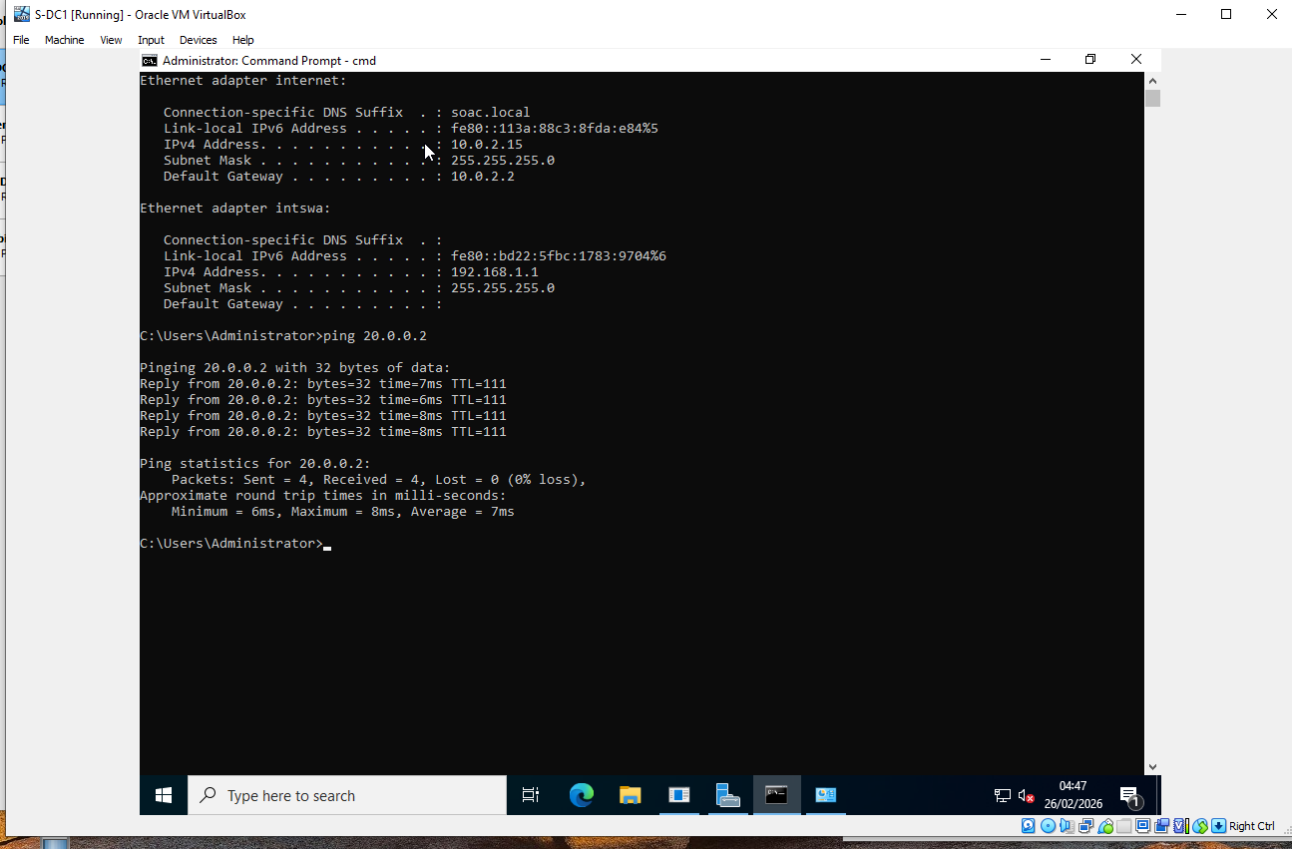

Pinged from client to Server Linux
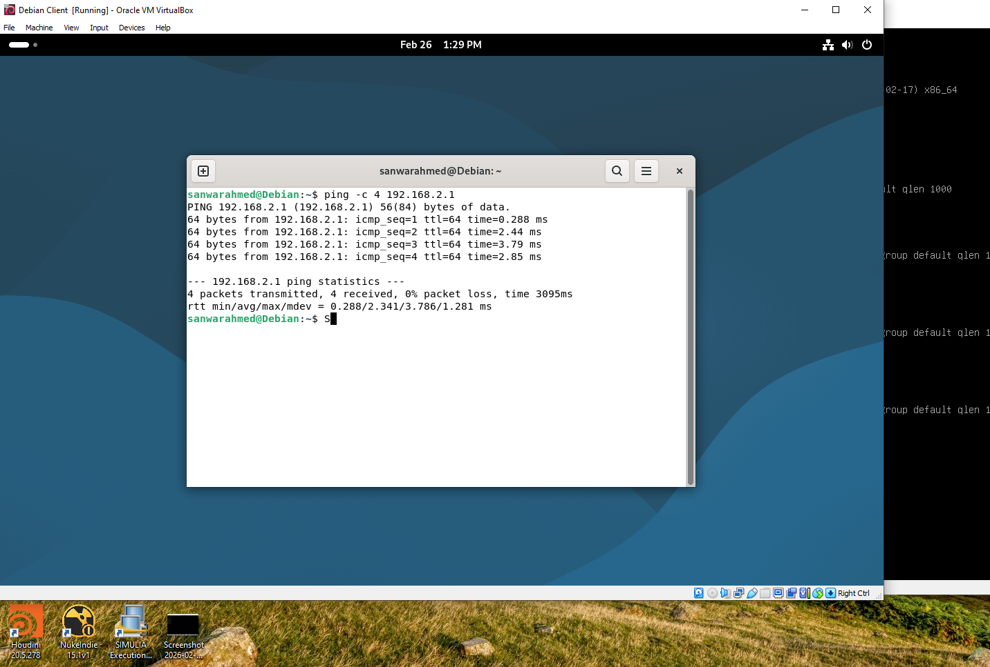

S-DC1 PC Name and Details
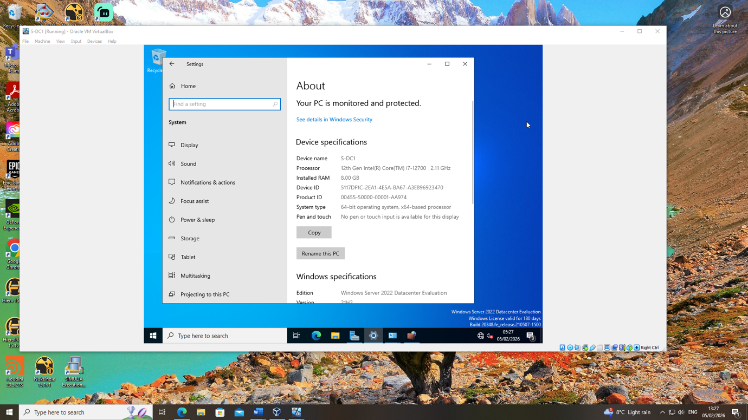

Windows Client S1 IPv4 Configuration
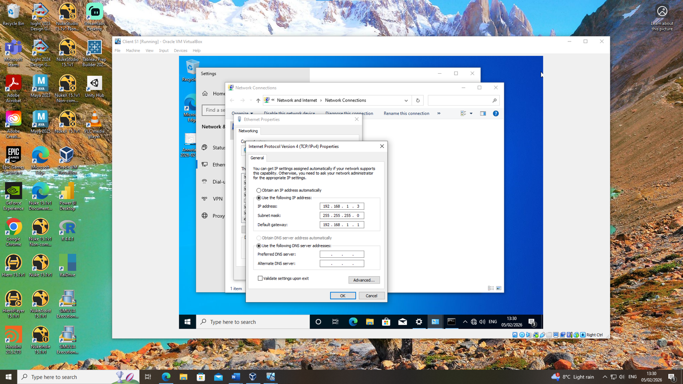

Client S1 successful ping to S-DC1
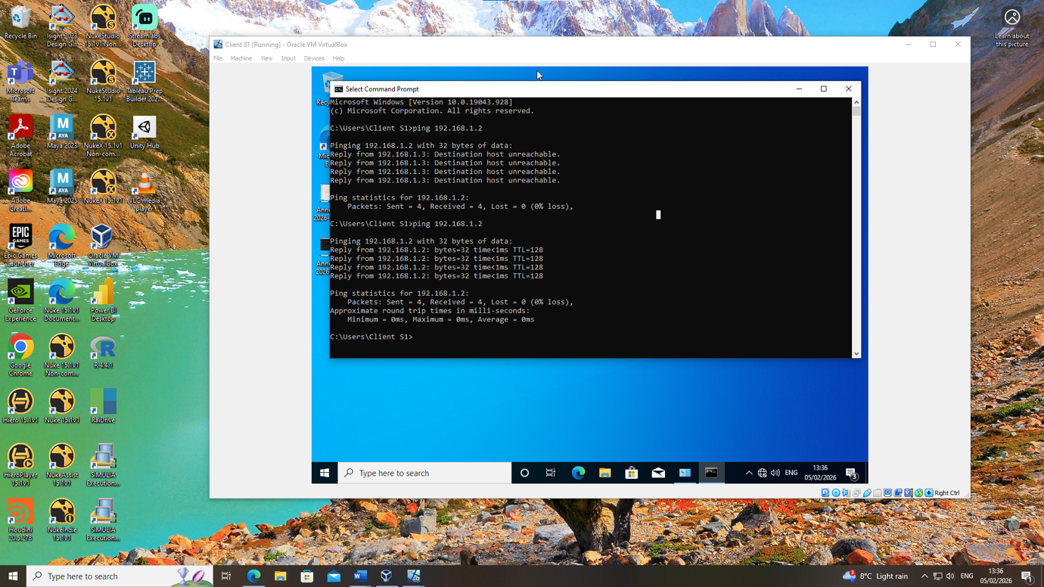

Login L-CD in terminal
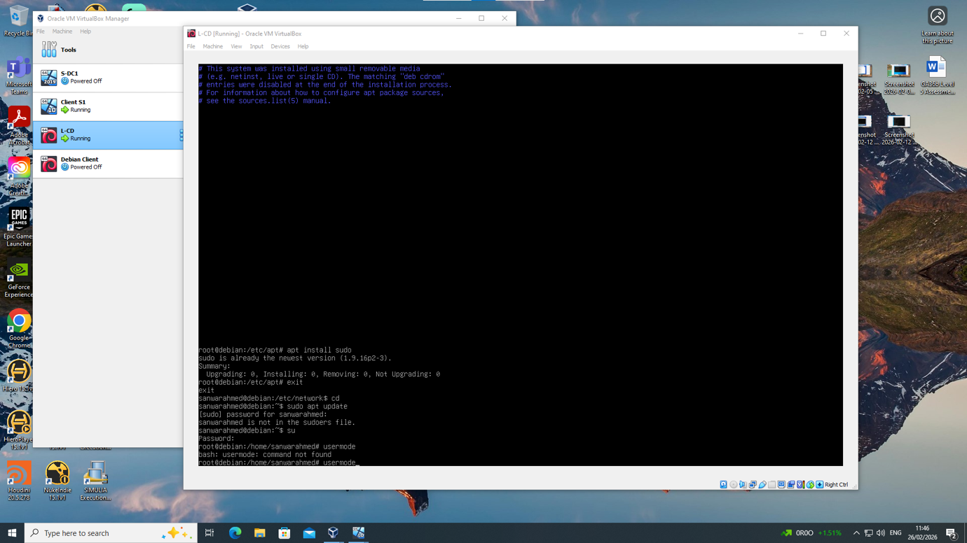

L-CD sudo update in terminal
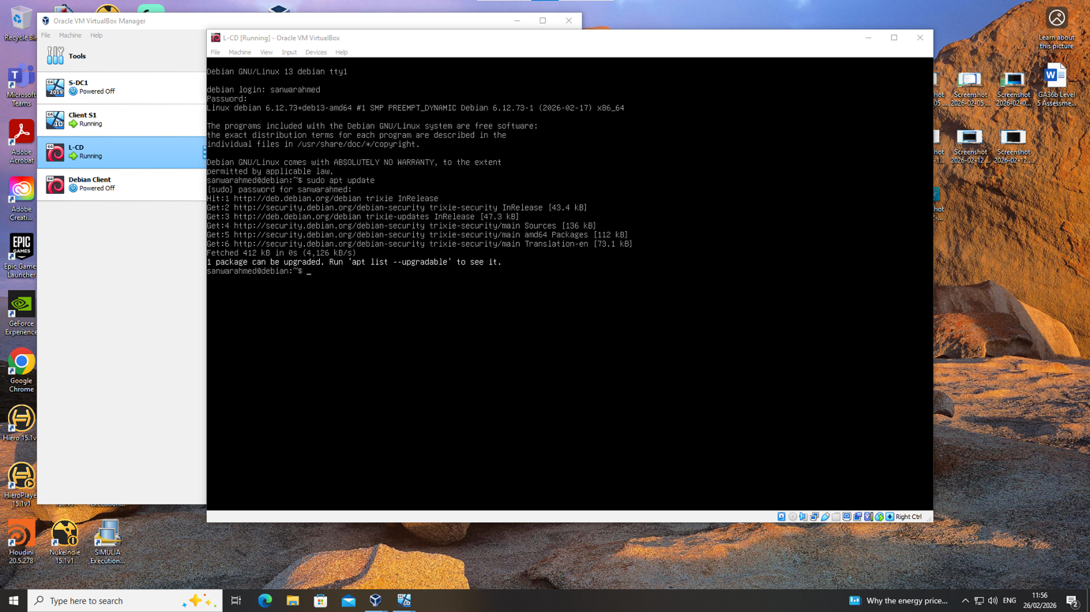

L-CD manual IP configuration in terminal
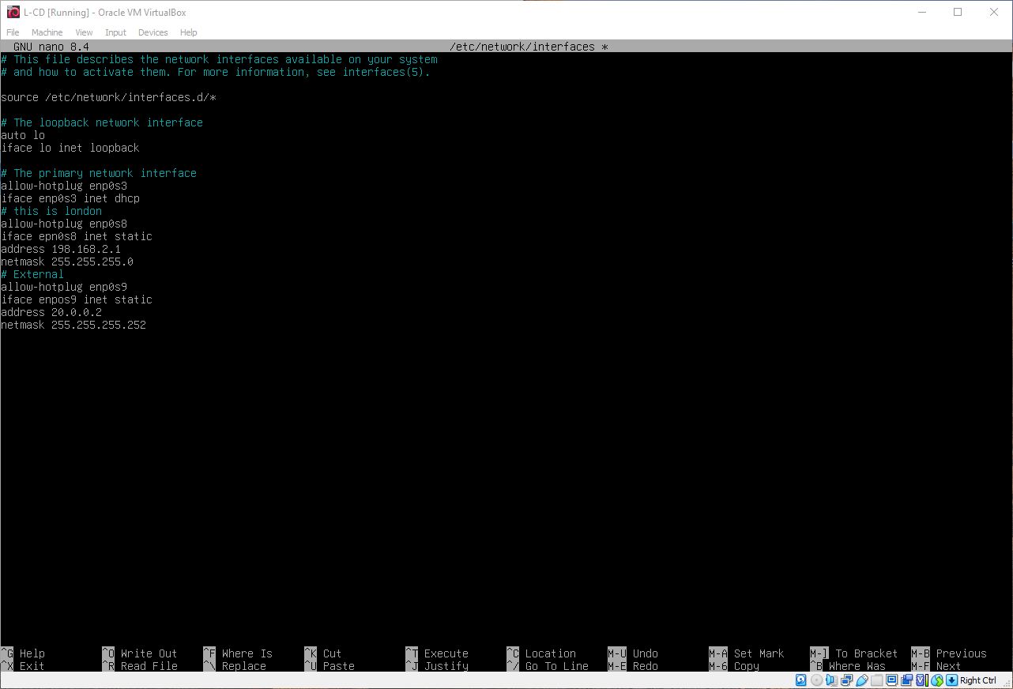

L-CD Sudo update and directory
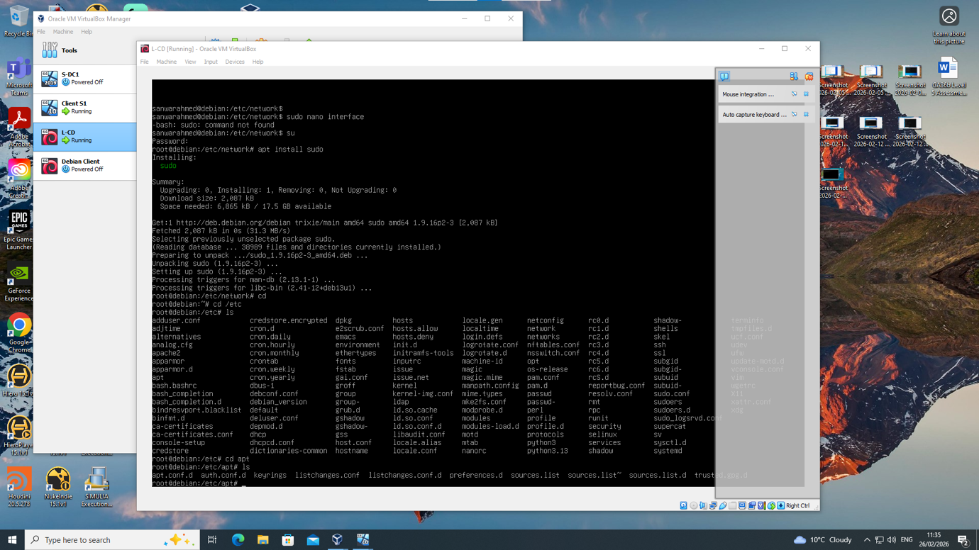

Task 3

Reflection

I learnt about virtualisation and type 2 hypervisor installing four operating system virtual OS on one PC host Two Machines and Two Linux Machines,
You become aware that host machine, must have significant hardware resources to adequately host four virtual machines, in our case 64GB Ram, minimum 8 CPUs and
600/800GB HD.
Starting with downloading OS as IOS file then installing with Oracle VB on host PC Correcting configuring correct configuration for installation slightly difference between Windows and Linux, making sure correct Internet setting is selected to provide connectivity between machines, setting machine names, user logins and passwords.
My issue was configuring Linux IP configuration must be done in terminal slightly overwhelming at the beginning, in contrast windows is a graphical interface it’s likely easier.
Also making sure all firewalls must be disabled before communication is allowed,
This process was consuming and you needed to identify each problem individually then. This process allows visualisation on testing which is resource optimise not needing physical hardware to test and deploy network virtual infrastructure, without compromising host machine, or real machines with security issues or viruses.

END

Sanwar Ahmed

