Audit Report
Accor

BMIH5004
Management and Organisational Behaviour
Lecturer: Dale Clarke

Popescu Felicia
2119254



Executive Summary

Accor Hotel Group, a global leader in the hospitality industry, has exhibited a strategic and resilient approach in its operations and performance in 2023. The Group's first-quarter revenue saw a 54% like-for-like increase, with RevPAR rising by 57%, indicating a robust recovery post-pandemic. Accor's differentiation strategy, marked by its diverse brand portfolio, and focus on high-growth markets, especially in Asia and the Middle East, has contributed significantly to its success. The company's commitment to digital innovation and sustainability aligns with modern consumer preferences, enhancing its brand appeal. Despite challenges like dependence on the European market and the need for technological adaptation, Accor's strategic direction and business performance position it well for continued success. The company's ability to adapt to market changes and continuously evolve its strategies ensures its competitiveness in the dynamic hospitality industry.

Table of Contents
- Executive Summary ………………………………………………………………………….…..1
- Introduction………………………………………………………………………………………...3
- Organization Structure, Culture, and Goals of Accor Hotel Group……………………...4
    - Organizational Structure: Agility and Decentralization………………………4
    - Corporate Culture: Innovation and Diversity…………………………………5
    - Strategic Alignment of Goals…………………………………………………..5
    - Strategic Synergy…………………………………………………………….…6
- Recent Change Initiatives at Accor Hotel Group………………………………………...…7
  - Digital Transformation Strategy: Objective and Implementation………………….…7
  - Expansion into New Markets: Strategy and Challenges…………………………..…8
  - Application of Lewin’s Change Management Model……………………………….…9
  - Impact on Performance and Employee Morale………………………………………10
- Strategic Direction and Business Performance……………………………………………11
  - Strategic Approach: Differentiation and Focus…………………………………….…11
  - Commitment to Sustainability and Digital Innovation……………………………..…12
  - Business Performance Analysis…………………………………………………….…12
  - SWOT Analysis……………………………………………………………….…………13
- Conclusion………………………………………………………………………………….……14
- Recommendations for Accor Hotel Group…………………………………………………15
- References………………………………………………………………………………….……17

Introduction

Notable in the world of hospitality, Accor Hotel Group has proven to be a dynamic and progressive company when it comes to commercial performance and strategic orientation in 2023. Accor is a notable company with a strong market presence and a wide range of offerings, ranging from luxury to economy segments. It is recognised for its ability to adapt and remain resilient, particularly in light of recent global difficulties. In Q1 2023, there was a significant 54% increase in like-for-like revenue and a 57% growth in RevPAR compared to the previous year. This indicates a robust recovery in occupancy rates and average room prices. Accor's performance demonstrates its strategic agility through differentiation and expansion into high-growth markets, particularly in Asia and the Middle East. The group's dedication to digital innovation and sustainability strengthens its attractiveness in an industry that is increasingly influenced by technological progress and environmental awareness. This introduction provides an overview of Accor's strategic approach, business performance, and the challenges and opportunities it faces. It offers insights into how the company manages the complexities of the modern hospitality industry.
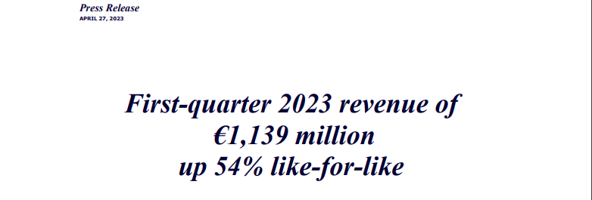

Main Findings
Organization Structure, Culture, and Goals of Accor Hotel Group
Organizational Structure:
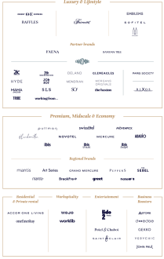
Agility and Decentralization

As of 2023, Accor Hotel Group has implemented a more dynamic and decentralised structure. The group has implemented a restructuring plan, dividing its operations into two main divisions: Premium, Midscale & Economy, and Luxury & Lifestyle. Each division is overseen by an Executive Committee and supported by a Group Management Board and a Global Shared Platform. The reorganisation, led by Sébastien Bazin and Jean-Jacques Morin, aims to enhance growth, adapt to market changes, improve service quality, and meet guest requirements more efficiently (Accor, 2023). According to Wynn and Jones (2022), this structure grants considerable independence to hotels and regions, enabling them to quickly adjust to local market demands and trends. This is seen as a crucial advantage in the dynamic hospitality industry.

Corporate Culture:
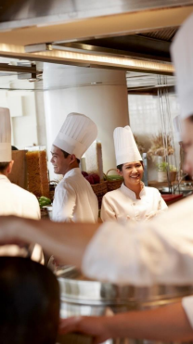
Innovation and Diversity
Accor's corporate culture demonstrates innovation and diversity, which is evident in its diverse brand portfolio across different market segments. The group's culture prioritises problem-solving, innovation, and empowerment at all levels of the organisation, aligning with Handy's 'Task Culture' quadrant that emphasises teamwork and flexibility (Accor, 2022). The approach discussed by Rowe et al. (2023) is crucial in the fast-paced and ever-changing hospitality industry. It emphasises the need for a collaborative and adaptable workforce that can effectively meet diverse and dynamic demands.

Strategic Alignment of Goals:
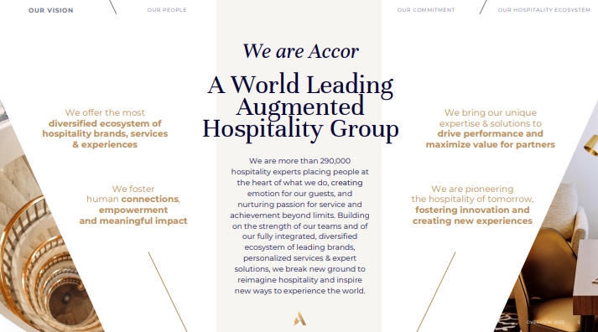The corporate culture and structure of Accor complement its strategic objectives. Accor (2022) reported a revenue of €4,224 million in 2022, indicating an 80% like-for-like growth compared to the previous year, showcasing its robust recovery and expansion trajectory. The company's aspiration to become a worldwide leader in augmented hospitality is apparent through its varied brand portfolio and substantial investments in digital innovation. Accor's focus on sustainable development and ethical practises aligns with the increasing consumer preference for environmentally responsible and socially conscious travel choices. Accor's establishment of specialised operational divisions with distinct expertise, ambitions, and objectives allows the company to effectively utilise its diverse range of brands and sustain its dominant position in the majority of markets (Accor, 2023).

Strategic Synergy:
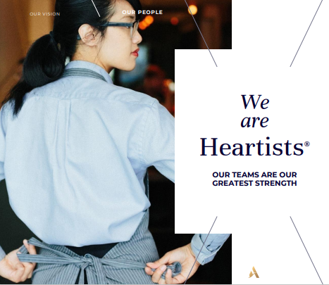
A skillfully implemented strategic synergy is demonstrated by the interaction of Accor's organisational structure, culture, and goals. According to Camelia et al. (2019), the company has effectively maintained a balance between local autonomy and corporate objectives, which has resulted in the promotion of innovation and teamwork. This approach is in line with Accor's goals to be a leader in the hospitality industry and allows it to effectively respond to market changes and consumer preferences. Accor's strategy demonstrates an in-depth understanding of the constantly shifting hospitality field, ensuring that its objectives are not only ambitious but also grounded in achievable and pragmatic plans. Accor (2022) reported a successful expansion in 2022, with the opening of 299 hotels and the addition of 43,000 rooms. This growth demonstrates the group's organic growth and its strong and adaptable organisational structure. Ye (2022) researched Accor's expansion strategy, digital transformation, and sustainability efforts, highlighting its role as a progressive leader in the hospitality industry.
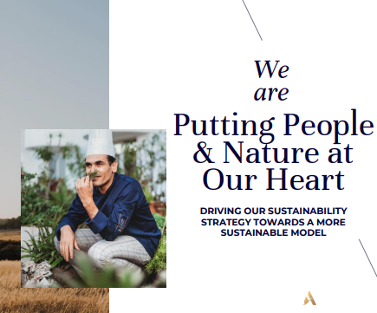
Accor's approach to decentralization, while providing regional autonomy, is balanced by a strong central leadership and a unified corporate culture that emphasizes innovation, diversity, and sustainability. The study conducted by Cunha, Kastenholz and Carneiro (2020) reinforces how this balance allows Accor to maintain brand consistency and high service standards across its global portfolio while being responsive to local market nuances and trends. The strategic alignment of its goals with its organizational culture and structure is a testament to Accor's commitment to maintaining its competitive edge in the hospitality sector. By continuing to focus on strategic growth, digital innovation, and sustainable practices, Accor is well-equipped to navigate future challenges and capitalize on emerging opportunities in the hospitality industry.

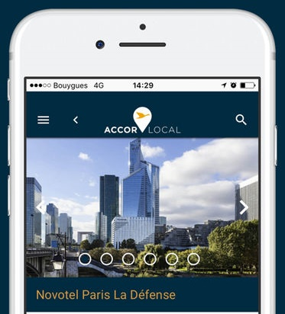
Recent Change Initiatives at Accor Hotel Group
1. Digital Transformation Strategy:
Objective and Implementation: Accor's digital transformation, known as “Leading Digital Hospitality,” is a comprehensive plan launched to integrate digital technology across the customer journey and streamline operations. This ambitious plan, backed by a €225 million investment, aims to solidify Accor's leadership in the rapidly changing hospitality industry. It focuses on enhancing customer experiences, improving services for investor partners, and consolidating the group's market share through advanced IT infrastructure and data management (Koumelis, 2014).

Outcomes and Impact: The transformation includes customer-focused programs like “Mobile First,” offering a seamless mobile application for all Accor services, and “Customer Centric,” which optimizes data usage for personalized services. “Seamless Journey” and “Mice & BtoB” further enhance customer convenience and business solutions, respectively (Koumelis, 2014). The digital overhaul has led to improved customer experiences, evident in enhanced satisfaction scores and online engagement, contributing significantly to Accor's financial performance.
2. Expansion into New Markets

Strategic Expansion: Accor plans to open over 1,200 hotels in the next five years, particularly focusing on Asia Pacific and the Middle East according to Vayet, and Sheehan (2023). Mahapatra and Sarin (2023) sustain the theory on how expansion reflects a strong demand for travel post-pandemic and aims to tap into emerging markets' potential, where hospitality demand is growing.
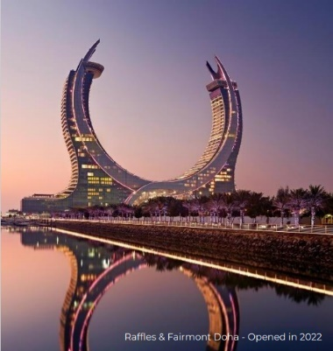
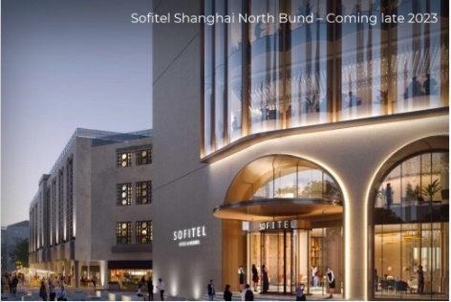
Market Integration and Challenges: The expansion strategy includes plans to double its presence in Saudi Arabia by 2027, with new hotels in Riyadh and Jeddah. This global expansion is driven by broad international demand across different countries, reflecting the growth of the middle classes in Asia and the younger generation's appetite for unique travel experiences (Issuu, 2023).

3. Application of Lewin’s Change Management Model
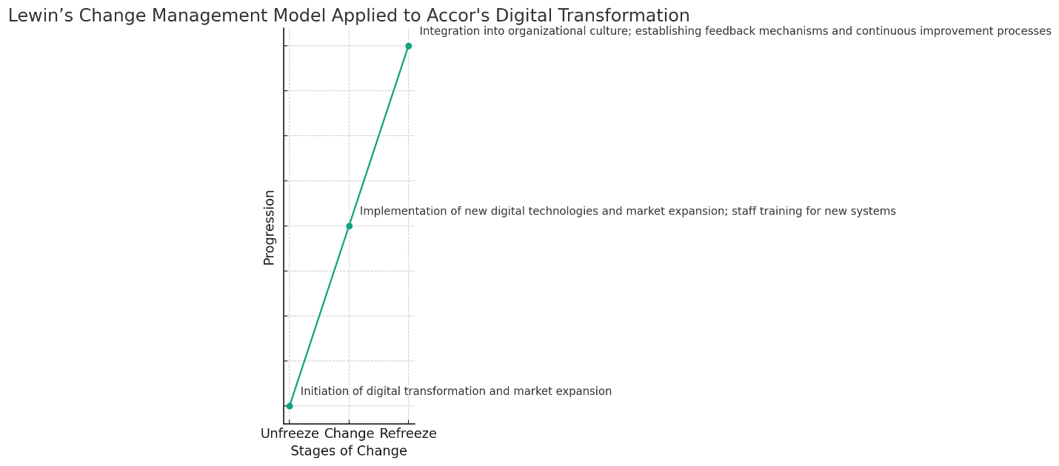
Unfreeze Stage: The initiation of digital transformation and market expansion strategies marked the 'Unfreeze' stage for Accor, wherein the organization prepared itself for significant changes.
Change Stage: During this stage, Accor implemented new digital technologies and pursued market expansion, involving significant training for staff to adapt to new systems and cultural differences in new markets.
Refreeze Stage: Accor solidified these changes by integrating them into the organizational culture and practices, establishing regular feedback mechanisms and continuous improvement processes (Koumelis, 2014)
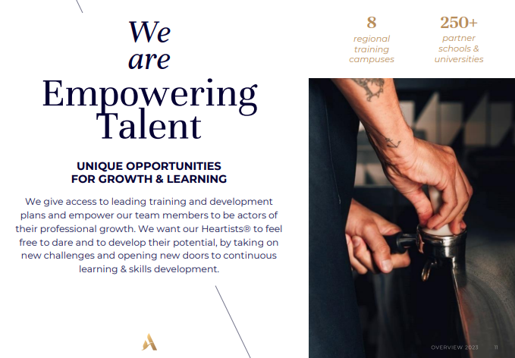
4. Impact on Performance and Employee Morale
Performance Enhancement: The change initiatives diversified Accor’s revenue streams and augmented its global presence. The digital transformation, in particular, positively impacted operational efficiencies and customer engagement.
Employee Adaptation and Morale: The introduction of new technologies initially led to resistance among employees. Accor tackled these challenges by providing extensive training and effective communication, boosting morale and fostering a culture of adaptability and continuous learning (Tejayadi, Laba and Pradana, 2019).


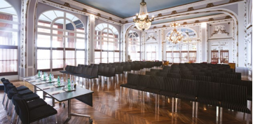
Accor Hotel Group’s recent initiatives demonstrate a strategic approach towards organizational transformation, emphasizing innovation, market expansion, and employee engagement. These changes have not only enhanced Accor's market position but also laid a foundation for sustainable growth and adaptability in a dynamic industry landscape.



Strategic Direction and Business Performance of Accor Hotel Group

1. Strategic Approach: Differentiation and Focus
Differentiation Strategy: Accor demonstrates a differentiation strategy through its wide range of offerings that cater to different customer segments. Accor's ability to cater to various customer preferences is evident in the substantial growth of its Premium, Midscale, and Economy division, with a 62% increase in revenue compared to Q1 2022. Similarly, the Luxury & Lifestyle division experienced a 52% growth in revenue, highlighting Accor's successful approach (Accor, 2023).
Focus on High-Growth Markets: Accor has prioritised high-growth markets, specifically in Asia and the Middle East. The Middle East Asia-Pacific region experienced a significant 69% rise in RevPAR during Q1 2023. This growth was primarily driven by the resurgence of Asia's tourism industry and the gradual recovery of international travel to popular destinations such as Thailand and Indonesia (Accor, 2023).

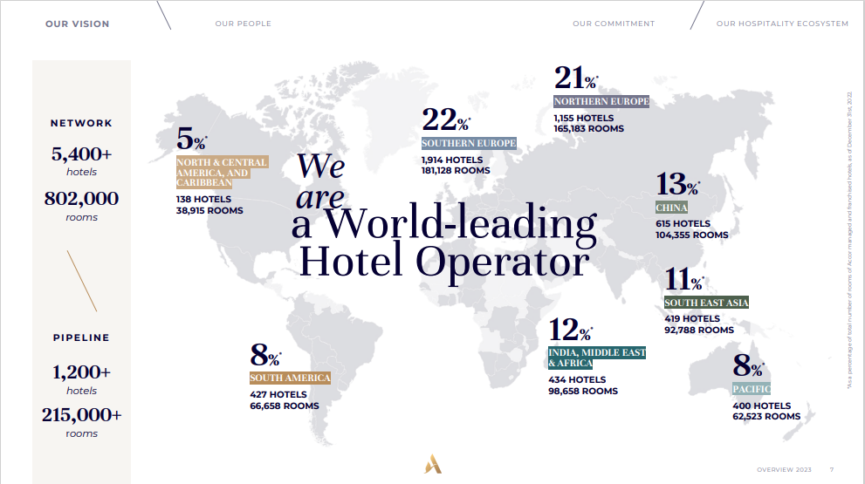

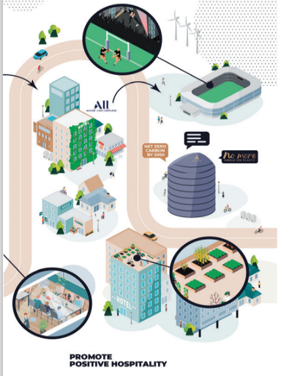
2. Commitment to Sustainability and Digital Innovation
Sustainable Practices: Accor's commitment to sustainability is integral to its differentiation strategy, aligning with the growing demand for environmentally conscious travel (Ofori, 2021).
Digital Innovation: Accor’s significant investment in digital innovation aims to enhance customer experience and streamline operations, as evidenced by its “Leading Digital Hospitality” plan, which focuses on improving customer knowledge, services, and convenience through digital technologies (Busulwa, Pickering and Mao, 2022)

3. Business Performance Analysis
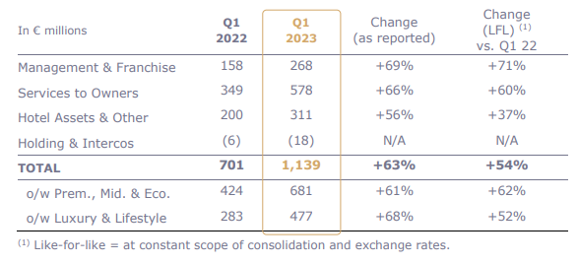
Resilience Post-Pandemic: Accor demonstrated strong recovery in Q1 2023, with revenue of €1,139 million, up 54% LFL compared to Q1 2022. This growth reflects the group's resilience, with a notable increase in RevPAR by 57% compared to Q1 2022, and 19% compared to Q1 2019 (Accor, 2023)
Competitive Market Position: Despite competition, Accor's diverse brand offerings and strategic market presence have maintained a competitive position. The Management & Franchise segment, in particular, saw a revenue increase of 71% LFL compared to Q1 2022, indicating strong growth in its operational model (Accor, 2023)
4. SWOT Analysis
Strengths: Accor’s strengths include a diverse brand portfolio, strong global presence, and a focus on sustainability and digital innovation.
Weaknesses: The company faces challenges due to high dependence on the European market and complexities in its organizational structure.
Opportunities: Expansion in emerging markets and growth in luxury and lifestyle segments present significant opportunities.
Threats: Accor faces threats from intense competition and rapid technological changes (Limidy, Toro and Maulidasari, 2023).

Addressing Future Challenges Accor's strategic approach, focusing on differentiation and targeting growth markets, along with its strong financial performance, positions the company for ongoing success. Addressing challenges identified in the SWOT analysis is vital for maintaining a competitive advantage. Accor's adaptability and strategic evolution are crucial for maintaining a competitive edge in the hospitality industry.

Conclusion
Accor Hotel Group's strategic direction and business performance in Q1 2023 exhibit resilience and flexibility within the dynamic hospitality industry. Accor has demonstrated resilience and agility by achieving a 54% increase in revenue on a like-for-like basis and a notable 57% rise in revenue per available room (RevPAR) compared to the previous year. This rapid recovery post-pandemic is outstanding. Accor's strategic emphasis on differentiation, demonstrated by its varied brand portfolio and entry into rapidly growing markets such as Asia and the Middle East, has allowed the company to sustain a robust competitive advantage and take advantage of emerging travel patterns. Additionally, the group's dedication to sustainability and digital innovation, which are essential components of its operational framework, is in line with contemporary consumer preferences and strengthens its brand attractiveness. Nevertheless, ongoing strategic vigilance is necessary due to challenges like reliance on the European market and the need to adapt to rapid technological advancements. In summary, Accor has effectively managed challenges and capitalised on its strengths, positioning itself for long-term success and growth, and establishing a strong presence in the global hospitality industry.


Recommendations for Accor Hotel Group

Enhance Organizational Structure: Periodic reviews should be carried out to ensure that Accor's new two-division structure effectively aligns with changing market demands. Regular assessment and potential adjustments are necessary to ensure the continued effectiveness of this balanced decentralisation approach (Ushakov et al., 2021).
Strengthen Change Management: Investing in employee training and feedback systems is essential. Accor should prioritise improving these aspects to facilitate seamless transitions during organisational changes and ensure employee alignment with the company's strategic goals (Dogru, McGinley, & Kim, 2020).
Cultivate a Learning Culture: Accor's culture should prioritise continuous learning and leadership development. Enhancing training programmes and development initiatives will equip employees with essential skills for the dynamic hospitality industry, promoting a culture of adaptability and innovation (Dogru, McGinley, & Kim, 2020).
Refine Strategic Direction: Accor's market diversification is outstanding, but further examination of emerging markets, with a specific focus on sustainability and innovation, is necessary. Strategic refinement will decrease dependence on saturated markets and solidify Accor's position as a sustainable and innovative leader (Hussain et al., 2020).
Optimize Brand Portfolio Management: Accor should persist in evaluating and strategically placing its brands within the two divisions, guaranteeing that each brand effectively appeals to its intended market. Revitalising underperforming brands can enhance their alignment with market trends and customer expectations (Ushakov et al., 2021).
Advance Digital and Technological Capabilities: Accor should prioritise emerging technologies such as AI and IoT to enhance guest experiences and operational efficiency, building upon its digital transformation. Accor will be at the forefront of digital innovation in the hospitality industry (Limna, 2022).

References
1. Accor, 2023. Update on Accor’s Organization. Accor Strategy. https://press.accor.com/update-on-accors-organization/?lang=en
2. Wynn, M. and Jones, P., 2022. IT Strategy in the Hotel Industry in the Digital Era. https://www.mdpi.com/2071-1050/14/17/10705
3. Accor, 2022. Full-Year 2022 Results Solid and sustainable rebound in activity in 2022. Finance - https://press.accor.com/full-year-2022-resultssolid-and-sustainable-reboundin-activity-in-2022sustainable-revpar-recovery-above-pre-pandemic-levelfy-2023-group-revpar-expected-up-between-5-and-9-lfl-yoy-return-of/?lang=en
4. Rowe, L., Knight, L., Irvine, P. and Greenwood, J., 2023. Communities of practice for contemporary leadership development and knowledge exchange through work-based learning. Journal of Education and Work, 36(6), pp.494-510. https://www.tandfonline.com/doi/pdf/10.1080/13639080.2023.2255149
5. Camelia, G., Ioana-Valentina-Alexandra, M. and Larisa-Andreea, N., 2019. Organizational culture: A case study of the impact of ethical organizational culture on the efficiency of Accor Hotels. Romanian Economic and Business Review, 14(2), pp.86-96.
6. Ye, C.W., 2022. Equity research-Accor SA (Doctoral dissertation, Instituto Superior de Economia e Gestão). https://www.repository.utl.pt/bitstream/10400.5/26911/1/DM-CWY-2022.pdf
7. Cunha, C., Kastenholz, E. and Carneiro, M.J., 2020. Entrepreneurs in rural tourism: Do lifestyle motivations contribute to management practices that enhance sustainable entrepreneurial ecosystems?. Journal of hospitality and tourism management, 44, pp.215-226. https://doi.org/10.1016/j.jhtm.2020.06.007
8. Koumelis, T., 2014. Accor launches its digital transformation “Leading Digital Hospitality”. https://www.traveldailynews.com/hotels-lodging/accor-launches-its-digital-transformation-leading-digital-hospitality/
9. Veyet, T., Sheehan, G., 2023. Accor plans to open more than 1,200 hotels as travel demand picks up. https://www.reuters.com/business/hotel-group-accor-raises-outlook-room-revenue-growth-target-2023-06-27/
10. Mahapatra, S.K. and Sarin, V. eds., 2023. Changing World Economic Order in the Post-pandemic Period. IGI Global.
11. Issuu, 2023. Hospitality News ME#146. https://issuu.com/hospitalityservices/docs/hn146
12. Tejayadi, I.P.W., Laba, I.N. and Pradana, G.Y.K., 2019. The effect of organizational culture on employee satisfaction in Mercure Resort Sanur. International Journal of Green Tourism Research and Applications, 1(1), pp.63-72.
13. Accor, 2023. First-quarter 2023 revenue of €1,139 million up 54% like-for-like. https://press.accor.com/first-quarter-2023-revenue-ofe1139-millionup-54-like-for-like/?lang=en
14. Ofori, D., 2021. Opportunities and challenges of green marketing. Green Marketing in Emerging Markets: Strategic and Operational Perspectives, pp.251-276.
15. Busulwa, R., Pickering, M. and Mao, I., 2022. Digital transformation and hospitality management competencies: Toward an integrative framework. International Journal of Hospitality Management, 102, p.103132. https://www.sciencedirect.com/science/article/pii/S0278431921002759
16. Limidy, D.S., Toro, S. and Maulidasari, D., 2023. SWOT Analysis In Strategy Sales Call on Sales and Marketing Department At The Hotel All Seasons Jakarta Thamrin. International Journal of Travel, Hospitality and Events, 2(2), pp.188-199. https://journal.polteksahid.ac.id/index.php/ijothe/article/download/257/252
17. Ushakov, D.S., Kiselev, D.N., Zezyulko, A.V., Imangulova, T.V., Kulakhmetova, G.A. and Kulakhmetova, R.A., 2021. ORGANIZATION OF NETWORK BASIS FOR TRANSNATIONAL TOURISM ACTIVITY. GeoJournal of Tourism & Geosites, 34(1). https://core.ac.uk/download/pdf/430164852.pdf
18. Dogru, T., McGinley, S. and Kim, W.G., 2020. The effect of hotel investments on employment in the tourism, leisure and hospitality industries. International Journal of Contemporary Hospitality Management, 32(5), pp.1941-1965.
19. Hussain, I., Mu, S., Mohiuddin, M., Danish, R.Q. and Sair, S.A., 2020. Effects of sustainable brand equity and marketing innovation on market performance in hospitality industry: Mediating effects of sustainable competitive advantage. Sustainability, 12(7), p.2939. https://www.mdpi.com/2071-1050/12/7/2939/pdf
20. Limna, P., 2022. Artificial Intelligence (AI) in the hospitality industry: A review article. Int. J. Comput. Sci. Res, 6, pp.1-12 https://www.academia.edu/download/86406243/IJCSR_Palm_Limna_2022_.pdf

