

Student name: Umma Kulsum
Student ID: 2513410
Module name: Introduction to Health and Social Care
Module code: LCHS4003
Lecturer name: Eleni Koutsogeorgou-Andreou

Contents

Task 1 3
Task 2: Essay 4

References 6

Task 1
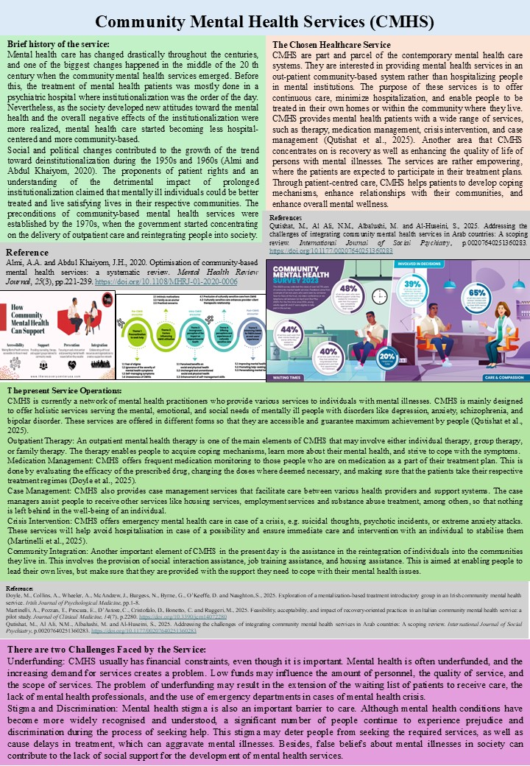

Task 2: Essay
Ambulance Services: A Critical Component of Healthcare
Emergency healthcare systems all over the world rely on ambulance services. Their major work is to deliver immediate medical attention and transportation to people who have life-threatening health crises. As the demand for quick emergency services continues to grow exponentially, ambulances have become very advanced mobile medical facilities with advanced medical equipment and manned by well-trained professionals. The significance of ambulance services is that it increases the chances of survival and minimise complications due to medical conditions, as patients can get timely medical care in critical situations.
The history of ambulance services can be traced back to the 18th century, when military wagons carried wounded soldiers on the battlefields to the medical stations. These primitive ambulances were intended to offer the necessary transport in times of war (Alacahan, 2025)
One of the key roles of ambulance services is emergency medical response. This is responded to in relation to 911 or emergency, inspection about the state of the patient, and actual treatment in the case of their transportation to health facilities (Miri et al., 2023). The issues of the ambulance services are the management of resources, including the fleet of vehicles, the level of work, and the supply of required medical equipment. Resource allocation plays a crucial role in ensuring that the ambulances are available when and where they are most required, especially during the peak in demand events such as medical emergencies following incidents of natural calamities or during major events within the country. The ambulance services are also significant in the response mechanism to a disaster, which should include the transportation of the victims and providing medical care to the victims in case there is an emergency, such as an accident, mass casualties, or even natural disasters (Ablard et al., 2023).
Ambulance services are significant in improving the quality of life of people who are faced with health emergencies. Life or death is often a matter of time when medical services are needed, e.g. with heart attacks, strokes, traumatic injuries, or respiratory failure. The ambulance services help to provide patients with treatment during the golden hour- the period right after a medical emergency or trauma when the interventions are most likely to prevent death or severe complications (Marchi et al., 2024).
Hardly any supply, the demand in the ambulance services is generally too high during peak times, such as during the occurrence of a health crisis due to a natural disaster or increased traffic flow. When this occurs, more calls are received by the ambulance service, and hence, there is a delay in responding. Traffic congestion within the urban areas also negatively contributes to these delays and can adversely affect the outcome for the patient, especially when it is essential to save every minute (Rezaei et al., 2025).
Resource Constraints: The ambulance services also have resource constraints, including funds, staffing, and equipment. The funds used to maintain a line of ambulances, the acquisition of life-saving medical equipment and hiring qualified personnel are expensive.
The ambulance services play a significant role in the healthcare system since it offers emergency care services to the patients. They cannot overestimate the contribution they have to life-saving and improved patient outcomes. However, despite the significance, these services still face certain problems, such as high demand and a lack of resources, that threaten their efficiency. Governments and healthcare institutions should invest in resources and technology, and also in workforce training to maintain and transform the ambulance services.

References
Ablard, S., Miller, E., Poulton, S., Cantrell, A., Booth, A., Lee, A., Mason, S. and Bell, F., 2023. Delivery of public health interventions by the ambulance sector: a scoping review. BMC Public Health, 23(1), p.2082. https://link.springer.com/article/10.1186/s12889-023-16473-2
Alacahan, Ö.F., 2025. Ambulance Services in the Context of Occupational Health and Safety and Risks Faced by Ambulance Attendants. Social Science Studies Journal, 11(2). https://www.researchgate.net/profile/Oemer-Faruk-Alacahan/publication/389484736_Ambulance_Services_in_the_Context_of_Occupational_Health_and_Safety_and_Risks_Faced_by_Ambulance_Attendants/links/67c3724796e7fb48b9d5593d/Ambulance-Services-in-the-Context-of-Occupational-Health-and-Safety-and-Risks-Faced-by-Ambulance-Attendants.pdf
Behura, A., 2024. Intelligent Ambulance Services Management: A Comprehensive Medical Service for Emergency Healthcare. In Healthcare Analytics and Advanced Computational Intelligence (pp. 104-123). CRC Press.
Marchi, M., Venturi, G., Visentini, C., Pinelli, M., Priebe, S. and Galeazzi, G.M., 2024. The therapeutic relationship in community mental health services: a systematic review of the literature. Social Psychiatry and Psychiatric Epidemiology, 59(5), pp.731-743.
Miri, K., Sabbaghi, M., Mazlum, S.R. and Namazinia, M., 2023. The trend of change in the role of pre-hospital emergency medical services in Iran’s healthcare system: a situational analysis. BMC Emergency Medicine, 23(1), p.99.
Rezaei, J., Azouji, R., Azouji, M. and Ghorbani, H., 2025. Application of the Analytical Hierarchy Process in the management of private ambulance care systems in three selected European countries: a strategic decision-making framework. Frontiers in Public Health, 13, p.1526586. https://doi.org/10.3389/fpubh.2025.1526586

