
Sustainable Logistical Operations (M5X01284)
Todor Stoykov 1702643
Critically evaluate the impact that European Legislation has influenced UK sustainable logistics operations.
Abstract
In today’s world of rising environmental cautious in society it is unavoidable that people who are in charge of any kind of logistical operation, whenever taking an active part in the process or a strategic role, have to carefully contemplate the environmental impact made by their actions. (Ruston A, 2015) Moreover, there are two groups that the environmental impact could be divided – internal and external. The internal part is based on the effects happening inside a certain logistical organization which concerns the safe use all systems and health issues with moving dangerous substances or noise pollution. (Ruston A, 2015) The external part issues everything happening outside an organization such as emissions, noise pollution and nature pollution. This report will address the impact that the EU legislation has influenced in UK sustainable logistics operations and discuss the potential future plans. (Ruston A, 2015)
Introduction
As the world becomes more connected, there is a bigger demand for logistical services which leads to a constant increase in the logistical operations by the organizations. (Ruston A, 2015) To continue with, more logistical operations means more negative effects on the environment. The European Union has stated that 2 billion tons of waste is being produced every year by the members of the union and the numbers of waste are increasing year by year. Furthermore, the EU has made a lot of legislation related to the environmental problems. A big step ahead in the waste fight is considered as the 2005 Thematic Strategy on Waste Prevention and Recycling released by the EU. (Ruston A, 2015) This strategy showed that the environmental issues are a global responsibility and it that the days of selling products into a chosen market are over, the manufacturing industry should account the long-term impact that their products have. Moreover, the process of manufacturing is one of the most polluting and so, it must be modified or changed to meet the acceptable level of pollution. Brands now have to consider the prospect of their products being fully recycled after its life cycle or at least parts of it. Other process that is affected by the legislation is how the products are being packed and the transporting as well. (Ruston A, 2015)
European Union’s vision by 2050
According to the European Commission in the year of 2050 people will be living within the earth’s ecological limits, so we need to build a strategy where the natural resources are well managed and products have a circular lifetime where nothing is wasted and as much as possible is recycled. (Ruston A, 2015) The EU is set to focus on nine priority objectives in this strategy. Firstly, more environmental awareness should be spread globally that we should protect the nature and build up ecological flexibility, make the most of sustainable resources that are more efficient and have lower carbon footprint in other to stop the growth of the pollution. To continue with, there are four more priority objectives, a better implementation of the EU environmental law should be better known. (Ruston A, 2015) Moreover, the necessary investments should be made to cover the new environment and climate change policies and the way these concerns and regulations are effecting other policies should be improved.

UK waste legislation
In 1997 new Producer Responsibility Obligations Regulations came into force in the UK and they have been modified a couple of times with the last changes taking part in 2008. (Ruston A, 2015) Furthermore, side to side with the Essential Requirements these regulations applied the EU direction on packaging and packaging waste and instructed each country member to set targets for recycling the packaging waste. The executing of these rules is shared by all packaging chain producers. (Ruston A, 2015)To continue with, the producers are obliged by the law to register with the appropriate Environmental Regulator in the UK and give data feedback on the packaging that was handled. Moreover, the producers are responsible for the recovery and recycle process of specified tonnages of packaging waste and that they need to make a statement that their obligations have been met. In 1991 the UK Environmental Protection Regulations were released. This involved the creation of new responsibilities for the import, production and transport industries. Furthermore, all organizations involved in these activities are charged with a “duty of care’’ which covers the possibility of escape of waste, the move of waste only to authorized receivers and all the documentation giving information about the waste and the firms involved in its disposal. To continue with, these regulations have been modified in 2010 by Environment Permitting Regulations released by England and Wales. The modifications were related to separate waste collection and from 1st January 2015 it was stated that authorities responsible for waste collection must collect waste paper, glass, metal and plastic separately. (Ruston A, 2015)
Freight Transport
The European Commission issued a logistics action plan in 2007 pointing out that the key strategy of all logistical organizations in Europe should be ensuring a sustainable and competitive mobility around the Union and contributing for a safer and cleaner environment, security of the energy supply. (Ruston A, 2015)Moreover, the idea behind the plan is to improve and make freight transport in Europe more efficient and sustainable. In order to succeed in this plan, first actions take place by introducing an e-freight and intelligent transport systems (ITS). (Ruston A, 2015) Furthermore, this included an innovation of paperless electronic way to transfer the information regarding the actual physical flow of the materials. The use of radio frequency identification (RFID) needed to be increased, the ability to track and trace freight transportation and the use of Galileo satellite positioning system are big part of this plan. To continue with, the sustainability and efficiency quality plan was more an internal environment issue. Moreover, this observed at constantly indentifying management and infrastructure-related issues with a view to problem solving solutions. Furthermore, another area will introduce improving the appeal of the logistics profession by staff training and pursuing the most efficient work environment. The plan states that “Green” transport corridors for freight will have effect on an integrated transport strategy where short sea shipping, in land water cannels, rail and road transportation will accompaniment with each other to ensure the choice of environmentally friendly freight movement.
DHL’s sustainability plan
This paragraph will address the future sustainability plans of one of the leading logistics companies in the world and at the same time have a look at their strategy and organization structure. Today DHL is the largest logistics company with over 360,000 employees and offices spread over 220 countries. (DHL)DHL call their 2020 social responsibility plan “Living Responsibility” and has an important role in their business strategy. Here is their 2020 vision: (DHL)
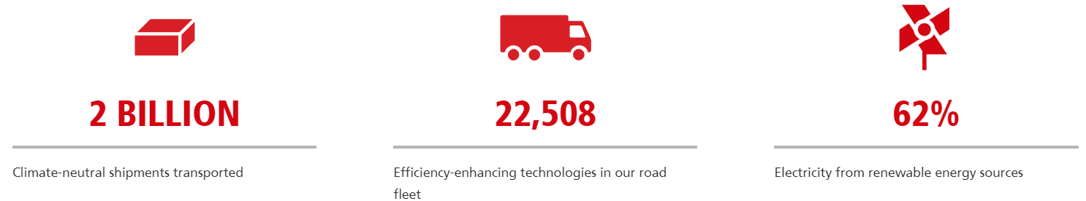
DHL is part of Deutsche Post DHL Group. In 2017 the company’s annual revenues were established at 60.4 billion Euros. The company is organized and divided into four operating divisions: ecommerce – Parcel, Express, Global forwarding, Freight and Supply Chain. (DHL) Moreover, each of these divisions is being managed by its own headquarters and separated into business units, functions and regions for reporting purposes. To continue with, the management functions in the organization are centralized in the Corporate Center and as for the IT services of the company and insurance and risk managements strategies, internal group services are being used.
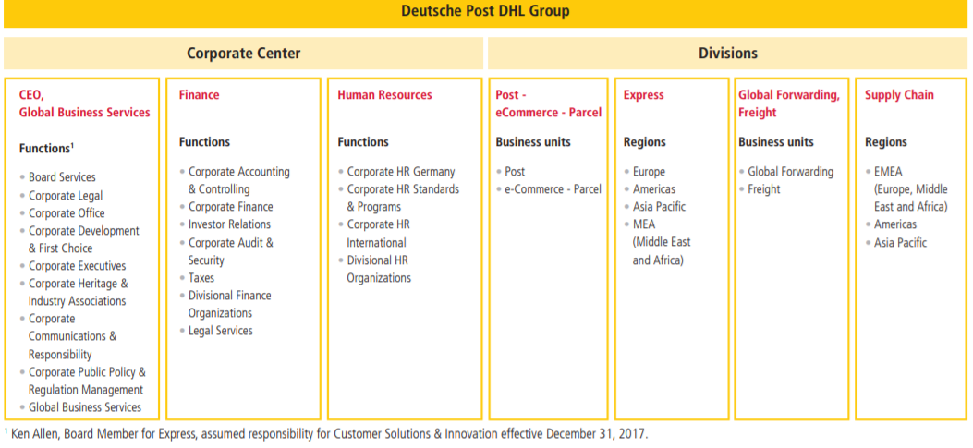
In the above stated 2017 the firm launched new projects and achieved great success with some of their ongoing campaigns. To begin with, DHL has been developing robotics for years and at this stage collaborative robots are being used to enhance the workloads at 19 co-packing logistic centers in the UK. The company also introduced fetches robots which have the ability to detect obstacles and navigate through sites on their own to transport up to 78 kg at the speed of 2 meters per second. (DHL)
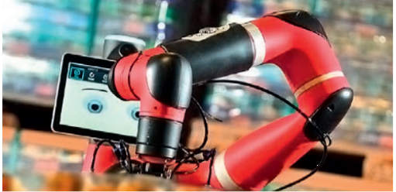
DHL has introduced fully electrical delivery vehicles with 500 km of range in order to minimize the noise pollution and improve the air quality. According to the company tests are being made on autonomous delivery vehicles as well as part of a collaboration project with an automotive brand and several IT firms that specialize in the artificial intelligence sector. (DHL)
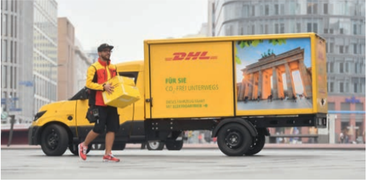
As technological advancements get better and better by every year DHL is working on a new product that allows clients to monitor in real time the tracking of their shipment and all processes during its journey. Moreover this is an essential progress in the area of warehousing digitalization with tests already being made in some locations in Germany and the Netherlands. (DHL)

Looking into the future and understanding the possible demands that will occur the company has started working on logistics solutions for special requirements and the developing of extensive infrastructure for the semiconductor industry has began for 50 facilities worldwide. Moreover, in the e-commerce circle the company is developing a model strategy for a vast-growing fashion industry company. To continue with, the firm is working on a service solution in the area of medical technology, which hospitals could use right on time to have access to the needed equipment and devices stored in warehouse. (DHL)

Brexit possible outcomes for Logistics
With two years of negotiations with the EU, talks are still going on and are getting into the most important phase, the deep details between the UK and the European Union after Brexit is still mostly unclear and possibilities like trading under the World Trade Organization (WTO). (Brexit and Logistics, 2018) This paragraph will address a few of the possible outcomes after Brexit for logistics. It is known that the UK is going to leave the EU on 29th March in 2019. (Brexit and Logistics, 2018)To continue with, by an agreement with the EU, the UK could enter an implementation period for one year so there could be a smooth transition that will lead to a future relationship. There are a few options that might be chosen. The ‘’Chequers deal” proposed by the UK government is about having a free trade area for goods that defends existing integrated supply chain processes, no hard border between Northern Ireland and Ireland is suggested and a ‘common rulebook’ for goods including agri-food meaning the UK needs to sign a treaty to an ongoing compliance with the EU regulations. (Brexit and Logistics, 2018)The second possibility is not signing any deals with EU meaning the UK has to commit to a WTO trading relationship. In this situation new customs arrangements at the UK borders with the EU need to be made, new tariffs need to be set by WTO schedules and a possible border infrastructure could be made between Northern Ireland and Ireland. (Brexit and Logistics, 2018)Finally the last option could be a ‘soft Brexit’ which means that the UK will continue their market and customs Union membership and the rules and regulations of goods transportation will stay the same. (Brexit and Logistics, 2018)

Conclusion
To sum up, Europe and the European Union have always had a major impact on the UK logistical operations because of the inevitable demand for trade with the other countries in the union. Moreover, all big improvements and innovations in the rules and regulations of transporting goods have been implemented from the European Union by the UK.

Bibliography
Brexit and Logistics. (2018, October 24). Retrieved March 2019, from Carousel: https://www.carousel.eu/en/news/2018/10/24/brexit-101/
DHL. (n.d.). Retrieved March 2019, from Corporate Responsibility: https://www.logistics.dhl/global-en/home/about-us/corporate-responsibility.html
Ruston A, C. P. (2015). In The Handbook of Logistics and Distribution Management 5th Edition (p. 640). The Chartered Institute of Logistics and Transport, London.

