

Institute of Inner-City Learning Birmingham Campus

BSc (Hons) Health and Social Care
DISSERTATION

Disclaimer
This document was correct at the time of publication. The Module Coordinator reserves the right to modify any statement if necessary, make variations to the content or methods of delivery of programmes of study, to discontinue programmes, or merge or combine programmes if such actions are reasonably considered to be necessary by UWTSD. Every effort will be made to keep disruption to a minimum, and to give as much notice as possible. An electronic copy of this handbook can be found on the Moodle page for the module.

DECLARATION
This work has not previously been accepted in substance for any degree and is not being concurrently submitted in candidature for any degree
Signed Ghuzala Begum……………………………………………
Date 07/04/2026……………………………………………
STATEMENT 1
This dissertation is being submitted in partial fulfilment of the requirements for the degree of BSc.
Signed Ghuzala Begum…………………………………………….
Date…07/04/2026……………………………………………
STATEMENT 2
This dissertation is the result of my own independent work/investigation, except where otherwise stated. Other sources are acknowledged by footnotes giving explicit references. A bibliography is appended.
Signed Ghuzala Begum…………………………………………
Date…07/04/2026……………………………………………
STATEMENT 3
I hereby give consent for my dissertation, if accepted, to be available for photocopying and for interlibrary loan, and for the title and summary to be made available to outside organisations.
Signed Ghuzala Begum………………………………………………
Date…07/04/2026………………………………………………
STATEMENT 4
I hereby give consent for my dissertation, if accepted, to be available on the university’s IT system to those who have consent to use the system.
Signed Ghuzala Begum……………………………………………
Date…07/04/2026………………………………………………

Holistic Care: An Evaluation
of its’ Effectiveness in Improving Quality of Life for the Elderly Person.

Ghuzala Begum
2244713
Module Code: 6020
Lecturer: Chloe Harries

Dissertation submitted as part of the requirements for the award BSc (Hons) Health and Social Care
ACKNOWLEDGEMENTS
When I first started my university journey, I was a little susceptible as I had no idea what lay ahead. As a school leaver my only academic achievements were my nine GCSEs, (for which I am very proud). I did not attend college or acquire any further higher education qualifications, so enrolling for a university degree seemed out of reach. However, I have proven myself wrong. I did it. I have completed 3 years at University of Wales St Trinidad! Alhamdulillah (All praise be to Allah).
So, I would like to take this opportunity to first thank Myself, yes Myself for all the hard work I have put in towards my Diploma of higher education and my Undergrad degree in BSc (Hons) Health and Social Care. It has not been an easy task, as a housewife and mother to two beautiful boys, I made sure I did not compromise my love and care towards my family and home all the while giving 100% towards my assignments.
I would also like to thank my dad, who will always be my ‘Hero’ I love you dad. Thank you for being amazing and constantly asking me “how much longer have you got until you finish your degree” I cannot explain why but these words gave me the strength to carry on.
To each lecturer at UWTSD who teach their students with full determination, thank you. No student would be able to be who they are and eventually who they become without you the staff. Thank you, it has been a pleasure.

ABSTRACT
Holistic care is the foundation of care deliverance. The aim of this research is to find out how effective is holistic care innovations in increasing the quality of life of elderly people. Statistically we are experiencing an ageing population. With ageing complications naturally occur. Many individuals must face chronic health problems and frailty.
A thematic analysis approach will be carried out for the research methods in collected data and information. Secondary research is the prime method considering ethical considerations and concluding with recommendations.
Providing personalised care plans with the consent of the patient and family members with of course the professional advice and observations of health professionals ultimately produces better outcomes. Health models and theories are key in making decisions about holistic implications, they help to analyse individual limitations which are applied when considering treatment plans.
NHS policies and procedures according to the long-term plan is working towards addressing the barriers and challenges which hinder health care outcomes. Together with local authorities they plan to change the way care is delivered. With a focus on taking the burden off hospitals and moving care towards community services, which wants to focus on preventative measures before health complications arise.
To overcome some of the barriers the recommendations suggest introducing holistic based assessments in elderly care, to help find out important information regarding the patient, so that better outcomes are achieved. Invest financial support towards educational training programmes for staff, so that they have a better understanding of holistic care to use in practice.
Further research needs to be carried out to better understand the complex needs of elderly people so that their health and wellbeing is monitored. This will help the healthcare system implement innovative treatments to allow them to live a better quality of life.

Table of Contents
Chapter 1- 1.1 Introduction…………………………………………………………………………8
1.2- Definitions and Terminology…………………………………………………………………...8
1.3- Rationale and Research……………………………………………………………………….9
1.4- Aims and Objectives…………………………………………………………………………...10
1.5- Chapter 1 Conclusion………………………………………………………………………….11
Chapter 2- Background information and analysis
2.1 introduction………………………………………………………………………………………11
2.2- Historical Background…………………………………………………………………………12
2,3- Theoretical Background……………………………………………………………………….13
2.4- International Context…………………………………………………………………………..14
2.5- National/Local Context………………………………………………………………………...16
2.6- Chapter 2 Conclusion…………………………………………………………………………18
Chapter 3- Methods and search strategy
3.1 introduction…………………………………………………………………………………….20
3.2- Search strategy………………………………………………………………………………20
3.3- Searching for information…………………………………………………………………….20
3.4- Research validation……………………………………………………………………………21
3.5- Inclusion and exclusion criteria………………………………………………………………21
3.6- Analysing research…………………………………………………………………………….22
3.7- Ethical considerations………………………………………………………………………..24
3.8- Chapter 3 Conclusion…………………………………………………………………………25
Chapter 4- Findings and discussion
4.1 introduction…………………………………………………………………………………….25
4.2- Thematic analysis……………………………………………………………………………25
4.3- Theme 1: Holistic care in elderly practice………………………………………………….26
4.4- Theme 2: Impact of holistic care on ‘Quality of life’ in the elderly……………………….33
4.5- Theme 3: Barriers and challenges to effective holistic care delivery……………………41
Chapter 5- Conclusion and Recommendations
5.1- Conclusion……………………………………………………………………………………53
5.2- Recommendations…………………………………………………………………………..53
5.2.1- Recommendation 1………………………………………………………………………..53
5.2.2- Recommendation 2……………………………………………………………………….53
5.2.3- Recommendation 3……………………………………………………………………..54
Chapter 6- References and Appendices
6.1- References…………………………………………………………………………………55
6.2- Appendices…………………………………………………………………………………62

Chapter 1
1.1 Introduction

The topic of this research paper is ‘Holistic Care’, an in-depth analysis will be carried out to evaluate its effectiveness in improving the quality of life (QOL) for the elderly person.
According to the Office for National Statistics (ONS) (2021), the UK is experiencing a significant rise in its ageing population. Projections indicate that by 2066, around 20.4 million people will be aged 65 or over. This demographic shift is reshaping the demands placed on the healthcare system. As life expectancy continues to rise, so too does the number of years individuals are likely to live with health conditions that affect their overall wellbeing (ONS, 2021).
The aim of this research literature is to establish how effective is the implementation of holistic care within conventional methods. The National Health Service (NHS) understands how people living with multiple health conditions have a poorer quality of life (Stafford et al, 2018) this has led to finding new ways of management and research into better models of care.
This literature will evaluate how holistic care influences the QOL of elderly individuals and to determine whether holistic approaches offer measurable benefits in practice. By examining existing evidence and exploring key components of holistic care, the study seeks to highlight effective strategies (Wong et al, 2022) that can support wellbeing in older adults. Ultimately, this research hopes to contribute to the wider field by informing person-centred care practices and guiding future improvements in elderly healthcare.

1.2 Definitions and Terminology

Holistic Care: “Holistic healthcare provides a comprehensive, individualised approach to health that considers patients’ physical, mental, emotional, and spiritual well-being” (British Association for Holistic Medicine and Healthcare, 2025).
Quality of life: “World Health Organisation defines quality of life as an individual's perception of their position in life in the context of the culture and value systems in which they live and in relation to their goals, expectations, standards and concerns” (WHO, 2025).
Elderly Person: “Generally, someone over the age of 65 might be considered an older person” (NHS England, 2025).

National Health Service (NHS).
World Health Organisation (WHO).
Office of National Statistics (ONS).
Health and Social Care (HSC).
Healthcare Professional (HCP).
Holistic Based Interventions (HBIs).
Quality of Life (QOL).
Health Related Quality of Life (HRQoL).
Multiple Chronic Conditions (MCCs).
Comprehensive Geriatric Assessment (CGA).
Nursing and Midwifery Council (NMC).
National Institute for Health and Care Excellence (NICE).
Thematic Analysis (TA). 143
Mild Cognitive Impairments (MCI).
Person-Centred Care (PCC).
Person-Centred Approach (PCA).

1.3 Rationale and Research

The topic of Holistic Care is very relevant for current literature because it will help to address the needs of an ageing population.
In the year leading up to mid-2024, the UK population rose to an estimated 69.3 million (69,281,400). Representing an increase of around 755,300 people, or 1.1%, compared with mid-2023. Population growth varied across the UK, with England experiencing the fastest rise at 1.2%, followed by Scotland at 0.7%, Wales at 0.6%, and Northern Ireland at 0.4% (ONS, 2025). The number of people who are aged 65 and over has increased in the year 2024, continuing the long-term trend of an ageing population. The population’s age structure is shaped by past trends in birth rates, death rates, and migration. As a result, the number of people within each age group differs depending on these historical patterns (ONS, 2025).
As the population grows older, more people are likely to develop and live with multiple long-term health conditions. A scoping review (McGilton et al, 2018) of over 36 studies was conducted to ‘identify and understand the health and social care (HSC) needs of older adults with multiple chronic conditions (MCCs) and their caregivers’. Twenty-eight of the studies included participants with MCCs, five with caregivers and 12 studies included health care providers (HCP). Several areas of needs were identified, some of which were coordination of services and supports, preventative, restorative and maintenance strategies and the need for person centred approach (PCA) (McGilton et al, 2018).
Older adults desire to be seen as a person and not just a number, highlights the need for PCA. Many felt they were not being heard, they want to be listened to and involved in care decisions, emphasising a need for patient-centred communication (McGilton et al, 2018). However, the HCP who adopted a PCA, taking time to listen and engage with their patients, faced consequences, as this often resulted in a full waiting room and delays for those awaiting their appointments.

1.4 Aim and Objectives

The purpose of this research is to examine how effective holistic care is for older adults. It seeks to determine whether holistic approaches can meet both the physical and psychosocial needs of patients, and to explore how the healthcare sector incorporates holistic care to enhance overall quality of life (QoL) (Stafford et al., 2018).
This proposal will be conducted using secondary research (University of Shefield, 2024) it will define and examine academic journals, books and health reviews on the chosen topic.
Evidently the UK has seen an increase in an ageing population who are living with chronic illnesses (Elston et al, 2019) putting pressure on the NHS and social services. A critical examination of up-to-date academic literature, which is no longer than 10 years old, will be analysed to evaluate the effectiveness of holistic care being implemented into the health care sector to enhance the QoL for the elderly population. It will further provide recommendations to any existing gaps in the healthcare outcomes framework; this coincides with the NHS Long Term Plan ‘Fit for the Future’ (GOV.UK 2025).

1.5 Conclusion

This research paper will evaluate Holistic Care, and how effective it is when implemented with conventional health and social care methods. Is there enough evidence to prove holistic care can improve the QOL of the elderly person.
With strong statistical projections of an ageing population, and having established that with age illnesses increase, the strain falls on the NHS to implement effective care models and methods to address the concerns of the elderly population. Preventative, restorative and maintenance strategies with PCA should be the focal point for treatment plans. Ultimately the purpose of this secondary research is to help guide future improvements in elderly healthcare.
The following chapter will review background information helping to analyse historical, theoretical and contextual facts and evidence.

Chapter 2 Background Information and Analysis

2.1 Introduction

This chapter will research historical background of holistic care highlighting any key milestones and events which may have influenced or shaped how it was introduced into elderly care provisions. From searching the history of Aneurin Bevan, the architect of the NHS (Powell, 2018) the literature review will reflect into the past to see which other significant figures have contributed to this field to have gone on to develop a better understanding of improving the QoL for elderly people.
How individuals age is better understood by examining theories of ageing such as the Disengagement theory (Nickerson, 2023) or the Activity theory (Practical Psychology, 2023). Theories provide a structural way of understanding subjects and topics; this literature review will analyse relevant theories related to holistic care. Carl Rogers wrote about ‘Person-Centred Care Approach’ (McLeod, 2025) in his theory, how has this theory which is 75 years old helped the current H&SC sector improve treatment plans.
The background chapter will also analyse the global context, considering how health services around the world cater for the ageing population. A closer look at national and local context will be explored and which policies and regulations impact holistic care approaches.

2.2 Historical Background

Let us first understand what holistic care is. “Holistic describes “whole person care” often acknowledging body, mind, and spirit” (Frisch and Rabinowitsch, 2019). Being able to look at an individual beyond the illness, acknowledging factors such as mental and physical well-being, spiritual beliefs, cognitive and behavioural patterns, along with their personal and social circumstances, all play an essential role in influencing their overall health journey (Nursing of Midwifery Council, 2025).
Since the 1700s, nursing has been rooted in holistic principles, using natural remedies and therapeutic practices to support healing. In the early days of nursing, it was routine to use a range of natural treatments such as compresses, fomentations, poultices, plasters, herbal oils, liniments, salves, ointments “see Appendix A” (Thornton, 2019) and medicinal herb teas to support healing and comfort. The scope of nursing education has always been to consider the ‘whole person’ addressing the physiological, sociological, emotional, psychological, spiritual, and relational aspects of humans (Thornton, 2019). Florence Nightingale, the founder of modern nursing, recognised the integral connection between human health and environmental factors. Florence emphasised the importance of pure air, pure water, hygiene, and light, indicating how crucial they are in advancing and sustaining health. Nightingale wrote in her notes for nursing, that nature is the main force behind healing “see Appendix B” (Thornton, 2019).
In the second century, Hippocrates, known as the “father of medicine,” emphasised a holistic understanding of illness (Kostakopoulos et al., 2024). He believed the body functions as an interconnected system, where imbalance in one area affects overall wellbeing. He argued that conditions like respiratory illness require whole-body assessment, viewing the patient as a unity of body, mind, and spirit, an approach that still influences modern clinical practice.
Coming back to the 20th century, when the NHS was established, the leading health service in England, which millions rely on for primary and acute health care and where all physicians and clinicians swear on the “Hippocratic Oath’ “see Appendix C” before practising medicine (Stigall, 2022). Aneurin Bevan, the ‘architect of the NHS,’ served as Labour’s health minister (1945–1951) he aimed to create a service free at the point of use. He believed a civilised society must provide care regardless of wealth and described the NHS as a major achievement of modern government (Powell, 2019).
According to Hugh Byrne, the idea that the NHS was solely created by Aneurin Bevan is a misconception. He argues that its foundations were already established through earlier developments, including the Beveridge Report and the 1944 White Paper ‘A National Health Service’ led by Henry Willink. Byrne suggests that much of the groundwork had been completed before Bevan, who ultimately received most of the recognition (Powell, 2019). “See Appendix D”.

2.3 Theoretical Background

A theory is an organised collection of concepts designed to explain, predict, or comprehend phenomena or behaviours. In healthcare ageing theories help professionals get a better understanding of their patients helping to form opinions towards older people and identify the quality of care provided (UWTSD Moodle Content Slide 43, 2025).
Carl Rogers (1902-1987) was a humanistic psychologist renowned for his perspectives on the healing alliance and his theories of personality and self-fulfilment. His Humanistic Theory emphasises that individuals possess an inherent drive toward personal growth and achieving self-actualisation (McLeod, 2025). He believed that people naturally strive to reach their full potential when they are in an environment that offers unconditional positive regard. Rogers’ work transformed psychotherapy by promoting a PCA, where the HCP provides empathy, genuineness, and acceptance to help individuals achieve personal development. The imbalance between Congruence, a strong alignment between how a person sees themselves and what they truly experience, and Incongruence (mismatch) causes tension and emotional conflict within the person (McLeod, 2025).
In practice when an individual is respected, valued and accepted without judgement, the HCP is applying an unconditional positive regard. Showing empathy, having a deep comprehension of how the patient may be feeling through their experience, helps to build an emotional connection (McLeod, 2025). And when showing congruence (Genuineness) showing your authentic self instead of maintaining a formal front, helps build an honest and trusting relationship where the patient can speak to you without fear of being judged (Main, 2022). “See Appendix E”.
While Rogers’ person-centred theory delivers a fundamental structure for understanding personal growth, it is limited by its focus on the individual and its neglect of culture, power, and social inequalities (Palmer, 2025). For example, unconditional positive regard might overlook systematic issues such as racism or poverty, and empathy can be constrained when HCP lack cultural understanding of their patients. It is important to understand how culture, power, and social inequalities influence people’s life experiences and struggles, so that limitations become concrete and easier to apply (Palmer, 2025). “See Appendix F”
Other ageing theories include the Disengagement Theory by Cumming and Henry (1961), and the Activity Theory by Robert J. Havighurst. The Activity Theory suggests individuals face different developmental tasks across the lifespan, from learning basic skills in childhood to adjusting to retirement and declining health in later life (Practical Psychology, 2023). However, these experiences vary depending on individual factors such as health and willingness to remain active, and while activity may support satisfaction, ageing and illness can limit participation.
In healthcare, continuing to remain active proves to have positive physical and mental outcomes. Activity engagement reduces the risk of disabilities and protects against cognitive decline. Systematic reviews confirm “social activities promote better health and QOL among older adults” (Fox et al, 2017).
In contrast to the Activity theory is the Disengagement theory (Nickerson, 2023), which is one of the earliest and most structured explanations of aging from both an individual and social psychological perspective. This theory suggests that as people get older, they naturally withdraw from work, social activities and responsibilities, seen as a normal and healthy part of ageing (Nickerson, 2023). Society also steps back, expecting less from older people. It suggests that ageing involves gradually reducing activity and accepting this as a natural process. However, the experience differs for men and women due to traditional work and family roles. Without replacing these roles, reduced involvement may lead to emotional strain and a loss of identity (Nickerson, 2023).
Day centres and life-long learning programmes are facilitated to use, but many individuals do not take advantage of this opportunity. It is not known why certain individuals choose to disengage from activities, further studies are needed to understand which factors influence activity disengagement (Fox et al, 2017). This will help improve learning programmes to encourage older people to engage in health-promoting activities.

2.4 International Context

In most societies, demographic trends show a continuous rise in the older population (ONS, 2021), (Stabner et al, 2019), driven by reduced fertility levels and enhanced medical interventions. Elderly individuals commonly experience multiple chronic illnesses, which often leads to the use of multiple medications, known as polypharmacy. Because of this, there is an increasing attention from health policies and healthcare research to improve health interventions.
In Germany they have disease management programmes, run by GPs, to help older people (Stabner et al, 2019). They are given an appointment every 3-6 months during which a treatment procedure is carried out. While standards and evidence-based care are important, focusing too much on them can cause healthcare for older adults to overlook personal needs that also affect their QOL. A study was carried out, the findings showed that self-efficacy was the strongest factor influencing their well-being. Self-efficacy helps patients reach their desired goals, ultimately resulting in better QOL (Stabner et al, 2019). “See Appendix G”
The study also looked at the spiritual needs of older people. Holistic practice recognises that a person’s well-being depends on spiritual beliefs. “A growing body of literature suggests connections between satisfaction of spiritual needs and mental and physical health” (Stabner et al, 2019).
Holistic based interventions (HBIs) are being recognised as valuable additions to conventional health care on a global scale. An umbrella review of systematic reviews was conducted to provide a comprehensive synthesis of their effectiveness (Arakelyan et al, 2023). The review chose diverse populations with diverse outcomes, conducting a systematic search of MEDLINE (Ovid), Embase (Ovid), PsycINFO (Ovid), CINAHL Plus (EBSCO), Scopus, ASSIA (ProQuest), the Cochrane Library, and the TRIP Medical Database for peer-reviewed studies published between Jan 1, 2010, and Sept 26, 2022, to ensure that the evidence reviewed was current (Arakelyan et al, 2023). One of the primary areas of interest was health related QOL (HRQoL).
The types of interventions included mindfulness, meditation, yoga, acupuncture and massage therapy along with other complementary approaches. The results collected from all searches concluded that hospital based holistic programmes did not improve QOL, community based holistic programmes did not reduce overall use of health care services or emergency visits, although Comprehensive Geriatric Assessment (CGA) did much better in comparison (Arakelyan et al, 2023).
There is evidence to prove that holistic interventions can reduce anxiety, depression and stress, associated with illness, but further research is needed to establish the long-term effectiveness of holistic approaches.

2.5 National/Local UK Context

The UK has many policies and practices which empower the older person, and Age UK (2025b) is one of them. The Age UK network is made up of independent charities working in partnership providing crucial support to older people helping them feel valued and included. The charities cover all regions, Age Cymru, this is the national charity for Wales supporting older people. Then there is Age Northern Ireland and Age Scotland.
Age UK strategy for 2024-2029
- Work with older people to change public attitudes.
- Reduce inequalities.
- Guarantee health and social care needs are met.
- Deliver Impactful services. (Age UK Our Strategy, 2025a)

Washwood Heath Health and Well-Being centre is a new community hub in East Birmingham, delivering coordinated, community-based care through multidisciplinary teams operating across localities and neighbourhoods. It is part of an Integrated Care System, ‘Community Care Collaborative’, which is being led by Birmingham Community Healthcare Foundation Trust (NHS England, 2025). The aim of the hub is to prevent ill health and move care from hospitals to the community. The hub works alongside GPs and the local hospital to co-ordinate care pathways including healthy lifestyle support. A recent report from the hub evaluated, “49% reduction in the number of physical health community services contacts and appointments” (NHS England, 2025). This proves to be a positive result for community-based interventions.
The Nursing and Midwifery Council (NMC) is a registered charity in England, Scotland and Wales, whos’ latest campaign is ‘seeing the whole person supports better care’ (NMC, 2024). This initiative supports nurses to think holistically, because this approach helps deliver the person-centred care (PCC) which patients expect. Nurses are expected to follow these standards:

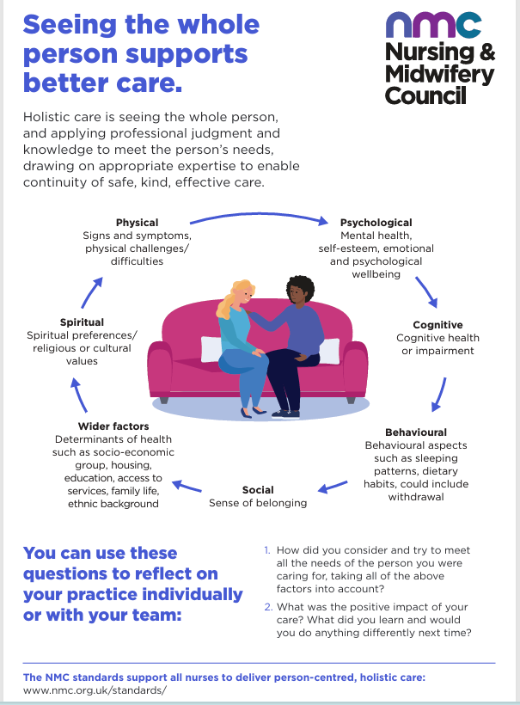
(NMC standards, 2024).

The Office of Health Improvement and Disparities (GOV. UK, 2022) have guidance on ‘Healthy Ageing: applying All Our Health’. This is a resource for helping HCP in their everyday practice to promote well-being and prevent ill health. In recent years the UK has seen a steady increase in life expectancy, there are now over half a million people aged over 90, more than two and a half times the number in 1985 (GOV. UK, 2022). And half of all adults in the UK are expected to be over 50 by the year 2035, however, people are not spending more of those extra years in good health. A significant reason for promoting healthy ageing.
The NHS along with other organisations are supporting healthy ageing by:
- Highlighting the importance of regular health checks.
- Develop and promote good practice.
- The Centre for Ageing Better (2025) aims to tackle inequalities and is striving to make communities and homes inclusive for older people.
- National Institute for Health and Care Excellence (NICE), (2015) has guidelines for how to delay or prevent the onset of dementia, disability and frailty in old age. “See Appendix H”.
- The British Geriatrics Society (Greenbrook, 2019) issued a report on how HCP can support older people stating, “A person’s changing needs should not be a barrier to maintaining or improving health and being able to continue to do the things that they value”.

Although delivering healthcare is the core responsibility of healthcare professionals, their role extends beyond clinical care to encompass a more holistic approach. This includes supporting patients in making healthy lifestyle choices, ensuring access to appropriate care, and advocating on their behalf (Greenbrook, 2019).

2.6 Conclusion

From having explored the background of the topic, this chapter can conclude the presence of holistic care through history. Long before the NHS was established, the father of medicine Hippocrates, holistic understanding of illness became a major contributor to healthcare delivery.
Ageing theories help to get a better understanding of how people age. They can assist HCPs to distinguish between different behaviours and temperaments. Carl Rogers’ (1902-1987) theory explained how individuals thrive in positive environments, and the Disengagement theory explains how the older person naturally withdraws from society, regardless of physical or emotional abilities.
Concerning the local and national context towards holistic care, there is a well-recognised implementation of HBIs within organisations, by complying with policies and legislation to help deliver a comprehensive person-centred approach.
The next chapter will expand on the methodology and search processes of academic literature used to gather information on the research question.

Chapter 3 Methods and Search Strategy
3.1 Introduction
This chapter will discuss the methodology and search processes carried out to gather information regarding the research aim. The secondary data (Wickham, 2019) which has already been collected by previous journals, books and or studies, will be searched. One of the benefits of using secondary data is that it has already been cited (Wickham, 2019).
A thematic analysis will be carried out, a simplified approach which has been used many times to complete literature reviews in health and social care (Aveyard, 2014, p143). Whereas the methodology poster was created as a visual summary, this chapter is a written expansion of the poster.
3.2 Search Strategy
For the search strategy keywords from the research question were used, such as ‘holistic care’, ‘older person’ and ‘quality of life’. A comprehensive search strategy for literature reviews can be developed by using ‘single-line search strategies’ (Bramer et al, 2018). By using a search syntax, such as field codes, and synonyms from the thesaurus, key words and codes are denominated.
Boolean operators were used to refine the search. By using ‘and’ which narrows a search by requiring all terms to be present, using ‘or’ which broadens a search by allowing any of the terms to be present and lastly using ‘not’ which excludes unwanted terms (Atkinson and Cipriani, 2018). During this search ‘holistic interventions’ and ‘elderly person’ was used. To help find the most relevant information, Boolean operators can help get better results.
3.3 Searching for Information
The initial search was conducted using the internet, with a primary focus on academic and peer-reviewed literature accessed through Google Scholar?
In addition, the University of Wales Trinity Saint David (UWTSD) library was used to access full-text journal articles, books, and electronic resources that were not freely available online. Several academic databases were also searched to ensure comprehensive coverage of the literature. Accessing information is easy but making sure that information is credible can be difficult. Using cues and heuristics can help but occasionally may be misleading (McGrew et al, 2018). The authenticity of the author or websites such as GOV.UK hold value to being credible. Filters were applied where available to refine the search results, such as limiting publications to peer-reviewed sources, English language, and a specified publication date range to ensure relevance and currency (Atkinson and Cipriani, 2018).
A source tracking table was created to record and summarise the findings. “See Appendix H”

3.4 Research Validation
To save time when searching for literature the skimming technique can be applied. By reviewing the title, abstract, introduction and headings you can get a quick idea of what the article is about (Tasmir, 2025). Skimming helps to determine the relevance of an article helping to eliminate the ones which do not meet the scope of the aim question. “See Appendix I” for Skimming articles Effectively.
Sources that appeared relevant were then evaluated in greater depth using the CRAAP test, which assesses Currency, Relevance, Authority, Accuracy, and Purpose (Fielding, 2019). Considering that not every article will meet the full standard of the CRAAP test, priority was given to the ones which strongly met the Currency, Relevance and Authority criteria.
The Accuracy of the information can be assessed by checking references and consistency with other reputable sources. McGrew et al (2018) wrote “Civic online reasoning consists of three primary constructs: Who is behind the information? What is the evidence? What do other sources say? In asking who is behind information, students should investigate the author and/or organisation that is presenting the information. These validation steps support informed decision-making and ensure that only high-quality, reliable evidence was included in the review.

3.5 Inclusion and Exclusion Criteria
Inclusion and exclusion criteria help to filter out any sources that do not meet the research needs.
Inclusion Criteria
- Sources that directly relate to the topic title e.g. ‘holistic care’.
- Literature written in the English language.
- Peer-reviewed academic journal articles/ Official Government sites and/or NHS reports.
- Studies focusing on the older person/aged over 65
- Current literature which is not more than 10 years old.
- Credible databases.
Exclusion Criteria
- Studies focusing on younger adults.
- Non-English publications
- Literature which is more than 10 years old.
- Not peer-reviewed or credible sources.
- Blogs, news articles or social media posts/opinion pieces.
- Studies which do not meet the CRAAP test or the 3 most important criteria.

Inclusion and exclusion criteria are the key features used to answer the research question (Patino and Ferreira, 2018).

3.6 Analysing Research
The second phase of thematic analysis involves generating initial codes, marking the transition from data familiarisation to the systematic identification of meaningful segments. Codes act as labels that identify important features and recurrent patterns within the dataset. Transparent and systematic coding practices contribute to the credibility and reproducibility of the findings (Ahmed et al, 2025).
The third phase of thematic analysis, focuses on searching for themes, representing a critical shift from the generation of initial codes to the identification of broader patterns within the dataset. Themes reflect recurring and meaningful patterns of significance that emerge from the coded data and are closely linked to the research question (Ahmed et al, 2025). Braun and Clarke emphasise that themes move beyond summarising codes to interpretatively capture what is meaningful within the data (Braun, Clarke and Hayfield, 2019).
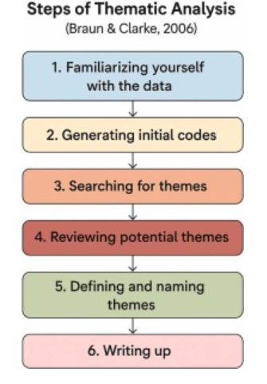(Ahmed et al, 2025).

A source tracking table was used to analyse data from sources used for this thematic analysis. “See Appendix H”.

3.7 Ethical Considerations
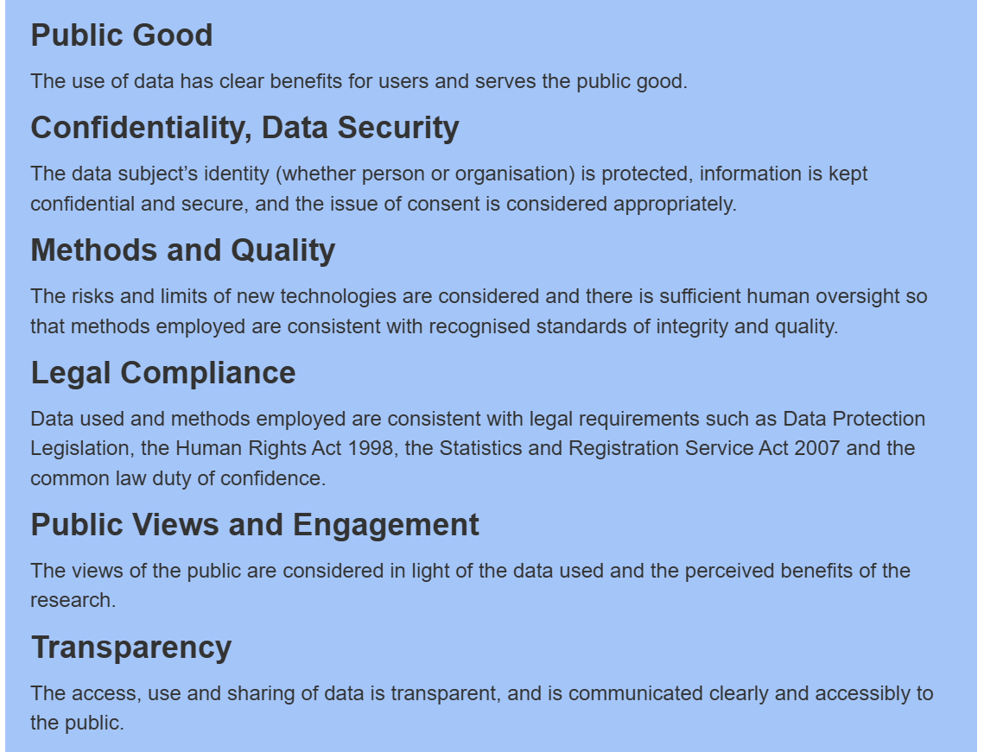
(UK Statistics Authority, 2022).
Ethical considerations are a critical component of secondary research, particularly in relation to academic integrity, transparency, and the credibility of findings, as the above image highlights. Since this is a secondary research paper it involves the analysis of existing data and published sources, ethical responsibility centres on the appropriate and responsible use of data rather than direct participant involvement (UK Statistics Authority, 2022).
Academic integrity is maintained through accurate representation of original sources, proper citation, and acknowledgement of all secondary data used in the study. Care was taken to avoid plagiarism by paraphrasing appropriately and referencing all materials in accordance with academic conventions. Transparency was ensured by clearly documenting the research process, including data sources, selection criteria, and analytical methods (UK Statistics Authority, 2022). The credibility of the research was enhanced using reputable, peer-reviewed sources and authoritative datasets. The study aims to produce findings that are both trustworthy and ethically sound.

3.8 Conclusion
When writing a secondary literature review it is important to focus on the search strategy. The search strategy used here is a thematic analysis approach. With a focus on identifying keywords and synonyms to the terms used in the research question it becomes easier to identify which literature to include and exclude. This further helps to develop codes and themes which enables a structured organisation of data. Ethical consideration is a critical component of secondary research as it complies with academic integrity, credibility and transparency.
The next chapter will discuss what kind of themes have been identified from the literature, with the help of the ‘results summary table’ and present the findings.

Chapter 4 Findings and Discussion
4.1 Introduction
This chapter will start off by providing a definition for thematic analysis and then go on to discuss the findings of the themes which have been identified from the collection of secondary academic literature. These themes are analysed in relation to existing research, theoretical frameworks, and contemporary practice.
A critical look at how holistic care implementation for elderly care provisions is enabled within healthcare and how the QOL of older people is affected with or without a person-centred approach. What kind of barriers and challenges can be identified to enable effective holistic care delivery will also be explored.

4.2 Thematic Analysis
“Thematic analysis (TA) is a method for identifying, analysing, and interpreting patterns of meaning (‘themes’) within qualitative data. TA is unusual in the canon of qualitative analytic approaches, because it offers a method – a tool or technique, unbounded by theoretical commitments – rather than a methodology (a theoretically informed, and confined, framework for research)” (Clarke and Braun, 2016).
One of the techniques is generating codes, as shown in the results summary table “See Appendix J”. Codes capture the interesting features of the data which can be potentially relevant to the research question, they act as the initial building blocks that are grouped together to create themes. Each theme captures a broader pattern of meaning and is unified by a central organising concept (Clarke and Braun, 2016).
The themes which have been identified are 1) Holistic Care in elderly Practice, 2) Impact of Holistic Care on Quality of Life in the Elderly and 3) Barriers and Challenges to Effective Holistic Care Delivery.
Thematic analysis is a flexible qualitative method that can be used across different theoretical frameworks and research questions. It goes beyond simply summarising data and focuses on interpreting meaning. “The final analysis is the product of deep and prolonged data immersion, thoughtfulness and reflection, something that is active and generative” (Braun and Clarke, 2019).

4.3 Theme 1: Holistic Care in Elderly Practice.
Holistic Care: “Complete or total patient care that considers the social, physical, psychological, cognitive, spiritual, and environmental well-being of the person, his or her response to illness, and the effect of the illness on the ability to meet self-care needs” (Jackson, Turner and Paterson, 2023).
While modern medicine reduces individuals to disease labels and relies on pharmaceutical ‘magic bullets’ (British Association for Holistic Medicine and Health Care, 2025), holistic healthcare integrates a broad spectrum of alternative and traditional practices to promote wellness.
Florence Nightingale, born in the 1800s, established modern nursing based on holistic principles rooted in earlier healing practices (Thornton, 2019). She believed nurses should think critically and provide appropriate care to support healing (Riegel et al., 2021). While early nursing was holistic and relationship-centred, this declined by the late 1900s as technology and profit-driven systems took priority, leading to reduced human connection and nurse dissatisfaction (Thornton, 2019).
However, thanks to Hippocrates and his principles modern day medicine is inclined to adopt Hippocrates holistic approach which has become more relevant to modern day healthcare (Brigic et al, 2021).
With an ageing population (ONS, 2025) most of whom will be living with chronic illnesses (Elston et al, 2019) the burden is on the NHS to support care needs but, because of the challenges affecting both formal and informal care systems in the United Kingdom the number of elderly people with unmet needs is increasing (Abdi et al, 2019).
A scoping review written by Sarah Abdi and others (2019) titled “Understanding the Care Needs of Older People” conducted a review using the Arksey and O’Malley original and enhanced framework to understand the needs. A comprehensive search was conducted across five electronic databases, supplemented by grey literature and reference list screening. The identified studies were analysed and categorised using the WHO International Classification of Functioning, Disability and Health (ICF) framework (Abdi et al, 2019).
The results highlighted that due to chronic illnesses older people encountered a variety of challenges with physical, social and psychological dimensions. The three main areas which required care and support are 1) social activities and relationships; 2) psychological health; and 3) activities related to mobility, self-care and domestic life (Abdi et al, 2019). However, environmental factors disrupted these efforts, such as lack of professional advice regarding self-care strategies, poor communication and co-ordination of services and a gap in the knowledge of care and support needs (Abdi et al, 2019).
An integrative systematic review which looked at the holistic care impacts of individuals living in residential aged care facilities reported that since the Covid-19 outbreak, the ageing population being the most vulnerable, where affected badly because of the pandemic impacting them on all levels of QOL (Jackson, Turner and Paterson, 2023).
The study investigated various domains of holistic care and well-being including physical, social and psychological impacts. Following the pandemic and the negative effect it has left behind it has become prudent on public health departments and policy makers to identify any gaps and barriers to facilitate holistic care in the future (Jackson, Turner and Paterson, 2023). Using qualitative, quantitative and mixed methods the study concluded, the findings indicate that policy must prioritise QoL domains, rather than focusing solely on survival rates.
The NHS Long-Term plan (NHS Confederation, 2025) “See Appendix J” includes sustainability of the NHS and Adult social care, with an increasing demand from an ageing population there is added pressure on adult social care services (House of Lords, 2017). The box below demonstrates statistical forecast of an ageing population and the health demands which will be expected.
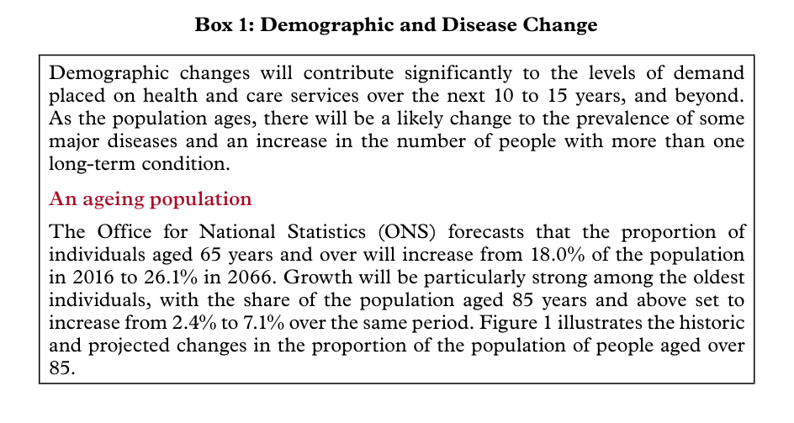
(House of Lords, 2017).

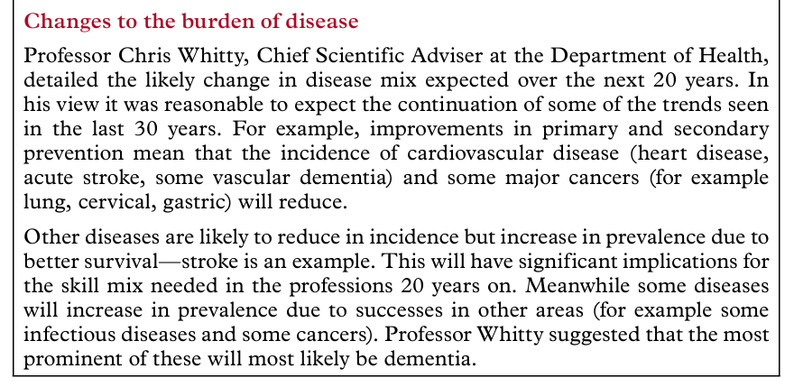
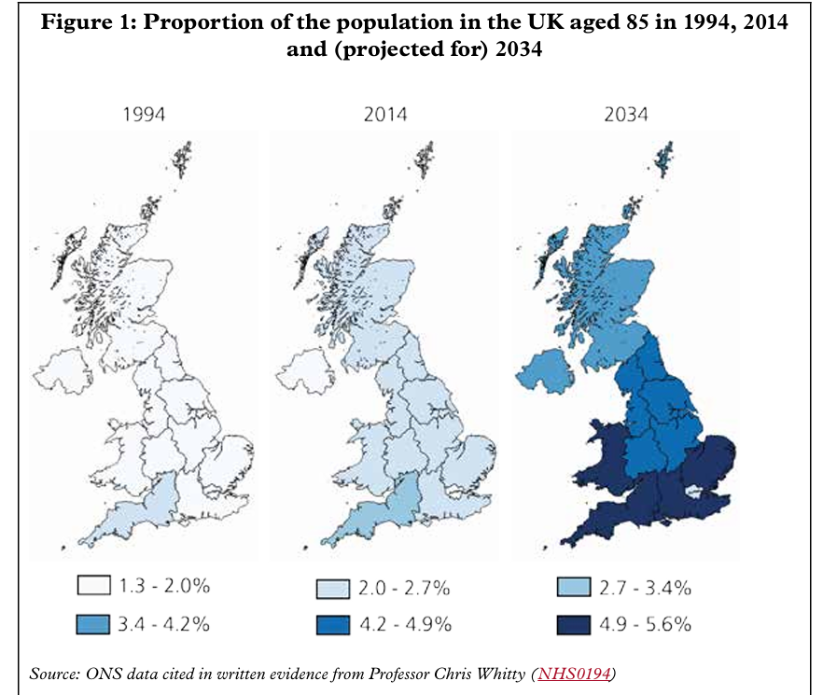
Figure 1 (House of Lords, 2017) demonstrates how the UK population is projected to age and the changes to the burden of diseases.
The NHS Long-Term Plan recognises the type of challenges which will arise and will need to maintain various aspects one of which is funding to adequately sustain adult social care. The government has implemented a range of social care policy reforms. The overall responsibility of the social care policy is to not lose sight of those who matter. “It was made clear to us throughout our inquiry that social care is not about looking after people who are a burden on our society, but is about supporting people to lead fulfilling, meaningful lives” (UK Parliament, 2022).
Carl Rogers developed Humanistic Theory in the 1950s, which emphasises understanding the whole person, individuality, free will, and self-actualisation (Joseph, 2025; McLeod, 2025). He also introduced client-centred (person-centred) therapy, a non-directive approach that promotes personal growth and psychological wellbeing, aligning with holistic care (McLeod, 2025).
According to Continuity theory, the continuation of long-standing activities plays a key role in promoting successful ageing by maintaining self-identity (Ng, Lim and Hsu, 2021) change is managed by keeping life as consistent as possible.
Ageing involves both growth and decline Developmental theory recognises losses (e.g. physical decline) but also ongoing growth, such as wisdom, emotional regulation, and self-understanding (Practical Psychology, 2023).
Positive and Negative Implications of Holistic Care
Holistic care is a complex concept that lacks a single, precise definition but is widely recognised as central to effective healthcare practice. By providing a comprehensive understanding of patients’ holistic care enhances patient satisfaction, supports self-responsibility, and improves understanding of how illness affects daily functioning (Jasemi et al, 2017).
Findings from multiple studies indicate that the HCP and nurses’ neglect of holistic care is influenced by factors including time constraints, poor professional relationships, inadequate documentation and supervision, limited resources, ineffective management, insufficient knowledge and motivation, and misunderstandings of the holistic care concept (Jasemi et al, 2017). Holistic care is frequently criticised for being unspecialised, unscientific, inefficient, and overly time-consuming.

A journal by Arekelyan et al (2023) did an umbrella review of systematic reviews to see how effective are HBIs for older adults with multiple long-term conditions and frailty. The results found that HBIs can be effective for those admitted to hospital, but it is unclear whether similar types of interventions can be as effective in communities. The review found no clear benefits of hospital based QOL which may lead to a reduction of emergency department return visits. And within the community no improvement in overall healthcare use, nursing home admissions, or mortality (Arekelyan et al, 2023).
Although there is heterogeneity in the components of complex interventions that have the same name, the study states that “NICE has highlighted the need for evidence on the effectiveness of such interventions in people with multiple long-term conditions” (Arekelyan et al, 2023) the content of this article connects directly to the theme.
This next article looks at the HCPs perspective of delivering holistic care (Wong et al, 2022) using the Theoretical Domains Framework via questionnaires. The aim is to identify what influences HCPs to deliver holistic care. It is suggested that despite policies, holistic care is not being delivered consistently. The reasons being a lack of communication, empathy and clinical skills, time constraints and a perceived impact on patient outcomes (Wong et al, 2022). Although professionals value holistic care it is not prioritised due to complexity and automaticity.
In comparison to the journal by Arekelyan et al (2023) this article studies how holistic care is delivered rather than the overall outcomes of holistic care.
Strabner et al, in their journal of “Holistic care program for elderly patients to integrate spiritual needs, social activity, and self-care into disease management in primary care (HoPES3): study protocol for a cluster-randomized trial” (2019) aimed to explore whether combining ‘disease management programmes’ with HBIs, such as spirituality, has any impact on outcomes of patients with polypharmacy.

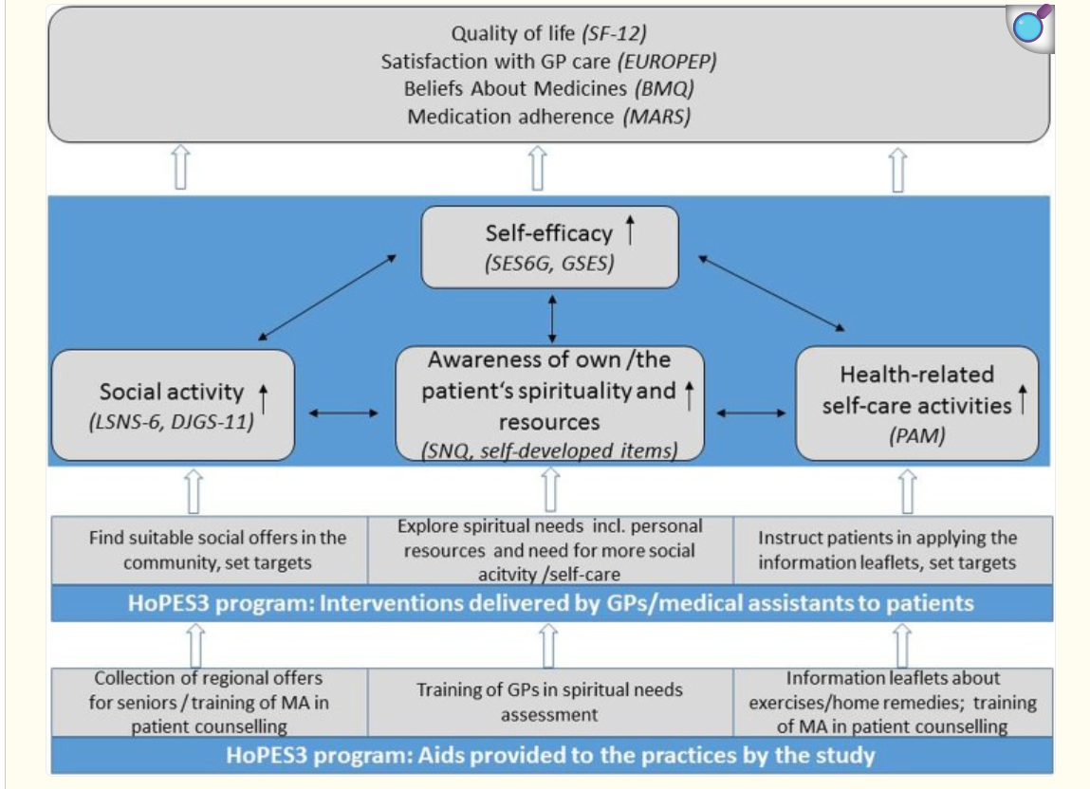
Logic model of the HoPES3 program (Stabner et al, 2019).
Research indicates that many patients are interested in discussing spiritual matters during medical consultations however, this aspect of care is often overlooked. Being a study protocol, HoPES3, it does not report outcomes, but the authors anticipate integrating a ‘spiritual needs assessment’ alongside disease management may strengthen self-efficacy and improve holistic well-being in elderly patients (Strabner et al, 2019).

The theme of ‘Holistic care in elderly practice’ not only interconnects but also overlaps with the next theme which is ‘Impact of holistic care on Quality of life in the elderly’. Since the era of ancient Greek philosophy and continuing into modern positive psychology, well-being has been conceptualised through two primary perspectives: hedonism (subjective well-being) and eudaimonism (psychological well-being) (Jiwattanasuk, Pannavoravat and Sirikanchana, 2022).
Subjective well-being refers to how individuals evaluate their lives emotionally and cognitively, including positive emotions, fewer negative emotions, and life satisfaction. Psychological well-being relates to feelings that arise from fulfilling personal needs shaped by values, identity, and motivation for growth (Jiwattanasuk, Pannavoravat and Sirikanchana, 2022). It is therefore an important indicator of quality of life.
In healthcare the questions which arise in relation to these concepts are “What course of treatment for a patient would be in his best interests? Would medication help him to lead a better life despite the side effects, or would he be better off with other therapies, or no treatment at all?” (Kim and Haybron, 2021).
4.4 Theme 2: Impact of Holistic care on ‘Quality of Life’ in the Elderly.

“WHO defines Quality of Life as an individual's perception of their position in life in the context of the culture and value systems in which they live and in relation to their goals, expectations, standards and concerns” (WHO, 2026).
In the 1960s doctors and health professionals started talking about QOL in medical studies. Medical treatments and strategies began to help people live longer, but that did not mean their daily lives felt much better or more comfortable. So, researchers began measuring QOL (Karimi and Brazier, 2016). Health Status Index (HIS) scale is the term given to the measurement of QOL. Over the years the new term for health status measures was introduced as Health Related QOL (HRQoL).
In the journal by Karimi and Brazier (2016) it states that it is problematic to define HRQoL in one definition, therefore in this literature there are four definitions.
- “How well a person functions in their life and his or her perceived wellbeing in physical, mental, and social domains of health”

- “Quality of life is an all-inclusive concept incorporating all factors that impact upon an individual’s life. Health-related quality of life includes only those factors that are part of an individual’s health”

- “Those aspects of self-perceived well-being that are related to or affected by the presence of disease or treatment”

- “Values assigned to different health states” (Karimi and Brazier, 2016).

HRQoL overlaps with both health and QoL, making it difficult to define. It focuses on how health influences overall QoL, often measuring individuals’ perceptions of their health status. Researchers recommend distinguishing health status from QoL, using HRQoL to assess the impact of health on people’s lives (Karimi and Brazier, 2016). Additionally, ‘Holistic healthcare involves coordinated care from multiple professionals to support the overall needs of people and improve their quality of life’ (Ventegodt et al, 2016).
In England, healthy life expectancy at birth was estimated to be 61.5 years for males and 61.9 years for females between 2021 and 2023, representing a long-term decline compared with 2016 to 2018, when healthy life expectancy was 63.3 years for males and 64.1 years for females (ONS, 2025). The graph below highlights the decline in life expectancy between 2011 and 2023.
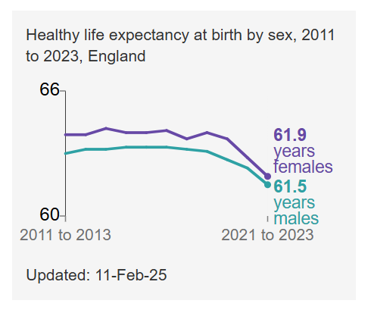(ONS, 2025).
In September 2024, 47.4% of adults in Great Britain reported that they were generally satisfied with the UK healthcare system, as indicated in the bar chart below.
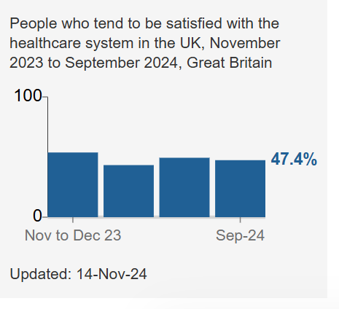(ONS, 2025).
Historically, healthcare viewed humans mechanistically and dichotomously, treating the body as separate parts and separating physical health from the mind (Redemptus, Weraman and Roga, 2023). This led to a focus on physical illness rather than the whole person. However, advances in knowledge now recognise that health is complex and influenced by interconnected physical and mental factors (Redemptus, Weraman and Roga, 2023).
The journal ‘Holistic Therapy to Improve Quality of Life in Chronic Disease Patients’ (2023) looks at the holistic approach and its impact on individuals. It indicates how incorporating HBIs adversely affects their overall health.
- Improves communication and collaboration between HCP leading to more coordinated care. This is especially important for patients with complex chronic conditions, ensuring all aspects of their treatment are effectively managed.
- Improves self-management leads to better control over health which leads to, reduced hospitalisation and improved outcomes.
- A comprehensive understanding of the patients’ experience leads to better support of emotional well-being.
- PCC considers the needs of patients. The patient needs to feel satisfied of how they are being treated by the healthcare organisation involved.
- Reduces healthcare costs “a holistic approach to medical care can potentially reduce health costs associated with chronic conditions” (Redemptus, Weraman and Roga, 2023).
The journal concludes by saying conventional and complementary therapies can improve both physical and mental health in patients by supporting better symptom control, reduce pain, and enhances overall quality of life. (Redemptus, Weraman and Roga, 2023).
A journal article by Gong and Tao (2021) carried out a randomised trial on the effects of biopsychosocial holistic models on the cognitive function and Quality of life of elderly patients with mild cognitive impairments (MCI). Cognitive dysfunction is a condition that arises following damage to brain tissue and can range from mild to severe in its impact, particularly among older adults.
A cohort of 140 patients diagnosed with MCI at Nantong People’s Hospital (Nantong, China) between March 2019 and March 2020 was included in the study. Participants were randomly allocated, using a computer-generated randomisation method, into either an observation group or a control group, with 70 patients in each. Cognitive function and quality of life were compared between the two groups at baseline, as well as at 1 month and 3 months post-treatment (Gong and Tao, 2021).
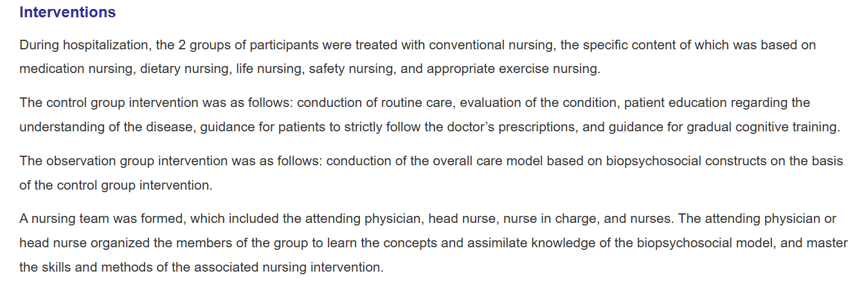
Types of interventions for the study included:
(Gong and Tao, 2021).

For further information on types of interventions and steps taken in the study please “See Appendix K”.
Cognitive function was measured using MMSE (Mini-Mental State Examination) and MoCA (Montreal Cognitive Assessment). Researchers measured how well elderly patients can manage everyday tasks using the Activities of Daily Living (ADL) scale, a tool used to assess an older person’s overall health and independence, in the 2 main areas, Basic self-care (PSMS) and more complex daily tasks (IADL) (Gong and Tao, 2021). “See Appendix L”.

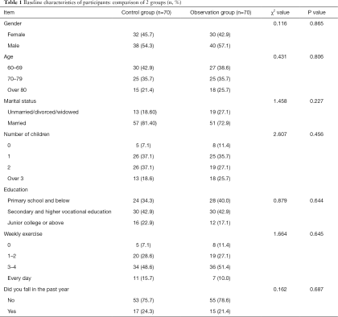
Table showing baseline characteristics of participants.

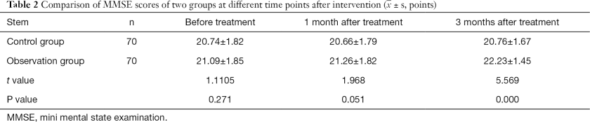

Table 2 highlights the scores of the MMSE before and after treatment.
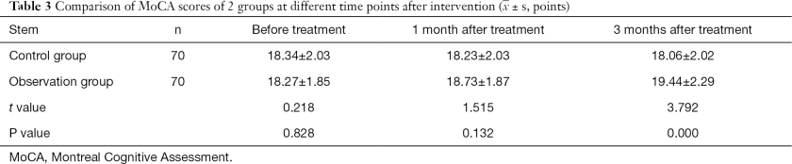
Table 3 shows the comparison between the 2 groups of MoCA.
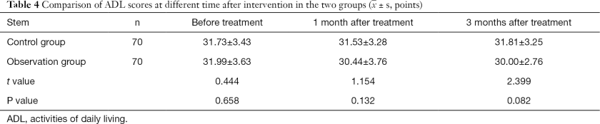
Table 4 shows the scores of ADL (Gong and Tao, 2021).
The study found that, after nursing care, the observation group had significantly higher MMSE and MoCA scores than the control group (P<0.05), indicating improved cognitive function. Additionally, the observation group showed lower quality of life scores, suggesting better self-care ability and overall improvement, to conclude “the biopsychosocial holistic care model has a positive effect on improving the quality of life of elderly patients with MCI” (Gong and Tao, 2021).

.
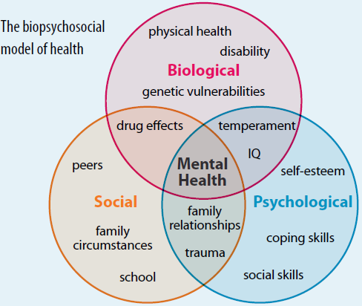
.
The Biopsychosocial Model of Health (Physiopedia, 2026) explaining health as a combination of biological, psychological, and social factors.
There is now growing recognition that a biopsychosocial approach, rather than separating medical and psychosocial factors, supports more effective treatment planning and can help prevent distress. Human development occurs through interconnected systems that influence the three core areas of the biopsychosocial model: the biological (body systems), the psychological (mind), and the social or interpersonal domain. To approach the concept of QOL, requires considering the interaction between the three factors simultaneously (Irtelli and Durbano, 2019).
The Care Act (2014) places well-being and QOL at the centre of care, requiring services to promote independence and dignity. This review focuses on the elderly person and their needs, and it seems obvious that the elderly population who become burdened with illnesses also may require carers. In the form of professionals or friends and family. A journal article by O’Rourke et al (2020) looks at supporting older carers of older people.
The Care Act 2014 treats carers as just as important as the people they care for “parity of esteem”. It ensures carers are supported by focusing on their well-being, giving them the right to have their needs assessed, and setting clear national rules for accessing support services (O’Rourke et al, 2020). When the care giver is also being cared for, ethically and through policy, patient outcomes are improved.
The journal by Strabner et al (2019) which is a study protocol for Holistic care program for elderly patients to integrate spiritual needs, social activity, and self-care into disease management in primary care. The aim of this study is to evaluate the effectiveness of complex interventions in comparison to standard care. As a study protocol it does not provide a clear outcome but does provide a conceptual summary of why HBIs are expected to improve QOL (Strabner et al, 2019).
The article repeatedly stresses that self-efficacy is one of the strongest determinants of well-being. It suggests that addressing Spiritual Needs enhances emotional and mental well‑being, spiritual distress is associated with increased hopelessness, lower treatment adherence, and diminished well-being (Strabner et al, 2019). Loneliness is associated with cognitive decline, depression, increased pain and fatigue, and greater use of healthcare services, enhancing social activity reduces loneliness and improves QoL.
By promoting self-care skills (e.g. exercise) the intervention seeks to enhance daily functioning, improve symptom management, and increase independence, thereby improving QoL. In conclusion this study suggests implementation of HBIs to improve QoL for the elderly patient by focusing on overlooked yet vital aspects of ageing (Strabner et al, 2019).
An umbrella review of systematic reviews (Arakelyan et al, 2023) which sought to find the effectiveness of HABIs (Holistic assessment-based interventions) for adults with multiple long-term conditions and frailty found, largely inconsistent and low-quality evidence to support that HABIs improve HRQol.
“A holistic assessment in health and social care is a comprehensive and thorough means of evaluating an individual’s health and well-being” (Care Learning, 2024a). This type of assessment considers the physical, emotional, social and environmental factors. Considering the interconnection the aim is to provide personalised care plans to address the root cause of the illness (Care Learning, 2024a).
The review reported the benefit on QOL:
- Hospital Based HABIs = NO benefit
- Community Based HABIs = Mostly no benefit
- Patient Centred Medical Home = Small but statistically significant improvement

It further goes on to say that differences in how HABIs are designed mean that a one-size-fits-all solution does not exist. As a result, those working in health and social care improvement need to carefully take their own context into account when planning and implementing similar interventions (Arakelyan et al, 2023).
NHS England (2025) web page ‘Improving care for older people’ does not explicitly use the term QoL, although the content fundamentally discusses ‘protecting and improving QoL as people age’. “If we don’t improve the way we provide support to older people then the NHS will struggle to meet the increasing demand for resources as well as changing patient needs” (NHS, 2025).
The page highlights that although people are living longer, many experience multiple long-term conditions. Improving QoL therefore involves helping older adults maintain health and independence for as long as possible, minimising time spent in poor health, and recognising that frailty rather than age alone, is a key predictor of decline and support needs. This reflects the wider gerontological perspective that QoL is closely linked to autonomy, mobility, and the ability to carry out daily activities (NHS, 2025). Finding ways to improve QoL is seen as a moral and practical necessity.
Enhancing and improving QoL by implementing strategies, policies and techniques is repetitive and a focal point in all the articles discussed. Tailored care plans with a holistic approach in today’s modern medicine is becoming a practical and beneficial element towards preserving life. The next chapter will discuss ‘Barriers and challenges to effective holistic care delivery’.

4.5 Theme 3 Barriers and Challenges to effective holistic care delivery.
“Barriers in HSC can be defined as obstacles that prevent individuals from accessing or receiving effective healthcare and support. These barriers can arise from physical, economic, social, cultural, systemic, psychological, and technological factors” (Care Learning, 2024b).
HSC involve a wide range of services aimed at promoting individuals’ health and wellbeing. While the system aims to provide accessible, high-quality care, several barriers can limit its effectiveness. Recognising these challenges and their impact is key to developing a more inclusive and efficient healthcare system (Care Learning, 2024b).
The book Rethinking the National Health Service in its’ chapter 1968-1977 (The Nuffield Trust, 2019) writes about the historical developments of the NHS in that period. It was decided that changes had to be made due to recognising that services had been ‘administered’ rather than ‘managed’.
It was the third decade for the NHS being under financial restrain prompting a call for a structural reform. The year 1968 announced the first Green Paper on NHS Reorganisation with a “demand for a new service designed to meet the requirements of modern medicine” (The Nuffield Trust, 2019). Changes in society began to take place, there was in rise in chronic illnesses highlighting the need for lifestyle changes. Technological advances and genetic engineering to develop new drugs was established. “See Appendix M”.
However, the growing complexity of medicine reduced the emphasis on empathy, as clinicians faced increasing technical demands.

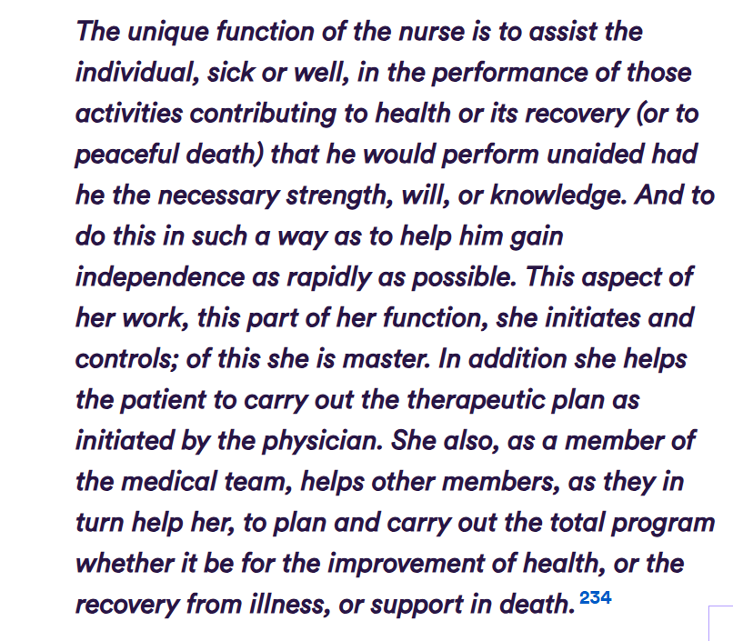
Principles and Practice of Nursing (The Nuffield Trust, 2019).
From financial constraints to organisational disputes, including political agendas and the social determinants of health this became the decade the NHS confronted limitations, embraced prevention and overcame tensions.

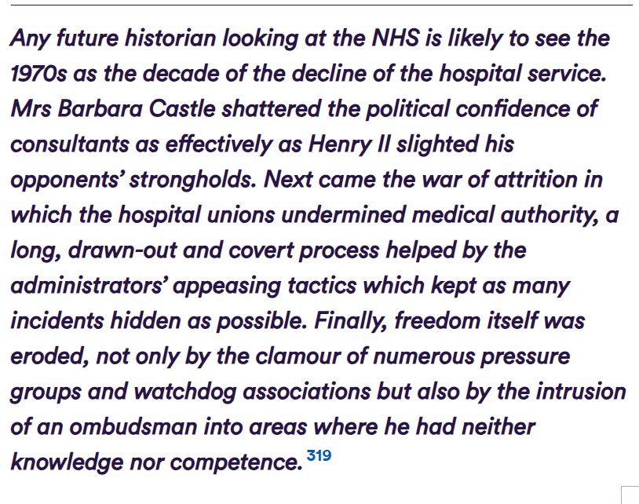
(The Nuffield Trust, 2019). The primary aim of health services is to deliver high quality care that improves outcomes for both patients and the wider community. In professional care, individuals are viewed holistically, considering biological, psychological, social, and spiritual needs, with balance between these aspects supporting overall health. The journal by Momeni, Hashemi and Hemati (2022) looked at the barriers to providing spiritual care.
The type of barriers included:
- Organisational barriers
- Lack of staff
- Staff burnout
- Educational, lack of recognising the importance of dealing with spirituality in care and treatment
- Communication
- Cultural and societal (Momeni, Hashemi and Hemati, 2022).
One other aspect mentioned in the journal was that of improving the salaries and benefits of nurses, they felt their pay was unfair, which reduced motivation to deliver high-quality, holistic, and spiritual care. It also emphasises the need for teamwork, suggesting that input from other healthcare professionals should be considered to better understand and overcome these barriers (Momeni, Hashemi and Hemati, 2022).
A qualitative ethnographic study which explores the ‘compassionate care challenges and barriers in clinical nurses’ (2019), interviewed 40 nurses, 16 patients and 8 family members drawing on observations. Data analysis identified three main themes as barriers to compassionate care, those linked to the hospital environment, sociocultural factors, and staff related challenges. Table below shows the themes of barriers to compassionate care.
Themes and subthemes of barriers to compassionate care
Themes | Subthemes
Challenges and barriers related to the contextual environment of hospital | Inconsistency between the workload and its allocated time  Inattention to the needs of the nurse by the organization  Lack of a role model for compassionate behavior  Focus on routines instead of patients
Sociocultural challenges and barriers | Gender as the determining factor of compassionate behavior  Lack of a mutual language between the nurse and the patient  Implausibility of friendly behavior in medical relations
Challenges and barriers related to staff | Personal and professional attitude of nurses  Lack of a holistic approach to providing care
(Babei and Taleghani, 2019).
Due to environmental factors high patient numbers, the presence of family members on wards, unstable ward conditions, and staff shortages create an imbalance between nurses’ workload and available time, limiting their ability to provide compassionate care (Babei and Taleghani, 2019).
Sociocultural barriers also create complications towards providing compassionate care. Nurses occasionally felt uncomfortable when caring for patients of the opposite gender, “Sometimes, when you treat a male patient kindly or support them it becomes problematic, I prefer to care for female patients and show them my care and compassion” (Babei and Taleghani, 2019).
To improve care, steps should be taken to address existing barriers and improve facilities needed by HCP. Greater focus is needed on holistic, PCC, alongside reducing nurses’ workload and supporting their physical and emotional wellbeing. Care should also respect patients’ cultural and religious values, with increased emphasis on teaching compassion in clinical practice (Babei and Taleghano, 2019).
Health inequality is a major global public health challenge and a key policy priority, as it disproportionately harms poorer populations. These avoidable differences are considered unfair and unjust. The World Health Organisation defines health inequalities as systematic, socially produced differences in health between socio-economic groups that are modifiable and inequitable (Regmi and Mudyarabikwa, 2020).
Since the establishment of the NHS in 1948, it has undergone numerous organisational changes, shaped by developments in commissioning and efforts to address health inequalities. Commissioning involves a range of activities, from assessing population health needs and designing patient pathways, to specifying services, negotiating or procuring contracts, and continuously monitoring quality. Effective clinical commissioning relies on collaboration, partnership, and engagement, alongside a focus on prevention, early intervention, and clear planning based on shared needs assessments (Regmi and Mudyarabikwa, 2020).
Nevertheless, further research is needed to identify effective measures and approaches that link clinical commissioning to reducing health inequalities, improving access, outcomes, and partnership working.
The Health and Social Care Act (2012) places duties on organisations like NHS England and local authorities to reduce health inequalities and improve access to services.
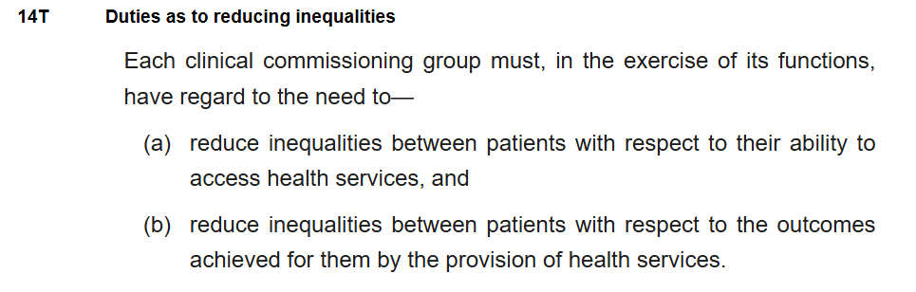
(Legislation.gov.uk, section 26, 2012).

‘What the NHS 10-year plan means for older people’ (Age UK, 2025d), highlights the key points of the plan which will impact care changes for older people. As older people represent a large proportion of NHS users, Age UK welcomed the opportunity to contribute to the plan, co-chairing a working group focused on care for those with long-term conditions.
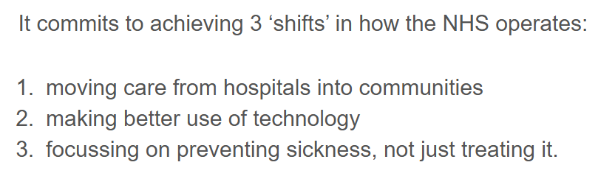
(Age UK, 2025).
These services aim to integrate community-based health and care professionals with GPs to better meet patient needs, supporting proactive management of long-term conditions and reducing the need for crisis care (Age UK, 2025). Technology will be used in preventative measures and for collecting data to improve treatment plans. The list below highlights some of the initiatives for the NHS long-term plan.
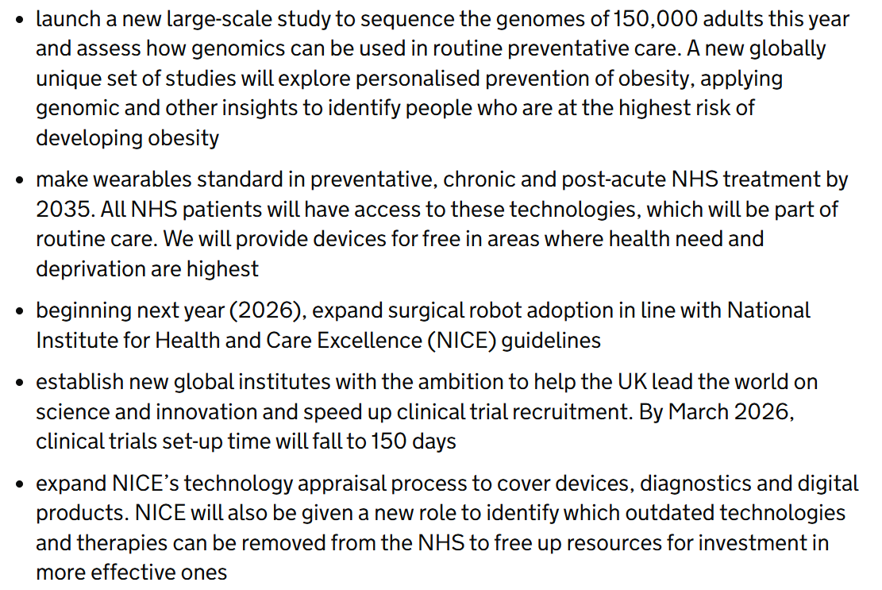
(Department of Health and Social Care, 2025).

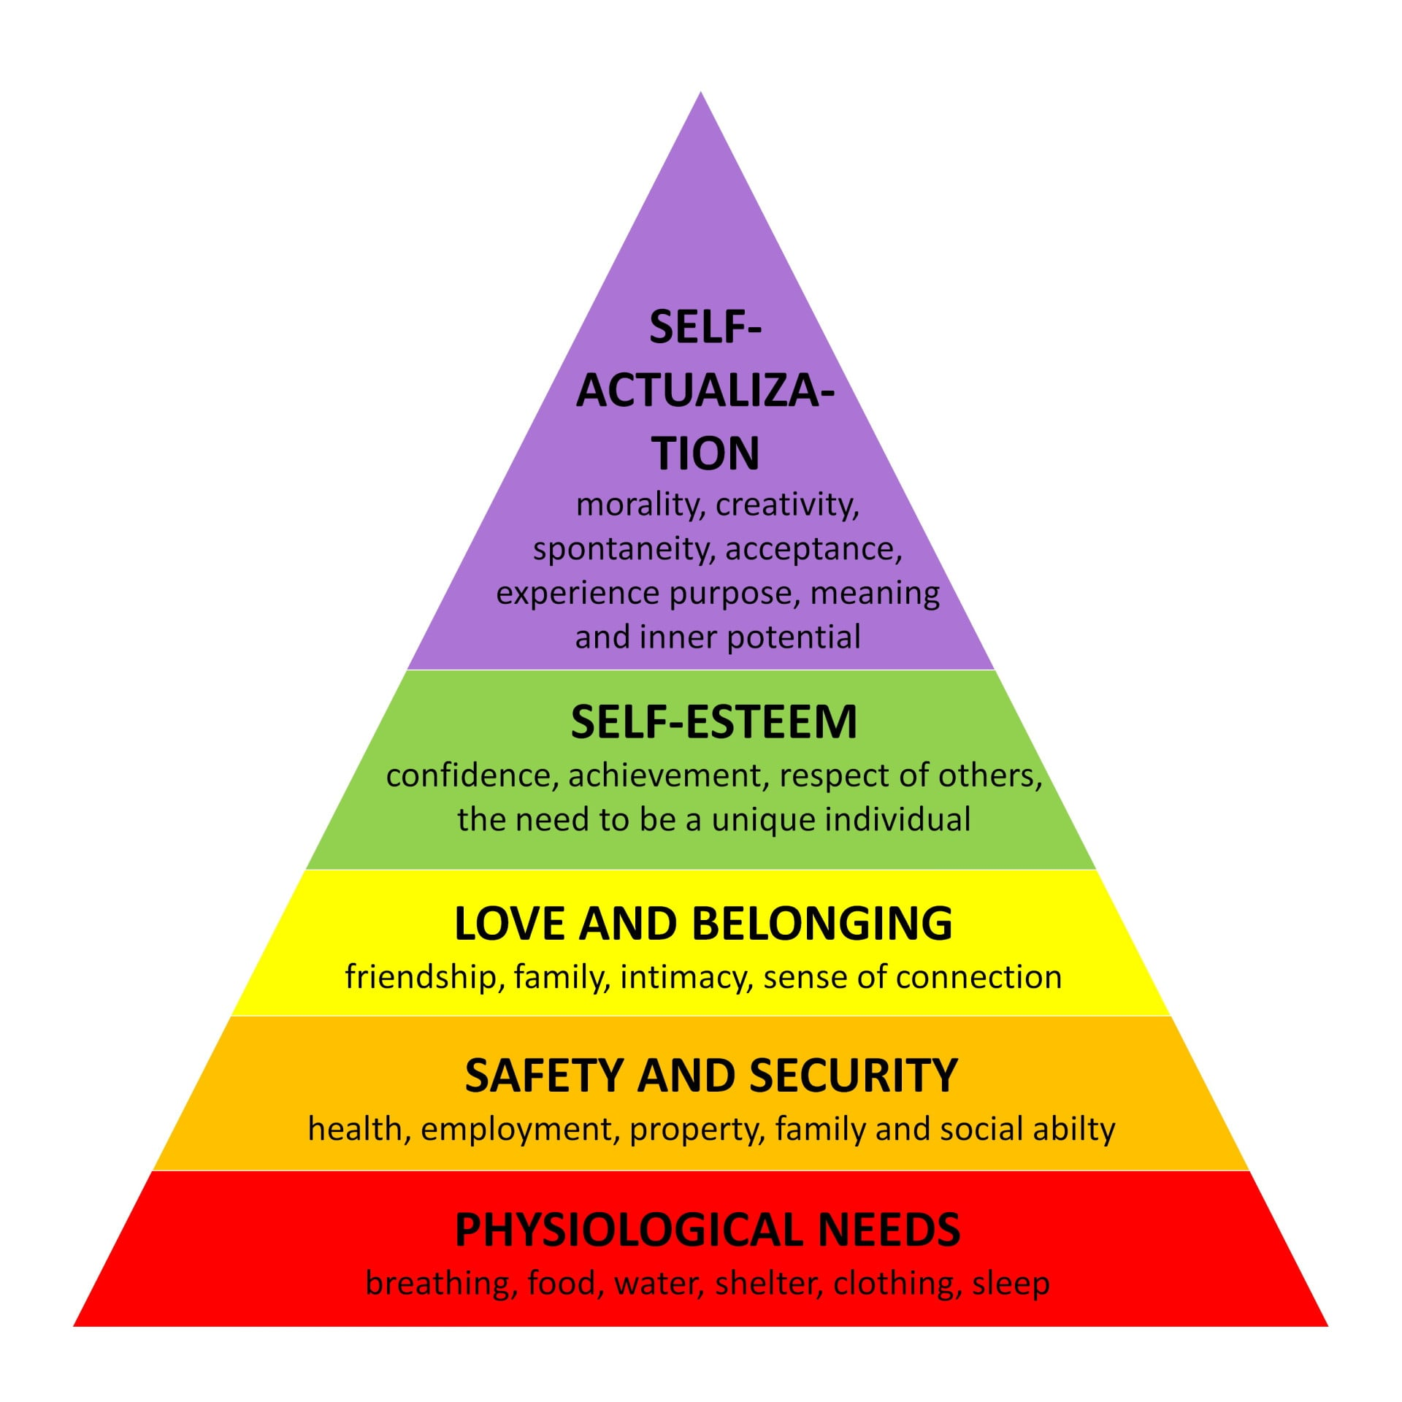
Abraham Maslow’s Hierarchy of Needs (1943) (McLeod, 2026) suggests that QoL improves as individuals meet basic needs.
(McLeod, 2026).
Maslow’s theory regarding healthcare and nursing structures a holistic framework for patient care: physiological - safety - belonging - esteem - self-actualisation (McLeod, 2026). With a structured approach the theory helps to comprehend and address the diverse needs of individuals, overcoming barriers to healthcare (Care Learning, 2024c).
Abraham Maslow’s theory remains influential for its holistic, humanistic view of motivation. However, contemporary psychology sees needs as flexible, overlapping, and shaped by cultural context rather than a fixed hierarchy.
A very important aspect of delivering positive outcomes in healthcare is being able to address barriers, limitations and challenges. The ONS (2021) recognises an ageing population means added strain on NHS resources such as funding. In their page ‘Living Longer: how our population is changing and why it matters’ (2021) highlights how the complexities of the elderly populations needs’ face structural barriers.
For those who live in rural areas accessibility to healthcare services can become difficult because of no services available nearby and/or because it becomes difficult for them to get to a relatively close clinic or hospital (ONS, 2021). This creates a barrier, the chart below shows some of the reasons behind why the elderly miss out on healthcare due to not using public transport.
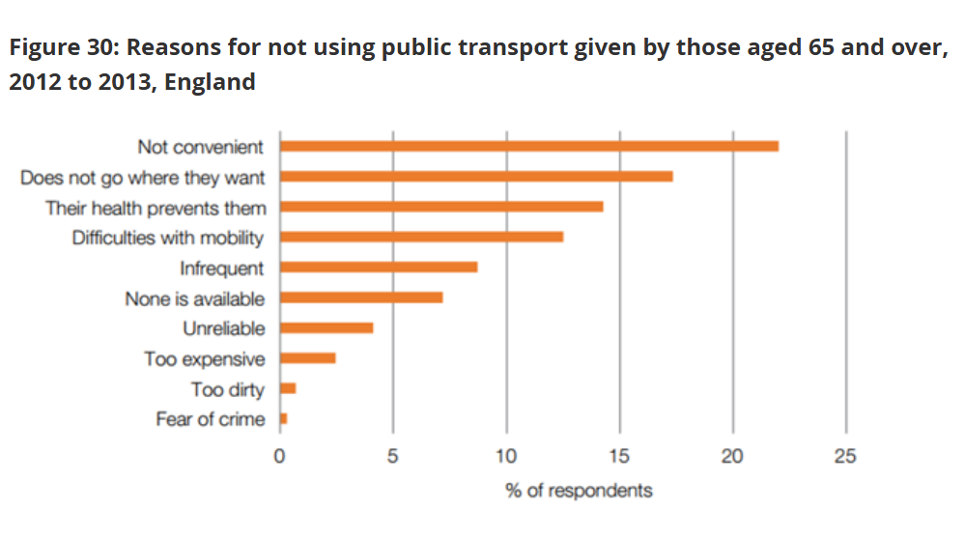
(ONS, 2021)
Having to pay for taxis can be expensive especially for the older person so they miss out on vital appointments. This is also a financial barrier to accessing services. The article points out a need for long-term planning and investment to meet future care needs (ONS, 2021).
The journal ‘Healthcare professionals’ perspective on delivering personalised and holistic care’ by Wong et al (2022) addresses the barriers faced by HCP. The journal found seven domains:
- Social influence
- Motivation and goals
- Environmental context and resources
- Skills
- Beliefs about consequences
- Behaviour regulation
- Nature of behaviour (Wong et al, 2022).
High workload, lack of staffing and limited time are environmental barriers that staff face when trying to implement holistic practice. Team culture significantly affects behaviours as does lack of skills. Holistic care is grounded in effective communication, empathy, shared decision making, and strong relational skills, capabilities that need continuous development, training, and reinforcement (Wong et al, 2022).
Staff doubt whether time spent delivering holistic care improves outcomes and if the organisation approves of such behaviours. Complex behaviours are difficult to sustain consistently without robust support systems in place. To tackle these barriers organisations should reduce time pressure and make holistic care a shared cultural norm, strengthening social support within multidisciplinary teams (Wong et al, 2022).
An umbrella review of systematic reviews (Arakelyan et al, 2023) looked at the effectiveness of HABIs for adults with multiple long-term conditions and frailty. The journal recognises multiple long-term conditions pose notable challenges resulting in poor health outcomes, and states, “Health systems need effective and sustainable interventions to improve health outcomes and mitigate the risks of adverse events for people with multiple long-term conditions and frailty” (Arakelyan et al, 2023). One way to achieve this is by implementing HABIs.
The review highlights that holistic assessment is a core element across many complex care models, even when they are described using different terms such as CGA, integrated care, or discharge planning. CGA is considered inherently holistic as it addresses multiple aspects of a person’s life and involves input from multidisciplinary teams. Although this type of assessment helps identify individual needs it is rarely available because it is resource intensive (Arakelyan et al, 2023).
One similarity in barriers found amongst the articles is that of financial and time constraints. The NHS long-term plan going forward plans on improving health outcomes especially for the elderly person as the UK is experiencing an ageing population. Success lies in overcoming the challenges and barriers which hinder implementation of positive care and treatment. Evidently more research is needed to identify the types of barriers and limitations the health care sector faces.
Chapter 4 started off by giving a definition for ‘thematic analysis’ followed by an in-depth analysis of the three identified themes from the literature which was reviewed. The findings were explored and discussed to see if person centred and holistic care implementation proves to be effective in improving the quality of life for the elderly person and what types of barriers or limitations hinder outcomes.
Chapter 5 will include the conclusion and recommendations of the findings.
Chapter 5 Conclusion and recommendations.
5.1 Conclusion
The aim of this research was to find out whether implementing holistic care into treatment plans enhances the quality of life of the elderly patients. Globally and nationally statistics highlight an ageing population (ONS, 2021). With age the onset of frailty and chronic diseases increase, here in the UK the burden lies with the NHS to be able to manage the ailing demands of an ageing population.
Holistic care provisions are deep rooted in nursing care well before the establishment of the NHS. Florence Nightingale and Hippocrates both recognised how seeing the patient as a ‘whole person’ physically, emotionally and spiritually, helps improve healthcare outcomes. Healthcare models and theories further help HCP to understand complex and diverse individual needs to create personalised care plans.
Although the NHS long-term plans, policies and strategies aim to address the health implications of elderly people, there are many hurdles and barriers to overcome. Social determinants of health along with internal environment conflicts influence service delivery of holistic and person-centred care. The biggest barriers are inadequate funding for example; more money needs to be spent on training programs for HBIs to help HCP gain the skills needed. Other barriers include lack of staff and time management.
Holistic care is a welcoming approach to enhance the QOL of elderly patients, but given the heterogeneity of the studies, the findings to the research question vary across methodological approaches, context and sample characteristics. Further research is needed to help determine if holistic based approaches enhance quality of life.
5.2 Recommendations
5.2.1 Recommendation 1- Invest in staff training programs.
Staff training programs which provide ongoing training in communication, empathy and cultural competence leading to shared decision making which improves quality of care.
Compassionate care challenges faced by clinical nurses creates complications. Religious and cultural values should be understood by HCP. These values may also differ between genders. Complications can arise when a female patient may not want personal care from a male nurse or vice versa. Understanding of these complexities can save time and emotional distress when delivering care.
The growing complexity of medicine has reduced the emphasis on empathy. Professional care organisations view individuals holistically however there are barriers to providing spiritual care. Staff lack the educational knowledge of the importance of spirituality in care and treatment. Spirituality strengthens holistic care, lack of education challenges providing good quality care. When the quality of care is affected the health outcomes suffer.
The government needs to provide the NHS with funding to be able to initiate the training programmes. Health care organisations must include these in their policies ensuring staff have the time, resources, and organisational support needed to apply these skills in practice otherwise, holistic care becomes difficult to sustain.

5.2.2 Recommendation 2- Introduce holistic based assessments in care plans.
To fully understand a patients’ needs, holistic based assessments need to be carried out. They look at the whole person with a holistic view. CGA addresses multiple aspects of an individual’s life and provides input from many disciplinaries across different teams in healthcare.
Holistic assessment tools help evaluate not just medical conditions but also emotional wellbeing, social circumstances, functional ability, and patient preferences. The assessments help establish patient abilities and disabilities, both physical and cognitive. Understanding what a patient can manage on their own, regarding daily activities, helps understand the quality of life they are experiencing.
Frontline healthcare professionals are central to implementing holistic based assessments in day-to-day practice along with others such as social care supporters, physiotherapists and care-coordinators. These assessments help build relationships with patients and their families. Their involvement helps build meaningful personalised care plans ensuring patient satisfaction and avoiding gaps in service delivery. Clear communication and shared care plans help maintain consistency and continuity of care.

5.2.3 Recommendation 3- Addressing staff burnout and staff shortages.
Addressing staff burnout and shortages is essential if person-centred holistic care is going to be delivered consistently otherwise care interventions can be difficult to sustain.
Carl Rogers (1902-1987) in his person-centred theory emphasises empathy, authenticity (genuineness), and unconditional positive regard. While it is often applied to patient care, these same principles can be applied to how organisations support staff. Staff members also need empathy and support; burnout often occurs when staff feel unheard or emotionally exhausted. Encouraging managers and teams to actively listen, show understanding, and validate staff experiences helps reduce stress and avoid burnout. Supportive environments help staff to thrive. In practice, this means creating workplaces where staff feel safe to express concerns, admit difficulties, and seek help without fear of criticism.
Staff threshold is another barrier to staff shortages. When there are insufficient salaries for nurses and other HCP, they will obviously not want to be a part of the organisation. Increased work hours and low wages do not motivate individuals in the workplace. When staff put in significant effort long hours, emotional labour, complex care but receive low financial return, it creates frustration and disengagement. This imbalance can lead to burnout and reduced commitment.
The NHS is often seen in headline news because of doctors and nurses who are on strike due to pay cuts or low wages. To tackle burnout and staff shortages, organisations need to support staff, optimise resources, increase salaries and create realistic working conditions otherwise, even well-designed holistic care interventions will be difficult to sustain.
All three recommendations, with the help of multidisciplinary teams within health care organisations and stakeholders, helping to provide the funding for training programmes and instilling HABIs and addressing lack of staff, can ultimately achieve positive results to provide holistic care in elderly care provisions, helping to increase quality of life of much valued citizens.

CHAPTER 6 – References and Appendices
6.1 – References

Abdi, S., Spann, A., Borilovic, J., De-Witte, L. and Hawley, M, C. (2019) ‘Understanding the Care and Support Needs of Older People: A Scoping Review and Categorisation Using the WHO International Classification of Functioning, Disability and Health Framework (ICF)’, BMC Geriatr. 19, (1, July), pp195. Available at: https://doi.org/10.1186/s12877-019-1189-9 (Accessed: 25th February 2026).

Age UK (2025c). Every Older Person should be Included and Valued, through Campaigning, Local Support, Advice and Friendship: We’re Changing the way we Age. Available at: https://www.ageuk.org.uk/about-us/what-we-do/ (Accessed: 17th December 2025).

Age UK (2025a) Our Strategy. Available at: https://www.ageuk.org.uk/about-us/what-we-do/our-strategy/ (Accessed: 17th December 2025).

Age UK (2025b). Who we Are, ‘We are Local, National and International and together we’re Providing Crucial Support for Older People’. Available at: https://www.ageuk.org.uk/about-us/who-we-are/ (Accessed: 17th December 2025).

Age UK (2025d). What the NHS 10 Year Plan Means for Older People. Available at: https://www.ageuk.org.uk/discover/2025/july/what-the-nhs-10-year-plan-means-for-older-people/ (Accessed: 4th April 2026).

Ahmed, S, K., Mohammed, R, A., Nashwan, A, J., Ibrahim, R, H., Abdalla, A, Q., Ameen, B, M, M. and Khadir, R, M. (2025) ‘Using Thematic Analysis in Qualitative Research’, Journal of Medical Surgery and Public Health. 6. Available at: https://doi.org/10.1016/j.glmedi-2025.100198 (Accessed: 7th February 2026).

Arakelyan, S., Mikula-Noble, N., Ho, L., Lone, N., Anand, A., Lyall, M.J., Mercer, S.W. and Guthrie, B. (2023). Effectiveness of Holistic Assessment-Based Interventions for Adults with Multiple Long-Term Conditions and Frailty: An Umbrella Review of Systematic Reviews. The Lancet Healthy Longevity. 4, (11), pp. e629–e644. Available at: https://doi.org/10.1016/S2666-7568(23)00190-3. (Accessed: 11th December 2025).
Atkinson, L, Z. and Cipriani, A. (2018) ‘How to Carry out a Literature Search for a Systematic Review: A Practical Guide’, B J Psych Advances. 24, (2, March), pp74-82. Available at: https://doi.org/10.1192/bja.2017.3 (Accessed: 5th February 2026).
Aveyard, H. (2014) Doing a Literature Review in Health and Social Care. Third Edition. England: McGraw-Hill Education/Open University Press. (Accessed: 5th February 2026).
Babaei, S. and Taleghani, F. (2019) ‘Compassionate Care Challenges and Barriers in Clinical Nursers: A Qualitative Study’, Iranian Journal of Nursing and Midwifery Research. 24, (3, May-June), pp213-219. Available at: https://doi.org/10.4103/ijnmr.IJNMR_100_18 (Accessed: 3rd April 2026).
Bramer, W, M., De-Jonge, G, B., Rethlefsen, M, L., Mast, F. and Kleljnen, J. (2018). ‘A Systematic Approach to Searching, An Efficient and Complete Method to Develop Literature Searches ‘, Journal of the Medical Library Association. 106, (4, October), pp531-541. Available at: https://jmla.pitt.edu/ojs/jmla/article/view/283 (Accessed: 5th February 2026).

Braun, V. and Clarke, V. (2022) ‘Toward good Practice in Thematic Analysis: Avoiding Common Problems and be(com)ing a Knowing Researcher’, International Journal of Transgender Health. 24, (1), pp1-6. Available at: https://doi.org/10.1080/26895269.2022.2129597 (Accessed: 5th February 2026)
Braun, V., Clarke, V. and Hayfield, N. (2019) ‘A Starting Point for Your Journey, not a Map: Nicki Hayfield in Conversation with Virginia Braun and Victoria Clarke about Thematic Analysis’, Qualitative Research in Psychology. 19, (2, September), pp424-445. Available at: https://doi-uwtsd.idm.oclc-org/10.1080/14780887.2019.1670765 (Accessed: 7th February 2026).
Braun, V. and Clarke, V. (2019) ‘Reflecting on Reflexive Thematic Analysis’, Qualitative Research in Sport and Health. 11, (14, June), pp589-597. Available at: https://doi.org/10.1080/2159676x.2019.1628806 (Accessed: 22nd February 2026).
Brijic, A., Hasanovic, M., Pajevic, I., Aljukic, N., Hamidovic, J. and JakouLjevic, M. (2021) ‘Principles of Hippocrates Medicine from the Prospective of Modern Medicine’, Psychiatr Danub. 33, (4), pp1210-1217. Available at: https://pubmed.ncbi.nlm.nih.gov/35354189 (Accessed: 25th February 2026).

British Association for Holistic Medicine and Healthcare. (2025) What is Holistic Care. Available at: https://bhma.org/about-us/what-is-holistic-healthcare/ (Accessed: 17th November 2025).

Care Learning. (2026a) What is a Holistic Assessment in Health and Social Care? Available at: https://carelearning.org.uk/blog/assessments/what-is-holistic-assessment-in-health-and-social-care/ (Accessed: 28th March 2026).

Care Learning. (2026b) What are Barriers in Health and Social Care? Available at: https://carelearning.org.uk/blog/accessibility/what-are-the-barriers-in-health-and-social-care/ (Accessed: 30th March 2026).

Care Learning. (2024c) Examples of Maslow’s Hierarchy of Needs in Healthcare. Available at: https://carelearning.org.uk/blog/models/examples-of-maslows-hierarchy-of-needs-in-healthcare/ (Accessed: 6th April 2026).

Centre for Ageing Better. (2025) Action Today for all Our Tomorrows. Available at: https://ageing-better.org.uk (Accessed: 7th January 2026).

Clarke, V. and Braun, V. (2016) ‘Thematic Analysis’, The Journal of Positive Psychology. 12, (3, December), pp297-298. Available at: https://doi.org/10.1080/17439760.2016.1262613 (Accessed: 22nd February 2026).

Department of Health and Social Care, GOV.UK (2025) Fit for the Future: 10 Year Health Plan for England- executive summary (accessible version). Available at: https://www.gov.uk/government/publications/10-year-health-plan-for-england-fit-for-the-future/fit-for-the-future-10-year-health-plan-for-england-executive-summary (Accessed: 4th April 2026).

Elston, J., Gradinger, F., Asthana, S., Lilley-Woolnough, C., Wroe, S., Harman, H. and Byng, R. (2019) ‘Does a Social Prescribing ‘Holistic’ Link-Worker for Older People with Complex, Multimorbidity Improve Well-Being and Frailty and Reduce Health and Social Care use and Costs? A 12-Month Before-and-After Evaluation’, Primary Healthcare Research and Development. Available at: https://doi.org/10.1017/S1463423619000598 (Accessed: 15th November 2025).
Empowering the Older Person BMHP6027. (2025) Theories of Ageing and its’ Implication Isolation and Loneliness. Available at: https://moodle.uwtsd.ac.uk/course/section.php?id=172134 (Accessed: 5th December 2025).
Fielding, J, A. (2019). ‘Rethinking CRAAP: Getting Students Thinking Like Fact Checkers in Evaluating Web Sources’, College and Research Libraries News. 80, (11). Available at: https://crln.acrl.org/index.php/cr/news/article/view/24195/32005 (Accessed: 6th February 2026).
Fox, K., Morrow-Howell, N., Herbers, S., Battista, P. and Baum, C, M. (2017) ‘Activity Disengagement: Understanding Challenges and Opportunities for Re-engagement’, Occupational Therapy International. Available at: https://doi.org/10.1155/2017/1983414 (Accessed: 9th December 2025).
Frisch, N, C. and Rabinowitsch, D. (2019) ‘What’s in a Definition? Holistic Nursing, Integrative Healthcare, and Integrative Nursing: Report of an Integrated Literature Review’, Journal of Holistic Nursing. 37, (3, July). Available at: https://doi-org.ezproxy.uwtsd.ac.uk/10.1177/0898010119860685 (Accessed: 28th November 2025).
Gong, L, L. and Tao, F, Y. (2021) ‘The Effect of Biopsychosocial Holistic Care Models on the Cognitive Function and Quality of Life of Elderly Patients with Mild Cognitive Impairments: A Randomised Trial’, Annals of Palliative Medicine. 10, (5, May). Available at: https://apm.amegroups.org/article/view/70839/html (Accessed: 25th March 2026).
GOV.UK Legislation Care Act 2014. Available at: https://www.legislation.gov.uk/ukpga/2014/23/section/1 (Accessed: 27th March 2026).
GOV.UK (2025) Fit for the Future: 10 Year Health Plan for England-Executive Summary. Available at: https://www.gov.uk/government/publications/10-year-health-plan-for-england-fit-for-the-future/fit-for-the-future-10-year-health-plan-for-england-executive-summary (Accessed: 18th November 2025).
GOV.UK (2022) Office for Health Improvement and Disparities, Healthy Ageing: applying All Our Health. Available at: https://www.gov.uk/government/publications/healthy-ageing/healthy-ageing-applying-all-our-health (Accessed: 7th January 2026).
Greenbrook, S. (2019) ‘Healthier for Longer: How Healthcare Professionals Can Support Older People’, British Geriatrics Society. Available at: https://www.bgs.org.uk/resources/healthier-for-longer-how-healthcare-professionals-can-support-older-people (Accessed: 7th January 2026).
House of Lords Select Committee on the Long-Term Sustainability of the NHS. (2017) The Long-Term Sustainability of the NHS and Adult Social Care. Available at: https://www.abhi.org.uk/media/1501/hol-long-term-sustainability-of-the-nhs-report.pdf (Accessed: 28th February 2026).
Irtelli, F. and Durbano, F. (2019) ‘Quality of Life and Biopsychosocial Paradigm: A Narrative Review of the Concept and Specific Insights’, in Quality-of-Life Biopsychosocial Perspectives (Online edn). Intech open. Available at: https://www.intechopen.com/chapters/71633 (Accessed: 26th March 2026).
Jackson, N., Turner, M. and Paterson, C. (2023) ‘What are the Holistic Care Impacts Among Individuals Living Through the Covid-19 Pandemic in Residential or Community Care Settings: An Integrative Systematic Review’, Journal of Older People Nursing. 18, (5, September). Available at: https://doi.org/10.1111/opn.12557 (Accessed: 25th February 2026).
Jasemi, M., Valizadeh, L., Zamanzadeh, V. and Keogh, B. (2017) ‘A Concept Analysis of Holistic Care by Hybrid Model’, Indian Journal of Palliative Care. 23, (1, January-March), pp71-80. Available at: https://doi.org/10.4103/0973-1075.197960 (Accessed: 4th March 2026).
Jiwattanasuk, N., Pannavoravat, P. and Sirikanchana, P. (2022) ‘The Holistic Well-Being Concepts in Relation to Quality of Life’, ABAC ODI Journal Vision, Action, Outcome. 10, (1), pp20-41. Available at: https://doi.nrct.go.th/admin/doc/doc_628815.pdf (Accessed: 8th March 2026).
Joseph, S, A. (2025) The Humanistic Psychology of Carl Rogers: Understanding the Person-Centred Approach. Oxford University Press. Available at: https://doi.org/10.1093/9780197790632.001.0001 (Accessed: 8th March 2026).
Karimi, M. and Brazier, J. (2016) ‘Health, Health-Related Quality of Life, and Quality of Life: What is the Difference? PharmaCo Economics. 34, pp645-649. Available at: https://doi.org/10.1007/s40273-016-0389-9. (Accessed: 14th March 2026).
Kim, R. and Haybron, D, M. (2021) ‘Well-Being and Health’, Journal of Medicine and Philosophy. 46, (6), pp645-655. Available at: https://doi.org/10.1093/jmp/jhab029. (Accessed: 8th March 2026).
Kostakopoulos, N., Bellos, T, C., Katsimperis, S. and Tzelves, L. (2024) ‘Hippocrates of Kos (460-377BC): The Founder and Pioneer of Clinical Medicine’, Cureus. 1, (10). Available at: https://doi.org.10.7759/cureus.70602 (Accessed: 2nd December 2025).
Legislation. Gov.UK (2012) Health and Social Care Act 2012. Available at: https://www.legislation.gov.uk/ukpga/2012/7/section/26 (Accessed: 4th April 2026).
Main, P. (2022) ‘Carl Rogers’ Theory’, Structural Learning. Available at: https://www.structural-learning.com/post/cafrl-rogers-theory (Accessed: 5th December 2025).
Maslow, A, H. (1943) ‘A Theory of Human Motivation’, Psychology Review. 50, (4), pp370-396. Available at: https://doi.org/10.1037/h0054346 (Accessed: 5th April 2026).
McGilton, K.S., Vellani, S., Yeung, L., Chishtie, J., Commisso, E., Ploeg, J., Andrew, M.K., Ayala, A.P., Gray, M., Morgan, D., Chow, A.F., Parrott, E., Stephens, D., Hale, L., Keatings, M., Walker, J., Wodchis, W.P., Dubé, V., McElhaney, J. and Puts, M. (2018). ‘Identifying and Understanding the Health and Social Care Needs of Older Adults with Multiple Chronic Conditions and their Caregivers: A scoping review’, BMC Geriatrics. 18, (231, October). Available at: https://doi.org/10.1186/s12877-018-0925-x (Accessed: 19th November 2025).
McGrew, S., Breakstone, J., Ortega, T., Smith, M. and Wineburg, S. (2018). ‘Can Students Evaluate Online Sources? Learning from Assessments of Civic Online Reasoning’, Theory and Research in social Education. 46, (2, January), pp165-193. Available at: https://doi-org.uwtsd.idm.oclc.org/10.1080/00933104.2017.1416320 (Accessed: 6th February 2026).

McLeod, S. (2025) ‘Carl Rogers Humanistic Theory and Contribution to Psychology’, Simply Psychology. Available at: https://www.simplypsychology.org/carl-rogers.html (Accessed: 27th November 2025).
McLeod, S. (2026) ‘Maslow’s Hierarchy of Needs’, Simply Psychology. Available at: https://www.simplypsychology.org/maslow.html (Accessed: 5th April 2026).
Momeni, G., Hashemi, M, S. and Hemati, Z. (2022) ‘Barriers to Providing Spiritual Care from a Nurses’ Perspective: A Content Analysis Study’, Iranian Journal of Nursing and Midwifery Research. 18, (27, November), pp575-580. Available at: https://doi.org/10.4103/ijnmr.ijnmr_422_21 (Accessed: 2nd April 2026).
National Institute for Health and Care Excellence. (2015) Dementia, Disability and Frailty in Later Life-Mid-Life. Approaches to Delay or Prevent Onset. Available at: https://www.nice.org.uk/guidance/ng16/resources/dementia-disability-and-frailty-in-later-life-midlife-approaches-to-delay-or-prevent-onset-pdf-1837274790085 (Accessed: 7th January 2026).
NHS Confederation. (2025) 10 Year Health Plan What You Need to Know. Available at: https://www.nhsconfed.org/publications/ten-year-health-plan-what-you-need-to-know (Accessed: 8th March 2026).

NHS England (2025). Improving Care for the Older People. Available at: https://www.england.nhs.uk/ourwork/clinical-policy/older-people/improving-care-for-older-people (Accessed: 17th November 2025).

NHS England. (2025) Provision of Person-Centred Holistic Care Delivered by Neighbourhood Multidisciplinary Teams (High Intensity Use Focused). Available at: https://www.england.nhs.uk/long-read/provision-of-person-centred-holistic-care-delivered-by-neighbourhood-multidisciplinary-teams-high-intensity-use-focused/ (Accessed: 18th December 2025).

Ng, S, I., Lim, X, J. and Hsu, H, C. (2021) ‘The Importance of Age- Friendly City on Older People’s Continuity and Life Satisfaction’, International Journal of Environmental Research and Public Health. 18, (14, July), pp7252. Available at: https://doi.org/10.3390/ijerph18147252 (Accessed: 3rd March 2026).

Nickerson, C. (2025) ‘Disengagement Theory of Aging’, Simply Psychology. Available at: https://www.simplypsychology.org/disengagement-theory.html (Accessed: 27th November 2025).

Nursing and Midwifery Council. (2024) Seeing the Whole Person Supports Better Care. Available at: https://www.nmc.org.uk/globalassets/sitedocuments/standards/holistic/holistic-care-infographic_aw.pdf (Accessed: 19th December 2025).

Nursing and Midwifery Council. (2024) NMC Publishes New Holistic Care Resources. Available at: https://www.nmc.org.uk/news/news-and-updates/nmc-publishes-new-holistic-care-resources/ (Accessed: 19th December 2025).

Nursing and Midwifery Council. (2025) Seeing the Whole Person Supports Better Care. Available at: https://www.nmc.org.uk/standards/guidance/holistic-care/ (Accessed: 28th November 2025).

Office for National Statistics. (2021) Living Longer: How our Population is Changing and Why it Matters. Available at: https://www.ons.gov.uk/peoplepopulationandcommunity/birthsdeathsandmarriages/ageing/articles/livinglongerhowourpopulationischangingandwhyitmatters/2018-08-13#what-are-the-implications-of-living-longer-for-social-care-services- (Accessed: 14th November 2025).
Office for National Statistics. (2025) Population Estimates for the UK, England, Wales, Scotland and Northern Ireland: mid-2024. Available at: https://www.ons.gov.uk/peoplepopulationandcommunity/populationandmigration/populationestimates/bulletins/annualmidyearpopulationestimates/mid2024 (Accessed: 19th November 2025).
Office for National Statistics. (2025) UK Measures of National Well-Being Dashboard. Available at: https://www.ons.gov.uk/peoplepopulationandcommunity/wellbeing/articles/ukmeasuresofnationalwellbeing/dashboard (Accessed: 15th March 2026).
O’Rourke, G., Lloyd, L., Bezzina, A., Cameron, A., Jessiman, T. and Smith, R. (2020) ‘Supporting Older Co-Resident Carers of Older People- The Impact of Care Act Implementation in Four Local Authorities in England’, Social Policy and Society. 20, (3, September), pp. 371-384. Available at: https://www-cambridge-org.uwtsd.idm.oclc.org/core/journals/social-policy-and-society/article/supporting-older-coresident-carers-of-older-people-the-impact-of-care-act-implementation-in-four-local-authorities-in-england/D133EA07EB9B70DCB1B1B1C6D8A44020 (Accessed: 27th March 2026).
Palmer, B. (2025) ‘Individual and Social Growth: A Commentary on “Carl Rogers” Struggle to be Real’, Theory and Psychology. 35, (4, July). Available at: https://doi-org.ezproxy.uwtsd.ac.uk/10.1177/095935432513524440 (Accessed: 7th December 2025).
Patino, C, M. and Ferreira, J, C. (2018) ‘Inclusion and Exclusion Criteria in Research Studies: Definitions and Why they Matter’, Journal Brasileiro de Pneumologia. Available at: https://doi.org/10.1590/S1806-3756201800000008 (Accessed: 6th February 2026).

Physiopedia. (2026) Biopsychosocial Model. Available at: https://www.physio-pedia.com/Biopsychosocial_Model (Accessed: 26th March 2026).

Powell, M. (2018) ‘Aneurin Bevan’s Long Shadow Over 70 Years of the British National Health Service’, Health Services Management Research. 31, (2, March). Available at: https://doi-org.ezproxy.uwtsd.ac.uk/10.1177/0951484818767607 (Accessed: 27th November 2025).
Practical Psychology. (2023) Havighurst’s Developmental Task Theory. Available at: https://practicalpie.com/havighursts-developmental-task-theory/ (Accessed: 27th November 2025).
Regmi, K. and Mudyarabikwa, O. (2020) ‘A Systematic Review of the Factors- Barriers- and Enablers- Affecting the Implementation of Clinical Commissioning Policy to Reduce Health Inequalities in the National Health Service (NHS), UK’, Public Health. 186, pp271-282. Available at: https://doi.org/10.1016/j.puhe.2020.07.027 (Accessed: 3rd April 2026).
Strabner, C., Frick, E., Stotz-Ingenlath, G., Buhlinger-Göpfarth, N., Szecsenyi, J., Krisam, J., Schalhorn, F., Valentini, J., Stolz, R. and Joos, S. (2019). ‘Holistic Care Program for Elderly Patients to Integrate Spiritual Needs, Social Activity, and Self-Care into Disease Management in Care (HoPES3): Study Protocol for a Cluster-Randomized Trial’, Trials. 20, (364, June). Available at: https://doi.org/10.1186/s13063-019-3435-z. (Accessed: 10th November 2025).
Redemptus. P., Weraman, P. and Roga, A, U. (2023) ‘Holistic Therapy to Improve Quality of Life in Chronic Disease Patients’, The Indonesian Journal of Health Promotion and Health Education. 11, (1, August), pp108-112. Available at: https://doi.org/10.20473/jpk.v11.IISP.2023.108_112 (Accessed: 15th March 2026).
Riegal, F., Crossetti, M, da G, O., Martini, J, G. and Nes, A, A, G. (2021) ‘Florence Nightingale’s Theory and Her Contributions to Holistic Critical Thinking in Nursing’, Revista Brasileira De Enfermagem. 74, (2), pp1-5. Available at: https://doi.org/10.1590/0034-7167-2020-0139 (Accessed: 8th March 2026).
Stafford, M., Steventon, A., Thorlby, R., Fisher, R., Turton, C. and Deeny, S. (2018) ‘Briefing: Understanding the Health Care Needs of People with Multiple Health Conditions’, The Health Foundation. Available at: https://www.health.org.uk/sites/default/files/upload/publications/2018/Understanding%20the%20health%20care%20needs%20of%20people%20with%20multiple%20health%20conditions.pdf (Accessed: 17th November 2025).
Stigall, W. (2022) ‘The Hippocratic Oath’, The Linacre Quarterly. 2, (3), pp275-286. Available at: https://doi.org/10.1177/00243639211069431 (Accessed: 4th December 2025).
Tasmir, M, S. (2025) ‘Mastering Skimming Articles for Effective Research’, Nova Scholar. Available at: https://www.novascholar.org/blog-posts/mastering-article-skimming-for-effective-research-a-step-by-step-guide (Accessed: 6th February 2026).

The Open University. (2025) Identifying a Source. Available at: https://university.open.ac.uk/library/referencing-and-plagarism/identifying-a-source (Accessed: 14th November 2025).

The Nuffield Trust. (2019) 1968-1977: Rethinking the National Health Service. Available at: https://www.nuffieldtrust.org.uk/chapter/1968-1977-rethinking-the-national-health-service-1 (Accessed: 30th March 2025).

Thornton, L. (2019) ‘A Brief History and Overview of Holistic Nursing’, Integrative Medicine: A Clinician’s Journal. 18, (4, August), pp32-33. Available at: https://pmc.ncbi.nlm.nih.gov/articles/PMC7219452/ (Accessed: 28th November 2025).
UK Parliament. (2022) Long Term Funding of Adult Social Care. Available at: https://publications.parliament.uk/pa/cm5803/cmselect/cmcomloc/19/report.html#:~text=In%20September%202021%2c%20it%20announced%20a%20new%20”Health.data%2c%20the%20social%20care%20workforce%2c%20and%20unpaid%20carers (Accessed: 1st March 2026).
UK Statistics Authority. (2022) Ethical Considerations Associated with Qualitative Research Methods. Available at: https://uksa.statisticsauthority.gov.uk/publication/ethical-considerations-associated-with-qualitative-research-methods/pages/2/ (Accessed: 7th February 2026).
University of Sheffield. (2024) How to Write a Research Proposal: Advice and Guidance on Writing a Proposal for a Student Research Project. Available at: https://sheffield.ac.uk/study-skills/research/methods/proposal (Accessed: 18th November 2025).
Ventegodt, S., Kandel, I., Ervin, D, A. and Merrick, J. (2016) ‘Concepts of Holistic Care’, Healthcare for People with Intellectual and Developmental Disabilities Across the Lifespan. 1, (1), pp1935-1941. Available at: https://doi.org/10.1007/978-3-319-18096-0._148. (Accessed: 15th March 2026).
Wickham, R, J. (2019) ‘Secondary Analysis Research’, Journal of Advanced Practitioner in Oncology. 10, (4, May/June), pp395-400. Available at: https://doi.org/10.6004/jadpro.2019.10.4.7 (Accessed: 5th February 2026).

World Health Organisation. (2025) WHOQOL: Measuring Quality of Life. Available at: https://www.who.int/tools/whoqol (Accessed: 14th March 2026).
Wong, E., Mavondo, F., Horvat, L., McKinlay, L. and Fisher, J. (2022) ‘Healthcare Professionals’ Perspective on Delivering Personalised and Holistic Care: Using the Theoretical Domains Framework’, BMC Health Services Research. 22, (281, March). Available at: https://link.springer.com/article/10.1186/s12913-022-07630-1 (Accessed: 18th November 2025).

6.2 – Appendices

Appendix A: These are all traditional or natural healing treatments that have been used in nursing and home care for centuries.
Compresses – Cloths soaked in hot or cold liquid and placed on the body to reduce pain, swelling, or inflammation.
Fomentations – Similar to compresses, but typically warm or hot herbal cloth applications used to soothe aches, cramps, or congestion.
Poultices – Soft, moist mixtures of herbs, plants, or other substances spread on cloth and applied to the skin to draw out infection, reduce inflammation, or promote healing.
Plasters – Thick, sticky preparations applied to the skin that dry and stay in place to provide warmth, relieve pain, or support healing.
Oils – Plant-based or medicinal oils applied to the skin for massage, soothing, moisturizing, or therapeutic effects.
Liniments – Liquid or semi-liquid preparations rubbed on the skin to relieve muscle soreness, stiffness, or pain (often containing warming ingredients like menthol).
Salves – Thick, herbal or medicinal mixtures applied to the skin to soothe irritation, heal wounds, or protect damaged skin.
Ointments – Similar to salves but typically smoother and more medicated; used to treat skin conditions, infections, or irritation.

Appendix B: Florence Nightingales notes for nursing “It is often thought that medicine is the curative process. It is no such thing … Surgery removes the bullet out of the limb, which is an obstruction to cure, but nature heals the wound. So it is with medicine; medicine so far as we know, assists nature to remove the obstruction, but does nothing more. And what nursing has to do in either case, is to put the patient in the best condition for nature to act upon him.”

Appendix C: Hippocratic Oath- This oath is what physicians would swear upon to uphold a moral code of conduct. The priority lies with the patients’ well-being, including confidentiality and an ethical application of the learnt skills. Serving as a formal commitment to the principles of medicine.

“I swear by Apollo Physician and Asclepius and Hygieia and Panaceia and all the gods and goddesses, making them my witnesses, that I will fulfil according to my ability and judgment this oath and this covenant” (In Greek culture it was customary to swear by a god or gods when promising or certifying something of great importance).

“To hold the one who has taught me this art as equal to my parents and to live my life in partnership with him, and if he is in need of money to give him a share of mine, and to regard his offspring as equal to my brothers in male lineage and to teach them this art—if they desire to learn it—without fee and covenant; to give a share of precepts and oral instruction and all the other learning to my sons and to the sons of him who has instructed me and to pupils who have signed the covenant and have taken an oath according to the medical law, but no one else”.

“I will apply dietetic measures for the benefit of the sick according to my ability and judgment; I will keep them from harm and injustice”.

“I will neither give a deadly drug to anybody who asked for it, nor will I make a suggestion to this effect. Similarly, I will not give to a woman an abortive remedy. In purity and holiness, I will guard my life and my art”.

“I will not use the knife, not even on sufferers from stone, but will withdraw in favor of such men as are engaged in this work. Into whatever houses I may enter, I will come for the benefit of the sick, remaining clear of all voluntary injustice and of other mischief and of sexual deeds upon bodies of females and males, be they free or slaves”.

“Things I may see or hear in the course of the treatment or even outside of treatment regarding the life of human beings, things which one should never divulge outside, I will keep to myself, holding such things shameful to be spoken”.

“If I fulfil this oath and do not violate it, may it be granted to me to enjoy life and art, being honoured with fame among all men for all time to come; if I transgress it and swear falsely, may the opposite of all this be my lot” (Stigall, 2022).

Appendix D: Aneurin Bevan- Later in 2017 during a Conservative party conference (Powell, 2019) health secretary Jeremy Hunt said, “Bevan deserves credit for founding the NHS in 1948” although, indicating to Conservative Health Minister, “it was Sir Henry Willink, whose, 1944 White Paper announced the setting up of the NHS”.

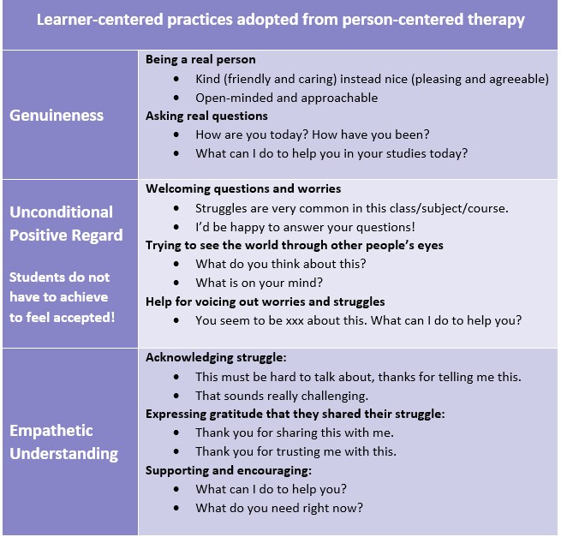
Appendix E: Carl Rogers-

Appendix F: Limitations to the theory
Others argue that the theory is culturally biased, because it focuses on Western individualistic values, so it may not apply to other cultures. Also, it may be less effective for severe mental disorders such as schizophrenia where more structured interventions are needed (McLeod, 2025).

Appendix G: Interlinked domains related to self-efficacy a) Spiritual needs b) Self-care and c) Social activity.

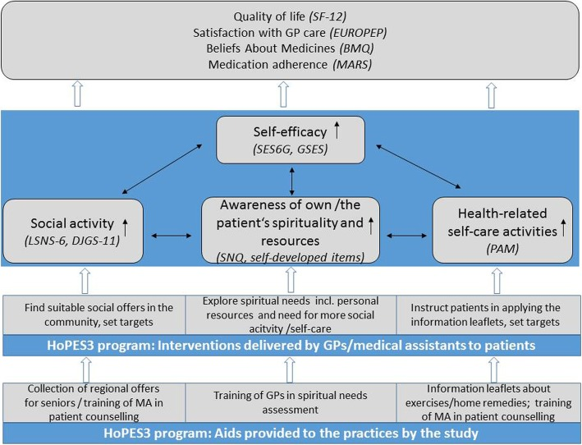
“Logic model of the HoPES3 program. BMQ Beliefs About Medicines Questionnaire, DJGS-11 11-Item De-Jong-Gierveld Loneliness Scale, EUROPEP European Project on Patient Evaluation of General Practice, GP general practitioner, GSES General Self-Efficacy Scale, LSNS-6 6-Item Lubben Social Network Scale, MA medical Assistant, MARS Medication Adherence Report Scale, PAM Patient Activation Measure, SES6G Self-Efficacy for Managing Chronic Disease 6-Item Scale, SF-12 Short-Form Health Survey, SNQ Spiritual Needs Questionnaire” (Stabner et al, 2019).

Appendix H: Source Tracking Table

✅ Saved? | Author & Year | Title | Summary | CRAAP Notes | File Name / Link to Source
Yes | British Association for Holistic Medicine and Healthcare 2025. | What is Holistic Care | Blog post from the Charity explaining what Holistic Care is. | Current,  Relevant and backed by health professional. | Bhma.org  2025.
Yes | WHO 2025. | Measuring Quality of Life. | Explanation of the Tools used for measuring quality of life. | Relevant,  Authoritative,  Purposeful. | www.who.int  2025.
No | Gullace, G.  2019 | Hippocrates  Dream: what has Hippocratic revolution left in modern medicine? | The influence of Hippocrates towards modern medicine. | Not peer reviewed. | Journal of Cardiology and Cardiovascular Therapy.
Yes | Thornton, L. 2019 | A Brief History and overview of Holistic Nursing. | History of holistic nursing past and present. | Relevant,  Written by Board of Chair Academy of Integrative Health and Medicine. | Integrative Medicine: A Clinician’s Journal.
Yes | Arakelyan, S. 2023 | Effectiveness of Holistic Assessment Based Interventions. | An Umbrella review of Systematic reviews. | Current, relevant, and purposeful to the dissertation question. | The Lancelet Health Longevity.
Yes | Age UK.  2025 | What we do, Age UK | News updates from charity explaining services and strategies available to the older person in regard to health and well-being. | Relevant  Current  Purposeful. | www.ageuk.org.uk
Yes | Office for National Statistics, 2021 | Living Longer: how our population is changing and why it matters. | Statistical report on an aging population and how the health and well-being of the older person will be affected by challenges. | Relevant  Current  Accurate | www.ons.gov.uk
Yes | McGilton et al, 2018 | Identifying and understanding the health and social care needs of older adults with multiple chronic conditions and their caregivers: a scoping review | A scoping review which investigates the health and social care needs of older people with health conditions. | Relevant: focuses on older people.  Accurate: peer reviewed.  Current.  Authoritative and Purposeful. | BMC Geriatrics  Journal.
Yes | NHS England, 2025 | Improving Care for Older People. | Speaks about how NHS England is working towards implementing health policies and strategies to overcome challenges that arise from old age. | Relevant.  Purposeful.  UK health policy compliant. | www.england.nhs.uk
Yes | Wong et al, 2022 | Healthcare professionals’ perspective on delivering personalised and holistic care: using the Theoretical Domains Framework | Public health services study of what health care professional s thought about holistic care implemenation. | Current  Relevant  Accurate  Purposeful  Authoritative. | BMC Health Services  Research.

Appendix I: Skimming Articles Effectively
“1. Start with the Title and Abstract
The title and abstract give the article’s main idea, scope, and relevance. Ask yourself: Does this source align with my research question? If not, move on quickly.
2. Read the Introduction and Conclusion
These two sections reveal the purpose of the study, the main arguments, and the final outcomes. They also highlight the types of skimming you might use later whether you need an overview or a deeper scan.
3. Focus on Headings and Subheadings
These guide you through the structure of the article. Skim them to understand how the author organizes information and where key points might appear.
4. Examine Visuals and Data
Charts, graphs, and tables often summarize results faster than reading paragraphs. A quick glance helps you identify trends or major findings.
5. Read the First and Last Sentences of Paragraphs
These usually contain topic sentences and summaries. They reveal how each section supports the main argument.
6. Highlight Keywords and Concepts
As you skim, mark important phrases, definitions, or theories that connect to your topic. This makes later referencing easier.
7. Review References or Citations
The bibliography shows which scholars or studies influenced the work. It helps you discover related articles for deeper research.
By following these steps, you can decide which sources deserve a full read and which can be set aside, saving time without losing quality” (Tasmir, 2025).Appendix J: NHS Long-Term Plan
“The plan identifies four structural challenges facing the future healthcare:
  - an ageing population living with multiple health conditions demands greater integration of services
  - changes in illness require greater continuity for those with long-term conditions
  - higher public expectations require rapid digitisation of services and enabling the public with more choice
  - increases in cost require a different solution to health spending taking up an increasing share of national wealth, through a value-based approach that delivers better value to taxpayers” (NHS Confederation, 2025).

Appendix J: Results Summary Table

Appendix K: Types of interventions and steps conducted during the randomised trial.
“The steps for the observation group intervention were conducted as follows:
- Disease cognition: in the routine nursing process, nursing staff determined a reasonable way to explain the causes, progress, and treatment effects of MCI according to the education level of each patient, so as to enhance disease awareness, persuade the patient to face the disease squarely, and strengthen treatment compliance.
- Psychological care: patients often show symptoms such as hyperesthesia, hypoesthesia, memory impairment, memory errors, associative process disorder, thinking logic disorder, delusion, and so on, leading to many obstacles in communication, the relationship between the patient and family members and the emotional comfort of family members also becomes affected. Professional psychological support was provided to support the collaboration of patients and their family members in understanding and accommodating such symptoms and soothe the emotions of patients and their families.
- Cognitive training, memory strengthening training: encouraging patients to remember a thing or number, memory and cognition could be strengthened through repetition. Attention training through the deliberate deletion of a word or a number in speech, strengthening through repetition. Orientation training, performed in combination with family photos to allow patients to recognize, report the name and family association. Patients were also engaged in carrying out calligraphy, painting, and language exchange training. An individualized overall care plan was developed according to the different education level of patients (including language expression training, calculation and attention training, orientation training, memory strengthening training), which was then implemented for 30min/time, once a day. The time of training was set to avoid the peak of treatment and nursing, usually 4:00-5:00 pm every afternoon was appropriate.
Language expression training: for those with an education level of junior high school and above, patients were instructed to engage in daily newspaper reading training, and were also encouraged to retell and discuss the content of the newspaper; for those with an elementary school education level and below, nurses implemented semi-structured interviews to find topics of interest to patients as much as possible, such as “What did you eat this morning”, “What exercise do you like to do”, and so on, to mobilize their enthusiasm for communication and strengthen communication skills.
Calculation ability and attention training: for junior high school students and above, nurses issued a piece of A4 paper full of Chinese characters, asked patients to find a Chinese character or a Chinese character containing a radical, and calculate the number of Chinese characters; for primary school students and below, nurses issued a piece of A4 paper full of graphics, asked patients to find a graphic, and calculate the number of the graphic. The patient’s computing ability was also fostered through playing cards, games, and other recreational activities.
Orientation training: elderly AD patients are prone to the dusk phenomenon, that is, as the light fades to darkness, the reaction ability of patients decreases accordingly. Therefore, when visiting the ward every evening, nurses asked the patient questions, such as “what is your bed number”, “what is today’s date” and the names of surrounding items, so as to strengthen their concept of night, day, where, and here.
- Life guidance: the patients were instructed to master daily activities such as washing, dressing, eating, urinating, and defecation to ensure that they could complete them independently; instructing patients to eat scientifically, with high-calorie, high-protein, and vitamin-rich diets; instructing patients to maintain a healthy balance of work and rest. Patients were instructed to perform appropriate exercises, such as jogging, sports, Tai Chi, and so on. These activities were instructed to be undertaken in the company of medical staff or family members at least twice a week.
- Family and social care: nursing staff worked to strengthen communication with the patients’ family members, so that they could accurately and comprehensively understand the patient’s condition and physical and mental state. The nursing staff entreated these family members to encourage, support, and accompany the patient, and inform and encourage friends and relatives to visit them, and help them feel surrounded by family and social support.
At the first month and the third month after the intervention, the indexes of cognitive function and quality of life of the 2 groups were recorded” (Gong and Tao, 2021).

Appendix L: Cognitive Function Tools and Activities of Daily Living Scale.
MMSE (Mini-Mental State Examination):
This test checks different mental abilities like memory, attention, language, and orientation. It has 30 questions, and each correct answer scores 1 point.
Scores show the level of cognitive function:
  - 25–30 = normal
  - 21–24 = mild impairment (MCI)
  - 14–20 = moderate impairment
  - 13 or below = severe impairment

MoCA (Montreal Cognitive Assessment):
This test looks at a wider range of thinking skills, including memory, attention, language, and problem-solving. It is also scored out of 30, with higher scores meaning better cognitive function. A score of 26 or above is considered normal. If someone has 12 or fewer years of education, they get an extra point to make the test fair. This test is also shown to be reliable and accurate.
The ADL is a common tool used to assess an older person’s overall health and independence. It looks at two main areas:
Basic self-care (PSMS): things like dressing, bathing, eating, getting in and out of bed, using the toilet, and controlling bowel movements.
More complex daily tasks (IADL): such as cooking, cleaning, shopping, managing money, taking medication, and using the phone.
Each activity is scored based on how difficult it is:
- 1 = no difficulty
- 2 = some difficulty but can still do it
- 3 = needs help
- 4 = unable to do it
Total scores range from 12 to 48:
- 12 = normal (fully independent)
- Higher scores = more difficulty and greater dependence

The ADL scale measures how independent someone is in daily life, with higher scores showing more serious difficulty in managing everyday activities (Gong and Tao, 2021).
Appendix M: 1968-1977 Rethinking the National Health Service
Advances in medical practice introduced complex diagnostics, new drugs, and specialised surgeries, leading to increased sub-specialisation within fields such as orthopaedics. Patient care often required collaboration across multiple specialties, particularly in areas like resuscitation, dialysis, and transplantation. Technological developments, including computerised laboratory systems and fibreoptic endoscopy, improved diagnosis and treatment. “Spare part” surgery and organ transplants became more common, while intensive care units enabled continuous monitoring of critically ill patients.

“The most important advance of the decade was the introduction of X-ray computed tomography (CT). Since the first x-rays in 1895, all radiographs had shared the same constraint – a two-dimensional image. The limit on progress was thought to lie in the systems producing radiation. Now orthodoxy was challenged. Interest shifted from the source of the radiation to the detection of the image. Advances in detection, combined with a finely collimated beam, allowed a 1,000-fold increase in the power of systems. Godfrey Hounsfield, an engineer at EMI (Electrical Musical Industries), announced the development of X-ray computed tomography at the British Institute of Radiology Congress in 1972” (The Nuffield Trust, 2019).

