Content
Introduction to Maya 2
6/10/2023 2
13/10/23 3
26/10/23 4
• 1 4
• 2 6
• 3 Ikea Chair 9
27/10/23 11
• 1 Lego Figure 11
• 2 Monitor 12
• 3 Horse 13
28/10/23 Dumpster 14
29/10/23 House 15
4/11/23 Lamp post 16
10/11/23 Soda Can 21
Teacup and Teapot 23
Conclusion 25
Bibliography 25

Oliver Altissimo (2305263)
Learning in the Digital Era 2023/24

Introduction to Maya
6/10/2023
Today in class we open for the first time the 3D modeling program “Maya 2024”.
To start our journey with “Maya 2024” Adam suggested us to open the tutorial within the program.
With the tutorial we learned how to move and the camera in three diverse ways:
Tumble: (Alt + Left Click) we can rotate the camera.
Track: (Alt + Middel-Click Drag) we can move the camera in the X, Y, Z axis.
Dolly: (Alt + Right Click) we can zoom in or out for the object.
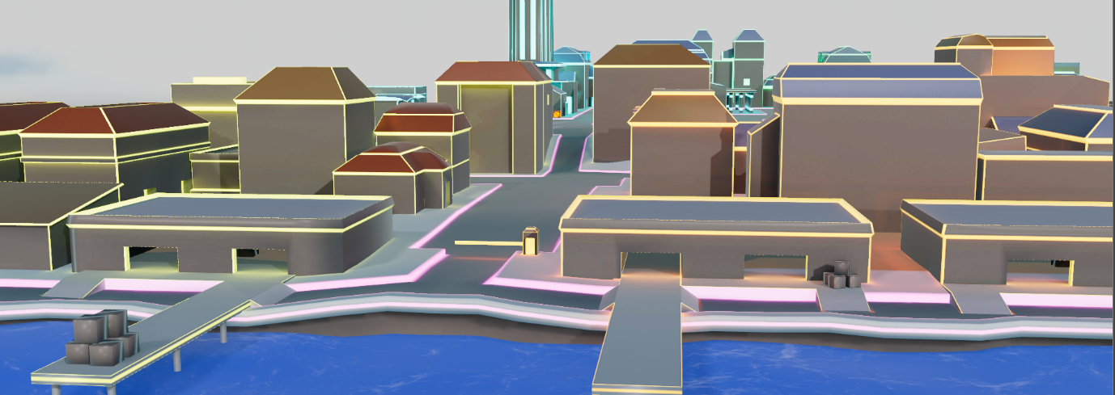
After this little exercise we had to find Mayabot in this city.
Figure 1 This image is from the tutorial.
To search Mayabot I had to “Tumble” and “Track” the camera.
After finding Mayabot in the middle of the city we learned that we could select objects in that world and can-do different things.
When we select an object, we can also move, rotate, or scale the selected object.
As for a quick exercise we had to find all the orange crates and had to stack them together.
We also learned about the out linear and how that can help us how to find objects in that 3d world.
After finding and stacking all the remaining crates the tutorial I finished the tutorial.
The point of this exercise was to show us how to navigate the 3D world in Maya, selecting the object and moving theme.

13/10/23
- Today in class Adam showed us how to Model a “lamp post.”
- To begin with we started with the basic shape, a cylinder, and we extruded upwards creating the main body of the lamp post.
- Once I was happy with the proportions for the body, Adam told us how to model the head of the lamp post.
- Adam used the tool “Insert an edge loop” and by doing this we have made two incisions on the top of the lamp and created a new set of faces and with that giving us the bases to create the head.
- Once selecting the face, I extruded theme so I could have the base. Still having the two faces selected, Adam shows us to extrude the faces outward in the X Axis.
- Once I have pulled the faces outwards using the “Move Tool” and the “Scale Tool.”
- Repeating this process, I start having a proper shape and size for my lamp.
- Adam showed us that by selecting the faces on the top of the lamp and extruding and scaling the faces upwards we start having a more rounded shape.
- After applying these techniques, I have created a 3D model of a lamp.
- This was quite exciting and fun.
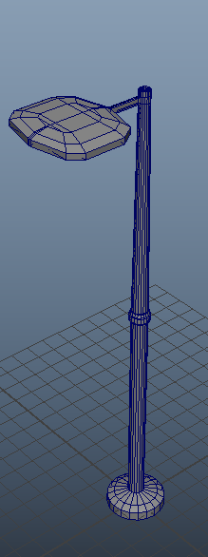
Figure 2 This is the first model i made

26/10/23
- In classes I was challenged to model three objects: a screwdriver, anvil, and Ikea furniture and to create each model we only had 10 minutes.
- The first object I created was a screwdriver.

1

- First, I found my reference from the internet
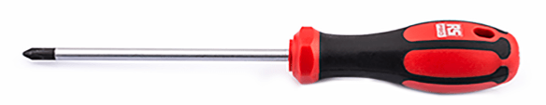 [1]
- To start I used a basic object, the cylinder.
- The next step I stretch with the cylinder with scale tool on the y axis to create the right length of the handle.
- Happy with right the length of the screwdriver I used the insert “edge loop tool” so I could create the mettle of the screwdriver. I selected the face and extruded inwards the faces so I could have the right size for the metal screw. To create the point bit on the top of the screwdriver is selected the faces on top and I extruded the face up and inwards and creating the point of the screw.
- After giving the general shape I started adding edge loops so I could give a better shape to the screwdriver.
- Once I had the general shape, I started to create the hole on the bottom.
- So, to create the hole I had to select the faces on opposite sides and extruded them once aging inwards.
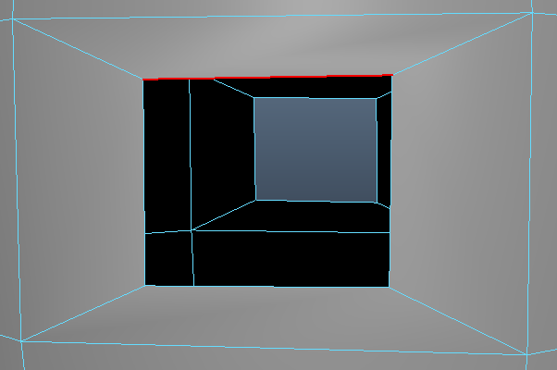
Figure 3 the hole
- Once happy with the size of the of the extrusions I canceled the selected faces. The next step was to bridge the two holes.
- To bridge the holes, I had to first select the edges on the opposite side and use the bridge tool.
- After bridging the hole, I selected all four edges inside the hole and used the bevel tool to create the curved shape, but this left me with nGones. nGones are bad because they have more than four edges
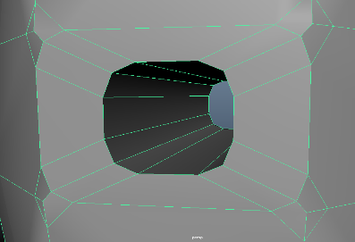
Figure 4 the Hole I tried to create, but I accidentally created Ngons.
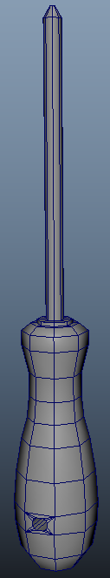
- To fix this issue I had to merge the vertexes in the middle and to do so I used the tool target weld to merge the vertices and try fixing the nGons [2] problem.
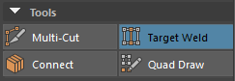 [3]
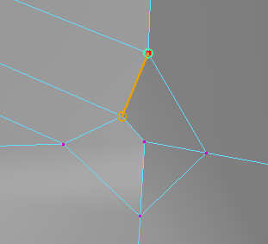
Figure 5 Showing how the weld tool works.

- Once fixed the nGons on both sides of the model, I finished the model.

- 2
- The second object that I created was an anvil.
- This time Adam showed us how we can add our references [4] imagine inside on maya. So, for the reference images we had to look at an “orthographic” view of an anvil.
- This was my imagine of the orthographic view of the anvil 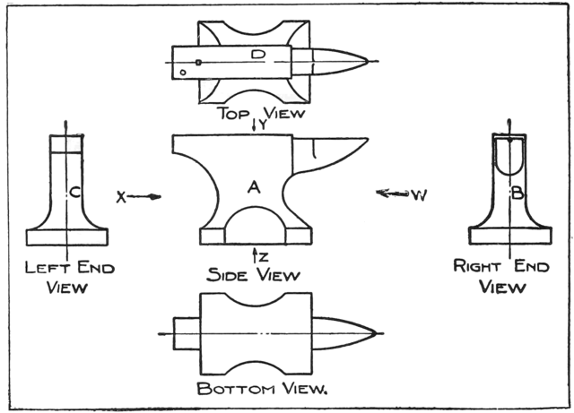 [5]
Figure 6 Orthographic view of the anvil
- Once I found my image it was time to add it in maya.
- To add an image in maya I did was:
1) Go to the other viewpoint in maya (Top, Side, Front).
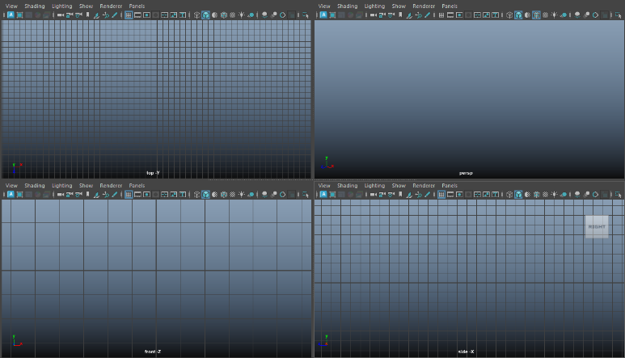
Figure 7 The 4 points of view in Maya (Top, Side, Front)
2) In the toolbar I used the “image Plane” to add my reference In.
3) Once added in the reference image, I had to redo the step for the other viewpoint
4) Once finished I tried to align all the three images so I would have all the orthographic aligned.
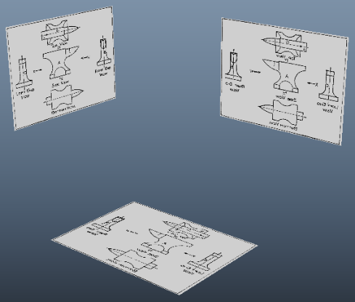

- To start my modeling, I started with the cube.
- I started modeling the base. After fishing the base of the anvil, I started modeling the top.
- The general shape of the anvil was easy enough and the difficult part was to model the horn.
- The way I proceeded to model the horn was to extrude the faces forward plus squeezing theme.
- I was trying to stick with the reference image, but the horn remained squared with sharp edges.
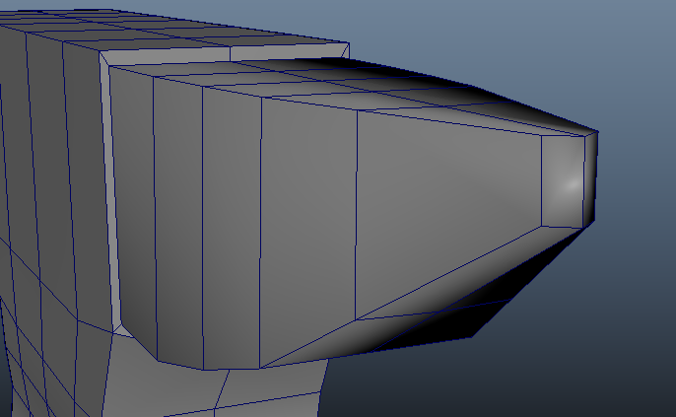
- into try and fix this I used the edge loop tool and creating new edges.
- Selecting these new edges, I start using the move and scale tool.
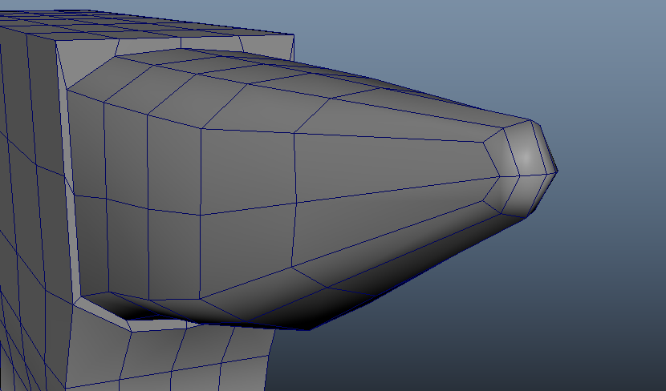

- The other part I had most trouble with was creating the base, since it has a semi-indent spherical shape.
- In trying to create this shape I created an edge loop, and this allowed me to have better control over the size and curvature.
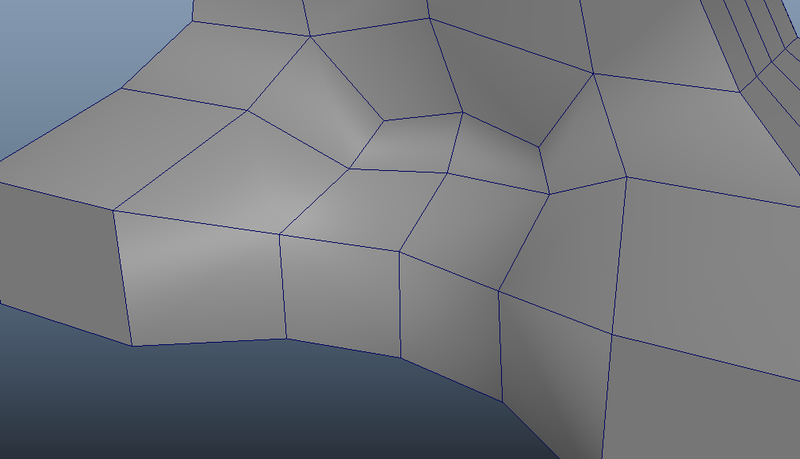
- These were my main two struggles: The horn and the indent base.
But overall, I was happy with the model I made.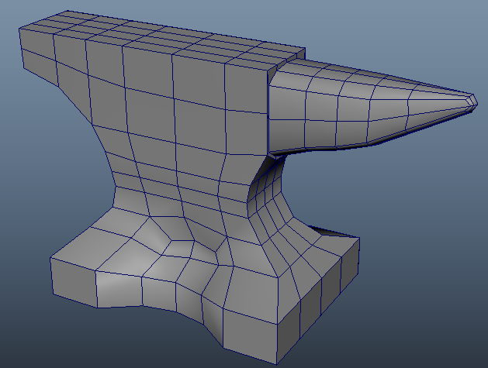
Figure 8 Finish anvil

3 Ikea Chair
- The third item that came out of the wheel was an Ikea furniture.
- looking for my reference image I found this Ikea chair:
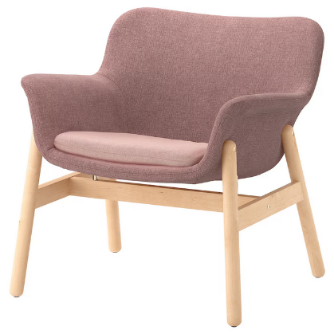 [6]
- To model this chair was more of a challenge since it had lots of curves and pointy edges.
- I started with the cube and created the genera shape for the chair 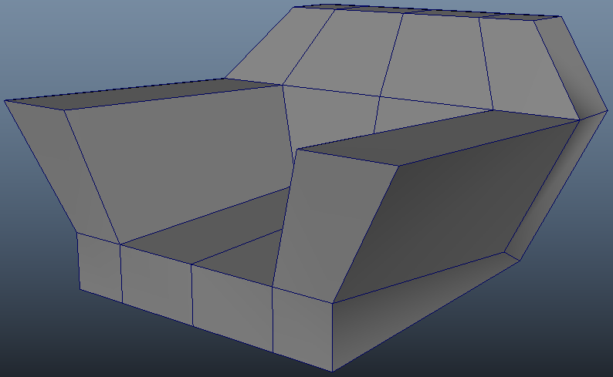
- From this very blocky chair I was questioning myself to how I can make this chair smooth. I experimented with “Smooth Tool” located in the Modelling Tool Kit. Experimented with the “Smooth tool,” [7]lead from a chair with shaper corners and edges to a refined smooth curve chair.
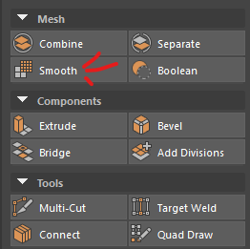

- For adding the legs there, I simply used two basic shapes (Cylinder, cubes)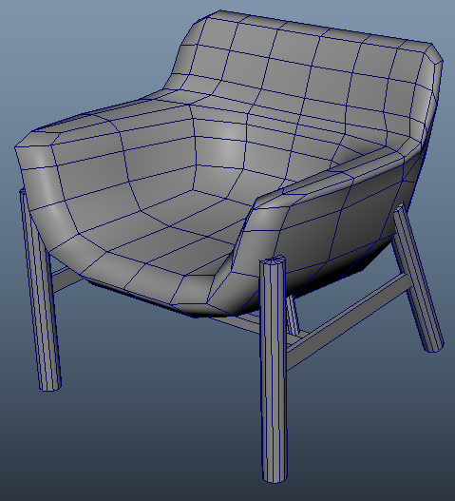

27/10/23

- Today in class we did the same challenge as yesterday but this time we had less time, from 20m we went to 10m.

1 Lego Figure
- Our first challenge was to create a Lego Figure and first off was to look for the orthographic reference images:
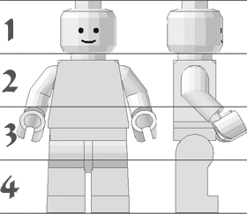 [8]
- This was fairly easy, and fun to create as it had a mixture of shapes. For the head I used a cylinder, for the body I used a cube and for the legs I use a combination of a cube and cylinder.
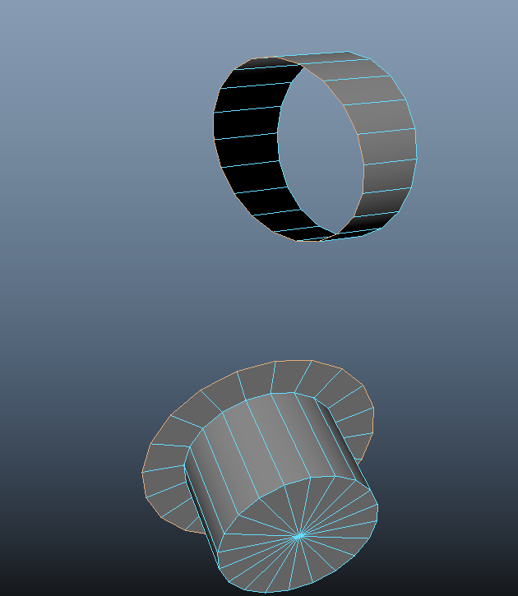
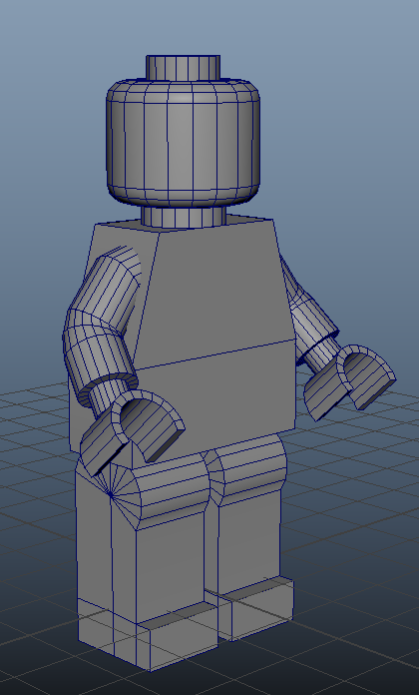
- But the hardest part of the model was to create the arms since they curved. But to fix this problem I use a technique called bridge [9]. When bridging to surfaces together it connects the face to each other, but within the bridging tools in can apply a setting called blend and curves the bridge giving the result of the two bridge objects a curve.

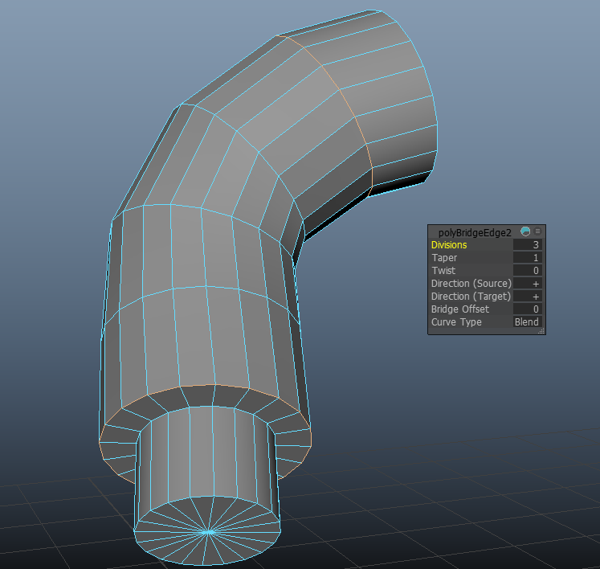

2 Monitor
- The monitor was another ferly easy and simple model to do as the overall object was just a square.
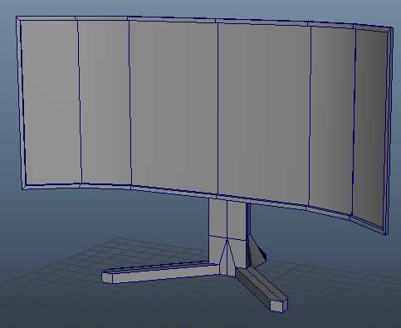
- The one little bit harder was the stand to create since it has two legs staking out from the bottom.
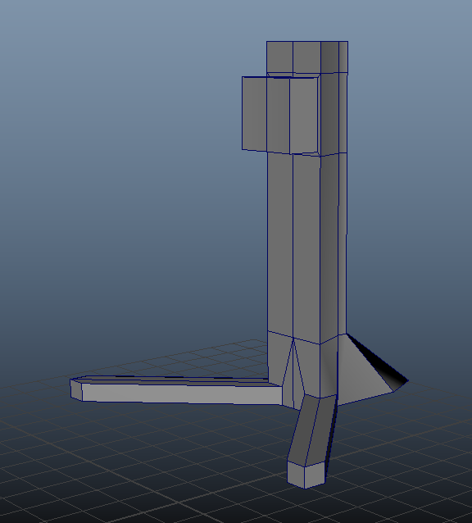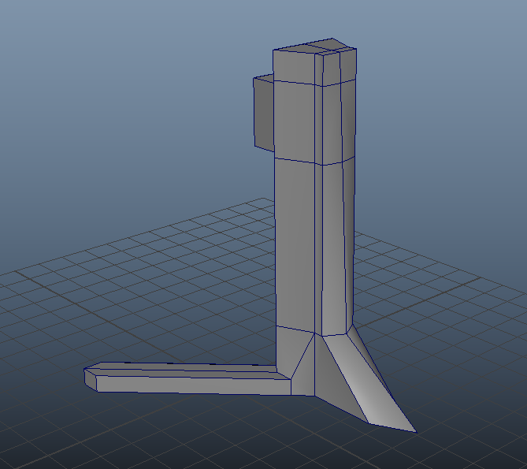

3 Horse
- The horse was a little bit more challenging since the model is organic and maya is not good at creating organic modeling.
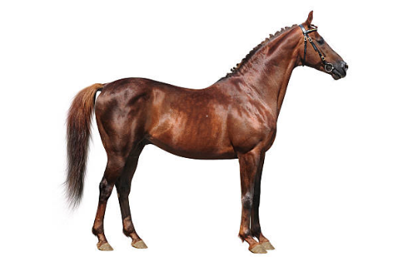
- I started to create models from the cube and started to create the horse.
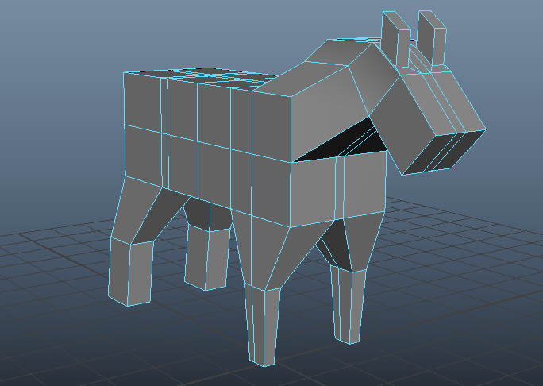
- Once happy with the overall shape I used the skill I have acquired with the smooth tool.
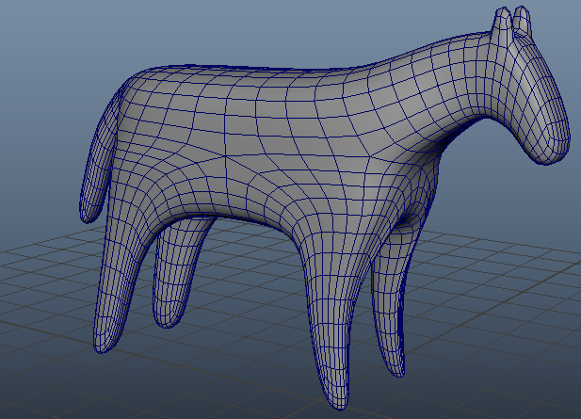
- With this model it was mostly difficult to create the shape since Maya is a modeling program focused on Hard to Surface modeling and not organic modeling.

28/10/23 Dumpster

- Today I tried to create one of the models from the list and I picked the dumpsters.
- First off all I tried to find the refence image but could not decide one, so I decided for both these.
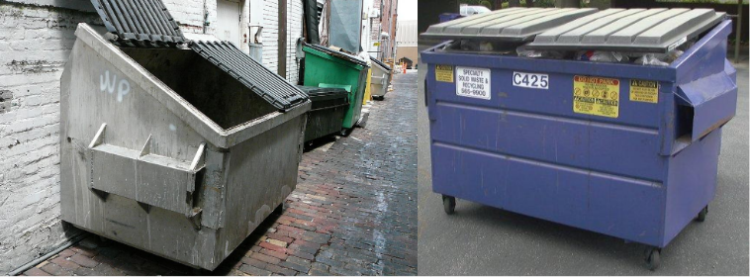 [10]
- By starting to model the dumpster I used the cube as the basic shape and started to use the scale tool.
- I tried to stay as close as possible to the references.
- As the top of the dumpster was flat, I tried to give it a more of an angle to it.
- I also modelled the lids of the dumpster by extruding the top faces in
- I used another cube for the side and made theme hollo.
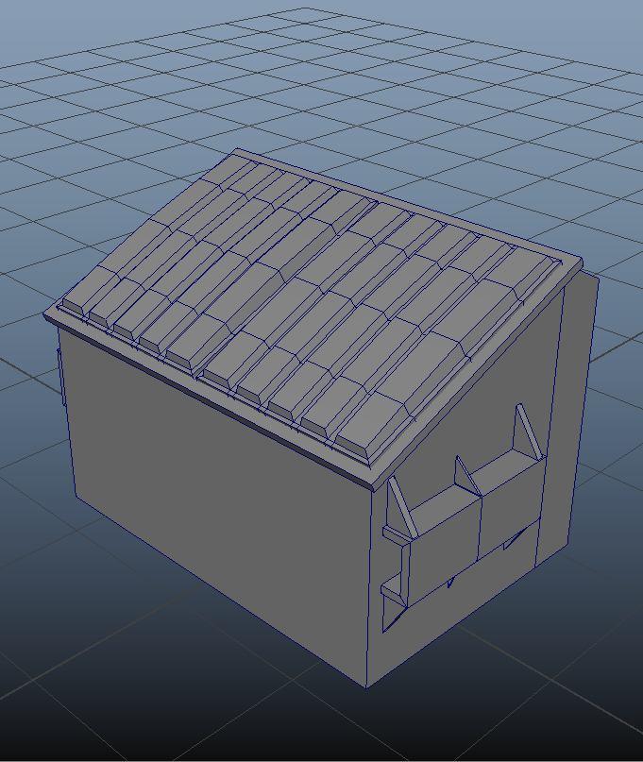
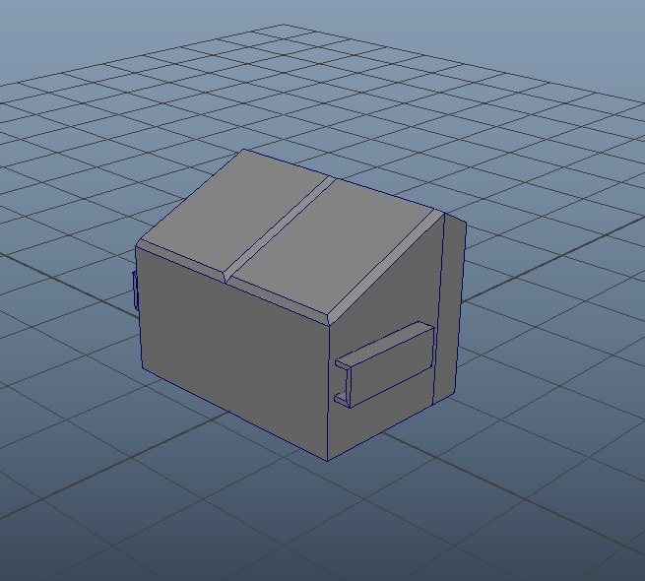

- Happy with the shape of the dumpster I started to give more details to it.
- For the lids I give them grove and give it a more of a curve
- As for the front of the dumpster I added ridges.
- After half an hour I had my dumpster asset.
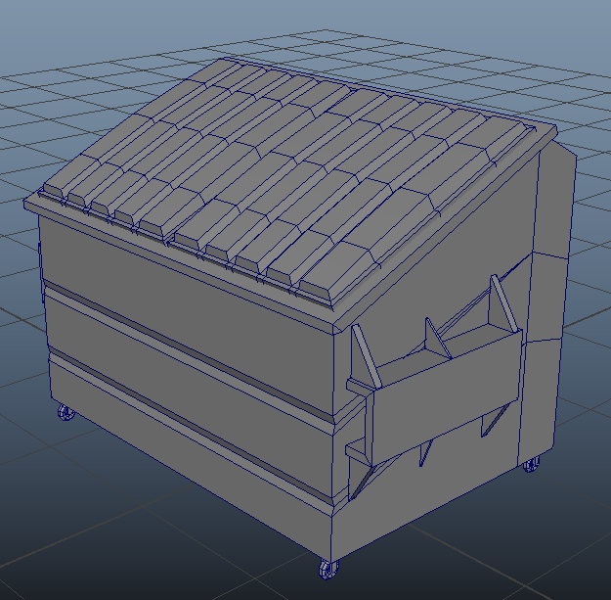

29/10/23 House

- Today I model the house asset.
- While looking for the reference image this was what it caught my eye [11]
- Staring of with the cube I started to scale and stretching it.
- Satisfied with the proportions of the house, I had to create the windows and the doors.
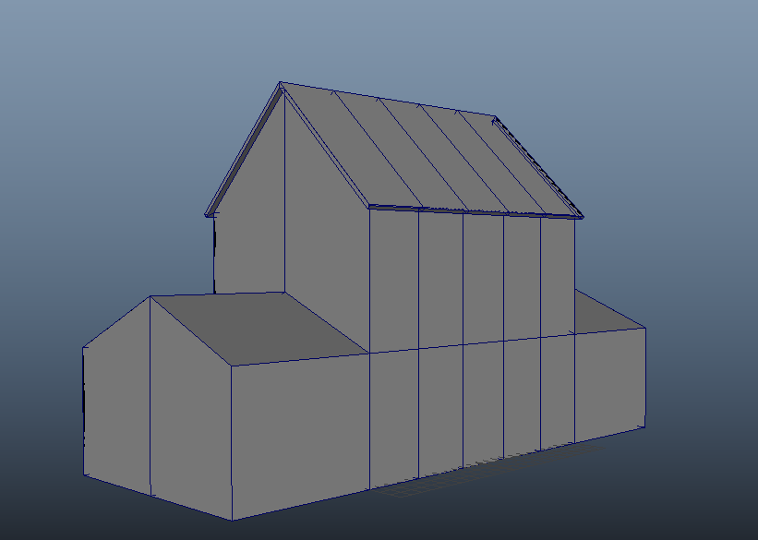

- For the door I tried to create a little roof and columns to give the effect of a posh house
- And for the windows a created two types: The common window and the bay windows
- Also decide to add the gutters for giving a more realistic feel to the house
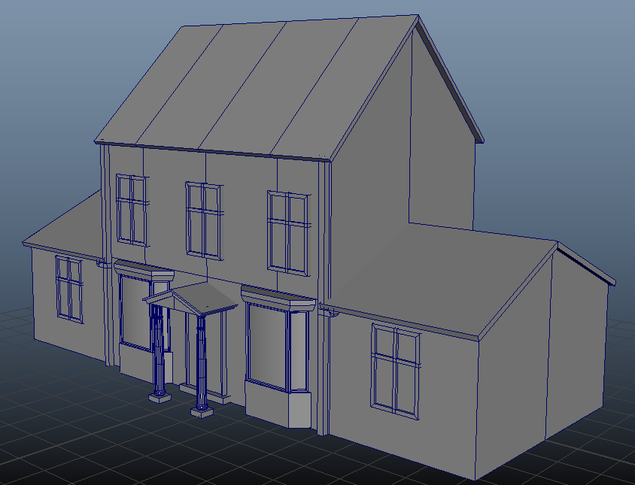

4/11/23 Lamp post
- Today in I tried to model the lamp post, and this was difficult one to do.
- This was to evaluate myself and model a complicated lamp.
- My reference was a lamp post from Spain and this lamp was create by Antoni Gaudi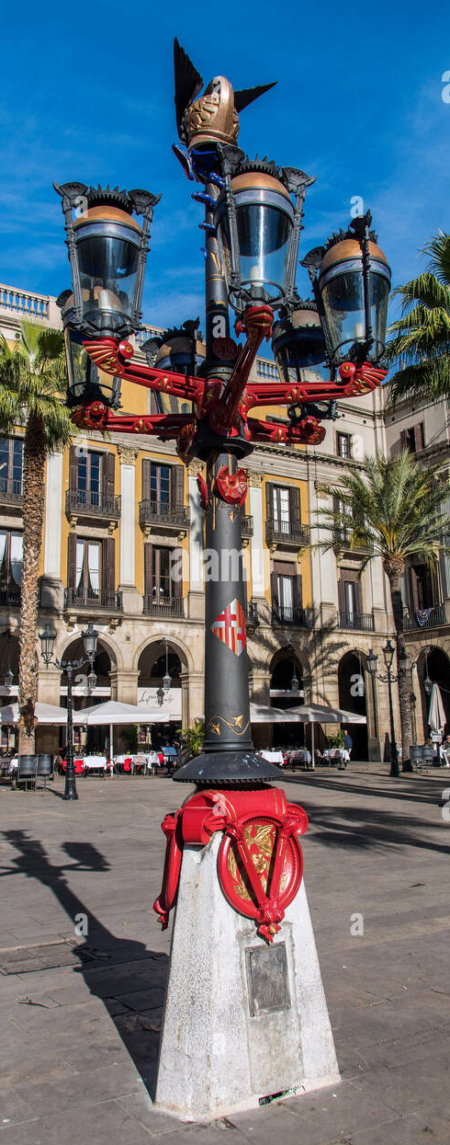 [12]
- To start of I created the pole I used a cylinder and stretched it. and for the concreate base I used a cube and deleted an edge an creating a triangle.
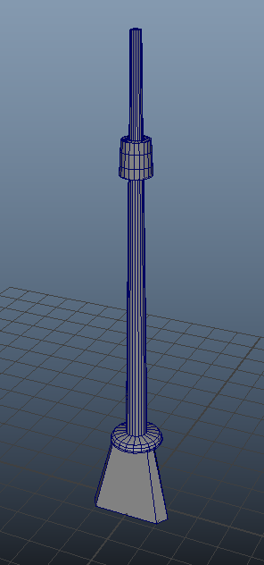
- Next was to create the lamps and this was hard to create.
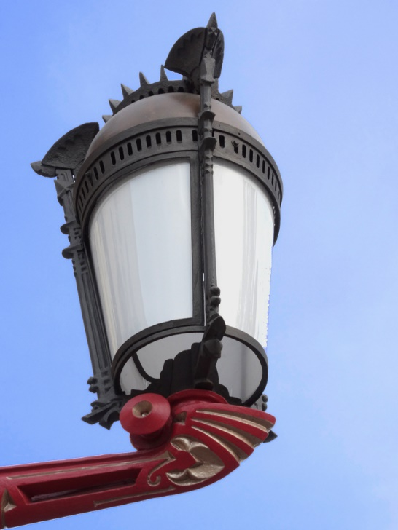 [12]

- First, I followed a tutorial on YouTube which showed me how to merge two objects tighter by using the weld tool.
- So, I used the cylinder and a sphere to create the lamp and welded the sphere on the top and for the base I just used a cube, stretched it, and extruded it.
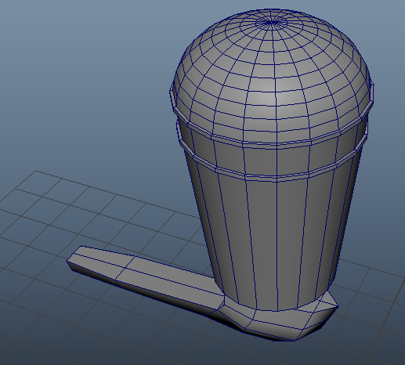
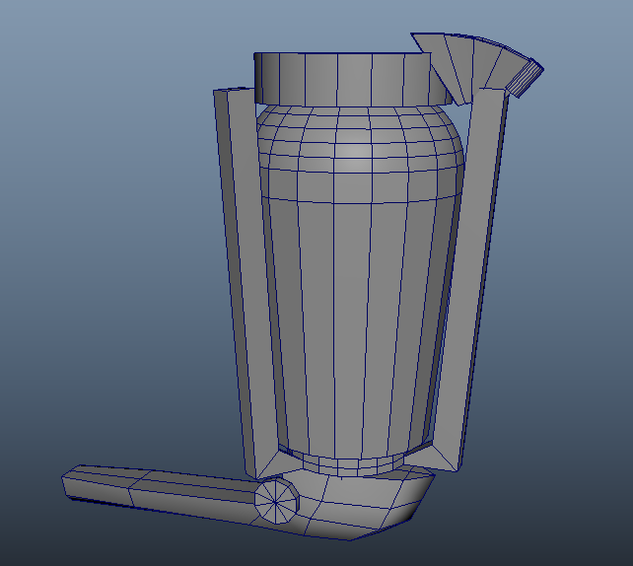
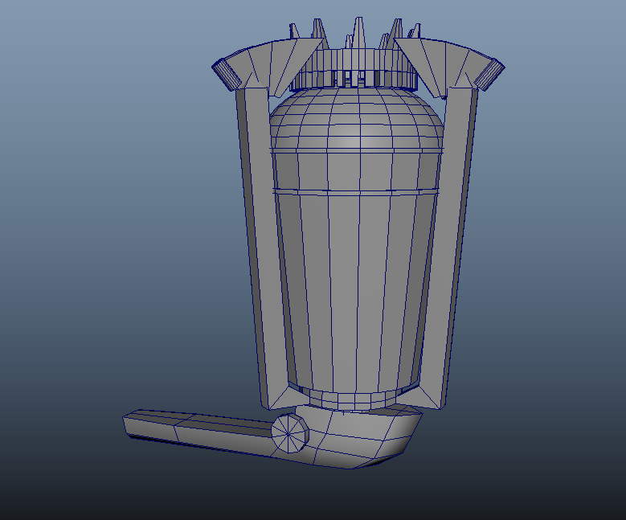
- For the decoration on the top and bottom of the lamp I use a cylinder and to create the supporting arms I extruded the faces on both the cylinders and connected theme together.

- Once happy with proportions of the lamp the next stap was to spread around the lamps.
This step was the easy bit of this model. I just grouped the original lamp (CTRL+G) and duplicated theme around the pole.
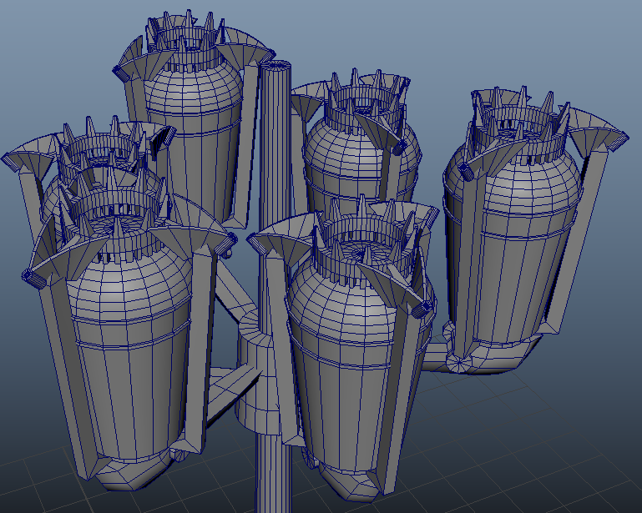
- The next piece to model was to create the snake and the helmet on the top of the lamppost.
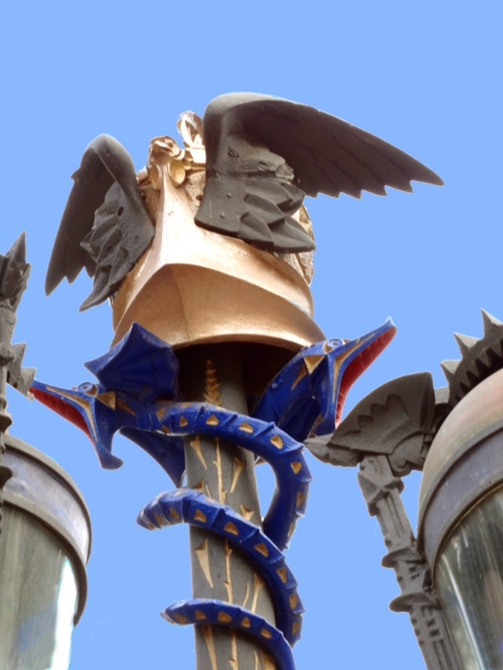 [12]

- So, to create the helmet I cut ¼ of the sphere and extruded it length way. And for the wings I just used the plane and inserted edge loops and with the use of soft selections [13] I could bend them and give the wings a curve.
- The hardest bit was to create the snakes. To create this snake, I used a cylinder.
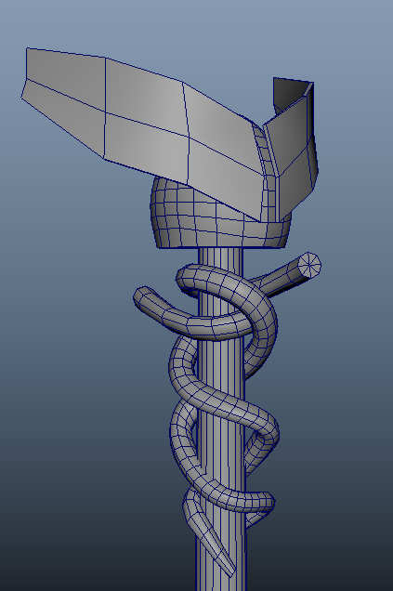
- My initial though was to extrude and curve it. But I look up on the internet and found out this tutorial of how to create a cords and ropes by using the Curve Tool [14] and with the tutorial I managed to create the snakes.
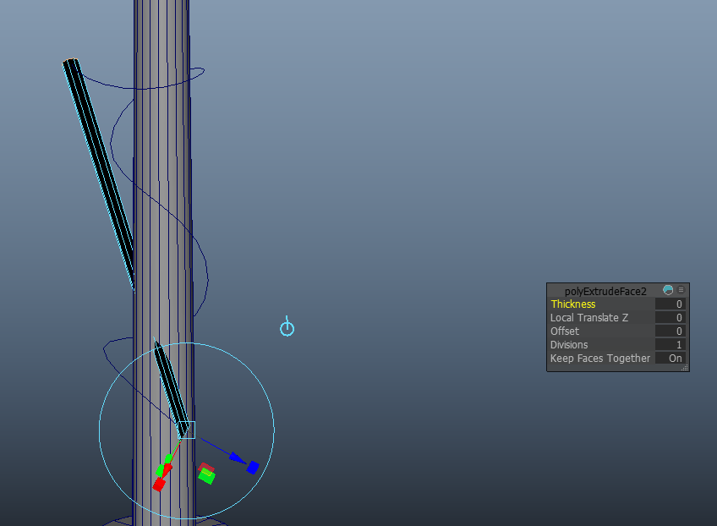
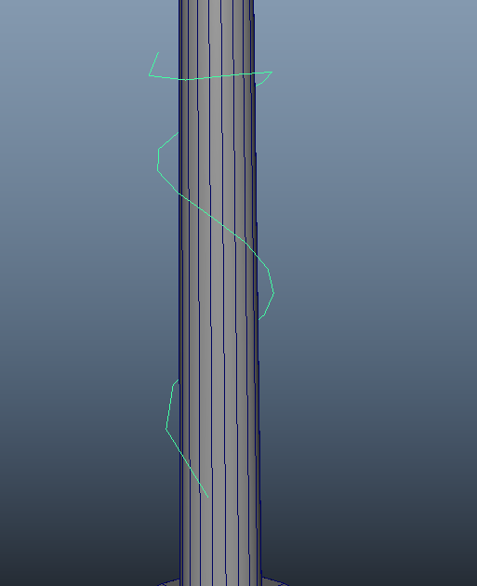
- And at the end I was I created Antoni Gaudi lamppost
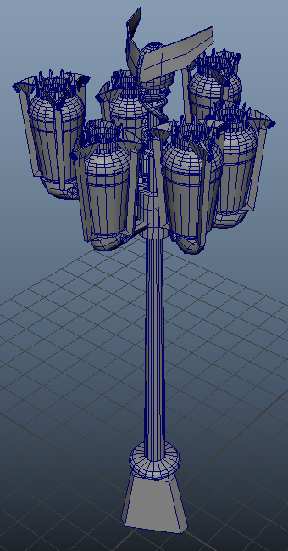

10/11/23 Soda Can

- Today I tried to create the Soda Can and this model was easy to do as is just on simple shape the cylinder.
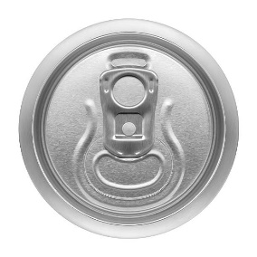 [15]
- I started to stretch the cylinder on the y axis to give the right high and start to start to create the top of the Soda Can. To create the top of the Soda Can I extruded the top face inwards and did the same step down. To the top of the Soda Can I also added the indentations around de edges, started giving the top details.
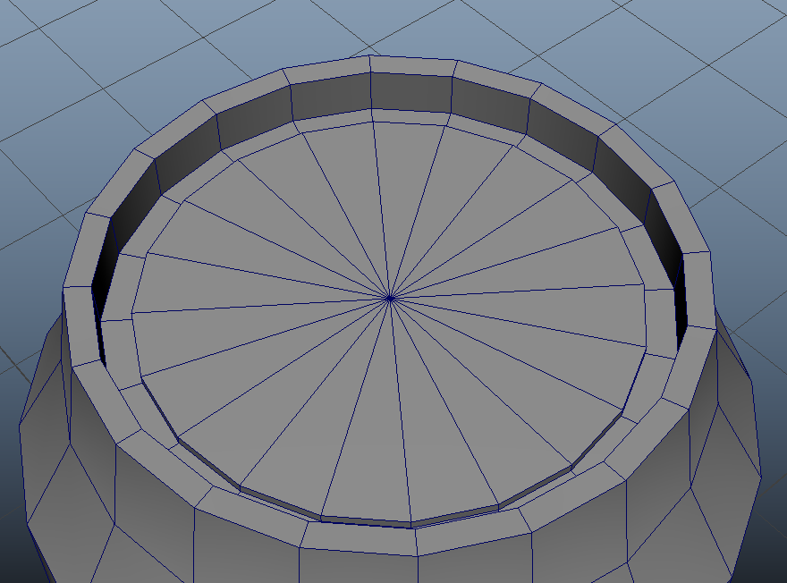
- The next step was to create the finer detail. The first details I added in was the little notch next to the “pull Tab.” Extruding the top face giving me a space to create little indentation. I selected the faces and extruded them downwards.
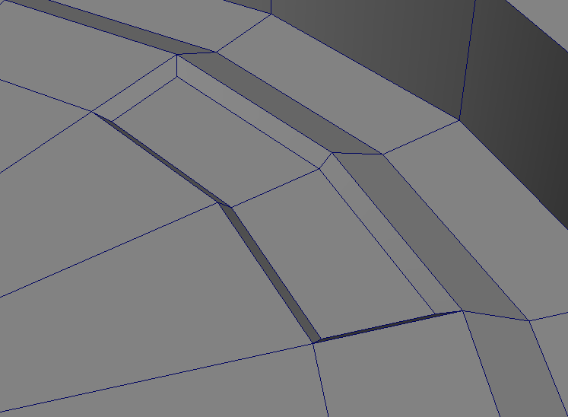

- The indentations I created was big, so I made smaller by selecting the faces and extruding it inwards. After adjusting the little indent, it was time to give the top of the Soda Can smooth edges. So, I selected all the sharp edges and use the tool “Bevel” [16] to give the edge’s a smooth shape.
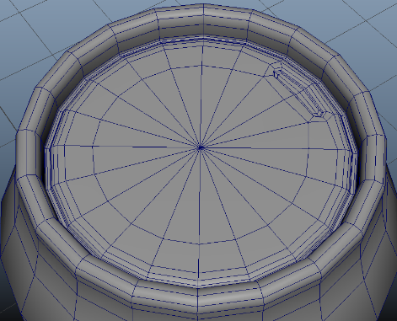
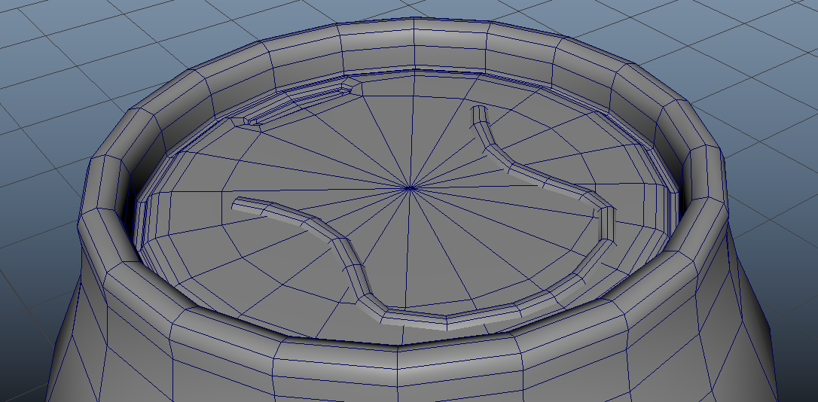
- The next step was to create the details on the top, and to do this I follow a tutorial on YouTube where they showed how to use a tool called Quad Draw [17].
Quad Draw allowed me to place dots on a surface and from dose dots I can create a surface allowing me to create intricate shapes. Using an image reference on the bottom of the Soda Can I had to just add the dots around the dents.
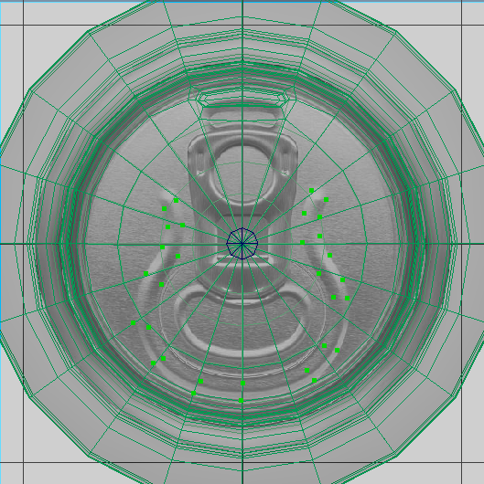
- I applied this knowledge and used the Quad Draw to crate the “Tab” and the other dents.
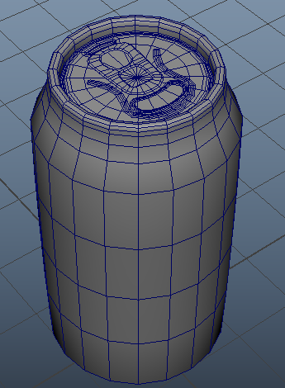
Creating the Soda can was interesting. The Quad Draw in a useful tool to create new surface without moving each vertex with the move tool.

Teacup and Teapot
- The last object I create was the Teacup and a Teapot
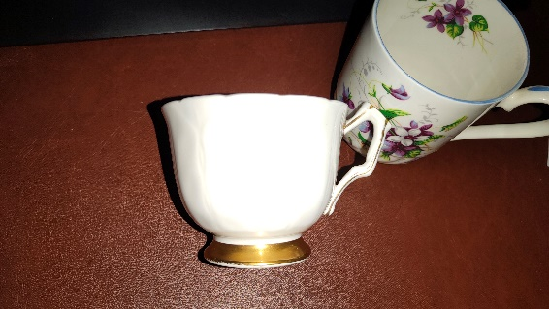
Figure 9 A photo I took of a teacup.
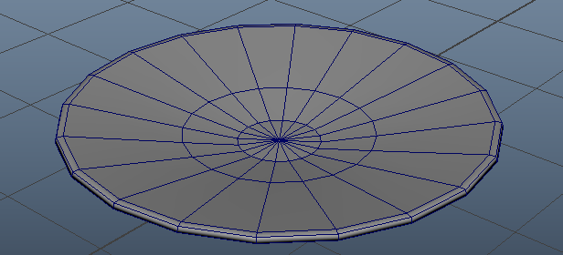
- First, I started with the teacup, and I use a cylinder for the basic shape. To create the handle, I used the quad draw tool.
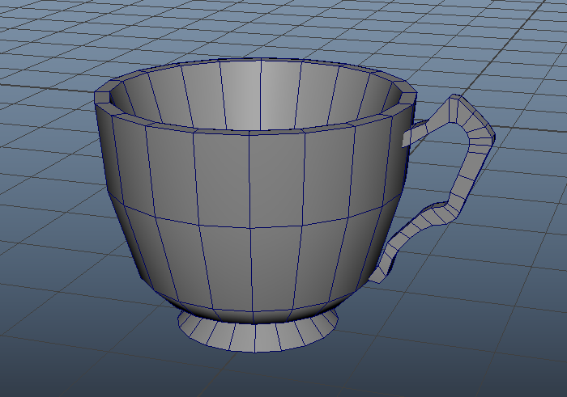
- Having the basic shapes, I started to give the cup more details. I also applied the smooth tool on the cup, and it give curve and smoothness.
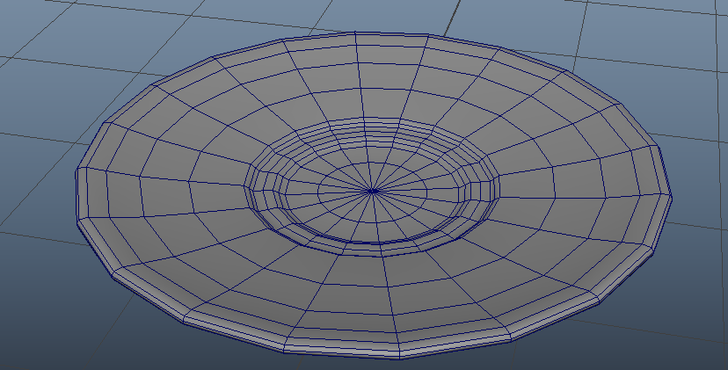
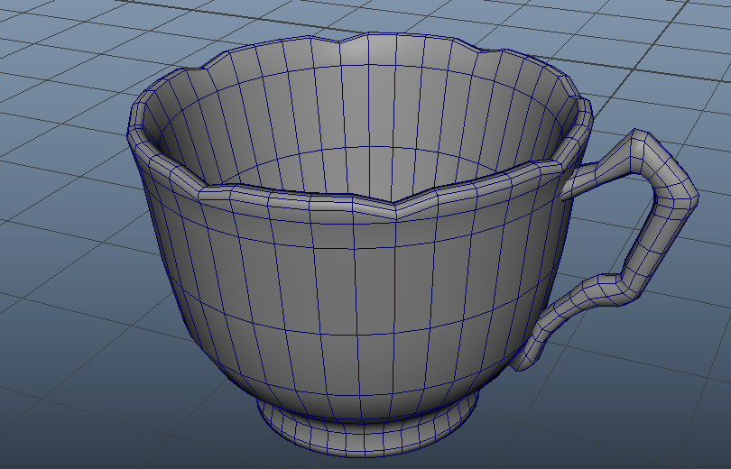
- The next model I created was the Teapot and this was little bit challenging.
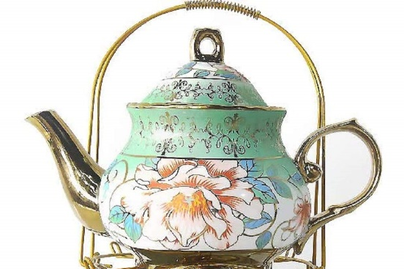
- This time I started with a sphere because the main body is a spherical shape.
Cutting the bottom and the top of the sphere I get the rough shape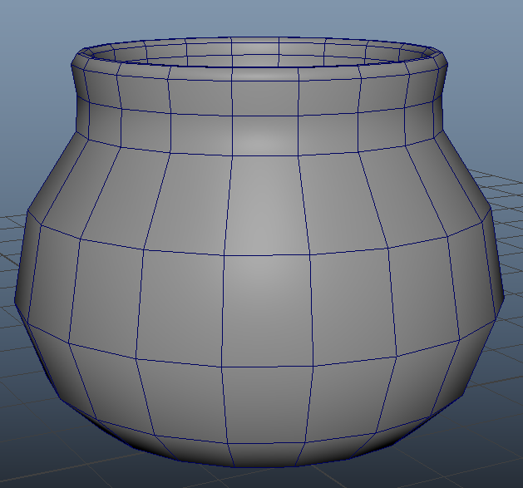
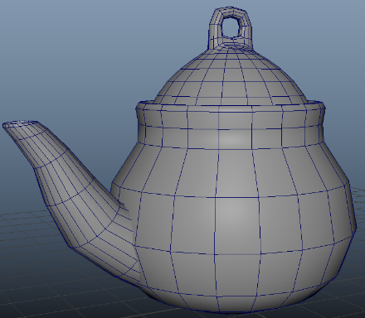
- Started to create the spout I used a cylinder and extruding until I got the shape. I created the lid for the teapot by cutting a sphere and extruding the top.
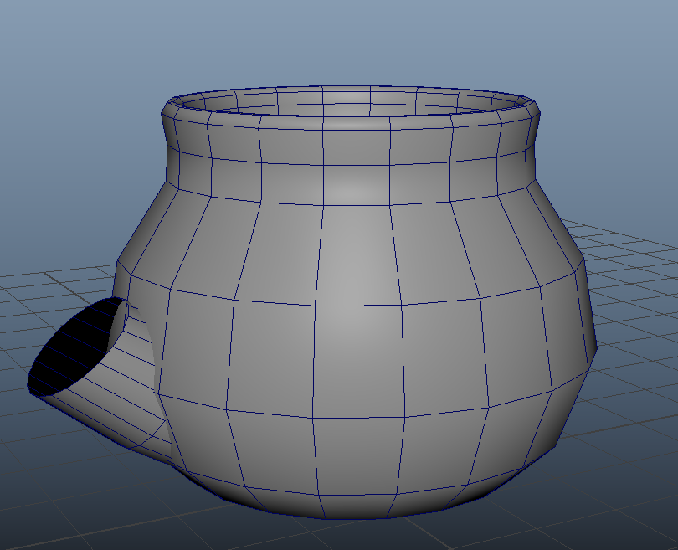
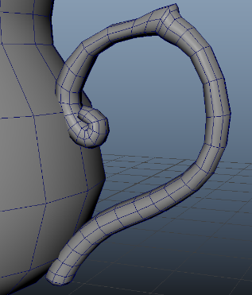
- The last part to create was the handle and to do this I used the Quad Draw and followed the reference image. After creating the handle, I give it a thickness by extruding it, I also added to the handle a smooth edge with the Smooth Toll.
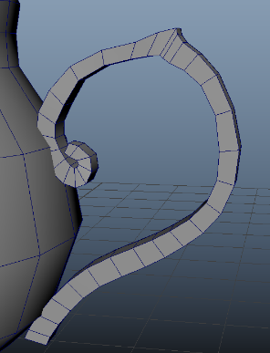
- Finaly, I have completed the Teacup and Teapot and these two models where fun to create since I had to think of how I can create intriguing shapes with spheres and cylinders.
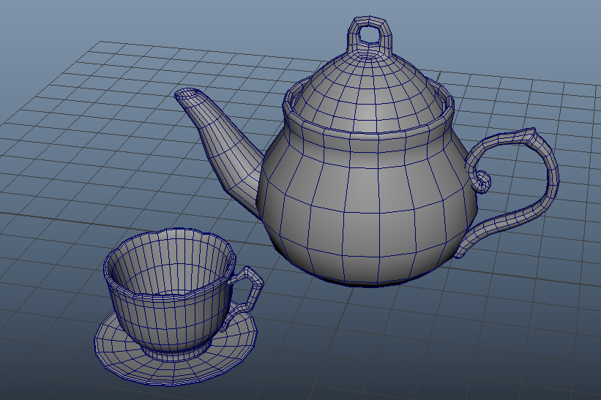

Conclusion
Learning Maya was challenging from learning different tools and what they can do and the different techniques and my knowledge of 3d modelling has improved, and I know there is even more to explore with in this program. But it was also fun to explore what the program can do and now I can create a wide range of object, props, weapons, and assets.

Bibliography

[1] | N/A, Artist, A Side View of a Scredriver. [Art]. https://in.rsdelivers.com/product/rs-pro/rs-pro-phillips-screwdriver-ph2-tip-125-mm-blade/1829692.
[2] | t. M. H. MH Tutorials, “Maya 2019 tutorial : What are nGons and why to avoid them ? ( BEGINNER LEVEL ),” Youtube, 27 2 2019. [Online]. Available: https://www.youtube.com/watch?app=desktop&v=fgdzunSmFuo.
[3] | . R. Gioia, “Maya Tutorial How to use the Target Weld Tool,” 2016, 12 1. [Online]. Available: https://www.youtube.com/watch?v=ZAMxrlWjsUc.
[4] | H. D. I. James, “Maya - Importing & Using Image Plane References,” youtube, 19 2 2022. [Online]. Available: https://www.youtube.com/watch?v=Q8IMNtYMegU.
[5] | N/A, Artist, orthographic view of an anvil. [Art]. https://www.turbosquid.com/3d-models/black-smith-tools-3d-model-2075918.
[6] | N/A, Artist, Ikea Chair. [Art]. https://www.ikea.lv/en/rooms/living-room/sofa-armchairs/armchairs/vedbo-armchair-light-brown-pink-art-40552221.
[7] | J. Antonio, “Maya's Smooth Mesh Tool,” Youtube, 22 3 2021. [Online]. Available: https://www.youtube.com/watch?v=igeCjABWI7U.
[8] | N/A, Artist, Orthographic View of an Lego Figure. [Art]. https://www.seanmichaelragan.com/img/LEGO_figure_4_heads_tall.jpg.
[9] | J. Antonio, “Maya's Bridge Tool,” Youtube, 10 5 2021. [Online]. Available: https://www.youtube.com/watch?v=4wIUIQNHIms.
[10] | N/A, Artist, 2 refrence images of Dumpsters. [Art].
[11] | N/A, Artist, Image of a house. [Art].
[12] | A. Gaudi, Artist, Gaudi’s Lamp Posts. [Art].
[13] | Figura, “Maya Tutorial - Soft Selection,” Youtube , 6 4 2021. [Online]. Available: https://www.youtube.com/watch?v=rj5PhQOblK0.
[14] | A. P. Plus, “How to Quickly Model a Wire/Cable using Maya 2018,” Youtube, 22 6 2018. [Online]. Available: https://www.youtube.com/watch?v=4igTVJOEJw0.
[15] | N/A, Artist, Side and top view of a Cocacol Can. [Art].
[16] | 3DWolf, “Maya Tutorial for Beginners | Bevel Tool in Maya 2022,” Youtube, 27 03 2022. [Online]. Available: https://www.youtube.com/watch?v=gknvC3lJyDI.
[17] | J. Antonio, “Maya's Quad Draw Tool,” Youtube , 25 10 2021. [Online]. Available: https://www.youtube.com/watch?v=4SfcG9GGjpY.
[18] | R. Gioia, “Maya Tutorial: How to Bridge two polygon objects - Edit Mesh Bridge,” YouTube, 1 9 2016. [Online]. Available: https://www.youtube.com/watch?v=4Vcrawzz2Rg.
[19] | N/A, “Bridge between border edges,” Autodesk, [Online]. Available: https://help.autodesk.com/view/MAYAUL/2023/ENU/?guid=GUID-37DF6F1C-49F2-48C2-889C-ED0337E88307.

