ER Diagram
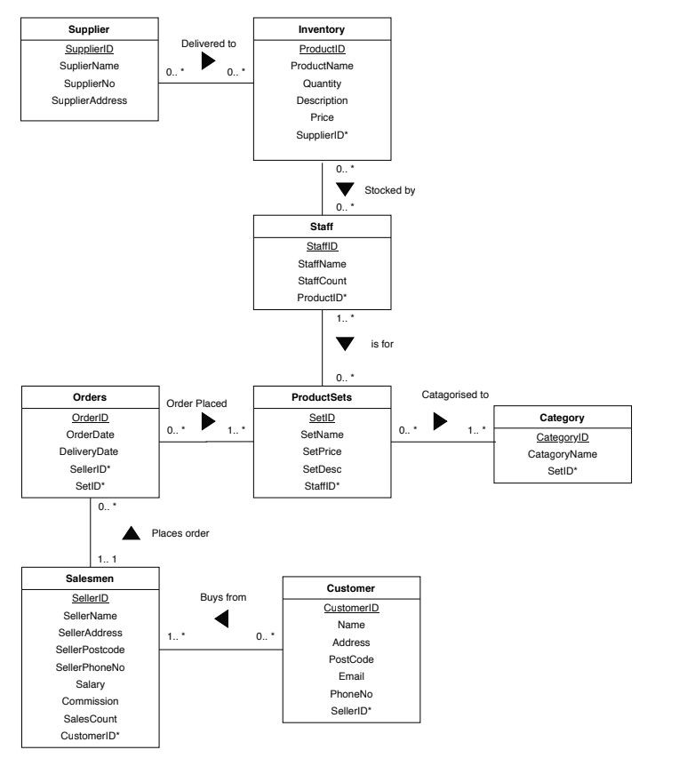

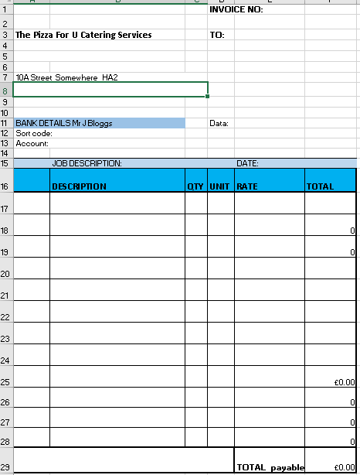

This is the new invoice model made

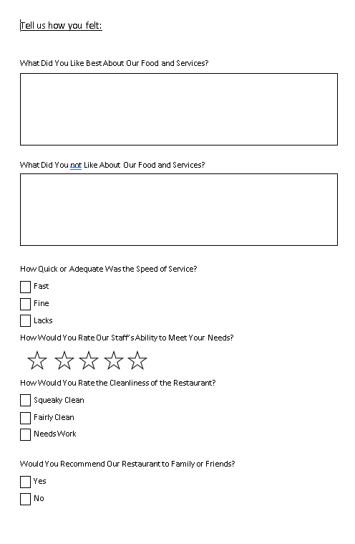
This is the new questionnaire for when people have events
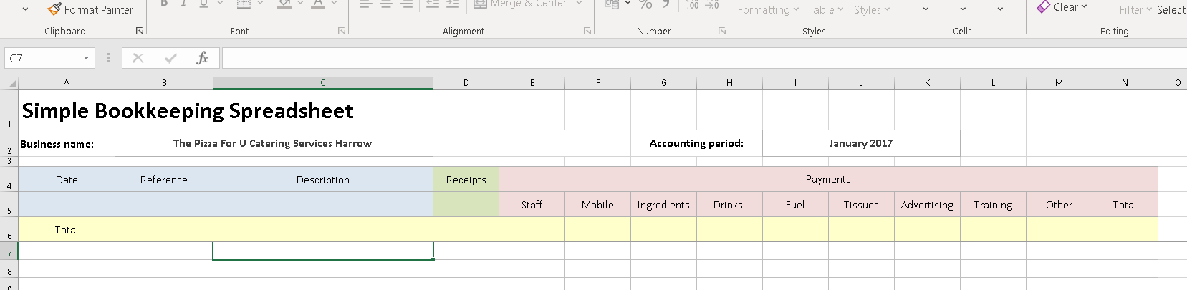

This screenshot is the record of transactions recorder.

