Choose 2 images (one positive and one negative) of ONE group in society and compare and contrast how such a group is portrayed and potentially misrepresented in society.
Introduction
This submission will look at two images of people from a particular group in society, discuss how they portray that group, in relation to theoretical and legislative context. Initially a positive image of the group will be critiqued, then moving on to a negative image, and then comparing and contrasting the two images before concluding. The social group that will be discussed is that of mothers. The depiction of mothers in the media can have a narrow depiction of what makes a “good” mother, who has attributes such as being of a certain age, attractive, fertile, and middle class (Gillespie, 1999, 2001, cited in Hadfield, Rudoe, N., & Sanderson-Mann, J., 2007). Furthermore, types of mother who are seen to be outside of this definition are particularly depicted with negative connotations, such as teenaged mothers, single mothers, and older mothers (Hadfield, Rudoe, N., & Sanderson-Mann, J., 2007). Image A (Daily Mail, 2021) is a positive image, showing a well-dressed woman with styled hair, handbag and watch, withdrawing money from an ATM while holding a baby. Image B (Dave Evitts, 2016) is seen to be a negative image, of a woman in casual clothes holding a child with several other children gathered around her.
Image A

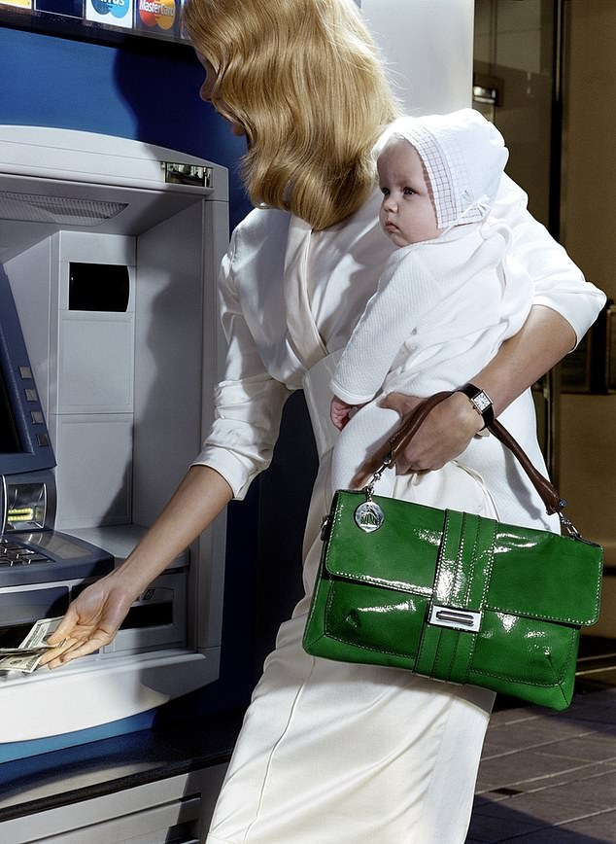
The initial impression on looking at this image might be the connotations of wealth. The woman is withdrawing cash from an ATM, she is slim and has styled hair and a formal outfit, and is carrying a formal handbag and is wearing an expensive-looking watch, while holding a smartly dressed baby. Therefore the impression gained is that she is of middle or upper class, characterised by income and cultural and social capital (Jones, 2013), thus complying with ideas around what a ‘good’ mother is. The idea of social capital revolves around social relationships and connections and how this impacts of wider social structures (Tzanakis, 2013, p1). As Tzanakis goes on to explain, social capital exists as both a factor in the causation of social inequality, and as a consequence of it (Tzanakis, 2013, p14). This relates directly to ideas around wealth and socioeconomic position; social capital can be seen as interlinked to human capital (Schuller, 2001, cited in Tzanakis, 2013, p.14), for example, social connections can enable people to obtain higher-paid employment than others of equal education (Light, 2001, cited in Tzanakis, 2013, p.14), and it has also been shown that these connections or networks can not only help people in gaining employment, but can also be used to deny it to people outside of the network (Portes, 1998, 2000, cited in Tzanakis, 2013, p.14).
Another impression that this image gives is that the woman is concerned with her appearance. She is wearing a formal white dress with accessories, her hair is very neat and styled, and the baby she is holding is also pristine and dressed in white. This could link to ideas and ‘beauty standards’ relating to mothers; it has been shown that appearing like the cliched idea of a what a mother looks like is seen to be undesirable (Prinds, Nicolajsen, & Folman, 2019), and this is highlighted by the phrase “Yummy Mummy”, used in describing attractive, younger mothers. Prinds et al describe four themes which arose from their research with mothers. They discovered that weight loss was a significant focus for the women; they felt that losing the weight gained in pregnancy was a priority for the women they interviewed, and that they wanted to “get their body back”. Secondly, they discovered that the mothers reflected on general ideas of what beauty is, the standards set by popular culture, and the difficulty in not being influenced by these ideals. Thirdly, the mothers discussed feeling judgemental to themselves and others over physical appearance. Finally, they described how the women sought to distance themselves from the idea of what a mother physically looks like, and how there were ideals of lifestyle related to being a mother (Prinds, Nicolajsen, & Folman, 2019). It could be argued that these findings relate to the ‘good’ mother ideal, and that the woman in the picture is adhering to these standards in order to maintain her social position as such.
The outcome of this picture is that we see a slender, well-dressed woman with a baby who is withdrawing money. The image has connotations that she has some wealth, plus cultural and social capital, inferred by her expensive looking clothing. She is slim and well-groomed, which could show that she is concerned with her appearance. This complies directly with the idea of a ‘good’ mother, who looks attractive, is middle class, within a particular age range, and slim. This could then link to an improved position for her and her children, perhaps through better treatment in social, educational and sports settings. However, the stereotypes around motherhood may have some elements of control, coercing her into maintaining the expected appearance of the group.

Image B
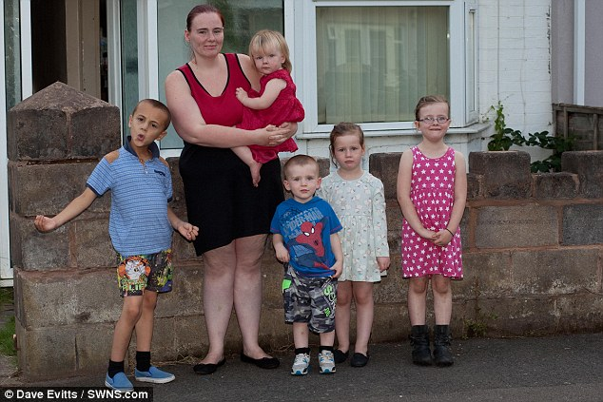
Image B shows a woman dressed in casual clothes, of average size, who is standing outside a house holding a child and accompanied by her other children. The five children appear to be of close ages and are dressed in mismatched clothing. The immediate impression that the image gives is that the family are of lower income and perhaps living in poverty. There is also no second adult shown in the image, so it could therefore be assumed that the mother is single. These aspects of the image might suggest that she doesn’t comply with the stereotyped ideal of the ‘good’ mother, as she is not shown as being attractive or middle class.
Lone parent families have been shown to be more likely to experience poverty then two-parent families (Harkness, Gregg & Macmillan, 2012, p.7). It is unclear, however, as to why this is; single parents may have other factors which make them more likely to experience poverty, for example, less achievement educationally; it has been shown that lone parents are less qualified than married parents (Kiernan et al, cited in Harkness, Gregg & Macmillan, 2012, p.8). Furthermore, rather than the position of being a lone parent increasing likelihood of poverty, it has been suggested that it is actually the economic circumstances which shape the structure of families (Harkness, Gregg & Macmillan, 2012, p.9). However, it isn’t specified about how this affects an individual’s ability to adequately parent children; as Goodman and Greaves discovered, while children aged three and five who belong to two-parent families appear to perform better, these discrepancies disappear when the data is controlled for other factors, such as parental education (2010, cited in Harkness, Gregg & Macmillan, 2012, p.8).
The mother shown in the image looks to be of lower income, and there’s no indication of her being in employment at all. It could be assumed therefore that she may belong to the class of the ‘precariat’, a contraction of the words precarious proletariat, characterised by lower earnings and little savings, and with a decreased likelihood of having attended higher education. Research shows that children who come from a poor background are less likely to do well in certain areas than those with richer backgrounds. This however may relate in particular to the mother’s level of education; it has been shown that this can have a direct impact on the outcomes for children (Magnuson and McGroder, 2002, cited in Harkness, Gregg & Macmillan, 2012, p29). It was shown that readiness for school increased and educational difficulties decreased in line with the education of the mother (Magnuson & McGroder, 2012, cited in Harkness, Gregg & Macmillan, 2012, p29). More factors which may impact on the outcomes for children is the lifestyle and mindset of the parents, with things such as regular routines, health, family relationships, access to educational materials at home, and a positive stance on education; it was shown that these attitudes in the parents could account for up to a third of the disparity in progress in rich and poor children (Gregg & Goodman, 2010, cited in Harkness, Gregg & Macmillan, 2012, p.30). The woman in the image doesn’t seem to embody the idea of the ‘good’ mother because of this, however it can be seen that there are other factors involved.
As discussed in Image A, the idea of a ‘good’ mother also includes attractiveness. In Image B however, it doesn’t appear as though the woman is concerned much with that: her hair is pulled back, we can’t see makeup, she is wearing very casual clothes. The visibility of celebrities and the idea of the ‘yummy mummy’ may contribute to discrimination associated with not fitting in with that stereotype, a stigma around what has been termed as “failed femininity” (McRobbie, 2006, cited in Hadfield, Rudoe, N., & Sanderson-Mann, J., 2007, p.5). Also, Prinds et al (2019, p.269) found attitudes of pity and sympathy for women who had not lost weight after having their children, which may contribute to stigma.
Comparisons and contrasts in the two images
The main contrasts between the two images is that of money. In image A, the woman is presented as affluent as shown by the money she’s withdrawing, her clothes and general appearance, while image B depicts a woman dressed casually with several children in mismatched clothing. The images can be used to gain some idea of which social class the women might be said to belong to. Image A gives an idea of elevated class, with the implications of money, cultural and social capital, while in image B, there is the implication of lower, with the associated preconceptions of lower levels of education and perhaps poverty. This contributes to the ‘good’ mother stereotype, with the assumed-middle class mother perhaps seen as a better mother than the lower class mother. This could be argued to be relating to neoliberalism, in that the attitudes reinforce the responsibility for poverty being placed squarely on the shoulders of the impoverished themselves (Azevedo & Jost, 2019), with a further analysis stating that these ideas allow the richer people to justify themselves without acknowledging the advantages they may have, and the poorer people feeling culpable for their poverty, despite having no way of changing their circumstances (Monbiot, 2016, cited in Azevedo & Jost, 2019).
Another way in which the images contrast is in the appearances of the women, image A being very well-presented, and less concern over appearance in image B. However, it could be argued that both women in the images are impacted by this. In image A, with the connotation of money and class, she may look a certain way in order to maintain her social position and her role as a ‘good’ mother. Conversely, the woman in image B, might experience stigma and discrimination because she isn’t presenting herself in that way, and she is deviating from the stereotypes.
Conclusion
This essay focuses on the social group of mothers and the ways that they have been depicted in the two images. It could be argued that neither of the images are a fair representation of this social group; as mothers necessarily exist in separate classes and cultures, the idea of the ‘good’ mother is a very narrow definition of what that means. As discussed, the attributes in this definition may not even relate to a mother’s capability in parenting her children, with parental attitudes and education making a significant impact on the outcomes for children.
The ideas around mothers is important as it impacts on different people. The people who deviate from the stereotyped role may experience discrimination and stigma, which could reinforce the victim-blaming stance seen in neoliberalism. Also, if a person is dependant on being seen in a certain way to retain their social capital, this could impact on their ability to make choices and could be seen as a form of control. Furthermore, it has impact on the lives of the children that these women have, as social capital could lead to increased opportunities for the children in wealthier families, which the children from poorer backgrounds could be subject to the effects of discrimination and the fewer opportunities available, thus widening the gap in wealth and education.
In order to change these oppressions that mothers are subject to would involve looking at the structures that exist around them. The ideas of social class could be said to be restrictive, and motherhood exists within the frame of a society where attitudes to women are negative, and dangerous in some respects. Furthermore, the intersection of classism and sexism is further sharpened into a specific set of characteristics, referred to in this essay as the ‘good’ mother. In order to address this, it could be suggested that more role models of motherhood become prevalent in the public eye, including celebrities, real people, characters in film and literature etc., in order to dispel myths about mothers and present a diversity in how mothers are presented.

Word count: 2139
References:
Azevedo, F. & Jost, J., (2019) ‘Neoliberal Ideology and the Justification of Inequality in Capitalist Societies: Why Social and Economic Dimensions of Ideology Are Intertwined’, Journal of Social Issues, Vol. 75, No. 1, 2019, pp. 49—88, doi: 10.1111/josi.12310

Daily Mail (file image) (2021). Available at https://www.dailymail.co.uk/femail/article-10042311/Why-ban-toxic-phrase-mum-guilt.html (Accessed 28 January 2022).
Dave Evitts (2016), Daily Mail. Available at https://www.dailymail.co.uk/news/article-3793976/Mother-five-pockets-19-000-year-benefits-says-needs-t-afford-buy-school-uniforms-children.html (Accessed 28 January 2022).
Hadfield, Rudoe, N., & Sanderson-Mann, J. (2007). Motherhood, choice and the British media: a time to reflect. Gender and Education, 19(2), 255–263. https://doi.org/10.1080/09540250601166100.
Jones, S. (2013), ‘Great British class Survey finds seven social classes in UK’, The Guardian, Apr 3. Available at https://www.theguardian.com/society/2013/apr/03/great-british-class-survey-seven (Accessed 28 January 2022).
Joseph Rowntree Foundation (2012), ‘Poverty: the role of institutions, behaviours and culture’, Joseph Rowntree Foundation.

Prinds, C., Nikolajsen, H., & Folmann, B. (2020). ‘Yummy Mummy — The ideal of not looking like a mother’, Women and Birth: Journal of the Australian College of Midwives, 33(3), e266–e273. https://doi.org/10.1016/j.wombi.2019.05.009
Tzanakis, M. (2013), ‘Social capital in Bourdieu’s, Coleman’s and Putnam’s theory: empirical evidence and emergent measurement issues’, Educate, Vol. 13, No. 2, 2013, p. 2-23.

