
School of Engineering
Postgraduate Research Method ACFA 7004
Shucheng Fu
2009975
Automotive Engineering Beng
6th, April, 2021
Postgraduate Research Method
Contents
Research 3
1 Introduction 3
2 Industrial Relevance 4
3 Literature Review 6
4 Proposed Methodologies 10
4.1 Upper controller (motion controller) design and debug 10
4.2 Design and debug of the lower controller (driving force distributor) 11
5 Results Collection & Analysis 12
5.1 Emergency lane change test 13
5.2 Lateral transient response test 13
5.3 Steering-release test 13
5.4 Stable steering test 13
5.5Weave test 14
6 Project Planning/Timescales 14
7 Evaluation 14
Reference 16

Research Proposal of Direct Yaw Moment Control of In-wheel motor Electric Vehicle

1 Introduction
In order to solve energy and environmental problems, the development of a new generation of electric vehicles has become a hot spot in automotive research and development. Compared with internal combustion engine, motor cause less pollution and can respond to input signal sensitively. What’s more, motors have convenience in measuring the torque and speed. The four-wheel independent drive electric vehicles based on in-wheel motor is a promising one.
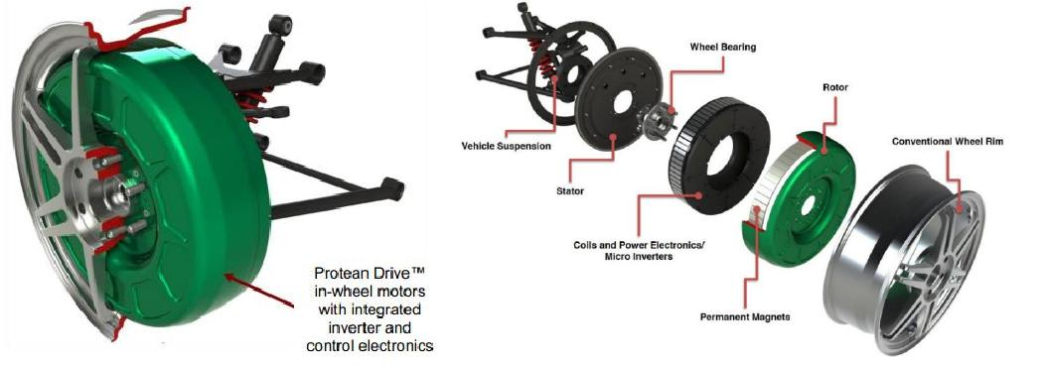
Figure 1 Protean Driver TM in-wheel motor
From the perspective of electric vehicles, those driven by in-wheel motor have significant advantages. First, each motor is independent and controllable, which makes it suitable for slip control and yaw control. Second, they abandon traditional driveline, meanwhile gain installation space and improve efficiency. With these advantages, it’s feasible to change the yaw moment acting on the car by controlling the torque of each motor instantaneously to produce longitudinal force and reduce vehicle mass, therefore improve the stability of the car. In this project, the control strategy of four independently actuated in-wheel motors will be researched. The focus is the torque control, for the sake of stabilizing yaw velocity.
To improve the safety and handling of cars, a variety of chassis control systems, such as the four-wheel steering (4WS), active front steering (AFS), direct yaw moment control (DYC), etc. were developed. 4WS is the earliest chassis control system, which is achieved by adjusting the angle of the rear wheel on the basis of the difference between actual yaw velocity and the reference yaw velocity. By changing the lateral force on the rear wheels, 4WS improve the handling and stability of vehicles [1]. The method of AFS is to add a certain additional angle on the basis of steering wheel angle, making changes to side force acting on the front wheel, to improve the handling stability of vehicles [2]. While the lateral acceleration is small, the lateral force is proportional to the wheel side angle, both 4WS and AFS perform well. However, while the lateral acceleration becomes larger, the lateral force tends to be saturated, and the handling of 4WS and AFS vehicles become worse. DYC is a method to generate yaw moment by using the difference of longitudinal forces on the left/right sides of the wheel to improve the vehicle handling stability, and DYC has been proved to have a good control effect when approaching the limit of adhesion [3].
Traditional DYC is achieved by limited slip differential, and its structure is relatively complex [4]. Different torques can be acted on each wheel on in-wheel motor driven vehicles independently without limited slip differential, due to the special structure. It can be said that in-wheel motor electric vehicle is an ideal platform to implement DYC.
The mathematical model of vehicle dynamics would be presented firstly, then the control method would be determined. All the relationships between physical variables of chassis system are supposed to be found out before the combined simulation via MATLAB/Simulink& VI-Grade. With MATLB/Simulink, it is convenient to compose torque control algorithm and optimization algorithm of torque distribution. Events and dynamic model of vehicle can be edited in VI-Grade. An assessment of stability of vehicle would be done after the simulation. The final goal of this project is achieving high stability of vehicles in particular events through DYC based on in-wheel motor electric vehicle.

2 Industrial Relevance
In 1900, Porsche developed a front-wheel drive electric car called the System Lohner-Porsche with two in-wheel motors [5]. Later, due to the advantages of internal combustion engine vehicles relative to electric vehicles in driving range, power performance and other aspects, internal combustion engine vehicles became the mainstream of the automobile, and the process of development of electric vehicles stopped for the present, in-wheel motor electric vehicles did not come to industrialization. In the 1950s, Robert, an American, invented a hub device that integrated an electric motor, a transmission system and a braking system. The hub device was used by General Motors in 1968 on a large mining dump truck.
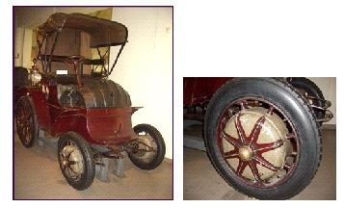
Figure 2 Porsche’s Lohner Electric Vehicle
Japan started research in in-wheel motor EV early. In the end of 1990s, Toyota Motor Corporation of Japan began to research and develop a four-wheel independent drive electric vehicle based on in-wheel motor. In 2011, Professor Hiroshi Shimizu, founder of SIM-Drive, designed the “ELIICA” electric vehicle [6]. “ELIICA” was driven by eight independent in-wheel motors (60kW for single motor) and can reach a maximum speed of 370 km/h. In the same year, the "SIM-LEI" electric vehicle was developed. “SIM-LEI” can travel for 308km within single charge, it needs 4.8s to accelerate from 0 to 100 km/h, and its top speed can reach 150 km/h. In 2014, SIM-Drive unveiled its “SIM-WIL” electric vehicle, which improved energy transfer efficiency and increased battery capacity, with a range of 351km on a single charge.
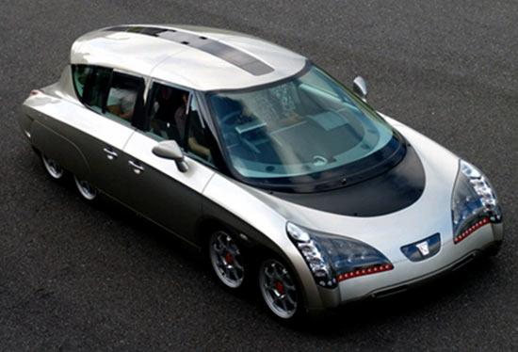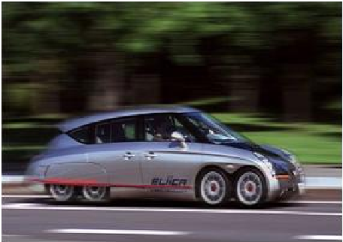
Figure 3 Eight-wheeled electric sedan “ELIICA” from Keio University
Mitsubishi has focused on key technologies for the productization of in-wheel motor electric vehicles as well, and researches on dynamic stability control of electric vehicles using the characteristics of in-wheel motor torque independent control. Mitsubishi introduced its MiEV (Mitsubishi In-Wheel Motor Electric Vehicle) at the 39th Tokyo Motor Show In 2005.
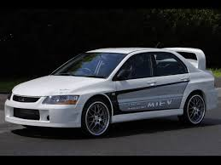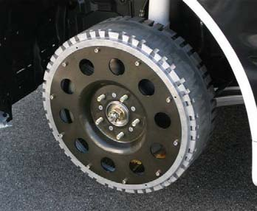
Figure 4 Mitubishi i-MiEV Figure 5 i-MiEV in-wheel motor assembly
Protean is an advanced in-wheel motor supplier, with mature technology in the field of outer rotor direct drive (without reducer), which is in the leading level in the world [7]. The company's in-wheel motor, Protean Driver TM, delivers 81 kW of power, 800 N·m of torque, weighs just 31 kg and can be mounted on conventional wheels with diameters ranging from 18 to 24 inches. Protean Driver TM in-wheel motor has good regenerative braking performance, which can recover 85% of the kinetic energy during braking and increase the driving range by more than 30%, ensuring the range while reducing the battery capacity and cost. Protean Electric has cooperated with a number of vehicle manufacturers to develop a number of prototype and modified vehicles with in-wheel motors, including Ford F150-EV, Volvo C30 Series HEV, Vauxhall Vivaro van, Trumpchi EV and BARBUS Electric vehicle based on Mercedes-Benz E-Class.
Volvo developed the C30 4WD hybrid cars. It is equipped with four in wheel motors produced by Protean, with an acceleration time of only 5.1s per 100 km and a maximum driving speed of 200km/h, which indicates its good power performance [7].
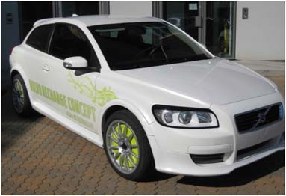
Figure 6 Volvo C30 4WD
TM4 of France, PML of Britain, SIEMENS VDO of Germany and Bridgestone of Japan developed their own hub motors. Companies such as BRIDGSTONE in Japan, Protean in Britain and Michelin in France have developed various practical hub motors and conceptual electric wheels, which have been applied to various new energy vehicles [8-10].
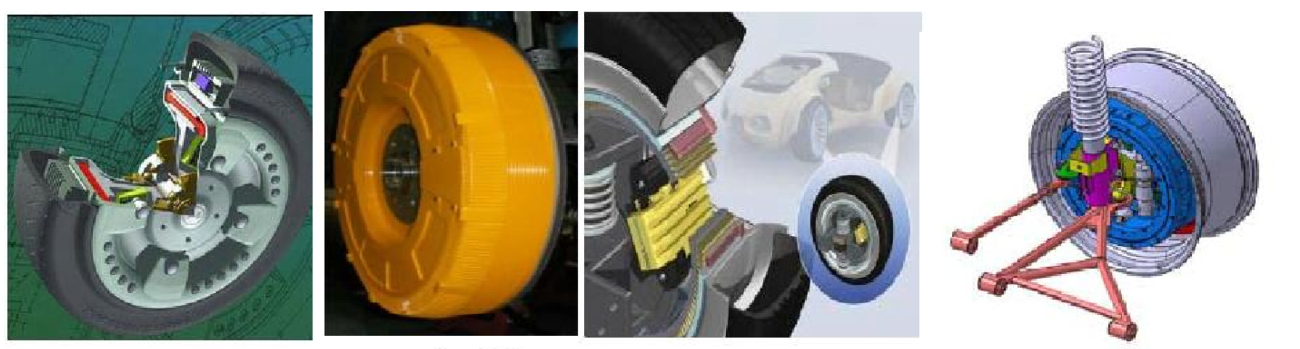
TM4 PML SIEMENS BRIGDESTONE
Figure 7 In-wheel motors of various companies
Many large automobile companies have carried out certain research on in-wheel motor vehicle, which indicates that in-wheel motor has assignable impact on electric vehicle industry. As a significant component of in-wheel motor control system, direct yaw moment control would never be too essential to investigate.

3 Literature Review
A number of universities in Japan have done a lot of work in the in-wheel motor electric vehicle development. In the University of Tokyo, the team led by Professor Hori had developed two types of in-wheel motor electric vehicles named “UOT Electric March” and “UOT Electric March II”. Professor Hori and his team realized the four-wheel independent drive/brake control, which was focused on the vehicle longitudinal slip, lateral stability and the roll stability control. Based on traditional steering and suspension system, Pro. Hori improved the robustness of the control and took the advantages of four-wheel independent drive electric vehicles to accurately estimate the vehicle condition [11-12]. The laboratory has recently developed an in-wheel motor electric vehicle with active 4WS, and studied the stability control of yaw and roll by using four-wheel steering [13].
Masao Nagai, professor from Tokyo A&T University, Japan, made systematic study on the application of active safety control system in in-wheel motor driven vehicles, especially the integrated control of yaw moment control and active front wheel steering, and specially developed the NOVEL series of electric vehicles to verify the control strategy [14]. According to the expected yaw moment calculated by the controller, it is evenly distributed to two rear-wheel motor torques, and the hidden Markov algorithm is used to identify the driving behavior to ensure the stability of the vehicle. The research results show that the integrated control can significantly improve the vehicle dynamic control characteristics compared with the single control.
Yokohama National University collaborated with Toyota to develop an in-wheel-motor & four-wheel steering electric vehicle. The research focused on the yaw moment control of electric vehicle by active steering and drive/braking force distribution, and proposes a lateral force observer least-squares method to evenly distribute the load of each wheel to achieve maximum stability of the vehicle [15].
The new energy vehicle project team of Ohio State University built an in-wheel motor drive technology platform, studied the torque distribution of four motors with the goal of energy saving and efficiency, established the objective function of the minimum vehicle power, and optimized the driving or braking torque of the motors. The test results show that the control strategy proposed by the project team can effectively reduce the power consumption of the vehicle [16].
Valentin Ivanov from Ilmenau University of Technology and De Novellis from the University of Lansurrey, proposed in view of the in-wheel motor driver technology such as torque vector control algorithm with the traditional control algorithm based on braking stability, the torque vector control method in vehicle dynamics control, which can effectively improve maneuverability of the vehicle and decrease the wheel slip rate without decreasing the vehicle's power performance [17].
Based on the “Chunhui” in-wheel motor driven platform, professor Zhuoping Yu and his team in Tongji university carried out series of systematic research on road recognition, drive torque control and yawing moment control of in-wheel motor driven car. In the design of car body motion controller, zeroing the centroid side-slip angle was defined as a basis to calculate the expected yawing moment. Also, in the research of distribution of the torque on the wheel after reaching constraint saturated, Professor Yu and his team did a respectable job through iteration of motor torque redistribution problem [18].
Professor Li and his electric vehicle team from Tsinghua University set up an in-wheel motor driven technology platform. Li and his team strengthened vehicle stability control by reducing the surface adhesion potential of the tire load rate, and improve vehicle maneuverability by narrowing the expectation gap between the current value of wheel torque and the responded yawing moment. In the optimization of the allocation of torque, Li assigned weight coefficient to stability and maneuverability, and took the surface adhesion and motor peak torque constraints on the effects of stability control system into consideration [19].
In addition, the research on direct yaw moment control strategy also includes the following contents:
Huang et al. designed a multi-model control system based on the BP-PID control algorithm, and the simulation test showed that the designed microcontroller had good control performance and guaranteed the lateral stability of the distributed drive vehicle under different road adhesion coefficients [20].
Hierarchy control is adopted by Asiabar et al. The upper controller includes PID controller with constant longitudinal velocity and yaw moment controller based on adaptive sliding mode control algorithm, while the lower controller includes longitudinal slip rate controller and torque distributor. Lane change, double lane shift and step steering conditions were simulated and verified in Simulink software, and the results show that the designed control algorithm can improve the vehicle's operating stability [21].
Beal et al. defined the state boundary based on the parameters estimated by the roll Angle of the centroid and road surface adhesion, and selected the model prediction algorithm to design the stability controller, so that the vehicle movement could be maintained within the stable area. The results show that the designed control algorithm can improve the stability of the vehicle in the limit condition very well [22].
Based on the 2DOF vehicle reference model, Wang et al. controlled the yaw rate based on the fuzzy algorithm, and generated the yaw moment of the vehicle by adjusting the torque of the in-wheel motor. It was verified in the co-simulation platform built by Simulink and CarSim, and the results show that the designed fuzzy control strategy can improve the vehicle handling stability very well [23].
Yan Yunbing et al. designed the direct yaw moment control strategy based on the neural network PID control algorithm, and then realized the distribution of additional yaw moment through the method of dynamic load distribution of front and rear axles. Based on CarSim/Simulink co-simulation, the results show that this method can improve the stability of vehicles at medium and high speeds [24].
Chen Jie et al. designed the vehicle stability control strategy based on the model predictive control algorithm of nonlinear vehicle model, and carried out simulation verification through step steering and FMVSS126 conditions. The results show that the designed stability controller is effective [25].
Chen Long et al. designed a vehicle stability controller based on the  control theory. The results show that the designed stability controller can improve the stability and safety of the vehicle with high robustness [26].
Li Shoutao et al. adopted a layered structure, and the upper system was based on sliding mode variable structure algorithm to jointly control the yaw rate and sidesyaw Angle of the center of mass, and to determine the required additional yaw moment. The lower system distributes the yaw moment reasonably in the upper system. The medium-speed Fishhook condition verification based on low adhesion road surface can quickly track the reference target and improve the stability and safety of the vehicle [27].
Other studies on torque distribution methods are shown below:
Based on the rule method, Shino et al., the front and rear axle wheels and the coaxial left and right wheels distribute the vehicle torque according to a certain proportional coefficient [28].
Based on the rule method, Mutoh et al. designed the driving torque distribution method and braking torque distribution method during steering according to the change of wheel vertical load. Simulation verification was carried out on low-adhesion road surface, and the results show that the designed torque distribution is effective [29].
Peng et al. designed the optimal tire force distribution with the goal of minimizing the tire adhesion margin variance. The results showed that the torque distribution method designed by Peng et al. could achieve uniform utilization of tire force and had good robustness to road roughness disturbance [30].
Mokhiamar et al. established a multi-objective function with the minimum tire load rate, the minimum error of total driving moment and the minimum error of additional yaw moment, and designed different weighting coefficients for different objectives to meet the design requirements. The results show that the designed method can well improve the vehicle handling stability [31].
Yan Yunbing et al. designed a direct yaw torque controller based on the neural network PID algorithm. Considering the limitations of the road surface and actuators, the yaw torque distribution was realized through the principle of dynamic load distribution of the front and rear axles. Moreover, based on the verification of emergency steering and emergency lane shifting conditions on medium-speed smooth road surface, the vehicle's handling stability is improved [24].
Lisheng Jin et al. took the minimum sum of wheel utilization rate as optimization index, road conditions and actuators as constraint conditions, converted it into quadratic programming form based on the theory of quadratic programming, and designed a yaw-moment distributor to realize the distribution of wheel torque. Moreover, based on the high-speed acceleration and deceleration double-lane shifting condition of high adhesion road surface, it is verified that the vehicle can be driven according to the driver's will, and the utilization rate of tires is reduced, which greatly improves the vehicle's operating stability [32].
To sum up, many large car companies and well-known universities have done a lot of research and development work in in-wheel motor electric vehicles. With the mature of in-wheel motor technology and battery technology, in-wheel motor electric vehicle will become the development direction of the next generation of electric vehicles due to its unique advantages. At present, the direct yaw moment control method is mainly used to study the handling and stability of in-wheel motor electric vehicle. Specifically speaking, DYC is to calculate the yaw moment required under the ideal state according to the input of steering wheel and accelerator pedal and the state information collected by the sensor. By reasonably distributing the torque of each wheel, the yaw moment is generated, so as to improve the handling and stability of the vehicle. Its advantage lies in the yaw moment control can be completed without the intervention of the braking system, improve the economy at the same time, ensure the dynamic performance of the vehicle, and improve the speed of turning as well. Because the motor is the only actuator, the direct yaw moment control responds more rapidly and the control effect is more ideal.

4 Proposed Methodologies
In this project, the research will take the form of Matlab/Simulink and VI-grade co-simulation. VI has a platform for parametric modeling of the vehicle, which is very convenient for researchers because it eliminates the need for them to construct a vehicle dynamics model separately. Therefore, researchers can focus on the creation of controller, which is the core of this project. The main problems to be solved in this project are shown as follows:

4.1 Upper controller (motion controller) design and debug
Hierarchical control is usually used as the structure in direct yaw moment control. The main function of the upper controller is to calculate the total longitudinal force, lateral force and yaw moment required by vehicle movement according to the reference model and state of motion of vehicle. The lower controller is generally a torque distributor, mainly determining how to optimize the distribution of the torque of each wheel. The upper controller may adopt the following schemes:
1. PID control
According to the difference between the target yaw velocity and the actual yaw torque, the yaw torque needed to stabilize the vehicle is calculated in the control method based on proportional adjustment. This feedback control method based on proportion is simple and practical, and can achieve better control effect. However, with the change of driving conditions, the control effect will have obvious fluctuations and lack of robustness.
2. Sliding mode control
The basic idea of sliding mode control is to make the system state converge to the sliding mode plane by presetting the sliding mode plane. This control algorithm has good anti-interference ability and strong robustness. However, due to its control characteristics, it is easy for some state variables to present chattering.
3. Fuzzy control
Fuzzy control is an intelligent control method, which does not need to know the precise mathematical model of the control object and has good control robustness. However, it has high requirements for the design of subfunction in fuzzy logic. The quality of its control depends on whether the formulation of rules among control variables is reasonable.

4.2 Design and debug of the lower controller (driving force distributor)
The driving force distributor is a link at the bottom of the whole dynamic control, and the quality of the distributor determines the quality of handling and stability control. In previous studies, the design scheme can be divided into the following types:
4.2.1 Rules-based distribution of drivers
To be specific, the rule-based driving force distribution scheme does not calculate the generalized control force of the vehicle. Instead, the vehicle is divided into starting, normal driving, skid, steering, braking and other conditions through driver input, and the torque of each wheel is adjusted according to different conditions to achieve the goal of stability or economy. These methods are easy to implement, and the computation is small, which improves their instantaneity. A problem which this method has is that it is difficult to divide the conditions into details, and the principles for distinguishing different conditions are not quite reasonable. What’s more, it is difficult to adapt to the real environments which are more complex.
4.2.2 Driving force allocation based on objective optimization
Most in-wheel electric vehicles are equipped with four motors, while the yaw moment controller only calculates the generalized yaw moment and longitudinal force, so the problem of driving force distribution is an optimization problem of over-drive system. As a result, more current studies adopt the method of multi-objective optimization distribution. Among those torque allocation distribute algorithms, the improved algorithm based on the generalized inversing and mathematical programming method shows a good application prospect and has received relatively wide attention due to its fast calculation speed, instantaneity and ability to handle constraint conditions well.
(1) quadratic programming
The basic principle of quadratic programming is to construct the Lagrange equation of the objective function and get the final optimal solution through iteration. Its expression is as follows, where G is the weight of the quadratic term and h is the weight of the first order term. This method can flexibly weight some control variables, so as to make the objective function more consistent with the actual situation.
$$\min{\frac{1}{2}}x^{T}Gx+h^{T}x$$
$$Ax≥b$$
$$A_{d}x=b_{d}$$
(2) Generalized inversing
For non-square matrix inverse, the generalized inverse method is widely used, and the solution is relatively simple. However, for a specific driving force calculation matrix, there are many generalized inverse matrices, so the pseudo-inverse method is often used to find the optimal solution. Its expression is as follows. Where, u is the driving force of the wheel, Fd is the generalized force, and Mu is the calculation matrix of the driving force. The pseudo-inverse method is to find the solution that minimizes the second norm of the driving force.
$$F_{d}=M_{u}u$$
$$u=M_{u}^{-}F_{d}$$
$$\min{\frac{1}{2}}u^{T}u$$
Another advantage of the optimal allocation algorithm is that the road adhesion condition can be used as a constraint, so that the driving force assigned to each wheel does not exceed the adhesion force provided by the ground. In this way, wheel slip can be avoided without the need to design a complex slip rate controller.

5 Results Collection & Analysis
Vehicle handling and stability refers to the ability of vehicles to maintain stable while the operator is in the natural comfort state, and the vehicle can be driven according to the instructions as well. In the 1970s, ISO(International Organization for Standardization) took the lead in drafting and developing a series of standards for testing the stability of vehicles. The relevant test methods are shown below. During the experiments, the longitudinal velocity, steering wheel Angle, yaw velocity and lateral acceleration of the car will be measured and recorded.

5.1 Emergency lane change test
This test simulates the process of a car quickly changing lanes and returning to its original lane in an emergency. ISO 3888-1:2018 recommends two test methods in its appendix, namely an entry speed of 80 km/h and a maximum safe speed. The common point is that the throttle should be kept constant during the test, and the time history of input of steering wheel and body motion parameters, driver control strategy and subjective evaluation should be recorded.

5.2 Lateral transient response test
Lateral transient response test refers to the intermediate transition process of the vehicle after changing the steering wheel Angle. Researchers can obtain the response characteristics in time domain or frequency domain through different types of input steering Angle. According to ISO 7401:2011, there are five types of steering wheel input: step input, single sine wave input, random input, pulse input, continuous sine wave input. Among them, the first two can get the time domain characteristics, the last three can get the frequency domain characteristics. In order to make the data more representational, the first two test methods will be adopted in this project.
The yaw velocity (response time, peak response time, overshoot) and lateral acceleration (response time, peak response time, overshoot) of the step input are evaluated.

5.3 Steering-release test
Steering-release test is to release the hands when driving the car turning and record the dynamic process of various variables in the oscillating process of steering wheel returning to the middle position.
The ratio of the second peak to the first peak after releasing steering wheel (roll velocity, yaw velocity, steering wheel Angle), the second peak after releasing steering wheel (roll velocity, yaw velocity, steering wheel Angle), and the time delay from t50 to the first peak (steering wheel Angle, lateral acceleration) will be used as evaluation indexes.

5.4 Stable steering test
Keeping the speed constant, the vehicle turns along the arc of different radius, increasing the lateral acceleration to the limit (the maximum speed maintaining the current turning radius). During this process, the roll Angle, longitudinal acceleration and steering torque are also recorded.
Indicators involved in the evaluation include: lateral acceleration, turning radius ratio, understeer, body rolling.

5.5Weave test
Weave test refers to the steering characteristics of the vehicle in the process of driving along a straight line when the vehicle speed is very high. In other words, it is at a higher speed to the steering wheel input amplitude of small vibration Angle (generally sine wave).
For DYC research towards in-wheel motor electric vehicles, the task in steering-release test is similar to the single sine wave input task in lateral transient response test (both change the yawing moment acting on the vehicle in an instant). Yaw velocity of vehicle in stable steering test changes too slowly to extrude the advantages of DYC. Weave test is similar to the second method of sine wave input. Therefore, this study will only take emergency lane change test and lateral transient response test to evaluate the handling and stability of the vehicle.

6 Project Planning/Timescales
Week | Tasks to be Done
1~2 | Study related control theory in depth to determine the type of upper controller.
3~4 | Further research on related theories of torque distribution algorithm to determine the specific form of the lower controller (optimization function)
5~7 | Build dynamics model of in-wheel motor EV in VI-grade and create events for stability testing.
8~10 | Construct the controller in Matlab/Simulink
11~12 | Run simulation and process the data
13~16 | Finish the main body of the paper

7 Evaluation
Multi-body dynamics simulation has some disadvantages, that is, the authenticity of the results is not as good as the real car test, because there are a lot of detailed matters that are not taken into account in multi-body dynamics simulation. In real DYC, the observation of vehicle motion state is also involved, because the parameters such as longitudinal velocity and roll Angle of the center of mass of the vehicle are not easily obtained directly from the sensor, and these parameters are very important for control. In this project, the observer of the vehicle state is not considered, and the vehicle motion parameters are directly obtained from the calculation process. It is a little unreasonable but will not have much influence, because the key point is the design of the controller.
Many studies show that even if only using multi-body dynamics simulation method, the vehicle stability will be improved through reasonable control of yaw moment. The multi-body dynamics simulation method is sufficient to show the differences between various control methods and optimization algorithms. These control algorithms also work in real cars. In addition, the obtained experimental data are very accurate because the experiment adopts the form of multi-body dynamics simulation. Combined with the optimization function of the algorithm, the maneuverability and stability of the vehicle will be improved, thus providing high quality experimental data.

Reference
[1] Sato H, Kawai H, Isikawa M, et al. Development of four-wheel steering system using yaw rate feedback control[R]. Nashville: SAE,1991.
[2] YU Zhuoping, ZHAO Zhiguo, CHEN Hui. Influences of active front wheel steering on vehicle maneuver and stability performance[J]. China Mechanical Engineering, 2005,16(7):652.
[3] Tahami F, Kazemi R, Farhanghi S.A novel driver assist stability system for all-wheel-drive electric vehicles[J].IEEE Transactions on Vehicular Technology,2003,52(3):683.
[4] Iksshima Y, Sawase K.A study on the effects of the active yaw moment control [R]. Detroit:SAE,1995.
[5] Satoshi Murata. Innovation by In-Wheel-Motor Drive Unit. Keynote Presentation[C]. AVEC10, 2010.
[6] KONG Chui-yi, DAI Ying, LUO Jian, Development and Trend of In-wheel Motor Technology for Electric Vehicles (School of Mechatronic Engineering and Automation, Shanghai University, Shanghai 200072, China)
[7] Andy Watts, Andrew Vallance etc. Integrating In-Wheel Motors into Vehicles-Real-World Experiences[C]. SAE Technical Paper 2012-01-1037, 2012, doi: 10.4271/2012-01-1037.
[8] Go Nagaya. In-Wheel Motor System. US Patent, Patent No.:US7,287,611 B2,2007.
[9] Andy Watts, Andrew Valance, Andrew Whitehead, etc. The Technology and Economics of In-wheel-Motors[C]. SAE Paper ,2010-01-2307.
[10] http://www.greencar.com/articles/michelin-hub-electric-drive.php
[11] C. Geng, Lotfi M., Mouloud D., Hori Y.. Direct yaw-moment control of an in-wheel- motored electric vehicle based on body slip angle fuzzy observer[C]. IEEE Trans. on Indusrial Electronics, 2009.
[12] Kawashima K., Uchida T, Hori Y.. Rolling stability control utilizing rollover index for in- wheel-motor electric vehicle[C]. IEEJ Trans. on Industry Applications, 2010.
[13] Y. Wang, K. Nam, H. Fujimoto, Y. Hori. Robust roll and yaw integrated control using 4-wheel steering based on yaw moment and lateral force observers[J]. 電気学会研究会資料. IIC, 産業計測制御研究会, 2011(134):25-30.
[14] Nagai, Masao. The Perspective of Research for Enhancing Active Safety Based on Advanced Control Technology[J]. J Automotive safety and Energy, 2010,1(1):14-22.
[15] Naoki Ando and Hiroshi F.. Yaw-rate Control for Electric Vehicle with Active Front/Rear Steering and Driving/Braking Force Distribution of Rear Wheels[C]. The 11th IEEE International Workshop on Advanced Motion Control, 2010.
[16] Rongrong Wang, Yan Chen, Daiwei Feng. Development and performance characterization of an electric ground vehicle with independently actuated in-wheel motors[J]. Journal of Power Sources 2011,196:3962–3971.
[17] De Novellis L, Sorniotti A, Gruber P et al. Torque vectoring for electric vehicles with individually controlled motors: State-of-the-art and future developments: proceedings of the 26th Electric Vehicle Symposium 2012, EVS 2012, May 6, 2012- May 9, 2012, Los Angeles, CA, United states, 2012[C]. Electric Drive Transportation Association.
[18] Yu Zhuoping, Jiang Wei, Zhang Lijun. Torque distribution control of electric vehicle driven by four-wheel in-wheel motor [J]. Journal of Tongji University (Natural Science Edition), 2008,36 (8): 1115-1119.
[19] Liu Li, Luo Yugong, Jiang Qingyun, Li Keqiang. Integrated Control of AFS/DYC Chassis Based on Generalized Predictive Theory [J]. Automotive Engineering, 2011,33 (1): 52-55.
[20] HUANG G M, YUAN X F, SHI K, et al. A BP-PID controller-based multi-model control system for lateral stability of distributed drive electric vehicle[J]. Journal of the Franklin Institute, 2019, 356(13): 7290-7311.
[21] ASIABAR A N, KAZEMI R. A direct yaw moment controller for a four in-wheel motor drive electric vehicle using adaptive sliding mode control[J]. Proceedings of the Institution of Mechanical Engineers, 2019, 233(3): 549-567.
[22] BEAL C E, GERDES J C. Model predictive control for vehicle stabilization at the limits of handling[J]. IEEE Transactions on Control Systems Technology, 2013, 21(4):1258-1269.
[23] WANG J, YANG Z, NAN J, et al. Stability Control for Four-wheel Independent Drive Electric Vehicle Based on Variable Universe Fuzzy Control[C]// 2016 4th International Conference on Mechanical Materials and Manufacturing Engineering. 2016.
[24] Yan Yunbing, Zhang Zhenyu, Xu Xiaowei, et al. Neural Network PID Stability Control for Independently Driven Electric Vehicle. Mechanical Science and Technology for Aerospace Engineering, 2019, 38(10): 1598-1605.
[25] Chen Jie, Li Liang, Song Jian. Research on Vehicle Stability Control Based on LTV-MPC. Automotive Engineering, 2016, 38(3): 308-316+336.
[26] Chen Long, Yuan Chaochun, Jiang Haobin. Automotive Engineering, 2008, 030(8): 705-708+712.
[27] Li Shoutao, Li Qiuyuan, Liu Hui, et al. Sliding Mode Variable Structure Strategy for Vehicle Stability Control [J]. Journal of Jilin University (Engineering and Technology Edition), 2019, 49(4): 1288-1292.
[28] SHINO M, NAGAI M. Yaw-moment control of electric vehicle for improving handling and stability[J]. JSAE Review, 2001, 22(4): 473-480.
[29] MUTOH N. Driving and braking torque distribution methods for front- and rear-wheel-independent drive-type electric vehicles on roads with low friction coefficient[J]. IEEE Transactions on Industrial Electronics, 2012, 59(10): 3919-3933.
[30] PENG H, SABAHI R, CHEN S K, et al. Integrated vehicle control based on tire force reserve optimization concept[C]// ASME International Mechanical Engineering Congress & Exposition. 2011.
[31] MOKHIAMAR O, ABE M. How the four wheels should share forces in an optimum cooperative chassis control[J]. Control Engineering Practice, 2006, 14(3):295-304.
[32] Jin Lisheng, Xie Xianyi, Gao Linlin, et al. Stability Control of Distributed Electric Vehicle Based on Quadratic Programming. Journal of Jilin University (Engineering and Technology Edition), 2018, 48(5): 1349-1359.

