

Assessment 1 – Reading Task Template
PART 1: Upload your photo of your A3 in-class notes here:
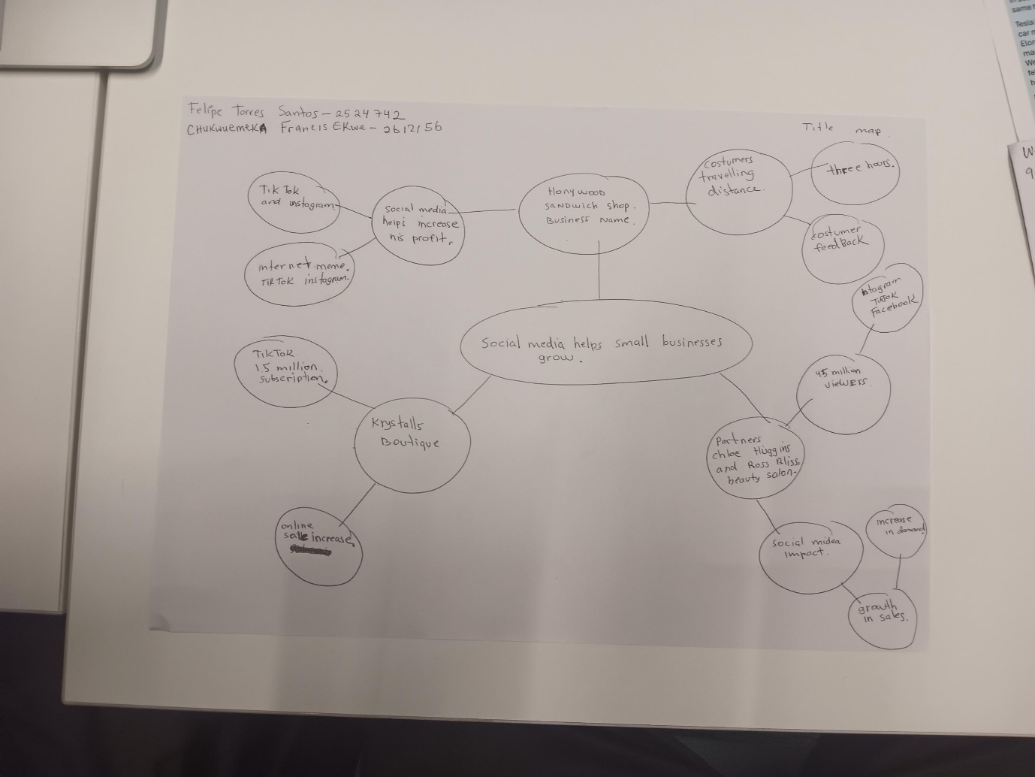

PART 2:
- Answer every question below in 1-3 full sentences.
- Use your own words. Do not use generative AI to answer these questions.
- Include a specific detail from the text when asked.
REMINDER
- The main idea is the overall message of the whole text.
- A key point helps to explain the main idea.
- A specific detail or example from the text shows that the key point is true.

- What is the main idea of the whole text?

The main idea of the whole text is how social media example like TikTok and Instagram made it easier to make business information helps in marketing and increase in growth and maximize profits

- What is one key point that supports the main idea, and which specific example from the text shows this?
The key point that supports the main idea is social media

- What is a different key point that supports the main idea, and which specific example from the text shows this?
Advertising by showing chicken burgers on the menu

- Which part of the text do you think is most important, and why?
Social media because it helps the business information to grow

Reflection:
- What did you find difficult in this task (including in-class components), and why was it difficult?
Reading and reflection

- What helped you with this difficulty, and how did it help you?
My fellow student and my lecturer plus my after class.

