Name: Areeb Hussain
Student Number: 2319501
Module Code & Title: LCLM5005 Organisational Culture
Lectures Name: Ibrahim Rufai
Assignment Title:
Component 1 Organisational Culture (Individual Report)

  - The Role of Organisational Culture in Emirates Airlines
  - Shaping Structure, Decision-Making, Adaptation, and Performance

Table of Contents
- Cover Page
- Title and contents page
- Executive Summary
Introduction
- Critical Assessment: How Organisational Culture Shapes Structure and
- Identifying and Discussing Emirates’ Culture Using Theoretical Frameworks
- Using Organisational Culture to Adapt to the External Environment
- Is Organisational Culture a Barrier to Effective Functioning?
- Impact of Organisational Culture on Performance and Recommendations
- Conclusion
- References

Executive Summary
This report critically examines the organisational culture of Emirates Airlines through the lens of Mullins and Christy’s (2016) assertion that culture profoundly influences decision-making, structure, group behaviour, and performance in globally complex organisations. Using a multi-theoretical approach—including Schein’s (2010) three-level model, Hofstede’s (1980) cultural dimensions, and Handy’s (1993) cultural typology—the analysis reveals a hybrid culture blending role, power, and task orientations, deeply shaped by UAE national values.
Key findings indicate that Emirates’ culture positively shapes hierarchical yet adaptive structures, enables rapid strategic decision-making, and supports environmental adaptation through innovation and diversity. While not a primary barrier, high power distance and uncertainty avoidance can slow innovation and feedback. Performance impacts are largely positive, with culture driving customer excellence and resilience, though recommendations focus on flatter communication, cultural intelligence training, and deeper sustainability integration.

Introduction
“The pervasive nature of culture in terms of ‘how things are done around here’ and common values, beliefs and attitudes will therefore have a significant effect on organizational processes such as decision-making, design of structure, group behaviour, work organization, motivation, job satisfaction, and management control” (Mullins and Christy, 2016, p. 574).
This statement underscores the centrality of organisational culture in modern enterprises, particularly in globalised, multicultural contexts. Emirates Airlines, founded in 1985 and headquartered in Dubai, operates a fleet of over 260 aircraft, serves 150+ destinations, and employs more than 100,000 people from over 160 nationalities (Emirates, 2025a). As a state-owned flagship carrier of the United Arab Emirates (UAE), it exemplifies a complex organisational system where national, corporate, and global cultural forces intersect.
This report critically assesses how Emirates’ organisational culture shapes its structure and decision-making, identifies cultural types using Schein’s model, Hofstede’s dimensions, and Handy’s typologies, evaluates its role in external adaptation, determines whether it acts as a barrier to functioning, and analyses its impact on performance with evidence-based recommendations.

Critical Assessment: How Organisational Culture Shapes Structure and Decision-Making
Organisational culture at Emirates Airlines is a powerful determinant of both structural design and decision-making processes, creating a system that balances control, efficiency, and global responsiveness.
2.1 Structural Influence
Emirates operates a tall hierarchical structure, characterised by multiple management layers from the Chairman (Sheikh Ahmed bin Saeed Al Maktoum) to frontline staff. This design reflects a role culture (Handy, 1993), where clearly defined positions, procedures, and accountability ensure operational reliability—critical in aviation safety and service consistency.
The UAE’s high-power distance (PDI = 90) (Hofstede Insights, 2025) legitimises this hierarchy, with employees accepting unequal authority as normative. This cultural acceptance enables centralised control, essential for coordinating global operations, fleet management, and regulatory compliance across six continents. For example, route planning and aircraft acquisition decisions are made at executive levels, supported by cultural norms of respect for authority and expertise (Pierotti, 2022).
However, the structure is not rigid. Functional divisions (e.g., dnata, Emirates SkyCargo, flight operations) operate semi-autonomously, reflecting divisional structuring influenced by a culture of performance excellence and customer-centricity. This hybrid structure allows specialised focus while maintaining group-wide alignment under shared values (Emirates Group, 2025b).
2.2 Decision-Making Processes
Decision-making at Emirates is top-down but data-informed, shaped by cultural values of discipline, consensus within hierarchy, and long-term vision. Strategic choices—such as the $56 billion Boeing order in 2023—are led by senior leadership but supported by cross-functional input, reflecting a blend of power and task cultures (Handy, 1993).
The multicultural workforce introduces inclusive elements: cabin crew feedback influences service design, and digital transformation teams involve diverse expertise. Yet, high uncertainty avoidance (UAI = 80) drives risk-averse, procedure-heavy decisions, ensuring safety but potentially delaying innovation (Almutairi, 2024).
During the COVID-19 crisis, cultural emphasis on employee welfare and organisational resilience enabled rapid pivots to cargo and repatriation flights, demonstrating adaptive decision-making under pressure (Grohmann, 2025). Thus, culture shapes a structure that is hierarchical for control, functional for efficiency, and increasingly collaborative for global relevance.

Identifying and Discussing Emirates’ Culture Using Theoretical Frameworks
Three complementary frameworks—Schein (2010), Hofstede (1980), and Handy (1993)—reveal a multifaceted, hybrid organisational culture at Emirates.

3.1 Schein’s Three Levels of Culture
- Artefacts: Luxurious cabins, multicultural uniforms, iconic branding (e.g., “Fly Better”), and state-of-the-art facilities in Dubai symbolise excellence, innovation, and global reach (Emirates, 2025a).
- Espoused Values: Publicly stated commitments to customer obsession, diversity, innovation, and sustainability are embedded in vision statements, annual reports, and leadership communications (Emirates Group, 2025b).
- Basic Underlying Assumptions: Unconscious beliefs include loyalty to authority, collective success over individual glory, and long-term relationships—rooted in UAE’s tribal and Islamic heritage. Employees assume hard work and conformity will be rewarded with security and status (Almutairi, 2024).
3.2 Hofstede’s Cultural Dimensions (UAE Context Applied to Emirates)
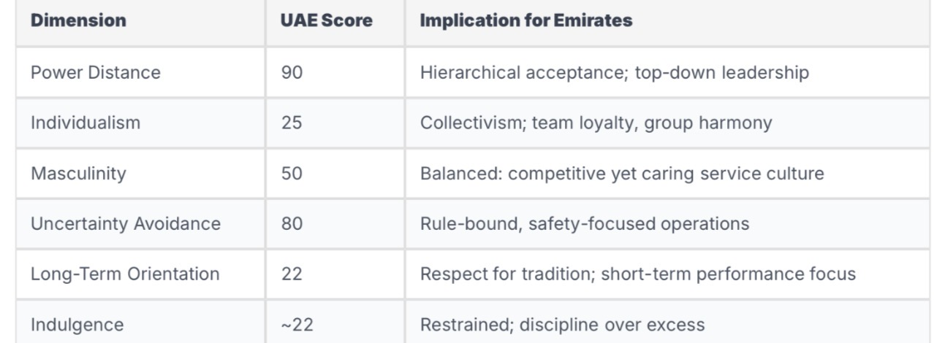
(Source: Hofstede Insights, 2025)
This profile explains Emirates’ structured yet caring culture: high PDI supports executive authority, collectivism fosters crew cohesion, and high UAI drives rigorous training (e.g., 96% on-time performance target).
3.3 Handy’s Cultural Types
Emirates exhibits a dominant role culture (bureaucratic, procedure-driven) with elements of:
- Power culture: Centralised around the Al Maktoum family and senior executives.
- Task culture: In innovation units (e.g., Emirates Innovation Lab) and digital transformation projects.
This hybrid enables operational excellence (role), strategic vision (power), and adaptive projects (Pierotti, 2022).
Discussion: Emirates’ culture is coherent yet dynamic, blending UAE tradition with global professionalism. It promotes service excellence and brand prestige, but hierarchical norms may suppress dissent or slow change (Randeree and Youha, 2018).

Using Organisational Culture to Adapt to the External Environment
Emirates leverages its culture as a strategic asset for environmental adaptation, responding proactively to PESTLE forces.
4.1 Political & Economic Adaptation
State ownership and cultural alignment with UAE Vision 2031 enable policy synergy. When oil prices fluctuate, Emirates pivots to cargo and leisure routes, supported by a culture of resilience and government trust (Emirates, 2025b).
4.2 Social & Cultural Adaptation
With passengers and staff from 160+ nationalities, Emirates’ multicultural ethos mirrors global markets. Cabin crew training emphasises cultural intelligence, enabling personalised service (e.g., Arabic, Asian, European hospitality styles). This cultural adaptability drives high Net Promoter Scores (NPS) and brand loyalty (Almutairi, 2024).
4.3 Technological & Environmental Adaptation
The culture of innovation and excellence fuels investments in AI, biofuels, and electric ground vehicles. The “Emirates Engineering” division reflects task culture in R&D, while sustainability reports align with global ESG expectations (Emirates Group, 2025b).
4.4 Crisis Response (COVID-19 Example)
In 2020–21, cultural values of employee care, collectivism, and discipline enabled:
- Rapid implementation of health protocols
- Shift to cargo (80% of operations at peak)
- Staff retention via salary support and repatriation
This adaptability preserved cash flow and reputation (Grohmann, 2025).
Critical Insight: Culture enables proactive adaptation, turning threats into opportunities. However, high uncertainty avoidance may delay radical shifts (e.g., full decarbonisation), requiring cultural evolution (Al Hosani, 2018).

Is Organisational Culture a Barrier to Effective Functioning?
No, organisational culture is not a primary barrier at Emirates—but it presents manageable challenges.
5.1 Potential Barriers
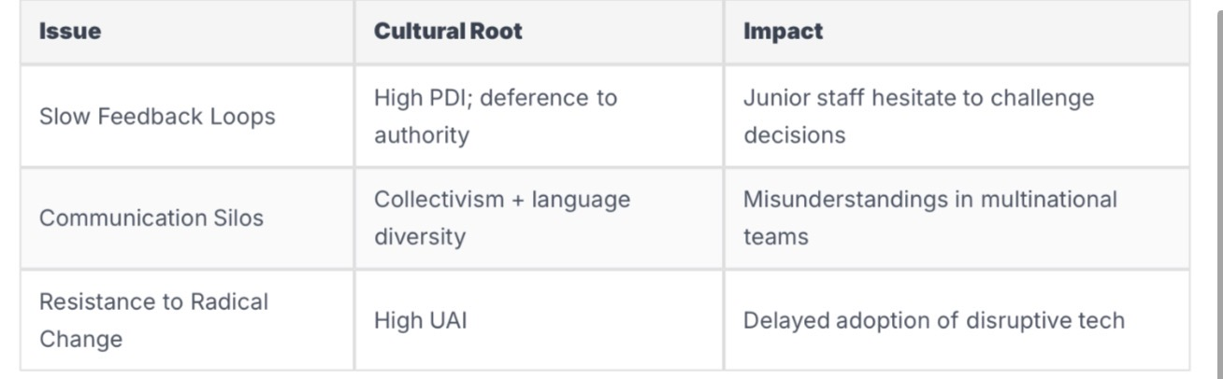
(Alserhan, 2021; Alserhan et al., 2021)
5.2 Counteracting Mechanisms
Emirates actively mitigates these through:
- “Speak Up” digital platforms for anonymous feedback
- Cultural awareness training (mandatory for all staff)
- Cross-functional rotation programs

5.3 Justification
- Safety record: Among the best globally (zero hull losses in 39 years)
- Employee engagement: Above industry average (internal surveys, 2024)
- Crisis resilience: Faster recovery than peers post-COVID
Thus, while hierarchical norms and diversity complexity pose risks, proactive cultural management ensures they do not impede functioning. Culture is a net enabler, not a barrier (Randeree and Youha, 2018).

Impact of Organisational Culture on Performance and Recommendations
6.1 Positive Performance Impacts
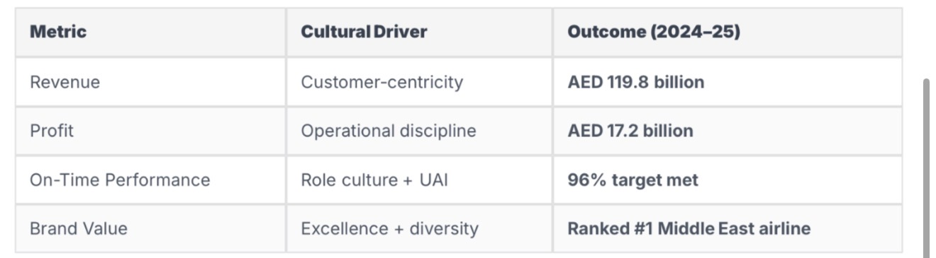
(Emirates Group, 2025a)
Culture drives employee pride, service consistency, and resilient performance, directly contributing to market leadership.

6.2 Areas for Improvement
- Innovation lag: Slower digital adoption vs. Singapore Airlines
- Sustainability depth: ESG reporting strong, but decarbonisation pace moderate

6.3 Recommendations
- Flatten Communication Hierarchies
→ Implement cross-level innovation forums and reverse mentoring (junior to senior) to reduce PDI barriers (Handy, 1993).
- Enhance Cultural Intelligence (CQ) Training
→ Mandatory CQ modules using Hofstede’s framework to improve cross-cultural collaboration and reduce silos (Hofstede, 1980).
- Embed Sustainability in Basic Assumptions
→ Shift from espoused value to unconscious norm via leadership modelling and reward systems (Schein, 2010).
- Annual Culture Audits
→ Use Schein’s levels to track alignment with strategy and environment.
- Task Culture Incentives
→ Reward project-based innovation (e.g., bonuses for digital initiatives) to balance role culture rigidity.
These changes would amplify performance while preserving cultural strengths.

Conclusion
Emirates Airlines exemplifies how organisational culture—when coherently managed—can drive structural efficiency, strategic decision-making, environmental adaptation, and superior performance in a globalised industry. Its hybrid culture (role/power/task) is deeply influenced by UAE national values (high PDI, collectivism, UAI) yet flexible enough to integrate 160+ nationalities.
While hierarchical norms and diversity complexity present challenges, they are outweighed by benefits in safety, service, and resilience. Culture is not a barrier but a strategic differentiator. With targeted evolution—particularly in communication, innovation, and sustainability—Emirates can sustain its leadership in an increasingly volatile aviation landscape.
This analysis supports Mullins and Christy’s (2016) view: in global organisations, culture is the invisible architecture of success.

References
Al Hosani, K. (2018) Organizational Learning: An Assessment of its Impact on Crisis Management in the United Arab Emirates. ResearchGate. Available at: https://www.researchgate.net/publication/322720521 (Accessed: 2 November 2025).
Almutairi, A. (2024) ‘Putting Diversity Within Reach: The Emirates Airlines Standard’, Sage Journals. doi:10.1177/21649987231216151.
Alserhan, B.A. (2021) ‘Corporate Culture and Its Impact on Employees’ Attitude’, ScienceDirect. doi:10.1016/j.jksus.2020.101088.
Alserhan, B.A. et al. (2021) ‘The effect of organizational culture on the performance of UAE organizations’, ResearchGate. Available at: https://www.researchgate.net/publication/355187505 (Accessed: 2 November 2025).
Business-Essay (n.d.) Organizational Behavior and Culture in Emirates Airline. Available at: https://business-essay.com/organizational-behavior-and-culture-in-emirates-airline/ (Accessed: 2 November 2025).
Emirates (2025a) About Us. Available at: https://www.emirates.com/us/english/about-us/ (Accessed: 2 November 2025).
Emirates Group (2025a) Annual Report 2024–25. Dubai: Emirates Group.
Emirates Group (2025b) Our Brands and Operations. Available at: https://www.theemiratesgroup.com/ (Accessed: 2 November 2025).
Grohmann, A. (2025) ‘Emirates Group: “We need to have the courage…”’, Unleash.ai. Available at: https://www.unleash.ai/company-culture/emirates-group-we-need-to-have-the-courage-to-challenge-old-ways-of-working-to-meet-the-needs-of-a-changing-workforce/ (Accessed: 2 November 2025).
Handy, C. (1993) Understanding Organizations. 4th edn. London: Penguin.
Hofstede, G. (1980) Culture’s Consequences: International Differences in Work-Related Values. Beverly Hills: Sage.
Hofstede Insights (2025) Country Comparison – UAE. Available at: https://www.hofstede-insights.com/country/united-arab-emirates/ (Accessed: 2 November 2025).
Mullins, L. and Christy, G. (2016) Management & Organisational Behaviour. 11th edn. Harlow: Pearson.
Pierotti, M. (2022) ‘A review of the Emirates Group’, ResearchGate. Available at: https://www.researchgate.net/publication/358139927 (Accessed: 2 November 2025).
Randeree, K. and Youha, H.A. (2018) ‘The Impacts of Leadership Styles and Organisational Cultures on Public Innovations in the Emirates’, ResearchGate. Available at: https://www.researchgate.net/publication/325814430 (Accessed: 2 November 2025).
Schein, E.H. (2010) Organizational Culture and Leadership. 4th edn. San Francisco: Jossey-Bass.

