Group written Report
(component 2)
Module name and code: Academic Skills LCBB4006
Program of study: Bachelor of Arts Business Management
Lecturer Name: Valentina Bartali
Student name and number:
- Andreea Alina Tudorache 2130698
- Mihaela Hermeneanu 2310013
- Magdalena Vintila 2216452
- Roland Mihai Baba 2216968

Introduction 2
Understanding Team Dynamics and Theories of Group Management 2
Exploring the Concept of Teamwork: 2
Theories and Models of Managing Groups: 2
Key Concepts in Team Development: 4
Real-World Examples of Effective Teamwork 5
Case Studies in Successful Team Collaboration: 5
Analysing High-Performing Teams: 6
Lessons from Exemplary Teamwork Scenarios: 6
Evaluating the Effectiveness of Different Management Approaches and Theories 7
Comparative Analysis of Team Management Theories: 7
Strengths and Weaknesses of Various Team Management Approaches: 8
Measuring Success and Efficiency in Teamwork: 9
Recommendations for Enhancing Team Performance and Management 9
Best Practices for Building and Sustaining Effective Teams: 9
Implementing Improvements in Teamwork: 10
Strategies for Maximizing Group Productivity and Collaboration: 10
Overcoming Common Challenges in Group Management: 10
Conclusion 11
Reference list: 12
Appendix 13

Introduction
The conversation has covered a wide range of ground, but maybe it has shed some light on the fundamentals of what makes for high-performing teams in terms of team dynamics, management philosophies, and successful teamwork. It started with an in-depth exploration of teamwork, discussing different ideas and approaches for managing groups and highlighting crucial components of team building. Subsequently, real-world examples demonstrated the practical implementation of good teamwork, putting light on the triumphs of organisations like SpaceX and the New Zealand All Blacks. In the evaluation part, we looked at how various theories of team management, management styles, and success indicators stack up against one another. Finally, suggestions for improving team performance and management were offered, touching on issues of both group dynamics and management.

Understanding Team Dynamics and Theories of Group Management

Exploring the Concept of Teamwork:
Teamwork is an essential component of today's modern businesses, which place an emphasis on combining the efforts of personnel equipped with a wide range of skills and capabilities to accomplish shared objectives. Collaboration is an extremely important skill to have in the business sector because it helps to increase production, stimulate creativity, and adapt to changing situations. It is vital for good teamwork to include the management of group dynamics as well as the application of a variety of theories and models for increasing the effectiveness of teams (Zaheer et al., 2019). The definition of teamwork is when individuals collaborate in order to achieve a common objective and do a better job of it than any one individual could do on their own. When partners in a relationship take on diverse tasks while still working together cohesively, the relationship thrives. There are many different sorts of teams, such as those that focus on particular projects, those that collaborate across departments, those that operate remotely, and so on. Teamwork entails a deeper level of collaboration when individuals actively support one another, share what they've learned, and work towards achieving a common objective (Nkomo et al., 2019). Working together is only one aspect of what it means to collaborate effectively in a team setting.

Theories and Models of Managing Groups:
Understanding the theories and concepts that govern the dynamics of teams and groups is essential for the effective management of these collectives. Over the years, numerous influential ideas and models have evolved, shedding light on the intricacies of group dynamics and leadership. Here are a few examples:
Tuckman's Stages of Group Development: According to the five-stage model developed by Bruce Tuckman, teams go through the following phases: forming, storming, norming, performing, and disbanding (WCUPA, 2022). This model describes the normal development of a team from its inception to its full potential, with the leader facing new and different obstacles at each step.
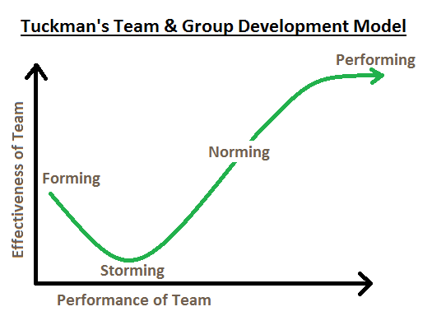
Figure: Tuckman's Stages of Group Development
(Source: WCUPA, 2022)
Belbin's Team Role Theory: According to the work of Dr Meredith Belbin, different members of a team take on different responsibilities, such as acting as the team's coordinator, implementer, or resource investigator. The team's dynamics and output can benefit from a deeper understanding of these roles and an equitable distribution of role types across team members (TSW, 2021).
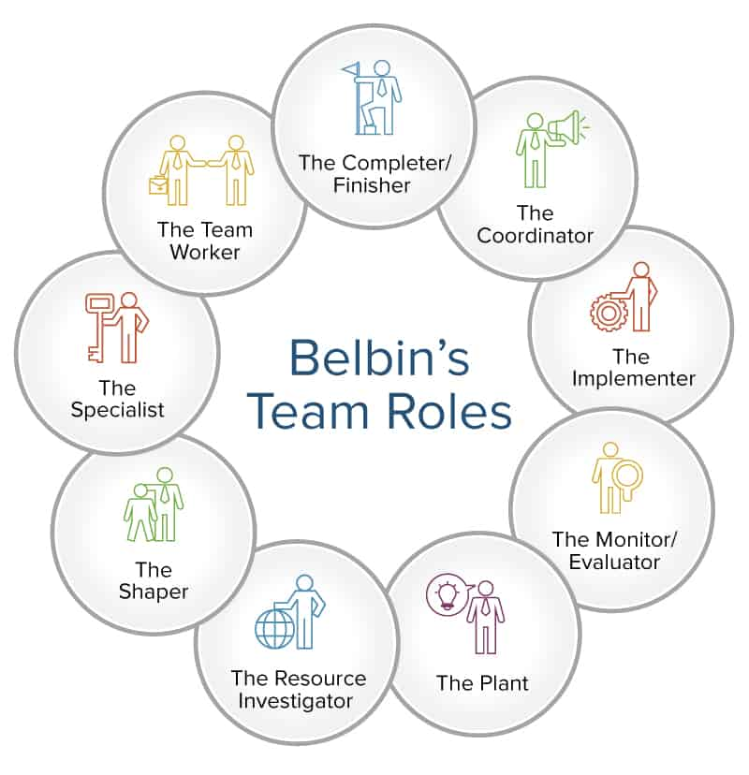
Figure: Belbin's Team Role Theory
(Source: TSW, 2021)
Hackman's Model of Team Effectiveness: In Richard Hackman's paradigm, establishing favourable conditions is given primary importance (HBR, 2019). He stresses the importance of things like well-defined objectives, sensible organisation, a positive work environment, and a skilled staff.
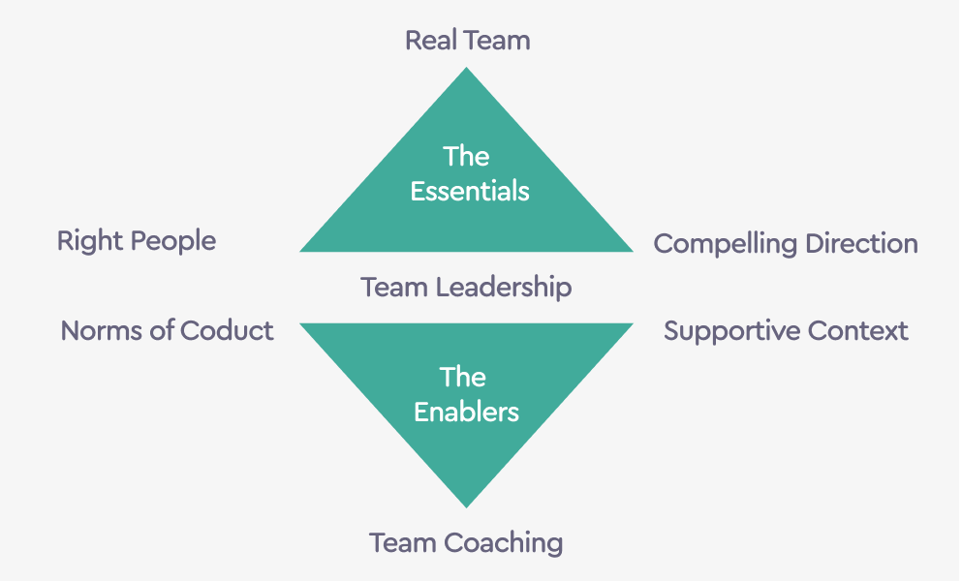
Figure: Hackman's Model of Team Effectiveness
(Source: HBR, 2019)

Key Concepts in Team Development:
To foster effective teamwork, organizations must consider key concepts in team development, which include:
- Trust and Psychological Safety: The cornerstone of productive groups is trust. Members need to be able to speak freely and take intelligent risks without fear of reprisal. A climate of psychological safety fosters honest communication and new ideas.
- Communication: The success of any group depends on its members' ability to exchange ideas, resolve disagreements, and work together towards a common goal. Effective teams value and practise consistent, open, and honest communication (Ali et al., 2021).
- Roles and Responsibilities: Members' contributions to the team's success can be better understood if their roles and responsibilities are specified in advance. Confusion and friction can arise when roles are not defined (Nkomo et al., 2019).
- Diversity and Inclusion: Teams perform better when they have members with different backgrounds, expertise, and viewpoints. Inclusive practises guarantee that all team members have a voice and may contribute to 1their full capacity.
- Feedback and Continuous Improvement: Individual and group feedback at regular intervals helps teams zero in on problem spots. Teams that dedicate themselves to lifelong education and improvement see significant gains in output over time.

Real-World Examples of Effective Teamwork

Case Studies in Successful Team Collaboration:
From business to medicine to sports to technology, successful teams are essential to achieving goals. Understanding what makes high-performing teams tick and how they get things done can be greatly aided by looking at real-world case studies of effective team collaboration.
SpaceX's Falcon 9 Team:
SpaceX, Elon Musk's aircraft manufacturer and space transportation enterprise, is widely regarded as a pioneer in the field. One of the prominent examples of excellent teamwork is the Falcon 9 rocket development and launches. The Falcon 9 crew's excellent teamwork ensured timely innovation, reduced expenses, and numerous mission successes. Engineers, designers, and technicians collaborated to improve the rocket's design and launch procedures through iterative iteration and the application of lean startup principles, agile development approaches, and continuous feedback loops (Proctor and Vu, 2019). This strategy enables SpaceX to revolutionise space travel by developing reusable rockets and substantially cutting launch costs.
Key takeaways:
- When applied to complicated projects, agile approaches and fast iteration can increase creativity and productivity.
- It is essential for diverse teams to constantly communicate and work together.
The 2010 Chilean Miners' Rescue:
When 33 miners were lost in the 2010 Copiapó mining tragedy in Chile, the entire globe took notice. Their successful rescue operation was a tribute to their cohesive teamwork. Under intense time constraints, a team consisting of engineers, doctors, psychiatrists, and government officials successfully formulated a strategy for the rescue of the miners (Proctor and Vu, 2019). Everyone in the team was essential to the mission's success. The organisation of the rescue operation relied heavily on open lines of communication, flexibility, and determination.
Key takeaways:
- The ability to work together effectively in times of crisis is crucial.
- The ability to solve problems as a whole requires a wide range of skills and perspectives.

Analysing High-Performing Teams:
There are commonalities among highly effective teams that serve as a foundation for their success. Let's examine these characteristics by looking at various examples:
Google's X Team (formerly Google X):
Some of Google's most forward-thinking endeavours, such as Google Glass and autonomous vehicles, are the work of the company's X Team. The team's accomplishments stem from its willingness to engage in "moonshot thinking." Setting ambitious, world-changing goals and fostering creative risk-taking, the X Team creates a culture where failure is viewed as a learning opportunity (Rohm, Stefl and Ward, 2021). This strategy encourages team members to explore breakthrough ideas, challenge limits, and eventually create exceptional results.
Key takeaways:
- Innovation can be fostered in a setting that rewards risk-taking and outside-the-box thinking.
- The ability to view setbacks as learning opportunities is a key characteristic of high-performing teams.
The New Zealand All Blacks Rugby Team:
The All Blacks are widely regarded as one of the best rugby teams ever. The foundation of their unwavering success is a tight-knit group dynamic they call "Whakapapa." The ethos of this team places a premium on modesty, regard, and loyalty to its history. Players for the All Blacks are held to these standards both on and off the pitch, and this has helped them achieve lasting success (Rohm, Stefl and Ward, 2021).
Key takeaways:
- When it comes to building a strong and effective team, team culture is crucial.
- The concepts of values-based leadership can help a team reach its full potential.

Lessons from Exemplary Teamwork Scenarios:
Insightful insights about effective teamwork can be gleaned from real-world instances. The following are some generalisations:
- Communication and Openness: Effective teamwork necessitates open and honest communication across members. Teams that value open communication, constructive criticism, and sharing of information are better able to work, adapt, and find solutions to challenges (Tannenbaum and Salas, 2020). Both the Falcon 9 team at SpaceX and the rescuers of the Chilean miners stress the need for clear and concise communication.
- Diversity and Inclusion: Greater strength in decision-making and innovation is achieved when team members bring unique experiences and viewpoints to the table. Google's X Team is a shining example of the benefits that may be gained from a diverse team makeup and their "moonshot thinking" approach to problem-solving (Tannenbaum and Salas, 2020).
- Trust and Shared Values: Trust and common values are cornerstones of high-performing teams. Long-term success may be fueled by a trusting and principled team culture, as seen by the New Zealand All Blacks.
- Adaptability and Innovation: Groups that are flexible, creative, and open to new ideas are more likely to succeed. The ability to quickly adjust to new circumstances and try out risky ideas are two characteristics shared by high-performing teams, as evidenced by SpaceX's innovative approach to rocket development and Google's openness to unconventional concepts.

Evaluating the Effectiveness of Different Management Approaches and Theories

Comparative Analysis of Team Management Theories:
There are a number of theories on team management that have been put forth to aid leaders in structuring effective teams. Let's do a little bit of comparing and contrasting among these theories:
Tuckman's Stages of Group Development:
The five stages of team development described by Bruce Tuckman's model—Forming, Storming, Norming, Performing, and Adjourning—offer an organised framework for studying the dynamics of groups throughout time. It highlights the normal development of teams through these phases and helps managers adjust their approach accordingly.
Strengths:
- Provides a structured approach to building effective teams.
- Facilitates foresight and action when leaders face and overcome typical obstacles (WCUPA, 2022).
- Fosters an appreciation for the ever-changing character of teams.
Weaknesses:
- Potentially oversimplifies the nuanced dynamics of effective teams.
- The order in which different teams complete these steps can vary widely.
Belbin's Team Role Theory:
The theory of Meredith Belbin classifies team members into predetermined roles, such as coordinator, implementer, and resource investigator (Rönkkö and Cho, 2022). The dynamics of a team can benefit from a better understanding and distribution of these positions.
Strengths:
- Offers a workable method for evaluating team members and allocating responsibilities.
- Fosters a more inclusive team environment.
- recognises the significance of individual contributions to the team's success (TSW, 2021).
Weaknesses:
- The intricacy of people's contributions could be oversimplified by reducing them to their assigned roles.
- There may be a lack of adaptability if people do not easily fit into predetermined positions (Krizanova et al., 2019).
Situational Leadership Theory:
Hersey and Blanchard's Situational Leadership Theory suggests that leaders' approaches need to change depending on how prepared or experienced their team members are. This method emphasises a leader's capacity to modify their approach depending on the team's development level (Zeithaml et al., 2020).
Strengths:
- Encourages leaders to think on their feet.
- Recognises the necessity of individualised leadership.
- Adapts method of leadership to the requirements of the group.
Weaknesses:
- Requires leaders to be very adaptive and intuitive.
- Potentially lacks specific recommendations about how leaders should act.

Strengths and Weaknesses of Various Team Management Approaches:
The advantages and disadvantages of various methods of team management vary widely depending on the circumstances and requirements of the team in question. Some broad things to think about are as follows:
Autocratic Leadership:
- Fast decision-making under pressure is a strength.
- a point in the right direction.
- Effective in structured hierarchies.
Weaknesses:
- Possible impediment to originality and progress.
- Can dampen enthusiasm and lower morale in the workplace (Rönkkö and Cho, 2022).
- Few openings for group contribution and cooperation.
Transformational Leadership:
Strengths:
- Motivates others to do their best work as a team.
- Encourages originality and a zest for change.
- Improves engagement and loyalty in the team.
Weaknesses:
- Not ideal, possibly especially in highly regimented settings.
- Depends a lot on the charisma and persuasion of the leader.
- needs consistent training and encouragement for leaders.
Servant Leadership:
Strengths:
- Encourages caring for and helping one's teammates.
- Encourages people to open up to one another and work together (Krizanova et al., 2019).
- Promotes individual responsibility and accountability on the team.
Weaknesses:
- Could be interpreted as being overly lenient at times.
- needs a serious dedication to helping team members grow.
- Organisational hierarchies can make this approach ineffective.

Measuring Success and Efficiency in Teamwork:
Measuring the efficacy of a team's efforts is crucial for making progress and meeting targets. Important criteria and techniques of assessment include:
- Key Performance Indicators (KPIs): Establish team goals-based KPIs. Examples include completion time, error rates, customer satisfaction, and revenue growth. Regularly measure these KPIs to track progress and identify issues.
- Team satisfaction surveys: To assess team happiness and fix difficulties, conduct frequent surveys or feedback sessions. High team satisfaction boosts output and productivity (Krizanova et al., 2019).
- Feedback 360: Team members, peers, and supervisors should provide feedback on team performance. This input may reveal strengths and weaknesses.
- Team Retrospectives: Periodic retrospectives or post-project reviews can improve team performance, lessons learned, and change recommendations. This strategy promotes continuous progress.

Recommendations for Enhancing Team Performance and Management

Best Practices for Building and Sustaining Effective Teams:
- Clearly Define Roles and Responsibilities: Make sure everyone on the team knows what they're supposed to be doing and how it will help the group succeed. This reduces misunderstanding and increases accountability.
- Foster Trust and Psychological Safety: Make it such that everyone on the team can speak freely and honestly without worrying about what others may think of them. Creating a climate of trust and psychological safety fosters candid dialogue and stimulates original thought (Bansal et al., 2021).
- Establish Clear Goals and Objectives: Create SMART (Specific, Measurable, Achievable, Relevant, and Time-bound) objectives that further the organization's stated purpose. These objectives give a shared vision and purpose for the team.
- Encourage Diversity and Inclusion: Make sure the teams have people from a wide range of experiences and opinions. Make use of the group's synergy in terms of knowledge, ideas, and solutions by emphasising the diversity of thought and approach.

Implementing Improvements in Teamwork:
- Continuous Learning and Development: Provide opportunities for team members to learn and grow. Foster a culture of lifelong learning and skill development to maintain a competitive edge in a dynamic workplace.
- Regular Feedback and Evaluation: Make it a team norm to provide and receive feedback. In order to enhance procedures and outcomes, it is important to periodically assess team performance, solicit input from team members, and make improvements as needed.
- Effective Communication Channels: Make sure everyone on the team has easy access to a variety of different communication channels. Among these are IM, project management software, email, and meetings (Kremer, Villamor and Aguinis, 2019).
- Agile and Adaptive Approach: Adopt a growth mentality and agile practices that facilitate flexibility and rapid reaction to novel situations. It's important to be flexible in the approach and methods.

Strategies for Maximizing Group Productivity and Collaboration:
- Set Clear Expectations: Set performance, timeliness, and communication standards. Clear instructions help team members comprehend and avoid misunderstandings.
- Collaboration Tools: Teams can use programming and resources while separated. Collaboration and project management are easier using Slack, Trello, and Zoom.
- Team Building Activities: Team-building events foster trust and friendship. Activities like this can reduce workplace stress and promote morale (Northrup et al., 2021).
- Recognition and Reward Systems: Reward and recognise team members for outstanding performance. Recognition and rewards encourage teamwork and excellence.

Overcoming Common Challenges in Group Management:
- Conflict Resolution Skills: Leaders need conflict resolution training to resolve issues swiftly and effectively. Communicate honestly to reach mutually beneficial conclusions.
- Manage Time: Prioritise, use project management tools and meet deadlines to keep the team on track.
- Burnout Prevention: Monitor team workload and set limitations to avoid burnout. Manage stress and mental wellness and promote work-life balance.
- Change Management: Leading a group through organisational changes is crucial. Create a transition strategy that involves personnel in decision-making and transparent updates (Northrup et al., 2021).
- Conflict of Interest Resolution: Conflicts of interest must be managed by the team to ensure honesty and fairness. Create moral principles for dispute resolution.

Conclusion
The importance of teamwork in many fields is emphasised by the conclusive examination of team dynamics, management theories, and productive teamwork. The discourse has emphasised the need for learning and using varied management approaches, from the genesis of teamwork principles to examples of remarkable achievements in the actual world. The comparative analysis has illuminated the benefits and drawbacks of different methods, supplying decision-makers with a useful framework. In addition, the importance of KPIs and methods for continual improvement was emphasised. The supplied advice encompasses best practices for team management, optimisation tactics, and the resources needed to overcome typical obstacles. In essence, this debate provides a comprehensive manual for improving team output and leadership.

Reference list:
Ali, M. et al. (2021) ‘Linking humble leadership and project success: the moderating role of top management support with the mediation of team-building.’ International Journal of Managing Projects in Business, 14(3), pp.545-562.
Bansal, G. et al.( 2021) ‘Does the whole exceed its parts? the effect of ai explanations on complementary team performance.’ CHI Conference on Human Factors in Computing Systems 2021 (pp. 1-16).
HBR (2019) The Secrets of Great Teamwork. Available at https://hbr.org/2016/06/the-secrets-of-great-teamwork [Accessed on 5th November 2023]
Kremer, H., Villamor, I. and Aguinis, H. (2019) ‘Innovation leadership: Best-practice recommendations for promoting employee creativity, voice, and knowledge sharing.’ Business Horizons, 62(1), pp.65-74.
Krizanova, A. et al. (2019) ‘The effectiveness of marketing communication and the importance of its evaluation in an online environment.’ Sustainability, 11(24), p.7016.
Nkomo, S.M. et al. (2019) ‘Diversity at a critical juncture: New theories for a complex phenomenon.’ Academy of Management Review, 44(3), pp.498-517.
Northrup, H. et al. (2021) ‘Updated international tuberous sclerosis complex diagnostic criteria and surveillance and management recommendations.’ Pediatric Neurology, 123, pp.50-66.
Proctor, R.W. and Vu, K.P.L. (2019) ‘How psychologists help solve real-world problems in multidisciplinary research teams: Introduction to the special issue.’ American Psychologist, 74(3), p.271.
Rohm, A.J., Stefl, M. and Ward, N. (2021) ‘Future proof and real-world ready: the role of live project-based learning in students’ skill development.’ Journal of Marketing Education, 43(2), pp.204-215.
Rönkkö, M. and Cho, E., (2022) ‘An updated guideline for assessing discriminant validity.’ Organizational Research Methods, 25(1), pp.6-14.
Tannenbaum, S. and Salas, E. (2020) Teams that work: the seven drivers of team effectiveness. Oxford University Press.
TSW (2021) ‘Belbin’s Team Roles: How Can Team Roles Improve Performance In The Workplace?’ Available at https://www.tsw.co.uk/blog/leadership-and-management/belbins-team-roles/ [Accessed on 5th November 2023]
WCUPA (2022) ‘TUCKMAN'S STAGES OF GROUP DEVELOPMENT’. Available at https://www.wcupa.edu/coral/tuckmanStagesGroupDelvelopment.aspx#:~:text=These%20stages%20are%20commonly%20known,more%20collaborative%20or%20shared%20leadership. [Accessed on 5th November 2023]
Zaheer, S. et al. (2019) ‘The turnover intention of hospital staff in Ontario, Canada: Exploring the role of frontline supervisors, teamwork, and mindful organizing.’ Human resources for health, 17(1), pp.1-9.
Zeithaml, V.A. et al. (2020) ‘A theories-in-use approach to building marketing theory’. Journal of Marketing, 84(1), pp.32-51.

Appendix
Student 1: Andreea Alina Tudorache 2130698
Writing on: Introduction, understanding team dynamics and teories of group management, exploring the concept of teamwork, theories and managing of managing people.
Student 2: Mihaela Hermeneanu 2310013
Writing on key concepts in team development, case studies in successful team collaboration, analysing high performing teams, lessons from exemplary teamwork scenarios.
Student 3: Magdalena Vintila 2216452
Writing on comparative analysis of team management theories, strengths and weaknesses of various team management approaches, measuring success and efficiency in teamwork
Worked on references list (making the references in Harvard style)
Student 4: Roland Mihai Baba 2216968 (leader)
Writing on: Recommendations for enhancing team performance and management: best practises for building and sustaining effective teams, implementing in teamwork, strategies for maximising group productivity and collaboration, overcoming common challenges in group management, Conclusion.
Worked on revising the work and any mistakes.
Everyone worked individually on his part of the essay but also helped each other as a team.

