jOHNSON & jOHNSON
The Current Strategic Position of Johnson & Johnson Determined using the Strategic Formulation Framework

1601299 - Jade Farley
SBUS6104- Contemporary Themes in e-Business

Executive Summary
This report utilises the Strategy-Formulation Framework to identify competitive strategies for Johnson & Johnson, based on internal and external factors of influence to them. The recommended strategies for Johnson & Johnson are to;
- Increase research and development in releasing innovative products in response to increases in chronic diseases and changes in consumer demands, as Johnson & Johnson remain below the industry average for research and development
- Continue to improve on product recalls, to give a better-quality perception and improve brand reputation
- Increase the number of acquisitions as these have proven successful for Johnson & Johnson in previous years and are an important means of growth for players in this industry.
The finding from a number of the matrix suggest that Johnson & Johnson should consider backward, forward and horizontal integration, market penetration, market development and product development which is congruent with the recommendations made. This framework allowed for the strategies to be considered simultaneously, however, the decisions were based on uneducated judgements and therefore the reliability of the outcomes are affected.

Table of Contents
Executive Summary 1
1.0 Introduction 3
1.1 Johnson & Johnson Background 3
1.2 The Strategy-Formulation Framework 3
2.0 The Strategy-Formulation Framework Applied to Johnson & Johnson 4
2.1 The Input Stage 4
2.1.1 External Audit 4
2.1.2 Competitive Profile Matrix (CMP) 5
2.1.3 External Factor Evaluation Matrix (EFE Matrix) 6
2.1.4 Internal Audit 7
2.1.5 Internal Factor Evaluation Matrix (IFE Matrix) 8
2.2 The Matching Stage 9
2.2.1 Threats-Opportunities-Weaknesses-Strengths Matrix (TOWS Matrix) 10
2.2.2 Strategic Position and Action Evaluation Matrix (SPACE Matrix) 11
2.2.3 Grand Strategy Matrix (GS Matrix) 12
2.2.4 Internal External Matrix (IE Matrix) 13
2.3 The Decision Stage 14
2.3.1 Quantitative Strategic Planning Matrix (QSPM) 14
3.0 Evaluation of the Use of the Strategy-Formulation Framework as a Contemporary e-Business System for Gaining Competitive Advantage 15
4.0 Conclusion 16
References 17
Appendix 20

Introduction

Johnson & Johnson Background
Johnson & Johnson are the world’s largest and most broadly-based healthcare company, engaging in the research and development, manufacture and sale of a range of products in the healthcare field (Johnson & Johnson, 2019). Founded in America in 1886, Johnson & Johnson operate through three segments; Consumer, Pharmaceutical and Medical Devices (Reuters, 2019). Johnson & Johnson’s vision is, ‘Be yourself change the world’, as the brand believes that every person should use their unique experiences and backgrounds, together- to spark solutions that create a better, healthier world (Johnson & Johnson, 2019). Johnson & Johnson’s mission is to, ‘make diversity & inclusion how we work every day', by advancing their culture of belonging where open hearts and minds combine to unleash the potential of the brilliant mix of people in every corner of Johnson & Johnson (Johnson & Johnson, 2019).

The Strategy-Formulation Framework
The Strategy-Formulation Framework was developed by Fred David to assist businesses in developing strategies to obtain competitive advantage (David, 2016). Electronic commerce or business can be described a paradigm shift as it is, “More than just another way to sustain or enhance existing business practices” (Lee, 2001). Electronic commerce is an innovation which is dramatically changing the traditional way of doing business. Under the conditions of a fast changing environment, the Strategy-Formulation Analytical Framework is effective in, “assisting e‐commerce planners and strategic managers in assessing the critical success factors when formulating e‐commerce business models and strategies” (Lee, 2001).

The Strategy-Formulation Framework Applied to Johnson & Johnson

The Input Stage
The input stage summarises the basic input information needed to formulate strategies. “Making small decisions in the input matrices regarding the relative importance of external and internal factors allow strategists to more effectively generate and evaluate alternative strategies” (Osman, 2012).

External Audit
See Figure 1.0 in Appendix for detailed opportunities and threats of Johnson & Johnson.
Opportunities
- Opening-up of new markets due to government free trade agreement (Kyodo, 2019).
- Developments of medical devices and diagnostics (European Commission, 2017).
- Changes in consumer behaviour trends (Langston, 2019).
- Stable free cash flow allows for investment opportunities (Boyd, 2019).
- New environmental policies (Johnson & Johnson, 2019).
- Low inflation rate (Trading Economics, 2019)
- Diverse portfolio of solutions - many untapped opportunities for cross-selling products (Johnson & Johnson, 2019).
- Further acquisition opportunities (Crow, 2016).
- Generic medicines ban in some countries (Andalo, 2016).
- Research and Development (Johnson & Johnson, 2019).
- Increase of chronic disease (Air Liquide, 2018).
Threats
- Seasonal demand of highly profitable products (Johnson & Johnson, 2019).
- New environment regulations (United Nations, 2018).
- US trend toward isolationism (Petersen, 2017).
- Rising pal level (Cox, 2018).
- Intense Competition (Pfizer and Novartis) (Bhasin, 2018).
- Product release dependent on regulatory approval more so than market acceptance (Torjesen, 2015).
- Product Recalls (Miller, 2018).
- Generic pharmaceutical products (Hahn, 2018).
- Fight against harmful ingredients (Wischhover, 2018).
- BREXIT brings uncertainty in European market (Reuters, 2018)

Competitive Profile Matrix (CMP)
“Through the competitive profile matrix, companies can find out, which are the areas where they need to be strong in, and which are the ones where they need to improve” (Bhasin, 2018). This is done by analysing the main competitors in the market and assessing several success specific factors, such as; market share, range of products, brand reputation, etc.
Figure 2.0 Competitive Profile Matrix of Johnson & Johnson 2019
Figure 2.0 demonstrates the Competitive Profile Matrix of Johnson & Johnson for 2019. Pfizer and Novartis have been identified as Johnson & Johnson’s key competitors. Figure 2.1, in the Appendix, demonstrates the Competitive Profile Matrix of Johnson & Johnson for 2009. In 2009, Johnson & Johnson’s key competitors were Pfizer and Procter & Gamble. In 2009, research and development held the greatest weight baring as a critical success factor for the brand. Today this remains the same, however Johnson and Johnson have dipped in their rating of the success factor, due to falling below the industry average for research and development. In 2009, Johnson and Johnson scored well in terms of product quality compared to their competitors, however in 2019, Johnson and Johnson have experienced a number of issues regarding their product quality, subsequently they are now rated below their competitors in terms of product quality. In 2009, Johnson & Johnson received an overall weighted score of 3.38 for their critical success factors, with Pfizer scoring just 3.19. However, in 2019, factors such as price competitiveness, research and development and product quality have resulted in a reduction in the gap between Johnson & Johnson and Pfizer in terms of their success. New factors such as innovation and social responsibility have been added to the CPM Matrix for 2019 and are some of Johnson & Johnson’s strongest elements which have kept them ahead of their competition. Moving forward, Johnson and Johnson should focus on improving their research and development and product quality in order to gain competitive advantage in these elements over Pfizer and Novartis which will subsequently help them to continue leading the industry.

External Factor Evaluation Matrix (EFE Matrix)
An External Factor Evaluation Matrix is, “a strategy tool used to examine company’s external environment and to identify the available opportunities and threats” (Jurevicius, 2014).
Figure 3.0 – External Factor Evaluation Matrix of Johnson & Johnson 2019
Figure 3.0 demonstrates the EFE Matrix for Johnson & Johnson in 2019. The EFE Matrix for Johnson & Johnson in 2009 can be found in the Appendix as Figure 3.1. Johnson & Johnson are experiencing today, the same opportunities of acquisition and research and development, as they were in 2019. However, today, Johnson & Johnson are much more efficient in their acquisition ability and research and development investment, as although Johnson & Johnson are below the industry average for research and development investment, they are investing more in to research and development than ever before and should therefore continue to focus on these areas, as they hold the greatest weighted value in the updated EFE Matrix. Johnson & Johnson are currently experiencing many of the same threats that they were in 2009, with the negative impact of product recalls and competition from the generic pharmaceuticals market, holding the greatest weighted value. Therefore, Johnson & Johnson should continue to focus on many of the same external factors, as in 2009, such as product recalls, competition from generic pharmaceuticals, research & development and acquisitions. A total weighted score of 3.06 suggests that Johnson & Johnson are managing the identified opportunities and threats above the average of 2.5, therefore they should continue to focus on their threats as some could have damaging effects on the business if they failed to manage them effectively.

Internal Audit
See table 1.0 in Appendix for detailed strengths and weaknesses of Johnson & Johnson.
Strengths
- Worldwide sales continue to grow (Johnson & Johnson, 2018).
- Flexible business model that allows J&J to adapt quickly (Johnson & Johnson , 2017).
- Innovative product releases (Johnson & Johnson , 2014).
- Strong brand portfolio (Johnson & Johnson, 2018).
- Strong brand equity (Johnson & Johnson, 2018).
- Good returns on capital expenditure (CSI Market , 2019)..
- Highly skilled workforce (ProcureCon, 2019).
- Outstanding performance in new markets (Todd, 2011).
- Successful track record of integrating complimentary firms through mergers & acquisitions (Braun, 2017).
- Stable free cash flow (Market Watch, 2019).
- Automation of activities brought consistency of product quality (Johnson & Johnson , 2019).
- Good CSR (Johnson & Johnson , 2019).
Weaknesses
- Pharmaceutical companies criticised for high prices (Diego, 2018).
- Shares dropped after asbestos report – reputation damage (BBC News, 2018).
- Recent reports that employees of the company have stolen company secrets and information (Reisch, 2017).
- Investment in research and development below industry average (Johnson & Johnson, 2019).
- On the back foot with marketing rebrand (Rogers, 2018).
- High attrition rate in work force (Hilton, 2018).
- Revenue growth below industry average (CSI Market , 2019).

Internal Factor Evaluation Matrix (IFE Matrix)
An Internal Factor Evaluation Matrix is “a strategy tool used to evaluate firm’s internal environment and to reveal its strengths as well as weaknesses” (Jurevicius, 2014).
Figure 4.0 – Internal Factor Evaluation Matrix of Johnson & Johnson 2019
Figure 4.0 demonstrates the Internal Factor Evaluation Matrix of Johnson & Johnson for 2019, where they received a weighted score of 2.83. Figure 4.1, in the Appendix, demonstrates the Internal Factor Evaluation Matrix of Johnson & Johnson for 2009, where they received a weighted score of 2.72. This suggests that Johnson & Johnson are experiencing increasing influence from their key internal factors, which have changed over the ten-year period. In 2009, their key internal strengths were their diverse business offerings, forecast growth, global presence and differentiation strategies. While Johnson and Johnson still have a number of these strengths seen in 2009, today, their key internal strengths include innovative product releases, outstanding performance in new markets and a successful acquisition track record. One of the key internal weaknesses of Johnson & Johnson today is their pressure to reduce pricing, which has been carried forward from 2009. In 2009, this weakness held a greater weight than it does in 2019, however Johnson & Johnson were rated lower in response to this weakness. This is because a greater emphasis has been placed on weaknesses which could potentially have more damage on the business, such as, shares dropping due to there being reports of Johnson & Johnson’s baby powder containing asbestos, which has caused the next weakness of being on the back foot with a marketing rebrand, in an attempt to regain trust and boost brand reputation. The overall weighted score of 2.83 in 2019, indicates that Johnson & Johnson are above average in formulating strategies that capitalise on their strengths and minimise their weaknesses, however, Johnson & Johnson are experiencing weaknesses which could damage their reputation and should therefore place further emphasis on rectifying these weaknesses.

The Matching Stage
The matching stage focuses upon generating feasible alternative strategies by aligning key external and internal factors. The tools at this stage, “rely upon information derived from the input stage to match external opportunities and threats with internal strengths and weaknesses” (Rupcic & Jelenc, 2003).

Threats-Opportunities-Weaknesses-Strengths Matrix (TOWS Matrix)
The Threats-Opportunities-Weaknesses-Strengths Matrix is a tool which can be utilized to; determine how the organisation’s strengths can be used to benefit from existing external opportunities and to minimise the risk of or avoid potential external threats, and to determine how the organisation’s opportunities can be used to overcome the internal weaknesses.
Figure 5.0 – Threats – Opportunities – Weaknesses – Strengths Matrix of Johnson & Johnson 2019
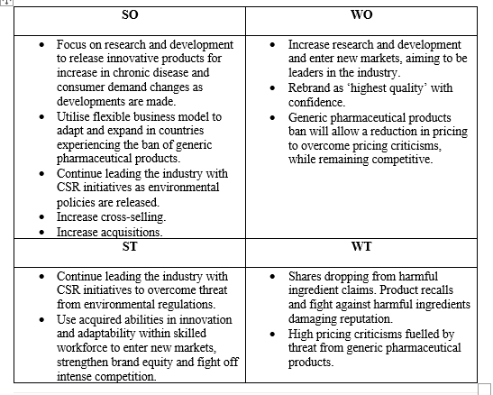
Figure 5.0 demonstrates the Threats – Opportunities – Weaknesses – Strengths Matrix of Johnson & Johnson for 2019, with Figure 5.1 demonstrating the 2009 version. In 2009 the identified strategies were to increase research and development in the pharmaceutical segment, improve on product recalls and improve cross-sell techniques of diversified products. In 2019, Johnson & Johnson should continue to increase on their research and development in releasing innovative products in response to increases in chronic diseases and changes in consumer demands, as they remain below the industry average for research and development. Johnson & Johnson should also continue to improve on product recalls, to give a better-quality perception and improve brand reputation. New for 2019, Johnson & Johnson should focus on increasing the number of acquisitions as these have proven successful for them in previous years and are an important means of growth for players in this industry.

Strategic Position and Action Evaluation Matrix (SPACE Matrix)
The Strategic Position and Action Evaluation Matrix is, “useful in determining the appropriate strategic posture for an organisation” (Louw & Radder, 1998).
Figure 6.0 – Strategic Position and Action Evaluation of Johnson & Johnson 2019
Figure 6.1 – Strategic Position and Action Evaluation of Johnson & Johnson 2019
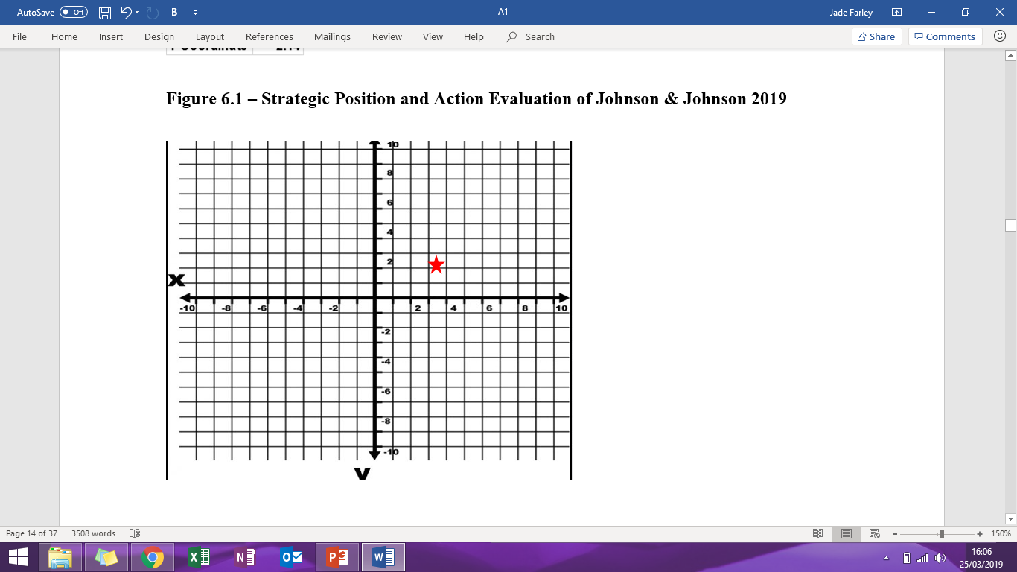
Figure 6.0 and 6.1 demonstrate the Strategic Position and Action Evaluation of Johnson & Johnson for 2019. The red star in figure 6.1 indicates that Johnson & Johnson have moved into the aggressive quadrant at present, from the conservative quadrant in 2009, as demonstrated by figure 6.3 in the Appendix. This shift to the right has come from strengthening of the industry and increased competitive advantage. Therefore Johnson & Johnson should adopt an aggressive growth strategy of backward, forward and horizontal integration, market penetration, product development and related diversification as they are currently in a strong and stable position to do so.

Grand Strategy Matrix (GS Matrix)
The Grand Strategy Matrix uses market growth and competitive position to determine the appropriate strategies an organisation should adopt (David, 2016).
Figure 7.0 – Grand Strategy Matrix of Johnson & Johnson 2019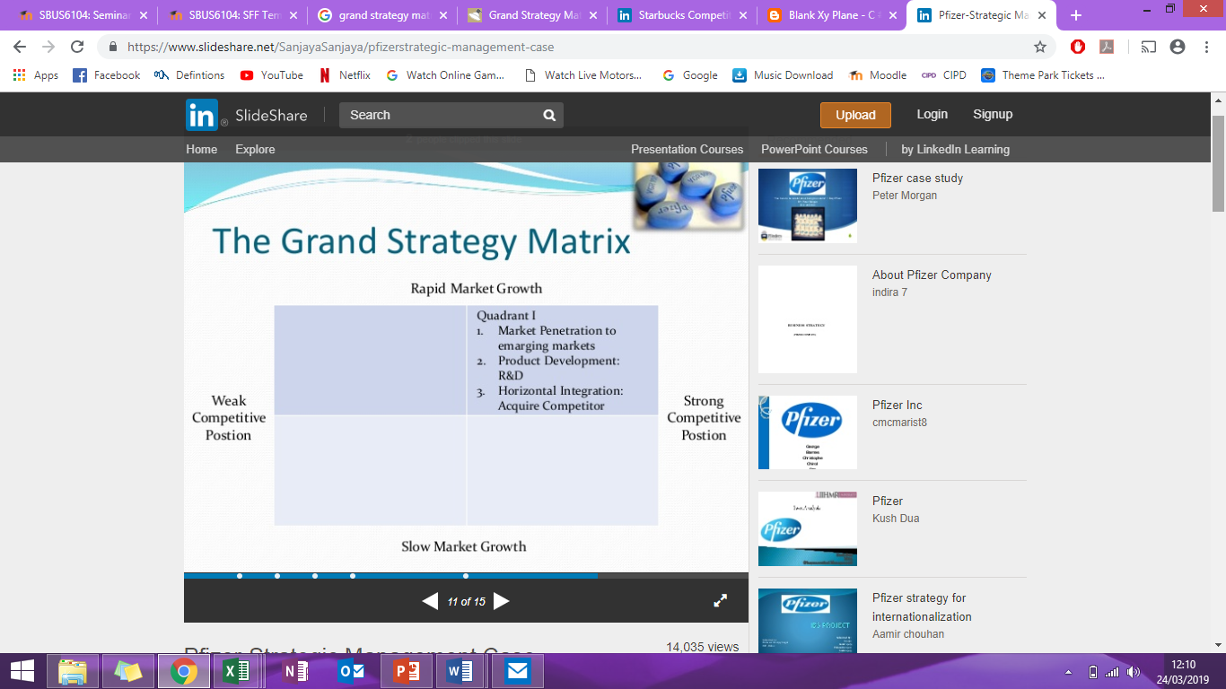
Figure 7.0 demonstrates the Grand Strategy Matrix of Johnson & Johnson for 2019, with Figure 7.1 demonstrating the 2009 version. Here, it can be seen that Johnson & Johnson have moved into quadrant I from quadrant II, as they have strengthened their competitive position. Johnson & Johnson should, therefore, concentrate continuously on market penetration, market development, and product development strategies and should also consider forward, backward or horizontal integration.

Internal External Matrix (IE Matrix)
The Internal External Matrix combines internal and external factors to determine whether an organisation is in the Grow & Build Region, Hold & Maintain Region or the Harvest or Divest Regions and thus the appropriate strategies dependent on the region (David, 2016).
Figure 8.0 – Internal External Matrix of Johnson & Johnson 2019
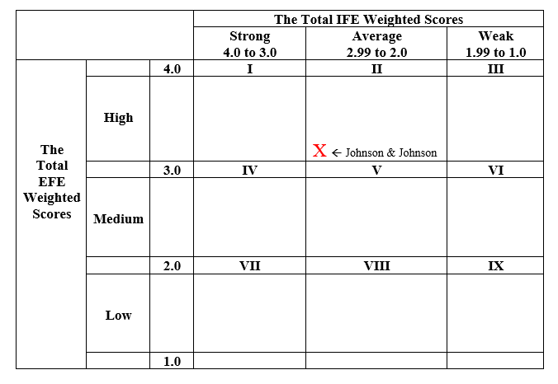
Figure 8.0 demonstrates the Internal External Matrix of Johnson & Johnson for 2019, with Figure 8.1 in the Appendix, demonstrating the 2009 version, where it can be seen that Johnson & Johnson have moved up a quadrant, from medium to high in terms of the total EFE weighted scores, but remained average in terms of total IFE weighted scores. Johnson & Johnson need to focus on improving the management of their key internal factors, as they are close to moving into the strong category for total IFE weighted score. Therefore, moving forward, Johnson & Johnson should implement a grow and build strategy, considering backward, forward and horizontal integration, market penetration, market development and product development.

The Decision Stage
The Decision stage uses information from the input stage and the matching stage to find the relative attractiveness of alternative strategies and, thus, provides an objective basis for selecting specific strategies (Torlak & Sanal, 2007). On the basis of outcomes emanating from techniques in the Matching Stage, the following three strategies have been identified for Johnson & Johnson;
- Increase research and development in releasing innovative products in response to increases in chronic diseases and changes in consumer demands, as Johnson & Johnson remain below the industry average for research and development.
- Continue to improve on product recalls, to give a better-quality perception and improve brand reputation.
- Increase the number of acquisitions as these have proven successful for Johnson & Johnson in previous years and are an important means of growth for players in this industry.

Quantitative Strategic Planning Matrix (QSPM)
The Quantitative Strategic Planning Matrix is a technique that, “objectively indicates which is the best alternative strategy” (Zulkarmain, et al., 2018). This is done by evaluating alternative strategies based on internal and external strategic factors which have been identified in the previous stages.

Figure 9.0 – Quantitative Strategic Planning Matrix of Johnson & Johnson 2019
Figure 9.0 demonstrates the Quantitative Strategic Planning Matrix of Johnson & Johnson for 2019 and Figure 9.1 demonstrates the 2009 version. For both 2009 and 2019, increasing research and development was found to be the most attractive strategy for Johnson & Johnson, when compared to improving product recalls and improving cross-selling techniques in 2009 and improving product recalls and increasing the number of acquisitions in 2019.

Evaluation of the Use of the Strategy-Formulation Framework as a Contemporary e-Business System for Gaining Competitive Advantage
The Strategy-Formulation Framework can offer organisations financial benefits, a framework for decision making, a measurement of progress and an organisational perspective (SAF International, 2017). Sets of strategies can be considered simultaneously and the integration of pertinent external and internal factors are accounted for in the decision-making process, using this framework. However, the application of the Strategy-Formulation Framework to Johnson & Johnson highlighted three key limitations to the use of the Strategy-Formulation Framework as a method of developing strategies to obtain competitive advantage. The Strategy-Formulation Framework requires intuitive judgments and educated assumptions as the numerical values assigned as rating/attractiveness scores are based on judgemental decisions instead of being based on information which is objective. (David, 1986) highlighted that the outcomes can only be as good as the prerequisite information and matching analyses which it is based upon. The individual conducting the framework may be acting in favour of the interests of higher managers of the organisation, meaning that the outcomes may be subsequently biased, as the process simply entails organising existing knowledge towards a specific purpose, which may be subconsciously aimed for (Kay, 1993). The final criticism is that the strategies identified using the framework, may not be congruent with the values, goals and objectives of the firm.

Conclusion
This report utilised the Strategy-Formulation Framework to identify competitive strategies for Johnson & Johnson, based on internal and external factors of influence to them. The recommended strategies for Johnson & Johnson are to; increase research and development in releasing innovative products in response to consumer demands and the increase in chronic diseases, as Johnson & Johnson remain below the industry average for research and development, continue to improve on product recalls, to give a better-quality perception and improve brand reputation and to increase the number of acquisitions as these have proven successful for Johnson & Johnson in previous years and are an important means of growth for players in this industry. A number of the matrix highlight that Johnson & Johnson should consider backward, forward and horizontal integration, market penetration, market development and product development which is congruent with the recommendations made. This framework allowed for the strategies to be considered simultaneously, however, the decisions were based on uneducated judgements and therefore the reliability of the outcomes are affected.
Word Count: 2738

References
Air Liquide, 2018. Air Liquide. [Online]
Available at: https://www.airliquide.com/healthcare/rise-chronic-diseases
[Accessed 15 March 2019].
Andalo, D., 2016. Dozens of generic drugs face EU ban. The Pharmaceutical Journal, 28 July.
BBC News, 2018. Johnson & Johnson shares drop after asbestos report. BBC News, 14 December .
Bhasin, H., 2018. Competitive Profile Matrix and Analysis. Marketing91, 2 May.
Bhasin, H., 2018. Top Johnson & Johnson Competitors. Marketing 91, 29 June .
Boyd, A., 2019. Has Johnson & Johnson (NYSE:JNJ) Hit a Sweet Spot? Target Weight For Portfolio Skips Higher to 0.07000. Augusta Review, 20 March .
Braun, D., 2017. Developing a new product or service - Consider acquisition. Capstone Strategic, 21 September .
Cox, J., 2018. Worker pay rate hits highest level since 2008. CNBC, 31 July.
Crow, D., 2016. Johnson & Johnson targets acquisitions with $18bn of cash pile. Financial Times, 26 January.
CSI Market , 2019. CSI Market. [Online]
Available at: https://csimarket.com/stocks/single_growth_rates.php?code=JNJ&capx
[Accessed 18 March 2019].
David, F. R., 1986. The strategic planning matrix - A quantitative approach. Long Range Planning, 19(5), pp. 102-107.
David, F. R., 2016. Strategic Management: A Competitive Advantage Approach, Concepts and Caes. 16 ed. s.l.:Pearson.
Diego, B., 2018. Pharma criticised over high price of cancer drugs - Spanish report. AMP Health Europe, 20 April.
European Commission, 2017. The new regulations on medical devices, s.l.: Europa.
Hahn, L., 2018. Johnson & Johnson Facing 3 Important Risks in Coming Year. Investor Place, 30 April.
Hilton, J., 2018. We set a goal to have the world’s healthiest workforce by 2020. Human Resources Director, 10 August .
Johnson & Johnson , 2014. Johnson & Johnson. [Online]
Available at: https://www.jnj.com/media-center/press-releases/johnson-johnson-innovation-catalyzes-new-and-exciting-science-and-technology-in-pharmaceutical-medical-device-diagnostic-and-consumer-healthcare-spaces
[Accessed 18 March 2019].
Johnson & Johnson , 2017. 2017 Health For Humanity Report- Manufacturing for the Future, s.l.: Johnson & Johnson.
Johnson & Johnson , 2019. Johnson & Johnson. [Online]
Available at: https://www.jnj.com/about-jnj/company-statements/johnson-johnson-quality-and-compliance-core-objective
[Accessed 18 March 2019].
Johnson & Johnson, 2018. Johnson & Johnson. [Online]
Available at: https://www.jnj.com/johnson-johnson-reports-2018-fourth-quarter-results
[Accessed 18 March 2019].
Johnson & Johnson, 2018. Johnson & Johnson. [Online]
Available at: https://www.jnj.com/latest-news/johnson-johnson-named-a-2018-fortune-worlds-most-admired-company
[Accessed 20 March 2019].
Johnson & Johnson, 2019. Johnson & Johnson. [Online]
Available at: https://www.jnj.com/about-jnj
[Accessed 8 March 2019].
Johnson & Johnson, 2019. Johnson & Johnson. [Online]
Available at: https://www.jnj.com/johnson-johnson-consumer-aligns-to-big-goals-in-environmental-sustainability-signs-new-plastics-economy-global-commitment
[Accessed 16 March 2019].
Jurevicius, O., 2014. IFE & EFE Matrices. Strategic Management Insight , 20 October.
Kay, J., 1993. Foundations of corporate success: How business strategies add value, New York: Oxford University Press.
Kyodo, J., 2019. U.S to push for comprehensive free trade agreement as it looks to open up Japan's market. Japan Times, 20 March .
Langston, R., 2019. According to latest research on baby disposable diapers market focusing on leading manufacturers, future demand, market analysis & outlook to 2024. Micro Finance Observer, 21 March .
Lee, C.-S., 2001. An analytical framework for evaluating e-commerce business models and strategies. Internet Research , 11(4), pp. 349-359.
Louw, L. & Radder, L., 1998. SPACE Matrix: A tool for calibrating competition. Journal of Social Sciences, 4(31), pp. 549-559.
Market Watch, 2019. Market Watch. [Online]
Available at: https://www.marketwatch.com/investing/stock/jnj/financials/cash-flow
[Accessed 17 March 2019].
Miller, E., 2018. Drug Watch. [Online]
Available at: https://www.drugwatch.com/manufacturers/johnson-and-johnson/
[Accessed 16 March 2019].
Osman, W., 2012. A comprehensive strategy formulation framework. BlogSpot, 17 May.
Petersen, T., 2017. US economic isolation hurts the global economy - and the US itself. Bertelsmann, 9 December .
ProcureCon, 2019. Johnson & Johnson is Prepared for the Talent Crunch with a Pipeline Full of Future Procurement Leaders, s.l.: WB Research.
Reisch, M., 2017. U.S. charges DuPont employee with trade secrets theft. Chemical & Engineering News, 95(16), p. 15.
Reuters, 2018. 'Brexit' uncertainty poses 'substantial' market impact -U.S. regulator. Euro News, 6 December .
Reuters, 2019. Reuters. [Online]
Available at: https://www.reuters.com/finance/stocks/company-profile/JNJ.N
[Accessed 8 March 2019].
Rogers, C., 2018. Johnson & Johnson sacrifices ‘sacred cows’ as it preps rebrand. Marketing Week, 27 June.
Rupcic, N. & Jelenc, L., 2003. Comprehensive Strategic Decision-Making Model in Building Sustainable Competitive Advantages, Croatia : Datoteka.
SAF International, 2017. Competitive Advantages Through Strategy Formulation. SAF International , 23 August .
Todd, S., 2011. Johnson & Johnson's push into emerging markets will require retooling sophisticated, expensive medical devices. NJ, 21 June .
Torjesen, 2015. Drug development: the journey of a medicine from lab to shelf. Pharmaceutical Journal, 12 May.
Torlak, N. & Sanal, M., 2007. David's Strategy Formulation Framework in Action: Example of Turkish Airlines on Domestic Air Transportation. Journal of Science Instanbul Commerce University, 6(12), pp. 81-11.
Trading Economics , 2019. Trading Economics. [Online]
Available at: https://tradingeconomics.com/united-states/inflation-cpi
[Accessed 18 March 2019].
United Nations, 2018. The Paris Agreement, s.l.: United Nations Framework Convention on Climate Change.
Wischhover, C., 2018. Johnson & Johnson accused of hiding the asbestos in its baby powder for decades. Vox, 14 December .
Zulkarmain, A., Wahyuningtias, D. & Putranto, T. S., 2018. Analysis of IFE, EFE and QSPM Matrix on business development strategy. IOP Conference Series: Earth and Environmental Science, 126(1).

Appendix
Figure 1.0 – Strengths, Weaknesses, Opportunities and Threats of Johnson & Johnson.

Figure 2.0 Competitive Profile Matrix of Johnson & Johnson 2019

Figure 2.1 Competitive Profile Matrix of Johnson & Johnson 2009
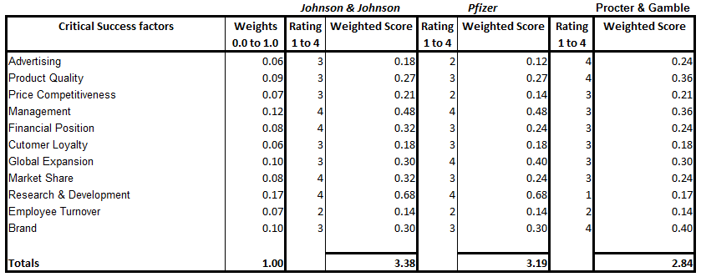

Figure 3.0 – External Factor Evaluation Matrix of Johnson & Johnson 2019
Figure 3.1 External Factor Evaluation Matrix of Johnson & Johnson 2009
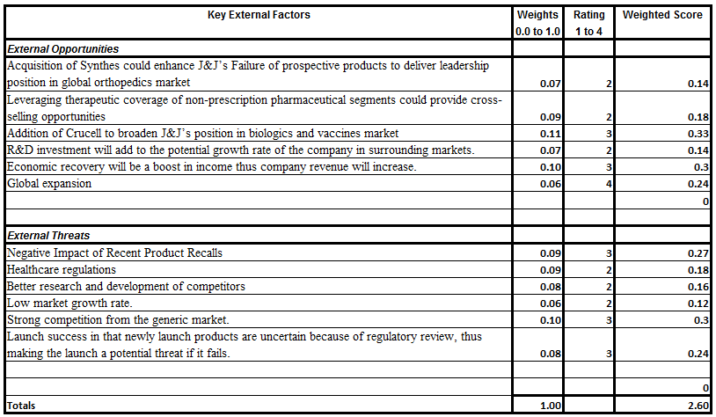

Figure 4.0 – Internal Factor Evaluation Matrix of Johnson & Johnson 2019
Figure 4.1 – Internal Factor Evaluation Matrix of Johnson & Johnson 2009
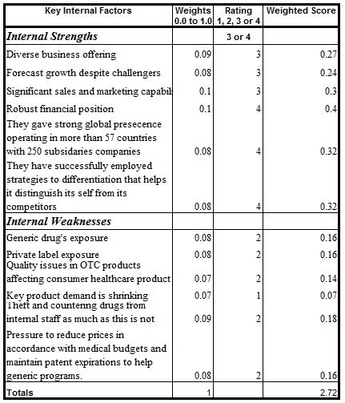
Figure 5.0 – Threats – Opportunities – Weaknesses – Strengths Matrix of Johnson & Johnson 2019
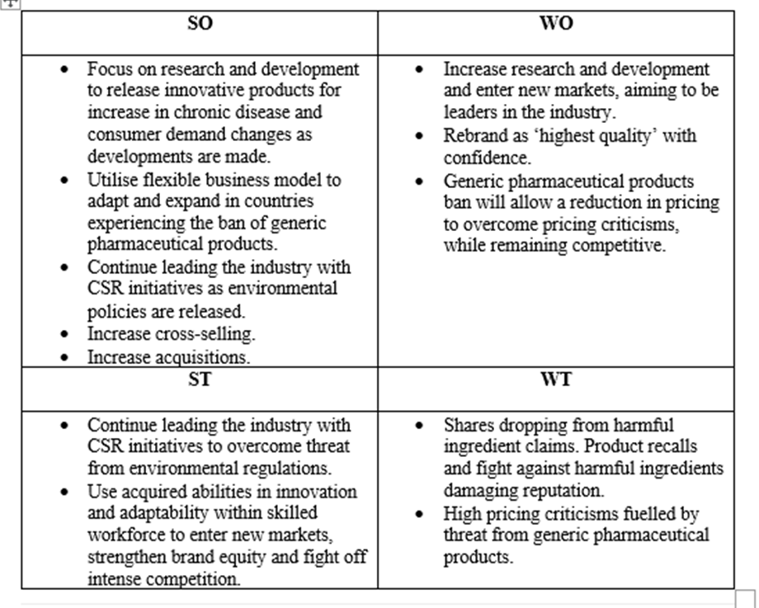
Figure 5.1 - Threats – Opportunities – Weaknesses – Strengths Matrix of Johnson & Johnson 2009
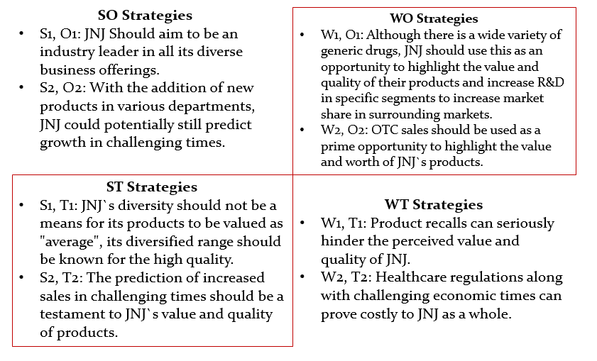
Figure 6.0 – Strategic Position and Action Evaluation of Johnson & Johnson 2019

Figure 6.1 – Strategic Position and Action Evaluation Matrix of Johnson & Johnson 2019
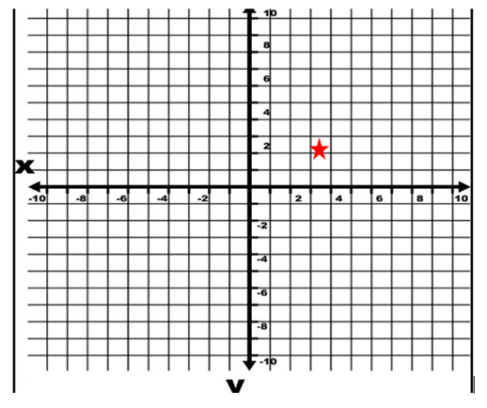
Figure 6.2 - Strategic Position and Action Evaluation of Johnson & Johnson 2009


Figure 6.3 - Strategic Position and Action Evaluation Matrix of Johnson & Johnson 2009

Figure 7.0 – Grand Strategy Matrix of Johnson & Johnson 2019

Figure 7.1 – Grand Strategy Matrix of Johnson & Johnson 2009
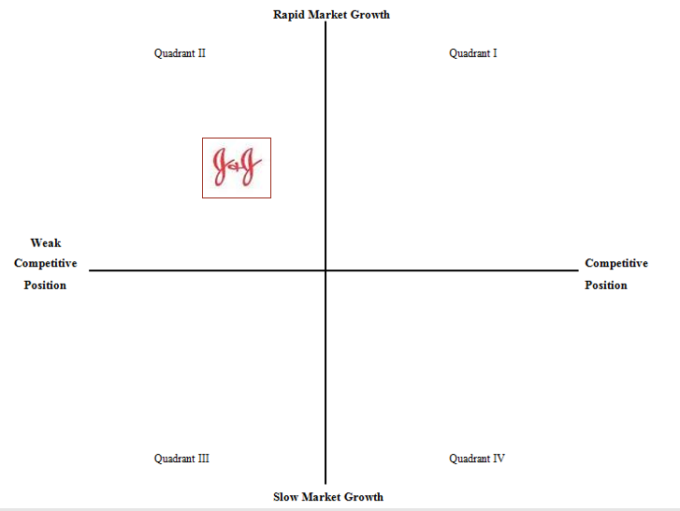

Figure 8.0 – Internal External Matrix of Johnson & Johnson 2019
Figure 8.1 – Internal External Matrix of Johnson & Johnson 2009
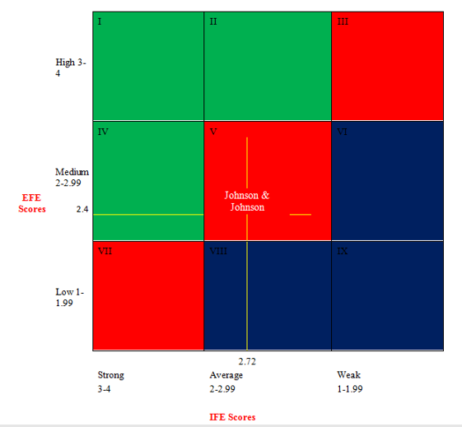

Figure 9.0 – Quantitative Strategic Planning Matrix of Johnson & Johnson 2019

Figure 9.1 – Quantitative Strategic Planning Matrix of Johnson & Johnson 2009


