

Module Name: Problem Solving and Innovation
Module Code: BMSW4014
Assessment Title: Understanding the Business Environment of the Influencer Industry
Student Name: Natasha Wilson
Student Number: 2506841
Lecturer: Chris Wilkin
Deadline: 10th July 2026 at 23:59

Wordcount: 1667

AI Statement

I acknowledge the use of ChatGPT (https://chatgpt.com/) on 28th June 2026 to help find sources and information for the report using prompt(s)

- find me industry reports for the creator economy

- find me legal evidence concerning child safety on social media

- find me government legal sources on online safety for children

- find me legal documents on under 16 social media ban UK

Chat in appendices

I confirm that I have not presented any AI generated text as my own work.

I confirm that I have copies of my drafts, notes, and other resources I used before, and after the use of AI tools which I may be asked to provide in evidence.

Executive Summary

This report critically analyses the business environment of the influencer industry, exploring how social media influencers have developed from individual content creators into important participants within the digital economy. The report examines the evolution of influencer careers, the growth of the creator economy and the external factors influencing the future sustainability of the industry.
Using STEEPLE analysis, DPSIR framework and influencer SWOT comparisons, the report evaluates the external pressures shaping the influencer industry. STEEPLE identifies the wider social, technological, economic, ethical, political and legal influences, while DPSIR explores the relationship between industry drivers, emerging pressures, impacts and possible responses. Influencer SWOT comparisons further examine the opportunities and challenges experienced by different creator models. Findings suggest that the industry provides significant opportunities through entrepreneurship, brand partnerships, audience communities and new digital business models. Influencers such as MrBeast, LadBaby, Ms Rachel and Londyn demonstrate the diversity of the industry, from large-scale commercial creators to educational and family-managed content.
However, the report also identifies several challenges affecting the future of the influencer industry. These include increasing concerns surrounding artificial intelligence, authenticity, platform dependency, child participation and the need for stronger digital regulation. The introduction of greater online safety measures and international responses to children’s social media use demonstrate that the external environment surrounding influencers is continuing to change.
Overall, the report concludes that although the influencer industry is expected to continue expanding, long-term sustainability will depend on creators and platforms adapting to technological innovation, regulatory developments and changing audience expectations. Future success will require balancing commercial growth with ethical responsibility, transparency and maintaining trust between creators and their communities.

Table of Contents
AI Statement 2
Executive Summary 3
1. Introduction. 5
2. What is an Influencer? 5
2.1 The Development of Influencers. 6
3. The Creator Economy. 7
a. Sustainability of the Creator Economy. 7
4.Legal and Ethical Challenges within the Influencer Industry. 8
4.1 Regulation and Industry Response 9
5.Future Lens and Predictions 10
6. Conclusion 11
Reference List 12
Appendices 18
AI Evidence 54

Introduction.

The influencer industry has become an increasingly important part of the digital business environment, changing how organisations communicate with consumers and how individuals create commercial opportunities online, demonstrating how influence has moved beyond traditional celebrities into digital communities.
This report will critically analyse how the influencer industry has developed and the wider external factors shaping its future. A STEEPLE analysis (Marmol and Feys, 2015) will be used to examine the factors affecting the industry (See Appendix A). A DPSIR framework (Tscherning et al., 2012), will explore the relationships between key components influencing the industry. (See Appendix C), while a SWOT analysis (Helms and Nixon, 2010) will evaluate selected influencer case studies. (See Appendix B)

What is an Influencer?

Traditionally, influence was associated with celebrities and public figures; however, the growth of social media has transformed this concept. Today, individuals can create digital content, build online communities and develop relationships with audiences through platforms such as YouTube, TikTok and Instagram. Freberg et al. (2011) define social media influencers as independent endorsers who shape audience attitudes and behaviours through their online presence.
As the industry continues to evolve, influencers are increasingly recognised as digital entrepreneurs who create value through audience relationships, brand partnerships, and online communities. Ki, Chow and Li (2022) suggest that trust and authenticity are essential for overcoming consumer scepticism. By bridging this trust gap, creators transform audience relationships into a valuable business asset.
Unlike traditional celebrities, influencers exist across different levels depending on audience size, reach and engagement. Campbell and Farrell (2020) identify different categories of influencers, ranging from nano and micro-influencers who often develop niche communities (See Appendix G).
However, influence is not solely determined by follower numbers. The effectiveness of influencers is increasingly connected to audience relationships, perceived expertise and engagement. Kim and Chan-Olmsted (2022) suggest that digital communities and creator-audience interactions shape consumer response to online content.

The Development of Influencers.

The development of social media platforms has transformed influencing from an informal online activity into an emerging professional career. The COVID-19 pandemic further accelerated digital behaviours, with individuals increasingly relying on social platforms for entertainment, communication and online interaction (Ofcom, 2023a). This shift increased opportunities for everyday users to create content, attract audiences and establish digital identities (See Appendix D).
As influencer culture developed, the industry moved away from relying solely on traditional celebrity endorsement. Baraybar-Fernández (2022) argues that influence has evolved into a structured business practice, where creators strategically manage their personal brands, content and relationships with audiences. This change has allowed individuals to gain visibility through authenticity and audience connection rather than traditional routes to fame.
The rise of short-form video platforms has further transformed influencer development. Cervi (2021) highlights how TikTok changed digital participation by enabling ordinary users to achieve significant reach through creativity, trends and platform engagement. This has lowered entry barriers, allowing new influencers to emerge across different niches and communities. digital success increasingly depends on managing audience relationships and engagement networks, with Libia et al. (2025) highlighting the value created through consumer-consumer interactions. More recently, influencers have progressed into Creatorpreneurs, combining creativity with entrepreneurial approaches to develop their online presence (Edeling and Wies, 2024). This demonstrates how influencers have shifted from content creators into digitally driven personal brands, creating the foundation for the wider creator economy (See Appendix J and K).

The Creator Economy.

The professionalisation of influencers has contributed to the emergence of the creator economy, where individuals generate value through content creation, online communities and digital platforms. Sujon and Ntalla (2025) explain that creators are now part of wider digital economies where visibility, participation and audience engagement contribute to economic value.
The creator economy has transformed influencers from individuals producing online content into business operators who develop multiple revenue streams. Bhargava (2022) argues that the creator economy functions as an interconnected ecosystem involving creators, audiences, platforms and businesses. Within this environment, influencers can monetise their personal brands through advertising, sponsorships, subscriptions, merchandise and collaborations (Beichert et al., 2023).
This shift can be demonstrated through creators such as MrBeast and LadBaby, who have expanded beyond traditional content creation by developing strong communities, partnerships and commercial opportunities (See Appendix J, K and O). However, the sustainability of influencer-led businesses depends on maintaining audience trust while adapting to increasing competition and changes within digital platforms.

Sustainability of the Creator Economy.

The sustainability of the creator economy depends on its ability to maintain economic growth while adapting to changing consumer expectations and digital market conditions. Industry predictions suggest continued expansion, with Goldman Sachs (2023) forecasting significant growth in the creator economy. Similarly, Deloitte (2026) highlights the increasing role of digital creators within modern business strategies, demonstrating how influencer-led approaches are becoming more established within commercial markets.
As organisations recognise the value of creator partnerships, Singh, Choudhary and Rawat (2025) suggest that businesses can leverage the content economy through both internal and external creators to support growth. However, long-term sustainability relies not only on financial opportunities but also on maintaining strong audience relationships. Reinikainen et al. (2020) argue that parasocial relationships can create meaningful connections between influencers and followers, increasing engagement and loyalty.
These relationships provide commercial value, with Masuda et al. (2022) suggesting influencer characteristics can impact consumer purchasing intentions. Similarly, Liu et al. (2026) highlights the importance of trust within electronic word-of-mouth, while Pan et al. (2024) identifies trust and engagement as important factors influencing influencer marketing effectiveness.
Despite these opportunities, creators remain vulnerable to external challenges. Analysis of creators such as MrBeast and LadBaby demonstrates opportunities for diversification but also risks surrounding reputation, competition and dependence on digital platforms (see Appendix C). Gorwa (2019) argues that platform governance creates challenges as creators operate within environments controlled by changing algorithms, policies and platform decisions.

4.Legal and Ethical Challenges within the Influencer Industry.

Despite the economic opportunities created by the influencer industry, its rapid growth has introduced new ethical and legal challenges, particularly surrounding children’s participation online (UK Parliament, 2022) (See Appendix P). Child-focused creators, such as Ms Rachel, demonstrate the educational potential of digital platforms (See Appendix H).
However, the rise of child influencers creates more complex concerns. Parent-managed accounts, such as Londyn’s, highlight questions around children’s consent, digital identity and control over their online presence (See Appendix L). Livingstone (2011) highlights that children’s digital participation involves balancing opportunities with protection, as online spaces create both benefits and risks (See Appendix F). More recently, Van den Abeele, Hudders and Vanwesenbeeck (2024) argue that kidfluencer content creates complex relationships between children, parents and audiences, particularly when authenticity becomes part of a commercial brand.
More critically, Masterson (2021) argues that child influencers may be vulnerable to exploitation because existing child labour protections have not adapted to family-managed digital content. Similarly, Divon, Annabell and Gámez (2025) suggest that children within influencer economies risk becoming monetised commodities, where childhood experiences become connected to economic value. Rees (2023) supports the need for greater consideration of child influencer protections, highlighting that regulation must evolve alongside new forms of digital work.

4.1 Regulation and Industry Response

The rapid expansion of the influencer industry has increased pressure for stronger digital governance, with governments and regulators attempting to balance online innovation with user protection (See Appendix E). Gorwa (2019) argues that platform governance has become increasingly important as digital spaces are influenced by decisions made by platforms, policymakers and regulatory bodies. This reflects wider concerns surrounding responsible digital innovation, with the CDIE (2022) highlighting the importance of ethical approaches to emerging technologies and data-driven decision making.
In the UK, the Online Safety Act (2023) represents a significant shift towards increased accountability, placing greater responsibilities on platforms to manage online risks, particularly those affecting children. Ofcom (2025) highlights age-assurance approaches, including facial age estimation technology, as potential methods platforms may use to identify and protect younger users. However, this creates further debate around privacy, data protection and the ethical use of emerging technologies.
Evidence from the Youth Justice Board (2026) further highlights concerns surrounding young people’s exposure to online harms, reinforcing the need for safeguarding approaches that evolve alongside digital environments. Internationally, Australia’s enforcement of under-16 social media restrictions in December 2025 demonstrates stronger government intervention towards children’s online access (See Appendix M). Similar restrictions have been discussed within the UK; however, Woodhouse (2026) identifies divided parental opinions, with concerns that limiting access may reduce young people’s digital participation and opportunities.
These debates demonstrate the wider social impact stage of the DPSIR framework, where regulatory responses affect multiple stakeholders identified within the STEEPLE analysis (see Appendix A). Parental reactions to proposed under-16 restrictions further highlight tensions between protecting young users from online harm and maintaining digital opportunities (Clinton and Bannock, 2026) (See Appendix I). Further regulatory pressure is reflected through government guidance restricting mobile phone use in schools (Department for Education, 2026), demonstrating wider societal concerns surrounding children’s relationship with technology.

5.Future Lens and Predictions

Looking towards the future, the influencer industry is predicted to continue expanding as creators become increasingly integrated within digital markets. Goldman Sachs (2023) forecasts significant growth within the creator economy, suggesting influencers will continue moving beyond content creation into entrepreneurial business models.
However, future development will also be shaped by technological change, regulation and changing social expectations (see Appendix A). The increasing use of artificial intelligence provides opportunities for creators through content production and audience analysis, reflecting wider digital transformation trends (Deloitte, 2026) however, AI-generated influencers create challenges surrounding transparency and maintaining authentic audience relationships.
A future regulatory shift may also occur as governments respond to similar concerns surrounding children’s online participation. Following Australia’s implementation of under-16 social media restrictions and ongoing discussions within the UK, comparable approaches may emerge in other countries such as Canada experiencing similar pressures around online safety, child wellbeing and platform accountability (See Appendix N). This demonstrates how global regulatory trends could reshape the future business environment for influencers and technology platforms.
Analysis of creators such as MrBeast and LadBaby reflects how creators can leverage the content economy for growth through diversification into products, partnerships and wider business activities (Singh, Choudhary and Rawat, 2025) However, creators must continue adapting to changing consumer expectations, technology developments and legal responsibilities to maintain long-term sustainability (see Appendix B).

6. Conclusion

This report has demonstrated that the influencer industry has evolved from individual content creation into a complex digital business environment. The development of social media platforms has enabled influencers to build communities, create commercial opportunities and establish themselves as digital entrepreneurs within the wider creator economy.
However, analysis of the external environment highlights that continued growth also creates challenges. While technological developments and changing consumer behaviours provide opportunities for innovation, concerns surrounding platform dependency, artificial intelligence, child participation and regulation create uncertainty for the future of the industry.
The STEEPLE analysis, DPSIR framework and influencer SWOT comparisons demonstrate that long-term sustainability will depend on creators’ ability to adapt to changing social, technological and legal pressures. Therefore, the future success of the influencer industry is likely to rely on balancing commercial growth with ethical responsibility, transparency and maintaining authentic audience trust.

Reference List

Allal‐Chérif, O., Puertas, R. and Carracedo, P. (2024). Intelligent Influencer marketing: How AI-powered Virtual Influencers Outperform Human Influencers. Technological Forecasting and Social Change, 200(1), pp.123113–123113. doi:10.1016/j.techfore.2023.123113.
Baraybar Fernández, A. (2022). The Evolution of the Influence Business. The Dynamics of Influencer Marketing, pp.80–98. doi:10.4324/9781003134176-6.
Beichert, M., Bayerl, A., Goldenberg, J. and Lanz, A. (2023). Revenue Generation through Influencer Marketing. Journal of Marketing, [online] 88(4), pp.40–63. doi:10.1177/00222429231217471.
Bhargava, H.K. (2022). The Creator Economy: Managing Ecosystem Supply, Revenue Sharing, and Platform Design. Management Science, 68(7). doi:10.1287/mnsc.2021.4126.
Campbell, C. and Farrell, J.R. (2020). More than Meets the eye: The Functional Components Underlying Influencer Marketing. Business Horizons, 63(4), pp.469–479. doi:https://doi.org/10.1016/j.bushor.2020.03.003.
Cervi, L. (2021). Tik Tok and Generation Z. Theatre, Dance and Performance Training, [online] 12(2), pp.198–204. doi:https://doi.org/10.1080/19443927.2021.1915617.
Centre for Data Ethics and Innovation (CDEI), 2022, Public Attitudes to Data and Artificial Intelligence Tracker Survey: Wave 1, December 2021, [data collection], UK Data Service, Accessed 5 July 2026. SN: 8946, DOI: http://doi.org/10.5255/UKDA-SN-8946-1
Chan-Olmsted, S. and Kim, H.J. (2022). Influencer Marketing Dynamics. The Dynamics of Influencer Marketing, pp.99–122. doi:10.4324/9781003134176-7.
Clinton, J. and Bannock, C. (2026). ‘The genie is out of the bottle’: Parents react to UK under-16s social media ban. [online] The Guardian. Available at: https://www.theguardian.com/uk-news/2026/jun/15/parents-react-to-uk-under-16s-social-media-ban [Accessed 9 July 2026].
Deloitte (2026). Creator Economy in 3D. [online] Deloitte. Available at: https://www.deloitte.com/content/dam/assets-zone3/us/en/docs/services/consulting/2024/creator-economy-in-3d-1.pdf [Accessed 30 June 2026].
Department for Education (2026) Mobile phones in schools: statutory guidance. Available at: https://www.gov.uk/government/publications/mobile-phones-in-schools/mobile-phones-in-schools (Accessed 7 July 2026).
Divon, T., Annabell, T. and Goanta, C. (2025). Children as concealed commodities: Ethnographic nuances and legal implications of kidfluencers’ monetisation on TikTok. New Media & Society, 28(3). doi:10.1177/14614448241304657.
Edeling, A. and Wies, S. (2024). Embracing entrepreneurship in the creator economy: The rise of creatrepreneurs. International Journal of Research in Marketing, 41(3). doi:10.1016/j.ijresmar.2024.07.003.
Freberg, K., Graham, K., McGaughey, K. and Freberg, L.A. (2011). Who Are the Social Media influencers? A Study of Public Perceptions of Personality. Public Relations Review, 37(1), pp.90–92. doi:https://doi.org/10.1016/j.pubrev.2010.11.001.
Goldman Sachs (2023). Creator Economy Primer: Assessing the Emerging Creator Economy & Short-Form Video Landscape. [online] Goldman Sachs. Available at: https://creatorswithinfluence.com/wp-content/uploads/2023/11/Goldman-Sachs-Global-Investment-Research-Assessing-the-Emerging-Creator-Economy-Short-Form-Video-Landscape-White-Paper-April-5-2023.pdf [Accessed 28 June 2026].
Gorwa, R. (2019). What Is Platform governance? Information, Communication & Society, [online] 22(6), pp.854–871. doi:10.1080/1369118x.2019.1573914.
Helms, M.M and Nixon, J. (2010) ‘Exploring SWOT analysis – where are we now? A review of academic research from the last decade; Journal of Strategy and Management, 3(3), p.p215-251.
Hong, Z. and Xiao, K. (2024). Digital economy structuring for sustainable development: The role of blockchain and artificial intelligence in improving supply chain and reducing negative environmental impacts. Scientific Reports, [online] 14(1), p.3912. Available at: https://www.nature.com/articles/s41598-024-53760-3 [Accessed 5 July 2026].
Ki, C.-W.C., Chow, T.C. and Li, C. (2022). Bridging the Trust Gap in Influencer Marketing: Ways to Sustain Consumers’ Trust and Assuage Their Distrust in the Social Media Influencer Landscape. International Journal of Human–Computer Interaction, 39(17), pp.1–16. doi:10.1080/10447318.2022.2097785.
Kim, H.J. and Chan-Olmsted, S. (2022). Influencer marketing and social commerce: Exploring the role of influencer communities in predicting usage intent. Journal of Interactive Advertising, 22(3), pp.1–20. doi:10.1080/15252019.2022.2111243.
Kim, J., Yu, M., Zhi, J., Milani, S., Cheng, J., Fan, X., Shen, H. and Forlizzi, J. (2026). Content Creation with Generative AI: How Do Content Creators Responsibly Use Generative AI Tools? CSCW009. Proceedings of the ACM on Human-Computer Interaction, 10(2), pp.1–28. doi:10.1145/3788080.
Libai, B., Rosario, A.B., Beichert, M., Donkers, B., Haenlein, M., Hofstetter, R., Kannan, P.K., van der Lans, R., Lanz, A., Li, H.A., Mayzlin, D., Muller, E., Shapira, D., Yang, J. and Zhang, L. (2025). Influencer marketing unlocked: Understanding the value chains driving the creator economy. Journal of the Academy of Marketing Science, [online] 53. doi:10.1007/s11747-024-01073-2.
Liu, S., Jiang, C., Lin, Z., Ding, Y., Duan, R. and Xu, Z. (2026). Identifying Effective Influencers Based on Trust for Electronic word-of-mouth marketing: a domain-aware Approach. Information Sciences, [online] 306(1), pp.34–52. doi:10.1016/j.ins.2015.01.034.
Livingstone, S., 2011, EU Kids Online: Enhancing Knowledge Regarding European Children's Use, Risk and Safety Online, 2010, [data collection], UK Data Service, Accessed 5 July 2026. SN: 6885, DOI: http://doi.org/10.5255/UKDA-SN-6885-1
Marmol, T.D and Feys, B. (2015) PESTLE analysis. Translated by C. Probert. Namur: Lemaitre Publishing.
Masterson, M.A. (2021). WHEN PLAY BECOMES WORK: CHILD LABOR LAWS IN THE ERA OF “KIDFLUENCERS.” University of Pennsylvania Law Review, [online] 169(2), pp.577–607. doi:10.2307/45473416.
Masuda, H., Han, S.H. and Lee, J. (2022). Impacts of Influencer Attributes on Purchase Intentions in Social Media Influencer marketing: Mediating Roles of Characterizations. Technological Forecasting and Social Change, [online] 174(121246), p.121246. doi:https://doi.org/10.1016/j.techfore.2021.121246.
Ofcom (2023a). Children and Parents: Media Use and Attitudes . [online] Ofcom, pp.1–48. Available at: https://www.ofcom.org.uk/siteassets/resources/documents/research-and-data/media-literacy-research/children/childrens-media-use-and-attitudes-2023/childrens-media-use-and-attitudes-report-2023.pdf?v=329412 [Accessed 29 June 2026a].
Ofcom (2023b). children’s Media Lives. [online] Ofcom. Available at: https://www.ofcom.org.uk/siteassets/resources/documents/research-and-data/media-literacy-research/children/childrens-media-lives-2023/childrens-media-lives-2023-summary-report.pdf?v=329411 [Accessed 29 June 2026b].
Ofcom (2025). Age checks to protect children online. [online] Www.ofcom.org.uk. Available at: https://www.ofcom.org.uk/online-safety/protecting-children/age-checks-to-protect-children-online [Accessed 1 July 2026].
Pan, M., Blut, M., Ghiassaleh, A. and Lee, Z.W.Y. (2024). Influencer Marketing effectiveness: A meta-analytic Review. Journal of the Academy of Marketing Science, [online] 53(1), pp.52–78. doi:10.1007/s11747-024-01052-7.
Rees, F. (2023). Child Influencer Project | University of Essex. [online] Essex.ac.uk. Available at: https://www.essex.ac.uk/research-projects/child-influencer-project.
Reinikainen, H., Munnukka, J., Maity, D. and Luoma-aho, V. (2020). ‘You Really Are a Great Big Sister’ – Parasocial relationships, credibility, and the Moderating Role of Audience Comments in Influencer Marketing. Journal of Marketing Management, 36(3–4), pp.279–298. doi:10.1080/0267257x.2019.1708781.
Singh, G.P., Choudhary, V. and Rawat, G. (2025). Leveraging content economy for growth-external influencers or internal creators? Journal of Information Technology Teaching Cases, 16(1). doi:10.1177/20438869251317549.
Sujon, Z. and Ntalla, I. (2025). Special issue introduction: Reflecting on TikTok creators and digital economies. Continuum, 40(2), pp.1–19. doi:10.1080/10304312.2025.2549003.
Tscherning, K., Helming, K., Krippner, B., Sieber, S. and Paloma, S.G. (2012). Does research applying the DPSIR framework support decision making? Land Use Policy, 29(1), pp.102–110. doi:10.1016/j.landusepol.2011.05.009.

UK Government (2023) Online Safety Act 2023. Available at: https://www.legislation.gov.uk/ukpga/2023/50/part/11/crossheading/power-to-require-providers-of-internet-services-to-prevent-or-restrict-access-by-children-to-internet-services (Accessed: 28 June 2026).
Van den Abeele, E., Hudders , L. and Vanwesenbeeck, I. (2024). Managing authenticity in a kidfluencers’ world: A qualitative study with kidfluencers and their parents. New Media & Society, 27(6). doi:10.1177/14614448231222558.
woodhouse, J. (2026). Proposals to Ban Social Media for Children. [online] House of Commons Library. London: House of Commons Library. Available at: https://researchbriefings.files.parliament.uk/documents/CBP-10468/CBP-10468.pdf [Accessed 28 June 2026].
Youth Justice Board (2026) Online harms affecting children: Evidence Pack. London: Youth Justice Bourd. Available at: https://yjresourcehub.uk/online-harms-affecting-children-evidence-pack/?__cf_chl_f_tk=yM5Kqe1Xh_9fTze.bkAU65PZjBVKzpibX5yX57TMPMo-1783076709-1.0.1.1-mUPlCZXAexknF93iWWMGnSopDLUdmg0iphFVD.45ZYA [Accessed 1 July 2026].

Appendices
A
STEEPLE Factor | Key Issue | Stakeholders | Impact on Influencer Industry
Social | Influencers have shifted from traditional celebrities to everyday creators developing personal brands and online communities (Freberg et al., 2011; Campbell and Farrell, 2020). | - Influencers  - Audiences  - Brands  - Social media platforms | Provides opportunities for creators of different sizes to build careers through audience relationships, authenticity and engagement (Kim and Chan-Olmsted, 2022).
Social | The rise of child and family influencers has created debate surrounding children’s digital participation, privacy and online identity (Livingstone, 2011; Masterson, 2021). | - Child influencers  - Parents  - Regulators, audiences | Allows educational and family-focused content such as Ms Rachel and Londyn to develop, but creates concerns around consent, commercialisation and children becoming part of influencer economies (Van den Abeele, Hudders and Vanwesenbeeck, 2024).
Social | Influencer success increasingly depends on trust, relationships and community engagement rather than follower numbers alone (Reininkainen et al., 2020). | - Followers  - Influencers  - Businesses | Strong parasocial relationships can increase audience loyalty and influence consumer behaviour (Masuda et al., 2022; Pan et al., 2024).
Social | Influencers now contribute to wider social movements including education, fundraising and community projects. | - Creators  - Charities  - Online communities  - Consumers | Case examples such as MrBeast, LadBaby, Ms Rachel and Londyn demonstrate the wider social value and different roles influencers can have within the creator economy (Rees, 2023).
STEEPLE Factor | Key Issue | Stakeholders | Impact on Influencer Industry
Technological | Development of social media platforms and short-form video has transformed how creators produce content and reach audiences (Cervi, 2021). | - Influencers  - Audiences  - social media platforms | Lower entry barriers allow everyday users to become creators through creativity, trends and platform engagement, increasing competition within the influencer industry.
Technological | Platform algorithms influence creator visibility and audience reach (Gorwa, 2019). | - Influencers  - Platforms  - businesses | Algorithm and policy changes can impact creator income, growth and stability, creating challenges for long-term sustainability.
Technological | Artificial intelligence and virtual influencers, transforming influencer marketing by changing content creation. (Allal‐Chérif, Puertas and Carracedo, 2024) | - Creators  - Brands,  - Audiences,  - Big Tech companies | AI creates opportunities for innovation, personalised content creation and audience insights; however, AI-generated influencers create challenges around authenticity and maintaining audience trust. (CDIE, 2022).
Technological | Digital platforms have enabled influencers to operate as online entrepreneurs within the wider creator economy (Bhargava, 2022; Sujon and Ntalla, 2025). | - Influencers  - Brands  - Consumers  - Digital businesses | Technology has expanded revenue opportunities through partnerships, advertising, subscriptions and digital business models (Beichert et al., 2023).
STEEPLE Factor | Key Issue | Stakeholders | Impact on Influencer Industry
Economic | The creator economy has created new opportunities for individuals to generate income through digital content and online communities (Sujon and Ntalla, 2025). | - Influencers  - Platforms  - Audiences  - businesses | Influencers have developed from content creators into digital entrepreneurs, creating new career pathways and commercial opportunities.
Economic | The creator economy is predicted to experience continued growth, increasing the commercial importance of digital creators (Goldman Sachs, 2023; Deloitte, 2026). | - Influencers  - Brands  - investors  - platforms | Increased investment encourages brand partnerships, sponsorships and creator-led business models.
Economic | Influencers can develop multiple revenue streams including advertising, subscriptions, products and collaborations (Bhargava, 2022; Beichert et al., 2023). | - Influencers  - Brands  - consumers | Examples such as MrBeast and LadBaby demonstrate how creators can expand beyond content creation into wider business opportunities.
Economic | Businesses are increasingly using creator partnerships as part of marketing and growth strategies (Singh, Choudhary and Rawat, 2025) | - Businesses  - influencers  - consumers | External creators provide organisations with access to engaged communities; however, financial success depends on maintaining trust and audience relationships (Liu et al., 2026).
STEEPLE Factor | Key Issue | Stakeholders | Impact on Influencer Industry
Environmental | Growth of digital industries increases discussion around the environmental impact of technology, data use and online systems. | - Tech companies  - Platforms  - creators,  - society | As the creator economy expands, platforms and digital businesses face increasing expectations to consider sustainable technology practices.
Environmental | Emerging technologies may support more sustainable digital systems, with research highlighting the role of innovation in improving efficiency and reducing environmental impacts (Hong and Xiao, 2024). | - Technology developers  - Platforms  - Businesses  - consumers | Future digital development may create opportunities for platforms and creators to adopt more responsible technology approaches.
Environmental | Influencers can use their platforms to increase environmental awareness and encourage social action. | - Influencers  - Audiences  - Charities  - communities | Examples such as MrBeast demonstrate how large creators can mobilise audiences through environmental campaigns and wider social responsibility initiatives.

STEEPLE Factor | Key Issue | Stakeholders | Impact on Influencer Industry
Political | Governments are increasing involvement in digital platforms due to concerns surrounding online safety and platform responsibility (Gorwa, 2019). | - Governments  - Regulators  - Platforms  - Influencers  - audiences | Increased political attention may change how platforms operate and how creators engage with audiences.
Political | International responses, such as Australia’s under-16 social media restrictions, demonstrate stronger government intervention into young people’s platform access. | - Young users  - parents,  - creators  - governments,  - platforms | Creates debate between protecting children from online risks and maintaining access to digital communities and opportunities.
Political | Proposed UK discussions around restricting young people’s social media access show divided opinions among families and policymakers (Woodhouse, 2026). | - Parents  - Children  - Policymakers  - schools | Highlights conflicting stakeholder views between safeguarding children and supporting digital participation.
Political | Wider concerns around children’s technology use have influenced government guidance on mobile phone restrictions in schools (Department for Education, 2026). | - Students  - Parents  - Schools  - government | Demonstrates increasing pressure to manage young people’s relationship with digital technology and online environments.

STEEPLE Factor | Key Issue | Stakeholders | Impact on Influencer Industry
Legal | Increased regulation has placed greater responsibility on platforms to manage online risks, particularly those affecting children (UK Government, 2023). | - Social media platforms  - Regulators  - Creators  - young users | The Online Safety Act increases accountability expectations and requires platforms to consider user protection within digital environments.
Legal | Age-assurance measures are developing as a response to concerns around children accessing unsuitable online spaces (Ofcom, 2025). | - Children  - parents  - platforms  - regulators | Methods such as facial age estimation create opportunities for protection but raise concerns around privacy and data use.
Legal | Existing child protection and labour laws have struggled to adapt to child influencers and family-managed content (Masterson, 2021). | - Child influencers  - Parents  - policymakers | Creates uncertainty around children’s rights, earnings, consent and protection within monetised online content.
Legal | Research highlights the need for stronger consideration of children involved in influencer economies and digital work (Rees, 2023). | - Child creators  - Families  - governments | Future regulation may need to recognise new forms of online labour created by the influencer industry.
Legal | Online harms continue to influence safeguarding discussions around children’s digital environments (Youth Justice Board, 2026). | - Young users  - Parents  - Schools  - online platforms | Highlights the need for legal responses to evolve alongside changing technology and digital behaviours.

STEEPLE Factor | Key Issue | Stakeholders | Impact on Influencer Industry
Ethical | The growth of child influencers creates ethical concerns surrounding consent, privacy and control of children’s digital identities (Livingstone, 2011; Van den Abeele, Hudders and Vanwesenbeeck, 2024). | - Child influencers  - Parents  - Audiences  - platforms | Parent-managed accounts, such as Londyn, demonstrate tensions between creating opportunities and protecting children from commercialisation.
Ethical | Monetisation of children’s online presence raises concerns about exploitation within influencer economies (Masterson, 2021; Divon, Annabell and Goanta, 2025). | - Child creators  - Families  - Brands  - regulators | Childhood experiences becoming linked to financial value creates debate around children’s rights and ethical responsibilities.
Ethical | Authenticity and trust remain central challenges as influencer marketing becomes increasingly commercialised (Liu et al., 2026 ; Pan et al., 2024). | - Influencers  - Audiences  - brands | Creators must balance commercial partnerships with maintaining credibility and transparent relationships with followers.
Ethical | Educational and socially positive content demonstrates potential benefits of influencer platforms. | - Children  - Parents  - educators  - communities | Creators such as Ms Rachel highlight how digital platforms can provide learning opportunities and positive audience engagement.
Ethical | Development of emerging technologies creates new ethical considerations around responsible innovation and digital decision making (CDIE, 2022). | - Platforms  - Tech companies  - creators  - users | Future industry development requires balancing innovation with transparency, responsibility and protection of online communities.
B

Creator | Strengths  SWOT Analysis for the Creators | Weaknesses | Opportunities | Threats

MrBeast  Large-scale  Creator  Entrepreneur | - Strong global brand recognition  - Diversified business model (content, products, ventures)  - High innovation and reinvestment strategies | - High production costs  - Dependence on audience attention and platform visibility  - Brand closely connected to individual reputation | - Expansion into global businesses  - New technologies including AI and interactive content  - Growth of creator-led companies | - Increased competition  - Ethical criticism around content methods  - Platform governance and algorithm changes

LadBaby  Family/Lifestyle  Creator | - Relatability and family-centred authenticity  - Strong audience connection and parasocial relationships  - Ability to expand into charity campaigns and commercial projects | - Personal brand relies on maintaining audience trust  - Limited separation between private family life and content | - Brand collaborations  - Diversifying income streams beyond social media  - Building long-term community loyalty | - Loss of authenticity through over-commercialisation  - Changing audience interests  - Public criticism/cancel culture

Ms Racheal  Educational  Creator | - Strong audience trust and perceived authenticity  - Educational focus creates social value  - Positive, parent/community relationships  - Strong educational  background | - Heavy reliance on social media platforms  - Content style may be difficult to evolve as audience ages  - Creator identity strongly linked to one individual | - Growth of online learning and educational creator markets  - Partnerships with education organisations/brands  - Expansion into products and wider media | - Increased regulation of children’s online content  - Platform algorithm changes reducing reach  - Concerns around children’s screen time

Londyn  Child-Influencer | - Strong niche audience and family/community appeal  - Early opportunities within the creator economy  - Potential for creativity and brand development | - Parent-managed digital identity  - Limited ability to give informed consent  - Blurred boundaries between childhood and work | - Development of child-focused brands/content  - Educational or positive collaborations  - Future creator career opportunities | - Child exploitation concerns  - Privacy and digital footprint risks  - Future legal restrictions on kidfluencers

C
DPSIR Element | Analysis of Influencer Industry
Drivers | The expansion of social media platforms and changing consumer behaviour have driven the growth of the influencer industry, allowing creators to develop communities and commercial opportunities online (Freberg et al., 2011; Ofcom, 2023a). The rise of the creator economy has further transformed influencers into digital entrepreneurs through sponsorships, partnerships and creator-led businesses (Bhargava, 2022; Sujon and Ntalla, 2025).
Pressures | Rapid industry growth has increased pressure on influencers to maintain authenticity, trust and audience engagement within competitive digital markets (Liu et al., 2026; Pan et al., 2024). Platform dependency, algorithm changes and governance issues also create uncertainty for creators operating within environments controlled by digital platforms (Gorwa, 2019).
State | The influencer industry has developed into a complex digital ecosystem where creators, audiences, brands and platforms interact. Influencers now range from educational creators such as Ms Rachel to large-scale entrepreneurs such as MrBeast; however, child influencers including parent-managed accounts such as Londyn highlight emerging ethical concerns around digital identity and consent (Van den Abeele, Hudders and Vanwesenbeeck, 2024).
Impacts | The creator economy provides economic opportunities, new careers and alternative business models (Goldman Sachs, 2023; Singh, Choudhary and Rawat, 2025). However, concerns have emerged regarding child commercialisation, online harms, privacy and exploitation risks within influencer economies (Livingstone, 2011; Masterson, 2021; Divon, Annabell and Goanta, 2025).
Responses | Governments, regulators and platforms are responding through increased digital governance and safeguarding measures. The Online Safety Act introduces greater platform accountability (UK Government, 2023), while Ofcom (2025) identifies age-assurance approaches to improve online protection. Future sustainability will require balancing innovation, commercial growth and ethical responsibility (CDIE, 2022).

D
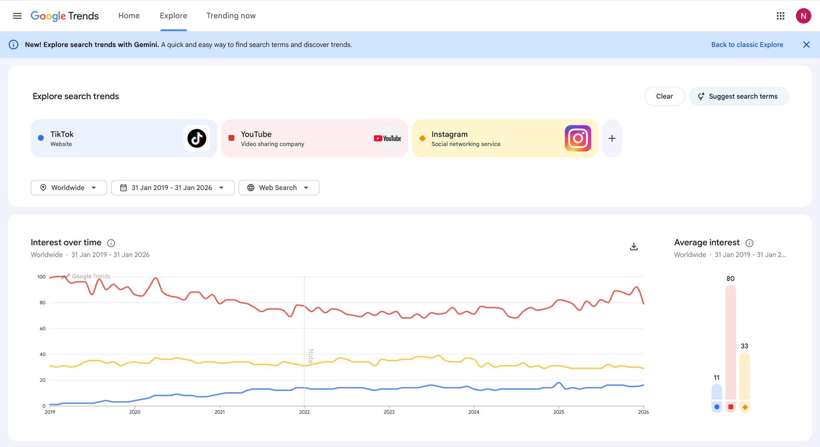
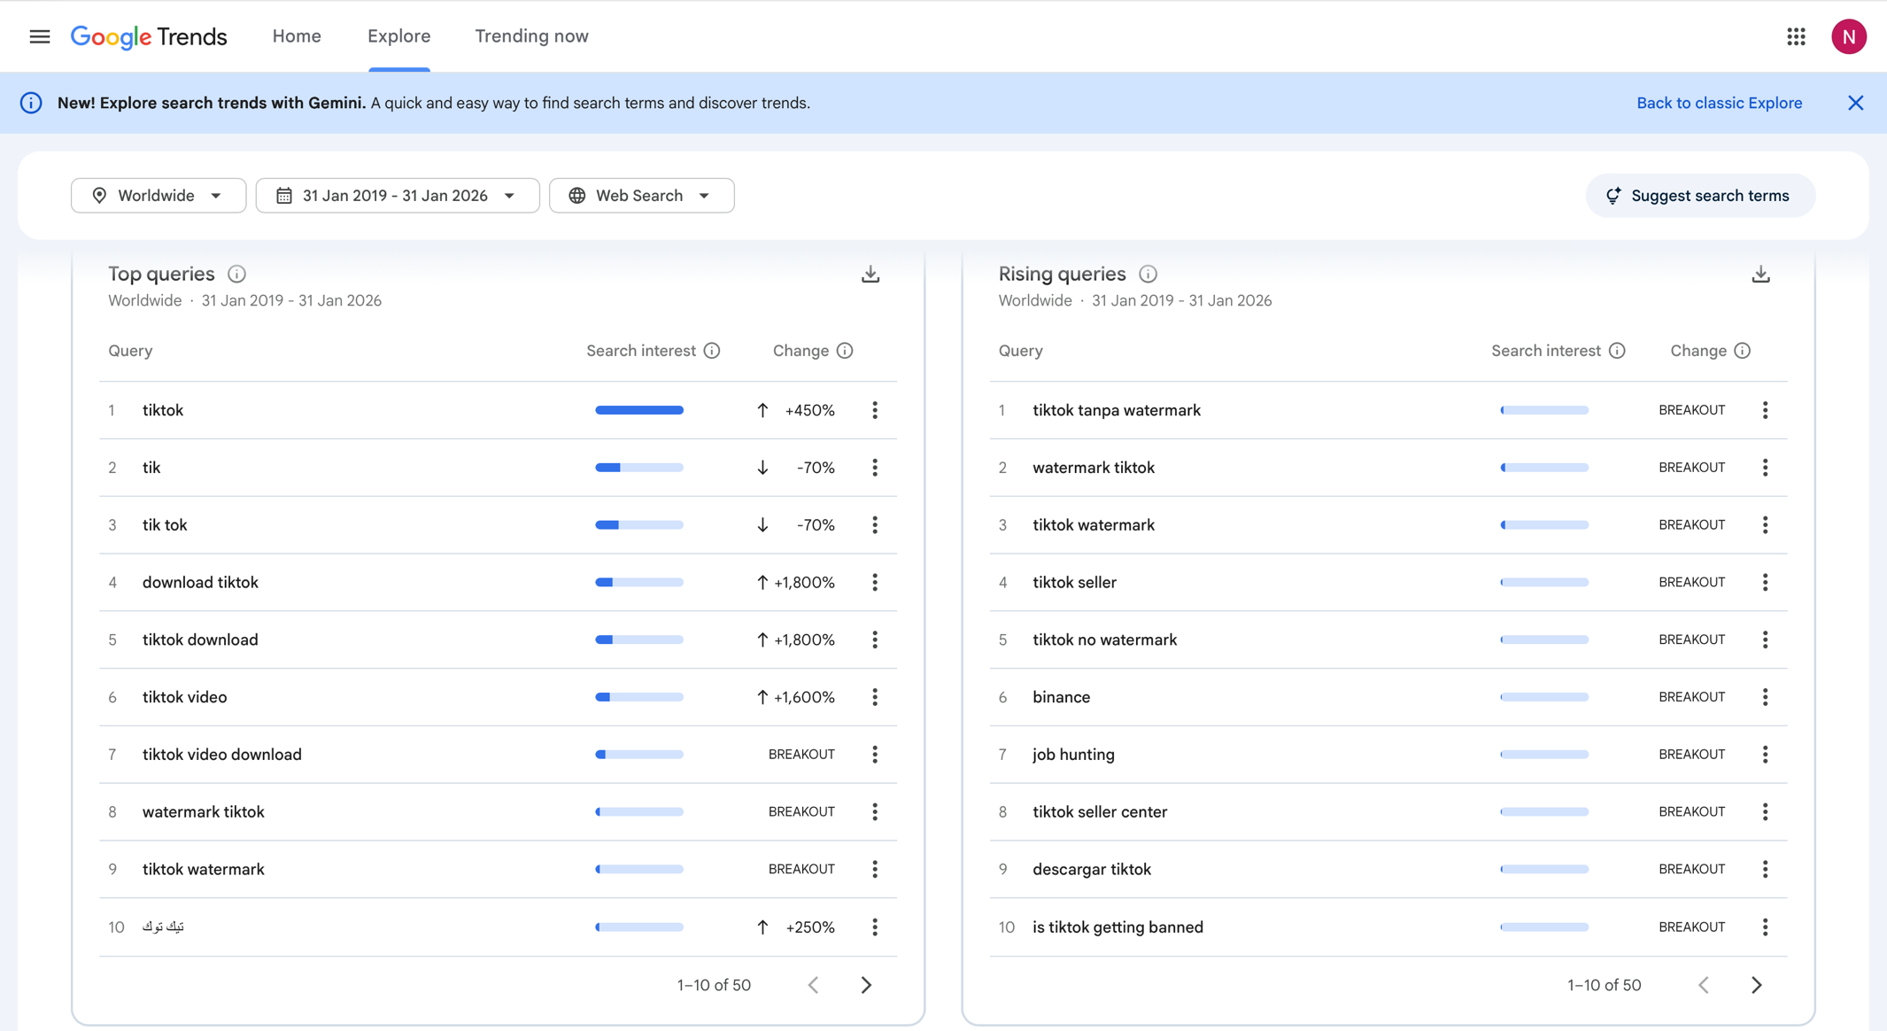

E

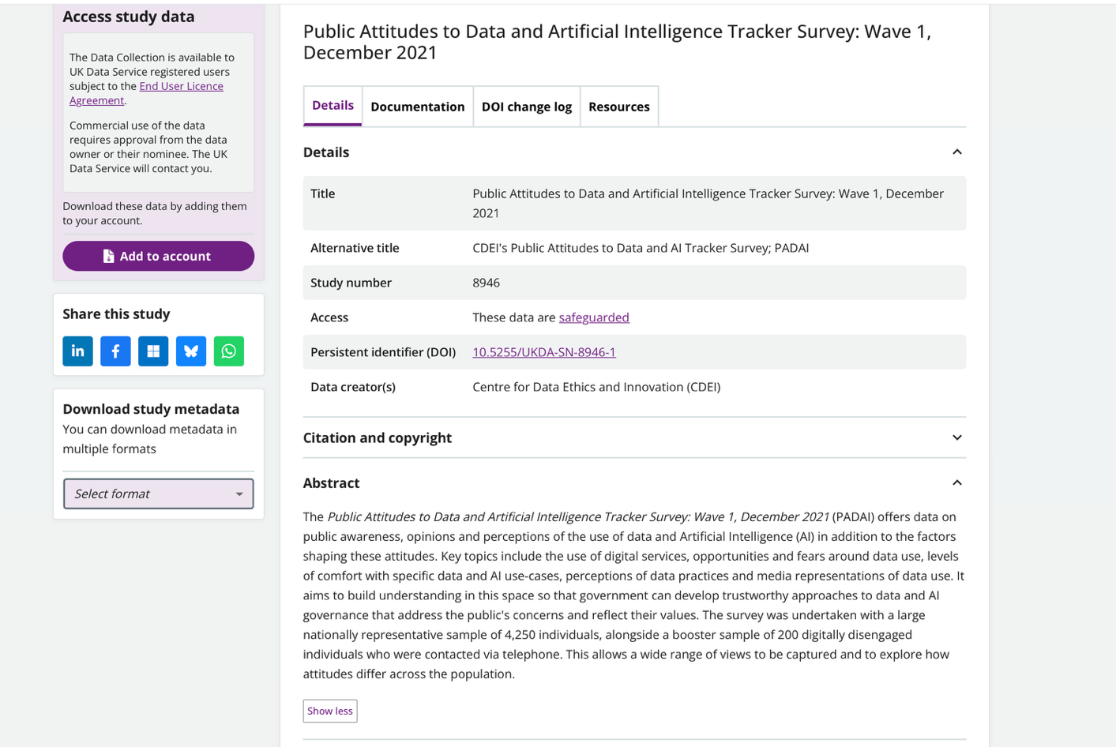
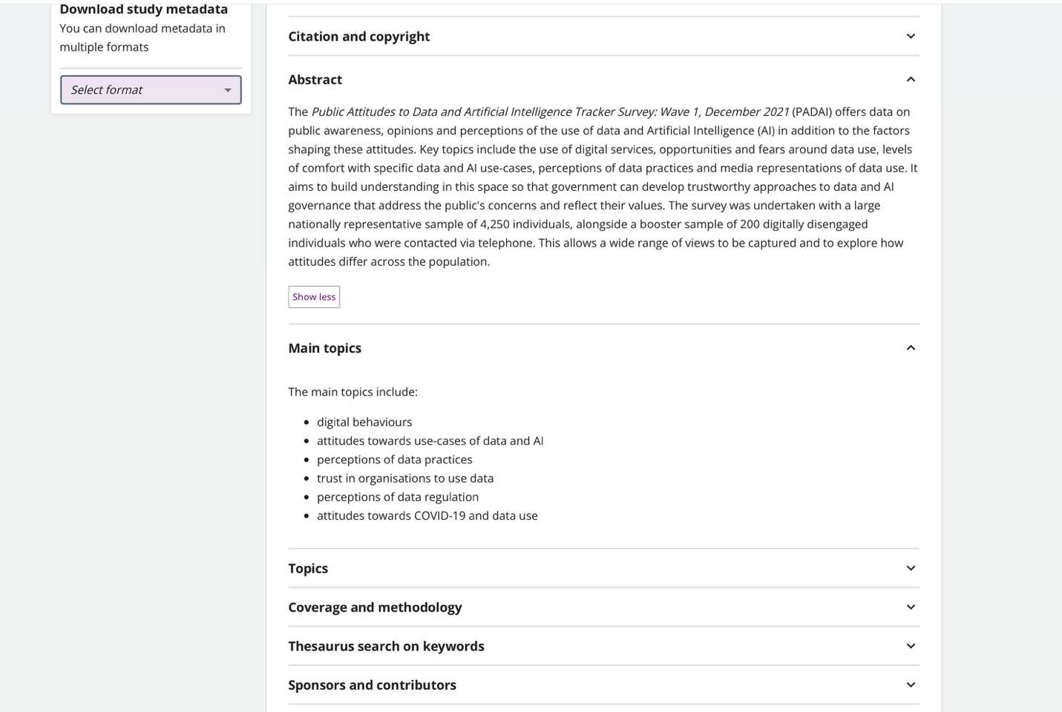

F

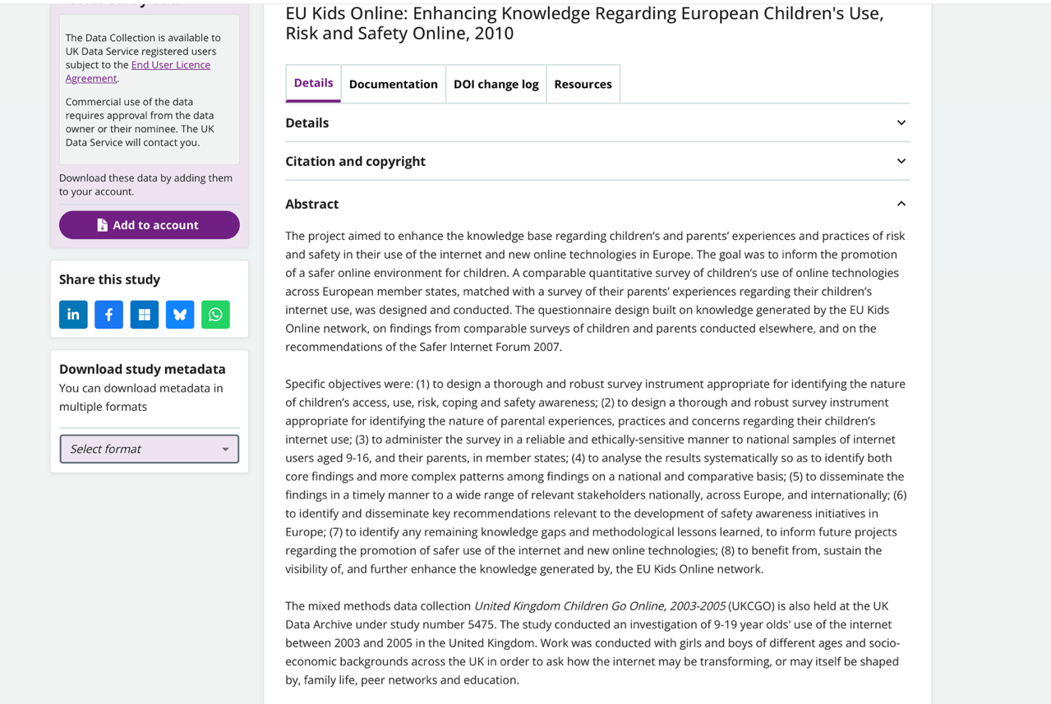
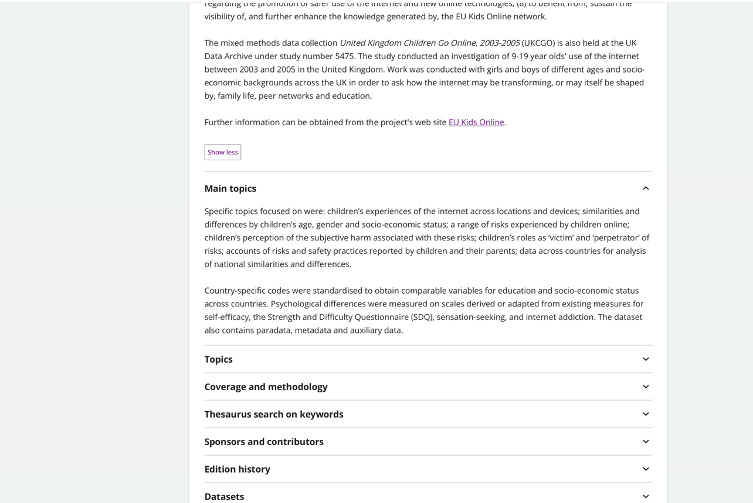

G

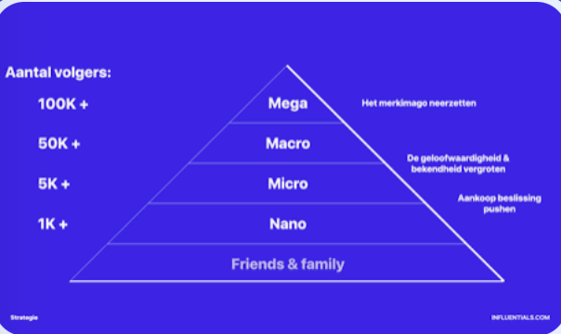

H
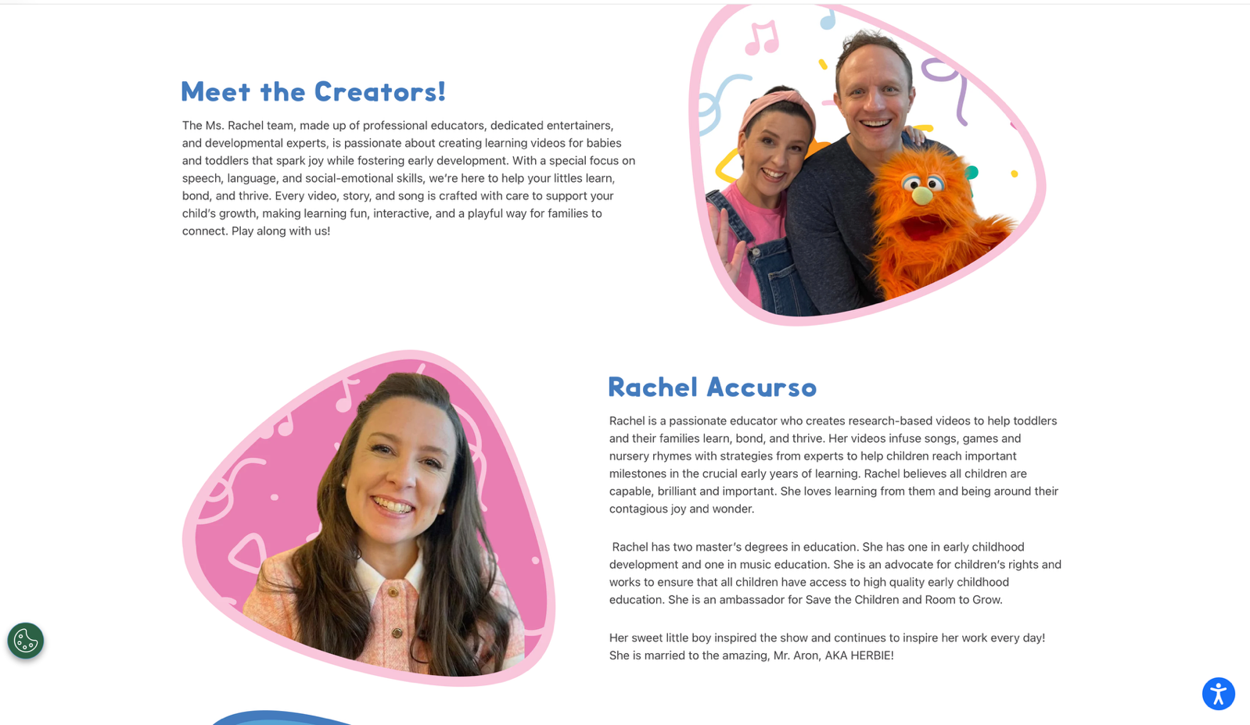
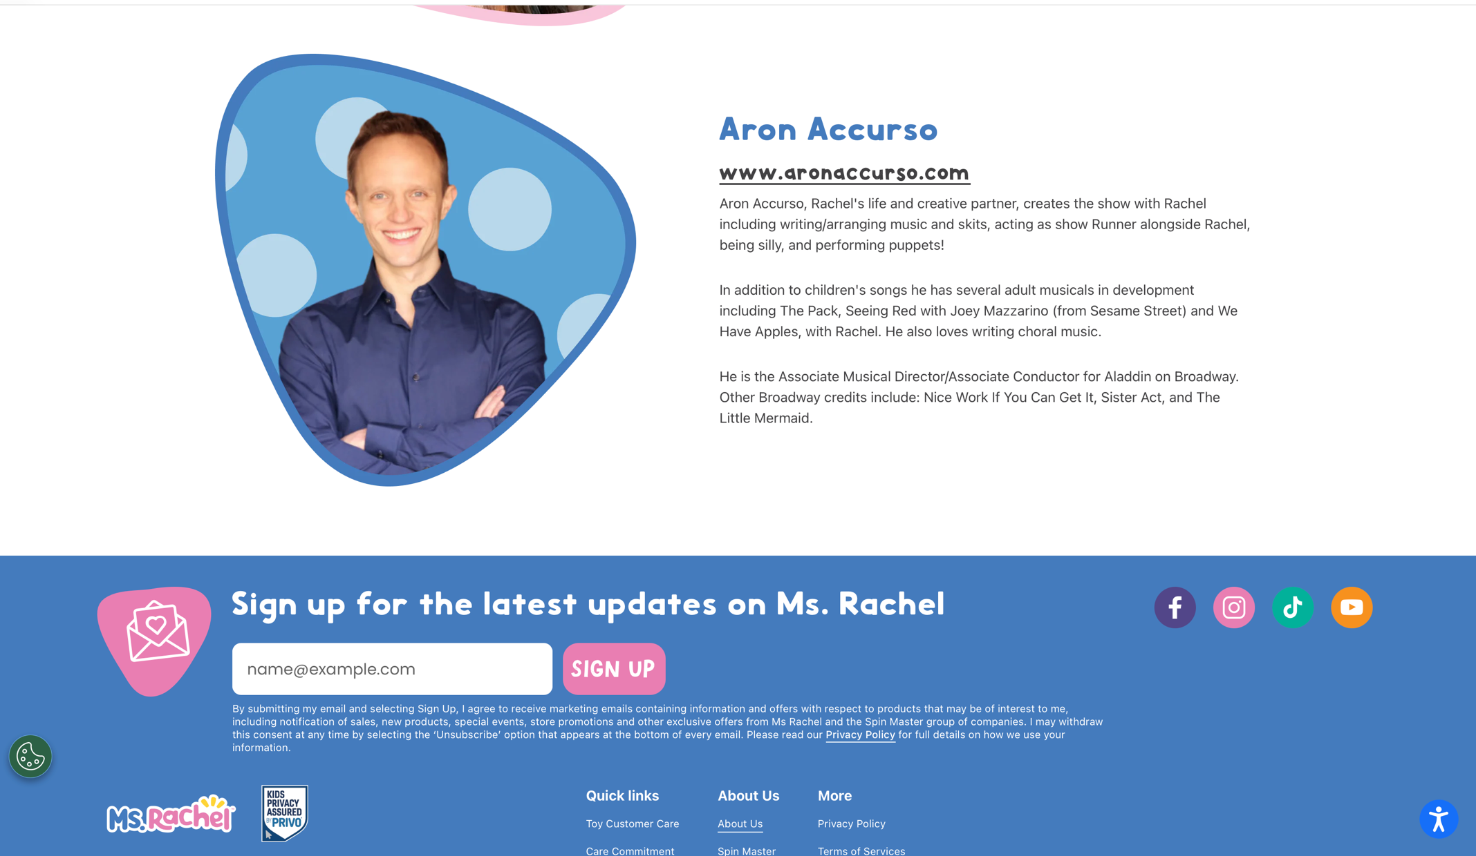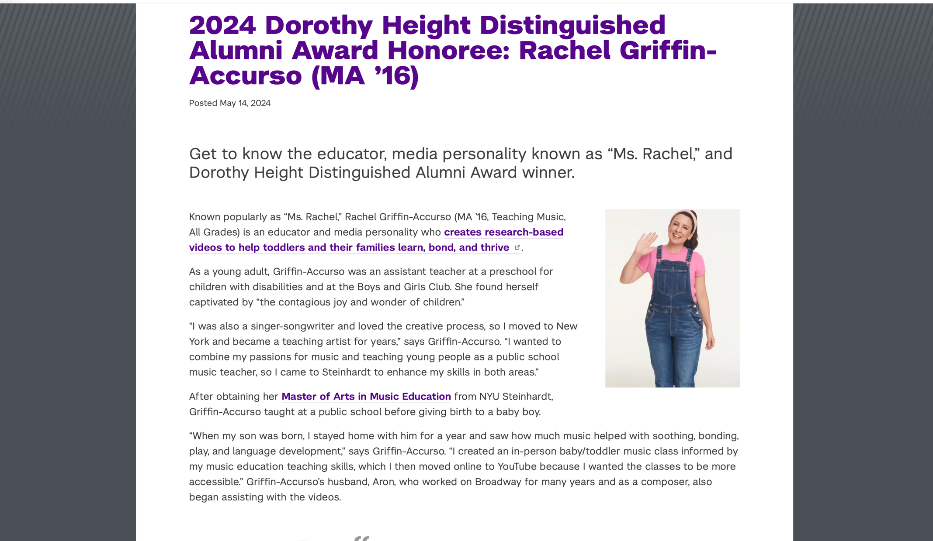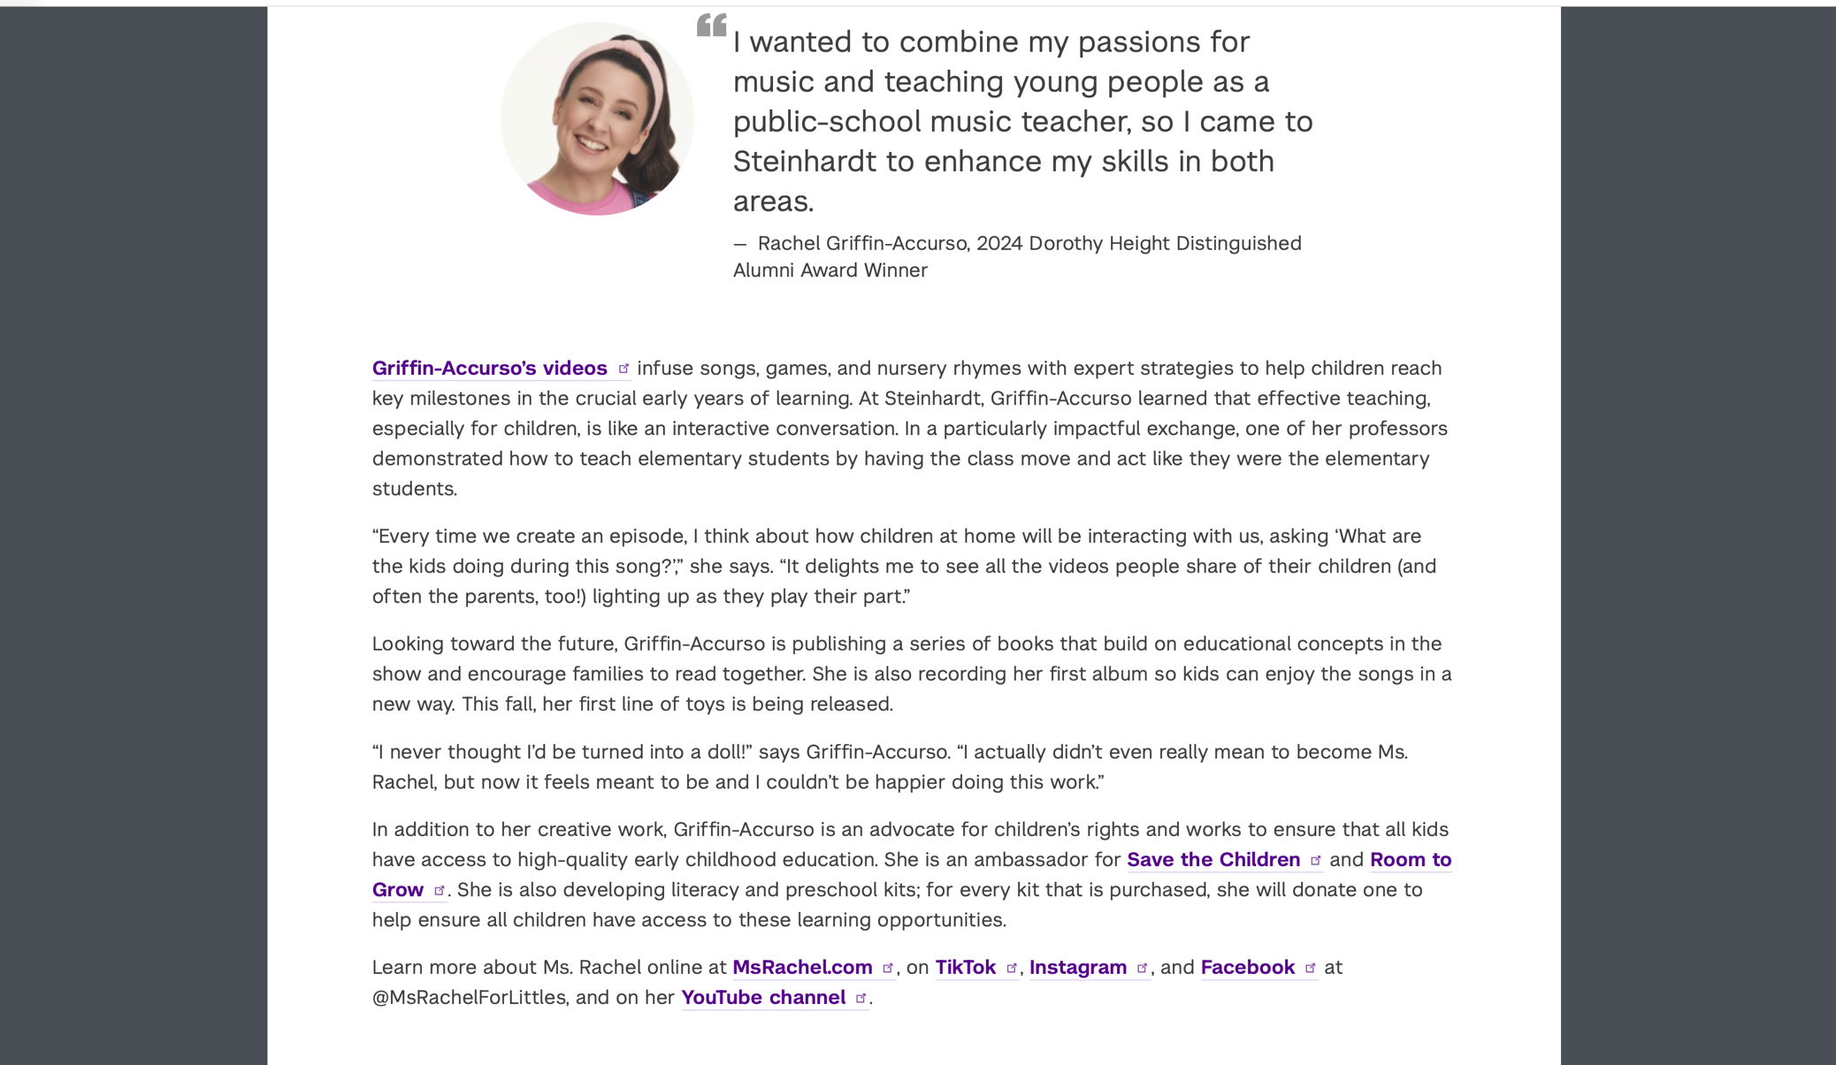

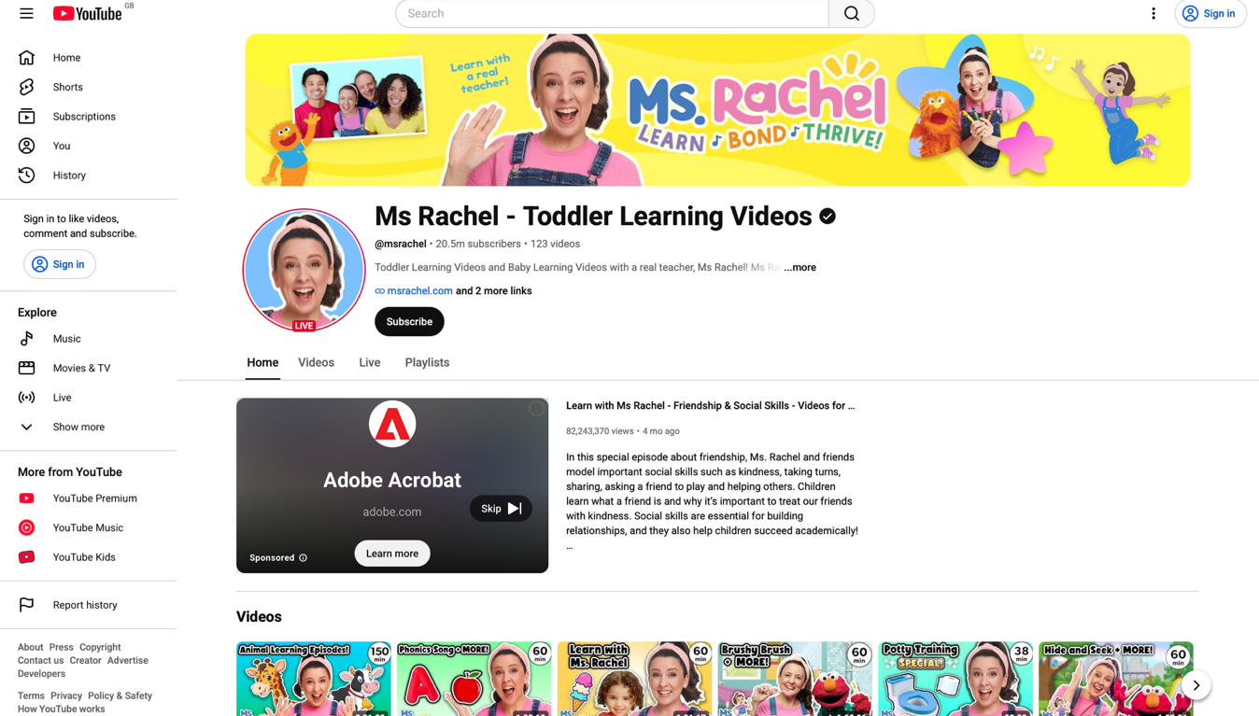

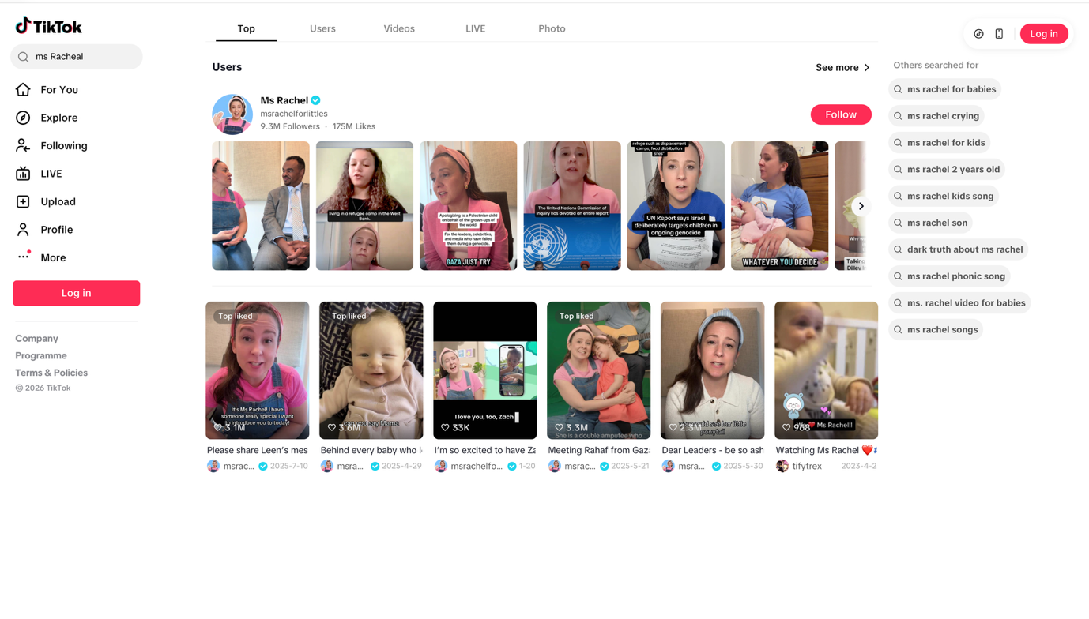

I

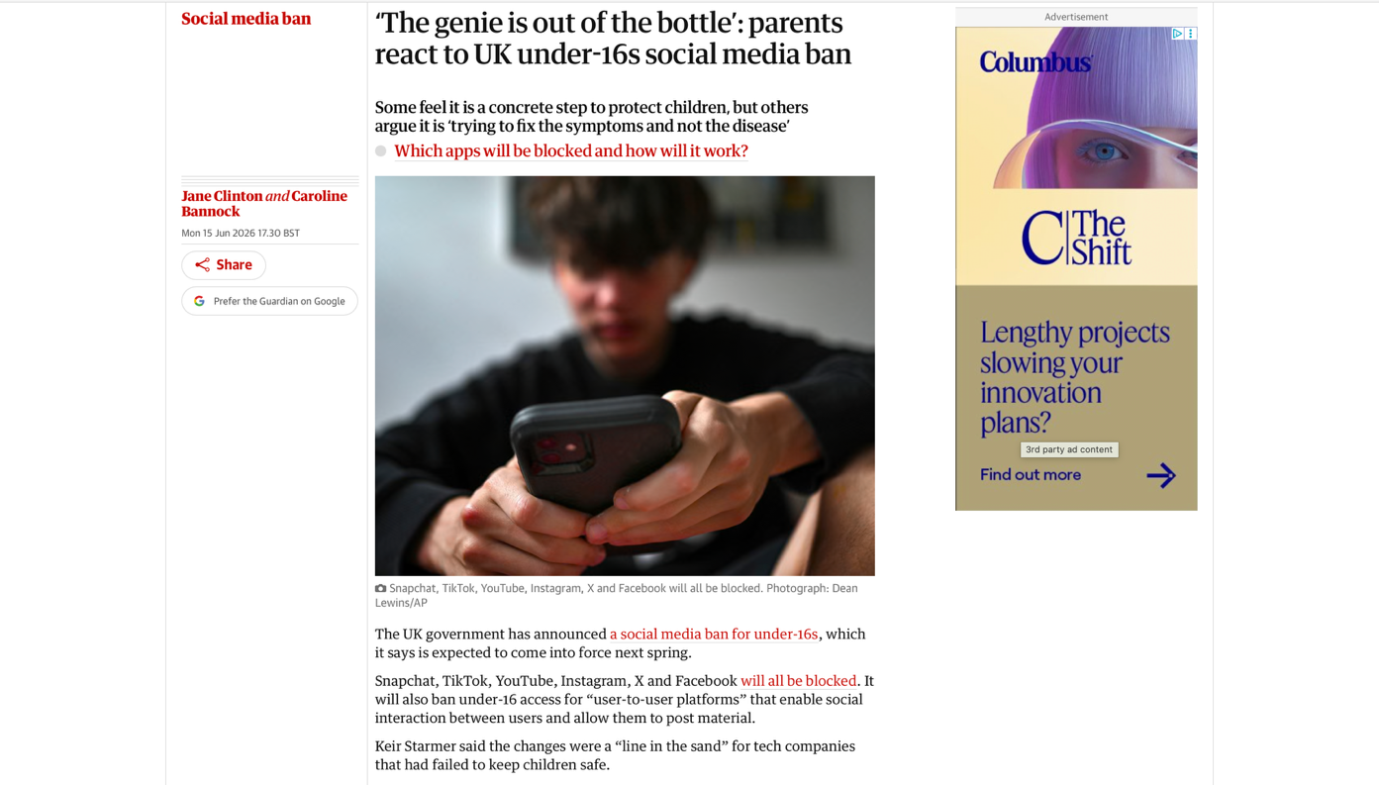

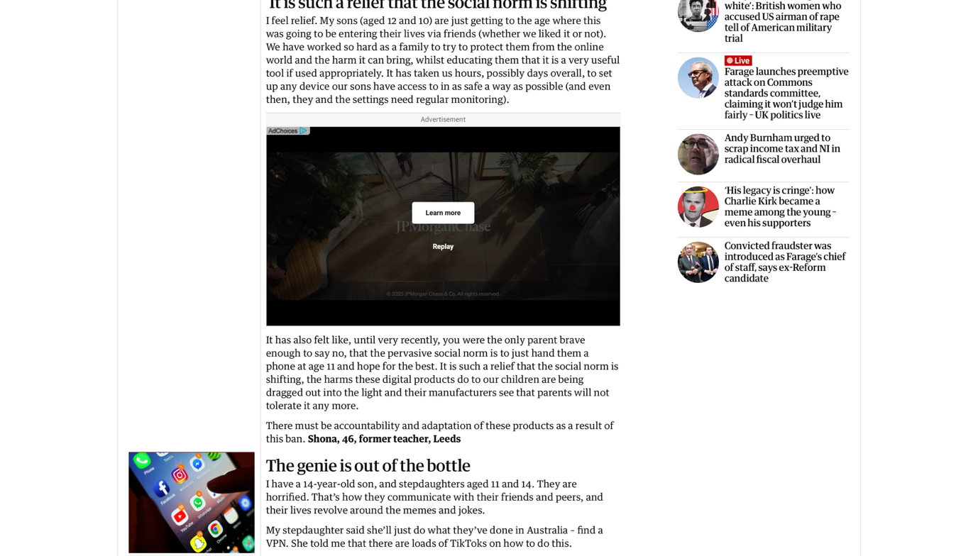

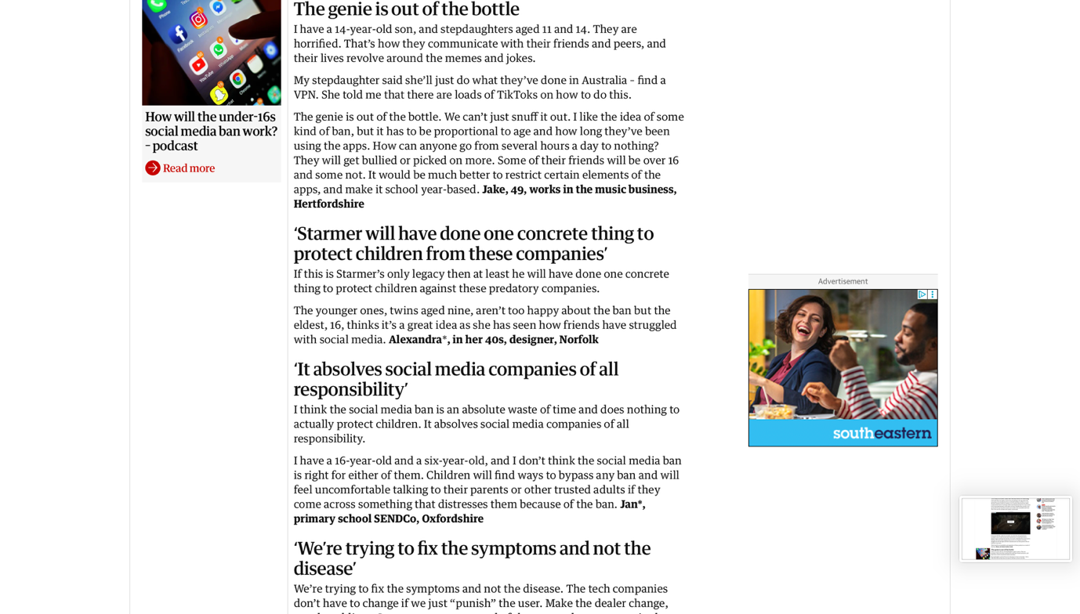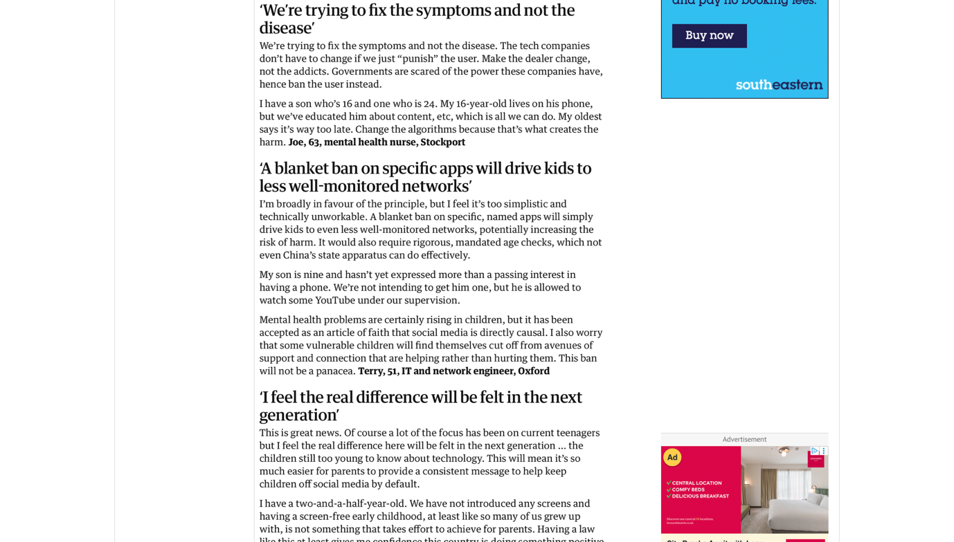

J

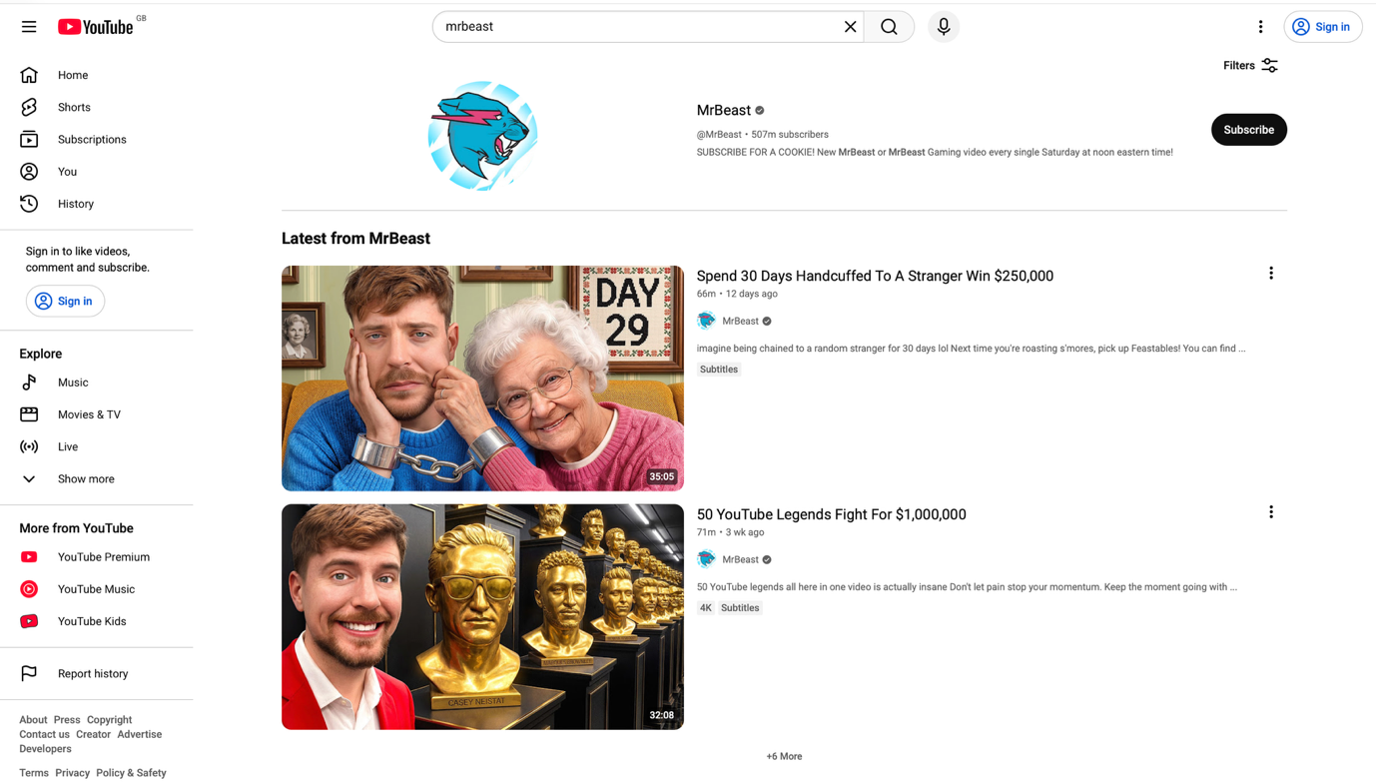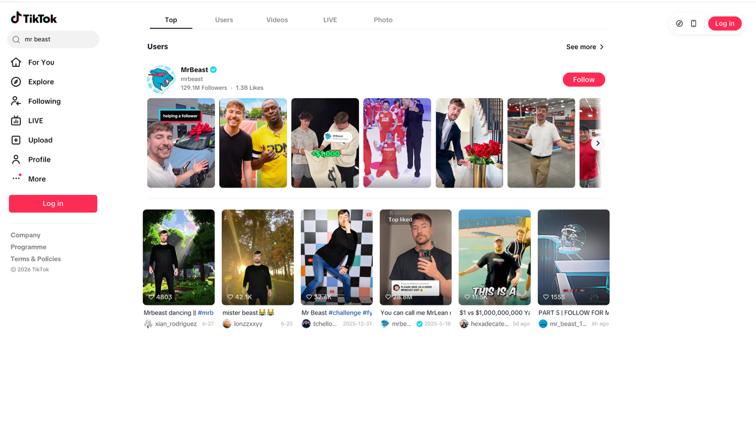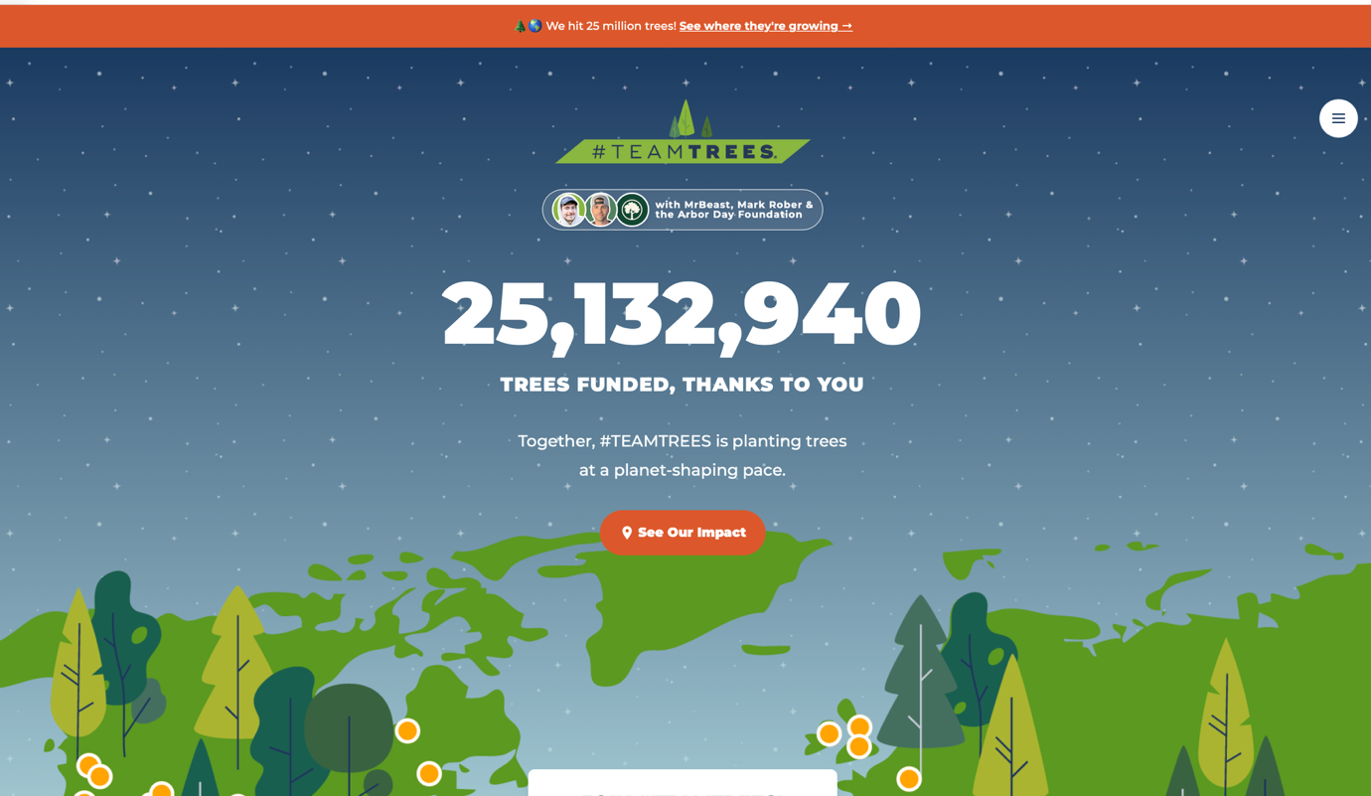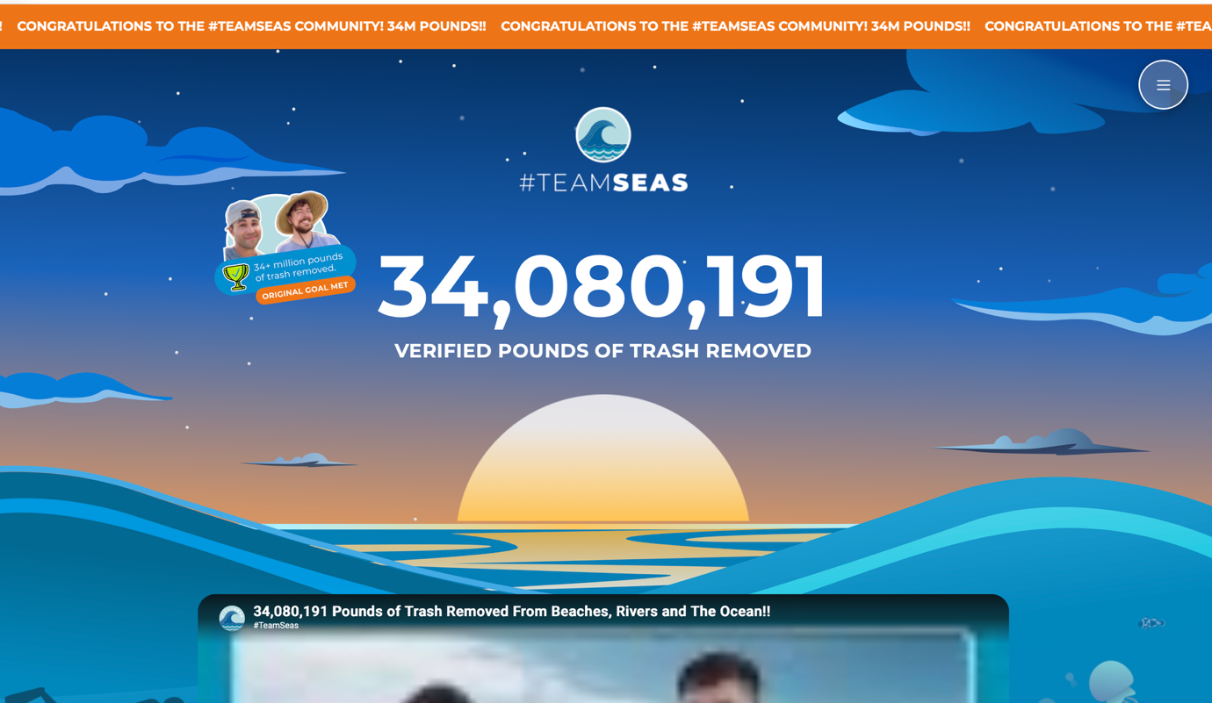

K
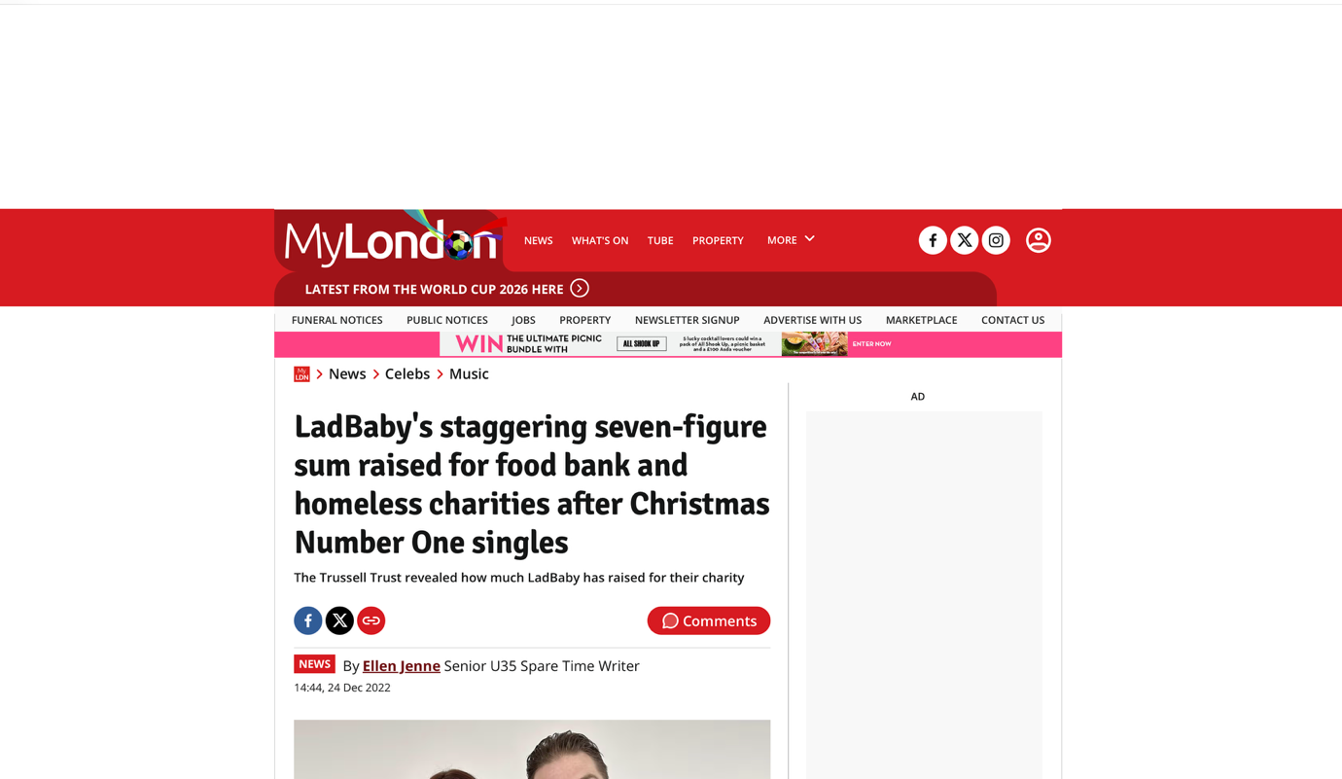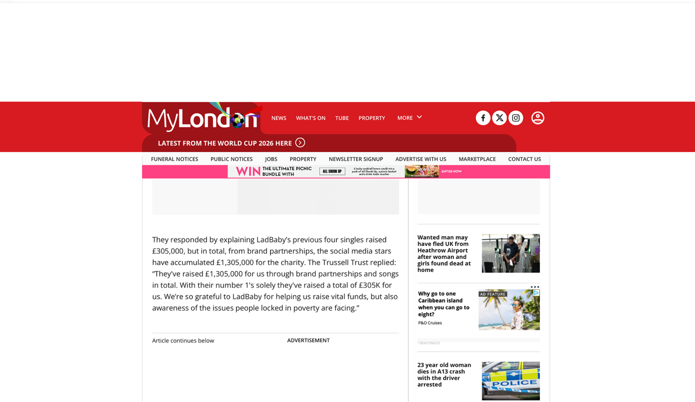
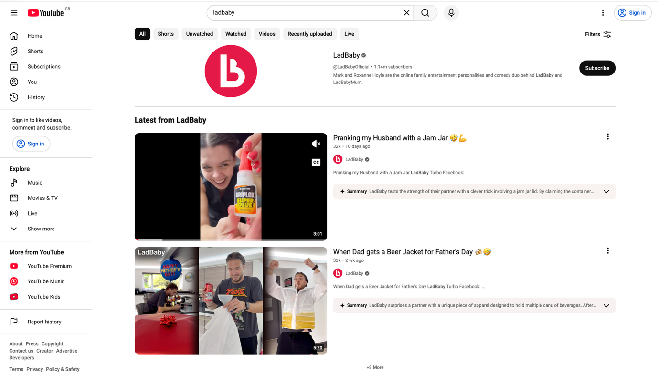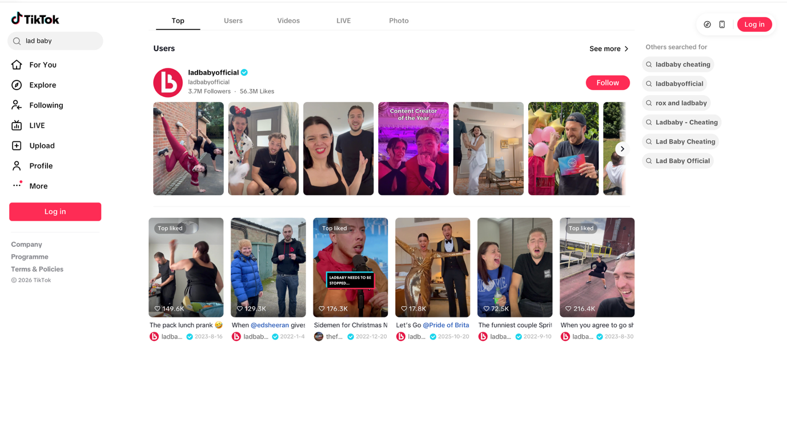

L

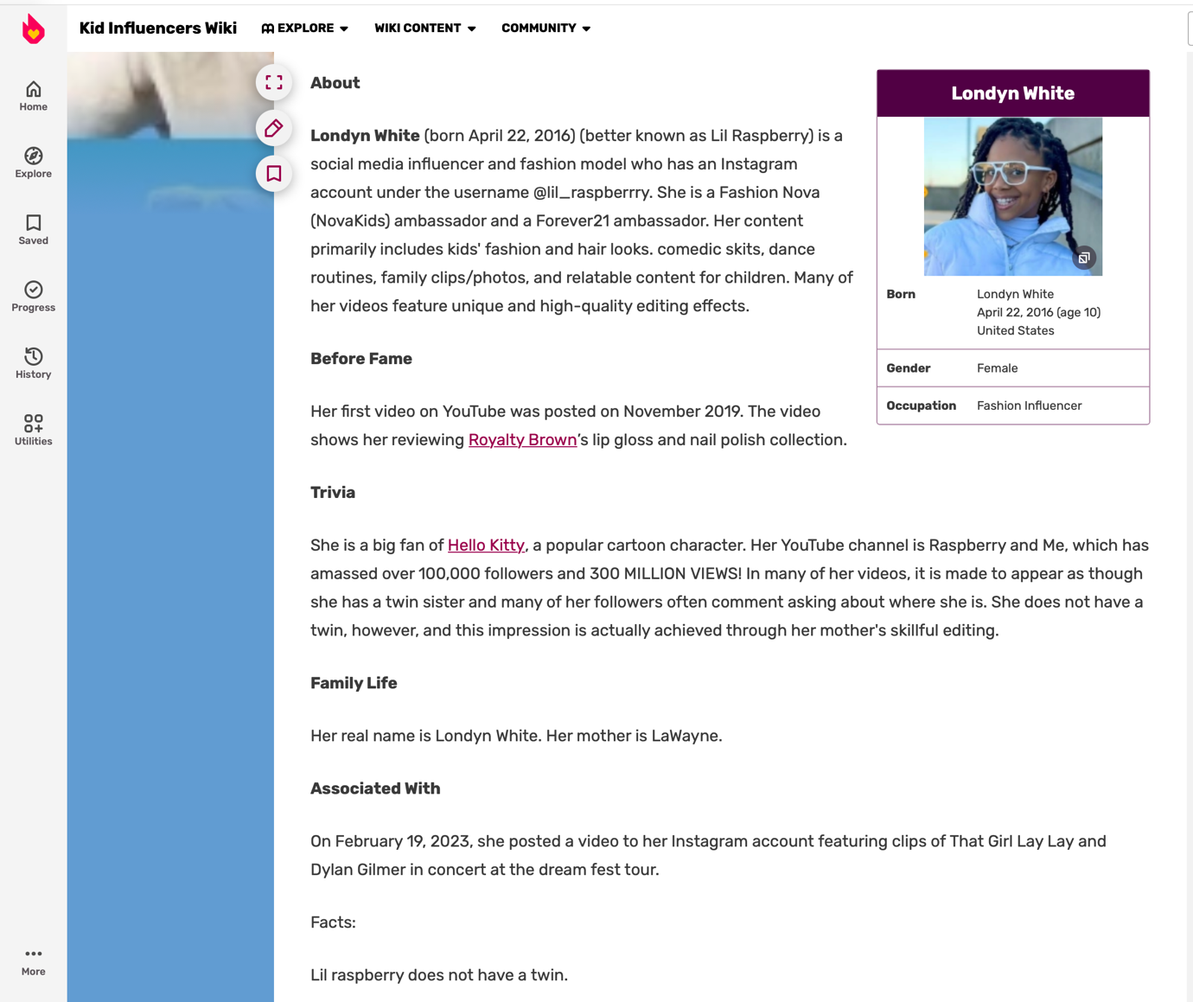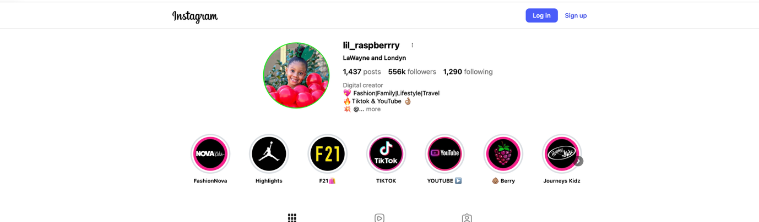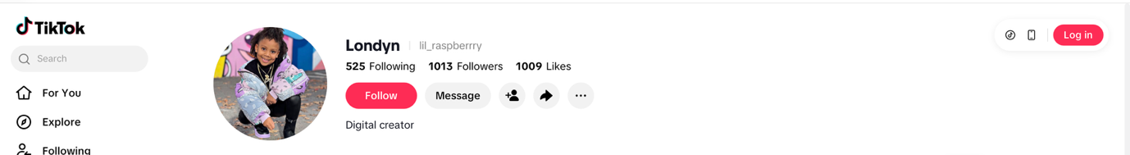

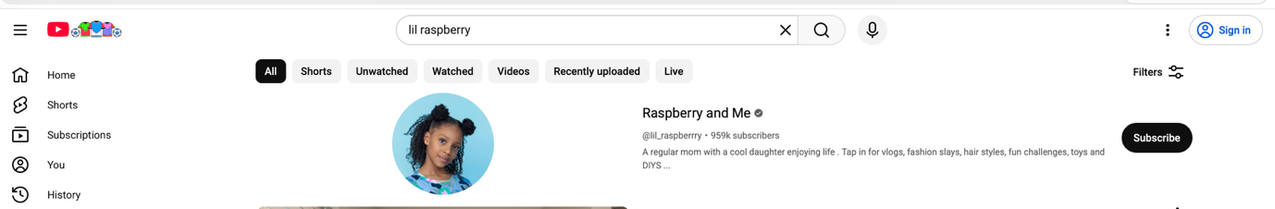

M

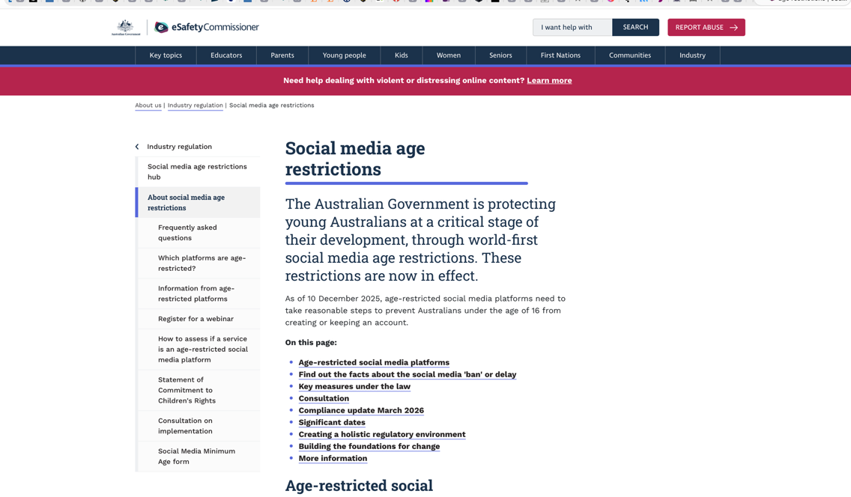

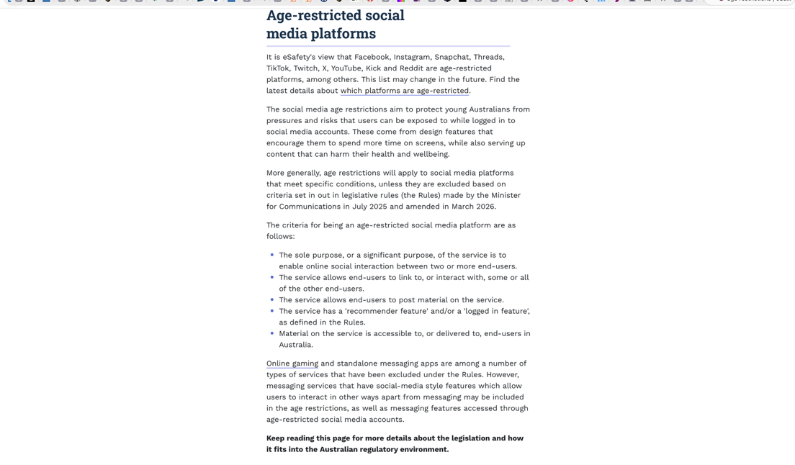
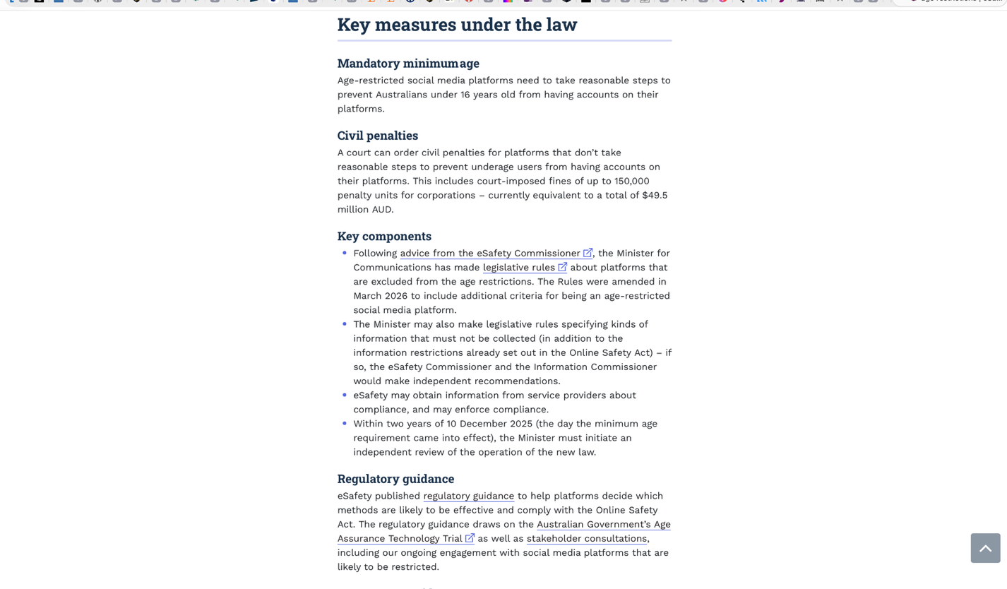

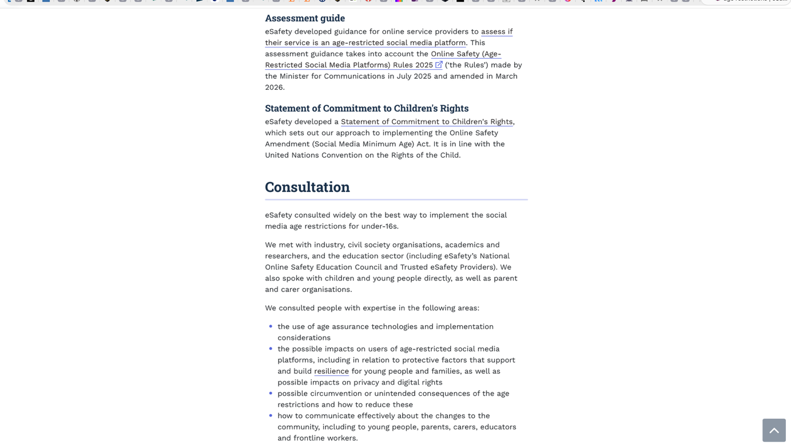

N

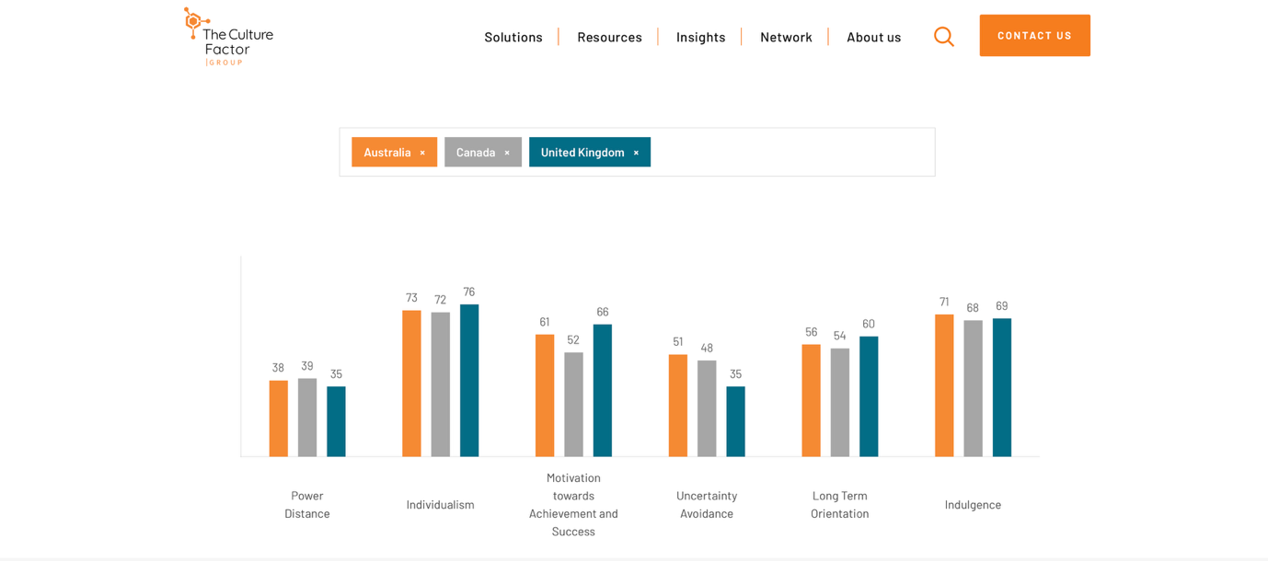

O Comparison of the Influencers
Influencer | Influencer Category | Main Platform | Content Focus | Business Model | Key Industry Issue Highlighted
MrBeast | - Mega influencer  - Entrepreneurial creator | - YouTube  - TikTok | - Entertainment  - Challenges  - Philanthropy | - Advertising revenue  - Brand partnerships  - Product ventures | Demonstrates influencer growth into business ownership but raises pressure around high-cost content and competition
LadBaby | - Macro influencer  - Family/lifestyle creator | - Facebook  - YouTube  - Instagram | - Family entertainment  - Charity campaigns | - Sponsored content  - Charity collaborations  - Media opportunities | Shows how authenticity and community trust influence engagement, but audiences may question commercialisation
Ms Rachel | - Educational creator  - Parent-focused influencer | - YouTube  - TikTok | - Early childhood education  - Learning content | - Platform income  - Educational brand development | Highlights opportunities in educational content but raises debate around children’s digital exposure
Londyn | - Child influencer  - Family-managed creator | - TikTok  - Instagram  - YouTube | - Child/family lifestyle content | - Parent managed social media presence  - Brand opportunities | Demonstrates growth of child influencers but highlights concerns around consent privacy and safeguarding.
P

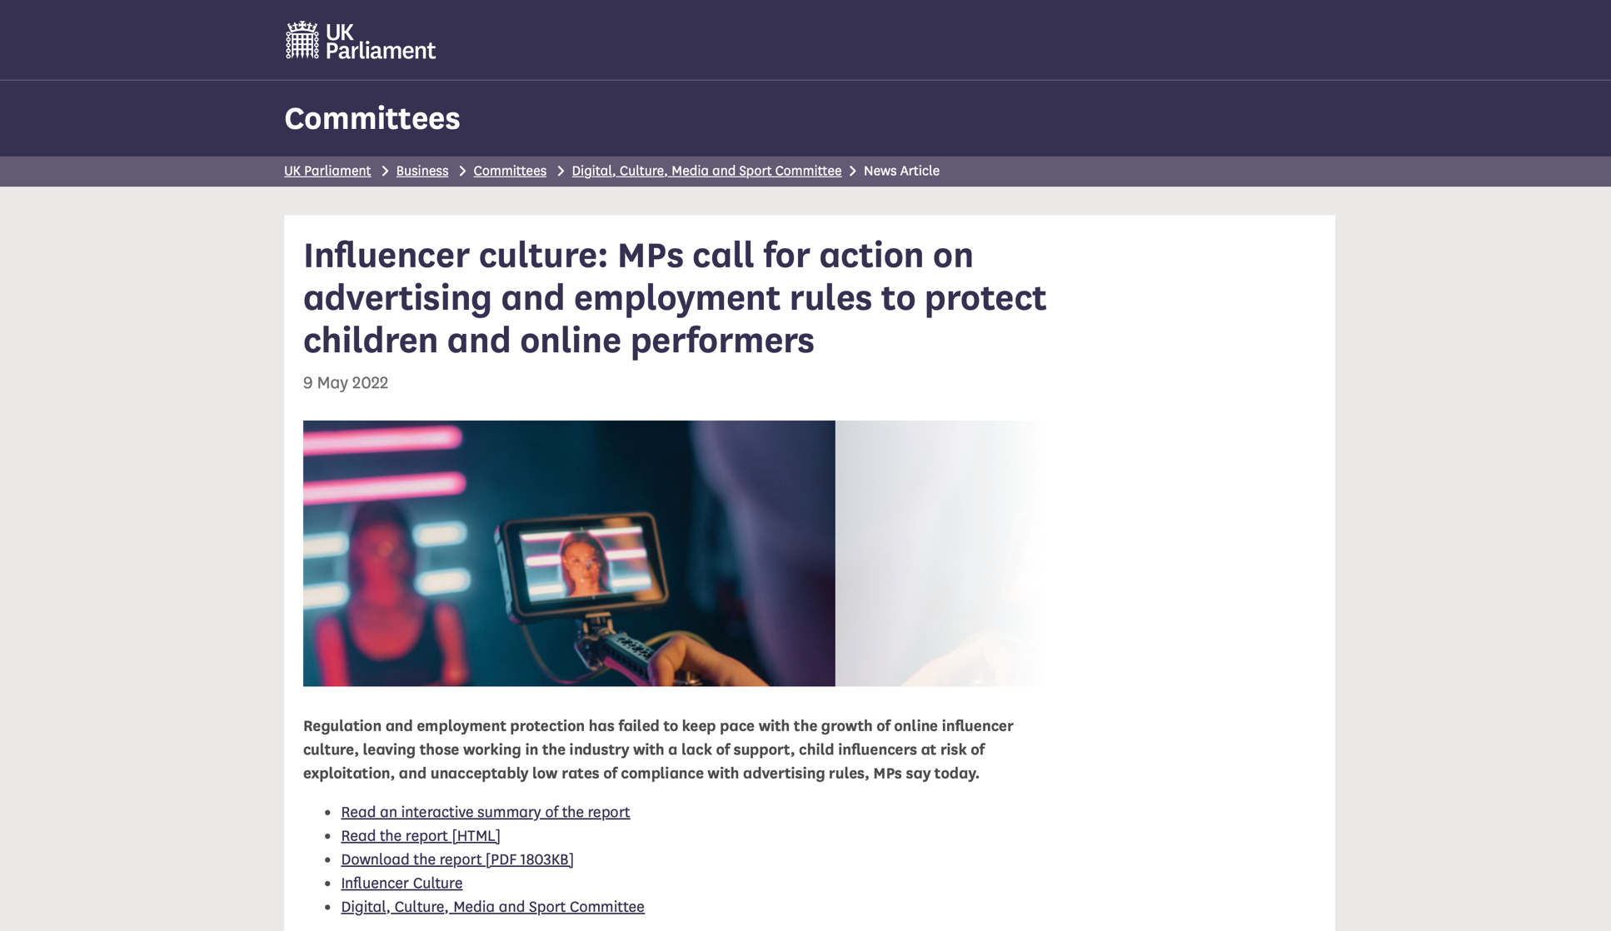
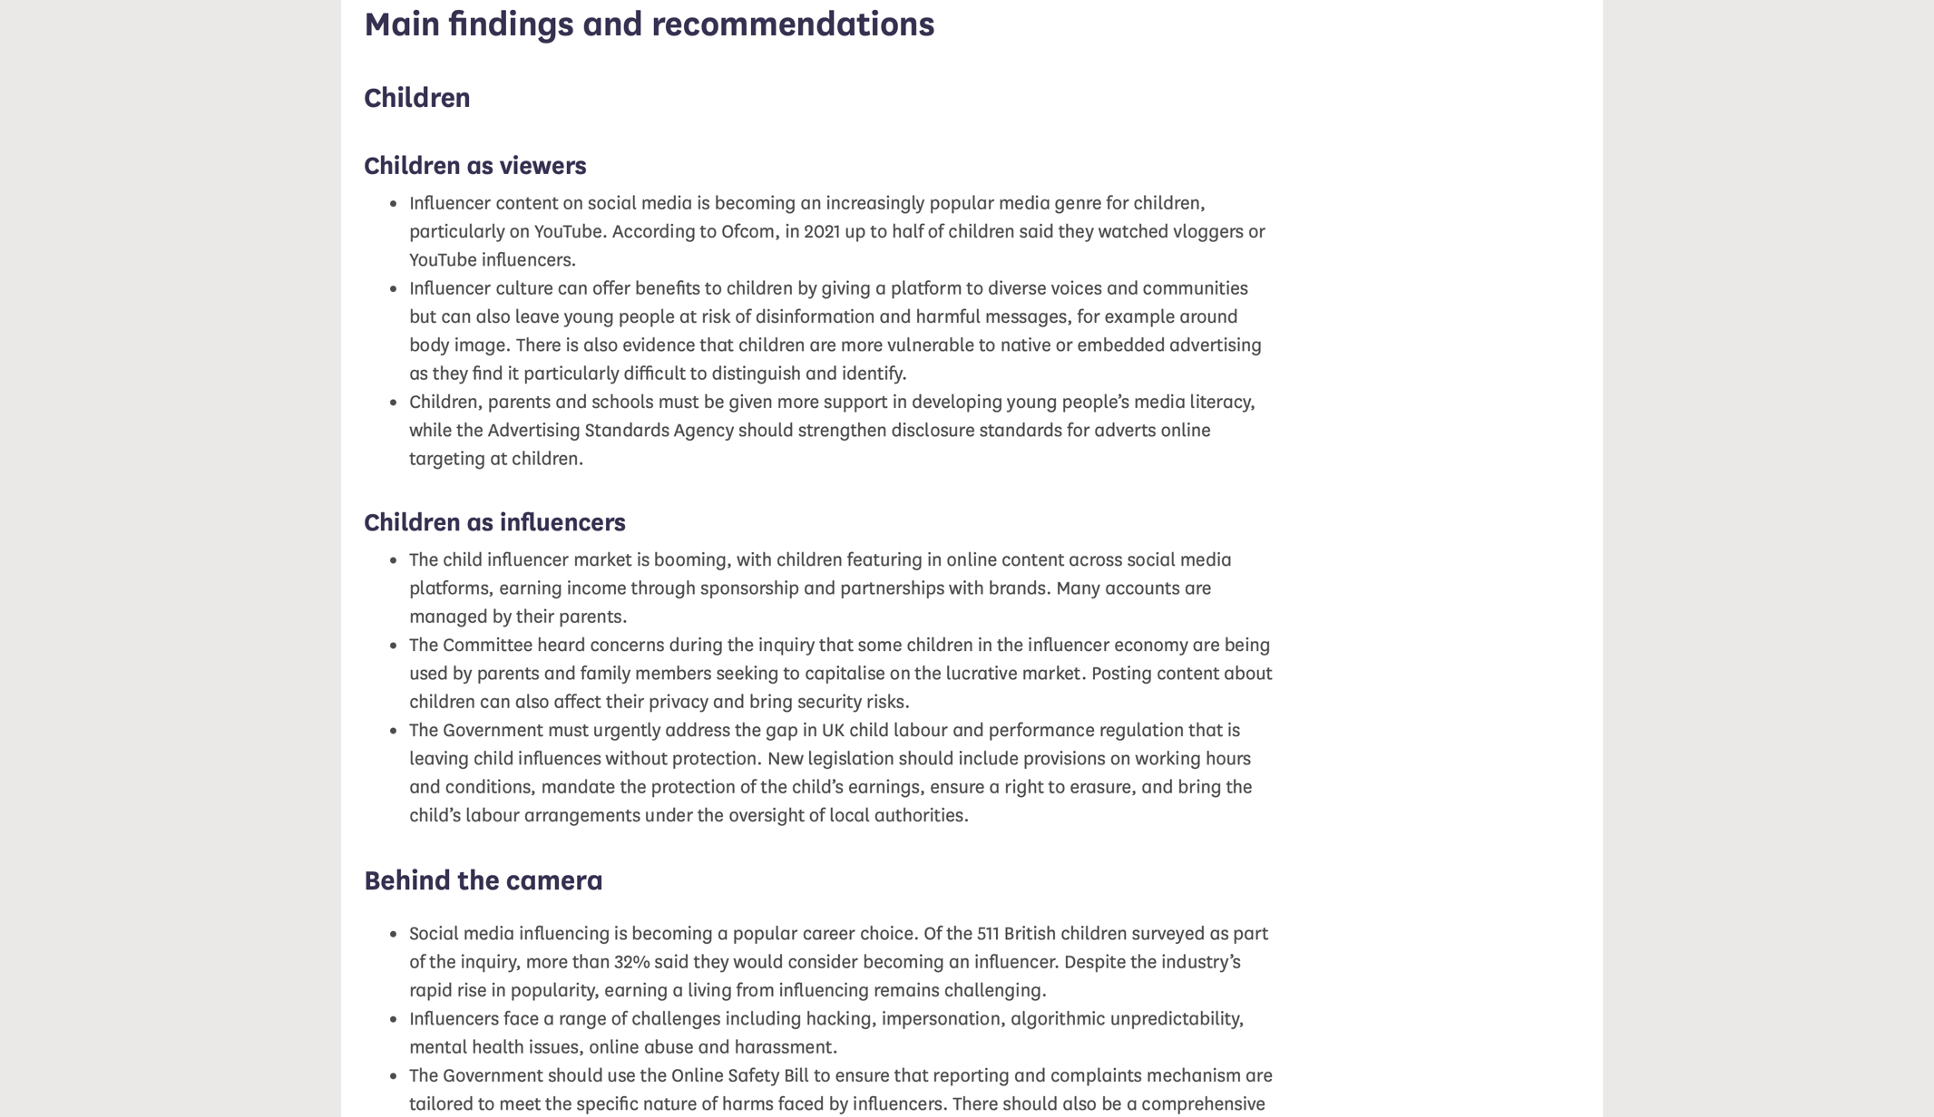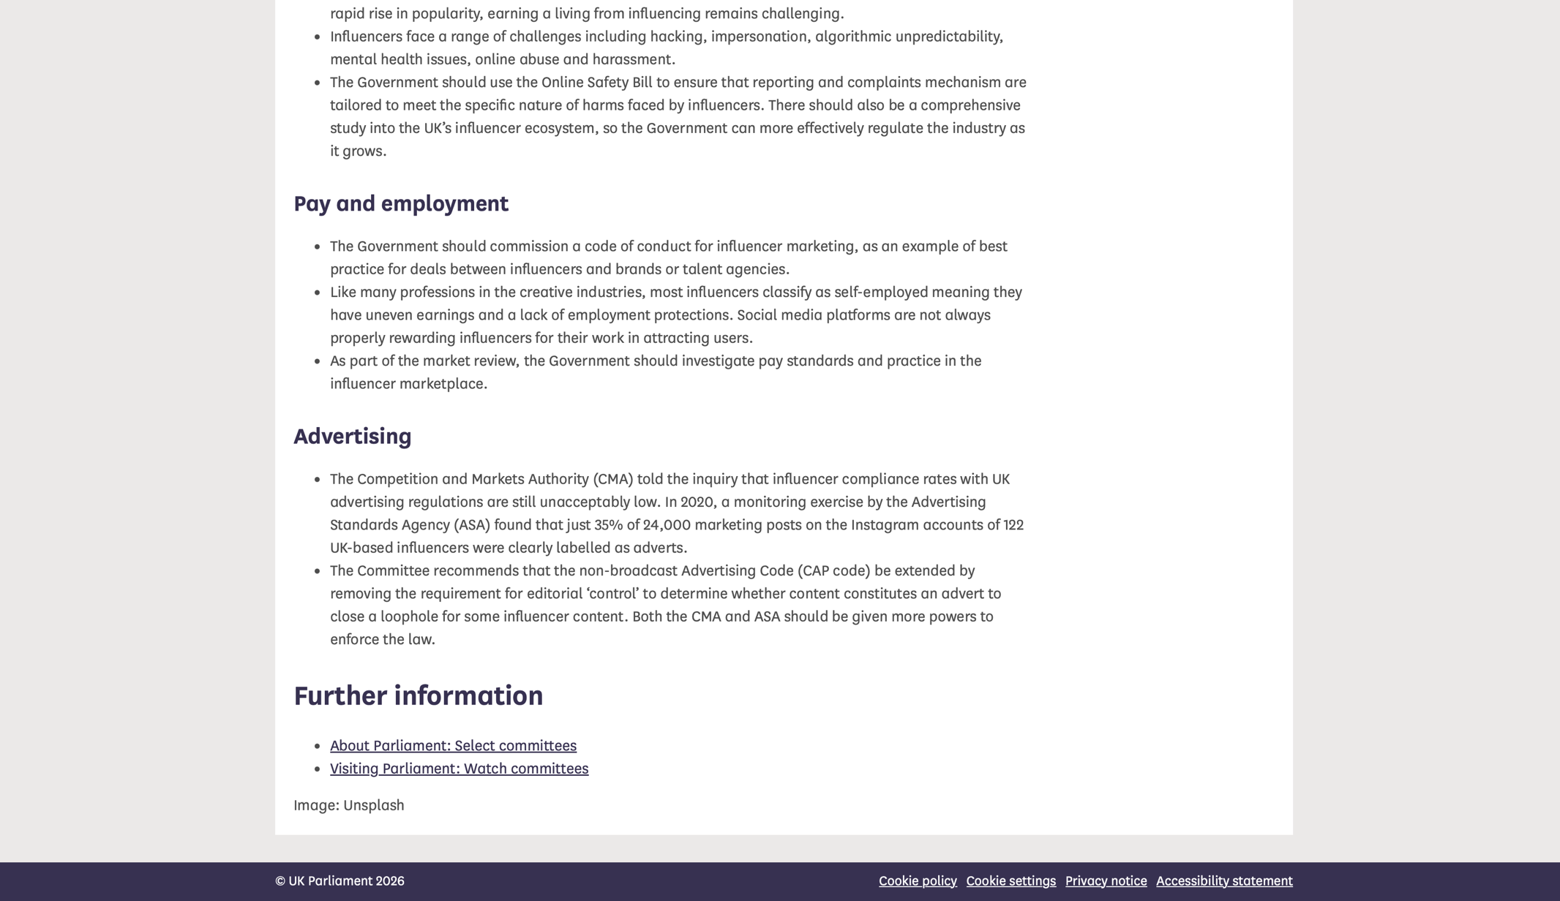

AI Evidence



