
Change Management
GlaxoSmithKline
Assignment Title: Strategic Change and Organisations
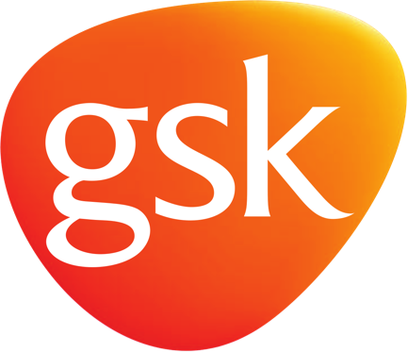

Table of Contents
1 Introduction 3
1.1 Background of the company 3
2 Critical analysis & Evaluation 4
2.1 Change management at GSK 4
2.2 Drivers of Strategic Change 5
2.3 Micro and Macro Environment 7
2.3.1 PEST analysis 7
2.3.2 SWOT 9
2.4 Role of manager in change management 10
2.5 Response to change 10
2.6 Politics and cultural processes in strategic change 11
2.7 Change and individual 11
2.8 Organisational learning 12
3 Application of analytical models 13
3.1 Kurt Lewin change management model 13
3.1.1 Unfreeze 13
3.1.2 Change 14
3.1.3 Refreeze 14
3.2 Kotter 8 step change model 15
3.3 Advantages of change at GSK 16
4 Organisational structural choices and design changes 17
5 Conclusion & recommendation of strategic choice 18
6 References 20

Introduction
Change within an organisation has been considered to be a very integral aspect as it is important for organisations to be change-oriented with the ever-volatile business environment. In such an environment, change management rises in significance to contain the effects of change for the betterment of the organisation. The essay discusses the management of change within a leading pharmaceutical, Glaxo Smith Kline. The change comes as the organisation transforms operations and culture to a more e-commerce oriented entity. Moreover, a changing culture shall be the crux of discussion where GSK transforms operation for moving forward with progress and rejects any operations that hinder growth and have lack of deliverance of the originally designed objectives.

Background of the company
According to the official website of the company, i.e. Glaxo smith Kline (2019), Glaxo Smith Kline is considered as one of the best pharmaceutical company in the world. Headquarter of the company is situated in London. A merger was occurred between Glaxo Wellcome and SmithKline Beecham in 2000 and changed its name to Glaxo Smith Kline. Glaxo Smith is documented as one of the top 20 FT global organisation and along with this, also recognised as the top 5 companies in the pharmaceutical industries in the world. The pharmaceutical company basically manufacture and promotes in two different sectors that include consumer health care and pharmaceutical. The company has expanded its operations in around 120 countries and is satisfying its customers over and over again.

Critical analysis & Evaluation

Change management at GSK
In the view of Mithas, Tafti and Mitchell (2013), every organisation in the present competitive environment is expressing huge challenges for developing a strong position within the industry they are operating in. In case of Glaxo Smith Kline the pharmaceutical company introduced a brand incubator which was used for rewiring some of the company brands for the modern consumer. Basically Glaxo Smith Kline is trailing a digital transformation agenda with an objective of boosting the performance of its e-commerce business and at the same time upgrading its media return on investment. The pharmaceutical brand considered to set its organisation in a way to gain capabilities so that it can compete in the digital world because the company is facing competition from its online pure-play businesses and direct to consumer. In addition to this Rogers (2018), stated that the digital and e-commerce director of the company in UK believes that they had clear knowledge of the opportunities along with the challenges the company would face after brand incubation. Some of the priorities set for the company in the near future for enhancing the performance and increasing growth include increasing media ROI, boosting commerce, developing efficient content and sparking disruption. These priorities were helpful in enhancing the digital transformation agenda of the company at Glaxo Smith Kline which is focusing on targeting its modern consumer.
In the view of Rava (2019), with the incubator, the team of specialist was developed that had the responsibility of rethinking about every product and now the brands had the strategy of addressing according to the needs of the customers in order to increase customer satisfaction level and gaining and maintaining a competitive edge in the industry. In addition to this Gerlach and Brem (2015), stated that the implemented changes was a part of the strategy for moving the company to a fail-fast culture that had the objective of stopping people across the business from being afraid of dumping projects that failed to deliver. The main objective of the business was to shape and lead the digital agenda for the UK. According to McNamara (2018), the brand wanted to renovate the way consumers interacts with it across all the pillars which should focus on, not just digital marketing but at the same time the e-commerce department as well. The new initiative of brand incubator was helpful in dealing with increasing challenges, especially in the digital market. Due to the initiative of improving the digital activities, the responsibility of the employees and managers was changed as they were responsible for the whole product line but now the focus has changed to the particular brand and they used the digital media to enhance the e-commerce. Due to initiative taken by GSK content for the brand was improved. They have also increased innovation by rethinking about the brand (McCarthy, 2019) However, in order to improve e-commerce and reaching out to the customer by using advanced technology. The employees were not aware of the advanced technology due to which digital transformation has disrupted their working condition. In order to use advanced technology, new technical staffs were hired (Linkedin, 2019) that has influence the working culture because the existing staffs were afraid of losing their jobs because of their lack of competency. This initiative entirely changed the working style of the employees and pressurized them to improve their performance. This leads to reducing the motivation level of employees. Thus, the company provided training to the existing employees and provided them opportunity to improve their skills so that the company can get the effective results (GSK, 2019).

Drivers of Strategic Change
According to Rock et al. (2016), strategic change basically refers to as the process that implements changes within the organisation. The external drivers involve the pressures from competitors, demand of the customers and technological change in the market. However, the internal drives involve the organisational policies, goals and profitability. In the view of (Rogers, 2018), GSK is the pharmaceutical firm whose major concern revolves around health of the customers. They also focused on improving the performance and maximize profit by providing value to the customers. The priorities of serving customers and enhancing growth are the internal driving force for the GSK to improve their performance. Therefore, it implemented digital advancement in the business and launched a brand incubator to boost their performance through e-commerce. As per the official website of GSK (2019), the company focuses on the innovation, performance, and trust as it has prioritised these to manage the culture of the organisation. However, these are also the internal forces that allow the company to bring innovation to the company. On the other hand, the maximizing profit is the core concern of every organization and GSK also aims to enhance growth and maximise profit (Annual Report, 2017). The strategic decision of bringing change in the form of technological transformation was made to increase its ROI to enhance profitability (Anuual Report, 2018). Further, the external driver for the GSK to bring the change is the pressure from the competitors in the marketplace as there is number of competitors that are earning good revenue but GSK has to retain the competitive advantage (UNCFTD, 2015). Thus, the company has to meet the competition in the digital world and for that, the company has decided to improve its e-commerce by introducing the brand incubation in their business. This will help in gaining more visibility in buying digital media and will also get a high return on investment. This will also help in dealing with the competition in the market and overcome the challenges in the digital world.

Micro and Macro Environment

PEST analysis

Political factors
In the view of Wright (2017), the political system of the United Kingdom is considered as one of most stable system and the country is recognised as one of the most powerful countries in the world. The country is documented as most popular and successful destinations for foreign direct investments. Different factors like unstable government rules, international trade regulations and an increase in taxes can influence the business of GSK in UK and other countries.

Economic factors
According to Dell'Ariccia, Rabanal, and Sandri (2018), the United Kingdom is recognised as the 5 largest economy and stable economy in the world. According to the statistics gathered in the second quarter of 2019, the GDP rate was recorded to be £513,029 million. Moreover, the consumer price inflation rate was increased to 2.1% in July 2019. The stable economy will result in increased profits and sales for GSK.
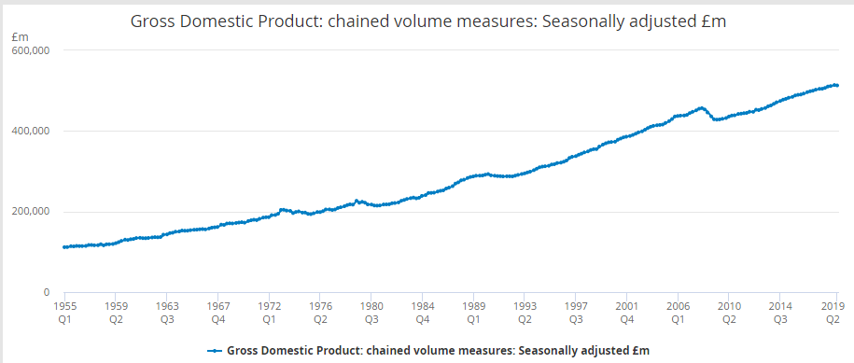
Figure 1 GDP rate of UK
Source: Office for national statistics (2019).

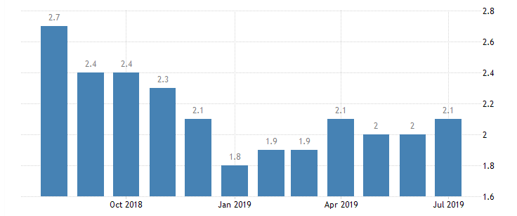
Figure 2 Inflation rate of UK
Source: Trading economics (2018)

Social factors
According to the official website ONS (2017), the UK has large consumer market and as per the data gathered in 2017 the total population was recorded to be 66.04 million. The country has a multicultural society and is in the list of top 10 countries that have most educated populace. The society is moving more towards technology advancement. The culture of shopping online is increasing steadily majority of people prefer shopping online than visiting any store.

Technological factors
According to McGoogan (2017), the UK is recognised as one of the most advanced countries in terms of technology. Therefore the technology sector of the country contributes the most to the economy of UK. The innovative infrastructure is helpful in providing huge opportunities to the entrepreneurs. Due to the changing trends of consumer in terms of shopping majority of the businesses are shifting more towards eCommerce. Having an online presence is considered as a competitive edge in the market.

SWOT
Strength | Weakness
- Ranked as one of the top five companies in the pharmaceutical industry in the world (Alder et al. 2016).  - Global presence in more than 100 countries.  - Strong sales and distribution network. | - Different controversies related to issues of safety of drugs influenced the company negatively (BBC 2012).  - Several cases of expired bulk buster products.  - Weak online presence
Opportunities | Threats
- Focus on digital transformation and its eCommerce  - For boosting the company’s research process it can develop strategic agreements with other organisations in the pharmaceutical industry (Kumar 2019).  - Increased demand and awareness related to quality healthcare gave the opportunity to improve the top line and bottom line of the company. | - Increase risk of unsuccessful new products.  - Likelihood of economic slowdown especially in the European countries can be a major threat for the company (Evoniuk et al.2017).  - Introduction of generic products had influenced the sales of the company.

Role of manager in change management
The idea of this part is to highlight the role of a manager in change management. Middle line managers are the best contributors to success of change management. It is mainly because managers build a positive perception of the staff and employees by showing the massive support for change (Vaccaro et al. 2012). It is also highlighted that middle line managers also lead employees through the process of change management by coaching them properly. A good manager needs to support the whole process of change, mainly when the change begins to impact the daily operational activities of employees (Ionescu et al. 2014). Managing the change at GSK especially the one being discussed is quite important. It is considered to be an eminent aspect of the organisation’s progress. Managers in GSK must be the drivers for the change, transforming operations and the culture is considered to be the integral role which the managers at GSK play to manage a change. Within a cultural shift where loss-making projects are dumped, managers at the time of change were considered to be the promoters for adoption of the new culture by GSK this considered to be the most eminent role which they play within GSK taking new culture of “fail-fast” culture along with larger focus on e-commerce.

Response to change
The change in GSK to introduce brand incubator brought the change in the working environment of the company as this change had affected the working procedures of the employees which made them dissatisfied with their job roles. Although, the rewiring of brand was beneficial for the organisation, the negative response was observed from the employees that resist them to accept the change. The reason for not accepting the change is the change in the working criteria as their regular work was disrupted. The digital transformation has also affected the working environment as they were not familiar with the technological change which also changed their emotional state of mind and can create fair of failure (Stensaker and Meyer, 2012).

Politics and cultural processes in strategic change
The strategic change in GSK was implemented by the power of the top management as it was the strategy that could help the company to grow in the competitive market. However, there was political influence in the working environment because the employees were not accepting the change and they even denied working with the new procedures and tried to change the decision (Saïd et al, 2019).

Change and individual
It is discussed in the article by Wittig, (2012) that the reaction of employees is justified as they move from the process of the stable and known atmosphere from the unstable and unknown atmosphere. Thus, GSK conducted meetings for the employees to make them aware of the change and explained the reason to reduce negative reactions. At first, the employees were unable to accept the change which made them frustrated. Some of them reached to depression because of lack of competencies. But soon after they got trained, they accepted the change as part of their job roles (Annual report, 2017).
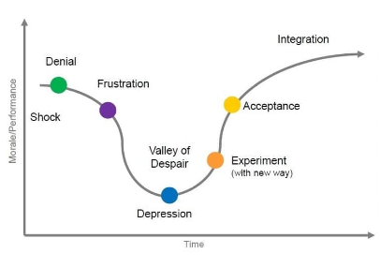
Figure 3: Emotional Transitioning
Source: Davey et al. (2013)

Organisational learning
In GSK, the change enhanced the knowledge that technical advancement was very essential for the organisation because it helped in improving the performance. However, there were different risks associated with the change but the change can be implemented if it is managed properly. In case of GSK, technological advancement helped the company to fulfil the demand of the customers. Also, the employees developed technical skills with the help of training and development which led to an improvement in the business performance (Annual report 2018: McEleny, 2019).

Application of analytical models

Kurt Lewin change management model
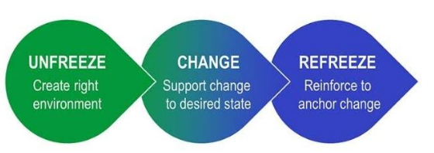
Figure 3: Kurt Lewin Model
(Source: Hussain et al (2018)
In the view of Hussain et al (2018), Kurt Lewin change management model is based on three steps which are the following:
- Unfreeze
- Change
- Refreeze

Unfreeze
In the first step of Kurt Lewin model, it is analysed that change is necessary and management starts preparing for it. The reason behind change is highlighted in front of employees so they can accept its importance (Shirey, 2013). The change in the GSK has managed effectively because the company implemented the model of change management as it first unfreezes the operations by informing the employees about the change before implementing it in the organisation. GSK determined the customer desire and thinks about them that help them to manage the change effectively. For that, GSK evaluated the behaviour of the employees provide them value by communicating the change to them to get the support of the employees for the change (McEleny, 2019).

Change
At this step, change is being implemented by management and communication is initiated. The leaders of the organisation analyses the performance of employees and resolve their issues which they are facing in change acceptance (Cummings et al, 2016). Employee resistance is also taken into consideration in this step. Once GSK informed about the change to the employees the change was implemented. Bringing change after communicating the employees leads to having no or less resistance to change. Although resistance to change was observed which influenced the performance of the employees, the managers at GSK focused on the successful implementation of change and overcome the resistance by motivating them through the effective leadership. The employees faced emotional change and felt anger but the effective leaders empowered them and involved them in the process to make the change successful (McEleny, 2019).

Refreeze
When change is completely adopted by employees, the manager seeks to evaluate the outcomes. Hierarchy analyses problems and loopholes that are likely to create issues. This takes into consideration the changes in organisational culture and the reaction of employees towards sustaining it (Hussain et al, 2018). After implementing the change, GSK evaluated the performance of employees and the organisation. As the change impacted the employee performance, there was a need to improve the strategies to retain the employees. Thus, GSK focused on providing rewards with proper performance management (GSK, 2019).

Kotter 8 step change model
Kotter provided an 8-step model to lead change in an organisation as it helps management to overcome challenges.
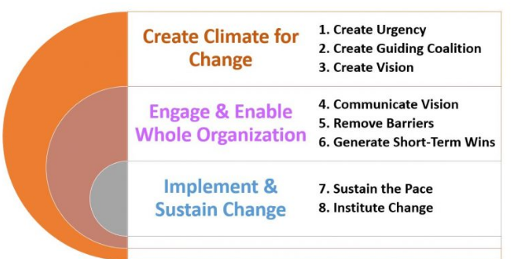
Figure 4: Kotter 8 step change management model
Source: Appelbaum et al (2012),
The model of Kotter for change management can be applied to explain the change management at GSK to manage its strategic change effectively and efficiently. As the model suggests creating a climate conducive to change by creating vision urgency and guiding coalition, similar was the case with GSK as the company communicated the change to the employees to make the environment that accepts the change (Summerfield, Barfield and White 2018). The change in the operations was due to the change in the brand incubation which was communicated to develop a sense of urgency so that the company can deliver effective strategic change. Further, the company built a team for the guidance of the employees that convey the vision of the organisation and provide direction to the employees so that the issues that occurred with the change in the organisation can be resolved. In order to enable and engage overall organisation, the vision of enhancing return on investment and improving e-commerce is communicated to the employees so that they accept the digital transformation in the business and perform accordingly. According to Ileri and Arik (2018), the barriers regarding emotions of employees were also reduced by effective leadership because they have motivated the employees by providing support in the job tasks. This helped in gaining the short term achievement as it improved employee performance. These achievement needs to be sustained for the long term as well, therefore, GSK has measured the performance of employees to ensure whether the change was adopted by the employees or they were still facing issues with the change. The performance of the employees was improved with the support of the leader which resulted in an increase in profit and growth of the organisation (Rogers, 2018: McEleny, 2019).

Advantages of change at GSK
In the view of Rogers (2018), Glaxo Smith Kline is recognised as the first consumer healthcare brand that had its own tech stack which was helpful for the company in enhancing its return on investment. With this change initiative, it was helpful for GSK in developing this in-house and was also helpful for the company in buying its digital media more effectively and gaining more visibility related to the media spending. Developing control on its tech stack had given the opportunity of organising and analysing the data more specifically and efficiently. Along with this it was also beneficial in driving creative excellence within the company (McEleny, 2019). Around 70% of the return on investment was usually coming from the creative excellence therefore it is necessary that it should be efficient and the company needs to make sure that they are not just making a TVC and broadcasting in on any of the digital formats, in order to capture the digital market it was necessary that the company should be efficient with that as well (Rogers (2018).

Organisational structural choices and design changes
In addition to this Goodman-Deane et al. (2018), stated that the digital and e-commerce director Kristensen believed that with the competitive environment the company does not have to focus on scientifically-backed brands but on its e-commerce as well because in the next five years the industry is expected to grow in the e-commerce. With this initiative it was helpful for the company in boosting its e-commerce and in order to do so, it introduced FCP framework (findability, conversion, and performance). The framework comprised of 10 steps which were followed by all the markets for a successful e-commerce business. Glaxo Smith Kline was able to agile for competing with the digitally native brands.
It was considered important in case of Glaxo Smith Kline and the brand incubator concept along with fail-fast cultural transformation that the structure becomes less bureaucratic. In order to bring about the change, GSK effectively indulged within the structuring of removing communication barriers and free communication within the organisation. This required structural reforms such as the removal of excessive reporting and decreased reporting lines within the entity. This highlights a flatter organisational structure. This changed the design for work process within the entity. Ecommerce is a fast-moving market where changes in products and trends are brisk and quite unexpected. Thus with GSK seeking the growth into e-commerce industry and expanding its operations, it is important that creative mind set prevails within the organisation and decisions are spontaneous (McEleny, 2019). Removal of reporting lines, allowed GSK to have low cost for hiring increased front line managers. Brand incubator and the development of the fail-fast cultures is well suited to a flat organisational structure that allows it to make decisions which are fast and can be implemented far more quickly. With GSK having operations across the globe this becomes a hectic task to perform however it is quite important to do so as GSK instead of going for a product based change within the entity has sought to transform the whole culture.

Conclusion & recommendation of strategic choice
In a nutshell, it can be stated that GSK implemented change in the organisation for improving the performance of the company and to increase the return on investment. The change brought was in terms of a brand incubator with the digital transformation to facilitate modern customers with the rewiring of the company’s brands. It has been found from the environmental analysis that technology is playing an active role in the development of the economy due to which the digitalisation has been increased which gave the opportunity to GSK to consider digital transformation. The change of introducing brand incubator made disruption in the working practices of the employees as a result of which they resisted the change. Although the change was successfully been implemented, it had room for improvement. Further, recommendations given to GSK are as follows:
- It is recommended to provide training to the employees regarding the change to eliminate the fear of failure from their minds.
- It is also suggested to communicate the change at all the levels not only to the top management level but also in the operational levels because technical staffs are the assets of the organisation and if they were not informed about the change it may affect their performance which would affect the organisational performance.

References

Alder, C.M., Hayler, J.D., Henderson, R.K., Redman, A.M., Shukla, L., Shuster, L.E. and Sneddon, H.F. (2016). Updating and further expanding GSK's solvent sustainability guide. Green Chemistry, 18(13), pp.3879-3890.
Appelbaum, S.H. Habashy, S. Malo, J.L. and Shafiq, H. (2012). Back to the future: revisiting Kotter's 1996 change model. Journal of Management Development, 31(8), pp.764-782.
BBC (2012). GlaxoSmithKline to pay $3bn in US drug fraud scandal. [Accessed on 25 Aug. 2019]. Available at<https://www.bbc.com/news/world-us-canada-18673220>.
Cummings, S., Bridgman, T., & Brown, K. G. (2016). Unfreezing change as three steps: Rethinking Kurt Lewin’s legacy for change management. Human relations, 69(1), pp. 33-60.
Davey, R., Fearon, C. and McLaughlin, H., (2013). Organizational grief: An emotional perspective on understanding employee reactions to job redundancy. Development and Learning in Organizations: An International Journal, 27(2), pp.5-8.
Dell'Ariccia, G., Rabanal, P. and Sandri, D. (2018). Unconventional monetary policies in the euro area, Japan, and the United Kingdom. Journal of Economic Perspectives, 32(4), pp.147-72.
Evoniuk, G., Mansi, B. DeCastro, B. and Sykes, J. (2017). Impact of study outcome on submission and acceptance metrics for peer reviewed medical journals: six year retrospective review of all completed GlaxoSmithKline human drug research studies. bmj, 357, p.1726.
Gerlach, S. and Brem, A. (2015). What determines a successful business incubator? Introduction to an incubator guide. International Journal of Entrepreneurial Venturing, 7(3), pp.286-307.
Glaxo smith Kline (2019). About us. [Accessed on 22 Aug. 2019]. Available at <https://www.gsk.com/en-gb/about-us/>.
Goodman-Deane, J., Waller, S.D., Bradley, M., Clarkson, P.J. and Bradley, O. (2018). Using Inclusive Design to Drive Usability Improvements Through to Implementation. In Cambridge Workshop on Universal Access and Assistive Technology. pp. 65-75.
GSK (2017) Annual Report [Accessed on 5 Sep. 2019]. Available at <https://pk.gsk.com/media/642405/gsk-annual-report-2017.pdf>
GSK (2018) Anuual Report [Accessed on 5 Sep. 2019]. Available at: <https://www.gsk.com/media/5349/annual-report-2018.pdf>
GSK (2019) Accelerating our priorities [Accessed on 5 Sep. 2019]. Available at: <https://www.gsk.com/media/5253/jpm-2019-emma-walmsley-presentation-slides.pdf>
GSK (2019) Rewarding performance [online] [Accessed on 27 August 2018] Available at: <https://uk.gsk.com/en-gb/careers/working-at-gsk/rewarding-performance/>
GSK (2019a) Technology [Accessed on 5 Sep. 2019]. Available at: <https://www.gsk.com/en-gb/careers/apprentices-students-and-graduates/future-leaders-graduate-programme/technology/>
Hussain, S.T. Lei, S. Akram, T. Haider, M.J. Hussain, S.H. and Ali, M. (2018). Kurt Lewin's change model: A critical review of the role of leadership and employee involvement in organisational change. Journal of Innovation & Knowledge, 3(3), pp.123-127.
Ileri, Y.Y. and Arik, O. (2018). Investigation of Resistance, Perception and Attitudes of Employees against Change in Information Systems Using Change Management Approach: A Study in a University Hospital. Journal of Information & Knowledge Management, 17(04), p.1850038.
Ionescu, E. I., Meruţă, A., & Dragomiroiu, R. (2014). Role of managers in the management of change. Procedia Economics and Finance, 16, pp. 293-298. Retrieved from < https://www.sciencedirect.com/science/article/pii/S2212567114008041>
Kumar, B.R. (2019). GlaxoSmithKline Merger. In Wealth Creation in the World’s Largest Mergers and Acquisitions. pp. 137-145.
Linkedin (2019) Digital Brand Incubator General Manage [Accessed on 5 Sep. 2019]. Available at: <https://uk.linkedin.com/jobs/view/digital-brand-incubator-general-manager-at-gsk-969207893>
McCarthy, J. (2019) GlaxoSmithKline begins marketing overhaul amid Pfizer merger [Accessed on 5 Sep. 2019]. Available at: < https://www.thedrum.com/news/2019/06/25/GlaxoSmithKline-marketing-overhaul-Pfizer-merger>
McEleny, C (2019) GSK and Accenture launch digital accelerator program for consumer brands in APAC [Accessed on 22 Aug. 2019]. Available at < https://www.thedrum.com/news/2019/06/04/gsk-and-accenture-launch-digital-accelerator-program-consumer-brands-apac >
McGoogan.C. (2017). Tech sector growing faster than UK economy with 72pc of investment outside London, report says. [Accessed on 25 Aug. 2019]. Available at <https://www.telegraph.co.uk/technology/2017/03/22/tech-sector-growing-faster-uk-economy-72pc-investment-outside/>.
McNamara. B. (2018). GSK consumer healthcare. [Accessed on 22 Aug. 2019]. Available at <https://www.gsk.com/media/5107/consumer-healthcare-investor-event-transcript-sept-2018.pdf>.
Mithas, S., Tafti, A. and Mitchell, W. (2013). How a firm's competitive environment and digital strategic posture influence digital business strategy. MIS quarterly, pp.511-536.
Office for national statistics (2017). Overview of the UK population: July 2017. [Accessed on 25 Aug. 2019]. Available at <https://www.ons.gov.uk/peoplepopulationandcommunity/populationandmigration/populationestimates/articles/overviewoftheukpopulation/july2017>.
Office for national statistics (2019). GDP rate of UK. [Accessed on 25 Aug. 2019]. Available at < https://www.ons.gov.uk/economy/grossdomesticproductgdp/timeseries/abmi/pn2>.
Rava (2019). GSK pursues a digital transformation, aims at boosting e-commerce. [Accessed on 22 Aug. 2019]. Available at <https://rava.pk/technology/gsk-pursues-a-digital-transformation-aims-at-boosting-e-commerce>.
Rock, M.L., Spooner, F., Nagro, S., Vasquez, E., Dunn, C., Leko, M., Luckner, J., Bausch, M., Donehower, C. and Jones, J.L., (2016). 21st century change drivers: Considerations for constructing transformative models of special education teacher development. Teacher Education and Special Education, 39(2), pp.98-120.
Rogers, C. (2018). GSK launches brand incubator as it shifts to ‘fail-fast’ culture. [Accessed on 22 Aug. 2019]. Available at <https://www.marketingweek.com/gsk-launch-brand-incubator/>.
Shirey, M. R. (2013). Lewin’s theory of planned change as a strategic resource. JONA: The Journal of Nursing Administration, 43(2), 69-72.
Stensaker, I. G., & Meyer, C. B. (2012). Change experience and employee reactions: developing capabilities for change. Personnel Review. [Accessed on 22 Aug. 2019]. Available at < https://www.researchgate.net/profile/Inger_Stensaker/publication/235318070_Change_experience_and_employee_reactions_Developing_capabilities_for_change/links/553b9b8c0cf2c415bb0ab213/Change-experience-and-employee-reactions-Developing-capabilities-for-change.pdf >
Summerfield, S.G., Barfield, M. and White, S.A. (2018). Incurred sample reanalysis at GSK: what have we learned?. Bioanalysis, 10(21), pp.1755-1766.
Trading economics (2018). Inflation rate of UK. [Accessed on 25 Aug. 2019]. Available at <https://tradingeconomics.com/united-kingdom/inflation-cpi>.
UNCFTD, (2015) The role of competition in the pharmaceutical sector and its benefits for consumers, United Nations Conference on Trade and Development [Accessed on 5 Sep. 2019]. Available at <https://unctad.org/meetings/en/SessionalDocuments/tdrbpconf8d3_en.pdf>
Vaccaro, I. G., Jansen, J. J., Van Den Bosch, F. A., & Volberda, H. W. (2012). Management innovation and leadership: The moderating role of organisational size. Journal of Management Studies, 49(1), 28-51. [Accessed on 22 Aug. 2019]. Available at < https://edisciplinas.usp.br/pluginfile.php/1751181/mod_resource/content/1/Vaccaro_et_al_2014.pdf >
Wittig, C. (2012). Employees’ reactions to organisational change. Od practitioner, 44(2), 23-28. [Accessed on 22 Aug. 2019]. Available at <https://pdfs.semanticscholar.org/3136/96331e181fd743106f91d9483a77d27686bf.pdf >
Wright, C.F. (2017). Employer organizations and labour immigration policy in Australia and the United Kingdom: The power of political salience and social institutional legacies. British Journal of Industrial Relations, 55(2), pp.347-371.

