Bus station book lockers
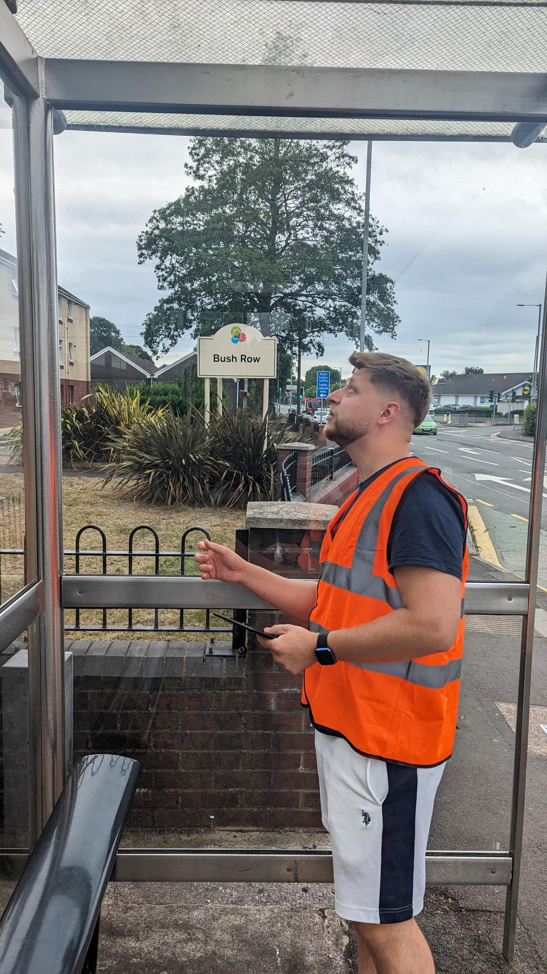

Introduction:
In a world driven by technological advancements, it's becoming increasingly important to create spaces that foster human connection and intellectual growth. Imagine a bus station where commuters waiting for their buses can indulge in the captivating world of literature. This is exactly what our team aims to achieve with our innovative business idea: transforming an ordinary bus station into a haven of books and knowledge. As part of the management team, my role as a plant (innovator) is crucial in shaping the creative direction of this venture.

My Role as a Plant:
As the plant in the management team, my primary responsibility is to generate and develop innovative ideas. I thrive on brainstorming sessions, where I challenge the status quo and introduce fresh perspectives to the team.

Belbin and Team Analysis:
Belbin's team analysis is a widely used framework to understand individual roles within a team. While it offers valuable insights into team dynamics, it's important to recognise that it does not always capture the complexity of human behaviour and the nuances of teamwork (West, 2012). People are multi-faceted and possess a range of skills that extend beyond the confines of a specific role. Belbin's categorisations should be seen as a starting point rather than an exhaustive analysis of team members' capabilities.

Conclusion:
The Book Bus Station is an exciting concept that blends the practicality of a bus station with the enchantment of literature. In my role as the plant in the management team, I bring a fresh perspective and innovative ideas to transform the ordinary into the extraordinary.

References:
West, M.A. (2012). Effective teamwork : practical lessons from organizational research. 3rd ed. Chichester, West Sussex: Pbs Blackwell.

