Student Name: Fasilat Abiodun Sanyaolu
Student ID: 2129103
Lecturer’s name: Heidi prosser,Lisa Bassier,Giulia Chifari
Module Code: BMIH5003
Assignment Title: Intercultural competence
Word’s count:979

A REPORT ON
INTERCULTURAL COMPETENCE
AND CULTURAL AWARENESS
FOR THE EXPANSION
OF DIVERSITY HOTEL AND SPA
IN FRANCE

Executive Summary
In pursuit of Diversity Hotel & Spa's intention to expand operations into France, the development of cultural intelligence and sensitivity within the organisation is considered essential by leadership. France, with its rich history and deeply ingrained cultural traditions, presents unique opportunities alongside challenges for the hotel chain looking to enter this new market. As noted by Hurn (2014), in an increasingly globalised business environment, organisations must purposefully cultivate cultural awareness as an imperative for successfully expanding into any new territory. This report has been structured to provide a comprehensive, research-based overview of French business culture and leadership styles. It additionally aims to outline recommendations for equipping Diversity Hotel & Spa staff with the global mindset required for cross-cultural success in France. With proper understanding and an inclusive orientation, the expansion can leverage synergies between the company's existing strengths and new possibilities within the nuanced French setting. The insights garnered herein are intended to chart an optimal course towards this next phase of the hotel chain's international growth.

Table of Contents
3. Executive Summary
4.Table of Contents
5. Introduction
6. Understanding French Culture and Customs
- Key aspects of French business culture
7. French Leadership Preferences and Cultural Dimensions
- GLOBE study findings on French leadership
8. Culture Awareness
- Navigating cross-cultural differences
9. Potential Challenges and Pitfalls
10. Recommendations
11. Conclusion
12. References

INTRODUCTION
As Diversity Hotel and Spa prepares for expansion into the French market, developing organisational cultural intelligence is considered essential for success by leadership. Given France's renowned cultural history and ingrained societal norms, this new market represents unique opportunities coupled with challenges needing navigation. As Hurn (2014) notes, with increasing globalisation, purposefully fostering cultural awareness becomes imperative for companies looking to enter new international territories.
This report will firstly highlight key aspects of French culture including communication styles, attitudes towards hierarchy, and business etiquette norms as analysed by scholars like Morgan & Bittman (2021). Relevant cross-cultural research on French leadership preferences will then be explored. Building on this foundation, the report will discuss the importance of cultural sensitivity in hotel management and potential leadership pitfalls.
With proper understanding and an inclusive mindset, it is believed Diversity Hotel & Spa can optimally blend its existing strengths with new opportunities in the French market. The insights within this report aim to chart a course toward successful international expansion through research-supported guidance tailored for the organisation's cross-cultural transition.

Understanding French Culture and Customs
Having conducted thorough research into French culture in preparation for this expansion – and drawing upon their own familiarity and deep appreciation for the Joies de Vivre of France, the need to sensitise themselves to key differences becomes imperative as staff integration is considered. With a wealth of cross-cultural expertise, they have identified areas that require improvement, ensuring that they serve as passionate yet pragmatic ambassadors for the Diversity Hotel brand. Key cultural considerations include:
- Formal salutations are the norm in French culture, utilising titles like Monsieur or Madame along with surnames until an invitation to use first names is extended.
- Punctuality takes a back seat to prioritising the delivery of quality work.
- Self-reliance is highly valued, with a preference for privacy over openly sharing personal matters.
- The appreciation for the finer aspects of life, such as wine and cuisine, is evident, and it is customary to indulge in leisurely lunches and dinners.
France – GLOBE Leadership Analysis
The GLOBE study on culture and leadership categorises France as preferring inspirational and team-oriented leadership (House et al., 2004). France ranks highly on intellectual and gender egalitarianism (Antal & Sobczak, 2007). Based on these findings, the following can be deduced:
- Acceptance of hierarchy and class structures.
- Intellectual discussion is embraced – which means there's a deepened appreciation for knowledge, reason, and education.
- Gender equality is a widely acknowledged and acceptable concept – hence, women can hold positions of authority.
- Visionary and persuasive leadership styles are perceived positively.
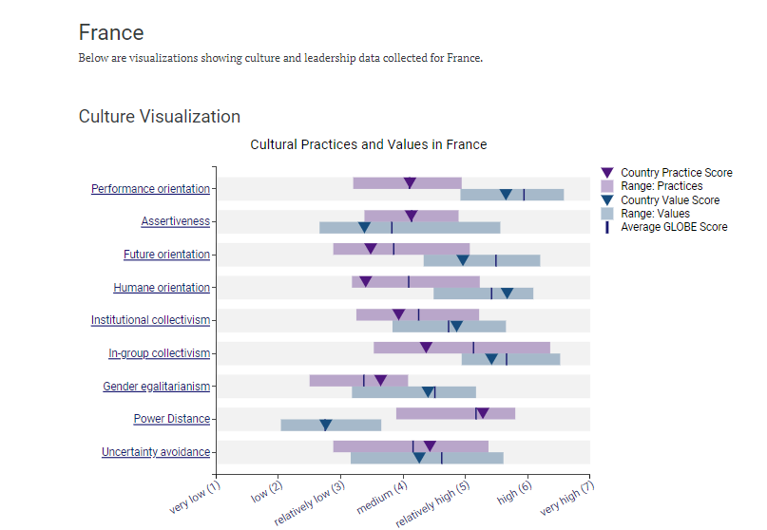
Figure 1. France GLOBE scores for culture visualisation
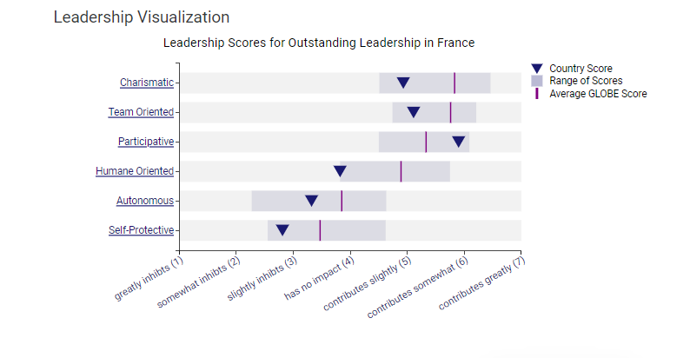Figure 2. France GLOBE scores for leadership visualisation
Cultural Awareness
As Diversity Hotel & Spa ventures into the French market, cultural awareness becomes an essential consideration in facilitating a seamless transition. It ensures that the brand comprehends the diverse cultural norms, behaviours, and customs that influence communication and business practices. Given France's rich history and deeply-rooted traditions, the opportunity for learning extends to staff at all levels of the hotel chain.
Cultural awareness transcends merely becoming experts in the intricacies of French culture; instead, it entails fostering respectful understanding to support positive interactions while avoiding culturally insensitive missteps. Significant investment in training programs and resources is necessary to enhance knowledge of French culture. This encompasses nuances related to greetings, etiquette, punctuality, communication norms, and other business customs, as previously outlined.
Encouraging curiosity and open discussions between British and French team members is imperative to facilitate the sharing of perspectives and the surfacing of assumptions.
Navigating Cross-cultural Differences
For navigating cross-cultural differences as Diversity Hotel & Spa expands, the following tips are crucial:
- Leaders should exhibit cultural intelligence (Earley & Mosakowski, 2004).
- Adapt approaches to respect local preferences while upholding core values.
- Invest time in understanding diverse communication styles and business etiquette (Hurn, 2014).
- Foster a flexible mindset and avoid cultural stereotypes and judgments (Morgan & Bittman, 2021).
- Implement regular training and two-way mentoring among staff from various cultures to build bridges (Salacuse, 2006). These strategies enhance cross-cultural effectiveness during expansion.

Potential Challenges and Pitfalls for the General Manager during the course of expansion
Understanding French culture is vital, but potential challenges from the GM's British cultural background must be acknowledged. Differences can arise due to conflicting British business norms and the more relaxed French attitudes towards time, indirect speech, and prioritising quality over speed. Awareness of these distinctions is essential. Additional challenges encompass:
- Perceived rudeness or impatience due to divergent British directness versus French subtlety (Lewis, 2015).
- Adaptation to the greater power distance and formality expected in French hierarchical structures (Hofstede, 2021).
- Coping with the loser approach to punctuality compared to British norms (Brule, 2021).
- Grappling with indirect speech and nuanced French language cues, in contrast to British preference for explicit, transparent communication (Salacuse, 2006).

Recommendations
As Diversity Hotel & Spa expands into the intricate French market, the leadership team may encounter challenges arising from cross-cultural differences. In navigating this expansion successfully, several recommendations have been identified:
- Embrace flexibility and patience while addressing cultural gaps.
- Dedicate time to understanding French norms without passing judgement.
- Adapt the communication style to be less direct while ensuring clarity.
- Solicit input from local staff to bridge cultural differences effectively.
- Maintain core values while allowing room for customization.

Conclusion
In conclusion, Diversity Hotel & Spa is well-prepared for the exciting expansion into the French market. With an understanding of Gallic culture and the brand's characteristic sensitivity, the company can effectively engage both staff and guests (Browaeys & Price, 2015). Anticipated intercultural challenges are viewed as opportunities for fostering cohesion through dialogue. Just as the London flagship embodies bespoke hospitality, the nascent French property can capture its terroir's essence, aligning with the mission of belonging. Diversity Hotel & Spa is confident that its diverse talents will synergize, pioneering new heights in hospitality. The company eagerly anticipates contributing to this expansion.

REFERENCE
Antal, A.B. & Sobczak, A. (2007). Corporate social responsibility in France: A mix of national traditions and international influences. Business & Society, 46(1), 9–32.
Browaeys, M-J. & Price, R. (2015). Understanding Cross-Cultural Management. Harlow: Pearson Education Limited.
Brule, J.F. (2021). Decoding French Business Culture. Chichester, UK: Capstone Publishing.
Earley, P.C., & Mosakowski, E. (2004). Cultural intelligence. Harvard Business Review, 82(10), 139-146.
GLOBE Project. (2020). Country profile: France. https://globeproject.com/results/countries/FRA?menu=list#country
Hofstede, G., Hofstede, G.J. & Minkov, M. (2021). Cultures and Organizations: Software of the Mind (4th ed.). New York: McGraw-Hill.
House, R.J. et al. (eds.). (2004). Culture, Leadership, and Organizations: The GLOBE Study of 62 Societies. Thousand Oaks, CA: Sage Publications.
Hurn, B.J. (2014). The Challenges of Leadership in International Hotel Management. International Journal of Leadership and Change, 2(1).
Lewis, R.D. (2015). When Teams Collide: Managing the International Team Successfully. London, UK: Nicholas Brealey Publishing.
Morgan, C. & Bittman, M. (2021). Navigating Cultural Complexity in Hotel Management. The International Hospitality Review, 34(4), 21-35.
Salacuse, J. W. (2006). Intercultural negotiations in international business. Group Decision and Negotiation, 15(3), 217-236.

